**Utilization of Sexual and Reproductive Health Services among undergraduate students in University of Ilorin, Ilorin, Kwara State.**

**Abstract**

*Historically, there has been a significant lack of attention given to the provision of reproductive health care for young individuals, resulting in their heightened susceptibility to various reproductive health issues such as Sexual Transmitted Infection (STI), unwanted pregnancy, unsafe abortion, and other detrimental practices. Despite the considerable amount of research conducted on reproductive health services (RHS), the continued prevalence of reproductive health issues among undergraduate students in Nigerian universities renders this study highly relevant. The objective of this study was to evaluate the utilization of Sexual and Reproductive Health services among undergraduate students in University of Ilorin, Ilorin, Kwara State. The research employed a descriptive cross-sectional design, which involved a sample of 400 undergraduate students that were selected to be representative of the target population. The data was collected via a semi-structured questionnaire and subsequently analyzed using fundamental statistical techniques, including frequencies, percentages, and chi-square analysis. The researcher utilized a significance level of p=0.05.*

*The majority of participants (76.2%) were aged 21 years and older, while 23.8% fell within the age range of 18-20 years. All participants demonstrated knowledge of various reproductive health services, including sexuality education (30.8%), family planning services (25.5%), and treatment of sexually transmitted infections (18.5%). The majority of participants (80.0%) indicated that they availed themselves of sexual and reproductive health services, with sexuality education (51.6%) and treatment of sexually transmitted infections (24.4%) being the most commonly utilized reproductive health services. Of the participants who reported being in romantic relationships, 22.8% engaged in sexual activity with their partners, whereas 50.5% engaged in cuddling activities. The majority of participants (61.8%) reported engaging in dangerous sexual practices, while 64.0% indicated that their first sexual experience occurred after the age of 18. The majority of participants (66.0%) reported having a single relationship, whereas 17.8% and 16.2% indicated having two and three or more partners, respectively. Of the individuals who reported being sexually active, 63.2% indicated that they availed themselves of sexual and reproductive health services. Hence, it is imperative to establish and cultivate relationships that facilitate and strengthen favourable health behaviours among teenagers. This entails the establishment of strong bonds between adolescents and their parents, which serve to promote and strengthen the adoption of healthy health behaviours among teenagers.*

**Introduction**

Sexual and reproductive health implies that people can experience a satisfying and safe sex life (Glasier *et al.,* 2016). This also include the ability to reproduce, decide when and how to produce. Reproductive health also addresses issues such as unwanted pregnancies, unsafe abortion, reproductive tract infections including sexually transmitted disease, gender-based violence, infertility, malnutrition and reproductive tract cancers (World Health Organization, 2019). Globally, it is estimated that there are 1.25 billion youth with about 85% of them living in developing countries. These youths due to unsafe premarital sex are mostly vulnerable to a range of reproductive health problems, including early pregnancy and childbearing, unsafe abortion and sexually transmitted infections (STIs) (Ingwersen, 2015). Premarital sexual activity is common and is on the rise worldwide (UNAIDS, 2018). Rates are highest in Sub-Saharan Africa where more than half of girls aged 15-19 years are sexually active (UNAIDS, 2018).

Students of Higher Education form a heterogeneous group with multiple socio-cultural backgrounds who begin autonomous life at younger age and mostly away from their families. Study findings revealed that most students in higher educational institutions engage in a range of maladaptive, high-risk extracurricular activities like alcohol use, substance and sexual abuse (Wakgari *et al.,* 2015). These social vices are attributed to a range of factors. It is claimed that poor mental health, sexual coercion, low trust in others, and increased university enrolment are associated with risky sexual behavior among university students (Devika *et al.,* 2016). Non-regular partners, unprotected sex, and crossgenerational sex among university students were also reported to be high among this group (Devika *et al.,* 2016). It has been asserted that economic problems, peer pressure, absence of preventive intervention and lack of access to Information Education Communication (IEC) on sexual and reproductive health issues are other reasons for unsafe sex life among university students (Tesfaye *et al.,* 2015). This can really be more paramount in institutions where systems are not properly developed to support the sexual and reproductive life of these students. Thus, this study assessed the utilization of Sexual and Reproductive Health among undergraduate students in University of Ilorin, Ilorin, Kwara State.

### ****Methodology****

#### **Research Design**

The study was descriptive cross-sectional study using quantitative method of data collection.

#### **Study Area**

#### The University of Ilorin (Unilorin), located in Ilorin, Kwara State, Nigeria, is positioned at a latitude of 8.4852° N and a longitude of 4.5490° E. Established by the Nigerian government in 1976, it spans approximately 15,000 hectares and serves as an educational hub for over 56,600 students and 4,500 staff members (Durotoye et al., 2020). The university comprises 15 faculties, along with a College of Health Sciences and a School of Preliminary Studies, reflecting a diverse academic environment (Durotoye et al., 2020).

#### As a testament to its growth, Unilorin increasingly integrates emerging technologies in education and research initiatives alongside its traditional academic offerings, facilitating modern instructional methods (Nuhu et al., 2022). The student population represents a wide range of disciplines, ensuring a broad spectrum of academic inquiry (Olumorin et al., 2022). Thus, Unilorin stands as a vital institution in Nigeria's educational landscape, shaping the next generation of leaders and professionals (Durotoye et al., 2020; Nuhu et al., 2022; Olumorin et al., 2022). **Target Population**

The research population comprised undergraduate students of University of Ilorin, Ilorin, Kwara State.

#### **Sample Size and Participant Recruitment**

The sample size was calculated based on a previously reported population that utilized maternal health services in previous study of 66.6% (Abdulahi, 2020), at a 95% confidence level and a 5% margin of error. To accommodate possible non-response or incomplete data, a 10% allowance was added, 400 questionnaires was distributed to improve the power of the study**.** A **multistage sampling technique** was used with a list of departments from the University of Ilorin, Ilorin, Kwara State were obtained and 4 departments were selected by simple random sampling. From each department, asystematic random sampling technique was used to select respondents for the sample study using the total number of students in the departmental nominal roll at the time of the study on each day of data collection as the sampling frame. The first respondent was randomly selected within the sampling interval, while subsequent respondents were selected using the sampling interval until the desired sample size for each department was completed

#### **Method of Data Collection and Data Analysis**

Data were collected through a **semi-structured interviewer-administered questionnaire**. Four research assistants were trained by the researcher to have a clear understanding of the study and well interpretation of the questionnaire on the field for data collection. The training will hold few days before the day of data collection and a pre- and post-training evaluation of the assistant was done by the researcher to ensure adequate knowledge of the objectives of this study and competence in the collection of required data. Data were entered, cleaned, and analyzed using **Statistical Package for the Social Sciences (SPSS) version 27**. The data analysis was conducted in line with the analysis structure to achieve the objectives set out at the outset. Descriptive statistics was used to summarize the data on respondent characteristics using; tables, graphs and charts. To test associations between the outcome variable (sexual and reproductive health utilization) and the independent variables/factors (demographic characteristics), Chi-square was used. The level of significance for the statistical tests was set at 0.05.

**Ethical Considerations**

A written permission was obtained prior to study from the Department of Public Health, School of Basic Medical Sciences, Kwara State University, Malete. Ethical approval for this study was obtained from the Ethical review Committee of the Kwara State University, Malete. Verbal informed consent would be obtained from women of reproductive age group who agreed to participate in the study. They would be told that participation is voluntary and they would not suffer any consequences if they chose not to participate. Anonymity and confidentiality of all information from respondents was maintained and assured throughout the study process. Information collected was kept confidential and the respondents name will not be asked in the questionnaire.

**Result**

### Table 1: Socio-demographic characteristics of respondents N= 400

|  |  |  |
| --- | --- | --- |
| **Variables** | **Frequency** | **Percentage** |
| **Age group**  16 – 20 | 95 | 23.8 |
| 21 and above | 305 | 76.2 |
| **Level**  100 | 82 | 20.5 |
| 200 | 101 | 25.3 |
| 300 | 104 | 26.0 |
| 400 | 105 | 26.3 |
| 500 | 8 | 2.0 |
| **Tribe**  Yoruba | 360 | 90.0 |
| Igbo | 10 | 2.5 |
| Hausa | 5 | 1.3 |
| Fulani | 15 | 3.8 |
| Others | 10 | 2.5 |
| **Religion** |  |  |
| Islam | | 156 | 39.0 | |
| Christianity | | 220 | 55.0 | |
| Traditional | | 10 | 2.5 | |
| Others | | 14 | 3.5 | |
| **Marital status** | |  |  | |
| Single | | 393 | 98.3 | |
| Married | | 6 | 1.5 | |
| Divorced | | 1 | 0.3 | |
| **Place of residence** | |  |  | |
| On campus | | 115 | 28.7 | |
| Off campus | | 285 | 71.3 | |

Most of the respondents (76.2%) were 21 years and above and 23.8% were between the ages of 18-20 years old. Almost all of the respondents (90.0%) were Yoruba, 3.8% and 2.5% were Fulani and Igbo respectively. Slightly more than half of the respondents (55.0%) were Christians, 39.0% were practicing Islamic religion while 2.5% were practicing Traditional religion. Almost all of the respondents (98.3%) were single, 1.5% and 0.3% were married and divorced respectively. On the place of residence of respondents, 71.3% lived off campus while 28.7% lived on campus.

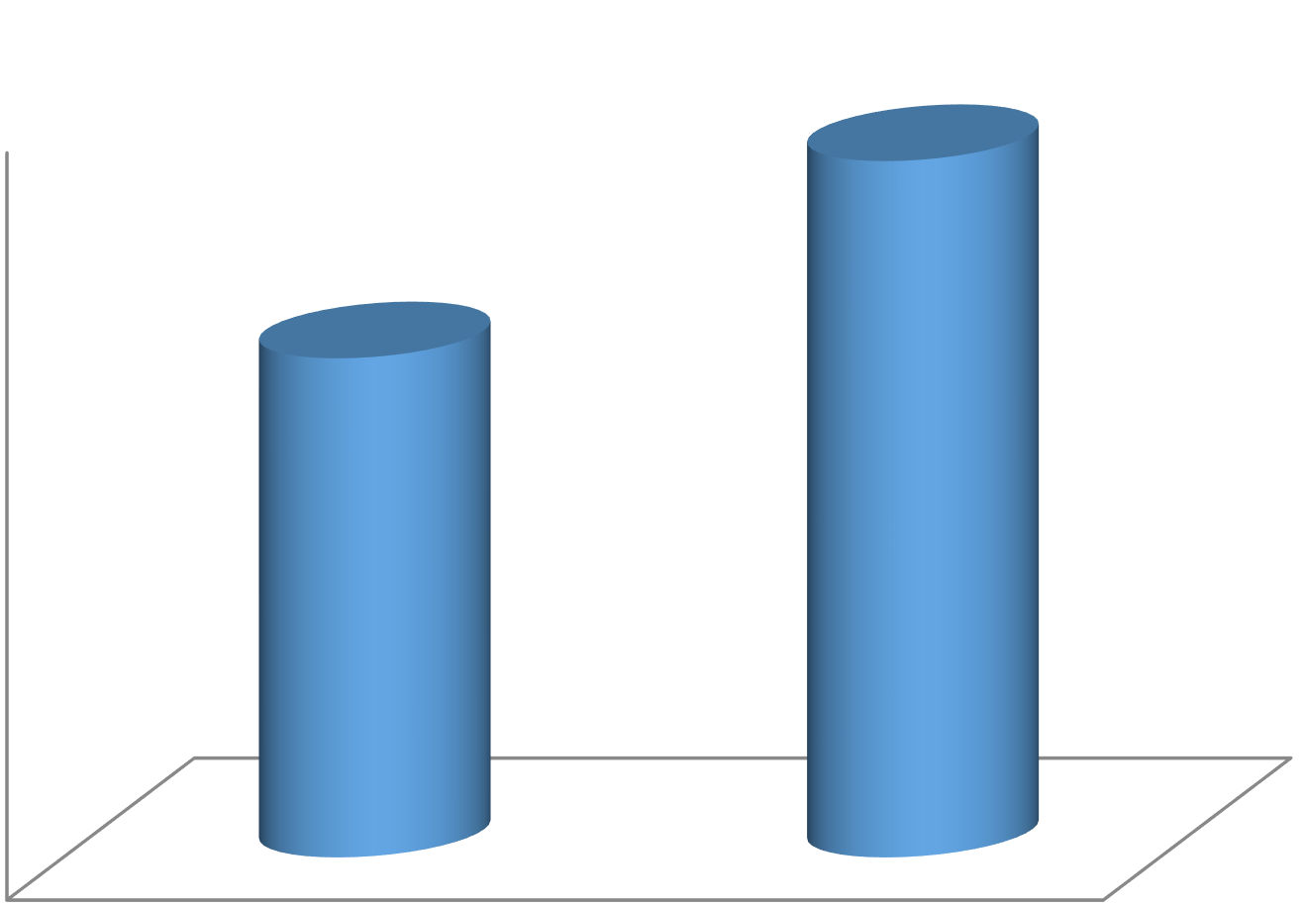

0

50

100

150

200

250

Male

Female

167 (41.8%)

233 (58.3%)

### Figure 1: Gender

More than half of the respondents (58.3%) were female while the remaining 41.8% of the respondents were males.

### Table 2: Awareness of the component of sexual and reproductive health services

|  |  |  |  |
| --- | --- | --- | --- |
| **Response** | **Frequency** | **Percentage** | |
| **Heard of reproductive health service** |  |  | |
| Yes | 400 | 100.0 | |
| **Known reproductive services** | |  |  |
| Sexuality education | | 123 | 30.8 |
| Family planning services | | 102 | 25.5 |
| Treatment of STI | | 74 | 18.5 |
| Voluntary and testing services | | 15 | 3.7 |
| Youth reproductive services | | 24 | 6.0 |
| Pregnancy testing services | | 25 | 6.2 |
| Post abortion care | | 19 | 4.8 |
| Antenatal services | | 11 | 2.8 |
| Prevention of treatment of infertility | | 7 | 1.7 |

All of the respondents were aware of reproductive health services with sexuality education (30.8%), family planning services (25.5%) and treatment of STI (18.5%) as the major reproductive health services known by the respondents.

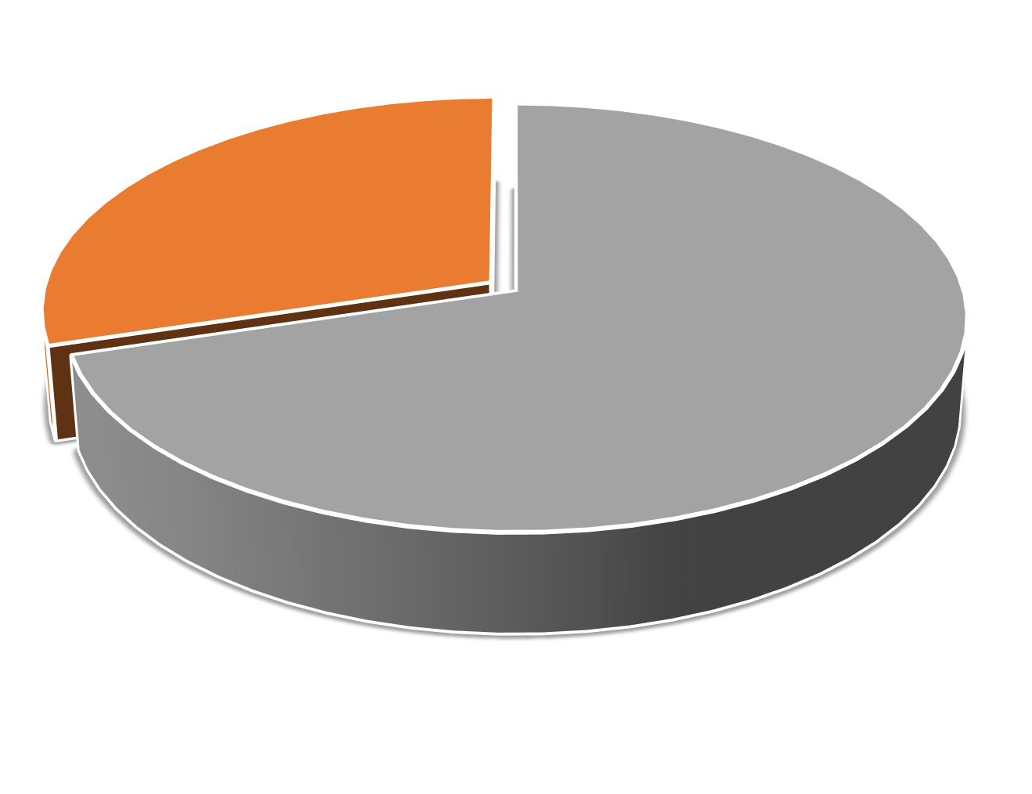

281

, 70.3%

119

, 29.8%

Yes

No

### Figure 2: Respondent has boy/girlfriend

Most of the respondents (70.3%) noted that they have a boyfriend/girlfriend while 29.8% noted that they did not have boy/girlfriend.

### Table 3: Utilization of sexual and reproductive health services

|  |  |  |  |
| --- | --- | --- | --- |
| **Response** | **Frequency** | **Percentage** | |
| **Used sexual and reproductive health services**  Yes | 320 | 80.0 | |
| No | 80 | 20.0 | |
| **Services used**  Sex education | 165 | 51.6 | |
| Post abortion care | 14 | 4.4 | |
| Youth reproductive health service | 1 | 0.3 | |
| STI clinic | 32 | 8.0 | |
| Pregnancy test services | 5 | 1.6 | |
| Voluntary counseling and test | 1 | 0.3 | |
| Antenatal care service | 1 | 0.3 | |
| Family planning services | 22 | 6.9 | |
| Prevention and treatment | 1 | 0.3 | |
| Treatment of STI | 78 | 24.4 | |
| **Activities done with boy/girlfriend** | **n = 281** |  | |
| Reading | 11 | 3.9 | |
| Having sex | | 64 | 22.8 |
| Watching movies | | 30 | 10.7 |
| Church programs | | 2 | 0.7 |
| Cuddling | | 142 | 50.5 |
| Don’t know | | 32 | 11.4 |
| **Had unsafe sex** | | **n =400** |  |
| Yes | | 247 | 61.8 |
| No | | 153 | 38.3 |
| **Age at first sex** | | **n = 247** |  |
| 15 – 18 | | 89 | 36.0 |
| Above 18 | | 158 | 64.0 |
| **Number of partner** | |  |  |
| 1 | | 163 | 66.0 |
| 2 | | 44 | 17.8 |
| 3 and above | | 40 | 16.2 |
| **Use reproductive health services** | |  |  |
| Yes | | 156 | 63.2 |
| No | | 91 | 36.8 |

Most of the respondents (80.0%) noted that they used sexual and reproductive health services with sexuality education (51.6%) and treatment of STI (24.4%) as the widely used reproductive health services utilized. Among the respondents that have boy/girlfriends,

22.8% and 50.0% noted that they have sex and cuddle their boy/girlfriend respectively. Most of the respondents (61.8%) identified that they have had unsafe sex with 64.0% had their debut sex at age above 18 years. Most of the respondents (66.0%) have only one partner, 17.8% and 16.2% noted that they have 2 and 3 or more partners respectively. Among the respondents that are sexually active, 63.2% noted that they utilized sexual and reproductive health services.

### Table 4: Association between socio-demographics and level of utilization of SRH

|  |  |  |  |  |  |  |
| --- | --- | --- | --- | --- | --- | --- |
| **Variables** | **Level of utilization of SRH**  **Yes (%) No (%)** | | **Total** | **χ²** | **p-value** | |
| **Age group** |  | |  | 0.345 | 0.557 | |
| 16 – 20 | 78 (82.1) 17 (17.9) | | 95 |  |  | |
| 21 and above | | 242 (79.3) | 63 (20.7) | 305 |  |  |
| **Level** | |  |  |  | 5.249 | 0.263 |
| 100 | | 63 (76.8) | 19 (23.2) | 82 |  |  |
| 200 | | 86 (85.1) | 15 (14.9) | 101 |  |  |
| 300 | | 79 (76.0) | 25 (24.0) | 104 |  |  |
| 400 | | 84 (80.0) | 21 (20.0) | 105 |  |  |
| 500 | | 8 (100.0) | 0 (0.0) | 8 |  |  |
| **Gender** | |  |  |  | 0.023 | 0.879 |
| Male | | 133 (79.6) | 34 (20.4) | 167 |  |  |
| Female | | 187 (80.3) | 46 (19.7) | 233 |  |  |
| **Marital status** | |  |  |  | 0.294 | 0.863 |
| Single | | 314 (79.9) | 79 (20.1) | 393 |  |  |
| Married | | 5 (83.3) | 1 (16.7) | 6 |  |  |
| Divorced | | 1 (100.0) | 0 (0.0) | 1 |  |  |
| **Place of residence** | |  |  |  | 214.264 | **0.001** |
| On campus | | 39 (33.9) | 76 (66.1) | 115 |  |  |
| Off campus | | 281 (98.6) | 4 (1.4) | 285 |  |  |

Association between socio-demographics and level of utilization of SRH was statistically significant with the place of residence of the respondents.

**Discussion**

Reproductive Health Services (SRHS) for the adolescent population. This cross-sectional study aimed to evaluate the utilization of adolescent reproductive health services and identify the factors associated with such utilization in various countries with differing levels of development. The study focused on the utilization of Sexual and Reproductive Health among undergraduate students in University of Ilorin, Ilorin, Kwara State. Within the scope of this investigation, a significant majority of the participants (76.2%) were within the age range of 21 years and above, while the remaining 23.8% were situated inside the 18-20 years old bracket. The majority of participants in the study identified as Yoruba, with 3.8% and 2.5% representing the Fulani and Igbo ethnic groups, respectively. A majority of the participants (55.0%) identified themselves as Christians, followed by 39.0% who practiced the Islamic religion, and a minority of 2.5% who adhered to Traditional religious beliefs. This information aligns with a study conducted by Adefalu et al. (2019), which reported that a total of 61 respondents (15.7%) fell within the age range of 16-18 years. Additionally, 148 respondents (38.1%) were between the ages of 19-21, while 112 respondents (28.9%) fell within the 22-24 age group. Furthermore, 67 respondents (17.3%) were 25 years or older. The majority of the respondents (60.8%) identified as female, and 205 respondents (52.8%) identified as Christians. It is worth noting that the vast majority of participants were single. In terms of ethnic background, the study revealed that 348 participants (89.7%) identified as Yoruba, while 12 (3.1%) identified as Hausa and Igbo, respectively. The remaining 16 participants (4.1%) belonged to other ethnic groups. The observed high population among the Yoruba can be attributed to the geographical location of the study area within Yoruba country. This study further substantiates the claim made in Ghana that a significant proportion of university students are below the age of 30 and are not married (Ahiadaku, 2019). Hence, it is crucial that healthcare interventions aimed at the youth, namely university students, who predominantly remain unmarried, should effectively cater to their distinct requirements. It has been posited that individuals under the age of 30 have a tendency to value their personal privacy and harbor concerns of potential victimization when engaging in discussions pertaining to sexuality. Hence, individuals exhibit hesitancy in discussing matters pertaining to reproductive health until the establishment of a secure and accessible setting (Marston & King, 2016). However, this study presents findings that are inconsistent with those of Adefalu et al. (2019) in terms of undergraduate students' residency. Adefalu et al. reported that 59.5% of the participants resided on campus, while 40.5% resided off campus. In contrast, the current study found that 71.3% of the participants lived off campus, while 28.7% stayed on campus.

The findings of this study indicate that a majority of the participants (80.0%) reported utilizing sexual and reproductive health services. Among these services, sexuality education (51.6%) and treatment of sexually transmitted infections (24.4%) were identified as the most often utilized reproductive health services. This finding challenges the findings of previous researchers such as Ilesanmi, Ezeokoli, Obasohan, Ayodele, and Olaoye (2015) as well as Schriver, Meagley, Norris, Geary, and Stein (2015), who reported a low utilization of reproductive health services among young individuals. These studies also highlighted the prevalence of sexual health issues among young males and females, including unintended pregnancies, unsafe abortions, and sexually transmitted infections (STIs) such as HIV/AIDS, which are largely preventable. The high utilization rate of the Secondary Health Care System (SRHS) in Ilorin could potentially be attributed to the presence of a greater number of private health centres, social doctors, and drug dealers within the region.

The findings indicated that a majority of the adolescent participants were presently engaged in sexual activity, typically without employing any type of contraception, such as a condom. This finding aligns with the results reported in a study conducted among adolescents who share similar characteristics, which demonstrated a significant prevalence of sexual activity and associated risks, including unwanted pregnancy, HIV, and sexually transmitted infections (Sommer & Mmari, 2015). Despite the potential consequences associated with sexual activity and the relatively substantial level of knowledge regarding sexual and reproductive health (SRH) concerns, particularly in relation to HIV compared to other sexually transmitted infections (STIs), it is noteworthy that 36.8% of the individuals surveyed had never sought information or services on SRH from a healthcare facility. Furthermore, over half of the participants expressed a lack of willingness to seek assistance from a healthcare facility in the future for any SRH matters. In a similar vein, several studies conducted in Nigeria have documented a satisfactory level of sexual and reproductive health (SRH) awareness among teenagers. Association between socio-demographics and level of utilization of SRH was statistically significant with the place of residence of the respondents while age and gender of the respondents showed no significant relationship.

**Conclusion and Recommendations**

The study revealed a high level of utilization of sexual and reproductive health services (SRHS) among undergraduate students at the University of Ilorin, with 80.0% of respondents reporting service usage. Sexuality education and treatment for sexually transmitted infections were the most commonly accessed services. Despite the encouraging utilization rates, a significant proportion of the respondents still engaged in unprotected sexual activities and expressed unwillingness to seek SRHS in the future. Socio-demographic characteristics, particularly place of residence, significantly influenced SRHS utilization, whereas age and gender did not. The findings highlight a gap between knowledge and actual health-seeking behavior, underlining the need for tailored interventions to address attitudinal and accessibility barriers.

COMPETING INTERESTS DISCLAIMER:

Authors have declared that they have no known competing financial interests OR non-financial interests OR personal relationships that could have appeared to influence the work reported in this paper.

**References**

Adefalu, G. A., & Ayodele, A. O. (2019). Factors influencing access and utilization of reproductive health services among undergraduates in selected tertiary institutions in Ogun State, Nigeria.

Ahiadaku, D. E. (2019). Sexting and risky sexual behavior among University of Ghana students. <http://197.255.68.203/handle/123456789/21463>

Devika, M., Anette, A., & Karen, O. (2016). Use of contraception: Determinants among Ugandan university students. Global Health Action, 9(1), 113–116. https://doi.org/10.3402/gha.v9.30790

Durotoye, I., Odunola, R., Adeyemi, O., Akanmu, A., Bolarinwa, O., Adeboye, M., … Aduloju, V. (2020). Pertinent roles of African higher institutions in the COVID‐19 pandemic response: The University of Ilorin, Ilorin, Nigeria; An African model. The International Journal of Health Planning and Management, 35(5), 1257–1259. <https://doi.org/10.1002/hpm.2984>

Glasier, A., Gülmezoglu, A. M., Schmid, G. P., Moreno, C. G., Van Look, P. F. A., & Horton, R. (2016). Sexual and reproductive health: A matter of life and death. The Lancet, 368(9547), 1595–1607.

Ingwersen, R. (2015). Youth reproductive and sexual health in the developing world. Development Bulletin, 56, 165–518.

Ilesanmi, A. O., Ezeokoli, R. N., Obasohan, M. O., Ayodele, K. O., & Olaoye, T. (2015). Sexual behaviour, HIV/STI prevention knowledge, and utilisation of VCT among the residents in Sagamu Metropolis of Ogun State, Nigeria. International Journal of Prevention and Treatment, 4(1), 8–15.

Marston, C., & King, E. (2016). Factors that shape young people’s sexual behaviour: A systematic review. The Lancet, 368(9547), 1581–1586. https://doi.org/10.1016/S0140-6736(06)69662-1

Nuhu, K., Adedokun, N., Aderele, S., & Aladesusi, G. (2022). Pre-service teachers’ integration of mobile learning technologies for instruction. Indonesian Journal of Educational Research and Review, 5(1), 158–168. <https://doi.org/10.23887/ijerr.v5i1.46159>

Olumorin, C., Babalola, E., Ashaolu, S., & Omolafe, E. (2022). Students’ attitude towards the utilization of Google Classroom for learning. Indonesian Journal of Educational Research and Technology, 2(3), 213–222. <https://doi.org/10.17509/ijert.v2i3.44828>

Schriver, B., Meagley, K., Norris, S., Geary, R., & Stein, A. D. (2015). Young people’s perceptions of youth-oriented health services in urban Soweto, South Africa: A qualitative investigation. BMC Health Services Research, 14, 625. https://doi.org/10.1186/s12913-014-0625-y

Sommer, M., & Mmari, K. (2015). Addressing structural and environmental factors for adolescent sexual and reproductive health in low-and middle-income countries. American Journal of Public Health, 105(10), 1973–1981. https://doi.org/10.2105/AJPH.2015.302740

Tesfaye, S., & Abulie, T. (2015). Sexual and reproductive health problems and service needs of university students in South East Ethiopia: Exploratory qualitative study. Science Journal of Public Health, 1, 14–18.

UNAIDS. (2018). Report on the global AIDS epidemic. Joint United Nations Programme on HIV/AIDS. <http://data.unaids.org/pub/globalreport/2018/jc1510_2018globalreport_en.pdf>

Wakgari, D., & Aklilu, A. (2015). Substance use and its predictors among undergraduate medical students of Addis Ababa University in Ethiopia. BMC Public Health, 11, 660. https://doi.org/10.1186/1471-2458-11-660

World Health Organization. (2019). Youth and health risks. <https://apps.who.int/gb/ebwha/pdf_files/WHA64/A64_25-en.pdf>