Original Research Article

A Hybrid LSTM_DCC Model for Multivariate Cryptocurrency Volatility Prediction

.

ABSTRACT

|  |
| --- |
| Accurate volatility forecasting remains a central challenge in the analysis of cryptocurrency markets, where extreme price fluctuations, nonlinear dependencies and evolving cross-asset correlations complicate traditional modeling approaches. This study aimed to improve forecasting accuracy by introducing a hybrid framework that integrates the Dynamic Conditional Correlation (DCC) GARCH model with Long Short-Term Memory (LSTM) networks. By combining the structural interpretability of econometric models with the nonlinear approximation capabilities of deep learning, the proposed LSTM–DCC model offers improved representation of volatility clustering, structural breaks and interdependencies among digital assets. Conducted using daily return data for Bitcoin (BTC), Ethereum (ETH) and Binance Coin (BNB) from January 2018 to March 2025, the study developed and evaluated the hybrid model across multiple forecast horizons, comparing its performance to standalone LSTM and DCC-GARCH models. Volatility forecasts were assessed using mean absolute error (MAE) and root mean square error (RMSE), with the LSTM–DCC model consistently producing lower forecast errors and better capturing market dynamics. These findings support the use of integrated modeling techniques in financial time series analysis and highlight the LSTM–DCC model as a reliable tool for forecasting cryptocurrency volatility. |

*Keywords: Deep Learning, MGARCH, LSTM-DCC, Hybrid Models, Cryptocurrency, Volatility Forecasting*

1. INTRODUCTION

Rapid evolution of cryptocurrency markets over the past decade has attracted significant academic and practitioner interest, driven by their high volatility and potential for substantial financial returns. Unlike traditional financial assets, cryptocurrencies exhibit unique market dynamics characterized by extreme price fluctuations, nonlinear dependencies and pronounced cross-asset interrelations (Corbet et al., 2019). These features pose considerable challenges for effective modeling and forecasting of their return volatility, which is critical for portfolio management, risk assessment and derivative pricing.

Accurately forecasting volatility in cryptocurrency markets has become increasingly important, particularly as institutional adoption and trading volumes grow. It plays a vital role in risk management, portfolio optimization and regulatory oversight (Zhou et al., 2025). Cryptocurrencies exhibit strong interdependencies, largely driven by shared sensitivity to macroeconomic factors, market sentiment and technological developments. Understanding these dynamics is essential for managing systemic risk, enhancing portfolio diversification and anticipating contagion effects within the digital asset ecosystem. However, forecasting volatility in this market remains highly challenging due to its nonlinear characteristics, heavy-tailed return distributions and rapid price fluctuations (Sheraz et al., 2022).

Traditional econometric models, such as the Generalized Autoregressive Conditional Heteroskedasticity (GARCH) family, have been extensively used in forecasting financial market volatility (Bollerslev, 1986). These models capture time-varying volatility effectively and their multivariate forms are capable of modeling dynamic relationships among multiple assets (Engle & Kroner, 1995). This feature is especially important in markets like cryptocurrencies, where assets are often interdependent. However, despite their mathematical rigor, GARCH models struggle to account for the nonlinear behavior and long memory commonly found in high-frequency or highly volatile markets (Cont, 2007). Their reliance on linear dynamics and fixed structures limits their responsiveness during periods of market stress.

Deep learning models, a subset of machine learning, have shown strong capabilities in identifying complex nonlinear structures and long-term dependencies in financial data (Fischer & Krauss, 2018). This makes them suitable for markets characterized by instability and structural complexity, such as cryptocurrencies (McNally et al., 2018). Nonetheless, these models face several issues. They often lack transparency, require large datasets and are sensitive to shifts in market conditions (Goodfellow et al., 2016). Additionally, they do not inherently include mechanisms to model volatility clustering, which is a central feature of traditional econometric methods (Zhang & Hamori, 2021).

To address these limitations, hybrid models have been developed. They combine the mathematical discipline of econometric techniques with the adaptive learning capacity of deep neural networks (Bao et al., 2017). These models aim to integrate structured statistical assumptions with the flexibility needed to capture evolving market dynamics (Kim & Kim, 2021). In doing so, they offer a more balanced framework for forecasting volatility that can accommodate both the known properties of financial time series and the irregular, nonlinear behavior seen in modern digital asset markets. In the case of cryptocurrencies, where price dynamics are influenced by a mix of economic signals, technological shifts and speculative behavior, such integrated approaches can provide improved forecasting accuracy and greater adaptability.

2. Review of Literature

The development of empirical approaches to modeling cryptocurrency volatility has shifted from traditional econometric techniques to more flexible machine learning and hybrid frameworks. Early studies applied GARCH-type models to account for time-varying volatility in digital assets. Bouoiyour and Selmi (2015) characterized Bitcoin as a speculative asset and Katsiampa (2017) showed that asymmetric models like EGARCH better captured leverage effects. As research progressed, multivariate models were introduced to address co-movements among cryptocurrencies. Katsiampa et al. (2019) utilized the DCC-GARCH model to examine dynamic correlations among major cryptocurrencies, while Zhang et al. (2022) applied the BEKK-GARCH approach to study volatility spillovers during financial stress. Troster et al. (2019) highlighted that linear models underperform in nonlinear market conditions, such as those observed during the COVID-19 crash and the Terra-LUNA collapse.

In light of these limitations, a growing body of research has turned to machine learning methods. Among these, Long Short-Term Memory (LSTM) networks have shown considerable potential. McNally et al. (2018) and Alessandretti et al. (2018) reported improved forecasting accuracy using LSTM compared to traditional econometric models. Jiang and Liang (2021) demonstrated that multivariate LSTM networks effectively captured cross-asset dependencies in financial data. Sebastião and Godinho (2021) confirmed the robustness of deep learning models under high-volatility conditions, while Lago et al. (2021) found that deep learning methods adapt well to structural changes in market regimes. Despite these advantages, machine learning models face certain limitations, including large data requirements, reduced interpretability and a lack of explicit mechanisms for capturing volatility clustering, a central feature of financial time series.

To address these challenges, recent studies have focused on hybrid models that integrate econometric structures with the flexibility of deep learning architectures. Michańków et al. (2023) developed a hybrid framework combining GARCH models with Gated Recurrent Unit (GRU) networks, which led to improved point forecasts, though not always better risk estimates. Xu et al. (2024) proposed a GARCH-Informed Neural Network (GINN), which incorporated GARCH dynamics into an LSTM structure, enhancing both forecast accuracy and interpretability. Ezzat et al. (2021) introduced an ARIMA–LSTM hybrid model that outperformed traditional methods in volatile cryptocurrency markets.

Several researchers have further extended hybrid methodologies. Kim et al. (2021) proposed a CNN-LSTM-GARCH hybrid model for real-time Bitcoin volatility forecasting, which showed greater responsiveness to structural breaks. Rundo (2020) demonstrated that combining statistical models with deep learning components improves volatility forecasts in nonlinear environments. Jiang et al. (2021) incorporated attention mechanisms into an LSTM-GARCH framework, improving feature selection and model transparency. Huang et al. (2023) employed a hybrid LSTM-CNN model that yielded superior out-of-sample forecasts and Abedin et al. (2023) used attention-based multivariate LSTMs to improve predictive accuracy in cryptocurrency volatility modeling. Nguyen et al. (2023) introduced an MGARCH-LSTM hybrid that outperformed benchmark models in capturing sudden shifts and structural breaks across multiple cryptocurrencies.

3. material and methods

3.1. Data

The empirical analysis utilizes a dataset comprising daily closing prices (denominated in USD) for three leading cryptocurrencies: Bitcoin (BTC), Ethereum (ETH) and Binance Coin (BNB), spanning the period from January 1, 2018, to January 1, 2025. The price data were sourced from CoinMarketCap..

The dataset consists of daily closing prices (in USD) for three major cryptocurrencies: Bitcoin (BTC), Ethereum (ETH) and Binance Coin (BNB), spanning the period from January 1, 2018, to January 1, 2025. The price data were sourced from CoinMarketCap. Daily logarithmic returns are computed as:

$$r_{i, t}=\ln\left(\frac{p_{i, t}}{p_{i,t-1}}\right), i∈\left\{BTC, ETH, BNB\right\} (1)$$

Where $p_{i, t}$ denotes the closing price of asset $i$ on day $t$. The resulting multivariate return vector $r_{t}=r_{BTC}, r_{ETH}, r_{BNB}$ is used as the input for all subsequent models.

**3.2 Dynamic Conditional Correlation Generalized Autoregressive Conditional Heteroskedasticity (DCC-MGARCH) Model**

The DCC-MGARCH model proposed by Engle (2002), extends the Constant Conditional Correlation (CCC) model by allowing the conditional correlations to evolve over time. The conditional variance-covariance matrix $Η_{t}$ is given by:

$$Η_{t}=D_{t}R_{t}D_{t} (2)$$

Here, $D_{t}$ is a diagonal matrix of conditional standard deviations and $R_{t}$ is the matrix of dynamic conditional correlations. The evolution of Dynamic Conditional Correlation matrix $Q_{t}$ is specified as:

$$Q_{t}=\left(1-α-β\right)\overline{Q}+αμ_{t-1}μ_{t-1}^{'}+βQ_{t-1} (3)$$

Here, $Q_{t}$ denotes the unconditional covariance matrix of the standardized residuals, $μ_{t-1}$ is the vector of standardized residuals at time $t-1$, $α$ and $β$ are non-negative parameters capturing the sensitivity and persistence of the correlation dynamics.

3.3 Long Short Term Memory (LSTM) Networks

Long Short-Term Memory (LSTM) networks, introduced by introduced by Hochreiter and Schmidhuber (1997), are a type of recurrent neural network (RNN) designed to capture long-term dependencies in sequential data. Unlike traditional RNNs, LSTMs use memory cells with specialized gates; input, forget and output gates that regulate the flow of information, enabling the model to retain and update memory states over time.

1. Forget gate layer: Determines what proportion of the previous cell state $C_{t-1}$ to retain
$$f_{t}=σ\left(W_{f}∙\left[h_{t-1}, x_{t},\right]+b_{f}\right) (4)$$

2. Input Gate Layer: Controls which new information to store in the cell state:

$$i_{t}=σ\left(W_{i}∙\left[h_{t-1}, x_{t}\right]+b_{i}\right) (5)$$

$$g_{t}=tanh\left(W_{g}∙\left[h_{t-1}, x_{t}\right]+b_{g}\right) (6)$$

Cell state update: Combines the retained memory and new information:

$$C_{t}=f_{t}*C_{t-1}+i_{t}*g_{t} (7)$$

1. The output gate layer: Determines the output based on the updated cell state:

$$o_{t}=σ \left(W_{o}∙\left[h_{t-1}, x_{t}\right]+b_{o}\right) (8)$$

$$h_{t}=O_{t}*\tanh\left(C_{t}\right) (9)$$

Where:

$x_{t}$: Input at time t.

$h_{t}, h_{t-1}$: Current and previous hidden states is the hidden state or output at time t

$C_{t}, C_{t-1}$: Current and previous cell state

$i_{t},f_{t}, o_{t} and g_{t}:$ Input, forget, output and candidate vectors

$σ$: Sigmoid activation function

$tanh$: Hyperbolic tangent activation function

$W_{f}, W_{i}, W_{o} and W_{g}$: Weight matrices for the respective gates.

$b_{i}, b_{f}, b_{o} and b_{g}$: Bias vectors for the respective gates

$*$: Element-wise (Hadamard) product

3.3 LSTM–DCC Hybrid Model

The LSTM–DCC Hybrid model synergistically combines the strengths of the DCC-MGARCH model with the adaptability of LSTM networks. In this hybrid framework, the DCC model is first used to estimate the time-varying covariance matrix $H_{t}$. This output is then introduced as an additional input feature to the LSTM model at each time step, enabling the network to learn from both the raw market data and the volatility dynamics captured by the DCC process. The modified LSTM gates for the hybrid model are defined as:

$$f_{t}=σ\left(W_{f}∙\left[h_{t-1}, x_{t},H_{t}\right]+b_{f}\right) \left(10\right)$$

$$i_{t}=σ\left(W_{i}∙\left[h_{t-1}, x_{t},H_{t}\right]+b_{i}\right) (11)$$

$${\tilde{C}}_{t}=tanh \left(W_{g}∙\left[h_{t-1}, x_{t},H_{t}\right]+b_{g}\right) (12)$$

$$o_{t}=σ \left(W_{o}∙\left[h_{t-1}, x_{t},H_{t}\right]+b_{o}\right) (13)$$

$$C_{t}=f_{t}*C_{t-1}+i_{t}*{\tilde{C}}_{t} (14)$$

$$h_{t}=O_{t}*σ_{h}\left(C_{t}\right) (15)$$

Here $H_{t}$ is the modeled covariance matrix at time t from the DCC model, ${\tilde{C}}_{t}$ is the candidate cell state and all other variables retain their meanings as described in Section 3.2.

4. RESULTS and DISCUSSION

This section presents the results of testing the performance of the DCC-MGARCH, LSTM and LSTM–DCC Hybrid models in forecasting cryptocurrency return volatility. It includes descriptive statistics, model performance evaluations and a comparative analysis, providing clear insights into each model’s ability to capture the complex and volatile dynamics of cryptocurrency markets.

4.1 Descriptive Statistics

Descriptive statistics provide an initial overview of the cryptocurrency data, offering insight into its general behavior and underlying characteristics. This forms the basis for further modeling and analysis.



Figure 1: Daily closing prices and returns of BTC, ETH and BNB

Figure 1 displays the daily closing prices and log returns of Bitcoin (BTC), Ethereum (ETH) and Binance Coin (BNB) from January 1 2018 to March 31 2025. The price trend and return patterns reveal periods of rapid growth, sharp declines and subsequent recoveries. Notably, BTC and ETH experienced substantial gains in 2020 and 2021, followed by corrections in 2022 and rebounds by 2024. BNB followed a similar trend, with pronounced growth in 2021, driven by the expansion of the Binance Smart Chain and continued recovery into 2025. These cryptocurrencies exhibit high volatility and correlated price movements. Their returns show large fluctuations, underscoring their speculative nature and making them suitable candidates for evaluating models designed for volatile markets.

Table 1 summarizes the descriptive statistics of the daily log returns. All three cryptocurrencies exhibit positive average returns, with BNB having the highest. ETH shows the greatest variability relative to its average return (as indicated by the coefficient of variation), whereas BNB is the least volatile. The return distributions include extreme highs and lows, with ETH and BNB experiencing particularly sharp negative drops. Skewness values indicate that BTC and ETH tend to have more frequent large negative returns, while BNB shows a slight positive bias. All three return distributions are leptokurtic, suggesting the presence of heavy tails and frequent extreme events. The Augmented Dickey-Fuller (ADF) test confirms stationarity of the return series, while the ARCH test detects volatility clustering. The Jarque-Bera (JB) test strongly rejects normality, justifying the use of models that account for non-Gaussian features.

Table 1:Descriptive Statistics of Daily Log Returns for Cryptocurrencies

| Statistic | BTC | ETH | BNB |
| --- | --- | --- | --- |
| Mean | 0.0006914895 | 0.0003410203 | 0.001619046 |
| Coefficient of Variation | 51.2047 | 133.7487 | 30.69602 |
| Minimum | -0.4647302 | -0.5507317 | -0.5430839 |
| Maximum | 0.1718206 | 0.2306952 | 0.5292179 |
| Skewness | -0.9645488 | -0.9376635 | 0.2971755 |
| Kurtosis | 13.9913 | 11.22384 | 20.49041 |
| ADF Test | -13.065 *** | -13.210 *** | -12.987 *** |
| ARCH Test | 63.593 *** | 84.460 *** | 258.950 *** |
| JB Test | 22,041 *** | 14,309 *** | 46,426 *** |

**Note** *** indicates the rejection of the null hypotheses at the 1% level

4.2 DCC-MGARCH Model Estimation

Table 2 reports the estimated parameters of the DCC-MGARCH model for BTC, ETH and BNB returns. The mean returns are positive, with statistical significance only for BTC, while AR(1) terms are negative and insignificant, suggesting limited short-term autocorrelation. Volatility parameters α₁ (ARCH) and β₁ (GARCH) are positive and highly significant across all assets, indicating strong volatility clustering and persistence. BTC and BNB exhibit higher α₁ estimates compared to ETH, whereas ETH has the highest β₁, reflecting subtle differences in volatility dynamics. The constant variance term ω is significant for BTC and BNB but not for ETH, suggesting a baseline volatility level is more pronounced in these assets. The joint DCC parameters reveal a highly persistent dynamic correlation process, consistent with existing literature on cryptocurrency market interdependencies. Overall, these results confirm the DCC-MGARCH model’s capacity to capture the complex conditional variance and correlation structures inherent in cryptocurrency returns.

Table 2: Parameter Estimates of the DCC-MGARCH Model

| Parameter | Estimate | Std. Error | t-value | p-value |
| --- | --- | --- | --- | --- |
| BTC Mean (μ) | 0.00142 | 0.00065 | 2.16 | 0.031 |
| BTC AR(1) | -0.03048 | 0.03396 | -0.90 | 0.369 |
| BTC Alpha (α₁) | 0.10014 | 0.04653 | 2.15 | 0.031 |
| BTC Beta (β₁) | 0.84985 | 0.04470 | 19.01 | <0.01 |
| BTC Omega (ω) | 0.00007 | 0.00003 | 2.69 | 0.007 |
| ETH Mean (μ) | 0.00096 | 0.00076 | 1.26 | 0.208 |
| ETH AR(1) | -0.02576 | 0.02184 | -1.18 | 0.238 |
| ETH Alpha (α₁) | 0.07416 | 0.03124 | 2.37 | 0.018 |
| ETH Beta (β₁) | 0.90885 | 0.03787 | 23.99 | <0.01 |
| ETH Omega (ω) | 0.00004 | 0.00003 | 1.45 | 0.146 |
| BNB Mean (μ) | 0.00105 | 0.00068 | 1.55 | 0.121 |
| BNB AR(1) | -0.03646 | 0.02638 | -1.38 | 0.167 |
| BNB Alpha (α₁) | 0.15345 | 0.05163 | 2.97 | <0.01 |
| BNB Beta (β₁) | 0.84478 | 0.04164 | 20.29 | <0.01 |
| BNB Omega (ω) | 0.00005 | 0.00002 | 2.18 | 0.029 |
| Joint dcca1 | 0.04202 | 0.00756 | 5.56 | <0.01 |
| Joint dccb1 | 0.94351 | 0.01285 | 73.41 | <0.01 |

4.3 LSTM Model Estimation

Table 3 details the LSTM network architecture used for modeling normalized cryptocurrency data with a sequence length of 28 days. The model begins with an LSTM layer of 512 units employing ReLU activation, followed by a Dropout layer with a rate of 0.3 to prevent overfitting. Two subsequent Dense layers with 128 units (ReLU) and 3 units (output) map the learned features to the target variables. The model contains approximately 1.12 million fully trainable parameters, balancing complexity and regularization for effective temporal feature extraction.

Table 3. LSTM Network Architecture Summary

| Layer (Type) | Output Shape | Param # |
| --- | --- | --- |
| LSTM (lstm_1) | (None, 512) | 1,056,768 |
| Dropout (dropout_1) | (None, 512) | 0 |
| Dense (dense_2) | (None, 128) | 65,664 |
| Dense (dense_3) | (None, 3) | 387 |
| Total Parameters | — | 1,122,819 |
| Trainable Params | — | 1,122,819 |
| Non-trainable Params | — | 0 |

4.4 Hybrid LSTM–DCC Model Estimation

Table 4 outlines the architecture of the LSTM-DCC hybrid model, which extends the LSTM framework to support dynamic correlation analysis. Similar to the baseline LSTM model, the architecture begins with a 512-unit LSTM layer followed by a Dropout layer and a Dense layer with 128 units, maintaining a comparable structural backbone. However, the final Dense layer in this model outputs 12 features, in contrast to the 3-output configuration of the LSTM model (Table 3). This expanded output dimensionality is designed to generate latent representations of multiple series as inputs to the DCC model. The total number of trainable parameters increases slightly to 1.14 million, reflecting the broader output scope. The model remains fully trainable, enabling integrated feature extraction prior to the DCC estimation phase.

Table 4: LSTM-DCC Hybrid Model Architecture Summary

| Layer (type) | Output Shape | Parameters |
| --- | --- | --- |
| LSTM (lstm_2) | (None, 512) | 1,075,200 |
| Dropout (dropout_2) | (None, 512) | 0 |
| Dense (dense_4) | (None, 128) | 65,664 |
| Dense (dense_5) | (None, 12) | 1,548 |
| Total Parameters |  | 1,142,412 |
| Trainable params |  | 1,142,412 |
| Non-trainable params |  | 0 |

4.5 Comparative Analysis of Model Performance

Table 5 reports the average forecast errors for BTC, ETH and BNB returns across the DCC-MGARCH, LSTM and LSTM-DCC hybrid models, evaluated via Mean Absolute Error (MAE) and Root Mean Squared Error (RMSE) metrics over the training sample and at 30- and 60-step ahead horizons. The LSTM-DCC hybrid model exhibits consistently superior predictive accuracy, achieving the lowest average MAE and RMSE values across all horizons. This performance advantage becomes more pronounced at extended forecast horizons, underscoring the hybrid model’s enhanced ability to capture intricate nonlinear temporal dependencies and dynamic cross-asset interactions. The LSTM model also significantly outperforms the conventional DCC-MGARCH benchmark, reflecting the limitations of traditional volatility-based models in accommodating the complex behaviors characteristic of cryptocurrency markets. Collectively, these findings substantiate the efficacy of deep learning-based hybrid frameworks for robust multi-step forecasting in highly volatile and interdependent asset environments.

Table 5: Forecasting Performance on Cryptocurrency Return Series

|  |  |  |  |  |
| --- | --- | --- | --- | --- |
| Model | Metric | Train | 30 points ahead | 60 points ahead |
| DCC-MGARCH | MAE | 0.03539 | 0.02365 | 0.02526 |
| RMSE | 0.04142 | 0.02413 | 0.02631 |
| LSTM | MAE | 0.00429 | 0.00612 | 0.00720 |
| RMSE | 0.00710 | 0.00706 | 0.00857 |
| LSTM-DCC | MAE | 0.00165 | 0.00243 | 0.00371 |
| RMSE | 0.00417 | 0.00445 | 0.00572 |

Figure 2: LSTM–DCC Hybrid Model Training Loss and Volatility Forecasts

(c)

(b)

(d)

(a)

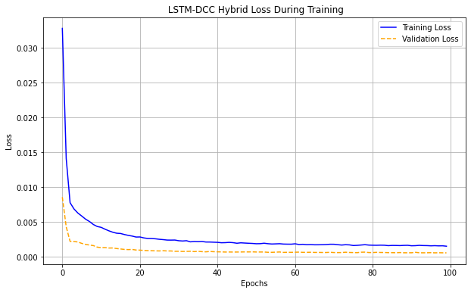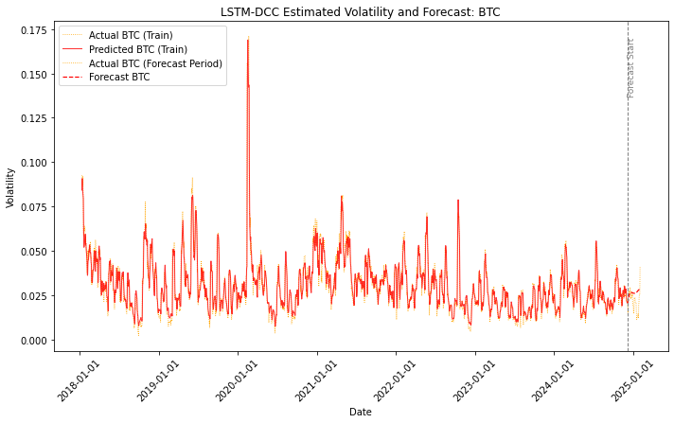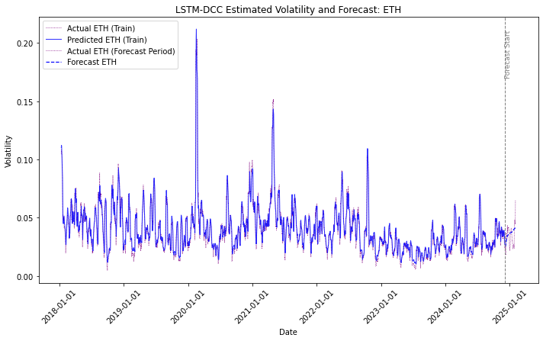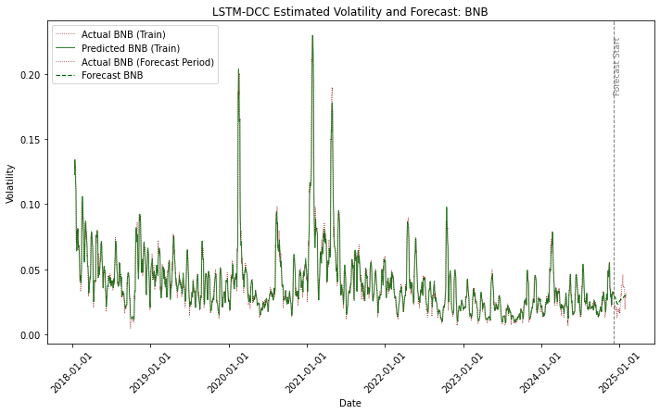

Figure 2 illustrates the LSTM-DCC hybrid model’s training dynamics and out-of-sample volatility forecasts for BTC, ETH and BNB. Subplot (a) shows rapid convergence of training and validation loss over 100 epochs with a minimal gap, indicating robust training and generalization. Subplots (b), (c) and (d) depict the model’s volatility forecasts for BTC, ETH and BNB, respectively. The model effectively captures key volatility spikes and overall patterns across all three assets, with minor underestimations during abrupt surges. Notably, it maintains strong predictive accuracy even amid the pronounced volatility bursts characteristic of BNB. These plots complement the quantitative findings in Table 5, collectively demonstrating the hybrid model’s efficacy in modeling complex, nonlinear volatility dynamics in cryptocurrency markets.

5. CONCLUSION

This study develops and evaluates an LSTM-DCC hybrid framework for modeling and forecasting volatility dynamics in major cryptocurrencies. By integrating DCC model’s ability to characterize time-varying cross-asset correlations with the LSTM deep learning Networks capacity to capture complex nonlinear temporal patterns, the proposed approach addresses critical limitations of traditional volatility models in highly volatile and interdependent markets. Empirical evaluation across Bitcoin, Ethereum and Binance Coin demonstrates that the hybrid model consistently outperforms both traditional DCC-MGARCH and standalone LSTM models in multi-step ahead forecast accuracy, while maintaining robust generalization and training stability. These results highlight the significant benefits of integrating deep learning architectures with established econometric models to enhance volatility modeling in complex financial environments. The findings contribute to the growing literature on hybrid approaches and provide a rigorous methodological foundation for improved risk management and asset allocation in cryptocurrency portfolios. Future work may explore extensions incorporating alternative neural network structures and high-frequency data to further advance forecasting precision and adaptability.

References

Abedin, Z., et al. (2023). Attention‑based multivariate LSTM for cryptocurrency return modelling. Eurasian Economic Review.

Alessandretti, L., ElBahrawy, A., Aiello, L. M., & Baronchelli, A. (2018). Anticipating cryptocurrency prices using machine learning. *Complexity*, *2018*(1), 8983590.

Bao, W., Yue, J., & Rao, Y. (2017). A deep learning framework for financial time series using stacked autoencoders and long-short term memory. *PloS one*, *12*(7), e0180944.

Bollerslev, T. (1986). Generalized autoregressive conditional heteroskedasticity. *Journal of econometrics*, *31*(3), 307-327.

Bouoiyour, J., & Selmi, R. (2015). What does Bitcoin look like?. *Annals of Economics & Finance*, *16*(2).

Cont, R. (2007). Volatility clustering in financial markets: empirical facts and agent-based models. In *Long memory in economics* (pp. 289-309). Berlin, Heidelberg: Springer Berlin Heidelberg.

Corbet, S., Lucey, B., Urquhart, A., & Yarovaya, L. (2019). Cryptocurrencies as a financial asset: A systematic analysis. *International Review of Financial Analysis*, *62*, 182-199.

Engle, R. (2002). Dynamic conditional correlation: A simple class of multivariate generalized autoregressive conditional heteroskedasticity models. *Journal of business & economic statistics*, *20*(3), 339-350.

Engle, R. F., & Kroner, K. F. (1995). Multivariate simultaneous generalized ARCH. *Econometric theory*, *11*(1), 122-150.

Ezzat, M., Mohamed, A., & Farouk, H. (2021). ARIMA–LSTM hybrid model for cryptocurrency price prediction. Plos One, 16(10), e0253876.

Fischer, T., & Krauss, C. (2018). Deep learning with long short-term memory networks for financial market predictions. *European journal of operational research*, *270*(2), 654-669.

Goodfellow, I., Bengio, Y., & Courville, A. (2016). Regularization for deep learning. *Deep learning*, 216-261.

Hochreiter, S., & Schmidhuber, J. (1997). Long short-term memory. *Neural computation*, *9*(8), 1735-1780.

Huang, Z. C., Sangiorgi, I., & Urquhart, A. (2023). Forecasting Bitcoin volatility using machine learning techniques. *Journal of International Financial Markets, Institutions and Money*, *97*, 102064.

Jiang, M., Zhou, X., & Li, Y. (2021). Attention‑enhanced LSTM‑GARCH hybrid for financial time series forecasting. Expert Systems with Applications, 167, 114–163.

Katsiampa, P. (2017). Volatility estimation for Bitcoin: A comparison of GARCH models. *Economics letters*, *158*, 3-6.

Katsiampa, P. (2019). Volatility co-movement between Bitcoin and Ether. *Finance Research Letters*, *30*, 221-227.

Kim, S., Lee, J., & Lee, D. (2021). A CNN‑LSTM‑GARCH hybrid for real‑time Bitcoin volatility forecasting. Journal of Computational Finance, 24(2), 123–145.

Kim, T., & Kim, H. Y. (2019). Forecasting stock prices with a feature fusion LSTM-CNN model using different representations of the same data. *PloS one*, *14*(2), e0212320.

McNally, S., Roche, J., & Caton, S. (2018, March). Predicting the price of bitcoin using machine learning. In *2018 26th euromicro international conference on parallel, distributed and network-based processing (PDP)* (pp. 339-343). IEEE.

Rundo, C. (2020). Hybrid volatility forecasting in nonlinear regimes: A case study of cryptocurrencies. Applied Soft Computing, 99, 106-125.

Sebastião, H., & Godinho, P. (2021). Forecasting and trading cryptocurrencies with machine learning under changing market conditions. *Financial Innovation*, *7*, 1-30.

Sheraz, M., Dedu, S., & Preda, V. (2022). Volatility dynamics of non-linear volatile time series and analysis of information flow: Evidence from cryptocurrency data. *Entropy*, *24*(10), 1410.

Troster, V., Sedgwick, D., & Kruger, S. (2019). Cryptocurrency behavior during market panic: Evidence from COVID‑19 crash. Journal of Behavioral Finance,

Xu, Z., Liechty, J., Benthall, S., Skar-Gislinge, N., & McComb, C. (2024, November). GARCH-Informed Neural Networks for Volatility Prediction in Financial Markets. In *Proceedings of the 5th ACM International Conference on AI in Finance* (pp. 600-607).

**Zhang, W., & Hamori, S. (2021).** Modeling volatility spillovers between cryptocurrencies and traditional financial assets: A comparison between VAR and LSTM models. International Review of Financial Analysis, 75, 101738.

Zhang, W., Wang, P., Li, X., & Shen, D. (2022). Persistence and volatility spillovers of Bitcoin to other leading cryptocurrencies: A BEKK‑GARCH analysis. Foresight: The Journal of Future Studies, Strategic Thinking and Policy, 26(1), 84–97.

Zhou, Y., Xie, C., Wang, G. J., Gong, J., & Zhu, Y. (2025). Forecasting cryptocurrency volatility: a novel framework based on the evolving multiscale graph neural network. *Financial Innovation*, *11*(1), 87.