Case report

Posterior sternoclavicular dislocation: A Case Report

ABSTRACT:
Posterior sternoclavicular joint dislocation (SCJ) is rare especially in the young patients and can be complicated by serious complications related to the proximity of the joint to mediastinal structures. We describe the case of a previously healthy 22-year-old male who presented with a right shoulder injury. Clinically, the patient only complained of pain in the right shoulder and right hemithorax with no functional deficit or signs of neurovascular or cardiorespiratory impairment. Following imaging, the diagnosis of a closed posterior SCJ dislocation without associated mediastinal injury was confirmed. Conservative management was initially planned because of the lack of complications and the patient's stable clinical condition. This is noteworthy with regards to that it is an unusual non-severe presentment of diagnosis of posterior SCJ dislocation. Currently, there is minimal evidence in the literature of this type of injury, but it should be taken into account as it may lead to fatal complications. Early imaging and multidisciplinary evaluation are necessary for the selection of appropriate management.

KEYWORDS: Sternoclavicular, Dislocation, Trauma, Conservative
INTRODUCTION :

Posterior dislocation of the sternoclavicular joint (SCJ) is an extremely uncommon injury and makes up less than 1% of all dislocation of joints; it is commonly caused by high-energy trauma in road traffic accidents and blunt force shouldering in contact sports (1,3). Although its infrequency, it is a high risk injury as the SCJ lies anatomically adjacent to important mediastinal structures as the great vessels, trachea, and esophagus for which passive reduction may be complex and dangerous, especially in emergent situations (1,2,3). Advances in imaging and reduction techniques have helped to refine management, however, diagnosis often is delayed, as patients may present with mild, subtle or atypical symptoms especially in the absence of neurovascular or cardiopulmonary compromise (1,3,4). Our case is one such case of rare and atypical post-traumatic posterior SCJ dislocation in a 22-year-old otherwise healthy male with atraumatic antecedents who presented with isolated pain in the injury area without any signs of compression, and was managed conservatively.

CASE PRESENTATION

Presentation

A 22-year-old male without relevant previous history attended the ER after a direct blunt trauma on the right shoulder. His main complaint was the right shoulder and right anterior chest wall pain localized to the sternoclavicular joint. He did not complain of any weakness, or paraesthesia or numbness in the upper limbs, dysphagia, dyspnea, dysphonia, or cervical pain. There was no impairment of the upper limb function at the onset.

Physical Examination
At presentation, the patient was hemodynamically stable and not in any respiratory distress. Examination revealed slight asymmetry and local swelling over the right sternoclavicular area with no discernible cutaneous changes or venous dilatation. The medial end of right clavicle was tender on palpation. Shoulder range of motion was intact but painful on elevation. Right upper limb neurological examination was unremarkable. Peripheral pulses were present and symmetrical. There were no signs of vascular or thoracic outlet compression.

Imaging Studies
The initial imaging study consisted in 2 standard radiographies: a thorax radiography and a right shoulder X-ray. The chest X-ray (Fig. 1) presented with mild asymmetry at the sternal-clavicular level, but it was non-diagnostic. Right shoulder radiograph (Figure 2) showed normal glenohumeral joint but evidence of medial displacement of clavicle was identified.
Because the sternoclavicular joint is poorly visualized on plain radiographs, a chest CT was performed. CT examination (Figure 3) demonstrated an ipsilateral posterior dislocation of the right sternoclavicular joint with no associated fractures, vascular injury, or mediastinal compression. The trachea, brachiocephalic vessels and esophagus were preserved and non-compressed.

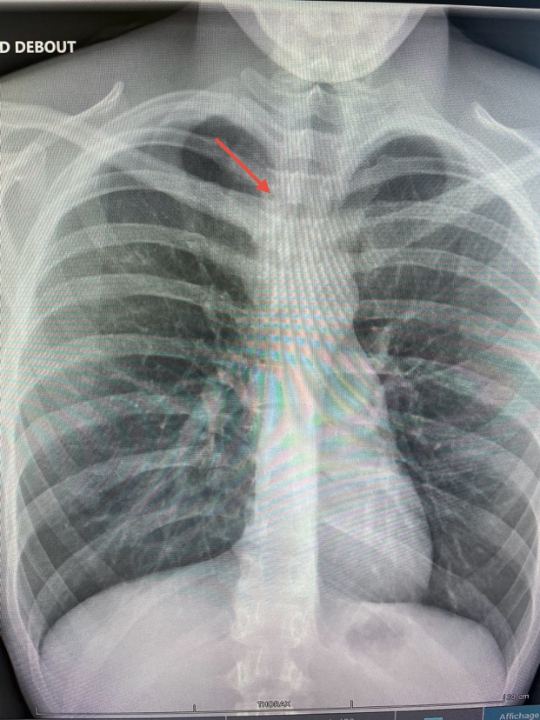
Figure 1. Standard chest X-ray showing asymmetry in the right sternoclavicular region.

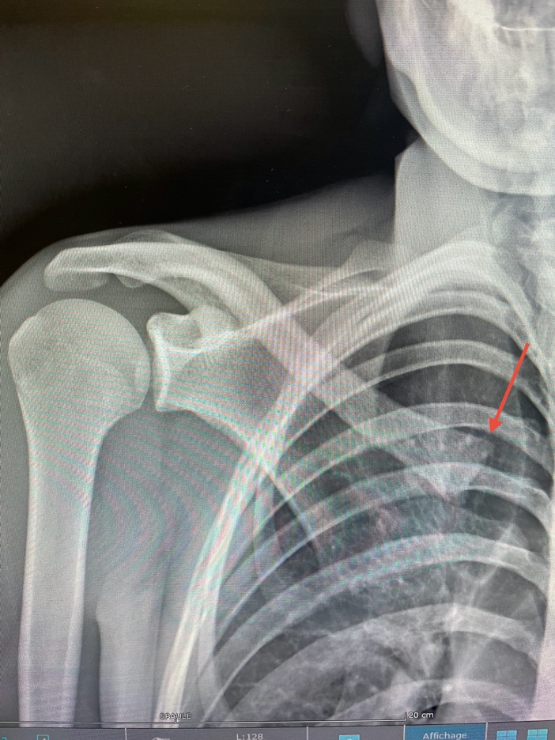
Figure 2. Standard radiograph of the right shoulder showing no glenohumeral injury but subtle medial clavicle displacement.

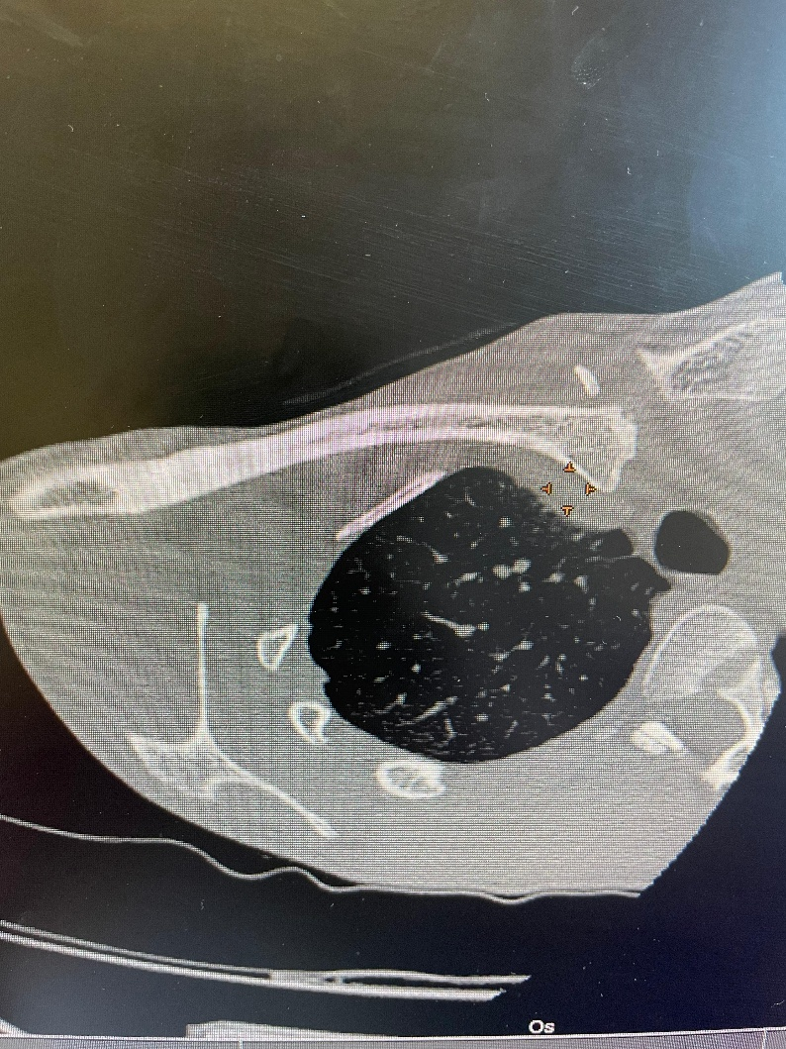
Figure 3. Axial thoracic CT scan confirming posterior dislocation of the right sternoclavicular joint without mediastinal compression.
Treatment and Procedure
Non-operative management was selected because neurovascular or mediastinal complications were not present, and a stable clinical status was noted. The patient was placed in a figure-eight clavicle strap along with an arm sling to limit motion and promote healing. Oral analgesics and NSAIDs were administered. Surgical intervention or reduction under anaesthesia was not considered to be warranted.

Follow-up
Two weeks after treatment, the patient noted marked improvement in her pain and had no recurrence of symptoms. Physical examination verified stability of the joints and increasing shoulder range of motion. At two- and three-months’ follow-up, the patient regained full, painless range of motion of the right shoulder, and no signs of instability were observed. A second CT scan revealed continued reduction and symmetric sternoclavicular joint position.

DISCUSSION :
It was found that traumatic posterior dislocation of the SCJ is a rare injury, accounting for less than 1% of all joint dislocations [2]. These injuries are usually high-energy injuries including road traffic accidents or sports injuries and are often missed as they often present with subtle and non-specific symptoms [5].
Potential complications of posterior dislocation of the SCJ are serious and include respiratory distress, vascular injury, brachial plexus palsy, pneumothorax, dysphagia and, rarely, death. This is due to the close anatomical relation of the medial clavicle with important mediastinal structures such as the trachea, esophagus and great vessels [6]. Up to 30% of patients with posterior dislocation can have complications associated with mediastinal compression in their presentation [7].
Due to rarity and vague presentation, this injury is diagnosed late, increasing the risk of severe outcomes. Standard radiographs are commonly inadequate to view SCJ dislocations with details, and advanced imaging such as CT is essential for diagnosis and evaluation of associated injuries [8].
These results emphasize the requirement for a high level of suspicion and the importance of a comprehensive imaging work-up for any suspected SCJ dislocation, particularly following high energy trauma [7].
The management of posterior SCJ dislocations is diverse and has changed over time; closed and open reduction methods are used. It has been reported that closed reduction is likely to succeed if the procedure is done within 48-72 hours after injury [9]. However, we also identified that closed reductions had a successful rate even after 10 days from injury [10]. Surgical stabilization is indicated if closed reduction is unsuccessful or if neurovascular impairment is present [1].
It is important to remember that, although dislocation of the posterior SCJ may have a relatively low index of suspicion for severity, there is high risk for life-threatening hemorrhage with lesions of the mediastinal vascular structures. Consequently, multidisciplinary approach with orthopedic, vascular, and anesthesia services is necessary for safety and complete treatment [11].

CONCLUSIONS :
Posterior dislocation of the sternoclavicular joint is an uncommon and potentially catastrophic injury because of the anatomic proximity to vital mediastinal structures. Our experience demonstrates that in the absence of neurovascular or respiratory impairments, and unstable fracture can theoretically be managed conservatively with a good outcome. Immediate imaging, especially CT, is necessary to make a correct diagnosis and to exclude involvement of the mediastinum. Multicentric study remains the cornerstone for optimal care and avoiding life-threatening complications.

Conflict of Interest:
The authors confirm that there are no conflicts of interest—financial or otherwise—that could have influenced the work reported in this paper.

REFERENCES :

- Evaluation and management of sternoclavicular dislocation in the emergency department. Carius BM, Long B, Gottlieb M. J Emerg Med. 2021;61:499–506. doi: 10.1016/j.jemermed.2021.07.038.

- Sternoclavicular joint surgery: how far does danger lurk below? Ponce BA, Kundukulam JA, Pflugner R, et al. J Shoulder Elbow Surg. 2013;22:993–999. doi: 10.1016/j.jse.2012.10.037.

- Traumatic posterior sternoclavicular joint dislocation - current aspects of management. Ingoe HM, Mohammed K, Malone AA, et al. Injury. 2023;54:110983. doi: 10.1016/j.injury.2023.110983.

- X-ray-negative posterior sternoclavicular dislocation after minor trauma. Jacob M, Snashall J, Dorfman A, Shesser R. Am J Emerg Med. 2013;31:260–265. doi: 10.1016/j.ajem.2012.03.014.

- Posterior dislocation of the sternoclavicular joint: report of two cases. Labronici PJ, Souza FC, Pires RE, Santos Filho FC, Gameiro VS, Labronici GJ. Rev Bras Ortop. 2016;51:601–605. doi: 10.1016/j.rboe.2016.08.019.

- Posterior sternoclavicular joint dislocation. Hoekzema N, Torchia M, Adkins M, Cassivi SD. https://pmc.ncbi.nlm.nih.gov/articles/PMC2386312/ Can J Surg. 2008;51:0–20.

- Posterior sternoclavicular dislocations: a brief review and technique for closed management of a rare but serious injury. Deren ME, Behrens SB, Vopat BG, Blaine TA. Orthop Rev (Pavia) 2014;6:5245. doi: 10.4081/or.2014.5245.

- Sternoclavicular joint dislocation and its management: a review of the literature. Morell DJ, Thyagarajan DS. World J Orthop. 2016;7:244–250. doi: 10.5312/wjo.v7.i4.244.

- Traumatic dislocation of the sternoclavicular joint. Philipson MR, Wallwork N. Orthop Trauma. 2012;26:380–384.

- Treatment of traumatic posterior sternoclavicular dislocations. Groh GI, Wirth MA, Rockwood CA Jr. J Shoulder Elbow Surg. 2011;20:107–113. doi: 10.1016/j.jse.2010.03.009.

- Fatal posterior sternoclavicular joint dislocation due to occult trauma. Fenig M, Lowman R, Thompson BP, Shayne PH. Am J Emerg Med. 2010;28:385–388. doi: 10.1016/j.ajem.2009.05.011.

