**Histochemistry and Immunological Evaluations of the Cerebellar - Hippocampal interactions After Artequin Administration in Adult Wistar Rats**

ABSTRACT

|  |
| --- |
| **Aims:** The combination therapy antimalarial drug, artequin is widely used in the treatment and management of *P. falciparum* malarial infections in Africa. Its effects on the histochemistry, immunoreactivity and neurobehavioral parameters were investigated in hippocampal – cerebellar interactions in adult Wistar rats.  **Study design:** Forty-two inbred adult male Wistar rats of average weight 200 g were divided into groups 1–6. Group 1 served as the control that received 5 ml kg-1 of water, while groups 2–6 received oral doses of 0.86/1.07 mg kg-1 (ATQ1), 1.71/2.14 mg kg-1 (ATQ2), 3.42/4.28 mg kg-1 (ATQ3), 6.84/8.56 mg kg-1 (ATQ4) and 13.68/17.12 mg kg-1 (ATQ5) body weight of artequin for three days. T – maze neurobehavioral tests were carried out two days prior and after the administration of artequin  **Place and Duration of Study:** Department of Zoology, Faculty of Biological Sciences, Akwa Ibom State University, Nigeria and Department of Anatomy, Faculty of Basic Medical Sciences, University of Uyo, Akwa Ibom State, Nigeria, between June 2024 and July 2024.  **Methodology:** Immediately after the neurobehavioral test, the animals were sacrificed after they were deeply anesthetized with ketamine–hydrochloride. The brains were perfused fixed in 10 % buffered formalin. They were processed using Cresyl violet staining methods for neuronal morphology and immunohistochemical labelling for neurofilament proteins.  **Results:** In the T-maze test, the artequin groups had significantly lower (p = 0.05) spontaneous alternation than the control group. Histochemical evaluations of the hippocampus and cerebellum of all the animals that received artequin showed histopathological features including karyorrhexis, hypertrophy and chromatolysis with decreased Nissl substance intensity and cellular densities. Immunohistochemical labeling revealed increased knockouts of neurofilament proteins in both brain areas in the treatment groups.  **Conclusion:** Artequin administration induced a dose-dependent adverse effects on the histochemistry and neurofilament protein immunolabelling of the hippocampus and cerebellum. This may suggest neuronal and glial degeneration, which may result in altered hippocampal - cerebellar interactions and functions |

***Keywords: Combination therapy, artequin, hippocampus, cerebellum, histopathology, Nissl substance, Neurofilament protein (NFL).***

1. INTRODUCTION

Malaria caused by *P. falciparum* is the most severe form of the disease (WHO, 2024). Despite efforts to control or completely eradicate this infection in Sub-Saharan Africa; malaria has remained a major cause of human morbidity in the tropics with about 228 million cases and 608,000 deaths at as the year 2022, with 76% of the reported death recorded in children under 5 years (Udofia *et al.,* 2022).The primary aims of the treatment are to prevent death and alleviate the symptoms of the disease as rapidly as possible through the use of drug combinations containing the peroxide antimalarial, *Artemisia,* which is derived from the herb *Artemisia annua* (Udoh *et al.,* 2014)*.* This combination known as artemisinin-based combination therapy (ACT) provides the solution to the problem of drug resistance (WHO, 2024).

The antimalarial drug, artequin, is commonly used in the treatment of all forms *P. falciparum* malaria infection. It is made up of two highly potent drugs, namely, artesunate and mefloquine (Sodiomon *et al.,* 2016; Udoh *et al.,* 2014; Udoh *et al.,* 2020). Artesunate is a water soluble, semi synthetic, sesquiterpene lactone derived from the Chinese medicinal herb *Qinghua* (Kouakou, *et al.,* (2019); Mohammadi *et al.,* (2020)It effects on the parasite is quick in reducing the parasite load, but its action has a short half – life (Udoh *et al.,* (2014); Mohammadi *et al.,* (2020). Mefloquine on the other hand, is a 4-quinoline methanol blood schizonticide with a long-acting half-life, which takes over the protection against re-infection (Kouakou, *et -al.,* (2019); Roche, (2011). Their properties complement and protect each other against the development of resistance (Solomon, *et al.,*2016).

However, previous research reports have shown that the mefloquine present in artequin affects some areas of the brain such as the cerebral cortex and the cerebellum, resulting in hypertrophy, pyknosis, reduced pyramidal cell density with increased expressions of glial fibrillary acidic protein (GFAP) (Ekanem *et al.,* 2009; Udoh *et al.,* 2014; Udoh *et al.,* 2025a; Udoh *et al,* 2025b).

The cerebellum is the largest portion of the hindbrain. Its principal function is to regulate and maintain balance, and to coordinate timing and precision of body movement (Wolf *et al.,* 2009; Harold and Vishy 2010), it also plays an important role in cognition (Wolf *et al., (*2009). The hippocampus on the other hand is part of the limbic system structure that is particularly involved in memory, connecting emotions and senses such as smell and sound to memories. Both structures are functionally connected to each other in a bidirectional manner, such that the hippocampus can influence cerebellar activity and vice versa in health and in disease (Yu and Magnuson (2015). This bidirectional interaction is usually because the cerebellum has multiple connections with other parts of the brain such as the brain stem, thalamus, vestibular nuclei and the hippocampus (Harold and Vishy, 2010; Yu). This enables it to constantly monitor sensory inputs from effector organs and then refine and coordinate their responses (Harold and Vishy, 2010). As Mefloquine is reported with adverse effects such as the formation of pyknotic nuclei, hyperplasia and reactive astrocytes in the cerebral cortex and cerebellum, its presence in artequin may also indicate a possibility of danger to the hippocampal – cerebellar interaction, hence this study

2. materials and methods

Forty-two inbred adults male Wistar rats of average weight 200g were obtained and housed in the Animal House of the Faculty of Basic Medical Sciences, University of Uyo. The animals were housed in 14 standard home cages (40 cm × 35 cm) with wire gauze roof and wood shavings as bedding. The room temperature was maintained between 27oC – 30oC and animals were exposed to 12:12 hours light/dark cycles.The rats were fed with normal commercial pelletized growers mash (Grand Cereal Ltd, Jos, Nigeria) and clean water *ad libitum*. The animals were allowed to acclimatize for fourteen days before commencement of the experiment. Ethical approval was obtained from the Ethics Committee of the University of Uyo, and the animals were handled according to international guidelines as laid down by the National Institute of Health (2011) of the United States of America for the regulation of laboratory animals.

The artequin (J0004912, Acino Pharmaceutical Limited, Switzerland) used in this research was obtained from the University of Uyo Pharmacy, Uyo, Nigeria. The Artequin was dissolved in 100 ml of distilled water. The therapeutic dosages for the rats were determined against the therapeutic doses for humans, which is 600/750 mg/kg of Artequin. The drug suspensions were administered orally to the animals based on their body weight with the aid of orogastric tubes.

**Animal Grouping and Administration of Artequin**

The adult male Wistar rats were weighed, labelled and confined in cages. The rats were divided into six groups 1- 6 of seven animals each. Group 1 was the control group, and was given distilled water. Groups 2 - 6 served as the treatment groups. Each co-blister tablet of the drugs (artesunate, 600 / mefloquine, 750 mgkg-1) dissolved in 100 ml of distilled water was administered to the animals orally with the aid of orogastric tubes for three days according to their body weights (Table 1).

**Table I: Weights and dosages of drugs administered to the rats for three days**

|  |  |  |
| --- | --- | --- |
| **Groups (n-6)** | **Drugs** | **Dosages /day** |
| 1 (Control) | Water | 5 mL kg-1 |
| ATQ1 | ATQ (LD eqv) | 0.86/1.07 mgkg-1 |
| ATQ2 | ATQ (LD eqv) | 1.71/2.14 mgkg-1 |
| ATQ3 | ATQ (TD eqv) | 3.42/4.28 mgkg-1 |
| ATQ4 | ATQ (HD eqv) | 6.84/8.56 mgkg-1 |
| ATQ5 | ATQ (HD eqv) | 13.68/17.12 mgkg-1 |
|  |  |  |

*\*ATQ = Artequin LD eqv = low dose equivalent = TD eqv.: therapeutic dose equivalent = HD eqv = high dose equivalent*

**T-Maze Neurobehavioural Studies –** Two days prior and after the drug administration, the T-maze neurobehavioural studies was caried out on the animals. Briefly, the T – maze, an elevated or enclosed apparatus in the form of a ‘T’ placed horizontally as described by Robert *et al.,* (2006) was used for spontaneous alternation. The component parts of the T-maze included 2 goal arms measuring 50 ×10 cm, start area measuring 50 ×16 cm, central partition extending 10 cm into the start arm, bracing strip and guillotine doors cut to fit maze, all height measuring 30 cm. The width of the start alley was 10 cm suitable for the maze fitted with a central partition for spontaneous alternation which made for a sharper turn into the goal arm and therefore better proprioceptive feedback and performance. A removable central partition extending from the centre of the back of the ‘T’ into the start arm was also included, allowing access to only one goal arm at a time to avoid interference at the choice phase. The maze was made from a brown painted wood (The reason for painting the maze brown was because rodents avoid bright places, such as white painted floors. A white maze would provoke anxiety and habituation would be slower in the case of a rewarded alternation). The end and side walls and floor of the goal arm were cut to size and joined by a suitable adhesive. Extra strength was given by two bracing strips of square section glued to the exterior of the goal arm–start arm junction. Food wells were made from stock aluminum rod. A section was cut from the rod just below the bottom of the T to complete the well. They were glued to the floor of the maze and held in place by a mastic/adhesive compound.

The animals were left for 5–10 minutes after being taken into the testing room. This was to ensure that the animals were in an optimal state of arousal for testing, hence avoiding over-excitement and lack of concentration. Prior to commencing the procedure, the criterion point was determined. The criterion point for each trial was for the whole animal, including the tail tip to be on the insert/goal arm.

The maze was set so that the central partition was in place and the guillotine door rose. Each animal was placed in the start area and allowed to choose a goal arm. The animal was then confined in the chosen arm by quietly sliding the door down. After 30 seconds, the central partition was removed, followed by the animal with the aid of a plastic tube. The guillotine and the two sample doors were then raised up. The animal was replaced in the start area facing away from the goal arms. It was then allowed to choose between the two open goal arms. Each trial took no more than two minutes, one-minute minimum.

**Tissue Processing**

Immediately after the neurobehavioral test, the animals were sacrificed after they were deeply anesthetized with ketamine–hydrochloride (#50155, Rotex Medica, Trittau, Germany). Intracardial perfusion with phosphate-buffered saline (PBS, 2M, pH 6.4), was carried out on the animals by means of a cannula and then perfused-fixed using 10% buffered formalin. On complete perfusion, the skull was opened and the brain of the animal was removed and fixed in 10% buffered formalin for 48 hours. The whole brain was further routinely processed for histological study by Cresyl violet for histological studies and integrity of neurons modified after Luke *et al.,* (2016). According to the methods described by Erana-Rojas (2002) and Green (2015) sections were also used for immunohistochemical studies of neurofilament for neurofilament protein expressions. Sections were viewed under the light microscope and photomicrographs were obtained using the microscope camera linked to a computer.

**Determination of Cellular Density**

Nissl substance density of the three cortical layers of the hippocampus and neocerebellum was carried out by means of Image™ software linked to a computer. This approach involved manual cell counting and marking of the cells with the help of a plugin, modified after (Bindokas, *et al.,* 2020). This technique allows cell count by clicking on the image. Each click marked the cell with a coloured square and then added the cell to a tally sheet. The cellular population for each cortical layer was marked, tallied separately with a different colour square. After each counting session, the result for the total of all the cells in the three cortical layers plus the grand total of all the clicks was displayed at the bottom of the result window. This result log was copied and pasted in an excel spreadsheet for statistical analysis. The same procedure was repeated for the photomicrographs in all the groups as described by (Bindokas, *et al.,* 2020).

**Statistical Analysis**

One-way analysis of variance was used to analyse all the data, followed by a *post hoc* Tukey’s test. All analysis was done using GraphPad Prism for Windows (version 5.01, San Diego California, USA). Data at probability level P = .05 was regarded as significant and are presented as Mean ± Standard error of mean.

**3. RESULTS**

**3.1 Neurobehavioural Studies:** Prior to administration of the drug, there was no significant difference in spontaneous alternation between the test groups and the control. After the administration of the drug, all the artequin groups had significantly lower (p = 0.05) spontaneous alternation than the control group. However, no significant difference existed between the artequin groups (Table 2).

**Table 2: Spontaneous alternation test before and after the drug administration**

|  |  |  |  |  |  |  |
| --- | --- | --- | --- | --- | --- | --- |
| Groups (n=6) | Control | ATQ1 | ATQ2 | ATQ3 | ATQ4 | ATQ5 |
| Before Drug Administration  F=1.497  p= 0.215 | 85.71  ±5.71 | 68.57  ±10.56 NS | 74.29  ±5.71NS | 85.71  ±7.19NS | 85.71  ±3.69NS | 88.57  ±4.04NS |
| After Drug  Administration  F=13.155  p=0.000 | 88.57  ±4.04 | 48.57  ± 7.38* | 51.43  ± 7.38* | 37.14  ± 5.22* | 31.43  ±4.04* | 34.29  ±3.69* |

Mean ± Standard Error of Mean

*Significantly different from the control group at p<0.05

NS Not significantly different from the control group at p<0.05

F = F – ratio, P= Probability level, ATQ= Artequin,

**3.2 Histochemical observations:** The Stain for Nissl Substance reveals that the sections of the hippocampus of control group rat showed deeply stained Nissl substance in the pyramidal neurons in the pyramidal cell layer. The staining intensity can also be seen in the molecular and polymorphic cell layers (Figure 1a). The sections of the hippocampus of groups 2 and 3 animals given 0.86/1.07 mg/kg and 1.71/2.14 mg/kg artequin respectively, showed loss of Nissl substance in the pyramidal cell layer with less staining intensity of Nissl substance in the molecular and polymorphic layers (Figures 1b and c). The sections of the hippocampus of rats given 3.42/4.28, 6.84/8.56, and 13.68/17.12 mg/kg of artequin, showed greater reduction in staining intensity of the neurons in the pyramidal cell layer, as well as the molecular and polymorphic layers (Figures 1d, e and f) compared with the control group.

Sections of the cerebellum of control group showed deeply stained Nissl substance throughout the three cortical layers (Figure 2a). Sections of the cerebellum of groups 2 - 4 animals given 0.86/1.07, 1.71/2.14 and 3.42/4.28 mg/kg of artequin showed less Nissl substance staining in the three cortical layers (Figures 2b, c and d), also sections of the cerebellum of groups 5 and 6 given 6.84/8.56 mg/kg and 13.68/17.12 mg/kg artequin showed marked less intensity of Nissl substance in the three cortical layers (Figure 2e and f) compared with the control group.

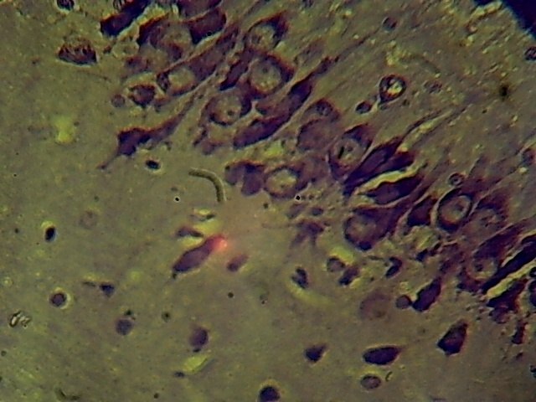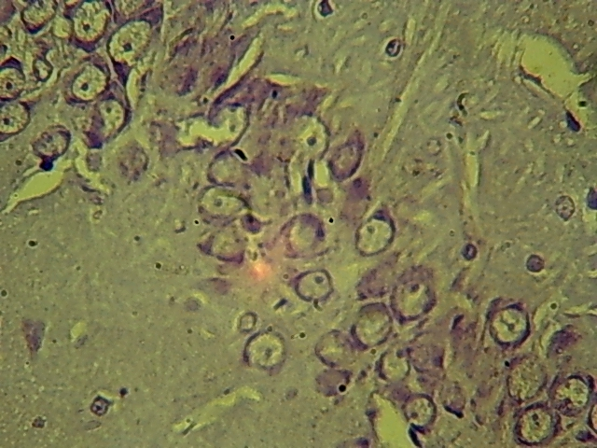

**(b)**

**(a)**

**PM**

**PCL**

**ML**

**PM**

**PCL**

**ML**

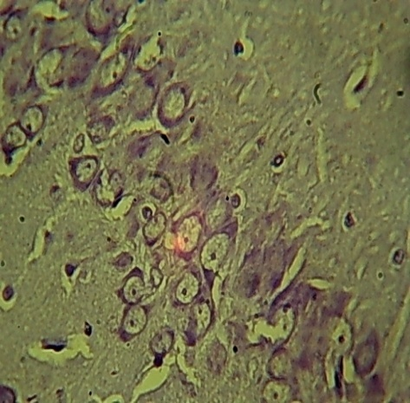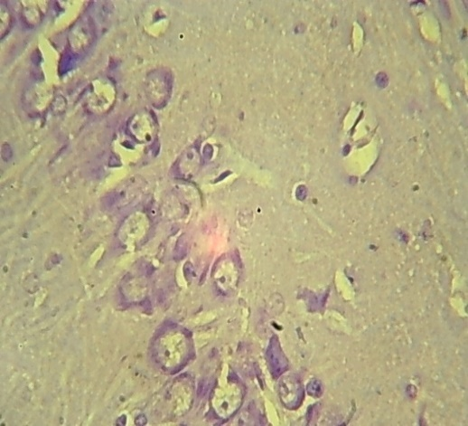

**PM**

**PCL**

**ML**

**(d)**

**(c)**

**PCL**

**ML**

**PM**

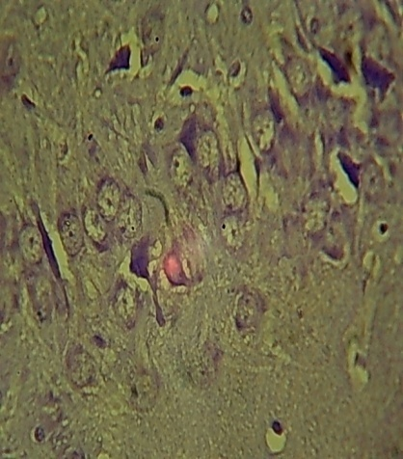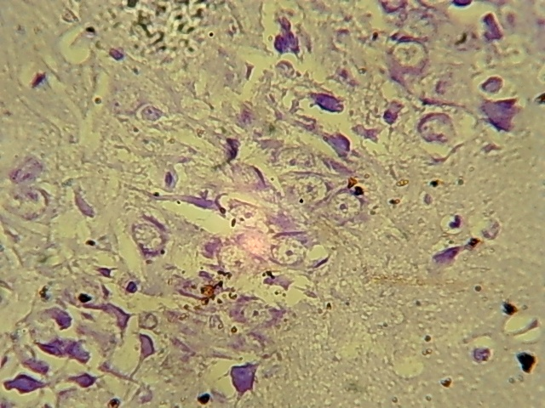

**(e)**

**(f)**

**PM**

**PCL**

**ML**

**PM**

**PCL**

**ML**

**Figure 1:** The sections of the hippocampus of the control and test groups: Cresyl fast violet (CFV).

a: Section of the hippocampus of control rat showing normal deeply stained Nissl substance in the pyramidal neurons of the pyramidal cell layer (PCL). This Nissl substance stain can also be seen in the molecular layer (ML) and the polymorphic layer (PM). ×400.

b: Section of hippocampus of rat given 0.86/1.07 mg/kg of Artequin, showing loss of Nissl substance with chromatolytic appearance (arrows) throughout the pyramidal cell layer (PCL). ×400.

c: Section of hippocampus of rat given 1.71/2.14 mg/kg, of artequin, showing less Nissl substance intensity with chromatolytic appearance (arrows) throughout the pyramidal cell layer (PCL). ×400.

d, e, f: Sections of the hippocampus of rat given 3.42/4.28 mg/kg, 6.84/8.56 mg/kg and 13.68/17.12 mg/kg artequin, shows marked loss of Nissl substance staining intensity (arrows) in the pyramidal cells (PCL). ×400**.**

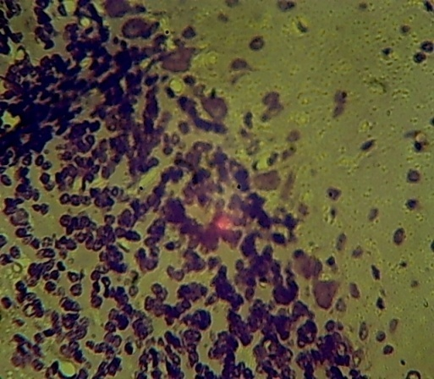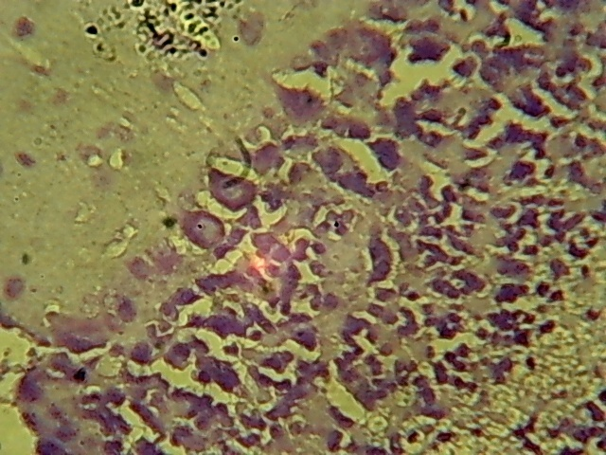

**ML**

**(a)**

**GL**

**PKL**

**PKL**

**ML**

**GL**

**(b)**

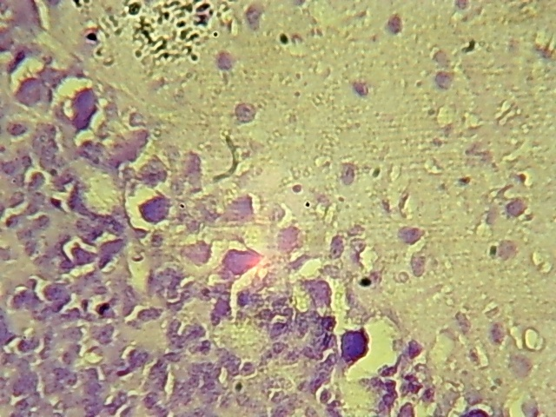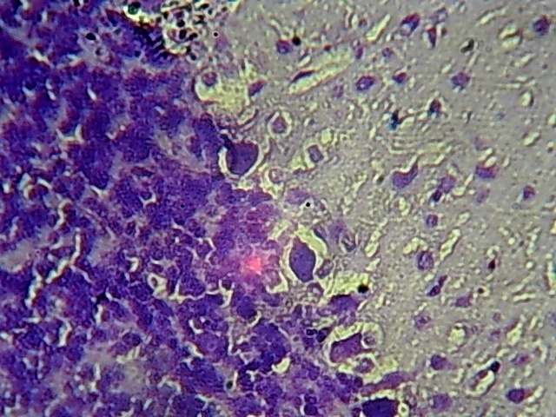

**GL**

**GL**

**PKL**

**PKL**

**(d)**

**(a)**

**(c)**

**ML**

**ML**

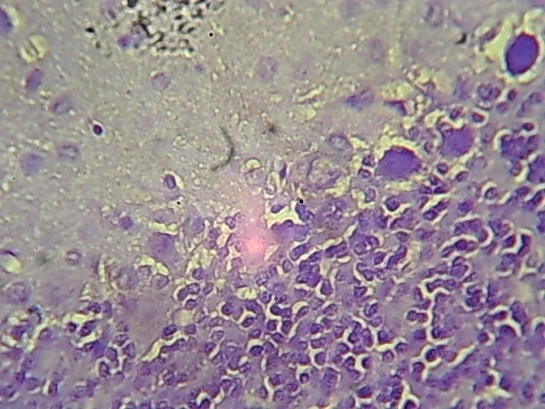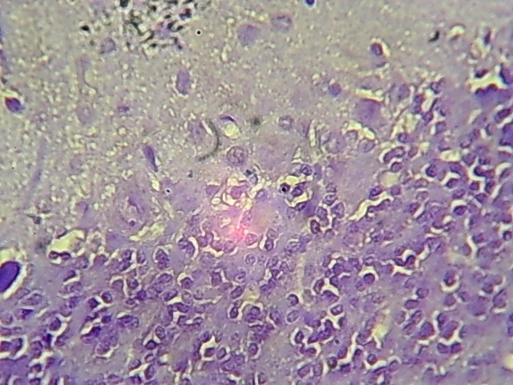

Figure 2: The sections of the cerebellum of the control and test group. Cresyl fast violet (CFV)

a: Section of the cerebellum of control rat showing well stained Nissl substance stains throughout the three cortical layers. ×400.

b: Sections of the cerebellum of rats given 0.86/1.07 mg/kg, artequin showing reduced Nissl substance staining intensity (arrows) in the three cortical layers. ×400.

c: Section of the cerebellum of rats given 1.71/2.14 mg/kg of artequin, showing less staining intensity in the Nissl substance (arrows) throughout the three cortical layers. ×400.

d: Section of the cerebellum of rats given 3.42/4.28 mg/kg of artequin showing some Nissl substance stains (arrows) in the three cortical layers. ×400.

e and f: Sections of the cerebellum of rats given 6.84/8.56 mg/kg and 13.68/17.12 mg/kg artequin respectively, showing marked loss of Nissl substance (arrows) in the three cortical layers. ×400.

**GL**

**(f)**

**PKL**

**ML**

**PKL**

**GL**

**ML**

**(e)**

**3.3 Nissl substance density:** The Nissl-stained cells density in the hippocampus were significantly lower (p = 0.05) in all the test groups compared with the control group. In the cerebellum, the Nissl-stained cells of the entire test groups were significantly lower (p = 0.05) compared with the control group. However, the Nissl substance densities for groups 2 and 3 were significantly lower (p =0.05) compared with groups 4, 5 and 6. (Figure 3).

*,b,c,d

1 2 3 4 5 6

**GROUPS**

**\***

**\***

**\*\*\***

**\*\*\***

**\*\*\***

*,b,c

*,b,c,d

**\*\*\***

**\*\*\***

Figure 3: Bar Chart showing Nissl substance density in cerebellum and hippocampus.

Data are presented as Mean ± Standard Error of Mean

* Significantly different from the control group at p = 0.05

*** Significantly different from the control group at p = 0.05

b Significantly lower than the group 2 at p = 0.05

c Significantly lower than the group 3 at p = 0.05

d Significantly lower than the group 4 at p = 0.05

**3.4 Immunolabelling Observations:** Immunohistochemical labelling for Neurofilament Protein shows that that the sections of the hippocampus of the control group animals showed that the neurons expressed evenly distributed neurofilament protein throughout the hippocampal layers (Figure 4a). The sections of the hippocampus of groups 2, 3 and 4 animals treated with 0.86/1.07 mg/kg, 1.71/2.14 mg/kg and 3.42/4.28mg/kg of artequin respectively, showed little or no expression of neurofilament protein throughout the hippocampal layers compared with the control group (Figure 4b, c and d).The sections of the hippocampus of groups 5 and 6 animals treated with 6.84/8.56 mg/kg and 13.68/17.12 mg/kg of artequin respectively, showed less expressions of neurofilament protein throughout the hippocampal layers compared with the control group (Figure 4e and f).

The sections of the cerebellum of the control group and group 2 animal administered 0.86/1.07 mg/kg artequin showed little or no expression of the neurofilament protein throughout the cortical layers (Figure 5a and b). However, sections of the cerebellum of group 3 animals given 1.71/2.14 mg/kg of artequin showed little expression of neurofilament protein only in the Purkinje layer compared to the control group (Figure 5c). The sections of the cerebellum of group 4 animals given 3.42/4.28 mg/kg artequin showed expressions of neurofilament protein in both the Purkinje and granular layers compared to the control group (Figure 5d). The section of cerebellum of group 5 animals given 6.84/8.56 mg/kg of artequin showed expression of neurofilament protein only in the Purkinje layer compared to the control group (Figure 5e). The section of cerebellum of group 6 animals given 13.68/17.12 mg/kg of artequin showed much expressions of neurofilament protein in the Purkinje and granular layers compared to the control group (Figure 5f)

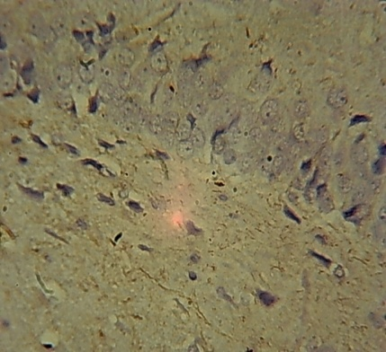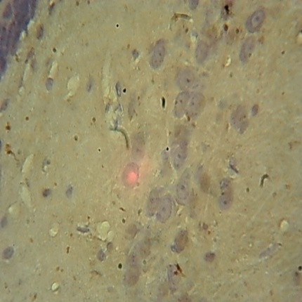

**ML**

**(b)**

**PM**

**PCL**

**ML**

**(a)**

**PCL**

**PM**

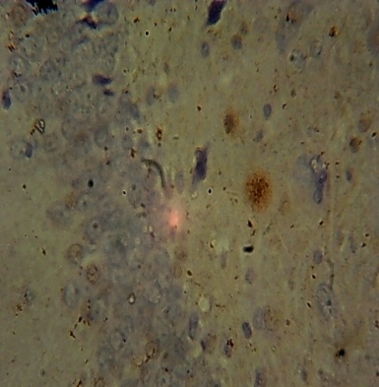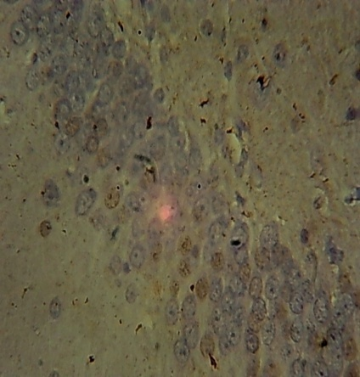

**PM**

**(d)**

**PCL**

**ML**

**ML**

**PM**

**PCL**

**(c)**

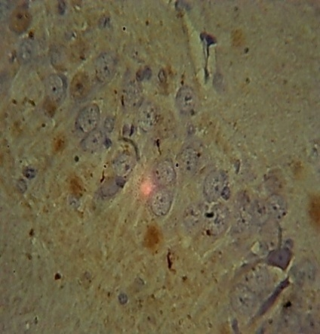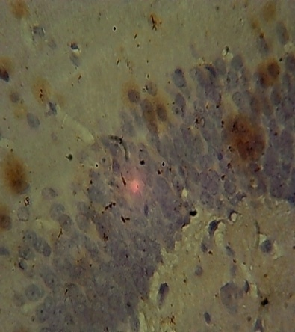

Figure 4: The sections of the hippocampus of control and treatment groups: Neurofilament

a: Section of the hippocampus of control rat given distilled water showing neurofilament protein expression throughout the hippocampal layers. ×400.

b: Section of the hippocampus of rats given 0.86/1.07 mg/kg, showing less expression of neurofilament protein (arrow) throughout the hippocampal layers. ×400.

c and d: Sections of the hippocampus of rats given 1.71/2.14 mg/kg and3.42/4.28mg/kg artequin respectively, showing less expression of neurofilament protein (arrow) throughout the hippocampal layers. ×400.

e and f: Sections of the hippocampus of rat given 6.84/8.56 mg/kg and 13.68/17.12 mg/kg of artequin respectively, showing aggregations of neurofilament protein (arrow) throughout the hippocampal layers. ×400

.

**ML**

**PM**

**(e)**

**(f)**

**PM**

**PCL**

**ML**

**PCL**

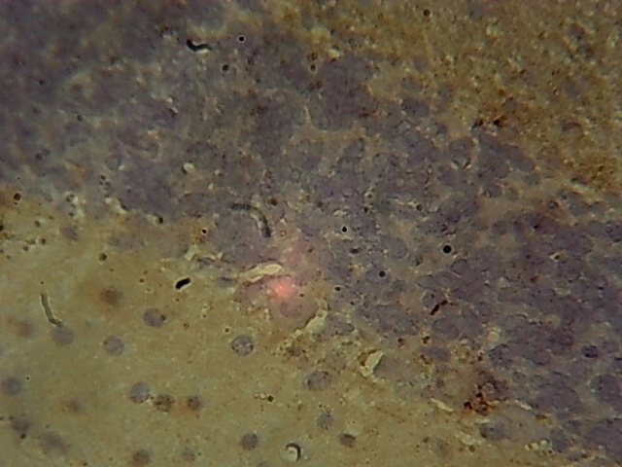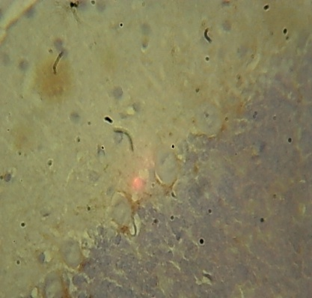

**(b)**

**(a)**

**CL**

**GL**

**PKL**

**ML**

**ML**

**PKL**

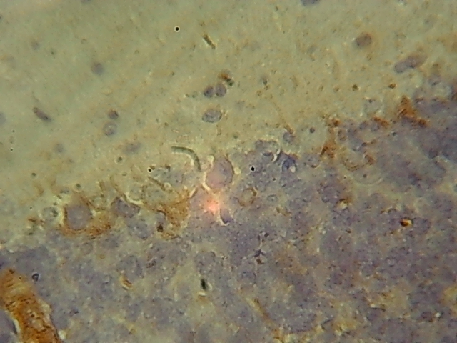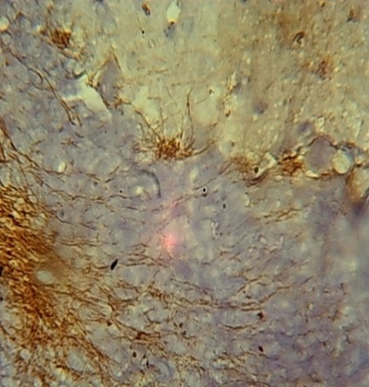

**ML**

**PKL**

**(d)**

**(c)**

**GL**

**GL**

**ML**

**PKL**

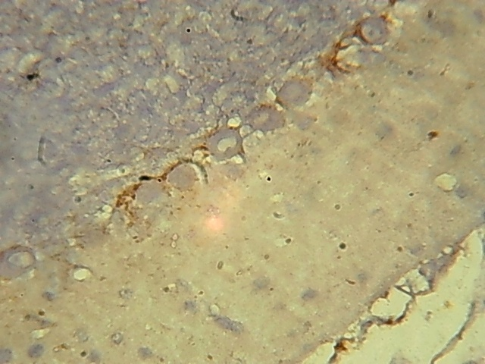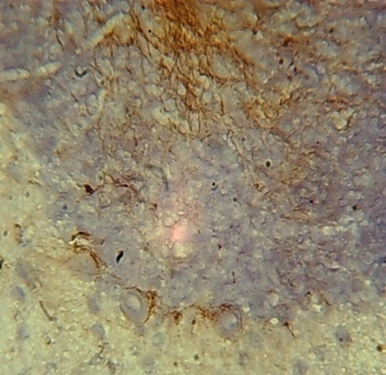

Figure 5: The sections of the cerebellum of control and test groups: Neurofilament.

a and b: Sections of the cerebellum of control rat given distilled water and the group given 0.86/1.07 mg/kg artequin, showing little or no expression of neurofilament protein throughout the cortical layers. ×40

c and d: Sections of cerebellum of rat given 1.71/2.14 mg/kg, and 3.42/4.28 mg/kg, of artequin showing expressions of neurofilament protein (arrows) in the Purkinje and granular layers ×400

e and f: Sections of cerebellum of rat given 6.84/8.56 mg/kg, 13.68/17.12 mg/kg of artequin showing aggregations of neurofilament protein (arrows) in the Purkinje and granular layers ×400

**PKL**

**(e)**

**(f)**

**ML**

**ML**

**PKL**

**GL**

**GL**

1. **Discussion**

The hippocampus plays an important role in learning, memory formation memory formation and visceral functions like regulation of negative feedback of hypothalamic-pituitary axis, which is an endocrine function of stress response (Okon et al., 2022; Udoh et al., 2022). The primary cells of the hippocampus, the pyramidal cells, constitute the circuitry for the vision guided motor function, as well as in complex object recognition in the visual processing area of the cortex. The cerebellum on the other hand plays an important role in [motor control](https://en.wikipedia.org/wiki/Motor_control) and [cognitive functions](https://en.wikipedia.org/wiki/Cognition) such as [attention](https://en.wikipedia.org/wiki/Attention) and [language](https://en.wikipedia.org/wiki/Language) and in regulating fear and pleasure responses with a solidly established fine movement-related functions (Jonah et al., 2022). The primary cells of the cerebellum, the Purkinje cells receive more synaptic inputs than any other type of cell in the brain with estimates of the number of spines on a single human Purkinje cell running as high as 200,000, coupled with their large size and distinctive activity pattern. The Purkinje cells form the heart of the cerebellar circuit (Shi *et al*., 2008). Both structures are reported to interact with each other during spatial and temporal memory processing, as well as during epileptic seizures (Wolf et al., 2009). However, damages to the hippocampus and the cerebellum upon the administration of the antimalarials, artequin as seen in this present study can impair these functions of the hippocampus and the cerebellum as well as the inter – relational functions.

One of the key functions of the hippocampus is spatial navigation (Eichenbaum, 2001; Dumont and Taube, 2015). However, it does not perform this role in isolation, but rather relies on information input from other brain areas. Studies have demonstrated an important contribution of the cerebellum in the formation of spatial representations (Lalonde and Botez, 1990; Wallesch and Horn, 1990; Petrosini *et al,* 1998). Spatial navigation involves a combination of internal cues such as proprioceptive and vestibular input, as well as external cues such as landmarks (Dumont and Taube, 2015). The cerebellum receives input from the vestibular nucleus and is believed to play a crucial role in encoding inertial motion and transforming self-motion vestibular information from an egocentric head-centred reference into allocentric earth-referenced spatial orientation (Yakusheva *et al.,*2007; Angelaki *et al.,*2010). Transgenic mice with impaired cerebellar function have deficits in goal-directed spatial trajectories, retention of spatial memory and tasks requiring use of self-motion information (Burguière *et al.,*2005; Rochefort *et al.,*2013).

The results of this present study on the effect of artequin on the spatial neurobehaviour of adult Wistar rats using the T-maze for spontaneous alternation showed that prior to administration of the drug, there was no difference in spontaneous alternation between the test groups and the control group. However, after the administration of the drug, all the artequin groups had lower spontaneous alternation than the control group, with no significant difference between the artequin groups.

The functional connection between the cerebellum and hippocampus in the context of spatial navigation is perhaps most strikingly seen in recordings from hippocampal neurons. Animals with certain impairments in cerebellar function have fewer hippocampal place cells and when forced to rely on self-motion cues for spatial navigation, place cells show decreased firing rates and reduced stability (Rochefort *et al.,*2013). Similarly, in healthy animals, removal of vestibular self-motion cues reduces the number of place cells (Ravassard *et al.,*2013). The spatial memory is responsible for recording information about rodent’s environment, as well as its spatial orientation (Robert *et al.,* 2006). It is this spatial memory that allows rodents to navigate its way through the various types of mazes and challenges presented to it by the experimenters. The cerebellum influences hippocampal spatial navigation by providing self-motion related information to grid cells in the entorhinal cortex and thereby contributes to the formation of spatial representations in the hippocampus (McNaughton *et al.,*2006; Passot *et al.,* 2012; Rochefort et al.*,*2013). However, given the sensitivity of place cells to cerebellar disturbances, and that place cells can exist in the absence of entorhinal cortex grid cells an alternative or additional mechanism seems likely, and there are many possibilities (Bush and Burgess, 2014; Hales *et al.,*2014).

These hippocampal – cerebellar connections may have been altered in this present study when the antimalarial drugs artequin was administered to the Wistar rats, hence the hindered or lower spontaneous alternation. The result in this present study is in agreement with the report by Deacon *et al.* (2001), who reported. that animals with hippocampal lesion rarely score above 60% correct spontaneous alternation over the trials, in line with what is seen in the present study. This is likely due to trauma to the hippocampus which is essential for learning and memory (Robert *et al.,* 2006),

Nissl bodies are granules found in neurons and function in the manufacture and release of protein for intracellular use (Udoh, *et al.,* 2025b). Results of this study showed loss of Nissl substance in the hippocampus and cerebellum of all the artequin groups, along with chromatolysis which indicates that artequin may have a deleterious effect on Nissl bodies. Nissl bodies show changes under physiological and pathological conditions where they may dissolve and disappear, a condition known as chromatolysis. Chromatolysis can be triggered by axotomy, ischemia and toxicity to the cell, as well as cell exhaustion or virus infections leading to disintegration of Nissl bodies (Goldstein *et al.,* 1987). It may also be altered by chemicals, toxins, certain drugs and hypoxia causing loss of function or interference in normal metabolism and a resultant impaired protein synthesis (Davis and Robertson, 1991).

Neuronal degeneration has also been reported to cause a decrease in Nissl bodies resulting from chromatolysis (Udoh *et al.,* 2025). Degeneration of Nissl substances is usually characterized by disintegrating cellular remains that are confined to the periphery of the cell with homogenous cytoplasm (Davis and Robertson, 1991). Other alterations are characterized by changes in the membrane configuration forming lamella bodies (Davis and Robertson, 1991). The observed loss of Nissl bodies in terms of reduced staining intensity in the hippocampal and cerebellar cortex of the treated rats in the present study agrees with the findings of Ajibade *et al.* (2006) and Adjene and Momah (2010). The findings according to these authors showed that the Nissl substances in the cerebellar cortex and the intracranial visual relay centres in control rats stained more intensely and distinctly compared with the less intense stain of degenerated Nissl substances in the treated rats upon quinine and efavirenz administrations respectively. Degeneration and loss of Nissl substances may consequently affect the synthesis of both structural proteins and transport proteins within the hippocampus and cerebellum.

The density of Nissl substance in the hippocampus was lower in all the test groups compared with the control. Injury to axons or neuronal exhaustion resulting from strong or prolonged stimuli causes a reduction in the number of Nissl bodies (Martin *et al.,* 2002). Change *et al*. (1983) reported that neurons acquire chromatolytic appearance with eccentric nuclei and loss of Nissl substances upon chronic trimethyl chloride administration. Similarly, research findings have shown that fatigue from over exertion; produced in the brain cells similar to those changes produced by fear resulted in exhaustion and consequently reduction in Nissl substance (Ajibade *et al.,*2012), similar to the findings in this present study. The result of this study is in line with Classen *et al*. (1999), who reported loss of Nissl substance in neurons and shrinkage of nucleus in the cerebellar roof, pontine and vestibular nuclei of dog following intramuscular administration of artemether. In the cerebellum, the cellular density of all test groups was lower compared with the control group. This result indicates that artequin may have a toxic effect on the Nissl substance of the cerebellar neurons resulting in the reduction in cellular density. This degenerative potential evident in the reduced cellular density and loss of Nissl substances in the cerebellum may consequently affect the synthesis of both structural protein and transport proteins.

Neurofilament proteins are the major components of the intermediate filaments expressed in the majority of mature neurons in the central nervous system. Immunolabelling of neurofilament protein in this present study showed less expression in the hippocampal and cerebellar cortical sections of animal given 0.86/1.07, 1.71/2.14 and 3.42/4.28mg/kg body weight of artequin respectively. The physiological consequences of the neurofilament inhibition by artequin as shown in this present study have been demonstrated in motor neurons and neurons with large axons. According to Zhu *et al.* (1997), mice with decreased levels of neurofilament were unable to form filaments. As a result, the mice had severe axonal hypotrophy and a lack of large myelinated axons. However, Rao *et al.* (1998) and Kriz *et al.* (2000) had reported that such decreased levels of neurofilament had minor effects in the calibre of motor axons. Despite not affecting the axonal calibre, decreases in the speed of conduction of action potential, and reduction of myelin thickness have also been detected (Perrot *et al.,* 2007). The result in this present study agrees with previous reports by Elder *et al.* (1999), Jacomy *et al.* (1999) and Zhu *et al.* (1997) who reported that the absence of the mid-sized neurofilament subunit decreases axonal calibres, levels of light neurofilament (NF-L), and neurofilament content

In the groups given 3.42/4.28, 6.84/8.56 and 13.68/17.12 mg/kg of artequin, there were increased accumulation and expression of neurofilament protein in the hippocampus and cerebellum of rats. The accumulation of neurofilament is a general hallmark for several neurodegenerative diseases including amyotrophic lateral sclerosis, Alzheimer disease, Lewy bodies in Parkinson’s disease, progressive supranuclear palsy, Charcot-Marie-Tooth disease, diabetic neuropathy and giant axonal neuropathy (Shepherd *et al.,* 2002). The detrimental effect of these accumulations is seen when the protein inclusions in axons mechanically block the transportation of particles through the axon, which will eventually lead to neuronal death (Lariviere and Julien, 2004). The increased expressions caused by artequin administration in this study may not only impair neurofilament transport along the axon, but also inhibits dendritic arborization as reported in earlier studies (Kong *et al.,* 1998). Over- expressed human neurofilament in mice have also been reported to result in severe loss of neurons in the parietal cortex and ventrobasal thalamus (Ma *et al.,* 1999). Neuron degeneration and loss resembles the pathology of amyotrophic lateral sclerosis (Xu *et al.,* 1993). Another report showed that the co-localization of copper/zinc superoxide dismutase and neuronal nitric oxide synthase to neurofilament aggregates may cause sequestration of neuronal nitric oxide synthase in neurofilament aggregates leading to enhanced N-methyl-D-aspartate mediated calcium (Sanelli *et al.,* 2004). Taken together, this may have been the case in the present study upon the administration of increasing dosages of artequin to the Wistar rats.

1. **Conclusion**

This study showed that oral administration of artequin resulted in loss of Nissl substance staining integrity, chromatolysis and neurofilament protein knockout which can hinder the bi– directional functional connectivity between the cerebellum and the hippocampus in adult Wistar rats. The effects were in a dose dependent manner

Consent

Not applicable

Ethical approval

The faculty of basic medical sciences research and ethical committee (FBMSREC) (ETHICAL NUMBER: UU_FBMSREC_2023_005) having undertaken a thorough review of the research proposal approved the research to be carried out.

REFERENCES

Adjene, J. O and Adenowo, T. K. (2004). Effect of subacute administration of chloroquine on the nissl substance of the inferior colliculus of adult Wistar rat. *Annal of Biomedical Science*, 3(1-2): 33 *–*38.

Ajibade, A. J., Adenowo, T. K., Fajemilehin, M. E., Caxton-Martins, E. A. and Omotoso, E.O. (2006). Some histological observations on the cerebellar cortex of adult Wistar rats following quinine administration. *Science Focus*, 11: 97 -100.

Angelaki, D. E., Yakusheva, T. A., Green, A. M., Dickman, J. D. and Blazquez, P. M. (2010). Computation of egomotion in the macaque cerebellar vermis. *Cerebellum,*9(4); 174 -182.

Bindokas, V., Labno, C., Bond, S., & Glick, B. (2020). Two ways to count cells with ImageJ™ software. Integrated Light Microscopy Core, University of Chicago, 1–5.

Burguière, E., Arleo, A., Hojjati, M., Elgersma, Y., De-Zeeuw, C. I. and Berthoz, A. (2005). Spatial navigation impairment in mice lacking cerebellar LTD: a dotor adaptation deficit.*Neuroscience,*8(10): 1292 - 1294.

Bush, D. and Burgess N. (2014). A hybrid oscillatory interference/continuous attractor network model of grid cell firing. *Journal of Neuroscience*.34(1):5065 - 5079.

Change, L.W., Tiemeyer, T. M., Wenger, G. R. and McMillian, D. E. (1983). Neuropathology trimethyl chloride intoxication. Three changes in the brains stem neurons.*Environmental Research*, 30(2):399 - 411.

Classen, W. B., Attman, P., Gretener, C., Souppart, P., Skelton-Stroud, G. and Kirinke, A.(Editors) (1999). *Differential Effects of Orally Versus Parentally Administered Qinghaosu Derivative Artemether in Dogs.* 7th International Neurotoxicology Association Meeting*.*No. 99(6)., Geneva Switzerland, pp1-47.

Davis, R. L. and Robertson, D. M. (1991). *Textbook of Neuropathology*, 2ndEdition.Williams and Wilkins, London,pp5-7

Deacon, R., Bannerman, D. and Rawlins, J. (2001).Conditional discriminations based on external and internal cues in rats with cytotoxic hippocampal lesions. *Behavioural Neuroscience,*115(2); 43 - 57.

Dumont, J. R and Taube, J. S. (2015).The neural correlates of navigation beyond the hippocampus. *Brain,*219(6); 83 - 102.

Eichenbaum, H. (2001). The hippocampus and declarative memory: cognitive mechanisms and neural codes. *Behavioural Brain Research*.127(9); 199 - 207.

Ekanem, T. B., Salami, E., Ekong, M. B., Eluwa, M., A. and Akpantah, A. O. (2009). Combination Therapy Anti -Malaria Drugs, Mefloquine and Artequin Induce Reactive Astrocyte Formation in the Hippocampus of Rats. *The International Journal of Health*, 9 (20): 46-51.

Ekong, M. B., Ekpene, U. U., Thompson, F. E., Peter, A. I., Udoh, N. B., & Ekandem, G. J. (2014). Effects of co-treatment of *Rauwolfia vomitoria* and *Gongronema latifolium* on neurobehavior and the neurohistology of the cerebral cortex in mice. *Internet Journal of Medical Update, 10*(1), 310. https://doi.org/10.4314/ijmu.v10i1.2

Elder, G.A., Friedrich, V. L.,Margita,A. and Lazzarini, R. A. (1999). Age-related atrophy of motor axons in mice deficient in the mid-sized neurofilament subunit. *Journal of Cell Biology,* 146(1):181 - 192.

Erana-Rojas, I. E (2002). Hippocampus. *Annal of Diagnostic Pathology*, 6(5):265 -271.

Goldstein, M. E., Cooper, H. S., Bruce, J., Carden, M. J., Lee, V. M. and Schlaepfer, W. W. (1987). Phosphorylation of neurofilament proteins and chromolysis following transection of rat sciatic nerve.*Journal of Neuroscience*, 5(5): 1586 - 1594.

Green, S. D. (2015). Preclinical antitumor efficiency of selected exportin inhibitor in gliablastoma.  *Neuronal Oncology* 17(1):697 -707.

Hales J. B., Schlesiger, M. I., Leutgeb, J. K., Squire, L. R., Leutgeb, S. and Clark, R. E. (2014). Medial entorhinal cortex lesions only partially disrupt hippocampal place cells and hippocampus-dependent place memory. *Cell Reproduction*.9(11): 893 - 901.

Harold. E., and Vishy M. (2010) Clinical Anatomy: Applied Anatmy for Students and Junior Doctors, 12th Edition, pp362 -363

Jacomy, H., Zhu, Q., Couillard-Despres S., Beaulieu, J. M. and Julien J. P. (1999). Disruption of type iv intermediate filament network in mice lacking the neurofilament medium and heavy subunits. *Journal of Neurochemistry,* 73(10):972 -984

Jonah, U. P., Udoh, N. B., & Udofia, L. E. (2022). Studies on the use of root extracts of *Triclisia subcordata* and *Hippocratea africana* on the neurohistology of the cerebellum of adult Wistar rats. *Asian Journal of Research and Reports in Neurology, 5*(2), 27–36. <https://www.sdiarticle5.com/reviewhistory/89227>

Kong J., Tung V. W., Aghajanian J. and Xu, Z. (1998).Antagonistic roles of neurofilament subunits NF-H and NF-M against NF-L in shaping dendritic arborization in spinal motor neurons. *Jounral of Cell Biology*,140(11):1167–1176.

Kouakou, Yobouet Ines., Michel Tod., Gilles Leboucher., Adeline Lavoigut., Guillaume Bannot., Anne – Lise Bienvenu., Stephane Picot. (2019). Systematic Review of Artesunate Pharmacokinetics: Implication for Treatment of Resistant Malaria.  *International Journal of Inffectious Diseases.,* 89 (2019) 30 – 44

Kriz, J., Zhu, Q., Julien, J. P. and Padjen, A. L (2000).Electrophysiological properties of axons in mice lacking neurofilament subunit genes: disparity between conduction velocity and axon diameter in absence of NF-H*. Brain Research,* 885(3):32 – 44

Lalonde, R. and Botez, M. I. (1990). The cerebellum and learning processes in animals. *Brain Research Review*,15(7): 325 332.

Lariviere, R. C. and Julien J. P. (2004).Functions of intermediate filaments in neuronal development and disease*. Journal of Neurobiology*,58(1): 131 - 148.

Luke, H., Rumelo. A., Arthur, C. and Rob, S. (2016). Cresyl violet staining (nissl staining),queensland brain institute's advanced microimaging and analysis facility. *American Journal of Tropical Medicine and Hygiene*, 70(2):238 - 243.

Ma, D. M., Descarries, L., Micheva, K. D., Lepage, Y., Julien, J. P. and Doucet, G. (1999).Severe neuronal losses with age in the parietal cortex and ventrobasal thalamus of mice transgenic for the human NF-l neurofilament protein. *Journal of Computational Neurology*,406(1): 433 - 448.

Martins, L. J., Al-Abdulla, N. A., Kirsh, J. R., Sieber, F. E. and Portera-Cailliau, C. (1978). Neurodegeneration in excitotoxicity, global cerebral ischaemia and target deprivation: a perspective on the contributions of apoptosis and necrosis. *Journal ofBrainResponse*, 46(4): 281 - 309.

McNaughton, B. L., Battaglia, F. P., Jensen, O., Moser, E., I. and Moser, M. B. (2006). Path integration and the neural basis of the cognitive map. *Nature ReviewedNeuroscience,*7(1):663 -678.

Mohammadi, S., Jafari, B., Asgharian, P., Martorell, M., Sharifi – Rad (2020). Medicinal Plant Used in the Treatment of Malaria: a key Emphasis to Artemisia *Cinchona, Crytolepsis*  and  *Tabebuia genera.*  *Phytotheraprutic Research* 34 (7):1556 – 1569.

National Institute of Health, (2011). Guide for the care and use of laboratory animals, 8th Edition. National Academies Press,Washington, pp1 – 2.

Nsikan-Abasi B. Udoh**,** Theresa B. Ekanem and Moses B. Ekong **(2020).** Behavioural and Microstructural Evaluation of the Hippocampus of Adult Wistar Rats Following Artequin Administration Current Research in Neuroscience 10 (1): 1-10,2020 10.3923/crn.2020.1.10, <https://scialert.net/abstract/?doi=crn.2020.1.10> DOI: [10.3923/crn.2020.1.10](https://doi.org/10.3923/crn.2020.1.10)

Nsikan-Abasi B. Udoh, Theresa B. Ekanem, Moses B. Ekong, Aniekan I. Peter, and Amabe O. Akpantah (2014) Hippocampal Glial Degenerative Potentials of Mefloquine and Artequin in Adult Wistar Rats. International Journal of Brain Science. Hindawi Publishing Corporation. International Journal of Brain Science Volume 2014, Article ID 104785, 5 pages <http://dx.doi.org/10.1155/2014/104785>

Okon, K. A., Edem, G. D., Udoh, N. B., & Umanah, S. N. (2022). *Rauvolfia vomitoria* remediates neurodegenerative deficiencies in hippocampus of Wistar rats treated with lead nitrate. *Journal of Advanced Education and Sciences*, 2(1), 19–23

Passot, J. B., Sheynikhovich, D., Duvelle, É. and Arleo A. (2012). Contribution of cerebellar sensorimotor adaptation to hippocampal spatial memory. *Journal of Anatomy*, 211(5): 589 -599.

Perrot, R., Lonchampt, P., Peterson, A. C. and Eyer, J. (2007). Axonal neurofilaments control multiple fiber properties but do not influence structure or spacing of nodes of ranvier. *Journal of Neuroscience,* 27(8):9573 -9584

Petrosini, L., Leggio, M. G. and Molinari, M. (1998). The cerebellum in the spatial problem solving: a co-star or a guest star.*Neurobiology,*56(1): 191 -210

Rao, M. V., Houseweart, M. K., Williamson, T. L., Crawford, T. O., Folmer, J. and Cleveland, D. W., (1998). Neurofilament dependent radial growth of motor axons and axonal organization of neurofilaments does not require the neurofilament heavy subunit (NF-H) or it’s phosphorylation. *Journal of Cell Biology,* 143(7):171 -181.

Ravassard, P., Kees, A., Willers, B., Ho, D., Aharoni, D. and Cushman J. (2013). Multisensory control of hippocampal spatiotemporal selectivity. *Science,*340(10): 1342 -1346.

Robert, M. J., Deacon, J., Nicholas, P. and Rawlins, S. (2006). T-maze alternation in the rodent.*Nature Protoc*ols, 8 (1)*:*1.

Robert, M. J., Deacon, J., Nicholas, P. and Rawlins, S. (2006). T-maze alternation in the rodent.*Nature Protoc*ols, 8 (1):1.

Roche: Lariam ® (2011). Mefloquine hydrochloroquine. Medication guide. *Hoffman-La Roche*. 151(10):1013-1024.

Rochefort, C., Lefort, J. M. andRondi-Reig, L. (2013). The cerebellum: a new key structure in the navigation system. *Front Neural Circuits,*7(7):35-38.

Sakaguchi, T., Okada, M., Kitamura, T. and Kawasaki, K. (1993).Reduced diameter and conduction velocity of myelinated fibers in the sciatic nerve of neurofilament-deficient mutant neurons. *Journal of Cell Biology*. 140(10): 1167–1176

Sanelli, T. R., Sopper, M. M.and Strong M. J. (2004). Sequestration of nos in neurofilamentous aggregate bearing neurons in vitro leads to enhanced nmda-mediated calcium influx. *Brain Research*,1004(17): 8–17.

Shepherd, C. E., McCann, H.,Thiel, E and Halliday, G. M. (2002).Neurofilament-immunoreactive neurons in alzheimer’s disease and dementia with lewy odies.*Neurobiological Diseases*,9(5): 249–257.

Shi. Z.,Zhang, Y., Meek, J., Qiao, J. and Han, V.Z. (2008). The neuronal organization of a unique cerebellar specialization: the valvula cerebelli of a mormyrid fish.Neurology.509(5): 449–473.

Sodiomon, B. Sirima., Bernhards, Ogutu,, John, P . A Lusingu., Ali Mtoro, Zakayo Mrango, Alphonse, Quedraogo, Jean Baptise Yaro., Kerm, Omondi Onyago., Samuel Gesase, Ernest Mnkande, Jame, Samell Ngocho., Isabelle Ackermann., Francis Aubin, Joelle Vanraes., Nathalie, Strub., Gwenaette Carn (2016). Comparison of Artesunate – mefloquine and Artemether – Lumefantrine Fixed – Dose Combination for Treatment of Uncomplicated *P.falciparum* Malaria in Children Younger than 5 years in Sub – Saharan Africa; a Randamised Multicentre phase 4 Trial. *Lancet; Infectious Diseases.* Vol 16; 10, p1123 -1133

Udofia, L. E., Udoh, N. B., Edohoabasi B. G., and Owowo E. E. (2022). Antimalarial Activity of *Bambusa vulgaris* on *Plasmodium berghei berghei* in mice. *Nigerian Journal of Parasitology* ISSN 1117 4145 Volume 43[2] September,2022. <https://dx.doi.org/10.4314/njpar.v43iXXX>

Udoh, N. B., Ekong, M. B., Udoakang, N. P., & Udofia, L. E. (2025a). Microstructural, immunoreactivity and biochemical studies of the cerebellum after artequin administration in adult Wistar rats. *Asian Journal of Research and Reports in Neurology, 8*(1), 57–70. <https://doi.org/10.9734/ajorrin/2025/v8i1124>

Udoh, N. B., Udoakang, N. P., & Oko, K. A. Ekong, M. B., (2025b). Effect of Ethanolic Extract of Psidium Guajava Leaves on the Histochemistry and Histological Integrity of the Cerebellum and Cerebral Cortex in Rats. *Asian Journal of Research and Reports in Neurology, 8*(1), 130–143. <https://doi.org/10.9734/ajorrin/2025/v8i1130>

Wallesch, C. W. and Horn, A. (1990). Long-term effects of cerebellar pathology on cognitive functions. *Brain Cognition*,14(4): 19–25.

Wolf, U., Rapoport, M. J. and Schweizer, T. A. (2009). Evaluating the affective component of the cerebellar cognitive affective syndrome. Neuropsychiatry and Clinical Neuroscience,21(3): 245–453.

Wolf, U., Rapoport, M. J. and Schweizer, T. A. (2009). Evaluating the affective component of the cerebellar cognitive affective syndrome. Neuropsychiatry and Clinical Neuroscience,21(3): 245–453*.*

World Health Organization. (2024). World Malaria Report. December 2024, WHO, Geneva, Switzerland

Xu, A., Cork, L. C., Griffin, J. W. and Cleveland, D. W. (1993).Increased expression of neurofilament subunit nf-lproduces morphological alterations that resemble the pathology of human motor neuron disease. *Cell,* 73(4): 23-33.

Yakusheva, T. A., Shaikh, A. G., Green, A. M., Blazquez, P. M., Dickman, J. D. and Angelaki, D. E. (2007). Purkinje cells in posterior cerebellar vermis encode motion in an inertial reference frame. *Neuron,*54(2): 973–985.

Yu, W. and Magnuson K, E. (2015). Cognitive collaborations: bidirectional functional connectivity between the cerebellum and the hippocampus*. Neuroscience*, 9(5): 177-187.

Zhu, Q., Couillard-Despres, S. and Julien, J. P. (1997). Delayed maturation of regenerating myelinated axons in mice lacking neurofilaments. *Experimental Neurology*, 148(2):299-316