Review Article

The Neurobiology of Rumination in Psychiatric Disorders: Neural Networks, Autonomic Regulation, and the Role of Educational Therapy in Treatment

ABSTRACT

Rumination, characterized by excessive repetitive and perseverative thinking about negative experiences and emotions, represents a transdiagnostic feature across multiple psychiatric disorders including major depressive disorder (MDD), anxiety disorders, post-traumatic stress disorder (PTSD), and obsessive-compulsive disorder (OCD). This review paper synthesizes current neurobiological research on rumination, examining its formation through the lens of large-scale brain networks, particularly the default mode network (DMN), and its integration with autonomic regulation via polyvagal theory. We explore the complex interplay between conscious and subconscious processes, key brain regions involved in ruminative cycles, and the underlying neurotransmitter pathways that sustain these maladaptive thought patterns. Understanding these neurobiological mechanisms provides crucial insights for developing targeted interventions through educational therapy, which offers personalized strategies to enhance cognitive flexibility, emotional regulation, and metacognitive skills. By empowering individuals to recognize and manage ruminative tendencies, educational therapy bridges neurobiological understanding with practical tools for resilience-building, thus advancing precision psychiatry approaches that are tailored to individual neurocognitive profiles.

Keywords: default mode network, educational therapy, neuroplasticity, neurotransmitters, rumination, polyvagal theory, psychiatric disorders

1. INTRODUCTION

Rumination is a cognitive process involving excessive repetitive, inflexible and passive focus on symptoms of distress and their causes and consequences, without engaging in active problem-solving (Stelmach-Lask et al., 2024). It is a key contributor to the onset and persistence of psychiatric disorders, notably MDD, anxiety, PTSD, OCD, schizophrenia, bipolar disorders and various eating disorders (Chiang et al., 2025; Di Tella & Romeo, 2025; Hawley et al., 2024; Palmieri et al., 2021). The persistent nature of ruminative thinking patterns contributes significantly to the maintenance and exacerbation of psychiatric symptoms, making it a crucial target for therapeutic intervention.

In the context of educational therapy (EdTx for short), which was endorsed by the World Health Organization (WHO) in 1986 under the procedural code 93.82 published in the International Statistical Classification of Diseases and Related Health Problems-9th edition-Clinical Modification (ICD-9-CM; WHO, 1986; also see Chua & Chia, 2023a, 2023b, for detail), it can play a vital role in addressing rumination by equipping individuals with metacognitive strategies (Ghanizadeh, Mirzaee, & Yousefzadeh, 2024), cognitive restructuring techniques, and emotional literacy. Unlike the conventional or traditional didactic learning, EdTx is customized to an individual’s cognitive and emotional needs, helping them understand their mental processes and develop personalized approaches to disrupt unproductive thought cycles. Moreover, it serves as a bridge between psychoeducation and behavioral change, enhancing therapeutic outcomes by fostering self-awareness and cognitive flexibility.

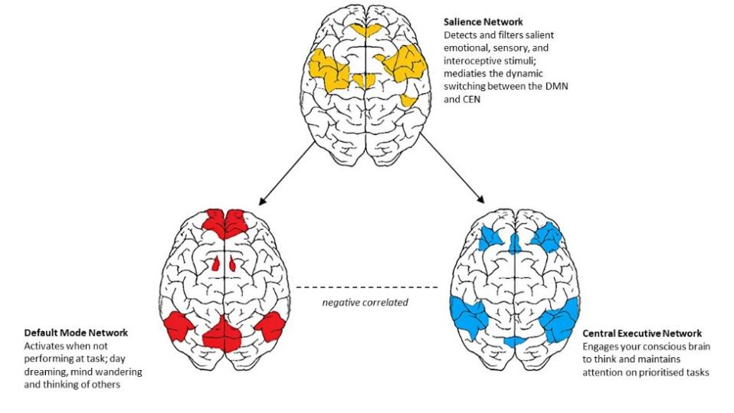
Figure 1: The triple network (De Ridder et al., 2024; van der Linden et al., 2021)

Neuroimaging and computational neuroscience have revealed rumination as an emergent property of dysfunctional interactions between multiple brain networks. The networks involved which are the default mode network (DMN), central executive network (CEN), and salience network (SN) form the commonly known name as the triple network (Wei et al., 2024; De Ridder et al., 2024)(see Figure 1).

The authors of this review paper hope to offer new perspectives for therapeutic targeting by synthesizing the current knowledge of five key aspects related to rumination: (i) the neurobiological mechanisms of rumination, (ii) its formation through network-level dysfunction, (iii) the key anatomical substrates, (iv) the role of subconscious processes, and (v) underlying neurotransmitter systems. Given the complexity of the neurobiological mechanisms involved in rumination, multimodal approaches, which also include the educational therapy (EdTx), are increasingly recognized for their potential to modulate cognitive patterns and support neural plasticity, thus complementing both pharmacological and psychotherapeutic interventions (Saccenti et al., 2024). Through integration of behavioral training with psychotherapeutic modalities, this can enhance the top-down regulatory control and also foster adaptive neural reorganization, leading to more sustainable intervention outcomes (National Academies of Sciences, Engineering and Medicine, Health and Medicine Division, Board on Health Sciences Policy, & Forum on Neuroscience and Nervous System Disorders, 2016).

2. COGNITIVE-NEUROBIOLOGICAL MODEL OF RUMINATION FORMATION

The formation of rumination involves a complex cascade of cognitive and neurobiological processes that transition from adaptive self-reflection to maladaptive perseveration. Initial triggers typically involve negative life events or internal distress signals that activate monitoring systems within the brain. Under normal circumstances, these monitoring processes engage problem-solving mechanisms that lead to resolution and disengagement. However, in vulnerable individuals, this process becomes dysregulated, leading to sustained activation of repetitive thought patterns.

The transition from adaptive reflection to maladaptive rumination involves several key factors:
(1) increased self-focus and attention to internal states,
(2) reduced cognitive flexibility and inability to disengage from negative content,
(3) heightened emotional reactivity to ruminative content, and
(4) impaired executive control over thought processes.

These factors above interact dynamically and create self-reinforcing cycles that maintain ruminative states. Repeated engagement in ruminative thinking patterns leads to neuroplastic changes that strengthen these pathways through Hebbian learning principles (Sumner et al., 2020). Functional connectivity between key nodes involved in rumination becomes increasingly rigid, while connections supporting cognitive flexibility and attention regulation become weakened. This neuroplastic consolidation explains why rumination becomes increasingly automatic and difficult to interrupt over time (Westhoff et al., 2024).

Educational therapy (EdTx) can offer a structured approach to intervening in this rumination cycle by assisting individuals build the metacognitive and executive functioning skills necessary to recognize, monitor, and redirect maladaptive thought patterns (also see Ciobotaru, 2025, for detail). By targeting self-awareness, attention control, and cognitive flexibility through mindfulness-based interventions for ruminative thinking (Mao et al., 2023), EdTx can help weaken entrenched ruminative circuits, while, at the same time, strengthening alternative pathways that support adaptive thinking and emotional regulation. Strategies (e.g., cognitive reframing, self-monitoring, and goal-oriented mental training) used in EdTx can foster active engagement with one’s own cognitive processes that is cruical for breaking the automaticity of rumination flow. Over time, this can contribute to positive neuroplastic changes that restore balance between introspective and executive systems in the brain (Pan et al., 2020).

3. DYSFUNCTIONAL TRIPLE NETWORK MODEL

The triple network model describes the interactions among three large-scale brain networks: the CEN, DMN, and SN. These networks, identified through functional magnetic resonance imaging (fMRI) and resting-state connectivity analyses, are critical for cognitive control, internal mentation, and salience detection. Their dynamic interplay supports complex behaviors, and disruptions are implicated in various neuropsychiatric disorders. These psychiatric disorders include schizophrenia, bipolar disorders, anxiety disorders, MDD, PTSD, OCD and autism. The model proposes that psychiatric symptoms emerge from dysfunction within and between three core networks of the triple network model (Wei et al., 2024).

Rumination is manifested in: (1) CEN hypoactivation and impaired cognitive control, (2) DMN hyperactivation and reduced deactivation, and (3) SN dysfunction leading to inappropriate switching between networks (see Figure 1; De Ridder et al., 2024).

EdTx offers focused or tailored cognitive/metacognitive interventions that can support more adaptive functioning across the triple network connectivity of CEN-DMN-SN (also see Lynn, 2021) mentioned above. For instance, training in structured attention and executive functioning exercises can help enhance CEN activity and improve working memory, cognitive flexibility, and inhibitory regulation (Bigliassi, Cabral, & Evans, 2025). Guided self-reflection and cognitive restructuring techniques can help reduce DMN hyperactivity by redirecting maladaptive self-referential thinking (Azarias et al., 2025). Moreover, strategies in emotional modulation and mindfulness-based attention - embedded within EdTx - can promote more effective SN functioning, particularly, by detecting relevant stimuli and supporting appropriate CEN-DMN-SN network switching. In this way, EdTx contributes to the functional rebalancing of the triple network connectivity of CEN-DMN-SN, and may support neuroplasticity in those with ruminative and related psychopathological patterns (Lynn, 2021).

Table 1: Functionalities of brain regions associated with components of the triple network

Network | Functions | Primary Regions | Clinical Relevance
Central Executive Network (CEN) | Working memory, attentional control, decision-making, goal-directed behaviour | Dorsolateral prefrontal cortex (DLPFC), posterior parietal cortex (PPC), Middle frontal gyrus, Superior frontal gyrus | Disrupted in ADHD, schizophrenia, dementia  (De Ridder et al., 2022; Bigliassi et al., 2025).
Default Mode Network (DMN) | Self-referential thinking, autobiographical memory, future planning, mentalizing, mind-wandering, episodic memory | Medial prefrontal cortex (mPFC), posterior cingulate cortex (PCC), precuneus, angular gyrus, Hippocampus & Parahippocampal gyrus, inferior parietal lobule, | Hyperactivity linked to depression, PTSD, schizophrenia  (Sanz-Morales & Melero, 2024; Guo et al., 2022; Smallwood et al., 2021)
Salience Network (SN) | Detects salient stimuli, mediates DMN-CEN switching, allocates neural resources | Anterior insula, dorsal anterior cingulate cortex (dACC), amygdala, ventral striatum, ventral tegmental area (VTA) | Dysfunction in autism, anxiety, addiction, schizophrenia  (Schimmelpfennig et al., 2023; Jones et al., 2023)

3.1 Central Executive Network (CEN)

According to van der Linden et al. (2021), the CEN is primarily responsible for high-level cognitive functions including working memory, attentional control, decision-making, and goal-directed behaviour. It is predominantly activated when individuals engage in externally focused tasks (e.g., solving puzzles or performing calculations) that align with its role in cognitive control, requiring sustained attention, problem solving, or cognitive flexibility. The network is anchored in the dorsolateral prefrontal cortex (dlPFC) that supports executive functions (e.g., planning and inhibition), and the posterior parietal cortex (PPC) particularly around the intraparietal sulcus that is associated with attention and spatial processing (see Figure 2). The CEN is essential for maintaining cognitive control and is often disrupted in conditions like attention-deficit/hyperactivity disorder (ADHD), schizophrenia, and dementia.

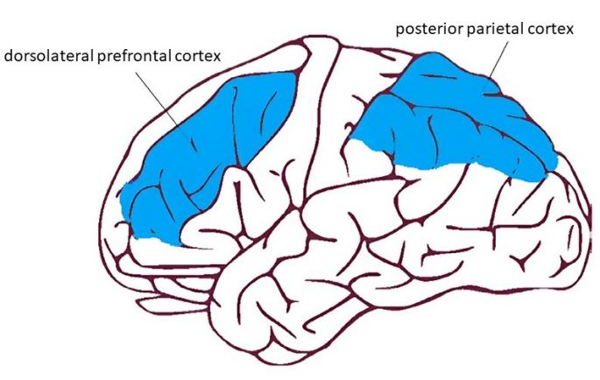
Figure 2: The main brain regions of the CEN (van der Linden et al., 2021)

EdTx can play a critical role in strengthening the CEN function by targeting its core domains, i.e., working memory, cognitive flexibility, and attentional control (Bigliassi, Cabral, & Evans, 2025; Zelazo, Blair, & Willoughby, 2016), through individualized, strategy-based interventions, e.g., metacognitive scaffolding, task-specific cognitive rehearsal, goal-setting, and inhibitory control exercises, which are designed to engage and reinforce dlPFC and PPC activation (also see Pattyn & Hauffa, 2024, for detail). Such structured cognitive interventions applied in EdTx help individuals to enhance their planning, organizing, attention-shifting with more flexibility, and also to sustain mental effort required in performing tasks. The ultimate goal is to improve the overall executive functioning. In neurodevelopmental and psychiatric conditions characterized by the CEN disruption, EdTx offers a non-pharmacological, neurocognitively-informed approach to restoring higher-order thinking and behavioral regulation (Tan et al., 2025).

3.2 Default Mode Network (DMN)

While the DMN supports introspective and reflective mental activity, hyperactivity or poor modulation of this network has been linked to rumination in MDD, intrusive thoughts in PTSD, and self-disconnection in schizophrenia. The default mode network (DMN) represents a collection of brain regions that exhibit high activity during rest and decreased activity during focused on external environment such as goal-directed tasks.

Core DMN regions include the medial prefrontal cortex (mPFC), posterior cingulate cortex (PCC), precuneus, and angular gyrus often extending to the hippocampal formation (van der Linden et al., 2021) (see Figure 3). In healthy individuals, the DMN facilitates self-referential thinking (reflecting on personal goals), autobiographical memory retrieval (recalling a childhood event), future planning (imagining a future vacation), mentalizing (understanding others' perspectives), mind-wandering (daydreaming) and moral reasoning (Smallwood et al., 2021). However, neuroimaging studies consistently demonstrate DMN hyperactivity in individuals prone to rumination across various psychiatric conditions during both resting states and cognitive tasks.

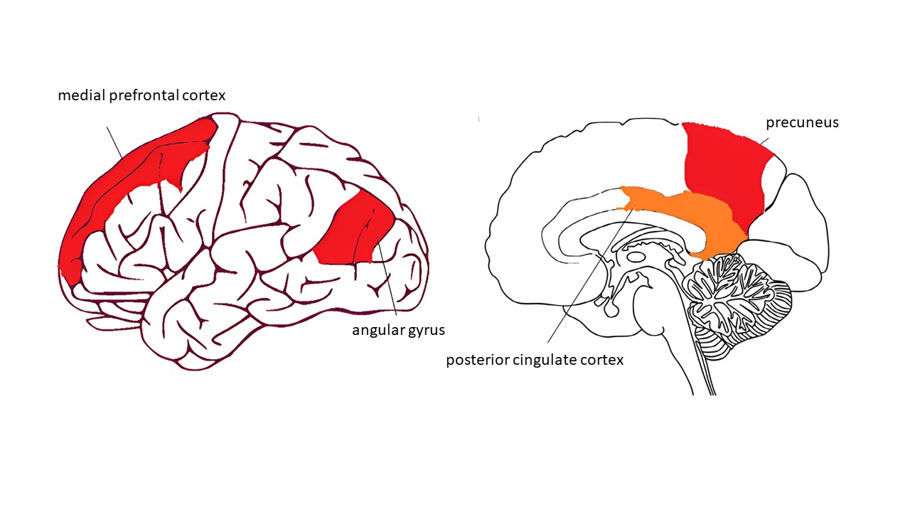
Figure 3: The main brain region of the DMN (van der Linden et al., 2021)

In teaching individuals how to monitor and shift away from maladaptive self-focused attention, EdTx offers practical strategies to address DMN dysregulation. Through structured interventions (e.g., guided self-reflection, thought-logging, and perspective-taking exercises), EdTx helps them become more mindful of their ruminative patterns in order to develop more positive and/or healthier ways to engage with internal thoughts. By integrating metacognitive training and emotional regulation strategies (Azevedo & Strain, 2011; McCombs, 1988), EdTx can reduce overactivation of the mPFC and PCC during rumination and also promote a more adaptive balance between introspection and task-focused engagement. In addition, memory restructuring strategies (e.g., re-contextualizing autobiographical memories or linking past experiences to personal strengths) can support the precuneus and hippocampal systems in disengaging from repetitive negative recall (Dominguez, Casagrande, & Raffone, 2022; Lane et al., 2015). These strategies collectively help to promote greater cognitive flexibility and affective insight that are essential for modulating DMN activity.

The mPFC shows increased activation during ruminative thinking episodes. This hyperactivity appears to reflect enhanced self-focus and emotional processing that characterizes ruminative states. The PCC serves as a central hub within the DMN, integrating information from multiple brain regions involved in memory, emotion, and self-referential processing. Increased PCC activity correlates with the intensity and frequency of ruminative episodes, suggesting its role in maintaining persistent negative thought patterns. The precuneus contributes to self-consciousness and autobiographical memory retrieval, processes that become dysregulated during rumination, leading to repetitive focus on past negative experiences (van der Linden et al., 2021). Beyond hyperactivity, rumination is characterized by dysregulated connectivity patterns within and between the subsystems of DMN. Increased between the DMN subsystems connectivity, particularly between the mPFC and PCC, correlates with greater ruminative tendencies.

3.3 Salience Network (SN)

The SN serves a crucial role in detecting and filtering salient emotional, sensory, and interoceptive stimuli, and in mediating the dynamic switching between the DMN and CEN. Its core regions include the anterior insula and the dorsal anterior cingulate cortex (dACC)(see Figure 4), with additional involvement from the amygdala, ventral striatum (nucleus accumbens and olfactory tubercle), and ventral tegmental area (VTA) (van der Linden et al., 2021).

The SN is vital for allocating neural resources to the most behaviourally relevant information and for initiating appropriate network transitions (e.g., suppressing the DMN and activating the CEN when attention is needed). Dysfunction in this network is implicated in autism spectrum disorder, anxiety, addiction, and schizophrenia, where the brain may either overreact or fail to respond to salient cues.

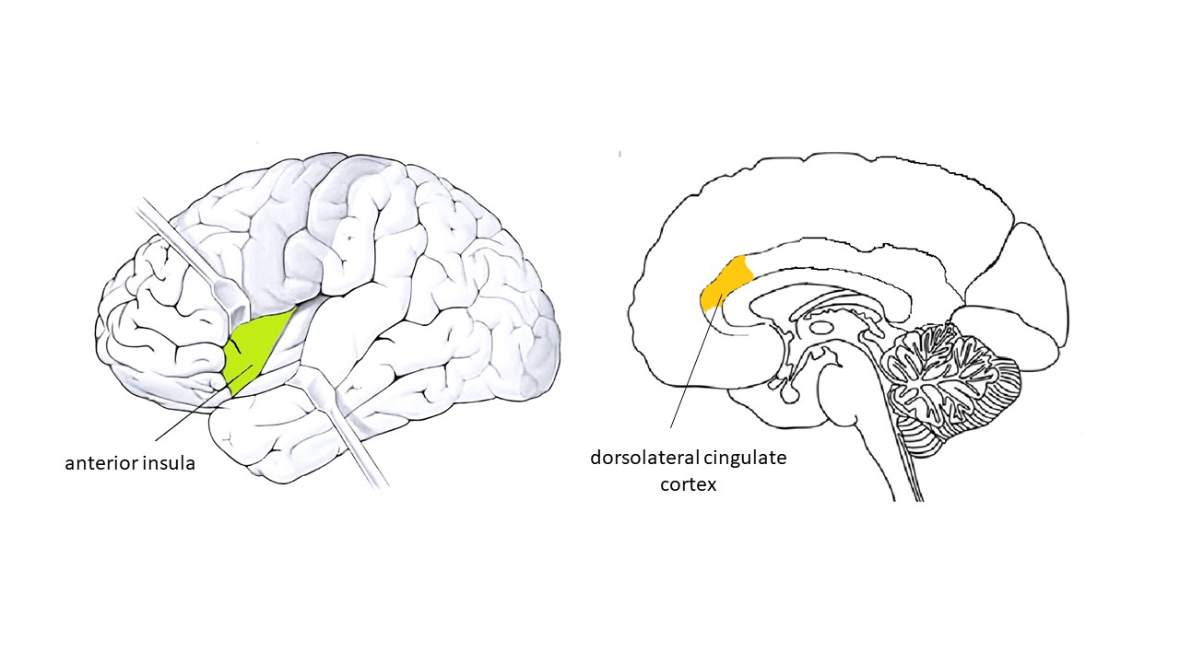

Figure 4: The main brain region of the SN (van der Linden et al., 2021)

By enhancing an individual’s ability to identify, interpret, and regulate sensory-affective input through structured cognitive-emotional learning, EdTx can help support salience network (SN) function. Strategies (e.g., interoceptive awareness training, emotional labeling, mindfulness-based attention shifting, and situational appraisal exercises) applied in EdTx help individuals to better detect and respond to relevant internal and external cues. By training the brain to more accurately prioritize and switch between task-relevant and self-referential states, EdTx can facilitate more efficient engagement of the core switching mechanisms of SN (see Calzolari, 2024, for detail). These skills are particularly crucial in clinical populations where the SN is compromised, e.g., in anxiety (where threat-related stimuli may be exaggerated) or in autism (where salience attribution is often diminished). Hence, EdTx can contribute to restoring the adaptive SN-mediated coordination between large-scale brain networks through fostering greater intentional control over attentional and emotional salience.

3.4 Network Switching Dysfunctional

According to Apazoglou et al. (2024), healthy cognitive function requires dynamic switching between different brain networks based on task demands and environmental context. In rumination, this switching becomes rigid and maladaptive. The SN, anchored by the anterior insula and dACC, fails to appropriately disengage the DMN when external attention is required, leading to sustained internal focus. Studies (e.g., Bernstein, Heeren, & McNally, 201; Jacob et al., 2020; Provenzano et al., 2021) reveal that rumination is associated with reduced network flexibility and increased modularity. Networks become more segregated and less able to reconfigure in response to changing demands. This reduced flexibility contributes to the stuck quality of ruminative thinking and the difficulty in shifting to more adaptive cognitive strategies.

EdTx offers focused interventions to directly support more flexible switching in neural network connectivity by equipping individuals the skills to recognize and interrupt rigid thought patterns. Through such structured exercises (e.g., task-switching drills, mindfulness-based cognitive shifting, and guided attention redirection), individuals can learn the steps to transition from maladaptive internal focus to more adaptive, externally oriented states. In addition, EdTx can integrate executive functioning strategies to strengthen an individual’s ability to disengage from the DMN and re-engage the CEN when appropriate. For instance, mirroring the neural network reconfiguration required for healthy cognition. By reinforcing the ability of the brain to shift attentional and cognitive sets in response to changing goals or stimuli, EdTx can actually promote greater neurocognitive flexibility (Greene, 2020) and adaptability (Lawrence et al., 2021), both of them are crucial in counteracting the persistent, automatic cycle of rumination.

4. SUBCONSCIOUS PROCESSES IN RUMINATION

Rumination involves both conscious, effortful processes and automatic, subconscious mechanisms. While individuals may be aware of their ruminative thoughts, much of the neural activity sustaining these patterns operates below the threshold of consciousness. Subconscious processes include automatic attention biases toward negative information, implicit memory associations, and emotional conditioning that maintains ruminative cycles (Teachman et al., 2019). Subconscious ruminative processes emerge from altered connectivity between cortical and subcortical regions, particularly involving the amygdala, hippocampus, inferior frontal gyrus and ACC (Wang et al., 2024).

The amygdala’s role in threat detection and emotional salience becomes dysregulated in psychiatric disorders. This leads to heightened reactivity to negative stimuli and persistent activation of stress response systems particularly the hypothalamic-pitutary-adrenal (HPA) axis (Tan et al., 2025). This hypervigilance creates a cognitive bias toward negative information processing, facilitating the initiation and maintenance of ruminative cycles (da Costa Silva et al., 2023). The hippocampus, critical for memory consolidation and retrieval, shows altered functioning that promotes preferential access to negative autobiographical memories, providing content for ruminative episodes.

Subconscious ruminative processing involves the inferior frontal gyrus and dACC in monitoring and detecting cognitive conflicts. In psychiatric disorders, these regions show altered activation patterns that fail to effectively regulate automatic negative thought processes, allowing rumination to persist without conscious awareness or control (Wang et al., 2024).

EdTx can address these subconscious contributors to rumination by fostering metacognitive awareness (Ghanizadeh, Mirzaee, & Yousefzadeh, 2024), cognitive-emotional integration, and bottom-up regulation strategies. Strategies (e.g., emotional pattern tracking, memory reattribution, and attentional bias modification) used in EdTx can bring implicit cognitive and emotional tendencies into conscious awareness, where they can be restructured. For instance, when an individual with ruminating problems learns to identify and label early affective cues (linked to amygdala hyperreactivity) or automatic negative thoughts drawn from maladaptive memory schemas (involving the hippocampus), they acquire the coping or managing tools to consciously interrupt these patterns. Moreover, EdTx also incorporates strategies that help to improve inhibitory control and cognitive monitoring (i.e., functions associated with the inferior frontal gyrus and dACC) by reinforcing executive functioning mechanisms through structured feedback and reflection activities. These interventions not only help to reduce the automaticity of ruminative processes, they also empower individuals to reshape their subconscious cognitive habits over time through repeated, deliberate act or practice (Espinet, Anderson, & Zelazo, 2013; Morin & Hamper, 2012).

4.1 Implicit Cognitive Biases

In the research conducted by Wessa et al. (2023), subconscious cognitive biases are found to play crucial roles in rumination maintenance. These include attention biases toward negative stimuli, interpretation biases that favour negative explanations, and memory biases that enhance recall for negative experiences. These biases operate automatically and contribute to the self-perpetuating nature of rumination by continuously feeding negative content into conscious awareness.

EdTx can directly address these implicit cognitive biases by guiding and/or teaching individuals how to identify, challenge, and reframe automatic patterns of negative thinking (Maynes, 2015; Thompson et al., 2023). Through guided cognitive restructuring exercises (Traeger, 2020), individuals learn to critically evaluate their interpretations of events, and, more importantly, to minimize the influence of negatively skewed appraisal. Attention bias modification and mindfulness-based attention training can teach the brain to shift focus away from negative thoughts or stimuli and instead concentrate on neutral or positive ones (Larsen et al., 2023). To counteract memory biases, narrative-based strategies used in EdTx for intervention can encourage a balanced recall of past experiences, and also promote more nuanced autobiographical memory retrieval. By translating subconscious distortions into conscious, modifiable processes, EdTx can foster cognitive flexibility and affective or emotional resilience (Greene, 2020), both being the key factors in disrupting the feedback loop that sustains rumination.

4.2 Emotional Memory Consolidation

During rumination, emotional memories are repeatedly reactivated, leading to their re-consolidation in increasingly negative and elaborate forms. This process occurs partially outside conscious awareness and involves interactions between the hippocampus, amygdala, and prefrontal regions. Each episode of rumination potentially strengthens negative memory traces while weakening positive or neutral associations (Wong et al., 2023).

EdTx can intervene in this maladaptive re-consolidation by aiding individuals to reshape the encode-recall-reinterpret process of their emotional memories. Through the structured narrative reconstruction (Scherer-Rath, 2014) with the aim of integrating alternative perspectives and affective meanings, individuals are led gradually to revisit their negative autobiographical memories. In this way, it promotes a more balanced affective encoding and also reduces the dominance of negatively skewed recall. Moreover, strategies (Arbuthnott, Arbuthnott, & Rossiter, 2001; Miguel-Alvaro et al., 2021; Ruppert & Eiroa-Orosa, 2018), such as guided imagery, positive memory retrieval practice, and contextual reframing, are generally applied in EdTx to strengthen access to positive or neutral memory networks as well as to counterbalance the reinforcement of negative traces. By engaging cognitive-affective systems during memory processing, EdTx supports more adaptive re-consolidation with the ultimate aim of reducing the affective or emotional intensity and recurrence of ruminative episodes.

5. NEUROTRANSMITTER PATHWAYS

Rumination has been found to associate with the dysregulation of several neurotransmitter pathways (Maniscalco, 2025). By targeting one or more of these neurotransmitters pharmacologically, or through behavioral and/or neuromodulatory interventions, there is a good possibility to rebalance neural network activity and break free from spiraling negative thoughts (Ghallab & Elassal, 2024). It is crucial for educational therapists to understand the nature of these key neurotransmitters in order to help their clients to manage their ruminating problems.

5.1 Serotonergic System

The widespread projections of serotonin to the prefrontal cortex, hippocampus, and limbic regions help balance mood, cognitive flexibility, and inhibition of negative thoughts (Gkintoni & Ortiz, 2023). In other words, low serotonin impairs feedback control of stress, and also hampers the mental agility needed to break free from rumination as it shifts away from self-critical loops (see Figure 5).

EdTx can help indirectly modulate serotonergic function by minimizing stress reactivity and, at the same time, enhance cognitive flexibility through mindfulness-based stress reduction (MBSR; Kabat-Zinn, 2003), structured problem-solving methods (Fensel & Motta, 2001), and cognitive reframing techniques (Dharsana et al., 2019). These strategies help to promote more adaptive emotional regulation and can modulate the limbic-prefrontal circuitry targeted by serotonin. Individuals, who practice and internalize the skills acquired from these techniques, show improvement in mood, adaptability, and inhibitory control that, in turn, enhance serotonergic tone over time (Calderone et al., 2024; Guendelman, Medeiros, & Rampes, 2017).

5.2 Dopaminergic System

Dopamine in the mesocorticolimbic pathway influences reward sensitivity and motivation. In the mesocortical branch, it supports working memory and attentional shifts. When dopamine tone is low, the ability to find pleasure in life diminishes resulting in anhedonia. The PFC loses some capacity to interrupt negative thought patterns. This double whammy fosters ruminative persistence (see Figure 5) (Pannu et al., 2025).

EdTx can address deficits in the dopaminergic system by engaging the brain in rewarding, mastery-oriented learning activities and goal-directed task-based behavior (Chia & Lim, 2016). Techniques applied in EdTx, e.g., structured achievement tracking, positive reinforcement systems, and motivational interviewing, can enhance reward sensitivity and facilitate behavioral activation. By fostering a sense of competence and pleasure, the techniques used in EdTx can help to counteract anhedonia and also increase engagement with cognitive strategies that reduce rumination.

5.3 Norepinephrine System

Norepinephrine (LC-NE) is required by the brain for threat detection. Overactivation of the synthesis at locus coeruleus drives sustained vigilance and autonomic arousal, resulting in driving attention toward negative content (McKlveen et al., 2015). When norepinephrine pathway is dysregulated at the PFC, working memory and cognitive flexibility weakens, resulting in heightened vigilant and ruminative thinking (see Figure 5).

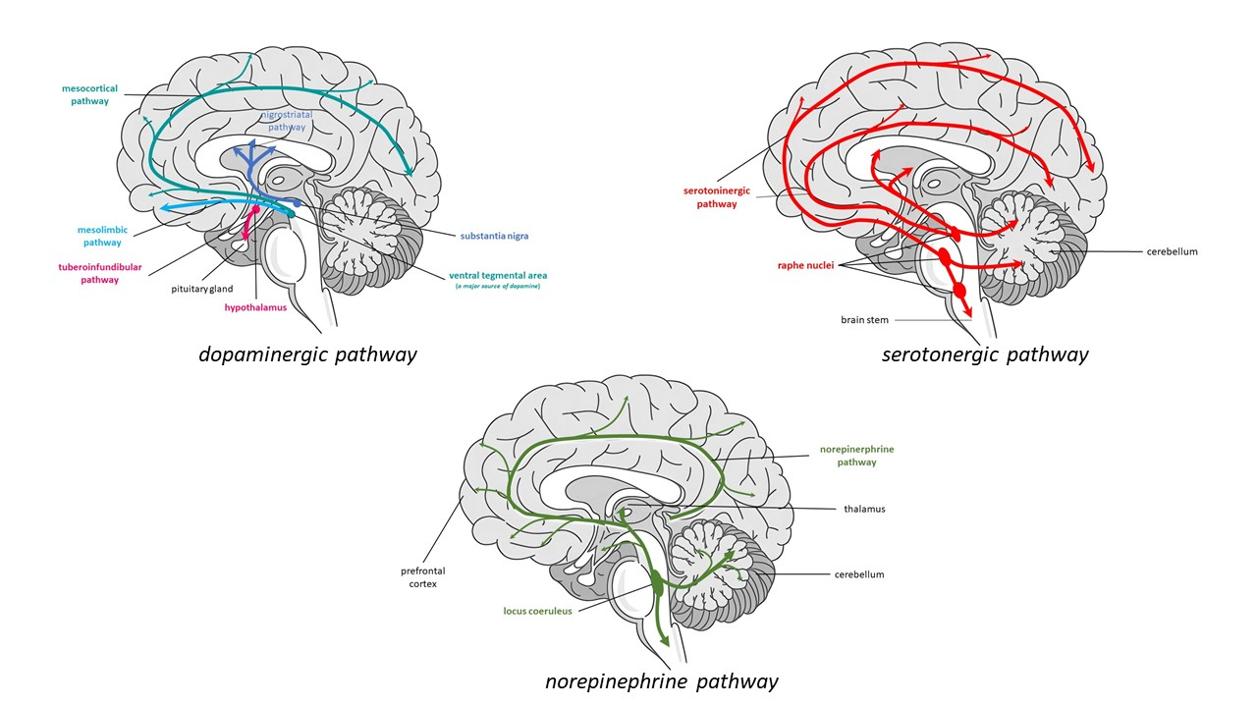
Figure 5: Dopaminergic, serotonergic and norepinephrinergic pathways (Tan et al., 2025)

EdTx can modulate the impact of norepinephrine dysregulation through techniques, such as relaxation training, paced breathing, attentional refocusing, and cognitive reappraisal exercises, which build emotional regulation and attentional control under stress. During the EdTx sessions, individuals can be taught how to downregulate autonomic hyperarousal (e.g., using paced or resonance breathing training and cognitive reappraisal with biofeedback) to improve top-down control, reduce the attentional narrowing and cognitive rigidity characteristic of high norepinephrine states (Andrews et al., 2025; Bachman et al., 2023).

5.4 Glutamatergic System

Glutamate drives synaptic plasticity and underpins healthy learning and memory. However, when the balance leans toward excitation, often while during GABA deficit, ruminative pathways strengthen with each cycle of repetitive thought (McGrath et al., 2022)

EdTx can provide structured, adaptive learning experiences that harness neuroplasticity constructively in order to facilitate healthy glutamatergic function. Strategies used in EdTx, e.g., spaced repetition (a subset of spaced learning), cognitive flexibility training (complementary in neurocognitive training), and error-based learning (involves feedback processing that is linked to dopaminergic and glutamatergic signaling in learning networks), help redirect neuroplastic changes away from maladaptive loops and move toward adaptive cognitive schemas (also see spaced learning in Kramár et al., 2012, and Smolen, Zhang, & Byrne, 2016). These strategies help to promote more balanced and flexible memory encoding, and also reduce the reinforcement of negatively valenced mental patterns.

5.5 GABAergic System

The inhibitory action of GABA is crucial for preventing runaway excitation in brain networks tied to self-referential thinking. Reduced GABAergic inhibition allows DMN regions to remain hyperactive, making it difficult to snap out of negative loops (Bruining et al., 2020). The dysregulation of GABA is unable to tone-down the excitatory inputs result in ruminative circuits being overdriven.

EdTx may help to counterbalance GABAergic deficits by integrating strategies that promote calm, focused mental states. Such strategies, e.g., mindfulness practices, guided visualization, and structured attention training, can mitigate cognitive hyperexcitability and facilitate inhibitory control. They foster internal calmness, enabling individuals to disengage from overactive self-referential thought and access more modulated, adaptive mental states, and hence, to minimize vulnerability to rumination. Over time, these strategies may contribute to a more inhibitory neural environment that mirrors GABAergic balance (Guglietti et al., 2013), and in the long run, to curtail susceptibility to rumination.

6. NON-PHARMACOLOGICAL THERAPEUTIC INTERVENTIONS

Though often under-recognized, educational therapy (EdTx) plays a pivotal role in the treatment of rumination by linking cognitive, behavioral, and neurobiological approaches. Being structured and skills-based, EdTx helps individuals develop metacognitive awareness (Ghanizadeh, Mirzaee, & Yousefzadeh, 2024), emotional regulation, and executive functioning. All the three foundational psychological capacities are crucial for interrupting ruminative cycles (Cano-López et al., 2022). Unlike purely clinical models, EdTx provides a customized, collaborative space in which clients learn to recognize their cognitive-affective patterns, acquire adaptive tools to manage them, and also to apply these strategies in academic, social, and everyday contexts (Chia, 2000). More importantly, EdTx is highly complementary to other non-pharmacological interventions, e.g., Cognitive Behavioral Therapy (CBT), Mindfulness-Based Cognitive Therapy (MBCT), Behavioral Activation Therapy (BAT), Acceptance and Commitment Therapy (ACT), and Interpersonal Therapy (IPT), as it reinforces and contextualizes these approaches through psychoeducation, self-monitoring, reflective learning, and executive function coaching. In addition, it is directly involved in the design and delivery of psychoeducational intervention programs with individualized coping strategies to equip individuals with lifelong skills to reduce vulnerability to rumination and related psychopathology (Şahin & Türk, 2021).

6.1 Cognitive Behavioral Therapy (CBT)

In a study conducted by Stenzel et al. (2025), the authors argued that CBT represents one of the most extensively researched and effective interventions for addressing rumination across psychiatric disorders. The efficacy of CBT stems from its direct targeting of cognitive patterns and behavioral responses that maintain ruminative cycles. The cognitive component of CBT focuses on identifying and challenging negative thought patterns that characterize rumination. Individuals learn to recognize cognitive distortions, such as catastrophic thinking and over-generalization, that fuel ruminative episodes (Lee & Cho, 2021). Through cognitive restructuring techniques, individuals develop skills to evaluate thought validity and generate alternative, more balanced perspectives.

Neuroimaging studies demonstrate that successful CBT intervention produces measurable changes in brain structure and function relevant to rumination. Increased activity in the dorsolateral PFC reflects enhanced cognitive control, while reduced amygdala reactivity indicates improved emotional regulation (König et al., 2025). These neural changes correlate with decreased rumination frequency and intensity, providing biological evidence for CBT's therapeutic mechanisms.

Behavioral activation components of CBT address the behavioral withdrawal and reduced activity levels that often accompany ruminative states. By scheduling pleasant activities and gradually increasing behavioral engagement, patients interrupt ruminative cycles through external focus and positive reinforcement. This approach leverages dopaminergic reward pathways to counter the anhedonia states that fuel depressive rumination (Andersson et al., 2024).

6.2 Mindfulness-Based Cognitive Therapy (MBCT)

Mindfulness-Based Cognitive Therapy combines mindfulness meditation practices with cognitive therapy principles to specifically target ruminative thinking patterns (Hawley et al., 2024). The mindfulness component teaches individuals to observe thoughts and emotions without judgment or automatic reactivity. This metacognitive awareness (see Ghanizadeh, Mirzaee, & Yousefzadeh, 2024, for detail) creates psychological distance from ruminative content, reducing its emotional impact and preventing automatic elaboration of negative thoughts. Regular mindfulness practice strengthens attentional control and present-moment awareness, providing alternatives to past-focused ruminative processing.

According to Voss et al. (2023). neurobiological research reveals that MBCT produces specific brain changes relevant to rumination reduction. Increased activity in the ACC and insula reflects enhanced interoceptive awareness and attention regulation. Reduced DMN hyperactivity indicates decreased self-referential processing that characterises ruminative states. These changes occur alongside structural modifications in regions associated with learning and memory, including increased cortical thickness in areas involved in attention and sensory processing.

The cognitive therapy elements of MBCT help individuals recognize early warning signs of ruminative episodes and develop specific strategies for disengaging from negative thought patterns. This combination of mindfulness skills and cognitive techniques provides comprehensive tools for both preventing and interrupting rumination when it occurs.

6.3 Behavioral Activation Therapy (BAT)

As claimed by Andersson et al. (2024), BAT focuses on increasing engagement in meaningful, value-based activities to counter the behavioral withdrawal and reduced reinforcement that maintain ruminative depression. This approach targets the behavioral components of rumination while indirectly affecting cognitive patterns through increased environmental engagement.

The therapeutic process involves identifying activities that provide meaning, pleasure, or mastery, then systematically scheduling and engaging in these behaviors. By increasing contact with positive reinforcement and reducing avoidance behaviors, patients experience improved mood and reduced tendency toward ruminative thinking patterns.

Neurobiological mechanisms underlying behavioral activation include enhanced dopaminergic signaling in reward circuits and improved PFC functions. This also reduces DMN activity through external focus and goal-directed behaviour (Schultz et al., 2017). These changes directly counter the neural patterns that maintain rumination while building alternative circuits associated with positive mood and adaptive functioning.

6.4 Acceptance and Commitment Therapy (ACT)

According to review conducted by Anusuya & Gayatridevi (2025), ACT offers unique approaches to rumination through its emphasis on psychological flexibility and values-based living. Rather than directly challenging ruminative thoughts, ACT guided individuals to accept difficult internal experiences while committing to meaningful behavioral choices.

The acceptance component involves developing willingness to experience negative thoughts and emotions without attempting to control or eliminate them. This approach reduces the struggle with ruminative content that often intensifies and prolongs negative thinking episodes. Diffusion techniques help patients see thoughts as mental events rather than literal truths, reducing their behavioral impact.

Commitment processes involve identifying personal values and engaging in behaviors consistent with these values regardless of internal experiences. This approach provides direction and motivation that counter the hopelessness and behavioral withdrawal associated with rumination. Values-based action creates positive reinforcement that competes with ruminative focus on problems and distress.

6.5 Educational and Psychoeducational Approaches

Educational interventions provide individuals with understanding of the nature of rumination, its triggers, and maintenance factors. Educational therapists help these individuals to recognize and provide the means to express their emotions, moods and thoughts. This knowledge empowers individuals to recognize ruminative patterns early and implement appropriate intervention strategies. Psychoeducation about the neurobiology of rumination helps normalize experiences while providing rationale for specific therapeutic techniques (Goss et al., 2017).

Group educational programs offer additional benefits through peer support and shared learning experiences. Participants learn from others’ experiences with rumination while developing social connections that counter the isolation often associated with ruminative disorders (Genç et al., 2023). These programs often incorporate elements from multiple therapeutic approaches, providing comprehensive skill-building opportunities.

Family education components help loved ones understand rumination's impact and learn supportive communication strategies. This approach addresses interpersonal factors that may trigger or maintain ruminative episodes while building environmental supports for recovery (Ottaviani et al., 2017).

6.6 Interpersonal Therapy (IPT)

Interpersonal Therapy addresses rumination through its focus on relationship patterns and social functioning (Gaetano et al., 2022). Many ruminative episodes involve interpersonal themes, making IPT particularly relevant for individuals whose negative thinking centers on relationship conflicts or losses.

The structured approach of IPT identifies specific interpersonal problem areas, including grief, role disputes, role transitions, and interpersonal deficits. By improving communication skills and relationship functioning, patients experience reduced interpersonal stress that often triggers ruminative episodes. Enhanced social support provides alternatives to solitary rumination while building resources for coping with future stressors.

The time-limited, problem-focused nature of IPT provides structure that counters the open-ended, problem-focused nature of rumination. By working toward specific interpersonal goals, patients develop sense of agency and progress that oppose the helplessness often associated with ruminative thinking patterns.

7. CONCLUSION

Rumination represents a complex phenomenon involving multiple interacting neurobiological systems, from molecular neurotransmitter pathways to large-scale brain networks. The hyperactivity of DMN, the PFC dysfunction, and the altered neurotransmitter signaling all create conditions that initiate and maintain ruminative thinking patterns across psychiatric disorders. Understanding these mechanisms provides foundations for developing and refining therapeutic interventions that effectively target the neurobiological underpinnings of rumination.

The neurobiological understanding of rumination continues to evolve as research techniques advance and theoretical models become more sophisticated. Integration of findings across multiple levels of analysis, from molecular mechanisms to neural circuits to psychological processes, provides increasingly comprehensive frameworks for understanding and treating ruminative disorders.

Non-pharmacological interventions, including CBT, MBCT, ACT, IPT and psychoeducational (i.e., behavioral and educational intervention) approaches, demonstrate efficacy in reducing rumination through their effects on relevant neural circuits and cognitive processes. These treatments produce measurable changes in brain structure and function that correspond to clinical improvements, validating neurobiological models of rumination and therapeutic change.

EdTx provides a uniquely supportive and integrative role within this non-pharmacological therapeutic landscape. By targeting at cognitive flexibility, emotional literacy, executive functioning, and metacognitive awareness, EdTx offers tools to translate scientific insight into individualized, practical interventions (Karamali Esmaili et al., 2017; Nakhostin-Khayyat et al., 2024; Ünver, Rodopman Arman, & Nur Akpunar, 2022)). Moreover, it equips individuals with the skills to know, identify, understand, and self-regulate ruminative tendencies. At the same time, it also helps to reinforce the gains of other clinical interventions through structured, goal-oriented learning experiences. More importantly, EdTx also empowers individuals across developmental stages (not just to cope with distress) to build sustainable cognitive-affectve resilience grounded in self-awareness as well as strategic thinking.

Future research efforts should continue integrating neurobiological findings with clinical observations to develop more precise and effective treatments for ruminative disorders. The ultimate goal remains translating scientific understanding into practical interventions that reduce suffering and improve quality of life for individuals struggling with persistent negative thinking patterns. As for the specialized domain of educational therapy, its unique capacity to connect neurobiological insight and day-to-day cognitive functioning certainly offers a valuable ally in achieving this goal.

REFERENCES

Andersson, R., Vigerland, S., Lenhard, F., Ahlen, J., Bottai, M., Mataix-Cols, D., & Serlachius, E. (2024). Single-blinded, randomized, parallel-group, controlled trial comparing the efficacy and cost-effectiveness of therapist- and self-guided internet-delivered behavioral activation versus treatment as usual for adolescents with mild to moderate depression: study protocol. British Medical Journal-Open, 14(10). AritcleID: e083507. Doi: 10.1136/bmjopen-2023-083507.
Andrews, R., Melnychuk, M., Moran, S., Walsh, T., Boylan, S., & Dockree, P. (2025). Paced breathing associated with pupil diameter oscillations at the same rate and reduced lapses in attention. Psychophysiology, 62(2). Article ID: e70003. Doi: 10.1111/psyp.70003.
Anusuya, P. S., & Gayatridevi, S. (2025). Acceptance and commitment therapy and psychological well-being: A narrative review. Cureus, 17(1). ArticleID: e77705. Doi: 10.7759/cureus.77705.
Apazoglou, K., Küng, A. L., Cordera, P., Aubry, J. M., Dayer, A., Vuilleumier, P., & Piguet, C. (2019). Rumination related activity in brain networks mediating attentional switching in euthymic bipolar patients. International Journal of Bipolar Disorders, 7(1). Article No. 3. Doi: 10.1186/s40345-018-0137-5.
Arbuthnott, K. D., Arbuthnott, D. W., & Rossiter, L. (2001). Guided imagery and memory: Implications for psychotherapists. Journal of Counseling Psychology, 48(2), 123-132. Doi: 10.1037/0022-0167.48.2.123
Azarias, F. R., Almeida, G. H. D. R., de Melo, L. F., Rici, R. E. G., & Maria, D. A. (2025). The journey of the default mode network (DMN): Development, function, and impact on mental health. Biology, 14(4). Article No. 395. Doi: 10.3390/biology14040395.
Azevedo, R., & Strain, A. C. (2011). Integrating cognitive, metacognitive, and affective regulatory processes with MetaTutor. In R. Calvo & S. D'Mello (Eds), New perspectives on affect and learning technologies: Explorations in the learning sciences, instructional systems and performance technologies (Vol. 3; pp. 141-154). New York, NY: Springer. Doi: 10.1007/978-1-4419-9625-1_11.
Bachman, S. L., Cole, S., Yoo, H. J., Nashiro, K., Min, J., Mercer, N., Nasseri, P., Thayer, J. F., Lehrer, P., & Mather, M. (2023). Daily heart rate variability biofeedback training decreases locus coeruleus MRI contrast in younger adults in a randomized clinical trial. International Journal of Psychophysiology, 193. Article ID: 112241. Doi: 10.1016/j.ijpsycho.2023.08.014.
Bernstein, E. E., Heeren, A., & McNally, R. J. (2019). Reexamining trait rumination as a system of repetitive negative thoughts: A network analysis. Journal of Behavior Therapy and Experimental Psychiatry, 63, 21-27. Doi: 10.1016/j.jbtep.2018.12.005.
Bigliassi, M., Cabral, D. F., & Evans, A. C. (2025). Improving brain health via the central executive network. The Journal of Physiology (Advance online publication). Doi: 10.1113/JP287099.
Bruining, H., Hardstone, R., Juarez-Martinez, E. L., Sprengers, J., Avramiea, A. E., Simpraga, S., Houtman, S. J., Poil, S. S., Dallares, E., Palva, S., Oranje, B., Matias Palva, J., Mansvelder, H. D., & Linkenkaer-Hansen, K. (2020). Measurement of excitation-inhibition ratio in autism spectrum disorder using critical brain dynamics. Scientific Reports, 10(1). Article ID: 9195. Doi: 10.1038/s41598-020-65500-4.
Calderone, A., Latella, D., Impellizzeri, F., de Pasquale, P., Famà, F., Quartarone, A., & Calabrò, R. S. (2024). Neurobiological changes induced by mindfulness and meditation: A systematic review. Biomedicines, 12(11). Article No. 2613. Doi: 10.3390/biomedicines12112613.
Calzolari, S. (2024). Shifting across internally and externally oriented cognition: behavioural and neural explorations using task-switching and resting-state paradigms (Publication No. 14010). [Doctoral dissertation, University of Birmingham]. University of Birmingham e-Theses Repository (UBIRA) e-Theses. https://etheses.bham.ac.uk/id/eprint/14010/
Chia, K. H. (2000). What is educational therapy? The Singapore Professional, 24(2), 4-5. Doi: 10.5281/zenodo.15278940.
Chia, K. H., & Lim, B. H (2016, Fall). Understanding how attention can be affected by different task behaviors. Unlimited Human! 5-7, 37. Doi: 10.5281/zenodo.15694964.
Chiang, Y. H., Wang, C. Y., Liu, C. Y., & Yang, C. Y. (2025). Effect of group rumination-focused cognitive behavior therapy on depressive symptoms in people with schizophrenia: A randomized controlled trial. Journal of Nursing Research, 33(2). Article ID: e383. Doi: 10.1097/jnr.0000000000000665.
Chua, C. K., & Chia, K. H. (2023a, Spring). A brief review of educational therapy & its current role: Part 1. Unlimited Human! 4-5. doi: 10.5281/zenodo.15219971.
Chua, C. K., & Chia, K. H. (2023b, Summer). A brief review of educational therapy & its current role: Part 2. Unlimited Human! 4-5. Doi: 10.5281/zenodo.15220110.
Ciobotaru, D. (2025). Cognitive, affective, and neural mechanisms of rumination in early adulthood and work: A multimethod approach (Publication No. 2025/3/18). [Doctoral dissertation, University of Surrey]. Openresearch@Surrey. https://www.surrey.ac.uk/people/delia-ciobotaru.
Da Costa Silva, L., Quinette, P., Dayan, J., Fraisse, F., Peschanski, D., de La Sayette, V., ... & Laisney, M. (2023). The dual impairment of emotional information processing in memory in relation to dissociative or hypervigilant profiles in post-traumatic stress disorder. European Journal of Psychotraumatology, 14. Doi: 10.1080/20008066.2023.2197737
De Ridder, D., Vanneste, S., Smith, M., & Adhia, D. (2022). Pain and the triple network model. Frontier in Neurology, 13. Article ID: 757241. Doi: 10.3389/fneur.2022.757241.
Dharsana, I. K. I. K., Dharsana, I. K., Sudarsana, G. N., Suarni, N. K., Paramartha, W. E., Tirka, I. W., & Rismawan, K. S. G. (2019, December). Cognitive counseling with reframing techniques to intervene in self aggression. Advances in Social Science, Education and Humanities Research, 382, 62-64. Doi: 10.2991/icet-19.2019.15.
Di Tella, M., & Romeo, A. (2025). Post-traumatic stress symptoms and rumination: The moderator effect of time. Psychology, Health & Medicine, 30(4), 697-707. Doi: 10.1080/13548506.2024.2433542.
Dominguez, E., Casagrande, M., & Raffone, A. (2022). Autobiographical memory and mindfulness: A critical review with a systematic search. Mindfulness, 13(7), 1614-1651. Doi: 10.1007/s12671-022-01902-x.
Espinet, S. D., Anderson, J. E., & Zelazo, P. D. (2013). Reflection training improves executive function in preschool-age children: behavioral and neural effects. Developmental Cognitive Neuroscience, 4, 3-15. Doi: 10.1016/j.dcn.2012.11.009.
Fensel, D.A., & Motta, E. (2001). Structured Development of Problem Solving Methods. IEEE Transactions on Knowledge and Data Engineering, 13, 913-932. Doi: 10.1109/69.971187.
Gaetano, P., Picardi, A., & Carcione, A. (2022). A cognitive therapy perspective on therapists’ feelings and interpersonal processes. In M. Biondi, A. Picardi, M. Pallagrosi, & L. Fonzi (Eds.), The clinician in the psychiatric diagnostic process (pp. 165-194). Cham, Switzerland: Springer Nature. Doi: 10.1007/978-3-030-90431-9_11.
Genç, A., Barut, Y. & Başol, G. (2023). The effect of group counseling program based on cognitive behavioral approach on adolescents’ rumination levels. Current Psychology, 42, 2221-2228. Doi: 10.1007/s12144-021-02481-1.
Ghallab, Y. K., & Elassal, O. S. (2024). Biochemical and neuropharmacology of psychiatric disorders. In W. Mohamed & F. Kobeissy (Eds.), Nutrition and psychiatric disorders: An evidence-based approach to understanding the diet-brain connection (pp. 25-47). Singapore: Springer Nature.
Ghanizadeh, A., Mirzaee, S., & Yousefzadeh, T. (2024). Metacognitive awarenaess as the predictor of positive self-critical rumination, personal best goals (PBs), and language achievement. Journal of Rational-Emotive & Cognitive-Behavior Therapy, 42(4), 812-829. Doi: 10.1007/s10942-024-00548-z
Gkintoni, E., & Ortiz, P. S. (2023). Neuropsychology of generalized anxiety disorder in clinical setting: A systematic evaluation. Healthcare, 11(17). Article No. 2446. Doi: 10.3390/healthcare11172446.
Goss, D., & Parnell, T. (2017). Integrating neuroscience into counselling psychology: Exploring the views and experiences of UK-based counselling psychologists. Counselling Psychology Review, 32, 4-17. Doi: 10.53841/bpscpr.2017.32.4.4.
Greene, T. C. (2020). Pathways to coping with extreme events: A study of the relation between cognitive flexibility and four types of rumination (Publication No. 0694N-12326). [Master's thesis, University of North Carolina at Charlotte]. Niner Commons, UNC Charlotte’s institutional Repository. https://ninercommons.charlotte.edu/record/1274?v=pdf.
Guendelman, S., Medeiros, S., & Rampes, H. (2017). Mindfulness and emotion regulation: Insights from neurobiological, psychological, and clinical studies. Frontiers in Psychology, 8. Article No. 220. Doi: 10.3389/fpsyg.2017.00220.
Guglietti, C. L., Daskalakis, Z. J., Radhu, N., Fitzgerald, P. B., & Ritvo, P. (2013). Meditation-related increases in GABAB modulated cortical inhibition. Brain Stimulation, 6(3), 397-402. Doi: 10.1016/j.brs.2012.08.005
Guo, Y., Wu, H., Li, Z., Zhao, L., & Feng, T. (2022). Episodic future thinking predicts differences in delay discounting: The mediating role of hippocampal structure. Frontier in Psychology, 12(13). Article ID: 992245. Doi: 10.3389/fpsyg.2022.992245.
Hawley, L. L., Lisi, D. M., Richter, M. A., Selchen, S., & Rector, N. A. (2024). The relationship of rumination, worry and OCD symptoms during technology supported mindfulness therapy for OCD. Clinical Psychology and Psychotherapy, 31(4). Article ID: e3018. Doi: 10.1002/cpp.3018.
Jacob, Y., Morris, L. S., Huang, K. H., Schneider, M., Rutter, S., Verma, G., Murrough, J. W., & Balchandani, P. (2020). Neural correlates of rumination in major depressive disorder: A brain network analysis. NeuroImage-Clinical, 25. Article ID: 102142. Doi: 10.1016/j.nicl.2019.102142.
Jones, J. S., Monaghan, A., Leyland-Craggs, A., CALM Team, & Astle, D. E. (2023). Testing the triple network model of psychopathology in a transdiagnostic neurodevelopmental cohort. Neuroimage Clinical, 40. Article ID: 103539. Doi: 10.1016/j.nicl.2023.103539.
Kabat-Zinn, J. (2003). Mindfulness-based stress reduction (MBSR). Constructivism in the Human Sciences, 8(2), 73–107.
Karamali Esmaili, S., Shafaroodi, N., Hassani Mehraban, A., Parand, A., Zarei, M., & Akbari-Zardkhaneh, S. (2017). Effect of play-based therapy on meta-cognitive and behavioral aspects of executive function: A randomized, controlled, clinical trial on the students with learning disabilities. Basic and Clinical Neuroscience, 8(3), 203-212. Doi: 10.18869/nirp.bcn.8.3.203.
König, P., Zwiky, E., Küttner, A., Uhlig, M., & Redlich, R. (2025). Brain functional effects of cognitive behavioral therapy for depression: A systematic review of task-based fMRI studies. Journal of Affective Disorders, 368, 872-887. Doi: 10.1016/j.jad.2024.09.084.
Kramár, E. A., Babayan, A. H., Gavin, C. F., Cox, C. D., Jafari, M., Gall, C. M., Rumbaugh, G., & Lynch, G. (2012). Synaptic evidence for the efficacy of spaced learning. Proceedings of the National Academy of Sciences of the United States of America, 109(13), 5121-5126. Doi: 10.1073/pnas.1120700109.
Lane, R. D., Ryan, L., Nadel, L., & Greenberg, L. (2015). Memory reconsolidation, emotional arousal, and the process of change in psychotherapy: New insights from brain science. The Behavioral and Brain Sciences, 38(e1). Doi: 10.1017/S0140525X14000041.
Lawrence, A. V., Alkozei, A., Irgens, M. S., Acevedo-Molina, M. C., Brener, S. A., … & O'Connor, M.-F. (2021). Think again: Adaptive repetitive thought as a transdiagnostic treatment for individuals predisposed to repetitive thinking styles. Journal of Psychotherapy Integration, 31(2), 208-222. Doi: 10.1037/int0000209.
Lee, S. H., & Cho, S. J. (2021). Cognitive Behavioral Therapy and Mindfulness-Based Cognitive Therapy for Depressive Disorders. Advances in Experimental Medicine and Biology, 1305, 295-310. Doi: 10.1007/978-981-33-6044-0_16.
Lipsitz, J. D., & Markowitz, J. C. (2013). Mechanisms of change in interpersonal therapy (IPT). Clinical Psychology Review, 33(8), 1134-1147. Doi: 10.1016/j.cpr.2013.09.002.
Lynn, E. K. (2021). Resting state and task triple network connectivity profiles in remitted depressed patients compared with healthy volunteers (Publication No. 1332540507) [Doctoral dissertation, Université d'Ottawa/University of Ottawa]. Library and Archives Canada. https://library-archives.canada.ca/eng/services/services-libraries/theses/Pages/item.aspx?idNumber=1332540507
Maniscalco, I. (2025). From rumination to cortical dysfunction: Hypothesis of a unique pathological process (Preprint). Cureus Journal of Medical Science. Doi: 10.13140/RG.2.2.13627.73764.
Mao, L., Li, P., Wu, Y., Luo, L., & Hu, M. (2023). The effectiveness of mindfulness-based interventions for ruminative thinking: A systematic review and meta-analysis of randomized controlled trials. Journal of Affective Disorders, 321, 83-95. Doi: 10.1016/j.jad.2022.10.022.
Maynes, J. (2015). Critical thinking and cognitive bias. Informal Logic, 35(2), 183-203.
McCombs, B. L. (1988). Motivational skills training: Combining metacognitive, cognitive, and affective learning strategies. In C. E. Weinstein, E. T. Goetz, & P. A. Alexander (Eds.), Learning and study strategies: Issues in assessment, instruction, and evaluation (pp. 141-169). New York, NY: Academic Press.
McGrath, T., Baskerville, R., Rogero, M., & Castell, L.. (2022). Emerging evidence for the widespread role of glutamatergic dysfunction in neuropsychiatric diseases. Nutrients, 14(5). Article No. 917. Doi: 10.3390/nu14050917.
McKlveen, J. M., Myers, B., & Herman, J. P. (2015). The medial prefrontal cortex: Coordinator of autonomic, neuroendocrine and behavioural responses to stress. Journal of Neuroendocrinology, 27(6), 446-456. Doi: 10.1111/jne.12272.
Miguel-Alvaro, A., Guillén, A. I., Contractor, A. A., & Crespo, M. (2021). Positive memory intervention techniques: A scoping review. Memory, 29(6), 793-810. Doi: 10.1080/09658211.2021.1937655.
Morin, A., & Hamper, B. (2012). Self-reflection and the inner voice: activation of the left inferior frontal gyrus during perceptual and conceptual self-referential thinking. The Open Neuroimaging Journal, 6, 78-89. Doi: 10.2174/1874440001206010078.
Nakhostin-Khayyat, M., Borjali, M., Zeinali, M. , Deniz Fardi, D., & Montazeri, A. (2024). The relationship between self-regulation, cognitive flexibility, and resilience among students: a structural equation modeling. BMC Psychology, 12. Article No. 337. Doi: 10.1186/s40359-024-01843-1.
National Academies of Sciences, Engineering and Medicine, Health and Medicine Division, Board on Health Sciences Policy, & Forum on Neuroscience and Nervous System Disorders. (2016). Developing multimodal therapies for brain disorders: Proceedings of a workshop. Washngton, DC: National Academies Press (US).
Ottaviani, C., Lonigro, A., Cioffi, B., Manzi, D., Laghi, F., & Baiocco, R. (2017). Family functioning and parents' dispositions moderate the affective, attentional and physiological consequences of rumination in children. Biological Psychology, 127, 220-228. Doi: 10.1016/j.biopsycho.2017.06.003.
Palmieri, S., Mansueto, G., Scaini, S., Caselli, G., Sapuppo, W., … & Ruggiero, G. M. (2021). Repetitive negative thinking and eating disorders: A meta-analysis of the role of worry and rumination. Journal of Clinical Medicine, 10(11). Article No. 2448. Doi: 10.3390/jcm10112448.
Pan, D. N., Hoid, D., Gu, R. L., & Li, X. (2020). Emotional working memory training reduces rumination and alters the EEG microstate in anxious individuals. NeuroImage-Clinical, 28. Article ID: 102488. Doi: 10.1016/j.nicl.2020.102488.
Pannu, A., & Goyal, R. K. (2025). The potential role of dopamine pathways in the pathophysiology of depression: Current advances and future aspects. CNS & Neurological Disorders - Drug Targets, 24(5), 340-352. Doi: 10.2174/0118715273357909241126064951.
Pattyn, N., & Hauffa, R. (2024). Handbook of mental performance. London, UK: Routledge. Doi: 10.4324/9781003378969.
Provenzano, J., Fossati, P., Dejonckheere, E., Verduyn, P., & Kuppens, P. (2021). Inflexibly sustained negative affect and rumination independently link default mode network efficiency to subclinical depressive symptoms. Journal of Affective Disorders, 293, 347–354. Doi: 10.1016/j.jad.2021.06.051.
Ruppert, J. C., & Eiroa-Orosa, F. J. (2018). Positive visual reframing: A randomized controlled trial using drawn visual imagery to defuse the intensity of negative experiences and regulate emotions in healthy adults. Anales de Psicología/Annals of Psychology, 34(2), 368-377. Doi: 10.6018/analesps.34.2.286191.
Şahin, H., & Türk, F. (2021). The Impact of cognitive-behavioral group psycho-education program on psychological resilience, irrational beliefs, and well-being. Journal of Rational-Emotive and Cognitive-Behavior Therapy, 39(4), 672-694. Doi: 10.1007/s10942-021-00392-5.
Sanz-Morales, E., & Melero, H. (2024). Advances in the fMRI analysis of the default mode network: A review. Brain Structure & Function, 230(1), 22. Doi: 10.1007/s00429-024-02888-z.
Scherer-Rath, M. (2014). Narrative reconstruction as creative contingency. In R. R. Ganzevoort (Ed.), Religious stories we live by: Narrative approaches in theology and religious studies (pp. 131-142). West Buckinghamshire, UK: Brill. Doi: 10.1163/9789004264069_011.
Schimmelpfennig, J., Topczewski, J., Zajkowski, W., & Jankowiak-Siuda, K. (2023). The role of the salience network in cognitive and affective deficits. Frontiers in Human Neuroscience, 17. Article ID: 1133367. Doi: 10.3389/fnhum.2023.1133367.
Schultz, W., Stauffer, W. R., & Lak, A. (2017). The phasic dopamine signal maturing: from reward via behavioral activation to formal economic utility. Current Opinions in Neurobiology, 43, 139-148. Doi: 10.1016/j.conb.2017.03.013.
Smallwood, J., Bernhardt, B. C., Leech, R., Bzdok, D., Jefferies, E., & Margulies, D. S. (2021). The default mode network in cognition: A topographical perspective. Nature Reviews: Neuroscience, 22(8), 503-513. Doi: 10.1038/s41583-021-00474-4
Smolen, P., Zhang, Y., & Byrne, J. H. (2016). The right time to learn: Mechanisms and optimization of spaced learning. Nature Reviews: Neuroscience, 17(2), 77-88. Doi: 10.1038/nrn.2015.18.
Stelmach-Lask, L., Glebov-Russinov, I., & Henik, A. (2024). What is high rumination?. Acta Psychologica, 248. Article ID: 104331. Doi: 10.1016/j.actpsy.2024.104331
Stenzel, K. L., Keller, J., Kirchner, L., Rief, W., & Berg, M. (2025). Efficacy of cognitive behavioral therapy in treating repetitive negative thinking, rumination, and worry: A transdiagnostic meta-analysis. Psychological Medicine, 55. Article No. e31. Doi: 10.1017/S0033291725000017.
Sumner, R. L., Spriggs, M. J., Muthukumaraswamy, S. D., & Kirk, I. J. (2020). The role of Hebbian learning in human perception: a methodological and theoretical review of the human Visual Long-Term Potentiation paradigm. Neuroscience and Biobehavioral Reviews, 115, 220-237. Doi: 10.1016/j.neubiorev.2020.03.013
Tan, M. K., Chia, K. H., Liu, A. L., & Singh, H. (2025). From synapse to support: How neuroscience can guide educational therapists & counselors in providing better mental wellness & behavior therapy. ISRG Journal of Clinical Medicine and Medical Research, 2(2), 39-59. Doi: 10.5281/zenodo.15302013.
Teachman, B. A., Clerkin, E. M., Cunningham, W. A., Dreyer-Oren, S., & Werntz, A. (2019). Implicit Cognition and Psychopathology: Looking Back and Looking Forward. Annual Review of Clinical Psychology, 15, 123-148. Doi: 10.1146/annurev-clinpsy-050718-095718
Thompson, J., Bujalka, H., McKeever, S., Lipscomb, A., Moore, S., Hill, N., Kinney, S., Cham, K. M., Martin, J., Bowers, P., & Gerdtz, M. (2023). Educational strategies in the health professions to mitigate cognitive and implicit bias impact on decision making: a scoping review. BMC Medical Education, 23(1). Article No. 455. Doi: 10.1186/s12909-023-04371-5.
Traeger, L. (2020). Cognitive restructuring. In M. D. Gellman (Ed.), Encyclopedia of behavioral medicine (pp. 498-502). Cham, Switzerland: Cham. Doi: 10.1007/978-3-030-39903-0_166.
Ünver, H., Rodopman Arman, A., & Nur Akpunar, Ş. (2022). Metacognitive awareness and emotional resilience in children with attention deficit hyperactivity disorder. Scandinavian Journal of Child and Adolescent Psychiatry and Psychology, 10(1), 33-39. Doi: 10.2478/sjcapp-2022-0003
Van der Linden, D., Tops, M., & Bakker A. B. (2021). Go with the flow: A neuroscientific view on being fully engaged. European Journal of Neuroscience, 53(4), 947-963. Doi: 10.1111/ejn.15014.
Voss, S., Boachie, D. A., Nieves, N., & Gothe, N. P. (2023). Mind-body practices, interoception and pain: a scoping review of behavioral and neural correlates. Annals of Medicine, 55(2). Article ID: 2275661. Doi: 10.1080/07853890.2023.2275661.
Wang, Z., He, D., Yang, L., Wang, P., Xiao, J., … & Robinson, O. J. (2024). Similarities and differences between post-traumatic stress disorder and major depressive disorder: Evidence from task-evoked functional magnetic resonance imaging meta-analysis. Journal of Affective Disorders, 361, 712-719. Doi: 10.1016/j.jad.2024.06.095.
Wei, L., Dong, H., Zhang, Z., Baeken, C., Wang, Y., & Wu, G. R. (2024). Decoding ruminative reflection in healthy individuals: The role of triple network connectivity. International Journal of Clinical Health & Psychology, 24(4). Article ID: 100508. Doi: 10.1016/j.ijchp.2024.100508.
Wessa, M., Domke-Wolf, M., & Jungmann, S. M. (2023). Dissociation of implicit and explicit interpretation bias: The role of depressive symptoms and negative cognitive schemata. Brain Science, 13(12). Article No. 1620. Doi: 10.3390/brainsci13121620.
Westhoff, M., Heshmati, S., Siepe, B., Vogelbacher, C., Ciarrochi, J., Hayes, S. C., & Hofmann, S. G. (2024). Psychological flexibility and cognitive-affective processes in young adults' daily lives. Scientific Reports, 14(1). Article No. 8182. Doi: 10.1038/s41598-024-58598-3.
Wong, S. M. Y., Chen, E. Y. H., Lee, M. C. Y., Suen, Y. N., & Hui, C. L. M. (2023). Rumination as a transdiagnostic phenomenon in the 21st century: The flow model of rumination. Brain Science, 13(7). Article No. 1041. Doi: 10.3390/brainsci13071041.
World Health Organization (WHO) (1986). International statistical classification of diseases and related health problems-9th edition-clinical modification (ICD-9-CM). Available from: https://iris.who.int/handle/10665/39473.
Zelazo, P. D., Blair, C. B., & Willoughby, M. T. (2016). Executive function: Implications for education (NCER 2017-2000). Washington, DC: National Center for Education Research, Institute of Education Sciences, U.S. Department of Education. Available from: http://ies.ed.gov/.

