**Simulation of the Thermal Behaviour of a Building Constructed with Local Materials**

**ABSTRACT**

|  |
| --- |
| This study analyzes the thermal behaviour of a single-zone building in Ouagadougou, constructed with local materials, through simulations performed using EnergyPlus. Four types of walls (concrete blocks, H-bricks, CEB, BLT) were compared under a metal roof, revealing that CEB (Compressed Earth Blocks) offers the best thermal performance, dampening external temperatures by 0.86 °C. Adding a false ceiling significantly reduces indoor temperatures, while increasing the thickness of CEB walls (up to 40 cm) and the roof (concrete or CEB, up to 30-40 cm) smooths thermal fluctuations, though it does not achieve thermal comfort (26 °C). External insulation of CEB walls with 10 cm of polystyrene results in maximum indoor temperatures of approximately 27 °C, close to the comfort zone. External insulation outperforms internal insulation by reducing thermal bridges. The results indicate that a combination of 20 cm CEB walls, externally insulated (8-10 cm), under a 15 cm CEB roof with a false ceiling, optimizes thermal comfort while limiting costs. This research highlights the importance of local materials and insulation for designing sustainable, energy-efficient buildings in Burkina Faso. |

*Keywords****:*** *Compressed earth blocks;**Insulation****;*** *thermal comfort; EnergyPlus; building insulation.*

1. **Introduction**

In Burkina Faso, the building sector faces major challenges due to the hot and arid climate, as well as the unsuitability of constructions to local conditions, leading to thermal discomfort and excessive energy consumption (Bontemps, S. P., 2015). Approximately 30 to 75% of total energy is dedicated to air conditioning and ventilation, with significant environmental impacts due to greenhouse gas emissions (Coulibaly, O., 2011). In Ouagadougou, the majority of buildings are constructed with concrete blocks under metal roofing, contributing to indoor overheating (Habib, N. D. M. E., 1997). In this context, the use of local materials, such as Compressed Earth Blocks (CEB), Laterite Blocks (BLT), and H-bricks, emerges as a promising approach to design thermally efficient and energy-saving buildings (Robelison, S., & Lips, B. 2008), (Houben, H., & Guillaud, H., 1989). These locally available materials are environmentally friendly, cost-effective, and capable of dampening temperature fluctuations due to their high thermal inertia (Lawane Gana, A., 2014). This study, relies on thermal simulations performed with EnergyPlus software to analyze the behaviour of a single-zone building in Ouagadougou (Bontemps, S. P., 2015). The objective is to evaluate the influence of local materials, wall and roof thicknesses, and thermal insulation on indoor temperature (Mokhtari, A. et al, 2008, Paulus, J., 2015). By exploring various configurations, including the addition of false ceilings and insulators like polystyrene, this research aims to identify architectural solutions adapted to the local climate, reducing reliance on air conditioning while ensuring thermal comfort close to the recommended temperature of 26 °C (Tchouateu, R., 2013), (Hamdani, M., 2016). This work contributes to the promotion of local materials and the design of sustainable buildings in Burkina Faso (Tapsoba, L., 2023).

**2. Methodology**

The EnergyPlus software was used to perform dynamic simulations to predict the thermal and energy behaviour of buildings (Bontemps, S. P.,

2015). Located in Ouagadougou, the simulated building is a single-zone structure of 25 m² (5 m × 5 m) with a height of 3 m. It includes a glazed window (south facade) of 1 m × 1.3 m with a metal frame and a metal door of 2 m × 1 m with a thickness of 4 cm thick. The glazing is single-pane, 4 mm thick. The walls are made of H-bricks, CEB, BLT, or concrete blocks, with a metal roofing (1.2 mm) and a detached false ceiling of 1.5 cm. The floor is concrete (15 cm) with tiling (5 mm), and an interior cement plaster (2.5 cm) is applied. No occupants or internal loads are considered, and the space is not cross-ventilated due to a single opening (Habib, N. D. M. E., 1997).

The parameters introduced into the software include: a weather file for Ouagadougou (data compiled over 30 years with hourly time steps), the geometric description of the building, wall thicknesses, south-facing orientation, and the thermal properties of materials (Coulibaly, O., 2011), Houben, H., & Guillaud, H., 1989, Lawane Gana, A., 2014, Mokhtari, A. et al, 2008).

Table 1 provides the thermal parameters of the materials used.

|  |  |  |  |  |
| --- | --- | --- | --- | --- |
| Component | Material | Materials, and Thermo-Physical Parameters | | |
| Thermal Conductivity λ [W/(m.K)] | Specific Heat Cp [J/(kg.K)] | Density $ρ[$ kg/ $m^{3}$] |
| Wall | CEB (cement-stabilized) | 0,93 | 850 | 2200 |
| BLT | 0.872 | 726 | 2271 |
| H-Brick | 0.80 | 920 | 1570 |
| Hollow Concrete Block | 0.67 | 880 | 1250 |
| Roof | Aluminum-Zinc Sheet | 60 | 800 | 7600 |
| Door | Metal | 45.28 | 444 | 7824 |
| Window | Single Glazing | 1.15 | 1000 | 840 |
| Floor | Concrete | 1.75 | 653 | 2100 |
| Tile | 1.15 | 980 | 100 |
| Ceiling | Wood (1.5 cm) | 0.12 | 2510 | 593 |
| Plaster | Cement | 0.87 | 1050 | 2200 |
| Insulation | Expanded Polystyrene | 0.032 | 1450 | 20 |

The study was conducted in three stages. First, four types of walls (concrete blocks, H-bricks, CEB, BLT) were tested under a metal roof to identify the most thermally efficient material (Coulibaly, O., 2011). Second, the selected material (CEB) was combined with a concrete or CEB roof, varying the thicknesses of walls and roofs to address the following questions: Does wall thickness influence indoor temperature? What is the minimum wall thickness for thermal comfort? Does roof thickness influence indoor temperature? What is the minimum roof thickness for thermal comfort? (Houben, H., & Guillaud, H., 1989, Lawane Gana, A., 2014). Third, the effect of internal and external insulation of CEB walls was studied, varying the thickness of walls and insulation (polystyrene) (Mokhtari, A. et al, 2008, Paulus, J., 2015).

**2.1 Thermal modeling equations**

Thermal simulations, conducted with EnergyPlus, rely on fundamental heat transfer equations to model the thermal behaviour of the building in Ouagadougou. These equations describe heat fluxes through walls and the evolution of indoor temperatures based on material properties. The conductive heat flux is modeled by Fourier’s law:

$q = -K.A. \frac{∆T}{∆x}$ (1)

where q is the heat flux (W), k is the thermal conductivity (W/m.K), A is the surface area (m²), ∆T is the temperature difference (°C), and ∆x is the thickness (m). The temporal temperature distribution in walls is described by the heat equation (Jannot, Y., 2009):

$\frac{∂T}{ ∂t} = α.\frac{∂^{2}T}{ ∂x^{2}}$ (2)

where $α =\frac{ k }{ρ·Cp}$ is the thermal diffusivity (m²/s), with ρ as density (kg/m³) and Cp as specific heat capacity (J/kg.K). The thermal effusivity, which quantifies a material’s ability to exchange heat with its environment, is expressed as:

$e = \sqrt{k.ρ. Cp}$ (3)

where e is in J/m²·K·s¹/².

The thermal balance for the indoor zone (single-zone model) is given by:

$ρ.C_{P}.V.\frac{dT_{i}}{dt} = Q_{cond} + Q_{conv} + Q_{rad}$ (4)

where Ti is the indoor temperature (°C), V is the volume (m³), and Qcond, Qconv and Qrad are the heat fluxes by conduction, convection, and radiation (W). Internal loads are neglected in this study.

These equations, combined with Ouagadougou’s climate data and the thermal properties of materials (CEB, BLT, concrete blocks), enable EnergyPlus to evaluate the thermal performance of the studied configurations.

**2.2 Initial and boundary conditions**

To solve the heat transfer equations in thermal simulations with EnergyPlus, initial and boundary conditions are applied, considering Ouagadougou’s climate data and the building’s characteristics. Initial conditions assume a uniform temperature at the start of the simulation for walls and the building’s interior:

$T(x, t = 0) = T_{init}, T_{i}(t = 0) = T_{init}$ (5)

where Tinit is the initial temperature (°C), derived from Ouagadougou’s hourly meteorological data at t=0. At the outer surface of walls (x=0), a mixed condition combining convection and radiation is applied:

${\left.-k.\frac{∂T}{∂x}\right|}_{x=0}=h_{ext}.\left(T_{ext}\left(t\right)-T\left(0,t\right)\right)+q_{rad}$ (6)

where k is the thermal conductivity (W/m.K), hext is the external convection coefficient (W/m²·K), Text(t) is the outdoor temperature (°C), and qrad is the solar radiative flux (W/m²), both sourced from the weather file. At the inner surface of walls (x=L), the condition is:

${\left.-k.\frac{∂T}{∂x}\right|}_{x=L}=h_{int}.\left(T\left(L,t\right)-T_{i}\left(t\right)\right)$ (7)

where hint is the internal convection coefficient (W/m²·K) and Ti(t) is the indoor temperature (°C).  
For the floor, in contact with the ground, a constant temperature is assumed:

$T\left(x=L_{floor},t\right)=T_{soil}$ (8)

where Tsoil is the soil temperature (°C), estimated from local climate data. These conditions, combined with the thermal properties of materials (Table 1) and meteorological data, allow EnergyPlus to solve the thermal equations and evaluate the building’s performance.

**3. Results and discussion**

The simulations cover one year, with a detailed analysis of April 15 and 16, representative days of April (Bontemps, S. P., 2015). The results are illustrated in Figures 1 to 10.

**3.1 Thermal behaviour of buildings under metal roofing without false ceiling**

Figure 1 shows the temperature evolution of buildings under metal roofing without a false ceiling.

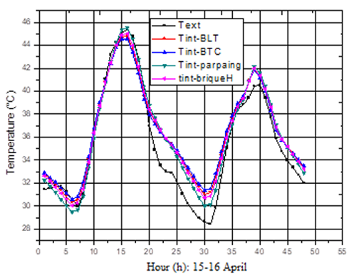

**Figure 1. Evolution of temperature in buildings under metal roofing without false ceiling**

The indoor temperature fluctuations of the four buildings follow those of the outdoor temperatures. It is observed that concrete blocks result in indoor temperatures higher than outdoor temperatures, even during overheating periods. In contrast, BLT, CEB, and H-bricks mitigate heat by 0.64°C, 0.86°C, and 0.4°C, respectively (Coulibaly, O., 2011). Overall, these buildings exhibit very high temperatures both day and night, making them uncomfortable for occupants. This could be explained by the presence of the metal roof, which conducts heat easily due to its high thermal conductivity (Habib, N. D. M. E., 1997). In the subsequent parts of the study, CEB was selected due to its superior thermal performance compared to the other three materials and its widespread availability across the country (Houben, H., & Guillaud, H., 1989).

**3.2 Influence of the variation in air gap thickness between the metal roof and false ceiling**

Figure 2 shows the evolution of indoor temperatures in a CEB building as a function of the air gap thickness between the metal roof and the false ceiling (wall thickness: 20 cm).

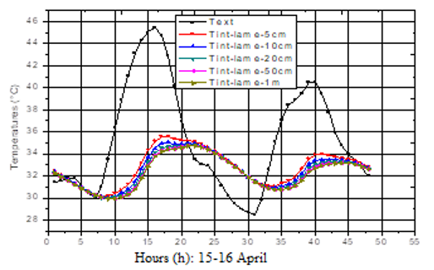

**Figure 2. Evolution of indoor temperatures in a CEB building as a function of the air gap thickness between the metal roof and false ceiling (wall thickness: 20 cm)**

Insulating the metal roof with a false ceiling cools the building’s interior (Robelison and Lips, 2008). Compared to Figure 1, Figure 2 highlights the importance of the false ceiling in reducing indoor temperatures. Its presence dampens indoor temperatures, attributed to the absence of conduction between the metal roof and the false ceiling due to the air gap, as well as the insulating properties of the ceiling itself.

The damping values as a function of air gap thickness are provided in Table 2.

**Table 2. Damping values as a function of air gap thickness**

|  |  |  |  |  |  |  |  |  |  |  |  |  |  |  |  |  |  |
| --- | --- | --- | --- | --- | --- | --- | --- | --- | --- | --- | --- | --- | --- | --- | --- | --- | --- |
| |  |  |  |  |  |  | | --- | --- | --- | --- | --- | --- | | Air Gap Thickness | 5cm | 10cm | 20 cm | 50 cm | 1 m | | Damping $∆T$ (°C) | 10.2 | 10.9 | 11.3 | 11.6 | 11.7 | |  |  |  |  |  |

∆T is the difference between the maximum outdoor temperature and the maximum indoor temperature.

The variation in air gap thickness has a minimal impact on indoor temperature variation. Nevertheless, slight changes in indoor temperatures are observed depending on the air gap thickness.

**3.3 Influence of the variation in CEB wall thickness**

The figure 3 shows the evolution of indoor temperatures in a CEB building under a metal roof with a false ceiling as a function of varying wall thickness.

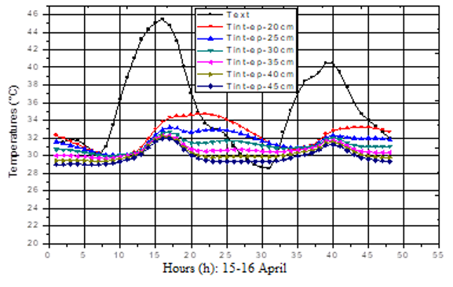

**Figure 3. Evolution of indoor temperatures in a CEB building under metal roofing with a false ceiling as a function of varying wall thickness**

The damping values as a function of wall thickness are provided in Table 3.

**Table 3. Damping values as a function of wall thickness**

|  |  |  |  |  |  |  |
| --- | --- | --- | --- | --- | --- | --- |
| Wall Thickness | 20 cm | 25 cm | 30 cm | 35 cm | 40 cm | 45 cm |
| Damping ∆𝑻 (°C) | 10.7 | 12.2 | 12.8 | 13 | 13.4 | 13.5 |

Wall thickness contributes to the climatic comfort of buildings (Mokhtari, A. et al, 2008). Increasing wall thickness leads to a decrease in indoor temperatures. Thicker walls better mitigate extreme heat, but beyond 40 cm, the variation is minimal (Houben, H., & Guillaud, H. 1989), Paulus, J., 2015). This value is close to 44 cm (Paulus, J., 2015).

**3.4 Influence of the variation in concrete roof thickness without false ceiling**

The figure 4 shows the evolution of indoor temperatures in a CEB building as a function of varying concrete roof thickness without a false ceiling.

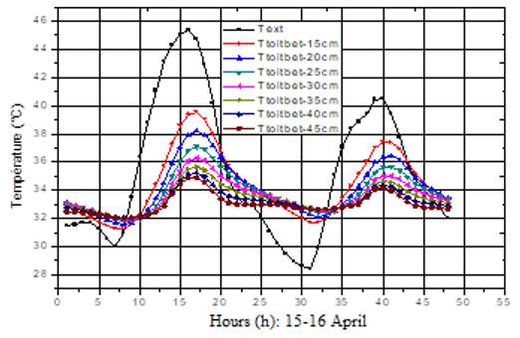

**Figure 4. Evolution of indoor temperatures in a CEB building as a function of varying concrete roof thickness without false ceiling**

**Table 4.Damping values as a function of concrete roof thickness**

|  |  |  |  |  |  |  |  |
| --- | --- | --- | --- | --- | --- | --- | --- |
| Roof Thickness | 15 cm | 20 cm | 25 cm | 30 cm | 35 cm | 40 cm | 45 cm |
| Damping ∆T (°C) | 6 | 7.2 | 8.4 | 9 | 9.8 | 10.2 | 10.5 |

The curves in Figure 4 show that thicker concrete roofs dampen outdoor temperature fluctuations more effectively than thinner ones. A 45 cm thick roof dampens indoor temperatures more than a 15 cm thick roof, although these temperatures remain far from those required for optimal thermal comfort (Tchouateu, R., 2013). A 40 cm thick roof is preferable, as beyond this thickness, the variation in indoor temperatures is minimal.

**3.5 Influence of the variation in concrete roof thickness with false ceiling**

The figure 5 shows evolution of Indoor Temperatures in the Building as a Function of Varying Concrete Roof Thickness with False Ceiling (Wall Thickness: 40 cm)

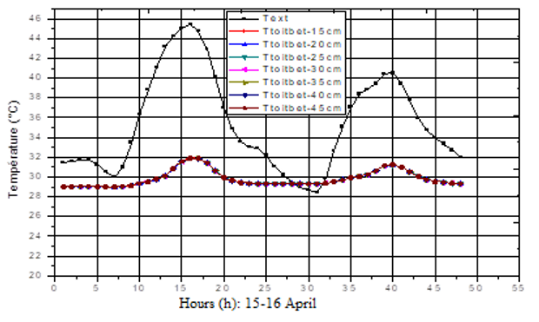

**Figure 5. Evolution of indoor temperatures in the building as a function of varying concrete roof thickness with false ceiling (wall thickness: 40 cm)**

The variation in concrete roof thickness with a false ceiling does not significantly affect indoor temperature variations, due to the presence of the false ceiling. However, a concrete roof with a false ceiling smooths indoor temperatures (∆T = 13.5°C). From this perspective, a thinner concrete roof (with a false ceiling) is preferable to a thicker one (with a false ceiling), as both produce the same effect. A thinner roof is thus recommended (Robelison, S., & Lips, B. 2008, Tchouateu, R., 2013).

**3.6 Influence of the variation in CEB roof thickness without false ceiling**

The figure 6 shows evolution of Indoor Temperatures in a CEB Building as a Function of Varying CEB Roof Thickness Without False Ceiling (Wall Thickness: 40 cm).

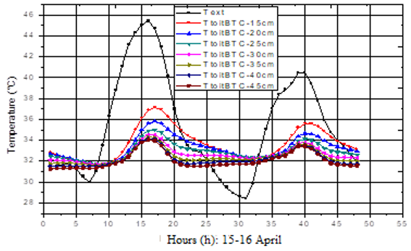

**Figure 6. Evolution of indoor temperatures in a ceb building as a function of varying CEB roof thickness without false ceiling (wall thickness: 40 cm)**

**Table 5** shows the damping values based on the thickness of the CEB roof.

**Table 5. Damping Values as a Function of CEB Roof Thickness**

|  |  |  |  |  |  |  |  |
| --- | --- | --- | --- | --- | --- | --- | --- |
| Roof Thickness | 15 cm | 20 cm | 25 cm | 30 cm | 35 cm | 40 cm | 45 cm |
| Damping ∆𝑻 (°C) | 8,4 | 9,6 | 10,4 | 10,9 | 11 | 11,2 | 11,4 |

A CEB roof significantly reduces outdoor temperature variations. The variation in CEB roof thickness has a considerable impact on the building’s thermal behaviour. A 30 cm thick roof is preferable, as beyond this thickness, the reduction in temperatures is no longer significant, confirming results from (Paulus, J., 2015, Hamdani, M., 2016). Additionally, it offers a 2.5°C reduction compared to a 15 cm thick roof.

**3.7 Influence of the variation in CEB roof thickness with false ceiling**

Figure 7 shows the thermal behavior of the CEB building based on the variation in CEB roof thickness with a false ceiling (wall thickness: 40 cm).

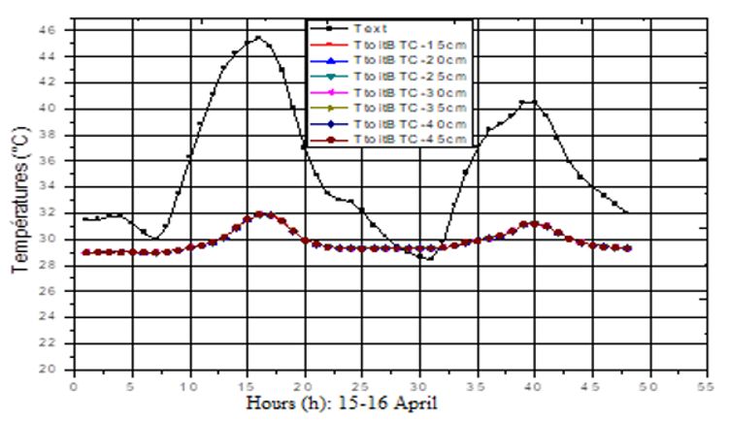

**Figure 7. Thermal behaviour of a CEB building as a function of varying CEB roof thickness with false ceiling (wall thickness: 40 cm)**

The variation in CEB roof thickness with a false ceiling does not significantly influence indoor temperatures, similar to the case of a concrete roof with a false ceiling. This is explained by the insulating effect of the false ceiling. When using a CEB roof with a false ceiling, a thinner roof is preferable to avoid additional costs, as it provides the same results as a thicker roof with a false ceiling (Robelison, S., & Lips, B., 2008).

**3.8 Wall insulation**

The study now focuses on a CEB building under a 15 cm thick CEB roof with a false ceiling. First, the influence of internal and external wall insulation on the building’s thermal behaviour is examined. Then, wall thickness is varied to assess its impact in the presence of insulation. The insulation used is 2 cm thick polystyrene. Finally, the effect of varying insulation thickness on indoor temperature evolution is analyzed.

**3.8.1 Influence of CEB wall insulation on indoor temperature evolution**

Figure 8 shows influence of Internal and External Wall Insulation on Indoor Temperature Evolution (Wall Thickness: 40 cm).

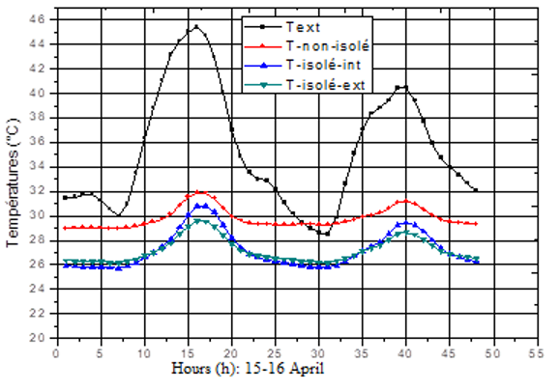

**Figure 8. Influence of internal and external wall Insulation on indoor temperature evolution (Wall thickness: 40 cm)**

Figure 8 reveals that insulated walls reduce heat exchange between the building’s interior and the external environment, with external insulation being more effective than internal insulation. Internal insulation achieves a damping of 14.6°C, while external insulation provides 15.8°C. This is explained by external insulation eliminating thermal bridges, which act as pathways for heat entry during hot periods.

**3.8.2 Influence of varying wall thickness with external insulation on indoor temperature evolution**

Figure 9 shows influence of varying wall thickness with external insulation on indoor temperature evolution.

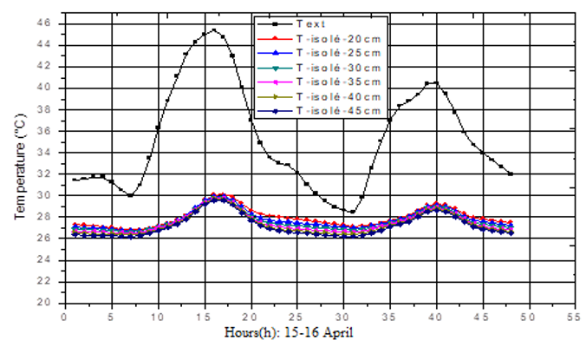

**Figure 9. Influence of varying wall thickness with external insulation on indoor temperature evolution**

With external insulation, varying wall thickness has minimal impact on indoor temperature evolution. This is due to the low thermal capacity of the insulation, which absorbs little heat. For external insulation, thinner walls are preferable to avoid additional costs.

**3.8.3 Influence of varying insulation thickness on indoor temperature evolution**

Figure 10 shows influence of varying insulation thickness on indoor temperature evolution (Wall thickness: 20 cm)

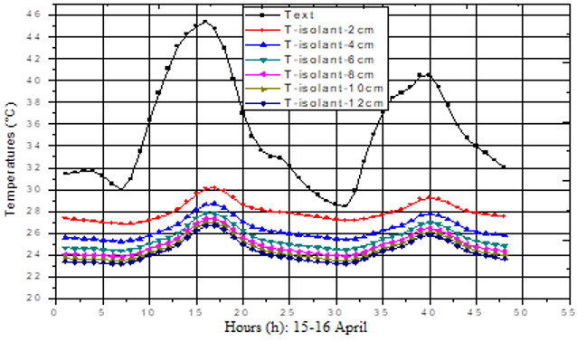

**Figure 10. Influence of varying insulation thickness on indoor temperature evolution (Wall thickness: 20 cm)**

**Table 6. Damping values as a function of insulation thickness**

|  |  |  |  |  |  |  |
| --- | --- | --- | --- | --- | --- | --- |
| Insulation Thickness | 2 cm | 4 cm | 6 cm | 8 cm | 10 cm | 12 cm |
| Damping $∆T$ (°C) | 15.4 | 16.7 | 17.6 | 18 | 18.5 | 18.7 |

The effect of an insulating material increases with its thickness (Mokhtari, A. et al, 2008). Varying insulation thickness impacts indoor temperatures; greater thickness leads to a more significant reduction in heat flux. Insulation thicknesses between 2 and 8 cm substantially lower indoor temperatures, but beyond 8 cm, the reduction is moderate. From 6 cm of polystyrene, energy consumption decreases moderately and approaches a limit. A 10 cm thick insulation achieves a maximum indoor temperature of approximately 27°C (Mokhtari, A. et al, 2008, UN-Habitat., 2020.

**Conclusion**

This study demonstrates the potential of local materials, particularly CEB, to improve thermal comfort in buildings in Ouagadougou. EnergyPlus simulations show that 20 cm CEB walls, externally insulated with 10 cm of polystyrene, under a 15 cm CEB roof with a false ceiling, achieve indoor temperatures close to 27°C, reducing reliance on air conditioning (Bontemps, S. P., 2015, Mokhtari, A. et al, 2008, UN-Habitat., 2020). While thicker walls and roofs enhance thermal inertia, external insulation is critical for eliminating thermal bridges and ensuring optimal comfort. These findings highlight the importance of bioclimatic design tailored to Burkina Faso’s hot climate, promoting cost-effective and environmentally friendly solutions (Hamdani, M., 2016). Further experimental measurements are needed to validate the simulations, and incorporating parameters like humidity and ventilation could refine thermal performance (UN-Habitat., 2020, Tapsoba, L., 2023). Promoting local materials through pilot projects and training is essential for their widespread adoption (Coulibaly, O., 2011).

**DISCLAIMER (ARTIFICIAL INTELLIGENCE)**

Author(s) hereby declares that NO generative AI technologies such as Large Language Models (ChatGPT, COPILOT, etc) and text-to-image generators have been used during writing or editing of this manuscript.

**COMPETING INTERESTS**

Authors have declared that no competing interests exist

COMPETING INTERESTS DISCLAIMER:

Authors have declared that they have no known competing financial interests OR non-financial interests OR personal relationships that could have appeared to influence the work reported in this paper.

**References**

Bontemps, S. P. (2015). Experimental

validation of models: Application to

low-energy buildings. University of

Bordeaux.

Coulibaly, O. (2011). Contribution to the

development of thermal and energy

regulations for buildings in Burkina

Faso: Multiparametric baseline data

and thermo-aeraulic modeling using

CoDyBa and TRNSYS. Doctoral

dissertation, University of

Ouagadougou.

Habib, N. D. M. E. (1997). Thermal comfort in

buildings. John Wiley & Sons, New

York.

Hamdani, M. (2016). Selection of orientation

and construction materials to improve

the thermal performance of buildings.

Aboubeker Belkaid University of

Tlemcen.

Houben, H., & Guillaud, H. (1989). Earth

construction treatise. Editions

Parenthèses.

Jannot, Y. (2009). Thermal Conduction and

Characterization of Insulating Materials.

Lavoisier Publishing, Paris.

Lawane Gana, A. (2014). Characterization of

hardened lateritic materials for improved use in housing in Africa. Le Havre.

Mokhtari, A., Brahimi, K., & Benziada, R.

(2008). Architecture and thermal

comfort in arid zones: Application to

the city of Béchar. Renewable Energy

Review, 11, 307-315.

Paulus, J. (2015). Raw earth construction:

Qualitative, constructive, and

architectural descriptions - application

to a practical case: Ouagadougou.

Robelison, S., & Lips, B. (2008). Thermal

influence of thatch roof placement

under metal roofing in housing in

Antananarivo-Madagascar. Afrique

Science: International Journal of

Science and Technology, 4.

Tapsoba, L. (2023). Experimental Validation of

Thermal Simulations in Hot Climates.

Proceedings of the International

Conference on Energy Technologies in

Hot Climates, Ouagadougou, Burkina

Faso, November 15-17, 2023.

Ouagadougou: Joseph KI-ZERBO

University, pp. 123-130.

Tchouateu, R. (2013). Study and development

of a high-energy-efficiency Sahelian

eco-habitat.

UN-Habitat. (2020). Sustainable Building in

Africa: Guide to Local Materials.

Technical Report, Nairobi.