***Original Research Article***

**Valorization of black plum seed (*Vitex doniana*) from Côte d'Ivoire as a coffee substitute : Evaluation of phenolic, antioxidant and organoleptic properties**

**ABSTRACT**

The objective of this study was to to investigate the phenolic composition, antioxidant activity and organoleptic characteristics of black plum seeds (*Vitex doniana*) as a coffee substitute. Black plums were harvested in the locality of Yamoussoukro (Ivory Coast), pulped and dried to obtain the seeds. The phenolic characteristics, antioxidant activity and organoleptic properties of fermented (FBPSP) and unfermented (BPSP) coffee substitute black plum seed powders were determined. The results indicate that black plum seed-based coffee substitutes (FBPSP and BPSP) have a high antioxidant capacity. They are an important source of phenolic compounds, particularly total polyphenols (FBPSP: 897.42 ± 13.19 mg GAE/100g of dry weight (DW) and BPSP: 297.90 ± 10.85 mg GAE/100g of DW) and flavonoids (FBPSP: 209.18 ± 13.08 mg QE/100g of DW and BPSP: 87.14 ± 5.17 mg QE/100g of DW). The results of the organoleptic analysis showed that BPSP coffee substitute was the most appreciated by tasters, with an average score of 5.54 ± 1.44. However, the consumption of both FBPSP and BPSP coffee substitutes BPSPF and BPSP is recommended, as they have nutritional characteristics that are beneficial to health.

**Keywords**: Black plum; *Vitex doniana*; coffee substitute; fermentation; phenolic compounds; antioxidant activity; organoleptic properties

# **1. Introduction**

Coffee is one of the most widely consumed beverages in the world due to its sensory (taste, aroma), energizing, stimulating and antioxidant properties that are beneficial to health (Fernandez-Gomez *and* *al*., 2016; Mostafa *and al*., 2021; O’Keefe *and al*., 2018). However, it causes anxiety, insomnia and digestive disorders in some subjects (Barrea *and al*., 2023; Bodar *and al*., 2020; Drake *and al*., 2013; O’Callaghan *and al*., 2018)due to the caffeine it contains, at high levels (over 400 mg per day), caffeine causes allergies, increases the risk of heart disease and raises blood pressure. These symptoms appear in caffeine-sensitive subjects (Fan *and al*., 2023; Machado *and al*., 2021; Malvina, 2020). The presence of caffeine in coffee therefore poses a public health problem for these subjects.

Ideally, then, caffeine should be extracted from coffee beans via several industrial processes ranging from: (i) extraction with an organic solvent to (ii) extraction with a supercritical fluid (carbon dioxide) to finish with (iii) extraction with water (Bermejo *and al*., 2016; İçen and Gürü, 2010; Kim *and al*., 2007; Shalmashi *and al*., 2008).

The first method, which has been used for years, is tending to be replaced by the latter for reasons of health (residual traces of solvents), environmental impact, cost and taste. The latter is the least effective and can distort the taste (Jacquier, 2024).

Today, the alternative is to use plant-based coffee substitutes, devoid of caffeine but rich in health-promoting compounds such as polyphenols, to replace coffee.

One such plant is the savannah plum (*Vitex doniana*), a natural plant species with multiple uses (food, therapeutic, cultural), highly prized in certain tropical regions for its fruits (pulp and seeds), which contain high levels of phenolic compounds (Traore *and al*., 2021). They are therefore sources of natural antioxidants capable of combating the free radicals constantly generated by the body (Sailaja Rao *and* *al*., 2011; Sundaram Sanjay and Shukla, 2021).

In Sudan, the seeds of the savannah plum tree, edible after roasting, are traditionally used to replace coffee (Salih and Yahia, 2015). In Côte d'Ivoire, on the other hand, these seeds are discarded in nature after consumption of the fruit pulp, and are considered waste. Yet they are an excellent source of bioactive compounds (Anien *and al*., 2023). The valorization of Côte d'Ivoire black plum seeds into coffee substitutes will therefore constitute an added value.

The general objective of this study is therefore to investigate the phenolic composition, antioxidant activity and organoleptic characteristics of black plum (*Vitex doniana*) seed as a coffee substitute.

# **2. MATERIAL AND METHODS**

## **2.1. Materiel**

The plant material used in this study is black plum seed (BPS) from the ripe fruit of the savannah plum tree (*Vitex doniana*). The black plums were randomly harvested in the locality of Yamoussoukro (GPS: 6°49'13.98" N -5°16'36.26" W ) between the savannah and forest zones, in central Côte d'Ivoire, on the basis of the morphological characteristics described by Traoré (2021) as follows: a tree with a rounded crown reaching up to 10 metres in height whose large leaves have 5 obovate elliptical leaflets with fruits with a flattened peduncle.

A MF 10 Basic grinder (Ika-0002836001, USA) was used to grind the black plum seeds (BPS) into powder (BPSP). BPSP was roasted in a roaster (Dbtxwdt 45-483-823, China) at adjustable temperatures ranging from 0 to 240°C.

A filter coffee maker (Black & Decker CM1010B, USA) was used to prepare the coffee substitute.

## **2.2. Methods**

### **2.2.1. Black plum seeds production methods**

Ripe black plums (BP) harvested and stored in cold storage at -4°C, were taken out and left at room temperature (23°C) on the bench for 30 min. These fruits were then diluted in city water (at room temperature, 5kg of fruit for 10L of water) before being pulped (totally or partially) by hand. This resulted in mucilage-free black plum seeds (BPS), which were dried directly on racks at an average temperature of 27°C. In addition, seeds with little mucilage (gelatinous layer covering the BPS) were fermented (FBPS) with banana leaves over 3 days. A further 3 days of drying stabilized the moisture content of both types of seed (fermented and unfermented) at an average of 6.5%.

### **2.2.2. Seed grinding and powder roasting**

After drying, fermented and unfermented black plum seeds were ground and sieved (sieve mesh 0.50 mm) to obtain fermented (FBPSP) and unfermented (BPSP) black plum seed powder.

The resulting powders (250 g of each product) were roasted to bring out the aromas of the black plum seed coffee substitute.

Following manufacturing diagram summarizes the various production processes (Fig. 1).

Pulping

Fermentation

Drying

Drying

Grinding

Grinding

Roasting

Roasting

**Fig. 1. Manufacturing process of BP seed powders**

### **2.2.3. Analysis of phytochemical compounds**

#### **2.2.3.1. Determination of total polyphenol content**

Total polyphenol contents of the roasted samples were obtained using the Folin-Ciocalteu reagent method (Elzaawely *and al*., 2007). For this purpose, a centrifugal extraction from methanol (8/2) was first performed by solubilizing 1 g of the products (FBPSP and BPSP) in 10 mL of 70% solvent. The mixture was then centrifuged at 6000 rpm. The supernatant collected was introduced into a test tube containing 1 mL of 10% Folin-Ciocalteu reagent, 1 mL of 20% sodium carbonate (Na2CO3), and 10 mL of distilled water. After 30 minutes in the dark incubation, the optical density was read at 745 nm against a blank control. A range of standards was established from a stock solution of gallic acid (0.1 mg/mL) under the same conditions as the assay. The concentrations of polyphenols contained in extracts of black plum seeds, expressed in mg/100g of mg gallic acid equivalents (GAE)/100g of dry weight (DW), were determined using the gallic acid standard curve.

#### **2.2.3.2. Determination of total flavonoid content**

Total flavonoids were measured using the method described by Žilić *and al*. (2013). A volume of 0.5 mL of extract was introduced into a test tube containing 0.5 mL of distilled water, 0.5 mL of 10% aluminum chloride, 0.5 mL of 5% sodium acetate, and finally 2 mL of distilled water. The resulting mixture was kept in the dark for 30 minutes at room temperature. Then, Absorbance was then measured at 415 nm against a blank. Flavonoid concentrations were determined by reference to a calibration curve performed with quercetin (0.1 mg/mL). Flavonoid concentration was expressed as milligram quercetin equivalent per 100g of dry weight (mg QE/100g of DW).

#### **2.2.3.3. Determination of tannins content**

Tannins were determined using the method described by Avallone *and al*. (1997). A volume of 1 mL of extract was introduced into a test tube, to which 5 mL of 1% vanillin prepared in 70% sulfuric acid was added. The absorbance of the solution was measured at 500 nm after 30 minutes in the dark against a blank. Tannin content was determined by means of a standard range using a catechol stock solution (0.1 mg/mL) prepared under the same conditions as the tests.

#### **2.2.3.4. Determination of antioxidant activity**

The phenolic composition and antioxidant activity (DPPH and FRAP tests) of a robusta reference coffee (Africafé, Centre National de Recherche Agronomique (CNRA)) were determined using the same analytical methods. The nutritional characteristics of this reference coffee were compared with those of coffee substitutes made from black plum seeds.

The DPPH radical scavenging activity of extracts from torrefied samples was determined according to the method of Farhadi *and al*. (2016). A volume of 50 µL of the different concentrations of the product extracts (BPSP and FBPSP) (6.25 mg/mL, 12.5 mg/mL, 25 mg/mL, 50 mg/mL and 100 mg/mL) was added to 1950 µL of a DPPH solution prepared in methanol at a concentration of 0.06 mg/mL. The negative control was prepared in parallel by mixing 50 µL of 70% methanol with 1950 µL of a methanolic DPPH solution at the same concentration used. Thus, after incubation in the dark for 30 minutes at room temperature, the degree of reduction in absorbance was recorded using a spectrophotometer (UV-6300PC, France) at 517 nm.

Reducing power was determined according to the method of Amarowicz and Shahidi (2017). A series of concentrations (0.016 mg/mL, 0.031 mg/mL, 0.063 mg/mL and 0.125 mg/mL) of the extracts was prepared. A volume of 1.25 mL of each cocentration was mixed with 1.25 mL of a 0.2 M phosphate buffer solution (pH = 6.6) and 1.25 mL of a 1% (w/v) potassium ferricyanide K3[Fe(CN)6] solution. The tubes were then incubated at 50°C for 20 minutes, to which 1.25 mL of 10% trichloroacetic acid (TCA) (w/v) was added following cooling. A volume of 1.25 mL of the resulting mixture was introduced into a test tube containing 1.25 mL of distilled water and 0.25 mL of 1% (w/v) ferric chloride solution (FeCl3). The absorbance of each solution was measured at 700 nm against a blank in a spectrophotometer (ONDA V-10 plus, France).

### **2.2.4. Organoleptic analysis of coffee substitutes made from black plum seeds**

#### **2.2.4.1. Preparation of coffee substitutes**

Coffee substitutes made from black plum seeds were prepared using the method described and modified by Houessou (2007). 100g of coffee substitute powder were introduced into the filter of a coffee maker containing 600 mL of distilled water. The hot beverages made from the coffee substitute were obtained and packaged in two different thermoses, coded 52 (thermos containing the coffee substitute BPSP) and 27 (thermos containing the coffee substitute FBPSP). The reference robusta coffee (RRob-Cof) used as a control, was prepared under the same conditions as coffee substitutes and packaged in a coded thermos 78.

#### **2.2.4.2. Sensory evaluation**

The tasters' level of satisfaction was assessed using a hedonic test. A panel of 78 untrained students from Institut National Polytechnique Félix-Houphouët Boigny (INP-HB) was tasked with providing their opinions on various products (coffee substitutes made from black plum seeds and reference coffee). This panel of tasters, consisting of 32 women and 46 men, aged between 18 and 25 years and between 26 and 35 years, was convened. For the tasting tests, the panelists, in groups of 4 people each (in the FAB LAB room of INP-HB) were each given a rating sheet with the following characteristics:

* a hedonic evaluation (color, aroma, taste, flavor) on a seven-point satisfaction scale
* and the free comments from the tasters to determine the overall degree of appreciation for the products.

Before the tests began, tasters were given a brief explanation of the test to be carried out, and then asked to rinse their mouths after each tasting.

### **2.2.5. Data analysis**

The tests related to the various analyses were conducted in triplicate, and the quantitative and qualitative data obtained were expressed as the mean plus or minus the standard deviation.

An analysis of variance (one-way ANOVA) for comparison of means was carried out on the results of the parameters studied for the coffee substitutes produced, in order to determine significant differences. These significant differences were highlighted using Tukey's test with a confidence level of 95%. This statistical analysis was carried out using GraphPad Prism 8.0.2 (Microsoft, USA).

For the sensory test results, Excel (Microsoft, USA) was used.

# **3.** **RESULTS AND DISCUSSION**

**3.1.****Comparison of phenolic compound contents of coffee substitutes (FBPSP and BPSP) and a reference robusta coffee**

The phenolic compound contents of FBPSP fermented coffee substitutes, BPSP unfermented coffee substitutes and robusta reference coffee (CRef_Rob) are shown in table 1.

| **Constituents** | **Samples** | | | |
| --- | --- | --- | --- | --- |
| **Fermented coffee substitute (FBPSP)** | **Unfermented coffee substitute (BPSP)** | | **Reference robusta coffee**  **(RRob_Cof)** |
| **Total phenolic**  **(****mg GAE/100 g DW)** | 897.42 ± 13.19b | 297.90 ± 10.85c | 944.5 ± 14.01a | |
| **Flavonoids**  **(mg QE/100 g DW)** | 209.18 ± 13.08b | 87.14 ± 5.17c | 383.76 ± 11.54a | |
| **Tannins**  **(mg CE/100 g DW)** | 5.61 ± 0.05b | 10.22 ± 0.12a | 10.27 ± 0.02a | |

**Table 1. Phenolic composition of coffee substitutes made from black plum seeds and reference coffee (industrial robusta)**

*Results are expressed as the mean ± standard deviation of three separate extractions and determinations. Data were compared using ANOVA (α=0.05). Different letters indicate significantly different values, otherwise values are significantly identical.*

Total phenolic values of the fermented coffee substitute FBPSP (897.42 ± 13.19 mg GAE/100g of dry weight (DW)) are comparable to the reference robusta coffee (944.50 ± 14.01 mg GAE/100g of DW) but higher than those of chicory (650 mg of GAE/100g of DW) (Heimler *and al*., 2009). The proximity of the phenolic compounds in the fermented coffee substitute FBPSP to that of the reference coffee is thought to be due to the fermentation of the two types of seed (coffee and black plum). Indeed, according to studies by Qin *and al*. (2024), fermentation of cascara seed showed an increase in polyphenol content and DPPH scavenging activity compared with unfermented cascara, whatever the microorganism used (W. *anomalus* YN5 and K. *humilis* YN9). The results are consistent with those of Adetuyi and Ibrahim (2014), who indicate that the action of proteolytic enzymes on polyphenols is responsible for their high levels. Indeed, during fermentation, proteolytic enzymes hydrolyze complex phenolic compounds into simple forms or insoluble phenols.

Unfermented coffee substitute BPSP contains a significant level of total phenolic of 297.90 ± 10.85 mg GAE/100g of dry weight (DW). For Pintać *and al*. (2022) reported in a study of polyphenols in instant coffee brands that these contained between 187 and 306 mg GAE/100g of DW.

Furthermore, a comparison of the flavonoid content of coffee substitutes made from black plum seeds with the literature shows that they are higher than that of coffee substitutes made from date seeds (24 ± 0.04 mg QE/100g of DW) (Ahmed *and al*., 2024). Dates are considered to be a good source of flavonoid antioxidants. On the other hand, other fruits used as coffee substitutes have lower flavonoid contents. These include blackberries (*Rubus coesins*) and black grapes (*Vitis* *vinifera*), with flavonoid contents of 55.5 and 77.1 mg QE/100g of DW, respectively (Marinova *and al*., 2005). The high levels of total flavonoids determined mean that coffee substitutes made from black plum seeds can be considered an excellent natural source of bioactive compounds.

The high total phenolic contents of plum seed-based coffee substitutes are due to the roasting temperature, which modifies the structure of certain molecules, including proteins associated with phenolic compounds that lead to an increase in phenolic compound content (Lemos *and al*., 2012). In addition to roasting, fermentation also increased the total polyphenol content of the PGPNF substitute.

Regarding tannins, table 1 shows that no significant difference was observed between the BPSP coffee substitute (10.22 ± 0.12 mg Catechol/100g of dry weight (DW) and the reference coffee (10.27 ± 0.02 mg Catechol/100g of DW). However, these values were significantly different from those of the PGPNF coffee substitute (5.61 ± 0.05 mg Catechol/100g of DW). This could be explained by the long fermentation time of 7 days for the PGPNF coffee substitute, compared with 3 days for the reference coffee. Indeed, according to Souare (2022), the production of enzymes, notably tannases, by microorganisms at longer fermentation times reduces tannin content. On the other hand, Kumar and Shiddamallayya (2021) reported that Buchanania lanzan fruits, which contained 14% tannins, were non-toxic to humans.

This difference could be due to the nature of the material, the duration of fermentation and physiological differences between the ferments (Chavan *and al*., 1989).

**3.2.** **Comparison of antioxidant activities of coffee substitutes (FBPSP and BPSP) and reference robusta coffee**

The DPPH radical-scavenging activity and reducing power of extracts from the referents (Industrial coffee and BHT) were compared with those of the black plum seed-based coffee substitutes (FBPSP and BPSP) formulated in this study (Fig. 2A and 2B). Fig. 2A shows that at all concentrations, extracts of these FBPSP and BPSP coffee substitutes have DPPH radical scavenging capacity. It also shows that Robusta coffee extracts have a higher antioxidant capacity than those of the coffee substitutes (FBPSP and BPSP). However, the antioxidant activity of PGPNF coffee substitute extracts is similar to that of industrial coffee and BHT at 25 and 54 mg/mL total polyphenols. Indeed, at a polyphenol concentration of 25 mg/mL and above, this extract inhibits around 81% of DPPH radicals, whereas industrial and robusta coffee trap over 81%.

Fig. 2B shows that at all concentrations, coffee substitute extracts (FBPSP and BPSP) are able to reduce ferric iron from the Fe3+ ferricyanide complex to ferrous iron.



**2A**

**2B**

**Fig. 2. Evolution of antioxidant power (DPPH (A), FRAP(B)) as a function of concentration of coffee substitutes made from black plum seeds, robusta coffee and BHT**

Figures 2A and 2B show that FBPSP coffee substitute has a high antioxidant capacity for both DPPH radical inhibition and iron reduction, as IC50 values are lower (8.06 ± 0.19 mg/mL for the DPPH test and 2.70 ± 0.22 mg/mL for the FRAP test (**Table 2**) compared with reference coffee and BHT. Moreover, these values are significantly different (P < 0.05) from the values obtained in the BPSP coffee substitute (DPPH test: 36.50 ± 1.05 mg/mL, FRAP test 6.85 ± 0.35 mg/mL) (**Table 2**).

**Table 2. Antioxidant activity values of the samples, expressed as IC50**

|  |  |  |
| --- | --- | --- |
| **Samples** | **IC50 (mg/ml)** | |
| DPPH | FRAP |
| **BHT** | 1.46 ± 0.05d | 0.15 ± 0.02d |
| **Reference robusta coffee (RRob_Cof)** | 3.81 ± 0.16c | 1.39 ± 0.10c |
| **Fermented coffee substitute (FBPSP)** | 8.06 ± 0.19b | 2.70 ± 0.22b |
| **Unfermented coffee substitute (BPSP)** | 36.50 ± 1.05a | 6.85 ± 0.35a |

FBPSP coffee substitute has the lowest IC50 value (8.06 ± 0.35 mg/mL), reflecting its higher antioxidant activity. Fermentation could be at the root of this high antioxidant activity. Adetuyi and Ibrahim (2014) have shown that fermentation increases the ability of drupe and citrus seeds to scavenge DPPH radicals. The high capacity of coffee substitutes based on black plum seeds to scavenge free radicals could be attributed to their high phenolic compound contents.

The IC50 values for coffee substitutes made from black plum seeds are higher than for Ivorian industrial coffee (1.81± 0.06 mg/mL) and BHT (0.88 ± 0, 04 mg/mL) but lower than chicory (22.7 ± 2.1 mg/mL), Indonesian robusta coffee (15 mg/mL) (Asy’ari and Rini, 2021) and organ coffee substitute (11.3 ± 3.3 mg/mL) (Torma *and al*., 2019). Consequently, the coffee substitutes formulated in this study have high antioxidant capacity.

**3.3. Comparison of organoleptic characteristics**

The averages of all sensory attributes of coffee substitutes (FBPSP and BPSP) and the reference coffee (RRob_Cof), are illustrated by **fig. 3A**, **3B** and **3C**.

**Fig. 3A** compares the organoleptic characteristics between the coffee substitute of coffee substitute from fermented black plum seeds (FBPSP) with those of robusta reference coffee (RRob_Cof). **Fig. 3B** compares the organoleptic characteristics of coffee substitute from unfermented black plum seeds (BPSP) with those of the RRob_Cof. Finally, **Fig. 3C** compares the organoleptic characteristics of the fermented coffee substitute FBPSP and unfermented BPSP.

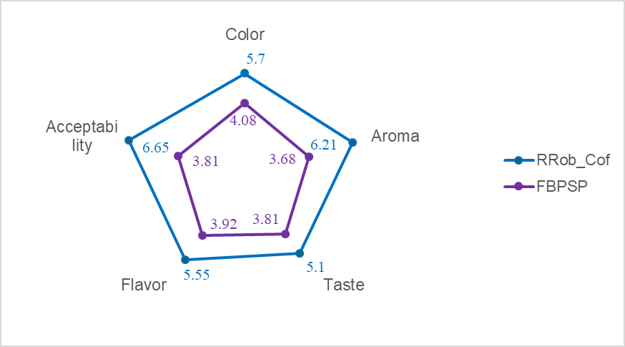

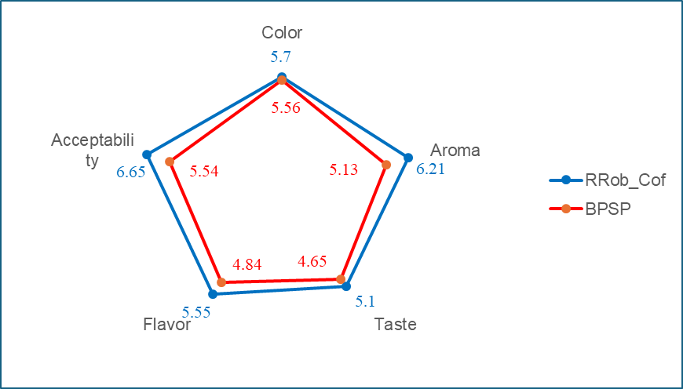**Fig. 3A. Sensory evaluation score of the FBPSP coffee substitute and the reference coffee**

**Fig. 3B. Sensory evaluation score of the BPSP coffee substitute and the reference coffee**

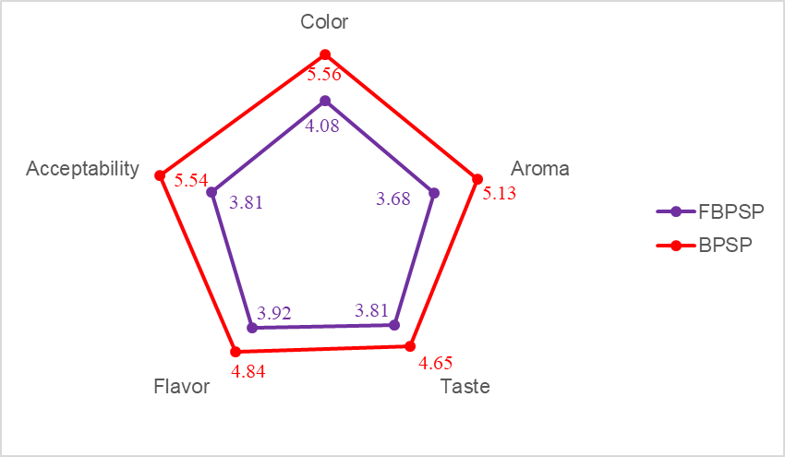

**Figure 3C. Sensory evaluation score of coffee substitutes FBPSP and BPSP**

The sensory attributes of the reference coffee achieved the highest scores compared to the substitutes made from black plum seeds.

Concerning color, the reference coffee achieved the highest average score of 5.70 ± 2.38, followed by the non-fermented coffee substitute BPSP (5.56 ± 1.15), and then the fermented coffee substitute FBPSP (4.08 ± 2.04).

As for the aroma of the reference coffee, it was the most favored product by the tasters with an average score of 6.21 ± 1.61. Moreover, these tasters also appreciated the aroma of the non-fermented coffee substitute BPSP (5.13 ± 1.66) in comparison to that of the fermented coffee substitute FBPSP (3.68 ± 2.03).

In terms of taste and flavor, they were rated higher by the tasters in the reference coffee with respective averages of 5.10 ± 3.08 for taste and 5.55 ± 1.57 for flavor. In contrast, these tasters favored the sensory attributes of taste and flavor in the non-fermented coffee substitute BPSP (4.65 ± 2.33: taste and 4.84 ± 1.62: flavor) more than in the fermented coffee substitute FBPSP (taste: 3.81 ± 2.61 and flavor: 3.92 ± 1.98).

Tasters' appreciation of the aroma, taste and flavour of PGPN coffee substitute is said to be due to its high chlorogenic acid content, which contributes to coffee's astringency, bitterness and acidity (Haler, 2013).

Furthermore, it is generally noted that the average score of the attributes of the coffee substitute FBPSP exceeds the anticipated average (3.50). This substitute is therefore acceptable and can be popularized from a sensory perspective.

# **4. CONCLUSION**

Coffee substitutes made from plum seeds (BPSP and FBPSP) produced are a good source of phenolic compounds, thus natural antioxidants capable of combating free radicals. They also have low levels of tannins (anti-nutritional compounds), indicating that they are safe for human consumption.

The results indicate a significant difference between the two coffee substitutes produced. The coffee substitute (FBPSP), made from fermented black plum seeds, has a much higher nutritional value than the coffee substitute (BPSP) made from unfermented black plums. However, its organoleptic characteristics, although above average (on a scale of 1 to 7 points), were less appreciated by tasters, due to its more tea-like coloration. The seed of the black plum, with its health-giving properties, is of major interest. For this reason, it would be important to conduct studies on the domestication of the savannah plum with a view to controlled orchard production.

**CONSENT**

All authors declare that the tasters have given their informed written consents to the publication of this article. A copy of the written consent will be available for review by the editorial office/editor/members of the editorial board of this journal.

**ETHICAL APPROVAL**

As the author of this study on « Valorization of black plum seed (*Vitex doniana*) from Côte d'Ivoire as a coffee substitute: Evaluation of phenolic, antioxidant and organoleptic properties », I would like to emphasize the fundamental importance of ethics in conducting our research. Our commitment to scientific integrity, respect for human rights and transparency guides every aspect of this study. Sensory tests do not require ethical approval in our country.This ethical statement reflects our commitment to conducting responsible and respectful research, thereby contributing to the advancement of knowledge while honoring the rights and dignity of individuals who have participated in our study.

**REFERENCES**

Adetuyi, F. O., & Ibrahim, T. A. (2014). Effect of fermentation time on the phenolic, flavonoid and vitamin C contents and antioxidant activities of okra (*Abelmoschus esculentus*) seeds. *Nigerian Food Journal*, *32*(2), 128–137. https://doi.org/10.1016/S0189-7241(15)30128-4

Ahmed, H. I. A., Ali, H. A. M., & Soliman, A. H. S. (2024). Chicory, barley extract, and date powder as a coffee-like drink.

Amarowicz, R., & Shahidi, F. (2017). Antioxidant activity of broad bean seed extract and its phenolic composition. *Journal of Functional Foods*, *38*, 656–662. https://doi.org/10.1016/j.jff.2017.04.002

Anien, M., Koné, K., & Traoré, F. (2023). Impact of production area and extraction solvent on phenolic compounds of black plum (*Vitex doniana*) seed from Côte d’Ivoire. *Journal of Environmental Science, Toxicology and Food Technology*, *17*, 54–62. https://doi.org/10.9790/2402-1701025462

Asy’ari, H. U. H., & Rini, U. D. (2021). Antioxidant activity and total phenolic compounds of arabica and robusta coffee at different roasting levels. *Journal of Physics: Conference Series*, *1764*(1), 012033. https://doi.org/10.1088/1742-6596/1764/1/012033

Avallone, R., Plessi, M., Baraldi, M., & Monzani, A. (1997). Determination of Chemical Composition of Carob (*Ceratonia siliqua*): Protein, Fat, Carbohydrates, and Tannins. *Journal of Food Composition and Analysis*, *10*(2), 166–172. https://doi.org/10.1006/jfca.1997.0528

Barrea, L., Pugliese, G., Frias-Toral, E., El Ghoch, M., Castellucci, B., Chapela, S. P., Carignano, M. D. L. A., Laudisio, D., Savastano, S., Colao, A., & Muscogiuri, G. (2023). Coffee consumption, health benefits and side effects: A narrative review and update for dietitians and nutritionists. *Critical Reviews in Food Science and Nutrition*, *63*(9), 1238–1261. https://doi.org/10.1080/10408398.2021.1963207

Bermejo, D. V., Ibáñez, E., Reglero, G., & Fornari, T. (2016). Effect of cosolvents (ethyl lactate, ethyl acetate and ethanol) on the supercritical CO2 extraction of caffeine from green tea. *The Journal of Supercritical Fluids*, *107*, 507–512. https://doi.org/10.1016/j.supflu.2015.07.008

Bodar, V., Chen, J., Sesso, H. D., Gaziano, J. M., & Djoussé, L. (2020). Coffee consumption and risk of heart failure in the physicians’ health study. *Clinical Nutrition ESPEN*, *40*, 133–137. https://doi.org/10.1016/j.clnesp.2020.09.216

Chavan, J. K., Kadam, S. S., & Beuchat, L. R. (1989). Nutritional improvement of cereals by fermentation. *Critical Reviews in Food Science and Nutrition*, *28*(5), 349–400. https://doi.org/10.1080/10408398909527507

Drake, C., Roehrs, T., Shambroom, J., & Roth, T. (2013). Caffeine effects on sleep taken 0, 3, or 6 hours before going to bed. *Journal of Clinical Sleep Medicine*, *09*(11), 1195–1200. https://doi.org/10.5664/jcsm.3170

Elzaawely, A., Xuan, T., Koyama, H., & Tawata, S. (2007). Antioxidant activity and contents of essential oil and phenolic compounds in flowers and seeds of *Alpinia* *zerumbet* (Pers.) B.L. Burtt. & R.M. Sm. *Food Chemistry*, *104*(4), 1648–1653. https://doi.org/10.1016/j.foodchem.2007.03.016

Fan, H., Xiong, Y., Huang, Y., Li, W., Xu, C., Feng, X., Hua, R., Yang, Y., Wang, Z., & Yuan, Z. (2023). Coffee consumption and abdominal aortic calcification among adults with and without hypertension, diabetes, and cardiovascular diseases. *Nutrition, Metabolism and Cardiovascular Diseases*, *33*(10), 1960–1968. https://doi.org/10.1016/j.numecd.2023.06.013

Farhadi, K., Esmaeilzadeh, F., Hatami, M., Forough, M., & Molaie, R. (2016). Determination of phenolic compounds content and antioxidant activity in skin, pulp, seed, cane and leaf of five native grape cultivars in West Azerbaijan province, Iran. *Food Chemistry*, *199*, 847–855. https://doi.org/10.1016/j.foodchem.2015.12.083

Fernandez-Gomez, B., Lezama, A., Amigo-Benavent, M., Ullate, M., Herrero, M., Martín, M. Á., Mesa, M. D., & del Castillo, M. D. (2016). Insights on the health benefits of the bioactive compounds of coffee silverskin extract. *Journal of Functional Foods*, *25*, 197–207. https://doi.org/10.1016/j.jff.2016.06.001

Haler, P. N. G. (2013). Le café: Les effets bénéfiques et néfastes sur la santé [Thèse de Doctorat]. Université de Lorraine.

Heimler, D., Isolani, L., Vignolini, P., & Romani, A. (2009). Polyphenol content and antiradical activity of *Cichorium intybus* L. from biodynamic and conventional farming. *Food Chemistry*, *114*(3), 765–770. https://doi.org/10.1016/j.foodchem.2008.10.010

Houessou, J. K. (2007). Polycyclic aromatic hydrocarbons in coffee: Development of analytical methods and study of the roasting process [Thèse de Doctorat]. Institut National Agronomique Paris-Grignon.

İçen, H., & Gürü, M. (2010). Effect of ethanol content on supercritical carbon dioxide extraction of caffeine from tea stalk and fiber wastes. *The Journal of Supercritical Fluids*, *55*(1), 156–160. https://doi.org/10.1016/j.supflu.2010.07.009

Jacquier, V. (2024). Le café décaféiné: Avantages et inconvénients pour votre santé. https://www.therapeutes.com/ma-sante/cafe-decafeine-avantages-inconvenients

Kim, W., Kim, J., & Oh, S. (2007). Supercritical carbon dioxide extraction of caffeine from Korean green tea. *Separation Science and Technology*, *42*(14), 3229–3242. https://doi.org/10.1080/01496390701513008

Kumar, G. M., & Shiddamallayya, N. (2021). Nutritional and anti-nutritional analysis of wild edible plants in Hassan district of Karnataka, India. *Indian Journal of Natural Products and Resources*, *12*(2), 281–290.

Lemos, M. R. B., Siqueira, E. M. D. A., Arruda, S. F., & Zambiazi, R. C. (2012). The effect of roasting on the phenolic compounds and antioxidant potential of baru nuts [*Dipteryx alata* Vog.]. *Food Research International*, *48*(2), 592–597. https://doi.org/10.1016/j.foodres.2012.05.027

Machado, A. M., Goulart, A. C., Benseñor, I. M., Lotufo, P. A., & Marchioni, D. M. (2021). Coffee consumption and risk of hypertension: A prospective analysis in the cohort study. *Clinical Nutrition*, *40*(2), 542–549. https://doi.org/10.1016/j.clnu.2020.05.052

Malvina, S. (2020). Le café et la santé [Thèse de Doctorat]. Université Clermont Auvergne.

Marinova, D., Ribarova, F., & Atanassova, M. (2005). Total Phenolics and total flavonoids in Bulgarian fruits and vegetables. *Journal of the University of Chemical Technology and Metallurgy,* *3*(40), 255–260.

Mostafa, M. M., Ali, E., Gamal, M., & Farag, M. A. (2021). How do coffee substitutes compare to coffee? A comprehensive review of its quality characteristics, sensory characters, phytochemicals, health benefits and safety. *Food Bioscience*, *43*, 101290. https://doi.org/10.1016/j.fbio.2021.101290

O’Callaghan, F., Muurlink, O., & Reid, N. (2018). Effects of caffeine on sleep quality and daytime functioning. *Risk Management and Healthcare Policy*, *Volume 11*, 263–271. https://doi.org/10.2147/RMHP.S156404

O’Keefe, J. H., DiNicolantonio, J. J., & Lavie, C. J. (2018). Coffee for cardioprotection and longevity. *Progress in Cardiovascular Diseases*, *61*(1), 38–42. https://doi.org/10.1016/j.pcad.2018.02.002

Pintać, D., Bekvalac, K., Mimica-Dukić, N., Rašeta, M., An\djelić, N., Lesjak, M., & Orčić, D. (2022). Comparison study between popular brands of coffee, tea and red wine regarding polyphenols content and antioxidant activity. *Food Chemistry Advances*, *1*, 100030.

Qin, S., Hu, F., Yang, N., Li, L., Yang, H., Suo, Y., & He, F. (2024). Influence of native coffee yeast fermentation on phenolic content, organic acids, and volatile compounds in cascara. Food Science and Technology, *210*, 116860. https://doi.org/10.1016/j.lwt.2024.116860

Sailaja Rao, P., Kalva, S., Yerramilli, A., & Mamidi, S. (2011). Free Radicals and Tissue Damage: Role of Antioxidants. *Free Radicals and Antioxidants*, *1*(4), 2–7. https://doi.org/10.5530/ax.2011.4.2

Salih, N., & Yahia, E. M. (2015). Phenolics and fatty acids compositions of vitex and baobab seeds used as coffee substitutes in Nuba Mountains, Sudan. *Agriculture and Biology Journal of North America*, *6*, 90–93.

Shalmashi, A., Golmohammad, F., & Eikani, M. H. (2008). Subcritical water extraction of caffeine from black tea leaf of Iran. *Journal of Food Process Engineering*, *31*(3), 330–338. https://doi.org/10.1111/j.1745-4530.2007.00156.x

Souare, M. L. (2022). *Étude de la composition biochimique et de la physico-chimie d’un modèle alimentaire à base de protéines de Parkia biglobosa* [Thèse de Doctorat]. Université Bourgogne Franche-Comté.

Sundaram Sanjay, S., & Shukla, A. K. (2021). *Potential Therapeutic Applications of Nano-antioxidants*. Springer Singapore. https://doi.org/10.1007/978-981-16-1143-8

Torma, A., Orbán, Cs., Bodor, Zs., & Benedek, Cs. (2019). Evaluation of sensory and antioxidant properties of commercial coffee substitutes. *Acta Alimentaria*, *48*(3), 297–305. https://doi.org/10.1556/066.2019.48.3.3

Traoré, K. F. (2021). *Conservation et valorisation de la prune noire (*Vitex doniana*) de Côte d’Ivoire en bioproduit* [Thèse de Doctorat]. Institut National Polytechnique Felix HOUPHOUËT-BOIGNY.

Traore, K. F., Kone, K. Y., Ahi, A. P., Soro, D., Assidjo, N. E., Fauconnier, M.-L., & Sindic, M. (2021). Phenolic compounds characterisation and antioxidant activity of black plum (*Vitex doniana*) fruit pulp and peel from Côte d’Ivoire. *Journal of Food Measurement and Characterization*, *15*(2), 1281–1293. https://doi.org/10.1007/s11694-020-00719-3

Žilić, S., Akıllıoğlu, H. G., Serpen, A., Perić, V., & Gökmen, V. (2013). Comparisons of phenolic compounds, isoflavones, antioxidant capacity and oxidative enzymes in yellow and black soybeans seed coat and dehulled bean. *European Food Research and Technology*, *237*(3), 409–418. https://doi.org/10.1007/s00217-013-2005-y

**ABBREVIATIONS**

BP : Black plums

BPS : Black plum seed

BPSP : unfermented coffee substitute

FBPSP : fermented coffee substitute

CE : Catechol equivalent

CNRA : Centre national de recherche agronomique

DW : Dry weight

GAE : Gallic acid equivalent

RRob_Cof : Reference robusta coffee

QE : Quercetin equivalent