**Ethnomedicinal Plants used in Maternity and Child Care: A comparative case study in Southern, Central and North-eastern India**

**ABSTRACT**

Traditional practices and medicinal plants play a significant role in maternity and healthcare, that are particularly observed in tribal and indigenous communities. Modern lifestyles have introduced various challenges to maternity health, including nutritional deficiencies, hypertension, and many health concerns. The shift towards processed foods and decreased physical activity has contributed to an increased risk of anaemia, malnutrition of essential nutrients, and other complications. Mental health issues, such as depression and anxiety, are also prevalent among pregnant women and new mothers, often exacerbated by social isolation and lack of support. The present study explores and compares traditional maternity and child healthcare practices in Southern India (Karnataka, Kerala), Central India (Odisha) and Northeastern India (Manipur), illustrating cultural similarities and differences. Through semi-structured interviews with indigenous and tribal women, the research has been conducted to reveals intriguing insights into the beliefs and uses of wild foods and medicinal plants during various stages of maternity. The study documents the utilization of 40^ different wild food and medicinal plants, as well as the avoidance of certain plants and foods during pregnancy, childbirth, and postpartum care. The findings demonstrate the diverse and resourceful use of medicinal plants in traditional maternity care, including their use to facilitate childbirth, support recovery, and address health issues and preserve India’s rich traditional knowledge on maternity and child care for future generations. The results of this study could contribute to the development of holistic and sustainable approaches to maternal and child health, and promote the integration of traditional practices with modern healthcare systems.

**Key words:** Traditional practices, maternity care, postpartum care, medicinal plants, food, cultural differences, similarity

**INTRODUCTION**

A sage once said, 'A woman's beauty multiplies tenfold when she conceives and gives birth to a healthy child.' A healthy pregnancy and childbirth can transform a woman, making her radiate from within. Physically, mentally, and emotionally, she undergoes a remarkable change. The joy a mother feels after welcoming her baby is indescribable, often eclipsing the challenges and discomforts of pregnancy. As she showers her love on the baby, she finds herself lost in motherhood. The hormonal shifts, particularly the surge of prolactin and oxytocin, are reflected in her behaviour, nurturing her maternal instincts. This beautiful design of nature brings new mothers and their children together. In India, traditional practices have long supported women during pregnancy, childbirth, and postpartum care, varying across different regions. The rapid modernization of healthcare has led to a decline in traditional maternity and childbirth care practices, with a growing reliance on pharmaceuticals and medical interventions. This shift is particularly pronounced in urban areas, where women often depend on doctor-prescribed medications and interventions for their well-being during pregnancy and childbirth. The World Health Organization (WHO) has raised concerns about the increasing rate of Caesarean section deliveries, which are often performed without medical necessity. This trend is alarming, as it can lead to unnecessary risks and complications for both mothers and babies. Over the past few decades, women's lifestyles have undergone significant changes, contributing to a range of health issues (Osterman 2022). Decreased physical activity, increased consumption of processed foods, and exposure to artificial chemicals have become more prevalent. In contrast, previous generations of women engaged in physically demanding household activities, prepared wholesome meals, and had more control over their diet and lifestyle. Given these changes, it is essential to document and study traditional maternity and child healthcare practices, which offer valuable insights into holistic and sustainable approaches to health. The health disorders and complications with respect to pregnancy are vomiting, Prevent miscarriage, tonic, flatulence, vaginal infections, uterine disorders, haemorrhage, breathlessness, back pain, abdominal pain and anemia. Child birth associated with vomiting, to facilitate delivery, flatulence, removal of placenta, preeclampsia, induce labor, haemorrhage and abdominal pain. Post-partum clinical issues associated with postpartum recovery, haemorrhage, lactation, tonic, restoration of health, fever, abdominal pain and uterus cleaning (Sharma and Sharma 2023). Some earlier reports of medicinal plants have been recorded in different parts of India including Manipur (Devi and Das 2018), Kerela (Anvar and Haneef 2015; Rajith et al., 2010; Nair and Mathew 2021), Assam (Boro et al., 2017), Odisha (Das et al., 2021), West Bengal (Abhijit and Jitendra 2011). The present study aims to compare traditional maternity and child healthcare practices in Southern India (Karnataka, Kerala), Central India (Odisha) and Northeastern India (Manipur), exploring cultural similarities and differences. By documenting these practices, it could validate the efficacy of traditional remedies through scientific research and preserve India's rich traditional knowledge on maternity and child care for future generations.

**METHODOLOGY**

The present study employed a qualitative research approach to explore traditional maternity and childcare practices in Southern India (Karnataka, Kerala), Central India (Odisha) and Northeastern India (Manipur). The study involved conducting semi-structured interviews with indigenous and tribal women in rural areas of both regions. The study focused on women between the ages of 50-70 years, who were selected based on their experience and knowledge of traditional maternity and childcare practices. Semi-structured questionnaires were used to collect data from the participants. The questionnaires were designed to gather information on various aspects of maternity and childcare, including traditional practices during pregnancy, childbirth, and postpartum care, use of medicinal plants and other natural remedies, cultural and spiritual beliefs related to maternity and childcare and changes in traditional practices over time (Jena et al., 2025; Cotton 1996).

**RESULTS AND DISCUSSION**

Pregnancy and childbirth bring about significant changes in a woman's life. Fifty years ago, childbirth was predominantly a natural process, with mothers, grandmothers, experienced women, and local healers providing care and support. This study compares the indigenous traditional knowledge on maternity and childcare in two culturally distinct regions of India: Southern India (Karnataka, Kerala), Central India (Odisha) and Northeastern India (Manipur). The research reveals intriguing insights into the beliefs and uses of wild foods and medicinal plants, including those considered taboo during specific stages of maternity. Notably, around 14^ plants are avoided during certain stages of pregnancy, childbirth, and postpartum care in both regions. Conversely, the study also highlights the utilization of 40^ different wild food and medicinal plants during various stages of maternity, illustrating the rich traditional knowledge and practices in these areas. During the survey, Manipuri women shared a common belief: "Childbirth is a time when a woman's blood gets renewed, and we carefully select her food to prevent unnecessary darkening of the skin." To achieve this, they avoid certain foods that might cause skin darkening, such as brinjal (*Solanum melongena*), *Parkia timoriana* legume, *Musa paradisiaca* flower, and *Brassica juncea* seeds, oil, or leaves. Lactating women also avoid mustard seeds and *Coriandrum sativum* leaves for similar reasons. Chilli (*Capsicum annuum*) is not given to new mothers, as it's believed to cause diarrhea in the newborn, and is often replaced with black pepper in food. Both regions share a common prohibition on consuming *Ananas comosus* and raw *Carica papaya* fruit during pregnancy, due to concerns about miscarriage. In Odisha, women additionally avoid foods like *Dillenia indica*, *Artocarpus heterophyllus*, *Psidium guajava*, *Amaranthus viridis* leaves, *Ipomoea batatas* tuber, and *Raphanus sativus* tuber to prevent miscarriage, gastric issues, and stomach discomforts (Table 1).

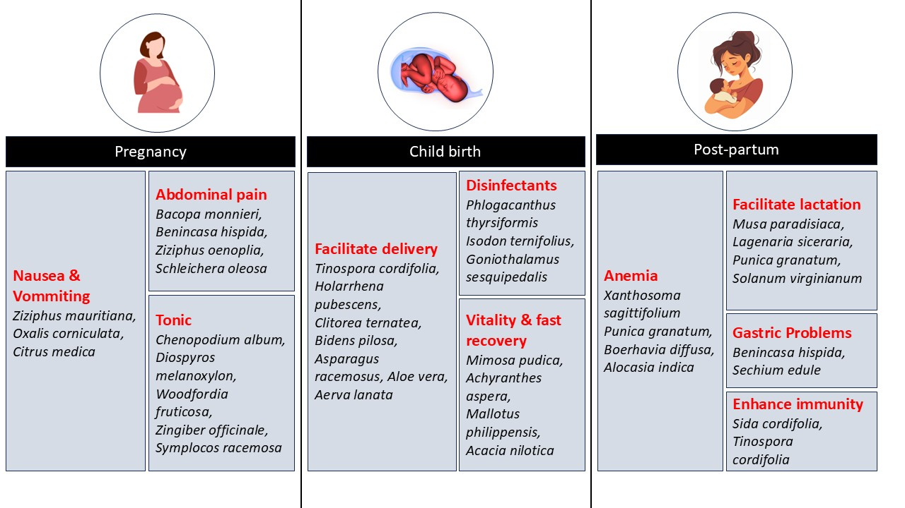

Figure 1: Illustration of various stages of maternity and use of various medicinal plants

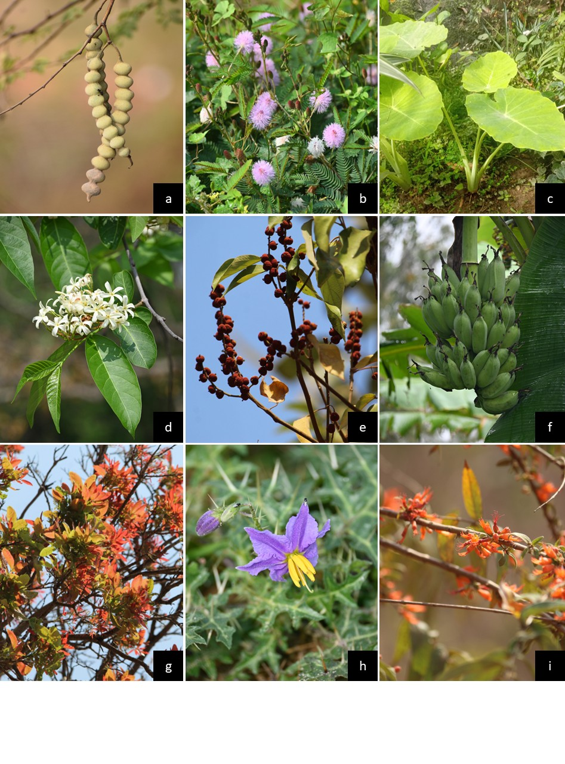

Figure 2: Medicinal plants used in different phases of maternity; a) *Acacia nilotica,* b) *Mimosa pudica,* c) *Alocasia indica,* d) *Holarrhena pubescens,* e) *Mallotus philippensis,* f) *Musa paradisiaca,* g) *Schleichera oleosa,* h) *Solanum virginianum,* i) *Woodfordia fruticosa*

The study revealed that various plants are used during different stages of maternity. During pregnancy, plants like *Citrus medica, Holarrhena pubescens, Oxalis corniculata, Schleicheraoleosa, Symplocos racemosus, Woodfordia fruticosa*, and *Bacopa monnieri* were utilized for their beneficial properties. To facilitate childbirth, plants such as *Acacia nilotica, Achyranthes aspera, Aerva lanata, Aloe vera, Asparagus racemosus* and *Bidens pilosa* were commonly used. In postpartum care, plants like *Benincasa hispida, Boerhavia diffusa, Chenopodium album, Lagenaria siceraria, Mimosa pudica, Musa paradisiaca, Sechium edule,* and *Solanum virginianum* are employed to support recovery and health. Specific medicinal plants were used for various purposes, including increasing vitality and recovery, inducing labor, and facilitating lactation. For example, *Mimosa pudica* and *Mallotus philippensis* were used to boost vitality, while *Asparagus racemosus, Achyranthus aspera*, and *Clitoreaternatea* were used to induce labor and facilitate delivery. *Chenopodium album* and *Diospyros melanoxylon* were used as tonics, and *Boerhavia diffusa, Musa paradisiaca*, and *Solanum virginianum* were used to facilitate lactation and address anaemia. *Bacopa monnieri* and *Benincasa hispida* were prescribed for abdominal pain relief. Additionally, traditional practices include using smoke from the combined dry leaves of *Goniothalamus sesquipedalis* and *Isodon ternifolius* as a disinfectant and to repel harmful microbes and spirits. Steam from *Phlogacanthus thyrsiformis* decoction is used to alleviate respiratory issues and as a disinfectant, demonstrating the diverse and resourceful use of medicinal plants in traditional maternity care (Figure 2). The medicinal plants used in different stages of maternity and childbirth (Figure 1) with name, plant part use, mode of use(s) and information collected region are given in Table 2.

**Table 1:** Plants prohibited to be consumed during different stages of Maternity

|  |  |  |  |
| --- | --- | --- | --- |
| **Botanical Name** | **Plant parts** | **Maternity Stage** | **Data collected from** |
| *Solanum melongena* | Fruit | Child birth | Manipur |
| *Capsicum annuum* | Fruit | Child birth | Manipur |
| *Parkia timoriana* | Bean | Child birth | Manipur |
| *Musa paradisiaca* | Flower | Child birth | Manipur |
| *Coriandrum sativum* | Aerial plant part | Child birth | Manipur |
| *Brassica juncea* | Leaves | Child birth | Manipur |
| *Ananas comosus* | Fruit | Pregnancy | Manipur & Odisha |
| *Carica papaya* | Raw fruit | Pregnancy | Odisha |
| *Raphanus sativus* | Tuber | Pregnancy & Child birth | Odisha |
| *Dillenia indica* | Fruit | Pregnancy & Child birth | Odisha |
| *Ipomoea batatas* | Tuber | Pregnancy & Child birth | Odisha |
| *Psidium guajava* | Fruit | Pregnancy & Child birth | Odisha |
| *Artocarpus heterophyllus* | Fruit | Pregnancy | Odisha |
| *Amaranthus viridis* | Leaves | Pregnancy | Odisha |

**Table 2:** Food and medicinal plants in different stages of maternity and childbirth

| **Botanical Name** | **Plant part(s) used** | **Use in Maternity Stage** | **Mode of use(s)** | **Data collected from** |
| --- | --- | --- | --- | --- |
| *Acacia nilotica* | Bark | Child birth | Sitting of the warm bark decoction increases vitality | Manipur |
| *Achyranthus aspera* | Roots | Childbirth | Roots are tied around the stomach before delivery to induce labor | Manipur |
| *Aerva lanata* | Aerial part | Child birth | Decoction is taken from few weeks before delivery helps in delivery | Odisha |
| *Alocasia indica* | Stem | Post-partum care | Cooked and consumed as stew to increase haemoglobin level or gain strength. Also used to treat anaemia. | Manipur |
| *Aloe vera* | Leaf | Childbirth | Juice taken before delivery for easy delivery | Odisha & Karnataka |
| *Asparagus recemosus* | Tuber | Childbirth | Taken in prescribed quantity for easy delivery | Odisha |
| *Bacopa monnieri* | Whole plant | Pregnancy | Small amount of juice taken to get rid of abdominal pain | Odisha |
| *Benincasa hispida* | Fruit | Post partum care | Boiled with rock sugar, Cardamom and *Cinnamomum tamala* leaves helps in lactation, gains energy and also treat gastric problems | Manipur |
| *Bidens pilosa* | Leaves | Childbirth | Decoction of the leaves are taken to induce labor | Odisha |
| *Boerhavia diffusa* | Leaves | Post-partum care | Cooked and consumed as vegetables to treat anaemia and urinary tract infection | Odisha |
| *Chenopodium album* | Leaves & shoots | Post partum care | Cooked as vegetable and consumed to provide essential nutrients and as tonic | Manipur |
| *Citrus medica* | Fruit | Pregnancy | Juice mixed with water taken to get rid of nausea | Manipur |
| *Clitorea ternatea* | Flowers | Childbirth | Taking tea of flowers helps in easy delivery | Odisha |
| *Diospyros melanoxylon* | Bark | Pregnancy | Bark decoction is taken as tonic | Odisha |
| *Goniothalamussesquipedalis* | Leaves | Child birth | Fumigate the room by directly burning with *Isodonternifolius* leaves | Manipur |
| *Holarrhena pubescens* | Bark | Pregnancy | Bark paste taken as tonic few weeks before delivery | Odisha |
| *Isodonternifolius* | Leaves | Child birth | Fumigate the room by directly burning with *Goniothalamussesquipedalis* leaves | Manipur |
| *Lagenaria siceraria* | Fruit | Post partum care | Cooked and consumed increases lactation | Odisha |
| *Mallotus philippensis* | Roots | Childbirth | Root paste taken to increase vitality | Odisha |
| *Mimosa pudica* | Whole plant | Post-partum care | Taking bath with decoction of the plant regains faster recovery and get relief from weakness | Manipur & Karnataka |
| *Musa paradisiaca* | Stem | Post-partum care | Stew with black pepper is taken to facilitate lactation | Manipur & Karnataka |
| *Oxalis corniculata* | Leaves | Pregnancy | Chewed to get rid of nausea | Odisha |
| *Phlogacanthus thyrsiformis* | Leaves | Child birth | Fumigate the room by boiling the leaves that is used as disinfectant and respiratory problems | Manipur |
| *Punica granatum* | Fruit & Seed | Child birth | Consumed to facilitate delivery and to regain from anemia | Manipur |
| *Saraca indica* | Bark | Childbirth | Taking bark decoction increases vitality and treats haemorrhage | Odisha& Kerala |
| *Schleichera oleosa* | Bark | Pregnancy | Take bath on warm bark decoction helps to get relief of abdominal pain | Odisha |
| *Sechium edule* | Fruit | Post partum care | Cooked and consumed as vegetables gains strength and gastric problems | Manipur |
| *Sida cordifolia* | Leaves | Childbirth | Decoction taken to improve immunity | Odisha & Karnataka |
| *Solanum virginianum* | Root | Post partum care | Root juice taken to improve lactation | Odisha |
| *Symplocos racemosa* | Bark | Pregnancy | Bark decoction taken as tonic | Odisha |
| *Tinospora*  *cordifolia* | Stem | Child birth | Juice taken before delivery to facilitate delivery and enhance immunity | Manipur & Kerala |
| *Trichosanthes tricuspidata* | Fruit | Abortion | Given in prescribed quantity in miscarriage & abortion | Odisha |
| *Vigna radiata* | Seeds | Child birth | Cooked and consumed for nutrition | Manipur |
| *Vigna umbellata* | Seeds | Child birth | Cooked and consumed for nutrition | Manipur |
| *Woodfordia fruticosa* | Flowers | Pregnancy | Cooked and consumed as tonic | Odisha |
| *Xanthosoma sagittifolium* | Stem | Post-partum care | Cooked and consumed as stew to increase haemoglobin level or gain strength. Also used to treat anemia. | Manipur |
| *Zingiber officinale* | Rhizome | Childbirth | Use as spices in food that also acts as tonic. | Odisha & Karnataka |
| *Ziziphus mauritiana* | Fruit | Pregnancy | Consume fruit in nausea and vomitting | Manipur |
| *Ziziphus oenoplia* | Bark | Pregnancy | Bark powder mixed with honey to get rid of abdominal pain | Odisha |
|  |  |  |  |  |
| *Asparagus recemosus* | Tuber | Post-partum care | Powder of dried  tuberous roots is used to increase production of breast milk in mother of new born baby.. | Karnataka |
| *Boerhaavia diffusa* | Leaves | Child care | Juice of leaves given to child for the treatment of cough and over flow of saliva. | Kerala |
| *Leucas aspera* | Leaves | Child care | Preparations of body massage oil for babies. | Karnataka & Kerala |
| *Ocimum sanctum* | Leaves | Child care | Decoction is used to cure stomach pain, cough etc. | Karnataka & Kerala |
| *Piper nigrum* | Fruits | Child care | Powder is used to cure stomach pain, cough etc. | Karnataka & Kerala |
| *Santalum album* | Heart wood | Child care | Paste is used to cure skin problems. | Karnataka & Kerala |
| *Phyllanthus emblica* | Fruits, Leaves, Stem | Post-partum care and child care | Decoction is used to cure body pain. Body massge oil preparation | Karnataka& Kerala |
| *Curcuma longa* | Rhizome | Post-partum care | Used for overcoming debility after child birth, treatment of cold and cough, applied on umbilical cord for its drying, | Karnataka & Kerala |
| *Datura metel* | Leaves | Post-partum care | Warm leaves are placed over breast to reduce swelling. | Karnataka |
| *Caryota urens* | Bark | Post-partum care | Recovery of mother body, uterus healing | Karnataka |
| *Cocos nucifera* | Kernel | Post-partum care and child care | Preparations of body massage oil for child and mother | Karnataka & Kerala |
| *Araceae calamus* | Root stocks | Child care | It helps to promote memory, longevity and good voice, to overcome from cold, headache, cough, asthma and fever | Karnataka & Kerala |
| *Calophyllum inophyllum* | Seed oil | Post-partum care and  Child care | Preparations of body massage oil for child and mother | Karnataka |
| *Azadirachta indica* | Leaves | Post-partum care and  Child care | Leaves are boiled and used for bath of mother after delivery and child bath | Karnataka & Kerala |
| *Loeseneriella arnottiana* | Young leaves | Child care | Extract of young leaves used to control cough in new babies | Karnataka |
| *Ventilago madraspatana* | Leaves , roots | Post-partum care and  Child care | Preparations of body massage oil for child and mother | Karnataka |
| *Allophyllus cobbe* | Leaves | Post-partum care and  Child care | Used along with hot water bath for babies and post natal women | Karnataka |
| *Mangifera indica* | Leaves, bark | Post-partum care and  Child care | Used along with hot water bath for babies. Decoction of bark is used to women  after delivery to check  uterine bleeding. | Karnataka & Kerala |
| *Erythrina variegata* | Leaves | Child care | Leaves are used to cure head injuries of small babies | Karnataka |
| *Cassia fistula* | Fruit | Pregnancy | Pulp of ripe fruit used for the treatment of constipation  in pregnant women. | Kerala |
| *Cassia tora* | Seeds | Child care | Seeds powder along with Mustard oil applied on body  of child to treat rickets | Kerala |
| *Calotropis procera* | Leaves | Child care | Leaves are dipped in  hot oil and kept on stomach of infant to relive stomachache. | Karnataka & Kerala |
| *Clitoria ternatea* | Flower | Child care and post natal care | Roots used to treat cold and cough in new born baby. Flowers used to control bleeding from uterus after delivery. | Kerala |
| *Eclipita alba* | Whole plant | Post-partum care, Child care | Used to relieve pain of vagina after childbirth and to stop uterine hemorrhage. Baby oil preparations | Karnataka & Kerala |
| *Ficus benghalensis* | Adventitious root | Post-partum care | Paste of new adventitious root is applied on breast of women after childbirth to promote lactation. | Karnataka & Kerala |
| *Sida cordifolia* | Young leaves | Child care | Treatment of rickets in child. | Karnataka |
| *Calycopteris floribunda* | Leaves | Child care | Preparation of Kashaya for herbal bathing, cleaning the child tongue using plant extract | Karnataka |
| *Psidium guajava* | Leaves | Child care | Plant extract used to control mouth ulcer. | Karnataka |
| *Careya arborea* | Leaves , bark | Child care | Preparation of Kashaya for herbal bathing, cleaning the child tongue & control mouth ulcer using plant extract | Karnataka |
| *Memecylonma labaricum* | Leaves | Child care | Preparation of Kashaya for herbal bathing, cleaning the child tongue using plant extract | Karnataka |
| *Ixora coccinea* | Young leaves | Child care | Preparation of Kashaya for herbal bathing & control mouth ulcer using plant extract | Karnataka |
| *Tinospora cordifolia* | Leaves, stem | Pregnancy & Post-partum care | Juice of plant parts are taken  with water and salt  for the treatment of  gastric trouble | Karnataka & Kerala |
| *Centella asiatica* | Leaves, stem | Child care | Preparation of Kashaya for herbal bathing, incearsing the memory power of child. | Karnataka & Kerala |
| *Hedyotis corymbosa* | Whole plant | Child care | Preparation of Kashaya for herbal bathing to cure rashes or skin infections | Karnataka & Kerala |
| *Vernonia anthelmintica* | Seeds | Post-partum care | Prepared decoction is given after delivery to remove toxins and infection producing agents from the body | Karnataka & Kerala |
| *Brassica guncea* | Seeds | Post-partum care | Preparing food with rice for lactation | Karnataka & Kerala |
| *Moullava spicata* | Leaves | Post-partum care | Prepared decoction is given after delivery to remove toxins and infection producing agents from the body | Karnataka |
| *Gymnostachyum febrifugum* | Whole plant | Post-partum care | Prepared decoction is given after delivery to remove toxins and infection producing agents from the body | Karnataka & Kerala |
| *Bambax malabaricum* | Root | Post-partum care | Powder of root used to promote lactation | Karnataka |
| *Acacia catechu* | Stem, leaves | Post-partum care | One cup of plant  decoction is given after  delivery for prevention of  infection, blood purification and weakness | Karnataka |
| *Achyranthes aspera* | Leaves, Root | Child birth | Root is tied over the waist of pregnant woman during labour pain. Decoction of fresh leaves given to control excessive bleeding after child birth | Karnataka |
| *Adhatoda vasica* | Leaves | Pregnancy & child care | Decoction of leaves is given to pregnant women for the treatment of bodyache and cough in child | Karnataka & Kerala |
| *Aegle marmelos* | Root, Fruit pulp | Pregnancy | Root extract given to pregnant women to check  Vomiting. Pulp use for the treatment of diarrhoea | Karnataka |
| *Allium sativum* | Bulb | Pregnancy | Used for the treatment of flatulence | Karnataka & Kerala |
| *Alstonia scholaris* | Bark | Post-partum care | Decoction is used to increase production of breast milk in mother of new born baby | Karnataka & Kerala |
| *Annona squamosa* | Fruit | Pregnancy | Control vomiting during pregnancy. | Karnataka |
| *Coriandrum sativum* | Fruits | Pregnancy | Fruits are boiled with fennel seeds and used for the treatment of dyspepsia and gastric trouble. | Karnataka & Kerala |
| *Madhuca indica* | Bark | Post-partum care | Decoction of bark is given  to women after delivery to  avoid infection | Karnataka & Kerala |
| *Bauhinia malabarica* | Flowers | Post-partum care | pinch of powder of  flowers is given with  honey to women for the  treatment of leucorrhoea | Karnataka & Kerala |
| *Butea monosperma* | Flowers | Post-partum care | Powder dried flowers is  given with sugar to treat leucorrhoea. | Kerala |
| *Solanum nigrum* | Leaves | Post-partum care | Juice of leaves is taken  with water for the treatment of painful menstruation. | Karnataka & Kerala |
| *Ruta graveolens* | Whole plant | Post-partum care | Decoction of plant is given to women as a uterine stimulant | Karnataka & Kerala |

**CONCLUSION**

The present study highlights the significance of traditional maternity and child healthcare practices in Southern India (Karnataka, Kerala), Central India (Odisha) and Northeastern India (Manipur). The research reveals a rich diversity of medicinal plants and traditional knowledge used during various stages of maternity, including pregnancy, childbirth, and postpartum care. The findings demonstrate the potential of traditional practices to support maternal health and well-being and demonstrates the importance of preserving and validating this knowledge through scientific research. By documenting and exploring these traditional practices, we can gain valuable insights into holistic and sustainable approaches to health, and promote a more nuanced understanding of the complex relationships between culture, health, and well-being. Ultimately, this study would contribute to a growing body of research that seeks to integrate traditional knowledge with modern healthcare practices, and promote a more inclusive and culturally sensitive approach to maternal healthcare.

COMPETING INTERESTS DISCLAIMER:

Authors have declared that they have no known competing financial interests OR non-financial interests OR personal relationships that could have appeared to influence the work reported in this paper.

**REFERENCES**

Abhijit DEY and Jitendra NDE. (2011). Traditional use of medicinal plants in pediatric and maternal care practiced by the ethnic groups of Purulia district, West Bengal, India. International Journal of Medicinal and Aromatic Plants. 1(3): 189-194.

Anvar K and Haneef J. (2015). Ethnobotanical plants used for postnatal care by traditional practitioners from Kozhikode district, Kerala, India. International Journal of Research in Pharmacy and Chemistry 5(4): 570-581.

Cotton CM (1996). Ethnobotany: principles and applications. John Wiley and Sons Ltd., Chichester. 1-80.

Das S, Mohaty S, Nayak S and Bhatta K. (2021). Plants of Gandhamardan in maternal care: an ethnobotanical approach. Asian Journal of Pharmaceutical and Clinical Research. 14(7): 70-73.

Devi LR and Das AK. (2018). Documentation of ethnomedicinal plants used for maternity care by the Paite tribe of Manipur, North-east India. International Journal of Advanced Research. 6(2): 825-828.

Jena N, Vimala, Singh B, Patra A, Sharma BP, Hossain E and Kumar S. (2025). Methods for ethnobotanical data collection, phytochemistry,antioxidant, anthelmintic, and antimicrobial activities for pharmacological evaluation of medicinal plants. Journal of Biodiversity and Conservation 9(2): 87-107.

Mitali Boro, Tikendrajit Sharma and Pranabjyoti Baishya. (2017). Evaluation of medicinal plants in North-East region relating to maternal and child health care. Journal of Ayurvedic and Herbal Medicine. 3(3): 150-158.

Nair HR and Mathew L. (2021). Sacred Grove Inhabiting Medicinal Plants for traditional postpartum maternal and newborn care practices among the ethnic communities of Central Kerala. Journal of Emerging Technologies and Innovative Research. (8(1): 28-35.

Osterman MJK. (2022). Changes in primary and repeat cesarean delivery: United States, 2016–2021. Vital Statistics Rapid Release; no 21. Hyattsville, MD: National Center for Health Statistics. DOI: https://dx.doi.org/10.15620/ cdc:117432

Rajith NP, Navas M, Thaha AM, Manju MJ, Anish N, Rajasekharan S and George V. (2010). A study on traditional mother care plants of rural communities of South Kerala. Indian Journal of Traditional Knowledge. 9 (1): 203-208.

Sharma PP and Sharma SP. (2023). Medicinal plants used during pregnancy, childbirth and postpartum care in India: a systematic review. International Journal of Research in Medical Sciences. 11(10):3803-3818.