**Ethnomycology of the Mamanwa Tribe in Las Navas, Northern Samar**

**Abstract**

The Philippine possesses a rich diversity of macrofungal species, many of which have been utilized for generations by indigenous communities. The Mamanwa Tribe, one of the country’s oldest ethnolinguistic groups, relies on mushrooms for both sustenance and traditional medicine. Despite their extensive knowledge their ethnomycological practices have not been systematically recorded. This study documented the macrofungi species traditionally utilized by the Mamanwa Indigenos People in Las Navas, Northern Samar. Fifteen (15) respondents participated in the survey. A total of seven (7) macrofungi species were collected and morphologically identified. Two additional species were reported through interviews but not encountered due to their seasonal occurrence. These findings underscore the depth of Mamanwa ethnomycological knowledge and its cultural relevance. There were five (5) species that were identified as food sources, commonly prepared using traditional methods such as ‘nilangtod” (cooked in coconut milk), ginisa (sauteed), and sinabawan (used in soups). Two (2) species, Ligbos and Uhong were used for medicinal purposes: G. rufa for eye treatment and D. spathularia for body pain and infections. These practices not widely documented in existing literature,highlight the importance of preserving indigenous medicinal knowledge and cultural heritage.

**Keywords**: ethnolinguistic, indigenous, ligbos, macrofungi, uhong

**Introduction**

Macrofungi are classified under Phylum Basidiomycota and form a large fruiting body which are spore-bearers and visible to the naked eye (Mueller et al., 2007). Most fungi cannot produce their food. Thus, they live as saprophytes, parasites or as mycorrhizal symbionts to plants for their survival (Reyes et al., 2009; Tang et al., 2015). Most fungi are usually found growing in on dead wood, soil, tree branches, coconut husk and decaying banana trunks (Jusayan et al, 2019), decaying plants and animals, twigs, leaf litter, animal manure, soil and even inside the body of insects. They play a very important role in the environment in the form of nutrient cycling; they act as decomposers of organic matter and even food for animals, including humans (Tang et al., 2015; Zotti et al., 2013) and many macrofungi are recognized due to their significant medical and economical importance for they are valuable sources of nutraceutical and food products.

The best-known examples of macrofungi are the mushrooms. They have a cap and a stalk and are frequently seen in fields and forests. Mushroom is a general term utilized largely for the fruiting body of the macro fungi (Ascomycota and Basidiomycota), and only has a short reproductive phase in their life cycle (Das, 2010). They inhabit diverse richness in the natural world, particularly in forest ecosystems (Pushpa & Purushothama, 2012). They have numerous impacts on ecology, biology, and the economy (Das, 2010).

In the Philippines, they frequently occur during the wet season. In countries with four seasons, they take place during spring as soon as the snow melts. As cited by Pushpa and Purushothama (2012), mushrooms are indeed the ‘fruits’ of the fungal mycelium located underground.

The majority of the people in rural areas depend on traditional fungi-based medicines to combat different illnesses. This ethnomycological survey was undertaken to document the traditional knowledge of mushrooms among the communities of the Mamanwa tribe in Barangay San Isidro, Las Navas, Northern Samar. Although macrofungi are exploited for food and medicine, their ethnomycological knowledge has not been documented in this community of the Mamanwa tribe.

In the Philippines, IPs were known to utilize macrofungi species for various purposes (Tayamen et al., 2004). The Aetas of Luzon are nomadic people. Their social activities revolve around hunting birds, frogs, and other animals and gathering fruits, insects, and mushrooms (Shimizu, 1989). Mushrooms also provide additional income to households if sold in regional markets (Yongabi et al., 2004). The Ayta communities reported 15 species of mushrooms (e.g., *V. volvacea*, *Termitomyces* spp., *A. polytricha*, *Auricularia auricula-judae*, *G. lucidum*, *Stereum sp*., *S. commune*) utilized as food and alternative medicine for cough, weakness, common colds, and poor eyesight (Tantengco et al., 2018). Mushrooms such as *A. polytricha, Cantharellus cibarius, Inocybe* *rimosa*, and *S. commune* were considered food by the people of Northern Samar and in the Island of San Antonio (Flores et al., 2014; Jusayan et al, 2019).

According to Lazo et al. (2016), the Gaddangs in Nueva Vizcaya have several indigenous beliefs during mushroom collection and utilization. The Gaddangs ask permission from the spirits before collecting mushrooms because they believe that spirits guard mushrooms and cannot be easily collected. They also believed that spontaneous lightning can stimulate mushroom growth. This belief has a scientific basis since lightning induces nitrogen to be converted to nitrite, which is important for the growth of macrofungi. As proof, several Japanese researchers are electrocuting a variety of mushrooms in lab-based garden plots with artificially induced lightning to determine whether the electricity can stimulate fungal multiplication (Ryall, 2010). According to Torres et al. (2020), all Bugkalot respondents knew about mushrooms, and they believe that they only grow during the rainy season and not 18 so much in the summertime. This is parallel with the reports from other indigenous groups that mushrooms are abundant during the wet season of the year (Lazo et al., 2015; De Leon et al., 2016; De Leon et al., 2018). They also said that mushrooms can be found in different substrates such as decaying logs, leaf litter, and soil, which is similarly reported by the Ifugaos (De Leon et al., 2018) and Gaddangs (Lazo et al., 2015). This claim could also be supported by the statement of Kalaw and Albinto (2014) that many species of macrofungi naturally appear on different substrates, such as leaf litter, decaying plant residues, and decomposing logs of trees, especially during the rainy season (Kalaw et al., 2014). According to Reyes et al. (2003) mushrooms could grow any time of the year in the Philippines as long as moisture is abundant.

The Kalanguya community believed that mushrooms grow in soil and decaying logs, which is similar to the beliefs of the Aeta communities in Pampanga, Tarlac and Zambales (De Leon et al., 2012). Mushrooms were also mainly collected for food and rarely for medicine and other purposes, such as insect repellant. Since most mushrooms were utilized for food, the cooking method preferred by the Kalanguyas for nearly all edible mushrooms was sautéed with other vegetables, similar to the Aeta indigenous tribe (De Leon et al., 2012). During the rainy season, the community consumed more than one kilo of mushrooms two to three times a week. They also mentioned that edible species of mushrooms can be distinguished from inedible ones based on their appearance, smell, and origin. Mushroom bright color, pungent smell, and presence of ring in the stipe of the fruiting body are some of their basis that mushrooms are poisonous and the Bugkalots ignore them. A similar 19 technique is also used by the Ifugaos (De Leon et al., 2018) and Gaddangs (Lazo et al., 2016), the Khasi tribe in Meghalaya, India (Das et al., 2014) and local IPs in Sabah, Malaysia (Fui et al., 2018). Moreover, insects perching on the mushroom fruiting body are an indication that it is edible. A similar observation was reported in another country that mushrooms being eaten by insects and other animals are also safe for human consumption.

On the other hand, Bugkalots emphasize that the names of mushrooms they use are derived depending on their appearance and the substrate where they are found growing. This is in congruence with the study of Teke et al. (2018), wherein the vernacular names of the local mushrooms were associated with their features or the substrates on which they proliferate (Teke et al., 2018). According to De Leon et al. (2012), the different Aeta sub-tribes in Central Luzon are also governed by different indigenous beliefs when it comes to mushroom collection, utilization, and cultivation. Some of their indigenous knowledge was as follows: (1) They do not cook mushrooms together with yellow or red vegetables or with shrimps, fish, and snails, as eating these cooked foods could cause fatal sickness. (2) One large mushroom species identified only as belonging to the genus Termitomyces is believed to be guarded by supernatural beings. Thus, before collecting this mushroom, subtribe Mag-Indi to perform dancing rituals or ask permission from the spirits and kiss the ground. Sub-tribe Zambal simply thanks their local deity “Apo Namalyari” for the abundance of their collected mushrooms.

Sub-tribe Mag-Antsi in Tarlac forbids combing their hair and singing while cooking mushrooms. They believed this could attract lightning to 20 strike the person.

Sub-tribe Zambal also mentioned that they should not observe the development of mushrooms on the ground as the mushroom will not continue to grow. (6) Interestingly, all Aeta sub-tribes believed that spontaneous lightning causes the growth of mushrooms. Such a belief was also known in Japanese farming folklore (Ryall, 2010). In fact, researchers in northern Japan bombarded a variety of mushrooms in lab-based garden plots with artificially induced lightning to see if electricity actually makes the fungi multiply (Ryall, 2010).

The Aeta sub-tribes also believed that mushrooms grow where the water used to wash or clean mushrooms was thrown. This is expected since mushroom spores present in the washed water would germinate and form fruiting bodies.

Considering that the ethnomycological knowledge of various tribes could serve as a tool to assess the fungal diversity in a country, this work is a contribution to the documentation of the edible and medicinal mushroom diversity in Las Navas, Northern Samar, particularly of the communities around Mamanwa tribe. There is therefore the need for ethnomycological knowledge documentation in the communities around in order to assess species availability as a prelude to conservation and ecological sustainability.

**Methodology**

**Locale of the Study**. Barangay San Isidro in Las Navas, Northern Samar, is situated at approximately 12.2712°N, 125.0633°E on the Island of Samar. It is the source of the Catubig-Las Navas River, near the Pinipisakan Falls, which is a pool-like body of water. It can be reached within 1 hour from the town proper and is accessible through small boats and motorcycles. Its total population consists of 3,392 individuals. Major sources of livelihood are coconut farming, rice farming, and abaca farming. The barangay center itself has an uneven topography with rolling hills towards the falls and the congruous mountain area (MPDO, 2020).

This barangay is where the “Mamanwa” community resides. The upland location of the Sitio, with its narrow and rocky road from the main barangay, can be reached by the river through small boats to kilometer tres (3km), then riding a motorcycle “habal-habal” or by hiking to sitio kilometer siete (km7), the Mamanwa community. They have been living in this place for forty (40) years now and are composed of only twenty-one (21) families. The Mamanwas living in the hinterland of sitio kilometro siete (km7), are descendants of the Mamanwa tribe in Mindanao, one of the oldest and extent tribes in the Philippines and which bear a striking physical resemblance to Negritos. A major source of livelihood is farming, hunting wild animals, planting rice, corn, bananas, and root crops, making abaca fiber, and 33 converting wild vines into “away” or rattan, which they would sell in the main barangay of San Isidro, Las Navas, Northern Samar (Corporal, 2020).

**Research Design.** The descriptive research design was used in this study. The descriptive study desires to obtain information concerning the current status of the phenomena and to describe “what exist” with respect to variables or condition in a given situation. In this study, the focus was on the collection and identification of the macrofungi in the study area, particularly in the grassland, forests, riverbank, and residential areas. Selected respondents from the Mamanwa community were interviewed informally to supplement the data.

**Research Instrument**. In this study, the researcher used the interview guide to obtain relevant data about distinguishing edible macrofungi from inedible macrofungi, ascertain what macrofungi were used for medicinal purposes, how they were prepared, and for what illness they were applied, and determine anthropogenic factors/activities that will influence the condition of macrofungi species. The interview guide was prepared in English and was translated into the Ninorte Samarnon dialect so that the respondents would have a clear idea about the questions.

**The Respondents.** The researcher purposively chose the respondents. Fifteen (15) respondents were selected for the interview. In the sampling site, selected respondents were purposively identified, especially chieftain leaders and elders who were involved in providing information about the macrofungi species present in the Mamanwa community.

**Data Gathering Procedure**. During the collection, sample specimens were removed from the substrate using the knife, but before picking up the specimen, a camera was used to take the picture of each specimen directly from where it was located. The specimen was handled carefully to avoid damage and destruction of useful identification characteristics. The collected specimen was put in brown paper and placed in close containers, so that important features will not be lost and they will not dry out. An interview with some of the residents of the study area was conducted in order to gather information on the macrofungi present in the sampling sites.

**Preservation of the Specimen**. The macrofungi were preserved by drying or immersing in liquid preservatives. Drying the macrofungi specimen was done on woody species of fungi. The specimen was air dry in the room under ordinary temperature. For those fragile and soft macrofungi specimens, it will preserve by immersing them in 10% formalin solution to make them rigid and firm. After one to two days, they were 37 removed, washed with water and transferred into jars containing 70% denatured alcohol, where they were kept and preserved indefinitely.

**Distinguishing the Edible from Inedible Species of Macrofungi Found in the Sampling Area**. Distinguishing the edible from inedible macrofungi species was done through informal interviews with the chieftain/leader, elders, and farmers in the sampling area. According to the study by Torres et al. (2020), edible species of mushrooms can be distinguished from inedible ones based on their appearance, smell, and origin. Mushroom bright color, pungent smell, and presence of ring in the stripe of the fruiting body are some of their basis that mushrooms are poisonous and the Bugkalots ignore them. A similar technique is also used by the Ifugaos (De Leon et al., 2018) and Gaddangs (Lazo et al., 2016), the Khasi tribe in Meghalaya, India (Das et al., 2014) and local IPs in Sabah, Malaysia (Fui et al., 2018). Moreover, insects perching on the mushroom's fruiting body are an indication that it is edible.

**Result and Discussion**

**The Different Macrofungi Species in the Mamanwa Tribe in Las Navas, Northern Samar**. Table 1 shows the macrofungi species among the Mamanwa communities in Las Navas, Northern Samar. The Mamanwa stated nine (9) mushrooms that are used as food and medicine.

During the sampling period, only seven mushrooms were collected and identified based on their morphological characteristics. There were five (5) collected edible mushrooms, namely; Lentinus tigrinus (Banay), *Schizophyllum commune* (Kurakdot), *Favolus tenuiculus* (Kurakdot), *Auricularia auricular-judae* (Tangog), *Volvariella volvacea* (Ulaping), and the two (2) medicinal mushrooms were *Galiella rufa* (Mata-mata), and *Dacryopinax spathularia* (Dulaw nga kurakdot).

Two species of macrofungi were not encountered during the conduct of the study, namely; Ligbos and Uhong. According to the Mamanwa, ligbos and uhong are seasonal mushrooms and can only be found during August, when thunderstorm frequently occurs.

The absence of certain mushroom species during the sampling period can be attributed to their seasonal fruiting patterns, which are strongly influenced by specific environmental conditions. Ethnomycological evidence from various Philippine regions indicates that mushrooms such as Termitomyces cartilagineus typically emerge only during the rainy season, particularly following thunderstorms. Studies have demonstrated that electrical and acoustic stimuli associated with lightning and thunder can trigger mushroom fruiting, as observed in species like *Lentinula edodes* (Kawasaki et al., 2010). This suggests that the absence of thunderstorms during the sampling window likely prevented the appearance of these mushrooms in the field. Therefore, the seasonality and weather dependence of these species must be considered in future sampling schedules and ecological assessments.

**Table 1. Mushrooms reported by the Mamanwa community in Las Nava, Northern Samar based on the interview and collected specimen.**

|  |  |  |
| --- | --- | --- |
| **Scientific name** | **Local name** | **Common name** |
| *Lentinus tigrinus* (Bull.) Fr. | Banay | Tiger sawgill |
| *Schizophyllum commune* Fr. | Kurakdot (1) | Split gill |
| *Favolus tenuiculus* P. Beauv. | Kurakdot (2) | Tropical white polypore |
| *Auricularia auricular-judae* (Bull) J. Schrot | Tangog | Jelly ear fungus, Wood ear |
| *Volvariella volvacea* (Bull. Ex. Fr.) Singer | Ulaping | Paddy straw mushroom |
| np | ligbos | np |
| np | uhong | np |
| *Galiella rufa (*Schwein) Nannf. & Kort | Mata-mata | Rubber cap |
| *Dacryopinax spathularia* (Schwein) G.W. Martin | Dulaw na kurakdot | Fan-shaped jelly fungus |

**np=** mushrooms not present during the sampling

**Edible and Inedible Macrofungi Species Reported by the Mamanwa Community Based on the Interview and Collected Specimen**. Based on the interview conducted, the Mamanwa stated six (6) local name of mushrooms that are used as food, namely: banay, kurakdot, tangog, ulaping, ligbos, and uhong. However, during the collection period, out of six (6) mushrooms, only four (4) locally known mushrooms were encountered, collected, and identified. These were *Lentinus tigrinus* (Banay), *Schizophyllum commune* (Kurakdot), *Favolus tenuiculus* (Kurakdot), *Auricularia auricular-judae* (Tangog), and *Volvariella volvacea* (Ulaping).

*L. tigrinus* (Banay), *S. commune (*Kurakdot), *F. tenuiculus* (Kurakdot), and *A. auricular-judae* (Tangog) are cooked with coconut milk, which is a local delicacy called “nilangtod” or “ginataan”. These mushrooms could also be cooked as “ginisa” or sautéed, and ‘sinabawan/nilaga,” which is a soup dish. V. vovacea (Ulaping) is only cooked as a “sinabawan” or “nilaga”, with calamansi juice sometimes added to enhance its flavor.

*S. commune* and *A. auricula-judae* were also used as food by the Ayta communities (Tantengco et al., 2018; De Leon et al., 2012), Gaddang communities (Lazo et al., 2015), and Bugkalot communities (Torres et al., 2020). However, there is no current record showing that L. tigrinus was utilized as food by the Ayta in Bataan (Tantengco et al., 2018), and V. volvacea was not yet documented to be used by the Bugkalot (Torres et al., 2020) as food.

This implies that Indigenous people from various groups have similarities and differences in knowledge regarding edible macrofungi species.

**Table 2. Edible and Inedible Macrofungi Species Reported by the Mamanwa Community Based on the Interview and Collected Specimen**

|  |  |  |  |
| --- | --- | --- | --- |
| **Scientific name** | **Local name** | **Common name** | **Edibility** |
| *Lentinus tigrinus* (Bull.) Fr. | Banay | Tiger sawgill | **/** |
| *Schizophyllum commune* Fr. | Kurakdot (1) | Split gill | **/** |
| *Favolus tenuiculus* P. Beauv. | Kurakdot (2) | Tropical white polypore | **/** |
| *Auricularia auricular-judae* (Bull) J. Schrot | Tangog | Jelly ear fungus, Wood ear | **/** |
| *Volvariella volvacea* (Bull. Ex. Fr.) Singer | Ulaping | Paddy straw mush-room | **/** |
| np | ligbos | np | **/** |
| np | uhong | np | **/** |
| Galiella rufa (Schwein) Nannf. & Kort | Mata-mata | Rubber cap | **x** |
| Dacryopinax spathularia (Schwein) G.W. Martin | Dulaw na kurakdot | Fan-shaped jelly fungus | **x** |  |

**Legend:** (/) Edible (x) Inedible (np) Not present during the sampling

**Macrofungi Used for Medicinal Purposes and Illnesses they are Used for and the Method of Preparation**. Based on the interview conducted in the sampling area, the Mamanwa stated two (2) mushrooms that are used for medicinal purposes, namely *Galiella rufa* (mata-mata) and *Dacryopinax spathularia* (dulaw nga kurakdot).

According to the Mamanwa, *Galiella rufa* (Mata-mata) is a mushroom that has a flat top surface and a watery fruiting body and is abundantly found during the wet season. *Dacryopinax spathularia* (Dulaw nga Kurakdot) is similar to the locally known “kurakdot” mushroom, but its color and texture differ from the edible one.

*G. rufa* (commonly known as Mata-mata) is traditionally used for treating poor eyesight, blurry vision, and eye irritation. The fruiting body of *G. rufa* is cut and squeezed to extract its liquid, which is then used as an ophthalmic drop ("pang-patak sa mata"). This eye drop is administered until the symptoms subside. *D. spathularia* (Dulaw nga Kurakdot) is utilized for relieving body pain, soreness, and infections. The preparation process involves a traditional method known as “tugmak”. “Pag tugmak” refers to “pag butang san mushroom sa dahon san saging ngan pag-dangdang sa kalayo," which refers to placing the mushroom’s fruiting body between banana leaves and then singeing it over an open flame. This rapid, high-heat exposure is believed to increase the amount of its extract. After "pag tugmak" (singeing), the heated fruiting body is wrapped in a clean cloth and applied to the affected part of the body, a process known as "pag-tapal" (poultice application). An alternative method involves crushing the fruiting body and applying 54 it directly to the affected area without a poultice. The treatment is continued until the ailment is cured.

*G. rufa* and *D. spathularia* were utilized by the Mamanwa as medicine; however, based on an ethnomycological survey of Ayta communities (Tantengco et al., 2018; De Leon et al., 2012), Gaddang communities (Lazo et al., 2015), and Bugkalot communities (Torres et al., 2020), there is no record of utilization of this mushroom.

*Fomiptosis sp., Ganoderma applanatum, Ganoderma lucidum, Polyporus picipes*, and *Polyporus sp.* were used by the Bugkalots as a treatment for skin infection (Torres et al., 2020). However, none of these mushrooms was mentioned by the Mamanwa as medicinal mushrooms.

This implies that the Mamanwa tribe utilizes medicinal mushrooms that are not acknowledged by other indigenous tribes as medicinal. Likewise, another indigenous tribe utilizes medicinal mushrooms that the Mamanwa does not recognize. Their knowledge regarding medicinal mushrooms greatly differs from one another.

**Table 3. Macrofungi Used for Medicinal Purposes and for What Illnesses they are Used for and the Method of Preparation**

|  |  |  |  |  |
| --- | --- | --- | --- | --- |
| **Scientific name** | **Local name** | **Parts Used** | **Method of Preparation** | **Used for treating** |
| *Galiella rufa* (Schwein) Nannf. & Kort | Mata-mata | Fruiting body | Extracting and Topical Ophthalmic Administration of Extract | Blurry Vision, Poor eyesight, Eye irritation |
| *Dacryopinax spathularia* (Schwein) | Dulaw nga Kurakdot | Fruiting body | Pag tugmak” or placing the mushroom between banana leaves and singeing it over an open flame. “Tapal/pag tapal” or making and applying a poultice | Body pain, soreness, and Infection |

**Conclusions**

Although, Mamanwa tribe have a good traditional knowledge and practice, the attempt to document, utilize, and conserve these valuable wild resources was very poor. Lack of concern in mushroom research in the Mamanwa tribe and also in the province of Northern Samar has affected negatively the integration of this knowledge as an input in food security and mycomedicinal studies. In addition, the very low concern of supporting and funding mushroom-related research in the province has also contributed to the decline of indigenous knowledge on mushrooms in the area.

**Recommendations**

Mycochemical analysis is recommended to acquire information regarding the bioactive compounds present in these medicinal mushrooms utilized by the Mamanwa and further studies are recommended for developing protocols of cultivation of these macrofungi so that their future availability is ascertained along with creating income resources for the Mamanwa tribe.

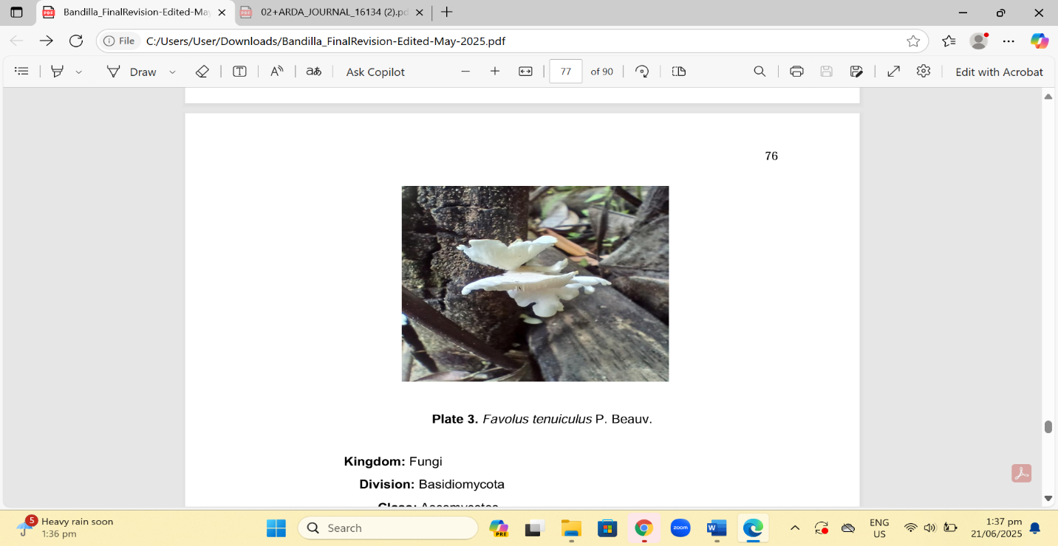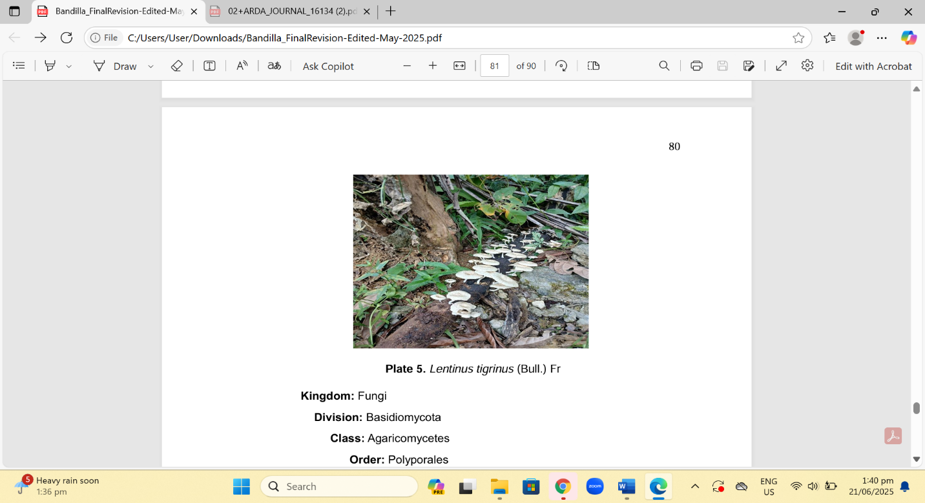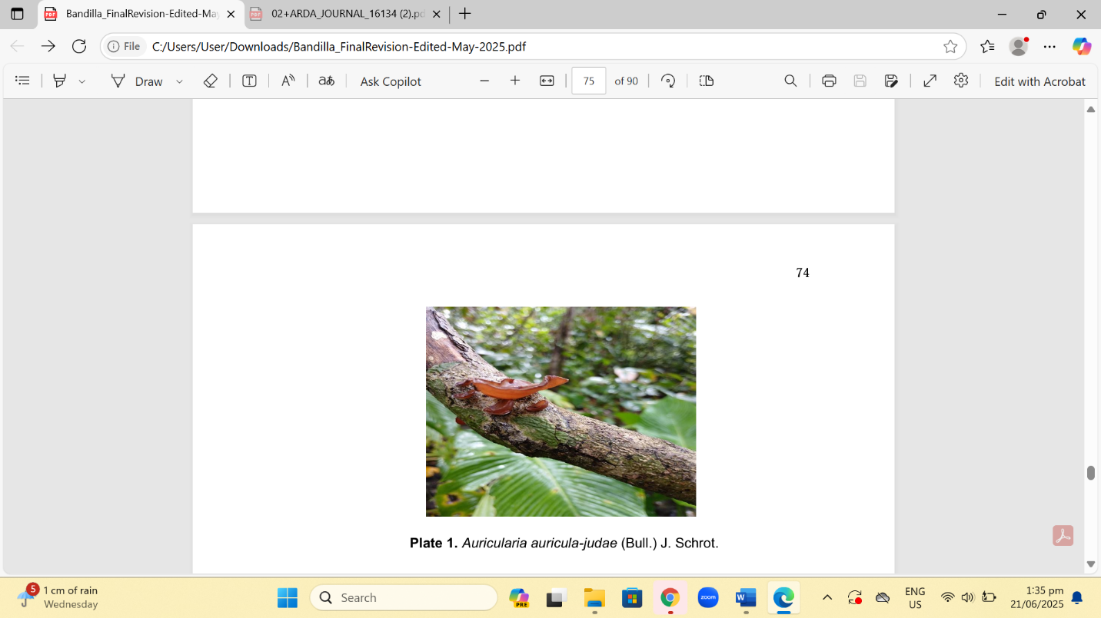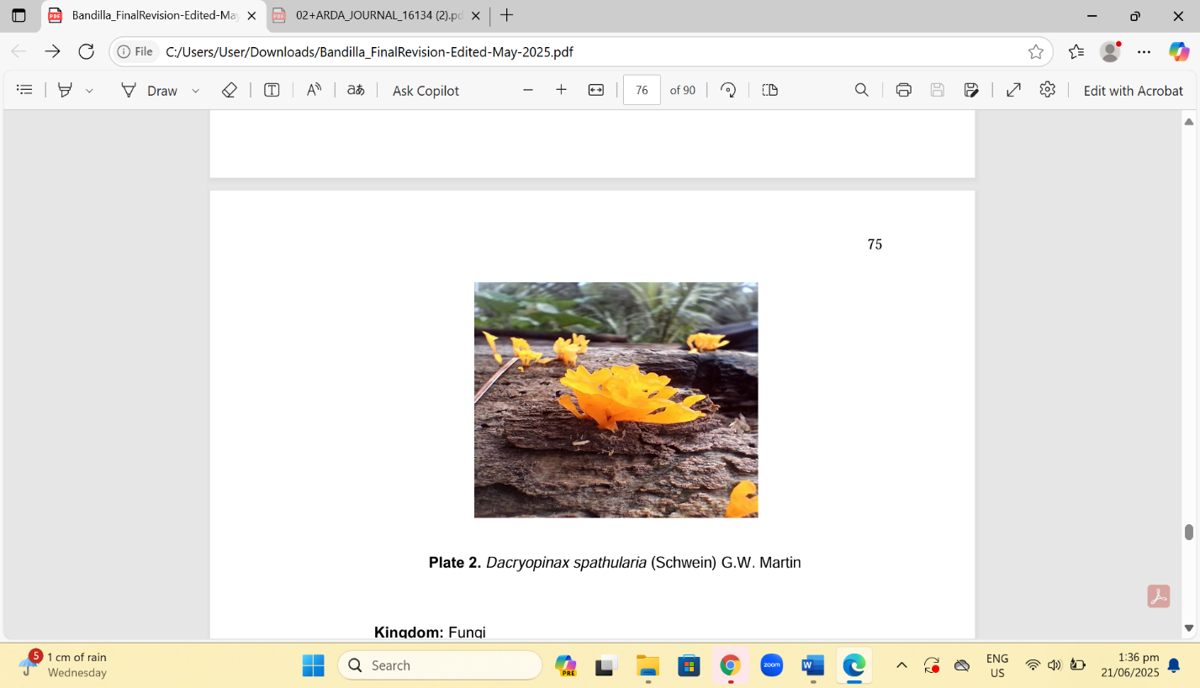

a

b

d

c1

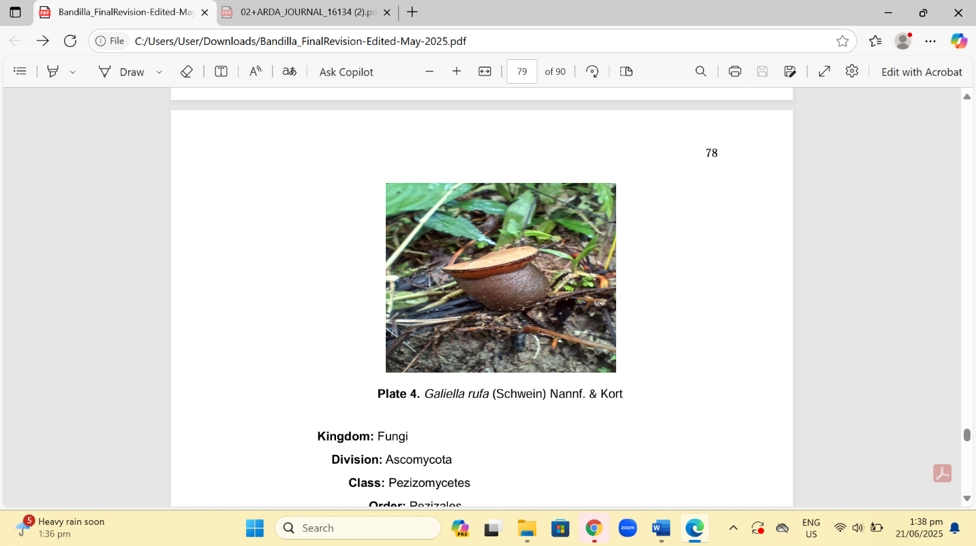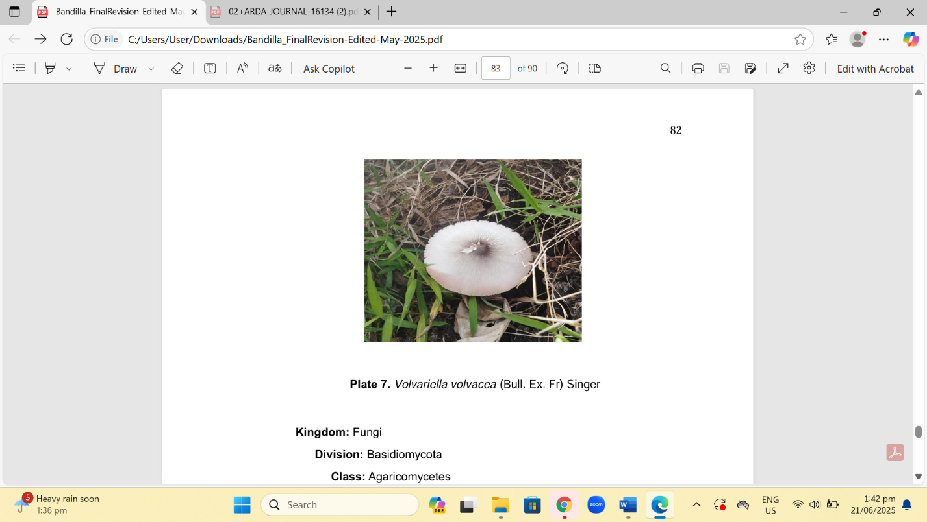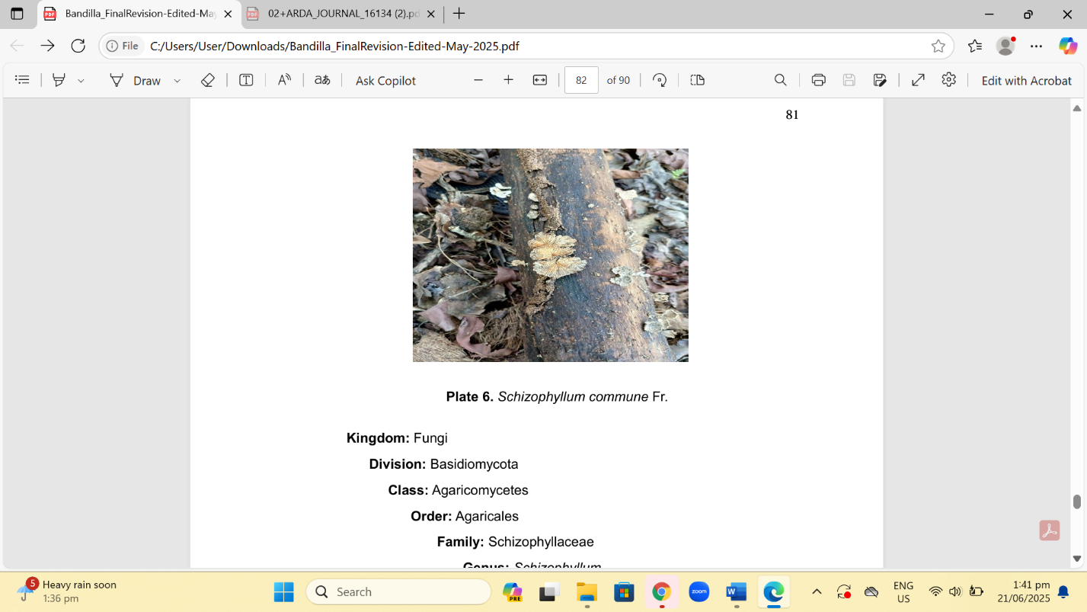

e1

f

g

**Figure 1.** Macrofungi species utilized by the Mamanwa tribe in Las Navas, Nrthern Samar. **a.** *Dacryopinax spathularia* (Schwein) G.W. Martin; **b**. *Auricularia auricula-judae* (Bull.) J. Schrot.; **c.** *Favolus tenuiculus* P. Beauv.; **d.** Lentinus tigrinus (Bull.) Fr.; **e.** *Galiella rufa* (Schwein) Nannf. & Kort; **f.** *Volvariella volvacea* (Bull. Ex. Fr) Singer; g. Schizophyllum commune Fr.

COMPETING INTERESTS DISCLAIMER:

Authors have declared that they have no known competing financial interests OR non-financial interests OR personal relationships that could have appeared to influence the work reported in this paper.

**Reference**

Das, K., Lamo, A., Paul, D., & Jha, L. H. (2014). Ethnomycological knowledge on wild edible mushrooms of Khasi Tribes of Meghalaya, North-Eastern India. European Academic Research, https://euacademic.org/UploadArticle/629.

De Leon, A. M., Reyes, R. G., & Dela Cruz, T. E. E. (2012). An ethnomycological survey of macrofungi utilized by Aeta communities in Central Luzon, Philippines. Mycosphere, https://www.mycosphere.org/pdf/MC3_2_No9 3(2), 251–259.

De Leon, A. M., Reyes, R. G., & Dela Cruz, T. E. (2018). Wild edible mushrooms in the Philippines: Diversity, utilization, and conservation. Mycosphere, 9(5), 1120-1135.

Flores, A. A. U., Jr., Alvarez, M. L. C., Cortez, F. E., & Perez, B. E. (2014). Inventory and utilization of macrofungi species for food and medicine. International Conference on Biological, Chemical and Environmental Sciences (BCES-2014), Penang, https://www.creamjournal.org/pdf/CREAM_8_1_9 Malaysia. 65

Fui, F. S., Saikim, F. H., Kulip, J., & Seelan, J. S. S. (2018). Distribution and ethnomycological knowledge of wild edible mushrooms in Sabah (North Borneo), Malaysia. Journal of Tropical Biology and Conservation, 15, 203 222. https://jurcon.ums.edu.my/ojums/index.php/jtbc/article/view/1494/967

Jusayan, Rockett Rikki T. | Manuela Cecille G. Vicencio, (2019). "The Macrofungi in the Island of San Antonio, Northern Samar, Philippines". International Journal of Trend in Scientific Research and Development (ijtsrd), ISSN: 2456-6470, Volume-3 | Issue-3, pp.968-975, URL: https://www.ijtsrd.com/papers/ijtsrd23228.pdf

Kalaw, S. P., & Albinto, M. R. (2014). Ecological roles and seasonal variation of macrofungi in tropical forest ecosystems. Fungal Diversity, 66(3), 187-198.

Kawasaki, Y., Akita, M., Doi, Y., & Sakamoto, Y. (2010). "Fruit body induction of mushrooms using high-voltage electric stimulation." Journal of the Institute of Electrical Engineers of Japan, 130(3), 184–189.

Lazo, C. R. M., Kalaw, S. P., & De Leon, A. M. (2015). Ethnomycological survey of macrofungi utilized by Gaddang communities in Nueva Vizcaya, Philippines. Current Research in Environmental and Applied Mycology, 5(3), 256–262.

Lazo, R. G., Santos, A. M., & Flores, M. B. (2016). Mushroom collection and spiritual beliefs among the Gaddangs in Nueva Vizcaya, Philippines. Journal of Ethnomycology, 4(1), 57-63.

Mueller, G. M., Bills, G. F., & Foster, M. S. (2007). Biodiversity of fungi: Inventory and monitoring methods. Elsevier.

Pushpa, H., & Purushothama, K. B. (2012). Diversity of mushrooms in Indian forests: Ecological and economic importance. Current Research in Environmental & Applied Mycology, 2(3), 101-107.

Shimizu, M. (1989). Ethnographic study on the hunting and gathering practices of indigenous tribes in the Philippines. Asian Anthropology Journal, 14(1), 75 92.

Reyes, R. G., Kalaw, S. P., & Cajuday, L. A. (2009). Mycorrhizal associations and nutrient absorption in fungi. Mycological Research, 8(4), 129-139.

Ryall, J. (2010). Can lightning stimulate mushroom growth? Japanese scientists investigate fungal responses to electricity. Scientific American, 22(7), 18 19.

Tang, Y., Wu, X., & Zhou, S. (2015). Fungal ecology and nutrient cycling in forest ecosystems. Ecological Research, 30(5), 765-778.

Tantengco OAG, Ragragio EM (2018). Ethnomycological survey of macrofungi utilized by Ayta communities in Bataan, Philippines. Current Research in Environmental & Applied Mycology (Journal of Fungal Biology) 8(1), 104–108, Doi 10.5943/cream/8/1/9

Tayamen MJ, Reyes RG, Floresca EJ, Abella EA. 2004 – Domestication of wild edible mushrooms as non-timber forest products resources among the Aetas of Mt. Nagpale, Abucay, Bataan: Ganoderma sp. and Auricularia polytricha. The Journal of Tropical Biology 3, 49–51.

Torres ML, Tadiosa ER, Reyes RG 2020 – Species listing of macrofungi on the Bugkalot Tribal community in Alfonso Castañeda, Nueva Vizcaya, Philippines. Current Research in Environmental & Applied Mycology (Journal of Fungal Biology) 10(1), 475–493, Doi 10.5943/cream/10/1/37

Yongabi K, Agho M, Carrera DM. 2004 – Ethnomycological Studies on Wild Mushrooms in Cameroon, Central Africa. Micologia Aplicada International. 16(2), 34–36.

Zotti, M., Ferraro, A., & Vizzini, A. (2013). Fungi as decomposers: Their role in organic matter breakdown and ecosystem functioning. Mycologia, 105(4), 874-889.