ANTIOXIDANT ACTIVITY OF ETHANOLIC EXTRACTS OF *ASTERACANTHA LONGIFOLIA* AND *MORINGA OLEIFERA* USING DPPH, NITRIC OXIDE, HYDROGEN PEROXIDE AND FRAP MODEL

ABSTRACT

|  |
| --- |
| **Aims:** The current study was conducted to evaluate and compare the antioxidant activity of 70% ethanolic extracts of Asteracantha longifolia (aerial parts and roots) and Moringa oleifera (stem and leaves) using four *in vitro* models: DPPH, nitric oxide (NO), hydrogen peroxide (H₂O₂), and ferric reducing antioxidant power (FRAP) assays.  **Study design:** The plant parts, such as the aerial parts and roots of *Asteracantha longifolia* and the stem and leaves of *Moringa oleifera* were collected from nearby areas of Sambalpur district. Dust particles were removed by washing with tap water followed by distilled water and then the plant materials were air-dried. The dried plant material was ground to a fine powder using a mechanical grinder and kept in airtight polybags. Ascorbic acid was used as a standard antioxidant reference. All three plant extracts demonstrated as dose-dependent antioxidant activity in the tested models.  **Place and Duration of Study:** The study was conducted in the Department of Biotechnology and Bioinformatics, Sambalpur University in the year 2024-2025.  **Methodology:** The powder samples were taken for Soxlet extraction. 60g powder of aerial parts and 54g of *Asteracantha longifolia* root; 54g of *Moringa oleifera* stem and leaves were used for Soxhlet extraction. Ethanol, distilled water, and a hydro-alcoholic solution (ethanol: distilled water, 70:30) were used as solvent. Then the antioxidant activity study was performed through DPPH, nitric oxide (NO), hydrogen peroxide (H₂O₂), and ferric reducing antioxidant power (FRAP) assays.  **Results:** All three plant extracts demonstrated as dose-dependent antioxidant activity in the tested models. Among them, Moringa oleifera exhibited the highest free radical scavenging activity in DPPH (51.32% inhibition), NO (55.34%), and H₂O₂ (53.99%) assays with the lowest IC₅₀ values, indicating potent antioxidant potential. In the FRAP assay, all extracts showed appreciable ferric reducing ability, with Asteracantha longifolia showing slightly higher values than Moringa oleifera.  **Conclusion:** These findings suggest that the tested plant extracts, especially Moringa oleifera, can serve as promising sources of natural antioxidants. Further investigations are warranted to isolate the active. |

*Keywords: Asteracantha longifolia, Moringa oleifera, antioxidant activity, DPPH, nitric oxide, hydrogen peroxide, FRAP assay, IC₅₀*

1. INTRODUCTION

Reactive oxygen species (ROS) and free radicals are continuously generated in the human body as byproducts of normal metabolic processes or due to environmental factors such as pollution, radiation, and exposure to toxic substances [1]. ROS plays essential roles in cell signaling and immune responses, their excessive accumulation leads to oxidative stress, which has been implicated in the onset and progression of numerous chronic diseases, including cancer, cardiovascular diseases, diabetes, and neurodegenerative disorders. In this context, antioxidants play a crucial role by neutralizing free radicals and protecting cellular components from oxidative damage [2]. Natural antioxidants derived from medicinal plants are of growing interest due to their safety profile, affordability, and therapeutic potential [3]. The plant-based compounds, particularly polyphenols, flavonoids, tannins, and other secondary metabolites, exert antioxidant effects through multiple mechanisms, including free radical scavenging, metal ion chelation, and inhibition of oxidative enzymes [4]. *Moringa oleifera* is widely recognized for its rich content of vitamins, phenolics, flavonoids, and minerals, which contribute to its potent antioxidant and anti-inflammatory properties [5]. *Asteracantha longifolia* is traditionally used in Ayurvedic medicine to treat liver disorders, inflammation, and kidney diseases and is known to contain flavonoids, steroids, and other antioxidant phytochemicals [6]. *Asteracantha longifolia* phytochemicals have been proven to have high antioxidant activities, which have been linked to a lower incidence and mortality rate of degenerative disorders in humans [7]. DPPH(2,2-diphenyl-1-picryl-hydrazyl-hydrate) free radical process is an antioxidant assay based on electron-transfer that produces a violet solution in ethanol [8,9]. The nitric oxide (NO) scavenging assay assesses the inhibition of nitric oxide radicals, which play a significant role in inflammation and oxidative injury [10]. The hydrogen peroxide scavenging assay determines the extract’s potential to neutralize H₂O₂, a relatively stable reactive oxygen species that can convert into more harmful radicals [11]. Furthermore, the Ferric Reducing Antioxidant Power (FRAP) assay is used to estimate the reducing ability of the plant extracts, reflecting their overall antioxidant power [12]. So, this investigation aims to provide comparative insights into the antioxidant activities of *Asteracantha longifolia* (aerial parts and roots), and *Moringa oleifera* (stem and leaves) ethanolic extracts, thereby validating their traditional medicinal uses and supporting their potential applications in the development of natural antioxidant therapies.

2. material and methods

**2.1. Sample collection**

The plant parts, such as the aerial parts and roots of *Asteracantha longifolia* and the stem and leaves of *Moringa oleifera* were collected from nearby areas of Sambalpur district. Dust particles were removed by washing with tap water followed by distilled water and then the plant materials were air-dried. The dried plant material was ground to a fine powder using a mechanical grinder and kept in airtight polybags.

**2.2. Chemicals used**

Ethanol (analytical grade) was obtained from Merck Life Science Pvt. Ltd., Mumbai, India. DPPH (2,2-diphenyl-1-picrylhydrazyl), sodium nitroprusside, sulfanilic acid, naphthyl ethylenediamine dihydrochloride, and hydrogen peroxide were supplied by Sigma-Aldrich, India. Ascorbic acid (standard antioxidant) and all other reagents used were of analytical grade and procured from S.D. Fine Chemicals Ltd., Mumbai, India. Double-distilled water was used throughout the experimental procedures. All chemicals and reagents were used without further purification.

**2.3. Soxhlet extraction**

The powder samples were taken for soxlet extraction. 60g powder of aerial parts and 54g of *Asteracantha longifolia* root; 54g of *Moringa oleifera* stem and leaves were used for Soxhlet extraction. Ethanol, distilled water, and a hydro-alcoholic solution (ethanol: distilled water, 70:30) were used as solvent. To guarantee the highest phytochemical output, the extraction procedure was conducted for 48 hours and included continuous cycles of solvent reflux and condensation. After passing through the Whatman filter paper, the extracts were concentrated at 50°C in a rotary evaporator [13].

**2.4. *In-vitro* antioxidant activity of 70% ethanolic extract (Soxhlet extraction method) using different methods**

**2.4.1. DPPH method**

Total free radical scavenging capacities of extract were estimated according to the previously reported method with slight modification [14]. Solution of DPPH (6 mg in 100ml methanol) was prepared and stored in dark place. Different concentration of standard and test (10- 100 µg/ml) was prepared. 1.5 ml of DPPH and 1.5 ml of each standard and test was taken in separate test tubes; absorbance of this solution was taken immediately at 517nm. 1.5 ml of DPPH and 1.5 ml of the methanol was taken as control absorbance at 517nm.

The percentage inhibition of free radical DPPH was calculated from the following equation: % inhibition = [(absorbance of control - absorbance of sample)/absorbance of control] × 100%.

**2.4.2. Nitric oxide method**

Nitric oxide was produced from sodium nitroprusside and the Griess reagent was measured. Sodium nitroprusside spontaneously produces nitric oxide in aqueous solution at physiological pH, interacting with oxygen to generate nitric ions that can be estimated using Griess reagent. Nitric oxide scavengers compete with oxygen resulting in decreased nitric oxide manufacturing [15]. Sodium nitroprusside (10 mmol / L) was mixed with various extract concentrations in phosphate buffer saline (PBS) and incubated at 25°C for 150 min. Griess reagent (1% sulphanilamide, 2% H3PO4 and 0.1% napthylethylenediamine dihydrochloride) was added to the specimens. The chromophore absorbance created during the diazotization of sulphanilamide nitrite and subsequent coupling with napthylethyleneediamine was read at 546 nm and referred to the absorption of conventional ascorbic acid solutions treated in the same manner with Griess reagent as a positive control. The inhibition proportion was evaluated using the following formula:

Radical scavenging activity (%) = (A control-A test)/A control×100

Where A control is the absorption (without extract) of the control and where A test is the absorption in the presence of the extract / standard.

**2.4.3. Hydrogen peroxide method**

*In-vitro* antioxidant activity ofextract using hydrogen peroxide was performed [16] proposed. Added 2ml hydrogen peroxide (43 mol) and 1.0 ml hydroalcoholic sample [20-100 μl different extracts (4 mg / ml) ethanol] accompanied by 2.4 ml 0.1 M phosphate buffer (pH 7.4). The resulting solution was maintained for 10 minutes and the absorbance at 230 nm was recorded. Without adding hydrogen peroxide, blank was ready and control was prepared without sample. It was used as a conventional compound with ascorbic acid. Free radical hydrogen peroxide scavenging activity (percent) has been calculated.

**2.4.4. Ferric Reducing antioxidant power (FRAP)**

Exactly 1.5ml of freshly prepared FRAP working reagent (25ml acetate buffer (300mM: pH 3.6), 2.5 ml of 2, 4, 6-tripyridyl-s-triazine (10mM TPTZ prepared in 40mM HCl), and 2.5ml of 20mM ferric chloride (FeCl3.6H2O) was mixed with 1 ml of extracts at various concentration (0.2-1mg/ml) in test tubes. The mixture was incubated at 370C for 30 min and Absorbance at 593 nm was measured. Similar concentrations of FeSO4 were used to prepare the calibration curve and values were expressed as µmol FeSO4 equivalents per gram of sample. The Standard (Ascorbic acid) was also performed following similar experimental condition [17].

3. results and discussion

The present study evaluated and compared the antioxidant potential of 70% ethanolic extracts of Asteracantha longifolia (aerial parts), Asteracantha longifolia (roots), and Moringa oleifera (stem and leaves) using four different in vitro models DPPH, nitric oxide, hydrogen peroxide scavenging assays, and the ferric reducing antioxidant power (FRAP) assay with ascorbic acid as the standard reference. The **DPPH radical scavenging assay** (Table 1, Figure 1) revealed a concentration-dependent increase in antioxidant activity across all extracts. Moringa oleifera demonstrated the highest inhibition at 100 µg/ml (51.32%), followed by aerial parts ofAsteracantha longifolia (37.22%) and root extract of Asteracantha longifolia (33.43%) and IC50 value was Also, the study of [18],[19] reported that *Asteracantha longifolia* root exhibited good antioxidant activity. Correspondingly, Moringa oleifera showed a lower IC₅₀ value (113.60 µg/ml), indicating better radical scavenging capacity compared to the other extracts. In the study of [20] methanolic extract of a bark, stem and leaf of *Moringa oleifera* revealed high potential free radical scavenging activity having IC50 value of 40, 320 and 720 (μg/ml) respectively. In the **nitric oxide scavenging assay** (Table 2, Figure 2), a similar trend was observed. Moringa oleifera again showed the highest inhibition (55.34% at 100 µg/ml) and a relatively lower IC₅₀ (84.90 µg/ml), while Asteracantha longifolia (roots) and Asteracantha longifolia (areal parts) demonstrated moderate activity. Lower the IC50 value of better is the scavenging ability of the sample [21]. The **hydrogen peroxide scavenging assay** (Table 3, Figure 3) further supported the strong antioxidant capacity of Moringa oleifera, which reached 53.99% inhibition at 100 µg/ml and exhibited the lowest IC₅₀ among the extracts tested (89.23 µg/ml). In contrast, Asteracantha longifolia (roots) and Asteracantha longifolia (areal parts) displayed lower inhibition percentages and higher IC₅₀ values, indicating less efficiency in scavenging hydrogen peroxide radicals. Finally, the **FRAP assay** (Table 4, Figure 4) showed that all extracts had ferric reducing potential, with Asteracantha longifolia exhibiting slightly higher FRAP values (6.76 µM Fe (II)/g of extract) than Moringa oleifera (5.99 µM Fe (II)/g of extract), though the overall differences were minimal. The FRAP values were in agreement with the radical scavenging assays, validating the reducing capacity of the extracts.

**Table 1: % Inhibition of ascorbic acid and 70% ethanolic extracts of *Asteracantha longifolia*** **and** ***Moringa oleifera* using DPPH method**

|  |  |  |  |  |  |
| --- | --- | --- | --- | --- | --- |
| **S. No.** | **Concentration**  **(µg/ml)** | **% Inhibition** | | | |
| **Ascorbic acid** | ***A. longifolia*** **extract (Aerial parts) extract** | ***Asteracantha longifolia*** **extract (Root)** | ***Moringa oleifera*** **extract (Stem and leaves)** |
| 1 | 10 | 41.88 | 16.61 | 16.46 | 34.50 |
| 2 | 20 | 48.82 | 28.35 | 24.70 | 37.08 |
| 3 | 40 | 55.26 | 29.63 | 31.85 | 39.44 |
| 4 | 60 | 57.84 | 35.93 | 31.85 | 40.01 |
| 5 | 80 | 66.71 | 36.36 | 32.93 | 41.52 |
| 6 | 100 | 76.74 | 37.22 | 33.43 | 51.32 |
| IC 50 | | 29.34 | 150.112 | 185.367 | 113.60 |

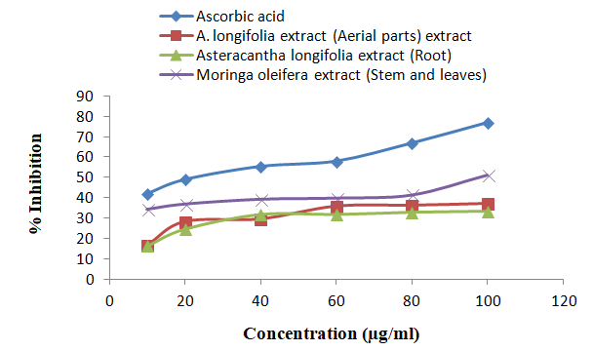

**Fig. 1. % Inhibition of ascorbic acid and extracts using DPPH method**

**Table 2. % Inhibition of ascorbic acid and 70% ethanolic extracts of *Asteracantha longifolia*** and ***Moringa oleifera* using Nitric oxide method**

|  |  |  |  |  |  |
| --- | --- | --- | --- | --- | --- |
| **Sl. No.** | **Concentration**  **(µg/ml)** | **% Inhibition** | | | |
| **Ascorbic acid** | ***A. longifolia*** **extract (Aerial parts) extract** | ***Asteracantha longifolia*** **extract (Root)** | ***Moringa oleifera*** **extract (Stem and leaves)** |
| 1 | 10 | 40.99 | 5.65 | 10.49 | 10.49 |
| 2 | 20 | 54.08 | 13.45 | 19.73 | 20.63 |
| 3 | 40 | 56.50 | 20.00 | 28.43 | 28.61 |
| 4 | 60 | 67.26 | 33.18 | 36.14 | 37.40 |
| 5 | 80 | 74.44 | 38.57 | 40.09 | 49.96 |
| 6 | 100 | 82.24 | 49.96 | 44.66 | 55.34 |
| IC 50 | | 21.81 | 100.51 | 81.65 | 84.90 |

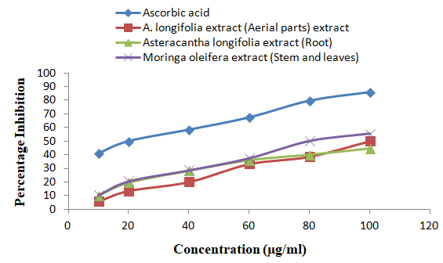

**Fig. 2. % Inhibition of ascorbic acid and extracts using Nitric oxide method**

**Table 3. % Inhibition of ascorbic acid and 70% ethanolic extracts of *Asteracantha longifolia*** and ***Moringa oleifera* using hydrogen peroxide method**

|  |  |  |  |  |  |
| --- | --- | --- | --- | --- | --- |
| **S. No.** | **Concentration**  **(µg/ml)** | **% Inhibition** | | | |
| **Ascorbic acid** | ***A. longifolia*** **extract (Aerial parts) extract** | ***Asteracantha longifolia*** **extract (Root)** | ***Moringa oleifera*** **extract (Stem and leaves)** |
| 1 | 10 | 41.83 | 7.60 | 11.41 | 22.05 |
| 2 | 20 | 49.20 | 14.98 | 17.49 | 24.33 |
| 3 | 40 | 54.52 | 24.33 | 26.62 | 35.06 |
| 4 | 60 | 62.28 | 32.40 | 35.74 | 41.83 |
| 5 | 80 | 74.30 | 41.52 | 39.47 | 44.33 |
| 6 | 100 | 82.59 | 49.20 | 49.20 | 53.99 |
| IC 50 | | 27.17 | 99.60 | 101.262 | 89.23 |

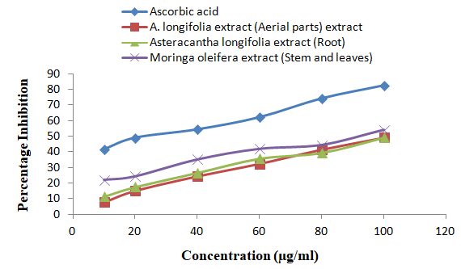

**Fig. 3. % Inhibition of ascorbic acid and extracts using Hydrogen peroxide method**

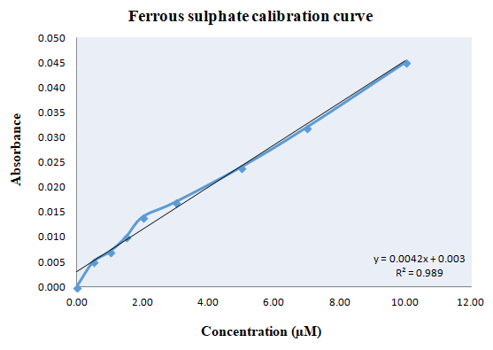

**Fig. 4. Linearity of FRAP (dose–response line) for standard solutions of ferrous sulphate**

**Table 4. Antioxidant activity of ascorbic acid and 70% ethanolic extracts of *Asteracantha longifolia*** and ***Moringa oleifera*** **using FRAP assay**

|  |  |  |  |  |
| --- | --- | --- | --- | --- |
| **S. No.** | **Conc. Fe (II)(µM/g of extract)** | | | |
| **Ascorbic acid** | ***A. longifolia*** **extract (Aerial parts) extract** | ***A. longifolia*** **extract (Root)** | ***M. oleifera*** **extract (Stem and leaves)** |
| 1 | 23.95±12.04 | 6.76±5.38 | 6.76±5.38 | 5.99±1.83 |

4. Conclusion

The present study demonstrated that the 70% ethanolic extracts of Asteracantha longifolia (aerial parts), Asteracantha longifolia (roots), and Moringa oleifera (stem and leaves) possess notable antioxidant activity as evidenced by DPPH, nitric oxide, hydrogen peroxide scavenging, and FRAP assays. Among the tested plant extracts, Moringa oleifera exhibited the highest antioxidant potential across all models, as reflected by its higher % inhibition and lower IC₅₀ values. This suggests a stronger free radical scavenging ability and potential for therapeutic application as a natural antioxidant source. Although Asteracantha longifolia showed comparatively lower antioxidant activities, they still exhibited measurable effects, indicating the presence of bioactive constituents capable of contributing to oxidative stress reduction. These findings support the traditional use of these plants in herbal medicine and highlight their potential for development into antioxidant-rich formulations or dietary supplements. Further studies, including isolation and characterization of the active constituents, as well as *in vivo* evaluations, are recommended to establish the full therapeutic potential of these extracts in oxidative stress-related disorders.

References

1. Ozougwu, J.C. (2016). The role of reactive oxygen species and antioxidants in oxidative stress. International Journal of Research,1(8),1-8.
2. Li, Z., Xu, X., Leng, X., He, M., & Wang, J. (2017). Cheng S, Wu H. Roles of reactive oxygen species in cell signaling pathways and immune responses to viral infections. Archives of virology, 162,603-610.
3. Sultana, N., Saini, P.K., Kiran, S.R., & Kanaka, S. (2023). Exploring the antioxidant potential of medicinal plant species: A comprehensive review. Journal of Plant Biota, 2, 9-13.
4. Abeyrathne, E.D., Nam, K., Huang, X., Ahn, D.U. (2022). Plant-and animal-based antioxidants’ structure, efficacy, mechanisms, and applications: A review. Antioxidants, 11(5),1025.
5. Chavan, T.C., & Kuvalekar, A.A. (2019). A review on drug induced hepatotoxicity and alternative therapies. Journal of Nutrition Health Food Sciences,7(3),1-29.
6. Juthi, T.S. (2017). Studies on the Effects of Asteracantha longifolia on Retardation of Glucose Absorption and Carbohydrate Digestion in Long-Evans Rats (Doctoral dissertation, East West University).
7. Shukla, A.K., Malviya, R.K., & Mishra, J.N. (2022). A review on pharmacological potential of *Asteracantha longifolia*. International Journal of Health Sciences, 6 (S1),14361–14369. https://doi.org/10.53730/ijhs.v6nS1.8682
8. Huang, D.J., Ou, B.X., & Prior, R.L. (2005). The chemistry behind antioxidant capacity assays. Journal of Agricultural Food Chemistry, 53,1841-1856.
9. Chekuri, S., Arunjyothi, B. & Anupalli, R.R. (2018). Radical scavenging activity (2, 2-diphenyl-1- picrylhydrazyl) of *Acalypha indica* linn. (Euphorbeace family) International Journal Of Pharmaceutical Sciences And Research, 9(1), 313-317
10. Basu, S., & Hazra, B. (2006). Evaluation of nitric oxide scavenging activity, in vitro and ex vivo, of selected medicinal plants traditionally used in inflammatory diseases. Phytotherapy Research: An International Journal Devoted to Pharmacological and Toxicological Evaluation of Natural Product Derivatives, 20(10),896-900.
11. Fernando, C.D., & Soysa, P. (2015). Optimized enzymatic colorimetric assay for determination of hydrogen peroxide (H2O2) scavenging activity of plant extracts. MethodsX, 2, 283-291.
12. Wong, C.C., Li, H.B., Cheng, K.W., & Chen, F. (2006). A systematic survey of antioxidant activity of 30 Chinese medicinal plants using the ferric reducing antioxidant power assay. Food chemistry, 97(4),705-711.
13. Alara, O.R., Abdurahman, N.H., & Ukaegbu, C.I. (2018). Soxhlet extraction of phenolic compounds from Vernonia cinerea leaves and its antioxidant activity. Journal of Applied Research on Medicinal and Aromatic Plants,11,12-17.
14. Parkhe, G., & Jain, P. (2018). Study of antioxidant potential of hydroalcoholic extract of *Anethum graveolens*. Career International Journal of Science and Technology, 1(2),39-45.
15. Bawane, A.A., Tiwari, O.P., & Jain, A. P. (2020). Phytochemical analysis and *in vitro* antioxidant studies of *Lagerstroemia parviflora* roxb bark. Journal of Advance Scientific Research, 11 (3), Sl 7, 174-178.
16. Wasiullah, Korde, Mr. B., & Dubey, Dr. B. K. (2023). Phytochemical analysis and in vitro antioxidant activity of hydroalcoholic extract of *Anacyclus Pyrethrum*. International Journal of Pharmaceutics and Drug Research, 12, 42-50.
17. Al-Farsi, M., Alasalvar, C., Morris, A., Baron, M., & Shahidi, F. (2005). Comparison of antioxidant activity, anthocyanins, carotenoids, and phenolics of three native fresh and sun-dried date (Phoenix dactylifera L.) varieties grown in Oman. Journal of Agricultural and Food Chemistry, 53,7592 - 9.
18. Samrit, S.R., Kamble, N. S., Dambhare, A., Hemke, A.T., & Umekar M. J. (2020). Preliminary phytochemical screening of ethanolic extract of *Astercantha longifolia* (*Hygrophylla schulli*) roots along with various activities. World Journal of Pharmaceutical Research, 9(15), 1267-1279.
19. Shukla, A. K., Malviya, R.K., & Mishra J. N. (2022). Analysis of phytoconstituents and antioxidant activity of root extract of *Asteracantha longifolia.* Journal of pharmaceutical negative results, 13(8),4434-4438.
20. Abdulkadir,A.R., Zawawi, D. D. & Jahan Md. S. (2015). DPPH antioxidant activity, total phenolic and total flavonoid content of different part of Drumstic tree (*Moringa oleifera Lam*.) Journal of Chemical and Pharmaceutical Research, 7(4),1423-1428.
21. Lobo, V. C., Phatak, A., & Chandra, N. (2010). Antioxidant and Free Radical Scavenging Activity of *Hygrophila schulli* (Buch.-Ham.) Almeida and Almeida. Seeds. Advances in bioresearch, 1 (2), 72 – 78.