**A prospective observational study to compare DTT treated ABO isoagglutinin titers performed by two different methods, Conventional tube technique (CTT) and Column agglutination technique (CAT) with Hemagglutination (HA)/ Solid Phase Red Cell Adherence (SPRCA) in O blood group individuals**

**ABSTRACT:**

**BACKGROUND AND AIMS**: Accurate measurement of IgG isoagglutinin titers often requires treating plasma with dithiothreitol (DTT). This study aimed to compare DTT-treated ABO antibody titers using two methods: the conventional tube technique (CTT), column agglutination technique (CAT), with hemagglutination/solid-phase red cell adherence (HA/SPRCA).

**MATERIALS AND METHODS:** A prospective observational study was conducted from November 2018 to April 2020. All consenting group O blood donors were enrolled. Antibody titers were measured using CTT and CAT, both before and after DTT treatment (pCTT, pCAT), and were also tested using the HA/SPRCA method.

**RESULTS:** A total of 2004 donors were analyzed. IgG titers were generally higher than IgM titers. Results from pCTT closely matched or were lower than those from HA/SPRCA, whereas pCAT yielded significantly higher IgG titers compared to HA/SPRCA. Titers from pCTT were lower than those from both pCAT and HA/SPRCA, with most values falling below 64. The highest median IgG and IgM titers for both anti-A and anti-B were observed with pCAT. In contrast, the median titers obtained using HA/SPRCA were similar to those from pCTT.

**CONCLUSION:** HA/SPRCA results closely resembled those from pCTT, while pCAT consistently showed higher titers that did not align with either method. HA/SPRCA offers several advantages, including automation, reduced inter-observer variability, and faster processing time, making it a potential alternative to pCTT. However, further studies assessing the clinical relevance of these findings are necessary to determine the most appropriate testing method.

**KEYWORDS: ABO, Conventional tube technique, Column agglutination technology, DTT, titration,SPRCA**

**INTRODUCTION:**

ABO isohemagglutinins significantly influence graft outcomes in both ABO-incompatible solid organ transplants and hematopoietic stem cell transplants [1-4]. Hyperacute graft rejection, pure red cell aplasia, and delayed engraftment are major complications associated with such transplants, commonly attributed to the presence of ABO antibodies [5-7]. Anti-A and anti-B antibodies in individuals with blood groups A and B are predominantly of the IgM type, whereas in group O individuals, they are mainly of the IgG type. As these antibodies play a crucial role in immune responses during transfusion and transplantation, accurate measurement is essential. However, during routine laboratory testing, the presence of IgM antibodies can mask the detection of IgG antibodies, making their precise quantification challenging [1]. Therefore, it becomes necessary to inactivate IgM antibodies to accurately determine the true concentration of IgG antibodies. Several methods have been described in the literature for this purpose, including heat inactivation at 63°C and the use of sulfhydryl reagents such as 2-mercaptoethanol (2-ME) and dithiothreitol (DTT) [8,9]. Dithiothreitol (DTT), also known as Cleland’s reagent, is a sulfhydryl compound that inactivates IgM antibodies by breaking the inter-subunit disulfide bonds that maintain their pentameric structure [10,11]. DTT offers advantages over 2-mercaptoethanol (2-ME), including the absence of a strong, unpleasant odor and, in certain cases, eliminating the need for specimen dialysis [10,12,13]. IgG antibodies are less susceptible to DTT because the disulfide bonds in their structure are more stable and less labile compared to those in IgM antibodies [13,14]. Since DTT effectively inactivates IgM antibodies, its routine use has been recommended in clinical laboratories, particularly in cases where IgM interference is suspected [10,15].

Titration is a semi-quantitative technique commonly used to estimate the concentration of these antibodies. [16,17]. Several methods exist for ABO titration; however, a universally recognized reference method to define safe clinical titers is still lacking. The conventional test tube technique (CTT) is the oldest and most standardized approach but has notable limitations. It is labor-intensive, time-consuming, susceptible to technical errors, and subject to inter-observer variability. To improve efficiency and productivity, automation has been introduced into immunohematology testing [18-21]. Automated immunohematology analyzers offer advantages such as high throughput, reduced inter-observer and inter-laboratory variability, and greater ease of use for laboratory personnel. These analyzers employ various techniques, including column agglutination technology (CAT) and solid-phase red cell adherence (SPRCA) or hemagglutination (HA). Numerous studies comparing different titration methods have concluded that results obtained by the traditional CTT often do not correlate well with those from these newer techniques [22,26]. While automation offers benefits such as accessibility, easy to use, reproducibility, and clearly defined endpoints for agglutination reactions, standardisation of these techniques remains challenging. Significant variability persists between different techniques and across laboratories [22-27]. The aim of this study was to compare the results of HA/SPRCA with those obtained by CTT and CAT using DTT-treated plasma (pCTT, pCAT) by:  
a) Calculation of correlation between anti-A and anti-B (IgG and IgM) results from pCTT (using a 1+ reaction strength as the endpoint) and pCAT (using 1+, 2+, or 3+ reaction strengths as endpoints) with the results from SPRCA/HA.  
b) Calculation and comparison of median anti-A and anti-B (IgG and IgM) titers obtained by pCTT, pCAT, and SPRCA/HA.

**MATERIALS AND METHODS:**

**1.1** **Settings and design:**

This prospective and observational study was conducted in the Department of Transfusion Medicine at a tertiary healthcare center from November 2018 to April 2020. A target sample size of 2000 donors was planned. Serum from each donor was treated with DTT, and titers were simultaneously measured using both CTT and CAT. Untreated samples were tested for anti-A and anti-B titers using all three methods: CAT, CTT, and HA/SPRCA. All results were recorded for comparative analysis.

**1.2 Study population:**

All consecutive blood group O donors who met the eligibility criteria for blood donation according to the Drugs and Cosmetics Act, 1940, and the Standards for Blood Banks and Blood Transfusion Services were included in the study [28,29]. Pilot tubes collected during donation were used for titration. Following routine testing, antibody titration was conducted on the remaining sample either the same day or the next day. Samples tested the following day were stored at 4°C. Donors who did not consent to participate, those positive for transfusion-transmitted infections, and samples with a positive direct antiglobulin test or antibody screen were excluded from the study.

**1.3 DTT preparation and treatment of serum:**

A 0.01M DTT solution was prepared by dissolving 0.154 g of DTT in 100 ml of PBS (pH 7.3), following the procedure outlined in the AABB Technical Manual [1].Serum was treated with 0.01M DTT following the procedure described in the AABB Technical Manual [1]. Equal volumes of the prepared 0.01M DTT solution and serum were mixed together. The mixture was incubated at 37°C for 30 to 45 minutes, with gentle mixing every 5 minutes. Serial dilutions were then prepared from this mixture, and antibody titration for both IgM and IgG was performed using CAT and CTT. As a dilution control, an equal volume of patient serum was mixed with PBS, and serial dilutions and titrations were conducted on this mixture to ensure that any reduction in reactivity was not due to dilution alone.

**1.4 Methods of titration:**

**1.4.1 Conventional Tube Technique (CTT):** Titration was performed using the CTT method as outlined in the AABB Technical Manual [2]. The titer endpoint was defined as the reciprocal of the highest dilution showing 1+ agglutination visible to the naked eye. Reactions for both IgM and IgG were documented on a case reporting form.

**1.4.2 Column Agglutination Technique (CAT):** For IgM titer determination, Neutral Ortho BioVue System cassettes (Ortho Clinical Diagnostics, Raritan, New Jersey, USA) were used while for IgG, Anti-IgG Monospecific Ortho BioVue System cassettes (Ortho Clinical Diagnostics, Raritan, New Jersey, USA) were used. The reactions were read and recorded. The titer endpoint was defined as the lowest dilution showing 1+, 2+, or 3+ agglutination as seen by naked eye.

**1.4.3 ANTIBODY TITRATION BY NEO IMMUOHEMATOLOGY ANALYZER (AUTOMATED METHOD):** IgM titers were measured using hemagglutination (HA), and IgG titers were determined by solid-phase red cell adherence (SPRCA), following the manufacturer’s instructions. Capturing and analysis of agglutination reactions was done by automated cameras. The titer endpoint was defined as the reciprocal of the lowest dilution exhibiting 1+, 2+, or 3+ agglutination.

**1.5 INTER-OBSERVER VARIATION:** For minimizing inter-observer bias in the manual (CTT) and semi-automated (CAT) methods, independent testing of every sample was done by two different personnel. Transfusion Medicine physician reviewed the results and made the final determination.

**1.6 Statistical Analysis:**

Data were entered into an MS Excel sheet, and numerical values, percentages, means, and standard deviations were calculated. Statistical analysis was conducted using SPSS software (Version 25.0.0.0, Chicago, USA). Median IgM and IgG titers for anti-A and anti-B obtained by pCTT, pCAT, and HA/SPRCA were calculated. Correlation between the methods was assessed using Spearman’s rho on the first 200 samples. The strength of the correlation was interpreted based on the absolute value of rs as follows:

0.0-0.18 - very weak

0.19-0.38 - weak

0.39-0.58 - moderate

0.59-0.78 - strong

0.79-1.0 - very strong

To assess the significance of differences in IgM and IgG results between pCTT (1+) and pCAT (1+), pCTT (1+) and HA/SPRCA, and pCAT (1+) and HA/SPRCA for each sample, nonparametric Wilcoxon signed-rank paired test was used. For this analysis, a total of 10 samples (every 199th sample) were included.

**ETHICAL APPROVAL:**

All donors who provided consent were included in the study. The study received approval from the Institutional Review Board (IRB) and the Institutional Ethics Committee (IEC).

**RESULTS:**

A total of 2004 healthy whole blood donors with blood group O participated in this study, of whom 1914 (95.5%) were male and 90 (4.5%) were female. The mean age of the participants was 32.1 ± 8.06 years. Inter-observer variation was observed in 297 (14.82%) samples tested by CTT and in 49 (2.44%) samples tested by CAT. The distribution of anti-A and anti-B IgG and IgM titers measured by pCTT, pCAT, and HA/SPRCA using a 1+ reaction strength as the endpoint, illustrated through box-and-whisker plots in figure 1. For both anti-A and anti-B, IgM titers were lower than IgG titers. In pCTT, anti-A IgG titers were lower than anti-B IgG titers, whereas anti-B IgM titers were lower than anti-A IgM titers. In pCAT, anti-A and anti-B IgM titers were similar, but anti-A IgM titers were lower than anti-B IgM titers. In HA/SPRCA, both IgM and IgG titers for anti-A and anti-B were comparable.

Figure 2 compares the distribution of IgM and IgG ABO isoagglutinin titers obtained by pCAT, pCTT, and HA/SPRCA at the 1+ strength endpoint. Overall, HA/SPRCA results were lower than those from pCAT but higher than those from pCTT. Most titers measured by pCAT were above 32, while the majority of pCTT results were below 64. The distribution of IgM titers for anti-A and anti-B was similar, whereas a leftward shift was observed for anti-B IgG titers compared to anti-A, indicating lower anti-B IgG titers. Additionally, IgG titers showed a rightward shift relative to IgM titers, reflecting generally higher IgG levels.

Figure 3 compares the median IgM and IgG titers for anti-A and anti-B measured by pCAT, pCTT, and HA/SPRCA, at 1+, 2+, and 3+ endpoints. Median IgG titers for both anti-A and anti-B were higher than median IgM titers. Among the methods, median IgM and IgG titers were highest with pCAT, followed by HA/SPRCA, and lowest with pCTT. For anti-A IgM, pCTT at 1+ strength matched HA at 2+ strength, while pCAT at 2+ strength matched HA at 3+ strength. For anti-A IgG, pCTT at 1+ and pCAT at 3+ strengths corresponded to SPRCA at 2+ strength. For anti-B IgM, pCTT at 1+ matched HA at both 2+ and 3+ strengths, and pCAT at 2+ matched HA at 1+ strength. For anti-B IgG, pCTT at 1+ matched SPRCA at 2+ strength, while pCAT at 2+ matched SPRCA at 1+ strength. Overall, median titers from pCTT (1+ strength) closely resembled HA/SPRCA results, differing by only one dilution across categories, whereas median pCAT titers were substantially higher than both median HA/SPRCA and pCTT titers.

Table 1 presents Spearman’s rho (rs) values indicating the correlation between pCTT (1+ strength) and HA/SPRCA, and between pCAT (at 1+, 2+, and 3+ strengths) and HA/SPRCA for the first 199 samples. The statistical analysis was conducted separately for IgG and IgM titers of anti-A and anti-B antibodies. Their results demonstrate that correlations between HA/SPRCA and both pCAT and pCTT were stronger for IgG titers compared to IgM titers.

Figure 4 shows the trends of IgG and IgM results obtained for every 199th sample by the three methods. To compare pCTT (1+) with pCAT (1+), pCTT (1+) with HA/SPRCA, and pCAT (1+) with HA/SPRCA for statistical significance, a Wilcoxon signed-rank paired test was used. For anti-A and anti-B IgG results, no statistically significant difference was found between pCTT and SPRCA, whereas significant differences were observed between pCAT and SPRCA, and between pCTT and pCAT. For anti-A and anti-B IgM results, statistically significant difference was not observed between pCAT and HA, while significant differences were noted between pCTT and pCAT, as well as between pCTT and HA.

**DISCUSSION:**

ABO isohemagglutinins are quantified by preparing serial dilutions of plasma. CTT is the traditional method used for ABO antibody titration. But this method is time-consuming which requires specialized expertise, and is susceptible to errors. Additionally, its reproducibility is low and shows considerable inter-laboratory and inter-observer variability. To enhance laboratory efficiency, automation has been widely adopted for various tests which also includes immunohematology. ABO titration by automation offers benefits such as high throughput, reduced turnaround time, minimal training requirements for existing staff, and the capability to individually quantify both IgM and IgG antibodies. However, the antibody titration end points and their clinical relevance have yet to be clearly established.

IgG antibodies are considered to play a critical role in graft outcomes, which is why estimating IgG titers using DTT treatment has been recommended [10,15]. IgM antibodies are inactivated by DTT which has less effect on IgG antibodies [10,13]. While DTT treatment is necessary for accurate IgG titer estimation using CTT and CAT, it is not required with HA/SPRCA. HA exclusively measures IgM titers, while SPRCA specifically detects IgG, effectively eliminating interference from IgM antibodies and the need for their inactivation. In this study, ABO antibody titration was performed in O blood group donors where DTT-treated plasma was used with both CAT and CTT, and the results with those obtained by HA/SPRCA were compared.

Tendulkar et al did titration for 100 O blood group donors by using tube technique and microplate method [30]. They measured the median anti-A and anti-B titer by microplate method and found them to be 128 with a range from 4 to 2048. There was good correlation. In our study, the median Anti-A IgM and IgG titers measured by HA/SPRCA were 16 and 32 respectively and those for Anti-B were 16 and 64. The Spearman’s correlation coefficient was moderate between pCTT and HA/SPRCA; and between pCAT and HA/SPRCA for both anti-A and anti-B IgG titers.

Matsura et al used DTT treated plasma for automated titer estimation by CAT to define the cut-off value in antibody titration and found 45% concordance and a significant positive correlation between CTT and automated CAT with weak strength of reaction. They recommended use of DTT for titer estimation by automated CAT [31]. Kang et al concluded from their study that there were significant differences in the titers depending on the detection method used, and each method showed a different detection capacity for each ABO antibody depending on the ABO blood group tested and therefore, caution should be exercised in interpreting ABO antibody titer results, taking into consideration the detection method used and the blood group [15]. For blood group O, mean titers of CAT were higher than CTT. Similarly, in the present study, there were differences in the results obtained by different methods. Both IgM and IgG titers obtained by pCAT were found to be higher than pCTT and HA/SPRCA.

Shim et al compared three methods of antibody titration and found that the median IgM and IgG titres were higher by CAT [32]. In the present study, median titers were determined separately for IgM and IgG for anti-A and anti-B. Median titers observed by pCAT were higher than those obtained by pCTT. Park et al compared only IgG titers of CTT with CAT and found that no statistically significant difference was found between them for blood group A and B while for blood group O, the titers were more in CAT than CTT [17].In the present study, when comparing 1+ reaction strength, both IgM and IgG titers were found to be higher when measured by pCAT as compared to pCTT. Nayak et al compared five methods of titration on 50 samples and concluded that SPRCA was superior to CTT and comparable to CAT [33]. The study population discussed by Nayak et al included only 2 (4%) female participants which was similar to the present study. While the agreement found in the present study between of HA/SPRCA was found to be poor with pCTT and pCAT results, the correlation of IgG results was found to be satisfactory. HA/SPRCA results were found to be higher than pCTT results and lower than pCAT results. It was difficult to determine which method of titration is superior.

Shim et al compared three methods of antibody titration using 40 samples and found that median ABO IgM and IgG titers of all blood groups obtained by the erythrocyte-magnetized technology method were higher than that obtained by the conventional tube haemagglutination and micro-column agglutination [32]. They found that the agreement between the methods was low in IgG. In the present study results of pCAT were found to be higher than those found by pCTT, concordance between HA/SPRCA and pCTT, pCAT was found to be poor. However, the correlation was found to be positive for IgG titers.

Lally et al. compared antibody titer results obtained using an automated, solid-phase and agglutination-based platform with those from manual gel testing across 54 patient samples [34]. Out of the 54 patient samples included in the study, 17 were from group O individuals. In this subgroup, the study found that for both anti-A and anti-B antibodies, the results obtained using CAT and HA/SPRCA showed statistically significant correlation. In the present study, comparison of anti-A and anti-B IgG results revealed no significant difference between pCTT and SPRCA; however, significant differences were observed between pCAT and SPRCA, as well as between pCTT and pCAT. In contrast, for anti-A and anti-B IgM results, no significant difference was found between pCAT and HA, whereas significant differences were noted between pCTT and pCAT, and between pCTT and HA.

The strengths of this study include a large and robust sample size, as well as the use of duplicate testing by two independent individuals to minimize observer bias. Notably, this is the first study to evaluate the impact of DTT on anti-A and anti-B titers and to compare these results with HA/SPRCA in a cohort of over 2000 group O individuals. A key limitation of the study is the inability to evaluate the clinical relevance or impact of titration results obtained after DTT treatment.

**CONCLUSION:**

In conclusion, IgG titers were consistently higher than IgM titers across all three methods, pCAT, pCTT, and HA/SPRCA. DTT treatment effectively reduces IgM interference and is therefore strongly recommended for accurately determining IgG titers when using CTT or CAT methods. Although more time-consuming, DTT ensures a more reliable estimation of true IgG antibody levels. Among the methods compared, HA/SPRCA results were more closely aligned with those obtained by pCTT, while pCAT titers were notably higher and did not correlate well with either HA/SPRCA or pCTT. SPRCA offers several advantages, including automation, reduced inter-observer variability, and faster turnaround times, as it specifically measures IgG without IgM interference, eliminating the need for DTT treatment. Nonetheless, further research is needed to evaluate the clinical significance of these findings and to determine the most appropriate method for use in transfusion and transplant settings.

**REFERENCES:**

1. Davis CS, Milia D, Gottschall JL, Weigelt JA. Massive transfusion associated with a hemolytic transfusion reaction: necessary precautions for prevention. Transfusion 2019;59:2532-5.

2. Fung MK, Eder AF, Spitalnik SL, Westhoff C M. Technical Manual, 19th edn. AABB, Bethesda, MD, 2017.

3. Rowley SD, Donato ML, Bhattacharyya P: Red blood cell-incompatible allogeneic hematopoietic progenitor cell transplantation. Bone Marrow Transplant 2011; 46:1167–85.

4. Simmons DP, Savage WJ: Hemolysis from ABO incompatibility. Hematol Oncol Clin North Am 2015; 29:429– 43.

5. Booth GS, Gehrie EA, Bolan CD, Savani BN. Clinical guide to ABO-incompatible allogeneic stem cell transplantation. Biology of Blood and Marrow Transplantation. 2013;19:1152-8.

6. Tobian AAR, Shirey RS, King KE: ABO antibody titer monitoring for incompatible renal transplantation. Transfusion 2011; 51:454–7.

7. Stussi G, Halter J, Bucheli E, Valli PV, Seebach L, Gmür J, et al. Prevention of pure red cell aplasia after major or bidirectional ABO blood group incompatible hematopoietic stem cell transplantation by pretransplant reduction of host anti-donor isoagglutinins. haematologica. 2009;94:239–48.

8. Reesink HW, van der Hart M, Loghem JV. Evaluation of a simple method for determination of IgG titre anti‐A or‐B in cases of possible ABO blood group incompatibility. Vox sanguinis. 1972;22:397-407.

9. Olson PR, Weiblen BJ, O'Leary JJ, Moscowitz AJ, McCullough J. A Simple Technique for the Inactivation of IgM Antibodies Using Dithiothreitol. Vox sanguinis. 1976;30:149-59.

10. Okuno TA, Kondelis NI. Evaluation of dithiothreitol (DTT) for inactivation of IgM antibodies. Journal of clinical pathology. 1978;31:1152-5.

11. Cleland WW. Dithiothreitol, a new protective reagent for SH groups. Biochemistry. 1964;3:480-2.

12. Pirofsky B, Rosner ER. DTT Test: A New Method to Differentiate IgM and IgG Erythrocyte Antibodies 1. Vox sanguinis. 1974;27:480-8.

13. Moore, S. B., and Steane, E. A. (1976). Thiol reagents in blood banking. In Special Serological Techniques. Useful in Problem Solving, pp. 17-51. American Association of Blood Banks, Washington, DC.

14. Chapman JR, Taylor CJ, Ting A, Morris PJ. Immunoglobulin class and specificity of antibodies causing positive T cell crossmatches. Relationship to renal transplant outcome. Transplantation. 1986;42:608-13.

15. Kang SJ, Lim YA, Baik SY. Comparison of ABO antibody titers on the basis of the antibody detection method used. Ann Lab Med.2014;34:300-6.

16. Adriaansen MJ, Perry HE. Validation of column agglutination technology for blood group alloantibody titration. New Zealand Journal of Medical Laboratory Science. 2013;67:92.

17. Park ES, Jo KI, Shin JW, Park R, Choi TY, Bang HI, et al. Comparison of total and IgG ABO antibody titers in healthy individuals by using tube and column agglutination techniques. Annals of laboratory medicine. 2014;34:223-9.

18. Bruce M, Chapman JF, Duguid J, Kelsey P, Knowles S, Murphy M, et al. Addendum for guidelines for blood grouping and red cell antibody testing during pregnancy. BCSH Transfusion Task Force. Transfusion medicine (Oxford, England). 1999;9:99-101.

19. AuBuchon JP, de Wildt‐Eggen J, Dumont LJ, Biomedical Excellence for Safer Transfusion Collaborative, Transfusion Medicine Resource Committee of the College of American Pathologists. Reducing the variation in performance of antibody titrations. Vox sanguinis. 2008;95:57-65.

20. Bajpai M, Kaur R, Gupta E. Automation in immunohematology. Asian journal of transfusion science. 2012;6:140.

21. Rumsey DH, Ciesielski DJ. New protocols in serologic testing: A review of techniques to meet today's challenges. IMMUNOHEMATOLOGY-WASHINGTON DC-. 2000;16:131-7.

22. Siani B, Willimann K, Wymann S, Marques AA, Widmer E. Isoagglutinin reduction in human immunoglobulin products by donor screening. Biologics in therapy. 2014;4:15-26

23. Kim B, Jin Park Y, Kim JJ, Lee E, Kim S, Kim HO. Evaluation of the automated immunohematology analyzer ORTHO VISION for ABO antibody titration. The Korean Journal of Blood Transfusion. 2015;26:257-65.

24. Yoo J, Yu H, Choi H, Lee GW, Song YS, Lee S, et al. Evaluation of the automated immunohematology analyzer DAYMATE M. Laboratory Medicine Online. 2017;7:163-9.

25. Denise M. Harmening, editor. 6th edition. USA. Modern Blood Banking and Transfusion Practices; 2005.

26. Ching E: Solid Phase Red Cell Adherence Assay: a tubeless method for pretransfusion testing and other applications in transfusion science. Transfus Apher Sci 2012; 46:287–291.

27. Finck R, Lui‐Deguzman C, Teng SM, Davis R, Yuan S. Comparison of a gel microcolumn assay with the conventional tube test for red blood cell alloantibody titration. Transfusion. 2013;53:811-5.

28. The Drug and Cosmetics Act, 1940 and the Drug and Cosmetics Rules, 1945, as amended up to 30th June, 2005. Schedule F. Part XIIB. Central Drugs Standard Control Organization. Director General of Health Services. Ministry of Health and Family Welfare. Government of India; 268–288. Available from URL: http://www.cdsco.nic.in/writereaddata/drugs&cosmeticact.pdf

29. Standards For Blood Banks & Blood Transfusion Services, National AIDS Control Organization, Ministry of Health and Family Welfare, Government of India, New Delhi, 2007.

30. Tendulkar AA, Jain PA, Velaye S. Antibody titers in Group O platelet donors. Asian journal of transfusion science. 2017;11:22.

31. Matsuura H, Akatsuka Y, Matsuno T, Sugiura Y, Arakawa S, Oikawa S, et al. Comparison of the tube test and column agglutination techniques for anti‐A/‐B antibody titration in healthy individuals. Vox sanguinis. 2018;113:787-94.

32. Shim H, Hwang JH, Kang SJ, Seo HS, Park EY, Park KU, et al. Comparison of ABO isoagglutinin titers by three different methods: tube haemagglutination, micro‐column agglutination and automated immunohematology analyzer based on erythrocyte‐magnetized technology. Vox Sanguinis. 2020;115:233-40.

33. Nayak S, Makroo RN, Prakash B, Chandra T, Agrawal S, Chowdhry M, et al. Comparative Evaluation of Five Different Methods of Anti‐ABO Antibody Titration: An Aid for ABO‐Incompatible Organ Transplants. Therapeutic Apheresis and Dialysis. 2019;23:86-91.

34. Lally K, Kruse RL, Smetana H, Davis R, Roots A, Marshall C, et al. Isohemagglutinin titering performed on an automated solid‐phase and hemagglutinin‐based analyzer is comparable to results obtained by manual gel testing. Transfusion. 2020;60:628-36.

**Table 1:** **Correlation between ABO isohemagglutinin titer results:**

**[a] Anti-A and Anti-B IgM and IgG titres done by pCAT and HA/SPRCA**

|  |  |  |  |  |  |  |  |
| --- | --- | --- | --- | --- | --- | --- | --- |
| **Antibody** | **Comparing methods** | **Spearman’s rho** | **P-value** | | **Strength of correlation** | **Association** | **Direction of correlation** |
|  | | | | | | | |
| **IgM** | | | | | | | |
| **Anti-A** | HA – pCAT(1+) | 0.37 | <0.05 | | Weak | Significant | Positive |
| **Anti-B** | HA– pCAT(1+) | 0.45 | <0.05 | | Moderate | Significant | Positive |
| **IgG** | | | | | | | |
| **Anti-A** | SPRCA –pCAT(1+) | 0.54 | <0.05 | | Moderate | Significant | Positive |
| **Anti-B** | SPRCA– pCAT(1+) | 0.58 | <0.05 | | Moderate | Significant | Positive |
| **IgM** | | | | | | | |
| **Anti-A** | HA – pCAT(2+) | 0.37 | <0.05 | | Weak | Significant | Positive |
| **Anti-B** | HA – pCAT(2+) | 0.47 | <0.05 | | Moderate | Significant | Positive |
| **IgG** | | | | | | | |
| **Anti-A** | SPRCA– pCAT(2+) | 0.53 | <0.05 | | Moderate | Significant | Positive |
| **Anti-B** | SPRCA– pCAT(2+) | 0.55 | <0.05 | | Moderate | Significant | Positive |
| **IgM** | | | | | | | |
| **Anti-A** | HA – pCAT(3+) | 0.36 | <0.05 | | Weak | Significant | Positive |
| **Anti-B** | HA– pCAT(3+) | 0.48 | <0.05 | | Moderate | Significant | Positive |
| **IgG** | | | | | | | |
| **Anti-A** | SPRCA– pCAT(3+) | 0.51 | <0.05 | | Moderate | Significant | Positive |
| **Anti-B** | SPRCA– pCAT(3+) | 0.56 | <0.05 | | Moderate | Significant | Positive |
| pCTT: post DTT treatment performed by CTT | | | | pCAT: post DTT treatment performed by CAT | | | |

**[b] Anti-A and Anti-B IgM and IgG titres done by pCTT and HA/SPRCA**

|  |  |  |  |  |  |  |  |
| --- | --- | --- | --- | --- | --- | --- | --- |
| **Antibody** | **Comparing methods** | **Spearman’s rho** | **P-value** | | **Strength of correlation** | **Association** | **Direction of correlation** |
|  | | | | | | | |
| **IgM** | | | | | | | |
| **Anti-A** | HA – pCTT(1+) | 0.37 | <0.05 | | Weak | Significant | Positive |
| **Anti-B** | HA– pCTT(1+) | 0.35 | <0.05 | | Weak | Significant | Positive |
| **IgG** | | | | | | | |
| **Anti-A** | SPRCA –pCTT(1+) | 0.52 | <0.05 | | Moderate | Significant | Positive |
| **Anti-B** | SPRCA– pCTT(1+) | 0.50 | <0.05 | | Moderate | Significant | Positive |
| pCTT: post DTT treatment performed by CTT | | | | pCAT: post DTT treatment performed by CAT | | | |

**Figure 1**: **Anti-A and anti-B titers distribution:**

**[a] Titers done by pCTT and HA: IgM**

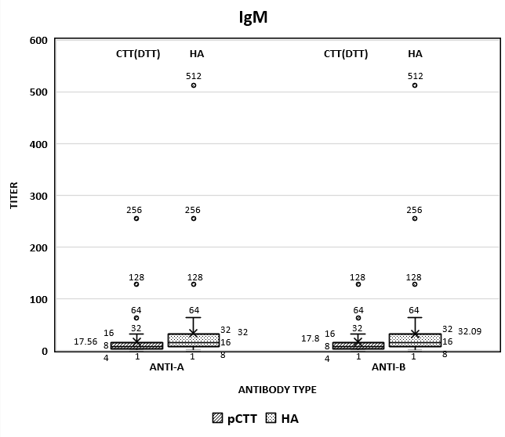

**[b] Titres done by pCTT and SPRCA: IgG**

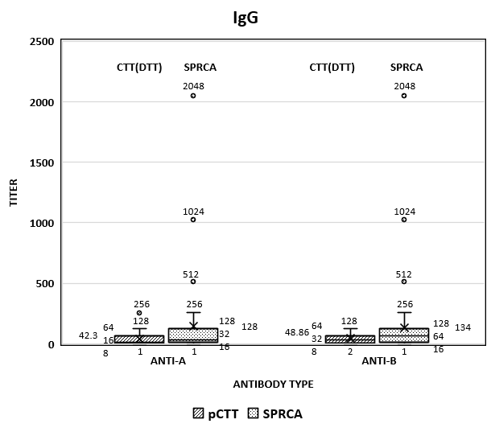

**[c] Titers done by pCAT and HA: IgM**

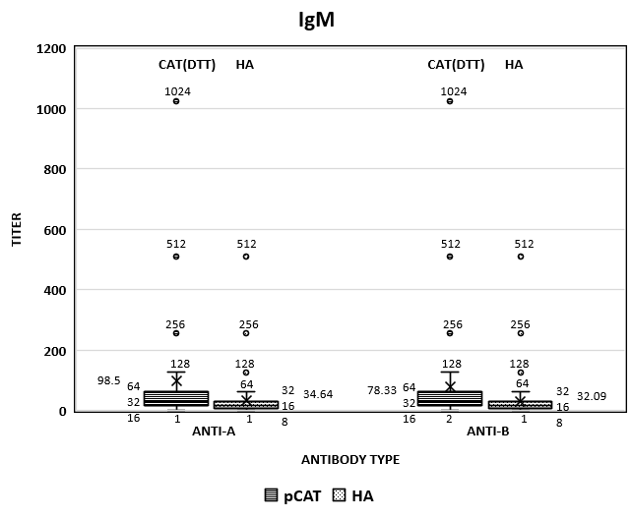

**[d] Titers done by pCAT and SPRCA: IgG**

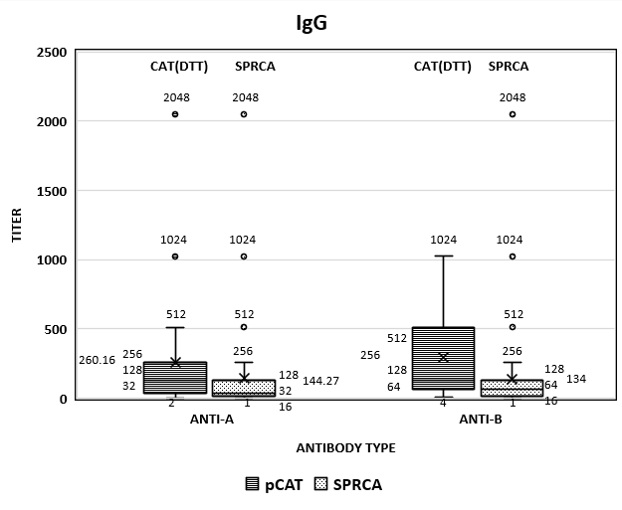

**Figure 2: Comparison of distribution of titers at 1+ strength end points:**

**[a] Comparison of Anti-A IgM titres done by pCTT, pCAT and HA (MP)**

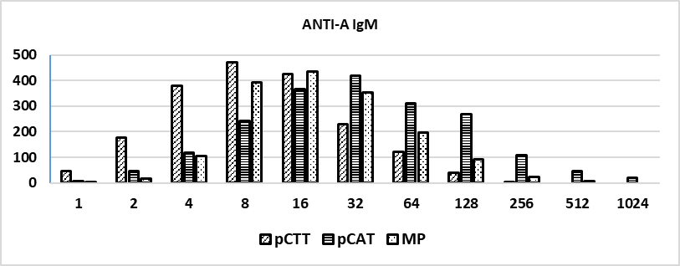

**[b] Comparison of Anti-A IgG titres done by pCTT, pCAT and SPRCA (MP)**

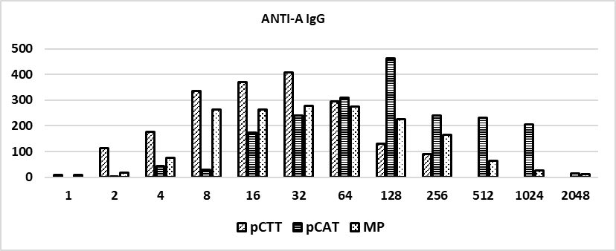

**[c] Comparison of Anti-B IgM titres done by pCTT, pCAT and HA (MP)**

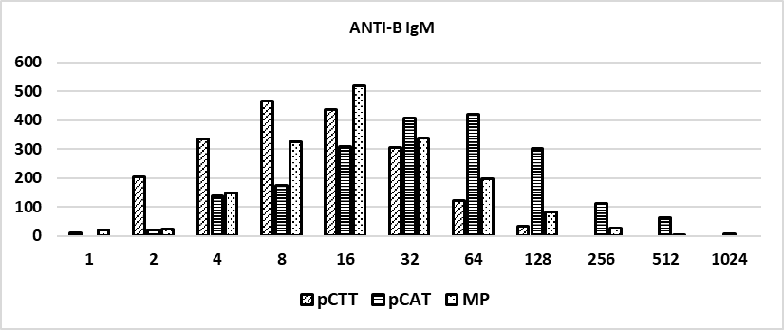

**[d] Comparison of Anti-B IgG titres done by pCTT, pCAT and SPRCA (MP)**

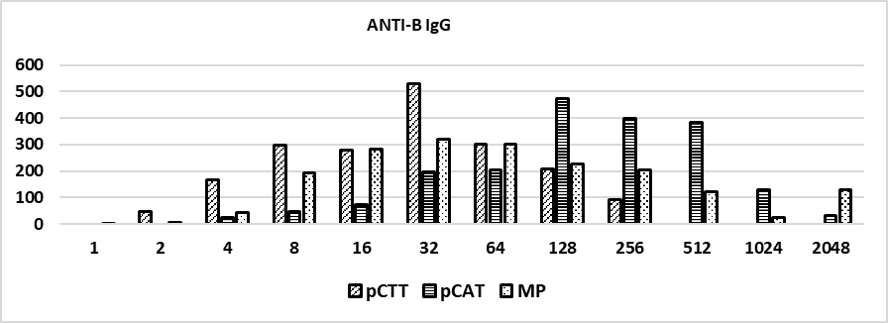

**Figure 3: Comparison of median titres interpreted at 1+, 2+ and 3+ end points:**

**[a] Comparison of median Anti-A IgM titres done by pCTT, pCAT and HA**

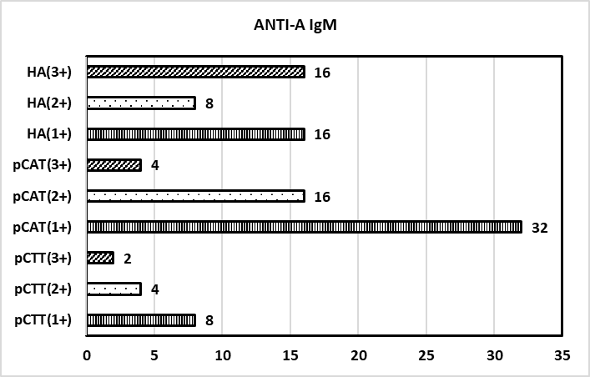

**[b] Comparison of median Anti-A IgG titres done by pCTT, pCAT and SPRCA**

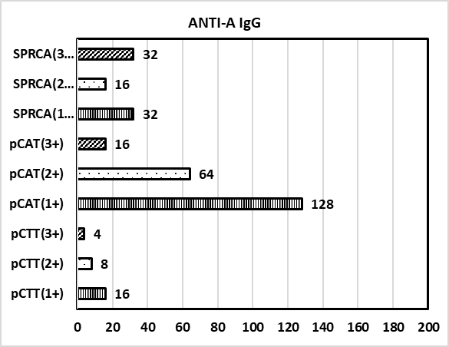

**[c] Comparison of median Anti-B IgM titres done by pCTT, pCAT and HA**

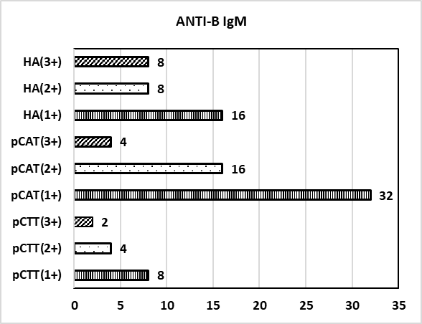

**[d] Comparison of median Anti-B IgG titres done by pCTT, pCAT and SPRCA**

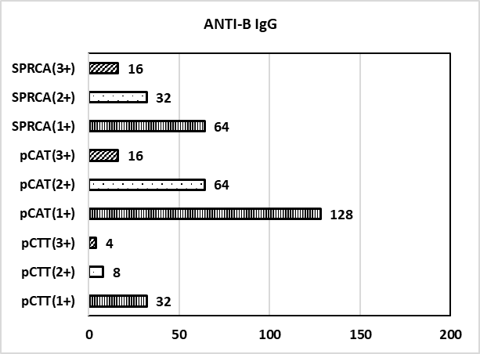

**Figure 4: Comparison of titers of 10 samples based on Wilcoxon signed rank test (S indicates significant and NS indicates not significant):**

**[a] Comparison of Anti-A IgM titers done by pCTT (+1 end point), pCAT (+1 end point) and HA**

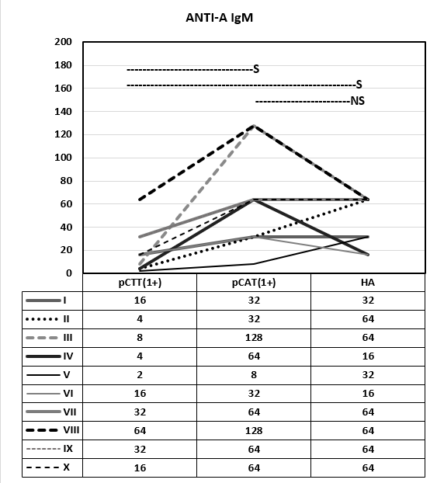

**[b] Comparison of Anti-A IgG titers done by pCTT (+1 end point), pCAT (+1 end point) and SPRCA**

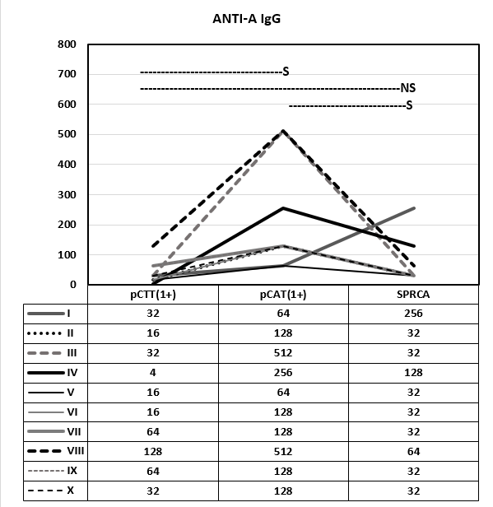

**[c] Comparison of Anti-B IgM titers done by pCTT(+1 end point), pCAT (+1 end point) and HA**

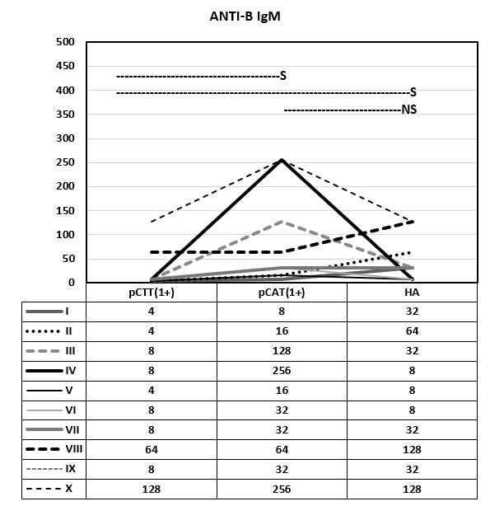

**[d] Comparison of Anti-B IgG titers done by pCTT(+1 end point), pCAT (+1 end point) and SPRCA**

