**Case report**

**Hemoadsorption with CytoSorb in Pediatric Patient of Dengue Shock Syndrome: A Case Report**

**Abstract**

Dengue Shock Syndrome (DSS), a severe manifestation of dengue virus infection, poses significant challenges in pediatric populations due to its rapid progression to systemic inflammation and multi-organ dysfunction syndrome (MODS). Conventional management often proves inadequate in fulminant cases. CytoSorb hemoadsorption, an extracorporeal cytokine removal therapy, has shown promise in controlling cytokine storms associated with critical illness but remains underexplored in dengue. We report the case of a 13-year-old male presenting with DSS complicated by respiratory failure, coagulopathy, renal impairment, and persistent shock unresponsive to standard treatment. Despite intensive supportive care, including mechanical ventilation, vasopressors, and blood products, the patient's condition continued to deteriorate. CytoSorb therapy was initiated as a rescue intervention. Two sessions led to rapid clinical and laboratory improvements, including resolution of shock, normalization of inflammatory markers (IL-6, CRP, lactate), improved oxygenation, and recovery of organ function. The patient was extubated within 48 hours of the second session and was shifted to ward in stable condition by ICU day 7.

This case highlights the potential utility of CytoSorb hemoadsorption as an effective adjunctive therapy in severe DSS with MODS, particularly where traditional approaches are insufficient. Further studies are warranted to validate its efficacy in pediatric dengue care.

Keywords: CytoSorb, Dengue, Shock Syndrome, Case report.

**Introduction**

Dengue virus (DENV), transmitted by the *Aedes* mosquito, continues to be a significant global health burden with an estimated 390 million infections annually, of which approximately 500,000 develop into severe forms such as Dengue Hemorrhagic Fever (DHF) or Dengue Shock Syndrome (DSS) [1,2]. DSS is characterized by systemic vascular leak syndrome leading to hypovolemia, hypotension, and multiple organ dysfunction syndrome (MODS) [3,4]. The condition primarily affects pediatric populations in endemic regions, posing a major challenge due to the limited therapeutic options beyond supportive care [5,6]. The pathophysiology of DSS is increasingly understood to involve a hypercytokinemia state, similar to sepsis and hemophagocytic lymphohistiocytosis (HLH), marked by elevated interleukin-6 (IL-6), tumor necrosis factor-alpha (TNF-α), and interferon gamma (IFN-γ) [7,8]. Current supportive therapies include fluid resuscitation, vasopressors, and blood product transfusions. However, in fulminant cases, these interventions are often insufficient to reverse the inflammatory cascade and restore hemodynamic stability [9].

CytoSorb is an extracorporeal cytokine adsorber device approved in the European Union and used worldwide for sepsis, cytokine storm, and MODS. The polymer beads in CytoSorb selectively remove mid-molecular-weight inflammatory mediators, thereby mitigating systemic inflammation [10-12]. Its role in dengue-associated cytokine storm, though not extensively studied, has shown promise in preliminary case reports and observational series [13,14]. Emerging evidence suggests CytoSorb can shorten ICU stays, reduce vasopressor duration, and improve survival in sepsis-related MODS [15-17]. Pediatric use, while limited, has been reported in severe viral infections, postoperative inflammation, and refractory septic shock [18-20]. Given these precedents, CytoSorb may offer an effective adjunctive strategy in severe dengue infections where traditional measures fail to control inflammation and organ dysfunction [21,22].

**Case Presentation**

A 13-year-old previously healthy male, weighing 37 kg, presented to the emergency department at Apollo Imperial Hospital, Chattogram, Bangladesh, with a 4-day history of high-grade fever, generalized body aches, anorexia, and progressive abdominal distension. On examination, the patient was febrile (39.2°C), tachycardic (heart rate: 132 bpm), hypotensive (BP: 85/50 mmHg), and had reduced urine output over the past 12 hours. Notably, there was abdominal tenderness with visible distension, reduced breath sounds at both lung bases, and subconjunctival hemorrhages — clinical signs suggestive of plasma leakage and early third spacing.

Initial laboratory tests showed hemoconcentration with elevated hematocrit, thrombocytopenia (platelets 18,000/mm³), leukopenia, and elevated liver enzymes. Chest X-ray revealed bilateral infiltrates suggestive of pulmonary edema or evolving acute respiratory distress syndrome (ARDS). Given his deteriorating respiratory status and altered mental state, he was urgently admitted to the intensive care unit (ICU). Shortly after ICU admission, the patient developed worsening respiratory distress with a PaO₂/FiO₂ ratio <200, consistent with Type 1 respiratory failure. He was intubated and mechanically ventilated. Arterial blood gas analysis showed lactic acidosis (serum lactate 5.8 mmol/L), metabolic acidosis (pH 7.23), and a base excess of -6.7. He remained hypotensive despite fluid resuscitation, necessitating vasopressor support with norepinephrine.

In the subsequent 24 hours, he developed signs of multi-organ dysfunction syndrome (MODS), including renal impairment (oliguria and rising creatinine), coagulopathy, and hepatic transaminitis. Empirical broad-spectrum antibiotics were initiated after obtaining blood and bronchoalveolar lavage (BAL) cultures to rule out secondary bacterial or fungal infections. Despite platelet and plasma transfusions (SDP, RDP, and FFP), thrombocytopenia persisted, and his condition continued to deteriorate. In view of refractory hemodynamic instability, worsening inflammatory markers, and escalating vasopressor requirements, a decision was made to initiate CytoSorb hemoadsorption therapy as a rescue adjunct to modulate the hyperinflammatory response and stabilize the patient.

**Treatment**

The patient was managed in the intensive care unit with a multimodal approach targeting respiratory failure, circulatory shock, and systemic inflammation. Initial management included mechanical ventilation for acute hypoxic respiratory failure, aggressive fluid resuscitation, and vasopressor support with norepinephrine to stabilize hemodynamics. He received transfusions of single donor platelets (SDP), random donor platelets (RDP), and fresh frozen plasma (FFP) due to persistent thrombocytopenia and coagulopathy, along with electrolyte correction including potassium supplementation. Broad-spectrum antibiotics were started empirically after collecting blood and bronchoalveolar lavage (BAL) samples to rule out secondary infections.

**A pivotal turning point in his management was the initiation of CytoSorb hemoadsorption therapy,** which was introduced as a rescue intervention in the face of progressive multi-organ dysfunction, severe lactic acidosis, and persistent hemodynamic instability unresponsive to conventional treatment. The therapy was conducted in a standalone mode with a blood flow rate of 120 mL/min and anticoagulated using unfractionated heparin. The first session was administered on ICU day 1 and lasted 8 hours, while a second session was given on day 3 for a longer duration of 12 hours. CytoSorb was selected specifically for its ability to reduce systemic inflammation and modulate the cytokine storm that was suspected to be driving the patient’s rapid clinical decline. Remarkably, clinical and laboratory improvements began shortly after the first session, with marked stabilization following the second. The use of CytoSorb was thus a cornerstone of the patient’s recovery trajectory, facilitating respiratory improvement, extubation, and resolution of shock.

**Results**

**Radiological Findings:** Chest X-ray before treatment revealed bilateral pulmonary infiltration consistent with ARDS. And after the treatment with Cytosorb, the condition was resolved.

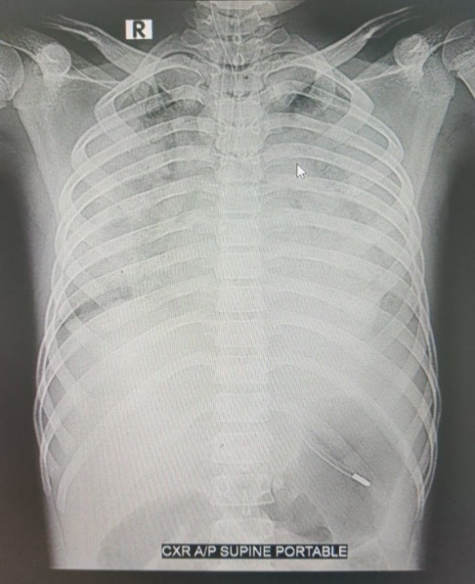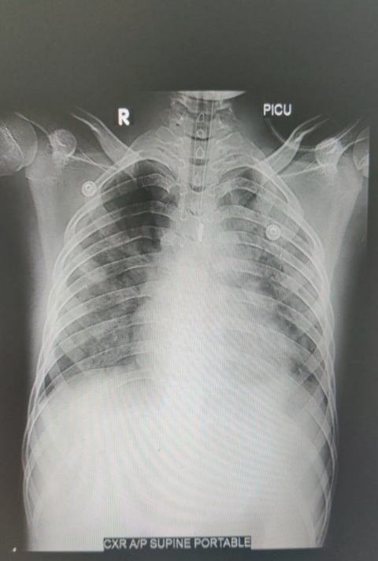

Before After

Before After

**Fig 1-Chest X-ray before and after CytoSorb**

**Laboratory Markers:** Initial inflammatory markers (e.g., CRP, IL-6) were markedly elevated. Lactic acid levels confirmed ongoing anaerobic metabolism due to shock.

**Table 1- Lab parameters indicating Pre and Post CytoSorb**

|  |  |  |
| --- | --- | --- |
| Lab parameters | Pre CytoSorb | Post CytoSorb |
| Procalcitonin | 6.06 ng/ml | 2.8 ng/ml |
| Interleukin-6 | 45 pg/ml | 3.9 pg/ml |
| Ferritin | 890 ng/ml | 702 ng/ml |
| Lactate | 3.8 mmol/l | 1.0 mmol/l |
| CRP | 33.2 mg/l | 9.9 mg/l |
| ABG | $P^{H}$ =7.30, P $O_{2}$ =30.3, Fi $O_{2}$ =60% (Type I respiratory failure), Lactate=3.5 | $P^{H}$ =7.38, P $O_{2}$ =129, Fi $O_{2}$ =70%, Lactate=1.7 |

**Microbiology:** Blood and BAL cultures were sent prior to antibiotic initiation and no growth was found.

**Hematologic Evaluation:** Profound thrombocytopenia and rising hematocrit indicated plasma leakage.

Following two CytoSorb sessions, the patient demonstrated significant clinical and biochemical improvement. Inflammatory markers dropped from a peak of 8.5 to 3.2 units. Respiratory function improved, allowing extubation within 48 hours of the second session. Chest imaging revealed reduced infiltrates. Hemodynamic parameters stabilized, vasopressors were weaned, and organ functions normalized. The patient's rapid improvement correlated temporally with the CytoSorb therapy, supporting its role in resolving the inflammatory cascade. He was shifted to ward home in stable condition on ICU day 7.

**Patient Follow-Up**

The patient was followed up 2 weeks after shifted to ward. He remained asymptomatic, afebrile, with normal platelet counts and normal chest auscultation. No rebound inflammation or delayed complications were noted.

**Discussion**

Dengue Shock Syndrome, particularly in pediatric populations, can result in critical complications, including MODS and death if not promptly and effectively managed [3,6]. Standard treatments largely address the consequences of systemic inflammation but do little to halt its upstream drivers. In this case, CytoSorb served as a rescue therapy by directly targeting inflammatory mediators responsible for the clinical deterioration. This aligns with other studies that support CytoSorb’s effectiveness in reducing cytokine burden and improving hemodynamics in critically ill patients [10,11,15]. In pediatric populations, its use has been limited but encouraging, with successful outcomes in septic shock, viral myocarditis, and post-cardiac surgery inflammation [18-20]. Importantly, CytoSorb does not remove essential antibiotics or cause significant hemodynamic instability during operation, making it a practical ICU tool [12,16]. The reduction in IL-6 and TNF-α, both known markers of poor prognosis in dengue and sepsis, suggests that CytoSorb could interrupt the pathogenic inflammatory loop characteristic of DSS [7,8,14]. While no randomized trials have evaluated its use specifically in dengue, anecdotal and small observational studies support its benefit in similar hyperinflammatory conditions [19,21].

Given its safety, biocompatibility, and efficacy in reducing inflammation, CytoSorb should be considered early in the course of DSS with MODS where conventional therapies are failing. Larger pediatric trials are necessary to validate these findings and establish treatment protocols tailored to viral shock syndromes.

**Conclusion**

CytoSorb hemoadsorption therapy proved to be an effective adjunct in the management of Dengue Shock Syndrome complicated by severe inflammation and MODS in this pediatric patient. Its timely initiation was associated with rapid clinical recovery, resolution of organ dysfunction, and normalization of inflammatory parameters. These findings support the potential role of CytoSorb in critical dengue care, warranting further investigation through controlled studies.

**Conflict of Interest:** There is no conflict of Interest.

**References**

1. Bhatt S, et al. Nature. 2013;496(7446):504–7.
2. WHO. Dengue Guidelines for Diagnosis, Treatment, Prevention and Control. Geneva: WHO; 2009.
3. Wills BA, et al. Clin Infect Dis. 2002;35(9):1047–52.
4. Martina BE, et al. Nat Rev Microbiol. 2009;7(3):161–71.
5. Guzman MG, et al. N Engl J Med. 2016;374(16):1551–62.
6. Srikiatkhachorn A, et al. J Infect Dis. 2017;215(suppl_2):S83–S95.
7. Malavige GN, et al. Clin Exp Immunol. 2013;172(3):392–403.
8. Green S, Rothman A. Curr Opin Infect Dis. 2006;19(5):429–36.
9. Lee IK, et al. J Microbiol Immunol Infect. 2012;45(3):206–12.
10. Kellum JA, et al. Crit Care. 2015;19:166.
11. Schadler D, et al. Crit Care. 2013;17:R55.
12. Ankawi G, et al. Blood Purif. 2019;47(Suppl 3):1–12.
13. Ronco C, et al. Crit Care. 2021;25(1):1–12.
14. Honore PM, et al. Ann Intensive Care. 2019;9(1):22.
15. Kogelmann K, et al. J Crit Care. 2021;61:247–252.
16. Malard B, et al. Crit Care. 2020;24:342.
17. Friesecke S, et al. Crit Care. 2017;21:74.
18. Neidlinger NA, et al. Pediatr Crit Care Med. 2020;21(4):e182–e186.
19. Vishwanathan S, et al. Indian Pediatr. 2021;58(10):972–974.
20. Supady A, et al. Crit Care. 2021;25(1):194.
21. Brouwer WP, et al. Crit Care. 2019;23(1):317.
22. Vijayan A, et al. Kidney Int. 2017;91(3):559–567.