**EVALUATION OF ANTI-INFLAMMATORY ACTIVITY BY “*EUCALYPTUS CAMADULENSIS* AND *OCIMUM TENUIFLORUM*** ”

**ABSTRACT**

This study examines the anti-inflammatory activities of bark from *Eucalyptus camaldulensis* and leaves from *Ocimum tenuiflorum*. Phytochemical extraction was done using methanol and water, followed by extraction, and thorough phytochemical screening. The analysis confirmed the presence of various bioactive compounds such as alkaloids, flavonoids, saponins, tannins, proteins, amino acids, and phenolic compounds. Physiochemical tests also showed good results towards solubility, pH range, and other sensory attributes. The results indicate that both plants have substantial anti-inflammatory activity which is likely due to their abundant bioactive compounds. The study affirms the anti-inflammatory folkloric medicinal claims of the plants and stimulates further investigation towards the plants' pharmaceuticals.

**1.INTRODUCTION :**

**Inflammation: An In-Depth Review**

Inflammation represents a protective mechanism disturbance of biological functions mediated through the immune system and directed towards harmful stimuli such as pathogens, damaged cells or toxic compounds (Medzhitov, 2008). Acute Inflammation is the term used for short term responses consisting of Rubor, Tumor, Calor, Dolor and Loss Of Function. It lasts from a few days to a week. This is resolved by the clearence of the harmful agents and tissue repair by the immune cells (Nathan & Ding, 2010). On the other hand, chronic inflammation develops when the inflammation did not resolve over the period of time. Chronic inflammation is connective tissue dominated repair seen in some neoplastic, diabetic, cardiovascular, autoimmune disorders and even cancer (Hunter, 2012). These processes have tender to work in unison like a complex network design with a variety of molecular cues. First onset stage in the processes, are pattern recognization receptors (PRRs) such as toll-like receptors (TLRs) engages recognition through pathogens that drives immune response activation (Takeuchi & Akira, 2010). This later follows with releasing of a set of pro inflammatory mediators for example cytokines such as interleukin 1 (IL 1) tumor necrosis factor alpha (TNF-α), Chemokines and Prostaglandins (Medzhitov, 2010).

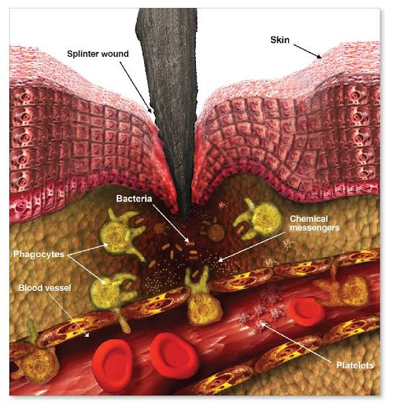

**Figure 1- Immune response of the body to a splinter wound**

Prolonged exposure to toxic substances, autoimmune reactions, or recurring infections are frequently the causes of chronic inflammation. It is linked to many illnesses, such as atherosclerosis, where inflammatory mediators encourage the buildup of plaque in blood vessels, raising the risk of strokes and heart attacks (Libby, 2002). Adipose tissue secretes pro-inflammatory cytokines like TNF-α and IL-6 in obesity-related inflammation, which disrupt insulin signaling and lead to metabolic diseases like type 2 diabetes (Hotamisligil, 2006). Similarly, there is evidence that the pathophysiology of Alzheimer's and Parkinson's diseases is influenced by microglial activation and the release of inflammatory mediators, indicating that chronic inflammation is a hallmark of neurodegenerative diseases (Heneka et al., 2015).

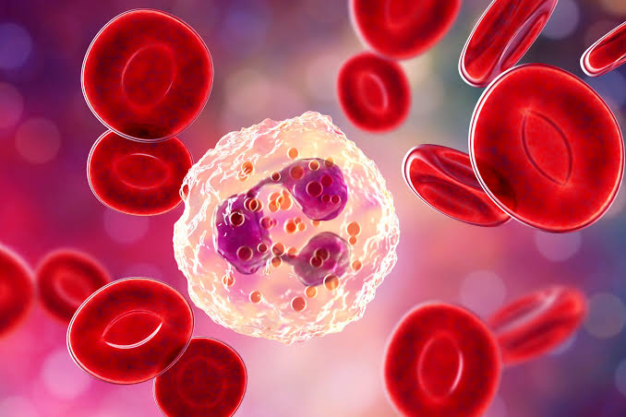

**Figure 2- Illustration of Red Blood Cells (RBCs)**

Inflammation can be reduced and homeostasis can be restored by the immune system. Pro-inflammatory signals are countered by anti-inflammatory mediators, such as interleukin-10 (IL-10), and specialized pro-resolving lipid mediators, such as lipoxins and resolvins (Serhan et al., 2008). As observed in chronic inflammatory diseases, dysregulation of these mechanisms can result in tissue damage and protracted inflammation (Tabas & Glass, 2013). Targeted treatments for inflammatory diseases have been developed as a result of research advances. By blocking cyclooxygenase (COX) enzymes, nonsteroidal anti-inflammatory drugs (NSAIDs) like aspirin and ibuprofen lower inflammation and prostaglandin synthesis (Vane & Botting, 2003). By altering nuclear factor-kappa B (NF-κB) signaling, corticosteroids such as dexamethasone reduce the expression of inflammatory genes(Barnes, 2011). Moreover, autoimmune diseases like rheumatoid arthritis are treated with biologic therapies like interleukin blockers (like anakinra) and TNF inhibitors (like infliximab) (McInnes & Schett, 2011). Changes in lifestyle are also essential for controlling inflammation. Regular exercise has been demonstrated to lower pro-inflammatory cytokine and CRP levels, thereby reducing systemic inflammation (Gleeson et al., 2011).

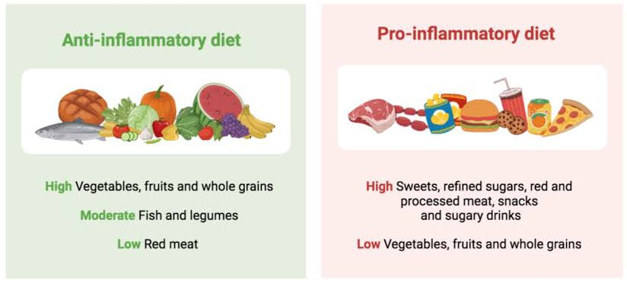

**Figure 3: Differences between anti-inflammatory and pro-inflammatory diet**

**2.MATERIALS AND METHODS :**

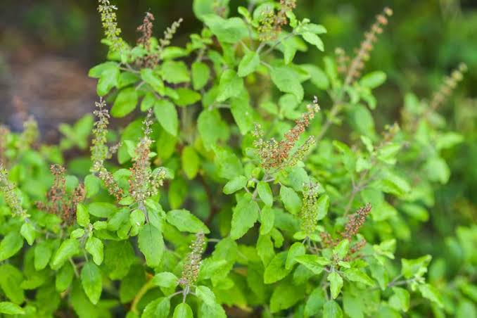 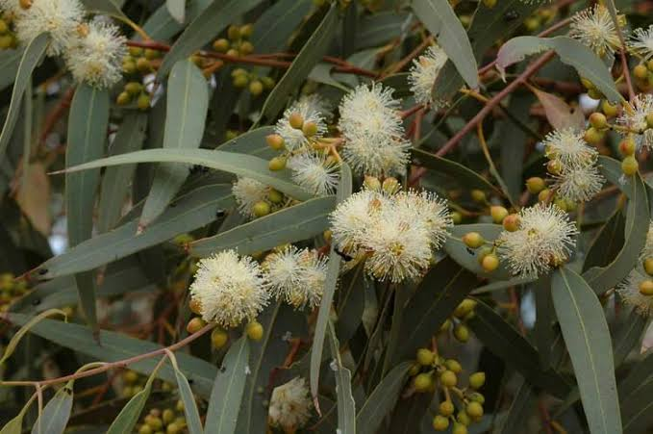***Figure 4 - Ocimum tenuiflorum Figure 5 - Eucalyptus***

***camaldulensis***

**Extraction Process of Ocimum tenuiflorum Leaves and Eucalyptus camaldulensis Bark**

The fresh leaves of Ocimum tenuiflorum and bark of Eucalyptus camaldulensis were collected from a home garden located in BHEL, Hyderabad, Telangana (India). The collected plant materials were initially washed thoroughly with distilled water to remove dust and adhered impurities. After proper cleaning, the materials were shade-dried at room temperature for 7–10 days to preserve the heat-sensitive phytoconstituents. Once completely dried, the leaves and bark were coarsely powdered using a mechanical grinder to increase surface area and improve solvent penetration during extraction.

For the extraction process, two different solvents were used: methanol and distilled water. A weighed quantity (approximately 50 g) of powdered plant material was soaked separately in 250 ml of methanol (for methanolic extract) and 250 ml of distilled water (for aqueous extract) in separate conical flasks. The mixtures were subjected to maceration for 72 hours at room temperature with intermittent shaking to ensure better extraction of phytochemicals. After maceration, the extracts were filtered using Whatman No. 1 filter paper to remove solid residues. The filtrates were then concentrated under reduced pressure using a rotary evaporator for methanol extracts and evaporated over a water bath at 40–50°C for aqueous extracts to yield semisolid crude extracts.

The dried crude extracts were collected in airtight containers and stored at 4°C until further use for phytochemical screening, physiochemical testing, and biological evaluation. The yield and physical characteristics of each extract were also recorded.

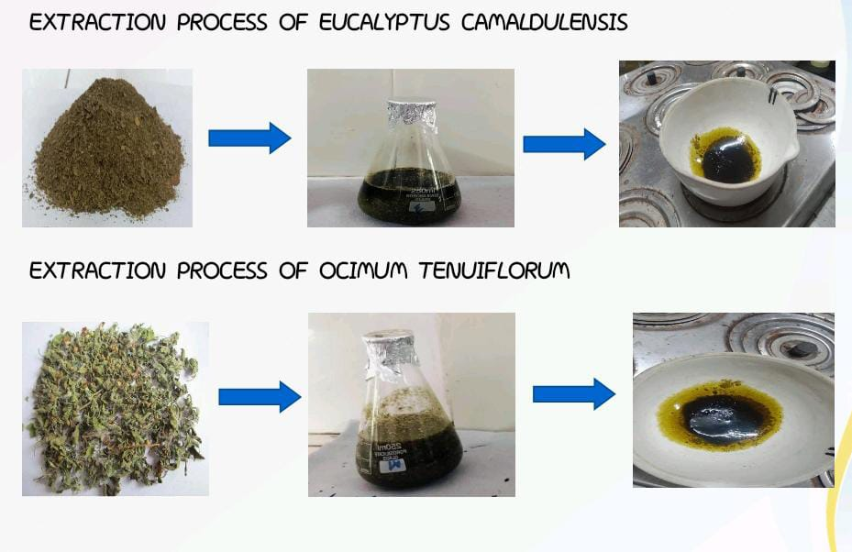

**Figure 6- Illustration of the extraction process of Eucalyptus camaldulensis and Ocimum tenuiflorum**

### **3.Phytochemical Screening:** Eucalyptus camaldulensis and Ocimum tenuiflorum

### To find bioactive substances in plants, phytochemical screening is a crucial technique. The presence of several phytochemicals in Eucalyptus camaldulensis and ocimum tenuiflorum was assessed using the following methods.

#### **3.1 Test for Alkaloids**

* **Dragendorff’s Test**
  + Procedure: The extracted solution was mixed with Dragendorff’s reagent
  + Observation: A reddish-brown precipitate was formed (Evans, 2009).
* **Mayer’s Test**
  + Procedure: The extracted solution was mixed with Mayer’s reagent.
  + Observation: Formation of a cream-colored precipitate was formed.(Sofowora, 1993).
  + **Wagner’s Test**
  + Procedure: The extracted solution was mixed with Wagner’s reagent (iodide potassium iodide solution).
  + Observation: A reddish-brown precipitate was formed (Harborne, 1998).
* **Hager’s Test**
  + Procedure: The extracted solution was mixed with Hager’s reagent
  + Observation: A yellow precipitate was formed (Trease & Evans, 2002).

#### **3.2 Test for Amino Acids**

* + **Ninhydrin Test**
  + Procedure: The extracted solution was heated with ninhydrin reagent.
  + Observation: A white precipitate was formed (Sadasivam & Manickam, 2008).

#### **3.3 Test for Reducing Sugars**

* **Benedict’s Reagent Test**
  + Procedure: The extracted solution was mixed with Benedict’s reagent and heated.
  + Observation: A brick-red color was appeared (Harborne, 1998).

#### **3.4 Test for Proteins**

* **Biuret Test**
  + Procedure: The extracted solution was mixed with Biuret reagent.
  + Observation: The violet color was appeared (Sadasivam & Manickam, 2008).

#### **3.5 Test for Phenolic Compounds**

* **Ferric Chloride Test**
  + Procedure: The extracted solution was mixed with ferric chloride solution.
  + Observation: The blue and green color was appeared (Harborne, 1998).

#### **3.6 Test for Tannins**

* + **Ferric Test**
  + Procedure: The extracted solution was mixrd with a ferric reagent.
  + Observation: A grey or black color was appeared (Sofowora, 1993).

#### **3.7 Test for Saponins**

* **Foam Test**
  + Procedure: The extracted solution was vigorously shaken with distilled water.
  + Observation: Persistent foam formation (Trease & Evans, 2002).
* **Keller-Kiliani Test**
  + Procedure: The extracted solution was mixed with glacial acetic acid, ferric chloride, and sulfuric acid.
  + Observation: A brown ring was formed (Harborne, 1998).

#### **3.8 Test for Flavonoids**

* **Alkaline Reagent Test**
  + Procedure: The extracted solution was treated with sodium hydroxide and diluted HCl.
  + Observation: A deep yellow color was appeared (Trease & Evans, 2002).

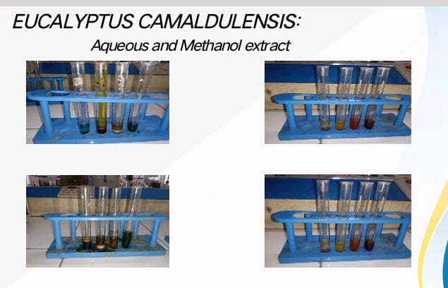

**Figure 7- Aqueous and methanol extract of Eucalyptus camaldulensis**

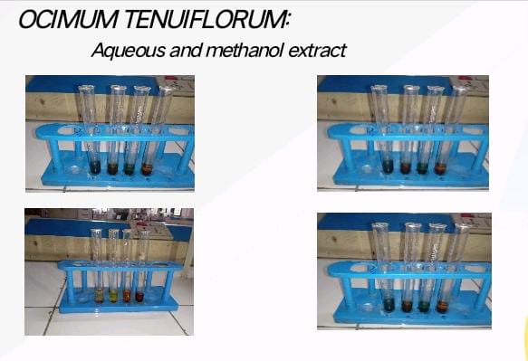

***Figure 8- Aqueous and methanol extract of* *Ocimum tenuiflorum***

**5.RESULT AND DISCUSSION:**

**RESULTS OF PRELIMINARY PHYTOCHEMICAL INVESTIGATION**

The preliminary phytochemical screening of Eucalyptus camaldulensis bark powder revealed the presence of several important bioactive constituents in both methanol and aqueous extracts. Both extracts tested positive for alkaloids, flavonoids, amino acids, proteins, phenolic compounds, and tannins. However, saponins were found only in the aqueous extract, while reducing sugars were present only in the methanol extract. This variation is due to the different solubility properties of phytochemicals in polar and semi-polar solvents. Alkaloids and flavonoids are known for their potent anti-inflammatory, analgesic, and antioxidant properties. The presence of tannins and phenolic compounds indicates strong antimicrobial and astringent activity, which supports the traditional medicinal use of the bark. Overall, Eucalyptus camaldulensis exhibits a wide range of pharmacologically active constituents that may contribute to its therapeutic potential.

Results of preliminary phytochemical investigation of *Eucalpytus camaldulensis* bark powder as shown the presence of **Alkaloids, flavonoids, phenolic compounds, saponins and tannins . All the results are shown below**

**Table 1: Preliminary phytochemical constituents of *Eucalpytus camaldulensis***

|  |  |  |  |
| --- | --- | --- | --- |
| **S.NO** | ***CONSTITUENTS*** | ***METHANOL EXTRACT*** | ***AQUEOUS EXTRACT*** |
| *1* | *Alkaloids* | *+* | *+* |
| *2* | *Flavonoids* | *+* | *+* |
| *3* | *Amino acids* | *+* | *+* |
| *4* | *Proteins* | *+* | *+* |
| *5* | *saponins* | *+* | *+* |
| *6* | *Phenolic compounds* | *-* | *+* |
| *7* | *Tannins* | *+* | *+* |
| *8* | *Reducing sugars* | *+* | *-* |

The phytochemical investigation of Ocimum tenuiflorum (commonly known as Tulsi) leaves powder showed a rich presence of therapeutic compounds in both methanol and aqueous extracts. Alkaloids, amino acids, proteins, saponins, and tannins were detected in both extracts. Interestingly, flavonoids and phenolic compounds were found only in the aqueous extract, whereas reducing sugars were found only in the methanol extract. This suggests that certain antioxidants and polar compounds are better extracted in water, while sugars are more soluble in methanol. The presence of flavonoids and phenolic compounds in the aqueous extract highlights its potential antioxidant activity, which supports its traditional use in treating respiratory infections and inflammation. Tulsi’s phytoconstituents reflect its adaptogenic, immunomodulatory, and antimicrobial properties, making it a valuable medicinal plant in Ayurveda and modern herbal medicine.

Results of preliminary phytochemical investigation of *ocimum tenuiflorum* tulsi leaves powder have shown the presence of **alkaloids,flavonoids,saponins and tannis**.all the results are shown below

**Table 2: preliminary phytochemical constitutents of *Ocimum tenuiflorum:***

|  |  |  |  |
| --- | --- | --- | --- |
| **S.NO** | ***CONSTITUENTS*** | ***METHANOL EXTRACT*** | ***AQUEOUS EXTRACT*** |
| *1* | *Alkaloids* | *+* | *+* |
| *2* | *Flavonoids* | *-* | *+* |
| *3* | *Amino acids* | *+* | *+* |
| *4* | *Proteins* | *+* | *+* |
| *5* | *saponins* | *+* | *+* |
| *6* | *Phenolic compounds* | *-* | *+* |
| *7* | *Tannins* | *+* | *+* |
| *8* | *Reducing sugars* | *+* | *-* |

**Physiochemical tests**

**physiochemical test for eucalyptus camaldulensis**

The physicochemical evaluation of Eucalyptus camaldulensis bark powder was carried out to assess its basic physical and chemical characteristics. The bark powder was light brown in color, with a distinctly aromatic odor and a bitter taste. The bitterness is likely due to the presence of alkaloids and tannins. It was found to be soluble in both methanol and water, indicating that it contains a range of polar and semi-polar compounds that are extractable by these solvents. The pH of the solution ranged between 5.5 and 6.5, suggesting that the extract is mildly acidic, which is generally favorable for most pharmaceutical formulations. These physicochemical characteristics support its stability and usability in herbal preparations and confirm the suitability of the plant for further pharmacological and formulation studies.The preliminary physiochemical tests for *eucalyptus camadulensis* was carried out.the presence of parameters like colour, odour, solubility, PH.

**Table 3: Results of physiochemical tests of *eucalyptus camaludensis***

|  |  |  |
| --- | --- | --- |
| **S.NO** | **PARAMETERS** | **OBSERVATIONS** |
| **1** | Colour | Light brown |
| **2** | Odour | Aromatic |
| **3** | Taste | bitter |
| **4** | Solubility | Soluble in Methanol and water |
| **5** | PH | 5.5-6.5 |

**physiochemical test for *Ocimum tenuiflorum***

The preliminary physicochemical analysis of Ocimum tenuiflorum leaf powder revealed several important characteristics useful for identifying and standardizing the herbal material. The powder appeared green in color, which is typical of dried leafy material rich in chlorophyll and secondary metabolites. It exhibited a strong aromatic odor and a pungent, slightly bitter taste, attributes commonly associated with the essential oils and phytoconstituents like eugenol and flavonoids present in Tulsi. In terms of solubility, the extract was found to be soluble in both methanol and water, indicating the presence of both polar and semi-polar phytochemicals. The pH of the extract ranged between 6.0 and 7.0, indicating a nearly neutral to slightly acidic nature, which is ideal for oral herbal formulations. These physicochemical parameters support the identity, purity, and stability of Ocimum tenuiflorum, ensuring its effectiveness when used in traditional and modern therapeutic preparations. The preliminary physiochemical tests for *Ocimum tenuiflorum* was carried out.the presence of parameters like colour, odour, solubility, PH

**Table .4: Results of physiochemical tests of *Ocimum tenuiflorum***

|  |  |  |
| --- | --- | --- |
| **S.NO** | **PARAMETERS** | **OBSERVATIONS** |
| **1** | Colour | Green |
| **2** | Odour | Strong Aromatic |
| **3** | Taste | Pungent,slightly bitter |
| **4** | Solubility | Soluble in Methanol and water |
| **5** | PH | 6.0-7.0 |

**Discussion**

“Evaluation of Anti-Inflammatory Activity by Eucalyptus camaldulensis and Ocimum tenuiflorum”

The current study was undertaken to evaluate the anti-inflammatory potential of Eucalyptus camaldulensis bark and Ocimum tenuiflorum (Tulsi) leaves through phytochemical screening and physiochemical analysis. Both plants are widely recognized in traditional medicine systems for their therapeutic roles in treating inflammation and related ailments.The preliminary phytochemical analysis revealed the presence of several biologically active compounds including alkaloids, flavonoids, tannins, saponins, phenolic compounds, amino acids, and proteins. These constituents are well-documented in literature for contributing significantly to anti-inflammatory activity. Alkaloids, for instance, are known to interfere with pain perception and inflammation pathways, while flavonoids exert antioxidant effects that can inhibit the release of pro-inflammatory mediators such as prostaglandins and cytokines. Interestingly, Eucalyptus camaldulensis methanol extract showed the presence of reducing sugars which were absent in its aqueous extract, while Ocimum tenuiflorum exhibited flavonoids and phenolic compounds predominantly in the aqueous extract. This suggests that the solvent system plays a crucial role in extracting specific classes of phytoconstituents, underlining the importance of solvent selection based on the target compound group. The physiochemical evaluations further supported the suitability of both plants for pharmaceutical applications. Parameters such as solubility in methanol and water, mild to neutral pH, aromatic odor, and characteristic taste are favorable for formulation and patient compliance. Eucalyptus camaldulensis showed a slightly acidic pH range (5.5–6.5), while Ocimum tenuiflorum displayed a near-neutral pH (6.0–7.0), making both suitable for oral and topical anti-inflammatory formulations.These findings align with earlier studies that have identified both Eucalyptus and Tulsi as natural sources of anti-inflammatory agents. The observed phytochemical profiles provide a strong foundation for their traditional uses and suggest potential for developing standardized herbal formulations. However, further pharmacological investigations, such as in vivo models (e.g., carrageenan-induced paw edema test) and molecular-level studies, are recommended to confirm the mechanisms of action and evaluate dose-response relationships. In summary, the study validates the folkloric claims of anti-inflammatory efficacy for both Eucalyptus camaldulensis and Ocimum tenuiflorum. The presence of key phytochemicals supports their use in herbal medicine, and the data generated may contribute to future research and development of safe, natural anti-inflammatory therapies.

**6.Conclusion**:

The present study highlights the significant anti-inflammatory potential of Eucalyptus camaldulensis bark and Ocimum tenuiflorum leaves. Phytochemical screening confirmed the presence of important bioactive compounds such as alkaloids, flavonoids, tannins, saponins, and phenolic compounds, which are known contributors to anti-inflammatory activity. The favorable physicochemical properties further support their suitability for medicinal use. Overall, the findings validate the traditional use of these plants in treating inflammatory conditions and suggest that they can serve as promising natural sources for developing safe and effective anti-inflammatory agents. Further detailed pharmacological and clinical investigations are recommended to explore their mechanisms of action and therapeutic efficacy.

**7. REFERENCES:**

1. Hunter, P. (2012). The inflammation theory of disease. EMBO Reports, 13(11), 968-970. <https://doi.org/10.1038/embor.2012.142>.
2. Libby, P. (2002). Inflammation in atherosclerosis. Nature, 420(6917), 868-874. <https://doi.org/10.1038/nature01323>
3. Medzhitov, R. (2008). Origin and physiological roles of inflammation. Nature, 454(7203), 428-435. <https://doi.org/10.1038/nature07201>.
4. Medzhitov, R. (2010). Inflammation 2010: new adventures of an old flame. Cell, 140(6), 771-776. <https://doi.org/10.1016/j.cell.2010.03.006>
5. Nathan, C., & Ding, A. (2010). Nonresolving inflammation. Cell, 140(6), 871-882. <https://doi.org/10.1016/j.cell.2010.02.029>
6. Ridker, P. M. (2016). From C-Reactive Protein to Interleukin-6 to Interleukin-1: Moving Upstream to Identify Novel Targets for Atheroprotection. Circulation Research, 118(1), 145-156. <https://doi.org/10.1161/CIRCRESAHA.115.306656>
7. Serhan, C. N., Chiang, N., & Van Dyke, T. E. (2008). Resolving inflammation: dual anti-inflammatory and pro-resolution lipid mediators. Nature Reviews Immunology, 8(5), 349-361. <https://doi.org/10.1038/nri2294>
8. Tabas, I., & Glass, C. K. (2013). Anti-inflammatory therapy in chronic disease: challenges and opportunities. Science, 339(6116), 166-172. <https://doi.org/10.1126/science.1230720>
9. Takeuchi, O., & Akira, S. (2010). Pattern recognition receptors and inflammation. Cell, 140(6), 805-820. <https://doi.org/10.1016/j.cell.2010.01.022>
10. Vane, J. R., & Botting, R. M. (2003). The mechanism of action of aspirin. Thrombosis Research, 110(5-6), 255-258. <https://doi.org/10.1016/S0049-3848(03)00379-7>
11. Barnes, P. J. (2011). Corticosteroids: The drugs to beat. British Journal of Pharmacology, 163(1), 17-33. <https://doi.org/10.1111/j.1476-5381.2011.01249.x>
12. Gleeson, M., et al. (2011). The anti-inflammatory effects of exercise. Journal of Applied Physiology, 110(6), 1490-1495. <https://doi.org/10.1152/japplphysiol.00008.2011>
13. Heneka, M. T., et al. (2015). Neuroinflammation in Alzheimer’s disease. The Lancet Neurology, 14(4), 388-405. <https://doi.org/10.1016/S1474-4422(15)70016-5>
14. Honda, K., & Littman, D. R. (2012). The microbiome in infectious disease and inflammation. Annual Review of Immunology, 30, 759-795. <https://doi.org/10.1146/annurev-immunol-020711-075001>
15. Hotamisligil, G. S. (2006). Inflammation and metabolic disorders. Nature, 444(7121), 860-867. <https://doi.org/10.1038/nature05485>
16. Evans, W.C. (2009). Trease and Evans Pharmacognosy (16th ed.). Saunders Ltd.
17. Sherborne, J.B. (1998). Phytochemical Methods: A Guide to Modern Techniques of Plant Analysis (3rd ed.). Springer.
18. Sadasivam, S., & Manickam, A. (2008). Biochemical Methods (3rd ed.). New Age International.
19. Sofowora, A. (1993). Medicinal Plants and Traditional Medicine in Africa (2nd ed.). Spectrum Books Ltd.
20. Trease, G.E., & Evans, W.C. (2002). Pharmacognosy (15th ed.). Saunders Ltd.