***Minireview Article***

**EVOLUTION OF SEVERE DENGUE IN THE PERIOD BEFORE AND AFTER THE COVID-19 PANDEMIC**

.

**ABSTRACT**

|  |
| --- |
| **Introduction:** Dengue is an arbovirus transmitted by female *Aedes aegypti* mosquitoes, and to a lesser extent by *Aedes albopictus* mosquitoes. There are four serotypes: DENV-1, DENV-2, DENV-3 and DENV-4; both have similar symptoms, with the main difference being the severity. Clinically differentiated by phase, dengue can be classified as: classic dengue fever, dengue hemorrhagic fever or dengue hemorrhagic fever, dengue shock syndrome. The main symptoms are acute fever, joint pain, headaches, leukopenia and rash, with the most serious manifestations being hemorrhage, hepatomegaly, circulatory failure and others. **Objective:**  Comparing the cases and progress of severe dengue during the pre- and post-pandemic periods, relating the changes to the incidence of cases. **Methodology:** The article is exploratory and descriptive, and the inclusion method was: literature review articles, journals of scientific relevance; searched in both English and Spanish; all in a time span of 2014-2024. The PubMed, SciELO and Ministry of Health databases were used; with the help of the Descriptors in Science and Health (DeCS) website with the keywords: "Dengue" , "Dengue hemorrhagic fever" , "Classical dengue" , "Dengue fever" , "Dengue hemorrhagic fever" , "Dengue Shock Syndrome" and "Dengue severe". **Results and Discussion:** According to the data found, before the pandemic, cases grew exponentially, with estimates of more than 100 to 400 million cases a year worldwide, with a high severity rate. In the post-pandemic period, there was an increase in the mortality rate, with a greater impact on specific age groups and those with comorbidities. In the meantime, there has been a greater institutional response to dengue awareness and prevention campaigns. **Conclusion:**  It is clear that during the pandemic, public health was focused on the COVID-19 virus. However, due to the growing number of cases, interventions against dengue have been stepped up. As for clinical changes in the disease, there have been no significant developments, but due to climate change and the population's health conditions, the number of cases has risen dramatically.  ***Keywords:***  *"Dengue", "Dengue Fever”, "Dengue Hemorrhagic Fever”, “Dengue Shock Syndrome” e “Dengue severe* |

**1. INTRODUCTION**

Dengue is an arboviral disease transmitted by female mosquitoes of the Aedes aegypti species, and to a lesser extent, by Aedes albopictus mosquitoes. There are four serotypes: DENV-1, DENV-2, DENV-3, and DENV-4; all of them have similar symptoms, mainly varying in severity. The clinical manifestations of the disease can vary from patient to patient; thus, to facilitate diagnosis, the WHO has "standardized" symptoms for better analysis and diagnosis (LEE TH, LEE LK, LYE DC, LEO YS, 2017).

Differentiated by phases, dengue can be classified as: classical dengue fever, dengue hemorrhagic fever, or dengue shock syndrome. The main symptoms are acute fever, joint pains, headaches, leukopenia, and rash, with the most severe manifestations being hemorrhage, hepatomegaly, circulatory failure, among others.(WANG; URBINA et al., 2020)

Dengue hemorrhagic fever is the most severe phase of the disease, caused by the DENV-2 cosmopolitan genotype, resulting in shock, severe organ impairment, plasma leakage, and bleeding. This leads patients who develop this clinical condition to have a higher chance of mortality.(BUI; LE et al., 2017).

During the pre and post-pandemic periods, severe dengue cases remained high in the years 2015 and 2019, but occurrences were not reported due to COVID-19. Again, dengue had a sharp increase in 2024, along with high death rates according to SINAN data, leading to increased government attention and intervention. BRASIL, 2024).

Thus, by comparing cases and advances of severe dengue during the pre and post-pandemic period, relating changes to the incidence of cases, this article helps to understand the reason for the sudden increase in severe dengue cases and deaths in recent years. This study is based on understanding the epidemiological, genetic, and demographic data related to severe dengue for a better strategy of control and prevention in health units and the population.

**2. METHODOLOGY**

It was a bibliographic study of the exploratory-descriptive type with a qualitative approach, and these data were used for the elaboration of the scientific article. According to Gil (2022): bibliographic research is developed based on already elaborated material, mainly consisting of books and scientific articles, that is, it is the one that carries out the theoretical survey of a certain subject from the collection of information about what different authors report on the topic.

A study has an exploratory nature when it involves bibliographic research, interviews with people who have had (or have) practical experiences with the researched problem, and analysis of examples that stimulate understanding. It also aims to develop, clarify, and modify concepts and ideas for the formulation of subsequent approaches. Thus, this type of study aims to provide greater knowledge for the researcher about the subject, so that they can formulate more precise problems or create hypotheses that can be researched by later studies (GIL, 2022).

According to Gonçalves (2003), descriptive research records, analyzes, classifies, and interprets the observed facts, often establishing relationships between them. Regarding the approach, this study is qualitative. Minayo (1994) describes qualitative research as one in which the researcher's concern is not directed towards the quantitative profile of the data, but rather towards the value of the information that can be collected, correlating phenomena and variables to reality, in order to understand this experience in deeper dimensions, encompassing creativity and directing towards the construction of scenarios and new perspectives within the same reality. Data collection was carried out through bibliographic research conducted through scientific production searches on the proposed theme, from 2014 to 2024. The inclusion criteria for selecting content were those published in full according to the theme, old, published in Portuguese, English, and Spanish.

Exclusion criteria included articles that were not relevant to the theme, duplicated materials, incomplete, debates, reviews, abstracts, and materials unavailable in full. Literature search was conducted in the following databases: Latin American and Caribbean Health Sciences Literature (LILACS), Scientific Electronic Library Online (SciELO), and PubMed. It is worth noting that the LILACS and BDENF databases were consulted through the Virtual Health Library (VHL). Abbreviations were performed using Health Science Descriptors (DeCS) and the Regional Library of Medicine (Bireme): "Dengue", "Hemorrhagic Dengue", "Classical dengue", "Dengue fever", "Dengue hemorrhagic fever", "Dengue Shock Syndrome", and "Dengue severe", in Portuguese and English with the aid of the boolean operators "AND" and "OR".

Therefore, data analysis will proceed in three stages: firstly, by conducting a floating reading, where the researcher begins to have an overview of the participants' opinions; secondly, a thorough reading will be conducted, that is, a detailed and repeated reading of all collected data; and thirdly, the construction of categories will be carried out for better data analysis.

**2.1 What are the main factors that influence the evolution of severe dengue**

Dengue is a viral disease transmitted by Aedes aegypti and Aedes albopictus mosquitoes, with four known serotypes: DENV-1, DENV-2, DENV-3, and DENV-4. Symptoms range from mild to severe, with the virus genotype also influencing the severity of the disease. Common symptoms include vomiting,epigastric pain, plasma leakage, and shock(SUPPIAH et al., 2018).

As it is a re-emerging disease, with epidemiological diversity and different clinical manifestations between children and adults (VICENTE et al., 2017), the first factor to be pointed out is the age group of the patients who acquired the disease. The older the person, the greater the severity of the disease, with patients between 50 and 60 years old having a much higher risk of severe dengue (LIN et al., 2016).

Another relevant factor is patients with comorbidities, such as hypertension, liver problems, and diabetes, which increase susceptibility to the disease. Furthermore, coinfected patients have a higher incidence of hemorrhagic problems and other symptoms such as arthralgia, rash, and ocular pain, among others (Martins MARTINS et al., 2014).

The period of highest incidence of cases is during the rainy season, between May and November, when there is a significant increase in cases annually. Males have a higher incidence of contracting dengue, but there is no gender specificity (WARNES; Santacruz-Sanmartín SANTACRUZ-SANMARTIN; BUSTOS; VELEZ, 2021).

Differences in severe dengue manifestations across different age groups highlight the need for age-specific management protocols to reduce disease morbidity and mortality and identify priority groups for immunization campaigns(VICENTE et al., 2017).

The circulation of various serotypes/genotypes of dengue can alert to the increase in cases and the possibility of coinfections, with distinct risk factors (DIENG et al., 2021). Although the co-circulation of different serotypes/genotypes of dengue is a rare event, it is a point to be observed when there is a disproportionate increase in cases of the disease, as it affects people of various age groups and presents symptoms ranging from the most severe in some cases to milder in others. Therefore, the rapid identification of cases is of great importance for clinical prognosis and the identification of risk factors for severe dengue (ZHANG et al., 2021).

**2.1.1 Incidence of severe dengue cases changed between the pre-pandemic and post-pandemic periods**

Dengue has been a growing concern in global public health, as noted by various sources, including the World Health Organization (WHO). Estimates suggest an exponential increase in cases over the years, with alarming figures ranging from 100 to 400 million cases per year worldwide (HUY; TOAN, 2022).

Approximately 390 million people have been infected with dengue in over 100 countries, with Asia accounting for about 70% of these infections. Previously confined to regions with tropical or subtropical climates, the disease is now spreading to areas with temperate or Mediterranean climates(DUSSART et al., 2020).

In recent years, such as 2018 and 2019, approximately 487,600 people were recorded to be affected by dengue (BOWER et al., 2021). Dengue viruses are classified as the most important arthropod-borne viruses in humans, with millions of annual infections, of which a large number manifest some level of disease severity(RODRIGUEZ-ROCHE et al., 2016).

**3. results and discussion**

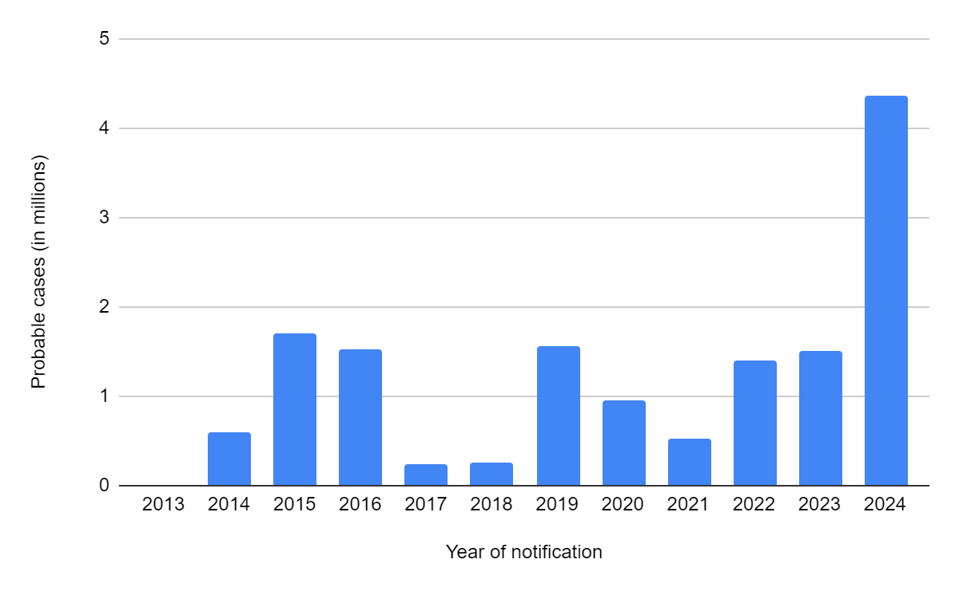

**Fig 1: Incidence of probable DENV cases from 2013 to 2024**

**Source: Ministry of Health/SVSA - Notification Aggravation Information System - Sinan Net <Accessed on April 15, 2024>**

The graph shows the incidence of probable DENV cases from 2013 to 2024, with 2024 notably having the highest number of reported cases in the last ten years, surpassing the previous peak in 2015. It highlights that 2017 and 2018 were the years with the most stable case numbers. It's worth noting that the population was concerned about the previous year's figures, and the healthcare system frequently issued precautionary alerts.

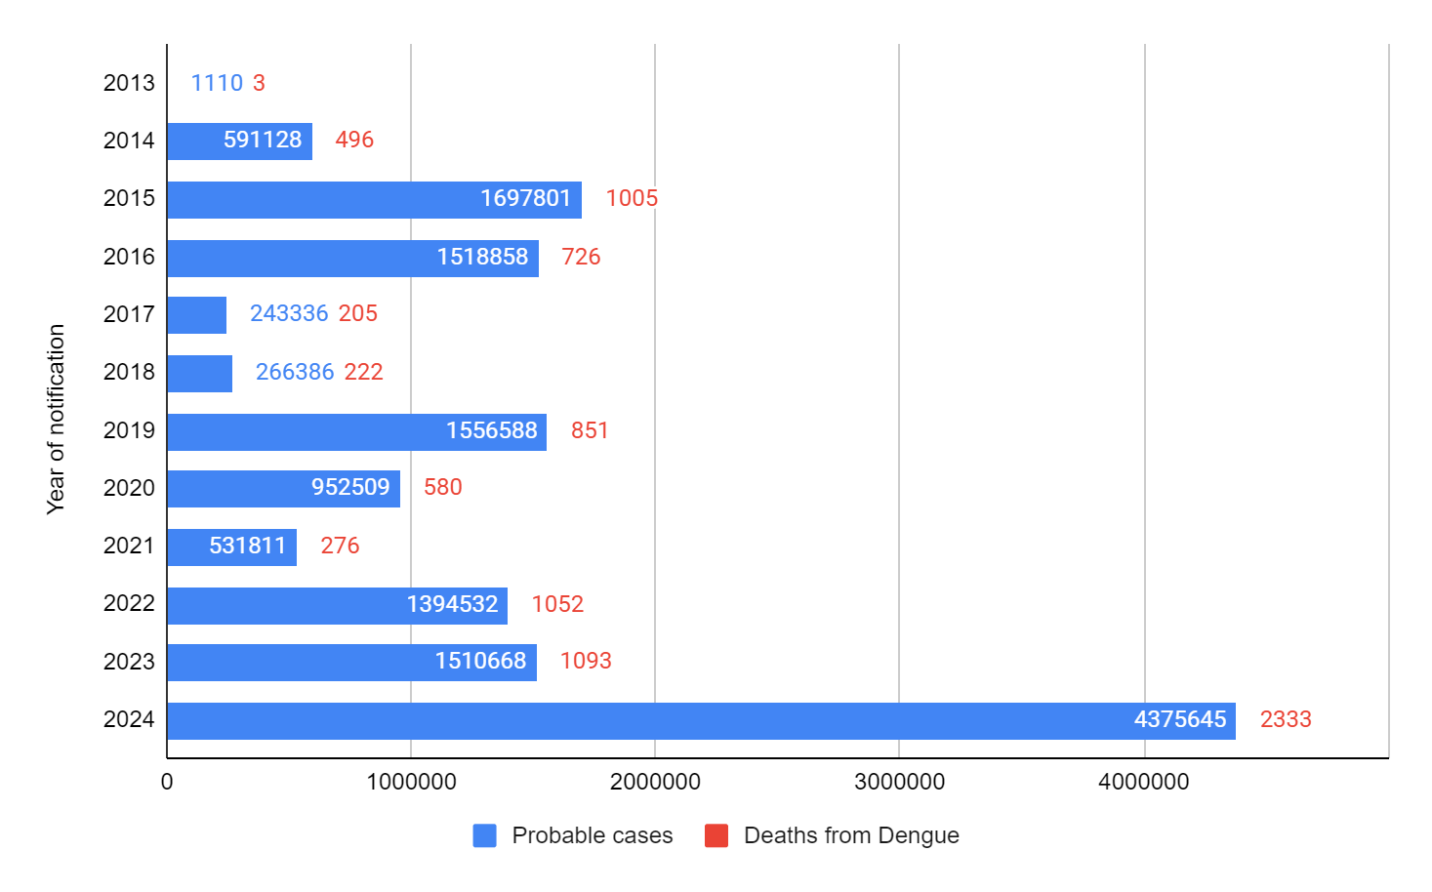

Fig 2: Incidence of deaths from DENV over the past ten years

Source: Ministry of Health/SVSA - Notification Aggravation Information System - Sinan Net <Accessed on April 15, 2024>

In this graph, it shows the incidence of deaths from DENV over the past ten years, with 2024 having the highest number of reported deaths, marking 2,333 deaths, surpassing the previous peak in 2023 with 1,093 deaths. It emphasizes that this was during the pandemic period. The year with the fewest cases and confirmed deaths was 2013, with only 3 deaths registered, and 2017 with 205 deaths. The WHO emphasizes that dengue is one of the most relevant arboviruses globally, with a significant impact on public health. (HERINGER et al., 2017)

In 2024, the Emergency Operations Center (EOC) was established to combat dengue, composed of representatives from various areas such as Anvisa, Fiocruz, OPAN, and health councils. This initiative seeks careful and precise organization, with mobilizations to raise awareness in society (BRAZIL, 2024).

**4. Conclusion**

It is concluded that during the pandemic, public health efforts were focused on the COVID-19 virus. However, due to the increasing cases, interventions against dengue were reinforced. Regarding clinical changes in the disease, there were no significant advancements, but due to climate changes and population health conditions, the case rate grew drastically. Thus, public awareness along with government actions towards the country's infrastructure is necessary for the control and prevention of Dengue.

References

1. Aguilar-Briseño, José A, et al. **“Understanding Immunopathology of Severe Dengue: Lessons Learnt from Sepsis.”** *Current Opinion in Virology*, vol. 43, no. 32896675, 1 Aug. 2020, pp. 41–49, www.sciencedirect.com/science/article/pii/S1879625720300535, https://doi.org/10.1016/j.coviro.2020.07.010. Acesso em 15 Mar. 2024.
2. Bower, Hilary, et al. **““Kankasha” in Kassala: A Prospective Observational Cohort Study of the Clinical Characteristics, Epidemiology, Genetic Origin, and Chronic Impact of the 2018 Epidemic of Chikungunya Virus Infection in Kassala, Sudan.”** *PLOS Neglected Tropical Diseases*, vol. 15, no. 4, 30 Apr. 2021, pp. e0009387–e0009387, https://doi.org/10.1371/journal.pntd.0009387. Acesso em 10 Mar. 2024.
3. Descloux, E., et al. **“Clinical Significance of Intra-Host Variability of Dengue-1 Virus in Venous and Capillary Blood.”** *Clinical Microbiology and Infection*, vol. 20, no. 3, Mar. 2014, pp. O167–O175, https://doi.org/10.1111/1469-0691.12368. Acesso 12 Mar. 2024.
4. Dhanoa, Amreeta, et al. **“Impact of Dengue Virus (DENV) Co-Infection on Clinical Manifestations, Disease Severity and Laboratory Parameters.”** *BMC Infectious Diseases*, vol. 16, no. 1, 11 Aug. 2016, https://doi.org/10.1186/s12879-016-1731-8. Acesso 10 Mai. 2024.
5. Diallo, I, et al. **“À Propos de 98 Cas de Dengue Hospitalisés Dans Une Clinique Privée de Ouagadougou : Aspects Épidémiologiques, Diagnostiques et Évolutifs.”** *Bulletin de La Societe de Pathologie Exotique*, vol. 110, no. 5, 1 Dec. 2017, pp. 291–296, https://doi.org/10.1007/s13149-017-0585-7. Acesso 25 Mar. 2024.
6. Dieng, Idrissa, et al. **“Multifoci and Multiserotypes Circulation of Dengue Virus in Senegal between 2017 and 2018.”** *BMC Infectious Diseases*, vol. 21, no. 1, 24 Mar. 2021, https://doi.org/10.1186/s12879-021-06580-z.
7. García Gili, Manuel I., et al. **“[Argentine Hemorrhagic Fever: Report of Two Cases in a Non-Endemic Area].”** *Medicina*, vol. 83, no. 1, 2023, pp. 129–132, pubmed.ncbi.nlm.nih.gov/36774608/. Acesso 25 Mar. 2024.
8. Halstead, Scott, and Annelies Wilder-Smith. **“Severe Dengue in Travellers: Pathogenesis, Risk and Clinical Management.”** *Journal of Travel Medicine*, vol. 26, no. 7, 2019, https://doi.org/10.1093/jtm/taz062.
9. Hapuarachchi, Hapuarachchige Chanditha, et al. **“Clinical Outcome and Genetic Differences within a Monophyletic Dengue Virus Type 2 Population.”** *PLOS ONE*, vol. 10, no. 3, 26 Mar. 2015, p. e0121696, https://doi.org/10.1371/journal.pone.0121696. Acesso 17 Mar. 2024.
10. Heringer, Manoela, et al. **“Dengue Type 4 in Rio de Janeiro, Brazil: Case Characterization Following Its Introduction in an Endemic Region.”** *BMC Infectious Diseases*, vol. 17, no. 1, 9 June 2017, https://doi.org/10.1186/s12879-017-2488-4.
11. Huy, Bùi Vũ, and Ngô Văn Toàn. **“Prognostic Indicators Associated with Progresses of Severe Dengue.”** *PLOS ONE*, vol. 17, no. 1, 5 Mar. 2024, p. e0262096, https://doi.org/10.1371/journal.pone.0262096.
12. Lin, Fen, et al. **“The Analysis of Clinical and Laboratory Data: A Large Outbreak of Dengue Fever in Chaozhou, Guangdong Province, China.”** *Archives of Virology*, vol. 164, no. 8, 2019, pp. 2131–2135, www.ncbi.nlm.nih.gov/pmc/articles/PMC6591201/, https://doi.org/10.1007/s00705-019-04266-1. Acesso 18 Mar. 2024.
13. Lin, Yong Ping, et al. **“Clinical and Epidemiological Features of the 2014 Large-Scale Dengue Outbreak in Guangzhou City, China.”** *BMC Infectious Diseases*, vol. 16, no. 102, 1 Mar. 2024, p. 102, pubmed.ncbi.nlm.nih.gov/26932451/, https://doi.org/10.1186/s12879-016-1379-4.
14. Mamoudou, Savadogo, and Boushab Mohamed Boushab. **“Formes Hémorragiques de Dengue Observées Dans Le Service Des Maladies Infectieuses Du CHU Yalgado Ouédraogo, Burkina Faso.”** *Pan African Medical Journal*, vol. 23, no. 27303584, 2016, https://doi.org/10.11604/pamj.2016.23.168.9234. Acesso 25 Mar. 2024.
15. Martins, Valquiria do Carmo Alves, et al. **“Clinical and Virological Descriptive Study in the 2011 Outbreak of Dengue in the Amazonas, Brazil.”** *PLoS ONE*, vol. 9, no. 6, 30 Mar 2024, www.ncbi.nlm.nih.gov/pmc/articles/PMC4076277/, https://doi.org/10.1371/journal.pone.0100535.
16. Morra, Mostafa Ebraheem, et al. **“Definitions for Warning Signs and Signs of Severe Dengue according to the WHO 2009 Classification: Systematic Review of Literature.”** *Reviews in Medical Virology*, vol. 28, no. 4, 24 Abr. 2024, p. e1979, <https://doi.org/10.1002/rmv.1979>.
17. Nandan, Devki, et al. **“Predictors of Severe Dengue amongst Children as per the Revised WHO Classification.”** *Journal of Vector Borne Diseases*, vol. 0, no. 0, 2021,
18. p. 0, https://doi.org/10.4103/0972-9062.318312. Acesso 27 Mar. 2024.
19. Pang, Xiaojing, et al. **“Progress towards Understanding the Pathogenesis of Dengue Hemorrhagic Fever.”** *Virologica Sinica*, vol. 32, no. 1, 14 Mar. 2024, pp. 16–22, <https://doi.org/10.1007/s12250-016-3855-9>.
20. Philippe Dussart, et al. **“Comparison of Dengue Case Classification Schemes and Evaluation of Biological Changes in Different Dengue Clinical Patterns in a Longitudinal Follow-up of Hospitalized Children in Cambodia.”** *ECollection* , vol. 14, no. 9, 14 Sept. 2020, pp. e0008603–e0008603, https://doi.org/10.1371/journal.pntd.0008603. Acesso 25 Mar. 2024.
21. Rajesh, N. T., et al. **“Serotype‐Specific Differences in the Laboratory Parameters among Hospitalized Children with Dengue and Genetic Diversity of Dengue Viruses Circulating in Tamil Nadu, India during 2017.”** *Journal of Medical Virology*, vol. 92, no. 8, 9 Dec. 2019, pp. 1013–1022, https://doi.org/10.1002/jmv.25639. Acesso 4 Mar. 2024.
22. Rosmari Rodriguez-Roche, et al. **“Increasing Clinical Severity during a Dengue Virus Type 3 Cuban Epidemic: Deep Sequencing of Evolving Viral Populations.”** *Journal of Virology*, vol. 90, no. 9, 1 May 2016, pp. 4320–4333, https://doi.org/10.1128/jvi.02647-15. Acesso 25 Mar. 2024.
23. Suppiah, Jeyanthi, et al. **“Clinical Manifestations of Dengue in Relation to Dengue Serotype and Genotype in Malaysia: A Retrospective Observational Study.”** *PLOS Neglected Tropical Diseases*, vol. 12, no. 9, 18 Sept. 2018, p. e0006817, https://doi.org/10.1371/journal.pntd.0006817. Acesso 8 Abr. 2020.
24. Tissera, Hasitha A., et al. **“Severe Dengue Epidemic, Sri Lanka, 2017 - Volume 26, Number 4—April 2020 - Emerging Infectious Diseases Journal - CDC.”** *Wwwnc.cdc.gov*, vol. 26, no. 4, 2020, wwwnc.cdc.gov/eid/article/26/4/19-0435_article, <https://doi.org/10.3201/eid2604.190435>.
25. Tsheten, Tsheten, et al. **“Clinical Predictors of Severe Dengue: A Systematic Review and Meta-Analysis.”** *Infectious Diseases of Poverty*, vol. 10, no. 1, 9 Abri. 2024, https://doi.org/10.1186/s40249-021-00908-2.
26. VICENTE, C. R., et al. **“Influence of Demographics on Clinical Outcome of Dengue: A Cross-Sectional Study of 6703 Confirmed Cases in Vitória, Espírito Santo State, Brazil.”** *Epidemiology and Infection*, vol. 145, no. 1, 9 Sept. 2016, pp. 46–53, https://doi.org/10.1017/s0950268816002004. Acesso 25 Mar. 2024.
27. Wang, Wen-Hung, et al. **“Dengue Hemorrhagic Fever – a Systemic Literature Review of Current Perspectives on Pathogenesis, Prevention and Control.”** *Journal of Microbiology, Immunology and Infection*, vol. 53, no. 6, Mar. 2024, https://doi.org/10.1016/j.jmii.2020.03.007.
28. Warnes, Colin M., et al. **“Surveillance and Epidemiology of Dengue in Medellín, Colombia from 2009 to 2017.”** *The American Journal of Tropical Medicine and Hygiene*, vol. 104, no. 5, 5 May 2021, pp. 1719–1728, www.ncbi.nlm.nih.gov/pmc/articles/PMC8103481/, https://doi.org/10.4269/ajtmh.19-0728. Accessed 25 Mar. 2024.
29. Xavier, Ana Lúcia Rampazzo, et al. **“Manifestações Clínicas Na Dengue: Diagnóstico Laboratorial.”** *J. Bras. Med*, vol. 102, no. 102, 2014, [pesquisa.bvsalud.org/portal/resource/pt/lil-712222](http://pesquisa.bvsalud.org/portal/resource/pt/lil-712222).
30. Yacoub, Sophie, et al. **“Association of Microvascular Function and Endothelial Biomarkers with Clinical Outcome in Dengue: An Observational Study.”** *The Journal of Infectious Diseases*, vol. 214, no. 5, 1 Sept. 2016, pp. 697–706, pubmed.ncbi.nlm.nih.gov/27230099/, https://doi.org/10.1093/infdis/jiw220. Acesso 7 Mar. 2024.
31. Yuan, Kangzhuang, et al. **“Risk and Predictive Factors for Severe Dengue Infection: A Systematic Review and Meta-Analysis.”** *PLOS ONE*, vol. 17, no. 4, 15 Abr. 2024, p. e0267186, <https://doi.org/10.1371/journal.pone.0267186>.
32. Zhang, Juan, et al. **“Co-Circulation of Three Dengue Virus Serotypes Led to a Severe Dengue Outbreak in Xishuangbanna, a Border Area of China, Myanmar, and Laos, in 2019.”** *International Journal of Infectious Diseases*, vol. 107, no. 33857610, June 2021, pp. 15–17, https://doi.org/10.1016/j.ijid.2021.04.010. Acesso 17 Abr. 2024.