Original Research Article

Endotyping Cellular and Humoral cross-reactivity between Blomia tropicalis and

Farfantepenaeus brasiliensis in patients with Allergic Multimorbidity.

ABSTRACT

Background: Panallergens, such as tropomyosin, produce cross-reactivity between indoor allergens and food allergens, including the house dust mite Blomia tropicalis and the Brazilian pink shrimp Farfantepenaeus brasiliensis, and are responsible for the clinical symptoms present in patients with allergic multimorbidity phenotypes.
Aim: To evaluate the potential of the Tube Titration of Precipitins (TTP) and the Leukocyte Adherence Inhibition Test (LAIT) to discriminate and correlate cellular and humoral immunoreactivity against protein extracts of B. tropicalis and F. brasiliensis in patients with non–IgE-mediated allergic multimorbidity phenotypes.
Study Design: We examined retrospectively the medical charts of two cohorts of patients clinically diagnosed with non–IgE-mediated allergic multimorbidity phenotypes related to inhalation or contact with house dust and/or consumption of shrimps, who were concomitantly investigated for these allergens with the help of TTP or LAIT.
Methodology: The registered results of the TTP and LAIT against protein extracts of B. tropicalis and F. brasiliensis were distributed in ranges through cascade distribution charts. The correlation between the paired assays was calculated using Pearson's methodology and demonstrated by dispersion graphs.
Results: The TTP for the B. tropicalis extract showed a distribution concentrated on the higher dilutions. The mean was 1:353; the median was 1:256; the standard deviation was 1:163; the mode was 1:512 (appeared 49 times). The TTP for the F. brasiliensis extract showed a distribution concentrated on the higher dilutions. The mean was 1:380; the median was 1:512; the standard deviation was 1:157; the mode was 1:512 (which appeared 57 times). The LAIT for the B. tropicalis extract showed a wide distribution range of results. The LAI ranged from 0% to 100%. The mean was 49.8%; the median was 51.5%; the standard deviation was 30.0%; the mode was 0% (appeared eleven times). The LAIT for the F. brasiliensis extract showed a wide distribution range of results. The LAI ranged from 0% to 100%. The mean was 55%; the median was 56%; the standard deviation was 28.8%; the mode was 0% (appeared five times). There was no significant correlation between B. tropicalis and F. brasiliensis when analyzed by TTP or LAIT results.
Conclusion: Our preliminary results suggest that the TTP and LAIT may reveal humoral and cellular immunoreactivity in patients with allergic multimorbidity phenotypes using protein extracts of B. tropicalis and F. brasiliensis.

Keywords: Blomia tropicalis; Farfantepenaeus brasiliensis; Hypersensitivity; House Dust Mite; Leukocyte Adherence Inhibition Test; Non–IgE-mediated Immunoreactivity; Shrimp; Precipitins.

Abbreviations:
LAI: Leukocyte Adherence Inhibition.
LAIT: Leukocyte Adherence Inhibition Test
TTP: Tube Titration of Precipitins

1. INTRODUCTION

Blomia tropicalis is an arthropod (phylum) of the subphylum Chelicerata; class Arachnida; subclass Acari; superorder Acariformes; order Sarcoptiformes; suborder Astigmata; superfamily Glycyphagoidea; family Echimyopodidae (Schoch CL et al. 2020a).
Farfantepenaeus brasiliensis (Penaeus brasiliensis) is an arthropod (phylum) of the subphylum Crustacea; class Malacostraca; order Decapoda; suborder Dendrobranchiata; superfamily Penaeoidea; family Penaeidae (Schoch CL et al. 2020b).
The first suspicion and evidence that house dust mites (HDM), from the genus Dermatophagoides, were causing respiratory allergies were publicized in the mid-1960s (Voorhorst, Spieksma-Boezeman, and Spieksma, 1964; Fain, 1966). The allergenicity of HDM from the Blomia genus and its cross-reactivity with other HDM species were studied using in vitro neutralization of skin-sensitizing antibodies, as described in Japan in the late 1960s (Miyamoto et al. 1969). The species Blomia tropicalis was described in the early 1970s as a dust and storage mite found in tropical and subtropical regions (van Bronswijk, de Cock, and Oshima, 1973). Soon, several reports on the allergenicity of Blomia tropicalis in Western tropical countries were also published (Fernández-Caldas et al., 1990; Fernández-Caldas et al., 1993; Chew et al., 1999; Baqueiro et al., 2006).
Almost six decades after the discovery of their causality in respiratory allergies, several reports have indicated that food contamination with HDM, including Blomia tropicalis, also produces urticaria and anaphylaxis and is associated with hypersensitivity to non-steroidal anti-inflammatory drugs (Sánchez-Borges et al., 2013; Barrera-de-Pino, Murgas, and Miranda, 2012). After that, it was noticed that the HDM, including Blomia tropicalis, also produced Atopic Dermatitis (Emran et al. 2019).
The Allergen Nomenclature Sub-Committee of the World Health Organization and the International Union of Immunological Societies (WHO/IUIS) has recognized twenty-six allergens to date, ranging in molecular weight from 7 to 110 kDa, which have been identified in Blomia tropicalis (Sub-Committee, 2025a; Chua et al., 2007).
Tropomyosin is a phylogenetically conserved heat-stable alpha-helical coiled-coil dimeric protein found in vertebrates and invertebrates that interacts with actin, producing muscle contraction (Bailey 1946) (Reese, Ayuso, and Lehrer 1999). Tropomyosin homologs are defined as the group 10 HDM allergens, and Blo t 10 is the Blomia tropicalis tropomyosin, sharing amino acid sequence homology with several forms of tropomyosins that are involved in cross-reactivity with mites, cockroaches, shrimps, snails, oysters, crabs, lobsters, squids, and other invertebrates (Martínez et al. 2024, Papia, Bellia and Uasuf 2021).
Tropomyosin is the major allergen of crustaceans from the genus Penaeus (Daul et al. 1994). Tropomyosin is considered a panallergen, a sensitizing protein acquired from different fonts, responsible for (apparently) unrelated clinical allergic reactions such as respiratory symptoms (elicited by inhalation of house dust mites) or systemic symptoms (elicited by the ingestion of edible invertebrates such as shrimps) (Wong, Huang, and Lee 2016, Yang et al. 2010).
Farfantepenaeus brasiliensis (pink shrimp) is the most exploited shrimp species along the Brazilian Coast (Carvalho, Keunecke, and Lavrado, 2019). Shrimp's tropomyosin is a 34- to 38-kDa heat-stable allergen that can provoke IgE-mediated immediate-type hypersensitivity reactions after ingestion (Shanti et al., 1993). Tropomyosin is considered the major allergen of shrimp and is usually classified as a group 1 allergen, following the group 1 allergens (Crac c 1, Exo m 1, Lit v 1, Met e 1, Pan b 1, Pen a 1, Pen i 1, Pen m 1) (Sub-Committee, 2025b). Nevertheless, uncharacterized, the Farfantepenaeus brasiliensis tropomyosin should receive the allergen nomenclature Far b 1). Besides the common major allergen, tropomyosin, several species-specific shrimp allergens may also participate in allergic reactions (Morgan et al. 1989).
Several symptoms have been attributed to shrimp allergy (urticaria, angioedema, chest tightness, shortness of breath, nausea, vomiting, diarrhea, fainting with documented hypotension, chills, fever, abdominal discomfort, abdominal pain, and finger stiffness) (Waring et al. 1985).
Allergic Multimorbidity is defined as the presence of concomitant or consecutive allergic phenotypes that may be IgE-mediated, partly IgE-mediated, or non-IgE-mediated (Bousquet et al., 2015; Bousquet et al., 2025). Besides the IgE-mediated hypersensitivity mechanism, several types of hypersensitivity mechanisms are associated with allergic phenotypes (Jutel et al., 2023). The humoral-dependent non–IgE-mediated allergic phenotypes may be evaluated by the research of Precipitins (Augustin 1953; Augustin, Hayward, and Longbottom 1960; Cunningham-Rundles et al. 1978; Ferguson and Carswell 1972; Heiner, Sears and Kniker 1962). The Tube Titration of Precipitins (TTP) is routinely used at our facilities to evaluate humoral immunoreactivity against suspected allergens as a triage test prior to the exhaustive in vivo provocation tests, which define hypersensitivities diseases (Olivier et al. 2023e, Olivier et al. 2021e, Olivier et al. 2021d, Olivier et al. 2024e, Olivier et al. 2024c).
The Leukocyte Adherence Inhibition Test (LAIT) and its similar assay, the Leukocyte Migration Inhibition Test (LMIT), have traditionally been used to differentiate non–IgE-mediated immunoreactivity against microorganisms and aeroallergens (Fink et al. 1987, Kallen and Nilsson 1979, Kuratsuji 1981, Thomson 1982). The LAIT and the LMIT have also been classically used to differentiate non–IgE-mediated immunoreactivity against food allergens (Allardyce and Shearman 1975, George and Vaughan 1962, Ashkenazi et al. 1980, Butler et al. 1981, Papageorgiou et al. 1983).
Non–IgE-mediated cellular immunoreactivity against food allergens had also been reported by our group using LAIT (Olivier et al. 2022b, Olivier et al. 2022a, Olivier et al. 2022c, Olivier et al. 2023a). Non–IgE-mediated cellular immunoreactivity against aeroallergens and microorganisms had also been reported by our group with the help of the LAIT (Olivier et al. 2023d, Olivier et al. 2023f, Olivier et al. 2023b, Olivier et al. 2023c, Olivier et al. 2024f). We also routinely employ the LAIT and TTP to endotype cellular and humoral non–IgE-mediated immunoreactivity against allergens already proved to produce allergic symptoms by in vivo provocation tests (Olivier et al. 2024b, Olivier et al. 2024d, Olivier et al. 2024g, Olivier et al. 2025)
To evaluate the potential of the LAIT and TTP to endotyping non–IgE-mediated cellular and humoral immunoreactivity against Blomia tropicalis and Farfantepenaeus brasiliensis extract, we retrospectively compiled the electronic medical charts of patients diagnosed with non–IgE-mediated Allergic Multimorbidity who were investigated for immunoreactivity simultaneously by one of these assays.
The present study provides proof of concept that hypothesizes LAIT and the TTP may demonstrate cellular and/or humoral immunoreactivity against Blomia tropicalis and Farfantepenaeus brasiliensis proteins in patients suffering from non–IgE–mediated Allergic Multimorbidity.

2. MATERIALS AND METHODS

2.1 Subjects

After receiving Institutional Review Board approval from the Instituto Alergoimuno de Americana (Brazil; 04/2025), we reviewed the electronic chart of 10,500 outpatients who attended our facility from January 2018 to June 2025 selecting patients diagnosed with allergic multimorbidity who were evaluated simultaneously with LAIT or TTP against Blomia tropicalis or Farfantepenaeus brasiliensis extracts.
A cohort of 100 consecutive outside patients (TTP cohort) had been submitted to TTP with Blomia tropicalis extract and Farfantepenaeus brasiliensis extract for presenting non–IgE-mediated Allergic Multimorbidity as defined by the concomitant or consecutive presence of at least two allergic phenotypes (allergic rhinoconjunctivitis, allergic bronchitis, atopic dermatitis, urticaria, gastrointestinal hypersensitivity, and/or anaphylaxis). This cohort counted 42 males; mean age 41.2 years; SD 18.4 years; range 10 to 82 years; median 39 years; mode = 36 (appeared five times); geometric mean = 36.5 years.
A cohort of 100 consecutive outside patients (LAIT cohort) had been submitted to TTP with Blomia tropicalis extract and shrimp extract for presenting non–IgE-mediated Allergic Multimorbidity as defined by the concomitant or consecutive presence of at least two allergic phenotypes (allergic rhinoconjunctivitis, allergic bronchitis, atopic dermatitis, urticaria, gastrointestinal hypersensitivity, and/or anaphylaxis). This cohort counted 30 males; mean age 36.4 years; SD 23.5 years; range 2 to 91 years; median 35 years; modes = 5 (appeared five times); geometric mean = 26.4 years.
This study did not include patients under biological and/or systemic anti-inflammatory therapy. These procedures were offered to patients with allergen multimorbidity related to house dust and/or shrimp consumption who had indetectable specific IgE against these suspected agents and demonstrated non-reactive or inconclusive skin tests against Blomia tropicalis and Farfantepenaeus brasiliensis extracts (Olivier et al., 2013).

2.2 Preparation of the Blomia tropicalis extract

2.2.1 Origen of the Blomia tropicalis strain
The specimens of Blomia tropicalis were kindly provided by Prof. Dr. Jorge Martínez Quesada from the Faculty of Pharmacy at the University of the Basque Country, Spain. The culture medium was placed in 50 mL ThermoFisher® cell culture flasks (15 g per flask) in a sterile environment. These flasks were placed in an airtight container containing a saturated solution of distilled water and sodium chloride for at least 24 hours to maintain the humidity of the culture medium. They were brought to Brazil inside airtight bags containing cotton soaked in the saturated NaCl solution, thus maintaining humidity during the flight.

2.2.2. Preparation of the culture medium
The culture and extraction of Blomia tropicalis proteins were performed at the BioAllergy laboratory (Álvaro de Carvalho, São Paulo, Brazil). The culture media (yeast extract and Tetramin®) were weighed on Thermomix's built-in scale (Vorwerk, TM6®), then crushed using the device's primary function for 30 seconds at maximum speed (10), and this step was repeated three times until a fine, homogenized powder was obtained. After the grinding step in the Thermomix®, all culture media were sieved through a 60-mesh sieve (250 μm opening) to ensure standardization and granulometry of the medium. The sieved culture medium was then weighed (10 g) and placed in Erlenmeyer flasks with a cotton plug and gauze to be transferred to a sterilization and drying oven (Ethik Technology, 400D®), previously heated, where it remained for 1 hour at 110ºC. After cooling, the contents of the Erlenmeyer flasks were transferred to 50 mL cell culture flasks using a previously sterilized plastic funnel, which was performed under unidirectional airflow. The flasks had been previously treated with ultraviolet light for 15 minutes to prevent contamination by microorganisms and other mite species. The 50 mL culture flasks containing only the culture medium were kept in airtight boxes with a saturated sodium chloride solution and distilled water for at least 48 hours to humidify them before inoculating the mites. The population peak (71,000 mites/g of culture) was reached after 90 days of culture.

2.2.3 Production of Blomia tropicalis allergenic extract
The samples of whole culture (mites and culture medium) underwent the grinding process to improve the exposure of allergens to the extraction buffer. Next, they were subjected to the defatting process (using ethyl ether), which favored the loss of non-protein molecules. The material was sonicated to facilitate disruption. The sample was solubilized in Phosphate-Buffered Saline (pH 7.2; Sodium Chloride (NaCl) – 81.9 g/L; Potassium Chloride (KCl) – 1.87 g/L; Dibasic Sodium Phosphate (Anhydrous Na2HPO4) – 14.19 g/L; Monobasic Potassium Phosphate (KH2PO4) - 2.38 g/L). The extraction was performed at a rate of 10 mL of buffer per gram of raw material (10%), using gentle magnetic stirring (1,000 rpm) for 4 hours at 4ºC. The material was centrifuged at 5,000 rpm (3,020g for 30 minutes, and the supernatant was preserved. The sediment was resuspended under the same conditions as in the first step and kept under stirring for 2 hours. The centrifugation was then repeated, and the supernatants were mixed. The final extract was dialyzed against the buffer to eliminate low-molecular-weight proteins (<5,000 Da) for 24 hours, with three buffer changes and a 1:50 dilution ratio. The process was continued by centrifugation at 10,000 rpm (12,100 g) for 30 minutes at 4 °C. Protein concentration was determined using the Bradford method (Bradford, 1976). The solution was diluted in an antigen dilution solution (NaCl, 10g; KH₂PO₄, 0.72g; Na₃PO₄, 2.86g; methylparaben, 1g; propylparaben, 0.5g; glycerin, 400mL; H₂O, 600mL) to an estimated protein concentration of 1 mg/mL and stored at 4 °C in amber, opaque glass vials.

2.3 Shrimp extract

Farfantepenaeus brasiliensis was acquired from the local market and identified based on its morphological characteristics (Silveira et al., 2022). The sample was grounded for 48 hours at 4 °C with a Coca-based extractor solution added to cover the amount of antigen. The sample was centrifuged (4,500 rpm for 10 min) and filtered. The protein concentration was estimated spectrophotometrically and diluted to 1 mg/mL in antigen dilution solution to perform allergic skin tests, TTP, and LAIT.

2.4. LAIT: Ex vivo Investigation: Leukocyte Adherence Inhibition Test.

2.4.1 LAIT: Procedure for Allergen Ex Vivo Challenging.
We performed the LAIT as previously described (Olivier et al. 2012, Olivier et al. 2014, Olivier et al. 2021a, Olivier et al. 2021b, Olivier et al. 2021c). Shortly, each donor's fresh plasma was divided into two parts and used in parallel ex vivo challenging tests with the allergen extract and the unchallenged plasma (added with antigen dilution solution as a control). We collected plasma with high leukocyte content (buffy coat) from the heparinized tube after one hour of sedimentation at 37 °C. Then, we distributed aliquots of 100 μL into Eppendorf tubes with (or without) the challenging extract and kept them under agitation for 30 minutes (200 rpm at 37 °C).

2.4.2 LAIT: Procedure for adherence assay.
After incubation, the challenged plasma was allocated into a standard Neubauer hemocytometer counting chamber with a plain, non-metallic glass surface and left to stand for 2 hours at 37 °C in a humidified atmosphere of the covered water bath, allowing leukocytes to adhere to the glass. Next, we counted the leukocytes, removed the coverslip, and washed the chamber by immersing it in a beaker containing phosphate-buffered saline (PBS) at 37 °C. Then, we added a drop of PBS to the hemocytometer's chamber and allocated a clean coverslip over it. The remaining cells were counted in the same squares as previously examined.

2.4.3 LAIT: Procedure for calculation.
The percentage of Leukocyte Adherence (LA) of each assay was estimated as: (the number of leukocytes observed on the hemocytometry chamber after washing divided by the number of leukocytes observed on the hemocytometry chamber before washing) and multiplied by 100 (%). The Leukocyte Adherence Ratio (LAR) was estimated based on the ratio between the Leukocyte Adherence (LA) from the antigen-specific challenged plasma and the LA from the unchallenged control plasma: LAR = LA of the challenged sample divided by LA of the unchallenged control plasma, multiplied by 100 (%). To further calculate the Leukocyte Adherence Inhibition (LAI), we subtracted the LAR from 100 (%). We utilized the LAI results for the cascade distribution chart and the statistical calculations, both of which were performed using the Microsoft Excel® statistical package.

2.5 TTP: In vitro Investigation: Tube Titration of Precipitins.
As previously reported, the semi-quantitative TTP was performed in a transparent vitreous tube array (Olivier et al. 2024a). Shortly, the patient's blood was collected in a clot-activator collecting tube. After separation, the serum was centrifugated at 2,000 rpm for 10 minutes. Each allergen extract was allocated in sets of eleven glass tubes at progressively diluted serum concentrations. The progressive dilutions were combined with separated aliquots of 15 μL of the allergen extract with 250 μL of the patient's serum, progressively diluted into physiological saline solution (NaCl 0,9%) in the dilution ratios of 1:1; 1:2; 1:4; 1:8; 1:16; 1:32; 1:64; 1:128; 1:256; and 1:512. One tube was a blank control, performed with water and serum, to observe occasional spontaneous precipitation (Sia Test). After 24 hours, the tubes were examined, and the titers (the highest dilution factor that yields a positive reading) were recorded (Williams and Chase, 1971).
3. RESULTS

As a retrospective survey, no research protocol was in place; therefore, we report the incidental immune investigation as documented in the digital medical charts.
The TTP for the Blomia tropicalis extract showed a distribution concentrated on the higher dilutions (Fig 1). There was no negative result. The mean was estimated at 1:353; the median was 1:256; the standard deviation was estimated at 1:163; the mode was 1:512 (appeared 49 times).
The TTP for the Farfantepenaeus brasiliensis extract showed a distribution concentrated on the higher dilutions (Fig 1). There was no negative result. The mean was estimated at 1:380; the median was 1:512; the standard deviation was estimated at 1:157; the mode was 1:512 (which appeared 57 times).
Pearson's correlation indicated a non-significant, small positive relationship between TTP results for Blomia tropicalis and Farfantepenaeus brasiliensis; r(98) = 0.0629, p-value = 0.534 (see Fig. 3).
The LAIT for the Blomia tropicalis extract showed a wide distribution range of results. The LAI ranged from 0% to 100%. The mean was 49.8%; the median was 51.5%; the standard deviation was 30.0%; the mode was 0% (appeared eleven times). The cascade distribution demonstrates a wide range of LAI results (Fig. 4). Some patients showed low or moderate immunoreactivity during the ex vivo challenge test. In contrast, others displayed strong immunoreactivity, which could reflect the participation of Blomia tropicalis allergens in a non–IgE-mediated hypersensitivity condition in these patients (see Fig. 4)
The LAIT for the Farfantepenaeus brasiliensis extract showed a wide distribution range of results. The LAI ranged from 0% to 100%. The mean was 55%; the median was 56%; the standard deviation was 28.8%; the mode was 0% (appeared five times). The cascade distribution demonstrates a wide range of LAI results (Fig. 5). Some patients showed low or moderate immunoreactivity during the ex vivo challenge test. In contrast, others displayed strong immunoreactivity, which could reflect the participation of shrimp allergens in a non–IgE-mediated hypersensitivity condition in these patients (see Figure 5).
Pearson's correlation indicated a non-significant, small positive relationship between LAIT results for Blomia tropicalis and F. brasiliensis; r(98) = 0.0713, p-value = 0.481 (see Figure 6).

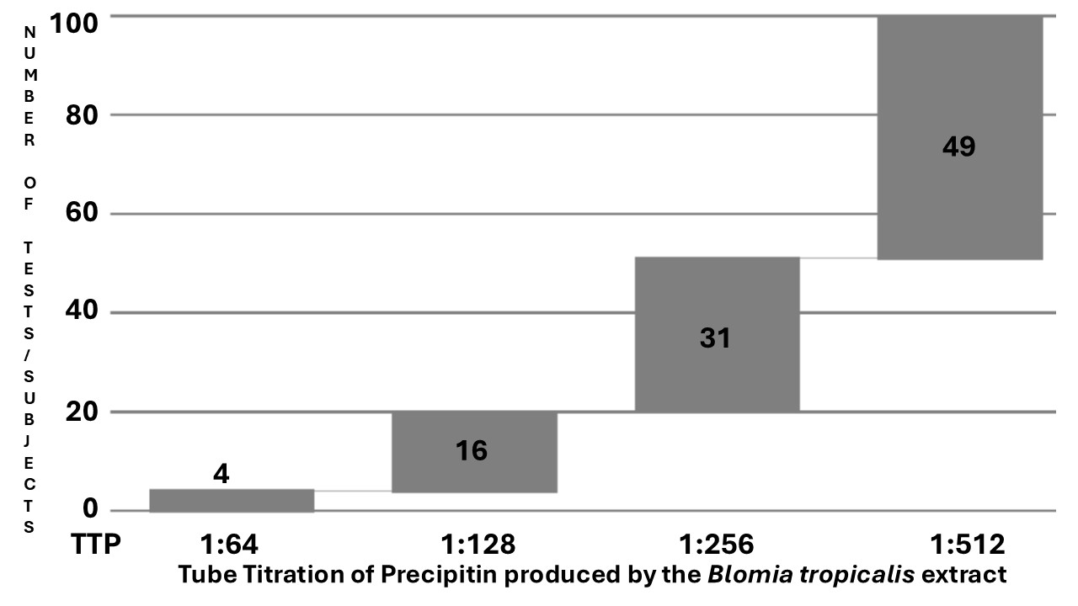

Fig. 1. Cascade distribution chart of the Tube Titration of Precipitins (x-axis %) resulting from the Blomia tropicalis extract against the serum of the TTP cohort of 100 tests/subjects (y-axis).

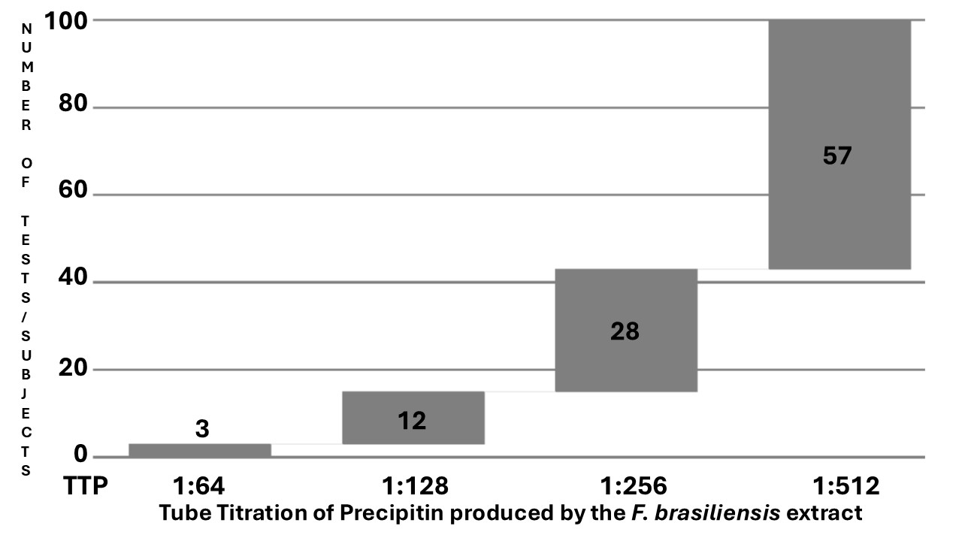

Fig. 2. Cascade distribution chart of the Tube Titration of Precipitins (x-axis %) resulting from the Farfantepenaeus brasiliensis extract against the serum of the TTP cohort of 100 tests/subjects (y-axis).

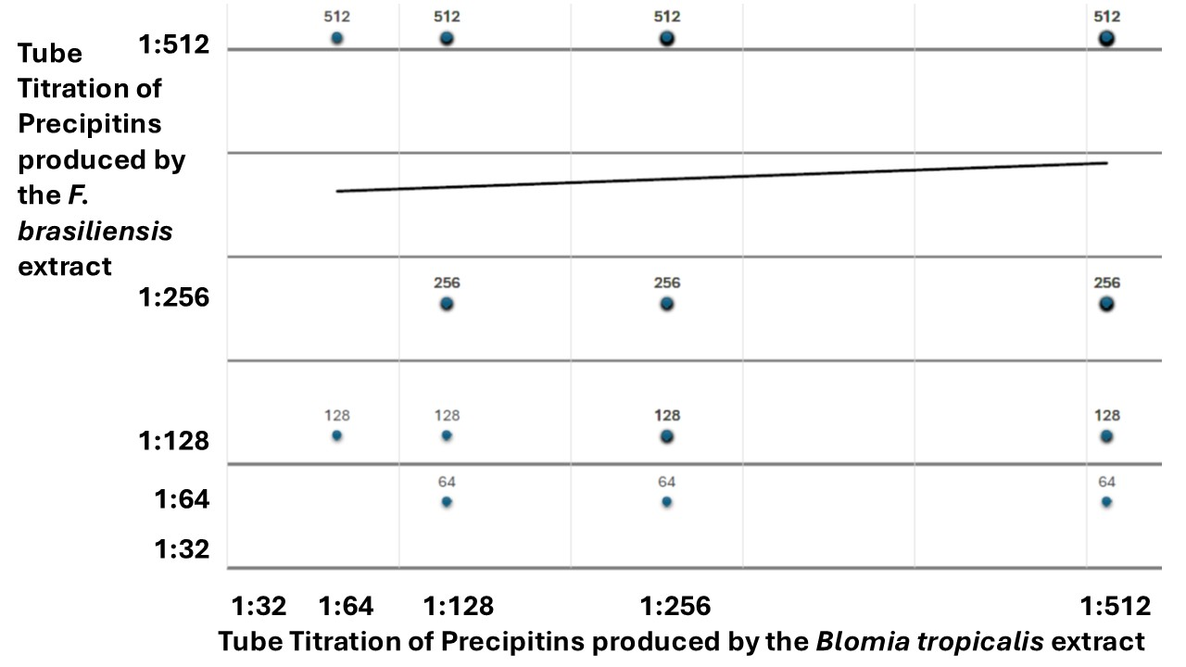

Fig. 3. Dispersion chart of the Tube Titration of Precipitins results of the ex vivo challenge test against Blomia tropicalis extract (x-axis %), plotted against the Tube Titration of Precipitins results of the ex vivo challenge test against Farfantepenaeus brasiliensis extract (y-axis %).

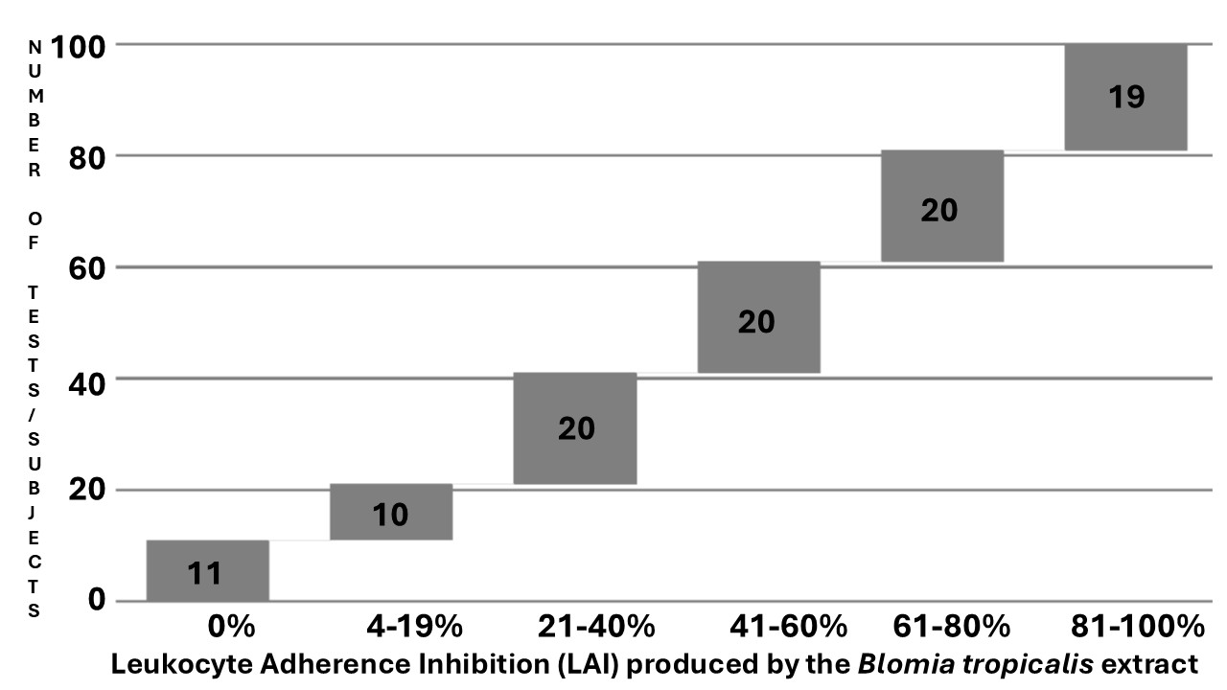

Fig. 4. Cascade distribution chart of the range groups of Leukocyte Adherence Inhibition (LAI) results (x-axis %) of the ex vivo challenge test against the Blomia tropicalis extract monitored by the Leukocyte Adherence Inhibition Test (LAIT), according to the respective number of outcomes over the LAIT cohort with 100 tests/subjects (y-axis).

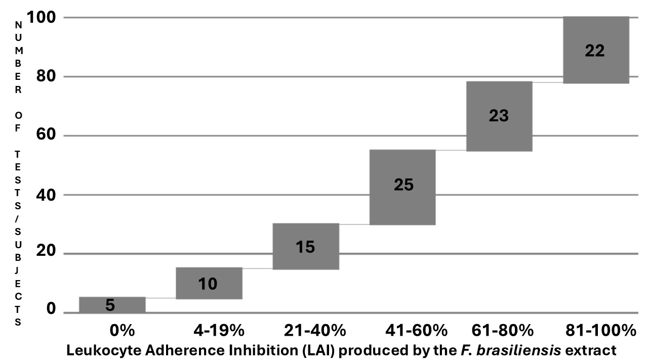

Fig. 5. Cascade distribution chart of the range groups of Leukocyte Adherence Inhibition (LAI) results (x-axis %) of the ex vivo challenge test against the Farfantepenaeus brasiliensis extract monitored by the Leukocyte Adherence Inhibition Test (LAIT), according to the respective number of outcomes over the LAIT cohort with 100 tests/subjects (y-axis).

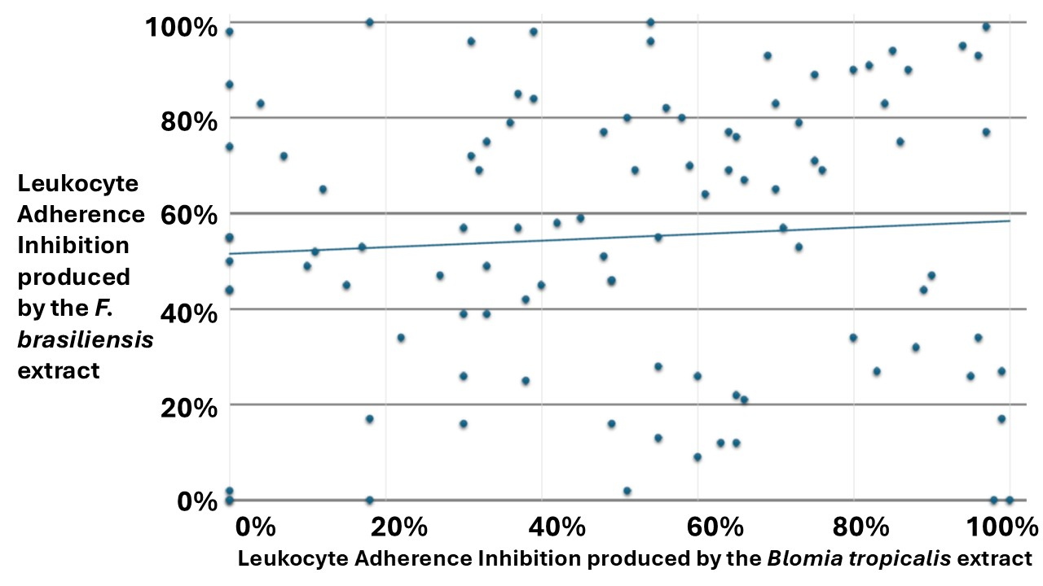
Fig. 6. Dispersion chart of the Leukocyte Adherence Inhibition (LAI) results of the ex vivo challenge test against Blomia tropicalis extract (x-axis %), plotted against the LAI results of the ex vivo challenge test against Farfantepenaeus brasiliensis extract (y-axis %).

4. DISCUSSION

Polysensitization and cross-reactivity are related phenomena frequently observed in patients with allergic multimorbidity (Zhang et al., 2025; Čelakovská et al., 2024; Hasnain, Alqassim, and Al-Frayl, 2017). When investigating the etiology of allergic reactions, it is advisable to maintain an open mind regarding cross-reactivity among panallergens, especially in polysensitized patients presenting with Allergic Multimorbidity (Miltner et al., 2024). The specificity and facility for researching precipitins transformed this immunoassay into a pioneering examination upon which the fundamentals of immunology were established (Hunter 1905). Precipitins are yet used nowadays to monitor emerging diseases when more precise and sophisticated assays are inexistent or unavailable (Bellanger et al., 2022). Precipitating antibodies indicate a humoral immune response against the tested antigens (Gell, Harington, and Rivers, 1946). Before the discovery of IgE, the research of precipitins was the only viable way to demonstrate immunoreactivity against allergenic agents (Augustin and Hayward, 1960) (Wells, 1911). Precipitin antibodies may belong to any Immunoglobulin class (except for IgG4), can mount immune complexes, and can participate in type II (antibody-dependent cell-mediated) and type III (immune complexes disease) Gell and Coombs hypersensitivity reactions, which may (theoretically) be demonstrated by the LAIT and the TTP assays, respectively (Gell and Coombs, 1968).
The LAIT is an ex vivo challenge test performed with live leukocytes, which allows the interaction of all immune-circulating cells with allergens. Several immune pathways can inhibit leukocyte adherence (Tong et al., 1979; Halliday, Maluish, and Miller, 1974).
The present study is a proof-of-concept that hypothesizes that LAIT and the TTP may differentiate diverse degrees of cellular and humoral immunoreactivity against Blomia tropicalis and Farfantepenaeus brasiliensis extracts among patients suffering from non–IgE-mediated Allergic Multimorbidity. As the tests were performed simultaneously using the same venous sample with both allergens, it was possible to calculate a correlation to distinguish any order of cross-reactivity between them.
The retrospective compilation of our data revealed a wide distribution of results when analyzing the LAIT results to explore cellular immunoreactivity. On the contrary, there was no such variability in the results of TTP, which demonstrated the presence of high titers of precipitin antibodies predominantly in the higher dilutions, suggesting the presence of humoral activity against these extracts in all selected patients, thereby limiting the analytical value of this immunoassay. Despite these immunoassays not precisely identifying the mechanisms responsible for the clinical condition, they provide general evidence about cellular and humoral immunoreactivity that may be involved in immune tolerance, sensitization, and clinical hypersensitivity.
This preliminary retrospective survey yielded diverse results from the TTP and the ex vivo challenge test, monitored by LAIT, against Blomia tropicalis and Farfantepenaeus brasiliensis extracts in two cohorts of patients diagnosed with non–IgE–mediated Allergic Multimorbidity. TTP and LAIT are complementary triage tests used at our facilities to select worthwhile antigens to proceed with more laborious in vivo provocation tests when the specific IgE is undetectable. None of our patients presented an exclusive reaction to these allergens. Every patient was simultaneously evaluated for several chemical and biological allergens, demonstrating positive results for some of them. Our results suggest that patients with allergies to HDM may exacerbate their symptoms by experiencing additional cross-immunoreactivity when consuming shrimp.
Assessing diverse pathways of immunoreactivity and hypersensitivity through tools such as TIAL and TTP against the whole extract of suspected allergens, as well as suspected molecular allergens, is a multi-omics approach that evaluates both diagnosis and treatment effectiveness in allergic patients (Hubert et al., 2023).

5. LIMITATIONS

This study is a retrospective analysis of data collected over a seven-year period since our facility began employing laboratory immune assays. There was no protocol research, and the subject's data was limited to the essentials available on our electronic sheets. Therefore, we were unable to establish a cross-comparison between the positive and negative controls to validate the results. The number of subjects is suitable for a preliminary study; however, future studies should be more comprehensive. The lack of a research protocol implies the possibility of bias introduced by the physician's point of view (CEO) based on a clinical suspicion driven solely by the anamnesis and physical examination. The study lost many of these patients to follow-up, so it is not yet possible to ensure the relationship between the immunoassay results and the patient's clinical outcome. Unfortunately, it was impossible to compare the two procedures using paired statistics methodologies because they were derived from two distinct patient groups.

6. CONCLUSION

Our preliminary results suggest that the LAIT and TTP may distinguish between varying degrees of immunoreactivity against Blomia tropicalis and Farfantepenaeus brasiliensis extracts in patients clinically diagnosed with non–IgE–mediated Allergic Multimorbidity. Despite requiring trained personnel for execution, LAIT and TTP are inexpensive, can be performed with minimal laboratory equipment, and can be incorporated into strategies to address health disparities in diagnosing respiratory and food allergies (Anagnostou et al., 2025). As a preliminary report, the propaedeutic significance of the presented results and the potential interfering factors must be established (Anouar, Hazim, and Brahim 2024). More studies focused on the quality-by-design approach with larger, prospective, double-blind cohorts are needed to evaluate the potential contribution of LAIT and TTP for endotyping cellular and humoral immunoreactivity in patients suspected of hypersensitivity to aeroallergens and food allergens (Chiarentin et al., 2023).

7. FUTURE DIRECTIONS AND RECOMMENDATIONS FOR CLINICAL PRACTICE
The primary intended use of in vitro or ex vivo allergen challenge tests is to spare patients from undergoing unnecessary, exhaustive, and potentially dangerous in vivo challenge tests. Exploring the humoral and the cellular arms of immune systems, the TTP and LAIT alone or combined may represent, in the near future, a tool for allergists to construct an etiologic diagnosis from their patients, as well as determine the endotypes (mechanisms) of hypersensitivity, in order to choose more convenient and personalized therapies for them. Adding data provided by TTP and LAIT may also contribute to streamlining biomedical research and improving tools, such as large language models, which clinicians often use as a decision support system to enhance diagnostic accuracy (Abers and Mathias, 2025).

CONSENT

As a retrospective survey of results recorded in cognito, consent was obtained collectively by the institution's ethics committee, following the principles outlined in the Declaration of Helsinki (World Medical Association, 2013).

ETHICAL APPROVALS

The authors have obtained and documented written ethical approval following international standards.

Disclaimer (artificial intelligence)
Authors hereby declare that NO generative AI technologies such as Large Language Models (ChatGPT, COPILOT, etc.) and text-to-image generators have been used during the writing or editing of this manuscript.

COMPETING INTERESTS DISCLAIMER:
Authors have declared that they have no known competing financial interests OR non-financial interests OR personal relationships that could have appeared to influence the work reported in this paper.

REFERENCES

Abers, M. S., Mathias, R. A. (2025). Novel applications of large language models in clinical research. Journal of Allergy and Clinical Immunology, 155(3): 813-814.
Allardyce, R. A., Shearman, D. J. (1975). Leukocyte reactivity to alpha-gliadin in dermatitis herpetiformis and adult coeliac disease. International Archives of Allergy and Applied Immunology, 48(3): 395-400.
Anagnostou, A., Wang, J., Chinthrajah, S., Gupta, R., Davis, C. M., Parrish, C., et al. (2025). Addressing health disparities in food allergy: A Position Statement of the AAAAI Prior Authorization Task Force. Journal of Allergy and Clinical Immunology, 155(1): 53-61.
Anouar, S., Hazim, R., Brahim, A. (2024). Interferences in Immunological Assays: Causes, Detection, and Prevention. Asian Journal of Immunology., 7(1): 71-78.
Ashkenazi, A., Levin, S., Idar, D., Or, A., Rosenberg, I., Handzel, Z. T. (1980). In Vitro Cell-Mediated Immunologic Assay for Cow's Milk Allergy. Pediatrics, 66(3): 399-402.
Augustin, R. (1953). Precipitins to grass pollen proteins. Nature, 172(4372): 307.
Augustin, R., Hayward, B. J. (1960). Human reagins to grass pollens and moulds: their purification and physico-chemical characterization. Immunology, 3(1): 45-73.
Augustin, R., Hayward, B. J., Longbottom, J. L. (1960). Isolation and physico-chemical characterization of reagins, blocking antibodies and precipitins to grass pollens. Clinical and Experimental Allergy (Copenhagen), 7: 31-37.
Bailey, K. (1946). Tropomyosin: a new asymmetric protein component of muscle. Nature, 157: 368.
Baqueiro, T., Carvalho, F. M., Rios, C. F., dos Santos, N. M., Alcântara-Neves, N. M. (2006). Dust mite species and allergen concentrations in beds of individuals belonging to different urban socioeconomic groups in Brazil. Journal of Asthma, 43(2): 101-105.
Barrera-de-Pino, O. M., Murgas, I., Miranda, R. J. (2012). First Report of Anaphylactic Shock Caused by the Ingestion of Mite-Infested Flour in Panama. Journal of the World Health Organization, 17(5): 104.
Bellanger, A. P., Lallemand, S., Tumasyan, H. A., Navellou, J. C., Barrera, C., Rouzet, A., et al. (2022). Investigation of the value of precipitins in severe acute respiratory syndrome coronavirus 2 (SARS-CoV-2) patients with a positive marker for Aspergillus species. Medical Mycology, 60(5).
Bousquet, J., Anto, J. M., Haahtela, T., Sousa-Pinto, B., Morais-Almeida, M. (2025). From "one airway, one disease" to "one airway, many diseases". Journal of Allergy and Clinical Immunology.
Bousquet, J., Anto, J. M., Wickman, M., Keil, T., Valenta, R., Haahtela, T., et al. (2015). Are allergic multimorbidities and IgE polysensitization associated with the persistence or re-occurrence of foetal type 2 signalling? The MeDALL hypothesis. Allergy, 70(9): 1062-1078.
Bradford, M. M. (1976). A rapid and sensitive method for the quantitation of microgram quantities of protein utilizing the principle of protein-dye binding. Analytical Biochemical, 72: 248-254.
Butler, H. L., Byrne, W. J., Marmer, D. J., Euler, A. R., Steele, R. W. (1981). Depressed Neutrophil Chemotaxis in Infants with Cow's Milk and/or Soy Protein Intolerance. Pediatrics, 67(2): 264-268.
Carvalho, C., Keunecke, K. A., Lavrado, H. P. (2019). Morphometric variation in pink shrimp populations at Rio de Janeiro coast (SE Brazil): are they really similar in closer areas? Anais da Academia Brasileira de Ciências, 91(2): e20180252.
Čelakovská, J., Čermákova, E., Andrýs, C., Boudkova, P., Krejsek, J. (2024). Sensitization to latex and food allergens in atopic dermatitis patients according to ALEX2 Allergy Xplorer test. Molecular Immunology, 175: 89-102.
Chew, F. T., Zhang, L., Ho, T. M., Lee, B. W. (1999). House Dust Mite Fauna of Tropical Singapore. Clinical and Experimental Allergy, 29(2): 201-206.
Chiarentin, L., Gonçalves, C., Augusto, C., Miranda, M., Cardoso, C., Vitorino, C. (2023). Drilling into "Quality by Design" Approach for Analytical Methods. Critical Reviews in Analytical Chemistry: 1-42.
Chua, K. Y., Cheong, N., Kuo, I. C., Lee, B. W., Yi, F. C., Huang, C. H., et al., (2007). The Blomia tropicalis allergens. Protein and Peptide Letters, 14(4): 325-333.
Cunningham-Rundles, C., Brandeis, W. E., Good, R. A., Day, N. K. (1978). Milk precipitins, circulating immune complexes, and IgA deficiency. Proceedings of the National Academy of Sciences of the United States of America, 75(7): 3387-3389.
Daul, C. B., Slattery, M., Reese, G., Lehrer, S. B. (1994). Identification of the major brown shrimp (Penaeus aztecus) allergen as the muscle protein tropomyosin. International Archives of Allergy and Immunology, 105(1): 49-55.
Emran, H., Chieng, C. S. E., Taib, S., Cunningham, A. C. (2019). House dust mite sensitisation and association with atopic dermatitis in Brunei: Allergen sensitization and allergic disease in Brunei. Clinical and Translational Allergy, 9: 65.
Fain, A. (1966). [Respiratory allergies caused by an acaridan (Dermatophagoides pteronyssinus) living in house dust]. Bulletin de l'Academie Royale de Medicine de Belgique, 6(6): 479-500.
Ferguson, A., Carswell, F. (1972). Precipitins to dietary proteins in serum and upper intestinal secretions of coeliac children. British Medical Journal, 1(5792): 75-77.
Fernández-Caldas, E., Fox, R. W., Bucholtz, G. A., Trudeau, W. L., Ledford, D. K., Lockey, R. F. (1990). House dust mite allergy in Florida. Mite survey in households of mite-sensitive individuals in Tampa, Florida. Allergy Proceedings, 11(6): 263-267.
Fernández-Caldas, E., Puerta, L., Mercado, D., Lockey, R. F., Caraballo, L. R. (1993). Mite fauna, Der p I, Der f I and Blomia tropicalis allergen levels in a tropical environment. Clinical and Experimental Allergy, 23(4): 292-297.
Fink, A., Heller, L., Eliraz, A., Weisman, Z., Miskin, A., Schlezinger, M., et al. (1987). Allergen-specific leukocyte adherence inhibition (LAI) assay: sensitivity, specificity and mechanism. Immunology Letters, 16(1): 65-70.
Gell, P. G. H. and Coombs, R. R. A. (1968). Classification of allergic reactions responsible for clinical hypersensitivity and disease. In: Clinical Aspects of Immunology (5th. ed., pp 576-596) Oxford Blackwell Scientific Publications.
Gell, P. G. H., Harington, C. R., Rivers, R. P. (1946). The antigenic function of simple chemical compounds; production of precipitins in rabbits. British Journal of Experimental Pathology, 27(5): 267-286.
George, M., Vaughan, J. H. (1962). In vitro cell migration as a model for delayed hypersensitivity. Proceedings of the Society of Experimental Biology and Medicine, 111: 514-521.
Halliday, W. J., Maluish, A., Miller, S. (1974). Blocking and unblocking of cell-mediated anti-tumor immunity in mice, as detected by the leucocyte adherence inhibition test. Cellular Immunology, 10(3): 467-475.
Hasnain, S. M., Alqassim, A., Al-Frayl, A. (2017). Diagnosis of allergy: IgE mediated cross-reactions amongst selected asthma elicitors. Journal of Disease and Global Health, 10(4): 111-122.
Heiner, D. C., Sears, J. W., Kniker, W. T. (1962). Multiple Precipitins to Cow's Milk in Chronic Respiratory Disease: A Syndrome Including Poor Growth, Gastrointestinal Symptoms, Evidence of Allergy, Iron Deficiency Anemia, and Pulmonary Hemosiderosis. American Journal of Diseases of Children, 103(5): 634-654.
Hubert, J., Vrtala, S., Sopko, B., Dowd, S. E., He, Q., Klimov, P. B., et al. (2023). Predicting Blomia tropicalis allergens using a multiomics approach. 13(10): e12302.
Hunter, A. (1905). On the chemical specificity of precipitins. The Journal of Physiology, 32(5-6): 327-342.
Jutel, M., Agache, I., Zemelka-Wiacek, M., Akdis, M., Chivato, T., Del Giacco, S., et al. (2023). Nomenclature of allergic diseases and hypersensitivity reactions: Adapted to modern needs: An EAACI position paper. Allergy, 78(11): 2851-2874.
Kallen, B., Nilsson, O. (1979). Effect of encephalitogenic protein. PPD and tetanus toxoid on leukocyte migration in agarose. A study of "cross-reactivity". Allergy, 34(2): 97-102.
Kuratsuji, T. (1981). Studies on leukocyte adherence inhibition test. Part II. Clinical applications of the LAI test to detect delayed-type hypersensitivity in infants and children. Keio Journal of Medicine, 30(2): 65-69.
Martínez, D., Fang, L., Meza-Torres, C., Garavito, G., López-Lluch, G., Egea, E. (2024). Toward Consensus Epitopes B and T of Tropomyosin Involved in Cross-Reactivity across Diverse Allergens: An In Silico Study. Biomedicines, 12(4).
Miltner, L. A., Vonk, J. M., van der Velde, J. L., Sprikkelman, A. B. (2024). Eczema in early childhood increases the risk of allergic multimorbidity. Clinical and Translational Allergy, 14(9): e12384.
Miyamoto, T., Oshima, S., Mizuno, K., Sasa, M., Ishizaki, T. (1969). Cross-antigenicity among six species of dust mites and house dust antigens. Journal of Allergy, 44(4): 228-238.
Morgan, J. E., O'Neil, C. E., Daul, C. B., Lehrer, S. B. (1989). Species-specific shrimp allergens: RAST and RAST-inhibition studies. Journal of Allergy and Clinical Immunology, 83(6): 1112-1117.
Olivier, C. E., Argentão, D. G. P., Santos, R. A. P. G., Silva, M. D., Lima, R. P. S., Zollner, R. L. (2013). Skin scrape test: an inexpensive and painless skin test for recognition of immediate hypersensitivity in children and adults. The Open Allergy Journal, 6: 9-17.
Olivier, C. E., Lima, R. P. S., Pinto, D. G., Santos, R. A. P. G. d. (2021a). The Plasma Preincubation with Papain Before the Assay Suggests that a Gell and Coombs Type II Reaction is Been Demonstrated by the Leukocyte Adherence Inhibition Test. Biomedical Journal of Scientific and Technical Research, 36(3): 28647-28655.
Olivier, C. E., Lima, R. P. S., Pinto, D. G., Santos, R. A. P. G., Silva, G. K. M., Lorena, S. L. S., et al. (2012). In search of a tolerance-induction strategy for cow's milk allergies: significant reduction of beta-lactoglobulin allergenicity via transglutaminase/cysteine polymerization. Clinics, 67(10): 1171-1179.
Olivier, C. E., Pinto, D. G., Lima, R. P. S., Silva, M. D. d., Santos, R. A. P. G., Teixeira, A. P. M., et al. (2021b). Assessment of Immunoreactivity against Therapeutic Options Employing the Leukocyte Adherence Inhibition Test as a Tool for Precision Medicine. European Journal of Clinical Medicine, 2(3): 40-45.
Olivier, C. E., Pinto, D. G., Santos, R. A. P. G., Lima, R. P. S. (2021c). Dextran's interference over the Leukocyte Adherence Inhibition Test. Academia Letter, Article (number): 3792.
Olivier, C. E., Pinto, D. G., Teixeira, A. P. M., Miguel, C. S., Santos, R. A. P. G., Rocha, N. S., Et-al. (2025). Endotyping Cellular and Humoral Immunoreactivity against Pollen and Citrus Fruits in Patients with Non–IgE-mediated Rhinoconjunctivitis. Asian Journal of Immunology, 8(1): 8-25.
Olivier, C. E., Pinto, D. G., Teixeira, A. P. M., Miguel, C. S., Santos, R. A. P. G., Santana, J. L. S., et al. (2024a). Cellular and Humoral Immunoreactivity against Hen's Egg White: Relevance in Allergic Patients. Asian Journal of Immunology, 7(1): 274-284.
Olivier, C. E., Pinto, D. G., Teixeira, A. P. M., Miguel, C. S., Santos, R. A. P. G., Santana, J. L. S., et al. (2024b). Endotyping Cellular and Humoral Immunoreactivity against Allium spices and Sulfites preservatives in Allergic Patients. A Retrospective Study. Asian Journal of Immunology, 7(1): 185-200.
Olivier, C. E., Pinto, D. G., Teixeira, A. P. M., Miguel, C. S., Santos, R. A. P. G., Santana, J. L. S., et al. (2024c). Endotyping Cellular and Humoral Immunoreactivity Against Tartrazine in Allergic Patients: A Retrospective Study. Asian Journal of Immunology, 7(1): 217-227.
Olivier, C. E., Pinto, D. G., Teixeira, A. P. M., Santana, J. L. S., Santos, R. A. P. G., Lima, R. P. S. (2021d). Self-imposed food restriction and oral food challenges are correlated with precipitin's accuracy in the diagnosis of non-IgE-mediated food-related adulthood acute episodes of urticaria. Journal of Allergy Therapy, 12(8): 1-8.
Olivier, C. E., Pinto, D. G., Teixeira, A. P. M., Santana, J. L. S., Santos, R. A. P. G., Lima, R. P. S. (2023a). Contribution of the Leukocyte Adherence Inhibition Test to the Diagnosis of Innate Non–IgE-mediated Immunoreactivity against Saccharomyces cerevisiae. Asian Journal of Immunology, 6(1): 234-241.
Olivier, C. E., Pinto, D. G., Teixeira, A. P. M., Santana, J. L. S., Santos, R. A. P. G., Lima, R. P. S. (2024d). Endotyping Cellular and Humoral Immunoreactivity against Aluminum in Allergic Patients: A Retrospective Study. Asian Journal of Immunology, 7(1): 149-158.
Olivier, C. E., Pinto, D. G., Teixeira, A. P. M., Santana, J. L. S., Santos, R. A. P. G., Lima, R. P. S. (2024e). Endotyping Non-IgE-mediated Immunoreactivity to Polyethylene Glycol: Implications for Allergic Patients. Asian Journal of Immunology, 7(1): 100-111.
Olivier, C. E., Pinto, D. G., Teixeira, A. P. M., Santana, J. L. S., Santos, R. A. P. G., Lima, R. P. S., et al. (2023b). Contribution of the Leukocyte Adherence Inhibition Test to the Diagnosis of Innate Non–IgE-mediated Immunoreactivity against Alternaria alternata. Asian Journal of Immunology, 6(1): 243-251.
Olivier, C. E., Pinto, D. G., Teixeira, A. P. M., Santana, J. L. S., Santos, R. A. P. G., Lima, R. P. S., et al. (2023c). Contribution of the Leukocyte Adherence Inhibition Test to the Diagnosis of Non–IgE-mediated Immunoreactivity against Candida albicans in Patients with Atopic Dermatitis. Asian Journal of Immunology, 6(1): 268-276.
Olivier, C. E., Pinto, D. G., Teixeira, A. P. M., Santana, J. L. S., Santos, R. A. P. G., Lima, R. P. S., et al. (2023d). Evaluating Non-IgE-mediated Allergens' Immunoreactivity in Patients with "Intrinsic" Persistent Rhinitis with Help of the Leukocyte Adherence Inhibition Test. European Journal of Medical and Health Sciences, 5(1): 17-22.
Olivier, C. E., Pinto, D. G., Teixeira, A. P. M., Santana, J. L. S., Santos, R. A. P. G., Lima, R. P. S., et al. (2024f). Contribution of the Leukocyte Adherence Inhibition Test in Diagnosing Non–IgE-Mediated Immunoreactivity against Aspergillus fumigatus in Patients with Allergic Rhinitis and Asthma. Asian Journal of Immunology, 7(1): 12-20.
Olivier, C. E., Pinto, D. G., Teixeira, A. P. M., Santana, J. L. S., Santos, R. A. P. G., Lima, R. P. S., et al. (2024g). Endotyping Non-IgE-Mediated Immunoreactivity to Dermatophagoides farinae: Implications for Allergic Patients. Asian Journal of Immunology, 7(1): 90-99.
Olivier, C. E., Pinto, D. G., Teixeira, A. P. M., Santana, J. L. S., Santos, R. A. P. G. S., Lima, R. P. S. (2021e). Intrinsic Atopic Dermatitis: Titration of Precipitins in the Screening of Food Allergens for Prescription of Elimination Diets and Desensitization Strategies. European Journal of Clinical Medicine, 2(6): 1-9.
Olivier, C. E., Pinto, D. G., Teixeira, A. P. M., Santana, J. L. S., Santos, R. A. P. G. S., Lima, R. P. S. (2022a). Contribution of the Leukocyte Adherence Inhibition Test for the evaluation of immunoreactivity against gluten extracts in non—IgE-mediated / non-autoimmune Gluten-Related Disorders. European Journal of Clinical Medicine, 3(2): 1-7.
Olivier, C. E., Pinto, D. G., Teixeira, A. P. M., Santana, J. L. S., Santos, R. A. P. G. S., Lima, R. P. S. (2022b). Contribution of the Leukocyte Adherence Inhibition Test to the Evaluation of Cellular Immunoreactivity against Latex Extracts for Non—IgE-Mediated Latex-Fruit-Pollen Syndrome in Allergic Candidates to Exclusion Diets and Allergic Desensitization. European Journal of Clinical Medicine, 3(1): 11-17.
Olivier, C. E., Pinto, D. G., Teixeira, A. P. M., Santana, J. L. S., Santos, R. A. P. G. S., Lima, R. P. S. (2022c). Leukocyte Adherence Inhibition Test to the Assessment of Immunoreactivity Against Cow's Milk Proteins in Non—IgE-Mediated Gastrointestinal Food Allergy. European Journal of Clinical Medicine, 3(2): 38-43.
Olivier, C. E., Pinto, D. G., Teixeira, A. P. M., Santana, J. L. S., Santos, R. A. P. G. S., Lima, R. P. S. (2023e). Anti-Saccharomyces cerevisiae antibodies (ASCA) researched by tube precipitins are elevated in patients with dermatologic and gastrointestinal non—IgE-mediated hypersensitivity. European Journal of Clinical Medicine, 4(2): 25-30.
Olivier, C. E., Pinto, D. G., Teixeira, A. P. M., Santana, J. L. S., Santos, R. A. P. G. S., Lima, R. P. S., et al. (2023f). Evaluating Non-IgE-Mediated Allergens' Immunoreactivity in Patients Formerly Classified as "Intrinsic" Asthmatics with Help of the Leukocyte Adherence Inhibition Test. European Journal of Clinical Medicine, 4(2): 1-7.
Olivier, C. E., Santos, R. A. P. G., Lima, R. P. S., Argentão, D. G. P., Silva, G. K. M., Silva, M. D. (2014). A Novel Utility for an Old Method: The Leukocyte Adherence Inhibition Test Is an Easy Way to Detect the Immunoreactive Interference of the Collection Tube Anticoagulant on Cellular Immunoassays. Journal of Cell Adhesion, Article ID 860427(http://dx.doi.org/10.1155/2014/860427): 1-6.
Papageorgiou, N., Lee, T. H., Nagakura, T., Cromwell, O., Wraith, D. G., Kay, A. B. (1983). Neutrophil chemotactic activity in milk-induced asthma. Journal of Allergy and Clinical Immunology, 72(1): 75-82.
Papia, F., Bellia, C., Uasuf, C. G. (2021). Tropomyosin: A panallergen that causes a worldwide allergic problem. Allergy and Asthma Proceedings, 42(5): e145-e151.
Reese, G., Ayuso, R., Lehrer, S. B. (1999). Tropomyosin: an invertebrate pan-allergen. International Archives of Allergy and Immunology, 119(4): 247-258.
Sánchez-Borges, M., Suárez Chacón, R., Capriles-Hulett, A., Caballero-Fonseca, F., Fernández-Caldas, E. 2013. Anaphylaxis from ingestion of mites: Pancake anaphylaxis. Journal of Allergy and Clinical Immunology, 131(1): 31-35.
Schoch CL, et al. (2020a). NCBI Taxonomy: Blomia tropicalis. In: NCBI Taxonomy: a comprehensive update on curation (https://www.ncbi.nlm.nih.gov/Taxonomy/Browser/wwwtax.cgi?lvl=0&amp;id=40697).
Schoch CL, et al. (2020b). NCBI Taxonomy: Farfantepenaeus brasiliensis. In: NCBI Taxonomy: a comprehensive update on curation (https://www.ncbi.nlm.nih.gov/Taxonomy/Browser/wwwtax.cgi).
Shanti, K. N., Martin, B. M., Nagpal, S., Metcalfe, D. D., Rao, P. V. (1993). Identification of Tropomyosin as the Major Shrimp Allergen and Characterization of Its IgE-Binding Epitopes Journal of Immunology, 151(10): 5354-5363.
Silveira, S., Fabiano, G., Pereyra, I., Laporta, M., Scarabino, F., Santana, O., Márquez, A., Errico, E. (2022). Presence of the Pink shrimp Farfantepenaeus brasiliensis (Latreille, 1817) in the coastal lagoons of Uruguay (Crustacea: Decapoda: Penaeoidea). Nauplius, 30.
Sub-Committee for Allergen Nomenclature, (2025a). The official list of allergens from Blomia tropicalis as compiled by the World Health Organization (WHO) and the International Union of Immunological Societies. (https://allergen.org/search.php?allergenname=&allergensource=Blomia+tropicalis&TaxSource=&TaxOrder=&foodallerg=all&bioname=).
Sub-Committee for Allergen Nomenclature (2025b). The official list of allergens from shrimps, as compiled by the WHO and the International Union of Immunological Societies. (https://allergen.org/search.php?allergensource=shrimp&searchsource=Search).
Thomson, D. M. P. (1982). Assessment of immune status by the leukocyte adherence inhibition test. New York: Academic Press.
Tong, A. W., Burger, D. R., Finke, P., Barney, C., Vandenbark, A. A., Vetto, R. M. (1979). Assessment of the mechanism of the leukocyte adherence inhibition test. Cancer Research, 39(2 Pt 2): 597-603.
van Bronswijk, J. E., de Cock, A. W., Oshima, S. (1973). The genus Blomia Oudemans (Acari: Glycyphagidae) I. Description of Blomia tropicalis sp. n. from house dust in tropical and sub-tropical regions. Acarologia, 15(3): 477-489.
Voorhorst, R., Spieksma-Boezeman, M. I., Spieksma, F. T. (1964). Is a mite (Dermatophagoides sp) the producer of the house dust allergen? Allergie und Asthma (Leipz), 10: 329-334.
Waring, N. P., Daul, C. B., deShazo, R. D., McCants, M. L., Lehrer, S. B. (1985). Hypersensitivity reactions to ingested crustacea: clinical evaluation and diagnostic studies in shrimp-sensitive individuals. Journal of Allergy and Clinical Immunology, 76(3): 440-445.
Wells, H. G. (1911). Studies on the chemistry of anaphylaxis (III). Experiments with isolated proteins, especially those of the hen's egg. Journal of Infectious Diseases, 9: 147-171.
Williams, C. A., Chase, M. W. (1971). Chapter 13 - Precipitation Reactions, Reactions of Antibodies with Soluble Antigens, Vol. 3: 1-102: Academic Press.
WMA. (2013). World Medical Association Declaration of Helsinki: Ethical Principles for Medical Research Involving Human Subjects. JAMA, 310(20): 2191-2194.
Wong, L., Huang, C. H., Lee, B. W. (2016). Shellfish and House Dust Mite Allergies: Is the Link Tropomyosin? Allergy, Asthma and Immunology Research, 8(2): 101-106.
Yang, A. C., Arruda, L. K., Santos, A. B. R., Barbosa, M. C. R., Chapman, M. D., Kalil, J., et al. (2010). Cross-reactivity Between Mite And Shrimp: The Effect Of Immunotherapy With Dust Mite Extract. Journal of Allergy and Clinical Immunology, 125(2): AB35.
Zhang, J., Tang, Y., Yang, D., Yu, J. (2025). Investigating allergen-specific IgE distribution and correlations in chronic urticaria: a retrospective study in Shanghai, China. European Journal of Medical Research, 30(1): 182.

