***Assessment on Invasive Plant Species Identification and Controlling Mechanisms to improve conservation challenges on Natural Resources in case of Abijata Shalla Lakes National Park, Ethiopia.***

***Abstract:***

*The study was conducted at Abijata Shalla Lakes National Park (ASLNP), Ethiopia in order to investigate Invasive Plant Species Identification and Controlling Mechanisms to improve conservation challenges on natural resources**and aimed to minimize and control invasive plant species for wildlife habitat Management. Data was collected both in local Afaan Oromoo and English languages. Structured interview by means of focus group discussions using a semi structured questionnaire regarding the typology, effects and controlling mechanisms of invasive species was used supplemented by professional ecologists, game rangers’ heads and surrounding local farmers’ who were questioned on invasive alien plants species affecting their agricultural lands. During field trips plants were initially identified by ecologists and respondents by means of their local names. Coupon specimens of some of the species cited during interviews were collected and their photos were captured for further guidance identification. Final identification was made with reference to field guide books and literatures. Five major invasive species: - Abutilon spp, Opuntia spp, Lantana camara, Parthenium hysterophorus and Prosopis julifora were identified in the study area during the investigation of this survey and review*. *The surrounding community’s concept and knowledge about these invasive were almost positive and they are deliberately dispersing the species. They use for fencing their farm land by planting on the series of land border, feed some of their fruits and used as shading during dry season which alarming their expansion. It is better to do cooperatively on how to minimize and control* i*nvasive species to enhance environmental productivity and sustainable biodiversity conservation management is extremely suggested.*

*Key words and phrases: Invasive species, Biodiversity, National Park, Controlling mechanism*

**Introduction:**

The augmented movement of humans throughout the globe has enabled the intentional and unintentional dispersion of species far from their native home ranges, often in a manner that can facilitate invasions (Wakshum *et al.*2019). Some of these presented plants have distinguished benefits to humans, but many of them have unwanted impacts that can result in substantial monetary costs and/or changes to entire ecosystems and social schemes (Mcneely, 2001: Kumschick *et al.* 2012). All concerned bodies of government sectors, non-governmental organizations, extension services, environmental protectionist, conservationists and scientists are all facing intensifying pressure to address and resolve a diversity of problems posed by invasive alien species (Hulme 2006). The human induced spread of species is a strong form of global change that impacts the population dynamics of native species, the composition of native communities, and the functioning of ecosystems.

In Ethiopia, there are about 22 invasive alien species (McGinley, 2007), and the country has very heterogeneous in species diversity and has a rich endemic fauna and floras. These invasive alien species (IAS) pose the major threats to biodiversity next habitat destruction and also pose a serious threat to agriculture (crop and livestock), livelihoods and human health in the country (Haysom and Murphy, 2003). Among these invasive alien species Parthenium weed (*Parthenium hysterophorus*), Mesquites (*Prosopis juliflora*), Water hyacinth (*Eichhornia crasspies*), *Lantana camara*, and Cactus (*Opuntia spp*) are causing major problems in the country. Protected areas are among the most affected ecosystem in Ethiopia.

Protected areas are the cornerstones of virtually all national and international conservation strategies, set aside to maintain functioning natural ecosystems, to act as refuges for species and to maintain ecological processes that cannot survive in most intensely managed landscapes and seascapes (Jaldu *et al.*, 2025). They are act as benchmarks against which we understand human interactions with the natural world. Today they are often the only hope we have of stopping many threatened or endemic species from becoming extinct. They are complementary to achieve conservation and sustainable use of biodiversity outside protected areas in accordance with Convention on Biological Diversity guidelines (Dudley N, 2008).

One of the main functions of protected areas is for their scientific interest. Research within the areas is, therefore, important particularly when the results and conclusions of the research are applicable and drive conservation actions. There are other two aspects to consider; i) the monitoring of key ecological attributes (that are linked to the health and well-being of conservation targets and the threats to them), and ii) survey work (A model for the protected area system of Ethiopia, (EWCA, undated).

The main conservation challenges and threats of protected areas are alien and invasive species that are different in type and size at different protected areas of the country. Alien and invasive species are worldwide threats against Biodiversity conservation. Invasive Alien Species (IAS) are of a great challenge in Ethiopia, posing particular problems on biodiversity of the country, agricultural lands, range lands, national parks, water ways, lakes, rivers, power dams, roadsides and urban green spaces with great economic and ecological consequences. Foremost among these are *parthenium* weed (*Parthenium hysterophorus*), Prosopis (*Prosopis juliflora*), water hyacinth (*Eichhornia crassipes*), cactus (*Euphorbia stricta*) and lantana weed (*Lantana camara*). They have been identified by the Environmental Policy and the National Biodiversity Strategy and Action Plan as a major threat to biodiversity of the country and economic wellbeing of its people. However, little attempt has been made in terms of research and management of IAS. Their high seed production capacity and spread, adaptation to wide climatic and soil conditions, spread by animal movement and their association with pastoralists way of life and overgrazing are challenges to their management in Ethiopia. Manual control of *Parthenium* by farmers resulted in some of them developing skin allergies, itching, fever, and asthma, *Prosopis* form impenetrable thicket that prohibits free movement of people and animals and its thorns damage eyes and hooves of animals (Taye *et al*. 2016).

*Prosopis juliflora* is a shrub or small tree in the *Fabaceae* family. It is native to Mexico, South America and the Caribbean which is one of the noxious invasive weeds in the world. It has invaded millions of hectares of land in the arid and semi-arid areas of Asia, Africa, Australia and America. In Africa alone, *Prosopis juliflora* is believed to have invaded over 4 million hectares, threatening crop production, challenging domestic life, desiccating water resources, and displacing native flora and fauna.

*Prosopis juliflora, Opuntia spp., Parthenium, Lanthana camara* and *Abutilon* are all invasive species that are more invading the semi-arid and arid areas of Ethiopia especially in protected areas of Ethiopia having strong negative impacts across the landscape, and has been ranked as one of the leading threats to traditional land use, and danger to nomadic pastoralists; because they are replacing the whole pasture grass land. In areas of Ethiopia where these invasive has invaded: the climate is very hot, arid and semi-arid, with scarce rainfall distribution, and the soil is saline in most cases; in such harsh environment where few plant species can survive, they grows vigorously and thrives ever green. This proves it is not easy candidate to eradicate and therefore it has been ranked as they most problematic plant invaders in Ethiopia due to they has become the most noxious, alien and invasive weed now a days, and the most dangerous cause of genetic Erosion replacing indigenous and endemic Flora and Fauna of all the invaded countries.

Their reproductive strength is prolific and adaptation range is widest, exploring the challenge of living: futurity of the natural ecosystems of indigenous and endemic Flora and Fauna is in the “Black list”. This ecological degradation has great negative impact on the wildlife and their habitat, which results in the decline of native and endemic Flora and Fauna (Taye *et al* .2016).

Abijata Shalla Lakes National Park is also one of the Ethiopian Protected areas affected by these invasive. Therefore, identification and controlling mechanisms of these invasive weed and shrub plant species will be concern to reduce their and promote indigenous and palatable plant species in the park This paper attempts to document the available research information on IAS, i.e., distribution and spread, impacts, control measures and suggest the future prospects of ecosystem management and strengthen the sustainable development of biodiversity conservation of the National Park resources.

**Objective**

**General Objective**

The overall objective this survey assessment and literature review on invasive species identification and controlling mechanism in Abijata Shalla Lakes National Park is to minimize and control invasive plant species for wildlife habitat Management.

**Specific objectives**

* To identify invasive plant species of the national park puts in order their infestation level and sites with their de-bushing mechanism.
* To control and minimize the expansion of invasive plants through mechanical de-bushing to rehabilitate the invaded areas in the park.
* To give clues and awareness on the environmental impacts of invasive plants and their controlling and mitigating mechanisms for the conservationist team from the experiences of review and the study.

**Excepted result**

* After the completion of this de-bushing program at least five hectare of the national park infested with the listed invasive plant species is cleared.
* The invasive plant species invaded in the national park is clearly identified and prioritized with their level of impacts.
* The knowledge and concepts of the team about invasive plant species and their mechanism to control would develop.
* The sites/areas of the national park ecosystem invaded by the invasive would listed by using GPS coordinates.

Scope and limitation of the Survey

In central Great Rift Valley of Ethiopia the protected area Abijata Shalla Lakes National Park is the hub of aquatic migratory and residence birds which is known as “Birds Paradise”. The National Park is threatening from deforestation, habitat alteration, invading of alien invasive species and many other challenges. The survey covers three of Villages Daka Horakalo, Daka Dalu Harangama and Dole Harowani from the villages surrounding the National Park. Then, the survey was mainly focused on the identification and controlling mechanisms of the alien invasive plant species with the practice of de-bushing as a mechanical control.

**Materials and Methods**

**The Study Area Description**

The Central Rift Valley of Ethiopia is found between 38°15’E and 39°25’E, and 7°10’N to 8°30’N approximately, and 150 km far from Addis Ababa to southern direction. The survey area is situated in two administrative regions (Oromia and the Southern Nations Nationalities and Peoples Region) (Figure 1).

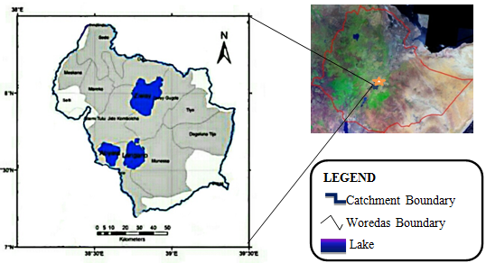

**Figure: 1. Map of survey area and location.**

Abijata-Shalla Lakes National Park (ASLNP) is one of the protected areas managed by the federal government. It is found within the central rift valley systems bordered by two zonal administration of Oromia National Regional State. The park derived its name from two lakes, Abijata and Shalla found in the park. It is located at a distance of 207 km South of Addis Ababa,capital city of the country. The general area of the park lies within the altitude range of 1540-2075 m.a.s.l. Besides Addis Ababa, other proximal townships to the park are Nagelle Arsi (c. 22 km), Batu (c. 56 km) and Shashemene (c. 50 km).   ASLNP was established as a national park in 1969 in response to two important missions carried out in 1963 and 1964-65 (Mohammed Abdi, 1993). The first mission led by Huxley, noted the ***spectacular ornithological impressions*** of the site and recommended that the area become a national park. Soon after the trip by Huxley, a UNESCO missionary led by the late L. H. Brown and Grim wood examined the possibilities of a national park and corroborated the mission of Huxley. Melvin Bolton (1969), who was a wildlife advisor to the Ethiopian Government in the 1960’s carried out a four month survey of the area and with recommendations that the site become a national park, then Imperial Government of Ethiopia established ASLNP in 1969. But the park is not still gazetted. Thepark has been regarded and managedas a protected area because of the high diversity of the bird, particularly water birds and its scenic beauty and other large mammals. The park covers a total area of 887 km2, of which 405 km2 is terrestrial and 482 km2 is aquatic (Hillman, 1993). The whole area is located in part of a basin known as the Dambal/Ziway-Shalla Basin (Fikadu and Rezenom, 2002). A total of over 460 bird species have been recorded in the park across 72 families, of which one endemic (Yellow Fronted Parrot), at least 144 species are water-associated and at least 292 are terrestrial (Mengesha and Bekele submitted, Tefera and Almaw, 2002).

In addition to ornithological significance, the park also holds a total of 76 mammal species recorded formerly at the park, six of them are endemic (Scott’s Hairy Bat, White-toothed Shrew, Mahomet’s Mouse, White-footed Rat, Ethiopian Grass Rat, and Harrington’s Scrub Rat). The mammals recorded includes Oryx, Swayne’s Hartebeest, Buffalo, Waterbuck, Giraffe and Lion, but now locally extinct in case of anthropogenic factors like illegal settlement, overgrazing, agricultural expansion and deforestations in the park (Yemata *et al.*, 2017 unpublished,). The park has different types of habitat that support different species, like Mountain Fike, Dadhaba River, Bulbula River, and Shalla Gike mountain areas.

Catchment, sub-catchments and surface water

The survey area contains three large lakes, Dambal/Ziway, Langano and Abijata. The lake Abijata is closed (terminal) lake without surface water outlet. Lake Shalla is situated in an adjacent catchment, however is part of the Abijata Shalla Lakes National Park. The national park consists of the two saline lakes, Lake Abijata and Lake Shalla, and the surrounding woodlands. The lakes have been submitted by the Ethiopian Government to the Ramsar Convention on wetlands in order to be recognized as an international Ramsar site but not yet.

Climate

The lakes of the Ethiopian Rift experience a wide range of climate, accentuated by the annual north-south movements of inter- and sub-tropical frontal zones across the country. The climate is humid to sub-humid in the highlands and semi-arid in the rift valley. The mean annual temperature is around 15°C in the highlands and 20°C in the rift valley. The average annual rainfall ranges from 650 mm in the rift floor and 1150 mm in the highlands (Kassie *et al*., 2013). The area a bi-modal rainfall pattern, main rainy season (June–September), locally known as Kiremt and a short rainy season (March–April), locally known as Belg as well as the dry season lasts from October to February.

Biodiversity

The four central rift valley lakes including Abijata are globally important natural resources that provide many ecosystems services and hosts Ethiopia’s rich biodiversity resources. Great White Pelicans, Flamingos, Ostrich, Ducks, and many other birds are among the avifauna (Senbeta and Feyera, 2001; Almaw, 2012; Worku, 2018; Asefa, 2018). Abijata was once named bird watchers’ paradise and well-known sites to see thousands of Lesser Flamingo population in Africa (Tefera and Almaw, 2002) which is significantly reduced in number now days (Asefa, 2018).

The Mammal species in the area include Grants Gazelle, Jackals, Oribi, Warthog, Bush Buck, Hyena, Rabbit, Monkey, and others (Worku, 2018). The vegetation around the lakes is tropical savannah dominated with acacia species, Balanties, shrub and bushes. Acacia trees are dominant and important means of income (charcoal) for the local people (Tefera and Almaw, 2002).

Lake Abijata is rich in phytoplankton. A dominant population of *Spirulina*species was reported from Lake Abijata in the 1960s (Wood and Talling, 1988). But later it was found to be sub-dominant with frequent blooms of a nitrogen-fixing cyano-bacterium *Anabaenopsisabijatae*and zooplanktons that exist in Abijata Lake where the Great White Pelicans depend on for feeding (Tefera and Almaw, 2002).

Methodology

Data was collected both in local Afaan Oromoo and English languages. Twenty two staff and community members from three villages were interviewed by means of focus group discussions using a semi structured questionnaire regarding the typology, effects and controlling mechanisms of invasive species. This was supplemented by professional ecologists, four game rangers’ heads and three local farmers’ leaders, one from each village, who were questioned on invasive alien plants species affecting their agricultural lands. During field trips plants were initially identified by ecologists and respondents by means of their local names. Coupon specimens of some of the species cited during interviews were collected and their photos were captured for further guidance identification. Final identification was made with reference to field guide literature (Moran and Zimmermann, 1991; Macdonald et al., 2003; Bromilow, 2001; Henderson, 2001). For conclusive identification and classification, all specimens collected were named and verified by professional ecologists, who were able to provide each species with both an English common name as well as a their scientific name, in addition to the local indigenous name provided by the informants. Finally secondary data literatures were compiled exhaustively reviewed and analyzed.

Data Analysis

All the collected data were stored in Microsoft Excel 2007 programme and was later analyzed for descriptive statistical patterns. The data collected were analyzed in terms of those species that had been most frequently cited by informants.

**Result**

Identification of invasive plant species and their infestation level

Invasive plant species of Abijata Shalla Lakes National Park (ASLNP) was identified clearly with their level of abundance and location. In the head office of 1km2 fenced compounds there were three major invasive plants Abutilon*, Parthenium* and *Opuntia spp*. were recorded in the area. These invasive were not only restricted in the fenced compound. They sparsely observed in terrestrial ecosystem of the National Park and farm lands of the surrounding communities. The ***Abutilon species*** were highly observed in the fenced compound as well as surrounding the asphalt and gravel roads of the area. It was not much known by local communities as it was negatively or positively affecting the area. Like *Parthenium; Abutilon* was highly dispersed by wind dispersal when it’s fruity season.

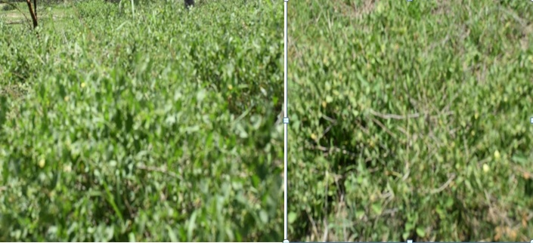Figure 1.The invasive *Abutilon species* infestation

The ***Opuntia species*** was majorly found around the asphalt side of the head office, in the fenced compound and Shalla Gike outpost. It was also highly dispersed in the farm lands of the communities due to they use as fencing material and feed its fresh fruits. Due this the surrounding communities know its little benefits rather than negative impacts. This was highly increasing the dispersal of the species and could dominate the areas and affect productivities of the surrounding farm land.

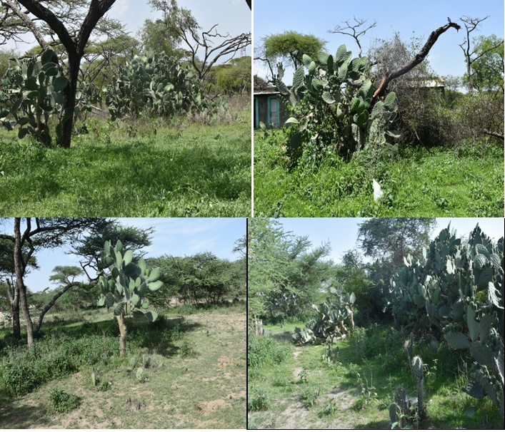Figure 2.The *Opuntia spp.* infestation in the fenced compound

***Parthenium hysterophorus*** was sparsely observed within the fenced compound and surrounding terrestrial areas of the Park. It was highly found around the farm lands, asphalt sides and especially on the delta of flooding lands. It dispersed majorly through wind dispersal during fruity season. The communities have negative attitude towards the weed due to it’s a weed affecting their farm land and agricultural productivity of the area.

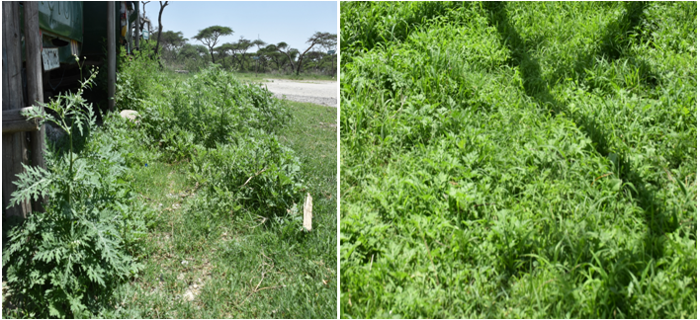 Figure3. *Parthenium hysterophorus* infestation of the area

Around Daka Dalu Harengama and Lake Abijata grass land plains there were two invasive plant species identified: ***Prosopis juliflora*** and ***Lantana camara***. The *Prosopis juliflora* was sparsely dispersed and it’s not well known as invasive by the surrounding and they need it for its shading purpose throughout the year.

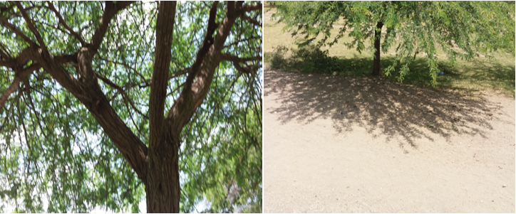 Figure4. The *Prosopis juliflora* infestation of the area

The ***Lantana camara*** was strongly invading the area following the road sides due the communities using as a fencing material and for shadings.

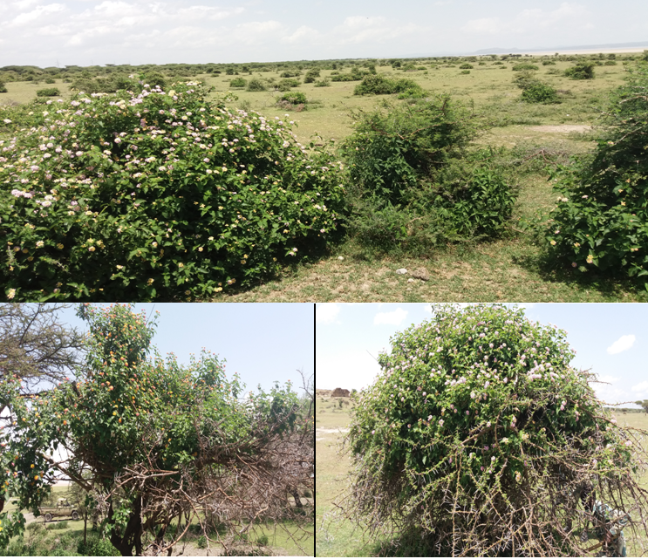 Figure5. The *Lantana camara* infestation of the study area

Even if it is difficult to determine the invasive plant species level of invasion through all the National Park within this study; we were intent ended to put their infestation level based on the area they invaded, their level of impacts on biodiversity conservation and environmental consequences of the area. Accordingly, even further study would be needed we putted the priority level of invasive plant species starting from the fenced compound to the rest terrestrial ecosystem of the National Park.

Table1. Infestation level of the National park invasive species invasion

|  |  |  |  |  |  |
| --- | --- | --- | --- | --- | --- |
| Level of infestation | The invasive local name | The invasive scientific /common name | Highly invaded area GPS location. | | |
| X: coordinate | Y: coordinate | Z: coordinate |
| 1st | - | *Abutilon spp.* | 462812 | 832193 | 1642m.asl |
| 2nd | Adami | *Opuntia spp.* | 463485 | 832038 | 1635m.asl |
| 3rd | Koricha Jarti | *Lantana camara* | 462358 | 842180 | 1576m.asl |
| 4th | Faramsisa | *Parthenium hysterophorus* | 462722 | 832004 | 1643m.asl |
| 5th | Woyane Zaf | *Prosopis juliflora* | 464238 | 846751 | 1580m.asl |

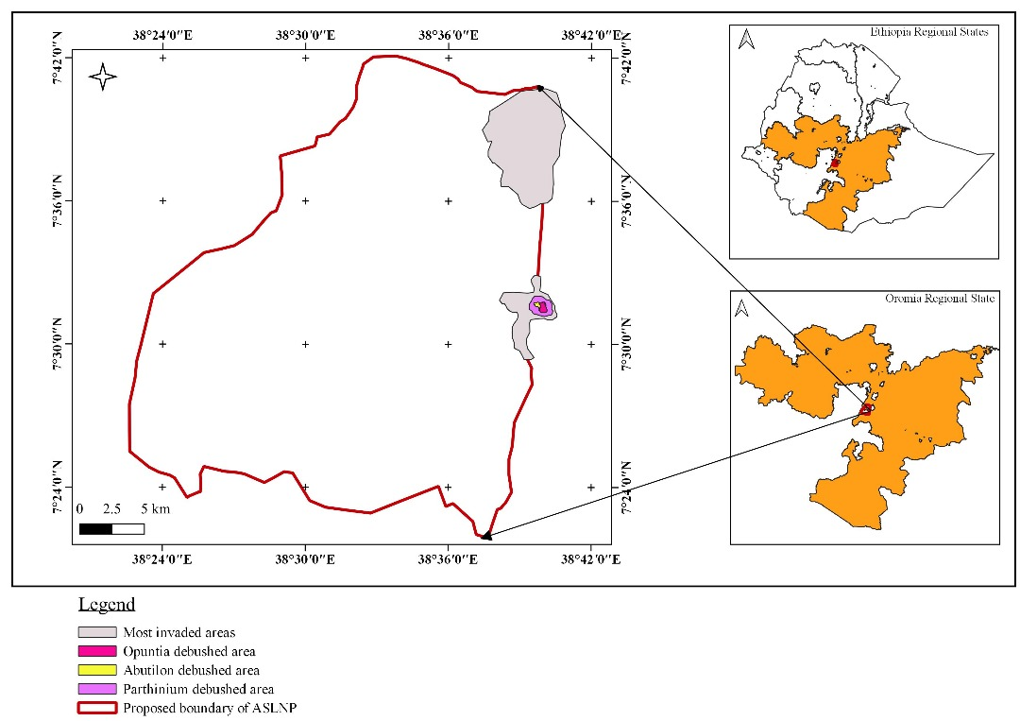

Figure6. Geographic locations of highly invaded and de-bushed invasive plant species of the study area

Controlling Mechanisms of Invasive Species Expansion at the study area

Mechanical de-bushing of the invasive plants to minimize the infestation level

The mechanical de-bushing through digging out of deep root was taken place for *Abutilon*, *Parthenium hysterophorus* and *Opuntia species* to minimize and control their ecosystem invasion. The harvested invasive weed of *Abutilon species* and *Parthenium hysterophorus* was collected and burned to prevent their regeneration probability.

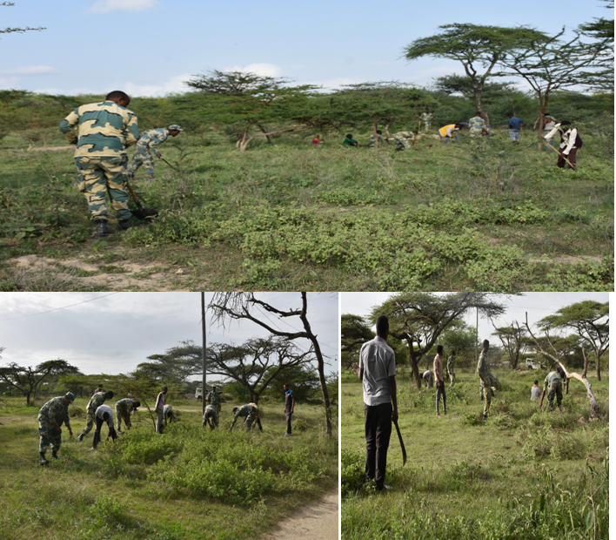 Figure7. Mechanical de-bushing of *Abutilon species*

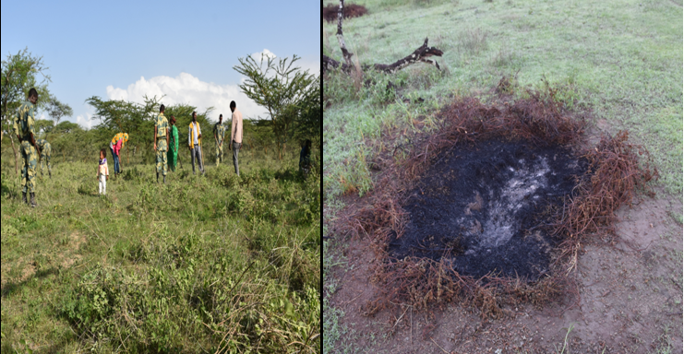

Figure8. Removing and burning of *Abutilon* *species* and *Parthenium hysterophorus*

Around **48,586m2 (4.9ha)** area of the National park ecosystem was clearly de-bushed from the *Abutilon species* which highly invading the area especially the fenced compound.

After digging out the deep root of *Opuntia species,* the whole parts (branches, shoot, leaves, roots and stems) was moved to the deep hill in the Park to prevent the opportunity of rehabilitation.

Around 307m2 area of the study area was clearly de-bushed from the *Parthenium hysterophorus* that speedily invading the area especially the fenced compound and farm lands of the surrounding communities. 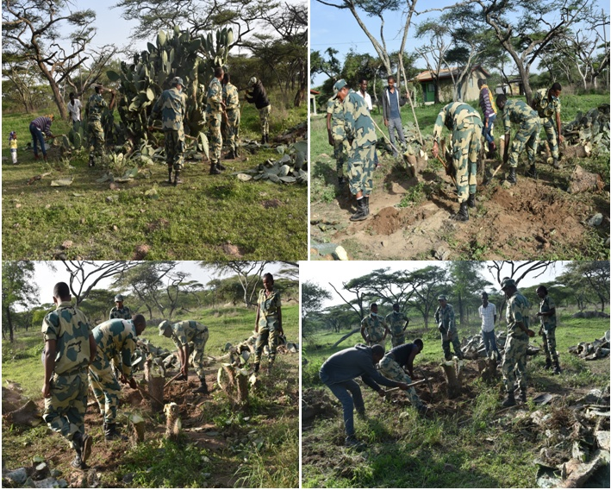Figure9. Mechanical digging out the deep rout of *Opuntia species*

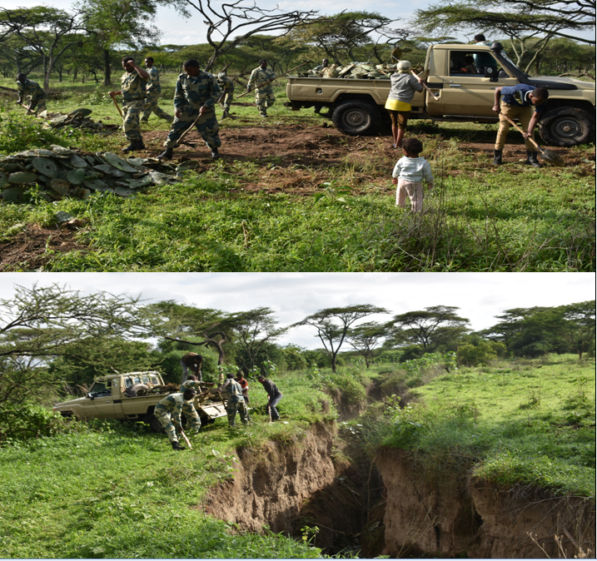

Figure10. Dropping of collected *Opuntia species* to very deep hills in the Park

Table2. Sample areas of mechanically de-bushed invasive.

|  |  |  |  |  |  |  |
| --- | --- | --- | --- | --- | --- | --- |
| Plot No. | The invasive spp. Name | Area or No. of root/tree de-bushed | GPS Coordinates | | | Remarks |
| X: Coordinate | Y: Coordinate | Z: coordinate |
| 1 | *Abutilon spp*. | 4,500m2 | 463075 | 832074 | 1640m.asl | On the right side from office to residential blocks |
| 2 | *Abutilon spp*. | 20,216m2 | 463185 | 832277 | 1638m.asl | In front of residential room B.09 |
| 3 | *Abutilon spp*. | 23,870m2 | 462812 | 832193 | 1642m.asl | Around the back exit |
| 4 | *Opuntia Spp.* | 3 | 456709 | 845302 | 1645m.asl | Around residential area (B.03), area= 1m*2m=2m2 |
| 5 | *Opuntia Spp.* | 2 | 462976 | 831858 | 1648m.asl | Around residential area (B.02) |
| 6 | *Opuntia Spp.* | 3 | 463038 | 831898 | 1643m.asl | Around residential area (B.06) |
| 7 | *Opuntia Spp.* | 1 | 462993 | 831944 | 1643m.asl | Around residential area (B.01) |
| 8 | *Opuntia Spp.* | 11 | 463042 | 831897 | 1643m.asl | Around residential area (B.01), area= 8m*4m=32m2 |
| 9 | *Opuntia Spp.* | 1 | 463002 | 831854 | 1645m.asl | Around residential area (B.01) 4m root length |
| 10 | *Opuntia Spp.* | 4 | 462936 | 831908 | 1647m.asl | Around residential area (B.03) |
| 11 | *Opuntia Spp.* | 8 | 462959 | 831904 | 1645m.asl | Around residential area (B.03) |
| 12 | *Opuntia Spp.* | 9 | 462926 | 831817 | 1645m.asl | Around residential area (B.05) |
| 13 | *Opuntia Spp.* | 1 | 463011 | 831819 | 1642m.asl | Around residential area (B.04) |
| 14 | *Opuntia Spp.* | 4 | 462969 | 831807 | 1643m.asl | Around residential area (B.05) |
| 15 | *Opuntia Spp.* | 1 | 463114 | 832018 | 1641m.asl | Around residential area (B.07) 7m root length |
| 16 | *Opuntia Spp.* | 1 | 463037 | 831709 | 1641m.asl | Around Tola farm land |
| 17 | *Opuntia Spp.* | 2 | 463390 | 831818 | 1642m.asl | Around Dole police station |
| 18 | *Opuntia Spp.* | 2 | 463498 | 831895 | 1638m.asl | North side of police station |
| 19 | *Opuntia Spp.* | 4 | 463498 | 831895 | 1638m.asl | Around residential area (B.05) |
| 20 | *Opuntia Spp.* | 3 | 463498 | 831895 | 1638m.asl | North side Tola farmland |
| 21 | *Opuntia Spp.* | 6 | 463498 | 831895 | 1638m.asl | Very small roots |
| 22 | *Opuntia Spp.* | 10 | 463552 | 831849 | 1640m.asl | On the corner of Police station side |
| 23 | *Opuntia Spp.* | 10 | 463548 | 831866 | 1640m.asl | On the side main asphalt |
| 24 | *Opuntia Spp.* | 5 | 463537 | 831882 | 1637m.asl | On the side main asphalt |
| 25 | *Opuntia Spp.* | 3 | 463513 | 831951 | 1637m.asl | On the side main asphalt |
| 26 | *Opuntia Spp.* | 10 | 463497 | 831996 | 1639m.asl | On the side main asphalt (Main gate) |
| 27 | *Opuntia Spp.* | 6 | 463481 | 832020 | 1637m.asl | On the side main asphalt |
| 28 | *Opuntia Spp.* | 5 | 463456 | 832024 | 1638m.sl | On the side main asphalt (Museum Straight) |
| 29 | *Opuntia Spp.* | 4 | 463406 | 832062 | 1638m.asl | On the side main asphalt (near Ostrich feeding bed) |
| 30 | *Opuntia Spp.* | 9 | 463442 | 832089 | 1639m.asl | On the side main asphalt (very denser) |
| 31 | *Opuntia Spp.* | 10 | 463485 | 832038 | 1635m.asl | On the side main asphalt (very denser) |
| 32 | *Opuntia Spp.* | 6 | 463455 | 832110 | 1638m.asl | On the side main asphalt (Main gate) |
| 33 | *Opuntia Spp.* | 3 | 463412 | 832229 | 1639m.asl | On the side main asphalt (Right side of main gate) |
| 34 | *Opuntia Spp.* | 1 | 463340 | 832401 | 1643m.asl | On the way to Haro Ogato |
| 35 | *Opuntia Spp.* | 1 | 463179 | 832328 | 1645m.asl | Residential area (B.09) |
| 36 | *Opuntia Spp.* | 1 | 463011 | 832304 | 1645m.asl | Near the road to Abijata |
| 37 | *Opuntia Spp.* | 3 | 463102 | 832067 | 1640m.asl | B/n office and R.B.07) |
| 38 | *Opuntia Spp.* | 1 | 463068 | 832110 | 1642m.asl | Around old crashed cars |
| 39 | *Opuntia Spp.* | 13 | 463102 | 832135 | 1640m.asl | Sapling near to parking |
| 40 | *Parthenium hysterophors* | 18m2 | 463112 | 832148 | 1640m.asl | Head office parking area |
| 41 | *Parthenium hysterophors* | 277m2 | 462722 | 832004 | 1643m.asl | Around Gazelle site |
| 42 | *Parthenium hysterophors* | 12m2 | 463058 | 832003 | 1639m.asl | Residential B-07 |

By assuming the area coverage of one rooted *Opuntia species* was 4m2 with the radius of 2m the total area cleared would be 167* 4m2= 668m2.

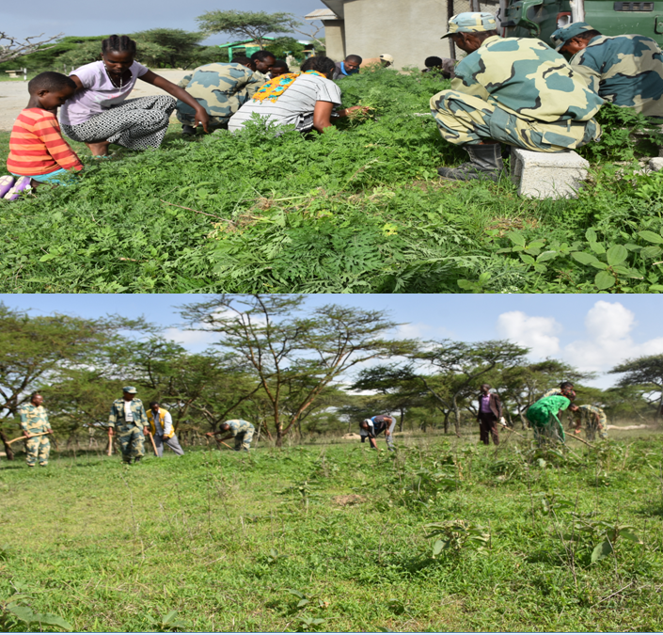Figure: 11. Mechanical de-bushing of the invasive *Parthenium hysterophorus*

Totally by the controlling and minimizing mechanisms minimum of five hectare areas of the National Park ecosystem was cleared from the invasive *Abutilon species, Opuntia species* and *Parthenium hysterophorus.* The rest two of identified invasive species (*Lantana camara* and *Prosopis juliflora*) were on the periphery and out of the National Park boundary, observed in Daka Dalu Harengama village and needs local communities and village leaders’ commitment to de-bush.

**Discussion**

Invasive alien species are originating in all taxon or organisms and exist all over the globe in all environments. They inhabit the native ecosystems; have either positive or negative consequences on socio-economic and the environmental services. The best control measures are prevention of seed dispersal, integrated management strategies and management by de-bushing and utilization (Wakshum *et al*. 2019). Worldwide, the impact of damage caused by invasive species has been estimated to be £1.5 trillion per year – close to 5% of global GDP. In developing countries, where agriculture accounts for a higher proportion of GDP, the negative impact of invasive species on food security as well as on economic presentation can be even greater. Almost all ecosystem types on the planet are affected by invasive species and they pose one of the biggest threats to biodiversity conservation worldwide. The increased in trade transport, travel and tourism will inevitably increase the intentional or accidental introduction of species to new environments, and it is widely predicted that climate change will further increase the threat modeled by invasive species. As spoken from the elders of the study area all of these invasive were came from different areas with aid shipments of crops, floods from upper catchments, vehicle transportations and livestock remains.

Currently, it has become strong that some alien species are having very negative impacts in Ethiopia. Numerous alien species are spreading at upsetting rate, threatening agricultural lands, rangelands, national parks, waterways, lakes, rivers, power dams, roadsides, urban green spaces and other protected area types.

Foremost among these Parthenium weed (***Parthenium hysterophorus***), mesquites (***Prosopis juliflora***), water hyacinth (***Eichhornia crassipes***), ***Lantana camara***and *Acacia* species (EBI, 2025). Eventually at the study area we identified the series impacts of ***Parthenium hysterophorus, Abutilon species*** and ***Opentia spp. (ficus-indica)*** especially onthe habitats of Ostriches, Grants gazelles, Reedbuck behor, Abyssinian hare and many other fauna species of the area by degrading grasses and other leafy flora species of the ecosystem.

***Parthenium hysterophorus*** is thought to be introduced accidentally via food aid shipments, and is dispersing rapidly, causing up to 90% reduction in forage production in some places. It affecting the natural ecosystem of biodiversity and reducing rangelands that forage of both wildlife and livestock resources.

***Lantana camara***has been deliberately familiarized into various neighborhoods in Ethiopia (especially urban areas and roadsides) as an ornamental shrub and fencing materials. It has been quickly dispersed by birds and animals that eat its fruits but cannot digest the woody seeds. The indications that seeds of ***Lantana camara***were water borne as young plants of this species were observed to escape from drainage ditches in the borders of Dambal and Langano Lakes at Dambal/Ziway Shalla sub basin. Hot spot areas of ***Lantana camara***were registered to be in eastern Harerge, Dambal Shalla sub basin and neighboring localities of the Somali region forming impassable woods in waste areas, abandoned cultivation, grasslands, and pastures.

***Prosopis juliflora*** was introduced intentionally as an agro-forestry species in the Awash River Basin, and now threatens biodiversity conservation, agricultural land and protected areas in the Awash National Park, Hallaydegie Asebot National Park and the surrounding ecosystems. It is aggressively invading pastoral areas, abolishing natural pasture, shifting native trees, forming impenetrable thickets, and reducing grazing potential. Even if it is not more observed at the study area, very few number of woody and shrubs were seen in Daka Harangama village and asphalt roadsides of Lake Langano. It needs quick response to manage on early stage as to prevent from further dispersion.

***Opentia spp. (ficus-indica)*** is an invasive drought-tolerant cactus that accompaniments in semi-arid and dry environments and is native to Mexico. It is a severely invasive shrub in Ethiopia, especially in the northern highlands slopes.  *Opuntia ficus-indica* is encroaching on the country native flora one of the main regional centers of endemism. Climate changes may make it simpler for this [invasive species](https://www.sciencedirect.com/topics/agricultural-and-biological-sciences/invasive-species) to be existing, reputable, and spread, which will have a harmful effect on the environment of the world. On the study area the Opuntia species was highly invading Shalla Gike and the Park Head office ecosystems. The effective management and control measure of the *Opuntia species* is digging out of the rout and buried in the dried hills or on the bare rocks as to prevent from rehabilitation, practically checked and Hussein *et al.* 2023).

From the practical demonstrations of the de-bushing practices a lot of lessons were learnt and many experience were shared for the National Park staffs and surrounding communities. On the de-bushed areas after a rainy season a lot of grasses and leafy shrubs were rehabilitated and regenerated. Many of *Ostriches*, *Grants gazelle, Abyssinian hare, Reedbuck behor and bird species* are observing on the area and restoration areas conserving by organized local youths and elders. From this practical lessons even if, time consume and takes labor force, it’s very essential to remove and minimize the invasive plant species through digging out deep routes, cutting at young leaves and finally collect and burn the residuals were fruitful. The practical exercise of restoring the degraded ecosystems by organizing the surrounding youths and elders of the study area was very example and would be continues in large scale.

Conclusion

The country Ethiopia of horn Africa region has diversified geographic landscape, and macro and micro-climatic variability. Though, there are threats its biodiversity through habitat change, invasive species, ecosystem degradation from unwise use of natural resources and unsustainable management. These pose the worsening and decrease of livelihood options of the communities in the invaded areas. Alien plant species mesquites (*Prosopis juliflora*), Parthenium weed (*Parthenium hysterophorus*), water hyacinth (*E. crassipes*), *Lantana camara*, *Parkinsonia aculeate*, *Opuntia species*, *Acacia species, Abutilon species* and Cryptostegia grandiflora are identified as invasive plant species in Ethiopia. Whereas *Abutilon spp, Opuntia spp, Lantana camara*, *Parthenium hysterophorus and Prosopis julifora were also identified at Abijata Shalla Lakes National Park.* The invasive species found in fenced compound: *Abutilon spp, Opuntia spp and Parthenium hysterophorus* were de-bushed and minimum of five hectare areas the Park ecosystem was cleared and rehabilitated from the invasion. The surrounding community’s concept and knowledge about these invasive were almost positive and they are deliberately dispersing the species. They use for fencing their farm land by *Opuntia spp* and *Lantana camara* by planting on the series of land border which dispersing the species alarmingly. Additionally they feed the *Opuntia species* fruit and use P*rosopis juliflora* as well as *Lantana camara* for shading. It needs commitments and cooperation to minimize and control these invasive plant species unless they would control the National Park and surrounding farm lands which result in biodiversity loss and less agricultural productivity.

Recommendation

Abijata Shalla Lakes National Park (ASLNP) is found in Great Central Rift Valley of Ethiopia in areas where the invasive species has invading alarmingly: the temperature is very hot, arid and semi-arid climate with scarce rainfall distribution and the soil is saline in most cases. In such harsh environment where few plant species can survive, the alien invasive plant species grow vigorously and thrives ever green. The area is home of biodiversity conservation and migratory bird destinations due to their aquatic ecosystems of the lakes; starting from Maki Katar Upper catchment to lower catchment Abay Chamo basins. Since the area is very sensitive to invasive species from the experiences the following recommendations are forwarded:-

* This study conducted on specific area and practiced de-bushing mechanisms. Further study on the invasive species identification, impacts on biodiversity conservation and environmental productivity as well as controlling mechanisms would be studied.
* The local communities are benefiting from the invasive plants even if they are impacting the area and losing biodiversity and environmental productivity of the area. Therefore it’s very important to facilitate a variety of livelihoods options for the communities, do awareness creation for all stakeholders on the environmental and biodiversity conservation impacts of invasive plant species could be strategically planned.
* The surrounding stakeholders’ government bodies, NGOs and local communities cooperative work on prevention of invasive species on how to minimize and control to increase environmental productivity and sustainable biodiversity conservation management of the area should be advocated.

**References**

Almaw, R. 2012. A Checklist of the Birds of the Abijata Shalla Lakes National Park, Ethiopian wildlife conservation authority, Addis Ababa, Ethiopia

Asefa, A.G. Mengesha, T. Sori and Y.Mamo. 2018. Local-use and landscape-level effects of land use change on bird diversity in Abijata-Shalla Lakes National Park, Ethiopia. *African Journal of Ecol*ogy 00: 1-8. <https://doi.org/10.1111/aje.12558>

Bromilow C (2001). Problem Plants of South Africa, A guide to the identification and control of more than 300 invasive plants and other weeds, Pretoria: Briza Publications.

Dudley N, 2008, Guidelines for Applying Protected Area Management Categories, IUCN Gland

EBI, 2025 accessed on June 26, 2025. <https://ebi.gov.et/biodiversity/conservation/invasive-species/threats-caused-by-ias/>

Ethiopian Wildlife Conservation Authority (EWCA, undated). A model for the protected area system of Ethiopia.

Fikadu Tefera and Rezenom Almaw, (2002). Conservation and Management Issues of Abijata Shalla Lakes National Park. Unpublished park office document. Oromia Natural Resource Conservation And environmental Protection Authority. Addis Ababa, Ethiopia, 35pp.

Henderson L (2001), Alien weeds and invasive plants. Plant Protection Research Institute Handbook, Pretoria: Plant Protection Research Institute.

Hulme, P. E. (2006). Beyond control: wider implications for the management of biological invasions. *Journal of Applied Ecology*, *43*(5), 835-847.

Hussein Abdulbasit and Solomon Estifanos, 2023.Modeling impacts of climate change on the distribution of invasive *Opuntia ficus-indica* (L.) Mill. in Ethiopia: Implications on biodiversity conservation.

Jaldu, L. M., Kifle, B., & Lemessa, D. Woody Species Diversity and Carbon Sequestration in Asebot Mountain Forest, Ethiopia: Implications for Climate Change Mitigation (Google Scholar) https://springjournals.net/articles/933215052025

Kassie, B.T., R.P.Rotter, H.Hengsdijk, S. Asseng, M. K. Vanittersum, H. Kahiluoto and H. Van Keulen. 2013. Climate variability and change in the Central Rift Valley of Ethiopia: Challenges for rainfed crop production. *The Journal of Agricultural Science*1-17. Doi10.1017/S0021859612000986.

Kumschick, S., Bacher, S., Dawson, W., Heikkila, J., Sendek, A., Pluess, T., & Kuhn, I. (2012). A conceptual framework for prioritization of invasive alien species for management according to their impacts

Macdonald IAW, Reaser JK, Bright C, Neville LE, Howard GW, Murphy SJ, Preston G (2003), Invasive alien species in southern Africa: National reports and directory of resources. Global Invasive Species Programme, Cape Town, South Africa.

McNeeley JA, Mooney HA, Neville LE, Schei P, Waage JK (2001) Global Strategy on Invasive Alien Species. UCN – the World Conservation Union, Gland. Link: <https://goo.gl/VPr4QX>

Moran VC, Zimmermann HG (1991), Biological control of jointed cactus Opuntia aurantiaca, in South Africa. Agriculture, Ecosystem, Environ. 37: 5-27.

Wakshum Shiferaw, Tamrat Bekele, Sebsebe Demissewand Ermias Aynekulu (2019): Socio-Ecological Impacts of Invasive Plant Species in Ethiopia: A Review Paper.

Senbeta, F. and F. Tefera. 2001. Environmental crisis in the Abijata-Shalla Lakes National Park. *Walia*. 22(3): 29-34.

Taye *et al.* (2001). Invasive Alien Plant Species In Ethiopia: Impacts, Challenges And Responses Taye Tessema, Christian Ulrichs and Carmen Buettner, Ethiopian Institute of Agricultural Research, Addis Ababa, Ethiopia, Faculty of Agriculture, Humboldt University of Berlin, Lentzealee 55/57 14195 Berlin.

Tefera, F. and R. Almaw. 2002. Major attractive fauna bird species of Abijata-Shalla Lakes National Park. Addis Ababa, Ethiopia. Unpublished park office document.

Wood, R.B. and J. F. Talling.1988. Chemical and algal relationship in a salinity series of Ethiopian inland waters, *Hydrobiologia*158: 29–67.

Worku, Z. 2018. Eco-Tourism Potentials of Abijata Shalla Lakes National Park (ASLNP), Central Rift-Valley of Ethiopia *Journal of Tourism, Hospitality and Sports* 37: 17-26.