**Levels of Crop Diversification and its Impact on Poor Farmers**

**(With Special Reference to Jashpur District, C.G.)**

**Abstract:**

Crop diversification of a region is expected to have an indirect implications to the supply (or availability) as well as the demand sides (or affordability) of food. The study area is geographically located in between 22017' North to 23015' North latitudes and 83030' East to 84024' East longitudes. The present study is analyzed the levels of crop diversification and its impact on poor farmers with reference to tribal populated Jashpur district considering various parameters like socio-economic conditions of poor farmers, change in cost cultivation, change in income and self-sufficiency of the farmers. Both, primary data and secondary data were used for the study. The main findings of this paper are that, high degree of crop diversification is generally found due to a combination of various factors. Farmers of the study area adopt crop diversification to reduce the impact of climate shocks, market fluctuations and pests, while also aiming to increase household income and improve dietary intake. Crop diversification has been shown to have significant impacts on poor farmers in the study area, as crop diversification improves their livelihoods, enhances food security and increases their resilience to climate change.

**Key Words:**

Agriculture, levels of crop diversification, Poor farmers and ensuring food security.

1. **INTRODUCTION:**

Agriculture plays a vital role in India’s economy. 54.6% of the total workforce is engaged in agricultural and allied sector activities (Census 2011). Agriculture in traditionally seen as one of the most significant means to earn livelihood especially in the rural India [**1**]. Small and marginal farmers are not economically viable and under the existing technological and socio-economic environment, they cannot generate adequate income to their family necessary to maintain a reasonable standard of living [**5**]. The farmers grow various crops to meet their family requirements under the subsistent farming systems [**2**]. Thus crop diversification has been found to play key role in ensuring food security in the concerned study region [**7**]. In other words, the paper establishes the fact that villages with greater crop diversification towards non-food grain crops have achieved more security in the access to food.

1. **METHODS AND MATERIAL:**

2.1 **Study Area:**

The present studyareais mainly tribal areas and economic structure of the study area is based on agricultural activities and predominantly agro-based industry. It is situated in north-eastern corner of Chhattisgarh state in India and the three district of state (Balrampur - Ramanujganj, Sarguja and Raigarh) are adjoining with Jashpur district. Jashpur district is geographically located in between 22017' North to 23015' North latitudes and 83030' East to 84024' East longitudes. The total Geographical area of Jashpur district is 5838.00 sq. km. The north-south length of this study area is about 150 kms. and its east-west breadth is 85 kms. The district having eight Tehsils which are namely - tehsil Bagicha, tehsil Duldula, tehsil Jashpur, tehsil Kansabel, tehsil Kunkuri, tehsil Manora, tehsil Pathalgaon and tehsil Farsabahar.

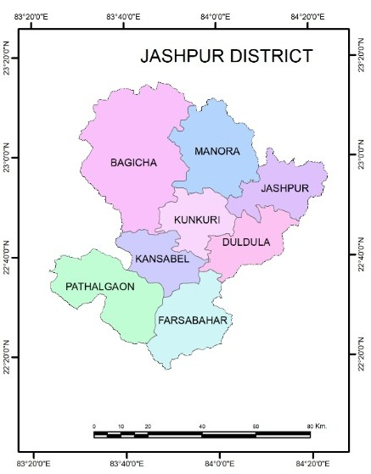

**Fig. no. 01:** Location map of the study area.

**2.2 Objectives of the study:**

The main objectives of the present study are to analyze the levels of crop diversification which is determine by the Gibbs - Martin index of crop diversification method (1962) and also study the impact of crop diversification on poor farmers.

**2.3 Sources of Data & Collection of Data:**

This research paper has been based on both the primary and secondary data. Primary data is obtained through schedule survey method and secondary data is collected from the ‘District Statistical Handbook’ (reference year: 2019-20) and ‘District Census Handbook’ (Census - 2011).

**2.4 Research Methodology:**

The Gibbs - Martin index of crop diversification (1962) method have been adapted for the determination of crop diversification levels in the study area. The obtained primary data and collected secondary data have been processed through the editing, coding, classification & tabulation method and analysis through the computer as well as the processed data are analyzed with the help of quantitative techniques and systematically presented through the cartographic techniques by Arc GIS software and using different maps and diagrams to make a significant interpretation of different variables as well as to bring out the reaching conclusion.

1. **RESULTS AND DISCUSSION:**

**3.1 Levels of Crop Diversification:**

Crop diversification refers to the number of crops grown in a geographical region within a specific period of time and it is an indicator of agricultural activities which indicates the intense comparison among various crops for space [**6**]. Crop diversification is now almost a normal feature of stable agriculture and progressive farm management in most of the extensive agricultural parts of the world [**8**]. Crop diversification is an opposite concept of crop specialization and most of the farmers of developing countries in all over the world try to grow the various crops on their agricultural landholdings in a particular agricultural year [**3**]. The levels of crop diversification are largely depends on geo-climatic, socio-economic conditions and development of technology in a region. In general way higher the level of agricultural technology, lesser the degree of crop diversification [**4**].

The **Gibbs - Martin index of diversification (1962)** have been adapted for the determination of crop diversification in the study area.

Where, **x =** It is the percentage of total cropped area occupied by each individual crop.

**Ʃ x 2**

**Crop Diversification Index = 1 -**

**(Ʃ x) 2**

**Tehsil Bagicha:**

**Table no. 01**

Percentages of total cropped area occupied by each individual crop in tehsil Bagicha

(Reference year: 2019-20)

|  |  |  |
| --- | --- | --- |
| **Crops** | **Name of the Tehsil : Bagicha** | |
| **% of Cropped area (x)** | **x 2** |
| Paddy | 61.77 | 3818.53 |
| Wheat | 0.72 | 0.52 |
| Jowar | 0.01 | 0.00 |
| Maize | 7.26 | 52.71 |
| Kodo-Kutki | 2.30 | 5.29 |
| Other Cereals | 2.06 | 4.24 |
| Pulses | 5.17 | 26.73 |
| Sugarcane | 0.13 | 0.02 |
| Fruits | 0.34 | 0.12 |
| Vegetables | 2.97 | 8.82 |
| Chili Spices | 0.47 | 0.22 |
| Oilseeds | 16.78 | 281.57 |
| Fibers | 0.02 | 0.00 |
| Drugs & Narcotics | 0.00 | 0.00 |

**Source:** Computed by Researchers. **Ʃ x = 100**  **Ʃ x 2 = 4198.77**

Ʃ x 2

**Crop diversification Index of Bagicha** = 1 -

(Ʃ x) 2

4198.77

= 1 -

(100) 2

4198.77

= 1 -

10,000

= 1 - 0.42

= 0.58

[

**Tehsil Kansabel:**

**Table no. 02**

Percentages of total cropped area occupied by each individual crop in tehsil Kansabel

(Reference year: 2019-20)

|  |  |  |
| --- | --- | --- |
| **Crops** | **Name of the Tehsil : Kansabel** | |
| **% of Cropped area (x)** | **x 2** |
| Paddy | 72.89 | 5312.95 |
| Wheat | 0.05 | 0.00 |
| Jowar | 0.03 | 0.00 |
| Maize | 0.88 | 0.77 |
| Kodo-Kutki | 0.01 | 0.00 |
| Other Cereals | 0.00 | 0.00 |
| Pulses | 12.62 | 159.26 |
| Sugarcane | 0.00 | 0.00 |
| Fruits | 0.22 | 0.05 |
| Vegetables | 2.25 | 5.06 |
| Chili Spices | 0.28 | 0.08 |
| Oilseeds | 10.76 | 115.78 |
| Fibers | 0.01 | 0.00 |
| Drugs & Narcotics | 0.00 | 0.00 |

**Source:** Computed by Researchers. **Ʃ x = 100**  **Ʃ x 2 = 5593.95**

Ʃ x 2

**Crop diversification Index of Kansabel** = 1 -

(Ʃ x) 2

5593.95

= 1 -

(100) 2

5593.95

= 1 -

10,000

= 1 - 0.56

= 0.44

**Tehsil Jashpur:**

**Table no. 03**

Percentages of total cropped area occupied by each individual crop in tehsil Jashpur

(Reference year: 2019-20)

|  |  |  |
| --- | --- | --- |
| **Crops** | **Name of the Tehsil : Jashpur** | |
| **% of Cropped area (x)** | **x 2** |
| Paddy | 76.06 | 5785.12 |
| Wheat | 0.09 | 0.01 |
| Jowar | 0.14 | 0.02 |
| Maize | 0.32 | 0.10 |
| Kodo-Kutki | 0.57 | 0.32 |
| Other Cereals | 0.39 | 0.15 |
| Pulses | 9.86 | 97.22 |
| Sugarcane | 0.00 | 0.00 |
| Fruits | 0.80 | 0.64 |
| Vegetables | 1.30 | 1.69 |
| Chili Spices | 0.16 | 0.03 |
| Oilseeds | 10.31 | 106.30 |
| Fibers | 0.00 | 0.00 |
| Drugs & Narcotics | 0.00 | 0.00 |

**Source*:*** Computed by Researchers. **Ʃ x = 100**  **Ʃ x 2 = 5991.60**

Ʃ x 2

**Crop diversification Index of Jashpur** = 1 -

(Ʃ x) 2

5991.60

= 1 -

(100) 2

5991.60

= 1 -

10,000

= 1 - 0.60

= 0.40

**Tehsil Manora:**

**Table no. 04**

Percentages of total cropped area occupied by each individual crop in tehsil Manora

(Reference year: 2019-20)

[

|  |  |  |
| --- | --- | --- |
| **Crops** | **Name of the Tehsil : Manora** | |
| **% of Cropped area (x)** | **x 2** |
| Paddy | 72.07 | 5194.08 |
| Wheat | 0.31 | 0.10 |
| Jowar | 0.03 | 0.00 |
| Maize | 2.17 | 4.71 |
| Kodo-Kutki | 0.66 | 0.44 |
| Other Cereals | 0.13 | 0.02 |
| Pulses | 5.03 | 25.30 |
| Sugarcane | 0.00 | 0.00 |
| Fruits | 0.22 | 0.05 |
| Vegetables | 1.64 | 2.69 |
| Chili Spices | 0.35 | 0.12 |
| Oilseeds | 17.37 | 301.72 |
| Fibers | 0.02 | 0.00 |
| Drugs & Narcotics | 0.00 | 0.00 |

**Source*:*** Computed by Researchers. **Ʃ x = 100**  **Ʃ x 2 = 5529.23**

Ʃ x 2

**Crop diversification Index of Manora** = 1 -

(Ʃ x) 2

5529.23

= 1 -

(100) 2

5529.23

= 1 -

10,000

= 1 - 0.55

= 0.45

**Tehsil Kunkuri:**

**Table no. 05**

Percentages of total cropped area occupied by each individual crop in tehsil Kunkuri

(Reference year: 2019-20)

|  |  |  |
| --- | --- | --- |
| **Crops** | **Name of the Tehsil : Kunkuri** | |
| **% of Cropped area (x)** | **x 2** |
| Paddy | 78.37 | 6141.86 |
| Wheat | 0.59 | 0.35 |
| Jowar | 0.01 | 0.00 |
| Maize | 0.75 | 0.56 |
| Kodo-Kutki | 0.02 | 0.00 |
| Other Cereals | 0.02 | 0.00 |
| Pulses | 8.88 | 78.85 |
| Sugarcane | 0.00 | 0.00 |
| Fruits | 0.51 | 0.26 |
| Vegetables | 1.70 | 2.89 |
| Chili Spices | 0.22 | 0.05 |
| Oilseeds | 8.90 | 79.21 |
| Fibers | 0.03 | 0.00 |
| Drugs & Narcotics | 0.00 | 0.00 |

**Source*:*** Computed by Researchers. **Ʃ x = 100**  **Ʃ x 2 = 6304.03**

Ʃ x 2

**Crop diversification Index of** **Kunkuri** = 1 -

(Ʃ x) 2

6304.03

= 1 -

(100) 2

6304.03

= 1 -

10,000

= 1 - 0.63

= 0.37

**Tehsil Duldula:**

**Table no. 06**

Percentages of total cropped area occupied by each individual crop in Tehsil Duldula

(Reference year: 2019-20)

|  |  |  |
| --- | --- | --- |
| **Crops** | **Name of the Tehsil : Duldula** | |
| **% of Cropped area (x)** | **x 2** |
| Paddy | 68.21 | 4652.60 |
| Wheat | 0.16 | 0.03 |
| Jowar | 0.02 | 0.00 |
| Maize | 0.46 | 0.21 |
| Kodo-Kutki | 0.10 | 0.01 |
| Other Cereals | 0.06 | 0.00 |
| Pulses | 14.67 | 215.21 |
| Sugarcane | 0.01 | 0.00 |
| Fruits | 0.72 | 0.52 |
| Vegetables | 5.19 | 26.94 |
| Chili Spices | 0.36 | 0.13 |
| Oilseeds | 10.03 | 100.60 |
| Fibers | 0.01 | 0.00 |
| Drugs & Narcotics | 0.00 | 0.00 |

**Source*:*** Computed by Researchers. **Ʃ x = 100**  **Ʃ x 2 = 4996.25**

Ʃ x 2

**Crop diversification Index of** **Duldula** = 1 -

(Ʃ x) 2

4996.25

= 1 -

(100) 2

4996.25

= 1 -

10,000

= 1 - 0.50

= 0.50

**Fig. no. 02:** Jashpur District: Comparison of total cropped area in percentage among the tehsils (Reference year: 2019-20)

**Tehsil Farsabahar:**

**Table no. 07**

Percentages of total cropped area occupied by each individual crop in Tehsil Farsabahar

(Reference year: 2019-20)

|  |  |  |
| --- | --- | --- |
| **Crops** | **Name of the Tehsil : Farsabahar** | |
| **% of Cropped area (x)** | **x 2** |
| Paddy | 81.34 | 6616.20 |
| Wheat | 0.19 | 0.04 |
| Jowar | 0.03 | 0.00 |
| Maize | 0.40 | 0.16 |
| Kodo-Kutki | 0.00 | 0.00 |
| Other Cereals | 0.00 | 0.00 |
| Pulses | 9.87 | 97.42 |
| Sugarcane | 0.00 | 0.00 |
| Fruits | 0.19 | 0.04 |
| Vegetables | 3.48 | 12.11 |
| Chili Spices | 0.18 | 0.03 |
| Oilseeds | 4.31 | 18.58 |
| Fibers | 0.01 | 0.00 |
| Drugs & Narcotics | 0.00 | 0.00 |

**Source*:*** Computed by Researchers. **Ʃ x = 100**  **Ʃ x 2 = 6744.58**

Ʃ x 2

**Crop diversification Index of** **Farsabahar** = 1 -

(Ʃ x) 2

6744.58

= 1 -

(100) 2

6744.58

= 1 -

10,000

= 1 - 0.67

= 0.33

**Tehsil Pathalgaon:**

**Table no. 08**

Percentages of total cropped area occupied by each individual crop in Tehsil Pathalgaon

(Reference year: 2019-20)

|  |  |  |
| --- | --- | --- |
| **Crops** | **Name of the Tehsil : Pathalgaon** | |
| **% of Cropped area (x)** | **x 2** |
| Paddy | 74.01 | 5477.48 |
| Wheat | 0.36 | 0.13 |
| Jowar | 0.02 | 0.00 |
| Maize | 0.96 | 0.92 |
| Kodo-Kutki | 0.00 | 0.00 |
| Other Cereals | 0.00 | 0.00 |
| Pulses | 9.78 | 95.65 |
| Sugarcane | 0.08 | 0.01 |
| Fruits | 0.09 | 0.01 |
| Vegetables | 8.34 | 69.56 |
| Chili Spices | 0.36 | 0.13 |
| Oilseeds | 5.93 | 35.16 |
| Fibers | 0.07 | 0.00 |
| Drugs & Narcotics | 0.00 | 0.00 |

**Source*:*** Computed by Researchers. **Ʃ x = 100**  **Ʃ x 2 = 5679.05**

Ʃ x 2

**Crop diversification Index of** **Pathalgaon** = 1 -

(Ʃ x) 2

5679.05

= 1 -

(100) 2

5679.05

= 1 -

10,000

= 1 - 0.57

= 0.43

**Table no. 09**

Tehsil wise Crop diversification Index (Reference year: 2019-20)

|  |  |  |
| --- | --- | --- |
| **Serial no.** | **Name of the Tehsils** | **Crop diversification Index** |
| 01. | Bagicha | 0.58 |
| 02. | Kansabel | 0.44 |
| 03. | Jashpur | 0.40 |
| 04. | Manora | 0.45 |
| 05. | Kunkuri | 0.37 |
| 06. | Duldula | 0.50 |
| 07. | Farsabahar | 0.33 |
| 08. | Pathalgaon | 0.43 |

**Source*:*** Computed by the researchers.

**Fig. no. 03:** Jashpur district: Tehsil wise crop diversification index (reference year: 2019-20)

Crop diversification index of the study area have been shown in the table no. 10 and it is categorized into three levels of diversification; High, Moderate and Low on the basis of crop diversification index of each tehsil.

**Table no. 10**

Crop Diversification Index of the study area by Gibbs-Marin Method (1962)

|  |  |  |
| --- | --- | --- |
| **Range of diversification Index** | **Category of diversification** | **Name of the Tehsils** |
| > 0.45 | High | Bagicha, Duldula |
| 0.35 – 0.45 | Moderate | Manora, Kansabel, Pathalgaon, Jashpur, Kunkuri |
| < 0.35 | Low | Farsabahar |

**Source:** Computed by the researchers on the basis of data taken from District Statistical Handbook,      Reference Year : 2019 - 20, Land Records Branch of Jashpur District (C.G.).

* **High degree of crop diversification (> 0.45):** A high degree of crop diversification is found in the two tehsils of Jashpur district such as Bagicha and Duldula.
* **Moderate level of crop diversification (0.35 - 0.45) :** The moderate level of crop  diversification is found in the five tehsils of Jashpur district such as Manora, Kansabel, Pathalgaon, Jashpur and Kunkuri.
* **Low degree of crop diversification (< 0.35):** Only one tehsil (Farsabahar) of the study area are falls under the low degree of crop diversification.

Variability of the degree of crop diversification among three categories is closely influenced by the soil moisture, soil characteristics, amount of rainfall received, the accessibility of the arable land, the availability of irrigation facilities and the technology developed by the villagers in the study area. The tehsils of the study area which have a high degree of crop diversification are generally found due to a combination of factors including the need to mitigate risks, improve livelihoods, and enhance ecosystem services. Farmers of the study area adopt crop diversification to reduce the impact of climate shocks, market fluctuations and pests, while also aiming to increase household income and improve dietary intake. Additionally, crop diversification among farmers is influenced by government policies, access to resources such as irrigation and credit, and the availability of diverse seed varieties. The main significance of a map showing the level of crop diversification is helps us for future planning as well as to development of agriculture.

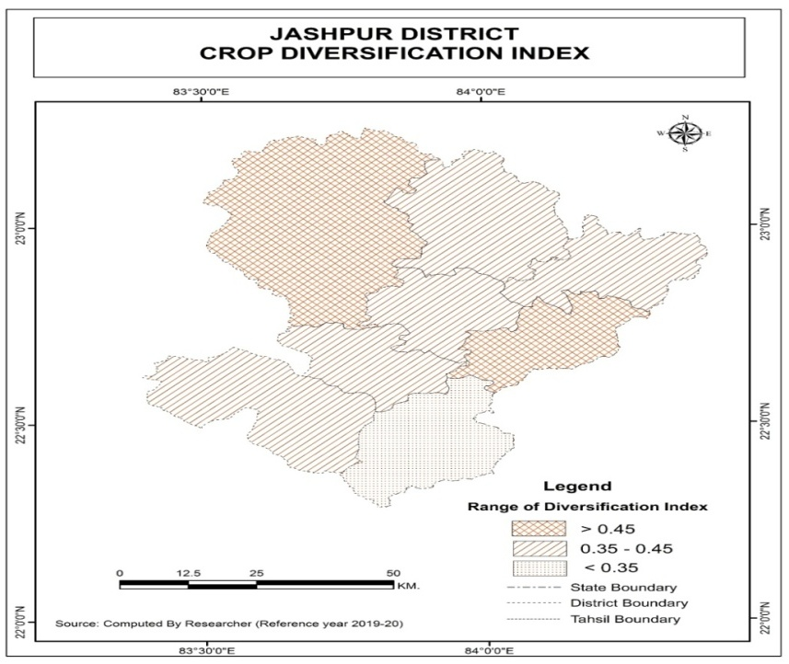

**Fig. no.** **04:** Crop Diversification Index of the study area by Gibbs-Marin Method (1962)

**3.2 Impact of Crop Diversification on Poor farmers:**

Crop diversification has been shown to have significant impacts on poor farmers in the study area, as crop diversification improves their livelihoods, enhances food security and increases their resilience to climate change. In the study area, poor farmers have reduced risks associated with market price fluctuations, pest outbreaks and climate variability by shifting from traditional monoculture to diversified crop cultivation.

In the study area, The poor farmers are mainly interested to the diversification of crops rather than the rich farmers due to the following causes – **(i)** In the areas of highly variable and erratic rainfall where adequate irrigation is not available , the farmers growing the several crops in a particular season for requiring different quantities of moisture. It is being done mainly to get something from their agricultural fields as well as even in the case of extreme weather conditions such as floods and drought. **(ii)** The farmers grow various crops to meet their family requirements under the subsistent farming systems. **(iii)** Crop diversification is generally done by the farmers to enhance nitrogen in the soil as well as to replenish the soil fertility. It is also increases the sustainability of the arable land of a given region. **(iv)** Crop diversification has given the more employment opportunities to the farmers throughout the year. **(v)** Crop diversification of a region enables the farmers to provide a reasonable quantity of costly inputs to their corps or agricultural fields.

1. **CONCLUSION:**

In conclusion, crop diversification offers a powerful pathway for improving the livelihoods of poor farmers by increasing their income, enhancing food security, and building resilience to various challenges. Crop diversification has great potential in improving yield, reducing the cost of cultivation and finally increase the net income realized by the poor farmers. However, successful implementation requires careful planning, access to resources, and appropriate support for poor farmers in the study area.

1. **References :**

[**1.**] Annual Report (2020-21): Department of Agriculture, Co-operation & Farmers’ Welfare,         Ministry of Agriculture & Farmers’ Welfare, Government of India, Krishi Bhawan, New Delhi -         110 001. [www.agricoop.nic.in](http://www.agricoop.nic.in)

[**2.**] Birthal, P.S., Roy, D. and Negi, D.S. (2015). Assessing the impact of Crop Diversification on        Farm Poverty in India. *World Development*, 72: 70-92, ISSN: 0305-750X.        [www.elsevier.com/locate/worlddev](http://www.elsevier.com/locate/worlddev)

[**3.**] Dala, Subhrajyoti and Shankar, Tanmoy (2022). Crop Diversification and its importance in        Agriculture: A Review. *Indian Journal of Natural Sciences*, 13 (72): 44540-44548, ISSN: 0976 -        0997. [*https://www.researchgate.net*](https://www.researchgate.net)

[**4.**] Gautam, Alka (2016). *Agricultural Geography*. Allahabad: Sharda Pustak Bhawan. 01- 422,         ISBN: 978-93-80285-89-4.

[**5.**] Gummagolmath, K.C., Bhawar, R.S., Ramya Lakshmi, S.B. and Patra, Priyanka (2020). Impact        of Crop Diversification on Farmers Socio-economic Conditions of the Farmers: A Case of        Himachal Pradesh. *Research Journal of Agricultural Sciences*, 11(1): 137-143, ISSN: 0976-       1675. <http://www.rjas.org>

[**6.**] Hebbar, Ashwini and Suma, A. P. (2024). Importance of Cropping Pattern and Crop         Diversification in agriculture - A Review. *Paripex - Indian Journal of Research*, 13 (04): 39-41,         ISSN: 2250-1991. [*https://www.worldwidejournals.com*](https://www.worldwidejournals.com)

[**7.**] Nahar, N., Rahman, M.W., Miah, M.A.M. and Hasan, M. (2024). The impact of crop                 diversification on food security of farmers in northern Bangladesh. *Agriculture and food         security*, 13 (09): 01-13. <https://doi.org/10.1186/s40066-023-00463-Z>

[**8.**] Paul, S., Laha, A. and Kuri, P.K. (2016). Crop Diversification and Its Implications to Food        Security: A Case Study of India with Special Reference to West Bengal. *Asia-Pacific Journal of       Rural Development*, XXVI (1): 61-84. <https://www.researchgate.net/publication/332614979>

-00-