**DECIPHERING LITHO-FACIES HETEROGENEITY AND SEDIMENTOLOGICAL VARIABILITY IN TROPICAL TIDAL FLATS OF THE CALABAR AND GREAT KWA RIVERS, NIGERIA: IMPLICATIONS FOR COASTAL SEDIMENT DYNAMICS**

**ABSTRACT**

This study investigates litho-facies heterogeneity and sedimentological variability across tidal flats of the Calabar and Great Kwa Rivers in southeastern Nigeria. Through systematic down-hole sediment profiling collected seasonally from four tidal flats, Adiabo, Marina, Atu, and Idundu, and analyzed using grain size statistics, sedimentary structure description, and facies correlation techniques, five main litho-facies; coarse sand, fine sand, silty sand, mud, and mixed facies, were identified, reflecting a complex depositional mosaic shaped by hydrodynamic energy gradients and sediment supply variations. Vertical fining-upward trends and pronounced lateral facies variability reveal dynamic depositional environments influenced by tidal currents, river discharge, and anthropogenic activities such as dredging. Litho-facies correlations demonstrate weak intra-river continuity but significant inter-river similarities, highlighting sediment connectivity within the estuarine basin. This multidisciplinary approach fills critical knowledge gaps in West African tidal flat sedimentology, providing a foundation for paleoenvironmental reconstructions and sustainable coastal management in tropical regions. The findings underscore the need to integrate natural and human factors in understanding and managing tropical tidal flat sediments under changing environmental conditions.

**Keywords:** *Tropical tidal flats, Litho-facies correlation, Coastal sedimentology, Calabar River, Anthropogenic impacts*

**INTRODUCTION**

Tidal flats, transitional zones between land and sea, are critical components of coastal sedimentary environments (Wang 2012; Wehrmann 2014). These areas accumulate sediments transported by tides, waves, and riverine inputs, forming complex litho-facies that record the interplay of physical, chemical, and biological processes (Yi et al. 2025). Litho-facies studies, detailed analyses of sediment characteristics, and their spatial distribution are fundamental to understanding depositional environments, sediment transport pathways, and the temporal evolution of tidal flats (Fan 2013).

In tidal flat systems, litho-facies provide insights into sedimentary processes such as grain size sorting, sediment supply variability, and depositional energy gradients (Wang and Ke 1997). For instance, sandy flats often indicate higher energy environments subjected to strong tidal currents, whereas muddy flats represent low-energy, more quiescent settings favoring fine sediment deposition (Anthony 2008). By characterizing litho-facies, scientists can reconstruct paleoenvironmental conditions, evaluate sediment budgets, and predict responses to natural and anthropogenic changes.

Beyond academic interest, litho-facies investigations have practical implications for coastal zone management, habitat conservation, and resource exploration (Harvey and Caton 2010). Understanding spatial heterogeneity within tidal flats informs the design of interventions for erosion control, dredging management, and pollution mitigation (Dada et al. 2019). Furthermore, litho-facies mapping supports ecological studies by linking sediment characteristics with benthic habitats and biodiversity patterns.

Recent advances in sedimentological techniques, including high-resolution coring, grain size statistics, and geochemical analyses, have enhanced the resolution and accuracy of litho-facies studies globally (Lynda E. and Asuquo; Okon and Seelam; Olayiwola and Bamford 2019; Shi et al. 2020; Jeong et al. 2020). Despite this, tropical tidal flats, especially in West Africa, remain relatively understudied, creating an urgent need for comprehensive sedimentological assessments. This study contributes to filling that gap by examining litho-facies heterogeneity in tidal flats of the Calabar and Great Kwa Rivers, offering new insights into tropical coastal sediment dynamics.

Tropical tidal flats present unique challenges for sedimentological characterization due to their dynamic and heterogeneous nature. The complex interaction of tidal currents, river discharge, wave energy, and sediment supply create spatially variable sedimentary facies that can change rapidly over short distances. This spatial heterogeneity complicates litho-facies correlation and the interpretation of depositional processes. Furthermore, tropical coastal zones are often influenced by seasonal variations in rainfall and river flow, which affect sediment supply and hydrodynamics (Asp et al. 2018). High river discharge during wet seasons can deliver large volumes of sediments, altering depositional environments temporarily (Desjardins et al. 2012). Conversely, dry seasons may see sediment starvation or reworking of previously deposited layers by tidal currents (An et al. 2025).

Anthropogenic activities such as dredging, sand mining, urbanization, and agriculture further modify sediment dynamics and complicate sedimentological patterns (Liu et al. 2024a). These activities can introduce localized sediment sources or sinks, disrupt natural sediment transport, and induce morphological changes in tidal flats.

Accurate litho-facies correlation thus requires detailed vertical and lateral sediment profiling combined with multi-parameter analyses, including grain size, sediment composition, and sedimentary structures (Chen et al. 2023). However, logistical constraints, limited accessibility, and sparse data coverage in many tropical regions hinder such comprehensive studies. Moreover, the paucity of region-specific sedimentological models for tropical tidal flats challenges the extrapolation of findings from temperate or subtropical settings. Tropical environments often exhibit distinct sediment sources, hydrodynamics, and biotic influences, necessitating dedicated research to unravel their sedimentary architecture (Wolanski and Elliott 2016; Gao 2019).

This study addresses these challenges by employing systematic down-hole sediment profiling and grain size statistical analyses across multiple tidal flats in the Calabar and Great Kwa Rivers, facilitating robust litho-facies correlation and interpretation of depositional variability in a tropical West African context. Despite the ecological and socio-economic importance of West African tidal flats (Dada et al. 2019, 2024; Almar et al. 2023; Nhantumbo et al. 2023), sedimentological research in this region remains limited. Most previous studies have focused on broad geomorphological descriptions or ecological assessments, with few addressing the detailed litho-facies heterogeneity necessary for understanding sedimentary processes.

Available research often lacks integrated sedimentological datasets combining vertical sediment profiles, grain size statistics, and hydrodynamic measurements (Almar et al. 2023). This restricts the ability to correlate litho-facies across tidal flats or between river systems, thereby limiting insights into sediment transport pathways and depositional dynamics. In addition, much of the existing literature is dated or geographically narrow, often confined to single tidal flats or short temporal windows. The role of anthropogenic influences such as dredging and urban expansion in altering sedimentary facies is particularly understudied.

The tidal flats in the Calabar and Great Kwa Rivers are subject to increasing human pressures. Urban expansion around Calabar City, industrial development, dredging activities, and artisanal mining have altered natural sediment supply and hydrodynamic regimes (Obia et al. 2015). Dredging operations, especially at Marina flat on the Calabar River, modify channel morphology and redistribute sediments, resulting in localized disruption of natural litho-facies patterns (Job Bassey et al. 2015). Urban runoff and agricultural activities contribute to sediment and nutrient loading, potentially affecting sediment composition and depositional environments. These anthropogenic impacts complicate natural sedimentation processes and increase sediment heterogeneity, highlighting the need for detailed sedimentological investigations to inform management and conservation strategies.

The Calabar and Great Kwa tidal flats represent ecologically and economically important tropical coastal environments that are understudied in sedimentology. Their sedimentary dynamics and litho-facies distribution have direct implications for coastal habitat quality, navigation, erosion control, and resource exploitation. The tidal flats are subject to various human activities, including artisanal fishing, sand mining, urban development, and dredging operations, particularly notable at the Marina flat on the Calabar River. These activities alter sediment supply and hydrodynamics, inducing changes in sediment texture and depositional patterns. Urban expansion in Calabar City has led to increased sediment input via surface runoff and waste discharge, affecting water quality and sediment characteristics. Dredging modifies channel morphology and sediment distribution, often disrupting natural litho-facies continuity. These anthropogenic pressures make the Calabar and Great Kwa tidal flats critical case studies for understanding human impacts on tropical sedimentary environments.

Studies in the region have begun to address these gaps by investigating sediment properties in parts of southeastern Nigeria (Lynda E. and Asuquo 2012; Emeka et al. 2023). However, comprehensive litho-facies correlation across multiple tidal flats and river systems, incorporating both spatial and vertical sediment variability, remains largely unexplored. This gap is critical, as West African tidal flats are highly vulnerable to environmental changes, including sea-level rise, increased sediment loads, and human disturbances. Improved sedimentological understanding is essential to inform coastal management, conservation, and climate adaptation strategies in the region.

The primary objective of this study is to delineate the litho-facies heterogeneity and sedimentological variability across tidal flats of the Calabar and Great Kwa Rivers, southeastern Nigeria. By integrating down-hole sediment profiling, grain size statistical analyses, and litho-facies correlation, the research aims to elucidate depositional environments and sediment transport processes in these tropical tidal systems. A key uniqueness of this work lies in its comparative approach, examining multiple tidal flats within and between two river systems to identify both intra- and inter-river litho-facies relationships. This multi-scale analysis advances beyond previous localized studies, enabling a basin-wide understanding of sediment dynamics.

This study provides critical baseline sedimentological data for these systems, contributing to the broader understanding of tropical tidal flat sedimentology in West Africa. Integrating multi-site sediment profiles with grain size and facies analyses supports informed coastal zone management under increasing environmental pressures. The contrasting natural and human-influenced sediment dynamics between the Calabar and Great Kwa Rivers provide a unique opportunity to investigate litho-facies heterogeneity at multiple spatial scales. Understanding sedimentary processes within these tidal flats is essential for effective coastal zone management, habitat conservation, and predicting responses to environmental change.

Furthermore, the study explicitly considers the impact of anthropogenic activities such as dredging and urban runoff on sediment characteristics and depositional facies. This holistic perspective bridges natural and human influences, providing a comprehensive sedimentological framework. The application of high-resolution vertical sediment profiles combined with robust statistical characterization is also a significant advancement for West African tidal flat research, where such detailed data remain scarce.

Ultimately, this study contributes insights into the spatial complexity of tropical tidal flat sediments, informs paleoenvironmental reconstructions, and supports sustainable coastal management in a rapidly changing region. The findings have broader implications for similar tropical tidal environments, where sedimentological heterogeneity shapes ecosystem structure and resilience.

**Study Area**

The Calabar and Great Kwa Rivers, located in Cross River State, Southeast Nigeria, represent two significant tropical tidal river systems that drain into the Atlantic Ocean via the Cross River estuarine complex. Both rivers originate from the Oban Hills region and flow through low-gradient coastal plains before discharging into the Gulf of Guinea (Lynda E. and Asuquo 2012). These rivers traverse extensive coastal plains and form broad tidal flats that provide a natural setting for investigating sedimentological variability and litho-facies heterogeneity in tropical environments.

The tidal flats of these river systems are expansive, extending several kilometres inland from the coastline. The flats comprise supratidal zones that are seldom flooded, intertidal zones regularly inundated during high tides, and subtidal zones that remain submerged. These zones display variations in sediment texture and depositional environments influenced by tidal currents, river discharge, and wave action. Prominent tidal flats studied include Adiabo and Marina on the Calabar River and Atu and Idundu on the Great Kwa River. Each flat exhibits distinct sedimentological and geomorphological characteristics shaped by distinct sedimentological characteristics and varying degrees of tidal influence and anthropogenic impact, making them ideal for comparative litho-facies analyses.

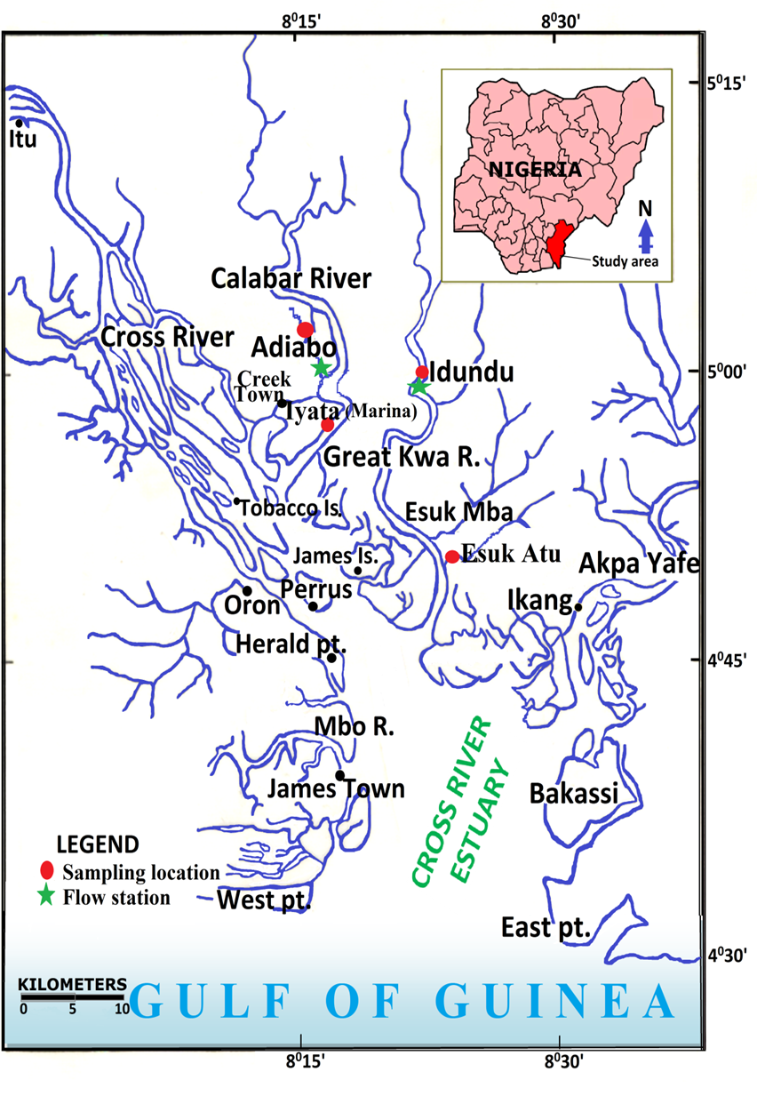

Fig. 1: Location Map and Sampling Sites Showing Calabar and Great Kwa Rivers with sampling sites at Adiabo, Marina, Atu, and Idundu

The sediments underlying these tidal flats mainly belong to the Coastal Plain Sands formation of Tertiary to Recent age. This unit consists predominantly of unconsolidated sands, silts, and clays derived from the weathering of inland basement rocks and sediments transported by fluvial and marine processes (Emeka et al. 2010). In certain areas, Cretaceous-age sediments associated with the Calabar Flank influence the deeper geological framework, but the surficial deposits are primarily Holocene in age, representing active sedimentation under tidal and fluvial influences (Okon 2014). Sediment provenance is dominantly fluvial, sourced from the Oban Hills and surrounding highlands, with sediment transport controlled by river discharge, tidal currents, and wave energy (Lynda E. and Asuquo 2012). Sediment deposition on the flats reflects a balance between these processes, resulting in lateral and vertical variability in grain size and facies distribution. The interplay between riverine sediment input and tidal reworking is a major factor controlling the spatial distribution of litho-facies (Lynda E. and Asuquo 2012).

The region experiences a humid tropical climate marked by distinct wet (April–November) and dry (December–March) seasons, with average annual rainfall exceeding 3,000 mm (Emeka 2023); this precipitation regime results in pronounced seasonal variability in river discharge, sediment load, and water quality. The tidal regime is semi-diurnal, with an average tidal range of approximately 1–2 meters, modulating the extent and duration of tidal inundation across the flats (Emeka et al. 2010). Tidal currents and river discharge together shape sediment transport and depositional patterns, influencing litho-facies distribution and sediment heterogeneity (Antia et al. 2012). Seasonal fluctuations in hydrology impact sediment dynamics; during the wet season, enhanced river flow increases sediment supply and may lead to the deposition of fine-grained sediments. Conversely, the dry season often sees sediment reworking and sorting due to reduced river input and stronger tidal currents.

**MATERIALS AND METHODS**

**Study Design and Sampling Strategy**

This study employed systematic sediment sampling, grain size statistical analysis, and litho-facies correlation techniques to characterize sedimentological variability and depositional environments across tidal flats of the Calabar and Great Kwa Rivers.

The sedimentological investigation was conducted across four tidal flats, Adiabo and Marina on the Calabar River and Atu and Idundu on the Great Kwa River, to capture spatial variability in litho-facies and sediment characteristics. Sampling sites were carefully selected to represent distinct tidal zones (supratidal, intertidal, subtidal) and sedimentary environments, allowing intra- and inter-river comparisons. Sampling campaigns were carried out during both wet and dry seasons to account for seasonal hydrodynamic and sediment supply variations, which influence depositional processes and sediment texture.

**Sediment Sampling**

**Sediment Core Collection and Analysis**

Sediment cores were collected from four representative tidal flats: Adiabo and Marina on the Calabar River and Atu and Idundu on the Great Kwa River. Each flat was sampled at multiple sites to cover supratidal, intertidal, and subtidal zones, providing vertical and lateral coverage of sedimentary facies.

Sampling was conducted during spring low tides to facilitate access and ensure minimal water interference. Push-core samplers with an internal diameter of approximately 7 cm were used to retrieve sediment cores up to 75 cm deep. Three replicate cores per zone were collected at each flat to account for spatial heterogeneity. The cores were labeled, transported to the laboratory, and sectioned into 2.5 cm intervals for detailed sedimentological analysis.

Each sediment interval was dried at room temperature and disaggregated gently to preserve grain integrity. Grain size analysis was conducted using dry sieving for sand fractions (>63 µm) with a mechanical sieve shaker and nested sieves ranging from 63 µm to 2 mm mesh sizes following standard protocols (Folk and Ward 1957). Grain size fractions were classified based on the Wentworth scale and converted to phi (ϕ) units for statistical analyses. Weight percentages of each size fraction were calculated and plotted as frequency and cumulative curves to visualize sediment distribution.

Grain size statistical parameters, mean grain size, sorting (inclusive standard deviation), skewness, and kurtosis were computed using the Folk and Ward (1957) method, implemented in the GRADISTAT software (Blott and Pye 2001). These parameters provided quantitative measures of sediment texture and depositional energy regimes.

**Litho-Facies Characterization**

Litho-facies were defined based on sediment texture, grain size statistics, and sedimentary structures observed in the cores. Each core was logged lithologically, documenting sediment grain size and layering, and any visible physical structures. Correlation of litho-facies across vertical profiles within and between tidal flats was performed to identify spatial continuity and variability of depositional environments. Cross-sectional litho-facies correlation diagrams were constructed to visualize lateral and vertical facies changes using standard stratigraphic techniques.

Differences in litho-facies were interpreted with respect to hydrodynamic energy, sediment supply, and anthropogenic influences, integrating sedimentological data with field observations. Sampling was performed systematically to ensure spatial representativeness. Replicate core analyses were conducted to check the reproducibility of grain size distributions and sedimentary features.

Statistical summaries of sediment parameters were used to classify sediment textures and infer depositional environments for each tidal flat and zone. Litho-facies were correlated using graphical methods to establish depositional trends and facies architecture. Interpretation of results considered regional hydrodynamic data from previous studies and ongoing measurements, linking litho-facies patterns to tidal and fluvial processes.

**RESULTS**

This section presents a comprehensive summary of the sedimentological characteristics, grain size distributions, and litho-facies correlations obtained from sediment cores collected across the tidal flats of the Calabar and Great Kwa Rivers. Emphasis is placed on the spatial heterogeneity observed both laterally and vertically, the architecture of sedimentary facies, and comparisons between the two river systems, highlighting the dynamic depositional processes shaping these tropical tidal flats.

**Sediment Texture and Grain Size Distribution**

A detailed grain size analysis was conducted on sediment cores retrieved from four tidal flats: Adiabo and Marina, situated along the Calabar River, and Atu and Idundu, located on the Great Kwa River (Fig. 2). The sediments exhibited marked variability in texture not only vertically within individual cores but also laterally across the different sites, reflecting the complex interplay of depositional dynamics typical of tropical tidal environments.

At Adiabo flat, sediment cores were predominantly composed of medium to coarse sands, with mean grain sizes ranging between approximately 0.85 and 2.40 phi. These values are consistent with high-energy depositional settings, where tidal currents exert a strong influence on sediment transport and deposition. The sorting of sediments within these cores generally ranged from poor to moderate, with values spanning 1.24 to 1.61 phi, indicative of variable sediment transport conditions and the dynamic nature of the environment. The vertical profiles in these cores revealed a clear fining-upward trend, with coarser sands deposited near the base, grading gradually to finer sands and silts toward the upper sections. This pattern suggests a decrease in depositional energy over time, possibly due to variations in sediment supply or shifts in hydrodynamic conditions. The sedimentary structures identified within the cores, including horizontal laminations and occasional evidence of bioturbation, reinforce interpretations of sedimentation dominated by tidal processes combined with intermittent biological reworking, which is common in intertidal environments.

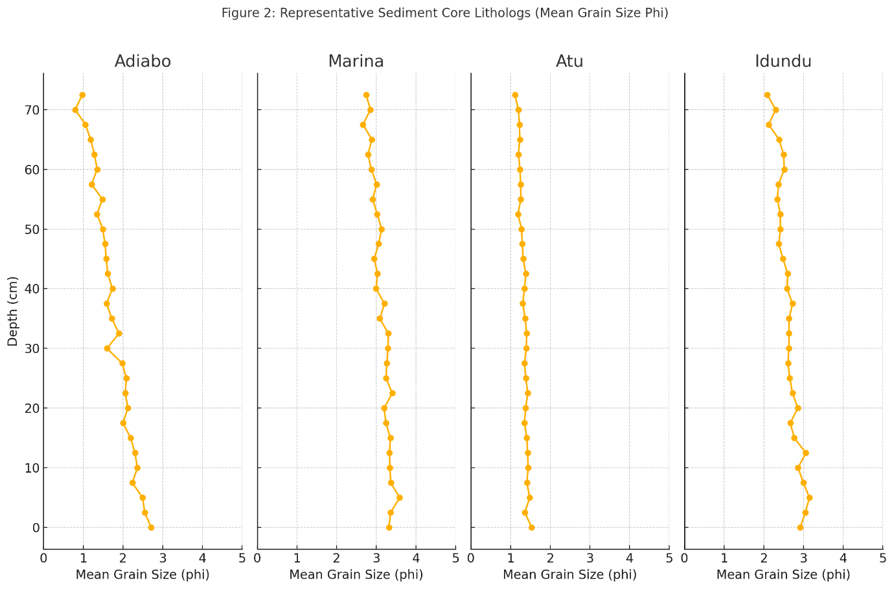

Fig. 2: Representative Sediment Grain Size Distribution Profiles for each tidal flats

Marina flat sediments presented a contrasting texture, characterized by finer materials dominated by very fine sands and a little proportion of silts. Mean grain sizes at this site ranged broadly between 1.63 and 4.40 phi. Sorting values here varied from moderate to poor, lying between 1.0 and 1.3 phi, reflecting a combination of natural variability and the influence of anthropogenic activities, most notably dredging. The vertical sediment profiles exhibited alternating layers of fine silts and medium sands, indicative of fluctuating energy conditions modulated by tidal cycles as well as disturbances associated with navigation channel maintenance. Compared to Adiabo, the sediments at Marina were more homogeneous vertically, likely reflecting ongoing resuspension and continuous deposition due to human activities that disrupt natural sediment layering.

Atu flat, situated on the Great Kwa River, was dominated by primarily coarse sands with mean grain sizes ranging from approximately 0.18 to 1.98 phi. Sorting values ranged from 0.89 to 1.73 phi, generally poorer than other sites, which suggests variable energy conditions and sediment supply. Vertical profiles from Atu did not display pronounced fining-upward trends seen at other locations, implying relatively consistent depositional energy over time. Laminated sands were the dominant sedimentary structure, with occasional mud drapes identified in certain intervals, indicating episodic periods of lower energy, allowing finer sediment deposition. These characteristics align well with a high-energy tidal flat environment subjected to significant current reworking.

The sediments at Idundu flat mostly consisted of fine to very fine sands, with mean grain sizes ranging from 2.30 to 3.83 phi and comparatively better sorting values between 1.0 and 1.2 phi. Vertical sediment profiles revealed fining-upward trends in some cores, with well-developed horizontal laminations and clear evidence of bioturbation, indicating biological activity modifying the sediment fabric. The sedimentary environment at Idundu appeared to be moderately energetic but more sheltered than Atu, allowing finer sediments to settle and accumulate, consistent with conditions often observed in protected intertidal zones.

Vertical sediment profiles from the cores typically displayed fining-upward sequences, consistent with progressive decreases in depositional energy over time or distance from sediment sources. However, lateral heterogeneity dominated, with abrupt facies changes occurring across short spatial scales, reflecting localized depositional settings modulated by tidal channels, sediment supply fluctuations, and anthropogenic disturbance. Such sediment heterogeneity challenges simplistic depositional models often applied to tidal flats and necessitates comprehensive sampling strategies that integrate vertical and lateral sediment variations for accurate sedimentological characterization.

**Litho-Facies Description and Correlation**

Combining sediment texture data, grain size statistics, sedimentary structure observations, and field logging, five primary litho-facies units were identified across the study area, each representing distinct depositional environments and processes.

The coarse sand facies were characterized by medium to coarse sands with poor sorting and exhibited horizontal laminations, predominantly observed at Atu and lower Adiabo flats. This facies are interpreted as representative of high-energy ebb tidal environments where strong currents dominate sediment transport and sorting. In contrast, the fine sand facies consisted of well-sorted fine sands with horizontal laminations and signs of bioturbation, common at Idundu and upper Adiabo flats, indicating moderate-energy depositional settings conducive to benthic colonization and sediment stability.

The silty sand facies were a mixed sedimentary unit comprising fine sands and silts, often poorly sorted and occasionally containing mud drapes. These facies predominated at Marina flat and specific intertidal zones, where fluctuating hydrodynamic conditions and human disturbances such as dredging influence sediment composition. The mud facies, composed mainly of fine silts and clays with low permeability and evidence of bioturbation, were restricted to sheltered subtidal pockets and tidal creeks, particularly at Marina. These facies typically accumulate under low-energy conditions conducive to organic matter preservation and reduced sediment reworking.

Finally, the mixed facies were characterized by cyclic alternations of sand and silt layers, reflecting the influence of tidal cycles and seasonal variations in sediment supply. These facies were sporadically distributed across the tidal flats, highlighting the dynamic and variable nature of the depositional environments in the study region.

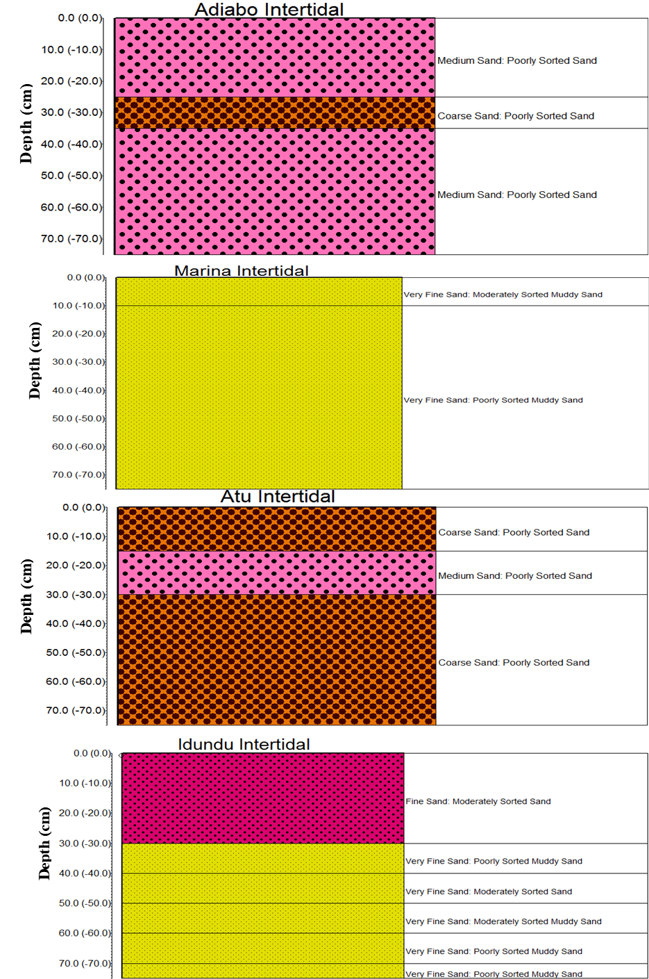Fig. 3: Down-hole sediment profiles at the intertidal zone of each tidal flat, illustrating vertical grain size trends.

Correlation of facies within and between the tidal flats revealed complex spatial relationships and heterogeneity. Within the Calabar River system, litho-facies continuity between Adiabo and Marina flats was weak, largely attributable to contrasting sediment supply and anthropogenic impacts. Marina's finer and disturbed sediments sharply contrast with the coarser and relatively more natural sedimentation observed at Adiabo. Notably, the inter-river correlation between Atu (Great Kwa River) and Marina (Calabar River) flats showed litho-facies similarity, with both flats exhibiting mixed fine sand and silt facies, suggesting shared sediment sources or comparable hydrodynamic regimes despite their location in different river systems.

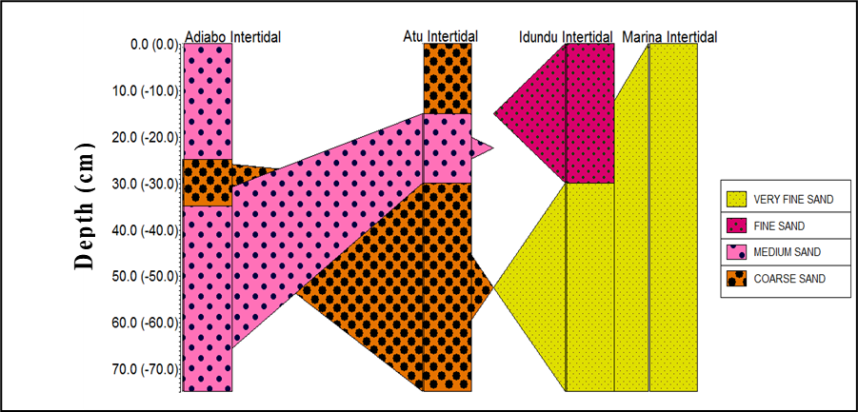

Fig. 4: A simplified cross-section showing litho-facies distribution and correlation across sampling sites at different depths, using color-coded sediment grain size facies blocks.

Lateral variability in litho-facies was more pronounced than vertical variability, with rapid facies transitions occurring over short distances, especially near dredging sites and tidal channels. This high spatial heterogeneity underscores the depositional complexity of tropical tidal flats and emphasizes the need for detailed spatial sampling to characterize sedimentary environments accurately. Cross-sectional litho-facies correlation diagrams produced in this study illustrate these patterns effectively, showing sediment heterogeneity governed by geomorphology, hydrodynamics, and anthropogenic factors.

**DISCUSSION**

**Litho-Facies Variability and Depositional Environments**

This study's comprehensive litho-facies characterization and sedimentological analysis of tidal flats in the Calabar and Great Kwa Rivers reveal significant spatial and vertical heterogeneity influenced by both natural hydrodynamics and anthropogenic activities. The findings contribute novel insights into tropical tidal flat sediment dynamics, addressing key gaps in West African coastal sedimentology. The identification of five distinct litho-facies, coarse sand, fine sand, silty sand, mud, and mixed facies, reflects the complex sedimentary characteristics of tropical tidal flat systems (Wang and Ke 1997; Flemming 2007; Anthony 2008; Daidu et al. 2013; Xing et al. 2022). The spatial distribution of these facies reflects gradients in hydrodynamic energy, sediment supply, and sediment reworking processes.

Coarse sand facies predominated in high-energy environments such as the Atu and Adiabo flats, where strong ebb tidal currents and river flows promote the deposition of well-sorted sands. This is consistent with sedimentological models in other tropical tidal flats where channelized flows maintain coarser grain sizes (Zeng et al. 2021; Ali et al. 2024). The presence of horizontal laminations and poor sorting further supports high-energy conditions with episodic sediment influxes. Fine sand and silty sand facies dominated sheltered intertidal zones, such as Marina and Idundu flats, reflecting lower hydrodynamic energy conducive to finer sediment accumulation. These environments are typically associated with tidal creeks, back-barrier areas, and flood tidal deltas (Flemming 2012; Fan 2013)). The alternation of sand and silt layers within mixed facies highlights the influence of tidal cycles and seasonal sediment supply, reinforcing the dynamic equilibrium model of tidal flat sedimentation (Bádenas et al. 2018; Gao 2019)

The presence of mud facies in sheltered pockets and creeks reflects depositional environments with minimal hydrodynamic disturbance where sediment settling velocity exceeds reworking forces, allowing fine sediments to settle. These findings align with previous observations in tropical estuaries (Wang 2012; Li et al. 2014)and underscore the ecological importance of such mudflats as habitat refuges. The fine-grained sediments and bioturbation observed here indicate stable, low-energy environments, which play important ecological roles by providing habitat diversity and organic matter retention (Zhang et al. 2023). Mixed facies characterized by alternating sand and silt layers indicate cyclic depositional patterns, likely governed by tidal fluctuations and seasonal sediment supply variations. Such cyclicity is well documented in tropical tidal flats worldwide (Hovikoski et al. 2008; Gao 2019) and reflects the dynamic equilibrium of sedimentation processes.

**Spatial and Vertical Facies Heterogeneity**

The pronounced lateral variability observed within and between tidal flats emphasizes the challenges of litho-facies correlation in tropical tidal environments (Mingyue). Vertical sediment profiles frequently displayed fining-upward trends, which can be interpreted as a progressive decrease in depositional energy, possibly related to changes in tidal amplitude, sediment supply, or channel migration (J.H. van den Berg et al. 2007). However, lateral heterogeneity was more pronounced, with abrupt facies transitions over short distances, particularly near dredged channels and tidal creek margins.

While vertical fining-upward trends suggest depositional energy attenuation over time or distance, rapid lateral facies transitions highlight localized influences such as tidal channel morphology and sediment input variations. This spatial complexity challenges assumptions of lateral homogeneity often applied in sedimentological models and calls for high-resolution sampling strategies. Our findings echo those from similar tropical settings where small-scale geomorphic features exert strong control on sediment distribution (Yang et al. 2008; Wroblewski et al. 2024). This spatial variability challenges assumptions of lateral facies continuity often made in sedimentological reconstructions and necessitates high-resolution spatial sampling to accurately characterize tidal flat sedimentation (Sleveland et al. 2020; Brunetta et al. 2021).

The weak intra-river litho-facies correlation observed within the Calabar River contrasts with stronger inter-river litho-facies similarity between Marina (Calabar) and Atu (Great Kwa) flats, suggesting interconnected sediment dynamics across basin-scale processes, particularly between Marina (Calabar) and Atu (Great Kwa) flats, possibly driven by shared sediment sources or comparable hydrodynamics. This suggests that sediment dynamics in these adjacent river systems are interconnected at a basin scale, potentially through shared sediment sources or similar hydrodynamic regimes. Such interconnectivity complicates sediment management but also offers opportunities for basin-wide approaches. This basin-wide sediment connectivity has implications for regional sediment management and ecosystem conservation strategies (Okon and Seelam 2023; Okon et al. 2023).

**Influence of Hydrodynamics and Sediment Supply**

Hydrodynamic conditions strongly control the observed litho-facies distributions. Tidal currents, river discharge, and wave energy determine sediment transport and deposition patterns. Higher-energy environments favour sand deposition and sorting, while sheltered zones allow finer sediment accumulation (Okon et al. 2023).

Seasonal fluctuations in river flow, driven by the region's wet and dry seasons, modulate sediment supply and influence sediment texture. The wet season increases sediment influx, promoting silt and mud deposition, while the dry season favours sediment reworking and sand deposition (Asuquo et al. 2020).

**Anthropogenic Impacts on Sedimentology**

Anthropogenic disturbances significantly impact sedimentary processes in the study area. Dredging operations cause sediment resuspension, channel deepening, and sediment redistribution, evident in Marina's sediment texture irregularities and disturbed facies sequences visible in irregular litho-facies layering (Maren et al. 2015). Such impacts have been widely reported in navigational channels globally, affecting sediment transport and benthic habitats (Bunke et al. 2019; Liu et al. 2024b).

Urbanization and land-use changes around Calabar contribute additional sediment loads and modify hydrodynamic conditions via runoff and altered river discharge. This introduces excess nutrients and pollutants, altering sediment chemistry and potentially enhancing fine sediment deposition due to increased organic matter loading (Bello and Haniffah 2021; Abali and Abua 2021; Abua et al. 2023; Abali and Nkii 2024). Such impacts may reduce sediment stability and alter benthic habitat quality.

These anthropogenic factors must be considered alongside natural processes in any sedimentological or ecological assessments, particularly in rapidly developing coastal regions. The combined effect of these pressures may accelerate sediment heterogeneity and alter natural depositional regimes, with implications for habitat stability and coastal resilience. This underscores the need for integrated management approaches that consider both natural processes and human interventions to safeguard tidal flat sedimentary environments.

**Regional and Global Comparisons**

The sedimentological characteristics observed in the Calabar and Great Kwa tidal flats exhibit similarities with tropical tidal flats globally, such as those in Southeast Asia (Zeng et al. 2021), the Gulf of Thailand (Zhang et al. 2022), and northern Australia (Li and Li 2018). These systems share features such as complex facies mosaics, fining-upward sequences, and seasonal sediment supply variability. However, the distinctive interplay of strong seasonal hydrology, tropical climate, and increasing anthropogenic pressures in West Africa presents unique sedimentological dynamics, highlighting the need for region-specific studies to refine generalized models.

**Implications for Coastal Management and Future Research**

Understanding litho-facies heterogeneity is crucial for effective coastal zone management, sediment budgeting, and habitat conservation, as it aids in delineating sediment transport pathways, habitat mapping, and assessing vulnerability to erosion and pollution. This study's basin-scale approach provides data essential for predicting sediment pathways, identifying erosion-prone areas, and managing anthropogenic impacts.

This study fills critical gaps by providing detailed litho-facies correlation data and sediment texture statistics in an understudied tropical West African region. The integration of vertical sediment profiles with lateral facies correlation offers a holistic understanding seldom achieved in the region's tidal flat research. By documenting human impacts alongside natural variability, the study advances a more realistic depiction of tropical tidal flat sedimentology, which is vital for predictive modeling under changing environmental conditions, including climate change and urban expansion.

Future research should integrate sediment transport modeling, biogeochemical analyses, and longer-term ecological assessments and monitoring to identify processes driving sediment heterogeneity and response to climate change. Expanding spatial coverage and temporal monitoring will refine predictions of tidal flat responses to anthropogenic and climate-driven changes and would enhance spatial resolution and basin-wide understanding.

**Conclusions**

This study provides a detailed sedimentological characterization and litho-facies correlation of tidal flats within the Calabar and Great Kwa Rivers, southeastern Nigeria, addressing significant knowledge gaps in tropical West African coastal sedimentology. Through systematic sediment core analysis and grain size statistical evaluation, the research reveals complex spatial and vertical heterogeneity in sediment deposition driven by hydrodynamic variability and anthropogenic influences.

Key findings include the identification of five principal litho-facies: coarse sand, fine sand, silty sand, mud, and mixed facies, distributed variably across tidal flats and tidal zones. The coarse sand facies dominate high-energy environments, particularly at Atu and Adiabo flats, reflecting strong tidal currents and fluvial influence. Conversely, fine sand and silty sand facies characterize sheltered areas such as Marina and Idundu flats, where low-energy depositional conditions allow the accumulation of finer sediments; this is consistent with classical depositional models but with local complexities. Mud facies occur in isolated low-energy pockets, while mixed facies with alternating sand and silt layers reveal dynamic depositional processes modulated by tidal cycles and seasonal sediment supply.

Litho-facies correlation shows significant lateral heterogeneity, with rapid facies transitions occurring over short distances, particularly near anthropogenically disturbed areas like Marina flat. Intra-river litho-facies continuity is weak, whereas inter-river correlations between Marina and Atu flats suggest basin-scale sediment connectivity within the broader estuarine basin. These spatial patterns underscore the complex interplay of hydrodynamics, sediment supply, and human impacts shaping sediment distribution. This highlights the importance of considering basin-wide sediment dynamics in management strategies.

Seasonal hydrological variations, especially between wet and dry seasons, further influence sediment texture and facies variability, emphasizing the dynamic nature of tropical tidal flat sedimentation. Anthropogenic pressures such as dredging and urban runoff substantially disrupt natural sedimentation processes, increasing sediment heterogeneity and altering depositional environments.

Anthropogenic activities, especially dredging and urban runoff, significantly influence sediment distribution and depositional patterns, increasing sediment heterogeneity and disrupting natural sedimentation. These impacts underscore the urgency of integrating human influences into coastal sedimentological studies and management frameworks.

The novelty of this research lies in its integrated, multi-river, and multi-site comparative approach, integrating vertical and lateral sedimentological data across multiple tidal flats within two river systems and employing high-resolution sediment core analyses combined with robust grain size statistics, providing unprecedented litho-facies insights for West African tropical tidal flats. This comprehensive dataset offers a valuable baseline for paleoenvironmental reconstruction, coastal habitat assessment, and sustainable coastal zone management.

For future work, integrating sedimentological findings with hydrodynamic modeling, geochemical analyses, and long-term monitoring will enhance understanding of sediment transport processes and ecosystem resilience under changing environmental and anthropogenic pressures. The study also recommends expanded temporal monitoring, sediment transport modeling, and interdisciplinary approaches better to understand sedimentary and ecological processes under ongoing environmental changes. Such efforts are critical for safeguarding the ecological and geomorphological integrity of tropical tidal flats facing increasing pressures globally.

In summary, this study advances the fundamental understanding of tropical tidal flat sedimentology in a rapidly developing coastal region and highlights the critical need to consider both natural variability and human influence in managing and conserving these vital coastal environments.

**References**

Abali T, Abua M (2021) Rainfall -Sediment Loss On Land use Types in Calabar River Catchment, Cross River State, Nigeria. 4:7–11

Abali T, Nkii L (2024) The Impact of Urban Land Use Changes on the Morphology of the New Calabar River Catchment, Port Harcourt Metropolis, Nigeria. Int J Environ Eng Educ 6:47–56. https://doi.org/10.55151/ijeedu.v6i1.131

Abua MA, Igelle EI, Eneyo VB, et al (2023) Predicting sediment yield on different landuse surfaces in Calabar River Catchment, Nigeria. Heliyon 9:e19071. https://doi.org/10.1016/j.heliyon.2023.e19071

Ali S, Siddiqui NA, Haque AE, et al (2024) Heterolytic tide-dominated sedimentary facies and depositional environment: An Example from the Boka Bil formation, Sitapahar anticline, Bangladesh. Heliyon 10:e38178. https://doi.org/10.1016/j.heliyon.2024.e38178

Almar R, Stieglitz T, Addo KA, et al (2023) Coastal Zone Changes in West Africa: Challenges and Opportunities for Satellite Earth Observations. Surv Geophys 44:249–275. https://doi.org/10.1007/s10712-022-09721-4

An NN, Hong PV, Binh NA, et al (2025) Spatiotemporal dynamics of suspended sediment in coastal Mekong Delta: a hydrodynamic modelling approach under tropical monsoon climate. Sci Rep 15:5851. https://doi.org/10.1038/s41598-025-89111-z

Anthony EJ (2008) Chapter Three Tidal Flats. In: Anthony EJBT-D in MG (ed) Shore Processes and their Palaeoenvironmental Applications. Elsevier, pp 51–129

Antia VI, Emeka NC, Ntekim EEU, Amah EA (2012) Grain Size Distribution and Flow Measurements in Qua-Iboe River Estuary and Calabar Tidal River, SE Nigeria. Eur J Sci Res 67:223–239

Asp N, Gomes V, Schettini C, et al (2018) Sediment dynamics of a tropical tide-dominated estuary: Turbidity maximum, mangroves and the role of the Amazon River sediment load. Estuar Coast Shelf Sci 214:10–24. https://doi.org/10.1016/j.ecss.2018.09.004

Asuquo FE, Okon LE, Agi-Odey E, et al (2020) Wind Influence On Longshore Current Velocity And Sea Surface Temperatures Along A Tropical Mesotidal Coastline, Southeast Nigeria. In: U6CAU Proceedings. pp 110–121

Bádenas B, Aurell M, Gasca J (2018) Facies model of a mixed clastic-carbonate, wave-dominated open-coast tidal flat (Tithonian-Berriasian, north-east Spain). Sedimentology 65:1631–1666. https://doi.org/10.1111/sed.12441

Bello A-AD, Haniffah MRM (2021) Modelling the effects of urbanization on nutrients pollution for prospective management of a tropical watershed: A case study of Skudai River watershed. Ecol Modell 459:109721. https://doi.org/https://doi.org/10.1016/j.ecolmodel.2021.109721

Blott S, Pye K (2001) Gradistat: A Grain Size Distribution And Statistics Package For The Analysis Of Unconsolidated Sediments. Earth Surf Process Landf 26:1237–12:26:1237–1248

Brunetta R, Duo E, Ciavola P (2021) Evaluating Short-Term Tidal Flat Evolution Through UAV Surveys: A Case Study in the Po Delta (Italy). Remote Sens. 13

Bunke D, Leipe T, Moros M, et al (2019) Natural and Anthropogenic Sediment Mixing Processes in the South-Western Baltic Sea. Front Mar Sci Volume 6-:

Chen Z, Li X, Chen H, et al (2023) The Characteristics of Lithofacies and Depositional Model of Fine-Grained Sedimentary Rocks in the Ordos Basin, China. Energies 16

Dada O, Adesina R, Asiwaju-Bello Y, Agbaje A (2019) Effect of coastal land use change on coastline dynamics along the Nigerian Transgressive Mahin mud coast. Ocean Coast Manag 168:251–264. https://doi.org/10.1016/j.ocecoaman.2018.11.014

Dada OA, Almar R, Morand P (2024) Coastal vulnerability assessment of the West African coast to flooding and erosion. Sci Rep 14:890. https://doi.org/10.1038/s41598-023-48612-5

Daidu F, Yuan W, Min L (2013) Classifications, sedimentary features and facies associations of tidal flats. J Palaeogeogr 2:66–80. https://doi.org/https://doi.org/10.3724/SP.J.1261.2013.00018

Desjardins PR, Buatois LA, Mángano MG (2012) Tidal Flats and Subtidal Sand Bodies. Dev Sedimentol 64:529–561. https://doi.org/10.1016/B978-0-444-53813-0.00018-6

Emeka CN, Emeka VI, Akpan E Ben, et al (2023) Dry season physicochemical characteristics of a tropical meso-tidal estuary: Cross River estuary, southeast Nigeria. Glob J Geol Sci 21:183–200

Emeka NC, Antia VI, Ukpong AJ, Amah EA (2010) A study on the Sedimentology of tidal rivers: Calabar and Great Kwa, SE Nigeria. Eur J Sci Res 47:370–386

Fan D (2013) Classifications, sedimentary features and facies associations of tidal flats. Palaeogeography 2:66–80

Flemming B (2012) Siliciclastic Back-Barrier Tidal Flats. In: Principles of Tidal Sedimentology. pp 231–267

Flemming BW (2007) The influence of grain-size analysis methods and sediment mixing on curve shapes and textural parameters: Implications for sediment trend analysis. Sediment Geol 202:425–435. https://doi.org/10.1016/j.sedgeo.2007.03.018

Folk R, Ward W (1957) Brazos River Bar : A Study in the Significance of Grain-Size Parameters. J Sediment Petrol 27:3–26

Gao S (2019) Chapter 10 - Geomorphology and Sedimentology of Tidal Flats. In: Perillo GME, Wolanski E, Cahoon DR, Hopkinson CSBT-CW (Second E (eds). Elsevier, pp 359–381

Harvey N, Caton B (2010) Coastal Management in Australia

Hovikoski J, Lemiski R, Gingras M, et al (2008) Ichnology and Sedimentology of a Mud-Dominated Deltaic Coast: Upper Cretaceous Alderson Member (Lea Park Fm), Western Canada. J Sediment Res 78:803–824. https://doi.org/10.2110/jsr.2008.089

J.H. van den Berg, J.R. Boersma, A. van Gelder (2007) Diagnostic sedimentary structures of the fluvial-tidaltransition zone – Evidence from deposits of the Rhine andMeuse. Netherlands J Geosci 86:287–306. https://doi.org/10.1017/S0016774600077866

Jeong J, Park E, Emelyanova I, et al (2020) Interpreting the Subsurface Lithofacies at High Lithological Resolution by Integrating Information From Well‐Log Data and Rock‐Core Digital Images. J Geophys Res Solid Earth 125:. https://doi.org/10.1029/2019JB018204

Job Bassey E, Edet EO, Iwuagwu EP (2015) Influence of tidal regimes in relation to industrial activities on the hydrodynamics of the Calabar River system in Southern Nigeria

Li L, Wang XH, Andutta F, Williams D (2014) Effects of mangroves and tidal flats on suspended-sediment dynamics: Observational and numerical study of Darwin Harbour, Australia. J Geophys Res Ocean 119:5854–5873. https://doi.org/https://doi.org/10.1002/2014JC009987

Li T, Li TJ (2018) Sediment transport processes in the Pearl River Estuary as revealed by grain-size end-member modeling and sediment trend analysis. Geo-Marine Lett 38:167–178. https://doi.org/10.1007/s00367-017-0518-2

Liu D, Lin Y, Zhang T, et al (2024b) Impact of Anthropogenic Activities on Sedimentary Records in the Lingdingyang Estuary of the Pearl River Delta, China. J Mar Sci Eng 12:1139. https://doi.org/10.3390/jmse12071139

Lynda E, ASUQUO FE (2012) The impact of flow regime on the sedimentation pattern of Calabar River, Southeast Nigeria. J Oceanogr Mar Sci 3:19–31

Maren D., Kessel T, Cronin K, Sittoni L (2015) The impact of channel deepening and dredging on estuarine sediment concentration. Cont Shelf Res 110:. https://doi.org/10.1016/j.csr.2014.12.010

Nhantumbo B, Dada O, Ghomsi F (2023) Sea Level Rise and Climate Change - Impacts on African Coastal Systems and Cities

Obia A, Itam E, Archibong A (2015) Urban development in the third world and threat to wetlands: The case study of Calabar, Nigeria. Glob J Eng Res 14:33. https://doi.org/10.4314/gjer.v14i1.5

Okon E (2014) Sedimentological and geochemical characterization of Cretaceous strata of Calabar Flank, SE Nigeria. J African Earth Sci 99:427–441. https://doi.org/10.1016/j.jafrearsci.2014.04.035

Okon L-UE, Seelam JK A REVIEW OF THE DETERMINISTIC APPROACHES TO COASTAL SEDIMENT TRANSPORT IN INDIA

Okon L-UE, Seelam JK (2023) Seasonal assessment of cross-shore morphodynamic behaviour of wave-dominated beaches using data-driven analysis. Earth Sci Informatics 16:1405–1425

Okon L-UE, Seelam JK, Kumari S, Hemanath L (2023) Sediment dynamics of tropical open coast beaches, central west coast of India: implications of spatio-temporal variability. Geo-Marine Lett 43:3

Olayiwola AM, Bamford KM (2019) Depositional environment and reservoir characterization of the deep offshore Upper Miocene to Early Pliocene Agbada Formation, Niger delta, Nigeria. J African Earth Sci 159:103578. https://doi.org/https://doi.org/10.1016/j.jafrearsci.2019.103578

Shi J, Jin Z, Liu Q, Huang Z (2020) Depositional process and astronomical forcing model of lacustrine fine-grained sedimentary rocks: A case study of the early Paleogene in the Dongying Sag, Bohai Bay Basin. Mar Pet Geol 113:103995. https://doi.org/https://doi.org/10.1016/j.marpetgeo.2019.08.023

Sleveland ARN, Midtkandal I, Galland O, Leanza HA (2020) Sedimentary Architecture of Storm-Influenced Tidal Flat Deposits of the Upper Mulichinco Formation, Neuquén Basin, Argentina. Front Earth Sci Volume 8-:

Wang P (2012) Principles of Sediment Transport Applicable in Tidal Environments. pp 19–34

Wang X, Ke X (1997) Grain-size characteristics of the extant tidal flat sediments along the Jiangsu coast, China. Sediment Geol 112:105–122. https://doi.org/https://doi.org/10.1016/S0037-0738(97)00026-2

Wehrmann A (2014) Tidal Depositional Systems. In: Encyclopedia of Earth Sciences Series. pp 1–13

Wolanski E, Elliott M (2016) Estuarine sediment dynamics. pp 77–125

Wroblewski AF-J, Steel RJ, Morris EA, Schueth J (2024) A tale of two end members: Tidal deposits in a semi-arid, low subsidence, open coastal setting versus a high runoff, high subsidence, restricted environment. Depos Rec 10:720–747. https://doi.org/https://doi.org/10.1002/dep2.284

Xing F, Wang Y, Jia J (2022) Hydrodynamics and sediment transport patterns on intertidal flats along middle Jiangsu coast. Anthr Coasts 5:. https://doi.org/10.1007/s44218-022-00012-4

Yang B, Gingras M, Pemberton G, Dalrymple R (2008) Wave-generated tidal bundles as an indicator of wave-dominated tidal flats. Geology 35:39–42. https://doi.org/10.1130/G24178A.1

Yi F, Zhan C, Wang Q, et al (2025) Physical study of the response of tidal flat development to the reduction in the input of Yellow River sediment into the sea. Front Mar Sci Volume 12:

Zeng L, Zhan C, Wang K, et al (2021) Sediment Coarsening in Tidal Flats and Stable Coastline of the Abandoned Southern Yellow River Sub-Delta in Response to Fluvial Sediment Flux Decrease During the Past Decades. Front Mar Sci 8:. https://doi.org/10.3389/fmars.2021.761368

Zhang H, Liu S, Wu K, et al (2022) Evolution of sedimentary environment in the Gulf of Thailand since the last deglaciation. Quat Int 629:36–43. https://doi.org/https://doi.org/10.1016/j.quaint.2021.02.018

Zhang Q, Tang M, Lu S, et al (2023) Effects of Mud Supply and Hydrodynamic Conditions on the Sedimentary Distribution of Estuaries: Insights from Sediment Dynamic Numerical Simulation. J. Mar. Sci. Eng. 11