*Original Research Article*

### THE PRICE OF NUTRITION: CAN HOUSEHOLD FOOD BUDGETS AFFORD A HEALTHY DIET?

.

ABSTRACT

|  |
| --- |
| **Aims:** To assess whether low- and middle-income households in Kolkata can afford a nutritionally adequate diet within their income using the Cost of the Diet (CotD) analysis. **Study design:** Cross-sectional, mixed-method study.  **Place and Duration of Study:** Khidirpur locality, Kolkata, conducted from February 2025 to March 2025.  **Methodology:** A survey of 70 households was conducted using a structured questionnaire adapted from the NSSO Household Consumer Expenditure Survey. Market surveys collected food prices, and CotD software was used to estimate the minimum cost of a nutritionally adequate diet for each household. The results were analyzed to assess affordability relative to income, along with perceptions, barriers, and willingness to adopt cost-effective meal plans.  **Results:** The average household spent ₹5,535/month on food. CotD analysis revealed the minimum cost of a nutritious diet for a 5-member household was ₹6,866—representing 33.28% of monthly income, which exceeds average food budgets. Most households consumed cereals daily but had inadequate intake of fruits, vegetables, and proteins. Major barriers included high cost of nutritious foods (64.3%) and limited availability. A majority (82.9%) expressed interest in low-cost nutritious meal plans.  **Conclusion:** The cost of a balanced diet often exceeds household food budgets, leading families to rely on cheaper, nutrient-poor diets. These findings emphasize the need for targeted food subsidies, nutrition education, and policy-level interventions to improve affordability and ensure dietary adequacy. |

*Keywords: Food affordability Cost of the Diet (CotD), nutritional adequacy, food security, malnutrition, public health, economic constraints.*

INTRODUCTION

Access to a nutritionally adequate diet is essential for physical development, disease prevention, cognitive performance, and economic productivity. However, the affordability of healthy diets remains a major global concern, especially for low- and middle-income populations (Barosh et al., 2014; Darmon & Drewnowski, 2015). In India, food expenditure consumes a substantial share of household budgets. Yet, due to income limitations and high food prices, many households prioritize energy-dense staples over nutrient-rich foods, compromising dietary quality (Kachwaha et al., 2020; Raghunathan et al., 2021a).

This study emerged from a practical question raised during nutrition planning exercises: Can a low-income family realistically afford the types of balanced diets typically recommended by nutritionists? This question prompted a deeper exploration of the link between food expenditure and nutritional adequacy for economically disadvantaged families in urban India. Evidence from various studies suggests that the affordability of healthy diets is shaped by more than just income and price. Factors such as household size, market access, local food systems, and purchasing behavior also influence food choices (Gupta et al., 2020; Rahmawati et al., 2025). While some low-income households termed “positive deviants” manage to maintain better diet quality at no additional cost through informed choices and efficient planning (Marty et al., 2015), such cases are exceptions rather than norms.

The Cost of the Diet (CotD) tool, developed by Save the Children, provides a standardized approach to estimate the minimum cost of a culturally acceptable and nutritionally adequate diet using locally available foods (Deptford et al., 2017a). Studies using this method in India and elsewhere have revealed that nutritious diets are often unaffordable without public intervention, especially for rural and urban low-income groups (Gupta et al., 2021; Raghunathan et al., 2021a; Kachwaha et al., 2020).Importantly, affordability is not merely a question of economic cost, but also of physical access and market availability. The Tasmanian Healthy Food Access Basket (HFAB) Survey (2014) highlighted that households in economically vulnerable regions often encounter compounded challenges of both high prices and limited availability of healthy food. Under nutrition and diet-related deficiencies continue to have long-term consequences. Poor diets contribute to stunting, weakened immunity, lower educational outcomes, increased susceptibility to chronic diseases, and reduced productivity (Mahapatra, 2021; Ruel & Alderman, 2013a). These nutritional deficits ultimately impair national development by straining healthcare systems and reducing human capital (Ford et al., 2017; James et al., 1997; Webb, 2010).

Given these concerns, the present study applies the CotD analysis to low- and middle-income households in the Khidirpore locality of Kolkata. The research aims to evaluate food affordability in relation to household income, identify nutritional gaps, and explore the barriers households face in accessing a healthy diet. Findings are expected to inform food policy by highlighting the importance of targeted subsidies, nutrition-sensitive agricultural interventions, and cost-effective public nutrition strategies.

MATERIAL AND METHODS

A cross-sectional, mixed-method research design was employed in this study to assess whether low- and middle-income households in Khidirpore, Kolkata, can financially access diets that meet established nutritional standards. The research was conducted over a two-month period from February to March 2025. The primary objective was to analyze household food expenditure patterns, assess whether current spending meets recommended dietary guidelines, and identify key economic and structural barriers to nutrition. A total of 70 households were selected purposively, and data were collected using a structured questionnaire adapted from the national sample survey office’s 2023–24 household consumption expenditure survey. The questionnaire gathered data on income, food expenditure, dietary consumption frequency, shopping behavior, and perceptions of diet quality.

To support the dietary cost analysis, a market survey was carried out simultaneously to collect current prices of locally available and culturally relevant foods from neighborhood wet markets and grocery stores. These included cereals, pulses, vegetables, fruits, oils, dairy products, and animal-source proteins. The collected price data were then analyzed using save the children’s cost of the diet (CotD) software to estimate the minimum cost of diets that meet age- and gender-specific nutritional requirements as per FAO/WHO guidelines. Four diet models were generated: energy-only, macronutrient-sufficient, fully nutritious, and food habits–based nutritious diets. The affordability of each model was evaluated by comparing its estimated monthly cost against reported household food expenditures. Gap analysis was used to quantify the shortfall between what households spend and what is required for dietary adequacy.

Quantitative data were analyzed using Microsoft excel. Descriptive statistics were used to summarize household income, food spending, and frequency of food group consumption. Correlation analysis was conducted to explore the relationship between income levels and diet affordability. All participants provided informed consent, and their identities and responses were handled with strict confidentiality and anonymity. The study was carried out solely for academic purposes and followed standard ethical research guidelines.

RESULTS

The survey of 70 households in Khidirpur, Kolkata, exposed critical vulnerabilities in diet affordability, consumption patterns, and nutritional adequacy. Despite allocating an average of ₹5,535 per month to food, nearly 43% of households reported spending less than ₹4,000, revealing stark limitations in purchasing power. With an average household income of ₹20,614.29, food expenses accounted for over 25% of monthly earnings, yet were still insufficient to secure balanced nutrition.

Daily consumption of cereals and grains was nearly universal (80%), reflecting a carbohydrate-heavy dietary structure. However, protein and micronutrient-rich food groups were consumed far less frequently. Only 17% of households consumed pulses daily, while more than 48% consumed fruits rarely or not at all. Daily intake of milk and dairy products was reported by just 10% of families, and only 12.9% consumed animal-source foods such as meat, fish, or eggs daily. In contrast, processed foods and sugary snacks were consumed 3–5 times a week by nearly half of the households, suggesting a drift toward energy-dense, nutrient-poor dietary patterns.

Household perceptions mirrored these findings: only 8.6% of respondents believed their diet were nutritious, while 57.1% considered it only “somewhat” nutritious, and 31.4% admitted it was not nutritious at all. These self-assessments highlight a growing awareness of dietary insufficiency, even in the absence of formal nutrition education.

When asked about barriers to healthier eating, 64.3% of respondents identified high costs as the primary constraint. Limited availability (11.4%) and lack of nutrition knowledge (11.4%) were secondary challenges. Nevertheless, the willingness to improve was evident: 82.9% of households expressed strong interest in adopting low-cost, nutritious meal plans, suggesting a high demand for practical, affordable solutions. Preferences for inclusion, if costs permitted, centered around eggs and lean meat (40%), pulses and legumes (22.9%), and fruits (24.3%)—indicating a desire for more protein- and vitamin-rich options.

CotD modeling revealed alarming affordability gaps. The estimated cost of a nutritionally adequate diet for a 5-member household was ₹6,866/month, yet the average monthly food expenditure fell short by ₹1,331—a 24.1% deficit. For nearly half the surveyed households, especially those spending below ₹4,000, achieving such a diet would require a 70% increase in food expenditure—an unattainable leap for families already struggling to meet basic needs.

Comparative diet models further illustrated the crisis:

• Energy-only diet: ₹3,088 (met 100% energy but <10% of vitamin A, C, B-12; iron 38%; calcium 10%)

• Macronutrient diet: ₹3,463 (met fats but remained critically deficient in micronutrients)

• Nutritious & culturally-acceptable nutritious diets: ₹6,866 (met all nutrient requirements)

Consequently, the price of a fully balanced diet was more than double that of a basic energy-only diet and accounted for 33.28% of household income, making it financially inaccessible for most surveyed families.

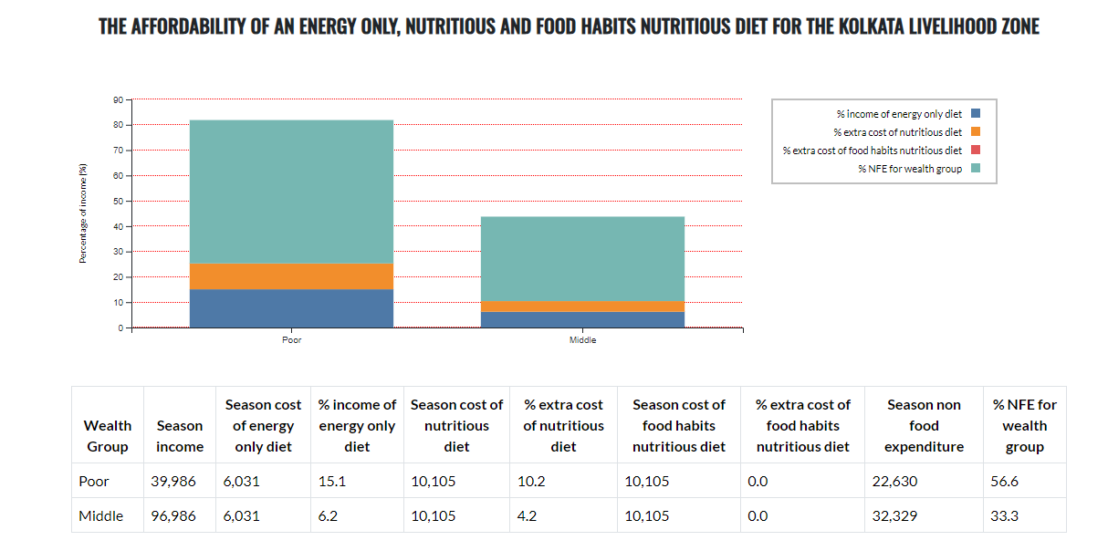

X

Y

The X- axis – Economic groups

The Y- axis –Percentage of income

**Figure 1. Affordability of various types of diet based on CotD analysis**

The public distribution system (PDS) and nutrition programs like ICDS and MDM while essential for calorie provision were found grossly inadequate for ensuring diet quality. These schemes focused heavily on cereal staples and lacked protein, dairy, or fruit components. School meal programs suffered from infrastructural weaknesses and inconsistent food safety standards.

Importantly, the study identified locally available, cost-effective, nutrient-dense foods such as chicken liver, mustard oil, and spinach that could significantly contribute to nutrient adequacy if promoted through targeted interventions. For instance, spinach alone could fulfill over 80% of vitamin A and C requirements, and chicken liver could cover 50% of vitamin B-12 needs at a fraction of the cost of other animal-source foods.

**Table 1. Inexpensive sources of essential nutrients, for a low cost nutritious diet with percentage of nutrient requirements met. (Based on CotD analysis)**

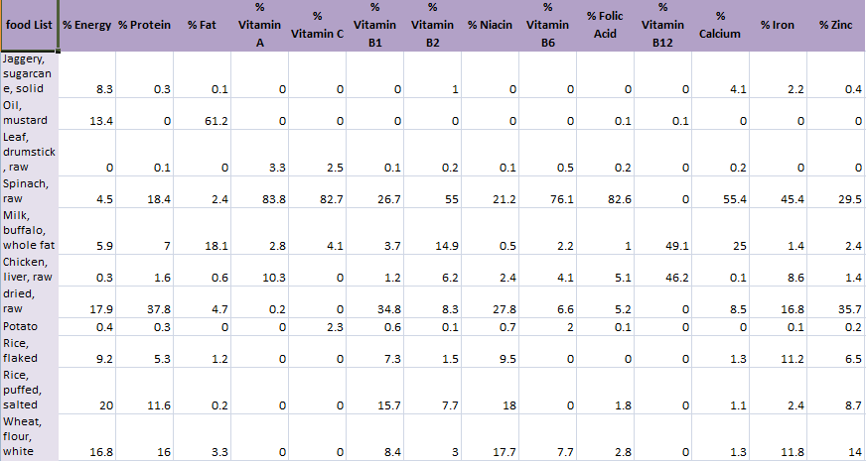

### ****DISCUSSION****

The findings of this study highlight the stark disconnect between recommended nutritional standards and the financial realities faced by low- and middle-income urban households. While access to food in terms of availability may not be a concern in urban markets like Khidirpur, access in terms of economic affordability remains a critical barrier to nutritional adequacy. This aligns with existing literature that consistently shows that the cost of nutrient-rich foods disproportionately affects lower-income households, who tend to rely on cheaper, energy-dense, and micronutrient-poor staples (Darmon & Drewnowski, 2015; Barosh et al., 2014). The affordability gap demonstrated by the Cost of the Diet (CotD) analysis in this study underscores the economic vulnerability of families trying to meet even the most basic dietary guidelines.

In urban India, diet choices are not only shaped by food prices but also by the broader food environment, which often encourages the consumption of processed and convenient foods that are high in fats, sugars, and salt. The moderate-to-high consumption of such items by families in this study reflects a systemic nutrition transition where traditional, home-cooked, nutrient-rich diets are being replaced by cheaper, mass-produced options that fail to meet essential dietary needs. These patterns raise concern about the growing burden of non-communicable diseases, especially among the urban poor who face the double challenge of under nutrition and obesity, as also observed by Ford et al. (2017).

This study also points to an underutilized opportunity: households have demonstrated a willingness to make dietary changes if practical, affordable options are provided. The strong interest in low-cost meal planning and nutrient-dense local foods suggests that behavior change communication when combined with affordability strategies can yield significant improvements in public nutrition. Such community-responsive strategies must be integrated into broader food policy and welfare programs, which currently focus heavily on calorie sufficiency but often overlook nutrient diversity. In this context, the CotD tool proves valuable not only for academic assessment but also as a policy planning instrument to tailor interventions according to real-world food pricing, consumption behavior, and income constraints.

Lastly, this study calls for a shift from blanket food assistance to targeted nutrition-sensitive programs. Interventions should aim to subsidize specific food groups such as fruits, pulses, and animal-source proteins and invest in nutrition education that empowers families to make informed choices within their economic means. Collaborative policy action between health, agriculture, and social welfare sectors is essential to ensure that affordability is not a barrier to dietary adequacy, and that no household is forced to choose between cost and nutrition.

Conclusion

This study reinforces the pressing reality that, for many urban low- and middle-income households in India, access to a nutritionally adequate diet remains economically unfeasible even when a significant portion of household income is allocated to food. The application of the Cost of the Diet (CotD) methodology revealed that while staple foods are accessible, nutrient-rich items essential for a balanced diet are often priced beyond the reach of vulnerable families. This affordability gap has serious implications, not only for individual health and well-being but also for national productivity, human capital development, and long-term economic growth (Ruel & Alderman, 2013; Webb, 2010).

Nutrient-deficient diets contribute to a cascade of public health challenges, including childhood stunting, weakened immunity, reduced cognitive capacity, and increased susceptibility to chronic diseases (WHO, 2020).These outcomes hinder educational achievement and workforce potential, disproportionately affecting the most economically marginalized populations (James et al., 1997; Hoddinott et al., 2013). Ford et al. (2017) emphasized that the simultaneous rise of undernutrition and obesity largely fueled by the widespread consumption of inexpensive, nutrient-poor foods reflects the growing phenomenon of the double burden of malnutrition, which increasingly affects populations across both urban and rural settings.

The findings of this study underscore the urgent need for nutrition-sensitive economic policies and programmatic reform. Existing food subsidy programs and public distribution systems must evolve to prioritize dietary quality alongside quantity. This includes targeted subsidies for nutrient-dense foods such as pulses, fruits, and dairy; community-level nutrition education campaigns; and the integration of low-cost, incorporating affordable, culturally familiar food options from local markets into community-based dietary planning and support programs (Gupta et al., 2021; Kachwaha et al., 2020). Furthermore, tools like the CotD can serve as effective mechanisms to design context-specific interventions and assess the real-world cost of dietary adequacy (Deptford et al., 2017).

In conclusion, ensuring that every household can afford a nutritious diet is not just a matter of food availability it is a matter of economic justice, health equity, and sustainable development. This study contributes valuable evidence for policymakers, practitioners, and researchers working toward a future where nutritional security is a guaranteed right, not a privilege.

**LIMITATIONS OF THE STUDY**

1. Limited Geographic Scope – The study was conducted in a single locality (Khidirpore, Kolkata), and while it provides important insights, food prices, incomes, and dietary habits may vary across different regions.
2. Single-Season Analysis – The study was conducted during only one season, which means it does not account for potential variations in food availability and pricing across different times of the year. A multi-seasonal study could provide a more comprehensive understanding of affordability challenges.
3. Broader Influences on Food Choices – While the study focuses on economic constraints, other factors like cultural preferences, nutritional awareness, and cooking accessibility also shape diets. Addressing these factors could strengthen future research.
4. Simplifications in Cost of the Diet (CotD) Model – The CotD method estimates the least-cost diet for meeting nutritional needs, but real-world food choices are influenced by preferences, availability, and preparation methods, which this model does not fully capture.

**FUTURE RESEARCH**

**1. Expand regional and time-based analysis-** Future investigations should consider multiple urban and rural locations across India and extend over different seasons to capture how food affordability fluctuates with economic and environmental factors.

**2. Examine social and cultural influences-** Further studies are needed to understand how cultural norms, family decision-making roles, and awareness of nutrition influence food selection in households with limited financial resources.

**3. Assess policy-level nutrition support-** Research should evaluate the practical impact of public schemes such as food subsidies, direct benefit transfers, and community kitchens on improving access to diverse and nutritious diets.

**4. Analyze local food environments-** There is scope to explore how the structure of local markets including the range, pricing, and accessibility of food options influences what people can realistically buy and consume.

**5. Link diet affordability with environmental health-** Future work should also investigate whether nutritious, low-cost diets can be aligned with sustainability goals, especially in the face of climate challenges and rising urban demand.

**6. Strengthen tools for planning and policy modeling-** Further development and application of planning frameworks like the Cost of the Diet tool could help design region-specific interventions that reflect real-world constraints and support better food policy decisions.

References

Barosh, L., Friel, S., Engelhardt, K., & Chan, L. (2014). The cost of a healthy and sustainable diet--who can afford it? Australian and New Zealand Journal of Public Health, 38(1), 7–12. <https://doi.org/10.1111/1753-6405.12158>

Darmon, N., & Drewnowski, A. (2015). Contribution of food prices and diet cost to socioeconomic disparities in diet quality and health: A systematic review and analysis. Nutrition Reviews, 73(10), 643–660. <https://doi.org/10.1093/NUTRIT/NUV027>

Kachwaha, S., Nguyen, P. H., DeFreese, M., Avula, R., Cyriac, S., Girard, A., & Menon, P. (2020). Assessing the economic feasibility of assuring nutritionally adequate diets for vulnerable populations in Uttar Pradesh, India: Findings from a “Cost of the Diet” analysis. Current Developments in Nutrition, 4(12), nzaa169. <https://doi.org/10.1093/CDN/NZAA169>

Raghunathan, K., Headey, D., & Herforth, A. (2021). Affordability of nutritious diets in rural India. Food Policy, 99, 101982. <https://doi.org/10.1016/J.FOODPOL.2020.101982>

Gupta, S., Sunder, N., & Pingali, P. L. (2020). Market access, production diversity, and diet diversity: Evidence from India. Food and Nutrition Bulletin, 41(2), 167–185. <https://doi.org/10.1177/0379572120920061>

Rahmawati, W., Wirawan, N. N., Fahmi, I., Cempaka, & Andarini, S. (2025). Energy density, nutrient density and nutrient-to-price ratio of Indonesian foods. Food Research, 8, 74–83. <https://doi.org/10.26656/fr.2017.8(S6).10>

Marty, L., Dubois, C., Gaubard, M. S., Maidon, A., Lesturgeon, A., Gaigi, H., & Darmon, N. (2015). Higher nutritional quality at no additional cost among low-income households: Insights from food purchases of “positive deviants.” The American Journal of Clinical Nutrition, 102(1), 190–198. <https://doi.org/10.3945/AJCN.114.104380>

Deptford, A., Allieri, T., Childs, R., Damu, C., Ferguson, E., Hilton, J., Parham, P., Perry, A., Rees, A., Seddon, J., & Hall, A. (2017). Cost of the Diet: A method and software to calculate the lowest cost of meeting recommended intakes of energy and nutrients from local foods. BMC Nutrition, 3(1), 1–17. <https://doi.org/10.1186/S40795-017-0136-4/FIGURES/6>

Tasmanian Healthy Food Access Basket (HFAB) Survey Final Report: Availability, cost, and affordability of a basket of healthy food in Tasmania. (2014). Funded by the Australian Government through Tasmania Medicare Local.

Ruel, M. T., & Alderman, H. (2013). Nutrition-sensitive interventions and programmes: How can they help to accelerate progress in improving maternal and child nutrition? *The Lancet*, *382*(9891), 536–551. <https://doi.org/10.1016/S0140-6736(13)60843-0/ATTACHMENT/C6193216-9BD2-45E0-915E-8D56FBB4A411/MMC1.PDF>

Ford, N. D., Patel, S. A., & Narayan, K. M. V. (2017). Obesity in low- and middle-income countries: burden, drivers, and emerging challenges. *Annu Rev Public Health*, *38*(1), 145–164. <https://doi.org/10.1146/annurev-publhealth-031816-044604>

James, W. P. T., Nelson, M., Ralph, A., & Leather, S. (1997). Socioeconomic determinants of health: The contribution of nutrition to inequalities in health. *British Medical Journal*, *314*(7093), 1545–1549. <https://doi.org/10.1136/BMJ.314.7093.1545>

Hoddinott, J., Alderman, H., Behrman, J. R., Haddad, L., & Horton, S. (2013). The economic rationale for investing in stunting reduction. *Maternal and Child Nutrition*, *9*(S2), 69–82. <https://doi.org/10.1111/MCN.12080;PAGEGROUP:STRING:PUBLICATION>

Webb, P. (2010). Medium- to long-run implications of high food prices for global nutrition. *Journal of Nutrition*, *140*(1). <https://doi.org/10.3945/JN.109.110536>