**Evaluation of Pattern of Antibiotics Utilization among Fish farmers and Detection of Tetracycline, Oxytetracycline and Ceftriaxone residue in Fish Samples in Lagos, Nigeria.**

**ABSTRACT**

**Background and Objectives:** This study assessed the use of antibiotics by fish farmers and the identification of antibiotic residue in fish samples in Lagos West Senatorial District, Lagos State, Nigeria.

**Methods:** A well-structured questionnaire was used to conduct a cross-sectional study with 50 fish farmers. High Performance Liquid Chromatography (HPLC) was used to quantify the amount of antibiotic residues found in fish muscle, liver, and heart samples.

**Results:** 90% of the 50 farmers were men, and the majority (80%) were between the ages of 20 and 50. 35 fish farmers (70%) engaged in intensive fish farming, 10 (20%) engaged in semi-intensive farming, and 5 (10%) engaged in vast fish farming. For the usage of antibiotic/ drug in fish ponds, 45(90%) of fish farmers were affirmative of antibiotics usage. Five (10%) of fish farmers utilized alternative antibiotic products, while 45 (90%) used tetracycline. Fish heart samples from fish farms at Oshodi/Isolo and Alimosho LGAs had total tetracycline residue concentrations (µg/ml) of 0.28 and 0.4, respectively. Total tetracycline residue concentration per weight (µg/g) in fish heart samples was 0.57 for fish farms at Oshodi/Isolo L.G.A. and 0.82 for fish farms at Alimosho L.G.A. Fish farms at Oshodi/Isolo LGAs had muscle and heart samples with ceftriaxone residues (µg/ml) of 2.13 and 2.7, respectively, whereas fish samples from the Ikotun area had muscle and heart residues of 1.69 and 1.92, respectively.

**Conclusions:** Fish farmers in Lagos State's West Senatorial District utilize antibiotics in aquaculture production in an unregulated and unsupervised manner.

**KEYWORDS:** Antibiotics; Antimicrobial Resistance (AMR); Fish; Fish Farmers; Antibiotic Residues

**INTRODUCTION**

The need for food from agricultural and animal products has increased due to population growth, particularly in Africa. The population of Africa is predicted to increase from 1.3 billion in 2019 to 2.4 billion in 2050, according to United Nations projections. The demand for food goods is rising in pace with the population. Thus, in order to meet dietary, social, and economic demands, more livestock and agricultural goods must be produced.1 One of the most affordable and sustainable sources of human protein is aquaculture, a fast expanding animal production industry that is predicted to rise by 62% by 2030.2-5. More than three billion people globally rely on it for about 15% of their animal protein needs.6 However, fish producers typically utilize antimicrobial medicines to prevent and treat infections as well as to stimulate growth since infectious diseases pose a severe danger to aquaculture productivity and the livelihoods of many people. Fish farms are the source of an increasing number of the fish purchased in the marketplace.8,9 It is common and occasionally required in aquaculture to employ antimicrobial substances to cure or prevent fish illnesses.10

Antimicrobial substances that are effective against bacteria include antibiotics. Antibiotic drugs are frequently employed in the treatment and prevention of bacterial infections since they represent the most significant class of antibacterial agent. By preventing the creation of cell walls, proteins, nucleic acids, transcription, and critical metabolites, they can either kill or stop the growth of bacteria.11,12

Aquaculture uses antibiotics for prophylactic, meta-, and therapeutic purposes.13 Additionally, fish farms employ antibiotics to treat or prevent bacterial infections, particularly in hatcheries.14 Antibiotic use, which is meant to preserve animal health and productivity, is unavoidable in intensive agriculture and food production systems.15 Negative consequences including the emergence and dissemination of resistant pathogenic bacteria are quite concerning. Contaminated animals and their byproducts, crops, soils, and surface and ground water can all directly transmit the resistant organisms. Indeed, one of the main causes of the growing emergence of antimicrobial resistance in the fish farming sector is the overuse and unregulated use of antibiotics, in addition to inadequate medication and health monitoring procedures.16 An estimated 75% of the antibiotic residues (ARs) administered to fish are excreted into the water, indicating that commonly used antibiotics that fish cannot efficiently metabolize may be released back into the environment.17 The persistence of ARs in fish is fast becoming a global health problem.18

In addition to health risks, low-level antibiotic dosages in food products that are consumed for extended periods of time may also cause an increase in antimicrobial resistance in bacterial species and strains. Additionally, antimicrobial resistance may develop and spread in fish-associated microorganisms and horizontally transfer resistance genes to other bacteria.19 Therefore, in order to maintain the effectiveness of the remaining powerful antibiotics, measures to address the abuse and overuse of antibiotics in Africa's human and animal health sectors must be stepped up. Drug abuse would be significantly decreased by raising awareness of the detrimental effects of overuse in connection to antibiotic resistance.20

Fish farms should receive special consideration among intensive livestock production methods that employ antimicrobial drugs due to their direct influence on the aquatic environment.21 Large amounts of antibiotics are used in aquaculture in low- and middle-income nations, frequently without expert oversight, which has an impact on the emergence and spread of resistance as well as public health worldwide. Antimicrobial medications are widely used in human, veterinary, and agricultural applications in Nigeria due to lax enforcement of laws governing the availability and use of pharmaceutical chemicals, frequently without expert guidance or oversight. As a result, Nigeria was listed as one of the 50 nations with the highest rates of livestock antibiotic use in 2010.22

The kinds and amounts of antibiotics used in Nigerian livestock and fish farming are mostly unknown. Nonetheless, the evidence that is currently available indicates that antibiotics are used extensively in the production of chickens, pigs, and aquaculture, 23,24 with little to no knowledge of the kinds and amounts utilized, the frequency of administration, and the purposes of use. Knowledge of bacterial susceptibility testing is typically not used to choose an antimicrobial drug in the majority of African nations.25 There is a pressing need for research on these topics because of this knowledge gap, which restricts the comprehension of the connection between the use of antibiotics and the emergence and spread of antibiotic resistance in the Nigerian fish production chain. The information produced will significantly advance scientific understanding of the usage of antibiotics in the nation's food animal industry. Thus, this study's main goal was to assess the antibiotic usage patterns of fish farmers in Lagos, South West Nigeria, as well as the presence of ceftriaxone, oxytetracycline, and tetracycline residues in fish samples.

**MATERIALS AND METHODS**

**STUDY AREA**

The Lagos West Senatorial District of Lagos State, Nigeria is where this study was carried out (Figure 1). In Lagos West Senatorial District has the following Local Government Areas: Alimosho, Agege, Ikeja, Ajeromi-Ifelodun, Badagry, Mushin and Ojo, Amuwo-Odofin, Ifako-Ijaiye and Oshodi-Isolo. The study was an analytical cross-sectional survey. This District was chosen because of its unique cosmopolitan metropolis, which has a high population index and a wide range of socioeconomic classes, including government employees, farmers, business moguls, entertainers, and even religious figures.

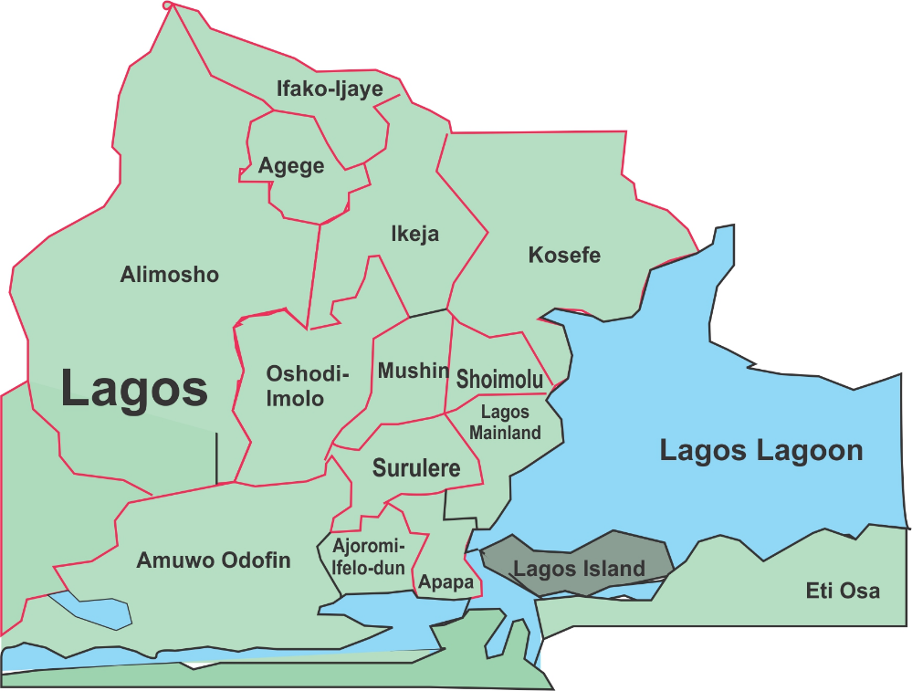

**Fig. 1: Map of Study Area with rectangle indicating where the study was conducted**

**Data Collection**

A well structured research questionnaire was used in the study. The data collection instrument consisted of five sections; biodermographic data of farm owners and workers/assistants, fish farm location, farm management, diseases and antibiotics/drug administration and antibiotics/drug residue effects awareness. Additional questions were also asked, when necessary to shed more light on some issues raised during questionnaire administration.

**Sample Collection**

Six fish farms were sampled in the Lagos West Senatorial district while a minimum of three (3) fishes between the ages of 6 months old, a (0.54kg – 1.00kg) were collected from the fish farms representing the different regions within the Lagos West Senatorial district. The fishes were sampled from plastic tanks and concrete ponds. The African catfish (*Clarias gariepinus*) samples were collected from the ponds, using a scoop set and transported to the Central Research Laboratory, College of Medicine of the University of Lagos, Lagos State. The weights of fishes were determined by industrial scale in kilograms.

**Detection of antibiotic residue in fishes**

Materials used were; Hand gloves, white tile, disserting scissors, paper tape, marker, sample bottles, a freshly prepared100ml-10% w/v phosphate saline buffer solution, weighing balance (Denver instrument), syringe filter, sonicator (Nickel – electro Ltd) (Clifton), centrifuge (eppendorf), porcelain mortar and pestle. Acetonitrile (ROMIL, Europe), citric acid (Sigma Aldrich), Tetrahydrafuran (Sigma Aldrich).

Instrumentation used were; High Performance Liquid Chromatography (HPLC) consisting of Agilent liquid chromatography, Agilent 1200 series ultraviolet detector, 50µl manual injector, software: chem. station Rev A. 10.02, column: Zorbax eclipse XD3C8RP150x4.6mm,5µm, Degasser, 20µl loop, ordinary pump. The pharmaceutical formulations used were; Oxytetracycline Capsules BP 250mg, tetracycline capsules BP 250mg and ceftriaxone powder for injection 1g.

The secondary reference standards were prepared to obtain caliberation curve, the standards were prepared from five capsules each of oxytetracycline 250mg and tetracycline 250mg capsules and ceftriaxone powder for injection 1g. Exactly 8.912mg/5mg, 6.204mg/5mg,and 5.939mg/5mg of oxytetracycline, tetracycline and ceftriaxone pharmaceuticals respectively, were weighed out according and from these, varying concentrations of total tetracycline (oxytetracycline and tetracycline) and ceftriaxone were prepared. (50, 25, 12.5, 6.25, 3.175, 1.588) µ/ml of total tetracycline solutions and (100, 50, 25, 12.5, 6.25, 3.175) µ/ml of ceftriaxone solutions. Each of the concentrations obtained were manually injected into the HPLC to be analyzed and results were obtained on a chromatogram to plot the calibration curve.

The fishes (three in number out of the lot sampled) were decapitated by pitching, that is, the fishes were paralyzed due to injury to the spinal cord, using the dissecting scissors. Liver, muscle (skin) and heart samples were obtained from each fish and processed for HPLC analysis.26

**Ethical Approval**

Ethical approval was obtained from College of Medicine, University of Lagos Health Research Ethics Committee and College of Medicine; University of Lagos Health Research Ethics Committee assigned number: CMUL/ACUREC/8/21/940. The number of animals used in this study was minimized to the number necessary to obtain scientifically valid data.

**Statistical Analysis**

One-way analysis of variance (ANOVA) was used to compare the levels of Tetracycline, Oxytetracycline, and Ceftriaxone residues in the sample from different locations at a 95% confidence level (P<0.05). Fish farmers' demographic information was evaluated using chi-square, simple mean, and percentage.

**RESULTS**

**Sociodemographic Data of Fish Farmers**

The sociodemographic characteristics of the fish farmers (Table 1) indicated that majority 40 (80%) were between 20-50 years; while about 10(20%) was between 50years and above. About 45(90%) of the farmers are males and 5(10%) are females. Regarding the highest level of education attained by the farmers, 10(20%) had tertiary education, 35(70%) are at secondary education level, and 5(10%) have no formal education at all. The primary occupation of the respondents includes; 30(60%) fish farmers, 15(30%) Business men/women, 5(10%) civil servants.

**Table 1: Sociodemographic characteristics of the stakeholders in the fish farms in Lagos West Senatorial District, Lagos State, Nigeria.**

|  |  |
| --- | --- |
| **Demographic Variables** | **Frequency (%)** |
| **Age (years)** | __  (40) 80%  (10) 20% |
| 20  20 – 50  50 and above |
| **Sex** |  |
| Males  Females | (45) 90%  (5) 10% |
| **Educational Status** |  |
| Secondary Education  Tertiary Education  No Formal Education | (35) 70%  (10) 20%  (5) 10% |
| **Primary Occupation** |  |
| Civil Servant  Farmers  Business Men/Women | (5) 10%  (30) 60%  (15) 30% |
| Civil Servant  Farmers  Business Men/Women | (5) 10%  (30) 60%  (15) 30% |

**Farm Management Practices**

The Farm Management Practices of the sampled farmers is presented in Table 2. Intensive system of fish farming was practiced by 35(70%) fish farmers, 10(20%) fish farmers are into semi intensive farming and 5(10%) fish farmers practices extensive fish farming. The purpose of fish farming business was for 45(90%) commercial purpose and in both cases of commercial and subsistence yielded 5(10%). On the issue of the type of fish species they dealt on, it is 100% African catfish (*Clarias gariepinus*) that was the major type of fish dealt on, 50(100%) of the fish farmers kept only fish in the farms. 35(70%) of the farmers had a fish pond holding capacity of 500-2000, 5(10%) of fish farmers had fish pond holding capacity of 2000-4000, while 10(20%) of fish farmers had fish pond holding capacity that is greater than 4000 quantities of fishes. Meanwhile, 10(20%) of fish farming is carried out using concrete type of pond and 40(80%) of fish farmers makes use plastic tanks. Fish marketing outlets / consumers are 5(10%) for hotels and restaurants, 40(80%) for markets, 2(4%) for households and 3(5%) of combination of above are marketing outlets for fish farmers.

**Table 2: Farm management practices among fish farmers in Lagos West Senatorial district, Lagos State.**

|  |  |
| --- | --- |
| **Variables** | **Frequency (%)** |
| Intensive  Semi intensive  Extensive | (35) 70%  (10) 20%  (5) 10% |
| **Purpose of Fish Farming** |  |
| Commercial  Subsistence  Both commercial and subsistence | (45) 90%  ---  (5) 10% |
| **Fish Species Kept** |  |
| Catfish  Tilapia  Mixed | (50) 100%  -  - |
| **Type of Livestock Kept** |  |
| Fish only  Fish and Poultry  Fish and Other Livestock | (50) 100%  -  - |
| **Presence of other fish farm around the farm** |  |
| Yes  No | (40) 80%  (10) 20% |
| **Access by other animal into fish pond** |  |
| Yes  No | -  (50) 100% |
| **No of ponds in the farm** |  |
| 1– 10  11– 20  >20 | (45) 90%  -  (5) 10% |
| **Pond type** |  |
| Concrete  Earthen  Plastic/fiber tanks  Combination of the above | (10) 20%  -  (40) 80%  -__ |
| **Pond holding capacity** |  |
| <500  500-2000  2000-4000  >4000 | -  (35) 70%  (5) 10%  (10) 20% |
| **Marketing Outlets** |  |
| Hotels and Restaurants  Markets  Household  Combination of the Above | (5) 10%  (40) 80%  (2) 4%  (3) 5% |

**Pattern of disease outbreak and antimicrobial drug use by farmers in fish Production.**

Table 3 shows the pattern of disease outbreak and antimicrobial drug use by farmers in fish production. 25(50%) of farmers said they have experienced disease between 2-5 episodes and 25(50%) of farmers also said they have experienced no disease at all. Within the farmers who have experienced disease said that apart from normal infections, some viral infections have also be detected such as fin rust and occasional boils on fish skin, which may eventually lead to death of fish or fishes, if not attended to. 10(20%) of fish farmers said that diseases outbreak occurs frequently, 30(60%) of fish farmers mentioned that they occasionally have disease outbreak and 10(20%) said they never experienced a disease outbreak. Meanwhile, the population of fish affected in the fish farms by diseases are 20(10%) of all fish was affected, 5(10%) of half of fish population and 40(80%) less than half of fish population was affected. For the usage of antibiotic/ drug in fish ponds, 45(90%) of fish farmers were affirmative of antibiotics usage, while 5(10%) declined usage. 45(90%) of fish farmers used tetracycline, 5(10%) of fish farmers used other antibiotic products. About 50(100%) of fish farmers makers use of antibiotic/drug use for treatment of disease. 20(40%) of fish farmers makes use of antibiotics once a week, 10(20%) of fish farmers makes use of antibiotics once a month. For the route of administration: 20(40%) makes use of water while 30(60%) makes use of feeds. For personnel responsible for recommending and administering antimicrobial drugs for fish farmers: 5(10%) of veterinarians were known to recommend and administer the antibiotics that was being used, 10(20%) of fellow fish farmer recommended and administered antibiotics and 35(70%) of fish farmers recommended and administered the antibiotics themselves (i.e., self recommended and administered).

**Table 3: Pattern of disease outbreak and antimicrobial drug use in fish farms in Lagos West Senatorial district, Lagos State.**

|  |  |
| --- | --- |
| **Disease episode in farm in the last 6months** | **Frequency (%)** |
| No episode  2-5 episode  Never | -  (25) 50%  (25) 50% |
| **Frequency of disease Outbreak** | **Frequency (%)** |
| Frequently  Occasionally  Rarely  Never | (10) 20%  (30) 60%  -  (10) 20% |
| **Population of fish affected** | **Frequency (%)** |
| All  Majority  Half  Less than half | (20) 10%  -  (5) 10%  (40) 80% |
| **Ever used antibiotic/drug in fish ponds** | **Frequency (%)** |
| Yes  No | (45) 90%  (5) 10% |
| **Type of antibiotic/drug used** | **Frequency (%)** |
| Tetracyclines  Sulphonamides  Others | (45) 90%  -  (5) 10% |
| **Purpose of antibiotic/drug use** | **Frequency (%)** |
| Disease treatment  Promote growth  Prophylaxis | (50) 100%  -  - |
| **Frequency of antibiotics** | **Frequency (%)** |
| Once weekly  Twice weekly  Once a month  Yearly | (20) 40%  (10) 20%  (20) 40%  - |
| **Route of administration** | **Frequency (%)** |
| Water  Feeds  Injection  Others | (20) 40%  **-**  (30) 60%  **-** |

**Table 4 Personnel responsible for recommending and administering antimicrobial drugs for fish farmers in Lagos West Senatorial District, Lagos State.**

|  |  |
| --- | --- |
| **Who recommends the antibiotic/drug to be used?** | **Frequency (%)** |
| Veterinarian  Animal Scientist  Livestock superintendent  Fellow fish Farmer  Self | (5) 10%  __  __  (10) 20%  (35) 70% |
| **Who administers the antibiotic/drug?** | **Frequency (%)** |
| Veterinarian  Animal Scientist  Livestock Superintendent  Fellow fish farmer  Self | (5) 10%  __  __  (10) 20%  (35) 70% |

Table 4 reveals that 70% of the farmer use antibiotics without recommendation from veterinarian. 70% of them also do the administration of the antibiotics themselves.

**Antibiotic/ drug residues effect/ awareness**

A shown in Table 5, 40(80%) of fish farmers are unaware of antibiotic/ drug residue effect, 10(20%) of fish farmers are aware of antibiotic/ drug residue effect. 40(80%) of fish farmers that are unaware mentioned that it is due to no source of information, meanwhile 10(20%) of fish farmers who are aware mentioned that they obtained the information from the television source. After brief enlightenment to the farm farmers on the dangers of antimicrobial drug residue, 45(90%) of the fish farmers/ respondents believed that there could be antimicrobial drug residue but don’t believe that fish farming practices using antibiotics could be cause while 5(10%) of the farm farmers did not believe and rather remained on the standpoint that antimicrobial drug residue do not really confer any significance danger.

**Table 5: Antibiotic/drug residues effect/ awareness**

|  |  |
| --- | --- |
| **Variables** | **Frequency**  **(%)** |
| **Antibiotics /drug residues effect** | 10(20%) |
| Aware |
| Unaware | 40(80%) |
| **Source of awareness** | **Frequency (%)** |
| Television source | 10(20%) |
| No source | 40(80%) |
| **Awareness of dangers of antimicrobial drug residue after enlightenment** | **Frequency (%)** |
| Yes | 90% |
| No | 10% |
|  |

**Detection of antibiotics residue in fishes**

Results obtained from preparation of secondary standard solutions of oxytetracycline, tetracycline (total tetracycline) and ceftriaxone that were prepared using varying concentration were used in plotting the caliberation curves (Figure 2 and 3), and the results were also displayed on the chromatogram (Figure 4).

The caliberation curve showed a plot of mean peak area (MAU) versus concentration (µg/ml) for oxytetracycline, tetracycline (total tetracycline) and ceftriaxone standard solutions (mixed standards) in the appendix. From the plot it was deduced that the linear fit curve is obtained using y=mc+b, for oxytetracycline and tetracycline (Total tetracycline) y=154.56x+306.64.

Where, x=mean peak area (MAU) and x = concentration (µg/ml) of oxytetracycline and tetracycline and the correlation coefficient (R2) = 0.9998.

The detection limit for oxytetracycline and tetracycline was 1.59µg/ml.

The mean retention times (RT) of the oxytetracycline and tetracycline was between 1.656 to 1.630. The linear fit curve obtained using Y=mx+b for ceftriaxone.

Y=26.421x-40.721

Where; x=mean peak area (MAU) and x= concentration (µg/ml) of ceftriaxone and the correlation coefficient (R2) = 0.9487. The detection limit for ceftriaxone will be 6.25µg/ml. The mean retention times (RT) of the ceftriaxone was found between 1.923 to 1.941 minutes.

Standard solutions of oxytetracycline, tetracycline (Total tetracycline) and ceftriaxone showing concentration (µg/ml), Peak Area (MAU) and Mean Peak Area (MAU) for standard solutions is presented in Table 4 while results of Peak Area (MAU), Mean Peak Area (MAU), Concentration (µg/ml), Concentration per weight (µg/g), for oxytetracycline & tetracycline (total tetracycline) and ceftriaxone antibiotics residues presence in fish muscle, liver and heart samples is shown in Table 6.

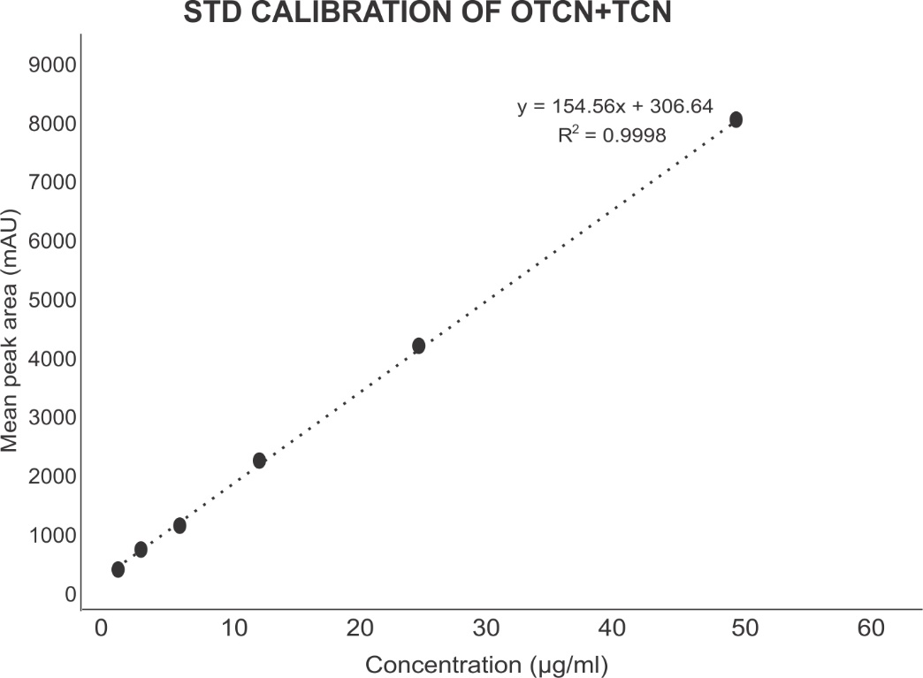

**Figure 2:** Oxytetracycline & Tetracycline Standard Curve



**Figure 3:** Ceftriaxone Standard Curve

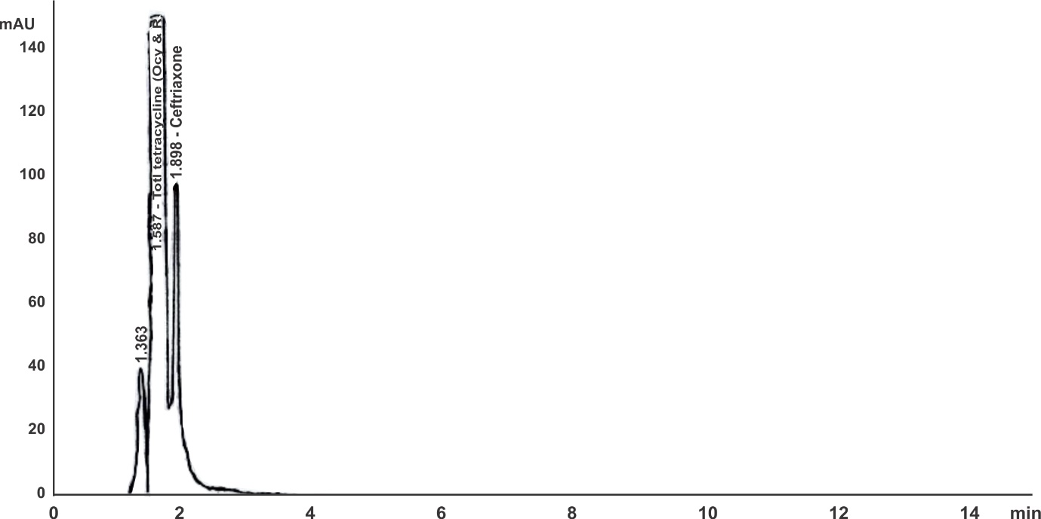

**Figure 4:** HPLC Chromatogram showing Total Tetracycline and Ceftriaxone concentration in samples

**Table 6a**: Standard solutions of oxytetracycline, tetracycline (Total tetracycline) and ceftriaxone showing concentration (µg/ml), Peak Area (MAU) and Mean Peak Area (MAU) for standard solutions.

|  |  |  |  |  |  |
| --- | --- | --- | --- | --- | --- |
| **TOTAL TETRACYCLINE**  **(oxytetracycline & tetracycline)** | | | **CEFTRIAXONE** | | |
| **Concentration (µg/ml)** | **Peak Area (MAU)** | **Mean Peak Area (MAU)** | **Concentration (µg/ml)** | **Peak Area (MAU)** | **Mean Peak Area (MAU)** |
| 1.59 | 569.946 | 569.946 | 3.18 | 117.763 | - |
| 3.175 | 820.810  825.507 | 823.159 | 6.25 | 138.110  138.759 | 138.435 |
| 6.25 | 1185.783  1231.438 | 1208.611 | 12.5 | 168.038 | 168.038 |
| 12.5 | 2255.906  12300.333 | 2278.120 | 25.0 | 777.535 | 777.535 |
| 25.0 | 4197.188  4085.037 | 4141.112 | 50.0 | 1230.111 | 1230.111 |
| 50.0 | 8103.302  7987.293 | 8045.298 | 100.0 | 1221.555  1074.700 | - |

**Table 6b: Results of Peak Area (MAU), Mean Peak Area (MAU), Concentration (µg/ml), Concentration per weight (µg/g), for oxytetracycline & tetracycline (total tetracycline) and ceftriaxone antibiotics residues presence in fish muscle, liver and heart samples.**

|  |  |  |  |  |  |  |  |  |  |
| --- | --- | --- | --- | --- | --- | --- | --- | --- | --- |
| **TOTAL TETRACYCLINE RESIDUES**  **(Oxytetracycline & Tetracycline residues)** | | | | | **CEFTRIAXONE RESIDUES** | | | | |
| **Sample**  **Identity** | **Peak Area (MAU)** | **Mean Peak Area (MAU)** | **Concentration**  **(µg/ml)** | **Concentration per weight (µg/g)** | **Peak Area (µg/ml)** | **Mean Peak Area (MAU)** | **Concen**  **tration**  **(µg/ml)** | | **Concentration**  **per weight**  **(µg/g)** |
| **Oshodi/Isolo**  Muscle | ND | **_** | **_** | **_** | 15.5894 | 15.5894 | | 2.1313 | 4.2626 |
| Liver | ND | **_** | **_** | **_** | ND | **_** | | **_** | **_** |
| Heart | 105.5749 | 103.9024 | 0.2899 | 0.5796 | 33.1859  28.3739 | 30.7799 | | 2.700 | 5.412 |
| **Ikotun Area**  Muscle | ND | **_** | **_** | **_** | 3.9345 | 3.9345 | | 1.690 | 3.38 |
| Liver | ND | **_** | **_** | **_** | ND | **_** | | **_** | **_** |
| Heart | ND | **_** | **_** | **_** | 10.7129 | 10.2368 | | 1.9287 | 3.857 |
| **Alimosho**  Muscle | ND | **_** | **_** | **_** | 5.1729 | 5.8718 | | 1.7635 | 3.527 |
| Liver | ND | **_** | **_** | **_** | ND | **_** | | **_** | **_** |
| Heart | 143.4338 | 143.4338 | 0.40014 | **_** | 2.6187 | 2.6187 | | 1.6404 | 3.2809 |

The concentration (µg/ml) of total tetracycline residue in fish heart samples for fish farms at Oshodi/Isolo and Alimosho LGAs were 0.28 and 0.4 respectively. Concentration per weight (µg/g) of total tetracycline residue in fish heart samples for fish farms at Oshodi/Isolo L.G.A was 0.57 while that for Alimosho L.G.A was 0.82. Ceftriaxone residue (µg/ml) in fish muscle and heart samples for fish farms at Oshodi/Isolo LGAs. Were 2.13 and 2.7 respectively, whereas those recorded in the muscle and heart of fish samples obtained from Ikotun area was 1.69 and 1.92 respectively.Concentration (µg/ml) of ceftriaxone residue in fish samples for fish farms at Alimosho LGA was 1.76 in the muscle and 1.64 in the heart.

**DISCUSSION**

One of the main causes of the growing emergence of antimicrobial resistance in the fish farming sector is the overuse and unregulated use of antibiotics, as well as inadequate treatment and health monitoring procedures. This emphasizes how important it is to comprehend how antibiotics are used in aquaculture and how they can be related to antibiotic resistance in bacterial infections. This understanding is essential for developing and putting into practice efficient control and farm management plans to deal with this urgent problem.16, 27-28 Therefore, this study assessed the use of antibiotics by fish farmers in Lagos, Nigeria, as well as the identification of ceftriaxone, oxytetracycline, and tetracycline residues in fish samples.

Forty (80%) of the fifty fish farmers in this study were between the ages of twenty and fifty; forty-five (90%) of the farmers were men. This finding is comparable to that of Aliyu *et al*., 23 who found that the majority of fish farmers in Kaduna State, Nigeria, were men between the ages of 20 and 59. In contrast, the study by Aliyu *et al*.,23 found that the majority (68.60%) of the farmers had university education, whereas 35 (70%) of the farmers in our study had only a secondary education. Three fish farmers in a research by Adelowo and Okunlola22 had advanced degrees, whereas the others only had elementary or secondary schooling.

50 (100%) of the fish farmers in this study utilized antibiotics to treat disease on their farms, with 45 (90%) using tetracycline and 5 (10%) using other antibiotic drugs. This result is in alignment with earlier research.10, 29 Aliyu *et al*.,23 reported that oxytetracycline was the most commonly utilized antibacterial agent. Farmers utilize oxytetracycline extensively in the production of fish and cattle because it is a broad-spectrum antibiotic that is reasonably priced.30 Tetracycline may therefore be the most commonly abused antimicrobial medication in aquaculture. Two studies addressing the same problem in different countries also revealed that tetracyclines were the most widely utilized antibiotics.31,32 Though Pham *et al*.,32 report a similar high prevalence use of trimethoprim and sulfonamides in addition to tetracyclines in Vietnamese aquaculture farms, Tuševljak *et al*.,31 report a high prevalence of fluoroquinolone use among fish farmers in the United States (70%) and Canada (67%). No farms employed sulfonamides in this investigation.

This study found that 70% of fish farmers self-administer antimicrobials, which is more than the percentages found in Kaduna State by Aliyu *et al.,*23 and Ibadan by Olatoye and Basiru.33 Similar to the 67% observed by Aliyu *et al*.,23 the majority of fish farmers (80.00%) did not know or had never heard of antibiotic or drug residue in food. There has been a lot of interest in the use of antibiotics in animals raised for food. Since over the past century, there has been a significant rise in the demand for fish products. High intensity aquaculture techniques, which are typified by high stock density and volume as well as the extensive use of formula feeds containing antibiotics and other chemicals, have increased in tandem with this.

Eighty percent of the farmers who used antibiotics were unaware of the risks connected to their careless usage in ponds. A similar finding was made by Adelowo and Okunlola,22 who found that many people (n = 15; 60%) were unaware of the harmful consequences of the careless use of antibiotics in fish farming. The outcome shows that there was a lack of knowledge about antimicrobial medication residues in fish and the risks connected to their usage and ingestion. It is possible to conclude from the data and information gathered from fish farmers and respondents that antibiotic use is widespread and varies, which may contribute to the problem of antibiotic use in aquaculture and the emergence of antibiotic resistance, which may pose health risks to consumers, as detailed by Alderman and Hustings.34 Given that policies controlling the availability and use of antimicrobial substances are often nonexistent or only loosely implemented in underdeveloped nations, these findings were not surprising. Antimicrobials and other essential medications are easily accessible over-the-counter in Nigeria, which makes it simple for fish farmers to use them on their farms. One important element encouraging the usage of these medications in Nigerian fish farms may be their accessibility. Antibiotic resistance has been linked to the un-prescribed dispensing of antibiotics.35

The European Union and other regulatory bodies across the world have set maximum residue limits (MRL) for antibiotic residues in animal products that reach the human food chain in order to safeguard human health.36 The concentrations of ceftriaxone residue (µg/ml) in fish muscle and heart samples from fish farms at Oshodi/Isolo LGAs were 2.13 and 2.7, respectively, while those found in the muscle and heart of fish samples taken from the Ikotun area were 1.69 and 1.92. The concentrations of total tetracycline residue (µg/ml) in fish heart samples for fish farms at Oshodi/Isolo and Alimosho LGAs were 0.28 and 0.4, respectively. Fish samples from fish farms at Alimosho LGA had ceftriaxone residual concentrations (µg/ml) of 1.76 in the muscle and 1.64 in the heartThe European Union (EU) recommends a limit of 100µg/kg of tetracycline and oxytetracycline residues in animal muscle.37 When compared to the concentrations of the muscle samples, the levels of tetracycline and oxytetracyline (total tetracycline) residue are below the EU limit, according to the data and results of the analysis.

The United States Food and Drug Administration (USFDA) has established a tolerance level of less than 2.0µg/g for oxytetraacycline residues in serum, liver, and muscle in fish species that represent a range of freshwater and saltwater culture conditions as well as temperature niches (Chen et al. 2004). Tetracycline and oxytetracycline residue levels in fish samples in this study are within the acceptable range/standards.

**CONCLUSION**

This study found that fish farmers in Lagos West Senatorial District utilize antibiotics; fish farmers in Lagos State administer antibiotics in aquaculture production in an unregulated and unmonitored manner even though some of the antibiotics residues in the fish samples were within the acceptable international limits. The appropriate use of antimicrobial medications should all be promoted for aquaculture disease prevention and control. Before selling treated fish to customers, fish farmers should receive education on the importance of strictly adhering to withdrawal periods following treatment. To protect the general public from the risks of consuming antibiotics, the government should impose stringent regulations on the use of veterinary medications in fish farming and educate fish farmers on the risks posed by antimicrobial drug residues in fish.

**Ethical approval**

Ethical approval was obtained from College of Medicine, University of Lagos Health Research Ethics Committee and College of Medicine; University of Lagos Health Research Ethics Committee assigned number: CMUL/ACUREC/8/21/940.

**REFERENCES**

1. Raman, N.M.; Easwaran, M.; Kaul, R.; Bharti, J.; Motelb, K.F.A.; Kaul, T. Antimicrobial Resistance with Special Emphasis on Pathogens in Agriculture. Antimicrob. Resist. One Health Perspect. 2020. [CrossRef]
2. Orororo O. C., Tonukari, N. J., Avwioroko, O. J. and Ezedom, T*.* (2014). Effect of Supplementation of Animal Feed with Dried Cassava (*Manihot esculenta*) Peels, and Stems of *Vernonia amygdalina* and *Pennisetum purpereum* on Some Biochemical Parameters in Pigs. *Nigerian Society for Experimental Biology (NISEB) Journal* 14(4):177-183
3. Moffo, F., Ndebé, M. M. F., Tangu, M. N., Noumedem, R. N. G., Awah‑Ndukum, J. and Mouiche, M. M. M. (2024). Antimicrobial use, residues and resistance in fish production in Africa: systematic review and meta-analysis. BMC Veterinary Research (2024) 20:307:1-16.
4. Olorunfemi, D. I., Oteri, O., Orororo, O. C., Enize, T. B., Pere, C. and Osioma, E. (2024). Genotoxic Effects of Cassava Effluent on the Expression of Selected Genes in the African Catfish, *Clarias gariepinus. Journal of Advances in Biology & Biotechnology;* 27(5):352-364.
5. Olorunfemi, D. I., Orororo, O. C., Iloduba, N. E., Osioma, E., Kpomah, N. D. and Osio, O. L. (2024). Evaluation of Genotoxicity by Comet assay in tissues of Clarias gariepinus exposed to cassava Effluent. *Asian Journal of Biochemistry, Genetics and Molecular Biology*; 16 (7): 98-108.
6. Efekemo, O., Davies, I. C., and Orororo, O. C. (2024). Water Quality Assessment and Heavy Metal Levels in Mudskipper (*Periophthalmus papilio*), Sediments and Water of Mangrove Swamps, Rivers State, Nigeria. *African Journal of Environment and Natural Science Research*; 7(1): 128-145.
7. Reverter M, Sarter S, Caruso D, Avarre JC, Combe M, Pepey E, Pouyaud L, Heredía SV, HVRE G. Aquaculture at the crossroads of global warming and antimicrobial resistance. Nat Commun. 2020;11:1870. https:// doi. org/ 10. 1038/ s41467-​020-​15735-6.
8. Efekemo, O., Orororo, O. C. and Davies, I. C. (2024). Evaluation of Water Quality and Heavy metal Concentrations in Shrimp (*P. Monodon*), Sediment and Surrounding Water of the Mangrove Swamps, Rivers State, Nigeria. *Scientia Africana*, 23 (2): 251-262
9. Olorunfemi1 Daniel I., Gabriela-Mary O. Nkemneme1, Olumide Afolabi2, Precious Ebisintei2, Happiness B. Okunoja3, Osuvwe C. Orororo4*, Enyohwo D. Kpomah5 and Juliet N. Tesi. (2024). biochemical, histological and molecular investigation of fish exposed to a brewery effluent. Journal of Basic and Applied Zoology; 2024; 85: 64: 1-12.
10. Kelly, T., Verner‐Jeffreys, D., Hinchliffe, S., Rahman, M. M., Bass, D., & Tyler, C. R. (2020). Evaluating antimicrobial resistance in the global shrimp industry. Reviews in Aquaculture, 12(2), 966-986.
11. Nwaiwu (2021). PHA 804 Lectures on Antibiotic toxicity, Mutagenicity, Carcinogenicity and teratogenesis. Department of Pharmacology, Theraupeutics and Toxicity, College of Medicine of the University of Lagos, Lagos state.
12. Felman A, Carter A, Pharm.D. (2019). Antibiotics: Uses, resistance and side effects. Medical News today.
13. Schulz, P.; Pajdak-Czaus, J.; Siwicki, A.K. In vivo bacteriophages’ application for the prevention and therapy of aquaculture animals– chosen aspects. Animals 2022, 12, 1233.
14. Donkor, E.S.; Anim-Baidoo, I.; Fei, E.; Amponsah, C.; Olu-Taiwo, M.; Nana-Adjei, D. Occurrence of antibiotic residues and antibiotic-resistant bacteria in Nile tilapia sold in some markets in Accra, Ghana: Public health implications. J. Food Res. 2018, 7, 129.
15. Phares, C.A.; Danquah, A.; Atiah, K.; Agyei, F.K.; Michael, O.-T.; Ercoli, V. Antibiotics utilization and farmers’ knowledge of its effects on soil ecosystem in the coastal drylands of Ghana. PLoS ONE 2020, 15, e0228777.
16. Almashhadany, D.A.; Hassan, A.A.; Rashid, R.F.; Abdulmawjood, A.; Khan, I.U.H. Assessment and Assay Comparison for Detection of Antimicrobial Residues in Freshwater Aquaculture Fish in Erbil Governorate, Iraq. Antibiotics 2024, 13, 225. https:// doi.org/10.3390/antibiotics13030225
17. Serweci ´ nska, L. Antimicrobials and Antibiotic-Resistant Bacteria: A risk to the environment and to public health. Water 2020, 12, 3313.
18. Okon, E.M.; Okocha, R.C.; Adesina, B.T.; Ehigie, J.O.; Alabi, O.O.; Bolanle, A.M.; Matekwe, N.; Falana, B.M.; Tiamiyu, A.M.; Olatoye, I.O.; et al. Antimicrobial resistance in fish and poultry: Public health implications for animal source food production in Nigeria, Egypt, and South Africa. Front. Antibiot. 2022, 1, 1043302.
19. Ibrahim, M.; Ahmad, F.; Yaqub, B.; Ramzan, A.; Imran, A.; Afzaal, M.; Mirza, S.A.; Mazhar, I.; Younus, M.; Akram, Q.; et al. Current trends of antimicrobials used in food animals and aquaculture. Antibiot. Antimicrob. Resist. Genes Environ. 2020, 1, 39–69.
20. Mshana, S.E.; Sindato, C.; Matee, M.I.; Mboera, L.E.G. Antimicrobial Use and Resistance in Agriculture and Food Production Systems in Africa: A Systematic Review. Antibiotics 2021, 10, 976. https://doi.org/10.3390/antibiotics10080976
21. Cabello F.C., Godfrey H.P., Tomova A., Ivanova L., Dölz H., Millanao, A., Buschmann A.H., 2013, Antimicrobial use in aquaculture re-examined: its relevance to antimicrobial resistance and to animal and human health. Environ. Microbiol. 15: 1917–1942. doi: 10.1111/1462-2920.12134
22. Adelowo O.O., Okunlola I., 2019. Field assessment of antibiotic use in fish farms in Southwestern Nigeria. Rev. Elev. Med. Vet. Pays Trop., 72 (4): 187-191, doi: 10.19182/remvt.31472
23. Aliyu, L.A., Chukwudi, O. E., Janaidu K., Ibukun-Olu, B. P. and Barde, I. J. (2021). Assessment of antimicrobial drugs use and their residue in the farmed fish of Kaduna, Nigeria. Global Journal of Fisheries Science Volume 3(3), pages 15-26.
24. Adebowale O.O., Adeyemo O.K., Awoyomi A., Dada R., Adebowale O., 2016. Antibiotic use and practices in commercial laying hens in Ogun state Nigeria. Rev. Elev. Med. Vet. Pays Trop., 69 (1): 41-45, doi: 10.19182/remvt.31170
25. Mouiche MMM, Moffo F, Akoachere KTJ-F, Okah-Nnane NH, Mapiefou PN, Ndze NV, Wade A, Djuikwo-Teukeng FF, Toghoua TGD, Zambou HR, et al. Antimicrobial resistance from a one health perspective in Cameroon: a systematic review and meta-analysis. BMC Pub Hlth. 2019;19:1135. https:// doi. org/ 10. 1186/ s12889-​019-​7450-5.
26. Pratik, M., Chakrapani, P., Bijay, K.B. & Basanta, K.D. (2018). Future aspects of integrated fish farming. Acta Scientific Agriculture, 2:45-47.
27. Busari, A. A., · Efejene, I. O., Olayemi, S. O., Orororo, O. C., and Egbune, E. O. (2024). Evaluation of antibiotic use and analysis of ciprofloxacin and gentamicin residue in fish samples from farms in Lagos, Nigeria. *Environmental Monitoring and Assessment;* (2024) 196:127:1-10.
28. Hasan MM, Rafiq K, Ferdous MRA, Hossain MT, Ripa AP, Haque SM. Screening of antibiotic residue in transported live fish and water collected from different fish markets in Mymensingh district of Bangladesh. J Adv Vet Anim Res 2022; 9(1):104–112.
29. Okocha, R.C.; Olatoye, I.O.; Adedeji, O.B. Food safety impacts of antimicrobial use and their residues in aquaculture. Public Health Rev. 2018, 39, 21.
30. Olatoye, I. O., & Ehinmowo, A. A. (2010). Oxytetracycline Residues in Edible Tissues of Cattle Slaughtered in Akure, Nigeria. Nigerian Veterinary Journal, 31(2), 93-102.
31. Tuševljak N., Dutil L., Rajić A., Uhland F.C., McClure C., St-Hilaire S., Reid-Smith R.J., et al., 2013. Antimicrobial use and resistance in aquaculture: findings of a globally administered survey of aquacultureallied professionals. Zoonoses Public Health, 60 (6): 426-36. doi: 10.1111/zph.12017
32. Pham D.K., Chu J., Do N.T., Brose F., Degand G., Delahaut P., Pauw E.D., et al., 2015. Monitoring Antibiotic Use and Residue in Freshwater Aquaculture for Domestic Use in Vietnam. EcoHealth., 12: 480–489, doi: 10.1007/s10393-014-1006-z
33. Olatoye, I. O., & Basiru, A. (2013). Antibiotic usage and oxytetracycline residue in a African catfish (Clarias gariepinus) in Ibadan, Nigeria. World Journal of Fish and Marine Sciences, 5(3), 302-309.
34. Alderman DJ, Hastings TS (2003). Antibiotic use in aquaculture: development of antibiotic resistance –potential for consumer health risks. International Journal of Food Science & Technology, volume 33, Issue 2/ pp. 139-155.
35. Plachouras D., Kavatha D., Antoniadou A., Giannitsioti E., Poulakou G., Kanellakopoulou K., Giamarellou H., 2010. Dispensing of antibiotics without prescription in Greece, 2008: Another link in the antibiotic resistance chain. Eurosurveillance, 15 (7), doi: 10.2807/ese.15.07.19488-en
36. Canada – Canada F, Munoz dela Pena A, Espinosa – Mansilla, A (2009). Analysis of antibiotics in fish samples Animal Health. 16(14):208-219
37. Onipede OJ, Nwankwo B, Adewuyi GO, Nwachukwu CU. (2021). Levels of antibiotics residues in chicken and catfish sold in some parts of Lagos state and Ota local government, Ogun state south- western, Nigeria.