**The Nexus Between Teacher Cognition and Metacognitive Strategy Utilization in Instructional Planning and Execution**

**Abstract**

This study investigates the Nexus Between teachers’ cognition and metacognitive strategy utilization in instructional planning and execution. with a focus on their impact on teaching effectiveness and student learning outcomes. However, the extent to which teachers understand and apply these strategies remains a critical concern, particularly in contexts where traditional, teacher-centered methods dominate.

Using a qualitative approach, this study examines the practical implementation of metacognitive strategies among teachers. Data were collected through surveys from 25 teachers in Ovia Southwest Local Government, Edo State, Nigeria. The findings reveal that while many teachers recognize the importance of metacognitive strategies, a huge barrier exists due to the lack of formal training, resources, or institutional support needed to integrate them meaningfully into their instructional practices. Time constraints, rigid curricula, and student resistance also emerged as key barriers.

The research highlights that teachers are aware of metacognition and actual classroom practice, suggesting that professional development alone is insufficient without systemic support and policy alignment. The study recommends the incorporation of metacognitive training into teacher education curricula, ongoing in-service training programs, and school-wide initiatives that foster reflective teaching cultures. Additionally, creating learner-friendly environments that encourage self-assessment, strategic thinking, and reflection can significantly enhance student engagement and achievement. Enhancing teachers’ capacity to use metacognitive strategies is essential for promoting deeper learning and improving educational outcomes. By equipping educators with the knowledge and tools to model and guide metacognitive processes, schools can bridge the gap between knowledge acquisition and meaningful learning, thus preparing students for success in a complex, ever-changing world.

Key words: Metacognitive strategies, Teacher awareness, Instructional Planning, Lesson delivery, reflective teaching, self-regulated learning.

**Introduction**

Teaching is more than just delivering content; it involves thoughtful planning, reflection, and continuous adaptation to meet students' needs. One of the most critical yet often overlooked aspects of effective teaching is metacognition, or the ability to think about one's own thinking processes. In the context of education, metacognitive strategies allow teachers to evaluate their instructional methods, refine lesson plans, and improve student learning outcomes. Despite its importance, many educators may not consciously integrate metacognitive strategies into their teaching practices. Understanding teachers' awareness and implementation of metacognitive strategies can provide valuable insights into improving lesson planning and delivery (Searcy & Maroney, 1996). Metacognition, often described as "thinking about thinking," encompasses the processes involved in planning, monitoring, evaluating, and modifying one's own cognitive processes (Li et al., 2023). It includes self-regulation and self-reflection on individual strengths and weaknesses (Kabbassova et al., 2021). Metacognitive skills are essential for adapting to novel situations where habitual responses are insufficient, empowering individuals to navigate challenges effectively (Djudin, 2018). Metacognition is a critical component of successful learning (Kabbassova et al., 2021). It equips learners with the ability to recognize, assess, and refine their perspectives, fostering a deeper understanding of the learning process (Baird et al., 1991). Metacognitive strategies enhance students' ability to learn and promote the development of self-regulation skills, which have been proven to improve academic performance (Mattern & Bauer, 2014). Improving metacognitive strategies related to students' schoolwork equips the students with tools to reflect and grow in their emotional and social lives (Djudin, 2018). The integration of metacognitive strategies into educational practices is crucial for fostering independent and adaptable learners (Dewi et al., 2021; Paris & Winograd, 1990).

Metacognition in teaching involves self**-**monitoring**,** self**-**questioning**,** andreflection, all of which contribute to a teacher’s ability to make informed instructional decisions. By employing metacognitive strategies, educators can assess their teaching effectiveness, identify areas of improvement, and create an environment that fosters deeper student engagement **.**Self-monitoring allows teachers to evaluate their teaching effectiveness in real-time, enabling adjustments to be made during lessons (Suganthi & Muthurasu, 2020).Continuous reflection on teaching practices leads to improved instructional strategies and better student outcomes (Jing & Yang, n.d.).Educators can utilize self-questioning to critically analyze their teaching methods and the impact on student engagement (Stephens & Santangelo, 2021).This practice encourages teachers to consider alternative approaches rather than relying solely on traditional methods (Suganthi & Muthurasu, 2020).Reflective practices help teachers to recognize their strengths and weaknesses, guiding professional development efforts (Jing & Yang, n.d.).By fostering a culture of reflection, educators can create an environment that promotes deeper student engagement and learning autonomy(Papleontiou-Louca, 2003).

While metacognitive strategies are essential for enhancing teaching effectiveness, some educators may struggle with implementation due to a lack of training or awareness of these techniques. This gap can hinder the potential benefits of metacognition in educational settings (CHEN, n.d.). However, research suggests that many teachers, particularly those early in their careers, may struggle to incorporate metacognitive techniques systematically. This study seeks to explore the extent to which teachers are aware of metacognition and how they apply it in lesson planning and instruction. learning perspective, metacognitive strategies—such as self-questioning, reflection, and goal-setting—are essential for developing independent, critical thinkers. When teachers intentionally embed these strategies into lessons, students become more aware of *how* they learn, not just *what* they learn. This research explores whether educators are actively facilitating metacognition in classrooms and how this impacts students’ ability to monitor, evaluate, and adjust their own learning processes.

The integration of metacognitive strategies in lesson planning allows educators to setclearobjectives**,** anticipatestudentmisconceptions**,** andadjustinstructionalapproachesaccordingly. Teachers who engage in reflective thinking during lesson preparation can better predict challenges students may face and devise strategies to enhance comprehension. Moreover, metacognition enables teachers to structure lessons that encourage students to think critically and take ownership of their learning. By examining how teachers utilize metacognitive strategies in lesson design, this research aims to highlight the significance of reflective teaching practices in improving instructional quality.

In addition to lesson planning, the delivery of lessons is another crucial aspect where metacognitive strategies play a role. Effective teachers continuously assess their instructional approach during lessons, making adjustments based on student responses and engagement levels. This may involve askingprobingquestions**,** encouragingstudentreflections**,** andmodifyingexplanations to cater to diverse learning needs. Investigating how teachers implement metacognitive techniques in lesson delivery can provide valuable insights into their ability to foster an adaptive and engaging classroom environment.

Although metacognitive strategies have been widely recognized as beneficial in education, barriers exist that may hinder their adoption among teachers. Lack of professionaldevelopment, insufficient awareness of metacognition, time constraints, and rigid curriculum structures can all contribute to educators’ difficulties in incorporating reflective practices. This study aims to identify these challenges and explore potential solutions for supporting teachers in the effective use of metacognitive strategies.

Students benefit when teachers model metacognitive thinking in the classroom. Teachers who explicitly demonstrateself**-**questioning**,** reasoning**,** andreflection help students develop their own metacognitive skills, leading to improved problem-solving and independent learning. Understanding how teachers integrate metacognitive strategies into their instructional approach can provide deeper insights into fostering students’ ability to regulate their own learning processes.

Understanding teachers’ awareness and use of metacognitive strategies is essential for improving lesson planning and delivery (Kang & Lee, 2022). By fostering metacognitive thinking among educators, schools can cultivate a learning environment that supports bothteachergrowthandstudentsuccess.

**Statement of the Problem**

Metacognitive strategies play a crucial role in effective lesson planning. Teachers who incorporate metacognitive strategies in their planning can better anticipate students' needs, identify potential challenges, and develop targeted interventions (Hativa 2013). By reflecting on their thought processes and planning strategies, teachers can optimize their lesson plans to promote students' engagement, motivation, and learning outcomes. Effective lesson planning involves more than just conveying content; it requires teachers to plan metacognitive development. This includes incorporating strategies that promote students' self-regulation, such as setting goals, monitoring progress, and evaluating outcomes. (Zimmerman 2000). By intentionally planning for metacognition, teachers can help students develop the skills they need to take ownership of their learning and become more independent learners.

Metacognitive strategies in lesson delivery

Metacognitive strategies play a vital role in lesson delivery, enabling students to take ownership of their learning and develop critical thinking skills. Teachers can model metacognitive strategies through think-alouds, demonstrating how to approach problems and tasks (king,1992) by verbalizing their thought processes. Teachers can help students understand the cognitive steps in learning and problem solving. Teachers can also use questioning techniques to encourage students to reflect on their thinking and learning, such as asking open-ended questions that prompt students to explain their reasoning (Beyer,2008). Additionally, teachers can provide feedback that guides students to reflect on their learning and adjust their approach, helping students develop metacognitive skills. Metacognitive strategies in lesson planning are essential for fostering independent and reflective learners. These strategies encourage students to think about their own thinking, helping them become more aware of their learning processes and improving their ability to adapt to new challenges. When teachers incorporate metacognition into lesson planning, they guide students in setting learning goals, monitoring their progress, and evaluating their understanding. This not only enhances comprehension but also builds confidence in students as they develop critical thinking and problem-solving skills.

One effective way to integrate metacognitive strategies is through explicit instruction in self-questioning techniques. Encouraging students to ask themselves questions before, during, and after learning activities helps them assess their prior knowledge, actively engage with new concepts, and reflect on their understanding. Teachers can model this process by thinking aloud, demonstrating how to approach complex tasks strategically. Additionally, incorporating activities like guided discussions, journal reflections, and concept mapping can reinforce metacognitive awareness, making learning more intentional and meaningful.

Another powerful tool in metacognitive lesson planning is formative assessment, which provides continuous feedback to students on their learning journey. Techniques such as peer review, self-assessment rubrics, and reflective exercises empower students to take charge of their own progress. By identifying areas of strength and improvement, they develop a growth mindset and become more resilient learners. This approach shifts the focus from purely memorizing facts to developing deeper conceptual understanding, ensuring long-term retention and application of knowledge.

Ultimately, metacognitive strategies transform lesson planning into a dynamic process that nurtures self-directed learners. When students are equipped with the skills to plan, monitor, and evaluate their learning, they become more adaptable and efficient in acquiring new information. Teachers play a crucial role in fostering this metacognitive culture by designing lessons that encourage curiosity, self-reflection, and strategic thinking ( Nordin& Yunus, 2020). By emphasizing these strategies, educators prepare students not just for academic success, but for lifelong learning and problem-solving in the real world.

**Research objectives**

1. To assess teachers' awareness of metacognitive strategies in lesson planning and instructional delivery.
2. Toexaminehowteachersintegratemetacognitivestrategies into their lesson planning processes.

**Literature Review**

Metacognition, or the ability to reflect on and regulate one’s own thinking processes, has been extensively studied in the field of education. Research on teachers'metacognitiveawareness suggests that educators who engage in reflective thinking tend to be more effective in lesson planning and instructional delivery. Studies have indicated that experienced teachers naturally employ metacognitive strategies, even if they are not explicitly trained in them, while novice teachers often struggle with intentional self-monitoring and reflection. For instance, (Schraw & Moshman (1995) highlight the importance of metacognitive knowledge and regulation in teaching, emphasizing that educators who are aware of their cognitive processes can better scaffold students' learning experiences. However, the depth of teachers' metacognitive awareness varies across disciplines, experience levels, and educational settings, necessitating further exploration.

One of the key aspects of metacognition in teaching involves self**-**monitoring, which enables educators to assess their instructional approach and make adjustments based on student comprehension and engagement. Research by Flavell (1979), who pioneered the concept of metacognition, outlines self-monitoring as a critical function that allows individuals to recognize when learning is effective or when strategies need modification. In classrooms, teachers who frequently reflect on their instruction can identify misconceptions early and adapt their lesson plans accordingly. Moreover, Zimmerman (2002) describes self-monitoring as an essential component of self**-**regulatedlearning, which applies not only to students but also to teachers as they refine their teaching methods based on cognitive feedback.

Reflection is another widely studied metacognitive strategy that has shown significant benefits in education. Schön (1983) introduced the idea of reflectivepractice, which has since become an integral part of teacher professional development. Teachers who engage in reflective practice assess their own instructional methods, identifying both strengths and areas for improvement. Studies indicate that educators who adopt reflection as a habit tend to exhibit higheradaptability, making them better equipped to cater to diverse student needs. Additionally, reflective teaching fosters an environment where continuous learning and improvement become part of an educator’s professional growth, strengthening overall teaching effectiveness.

Questioning techniques, which help teachers foster critical thinking and independent learning among students. Educators who strategically use questioning methods, such as Socratic questioning or guided inquiry, encourage learners to engage with content at a deeper level. Research by King (1991) emphasizes the importance of metacognitive questioning, showing that students who are frequently prompted to explain their thought processes develop stronger problem-solving skills. Furthermore, teachers who pose higher-order questions not only enhance students' comprehension but also promote self-regulation, allowing learners to reflect on their reasoning and knowledge construction. (Kalio et al 2018)

The impact of metacognitive strategies on student learning and engagement has been widely studied, with numerous findings supporting the notion that metacognition enhances academic success. Studies by Paris & Winograd (1990) illustrate that students who engage in metacognitive processes, such as planning, monitoring, and evaluating their learning, demonstrate improved retention and comprehension. Moreover, teachers who incorporate metacognitive strategies into their pedagogy encourage students to become autonomous learners, equipping them with skills to transfer knowledge across different contexts. (Eilam, 2017) Metacognitive teaching practices also contribute to increased classroom participation, as students feel more confident in expressing their thoughts and engaging in meaningful discussions.

Despite the advantages of metacognitive strategies,training teachers to effectively usemetacognition remains a significant challenge. Research suggests that many educators receive limited formal training in metacognitive instructional methods, leading to inconsistent application in classrooms. A study by Veenman et al. (2006) points out that while teachers may recognize the value of metacognition, they often struggle to translate theoretical understanding into practical teaching techniques. Additionally, time constraints and rigid curricular demands make it difficult for educators to integrate metacognitive strategies systematically. Addressing these challenges requires tailored professional development programs that focus on explicit training and modeling of metacognitive strategies.

Another barrier to implementing metacognition in teaching is the lackofinstitutionalsupport. Many schools prioritize content delivery over reflective teaching practices, making it challenging for teachers to experiment with metacognitive techniques. Research indicates that teachers who receive peersupportandmentorship are more likely to integrate metacognition into their classrooms. (Baylor, 2002) Collaborative professional learning communities, where educators share reflective practices and discuss instructional strategies, have been shown to enhance the application of metacognitive teaching methods. Therefore, institutional frameworks must be restructured to encourage teachers to engage in reflective thinking and self-monitoring as part of their professional growth. (Deliany &Cahyono 2020)

The literature underscores the importance of teachers'metacognitiveawareness and its impact on lesson planning and delivery. Prior studies highlight various metacognitive strategies, such as self**-**monitoring**,** reflection**,** andquestioning, all of which contribute to improved student engagement and learning outcomes.(Sawyer &Mayer 2018) However, challenges in trainingeducators and providing institutional support hinder the full integration of metacognitive practices in teaching. Addressing these gaps through professional development initiatives and school-wide pedagogical reforms can foster a cultureofreflectiveandadaptiveteaching, ultimately benefiting both teachers and students.

**Research questions.**

1. To what extent are teachers aware of metacognitive strategies in lesson planning and instructional delivery?
2. What barriers prevent teachers from effectively using metacognitive strategies, and how does this impact student learning outcomes?
3. How do teachers perceive the effectiveness of metacognitive strategies in enhancing student learning outcomes?

**Methodology**

To explore the Investigating teachers' awareness and use of metacognitive strategies in lesson planning and delivery, descriptive statistics and the t-test will be used to compare the analysis.25 teachers were randomly selected from Ovia southwest local government area of Edo state Nigeria.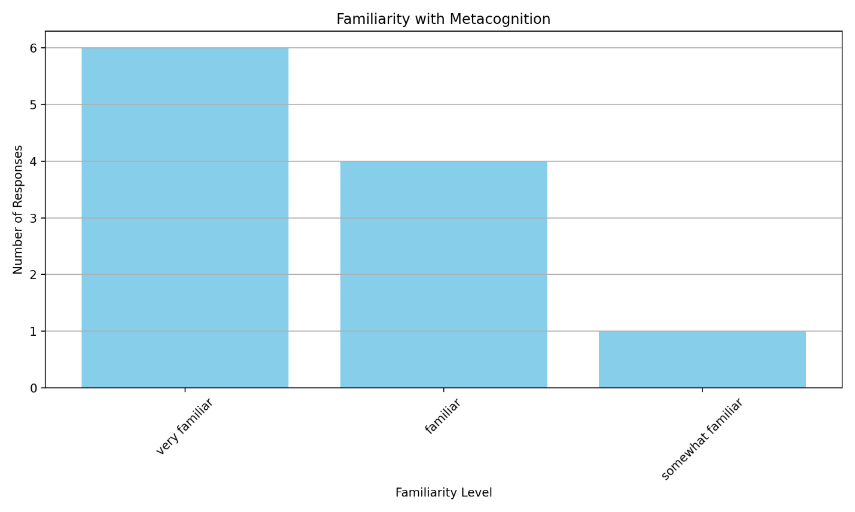

**Fig 1- Bar graph showing familiarity with metacognition**

From the bar chart, it shows that 10% of teachers are less familiar with metacognitive strategies in lesson planning and delivery, and 60% are more familiar with it. From the chart, it means teachers are aware of metacognitive strategies including self-questioning, reflection, awareness of strength and weakness, Mnemonic Aids, thinking Alouds , regular checklists. Teachers can use these strategies to develop a deeper understanding of their own learning process, leading to more effective learning and improved academic outcomes. Teachers can demonstrate how these strategies can solve academic problems. These strategies can be adopted to suit different learning styles and abilities, helping teachers cater for diverse student needs. These strategies can promote student engagement and understanding in the classroom. Here’s what the chart shows, question-by-question.

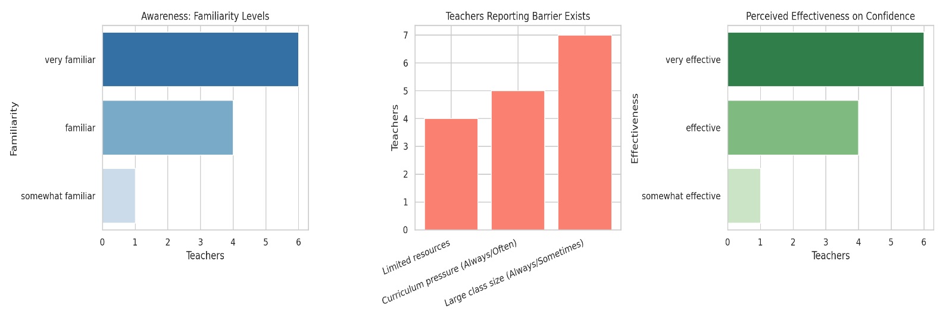

Fig 2- Bar graph showing Professional Training and Awareness

Teacher awareness

The first panel plots how familiar respondents say they are with metacognition. Most rate themselves “very familiar,” a smaller group “familiar,” and only one “somewhat familiar. This suggests a generally high level of conceptual awareness.

Barriers to classroom use  
 The middle panel aggregates the number of teachers who say each barrier is a real obstacle. Limited resources are the most frequently cited barrier. Roughly the same number report curriculum pressure (always/often) and large class size (always/sometimes) as impediments. These findings answer the second research-question theme: resource availability, curriculum pacing, and class size are key constraints. Barriers to the effectiveuseofmetacognitivestrategies by teachers are multi-dimensional rangingg from systemic to personal. These barriers directly impact studentlearningoutcomes, particularly in areas like critical thinking, self-regulation, and academic achievement.

**Results and discussion**

Barriers Preventing Teachers to Effectively use Metacognition

1. Insufficient Professional Training and Awareness.

A significant impediment to the proficient application of metacognitive strategies by educators is the inadequacy of formal training and awareness. Numerous teacher education curricula fail to adequately underscore the importance of metacognition in the learning process, culminating in a restricted comprehension among pedagogues regarding the nature of metacognitive strategies, their operational mechanisms, and their application within the classroom context (Veenman et al., 2006). In the absence of a robust foundational understanding, educators may encounter challenges in effectively modeling and imparting these strategies to their students. This deficiency in awareness frequently engenders misconceptions, wherein metacognitive practices are regarded as abstract concepts or solely pertinent to high-achieving learners.

2. Curriculum Pressures and function within stringent curricular frameworks and are compelled to fulfill syllabus requirements within a constrained academic timeframe. These temporal limitations dissuade the inclusion of metacognitive activities such as reflective journaling, think-aloud protocols, and guided self-assessment, all of which necessitate additional instructional time (Zohar & Barzilai, 2013). As a result, educators may prioritize the delivery of content over the instruction of metacognitive strategies, even when they acknowledge the significance of metacognition. The rapid pace characteristic of the educational environment often provides minimal opportunity for metacognitive reflection, impacting both educators and learners alike.

3. Absence of Institutional Support and Resources

Another pivotal barrier is the lack of institutional support, which encompasses access to instructional materials, opportunities for professional development, and collaborative learning environments. Educators may encounter insufficient backing from school administrators to experiment with or incorporate metacognitive strategies, particularly within traditional educational contexts that emphasize rote memorization and standardized testing outcomes (Hacker, Dunlosky, & Graesser, 2009). Furthermore, educational institutions that fail to cultivate a culture of reflective teaching and learning may inadvertently dissuade the utilization of metacognition by neglecting to allocate time for lesson planning, peer review, and mentorship.

4. Student Resistance and Insufficient Metacognitive Development.

Educators frequently confront resistance from students who are not accustomed to engaging in reflective thinking or who lack the developmental maturity necessary for participating in metacognitive activities. Younger learners or those originating from educational backgrounds predominantly focused on memorization may struggle to grasp the significance of metacognition (Paris & Paris, 2001). When students exhibit difficulty in engagement or display reluctance, educators may forgo metacognitive strategies in favor of more traditional instructional methodologies. This cyclical pattern further diminishes opportunities for students to evolve into independent, self-regulated learners.

5. Educator Beliefs and Attitudes

The beliefs held by educators regarding teaching and learning profoundly affect their instructional choices. If educators regard metacognitive instruction as overly complex, excessively time-consuming, or inappropriate subjects or student demographics, they are less inclined to implement such strategies (Dignath & Büttner, 2008). Additionally, some educators may harbor doubts about their capacity to effectively model metacognitive behaviors. These beliefs can act as psychological barriers, inhibiting even well-informed educators from seamlessly integrating reflective strategies into their pedagogical practices. Certainly. Below is an expanded 7-paragraph response discussing how teachers perceive the effectiveness of metacognitive strategies in enhancing student learning outcomes, with academic references.

Fig 3- Nexus between teacher cognition and metacognitive strategy

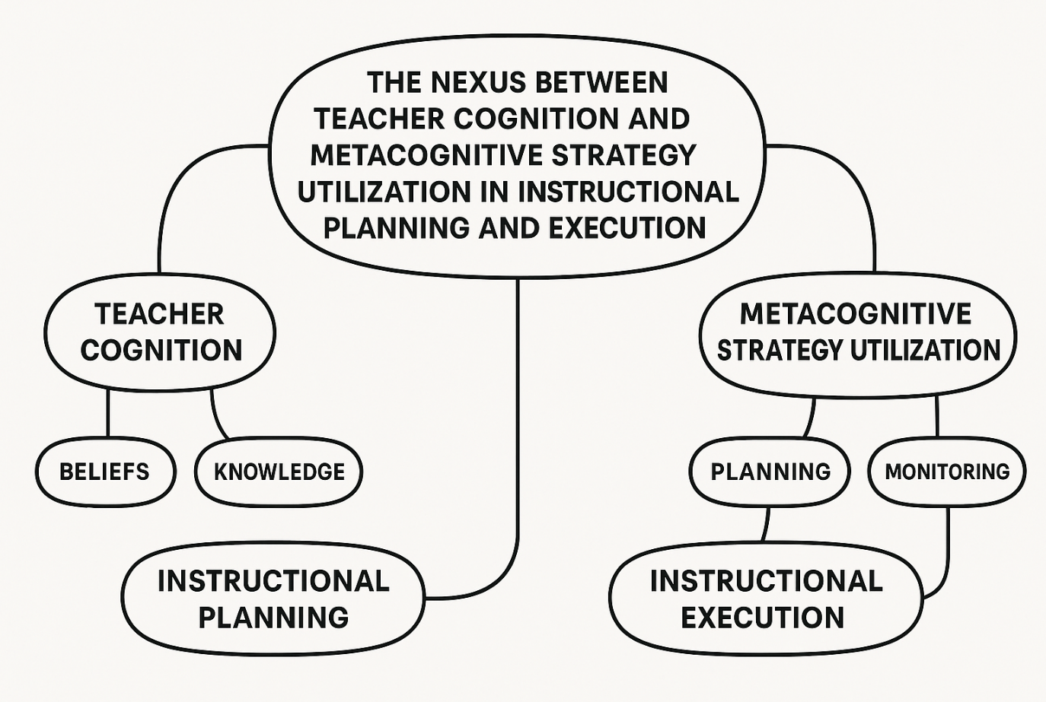

The diagram above shows the teacher needs to plan and monitor before they can effectively use metacognitive strategies in the classroom. Their beliefs and knowledge have a role to play in instructional planning and instructional execution

**Teachers Perceived effectiveness of metacognitive strategies**.

1. Improve learning outcome

Despite barriers, teachers overwhelmingly believe the strategies enhance academic performance and student confidence, reinforcing their value when conditions allow implementation. (Asikcan & Saban, 2018) Teachers increasingly recognize the value of metacognitive strategies in improving student learning outcomes. As educators are tasked with fostering critical thinking and independent learning, many perceive metacognition—the ability to think about and regulate one’s own thinking—as a foundational skill. Teachers often report that students who are taught how to plan, monitor, and evaluate their learning tend to exhibit greater autonomy and engagement in their educational journey. This perception aligns with educational goals emphasizing student-centered instruction and lifelong learning competencies.

**2. Student Engagement and Self-Regulation**

Teachers frequently observe that metacognitive strategies contribute to higher levels of student engagement. When students become aware of how they learn best and begin to actively reflect on their cognitive processes, they demonstrate increased motivation and responsibility. According to Schraw et al. (2006), students who utilize metacognitive

Strategies are more likely to stay focused, adjust learning tactics as needed, and maintain interest in learning tasks. Teachers view this transformation as a significant benefit, as it fosters a more active and reflective learning environment.

**3. Improved Academic Performance**

One of the most widely cited benefits among teachers is the noticeable improvement in academic performance when students apply metacognitive strategies. By encouraging learners to set specific goals, track their progress, and reflect on outcomes, teachers note that students achieve better results in assessments and classroom tasks. Dignath and Büttner (2008) found that instruction in metacognitive strategies had a moderate to strong effect on student achievement, particularly when implemented consistently across subjects. Teachers perceive this as evidence of the practical value of these strategies in everyday instruction.

**4. Enhanced Instructional Planning**

Teachers also report that incorporating metacognitive strategies helps them plan more effective and differentiated lessons. Metacognition allows educators to assess not just what students know, but how they approach learning tasks. This insight enables teachers to tailor instruction to meet the varied needs of learners, including high achievers and those who struggle academically. Instructional planning becomes more data-driven, reflective, and responsive, which educators see as enhancing both the quality and efficiency of their teaching.

**5. Facilitating Inclusive and Equitable Learning**

Teachers view metacognitive instruction as a powerful equalizer, especially in diverse classrooms. Because these strategies empower students to take control of their learning, they are particularly beneficial for learners with special needs, language barriers, or inconsistent academic backgrounds. Veenman et al. (2006) emphasize that metacognitive training fosters greater learner independence and persistence, qualities that are crucial for bridging achievement gaps. Teachers thus perceive metacognition as a means of promoting educational equity and supporting inclusive teaching practices.

**6. Influence of Teacher Training and Professional Development**

The extent to which teachers perceive metacognitive strategies as effective often correlates with their level of training and exposure. (Winne & Marx, 1982) Educators who have received formal professional development in metacognition tend to express more confidence in integrating these strategies into their teaching. Zohar and Barzilai (2013) stress that teacher cognition—especially beliefs about learning and instruction—greatly influences how metacognitive practices are implemented. Teachers who understand and value these strategies are more likely to model them in their instruction and promote them among students.

**Impact of metacognition on student learning outcome**

Metacognition, often described as "thinking about thinking," refers to the awareness and regulation of one’s own cognitive processes (Flavell, 1979). It involves planning, monitoring, and evaluating one’s learning strategies, which are essential components of effective learning. By fostering metacognitive skills, students gain the ability to assess their understanding, adjust, and apply strategies that enhance their academic performance. These self-regulatory processes are foundational for lifelong learning and are especially beneficial in complex problem-solving situations, where learners must adapt to new and challenging contexts (Schraw & Moshman, 1995).

**Enhancing Academic Performance**

Numerous studies have shown a strong correlation between metacognitive awareness and improved academic outcomes. Students who are taught to use metacognitive strategies such as goal setting, self-questioning, and reflective journaling often demonstrate higher retention rates, better comprehension, and more effective transfer of knowledge (Veenman, Van Hout-Wolters, & Afflerbach, 2006). These students are not only more likely to understand the material but also to adapt their approaches when facing difficulties, leading to higher performance across subjects. This effect is particularly pronounced in reading comprehension, mathematical reasoning, and science inquiry tasks, where deeper engagement with content is critical (Zimmerman, 2002).

**Promoting Learner Autonomy and Motivation**

One of the most significant impacts of metacognitive strategy use is the enhancement of learner autonomy. Students who can plan and evaluate their learning tend to take greater ownership of their educational journey (Paris & Paris, 2001). This self-direction is closely linked to increased motivation and engagement, as learners feel more in control and capable of influencing their academic success. Metacognition thus shifts the learner from a passive recipient of knowledge to an active participant, which in turn fosters resilience, confidence, and a growth mindset (Dignath & Büttner, 2008).

**Bridging Learning Gaps and Supporting Equity**

Metacognitive strategies are especially impactful for students with learning difficulties, low academic achievement, or those from underserved backgrounds. When teachers explicitly teach and model these strategies, they help bridge learning gaps by equipping students with tools to become more reflective and strategic learners (Hacker, Dunlosky, & Graesser, 2009). This empowers struggling students to understand their learning processes, recognize errors, and develop personalized approaches to overcome challenges. Consequently, metacognition not only improves overall academic performance but also contributes to more equitable learning outcomes by supporting diverse learners (Zohar & Barzilai, 2013).

**Conclusion**

The investigation into teachers’ awareness and use of metacognitive strategies in lesson planning and delivery reveals that while many educators understand the concept of metacognition, its practical application varies widely. (Aljohani & Ahmad, 2025) Some teachers intentionally integrate metacognitive elements such as goal setting, monitoring progress, and reflective evaluation into their teaching, while others demonstrate limited use due to lack of training or resources. This inconsistency underscores the need for a deeper understanding of how theoretical awareness translates into pedagogical action

Teachers who effectively use metacognitive strategies often report improvements in student engagement, independence, and academic outcomes. These teachers design lessons that not only transmit content but also develop students' thinking about how they learn. The ability to scaffold these strategies during planning and instructional delivery enhances the depth and retention of learning. As such, promoting metacognitive awareness among teachers has direct implications for improving instructional quality and learner outcomes across diverse educational contexts

One of the most consistent findings is that ongoing professional development is critical for increasing awareness and implementation of metacognitive strategies. (Searcy & Maroney, 1996) Many teachers express interest in applying these approaches but feel underprepared. Targeted workshops, peer learning communities, and coaching can empower educators to embed metacognitive processes into every phase of instruction. As teachers become more confident and skilled, their use of metacognitive strategies becomes more deliberate and effective.

Barriers such as rigid curricula, large class sizes, and limited planning time hinder the widespread use of metacognitive strategies. (Balcikanli, 2017) Moreover, in some contexts, educational policies may prioritize content delivery over cognitive development. Addressing these barriers requires systemic change, including school-level leadership that values reflective teaching, policies that promote critical thinking, and classroom environments that support student-centered learning. Teachers’ voices should also be included in reform efforts to ensure practical relevance and sustainability (Koc & Kuvac, 2016).

Recommendations

1. Incorporate Metacognitive Training within Teacher Education Frameworks: It is proposed that institutions dedicated to teacher education should integrate comprehensive instruction regarding metacognitive theory and the application of related strategies into the curricula for pre-service educators. Aspiring teachers ought to be provided with an in-depth comprehension of how to exemplify, instruct, and incorporate metacognitive methodologies across diverse subject domains. By establishing metacognitive pedagogy as a fundamental element of teacher training, novice educators will enter the educational environment equipped with both the assurance and proficiency necessary to effectively execute reflective and student-centered learning pedagogies.
2. Facilitate Ongoing Professional Development Initiatives For practicing educators:The provision of continuous professional development workshops concentrated on pragmatic metacognitive methodologies is imperative. Such workshops should encompass training on the design of metacognitive lesson plans, the utilization of instruments such as think-aloud strategies, self-evaluation checklists, and reflective journals, along with opportunities for collaborative learning and peer assessment. Educational institutions and governing bodies must ensure that these training sessions are sustained, contextually relevant, and bolstered by instructional coaching to facilitate the integration of learned concepts into routine classroom practices.
3. Establish Institutional Support Mechanisms: Educational leaders and policymakers ought to construct supportive frameworks that facilitate the incorporation of metacognitive strategies within educational settings. This encompasses the allocation of adequate time for lesson planning, the promotion of a culture that values reflective practice, and the mitigation of excessive focus on rote memorization and examination-driven teaching. The backing of leadership is vital in fostering an environment conducive to experimentation, professional development, and innovative teaching methodologies that enhance metacognitive reasoning among students.
4. Design and Distribute Metacognitive Teaching Resources: There exists a pressing demand for the creation and dissemination of practical, subject-specific resources that assist educators in the implementation of metacognitive strategies. Such resources may encompass strategy toolkits, lesson frameworks, digital materials, and instructional guides specifically tailored to conform to local educational curricula. Ensuring the accessibility of these resources will empower educators to design and execute lessons rich in metacognitive content without being encumbered by theoretical complexity.
5. Advocate for Student-Centered Learning Environments: Educational institutions should foster learning environments that promote student autonomy, reflective practices, and self-regulation. Educators should be encouraged to create opportunities for students to establish learning objectives, track their progress, and assess their outcomes. Encouraging student engagement in metacognitive activities not only augments their involvement but also enhances their ability to evolve into lifelong learners, adept at independently navigating new challenges.

REFERENCES

* Asikcan, M., & Saban, A. (2018). Prospective Teachers’ Metacognitive Awareness Levels of Reading Strategies. Cypriot Journal of Educational Sciences, 13(1), 23–30. <https://doi.org/10.18844/CJES.V13I1.3310B>
* Aljohani, O., & Ahmad, Z. (2025). Lesson Planning in EFL: Raising Learners’ Awareness of the Use of English Imperatives. *European Journal of Language and Culture Studies*, *4*(1), 1–10. <https://doi.org/10.24018/ejlang.2025.4.1.142>
* Baylor, A. L. (2002). Expanding preservice teachers’ metacognitive awareness of instructional planning through pedagogical agents. Educational Technology Research and Development, 50(2), 5–22. https://doi.org/10.1007/BF02504991
* Balcikanli, C. (2017). Metacognitive Awareness Inventory for Teachers (MAIT). *Electronic Journal of Research in Educational Psychology*, *9*(3), 1309–1332. <https://doi.org/10.25115/EJREP.V9I25.1620>
* Dignath, C., & Büttner, G. (2008). Components of fostering self-regulated learning among students: A meta-analysis on intervention studies at the primary and secondary school level. *Metacognition and Learning, 3*(3), 231–264
* .Deliany, Z., & Cahyono, B. Y. (2020). *Metacognitive reading strategies awareness and metacognitive reading strategies use of EFL university students across gender*. *7*(2), 421–437. <https://doi.org/10.24815/SIELE.V7I2.17026>
* Eilam, B. (2017). Probing Teachers’ Lesson Planning: Promoting Metacognition. *Teachers College Record*, *119*(13), 1–28. <https://doi.org/10.1177/016146811711901309>
* Flavell, J. H. (1979). Metacognition and cognitive monitoring: A new area of cognitive–developmental inquiry. *American Psychologist, 34*(10), 906–911.
* Hacker, D. J., Dunlosky, J., & Graesser, A. C. (Eds.). (2009). *Handbook of metacognition in education*. Routledge.Kallio, H.,
* Kallio, M., Virta, K., Iiskala, T., & Hotulainen, R. (2021). Teachers’ Support for Learners’ Metacognitive Awareness. *Scandinavian Journal of Educational Research*, *65*(5), 802–818. <https://doi.org/10.1080/00313831.2020.1755358>
* Koc, I., & Kuvac, M. (2016). Preservice science teachers’ metacognitive awareness levels. *European Journal of Education Studies*. <https://doi.org/10.46827/EJES.V0I0.212>
* Nordin, S., & Yunus, K. (2020). Exploring Metacognitive Awareness among Teachers. *International Journal of Academic Research in Progressive Education and Development*, *9*(2). <https://doi.org/10.6007/IJARPED/V9-I2/7490>
* Paris, S. G., & Paris, A. H. (2001). Classroom applications of research on self-regulated learning. *Educational Psychologist, 36*(2), 89–101
* .Sawyer, A. G., & Myers, J. (2018). Seeking Comfort: How and Why Preservice Teachers Use Internet Resources for Lesson Planning. *Journal of Early Childhood Teacher Education*, *39*(1), 16–31. <https://doi.org/10.1080/10901027.2017.1387625>
* Schraw, G., & Moshman, D. (1995). Metacognitive theories. *Educational Psychology Review, 7*(4), 351–371
* .Searcy, S., & Maroney, S. A. (1996). Lesson Planning Practices of Special Education Teachers. *Exceptionality*, *6*(3), 171–187. <https://doi.org/10.1207/S15327035EX0603_3>
* Veenman, M. V. J., Van Hout-Wolters, B. H. A. M., & Afflerbach, P. (2006). Metacognition and learning: Conceptual and methodological considerations. *Metacognition and Learning, 1*(1), 3–14.
* Zimmerman, B. J. (2002). Becoming a self-regulated learner: An overview. Theory into Practice, 41(2), 64–70
* .Zohar, A., & Barzilai, S. (2013). A review of research on metacognition in science education: Current and future directions. Studies in Science Education, 49(2), 121–169.(Asikcan & Saban, 2018)
* Dignath, C., & Büttner, G. (2008). Components of fostering self-regulated learning among students: A meta-analysis on intervention studies at the primary and secondary school level. Metacognition and Learning, 3(3), 231–264.
* Hacker, D. J., Dunlosky, J., & Graesser, A. C. (Eds.). (2009). *Handbook of metacognition in education*. Routledge.
* Paris, S. G., & Paris, A. H. (2001). Classroom applications of research on self-regulated learning. *Educational Psychologist, 36*(2), 89–101.
* Veenman, M. V. J., Van Hout-Wolters, B. H. A. M., & Afflerbach, P. (2006). Metacognition and learning: Conceptual and methodological considerations. *Metacognition and Learning, 1*(1), 3–14.(Asikcan & Saban, 2018)
* Asikcan, M., & Saban, A. (2018). Prospective Teachers’ Metacognitive Awareness Levels of Reading Strategies. Cypriot Journal of Educational Sciences, 13(1), 23–30. https://doi.org/10.18844/CJES.V13I1.3310
* Zohar, A., & Barzilai, S. (2013). A review of research on metacognition in science education: Current and future directions. *Studies in Science Education, 49*(2), 121–169
* (Kang & Lee, 2022)
* Kang, Y., & Lee, H. S. (2022). Teachers’ metacognitive awareness and use of empirically supported teaching strategies. The Korean Journal of Educational Psychology, 36(3), 303–327. https://doi.org/10.17286/kjep.2022.36.3.01
* Dignath, C., & Büttner, G. (2008). *Components of fostering self-regulated learning among students: A meta-analysis on intervention studies at the primary and secondary school level*. Metacognition and Learning, 3(3), 231–264
* Searcy, S., & Maroney, S. A. (1996). Lesson Planning Practices of Special Education Teachers. *Exceptionality*, *6*(3), 171–187. <https://doi.org/10.1207/S15327035EX0603_3>
* Schraw, G., Crippen, K. J., & Hartley, K. (2006). *Promoting self-regulation in science education: Metacognition as part of a broader perspective on learning*. Research in Science Education, 36(1), 111–139.
* Veenman, M. V. J., Van Hout-Wolters, B. H. A. M., & Afflerbach, P. (2006). *Metacognition and learning: Conceptual and methodological considerations*. Metacognition and Learning, 1(1), 3–14.
* Winne, P. H., & Marx, R. W. (1982). Students’ and Teachers’ Views of Thinking Processes for Classroom Learning. Elementary School Journal, 82(5), 493–518. https://doi.org/10.1086/461284
* Zohar, A., & Barzilai, S. (2013). *A review of research on metacognition in science education: Current and future directions*. Studies in Science Education, 49(2), 121–169.