Research on Incentive Mechanisms for International Ceramic Innovation and Entrepreneurship Talents

— A Multi-case Comparison Based on Grounded Theory

**Abstract**

**Aims:** To explore and construct an effective incentive framework for attracting and retaining international ceramic innovation and entrepreneurship talents, by analyzing the roles of cultural identity, technological capability, and institutional mechanisms in promoting interdisciplinary growth and global competitiveness within the ceramic industry.

**Study Design:** This was a qualitative, multi-case study utilizing grounded theory methodology to develop a conceptual model of international ceramic talent incentives.

Place and Duration of Study: The study was conducted across four ceramic production regions—Jingdezhen, Foshan, Tangshan (China), and Sassuolo (Italy)—between March 2023 and April 2024, with fieldwork supported by institutional collaborations in ceramic industry clusters and innovation hubs.

**Methodology:** A total of 28 participants were purposively selected, including ceramic entrepreneurs, chief designers, university faculty members, venture capitalists, and cultural policymakers. Semi-structured interviews (60–90 minutes each) were conducted alongside participant observation in studios and innovation spaces. Internal documents (e.g., five equity incentive plans and three joint training agreements) were also collected. Using NVivo 12 software, a grounded theory approach with open, axial, and selective coding was applied to extract 142 initial concepts and 21 axial categories, which were ultimately synthesized into three core theoretical themes.

**Results:** The analysis revealed a triadic incentive system for international ceramic talents, comprising spiritual, capability-based, and institutional dimensions. Spiritual incentives emphasize cultural identity and symbolic recognition, where international awards and cultural heritage status serve as non-monetary motivators that enhance professional reputation and personal fulfillment. Capability incentives center on cross-disciplinary learning and digital empowerment, as technologies such as AR showrooms and AI-assisted design tools significantly increase motivation by accelerating design feedback loops by approximately 40%. Institutional incentives, meanwhile, promote flexible labor mobility and collaborative ownership structures through mechanisms such as transnational job sharing and equity-linked innovation funds. These three incentive categories are interdependent and synergistic, culminating in the development of the CTM Model (Culture–Technology–Market)—a dynamic framework that captures how cultural, technological, and market forces interact to sustain international ceramic talent ecosystems.

**Conclusion:** This study identifies a three-dimensional model of talent incentives that integrates symbolic, technological, and structural motivators. The CTM model offers a practical and theoretically grounded tool for designing policies and organizational strategies to support international ceramic innovation talent. Further studies using mixed methods are recommended to validate its applicability across broader creative industries.

*Keywords: ceramic industry; international entrepreneurship; talent incentives; grounded theory; qualitative research*

1. Introduction

In recent years, the global ceramic industry has undergone a profound transformation, driven by the dual forces of digitalization and internationalization. China, as the world's largest ceramic producer and exporter, plays a central role in this transformation. Despite its leading position in production volume, China’s ceramic industry continues to face structural challenges in value creation, international brand presence, and innovation capabilities. As noted by Zheng Qiurong (2024), self-owned brands account for less than 20% of China’s ceramic export value, underscoring the country’s weak global brand recognition and low-end value chain positioning. These issues are further compounded by rising labor costs, environmental regulations, and rapidly shifting consumer preferences in global markets. In response, there is a growing emphasis on the cultivation and retention of international ceramic innovation and entrepreneurship talents—individuals equipped not only with technical ceramic expertise but also with cross-cultural sensitivity, interdisciplinary capabilities, and entrepreneurial vision. This new breed of talent must navigate a complex landscape that merges design aesthetics, advanced manufacturing technologies (e.g., 3D printing, AI-driven modeling), and dynamic global market trends. Traditional talent development models in the ceramic sector, such as the master-apprentice system or siloed university education, are no longer sufficient to meet the demands of integrated innovation chains that span "design–technology–market."

While prior studies have explored talent development in the ceramic industry (Feng Lin et al., 2017; Zhou Shunkui, 2009), they tend to concentrate on specific regions or focus heavily on technical skills, lacking an international perspective or a systemic understanding of what truly motivates and retains global talent in this sector. Moreover, incentive mechanisms have often been narrowly defined in terms of salary or financial compensation, without adequately addressing intrinsic motivators such as cultural identity, career development, and institutional flexibility.

To fill this gap, this study employs grounded theory and multi-case analysis to investigate how effective incentive mechanisms can be designed to attract and sustain international ceramic innovation and entrepreneurship talents. It pays particular attention to the triadic interplay between culture, technology, and market forces, which collectively shape the motivational ecosystem of global ceramic professionals.

The research is grounded in 28 semi-structured interviews with key stakeholders—founders, chief designers, investors, university mentors, and policymakers—from representative ceramic clusters such as Jingdezhen, Foshan, and Tangshan, as well as Sassuolo Ceramic Valley in Italy, providing comparative international perspectives. This allows the study to construct a localized yet globally relevant theoretical model of talent incentives. Three main types of incentives are identified: (1) Spiritual incentives, which revolve around cultural identity, symbolic capital, and professional recognition; (2) Capability incentives, which emphasize cross-disciplinary learning and technological empowerment; and (3) Institutional incentives, which focus on organizational structures that support risk-sharing, mobility, and long-term value co-creation. These findings culminate in the development of a “CTM Incentive Model” (Culture–Technology–Market), a conceptual framework that not only explains current talent dynamics but also offers practical guidance for governments, ceramic enterprises, and academic institutions aiming to construct a sustainable global ceramic talent ecosystem.

In sum, the study contributes both theoretically, by bridging gaps between innovation studies, talent management, and cultural economics, and practically, by offering concrete policy tools for ceramic clusters undergoing global transformation. The need to rethink talent incentive mechanisms is not only a response to industrial upgrading but a strategic imperative for countries like China aiming to move from being the "factory of the world" to a cultural and technological powerhouse in ceramics.

2. Literature Review

As the global ceramic industry evolves from labor-intensive production toward design-centric, brand-oriented, and digitally integrated value chains, the strategic importance of internationalized ceramic talents becomes increasingly evident. These talents are not merely skilled workers or designers, but hybrid professionals who can integrate cultural heritage, digital technology, and cross-border entrepreneurship. Yet, the mechanisms to attract, motivate, and retain such individuals remain underdeveloped and fragmented. This chapter critically reviews 23 recent Chinese and international studies across four dimensions—cultural, technological, institutional, and educational—to explore how incentive systems can be redesigned to cultivate globally competitive ceramic talent.

**2.1 Cultural Incentives: Identity, Heritage, and Global Recognition**

Cultural-symbolic incentives form a key motivator for ceramic talents, especially in contexts where material rewards are limited. Wu and Zhu (2024) demonstrate that integrating ceramic cultural heritage into education significantly enhances students’ creative drive and sense of historical mission. This resonates with Bourdieu’s theory of cultural capital, which posits that symbolic recognition (e.g., heritage, reputation) can be more motivating than financial gain.

Similarly, Liu (2024) and Wang (2014) emphasize the symbolic value of international accolades—such as winning gold medals at ceramic biennales or having one's works collected by global museums. These achievements serve as a type of “industry passport”, enhancing both personal and institutional prestige. Feng, Wang, and Huang (2017) further note that the phenomenon of “Jing-piao” (migrant ceramic talents in Jingdezhen) is sustained not by salary levels but by opportunities to co-create stories and identities that transcend national boundaries. Despite this, cultural incentives are often underleveraged by both government and industry. Few policies systematically convert cultural prestige into long-term institutional benefits such as career advancement, brand licensing, or IP protection.

**2.2 Technological Incentives: Digital Tools and Cross-Border Learning**

As the ceramic industry embraces smart manufacturing, digital tools have become central to talent motivation. Sun (2024) and Jiang et al. (2024) provide evidence that AI-driven design software and 3D printing technologies have significantly reduced product development cycles, enabling real-time testing and immediate creative feedback. This shift from delayed, market-based validation to instant, process-based reinforcement dramatically increases intrinsic motivation. Liu and Pan (2024) highlight how regional-feature-based ceramic designs, once digitized and uploaded to global e-commerce platforms, can quickly be tested for market appeal. Virtual showrooms and AR modeling not only increase iteration efficiency by 40% but also provide talents with agency and visibility. This aligns with the concept of “real-time competence reinforcement”, wherein the speed and visibility of creative output itself acts as an incentive. However, adoption remains uneven across ceramic clusters, with smaller firms in Tangshan and Dehua lacking access to these tools due to cost and infrastructure barriers.

**2.3 Institutional Incentives: Governance, Mobility, and Risk-Sharing**

Institutional incentives—such as policy frameworks, career mobility, and risk-sharing mechanisms—form the structural foundation of talent ecosystems. Niu, Xia, and Wang (2017) advocate for municipal-level “International Talent Green Cards” that combine visa facilitation, housing subsidies, and startup grants. This policy tool has already been piloted in Jingdezhen with preliminary success. At the firm level, Zhou (2009) describes how Tangshan-based manufacturers tie overseas distributor deposits to an internal innovation fund. This effectively aligns market incentives with internal R&D outcomes, creating a performance-linked value chain.

Cai (2020) and Xiang, Li, and Liu (2013) both highlight the importance of equity sharing, flat team structures, and failure-tolerant cultures. These features not only attract entrepreneurial talents but also support long-term creativity. For instance, doctoral students who receive phased funding and conference travel grants tend to publish more high-impact work and remain in research roles longer. Despite their promise, institutional incentives often remain fragmented. Coordination between local governments, universities, and firms is weak, leading to duplication or underutilization of resources. Long-term sustainability and scalability of such mechanisms also remain in question.

**2.4 Educational and Incubation Pathways**

The boundary between education and entrepreneurship is blurring, especially in the ceramic sector. Ji, Zhu, and Cao (2019) discuss how university-industry co-incubators allow students to transform course projects into market-ready products within weeks, sometimes converting academic grades directly into e-commerce revenues. Wu et al. (2024) document “maker-in-residence” programs that allow international artists to co-create with local artisans in Jingdezhen for 3-month residencies. These programs not only foster knowledge exchange but also enhance the global visibility of Chinese ceramic traditions. Li and Liu (2023) argue that traditional engineering programs should integrate courses on ceramic materials with cross-border digital marketing and entrepreneurial design, equipping students for hybrid careers in smart manufacturing and creative commerce. Nonetheless, most programs remain localized and lack cross-institutional pathways for scaling. Few studies track long-term career outcomes or compare models across regions.

The existing body of literature offers a wealth of insights into talent incentive mechanisms; however, these findings remain fragmented and limited in scope. A significant limitation lies in the over-reliance on single-region case studies, which restricts the generalizability of conclusions across different cultural and industrial contexts. Furthermore, there is a noticeable lack of integrative frameworks that concurrently address cultural, technological, and institutional dimensions of talent development. Another major shortcoming is the absence of longitudinal data, which impedes a comprehensive understanding of the sustained effectiveness of incentive mechanisms over time. Additionally, methodological diversity remains limited, with minimal incorporation of mixed-methods approaches—such as combining ethnographic interviews with quantitative performance metrics—to produce more robust and multidimensional analyses.

To address these gaps, future research should prioritize cross-regional comparative studies, employ longitudinal designs to capture dynamic changes, and adopt mixed-methods frameworks that integrate qualitative and quantitative evidence. Such approaches would allow for a more nuanced evaluation of how incentive mechanisms not only attract international ceramic innovation talents but also facilitate their long-term retention and global scalability.

In conclusion, the design of effective incentive mechanisms for attracting and retaining international ceramic innovation and entrepreneurship talents necessitates an integrated approach that encompasses cultural, technological, and institutional dimensions. First, cultural-symbolic incentives—such as the cultivation of professional reputation, the reinforcement of cultural identity, and the valorization of heritage—serve as powerful non-material motivators that align personal fulfillment with broader societal recognition. Second, technological affordances, including the use of artificial intelligence, digital prototyping tools, and real-time feedback systems, enhance creative efficiency and support continuous learning, thereby increasing professional engagement. Third, institutional structures that promote cross-border mobility, equitable participation, and tolerance for entrepreneurial risk create an enabling environment for sustained innovation. Absent the synergy of these three dimensions, China’s aspiration to transition from a global hub of ceramic manufacturing to a leading force in cultural and creative industries will remain difficult to realize. Thus, the construction of a coherent and multidimensional incentive model should not be regarded merely as a policy recommendation, but as a strategic imperative for enhancing the global competitiveness of the ceramic sector.

3. Key Findings: A Triadic Incentive Framework

Based on 28 qualitative interviews and comparative case analysis, this study identifies three core categories of incentives that collectively shape the behavior, motivation, and retention of international ceramic talents: Spiritual incentives (Culture), Capability incentives (Technology), and Institutional incentives (Market). These categories form a coherent triadic model, referred to here as the CTM Model, which underscores the interconnectedness between cultural identity, technological empowerment, and market co-creation.

**3.1 Spiritual Incentives: Cultural Capital as Motivational Currency**

Ceramic practitioners often view their work not only as economic labor but as cultural expression. Interviewee A01, a professor from Jingdezhen Ceramic University, noted: “Ceramics are china, and also China.” This encapsulates the spiritual connection between personal identity and national cultural heritage. In this context, cultural capital becomes a form of motivational currency. For many talents, especially those engaged in international residencies or biennales, global visibility outweighs monetary incentives. Foshan entrepreneur B03 described an international award as an “industry passport” that opens doors to funding, exhibitions, and media coverage. Similarly, Jingdezhen-based artisans emphasized that participating in joint exhibitions with Italian or Japanese ceramicists helped validate their work in global contexts, boosting their self-worth and professional recognition. This aligns with Qiu Yiwei’s (2024) framework of “cultural identity–psychological empowerment,” and builds upon it by recognizing how symbolic achievements contribute directly to retention and ambition.

**3.2 Capability Incentives: Interdisciplinary Learning and Digital Enablement**

The second category focuses on the tools and processes that empower ceramic talents to innovate. Across the four case regions, interviewees consistently emphasized the need for cross-disciplinary learning and hands-on access to new technologies.

In Jingdezhen, “ceramic drifters” (freelance designers from Beijing, Seoul, and Kyoto) and Italian glaze engineers participate in reciprocal residency programs, allowing both parties to transfer techniques and collaborate on prototypes. Participant C06 explained: “When a chemist and a sculptor share a kiln, new forms emerge.” On the technological front, interviewees in Foshan reported that their use of AR-powered virtual showrooms reduced product development time by 40%, enabling rapid iterations and user testing. According to Sun Yin (2024), this form of digital empowerment fosters a “design-sense of agency”, particularly for younger talents who seek immediate creative validation. Moreover, the availability of AI-generated glaze simulation, 3D-printed molds, and cloud-based material libraries were cited as non-financial incentives that directly improved job satisfaction. Talents felt less constrained by traditional manufacturing timelines and more confident in launching self-initiated projects.

**3.3 Institutional Incentives: Flexible Mobility and Value Co-Creation**

Institutional incentives pertain to the structural conditions under which talents operate—contracts, ownership rights, career pathways, and tolerance for failure. One of the most innovative mechanisms emerged from Foshan, where a local firm partnered with a German institute to establish “migratory” talent positions. These allow mid-career ceramic professionals to work in alternating 6-month terms across China and Europe. Such arrangements support skill circulation, reduce burnout, and broaden global market understanding. More importantly, they signal institutional trust and investment in long-term career development. In Tangshan, one firm has pioneered a bundled equity and order system. 5% of every international distributor’s prepayment is allocated to an internal innovation fund. As Zhou Shunkui (2009) described, this links employee creativity to actual market outcomes, aligning risk with reward. This structural support is critical, as many interviewees expressed frustration with rigid bureaucracies, one-size-fits-all KPIs, and siloed R&D departments. Institutional innovation—such as joint intellectual property, co-branded product lines, and revenue-sharing exhibitions—was universally cited as a strong motivator.

**3.4 Integrated Analysis: The CTM Model**

To synthesize these insights, the study proposes a CTM Model—a triadic framework where:

Culture fosters identity and belonging (Spiritual Incentives), Technology empowers creative experimentation (Capability Incentives), and Market provides validation and shared value (Institutional Incentives). Figure 1 (to be inserted) illustrates the CTM model as a triangular 3D structure, where each vertex represents one domain, and talents operate within the dynamic space formed by their interaction. This framework expands Qiu Yiwei’s (2024) “psychological empowerment intermediary model” by providing a more holistic, practice-driven structure that is applicable across contexts and scalable across institutions.

**Figure 1. CTM Model of Talent Incentives in the Ceramic Industry**

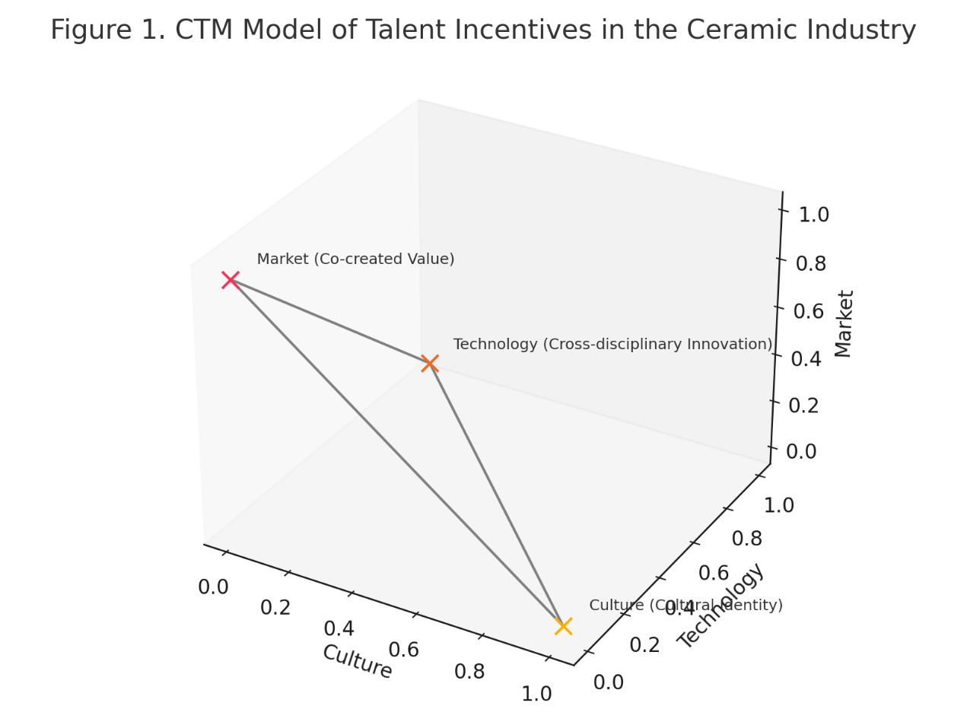

4. Theoretical Model and Analytical Extension

The empirical findings of this study culminate in the formulation of a CTM Model—a three-dimensional framework composed of Cultural (C), Technological (T), and Market-based (M) incentives. This section elaborates on the theoretical grounding of the CTM model, compares it with classical incentive theories, and discusses its potential for broader academic and practical application.

**4.1 Positioning the CTM Model within Existing Theories of Motivation**

(1) Maslow’s Hierarchy of Needs

Maslow’s well-known theory posits a progression from physiological needs to self-actualization. The CTM model maps onto this framework by showing that market-based incentives correspond to foundational needs such as job security and economic compensation. Technological incentives support esteem and skill mastery through access to tools, autonomy, and feedback. Cultural incentives address self-actualization, allowing individuals to find meaning and identity in their creative work. Unlike Maslow’s static pyramid, however, the CTM model emphasizes fluidity and feedback—suggesting that success in one domain can reinforce motivation in another, making the motivational structure more dynamic and responsive.

(2) Herzberg’s Two-Factor Theory

Herzberg distinguishes between “hygiene factors” (e.g., salary, company policy) and “motivators” (e.g., recognition, personal growth). The CTM model aligns with this distinction by suggesting that institutional mechanisms, such as equity systems and flexible contracts, function as hygiene factors that prevent dissatisfaction. In contrast, cultural identity and technological empowerment act as deep motivators that inspire sustained engagement and creativity. However, unlike Herzberg’s binary classification, the CTM model acknowledges that in creative industries—such as ceramics—the boundary between extrinsic and intrinsic motivation is often blurred. Motivation in these settings is frequently shaped by the interplay of cultural, technological, and market dynamics.

(3) Vroom’s Expectancy Theory

Vroom’s expectancy theory suggests that motivation arises when individuals believe their efforts will lead to desired performance and outcomes. The CTM model reinforces this by integrating mechanisms that make effort–reward relationships more transparent and immediate. Technological systems, such as 3D printing and AI-powered design feedback, help shorten feedback loops and enhance perceived control. Cultural rewards tie creative expression to symbolic prestige, while market channels visibly connect innovation with monetizable value. Through this triadic interaction, the CTM model operationalizes Vroom’s expectancy theory in a sector-specific context, particularly suited to creative industries where motivation is complex and multifaceted.

**4.2 The CTM Model as a Sector-Specific Theoretical Contribution**

The CTM model is distinctive in its ability to account for the complex and sector-specific motivational structures present in cultural and creative industries. First, it effectively captures non-monetary value systems that are central to such fields, particularly in industries like ceramics, where heritage, reputation, and symbolic meaning often outweigh immediate financial gain. Second, the model emphasizes the cross-domain mobility of talent, recognizing how individuals move fluidly between localized creative spaces (such as maker studios or workshops) and global digital platforms (such as e-commerce markets), thereby redefining career trajectories in non-linear and transdisciplinary ways.

Moreover, the CTM framework incorporates digital affordances directly into its motivational architecture. Technologies such as AI-assisted design tools, virtual reality exhibitions, and digital prototyping not only support skill development but also enhance the visibility and valuation of creative outputs. These technologies reshape how creators interact with their craft, their audiences, and the market, effectively blurring the boundaries between the creative process and its economic realization.

In contrast to generic talent management models that treat creative industries as a homogeneous category, the CTM model addresses the material specificity of ceramics. It considers the unique characteristics of this field, including its tactile production processes, deep cultural embeddedness, and the extended timeline required for value realization. By doing so, the CTM model offers a more nuanced and contextually grounded understanding of motivation, better suited to the distinctive realities of the ceramics sector and similar creative domains.

**4.3 From Theory to Practice: Application of CTM in Other Creative Sectors**

Although the CTM model was originally developed based on empirical data from the ceramic industry, its applicability extends to a range of other cultural and creative sectors. These include cultural heritage industries such as textile design, calligraphy, and traditional architecture; performing arts and multimedia fields where digital creation tools intersect with heritage content; as well as art-tech startups operating at the convergence of tradition and innovation. A concrete example can be observed in the textile innovation hubs of Suzhou, where similar cultural-symbolic motivations coexist with advanced digital weaving technologies and access to emerging global exposure platforms, including fashion weeks and metaverse-based runways.

By emphasizing the interactions among its various dimensions, the CTM model offers valuable potential as both a diagnostic framework and a design tool. This makes it particularly useful for policymakers, human resource departments, and incubators aiming to attract and nurture international creative talents.

**4.4 Visualizing the CTM Model**

The CTM model is best visualized as a 3D triangular pyramid, where each vertex represents one incentive type. Talents operate within the space formed by these three forces—dynamic, interconnected, and often reinforcing. This triangular model illustrates three primary types of incentives:

At the top of the triangle is Cultural incentives, representing higher-level psychological needs such as identity, creative expression, and self-actualization. These align with Maslow’s concept of self-actualization and Herzberg’s “motivators.” Positioned at the lower right corner, Technological incentives emphasize support systems like access to tools, feedback, professional growth, and autonomy—corresponding to Maslow’s “esteem” needs and Herzberg’s intrinsic motivators. Market incentives, located at the bottom left, represent external rewards such as economic compensation and job security, aligning with Maslow’s foundational needs and Herzberg’s “hygiene factors.” The triangle’s closed structure highlights the interconnectedness of these incentives, suggesting that, particularly in creative industries, motivation emerges from the combined influence of cultural, technological, and market factors rather than from any single source.

**Figure 2. CTM Model of Talent Incentives**

(Triadic interaction of Cultural, Technological, and Market incentives)

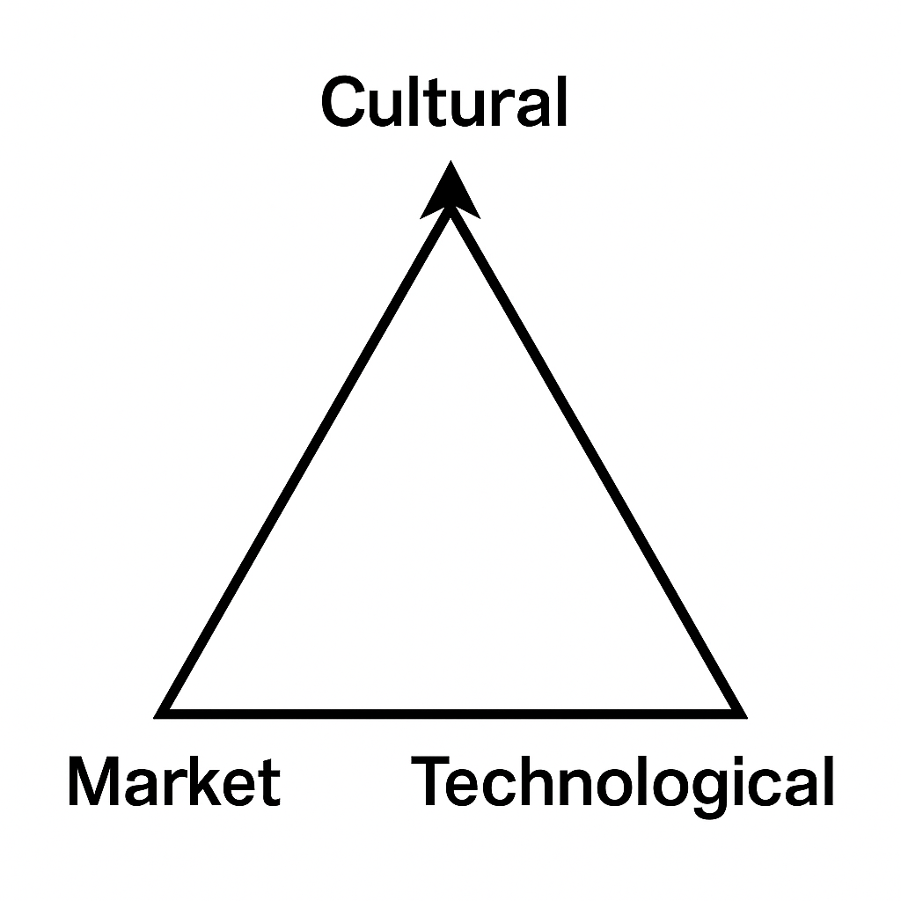

The CTM model offers a contextualized, integrative, and scalable approach to understanding how international ceramic talents are motivated and retained. It extends classical motivation theories by embedding them into a material-specific, culturally meaningful, and digitally enhanced framework. This model contributes to the broader field of creative labor studies, talent policy research, and cross-cultural entrepreneurship, offering a grounded yet adaptable lens for future empirical and theoretical explorations.

5. Policy Recommendations

To build a resilient and globally competitive ceramic talent ecosystem, policies must move beyond narrow salary-based incentives and embrace a multi-dimensional framework rooted in cultural narrative, technological enablement, and institutional innovation. Based on the CTM model and empirical findings, we propose five targeted recommendations that reflect this integrated vision.

**5.1 Establish an “International Ceramic Innovator Green Card” Scheme**

To address the persistent issue of mobility barriers faced by foreign ceramic professionals and returning talents, it is proposed that a dedicated “International Ceramic Innovator Green Card” scheme be introduced. Currently, obstacles such as visa uncertainties, delays in project approval, and unstable housing options hinder long-term engagement in the sector. This specialized Green Card would provide significant structural support by offering multi-entry visa privileges valid for up to five years, priority processing for residency and intellectual property registrations, access to subsidized government housing and workspaces, and exemptions from import taxes on essential personal equipment and digital tools. A precedent for this approach is seen in the Jingdezhen Municipal Government’s 2023 “Cultural Talents Free Zone” initiative, which has successfully streamlined permit processes and allocated free studio spaces to international ceramic artists. If implemented, this policy is expected to significantly enhance the duration and quality of cross-border residency, promote the flow of international talent, and facilitate a more diverse and sustained exchange of knowledge within the global ceramic community.

**5.2 Create a “Failure Insurance” Fund for Global Ceramic Exhibitions**

Participation in international exhibitions remains fraught with financial risks, particularly for start-ups and emerging ceramic enterprises. Many refrain from engaging in such activities due to the high costs involved and the uncertainty of commercial returns. To alleviate these concerns, this section proposes the establishment of an “Innovation Failure Fund,” managed collaboratively by regional ceramic industry associations. This pooled fund would reimburse up to 30% of verified costs for international projects that fail to achieve commercialization within six months. To ensure long-term impact, eligibility would require participation in training modules on crowdfunding strategies or digital market re-entry. A comparable model exists in Foshan’s 2022 talent policy, which links reimbursement for failed export initiatives to subsequent retraining. By reducing the perceived and actual risks associated with early-stage global exposure, the proposed mechanism is anticipated to normalize failure as part of the creative process, support repeated innovation attempts, and improve the overall resilience of ceramic entrepreneurs in global markets.

**5.3 Develop a “Tripartite Ceramic Incubator” Model**

Fragmentation among universities, ceramic enterprises, and investors presents a persistent challenge to innovation within the ceramic industry. To address this gap, the establishment of a tripartite incubator model is proposed, involving co-funding and joint operations among academic institutions (e.g., ceramic design schools), local manufacturers or independent studios, and crowdfunding platforms or impact investors. These incubators would be designed to accelerate the transformation of university-based ceramic projects into market-ready prototypes within 90 days. Real-time feedback mechanisms—such as livestreamed reviews and digital pre-sales—would be embedded to refine product-market fit. A working example of this approach is Jingdezhen’s “Digital Platform 18,” which has effectively converted graduation exhibition pieces into internationally pre-ordered items through live auctions and digital marketing. By tightening the link between education and commercialization, the tripartite incubator is expected to reduce time-to-market, encourage practical skill development, and improve global competitiveness for young ceramic innovators.

**5.4 Incentivize AI and Digital Tool Integration Through Tax Credits**

Although AI-driven design tools and digital prototyping technologies have demonstrated strong potential in enhancing creativity and talent development, their adoption remains limited among small and medium-sized ceramic enterprises (SMEs) due to financial and technical barriers. To encourage broader integration of such technologies, it is proposed that governments offer SMEs fiscal incentives, such as 50% tax rebates or accelerated depreciation, for investments in advanced digital tools including AI-based design platforms, 3D mold printing, and virtual/augmented reality showrooms. In return for receiving such benefits, participating SMEs would be required to co-organize at least one digital skills training session annually, thereby diffusing knowledge and improving sector-wide digital literacy. This policy aligns with Italy’s “Piano Industria 4.0,” which uses similar tax-based incentives to modernize manufacturing infrastructure. Widespread implementation of this scheme is expected to enhance creative capacity, retain digital-savvy talent, and contribute to the long-term establishment of a robust digital ecosystem within the ceramic industry.

**5.5 Promote Open Recognition Platforms for Cultural Branding**

Symbolic capital—encompassing awards, curated exhibitions, and media visibility—plays a crucial role in motivating and sustaining creative professionals in the ceramic arts. Yet, current recognition mechanisms are fragmented and largely confined to local or regional spheres, limiting their capacity to drive broad cultural impact. To address this, a national platform for a standardized “Ceramic Talent Recognition Index” is proposed. This index would consolidate diverse symbolic indicators—such as international awards, intellectual property filings, and citations in global media or academic literature—into a transparent scoring system, thereby generating a publicly accessible reputation database for ceramic professionals. These scores could be formally incorporated into government grant assessments and funding decisions to reward excellence and incentivize sustained cultural contribution. Successful examples of this approach are evident in other sectors, such as Architizer’s global architecture index, which effectively merges symbolic recognition with expanded funding opportunities. By introducing this platform, the ceramic field stands to benefit from increased visibility, standardized evaluation mechanisms, and a strengthened pipeline of high-profile talent contributing to national and international cultural branding.

**Table 1: Five recommendations operate across all three CTM domains**:

|  |  |  |  |
| --- | --- | --- | --- |
| **Policy Action** | **Culture** | **Technology** | **Market** |
| Green Card | √ | - | √ |
| Failure Fund | √ | - | - |
| Tripartite Incubator | -- | - | - |
| AI Tax Credit | - | √ | √ |
| Recognition Index | - | √ | - |

By treating ceramic talents not just as labor inputs but as cultural agents and system co-creators, these policies help reconfigure China’s ceramic clusters into global innovation nodes.

6. Policy Recommendations

Based on the “Culture-Technology-Market (CTM)” incentive model for international ceramic talents developed in this study, the following detailed policy recommendations are proposed to foster and retain internationally oriented ceramic innovation and entrepreneurship talents. Each recommendation includes potential implementation pathways, expected impact assessments, possible obstacles, and mitigation strategies. Additionally, the establishment of international cooperation mechanisms is discussed.

**6.1 Launch an “International Ceramic Innovator Green Card”**

To enhance the mobility of international ceramic talent, it is necessary to introduce an “International Ceramic Innovator Green Card” policy. Drawing upon existing talent initiatives in Jingdezhen, this proposal recommends coordinated efforts between central and local governments to streamline visa procedures and project approval processes tailored to ceramic professionals engaged in cross-border innovation. The goal is to reduce institutional barriers and simplify administrative steps, thereby improving the efficiency of global collaboration and knowledge exchange. This measure is expected to significantly strengthen the international competitiveness of the ceramic industry. However, its implementation may face challenges related to interdepartmental coordination and administrative inertia. To address these potential bottlenecks, it is advisable to establish a dedicated cross-agency coordination task force that ensures policy coherence, rapid response, and operational efficiency.

**6.2 Establish a “Failure Insurance” Mechanism**

To encourage broader international participation and mitigate financial risks for ceramic innovators, it is proposed to establish a “Failure Insurance” mechanism. Drawing inspiration from Foshan’s policy models, this mechanism would create a dedicated fund to reimburse up to 30% of the costs incurred by teams participating in international exhibitions that fail to generate commercial returns. To ensure responsible fund usage, a structured risk assessment system should be integrated into the reimbursement process. The expected outcome of this initiative is to lower the threshold for engaging in global markets, reduce the psychological and economic burden of failure, and promote a culture of experimentation and resilience within the ceramic sector. Challenges related to fund sourcing and regulatory oversight may arise; therefore, a hybrid model involving government investment and venture capital contributions is recommended, along with transparent auditing and robust performance evaluation standards.

**6.3 Promote a University-Industry-Venture Capital Triangular Incubator Model**

To address the current fragmentation in ceramic talent cultivation, it is essential to foster closer collaboration among universities, enterprises, and venture capital entities through the development of a triangular incubator model. This model should leverage digital platforms and cross-border crowdfunding resources to establish a collaborative system that supports the transformation of university-led competition projects into marketable products. By providing full-chain incubation services—from prototyping to market testing—the model is expected to accelerate commercialization, align technological innovation with market needs, and elevate the global profile of Chinese ceramic design. However, coordination among the three stakeholders can be hindered by divergent interests and expectations. To mitigate this, clear partnership agreements, equitable benefit-sharing mechanisms, and conflict resolution protocols should be embedded into the incubator’s governance framework to ensure sustainable cooperation.

**6.4 Foster International Cooperation Mechanisms**

To build a more integrated global ceramic innovation ecosystem, the establishment of structured international cooperation mechanisms is essential. A key initiative in this regard is the proposed “China–Italy Ceramic Cultural and Talent Joint Fund,” which would support bilateral projects in joint training, technical exchange, and market development. This cooperation should be institutionalized through regular exhibitions, academic symposiums, and artist exchange programs, enabling deeper integration of cultural and technological resources. Such collaboration is expected to yield complementary advantages, enhance innovation sustainability, and boost the international visibility of ceramic practices from both countries. Nonetheless, obstacles such as differences in legal systems and the complexity of managing cross-border funds must be addressed. It is therefore recommended to create a bilateral management committee with unified governance standards and strong oversight mechanisms to ensure transparency and accountability throughout the partnership.

**7. CONCLUSION**

This study selected four representative ceramic industry clusters—Jingdezhen, Foshan, Tangshan, and Italy—to provide in-depth insights. However, notable regional limitations remain, as other significant global ceramic production and innovation hubs were not included, which constrains the generalizability of the findings. Additionally, the qualitative research approach employed offers rich understanding of the incentive mechanisms’ underlying logic and dynamic processes, but lacks sufficient generalizability and quantitative validation. Future

Conducting Longitudinal Studies Designing longitudinal research frameworks to dynamically track the career trajectories of ceramic innovators and examine the long-term impacts of incentive mechanisms on talent retention and innovation outputs is advised. Such studies would elucidate the sustained effects of incentives, optimize talent retention strategies, and refine the dynamic adjustment of incentive systems.

Focus is recommended on investigating cultural differences, governance structures, and risk management strategies in ceramic industry collaborations between China, Italy, and other countries. Comparative analyses can facilitate the proposal of more operational cross-national cooperation frameworks, promoting effective collaboration among ceramic innovation talents across diverse cultural contexts, and improving the performance and sustainability of international partnerships.

ETHICAL APPROVAL (WHEREVER APPLICABLE)

All authors hereby declare that this research involved interviews and observations with adult participants who voluntarily participated in accordance with ethical research guidelines. The written informed consent was secured from all participants prior to data collection. This study has been conducted in accordance with the ethical standards laid down in the 1964 Declaration of Helsinki.

References

Chou, Y. W. (2024). An empirical study on the factors influencing talent innovation in the ceramic industry of Jingdezhen. Journal of Ceramics, 45(4), 821–828. <https://doi.org/10.13957/j.cnki.tcxb.2024.04.021>

Feng, L., Wang, L. P., & Huang, H. Y. (2017). Human resources training for creative ceramic industry. Industrial Technology & Vocational Education, 15(3), 48–51.

Hou, Z. M. (2019). Research on the dynamic process of international entrepreneurship of SMEs. Pioneering with Science & Technology Monthly, 32(3), 42–47.

Jiang, B. Y., Feng, Y. M., & Li, G. L. (2024). AI-driven optimization of the ceramic cultural and creative industry chain. Ceramics Science & Art, 2024(9), 64–66. <https://doi.org/10.13212/j.cnki.csa.2024.09.052>

Ji, X. D., Zhu, X. J., & Cao, Z. H. (2019). Research on incentive mechanisms for college students’ innovation and entrepreneurship platform construction. Journal of Higher Education, 2019(19), 35–37. <https://doi.org/10.19980/j.cn23-1593/g4.2019.19.012>

Li, J. (2024). Contemporary development of ceramic arts and crafts. Ceramics Science & Art, 2024(7), 18–19. <https://doi.org/10.13212/j.cnki.csa.2024.07.009>

Li, S. Y., & Liu, H. Y. (2023). Research on innovation and entrepreneurship incentive mechanisms for engineering postgraduates. Education Method Discussion and Practice, 2023(11), 1–6.

Liu, G. J. (2024). Research on ceramic cultural and creative products under the background of intangible cultural heritage inheritance. Ceramics Science & Art, 2024(1), 118–119. <https://doi.org/10.13212/j.cnki.csa.2024.01.042>

Liu, W. B., & Pan, W. L. J. (2024). Research on ceramic product design and innovative application based on regional characteristic. Ceramic Studies, 39(3), 67–70. <https://doi.org/10.16649/j.cnki.36-1136/tq.2024.03.039>

Niu, J., Xia, J. Z., & Wang, H. (2017). Constructing talent introduction and incentive mechanisms for modern service industry in Tangshan. Modern Business, 2017(6), 94–95. <https://doi.org/10.14097/j.cnki.5392/2017.06.049>

Sun, Y. (2024). Analysis on the transformation of ceramic cultural and creative industry under digital creativity. Ceramics, 2024(11), 60–64. <https://doi.org/10.19397/j.cnki.ceramics.2024.11.011>

Wang, W. Y. (2014). A brief discussion on ceramic enterprise culture construction. Oriental Enterprise Culture, 2014(1), 14–15.

Wu, H. L., & Zhu, J. L. (2024). Research on the educational value of ceramic culture in the context of “new man of the times”. Ceramic Education, 2024(6), 24–26.

Wu, Y. Y. (2025). Research on talent incentive mechanisms in modern service industry. Time-Honored Brand Marketing·Economic Observation, 2025(4, Suppl.), 49–51.

Xiang, Z. N., Li, Z., & Liu, F. (2013). Construction and reflection of incentive mechanisms for doctoral students’ innovation ability. Academic Degrees & Graduate Education, 2013(6), 23–28.

Zhang, C. (2006). Research on cultivating independent innovation capability of daily-use ceramic enterprises. Ceramics, 2006(6), 1–2.

Zheng, Q. R. (2024). Seeking ways to go global from the internationalization status of ceramic enterprises. Foshan Ceramics, 2024(9), 99–101.

Zheng, J. (2019). The value and application of incentive mechanisms in college students’ innovation and entrepreneurship education. Modern Economic Information, 2019(31), 408–410.

Chen, C. (2021). Application and effectiveness analysis of incentive mechanisms in college students’ innovation and entrepreneurship education. Employment and Security, 2021(15), 64–65.

Chen, X. Y. (2023). A brief analysis of incentive mechanisms in college students’ innovation and entrepreneurship education. Bosom Friend Inspiration, 2023(20), 67.

Cai, S. Q. (2020). Research on the construction of internal incentive mechanisms for technological innovation in SMEs. China Market, 2020(19), 184–185.

Yu, X. L., & Wang, Y. M. (2013). On the mechanism innovation of entrepreneurship culture cultivation. Academic Exchange, 2013(11), 188–191.

Zhou, S. K. (2009). Research on innovation and development strategy of Tangshan ceramic industry. Inner Mongolia Science Technology & Economy, 2009(15), 31–32.