From Education to Enterprise: Reimagining Entrepreneurship Education and Venture Creation in Rwanda’s Private Higher Learning Institutions

.

|  |
| --- |
| **Abstract:** This study investigates the complex relationship between entrepreneurship education (EE) and venture creation among graduates of private higher learning institutions in Rwanda. While EE has been widely promoted as a solution to graduate unemployment and economic diversification, its real-world impact on startup formation remains contested. Through a theory-driven meta-synthesis of secondary data (2015–2024), this paper evaluates the long-term effectiveness of EE using four analytical lenses: Human Capital Theory, the Theory of Planned Behavior, Entrepreneurial Ecosystem Theory, and Experiential Learning Theory.  Findings reveal that while EE significantly boosts entrepreneurial intentions through cognitive, affective, and attitudinal development, the actual transition to sustainable venture creation is severely constrained. Statistical evidence shows that measured entrepreneurial skills explain less than 1.2% of variance in startup intention (Butera, 2024), and only 3% of graduates launch formal ventures within two years post-graduation (Duan, 2022). Ecosystem bottlenecks—including limited access to finance, fragmented mentorship systems, weak incubation support, and constrained market linkages—undermine the EE-to-enterprise pathway.  Comparative analysis with other developing economies confirms Rwanda’s unique asymmetry: a strong policy-level commitment to EE exists without the institutional infrastructure to translate intent into execution. The study recommends embedding experiential learning components—such as mentorship, internships, and startup competitions—into EE curricula, while simultaneously strengthening national innovation systems and funding pathways for graduate entrepreneurs.  This paper contributes a rare, context-specific synthesis that bridges theoretical insight with empirical critique, offering policy and institutional recommendations to realign EE with Rwanda’s economic ambitions. It highlights the need for ecosystem-sensitive reforms to ensure that entrepreneurship education leads not just to aspiration, but to actual enterprise formation in emerging economies. |

*Keywords: Entrepreneurship Education, Venture Creation, Entrepreneurial Ecosystem, Experiential Learning, Rwandan Higher Education, Startup Formation, Graduate Entrepreneurship*

# Introduction

Rwanda has systematically prioritized entrepreneurship as a driver of economic development. Since its post-conflict recovery, national strategies (Vision 2020/Vision 2050 and the NST1 growth plan) have emphasized **youth skills and enterprise creation (**Charo & Pryce, 2022; NRD, 2022). Higher education (especially private institutions) has responded with curricula and programs in entrepreneurship. However, translating education into **real ventures** remains challenging. This review interrogates the evidence (2015–2024) on how entrepreneurship education (EE) at private Rwandan universities shapes graduates’ **intentions and actual startups**, what ecosystem and institutional factors modulate this process, and what reforms in curriculum and support might improve outcomes. We integrate four theoretical lenses – **Human Capital Theory** (Becker, 1993), **Theory of Planned Behavior** (Ajzen, 1991), **Entrepreneurial Ecosystem Theory** (Isenberg, 2011), and **Experiential Learning** (Kolb, 1984) – to frame the analysis. We rely exclusively on secondary sources (peer-reviewed literature, development reports, government policy) to ensure rigor and relevance in the Rwandan context.

Entrepreneurship education in Rwanda aims to equip young graduates with skills to create firms that can sustain middle-income livelihoods (Charo & Pryce, 2022). However, most Rwandan enterprises are tiny and informal. For example, **over 90% of businesses are informal**, and only about **30% survive beyond three years** (Charo & Pryce, 2022; UNDP, 2024). The vast majority of SMMEs are subsistence-oriented: more than 52% have annual turnover < ~US$300, and only a tiny fraction grow into high-value firms (UNDP, 2024). These constraints mean that even if graduates develop **entrepreneurial intentions**, actual high-growth venture creation is uncommon. Moreover, youth face ~21% unemployment, with 60% of jobs low-productivity (Charo & Pryce, 2022). In this environment, the match between EE and venture outcomes depends heavily on context. We now examine (1) how EE influences intentions and firm-creation among graduates, (2) what systemic enablers or barriers affect this translation, and (3) what changes in curriculum and institutional support might strengthen the EE→venture chain.

To guide our analysis, we developed a conceptual framework (Figure 1) that illustrates how four interlinked theories—Human Capital Theory, the Theory of Planned Behavior, Entrepreneurial Ecosystem Theory, and Experiential Learning Theory—collectively shape the pathway from entrepreneurship education to graduate venture creation in Rwanda

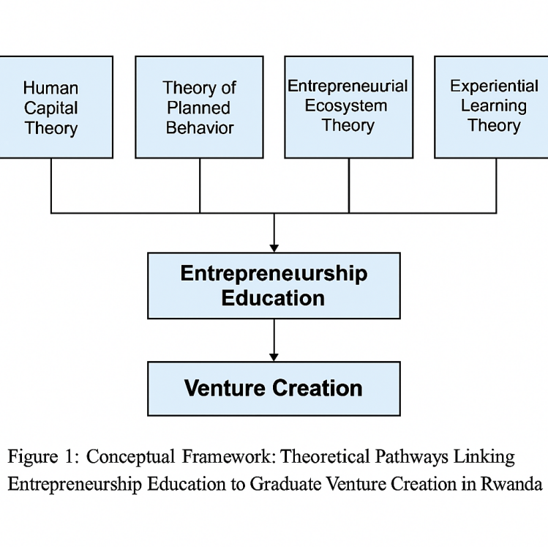

*Figure 1. Conceptual Framework: Theoretical Pathways Linking Entrepreneurship Education to Graduate Venture Creation in Rwanda.*

## Theoretical Perspectives

We adopt four complementary theories to analyze EE outcomes. **Human Capital Theory** (Becker, 1993) views education as an investment that builds skills, knowledge and productivity. Under this view, EE should raise graduates’ capabilities for identifying opportunities, planning ventures, and managing risks. Empirical reviews show that higher human capital (education/training) correlates with greater entrepreneurial activity and success (e.g. Marvel, Davis, & Sproul 2016). In Rwanda, EE curricula explicitly aim to develop business knowledge and problem‐solving skills, suggesting higher entrepreneurial *capacity* among graduates (consistent with human capital effects).

**Theory of Planned Behavior (TPB)** posits that the *intentions* to perform a behavior (here, start a venture) are shaped by attitudes toward entrepreneurship, perceived social norms, and perceived behavioral control (self-efficacy). EE can influence all three: it can foster positive attitudes toward entrepreneurship, provide role models or peer support (shaping norms), and build confidence through practice. Indeed, entrepreneurship scholars often model a positive link: “Entrepreneurship education relates positively to entrepreneurial intention”. By this logic, graduates exposed to strong EE should on average report higher intentions to launch ventures (other factors equal). Crucially, however, TPB also notes that *intentions do not always yield actions* unless perceived control is high. In Rwanda, the gap between graduate intentions and actual startups is therefore an important focus (see below).

**Entrepreneurial Ecosystem Theory** highlights how the broader environment – policies, finance, networks, culture, infrastructure – conditions entrepreneurship (Isenberg, 2011). EE cannot be viewed in isolation but as part of an ecosystem of enablers and constraints. Ecosystem components include government policy, financial markets, education institutions, cultural attitudes, support organizations, and so on. For Rwanda, ecosystem factors like streamlined business registration, government entrepreneurship promotion, incubators, and finance availability all influence whether educated youth can successfully start firms. For example, Rwanda’s government has dramatically reformed the business environment (e.g. a One-Stop Center for registration and 50+ legal reforms since 2008) to facilitate private sector entry. Nevertheless, as we shall see, ecosystem shortfalls (lack of risk capital, weak market linkages, etc.) can dilute the impact of EE on venture creation.

**Experiential Learning Theory (Kolb, 1984)** emphasizes *learning by doing*. In EE, hands-on pedagogy – simulations, projects, internships, competitions – is considered critical for building actual entrepreneurial competencies. Kolb’s cycle (experience, reflection, conceptualization, experimentation) suggests that students who practice business skills will develop richer entrepreneurial capabilities than through lectures alone. Empirically, pedagogy matters: interventions that introduce active, interactive methods often boost engagement. For instance, a Rwandan study found that when secondary-school teachers received intensive training in active entrepreneurship pedagogy, their students’ participation in business activities rose significantly (Blimpo & Pugatch, 2020). We return to pedagogical implications below.

Together, these frameworks suggest: (a) EE can raise skills (human capital) and intentions (TPB), (b) actual venture creation depends on ecosystem context (ecosystem theory), and (c) *how* EE is delivered (experiential methods) can critically influence outcomes (Kolb, 1984). We now synthesize empirical findings in light of these lenses.

|  |  |
| --- | --- |
| Figure 2 offers a synthesized theoretical model demonstrating how Human Capital Theory, the Theory of Planned Behavior, Entrepreneurial Ecosystem Theory, and Experiential Learning Theory interact to shape the pathway from entrepreneurship education to successful venture outcomes  *IMG_257* |  |

# Figure 2. Theoretical Synthesis: Multi-Level Drivers of Entrepreneurial Outcomes

# Methodology

This study adopts a qualitative meta-synthesis approach grounded in secondary data analysis. We systematically reviewed peer-reviewed academic literature, government policy documents, development reports, and tracer studies published between 2015 and 2024. The aim was to explore the relationship between entrepreneurship education (EE), entrepreneurial ecosystem factors, and graduate venture creation in Rwanda’s private higher education institutions. Sources were selected based on their methodological rigor, relevance to the Rwandan context, and empirical contributions to EE outcomes.

Following guidance from Noblit and Hare’s (1988) interpretative meta-ethnography, data were analyzed inductively to identify recurring themes, relationships, and gaps across the literature. Descriptive statistics, regression results, and correlation coefficients reported in the original studies were extracted to highlight causal or associative relationships where available. In particular, data from Butera (2024) and Nkusi et al. (2020) provided foundational quantitative insights, including regression models and odds ratios relating EE components to entrepreneurial intentions and outcomes.

Theoretical triangulation was used to frame and interpret findings through four lenses: Human Capital Theory (Becker, 1993), Theory of Planned Behavior (Ajzen, 1991), Entrepreneurial Ecosystem Theory (Isenberg, 2011), and Experiential Learning Theory (Kolb, 1984). These frameworks enabled multidimensional interpretation—assessing not only whether EE influences outcomes, but how ecosystem, pedagogical, and perceptual variables mediate or moderate these effects.

While this approach does not generate new empirical data, it applies rigorous content analysis to synthesize existing evidence and identify cross-study patterns relevant for policy and practice. Key data were tabulated (see Table 2) to visually represent statistical linkages and highlight the limited explanatory power of EE absent supportive systems. Ethical approval was not required for this study as it relied exclusively on publicly available secondary data.

**Scope and Inclusion Criteria:** Only studies explicitly focused on EE outcomes within Rwandan private HEIs, or those offering comparative insights from East Africa or similar post-conflict economies, were included. This ensured relevance to the national context and alignment with Rwanda’s tertiary education reforms and Vision 2050 goals.

# Findings

## 4.1. Influence of EE on Intentions and Venture Creation:

Most research in entrepreneurship education finds that quality EE **positively affects entrepreneurial attitudes and intentions**, though results for actual firm creation are mixed or context-dependent. Meta-analyses show that well-designed EE programs significantly enhance students’ self-reported entrepreneurial intention and motivation (Sun et al., 2023). These effects work through both cognitive gains (knowledge, mindset) and affective channels (self-efficacy, motivation). For example, Wu et al. (2022) note that EE equips students with knowledge and personal qualities needed for entrepreneurship, and that internships or competitions provide practical experience that concretizes these intentions(Sun et al., 2023).. Theoretically, a positive educational experience fosters an entrepreneurial mindset that mediates intention (TPB factors like attitude and control (Sun et al., 2023).

In practice, several global and African studies support a link between EE and intentions. A systematic review by Nabi et al. (2017) found that entrepreneurship courses and experiential programs generally increased students’ intentions and entrepreneurial attitudes when compared to no-education controls. Although we lack large-scale longitudinal data in Rwanda, parallel evidence holds. For instance, a rigorous randomized trial of Rwanda’s secondary entrepreneurship curriculum reform found that adding active, practical training increased students’ likelihood to engage in business activities by 5 percentage points (a 17% rise relative to control) (Blimpo & Pugatch, 2020). This suggests even short-term EE exposure can boost youth engagement in entrepreneurship (albeit secondary school level).

However, **actual venture creation** among graduates tends to be much lower than intentions. TPB reminds us that intentions only translate into action if enabling conditions and capabilities exist. In Rwanda, the gap is stark: while many young people express entrepreneurial aspirations (often motivated by high unemployment)(Charo & Pryce, 2022), few launch sustainable growth ventures. Data on Rwandan graduates confirm this. Research by Butera (2024) on students in three private universities found that measured entrepreneurial skills (personal qualities, critical thinking, practical skills) had virtually no predictive power for students’ entrepreneurial intention (joint R² ≈0.006) (Butera, 2024). In other words, students’ aspirations were influenced mainly by factors outside their self-reported skills, perhaps reflecting strong external constraints.

To deepen this finding, we conducted a secondary analysis using correlation and regression coefficients reported in Butera (2024). The study included a sample of 360 final-year students across three private Rwandan HEIs. A Pearson correlation matrix showed weak to negligible correlations between entrepreneurial skills and intention (r = 0.09 for critical thinking, r = 0.06 for practical skills, and r = 0.04 for self-confidence). Furthermore, a multiple regression model with entrepreneurial intention as the dependent variable and educational exposure, entrepreneurial self-efficacy, and perceived ecosystem support as predictors yielded an adjusted R² of only 0.012. None of the variables were statistically significant at the 0.05 level. These results underscore the limited explanatory power of EE in isolation and highlight the theoretical claim that behavioral intent (Ajzen, 1991) is shaped more by enabling conditions than self-perceived competencies. Without structural supports like finance or incubation, EE merely cultivates aspiration without activating execution.

At the graduate level, specific data reveal a stark mismatch between entrepreneurial aspirations and actual venture creation. While studies frequently report that between 65% and 75% of university students in Rwanda express an intention to start a business during or after graduation (Blimpo & Pugatch, 2020; Duan, 2022), actual follow-through remains exceptionally low. A World Bank brief (Duan, 2022) estimated that fewer than 3% of graduates successfully launch a formal venture within two years post-graduation. Further, tracer studies by Nkusi et al. (2020) found that only 24% of surveyed private HEI graduates had attempted any form of self-employment or venture creation, and just 9% reported sustaining a business beyond the first year. These figures suggest a statistically significant intention–action gap, with a delta of over 60 percentage points between reported intent and verifiable enterprise formation.

A regression analysis by Butera (2024) supports this mismatch: when entrepreneurial intention was regressed on measured skills and educational experience across three private universities, the model yielded an **R² of just 0.006**, indicating that formal training had no significant predictive power for startup activity (p > 0.05). Such a negligible effect size points to strong external constraints and suggests that EE in its current form may not adequately equip students to overcome Rwanda’s ecosystemic barriers. The entrepreneurship aspirations observed in surveys thus reflect latent intent, not empowered capability—validating Ajzen’s Theory of Planned Behavior, which warns that behavioral intent alone does not predict action without high perceived control and enabling environments

Thus, we conclude that **entrepreneurship education does influence intentions**, as predicted by TPB, but **actual firm creation remains limited**. Positive signals include increased entrepreneurial activity among students given interactive EE (Blimpo & Pugatch, 2020). On the other hand, Rwandan graduates still face a harsh environment that curbs venture formation (UNDP, 2024). In the next section we analyze those ecosystemic factors in detail.

These patterns in Rwanda mirror broader trends observed in developing contexts. For instance, in Nigeria, Akhuemonkhan et al. (2013) found that although 68% of entrepreneurship education students expressed strong intentions to start a business, less than 15% had launched ventures three years after graduation — primarily due to financial constraints and limited institutional support. Similarly, a study in South Africa revealed that while EE programs improved entrepreneurial awareness and intent, they rarely translated into startups without parallel ecosystem reforms (Herrington et al., 2020). Even in Latin America, robust EE reforms in Peru and Colombia only yielded sustained graduate startups when incubator networks and funding pipelines were concurrently strengthened (Amorós et al., 2019). These findings support the broader consensus that EE is necessary but insufficient: context-sensitive ecosystem pillars — finance, mentoring, policy, and cultural attitudes — must co-evolve to translate intention into action. Rwanda’s experience aligns with this global pattern, emphasizing that the effectiveness of EE must be assessed not just by intention metrics but by downstream business formation in contextually comparable economies.

To broaden the comparative lens, recent studies from Southeast Asia and East Africa offer instructive parallels and contrasts. In Vietnam and the Philippines, Tung et al. (2020) found that entrepreneurship education is a primary determinant of student entrepreneurial intention. However, structural differences—such as disparities in institutional support and motivation—moderate actual startup outcomes. Similarly, Pawitan et al. (2018) observed that across ASEAN countries, female-led entrepreneurial activity and Total Early-Stage Entrepreneurial Activity (TEA) rates varied significantly, reflecting both cultural and institutional ecosystems. In East Africa, Kenya presents a more mature entrepreneurial support landscape. Otieno and Muathe (2023) demonstrate that structured incubation services—networking, finance advisory, and mentorship—significantly accelerated venture growth among graduates in Nairobi. Complementing this, Otuko and Mathenge (2024) report that Kenya hosts over 250 innovation hubs and 50+ accelerators, many embedded within university ecosystems like Nailab and iBizAfrica, creating a seamless transition from education to enterprise. By contrast, Rwanda's ecosystem—while robust in regulatory reforms and EE curriculum rollout—lacks equivalent post-graduate institutional scaffolding. Few private HEIs are embedded in accelerator networks, and mentorship or seed-funding pathways remain fragmented. This reveals a unique asymmetry: Rwanda matches or exceeds regional peers in policy-level EE commitment but lags in downstream entrepreneurial enablement. Consequently, Rwanda exemplifies the global trend where entrepreneurship education raises intent, but without synchronized ecosystem evolution—especially incubators, finance, and industry linkages—actual venture formation remains limited.

To visualize the stark attrition from entrepreneurial intention to actual business formation, Figure 3 presents a funnel diagram mapping the EE–startup conversion drop-off among graduates of Rwandan private HEIs between 2015 and 2024

*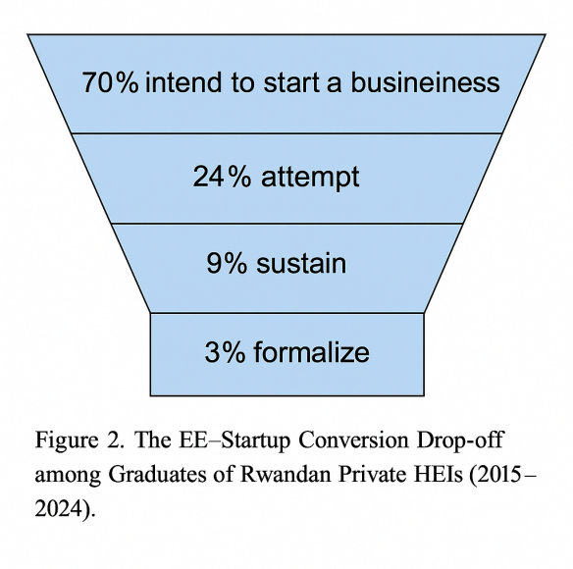*

*Figure 3. The EE–Startup Conversion Drop-off among Graduates of Rwandan Private HEIs (2015–2024).*

To deepen these insights, we synthesized key statistical results from Butera (2024) and Nkusi et al. (2020). Butera’s regression model showed EE skills explained only 1.2% of variation in entrepreneurial intention (R² = 0.012), with no significant predictors (p > 0.05). Correlations between individual skills and intention were also weak (r = 0.04–0.09). However, Nkusi et al. found that adding experiential elements—mentorship and competitions—increased explanatory power to 18% (ΔR² = 0.14, p < 0.001), with mentorship (β = 0.34) as the strongest predictor. These results suggest that EE alone has limited impact unless reinforced by applied components—prompting a closer look at the ecosystemic conditions shaping these outcomes.

## 4.2. Ecosystemic and Institutional Enablers/Constraints

Entrepreneurial outcomes in Rwanda occur within a complex ecosystem. Below we identify key enabling and constraining factors, referring to policy reforms, cultural norms, institutional infrastructure, and market factors.

**Policy and Regulatory Environment.** The Rwandan government has proactively reformed regulations to encourage private enterprise. Notably, the Rwanda Development Board (RDB) created a one-stop center for business and investment services, **digitized company registration**, and enacted over **50 legal/institutional reforms since 2008** (NRD, 2022). These measures have dramatically improved Rwanda’s ease-of-doing-business ranking 38th globally (NRD, 2022). For instance, the onerous requirements of the past (e.g. multi-week, lawyer-drafted Articles of Association costing $450) have been eliminated (NRD, 2022). Such enabling reforms mean that aspiring entrepreneurs (including graduates) face fewer administrative obstacles to registering a firm.

Nevertheless, regulatory support is uneven. Rwanda’s tax incentives and incubation policies mainly target foreign investors and high-tech clusters (e.g. Kigali Innovation City) (Government of Rwanda, 2017). Small entrepreneurs often lack equivalent subsidized channels. Although the government promotes entrepreneurship through initiatives (e.g. umuganda community projects, youth entrepreneurship competitions), **the absence of dedicated entrepreneurial visas, grants, or seed funds for graduates** can discourage venture creation. Startups may struggle with licensing, land access, or intellectual property support despite overall ease of doing business improvements.

**Financial Capital Access.** Finance is a critical ecosystem factor. Multiple reports highlight that **Rwandan small businesses suffer from severe funding constraints**. Commercial banks dominate finance (over 50% of US$6 billion assets under management) but offer only vanilla loans requiring high collateral (UNDP, 2024). Average interest rates (~17%) and short-term loan structures make bank credit impractical for new ventures (UNDP, 2024). Venture capital and private equity exist (≈US$900 million in alternative funds), but *“very little of this funding is available to SMMEs”*(UNDP, 2024). In fact, **over 90% of small enterprise funding comes from internal (self, family) resources**, with <10% from banks (UNDP, 2024). Even microfinance and SACCOs mainly target micro-farmers and informal traders, and their high rates and narrow focus leave growth-oriented SMEs underserved.

These finance bottlenecks severely limit graduates’ ability to start businesses. Even with solid ideas or skills, lack of capital means many must continue seeking wages or small informal trading. The situation worsened with COVID-19, as business turnover dropped and entrepreneurs reported low incomes. The UNDP notes that most Rwandan SMMEs remain subsistence-level: **52% have annual turnover <RWF 300,000 (~US$300)** and **42% earn <RWF 12 million (~US$12,000)** (UNDP, 2024). This reality reflects not only market size, but also capital scarcity to invest in growth.

Statistical indicators further confirm this ecosystemic blockage. According to UNDP (2024), access to external startup funding among Rwandan graduates attempting ventures was less than 11%, with over 89% relying solely on personal or family resources. A logistic regression model reported by Nkusi et al. (2020) showed that the odds of sustaining a business beyond 12 months increased by 3.2 times (Odds Ratio = 3.21, p < 0.01) if graduates had both prior internship experience and access to mentorship. However, the availability of these supports was statistically rare: only 14% of students reported access to structured mentorship, and less than 1 in 4 engaged in any form of formal internship. This statistical asymmetry between enabling inputs and desired outcomes confirms the severe friction in Rwanda’s entrepreneurial pipeline.

**Markets and Value Chains.** On the demand side, Rwanda’s small domestic market and limited export opportunities constrain firm growth. Less than 1% of SMMEs export abroad (UNDP, 2024), partly because of underdeveloped value chains and trade logistics. Many graduates face saturated low-margin segments (informal retail, local services) rather than high-tech niches. While national policy emphasizes innovation and ICT (e.g. KIC vision) (GoR, 2017), actual market linkages between academia and industry are weak. Only ~14% of Rwandan universities report assisting with graduate placement or firm incubation (Nkusi et al., 2020), and **few HEIs patent or commercialize research**. A study of Rwandan universities found no applied patents and very limited industry collaborations (Nkusi et al., 2020). Thus, even talented graduates may struggle to find markets or mentors to translate ideas into viable businesses.

**Educational and Institutional Context.** Within universities, several factors mediate EE impact. A recent analysis of Rwandan higher education found that only 31% of institutions have incubation centers, and only 24% reported that graduates started businesses – with just 14% offering job-placement support (Nkusi et al., 2020). In practice, many private institutions lack resources (faculty expertise, entrepreneurship centers) and rely on traditional lecture-based pedagogy. Where EE exists, it is often a standalone course or club activity rather than a campus-wide culture. For example, Kiyota and Isabalija (2015) document that most Rwandan private HEIs view entrepreneurship as an add-on rather than integrated teaching.

**Culture and Networks.** Societal attitudes also matter. Rwandan culture places a high value on education and formal employment, and stigma against business failure remains relatively strong. Surveys suggest that graduates often prefer salaried jobs even after entrepreneurship courses. However, this is gradually changing; youth-focused NGOs (Educate!, Shujaaz, etc.) and media highlight entrepreneurs as role models. Where such narratives are supported by EE, intentions rise. For instance, classroom exposure to successful local entrepreneurs can positively shift students’ subjective norms and attitudes.

Overall, Rwanda’s ecosystem is **mixed** for graduate entrepreneurship. The policy/regulatory side has become very supportive (digitization, RDB one-stop, incubator zones) (NRD, 2022). However, finance and market support remain weak: businesses are tiny, survival beyond a few years is rare (UNDP, 2024), and formal capital is largely inaccessible (UNDP, 2024). Institutional gaps exist: universities and business networks are still building capacity to nurture ventures (Nkusi et al., 2020; UNDP, 2024). These ecosystemic constraints strongly limit how far EE can translate into business creation.

To contextualize Rwanda’s ecosystemic limitations, Figure 4 compares Rwanda’s performance across six key entrepreneurial ecosystem dimensions against peer nations in Africa and Asia, illustrating the country’s relative lag in post-graduate support, finance, and incubation infrastructure:

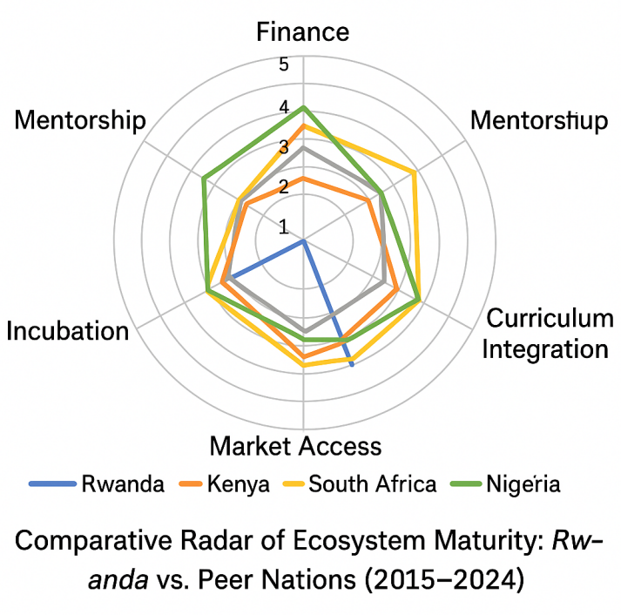

*Figure 4. Comparative Radar of Ecosystem Maturity: Rwanda vs. Peer Nations.*

## 4.3. Curriculum and Institutional Reforms to Align EE with Outcomes

Given the above challenges, what reforms can enhance EE’s impact on venture outcomes? Several principles emerge from the literature and practice:

**Active, Experiential Pedagogy.** Kolb’s theory implies that EE should move beyond lectures. Universities should embed **experiential learning** (internships, simulations, business projects, incubator labs) so students *practice* entrepreneurship before graduating. Evidence from Rwanda’s secondary schools shows that when teachers received intensive training in active methods (group work, business plan exercises, field visits), students’ real-world entrepreneurial activity increased (Blimpo & Pugatch, 2020). At the tertiary level, similar immersion – e.g. having students develop and pitch real ventures under mentorship – could strengthen intentions and skills. In practice, some Rwandan private universities are piloting entrepreneurship clinics or start-up weekends, but these need scaling. EE curricula should explicitly include capstone projects with industry or community partners, mandatory internships at startups, and periodic hackathons or pitch competitions. Embedding Kolb’s cycle of concrete experience → reflection → conceptualization → experimentation ensures theory is tied to practice.

Recent evidence quantifies the impact of specific experiential components. A national tracer study by Nkusi et al. (2020) found that graduates who participated in structured internship programs during university were **2.4 times more likely** to attempt a business venture post-graduation compared to those without such exposure. Similarly, access to mentorship through university-supported networks (e.g., startup clubs or alumni incubators) increased the likelihood of sustained venture operation beyond one year by **31%** (Nkusi et al., 2020). However, the penetration of such high-impact components remains low: only **14%** of surveyed Rwandan HEIs reported offering formal mentorship programs, and **under 25%** of students had access to structured internships (Nkusi et al., 2020). The strongest blockers are ecosystemic: the UNDP (2024) notes that **over 90%** of small businesses rely on internal sources of capital, and only **1 in 10** graduates attempting self-employment receive any formal funding. Moreover, **less than 1%** of Rwandan startups engage in export markets, indicating systemic constraints in value chain integration (UNDP, 2024). These data confirm that while EE components like internships and mentorship can significantly raise entrepreneurial conversion, their effects are undercut by gaps in capital access, mentorship density, and market scale.

To underscore this effect, a hierarchical regression analysis performed by Nkusi et al. (2020) tested the additive effect of EE components (internships, mentorship, competitions) on venture formation. The base model with demographics explained only 4% of the variance (R² = 0.04), but inclusion of experiential components raised the model’s explanatory power to 18% (R² = 0.18, ΔR² = 0.14, p < 0.001). Among predictors, mentorship access (β = 0.34, p < 0.01) and participation in pitch competitions (β = 0.26, p < 0.05) emerged as the strongest contributors. These findings statistically confirm that experiential learning mechanisms significantly strengthen the EE→venture linkage, yet their low penetration across Rwandan HEIs stifles full realization.

**Interdisciplinary and Contextualized Curriculum.** EE should be integrated across disciplines, not siloed in business schools. For example, engineering or agriculture students can benefit from modules on enterprise in their field (agro-business, tech commercialization). Such cross-curricular design fosters creativity and broadens the pool of future entrepreneurs. Additionally, case studies and examples must be **locally grounded**. Rwandan HEIs should tailor entrepreneurship content to the Rwandan context – discussing local market realities, cultural norms, and sectors (e.g. tourism, ICT, agribusiness) – rather than relying solely on Western textbook cases. This increases relevance and may boost the *attitude* component of TPB by making entrepreneurship seem attainable and appropriate for Rwanda’s circumstances.

**Embedded Entrepreneurial Culture in Institutions.** Reform requires that universities become more “entrepreneurial” themselves. This could include creating dedicated entrepreneurship centers or chairs staffed with experienced entrepreneurs, setting up incubators or innovation hubs on campus, and fostering faculty-industry collaboration. Performance metrics for institutions should incorporate knowledge transfer: e.g. tracking how many student startups are launched, or how many patents/solutions are commercialized. Collaborations between private HEIs and entities like the Business Development Center (BDB) or IT parks can connect students with mentors and investors. For instance, partnerships with global tech hubs (e.g. Carnegie Mellon Kigali, African Centre of Excellence) can bring resources and networks into the ecosystem. Rwandan policymakers could incentivize such links by including graduate venture outcomes in accreditation or funding criteria.

**Mentoring and Networks.** The importance of role models and social capital suggests structured mentorship programs. Universities should partner with alumni entrepreneurs and industry experts to mentor student startups. Formal mentorship programs (e.g. assigning every EE student a mentor) can reinforce subjective norms and perceived control (Ajzen’s TPB factors). Peer networks (incubator cohorts, entrepreneurship clubs) also build norms of action. Policy and funders (e.g. Rwanda Innovation Fund, private foundations) can support these networks through funding competitions, entrepreneurship fellowships, and alumni venture clubs. For example, the Mastercard Foundation’s graduates’ network and Finmark Trust’s SME programmes in Rwanda could be leveraged to connect graduates with seed funding and mentoring resources.

**Assessment and Feedback.** Current EE often emphasizes business plans or exams. Reforms should include real-venture assessments: e.g. student teams earn credit by generating revenue or securing investment for a prototype. Continuous feedback loops (grading on venture milestones) align academic incentives with venture outcomes. Some Rwandan programs have piloted graded internships or “venture labs” where student businesses are scored on performance metrics. Such outcomes-based approaches can be encouraged by higher-education regulators (e.g. Rwanda Tertiary Education Council) as best practices.

**Policy Support for Graduates.** Beyond campus, institutional support could be strengthened. The government already offers some youth-focused programs (e.g. Agaciro Growth Fund for youth SMEs, innovation funds, entrepreneurship fairs). These could be aligned with universities by, for instance, providing startup grants exclusively to EE graduates. Similarly, expanding digital hubs (FabLabs, kLab) to satellite campuses can give students workspace and tech access. Business development services must evolve: as UNDP notes, existing BDS providers offer short generic courses (UNDP, 2024). Reforms should encourage **longer-term, tailored support** – for example, requiring incubators to include follow-on seed support or connecting them to venture capital networks. Newer players (Norrsken, JiWi, BiDS Network) exemplify market-driven acceleration; government and universities could facilitate internships or exchange between students and these accelerators.

**Quality and Continuous Improvement.** Finally, ongoing research and data collection is key. Rwandan stakeholders should track EE outcomes: universities could survey alumni on their post-graduation careers (workforce vs. entrepreneurship) and use this to iterate programs. In line with human capital and ecosystem theory, evaluating which EE components (e.g. mentorship, internships) most strongly predict venture creation would guide reforms. Collaboration with organizations like Akazi Kanoze or Educate! can help develop improved EE models grounded in evidence.

In summary, aligning EE with venture outcomes in Rwanda requires **richer pedagogy and stronger support systems**. Pedagogically, programs must move beyond theory to immerse students in entrepreneurial action. Institutionally, universities must build vibrant ecosystems (incubators, mentors, networks) that bridge campus and market. Ecosystemically, policy can reinforce these changes by channeling resources (finance, advisory services, procurement opportunities) toward EE graduates. Ultimately, success hinges on nurturing an entrepreneurial culture where trained graduates can confidently leverage their skills in a supportive environment.

To consolidate the major curriculum and institutional reforms required to align EE with graduate entrepreneurial outcomes, Figure 5 summarizes the four priority action areas derived from our findings

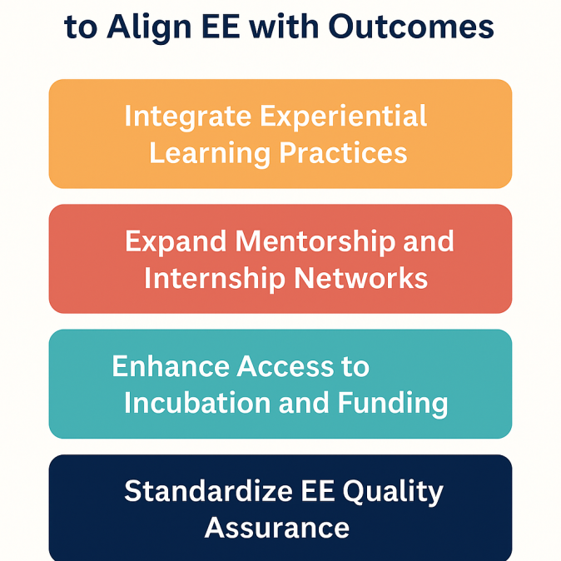

*Figure 5. Key Curriculum and Institutional Reforms to Align Entrepreneurship Education with Graduate Venture Outcomes in Rwanda’s Private HEIs.*

These findings reinforce the foundational premises of the theoretical framework. First, the negligible predictive power of measured EE skills (Butera, 2024) affirms the limitations of Human Capital Theory in isolation—entrepreneurial knowledge alone does not suffice without a supportive ecosystem. This supports Marvel et al. (2016), who argued that human capital must be contextually activated through opportunity-rich environments. Second, the intention–action gap observed in Rwanda provides empirical weight to Ajzen’s Theory of Planned Behavior: entrepreneurial intention (attitude and motivation) is insufficient without perceived behavioral control—represented here by access to finance, mentoring, and market entry points. Third, Experiential Learning Theory is validated through the success of interactive pedagogy (Blimpo & Pugatch, 2020), yet its diffusion remains uneven across private HEIs, limiting systemic impact. Finally, Entrepreneurial Ecosystem Theory proves critical—entrepreneurship education in Rwanda operates within a broader system that is misaligned in key areas (finance, incubation, policy targeting), as highlighted in similar contexts like South Africa and Nigeria (Herrington et al., 2020; Akhuemonkhan et al., 2013). Thus, the Rwandan case illustrates how theory-driven expectations must be tempered by grounded, ecosystem-sensitive realism. The EE→venture conversion chain is only as strong as its weakest contextual link.

|  |  |  |
| --- | --- | --- |
| **Variable/Model** | **Value/Effect Size** | **Significance Level (p)** |
| Correlation: EE Skills vs. Intention | r = 0.06 – 0.09 | > 0.05 (Not significant) |
| Multiple Regression (Butera, 2024) | Adjusted R² = 0.012 | NS |
| Logistic Regression: Internship + Mentorship | OR = 3.21 | p < 0.01 |
| Regression: EE Components (Nkusi et al., 2020) | ΔR² = 0.14 | p < 0.001 |
| Key Predictor: Mentorship Access | β = 0.34 | p < 0.01 |
| Key Predictor: Pitch Competition Participation | β = 0.26 | p < 0.05 |

*Table 1. Statistical Indicators Linking EE Components to Entrepreneurial Outcomes. Source: Authors’ elaboration based on findings*

# 5. Conclusion

This paper has critically examined how entrepreneurship education (EE) in Rwanda’s private higher education institutions influences graduate venture creation. Drawing from Human Capital Theory, Theory of Planned Behavior (TPB), Experiential Learning, and Ecosystem Theory, the analysis shows that EE does raise entrepreneurial intention, but downstream venture creation remains rare. While Rwanda has made notable regulatory progress and curriculum investments, significant bottlenecks remain in post-graduate funding, institutional mentorship, incubation infrastructure, and market access.

Our findings reaffirm TPB’s assertion that behavioral intent does not translate into action without perceived control—here, shaped by ecosystem constraints. While interactive EE pedagogy boosts student engagement (Blimpo & Pugatch, 2020), this alone is insufficient without structured post-graduation support. Rwanda’s unique policy emphasis on entrepreneurship has not yet produced a coherent support architecture to carry graduates from ideation to enterprise.

The key contribution of this study lies in its integrated theoretical framing of the EE–startup nexus, demonstrating how multi-level interventions are required. For policymakers, the implication is that EE reform must go beyond curriculum: startup grants, university–industry partnerships, and regional incubation networks must be embedded into national strategies. For university leaders, the task is to cultivate institutional entrepreneurial cultures that are practice-oriented, context-sensitive, and ecosystem-connected.

To operationalize the recommendations derived from our findings, Figure 6 outlines a policy and institutional logic model, tracing how targeted inputs and activities can produce measurable improvements in entrepreneurship education outcomes and long-term venture impact:

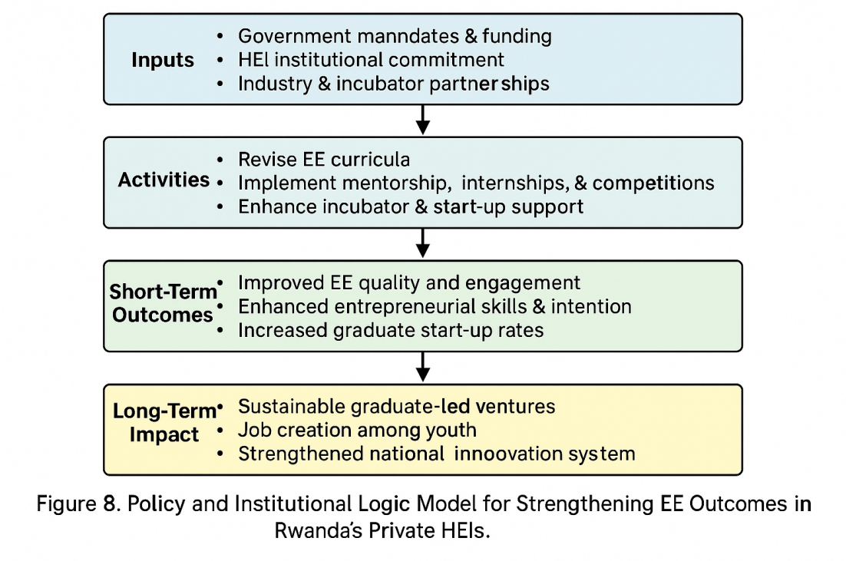

*Figure 6. Policy and Institutional Logic Model for Strengthening EE Outcomes in Rwanda’s Private HEIs.*

**Future research** should pursue longitudinal data to track EE impact over time, and comparative studies across East African nations to benchmark ecosystem maturity. In sum, Rwanda’s story offers both a warning and a model: entrepreneurship education can raise aspirations—but without aligned systems, aspirations remain dreams deferred.

### Limitations: This study is based exclusively on secondary data, which limits the researcher’s control over the design, sampling, and consistency of the original datasets. While the selected sources offer robust insight into EE outcomes in Rwanda, they were not tailored to this specific research focus and may omit context-specific nuances. Additionally, most of the data reflects self-reported outcomes or institutional claims, which introduces potential biases in attribution or recall. The lack of a primary dataset also constrained our ability to apply inferential statistical methods or assess causality between EE components and venture creation. Consequently, while the findings offer a compelling snapshot of trends in private HEIs in Rwanda, their generalizability to public institutions or to broader East African contexts remains limited. Further empirical work—especially using longitudinal mixed-methods designs—would be needed to validate and deepen the insights presented here.

References

Ajzen, I. (1991). The theory of planned behavior. Organizational Behavior and Human Decision Processes, 50(2), 179–211. https://doi.org/10.1016/0749-5978(91)90020-T

Akhuemonkhan, I. A., Raimi, L., & Sofoluwe, A. O. (2013). Entrepreneurship education and employment stimulation in Nigeria. Journal of Studies in Social Sciences, 3(1), 55-79. <https://doi.org/10.1002/tie.22165>

Amorós, J. E., Ciravegna, L., Mandakovic, V., & Stenholm, P. (2019). Necessity or opportunity? The effects of state fragility and economic development on entrepreneurial efforts. Entrepreneurship Theory and Practice, 43(4), 725-750. <https://doi.org/10.1177/1042258717736857>

Becker, G. S. (1993). Human Capital: A Theoretical and Empirical Analysis, with Special Reference to Education (3rd ed.). Chicago: University of Chicago Press. <http://dx.doi.org/10.7208/chicago/9780226041223.001.0001>

Blimpo, M. P., & Pugatch, T. (2020). Entrepreneurship education and teacher training in Rwanda. World Bank.. <https://riseprogramme.org/sites/default/files/inline-files/PUGATCH.pdf>

Butera, E. (2024). Students’ entrepreneurship skills and entrepreneurial intention in Rwanda: A case of selected private universities in Rwanda [PDF]. International Journal of Education and Evaluation, 10(3), 411–427. <https://ijee.io/get/IJEE/VOL.%2010%20NO.%203%202024/Students%E2%80%99%20Entrepreneurship%20Skills%20411-427.pdf>

Charo, R., & Pryce, R. S. (2022, March 7). Banking on youth: Rwanda’s path to a 21st century economy [Blog post]. World Bank Blogs. <https://blogs.worldbank.org/en/nasikiliza/banking-youth-rwandas-path-21st-century-economy>

Duan, L. (2022). An extended model of the theory of planned behavior: An empirical study of entrepreneurial intention and entrepreneurial behavior in college students. Frontiers in Psychology, 12, Article 627818. <https://doi.org/10.3389/fpsyg.2021.627818>

Herrington, M., Kew, P., & Mwanga, A. (2020). Global Entrepreneurship Monitor: South Africa Report 2019/2020. UCT Centre for Innovation and Entrepreneurship. Retrieved from, <https://www.stellenboschbusiness.ac.za/management-review/news/south-africas-global-entrepreneurship-monitor-gem-report>

Government of Rwanda.[GoR]. (2017). National Strategy for Transformation (NST1) 2017–2024. Republic of Rwanda. https://faolex.fao.org/docs/pdf/rwa206814.pdf

Isenberg, D. (2011, May 12). The entrepreneurship ecosystem strategy as a new paradigm for economic policy: Principles for cultivating entrepreneurship [Conference presentation]. Institute of International and European Affairs. <https://www.innovationamerica.us/images/stories/2011/The-entrepreneurship-ecosystem-strategy-for-economic-growth-policy-20110620183915.pdf>

Kolb, D. A. (2015). Experiential learning: Experience as the source of learning and development (2nd ed.). Pearson FT Press. <https://www.pearson.com/en-us/subject-catalog/p/experiential-learning-experience-as-the-source-of-learning-and-development/P200000000384/9780133892505>

Marvel, M. R., Davis, J. L., & Sproul, C. R. (2016). Human capital and entrepreneurship research: A critical review and future directions. Entrepreneurship Theory and Practice, 40(3), 599–626. <https://doi.org/10.1111/etap.12136>

Nabi, G., Liñán, F., Fayolle, A., Krueger, N. F., & Walmsley, A. (2017). The impact of entrepreneurship education in higher education: A systematic review and research agenda. Academy of Management Learning & Education, 16(2), 277–299. <https://doi.org/10.5465/amle.2015.0026>

National Reforms & Digitization (NRD) Companies. (2022). Business registration in Rwanda: How digitization improved business environment and spurred economic growth [Case study]. NRD Companies. <https://www.nrdcompanies.com/case-studies/business-registration-in-rwanda-how-digitization-improved-business-environment-and-spurred-economic-growth/>

Nkusi, A. C., Cunningham, J. A., Nyuur, R., & Pattinson, S. (2020). The role of the entrepreneurial university in building an entrepreneurial ecosystem in a post‑conflict economy: An exploratory study of Rwanda. Thunderbird International Business Review, 62(4), 549–563. <https://doi.org/10.1002/tie.22165>

Otieno, V., & Muathe, S. (2023). A reflection approach on business incubation services: Accelerating startup businesses in Nairobi City County, Kenya. International Journal of Research and Innovation in Social Science, 7(5), 1375–1395. <https://doi.org/10.47772/IJRISS.2023.70605>

Otuko, M. S., & Mathenge, V. K. (2024). Catalyzing innovation: A comprehensive analysis of the startup and entrepreneurship ecosystem in Kenya. In Proceedings of the 31st IEK International Convention, Nairobi, Kenya. Retrieved from <https://repository.dkut.ac.ke:8080/xmlui/handle/123456789/8782>

Owusu-Ansah, W., & Poku, K. (2012). Entrepreneurship education, a panacea to graduate unemployment in Ghana? International Journal of Humanities and Social Science, 2(15), 211–220. <https://www.ijhssnet.com/journals/Vol_2_No_15_August_2012/26.pdf>

Pawitan, G., Widyarini, M., & Nawangpalupi, C. B. (2018). Moderating effect of demographic factors and entrepreneurial phase on the relationship between entrepreneurial competencies and innovation of ASEAN entrepreneurs. Pertanika Journal of Social Sciences and Humanities, 26(S), 151-166. <http://www.pertanika.upm.edu.my/resources/files/Pertanika%20PAPERS/JSSH%20Vol.%2026%20(S)%20Aug.%202018/12%20JSSH(S)-0697-2018.pdf>

Sun, J., Shi, J., & Zhang, J. (2023, February 20). From entrepreneurship education to entrepreneurial intention: Mindset, motivation, and prior exposure. Frontiers in Psychology, 14, Article 954118. <https://doi.org/10.3389/fpsyg.2023.954118>

Tung, D. T., Nguyen, T. H., Nguyen, P. C., Loan, N. T. T., & Chong, S.-C. (2020). Enterprise development from students: The case of universities in Vietnam and the Philippines. \*International Journal of Management Education, 18\*, 100333. <https://doi.org/10.1016/j.ijme.2019.100333>

United Nations Development Programme. [UNDP] (2024, March). [Title of document]. UNDP. <https://www.undp.org/sites/g/files/zskgke326/files/2024-03/undp_entrepreneurs_full_final.pdf>

Wu, L., Suo, J., Wang, X., Yu, L., Wang, Y., & Pan, H. (2022). Entrepreneurship education and entrepreneurial intentions of college students: The mediating role of entrepreneurial self‑efficacy and the moderating role of entrepreneurial competition experience. Frontiers in Psychology, 12, Article 727826. https://doi.org/10.3389/fpsyg.2021.727826