**ENHANCING READING COMPREHENSION AMONG GRADE 3 LEARNERS THROUGH MULTISENSORY APPROACH**

# TITLE PAGE

**ABSTRACT**

Reading comprehension is a critical skill for academic success, yet many young learners continue to struggle with understanding texts. The 2022 Programme for International Student Assessment (PISA) showed that only 24% of Filipino 15-year-olds achieved at least Level 2 proficiency in reading, reflecting persistent challenges in literacy. This quasi-experimental research aimed to determine the effectiveness of the Multisensory Approach in improving the reading comprehension of Grade 3 pupils at Cateel Central Elementary School for the academic year 2024–2025. Grounded in the VAKT (Visual, Auditory, Kinesthetic, and Tactile) theory, the intervention utilized multisensory activities to support learning. A total of 45 pupils were purposively selected and divided into two groups: a control group and an experimental group. Both groups were assessed using validated pre-tests and post-tests. The control group received traditional instruction, while the experimental group was taught using multisensory strategies over a four-week period. Results showed that although both groups improved, the experimental group demonstrated greater gains in performance. The post-test mean of the experimental group was 14.91 (corresponding to a grade of 84 – "Satisfactory"), compared to the control group's 12.20 (corresponding to a grade of 75 – "Fairly Satisfactory"). A t-test revealed a statistically significant difference in the post-test scores, favoring the experimental group. Based on these findings, the Multisensory Approach is deemed effective in enhancing reading comprehension and is recommended for broader classroom application. Future researchers may replicate the study with low-performing learners for deeper insights.

**Keywords:** *Multisensory Approach, reading comprehension, VAKT theory*

# Introduction

Reading comprehension is a fundamental skill that significantly influences students' academic success and overall learning experiences. However, San Juan (2019) mentioned that among 79 participating countries and economies, the Philippines scored the lowest in reading comprehension in the 2018 Programme for International Student Assessment (PISA). Unfortunately, this trend persisted in the 2022 PISA results, where the Philippines remained in the bottom 10 out of 81 participating countries. Filipino students scored 347 in reading—well below the global average of 476—with only one in four learners achieving the minimum proficiency level required to understand written texts effectively (Philstar, 2023). This alarming result highlights the need for a closer examination of local schools' performance in reading comprehension. For instance, in the National Achievement Test (NAT), Lapasan National High School emerged as a low-performing school in the Filipino subject. Over two consecutive years, the school's mean score in reading comprehension showed minimal improvement, starting at 35.15 and slightly increasing to 43.98 (Spiro et al., 2017).

Moreover, the reading assessment conducted in Luzon, particularly in the Schools Division of Aurora, showed that only a few students achieved high scores in Filipino reading comprehension, wherein many Grade 1 and 2 students could read fluently but struggled to understand what they read even when materials were in their Mother Tongue (Tomas et al., 2021). Recent results from the Group Screening Test (GST) administered as part of the School Phil-IRI Pretest at Cateel Central Elementary School (2024) reveal a significant challenge in student literacy. Specifically, 16 out of the total grade 3 learners have been identified as sentence readers who exhibit difficulties with reading comprehension. This finding underscores the urgent need for targeted interventions to address these students' comprehension deficits, which may hinder their academic progress and overall literacy development.

Additionally, research suggests that significant factors contributing to low results on the National Achievement Test (NAT) include students' poor reading comprehension (Guimba & Alico, 2015). Students often struggle to apply various reading strategies and fail to effectively express their understanding of the text (Zahran, 2021). Additionally, they face challenges in deciphering the meanings of words, and their inference skills remain weak, particularly when connecting truths before, during, and after reading the text (Li et al., 2021). Moreover, a lack of motivation to read, especially when faced with lengthy texts, further exacerbates the problem (Pimentel, 2023).

Meanwhile, using a multisensory approach in the classroom enables students to engage with content through multiple senses, facilitating stronger cognitive connections and more effective information retention. This strategy, which integrates visual, auditory, and kinesthetic-tactile elements, fosters a more inclusive and engaging learning environment where diverse learners can thrive. Despite the increasing interest in multisensory approaches to enhance reading comprehension, a significant gap remains in research specifically targeting grade 3 learners in the Filipino subject, particularly at Cateel Central Elementary School.

While existing studies often focus on general literacy interventions, few address the unique challenges faced by young learners who are sentence readers but struggle with comprehension, as seen in the study by Pasqualotto et al. (2022), which explores reading skills through a video game. The prevalence of this issue underscores the need for implementing effective instructional strategies to enhance both reading fluency and comprehension skills within the local educational context.

Hence, the multisensory approach to reading comprehension can be highly effective in the Filipino subject. By engaging multiple senses—visual, auditory, and kinesthetic-tactile—this approach allows students to connect more deeply with Filipino texts. The use of visual aids, audio resources, and interactive exercises helps students contextualize unfamiliar vocabulary, thereby improving their overall comprehension (Escobar, 2021). This inclusive approach caters to diverse learning styles, fostering a more effective and equitable learning environment and boosting students' reading comprehension, confidence, and overall academic performance in Filipino.

## Significance of the Study

The results of this action research can benefit the following:

**Teachers.** The results of this study will provide teachers with practical insights into enhancing their instructional methods. With evidence of the Multisensory Approach’s effectiveness, teachers can refine their strategies to improve student engagement and comprehension. This study empowers educators to better support students in reaching higher reading comprehension levels, creating a more effective and engaging classroom environment.

**Students.** Students will benefit from this study as it helps identify their reading comprehension strengths and areas for improvement. By focusing on the Multisensory Approach, the study offers strategies that can help students become more independent readers. These improvements in reading skills can have a lasting positive impact on their academic performance and personal confidence.

**Future Researchers.** This study will provide valuable data and serve as a foundational reference for future research on reading comprehension strategies. Examining the Multisensory Approach in this specific context opens pathways for further exploration and comparison with other methods. Future researchers can build on this work to explore new applications or improvements, advancing the field of literacy education.

## Statement of the Problem

This study determined the effectiveness of the multisensory approach in enhancing pupils' reading comprehension. As such, this research paper sought to answer the following specific questions:

1. What is the level of pre-test scores in reading comprehension in Filipino of the experimental and control group?
2. Is there a significant difference in reading comprehension in Filipino between the pre-test scores of the experimental and control groups?
3. What is the level of post-test scores in reading comprehension in Filipino of the experimental and control group?
4. Is there a significant difference in reading comprehension in Filipino between the post-test scores of the experimental and control groups?
5. To what extent does the multisensory approach enhance the reading comprehension in Filipino of Grade 3 learners in Filipino subjects?

## Objectives of the Study

This study aimed to attain the following objectives.

1. To determine the level of pre-test scores in reading comprehension in Filipino between the experimental group and control group.
2. To determine if there is a significant difference in reading comprehension in Filipino between the pre-test scores of the experimental group and the control group.
3. To determine the level of post-test scores in reading comprehension in Filipino between the post-test scores of the experimental group and the control group.
4. To determine if there is a significant difference in reading comprehension in Filipino between the experimental group and control group.
5. To determine the extent to which the multisensory approach enhances the reading comprehension in Grade 3 learners in Filipino subjects.

## Scope and Limitation

This research investigated the effectiveness of multisensory approaches in enhancing reading comprehension among Filipino-speaking Grade 3 students at Cateel Central Elementary School during the 2024–2025 academic year. It aimed to evaluate how multisensory instructional strategies—such as visual aids, auditory inputs, and kinesthetic activities—affected reading comprehension skills. The study focused solely on the following learning competencies in the Filipino subject: *“Nasasagot ang mga tanong tungkol sa tekstong binasa (F3PB-IVa-3.2),” “Nakapagbibigay ng wakas ng binasang kuwento (F3PB-IVf-14),”* and *“Naibibigay ang buod o lagom ng tekstong binasa (F3PB-IVi-16).”*

The research was limited by its focus on a single school and grade level, which limits the generalizability of the findings to other settings. The study relied on the resources available at the school, including materials and teacher training. Additionally, the assessment tools that were used had their limitations and may not have fully captured all aspects of comprehension development. These parameters aimed to provide targeted insights into the role of multisensory approaches in enhancing reading comprehension within this specific educational context.

## Theoretical Framework

This research was grounded in the VAKT (Visual, Auditory, Kinesthetic, and Tactile) Theory of Murphy (1997). In VAKT theory, it implies that students learn best when information is presented using multiple senses (Murphy, 1997). This theory emphasizes the importance of engaging multiple sensory modalities to enhance learning outcomes, particularly for students who may struggle with traditional, single-sensory instructional methods. More recent studies support this approach, highlighting the effectiveness of multisensory techniques in improving understanding by allowing learners to connect information across different sensory pathways. Similarly, research by Dostie et al. (2015) demonstrated that the multisensory approach, aligned with VAKT theory, significantly improves engagement and comprehension in reading tasks.

Additionally, learning involves the use of two or more senses within an activity (Shahzadi, 2020). A multisensory approach combines activities that allow students to see, hear, and touch, engaging multiple senses to enhance understanding. In essence, it incorporates the learning styles of visual, auditory, kinesthetic, and tactile learners. For instance, Volpe and Gori (2019) highlighted how multisensory technologies enhance reading comprehension by engaging multiple senses, while Gharaibeh and Dukmak (2021) found that a computer-based multisensory approach improved reading comprehension. These findings underscore that engaging multiple senses through a multisensory approach creates an inclusive and effective environment for fostering reading comprehension, catering to the diverse needs of learners (Morin, 2024; Ricardez, 2024).

Moreover, in the context of this study, the Filipino subject, particularly Reading Comprehension, a multisensory approach can significantly enhance students' understanding of texts. For example, when studying a classic Filipino folktale or short story, the teacher can present an animated video adaptation of the story (visual-auditory). At the same time, students listen to the narration in Filipino. Afterward, students can engage in hands-on activities, such as creating dioramas of the story's setting using materials like colored paper, clay, and fabric to represent different textures or crafting puppets to depict the characters and retell the story (tactile-kinesthetic). Finally, students can act out scenes from the story in Filipino (auditory-kinesthetic), integrating movements and dialogues in the language to reinforce their comprehension and appreciation of the text. This method not only develops students' reading comprehension skills but also engages them in an interactive and culturally relevant learning experience. By utilizing Filipino texts and promoting active participation, the approach ensures that students connect with the material on a deeper level while appreciating the richness of their language and heritage.

## Definition of Terms

**Auditory Learning.** Auditory learning is a style of learning in which individuals primarily acquire knowledge and understanding through listening and verbal communication (Eads, 2024).

**Kinesthetic-Tactile Learning.** Learners excel when they engage in learning through movement, hands-on activities, and the use of tangible objects (Bryant, 2023).

**Multisensory Approach.** A multisensory approach incorporates the learning styles of visual, auditory, kinesthetic, and tactile learners (Murphy, 1997).

**Reading Comprehension.** Reading comprehension is the cognitive process of understanding, interpreting, and deriving meaning from written text (Dela Cruz & Santos, 2024).

**VAKT Theory.** VAKT (Visual, Auditory, Kinesthetic-Tactile) implies that students learn best when information is presented in multiple modalities (Murphy, 1997). The belief is that students learn a new concept most effectively when it is taught using all four modalities. The students see, hear, and touch.

**Visual Learning.** Visual learning is an educational approach that emphasizes the use of visual aids and strategies to facilitate the understanding and retention of information (Alabi, 2024).

# Review of Related Literature

This chapter presents a comprehensive review of relevant literature and studies that the researchers have considered to highlight the importance of the study. By synthesizing the existing literature, this chapter provided a deeper understanding of the research conducted.

**Understanding Reading Comprehension**

Reading comprehension is a multifaceted cognitive process that enables individuals to derive meaning from written text (Alfiani et al., 2024). It involves decoding symbols, understanding vocabulary, making inferences, and integrating new information with existing knowledge (Cartwright, 2023). According to Hailang (2022), reading comprehension is "the process of simultaneously extracting and constructing meaning through interaction and involvement with written language." This definition highlights the active engagement required between the reader and the text to achieve a deeper understanding.

Recent research highlights the significance of background knowledge in reading comprehension. A study by Smith et al. (2021) emphasizes that readers with extensive background knowledge on a subject can better understand and retain information from related texts. This finding suggests that educators should focus on building students' prior knowledge to enhance their comprehension skills.

Additionally, text characteristics play a crucial role in comprehension. Hazenberg et al. (2021) found that elements such as text structure, complexity, and coherence have a significant impact on a reader's ability to comprehend material. Well-organized and written texts facilitate better understanding, indicating that selecting appropriate reading materials is essential for effective comprehension instruction.

Moreover, developing reading comprehension skills is vital for academic success across various subjects. Buehl (2023) notes that proficiency in reading comprehension enables students to learn effectively in disciplines like science, history, and mathematics. Therefore, fostering these skills from an early age is crucial for overall educational achievement.

**Challenges in Filipino Reading Comprehension**

Reading comprehension is a crucial skill for academic success, playing a significant role in a student's ability to succeed across various subjects. In the Philippines, however, many students struggle to understand and process written texts. The challenges in reading comprehension can be attributed to various factors, including socioeconomic disparities, linguistic diversity, outdated teaching methodologies, and the influence of modern technology (Idulog, 2023). Understanding and addressing these challenges is essential for improving literacy outcomes and ensuring equitable educational opportunities for Filipino learners (Niyang, 2021).

One of the primary factors contributing to poor reading comprehension among Filipino students is socioeconomic inequality. Many students in rural and marginalized areas lack access to essential educational resources, including books, libraries, and the Internet. This lack of resources hinders their ability to develop essential literacy skills, as access to varied reading materials is critical for vocabulary development and comprehension (Ballesteros, 2021). Additionally, students from low-income families often struggle with malnutrition, which can negatively affect cognitive development and academic performance (Pascua, 2021).

Further, the multilingual context of the Philippines presents a significant challenge. While Filipino and English are the languages of instruction, many students speak regional languages or dialects at home, which makes it difficult for them to transition smoothly between languages (Ganeb & Morales, 2018). This linguistic barrier can lead to poor comprehension, particularly when students are expected to understand and process complex academic texts in Filipino (Ancheta & Perez, 2017). This multilingual divide often complicates language acquisition and comprehension skills for many students (Mendoza, 2021). Furthermore, Ziadat (2021) emphasized that group composition can significantly influence reading comprehension. Similarly, Velasquez (2024) found that differences in pupils' home literacy environments have a significant impact on their reading comprehension, particularly affecting their intellectual development and study habits.

Moreover, traditional teaching methodologies prevalent in the Philippine educational system often fail to engage students in active learning. Teachers frequently rely on rote memorization and lecture-based instruction, which do not promote critical thinking or deeper engagement with reading materials. As a result, students may struggle with comprehension, particularly when encountering abstract or complex concepts (Guillermo, 2019). Additionally, the increasing use of technology in classrooms has not been matched with adequate teacher training or pedagogical strategies, which further exacerbates comprehension issues (Delos Santos, 2022).

Another challenge is the growing prevalence of digital distractions. With the rise of social media and entertainment platforms, students are increasingly turning to digital devices, which can detract from their attention spans and hinder their ability to focus on academic reading tasks. Studies show that excessive screen time is linked to shorter attention spans and reduced engagement with text-based learning (Shanmugasundaram & Tamilarasu, 2023). This shift in focus presents a significant barrier to developing strong reading comprehension skills among Filipino students (Acedillo & Saro, 2023). Also, Viduya and Antonio (2022) found that many pupils performed below proficiency in reading comprehension in Filipino. Similarly, Idulog et al. (2023) reported that Filipino students face significant challenges in reading comprehension, highlighting the need for targeted instructional interventions.

The challenges in Filipino reading comprehension are multifaceted, involving issues related to socioeconomic status, linguistic diversity, teaching methods, and technological distractions. To address these problems, a comprehensive approach is needed. This includes improving access to learning resources, adopting more inclusive teaching strategies that cater to diverse learners, and addressing the effects of digital distractions on learning (eSchool News, 2024). Only through these efforts can the Philippines improve its literacy outcomes and ensure that all students have the opportunity to succeed academically (Gatcho et al., 2024).

**The Importance and Impact of the Multisensory Approach in Education**

The multisensory approach to learning, which engages visual, auditory, kinesthetic, and tactile senses, has emerged as a powerful tool for enhancing information acquisition and retention (Cherif, 2024). By involving multiple sensory pathways, this method strengthens neural connections, fostering improved understanding and memory (Leisman, 2022). This approach is particularly effective in teaching reading comprehension, as it accommodates diverse learning styles and addresses specific learning challenges.

The research underscores the efficacy of multisensory instruction in reading education. For example, Wafa’A and Khasawneh (2025) found that incorporating multisensory techniques significantly improved students' reading comprehension and fluency. By making learning more interactive and engaging, this approach proves especially valuable for young learners. Furthermore, Bøg et al. (2021) highlighted its effectiveness for students at risk of reading difficulties, while Babalola (2021) demonstrated that multisensory interventions can enhance reading skills in students with learning disabilities, resulting in better academic outcomes and increased motivation. These findings emphasize the importance of inclusive teaching strategies that cater to the needs of all learners.

Beyond academic performance, the multisensory approach has a positive impact on students' attitudes toward learning. Kucirkova and Leon (2020) discovered that students who engaged in multisensory activities reported higher levels of engagement and enjoyment, which in turn fostered sustained academic improvement and a lifelong interest in reading. Similarly, Vena and Yuliana (2023) observed increased motivation among students participating in multisensory learning, further highlighting the holistic benefits of this approach. As highlighted by Rizki (2024), conventional teaching approaches, when applied consistently and effectively, can still enhance students' reading comprehension. Moreover, Aring (2019) observed that traditional strategies, such as structured lectures and guided reading sessions, can lead to measurable gains in students' reading abilities. Additionally, Dinoro et al. (2023) reported that the implementation of systematic reading strategies, even within traditional frameworks, contributed to improved reading comprehension among learners in public schools.

In the same vein, Yilmazlar and Görgen (2022) found that learning environments enriched with multisensory reading activities enhanced reading comprehension skills, strategies, and motivation among primary school students. Similarly, Mitak et al. (2023) demonstrated that implementing a multisensory approach, which incorporates visual, auditory, tactile, and kinesthetic activities, improves reading abilities among students. Additionally, De Juan (2015) reported that a multisensory teaching-learning approach significantly improved reading performance among pupils at risk of dropping out, highlighting its effectiveness in fostering literacy skills in diverse learning contexts.

Implementing a multisensory approach in teaching involves designing lessons that engage multiple senses simultaneously, thereby accommodating different learning preferences and enhancing comprehension (Morin, 2024). In reading instruction, this might include activities such as tracing letters while vocalizing sounds, using tactile materials like sandpaper letters, or incorporating movement through word-related actions (Martineau, 2024). These strategies make abstract concepts more tangible and accessible to students.

Another study by Ziadat (2021) found that the multisensory approach enhances reading comprehension skills among third-grade students. Similarly, Lee (2016) reported that a multisensory approach, incorporating visual, auditory, and kinesthetic-tactile elements, effectively supported early readers, resulting in improved reading comprehension. Furthermore, this result is consistent with the study by Bangoy et al. (2024), which demonstrated that implementing audio-visual-assisted technology in reading instruction had a positive impact on the reading comprehension of third-grade students. Furthermore, Sarudin et al. (2019) reported that the multisensory approach, encompassing visual, auditory, kinesthetic, and tactile elements, effectively improved word recognition skills, which are foundational to reading comprehension.

Studies confirm the effectiveness of multisensory teaching methods. Fujita (2024) demonstrated that students receiving multisensory instruction showed greater improvements in reading achievement compared to those taught through traditional methods, with enhanced phonemic awareness and decoding skills as key outcomes. Additionally, Gazioglu and Karakus (2023) found that multisensory techniques helped bridge language barriers in culturally diverse classrooms, supporting the development of reading comprehension skills and promoting inclusivity.

For instance, Wu and Tai (2016) found that multisensory instruction improves comprehension by enabling learners to connect information through multiple sensory pathways. Additionally, Paul (2024) reported that multisensory reading interventions significantly boosted reading comprehension skills for students with diverse learning needs.

Meanwhile, implementing a multisensory approach based on the principles of VAKT theory has been shown to enhance reading comprehension among young learners effectively. This method engages visual, auditory, kinesthetic, and tactile senses, helping students process and retain reading material more deeply. For instance, Avni (2023) demonstrated that incorporating tactile and kinesthetic activities in reading lessons increased engagement and understanding among primary students.

To successfully implement multisensory strategies, educators require adequate training and resources. Evans (2024) emphasized the need for professional development programs that equip teachers with the knowledge and tools to effectively integrate multisensory methods. Williams (2024) further highlighted how such training enhances teachers' ability to support diverse learners and improve overall student outcomes in reading comprehension.

In conclusion, the multisensory approach is a transformative teaching strategy that not only enhances academic performance but also fosters inclusivity and engagement. By addressing diverse learning needs and creating a dynamic educational environment, this approach facilitates both immediate and long-term benefits in education.

# Methodology

This chapter presents the research locale and duration, research respondents, research design, research instrument, and data-gathering procedure that discusses the thorough process and steps in conducting the research as well as the gathering of data and data treatment, which includes the statistical tools utilized in answering the research questions and achieving the research objectives.

## Research Locale and Duration

The research was conducted at Cateel Central Elementary School, Barangay Poblacion, Cateel, Davao Oriental, during the second semester of the 2024–2025 academic year. Due to the evident challenges Grade 3 students faced in reading comprehension, this location provided an ideal setting to explore solutions that could directly support struggling readers in their literacy development.

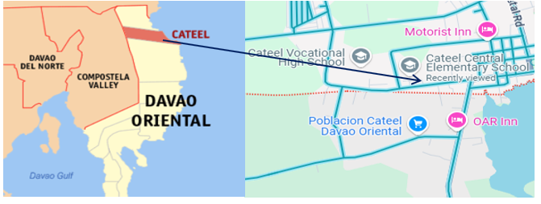

Figure 1. Map of the Cateel Central Elementary School

## Research Design

This study employed a quasi-experimental design with a control and experimental group to demonstrate the effectiveness of the intervention. A quasi-experimental design is a research approach that examines cause-and-effect relationships without random assignment, using comparison groups and controls to minimize bias (Lauren Thomas, 2024). This design allowed the implementation of interventions in real classroom settings. By utilizing existing classroom groups, the researchers were able to apply the multisensory approach and compare the reading comprehension outcomes of students who received this intervention with those who experienced traditional instruction.

## Respondents and Sampling Procedure

The respondents of this study were all Grade 3 students of Cateel Central Elementary School, totaling 44 students. This approach utilized complete enumeration sampling, in which 2 sections out of the 6 sections in Grade 3 were selected through a draw-lots method to participate in the study. The control and experimental groups were then randomly allocated using a toss-coin method, and all learners in each selected section were included as respondents.

The research-made pre-test and post-test questionnaires were administered to all respondents, with only those who completed both tests included in the final analysis. To ensure data validity, respondents who were absent during the post-test but completed the pre-test were excluded from the analysis.

## Research Instrument

The study employed a researcher-designed instrument to evaluate respondents' reading comprehension before and after the intervention. This 20-item test underwent rigorous validity and reliability testing. Content validity was established through the evaluation of three experts, who assessed the questionnaire based on its alignment with learning outcomes, relevance to the objectives, and the quality of the items. Their ratings were used to calculate Aiken's V coefficient, which resulted in a score of 0.94, indicating a high level of validity. For reliability, the instrument was pilot-tested in other schools, and Cronbach's alpha coefficient was calculated, yielding a value of 0.748, signifying high reliability. These processes ensured that the research instrument was both valid and reliable.

## Data Gathering Procedure

The researchers followed the following procedures in conducting the research action:

1. **Obtaining Research Ethical Clearance.** The first step in the data gathering process was to secure ethical clearance from the Research Ethics Office (REO). This involved submitting a research proposal that outlined the study's goals, methods, and how participant confidentiality would be protected. The REO reviewed the proposal to ensure it met ethical standards. Once approved, any feedback was addressed, allowing the research to proceed with the necessary ethical safeguards in place.
2. **Requesting Permission to Conduct Action Research.** The researchers submitted a permission letter to the School Principal of Cateel Central Elementary School to conduct the research. Once approval was granted, the class advisers were informed through a formal letter requesting permission to conduct the research and use the tool with the students. The researchers also introduced themselves and explained the purpose of the study to the class advisers. Additionally, letters and assent forms were distributed to the student's parents to secure their permission for their children's participation in the study.
3. **Administering Pre-Test.** The researchers administered the pre-test to the students to determine their basic comprehension or knowledge of the stated objective measures.
4. **Retrieving the Pre-Test.** After the learners answered the pre-test administered by the researchers, the questionnaires were retrieved.
5. **Conducting the Intervention.** The intervention lasted three days and involved structured, learner-centered activities that targeted the study's objectives. Each session was guided and interactive, with the researcher closely monitoring and supporting learners to ensure effectiveness.

**Experimental Group.** The experimental group participated in interactive activities that utilized multisensory strategies designed in alignment with the VAKT Theory, which incorporates visual, auditory, and kinesthetic learning approaches.

**Control Group**. The control group received traditional instruction methods without the structured Multisensory Approach.

1. **Administering of Post-Test.** The researchers administered the post-test questionnaires to the students.
2. **Retrieving of Post-Test.** After the learners answered the post-test questionnaire, the questionnaires were retrieved. The data gathered in the post-test were tallied, encoded, analyzed, and interpreted.

## Data Analysis

The following are the statistical tools that were utilized to analyze this study:

**Mean.** This tool was used to determine the level of pre-test and post-test scores of the experimental and control groups. The K-12 grading system was used to interpret the data results collected.

|  |  |
| --- | --- |
| Table 1. K to 12 Table of interpretation | |
| GRADING SCALE | INTERPRETATION |
| 90-100 | Outstanding |
| 85-89 | Very Satisfactory |
| 80-84 | Satisfactory |
| 75-79 | Fairly Satisfactory |
| Below 75 | Did Not Meet Expectations |

**T-test.** This tool was utilized to determine the significant difference between the pre-test scores of the experimental and control groups. Thus, this answered question 2 and achieved objectives 4.

# Results and Discussions

This chapter presents the results and discussion of the study, with the discussion focusing on the analysis and interpretation of the results. The discussion is organized according to the sequence of the research questions: the level of pre-test scores, the difference in pre-test scores between the control and experimental groups, the level of post-test scores, and the difference in post-test scores.

**Level of Pre-test Scores in Reading Comprehension in Filipino**

Table 2 presents the comparison of pre-test scores between the control and experimental groups. The control group obtained a total mean score of 7.35, corresponding to a transmuted grade of 69, which falls under the interpretation of "Did Not Meet Expectations." In contrast, the experimental group attained a higher mean score of 12.64 and a transmuted grade of 77, categorized as "Fairly Satisfactory."

|  |  |  |  |  |  |
| --- | --- | --- | --- | --- | --- |
| Table 2. Level of pre-test scores in reading comprehension in Filipino between the control and experimental group in reading comprehension | | | | | |
| Group | Total Score | Standard Deviation | Mean | Transmuted Grade | Remarks |
| Control | 20 | 3.05 | 7.35 | 69 | Did Not Meet Expectations |
| Experimental | 20 | 3.29 | 12.64 | 77 | Fairly Satisfactory |

The results show that learners from the control group failed to meet the standards in reading comprehension prior to the intervention, suggesting a lack of foundational knowledge. While learners from the experimental group partially met the learning standards and showed basic reading comprehension, further improvement in mastery and skill application is required.

Furthermore, although the results were interpreted as "Fairly Satisfactory," this level of performance still indicates low proficiency in reading comprehension. Roguel (2020) emphasized that a "fairly satisfactory" rating often signifies limited comprehension abilities. This finding aligns with the study by Viduya and Antonio (2022), which found that many pupils performed below the proficiency level in reading comprehension in Filipino. Similarly, Idulog et al. (2023) reported that Filipino students face significant challenges in reading comprehension, highlighting the need for targeted instructional interventions.

**Difference on the Level of Pre-test Scores in Reading Comprehension in Filipino**

Table 3 presents the results of the T-test comparing the pre-test scores of the control and experimental groups. The experimental group had a mean score of 12.64 with a standard deviation of 3.29, while the control group had a lower mean of 7.35 and a standard deviation of 3.05. The computed t-value of 5.386 and p-value of 0.001 indicate a statistically significant difference in the pre-test scores between the two groups. This suggests that the experimental group demonstrated superior initial reading comprehension skills compared to the control group.

|  |  |  |  |  |  |
| --- | --- | --- | --- | --- | --- |
| Table 3. Mean comparison between pre-test scores in reading comprehension in Filipino of control and experimental group | | | | | |
| Group | Mean | Standard Deviation | t-value | p-value | Interpretation |
| Control | 7.35 | 3.05 | 5.386 | 0.001 | There is a significant difference in the average pre-test score between the experimental and control group |
| Experimental | 12.64 | 3.29 |

The results show a varying level of prior knowledge in both groups despite being grouped heterogeneously. According to Barluado et al. (2024), this is attributed to learner-related factors such as the home literacy environment and learning motivation. Similarly, the 2019 National Early Grade Reading Assessment (EGRA) report highlighted that disparities in early reading skills among Filipino learners are often linked to differences in home literacy environments and access to reading materials. These findings align with the study by Ziadat (2021), which suggests that group composition can significantly influence reading comprehension. Similarly, Dong et al. (2024) found that differences in pupils' home literacy environments have a significant impact on their reading comprehension, particularly affecting their intellectual development and study habits.

**Level of Post-test Scores in Reading Comprehension in Filipino**

Table 4 presents the average post-test scores between the control and experimental groups. The control group obtained a mean score of 12.20 with a transmuted grade of 75, interpreted as "Fairly Satisfactory." In contrast, the experimental group obtained a higher mean score of 14.91 with a transmuted grade of 84, which is interpreted as "Satisfactory."

|  |  |  |  |  |  |
| --- | --- | --- | --- | --- | --- |
| Table 4. Level of post-test scores in reading comprehension in Filipino between the control and experimental groups | | | | | |
| Group | Total Score | Standard Deviation | Mean | Transmuted Grade | Remarks |
| Control | 20 | 2.61 | 12.20 | 75 | Fairly Satisfactory |
| Experimental | 20 | 2.69 | 14.91 | 84 | Satisfactory |

Based on the results, it can be concluded that both groups demonstrated improvement following the intervention. This level indicates that the control group partially met the learning standards, showing basic reading comprehension skills but requiring further development in mastery and skill application. Meanwhile, the experimental group meets the standards in reading comprehension and is generally progressing as expected.

The results underscore the significant impact of the multisensory approach on improving reading comprehension. This instructional strategy combines visual, auditory, kinesthetic, and tactile elements to engage students and support a range of learning preferences actively. According to Fisher (2016), the consistent use of a multisensory approach led to notable improvements in decoding skills, spelling of sight words, and reading comprehension among second-grade learners, along with heightened interest and confidence in reading. Similarly, Riaño (2023) found that implementing a multisensory approach in kindergarten classrooms significantly enhanced students' phonological awareness and reading readiness, emphasizing the approach's effectiveness in fostering early literacy skills. These findings confirm the effectiveness of the multisensory approach in improving reading skills among elementary students.

While the control group relied on traditional instructional methods, they still exhibited improvement in their post-test scores. Rizki (2024) emphasized that conventional teaching approaches when applied consistently and effectively, can enhance students' reading comprehension. Moreover, Aring (2019) observed that traditional strategies, such as structured lectures and guided reading sessions, can lead to measurable gains in students' reading abilities. Similarly, Dinoro et al. (2023) reported that the implementation of systematic reading strategies, even within traditional frameworks, contributed to improved reading comprehension among learners in public schools.

In contrast, the experimental group, which was exposed to a multisensory approach, demonstrated greater improvements in reading comprehension. These findings are supported by Faunillan (2023), who found that integrating visual, auditory, kinesthetic, and tactile strategies in reading instruction significantly enhances phonological awareness and literacy skills among young learners. Likewise, De Juan (2015) reported that a multisensory teaching-learning approach substantially improved reading performance among pupils at risk of dropping out, emphasizing its effectiveness in fostering literacy across diverse learning contexts.

**Differences in the Level of Post-test Scores** **in Reading Comprehension in Filipino**

Table 5 presents the results comparing the mean of post-test scores of the control and experimental groups. The experimental group achieved a mean score of 14.91 with a standard deviation of 2.69, while the control group had a lower mean score of 12.20 and a standard deviation of 2.61. The computed F-value of 40.524 and a p-value of 0.001 indicate a statistically significant difference between the post-test scores of the two groups. This suggested that the experimental group, which utilized the multisensory approach as an intervention, performed better than the control group.

|  |  |  |  |  |  |
| --- | --- | --- | --- | --- | --- |
| Table 5. Mean comparison between post-test scores in reading comprehension in Filipino of control and experimental group | | | | | |
| Group | Mean | Standard Deviation | f-value | p-value | Interpretation |
| Control | 12.20 | 2.61 | 40.524 | 0.001 | There is a significant difference in the average post-test score between the experimental and control group |
| Experimental | 14.91 | 2.69 |

While the experimental group outperformed the control group, the mean difference of 2.71 points suggests that both groups made progress. This relatively narrow margin may be attributed to factors such as teacher performance and classroom environment, which have a significant influence on student learning outcomes. Sukasih (2022) found that teacher performance and classroom environment have a positive impact on students' attitudes toward learning, contributing to improved academic performance. Additionally, effective classroom management creates a conducive learning environment that enhances student engagement and achievement (NSW Department of Education, 2020). These findings suggest that, even without the multisensory approach, the control group's learning environment and instructional quality contributed to their reading comprehension development.

These findings align with the study by Ziadat (2021), which suggests that the multisensory approach enhances reading comprehension skills among third-grade students. Similarly, Lee (2016) reported that a multisensory approach, incorporating visual, auditory, and kinesthetic-tactile elements, effectively supported early readers, resulting in improved reading comprehension. Furthermore, this result is consistent with the study by Bangoy et al. (2024), which found that implementing audio-visual-assisted technology in reading instruction had a positive impact on the reading comprehension of third-grade students. Furthermore, Sarudin et al. (2019) reported that the multisensory approach, encompassing visual, auditory, kinesthetic, and tactile elements, effectively improved word recognition skills, which are foundational to reading comprehension. These studies highlight the effectiveness of a multisensory approach, such as VAKT, in improving reading comprehension among primary school learners.

**Effects of Intervention**

Table 6 presents the effect sizes of the intervention, as calculated using Cohen's d. The result yielded a point estimate of 1.022, indicating a large effect size, with a 95% confidence interval ranging from 0.371 to 1.662. Based on Cohen's (1988) criteria, an effect size of 0.2 is considered small, 0.5 moderate, and 0.8 large. This confirmed a significant effect of the intervention. These findings demonstrated that the intervention, specifically the use of the multisensory approach, had a significant impact on students' reading comprehension.

|  |  |  |  |  |  |
| --- | --- | --- | --- | --- | --- |
| Table 6. Independent samples effect sizes | | | | | |
|  | | | | 95% Confidence Interval | |
|  | | Standardizer | Point Estimate | Lower | Upper |
| Post-test | Cohen’s d | 2.65056 | 1.022 | .371 | 1.662 |

This result confirms that educational interventions lead to significant improvements in academic performance, particularly in reading comprehension. For instance, Wu and Tai (2016) found that multisensory instruction improves comprehension by enabling learners to connect information through multiple sensory pathways. Additionally, Paul (2024) reported that multisensory reading interventions significantly boosted reading comprehension skills for students with diverse learning needs.

Meanwhile, implementing a multisensory approach based on the principles of VAKT theory has been shown to enhance reading comprehension among young learners effectively. This method engages visual, auditory, kinesthetic, and tactile senses, helping students process and retain reading material more deeply. For instance, Avni (2023) demonstrated that incorporating tactile and kinesthetic activities in reading lessons increased engagement and understanding among primary students**.** These findings collectively reinforce the value of multisensory techniques aligned with VAKT theory in developing stronger reading comprehension skills. These studies collectively affirm the positive impact of the VAKT strategy on reading comprehension, advocating for its integration into educational practices to support diverse learning needs.

**Implication to Reading Comprehension**

The findings of this study underscore the importance of integrating a multisensory approach to improve reading comprehension among Grade 3 learners. Yılmazlar and Görgen (2023) found that learning environments enriched with a multisensory approach significantly improved students' reading comprehension skills, strategies, and motivation compared to traditional methods. Similarly, the Neuhaus Education Center (2024) emphasized that combining visual, auditory, and tactile experiences strengthens memory and learning retention, helping students form stronger neural connections during literacy instruction. These insights highlight that a multisensory approach actively engages learners, supports comprehension development, and can be a powerful tool in enhancing reading outcomes at the elementary level.

# Summary, Conclusions, and Recommendations

# This chapter presents the study's summary, conclusions, and recommendations.

**Summary**

This study addressed the ongoing concern of low reading comprehension among Filipino learners, as evidenced by the results of the Group Screening Test (GST) administered during the School Phil-IRI Pretest at Cateel Central Elementary School (2024), which highlighted notable challenges in students' literacy levels. Specifically, 16 out of the total grade 3 learners have been identified as sentence readers who exhibit difficulties with reading comprehension. Despite numerous studies on general literacy, there is a limited research base targeting the reading comprehension of Grade 3 learners in the Filipino subject, particularly using a multisensory approach. This research was grounded in Murphy's (1997) VAKT theory, which emphasizes learning through visual, auditory, kinesthetic, and tactile experiences. This research aimed to evaluate the effectiveness of a multisensory approach in enhancing reading comprehension skills among Grade 3 students.

This study employed a quasi-experimental design involving two Grade 3 sections, randomly assigned as control and experimental groups, during the second semester of School Year (SY) 2024–2025 at Cateel Central Elementary School. A 20-item researcher-made test, validated by experts (Aiken’s V = 0.94) and pilot-tested for reliability (Cronbach’s alpha = 0.748). The mean, t-test, and Cohen’s d were used for data analysis to measure and compare student performance before and after the intervention, with results interpreted using the K–12 grading scale.

Additionally, the study revealed that the experimental group had a higher pre-test mean score (12.64) compared to the control group (7.35), indicating better initial reading comprehension. A t-test confirmed a significant difference between the groups' pre-test scores (p = 0.001). Post-test results showed improvement in both groups, with the control group scoring a mean of 12.20 and the experimental group scoring 14.91. A t-test confirmed a statistically significant difference in post-test scores (p = 0.001), favoring the experimental group. Effect size analysis using Cohen’s d indicated a large effect, confirming the substantial impact of the multisensory approach on improving reading comprehension.

**Conclusions**

The following conclusions were drawn from the findings:

1. The control group's pre-test scores fell under the "Did Not Meet Expectations" level. In contrast, the experimental group's scores were "Fairly Satisfactory," the results show that the control group failed to meet the standards. In contrast, the experimental group has partially met the basic requirements but still needs improvement. This suggests that the experimental group had a slightly better initial grasp of the concepts.
2. There was a statistically significant difference in pre-test scores, with the experimental group performing better, suggesting varying levels of prior knowledge between groups.
3. The control group, rated “Fairly Satisfactory,” partially met the learning standards but required improvement, while the experimental group, rated "Satisfactory," demonstrated a better understanding and more consistent progress.
4. The t-test results revealed a significant difference in favor of the experimental group, indicating that participants taught using the multisensory approach outperformed those in the control group.
5. The multisensory approach had a large and meaningful effect on learners’ reading comprehension, as confirmed by high effect sizes across Cohen’s d, proving its strong educational impact on the effectiveness of the multisensory approach in enhancing reading comprehension.

**Recommendations**

1. Future researchers are encouraged to develop and implement lesson plans that integrate the multisensory approach alongside extrinsic motivational strategies such as praise, rewards, and recognition. While this study focused solely on the use of the multisensory approach, incorporating extrinsic motivation may further enhance learner engagement, effort, and reading comprehension outcomes. This combined strategy could provide a more comprehensive approach to addressing diverse learning needs and maintaining student interest throughout the intervention.
2. Future researchers are encouraged to replicate or extend this study by applying the multisensory approach in other subject areas such as English, Araling Panlipunan, or Science, particularly where reading comprehension is essential. They may also consider implementing this approach across different grade levels or learner groups to evaluate its broader applicability. Additionally, in employing a similar quasi-experimental design, it is recommended to assign the intervention specifically to learners with the lowest reading comprehension levels rather than using random selection. This targeted approach can provide a more accurate assessment of the effectiveness of the multisensory VAKT-based strategy in addressing specific literacy challenges and promoting inclusive, evidence-based teaching practices.

# REFERENCES

Acedillo & Saro (2023). *Improving the Reading Comprehension Skills of Grade 5 Pupils through Contextualized Learning Materials: A School-Based Research.* https://www.ijsrp.org/research-paper-0323.php?rp=P13512791

Alabi, M. (2024). *Visual Learning: The Power of Visual Aids and Multimedia.* https://www.researchgate.net/publication/385662029_Visual_Learning_The_Power_of_Visual_Aids_and_Multimedia?fbclid=IwZXh0bgNhZW0CMTEAAR1lCepHsTYMNzBjeR3FSEfvfHGE-7bGmoc8WxDtOQl1mAqqIZCc_Mco2hY_aem_TRZ1bsl30MBIGjwyFCvUag

Alfiani et, al. (2024). *Affective and Cognitive Correlates of Reading Comprehension: A Structural Analysis.* https://scholar.google.com/scholar?hl=en&as_sdt=0%2C5&q=Reading+comprehension+is+a+multifaceted+cognitive+process+that+enables+individuals+to+derive+meaning+from+written+text.&btnG=#d=gs_qabs&t=1736942900052&u=%23p%3D0mQAXg0uak4J

Ancheta, J. & Perez, C. (2017). *Language learning difficulties of selected foreign students in National University, Philippines.* https://scholar.google.com/scholar?hl=en&as_sdt=0%2C5&q=This+linguistic+barrier+can+result+in+poor+comprehension%2C+especially+when+students+are+required+to+understand+and+process+complex+academic+texts+in+Filipino&btnG=#d=gs_qabs&t=1737343028897&u=%23p%3DEWyVilwswXAJ

Aring, A. (2019). *Reading Comprehension Strategies Relative to Traditional and Modern Approaches in Pedagogy.* Ascendens Asia Journal of Multidisciplinary Research Abstracts, 3(2F). Retrieved from https://ojs.aaresearchindex.com/index.php/AAJMRA/article/view/9142

Avni, B. (2023, August 30). *Primary school pupils’ responses to lessons that combine different teaching styles (Visual, Auditory, Reading/writing and Kinaesthetic) according to their own personal learning styles.* Figshare. https://aru.figshare.com/articles/thesis/Primary_school_pupils_responses_to_lessons_that_combine_different_teaching_styles_Visual_Auditory_Reading_writing_and_Kinaesthetic_according_to_their_own_personal_learning_styles/23757990?file=42195054

Babalola, F. (2021). *Effects of Multisensory Approach and Peer Tutoring on Academic Performance of Pupils with Attention Deficit Hyperactivity Disorder in Literacy.* https://scholar.google.com/scholar?hl=en&as_sdt=0%2C5&as_ylo=2021&q=multisensory+reading+interventions+can+enhance+reading+skills+in+students+with+learning+disabilities%2C+leading+to+better+academic+outcomes+and+increased+motivation.&btnG=#d=gs_qabs&t=1736944384413&u=%23p%3DeUF2PuE2QMEJ

Ballesteros, M. (2021). *The socioeconomic challenges of Filipino learners in reading.* Retrieved from https://files.eric.ed.gov/fulltext/EJ1364296.pdf

Bangoy, R. et, al. (2024). *Improving Reading Comprehension of Grade Three Pupils Through Audio-Visual Assisted Technology.* https://www.researchgate.net/publication/381995673_Improving_Reading_Comprehension_of_Grade_Three_Pupils_Through_Audio-Visual_Assisted_Technology/citations

Barluado, S. M., Opingo, K. M., & Revalde, H. (2024). *Influence of Home Literacy Environment on the Early Reading Proficiency of Grade Three Learners.* World Journal on Education and Humanities Research, 4(1), 107–120. Retrieved from https://www.researchgate.net/publication/379037362_Influence_of_Home_Literacy_Environment_on_the_Early_Reading_Proficiency_of_Grade_Three_Learners

Bøg et, al. (2021). *A multi-sensory tutoring program for students at risk of reading difficulties: Evidence from a randomized field experiment.* https://scholar.google.com/scholar?hl=en&as_sdt=0%2C5&as_ylo=2021&q=multisensory+approaches+have+been+found+to+be+effective+for+students+at+risk+of+reading+difficulties.+&btnG=#d=gs_qabs&t=1736944231885&u=%23p%3D_a46OxIVdgsJ

Bryant, A. (2023). *Primary Teacher Experiences with Kinesthetic and Tactile Learning in Virtual Settings.* https://scholar.google.com/scholar?hl=en&as_sdt=0%2C5&q=kinesthetic-tactile+learners+thrive+when+learning+through+movement%2C+hands-on+experiences%2C+and+tangible+objects.&btnG=#d=gs_qabs&t=1736519692335&u=%23p%3DzG4ogb_5t1oJ

Buehl, D. (2023). *Developing readers in the academic disciples.* https://scholar.google.com/scholar?hl=en&as_sdt=0%2C5&as_ylo=2021&q=proficiency+in+reading+comprehension+enables+students+to+learn+effectively+in+disciplines+like+science%2C+history%2C+and+mathematics.&btnG=#d=gs_qabs&t=1736943223074&u=%23p%3DFdnRoy8c7mYJ

Cartwright, K. (2023). *Executive skills and reading comprehension: A guide for educators.* https://scholar.google.com/scholar?start=30&q=It+involves+decoding+symbols,+understanding+vocabulary,+making+inferences,+and+integrating+new+information+with+existing+knowledge.&hl=en&as_sdt=0,5#d=gs_qabs&t=1736942937483&u=%23p%3D77UytYzDuJ0J

Chen, H., Yin, C., Li, R., Rong, W., Xiong, Z., & David, B. (2020). *Enhanced learning resource recommendation based on online learning style model. Tsinghua Science and Technology.* https://ieeexplore.ieee.org/abstract/document/8858089

Cherif, D. (2024). *The Use of the Multi-Sensory Teaching Approach in Enhancing Vocabulary Learning for EFL Young Learners.* https://scholar.google.com/scholar?hl=en&as_sdt=0%2C5&as_ylo=2021&q=The+multisensory+approach+to+learning+engages+multiple+senses%E2%80%94visual%2C+auditory%2C+kinesthetic%2C+and+tactile%E2%80%94to+enhance+the+acquisition+and+retention+of+information&btnG=#d=gs_qabs&t=1736944062320&u=%23p%3DiLjTuuBf3i8J

De Juan, V. M. T. (2015). *Multisensory Teaching-Learning Approach in Reading for Pupils at Risk of Dropping Out (PARDO).* University of Bohol Multidisciplinary Research Journal, 3(1), 48–59. https://doi.org/10.15631/ubmrj.v3i1.22

Dela Cruz, J. A., & Santos, R. M. (2024). *Learners' reading comprehension skills. International Multidisciplinary Journal of Research for Innovation, Sustainability, and Excellence*, 1(6), 974-988. https://risejournals.org/index.php/imjrise/article/view/542

Delos Santos, P. (2022). *The impact of technology on reading habits*. Retrieved from https://www.pressreader.com/philippines/sunstar-pampanga/20240423/281672554999424

Dinoro, A., Semilla, J.-R., Dangdang, G., Fajardo, M. F., Beldad, E., Dominguez, E., Grageda, C., & Tero, J. (2023). *Assessment of the Reading Strategies in the Philippine Basic Education.* Asia Research Network Journal of Education, 3(2), 59–73. Retrieved from https://so05.tci-thaijo.org/index.php/arnje/article/view/267017

Dong, Y. et., al. (2024). *The effects of home literacy environment on children’s reading comprehension development: A meta-analysis.* https://scholar.google.com/scholar?hl=en&as_sdt=0%2C5&q=found+that+differences+in+pupils%27+home+literacy+environments+significantly+impact+their+reading+comprehension%2C+particularly+affecting+their+intellectual+development+and+study+habit.&btnG=#d=gs_qabs&t=1747802350052&u=%23p%3Dkc583GosU4wJ

Dostie, M. J., et al. (2015). *The Use of Multisensory Technique in the Teaching Open Syllables*. Southeast Asia Early Childhood Journal, 9(2), 155–165. https://files.eric.ed.gov/fulltext/EJ1288817.pdf

Eads, A. (2024). *What Is the Auditory Learning Style?* (With Key Strategies). https://www.indeed.com/career-advice/career-development/auditory-learning-style?fbclid=IwZXh0bgNhZW0CMTEAAR1mXNYREwp_2Kiz0xNUectZJFo2pGtvojgNSTKiE29wzO5v08P18TFYUBk_aem_l0X_nvk3poL9HRQJu6Z_5Q#:~:text=Auditory%20learning%20is%20a%20style,speech%20rather%20than%20written%20form

Escobar, J. (2021). *Visual aids to facilitate comprehension and production in an efl class.* https://repositorio.beceneslp.edu.mx/jspui/handle/20.500.12584/787

Evans, A. (2024). *What is MultiSensory Learning and Why is it Important?* https://www.listening.com/blog/multisensory-learning?fbclid=IwZXh0bgNhZW0CMTEAAR1jaf-29W14alQkVWDfWSr0_qzxkMQIM-qJHO6twO10cAKiX3JBybVjH8c_aem_vE6R5u6YnwT7UgjTwR8thQ#:~:text=Implementing%20Multisensory%20Learning%20Techniques,3D%20models%20of%20alphabet%20letters

Fisher, E. A. (n.d.). *Outcome of implementing multisensory instruction with second grade students who struggle with reading.* Rowan Digital Works. https://rdw.rowan.edu/etd/582/?fbclid=IwY2xjawKzvoBleHRuA2FlbQIxMQABHuInK5SETAYKnRdBgaxLQgVuS4-mQ5GpR140vlmyBnigDtsmzQzPeGHwVJwd_aem_8TVGIURb975hjv5MzUwVDQ

Fujita, R. (2024). *The effectiveness of multisensory approaches in teaching reading to children with dyslexia.* https://www.educationjournal.info/article/208/4-2-9-682.pdf?fbclid=IwZXh0bgNhZW0CMTEAAR09V62UxlPdnd9rN239jc-vztF7MPDPSjoyNLkEGQvULTotW_BAkCdcZgQ_aem_gJrakd5gH6KnpF7IC2_OTw

Ganeb, M. & Morales, M. (2018). *Science fluency in primary school: Student transition from Filipino to English language learning.* https://search.informit.org/doi/abs/10.3316/INFORMIT.863910469956244

Gatcho et al., 2024. *Eye tracking research on readers’ interactions with multimodal texts: a mini-review.* https://www.frontiersin.org/journals/communication/articles/10.3389/fcomm.2024.1482105/full

Gazioğlu, M., & Karakuş, N. (2023). *The impact of multisensory learning model-based tale-telling on listening skills and student opinions about it. Frontiers in Education*, 8. https://doi.org/10.3389/feduc.2023.1137042

Gharaibeh, M. & Dukmak, S. (2021): *Effect of computer-based multisensory program on English reading skills of students with Dyslexia and reading difficulties, Applied Neuropsychology: Child*, DOI: 10.1080/21622965.2021.1898395

Guillermo, J. (2019). *Improving teaching methodologies for reading comprehension.* Retrieved from https://animorepository.dlsu.edu.ph

Guimba, W. & Alico, J. (2015). *Reading anxiety and comprehension of grade 8 Filipino learners*. Google Scholar. https://scholar.google.com/scholar?hl=en&as_sdt=0%2C5&q=One+of+the+reasons+for+its+low+results+in+the+Filipino+subject+is+that+the+students+low+reading+comprehension&btnG=#d=gs_qabs&t=1735608307358&u=%23p%3DxAS3iD-Q6wUJ

Hailang, A. (2022). *The Correlation between Reading Habit and Reading Comprehension of the Eight Grade Students at SMP Wisata Sanur in Academic Year 2021/2022.* https://scholar.google.com/scholar?hl=en&as_sdt=0%2C5&q=reading+comprehension+is+%22the+process+of+simultaneously+extracting+and+constructing+meaning+through+interaction+and+involvement+with+written+language.%22&btnG=#d=gs_qabs&t=1736942994105&u=%23p%3D1fUJFjk43acJ

Hazenberg, S. et al. (2021). *A meta-analysis on the effects of text structure instruction on reading comprehension in the upper elementary grades.* https://scholar.google.com/scholar?hl=en&as_sdt=0%2C5&as_ylo=2021&q=found+that+elements+such+as+text+structure%2C+complexity%2C+and+coherence+significantly+impact+a+reader%27s+ability+to+comprehend+material.&btnG=#d=gs_qabs&t=1736943139465&u=%23p%3D_t6oIo6BfeIJ

Idulog, (2023). *Filipino Students’ Reading Abilities: A Note on the Challenges and Potential Areas for Improvement.* https://philpapers.org/rec/IDUFSR-2

Idulog, M. V., Gadiano, R. C., & Toledo, E. G. (2023). *Filipino Students’ Reading Abilities: A Note on the Challenges and Potential Areas for Improvement.* International Journal of Education and Teaching Zone, 2(2), 233–242. https://doi.org/10.57092/ijetz.v2i2.128

Kucirkova, N. & Leon, L. (2020). *Multisensory Reading in Early Childhood: Systematic Review with Theoretical Guidance for Human Development Studies.* https://scholar.google.com/scholar?hl=en&as_sdt=0%2C5&as_ylo=2021&q=multisensory+learning+activities+reported+higher+levels+of+engagement+and+enjoyment+in+reading+tasks.&btnG=#d=gs_qabs&t=1736944564067&u=%23p%3DfEh1FxmXjooJ

Lauren Thomas, (2024). *Quasi-Experimental Design | Definition, Types & Examples.* https://www.scribbr.com/methodology/quasi-experimental-design/?fbclid=IwZXh0bgNhZW0CMTEAAR5tTdKI_HEFF6L56WM8atL1eE0e-8T7ZXiJNLTdPzbPjZ2bOgFQ4ddaQetGQg_aem_It6hfzl7CClaItWcKCXlPA

Lee, L. W. (2016). *Multisensory modalities for blending and segmenting among early readers.* Computer Assisted Language Learning, 29(5), 1019–1034. https://doi.org/10.1080/09588221.2015.1129347

Leisman, G. (2022). *On the application of developmental cognitive neuroscience in educational environments.* https://scholar.google.com/scholar?hl=en&as_sdt=0%2C5&as_ylo=2021&q=By+involving+various+sensory+pathways%2C+students+can+form+stronger+neural+connections%2C+leading+to+improved+understanding+and+memory&btnG=#d=gs_qabs&t=1736944005216&u=%23p%3DdL0PmcD3IhwJ

Li, M. et al. (2021). *Exlploring sources of poor reading comprehension in English language learners.* https://scholar.google.com/scholar?as_ylo=2020&q=They+have+difficulty+discovering+the+meanings+of+words+and+their+level+of+inference+is+also+low+based+on+the+ability+to+express+truths+before+reading,+while+reading,+and+especially+after+reading+the+text.&hl=en&as_sdt=0,5#d=gs_qabs&t=1735607722722&u=%23p%3DydikM-KkFdoJ

Martineau, G. (2024). *7 Multisensory learning techniques and tips for teaching reading.* https://www.listening.com/blog/multisensory-learning-techniques-for-reading/?fbclid=IwZXh0bgNhZW0CMTEAAR0pvIS63a0Pq56OIJA2IMgKquyVbSZ-SHfe_PTXlmj1m6Mc2IYjLjrRZN4_aem_DYg0ZYQFTsczBpX2gNPahw

Mendoza, A. (2021). *The Development of Numeracy Skills of Primary Grade Pupils Through Mother Tongue-Based Multilingual Education: A Phenomenological Study.* https://scholar.google.com/scholar?start=10&q=This+multilingual+divide+often+complicates+language+acquisition+and+comprehension+skills+for+many+students&hl=en&as_sdt=0,5&as_ylo=2021#d=gs_qabs&t=1737343183399&u=%23p%3Dvp1p7KiRQJwJ

Mitak, M., Fitriah, & Chesoh, M. (2023). *Implementing Multisensory Approach to Overcome Reading Difficulties in 4th Grade Students.* Buletin Edukasi Indonesia, 2(02), 55–60. https://doi.org/10.56741/bei.v2i02.184

Morin, A. (2024, October 10). *What is multisensory instruction? Understood.* https://www.understood.org/en/articles/multisensory-instruction-what-you-need-to-know?utm_source=chatgpt.com&fbclid=IwZXh0bgNhZW0CMTEAAR3OCKTMdSWdrTER-c3Iy8dI5GKYMtWJPc08pptfchNlEXGGndAJojADzZY_aem_FCXcZMlH6r186VpJbMYOjQ

Murphy, Nancy. (1997, May). A *multisensory vs. conventional approach to teaching spelling.* Unpublished masters thesis, Kean College, New Jersey, USA. (Eric Document Reproduction Service No. ED 405 564)

Neuhaus Education Center. (2024). *The Role of Multisensory Learning in Literacy Development.* https://neuhaus.org/the-role-of-multisensory-learning-in-literacy-development/?utm_source=chatgpt.com&fbclid=IwY2xjawKaNKVleHRuA2FlbQIxMQABHiAf4QpSa2rnWSkIpHkHTOHZuFxhBcXp1UU89xMYw1APm-TvsFr0_kQSNA24_aem_x5bH9I5eEnOz7rtA_fSugA

Pascua, E. (2021). *Multilingualism and reading comprehension in the Philippines.* Retrieved from https://www.nature.com/articles/s41599-023-01886-6

Paul, S. M. J. (2024, August 1). *Multisensory teaching method and reading comprehension.* https://repositorio.uta.edu.ec/items/ac7150c3-fb1c-40f2-9e6b-f49888ad881e

Pimentel, G. S. (2023). *Reading comprehension skills in Filipino of the second-year students.* Science International (Lahore), 35(4), 383-385. http://www.sci-int.com/pdf/638246134131282512.PAID.edited%20(1).pdf

Riaño R. (2024b, March 1). Enhancing phonemic awareness in bilingual kindergarten students : the impact of multisensory material in pre-reading skills. Repositorio Digital Fundación Universitaria Juan N. Corpas. https://repositorio.juanncorpas.edu.co/handle/001/244

Ricardez, (2024). *Teaching Students with Specific Learning Difficulties Using the Multisensory Approach.* https://scholar.google.com/scholar?hl=en&as_sdt=0%2C5&as_ylo=2024&q=multisensory+approach+does+not+limit+learners+to+a+single+learning+style+but+instead+enhances+understanding+through+the+use+of+two+or+more+senses.&btnG=

Rizki, B. N. T. R. B. N. T. (2024). *Exploring Reading Comprehension Strategies: Insights from Recent Studies.* Journal of Educational Studies, 2(2). https://doi.org/10.58218/jes.v2i2.1142

Roguel, S. M. (2020). *Does intervention matter in the reading performance of elementary pupils in the Philippines?* International Journal of Scientific & Technology Research, 9(2), 1149–1153. Retrieved from https://www.ijstr.org/final-print/feb2020/Does-Intervention-Matter-In-The-Reading-Performance-Of-Elementary-Pupils-In-The-Philippines.pdf

San Juan R. (2019). *Philippines lowest in reading comprehension among 79 countries.* Philstar.global. https://www.philstar.com/headlines/2019/12/03/1974002/philippines-lowest-reading-comprehension-among-79-countries

Sarudin, N. et al., (2019). *Multi-Sensory Approach: How It Helps in Improving Words Recognition?.* https://www.scirp.org/journal/paperinformation?paperid=96813

Shahzadi, I., 2020. *Multisensory Learning.* https://www.scribd.com/presentation/503180488/Multisensory-Learning?fbclid=IwZXh0bgNhZW0CMTEAAR22Ty57NjELgTgD1L_oc9dcNOVt8D1YhNYcwPe69OsiXWcL281hOAXjn5Y_aem_DUWL5zVGX5OADzxRaf50zg

Shanmugasundaram, M., & Tamilarasu, A. (2023). *The impact of digital technology, social media, and artificial intelligence on cognitive functions: a review.* Frontiers in Cognition, 2. https://doi.org/10.3389/fcogn.2023.1203077

Smith et al. (2021). *The role of background knowledge in reading comprehension: A critical review.* https://scholar.google.com/scholar?as_ylo=2021&q=emphasizes+that+readers+with+extensive+background+knowledge+on+a+subject+can+better+understand+and+retain+information+from+related+texts.+&hl=en&as_sdt=0,5#d=gs_qabs&t=1736943076205&u=%23p%3D4Xkooj6HRpEJ

Spiro, R. et al. (2017). *Theoretical issues in reading comprehension.* https://books.google.com.ph/books?hl=en&lr&id=NGymDwAAQBAJ&oi=fnd&pg=PT12&dq=info%3AZ8dOAD44lNIJ%3Ascholar.google.com%2F&ots=rvDYHziRNK&sig=9KjcuHwxS1oNvuz9CCzfKIQ6jPQ&redir_esc=y&fbclid=IwZXh0bgNhZW0CMTEAAR0U_qAQveqcO4tS7vTWX03h_34Og6kSPp1Ax0hMOfbnJdds6uEzUa46PEg_aem_E7XskkChnObg6cG5UiMyDw#v=onepage&q&f=false

Sukasih, S. (2022). Teacher Performance and Classroom Environment on Student Attitude Toward Indonesian Language Learning. Journal of Innovation in Educational and Cultural Research, 3(4), 607–616. https://www.researchgate.net/publication/363631784

Tomas, M. J. L., Villaros, E. T., & Galman, S. M. A. (2021). *The Perceived Challenges in Reading of Learners: Basis for School Reading Programs.* Open Journal of Social Sciences, 09(05), 107–122. https://doi.org/10.4236/jss.2021.95009

USAID. (2019). *2019 National Early Grade Reading Assessment (EGRA) Report.* Retrieved from https://ierc-publicfiles.s3.amazonaws.com/public/resources/2019%20National%20EGRA%20Report_Submitted%20Sept%2030.pdf

Vena, A. & Yuliana, Y. (2023). *The Role of Multisensory Approach in Fostering Student Well-Being in English Language Teaching for Young Learners: English.* https://scholar.google.com/scholar?hl=en&as_sdt=0%2C5&as_ylo=2021&q=multisensory+instruction+can+positively+impact+students%27+attitudes+toward+learning.&btnG=#d=gs_qabs&t=1736944442610&u=%23p%3DSrTuTb38t2oJ

Viduya, A. D., & Antonio, J. B. (2022). *Effect of reading comprehension to the academic performance of Grade 6 pupils in Filipino.* University of Baguio Research and Development Center. Retrieved from https://rdc.ubaguio.edu/effect-of-reading-comprehension-to-the-academic-performance-of-grade-6-pupils-in-filipino/

Wafa’A, H. & Khasawneh, M. (2025). *Exploring the Efficacy of Multisensory Techniques in Enhancing Reading Fluency for Dyslexic English Language Leaners.* https://scholar.google.com/scholar?hl=en&as_sdt=0%2C5&as_ylo=2021&q=demonstrated+that+incorporating+multisensory+techniques+in+teaching+reading+skills+led+to+significant+improvements+in+students%27+reading+comprehension+and+fluency&btnG=#d=gs_qabs&t=1736944091839&u=%23p%3DG65avvYNsNcJ

Williams, C. (2023, May 12). *Multi-Sensory teaching approaches for diverse learners. Center for Student Achievement Solutions.* https://www.studentachievementsolutions.com/multi-sensory-teaching-approaches-for-students-with-learning-disabilities/?fbclid=IwZXh0bgNhZW0CMTEAAR0G3UPvF48eLC1OjEf85_QURU-wxfIvnr9H-UXmeQmuOwwDEE-4_QOkIk4_aem_Cp47LZbd0QmmA_COk8bMoA#:~:text=In%20conclusion%2C%20multi%2Dsensory%20teaching,on%20your%20students'%20learning%20experiences

Wu, T., & Tai, Y. (2016). *Effects of multimedia information Technology Integrated Multi-Sensory instruction on students’ learning motivation and outcome*. Eurasia Journal of Mathematics Science and Technology Education, 12(4). https://doi.org/10.12973/eurasia.2016.1552a

Yılmazlar, H. Ş., & Görgen, İ. (2023). *The Effect of Learning Environments Enriched with Multisensory Reading Activities on Reading Comprehension, Reading Comprehension Strategies and Reading Motivation.* Mimbar Sekolah Dasar, 10(3), 527–546. https://doi.org/10.53400/mimbar-sd.v10i3.53092

Zahran, F. (2021). *The Impact of Merging 6TS and Blogging on University Students Critical Reading and Writing Skills.* https://scholar.google.com/scholar?start=50&q=They+lack+the+ability+to+combine+different+reading+methods+because+they+cannot+express+based+on+the+text+read&hl=en&as_sdt=0,5#d=gs_qabs&t=1735607536367&u=%23p%3DYQzcmVP7nhUJ

Ziadat, A. (2021). *The Impact of Using VAKT Strategy on Oral Reading and Reading Comprehension Skills of Elementary Students with Dyslexia.* https://www.researchgate.net/publication/350607590_The_Impact_of_Using_VAKT_Strategy_on_Oral_Reading_and_Reading_Comprehension_Skills_of_Elementary_Students_with_Dyslexia?utm_source=chatgpt.com

**PLATES**

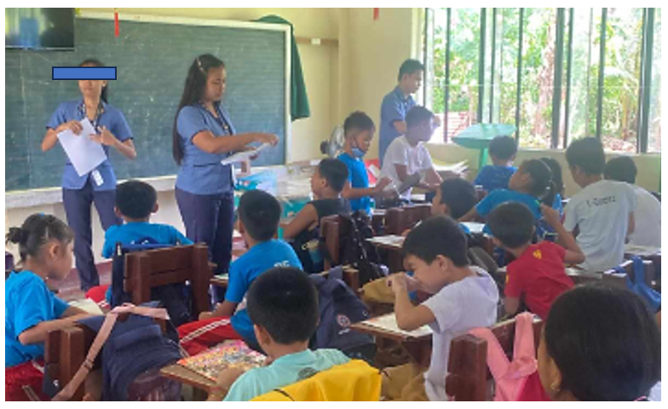

**Plate A.** The researchers conducted a pilot test with Grade 3 – Del Pilar at San Rafael Integrated School.

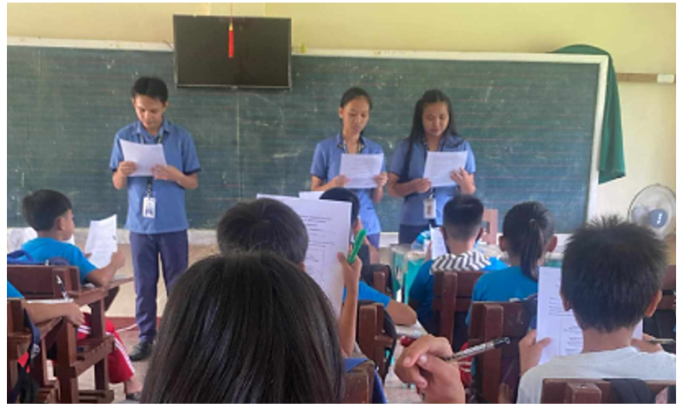

**Plate B.** The researchers conducted a pilot test with Grade 3 – Quezon at San Rafael Integrated School.

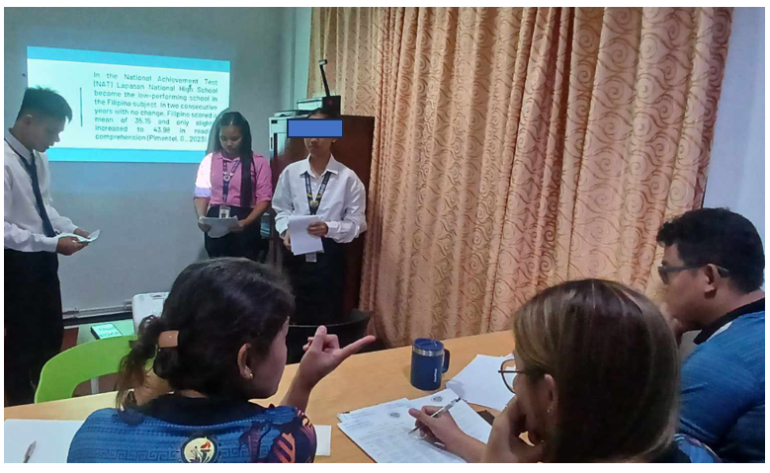

**Plate C.** The researchers presenting their Action Research (Proposal Defense).

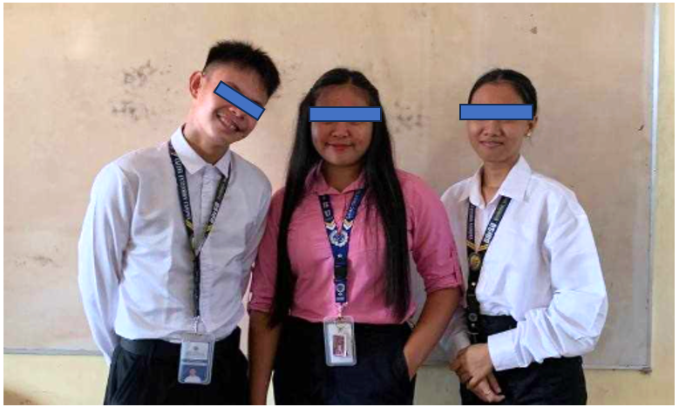

**Plate D.** Action Research proposal approved.

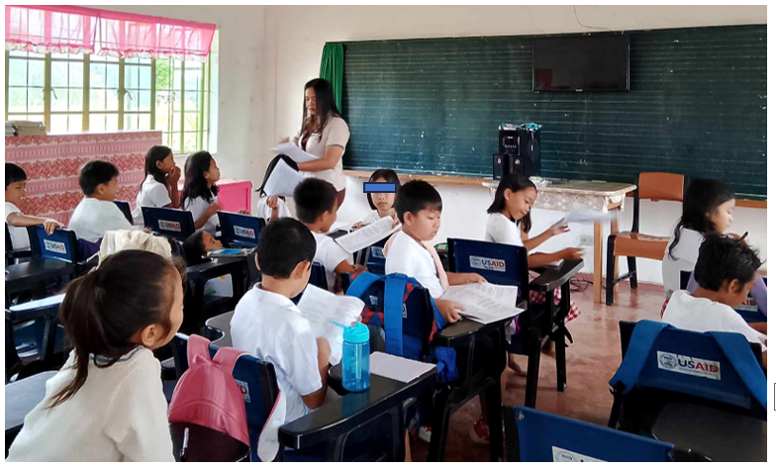

**Plate E.** The researchers distributed parental consent to the respondents of the study.

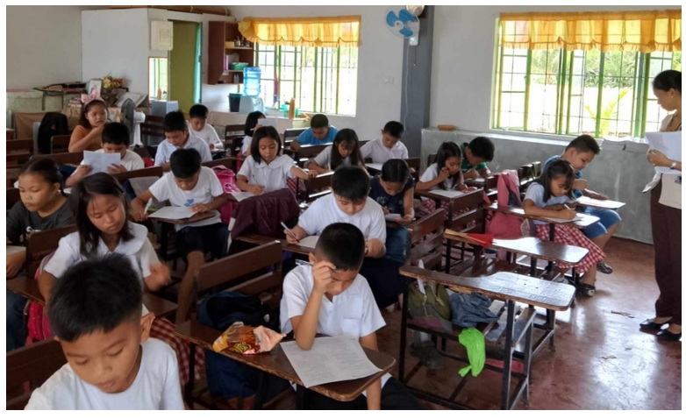

**Plate F.** The researchers conducted pre-test to the respondents.

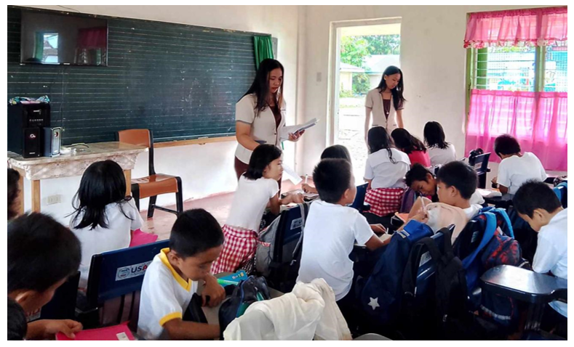

**Plate G.** The researchers conducted post-test to the respondents.

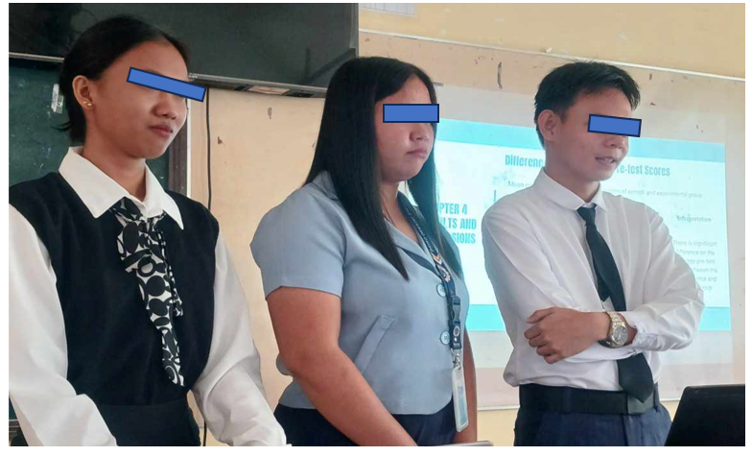

**Plate H.** The researchers presenting their Action Research (Final Defense).

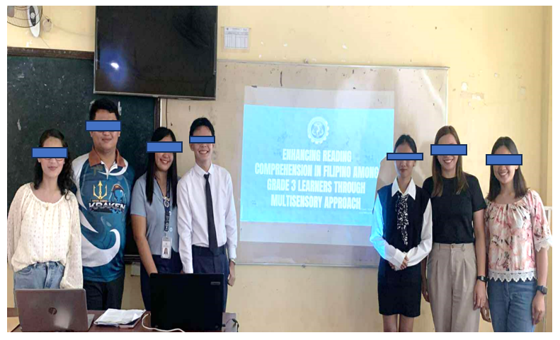

**Plate I.** Action Research defended.