Review Article

Bibliometric Analysis Based on China National Knowledge Infrastructure (2014-2024): Research Hotspots and Trends in Educational Technology Satisfaction

ABSTRACT

|  |
| --- |
| **Aims:** To analyse publication trends, core authors, research hotspots, and research trends in the field of educational technology satisfaction in China.  **Study design: Based** on 335 journal articles related to educational technology satisfaction collected from the China National Knowledge Infrastructure (CNKI) database from 2014 to 2024, a bibliometric analysis was conducted.  **Place and Duration of Study:** China, CNKI database, data range: 2014-2024  **Methodology:** CiteSpace software was used for literature visualization analysis, including publication trends, author co-occurrence, keyword co-occurrence, and keyword clustering analysis, to understand research hotspots and evolving trends in educational technology satisfaction.  **Results:** This study reveals the development trends in research related to educational technology satisfaction. In recent years, with the development and popularisation of educational technology, research on user satisfaction when applying emerging educational technologies such as AI and virtual simulation in special education fields like elderly education and vocational education has become a hot topic of interest among researchers. |

*Keywords: Satisfaction; Educational technology; Bibliometrics; Visualisation analysis*

**1. INTRODUCTION**

With the rapid development of information technology, educational technology has become the core driving force to promote education modernisation and digital transformation (Hu et al., 2025). The Chinese government also attaches great importance to the application and popularisation of educational technology, and documents related to the application of educational technology have also promoted the development of educational technology in China from a macro perspective. Satisfaction with educational technology, as an important indicator of the effectiveness of technology application and user experience, directly affects learning effectiveness, willingness to adopt technology, and the sustainable development of the educational ecosystem (Wang et al., 2019). Existing studies generally agree that educational technology satisfaction is a comprehensive evaluation of learners’ technology tools, platforms and support environments in multiple dimensions, such as technical performance, instructional design, service support, and user experience (Zhang et al., 2020). The core of this involves not only technical ease of use and usefulness (TAM model), but also complex factors such as instructional interaction design, emotional experience and cultural appropriateness (Zhao et al., 2022). In recent years, the popularity of emerging technologies such as artificial intelligence and big data has further expanded the connotation of satisfaction with educational technology, shifting it from a single assessment of technology acceptance to a dynamic and localised multidimensional analysis (Liu et al., 2023; Hu, et al., 2025).

However, current research still faces significant challenges. On the one hand, the research methodology overly relies on questionnaire surveys, with insufficient qualitative analyses and longitudinal tracking, resulting in limited explanatory power for dynamic changes in satisfaction (Spector, 2001); on the other hand, the research population focuses on the tertiary student population, with less attention paid to the basic education level, adult learners and teachers, which limits the generalisability of the findings (Schwabe et al., 2015 ). In addition, most theoretical frameworks follow the classical technology acceptance models (e.g., TAM, UTAUT), lack in-depth adaptation to local educational contexts, and insufficiently explore soft factors such as social interaction and learning autonomy (Chen et al., 2020; Hu et al., 2025). Against this background, this paper aims to systematically sort out the theoretical development, research hotspots and practical challenges of satisfaction with educational technology in China, and answer the following research questions.

1)What is the trend of publication of educational technology satisfaction in China?

2) Who are the main contributors in terms of authors on educational technology satisfaction in China?

3) What are the most frequently discussed hotspots and evolving trends in the educational technology in China?

This study aims to help researchers in related fields and teachers in general to understand the trend of development of educational technology satisfaction in China, the hotspots of research and the direction of future research, with a view to providing new ideas and references for future research, and to provide theoretical support for the cultivation of technologically innovative talents and the digital transformation of education under the strategy of a strong education nation.

# 2. methodS

This study adopts a combination of systematic literature review and scientific knowledge mapping analysis, aiming to systematically sort out the research hotspots, evolutionary veins and cutting-edge trends in the field. This study used the visual bibliometric tool CiteSpace to quantitatively analyse the screened literature, which is capable of visualising and analysing the authors, research institutions, citation development, and research keywords of the selected literature, and is able to summarise and predict the development trend of the research in the relevant fields (Liu&Mustapha, 2023). In recent years, this software has been widely used in literature analysis (Yin et al., 2023).

## 2.1 Research Design

The research design of this study consisted of three main parts: literature collection and screening, identification of research criteria and data analysis.

The source of data for this paper is the China National Knowledge Infrastructure (CNKI) database, which is the highest quality, most authoritative, and most widely used scientific database in China (Huang, 2022). In this study, this database was used to search the literature related to satisfaction with educational technology, which allows us to derive complete information about the literature, such as the author’s name, the title of the article, the author’s research institution, and the year of publication.

According to the purpose and research questions of this study, the following literature search criteria were set. First of all, this study determined the range of publication time of retrieved literature from 1st January 2014 to 31st December 2024, the type of literature is journal articles, and the language is Chinese literature. Meanwhile, in order to better retrieve the literature related to educational technology satisfaction, the researcher used Boolean expressions (title/abstract/title: educational technology satisfaction or online learning satisfaction or online learning satisfaction).

The data analysis in this study used CiteSpace, a tool developed by Professor Chao-Mei Chen, which is a literature visualisation and measurement tool based on the Java language, and which allows quantitative statistics based on a large amount of information from literature data. The use of this tool in literature research can effectively avoid subjectivity and bias (Donthu et al., 2021).

## 2.2 Data Collection

The researcher searched for literature containing “satisfaction with educational technology”, “satisfaction with online learning” or “satisfaction with online learning” in titles, keywords and abstracts, and the publication dates were from 1 January 2014 to 31 December 2024. From 1 January 2014 to 31 December 2024, a total of 2308 journal articles were obtained in Chinese.

After obtaining the preliminary screening by keywords, titles and abstracts, 60 duplicate documents were eliminated from repetition, and then the remaining 2248 documents were manually screened. The manual screening was mainly to review the titles, keywords and abstracts of the articles, and after eliminating irrelevant documents, a total of 336 documents were obtained in this study. After importing these documents into CiteSpace, formatting and de-weighting, a total of 335 documents were available for subsequent statistics.

# 3. results and discussion

## 3.1 Trend of publication

This study begins with a publication trend of valid literature between 2014-2024. As shown in the figure below, research related to satisfaction with educational technology has gone through four phases. The first stage, from 2014 to 2016, is the initial exploration period; 2017 to 2019 is the second stage, the rapid growth period; the third stage, from 2020 to 2022, this stage is the explosive growth period; and the fourth stage, from 2023 to 2024, is the rational retracement period.

Fig. 1. Publication trends of educational technology satisfaction study in China (2014-2024)

From 2014 to 2016, the number of related studies grew slowly, and the studies in this phase mainly explored the research on satisfaction with educational technology. The studies in this stage mainly focus on students’ satisfaction with the flipped classroom (Zhai & Lin, 2014; Cao, 2014; Mei, 2015; Xue & Zheng, 2016; Cui, 2016). The research in this stage focuses on a single educational technology tool, and the target of the research is mostly college students (Liu, 2014; Hu & Zhao, 2015; Liu et al. 2016; Jiang & Chen, 2016) . Therefore, this stage can be regarded as the exploratory stage of educational technology satisfaction research in China.

The period of 2017-2019 is a period of accelerated growth in related studies, with the promulgation of national policies as well as the publicity and promotion of modern educational technology, the number of related studies has gradually risen. From the studies in this phase, there are more types of educational technology. Some studies also still focus on the satisfaction of the flipped classroom (Hara et al. 2017; Wu, 2017; Lu & Ma, 2018; Zhang et al. 2019), but the studies on the satisfaction of the flipped classroom show a decreasing trend year by year. On the contrary, more and more researchers at this stage began to focus on the satisfaction of blended learning (Shi et al. 2017; Qiao, 2017; Zhang, 2018; Yang et al. 2019; Wang, 2019; Lu et al. 2019), the satisfaction of Internet+education (Wu, 2017; Tian & Nie, 2018; Zhang et al. 2019), and the satisfaction of MOOC learning (Dai et al. 2017; Shi et al. 2018; Yang et al. 2019; Du, 2019) and mobile learning satisfaction (Su et al. 2017; Zhang & Jiang, 2018; Zheng, 2019) . In this phase, the increase in the number of related studies has increased, and not only are there more types of educational technologies involved in the studies, but also more diverse groups of students involved in the studies.

After 2020, driven by the New Crown epidemic, online teaching becomes a normalised tool, leading to an explosive growth in related research, peaking in 2022. In the early stage of this phase, influenced by the new crown epidemic, Chinese schools at all levels and all types of large-scale, long-time online teaching, so this phase of the research is basically centred on the “online learning satisfaction”; then, the beginning of the online and offline courses in the form of a combination of teaching, so some researchers have carried out studies on the “blended learning satisfaction”. A number of researchers have actively explored different pedagogical models at both the theoretical and practical levels (Yao & Xu, 2020; Yao & Zhang, 2020; Xing, 2020; Yu & Tan, 2021; Niu et al. 2021; Zhou, 2022; Zhang et al. 2022), and these researchers have explored a variety of strategies, methods, and modes of blended teaching and learning online, or on-line and off-line, from the perspective of teaching and learning practical experience.

As the duration of online teaching has increased, some researchers have focused on the evaluation of online teaching. Some researchers focus on the evaluation of the overall behaviour and effects of online learning (Zhou, 2020; Liu & Sun, 2020; Wu & Zhu, 2021; Wu et al. 2021; Chen et al. 2022), while others focus on the evaluation of the quality of resources and technical support in the process of online learning (Qian & Bao, 2020; Wang, 2022).

Other researchers have noted the characteristics of online learning in different subjects, so some studies have looked at the characteristics of a subject to explore the satisfaction of educational technology in that subject. For example, Lingling Wang (2020), Zhang et al. (2021), Xiao and Xiao (2021), and Rongrong Yin and Zhiyong Zhang (2022) analysed and studied students’ satisfaction with online learning in practical courses such as Critical Care Emergency Medicine, Ball Games, and Engineering Manufacturing. The researchers discussed the factors affecting students’ learning satisfaction in terms of the characteristics of such courses, advantages and disadvantages of online learning. The researchers generally agreed that online live and recorded courses alone could not meet the learning needs of students, which led to lower satisfaction; but on the other hand, with the help of some virtual simulation technology and animation demonstrations, students could better understand the operation steps and processes.

From 2023 onwards, Chinese education in the post-epidemic era basically returns to the traditional offline teaching mode, so the number of related studies declines slightly. However, because of the rapid popularisation of AI technology and other technologies, as well as the state’s vigorous promotion and popularisation of modern education technology, research on satisfaction with education technology has also undergone some subtle changes. Researchers have analysed the topic more rationally, and the research has become more detailed and in-depth, and more diverse. The trend reflects the growing concern of society and the education system about the quality of online learning, and the issue of satisfaction has come to the forefront.

## 3.2 Author Co-occurrence Analysis

A number of core authors have played an important role in the development of various fields, and co-operation between authors can expand the scope of research, dig deeper into a particular topic, and also enable cross-disciplinary research, providing fruitful results and a solid foundation for subsequent research. Therefore, this study attempts to conduct author co-occurrence analysis through CiteSpace, so as to discover China’s current core authors in the field of satisfaction with educational technology. As can be seen from Figure 2, Qian Xiaolong, Zhang Chunmei, Liu Hongxia, Yang Jingjing and Liu Yanfei are the researchers with more publications at this stage, but the overall author network still has a loose structure. The sparseness of the collaborative network affects the integration and continuity of the research, and collaborative research should be strengthened in the future through subject group alliances and data sharing mechanisms.

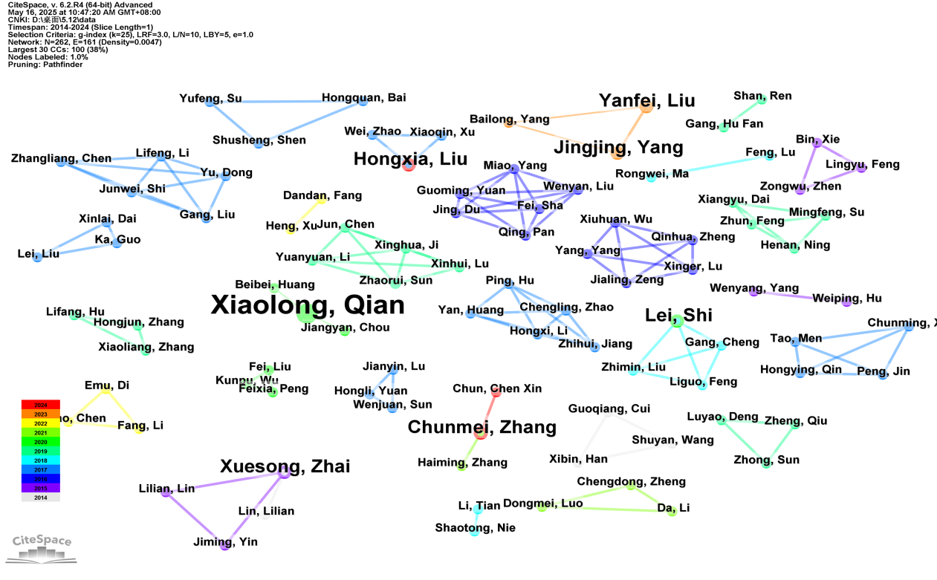

Fig. 2. The co-occurrence author research of educational technology satisfaction in CNKI (20124-2024)

From the point of view of the amount of articles and research content, Qian Xiaolong published a total of 4 articles during this period, and the content of the studies in this period focuses on the study of China’s catechism quality evaluation, which analyses and researches the quality evaluation of catechism courses from different courses and semesters (Qian & Guo, 2020; Qian, Qiu, et al. 2020; Qian, Wu, et al. 2020; Qian & Bao, 2020). The 2 articles by Jingjing Yang and Yanfei Liu are both studies on hybrid teaching models at the higher education level (Yang, Liu & Yang, 2023; Yang, Liu & Li, 2023) . Liu Hongxia’s similarly focused college students’ satisfaction with educational technology, whose early research was on the factors influencing satisfaction with online learning (Xu, Xiaoqing, Zhao, Wei & Liu, 2017), has also begun to turn her attention to AI+education with the development of time and educational technology (2024), which is the same as the overall development trend of the previous analyses. Also focusing on satisfaction with educational technology at the higher education level, Chunmei Zhang discusses her research on student satisfaction with the use of educational technology in teaching and learning, using the nursing programme as an example (2021; 2024).

The analysis of the co-occurrence of authors shows that although there are a large number of authors who have carried out research on satisfaction with educational technology, there is a very loose co-operation between the authors, as well as a lack of leaders in this field. This indicates that research on satisfaction with educational technology in China is still in the initial stage, and some representative researchers and research works have not appeared. Therefore, the second question of this study is about the main contributors to the current stage of research on satisfaction with educational technology in China, which is not found at present.

## 3.3 Keywords Analysis

### **3.3.1 Keywords Co-occurrence Analysis**

Keywords are a high degree of generalization and condensation of the topic of the literature, and by analyzing the high-frequency keywords of the literature, we can reveal the hotspots and trends of the research in this field and the relationship between the research topics (Luo et al., 2021). Through the keyword co-occurrence mapping in Figure 3, it is found that “online learning satisfaction” “online learning” and “information technology” “online teaching ”, “online teaching” and “learning outcomes” are the most frequently occurring keywords, which indicates that the current research on educational technology satisfaction in China focuses on the technology system level and teaching and learning outcomes. This suggests that the current research on satisfaction with online learning in China focuses on the technical system level and the teaching mode level.

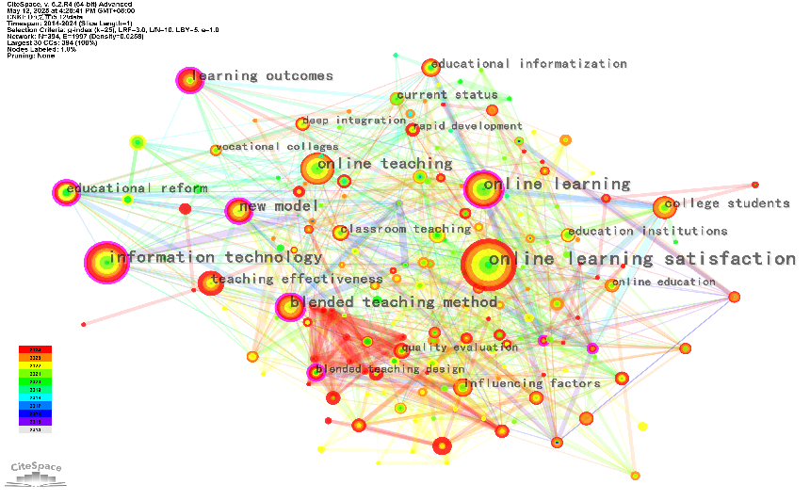

Fig. 3. The co-occurrence keywords research of educational technology satisfaction in CNKI (2014-2024)

Table 1 below shows the top ten keywords after eliminating invalid samples and combining synonyms. As can be seen from the data in the table, during the period of 2014-2015, most researchers focused on the two aspects of teachers’ teaching and students’ learning, and the research object was mainly college students. Thereafter, with the depth of research, quantitative research methods such as questionnaires began to be introduced into such studies. In 2020, with the outbreak of COVID-19, online teaching has become a normalized means of teaching and learning, so many scholars have begun to study online teaching practices.

Table 1 Top 10 Keywords of educational technology satisfaction in CNKI (2014-2024)

|  |  |  |  |  |
| --- | --- | --- | --- | --- |
| N | Count | Centrality | Year | Keywords |
| 1 | 185 | 0.04 | 2014 | online learning satisfaction |
| 2 | 98 | 0.04 | 2015 | information technology |
| 3 | 72 | 0.13 | 2014 | online learning |
| 4 | 55 | 0.05 | 2014 | online teaching |
| 5 | 51 | 0.04 | 2018 | learning outcomes |
| 6 | 47 | 0.15 | 2014 | college students |
| 7 | 36 | 0.09 | 2015 | educational reform |
| 8 | 34 | 0.05 | 2015 | blended learning |
| 9 | 33 | 0.08 | 2017 | questionnaire survey |
| 10 | 31 | 0.02 | 2020 | practical teaching |

### **3.3.2 Keywords Clustering Analysis**

Summarizing high-frequency keywords can reflect the theme of the literature and further reflect research hotspots (Liu, 2025). Keyword cluster analysis can effectively reflect important nodes and key connections in keywords. In order to better understand the research keywords related to online learning satisfaction, this study conducted a cluster analysis of keywords.

This study employs log-likelihood ratio (LLR) weighting algorithms for keyword clustering analysis. The results of the clustering analysis are shown in Figure 4. The current study can be summarized into six major thematic clusters: educational informatization, teaching reform, learning assessment, teaching model, learning assessment, and educational institutions. These six clusters respectively address dimensions such as technology integration, teaching innovation, evaluation systems, model design, process experience, and institutional differences, thereby constructing a comprehensive framework for research on online learning satisfaction.

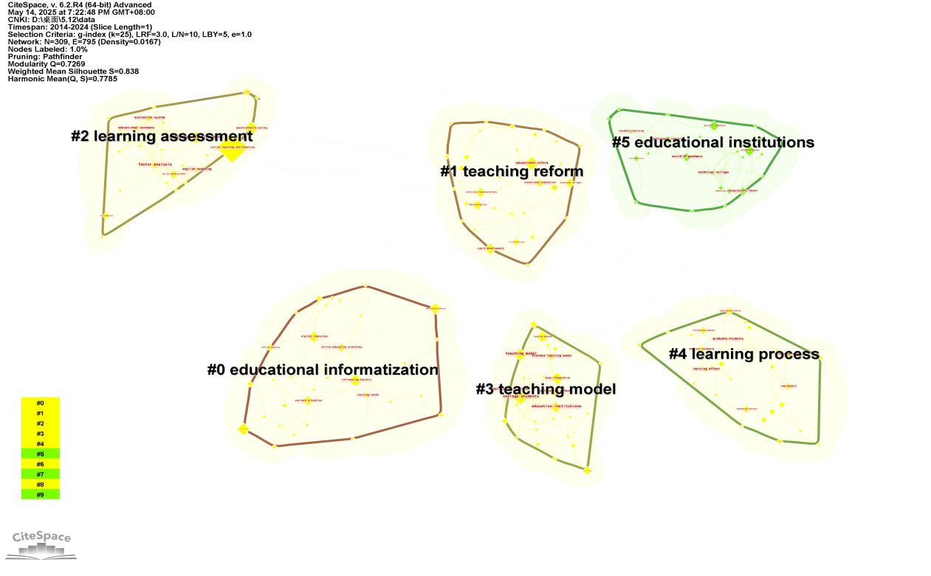

Fig. 4. The keywords clustering network of educational technology satisfaction in CNKI (2014-2024)

The first cluster is educational informatisation. Research under this cluster primarily focuses on the deep integration of information technology and education and teaching, exploring how digital tools achieve the goals of optimising learning environments and resource allocation in the context of educational informatisation. For example, Xue Wenfei et al. (2022) further pointed out in their study under the context of educational informatisation 2.0 that the stability of online teaching platforms and the intelligence of resource recommendations (such as personalised learning path recommendations) are key factors in enhancing graduate students’ online learning satisfaction. Additionally, Gao Jiangjiang et al. (2018) found in their MOOC virtual experiment study that the immersive experience of VR technology can enhance learners’ perception of task value, indirectly improving satisfaction, providing empirical support for the technological applications of educational informatisation. The core of educational informatisation lies in breaking through temporal and spatial constraints to promote resource sharing. For example, the National Open University leverages its nationwide online network to achieve inclusive education through the “Internet + Education” model (Zhang, 2022), while universities enhance teaching interactivity through smart classrooms and AI-assisted learning tools (Xue et al., 2022). These research findings indicate that advancements in educational technology are foundational conditions for optimising online learning satisfaction.

The second cluster is educational reform, with research in this cluster focusing more on innovation in teaching concepts and implementation paths in online learning. For example, Qi Lina et al. (2021) found that in blended learning research, the “online independent learning + offline flipped classroom” model can significantly improve undergraduate students’ learning engagement, and this teaching model also plays an intermediary role in the relationship between online learning participation and satisfaction. This conclusion is similar to the findings of Jiang Zhihui et al. (2018), who found that emotional support in teacher support services (such as timely feedback and motivation enhancement) is a core element of teaching reform, especially in live streaming scenarios, where teachers’ real-time interaction capabilities have a weight of 0.48 on students’ learning satisfaction (Jiang et al., 2017). Zhu Liancai et al. (2020) further pointed out that online teaching should shift from “knowledge transmission” to “skill development,” such as enhancing students’ active participation through project-based learning (PBL), which complements the teaching reform philosophy of traditional classrooms. Additionally, teaching reforms in an online learning context should also consider learner differences. Wu Shengxiong (2021) found, based on the theory of demand boundaries, that older learners prefer a “simple platform + socialised learning” model, which requires teaching reforms to adjust teaching strategies for different groups.

Learning assessment constitutes the third cluster, which focuses on the construction of an evaluation system for online learning outcomes. As research on educational technology satisfaction has deepened, some researchers have begun to focus on evaluating the effectiveness of educational technology applications in teaching and learning. For example, Yan Kailun et al. (2021) used deep learning algorithms to measure the weights of influencing factors and found that subjective evaluation indicators such as learning motivation and content usefulness are key predictors of satisfaction, providing quantitative evidence for the evaluation system. Gao Jiangjiang et al. (2018) employed structural equation modelling (SEM) in a virtual experiment study to construct a three-dimensional evaluation framework of “experimental design rationality — operational experience — knowledge mastery,” confirming that formative evaluation (such as real-time feedback and process recording) is more effective than summative evaluation in enhancing satisfaction. Shen Zhonghua et al. (2020) conducted an empirical analysis using structural equation modelling and found that learning evaluation should balance cognitive engagement and emotional experience, while traditional evaluation methods centred on scores have limitations. Xu Xiaoqing et al. (2017) further proposed that online learning evaluation should incorporate dimensions such as technology acceptance and social interaction quality to form a multi-dimensional evaluation system. These researchers employed different methods to study and analyse online learning evaluation from various dimensions.

The fourth cluster is teaching models, which focuses on the organisational forms and implementation strategies of online learning. For example, Jiang Zhihui et al. (2017) compared live and recorded broadcast scenarios and found that in live broadcasts, teachers’ professional knowledge and real-time support had a significant impact on satisfaction, while recorded broadcasts relied more on course content design (such as video pacing and knowledge point breakdown). This conclusion provides a basis for choosing different teaching models for different scenarios. The construction of personalised teaching models is another research focus. Wu Shengxiong (2021) proposed the “demand boundary theory” for elderly learners, suggesting that tasks should be designed based on learners’ ability boundaries. His research showed that this model could increase satisfaction by 32%. Cui Guoqiang et al. (2014) found that locus of control tendencies (internal vs. external) do not affect online learning satisfaction. This result suggests that teachers should focus on universal design when designing teaching models, balancing the personalized needs of special groups.

The fifth cluster is the learning process, which focuses on the behavioural and psychological characteristics of learners during the learning process when applying educational technology. Guo Lijun et al. (2022) confirmed that learning engagement plays a partial mediating role between teacher care and satisfaction, with motivation and concentration being the key mediating variables. This aligns with the findings of Qi Lina et al. (2021), who found that higher learning engagement leads to a stronger positive impact of online participation on satisfaction. Shen Zhonghua et al. (2020) used structural equation modelling to discover a chain-like association between self-efficacy, perceived task value, and satisfaction during the learning process: learners with higher self-efficacy are more likely to perceive task value, thereby enhancing learning persistence. Xu Xiaoqing et al. (2017) further noted that interactive behaviours in online learning (such as teacher-student interaction and group collaboration) can significantly reduce cognitive load and optimise the learning experience. The studies under this cluster analyse students’ learning processes supported by educational technology from different dimensions.

The sixth cluster of educational institutions focuses on the differences in the implementation of online education among various types of educational institutions under this keyword cluster. For example, Zhang Xueyan (2022) found through an explanatory structural model that student satisfaction at open education institutions is more significantly influenced by self-efficacy and teacher-student interaction, while students at general universities place greater emphasis on course quality and technical support. Xue Wenfei et al. (2022) compared “Double First-Class” universities with general institutions and found that the former, due to abundant resources (such as high-quality MOOCs and professional technical teams), had student online learning engagement 27% higher than the latter. Xiong Yijing et al. (2020) conducted a large-scale survey of vocational students, showing that online learning satisfaction in vocational education institutions is closely related to the design of practical components, such as the “theory live streaming + virtual practical training” model, which can enhance the learning outcomes of skill-based courses. Zhu Liancai et al. (2020) emphasised that universities need to establish a three-pronged support system comprising “platform maintenance — teacher training — student support.” For example, providing online teaching technology training for teachers and setting up a 24-hour technical consultation hotline for students can increase satisfaction by 15%–20%. These studies demonstrate that educational institutions of different types and at different stages are influenced by varying factors due to differences in teaching objectives, student learning situations, and teaching resources, thereby affecting student satisfaction with educational technology.

The results of the keyword cluster analysis show that current research on satisfaction with educational technology in China has entered a multi-dimensional research era. Researchers have conducted surveys, analyses, and discussions on user satisfaction at various stages of educational technology application. These results provide a solid theoretical and practical foundation for the development and application of educational technology in China.

## 4. Discussion

This study examines 336 pieces of literature related to educational technology satisfaction published between 2014 and 2024 and indexed in CNKI. Through bibliometric statistical analysis, it reveals the development trajectory of educational technology satisfaction research in China. The study found that from 2014 to 2024, the overall number of studies on educational technology satisfaction in China showed an upward trend. Specifically, the number of studies increased annually from 2014 to 2022, and entered a rapid growth phase starting in 2020 due to the COVID-19 pandemic. However, after 2023, while the number of studies on educational technology satisfaction slightly decreased, the research content became more in-depth, particularly in areas such as the application and research of AI technology in education. This result indicates that research on educational technology satisfaction continues to evolve with the development of educational technology, with research content becoming increasingly diverse.

Co-author research analysis has found that there are currently no experts in the field of educational technology satisfaction research, and research results are scattered, with no mature research team yet formed. This indicates that China is still immature in the field of educational technology satisfaction research, and relevant researchers are still in the exploratory stage.

The results of the keyword frequency analysis show that “online learning satisfaction” “information technology” and “teaching models” have consistently been the core focus of research. Notably, after 2020, the frequency of emerging terms such as “virtual simulation” and “AI + education” has significantly increased, while research on “flipped classrooms” has shown a decreasing trend. This indicates that the development of educational technology directly influences the research direction of educational technology satisfaction. Additionally, the keywords reveal that the primary research population consists of university students and vocational college students, with vocational colleges accounting for a notably higher number of studies compared to other institutions. Based on the above results, it is evident that future research will primarily focus on educational technology satisfaction studies within vocational education.

Keyword cluster analysis indicates that current research on educational technology satisfaction has preliminarily formed a closed-loop system comprising “technology empowerment - model innovation - evaluation feedback.” Educational informatisation serves as the foundation for educational technology satisfaction, providing the necessary technical support for the application and research of related educational technologies. Teaching reform and instructional design constitute the core, with the primary objective of educational technology satisfaction research being to fully leverage the advantages of educational technology to address the shortcomings of traditional teaching methods through its reasonable application in instructional design. The learning process and evaluation feedback act as the bridge in educational technology satisfaction research, enabling an understanding of students’ satisfaction with educational technology through studies on the evaluation and feedback of their learning processes and outcomes.

## 5. Conclusion

This paper employs bibliometric analysis to examine the status of research on educational technology satisfaction in China from 2014 to 2024. The study selected 335 journal articles on educational technology satisfaction published between 2014 and 2024 and indexed in the CNKI database as the sample. Using CiteSpace software, the publication trends, authors, and keywords of these documents were analysed visually. In terms of publication volume, the number of studies increased steadily from 2014 to 2022; although there was a slight decline after 2023, the overall research trend remains upward. Currently, there are many researchers in this field, but in terms of publication volume, there are no expert researchers or research teams in this field. Based on the keyword analysis results, it is evident that student and teacher satisfaction with advanced educational technologies such as AI, virtual simulation, and virtual laboratories during their application is the current focal point of research. Additionally, research on educational technology satisfaction in vocational education and elderly education has also shown a significant upward trend.

This paper can provide some references for future research in the field of educational technology satisfaction. However, this study still has some limitations. For example, due to format restrictions, the Citespace software cannot perform co-citation analysis on the references used in papers in CNKI, which may lead to the omission of some highly cited studies during the analysis process. Future research hopes to address these shortcomings.

References

Chen, M., & Zhou, T. (2020). Research on the relationship between learner satisfaction and learning outcomes in blended teaching mode. Journal of Distance Education, 41(8), 63-69.

Cui, G. Q., Han, X. B., & Wang, S. Y. (2014). Effects of students’ locus of control and other characteristics on their satisfaction with online learning. China Educational Technology, (8), 55–61.

Donthu, N.; Kumar, S.; Mukherjee, D.; Pandey, N.; Lim, W.M. How to Conduct a Bibliometric Analysis: An Overview and Guidelines. J. Bus. Res. 2021, 133, 285–296.

Gao, J. J., & Yu, P. (2018). Research on influencing factors of students’ virtual experiment learning satisfaction in MOOC environment. Experimental Technology and Management, 35 (1), 221–225.

Gao, J. J., & Yu, P. (2018). Research on influential factors of students’ satisfaction in virtual experiment learning under MOOC environment. Experimental Technology and Management, 35 (1), 221–225.

Guo, L. J., & Hu, H. Q. (2022). The relationship between teacher care and college students’ learning satisfaction in online teaching: The mediating role of learning engagement. Forum on Contemporary Education, (2), 42–50.

Hu, F., Wang, H., & Liu, M. (2025). Reaching the heights, anchoring the foundations: Pathway exploration for educational technology in the intelligence era. China Educational Technology, 460, 32-41.

Jiang, Z. H., & Zhao, C. L. (2018). Learner satisfaction: The ultimate destination of teacher support behavior in online learning. Modern Distance Education, (6), 51–59.

Jiang, Z. H., Zhao, C. L., Li, H. X., Hu, P., & Huang, Y. (2017). Influential factors of online learners’ satisfaction: A comparison between live broadcast and recorded broadcast contexts. Open Education Research, 23 (4), 76–85.

Li, H., & Liu, Q. (2021). Investigation and analysis of online learning satisfaction in universities under the COVID-19 pandemic. Modern Educational Technology, 31 (3), 78-85.

Liu, F., & Mustapha, S. M. (2023). Bibliometric Analysis (2012 - 2022) of Research Hotspots and Trends on Technological Pedagogical and Content Knowledge in China. European Journal of Computer Science and Information Technology, 11 (3), 24 - 43.

Luo, K. J., Zhang, Y. Y., & Li, Z. (2021). Changes in the academic field of public health event research in China: A visual analysis based on CiteSpace knowledge mapping (2000–2019). Journalism University, (5), 22–39, 121–122.

Qi, L. N., Xu, L. Y., Ma, S. H., et al. (2021). The mediating effect of undergraduates’ learning engagement on the relationship between online learning participation and learning satisfaction under the blended teaching model. Chinese Journal of Rehabilitation Medicine, 36 (10), 1283–1286.

Schwabe, F., McElvany, N., & Trendtel, M. (2015). The school age gender gap in reading achievement: Examining the influences of item format and intrinsic reading motivation. Reading Research Quarterly, 50 (1), 1-14. <https://doi.org/10.1002/rrq.123>

Shen, Z. H., & Wu, D. G. (2020). Exploration of the influencing factors of college students’ online learning effectiveness and satisfaction—An empirical analysis based on structural equation modeling. Research in Educational Development, 40 (11), 25–36+59.

Shen, Z. H., & Wu, D. G. (2020). Exploration of the influencing factors of college students’ online learning effectiveness and satisfaction—An empirical analysis based on structural equation modeling. Research in Educational Development, 40 (11), 25–36+59.

Spector, J. M. (2001). An overview of progress and problems in educational technology. Interactive Educational Multimedia, 3, 27-37.

Wang, Y., Zhang, L., & Zhao, L. (2019). Research on influencing factors of online learning satisfaction based on the TAM model. China Distance Education, 39 (5), 45-52.

Wu, S. X. (2021). Research on online learning needs and satisfaction of elderly students based on the demand boundary theory. Adult Education, (8), 22–30.

Xiong, Y. J., & Wu, Q. S. (2020). Investigation on online learning satisfaction of secondary vocational students under the background of “suspending classes without stopping learning"-Based on the survey and analysis of 27,199 secondary vocational students. Chinese Vocational and Technical Education, (29), 40–48.

Xu, X. Q., Zhao, W., & Liu, H. X. (2017). Research on the influencing factors of college students’ online learning satisfaction. Distance Education in China, (5), 43–50+79–80.

Xue, W. F., Li, J., & Zhang, P. F. (2022). Analysis of online learning satisfaction of full-time postgraduates under the background of Education Informatization 2.0. Journal of Hebei Normal University (Educational Science Edition), 24 (3), 69–73.

Yan, K. L., Wang, H. L., & Li, M. C. (2021). Research on online foreign language learning satisfaction and influencing factors among college students. Foreign Language World, (5), 23–32.

Yin J. J., Alias, A. H., Haron, N. A., & Abu Bakar, N. (2023). A Bibliometric Review on Safety Risk Assessment of Construction Based on CiteSpace Software and WoS Database. Sustainability, 15(15), 11803. <https://doi.org/10.3390/su151511803>

Zhang, X. Y., & Sun, L. X. (2022). Study on the influencing factors of online learning satisfaction of open education students based on interpretive structural model. Adult Education, (3), 48–57.

Zhao, L., & Wang, Y. (2022). Research on the influence mechanism of learning motivation on online learning satisfaction. China Educational Technology, 41 (12), 102-109.

Zhu, L. C., Wang, N., & Du, Y. T. (2020). Research on college students’ online learning satisfaction, its influencing factors and promotion strategies. Journal of the National Academy of Education Administration, (5), 82–88.