*Original Research Article*

**PUBLIC SCHOOL TEACHERS’ STANDPOINT ON VALIDATING ACADEMIC UPRIGHTNESS IN ELEMENTARY EDUCATION: A CONCEALED VERACITY**

.

ABSTRACT

|  |
| --- |
| This study aimed to explore the standpoints, coping mechanisms, and educational insights of elementary teachers in promoting and sustaining academic uprightness in the classroom. A qualitative research design using in-depth interviews was employed. Participants were elementary school teachers who shared their experiences and reflections on academic integrity. Thematic analysis was applied to categorize responses into meaningful themes that reflect their perspectives and strategies Findings revealed three major thematic areas: (1) Teachers’ standpoints toward promoting academic uprightness, which included personal commitment to integrity, fostering student accountability, and the role of the school environment; (2) Coping strategies against student dishonesty, encompassing proactive prevention, disciplinary measures, and open communication; and (3) Educational insights gained, such as the emphasis on character education, modeling ethical behavior, and strengthening school-home collaboration. Teachers perceived themselves as central agents in cultivating a culture of integrity, emphasizing the need to lead by example and uphold school-wide standards. Coping with dishonesty requires both preventive and responsive strategies, including empathetic communication. The study also highlighted the importance of holistic character education and strong partnerships between school and home to reinforce upright values consistently. These insights underscore the multifaceted role of educators in maintaining academic integrity and call for institutional support to sustain ethical teaching practices. |

*Keywords: Academic Uprightness, Elementary Education, Public Elementary Teachers*

1. INTRODUCTION

Academic dishonesty remains an underexplored yet persistent issue in elementary education, often veiled under practices that subtly compromise academic integrity. These include grade inflation, submission of plagiarized work, and unmerited academic recognitions. Teachers, who are at the frontline of instruction and assessment, sometimes experience pressure to manipulate academic results to meet institutional expectations or parental demands. This concealed form of misconduct not only distorts learners’ true capabilities but also undermines the values of fairness, honesty, and accountability that elementary education aims to instill (Daviers, 2023). Despite its long-term consequences on learner development, this issue is often normalized or left unaddressed, making it imperative to examine the perspectives of those directly involved in the academic evaluation process (Lim, 2024).

Globally, academic integrity is a growing concern, even at the foundational levels of education. In the United States, studies have reported increasing incidents of cheating and grade manipulation starting as early as elementary school, driven by high-stakes testing and performance-based funding (Weisbrod, 2025). In China, educational reforms have been implemented to curb the systemic culture of dishonesty in schools, yet challenges persist due to intense academic competition (Gow & Sun, 2024). Similarly, in Kenya, pressure to produce high-performing students in national examinations has led to ethical lapses in classrooms, including compromised assessments and favoritism (Pederson, 2025). These examples reflect a common global thread: the struggle to uphold academic uprightness amidst systemic pressures and unrealistic expectations.

In the Philippines, the issue of academic dishonesty in public elementary schools is a silent dilemma that many educators contend with. Teachers often encounter subtle coercions to adjust grades, pass failing students, or overlook misconduct to avoid conflicts with parents, administrators, or supervisors (Aguilar, 2021). The implementation of the K to 12 curriculum and DepEd’s policy on inclusive education has, at times, inadvertently contributed to unrealistic academic expectations, prompting teachers to resort to unethical grading practices (Cimene, 2024). Moreover, the lack of a robust monitoring system and clear enforcement mechanisms leaves room for these practices to persist unchallenged. As a result, the credibility of educational outcomes may be compromised, casting doubt on the authenticity of learners’ academic progress (Nwozor, 2025).

This study aimed to explore the lived experiences of public elementary school teachers in validating academic uprightness amid systemic and contextual challenges. Specifically, it sought to understand the challenges they faced in upholding academic integrity, the coping mechanisms they employed when confronted with ethical dilemmas, and the insights or lessons they derived from navigating these experiences. By uncovering the concealed veracity behind assessment practices, the study hoped to shed light on the realities of academic honesty in the elementary education system and offer practical recommendations for policy and pedagogical reforms.

**1.1 Purpose of the Study**

The purpose of this study was to examine the lived experiences of public elementary school teachers in validating academic uprightness within the framework of quality and ethical education. Anchored on the principles of the United Nations Sustainable Development Goals, particularly SDG 4 (Quality Education) and SDG 16 (Peace, Justice, and Strong Institutions), this research aimed to uncover the realities behind academic assessment practices and the ethical dilemmas encountered by educators. By exploring the challenges they faced, the coping strategies they employed, and the insights they gained, the study sought to contribute to the promotion of a just, inclusive, and morally grounded educational system. The findings aimed to inform policy directions, reinforce institutional accountability, and strengthen the ethical foundation of elementary education in pursuit of sustainable and equitable learning outcomes.

**1.3 Research Questions**

Teachers at the frontline of education frequently encountered instances of academic dishonesty, which challenged their efforts to uphold integrity and moral values within the learning environment. This phenomenological inquiry sought to explore their lived experiences in promoting academic uprightness amidst these challenges. The study was guided by the following research questions:

1. What are the perceptions and standpoints of public elementary school teachers regarding the promotion of academic uprightness in the classroom?
2. How do public elementary school teachers cope with instances of academic dishonesty among their students?
3. What educational insights and lessons have public elementary school teachers gained in their efforts to uphold academic integrity?

2. methodology

**2.1 Philosophical Assumptions of the Study**

The interview questions assumed that all participants would provide honest and thorough answers. The participants of the study were considered representative of in-depth face-to-face conversations. Axiology, methodology, ontology, and epistemology were all central beliefs that shaped the research. These philosophical assumptions were explored and discussed in terms of how they could be integrated into qualitative research and related to other interpretive frameworks within the research process.

**2.2 Qualitative Assumptions**

This study was grounded in several key qualitative assumptions that shaped its design and implementation. First, it assumed that reality is subjective and socially constructed, meaning that each participant's experience in promoting academic uprightness is unique and influenced by personal, cultural, and institutional contexts. Second, it recognized that meaning is embedded in lived experiences and can be best understood through direct interaction and engagement with participants, as is central to phenomenological inquiry. Third, it assumed that the researcher is an active instrument in the research process, responsible for interpreting data with sensitivity and reflexivity. Lastly, the study acknowledged that the depth and richness of the participants’ narratives are essential for uncovering the concealed veracity behind ethical teaching practices, rather than relying on numerical generalizations. These assumptions aligned with the study’s aim to explore the deeper meanings and insights behind teachers’ efforts to uphold academic integrity amid everyday classroom challenges.

**2.3 Research Design**

This study employed a qualitative phenomenological research design to explore and understand the lived experiences of public elementary school teachers in upholding academic uprightness. Phenomenology, as a research approach, seeks to uncover and describe how individuals perceive and make sense of their experiences in relation to a specific phenomenon (Creswell, 2013). Rooted in interpretivism, this design emphasizes subjective understanding and deep reflection on participants' personal narratives. In the context of this study, the phenomenological approach was appropriate as it allowed the researcher to delve into the nuanced realities of teachers who confront academic dishonesty, navigate ethical dilemmas, and strive to instill values of integrity in their learners. By capturing their thoughts, feelings, and coping strategies, this design provided rich insights into the concealed veracity behind classroom assessment practices and the moral responsibilities of educators in the Philippine public school system..

**2.4 Research Participants**

The participants in this study were selected through purposive sampling, a non-random sampling technique commonly used in qualitative research to identify individuals who possess specific characteristics relevant to the study’s focus. Ten (10) public elementary school teachers from Manay North District, Division of Davao Oriental, were invited to participate. These teachers had 10 to 15 years of experience handling elementary learners and had encountered repeated instances of academic dishonesty, including frequent complaints related to student cheating. These inclusion criteria ensured that the participants had substantial firsthand experience with the phenomenon under investigation, thereby enabling the collection of rich, meaningful, and saturated data to address the research questions effectively.

**2.5 Role of the Researcher**

Because the fundamental instrument in qualitative research was the human being, all observations and analyses were filtered through that person’s worldview, values, and standpoints. As a result, I considered the values, assumptions, beliefs, and biases that I brought to the research. This was significant because when another researcher examined the acquired data, they might have organized and interpreted the findings differently. I established an unbiased attitude through self-disclosure, which involved reflecting on the study problem in terms of my history and attitudes before conducting interviews.

**2.6 Data Gathering Procedure**

I devoted as much time as possible to the qualitative phenomenological study. As an active participant in the research process, I constantly assessed my role and interaction with participants, using this information to construct an understanding and interpretation. As a result, the research process evolved in terms of the direction and type of data gathered as well as my personal metamorphosis as the researcher.

After that, the participants were contacted. The letter stated that participation was voluntary and promised that all data collected throughout the research period would be kept strictly confidential. Before conducting the interviews, all participants signed an informed consent form. I translated questionnaires into the language most commonly used by the participants. Data were collected through in-depth interviews, field notes, recorded videos, and focus group discussions. Field notes documented nonverbal communication and interactions with the environment. The researcher administered the questionnaire orally, including both closed and open-ended questions. Interviews were semi-structured with open-ended questions and were conducted using an interview guide question matrix. I employed a question-and-answer method, allowing participants to ask additional questions. Data were collected during participant interviews using field notes, a voice recorder, or cellphone videos. All participants were given a pilot interview questionnaire.

**2.7 Data Analysis**

The data analysis in this study used the deductive thematic analysis approach, which is a structured method for qualitative data analysis. Utilizing the deductive thematic analysis approach provided a methodical framework for data analysis, ensuring that the findings were chronologically organized and resulted in insightful conclusions. The following step-by-step process was used for data analysis: (1) becoming familiar with the data, (2) generating initial codes, (3) searching for themes, (4) reviewing themes, (5) defining themes, and (6) writing up the findings. Conclusively, the data analysis allowed the researcher to explore how the data aligned with existing theories or concepts, providing valuable insights and supporting or challenging existing knowledge. The use of the deductive thematic analysis approach, involving the step-by-step processes mentioned, aimed to help the researcher gain a deeper understanding of the participants' experiences (Maguire & Delahunt, 2017).

**2.8 Ethical Considerations**

This study strictly adhered to established ethical standards to ensure the protection of participants' rights, dignity, and well-being throughout the research process. Informed consent was obtained from all participants, and they were fully briefed about the purpose of the study, the voluntary nature of their involvement, and their right to withdraw at any point without penalty. Confidentiality and anonymity were maintained by using pseudonyms and securely storing all data. The ethical procedures of this research were guided by the framework proposed by Pregoner et al. (2025), which emphasizes respect, integrity, and transparency in educational research. Prior to data collection, ethical clearance was obtained from the institutional ethics committee, ensuring that the study met all requirements for responsible conduct of research involving human participants.

3. results and discussion

**3.1** **Standpoints of Elementary Teachers Toward Promoting Academic Uprightness**

Through in-depth interviews and thematic analysis, this study explored the standpoints of elementary teachers regarding the promotion of academic uprightness. The analysis revealed three key themes that capture their perspectives: personal commitment to integrity, fostering student accountability, and the role of the school environment.

***Personal Commitment to Integrity***

Teachers expressed a strong personal belief in the importance of modeling academic integrity as a foundation for promoting uprightness among students. They emphasized leading by example and upholding honesty in their own professional conduct.

Here are some of the responses given by the participants during their interviews:

*“I believe that if we want students to be honest, we must first show integrity ourselves.” (P1)*

*“Teachers must practice what they preach to build trust and respect.” (P4)*

*“We need to show true integrity so that we can teach students about justice.” (P6)*

*“Demonstrating honesty is the foundation for promoting academic uprightness.” (P8)*

It can be observed that the responses of the participants, specifically Participant 1, emphasized the need to model integrity to encourage honesty. Participant 4 highlighted the importance of practicing what is taught to foster trust. Participant 6 noted the significance of demonstrating true integrity in teaching students justice. Participant 8 also pointed out that showing honesty is the foundation for promoting academic uprightness.

This theme echoes the work of Icka and Kochoska (2024), who emphasized that teachers’ personal dedication to ethical behavior serves as a powerful model for students. Similarly, van Dyk et al. (2022) noted that when educators consistently demonstrate honesty and integrity in their professional conduct, it fosters a culture of trust within the classroom. According to Nguyen et al. (2025), teachers who personally commit to upholding academic uprightness influence students to adopt similar values. Furthermore, Almutairi (2022) found that a teacher’s personal integrity encourages students to value and practice academic honesty.

***Fostering Student Accountability***

Many teachers highlighted the importance of encouraging students to take responsibility for their own learning and actions. They believed that promoting self-discipline and honesty among learners is essential to sustaining academic uprightness.

Here are some of the responses given by the participants during their interviews:

*“Teaching students to be accountable helps them understand the value of honesty.” (P2)*

*“We encourage learners to own their mistakes and learn from them.” (P5)*

*“We teach students to take ownership of their mistakes and learn from them.” (P7)*

*“It is important to compel students to show responsibility in their learning.” (P9)*

It can be noted that Participant 2 stressed the importance of accountability in understanding honesty. Participant 5 discussed encouraging students to accept and learn from their mistakes. Participant 7 emphasized teaching students to acknowledge their errors and learn from them. Participant 9 highlighted the importance of compelling students to show responsibility in their studies.

This theme demonstrates the findings of Guerrero-Dib et al. (2020), who highlighted that encouraging students to take responsibility for their actions is essential in promoting academic integrity. Likewise, Heryanto et al. (2023) emphasized that fostering accountability helps students understand the consequences of dishonesty and motivates them to uphold ethical standards. Similarly, Robertson et al. (2024) argued that when teachers hold students accountable, it cultivates a sense of ownership over their learning. Moreover, Sopcak and Hood (2022) found that accountability practices in classrooms contribute significantly to reducing instances of academic misconduct.

***Role of the School Environment***

Teachers acknowledged that a supportive and ethical school environment plays a vital role in upholding academic uprightness. They pointed out the need for clear policies, consistent enforcement, and collaborative efforts among staff and students.

Here are some of the responses given by the participants during their interviews:

*“A positive school culture reinforces the importance of integrity among everyone.” (P3)*

*“Clear rules and consistent consequences help maintain academic honesty.” (P10)*

*“The support from the school and colleagues helps strengthen academic integrity.” (P4)*

*“There must be clear rules and fair enforcement to prevent cheating.” (P6)*

It can be observed that Participant 3 emphasized the importance of a positive school culture in reinforcing integrity. Participant 10 pointed out that clear rules and consistent enforcement are key to maintaining honesty. Participant 4 highlighted the supportive role of the school and colleagues in strengthening academic uprightness. Participant 6 stressed the need for clear rules and fair implementation to prevent cheating.

This theme illustrates the conclusions of Brigue and Orlu (2023), who emphasized that a supportive and ethical school environment plays a crucial role in fostering academic integrity among students. Similarly, Tawiah (2021) found that schools with clear policies and a culture of honesty create a positive atmosphere that discourages cheating and promotes uprightness. In line with this, Duhoe and Segbefia (2023) highlighted that a nurturing environment, including supportive teachers and administrators, encourages students to adhere to academic standards. Furthermore, Langari and Soleimanpouromran (2024) argued that the physical and social school climate significantly impacts students’ attitudes towards honesty and ethical behavior.

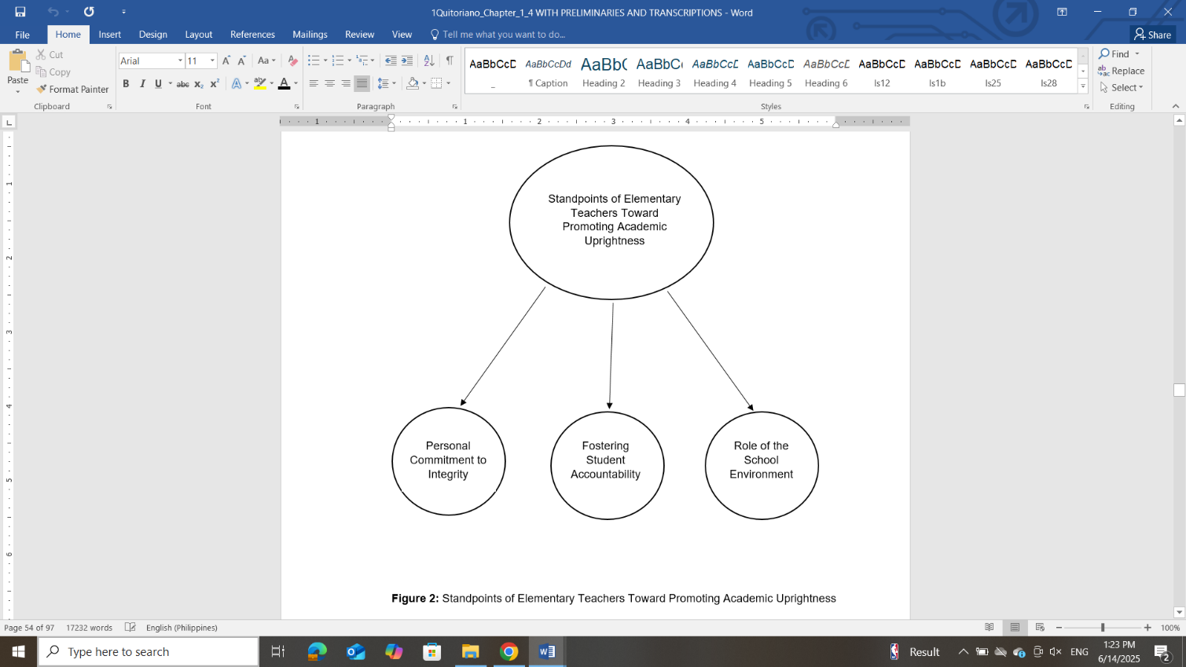

***Figure 1.*** *Standpoints of Elementary Teachers Toward Promoting Academic Uprightness*

**3.2 Coping Strategies of Teachers Toward Academic Dishonesty Committed by Students**

Through in-depth interviews and thematic analysis, this study explored how elementary teachers cope with academic dishonesty among students. Three main themes emerged: proactive prevention strategies, disciplinary measures, and promoting open communication.

***Proactive Prevention Strategies***

Teachers shared that they actively work to prevent cheating by creating engaging lessons, setting clear expectations, and promoting a culture of honesty in the classroom.

Here are some of the responses given by the participants during their interviews:

*“I try to design activities that keep students interested so they won’t feel the need to cheat.” (P1)*

*“We make our rules on honesty clear from the very beginning.” (P3)*

*“I make the class enjoyable for students to prevent cheating.” (P5)*

*“We remind students about honesty right from the beginning.” (P7)*

It can be observed that Participant 1 emphasized keeping students engaged to reduce cheating. Participant 3 highlighted the importance of clear rules about honesty. Participant 5 noted making classes enjoyable to prevent dishonesty. Participant 7 pointed out the early emphasis on academic integrity to set expectations.

This theme highlights the findings of Benson and Enstroem (2023), who emphasized that implementing proactive strategies is essential in preventing academic dishonesty before it occurs. Similarly, Ellis and Murdoch (2024) noted that early intervention programs, including student education on integrity and clear communication of rules, effectively reduce cheating incidents. Correspondingly, Tatum (2022) argued that preventive measures such as honor codes and academic workshops foster a culture of honesty among students. Moreover, Miles et al. (2022) demonstrated that proactive engagement between teachers and students promotes awareness and accountability, minimizing the occurrence of academic misconduct.

***Disciplinary Measures***

Several teachers reported using fair but firm disciplinary actions to address instances of dishonesty, ensuring students understand the consequences of their actions.

Here are some of the responses given by the participants during their interviews:

*“When cheating happens, I explain why it’s wrong and give consequences that help them learn.” (P2)*

*“We follow school policies strictly to handle cheating cases.” (P4)*

*“When cheating occurs, I talk to the student and give a consequence so they will learn.” (P6)*

*“We follow the school rules in disciplining students who cheat.” (P8)*

It can be noted that Participant 2 focused on explaining the wrongness of cheating and applying learning-focused consequences. Participant 4 stressed strict adherence to school policies. Participant 6 emphasized giving punishments that promote learning from mistakes. Participant 8 highlighted following school rules strictly in disciplinary actions.

This theme underscores the conclusions of Chiang et al. (2022), who emphasized the necessity of clear and consistent disciplinary actions to address academic dishonesty effectively. Likewise, Njeru (2023) found that well-defined consequences help reinforce the importance of academic integrity and deter students from cheating. In addition, Lodi et al. (2021) highlighted that restorative justice approaches, alongside traditional penalties, can encourage students to understand the impact of their actions and foster behavioral change. Furthermore, Pant (2025) pointed out that the consistent application of rules ensures accountability and upholds the institution’s ethical standards.

***Promoting Open Communication***

Teachers also highlighted the importance of building trustful relationships where students feel comfortable discussing pressures and challenges that might lead to dishonesty.

Here are some of the responses given by the participants during their interviews:

*“I encourage students to talk about their problems before they feel tempted to cheat.” (P9)*

*“We try to understand why students cheat and offer support rather than just punishment.” (P10)*

*“I encourage students to talk about their problems rather than cheat.” (P3)*

*“We support students by understanding their reasons for cheating.” (P5)*

It can be observed that Participant 9 stressed encouraging dialogue to prevent cheating. Participant 10 pointed out offering support alongside discipline. Participant 3 noted encouraging students to share their issues rather than cheat. Participant 5 emphasized understanding reasons behind dishonesty to provide support.

This theme corresponds with the findings of Çolak and Glendinning (2021), who highlighted the importance of fostering open dialogue between teachers and students to build trust and prevent academic dishonesty. Similarly, Henderson et al. (2023) emphasized that creating a safe space for students to express their concerns reduces the temptation to cheat. Additionally, Artyukhov (2024) found that transparent communication about academic expectations strengthens students’ commitment to integrity. Furthermore, Rahmat et al. (2025) argued that open communication fosters mutual understanding and respect, which are crucial in maintaining ethical learning environments.

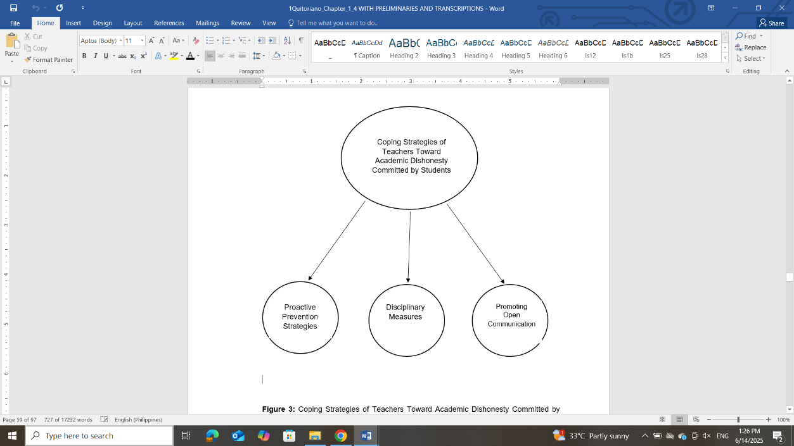

***Figure 2. Coping Strategies of Teachers Toward Academic Dishonesty Committed by Students***

**3.3 Educational Insights Gained by Teachers Regarding Academic Uprightness**

Through in-depth interviews and thematic analysis, this study uncovered the key educational insights gained by elementary teachers regarding academic uprightness. The analysis revealed three distinct themes: emphasizing character education, modeling ethical behavior, and strengthening school-home collaboration.

***Emphasizing Character Education***

Teachers shared that one of the key insights they gained was the importance of integrating character formation in daily teaching practices. They stressed that academic uprightness must be nurtured through consistent values education and moral instruction.

Here are some of the responses given by the participants during their interviews:

*“I realized that teaching values should be part of every lesson.” (P1)*

*“Character formation is just as important as academics in shaping students.” (P2)*

*“We should always integrate good values in the classroom.” (P3)*

*“Teaching moral values is really important to help them learn honesty.” (P6)*

It can be observed that the responses of the participants, specifically Participant 1, emphasized incorporating values in every lesson. Participant 2 noted the equal importance of character formation and academics. Participant 3 highlighted the need to consistently integrate good values in class. Participant 6 stressed the significance of moral values in teaching students to be honest.

This theme aligns with the research of Cholifah (2024), who emphasized that integrating character education into daily lessons fosters a learning environment rooted in honesty, respect, and responsibility. In a similar vein, Kumar (2024) highlighted that consistent moral instruction within academic content plays a crucial role in shaping students’ ethical behavior. Moreover, according to Nutor (2024), values-based education positively influences students' decision-making processes, reducing incidents of dishonesty in academic settings. Supporting this, Anisah (2023) argued that embedding character-building lessons into the curriculum helps students internalize upright behavior, reinforcing the significance of academic integrity from a young age.

***Modeling Ethical Behavior***

Teachers recognized that they serve as role models in promoting academic uprightness. They understood that their actions and attitudes toward honesty and fairness deeply influence students’ behavior and mindset.

Here are some of the responses given by the participants during their interviews:

*“Students are watching us. If we cheat the system, they will too.” (P5)*

*“We are examples whether we like it or not, so we have to act responsibly.” (P8)*

*“Children follow what we do, not just what we teach.” (P7)*

*“If we want them to truly be honest, we must be the ones to show it first.” (P10)*

It can be observed that Participant 5 stressed the risk of students imitating dishonest teacher behavior. Participant 6 emphasized the need to act responsibly as role models. Participant 7 pointed out that students follow teachers’ actions more than their words. Participant 8 underlined that teachers must demonstrate honesty if they want students to be honest.

This theme corresponds with the research of Icka and Kochoska (2024), who emphasized that teachers who consistently demonstrate ethical behavior serve as powerful role models for students, significantly influencing their moral development. Likewise, Abubakar (2024) asserted that the visible integrity of educators reinforces the value of honesty and fairness among learners. Similarly, Brigue and Orlu (2023) found that modeling ethical behavior not only promotes academic uprightness but also builds a culture of mutual respect and trust in educational settings. Furthermore, Malik et al. (2021) highlighted that when teachers uphold professional standards, they set a strong example that students naturally emulate, contributing to a more honest and principled learning environment.

***Strengthening School-Home Collaboration***

Teachers also gained the insight that promoting academic uprightness requires strong collaboration between the school and the home. They emphasized engaging parents in discussions about honesty and ensuring consistency in values taught at school and at home.

Here are some of the responses given by the participants during their interviews:

*“We encourage parents to reinforce honesty at home.” (P9)*

*“Academic uprightness must be a shared responsibility between teachers and families.” (P10)*

*“We tell parents that it’s important to support us in teaching honesty.” (P1)*

*“It’s more effective when honesty is taught both at home and in school.” (P8)*

It can be observed that Participant 9 emphasized involving parents in reinforcing honesty. Participant 10 noted that academic uprightness should be a shared responsibility. Participant 1 highlighted informing parents about the importance of supporting values education. Participant 8 stressed the effectiveness of consistency between home and school teachings.

This theme reflects the findings of Artyukhov (2024), who stressed that active communication and partnership between schools and families play a crucial role in promoting academic integrity among students. Similarly, Dykstra et al. (2020) highlighted that when parents are engaged and informed about academic expectations, students are less likely to engage in dishonest behaviors. Likewise, Rosales (2023) found that coordinated efforts between home and school environments create consistent messages about honesty and responsibility. Furthermore, Sserunkuuma (2023) emphasized that strengthening school-home ties contributes to a supportive atmosphere where academic uprightness is nurtured and sustained.

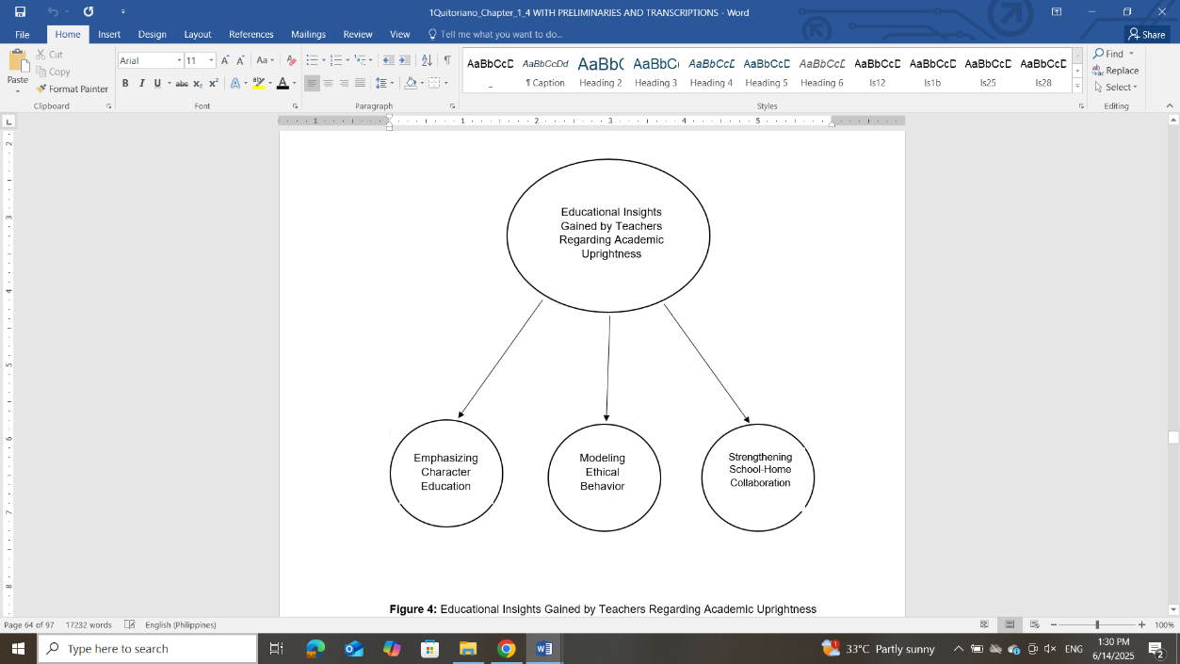

***Figure 3. Educational Insights Gained by Teachers Regarding Academic Uprightness***

4. conclusions

One of the key standpoints of elementary teachers toward promoting academic uprightness is their personal commitment to integrity. Teachers believe that fostering honesty among students begins with their own ethical behavior. By modeling integrity in their professional conduct, they set a standard that students are encouraged to follow. This underscores the importance of character-building not only in students but also in the professional identity of educators. The implication is clear: educational institutions must cultivate environments where ethical conduct is expected, reinforced, and supported at all levels of teaching practice. Another major standpoint involves fostering student accountability. Teachers emphasize the importance of helping students understand the consequences of their actions and encouraging them to take ownership of their academic work. This finding implies that classroom strategies should not only deter dishonesty but also actively develop a student’s sense of responsibility. Integrating lessons that emphasize decision-making, moral reasoning, and self-reflection can help reinforce these values across the curriculum. The third standpoint revealed is the role of the school environment. Participants shared that a school’s culture, including leadership practices, peer behavior, and institutional policies, greatly influences students’ ethical behavior. This highlights the broader role of the school community in promoting academic uprightness. Administrators and policymakers should ensure that clear, consistent guidelines are in place and that they foster an atmosphere of fairness and respect.

To cope with academic dishonesty, teachers use a variety of strategies. Proactive prevention strategies, such as setting clear expectations and designing assessments that minimize cheating, help deter dishonest behavior before it begins. This approach implies the need for ongoing teacher training in assessment design and classroom management techniques that promote integrity. Disciplinary measures are also commonly used, with teachers emphasizing consistency and fairness in applying consequences. This suggests that schools may adopt transparent and well-communicated disciplinary policies. Educators should be trained to implement these measures in a way that upholds justice while also offering opportunities for student growth and learning from mistakes. Another coping strategy is promoting open communication. Teachers encourage students to express the challenges they face, whether academic or personal, as a means of addressing the root causes of dishonesty. This implies that fostering a supportive classroom climate can be instrumental in preventing misconduct. Teachers and school counselors can work together to create open channels for student expression and emotional support.

Regarding educational insights, teachers strongly support emphasizing character education as a foundation for building academic uprightness. This implies that curriculum developers may integrate moral and ethical education across subjects and grade levels. Programs that teach empathy, fairness, and integrity can strengthen students’ moral development from an early age. Another insight is the importance of modeling ethical behavior, where teachers act as role models for honesty and professionalism. This finding highlights the need for continuous professional development that reinforces educators’ ethical responsibilities. Administrators may also lead by example to ensure consistency across all levels of the educational environment. Finally, strengthening school-home collaboration emerged as a key insight. Teachers acknowledged the critical role of parents and guardians in shaping students’ values and behavior. This implies that schools may engage families through regular communication, workshops, and collaborative efforts to reinforce the importance of academic honesty at home and in school.

**5. RECOMMENDATIONS**

Based on the findings of this study, several recommendations may be considered to support elementary school teachers in promoting academic uprightness and managing academic dishonesty among students.

The Department of Education (DepEd) and school administrators may consider integrating character education more explicitly into the curriculum. Emphasizing values such as honesty, responsibility, and integrity in lesson planning and daily classroom activities can help instill these principles in students from an early age. Additionally, school leaders may conduct regular training and workshops on ethical teaching practices to strengthen teachers’ ability to model and reinforce academic uprightness.

Policies that foster a strong school culture of integrity may also be developed. This includes implementing clear guidelines for addressing academic dishonesty and ensuring that all stakeholders—teachers, students, and parents are aware of expectations and consequences. A consistent and transparent disciplinary approach, combined with supportive communication channels, can contribute to a more honest academic environment.

Teachers, on their part, are encouraged to continue fostering open communication with students. By creating spaces where students feel safe discussing academic pressures and personal challenges, teachers can address the underlying causes of dishonesty and promote accountability. Teachers may also benefit from peer support networks and mentoring relationships that provide emotional reinforcement and opportunities for reflective practice.

For future studies, researchers may explore how academic uprightness is promoted in other school levels, such as secondary or tertiary institutions, to gain comparative insights. Studies could also examine the influence of parental involvement on students' ethical behavior and how home-school collaboration can be optimized. Furthermore, future research may investigate the effectiveness of specific interventions, such as digital honor codes, peer-led integrity programs, or values-based classroom activities, in cultivating honesty and reducing academic misconduct in educational settings.

References

Abubakar, A. (2024). Integration of Ethics And Morals In Educational Communication. *International Journal on Advanced Science, Education, and Religion*, *7*(3), 349-364. <http://ojs.staialfurqan.ac.id/IJoASER/article/view/691>

Aguilar, M. G. (2021). Academic dishonesty in the Philippines: The case of 21st century learners and teachers. *International Journal of Management, Technology, and Social Sciences*, *6*(1), 306-313. <https://www.academia.edu/download/68629552/704_Article_Text_257_1_10_20210714.pdf>

Almutairi, Y. M. N. (2022). Effects of academic integrity of faculty members on students’ ethical behavior. *Education Research International*, *2022*(1), 6806752. <https://onlinelibrary.wiley.com/doi/abs/10.1155/2022/6806752>

Anisah, A. (2023). Implementation Strengthening Education Character Student School Al-Anwar's Foundations Through School Culture. *Assyfa Journal of Islamic Studies*, *1*(1), 121-129. <https://journal.assyfa.com/index.php/ajis/article/view/296>

Artyukhov, A. (2024). UNIVERSITY SYSTEM FOR ENSURING ACADEMIC INTEGRITY: STRUCTURE AND ROLE OF STAKEHOLDERS. *Baltic Journal of Legal and Social Sciences*, (1), 261-267. <http://www.baltijapublishing.lv/index.php/bjlss/article/view/2615>

Artyukhov, A. (2024). UNIVERSITY SYSTEM FOR ENSURING ACADEMIC INTEGRITY: STRUCTURE AND ROLE OF STAKEHOLDERS. *Baltic Journal of Legal and Social Sciences*, (1), 261-267. <http://www.baltijapublishing.lv/index.php/bjlss/article/view/2615>

Benson, L., & Enstroem, R. (2023). A model for preventing academic misconduct: Evidence from a large-scale intervention. *International Journal for Educational Integrity*, *19*(1), 25. <https://link.springer.com/article/10.1007/s40979-023-00147-y>

Brigue, A. U., & Orlu, V. N. (2023). Ethical considerations of leaders and integrity in public universities. *International Journal of Institutional Leadership, Policy and Management*, *5*(2), 245-261. <https://www.ijilpm.com.ng/assets/vol.,-5(2)-brigue,-a.-u.,---orlu,-v.-n.pdf>

Brigue, A. U., & Orlu, V. N. (2023). Ethical considerations of leaders and integrity in public universities. *International Journal of Institutional Leadership, Policy and Management*, *5*(2), 245-261. <https://www.ijilpm.com.ng/assets/vol.,-5(2)-brigue,-a.-u.,---orlu,-v.-n.pdf>

Chiang, F. K., Zhu, D., & Yu, W. (2022). A systematic review of academic dishonesty in online learning environments. *Journal of Computer Assisted Learning*, *38*(4), 907-928. <https://onlinelibrary.wiley.com/doi/abs/10.1111/jcal.12656>

Cholifah, S. (2024). Educational Environment in the Implementation of Character Education. *Journal of Scientific Research, Education, and Technology (JSRET)*, *3*(2), 816-825. <https://jsret.knpub.com/index.php/jrest/article/view/418>

Cimene, F. T. A., Du, E. C., Alonsabe, O. C., Kurangking, J. A., Santander, M. E. D., Alvarez, J. B. G. C., ... & Uba, M. L. (2024). NAVIGATING THE EDUCATIONAL LANDSCAPE: PHILOSOPHY, TRENDS, AND ISSUES IN THE PHILIPPINES. <https://www.researchgate.net/profile/Francis-Thaise-Cimene/publication/379655243_NAVIGATING_THE_EDUCATIONAL_LANDSCAPE_PHILOSOPHY_TRENDS_AND_ISSUES_IN_THE_PHILIPPINES/links/6613b0952034097c54ff2889/NAVIGATING-THE-EDUCATIONAL-LANDSCAPE-PHILOSOPHY-TRENDS-AND-ISSUES-IN-THE-PHILIPPINES.pdf>

Çolak, M. K., & Glendinning, I. (2021). Embracing community-building in online classes to promote academic integrity. *The Literacy Trek*, *7*(1), 5-33. <https://dergipark.org.tr/en/pub/literacytrek/article/901935>

Davis, A. (2023). Academic integrity in the time of contradictions. *Cogent Education*, *10*(2), 2289307. <https://www.tandfonline.com/doi/abs/10.1080/2331186X.2023.2289307>

Dykstra, V. W., Willoughby, T., & Evans, A. D. (2020). A longitudinal examination of the relation between lie-telling, secrecy, parent–child relationship quality, and depressive symptoms in late-childhood and adolescence. *Journal of youth and adolescence*, *49*, 438-448. <https://link.springer.com/article/10.1007/s10964-019-01183-z>

Ellis, C., & Murdoch, K. (2024). The educational integrity enforcement pyramid: a new framework for challenging and responding to student cheating. *Assessment & Evaluation in Higher Education*, *49*(7), 924-934. <https://www.tandfonline.com/doi/abs/10.1080/02602938.2024.2329167>

Gow, S., & Sun, Q. (2024). Academic Integrity in China: Challenges for Policy, Practice, and Quality Assurance in Higher Education. In *Second Handbook of Academic Integrity* (pp. 975-999). Cham: Springer Nature Switzerland. <https://link.springer.com/content/pdf/10.1007/978-3-031-54144-5_175.pdf>

Guerrero-Dib, J. G., Portales, L., & Heredia-Escorza, Y. (2020). Impact of academic integrity on workplace ethical behaviour. *International Journal for Educational Integrity*, *16*(1), 2. <https://link.springer.com/article/10.1007/s40979-020-0051-3>

Henderson, M., Chung, J., Awdry, R., Ashford, C., Bryant, M., Mundy, M., & Ryan, K. (2023). The temptation to cheat in online exams: moving beyond the binary discourse of cheating and not cheating. *International Journal for Educational Integrity*, *19*(1), 21. <https://link.springer.com/article/10.1007/s40979-023-00143-2>

Heryanto, D., Susanti, A., & Darmansyah, A. (2023). The Implementation of Integrity Values to Foster Anti-Corruption Attitudes in Elementary School Students. *IJECA (International Journal of Education and Curriculum Application)*, *6*(3), 210-225. <https://journal.ummat.ac.id/index.php/IJECA/article/view/19476>

Icka, E., & Kochoska, J. (2024). THE INFLUENCE OF TEACHERS AS AN ETHICAL MODEL ON THE STUDENTS'DEVELOPMENT. *International journal of Education Teacher*, *27*, 99-107. <http://ijeteacher.com/index.php/ijet/article/view/41>

Icka, E., & Kochoska, J. (2024). THE INFLUENCE OF TEACHERS AS AN ETHICAL MODEL ON THE STUDENTS'DEVELOPMENT. *International journal of Education Teacher*, *27*, 99-107. <http://ijeteacher.com/index.php/ijet/article/view/41>

Kumar, P. (2024). The Role of Ethics and Moral Values in Teaching: A Comprehensive Examination. *Shodh Sari-An Int. Multidiscip. J*, *3*(01), 99-112. <https://icertpublication.com/wp-content/uploads/2024/01/115.-The-Role-of-Ethics-and-Moral-Values-in-Teaching.pdf>

Langari, R., & Soleimanpouromran, M. (2021). The Relationship between School Culture and Social Climate Governing School with Academic Ethics and the Mediating role of learners’ Academic. *Iranian journal of educational sociology*, *4*(1), 206-215. <https://iase-idje.ir/browse.php?a_id=497&sid=1&slc_lang=fa>

Lim, K. (2024). Assessing beyond grades: unravelling the implications on student learning and engagement in higher education. *Assessment & Evaluation in Higher Education*, *49*(5), 665-679. <https://www.tandfonline.com/doi/abs/10.1080/02602938.2024.2314703>

Lodi, E., Perrella, L., Lepri, G. L., Scarpa, M. L., & Patrizi, P. (2021). Use of restorative justice and restorative practices at school: A systematic literature review. *International Journal of Environmental Research and Public Health*, *19*(1), 96. <https://www.mdpi.com/1660-4601/19/1/96>

Malik, M. I., Naseem, S., Baby, S., & Rafique, H. (2021). Principled Standard of educators for Developing Professional and Ethical Vision in College Students. *Ilkogretim Online*, *20*(4). <https://search.ebscohost.com/login.aspx?direct=true&profile=ehost&scope=site&authtype=crawler&jrnl=13053515&AN=150156577&h=hXb6%2BnYENeIABh%2BgNz3%2BoSgA9iEa5hGohC2w4Zb%2B8%2FeOcLfd9bnm0H0Rsb%2BuWlXyI0AF7gezcV33lVpjzZqfMQ%3D%3D&crl=c>

Miles, P. J., Campbell, M., & Ruxton, G. D. (2022). Why students cheat and how understanding this can help reduce the frequency of academic misconduct in higher education: A literature review. *Journal of Undergraduate Neuroscience Education*, *20*(2), A150. <https://pmc.ncbi.nlm.nih.gov/articles/PMC10653228/>

Nguyen, A., Le, T. T. D., Nguyen, N. D., & Le, D. Q. T. (2025). Innovating Vietnam’s Values Education through the Lens of Confucian Philosophy. *DMMMSU Research and Extension Journal*, *9*(1), 22-43. <https://www.drej.dmmmsu.edu.ph/index.php/DOJ/article/view/59>

Njeru, J. N. (2023). *Critical Analysis of Academic Integrity in Higher Learning Institutions During the Era of Covid-19 Pandemic in Kenya* (Doctoral dissertation, University of Nairobi). <https://erepository.uonbi.ac.ke/handle/11295/165218>

Nutor, R. O. (2024). *Investigating the Influence of Personal Values on the Ethical Decision-making Behavior of Ashesi Students in Academic Settings* (Doctoral dissertation, Ashesi University). <https://air.ashesi.edu.gh/items/0ab8fd9e-452d-426b-b762-84ccd2a5d83c>

Nwozor, A. (2025). Artificial intelligence (AI) and academic honesty-dishonesty nexus: Trends and preventive measures. *AI and Ethics, Academic Integrity and the Future of Quality Assurance in Higher Education*, *27*. <https://www.researchgate.net/profile/Mamman-Muazu-2/publication/384969429_AI_Book_in_Honour_of_Prof_Abubakar_Adamu_Rasheed_Volume_3-Draft_Edition/links/67655cb9e74ca64e1f20db0b/AI-Book-in-Honour-of-Prof-Abubakar-Adamu-Rasheed-Volume-3-Draft-Edition.pdf#page=288>

Pant, P. (2025). Upholding Ethical Standards: Governance, Transparency, and Integrity in Higher Education Administration. In *Challenges of Public Administration Management for Higher Education* (pp. 195-208). IGI Global. <https://www.igi-global.com/chapter/upholding-ethical-standards/358145>

Pederson, O. M. (2025). Beyond the Exam Score: An Examination of the Kenyan Education System, Its Reforms, Inefficiencies, and Impact on Individuals and Society at Large. <https://digitalcommons.spu.edu/cgi/viewcontent.cgi?article=1244&context=honorsprojects>

Pregoner, J. D., Leopardas, R., Ganancial, I. J., Baguhin, M., & Sedo, F. (2025). Ethical Issues in Conducting Research Using Human Participants in the Post-COVID Era. *IMCC Journal of Science*, *5*(1), 1-9. <https://hal.science/hal-05073466/>

Rahmat, W., Tiawati, R. L., Septia, E., & Rahmad, H. A. (2025). Fostering cross-cultural communication ethics through a multiculturalism perspective. *Bhandar: Harvesting Community Service in Asia*, *2*(1). <https://jurnal.ppjb-sip.org/index.php/Bhandar/article/view/1088>

Robertson, S. D. (2024). *Teaching from multiple midsts: autonomous secondary ELA teachers negotiating agencies in the context of K-12 curricular revision* (Doctoral dissertation, University of British Columbia). <https://open.library.ubc.ca/soa/cIRcle/collections/ubctheses/24/items/1.0447352>

Rosales, R. A. (2023). Home-School Collaboration: Maximizing Resources and Efforts to Support Students’ Independent Learning. *International Journal of Multidisciplinary: Applied Business and Education Research*, *4*(3), 872-896. <https://www.ijmaberjournal.org/index.php/ijmaber/article/view/891>

Sopcak, P., & Hood, K. (2022). Building a culture of restorative practice and restorative responses to academic misconduct. In *Academic integrity in Canada: An enduring and essential challenge* (pp. 553-571). Cham: Springer International Publishing. <https://library.oapen.org/bitstream/handle/20.500.12657/53333/978-3-030-83255-1.pdf#page=553>

Sserunkuuma, A. (2023). *Parental support and the academic achievement of student in advanced level secondary schools in Nakaseke District, Uganda* (Doctoral dissertation, Kampala International University, College of education, open distance and e-learning.). <https://ir.kiu.ac.ug/handle/20.500.12306/14393>

Tatum, A. (2022). *Exploring Teacher Well-Being through Compassion: A Case Study on How Organizations Can Support Teachers’ Well-Being*. American University. <https://search.proquest.com/openview/e8a87be5efd3591f75a6eb245aa5fba1/1?pq-origsite=gscholar&cbl=18750&diss=y>

Tawiah, F. (2021). *The Ethical Value of Honesty Among Students: the Case of Assin Manso Senior High School, Central Region, Ghana* (Doctoral dissertation, University of Cape Coast). <https://ir.ucc.edu.gh/xmlui/handle/123456789/10499>

van Dyk, E. C., van Rensburg, G. H., & Janse van Rensburg, E. S. (2022). The educator as facilitator of trust in the nursing education environment. *Plos one*, *17*(8), e0266240. <https://journals.plos.org/plosone/article?id=10.1371/journal.pone.0266240>

Weisbrod, B. A. (2025). Incentives in K-12 Education-The Perils of Not Just Measuring Performance by Standardized Tests, but Financially Rewarding It Working Paper 2 in the Series: The Perils of Pay for Performance in Public Service Industries. *Northwestern University Institute for Public Policy Research, working papers*. <https://papers.ssrn.com/sol3/papers.cfm?abstract_id=5199295>