**How can we encourage active participation among class 12 students in classroom discussions to enhance their understanding of economics?**

**Abstract**

Encouraging classroom participation is a critical component of effective teaching and learning. When students actively engage in class discussions and collaborative activities, they are more likely to develop a deeper understanding of the subject matter and retain information for longer periods. Teaching and learning are dynamic processes through which students acquire knowledge from various sources, including educators, societal interactions, literature, and experiential activities. While traditional teacher-centered approaches have long dominated educational practices, there is a growing shift towards student-centered learning methodologies. A significant concern affecting the quality of education is the observed decline in classroom discussions and student participation. The research methods that are used in this action research project are mixed methods, which combine both qualitative and quantitative methods. To collect the research data, a variety of tools, such as survey questionnaires, interviews, and observations, are used. Baseline data is collected using these tools to provide a starting point for the research. Teacher-related factors appear to play a pivotal role in encouraging student participation. A striking 102 students agreed that their teacher makes the class interesting—the highest agreement rate in the dataset, indicating the strong influence of teaching style on classroom engagement. Overall, the results suggest that the intervention significantly reduced barriers to classroom participation, likely We also made the purpose and objectives of the research clear to the participants to ensure that there was no gender bias in the way we asked questions, conducted observations, and interviews. We also ensure that the responses provided by participants will be kept confidential to protect their privacy.

Keywords: classroom participation, Minority Problems, Bhutan's education system

# Introduction

Kurt Lewin is generally considered the ‘father’ of action research. He was concerned with social problems and focused on participative group processes for addressing conflict, crises, and change, generally within organizations. Lewin first introduced the term ‘action research’ in his 1946 paper “Action Research and Minority Problems”. Lewin believed that the motivation to change was strongly related to action. If people are actively involved in decisions affecting them, they are more likely to adopt new strategies (Brien' O.R., 1998). Action research is employed in real-world situations, rather than in contrived, experimental studies, as its primary focus is on addressing real problems.

Encouraging classroom participation is a critical component of effective teaching and learning. When students actively engage in class discussions and collaborative activities, they are more likely to develop a deeper understanding of the subject matter and retain information for longer periods. Active participation not only enhances academic outcomes but also fosters a more dynamic and inclusive learning environment for both students and educators. To promote engagement, educators can employ a range of strategies, including think-pair-share techniques, the use of open-ended questions, and creating a supportive atmosphere where all contributions are valued (Brookfield, 2015; Freeman et al., 2014). These may include using open-ended questions, providing opportunities for small group work, and creating a safe and supportive environment where students feel comfortable sharing their ideas. By implementing these strategies, teachers can foster a more interactive and engaging learning environment. Thus, this action research is on encouraging classroom participation.

# Reconnaissance

According to the Oxford Advanced Learner's Dictionary, the word "reconnaissance" originated in the early 19th century from French, from the word "reconnoiter," which means "recognize" and from the Latin word "recognoscere" which means "know again" from the prefix "re-" meaning "again." Maxwell (2003) stated that reconnaissance has three parts: situational analysis, competencies, and literature. Situational analysis involves looking at the situation in terms of factors such as resources and practices, competencies involve profiling and evaluating the researchers involved, and literature involves linking the work to previous research in the field (as cited in Rinchen, 2008).

# Situational Analysis

Bhutan is a small, landlocked country in South Asia with a unique culture and tradition. It is known for its focus on Gross National Happiness (GNH) as an alternative to Gross Domestic Product as a measure of national success. The country has a democratic constitutional monarchy, and its modern education system was developed in the 1960s with assistance from India. Today, Bhutan has a literacy rate of 71.4% and an unemployment rate of 2.4%. In order to continue improving these metrics, there is a need to upgrade the level of education provided to students (PHCB, 2019).

In the past, Bhutan's education system was based on teacher-centered learning, where instruction was largely delivered through lectures. However, with recent changes to the education system, a shift towards student-centered learning has occurred. This approach emphasizes student engagement and interaction with both teachers and peers. Students are now involved in class presentations, discussions, experiments, field work, and project work. As a result of these changes, the literacy rate in Bhutan has increased significantly, from 59.5% in 2005 to 71.4% in 2017, representing an increase of 11.9 percentage points.

# 

# About the School

Pakshikha Central School (PCS) is located in Bongo gewog, Chukha Dzongkhag, Bhutan. Established in 2011, the school has 57 teaching staff and 14 non-teaching staff. It offers classes from Pre-Primary to 12th grade and has a total of approximately 830 students. The school provides a child-friendly environment for learning and development, and has a computer lab, clubs, and classes for value education and counseling. The school plays a pivotal role in providing holistic education to the learners.

However, the lack of student participation in the learning process is one of the main problems faced by teachers and the management. Purposefully, this action research was conducted to focus on encouraging participation in classroom discussions in particularly for 12th-grade students in learning economics. The goal is to improve student engagement and create a more conducive learning environment for learning. By fostering participation in the classroom, students will be able to take a more active role in their learning and develop critical thinking skills. This can lead to a more positive and effective learning experience for both students and teachers.

# Competence

All of the teachers have experience with both action research and conventional research. Additionally, they have master's degrees and have been teaching upper-level classes for over 10 years. They have also received training in both action research and conventional research methods. Authors are also members of the school research team.

# 

# Literature Review

Teaching and learning are dynamic processes through which students acquire knowledge from various sources, including educators, societal interactions, literature, and experiential activities. While traditional teacher-centered approaches have long dominated educational practices, there is a growing shift towards student-centered learning methodologies. A significant concern affecting the quality of education is the observed decline in classroom discussions and student participation.

Active participation in classroom discussions is instrumental in enhancing students' critical thinking, communication skills, and overall engagement with the subject matter. Research indicates that students who actively engage in class are more likely to comprehend and retain information effectively (Bergdahl et al., 2024). Moreover, fostering an environment that encourages dialogue and interaction not only benefits individual learners but also contributes to a more collaborative and inclusive classroom atmosphere (Bardorfer, 2024).

It is often observed that teachers tend to use teacher-centered learning methods in which students rarely participate in classroom discussions. However, research has shown that students learn more when they are actively involved in discussions. Lowman (1995) suggests that well-organized discussions can promote independent thinking, motivation, and student engagement. Participation in classroom discussions also promotes active learning, critical thinking, the development of listening and speaking skills, and the ability to engage in disciplinary conversations. Bean and Peterson (1998) argue that discussions facilitate student thinking by asking provocative or rhetorical questions.

Multiple studies have shown that students are more attentive and engaged during discussions, which facilitates active learning (McKeachie & Svinicki, 2006). Tileston (2004) put forward that an effective classroom provides opportunities for students to hear, see, touch information, and engage actively in class. Similarly, Chauchan (2002) suggests that students may not participate in classroom activities due to a lack of general and professional knowledge, as well as a lack of self-confidence. However, it is also important to note that there may be an imbalance in participation, where some students participate frequently while others do not participate at all. One way to encourage student participation is through group work, as students are more likely to participate in group discussions than in whole-class discussions (Ruiz Ulloa & Adams, 2004). Group work can promote positive thinking and a collaborative attitude towards learning, as well as the development of skills such as interdependence, communication, and teamwork. It is also worth noting that in group discussions, male students tend to dominate the conversation and participate more frequently than female students (Fassinger, 1995). Wade's (1994) study of education majors' attitudes towards discussion found that three-fourths of male students believed their ideas "always" or "often" made an important contribution to the discussion, while less than half of female students had similar confidence in the quality of their contributions.

Piaget and Webb (1932, 2009) argue that cognitive conflict leads to higher levels of reasoning and learning. When students notice a conflict between their understanding and what they hear from other group members, this forces them to reconsider their concepts and restructure their ideas to align with the group. Conflicting ideas can lead to more questioning and negotiation, which can ultimately result in learning. Vygotsky (1978) adds that more learning occurs in a group when an expert helps a less expert individual through conversation to carry out a task that the less expert would not be able to do alone. Hull (1999) also believes that adults learn best in groups, as working in groups allows learners to develop higher-order thinking skills and retain knowledge longer than working individually.

# Action research question

How can we encourage active participation among class 12 students in classroom discussions to enhance their understanding of economics?

* 1. **Objectives**: To identify effective strategies that promote and enhance student participation in classroom discussions. To investigate the underlying factors contributing to low levels of student participation in classroom discussions.

# Intervention strategies

# The intervention strategies were designed and implemented to encourage student participation in the classroom discussion. This was done based on the findings from the baseline data. The following are the intervention strategies developed and implemented by the research team for four months

# Methodology

It is a fundamental requirement of any research. The research methods that are used in this action research project are mixed methods, which combine both qualitative and quantitative methods. To collect the research data, a variety of tools, such as survey questionnaires, interviews, and observations, are used. Baseline data is collected using these tools to provide a starting point for the research.

**Analysis Tools**

The data were analyzed using Microsoft Excel spreadsheets. Percentages were generated to help interpret and present the findings.

**Baseline Data Analysis**

The following figure shows the analysis of baseline data collected from the respondents.

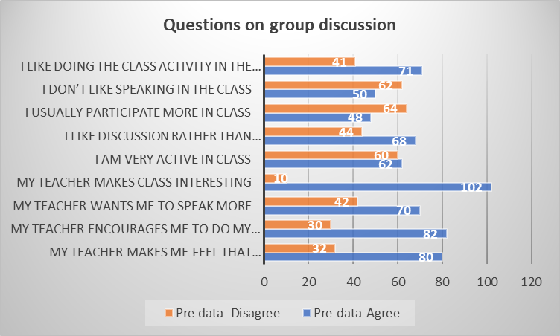

G*raph 1: Baseline data*

The above bar graph 1 presents pre-intervention data related to students’ perceptions and behaviours concerning classroom group discussions. The data is based on student responses to various statements, with responses categorized as “Agree” or “Disagree.” The findings reveal several key trends:

A significant proportion of students expressed a preference for engaging in classroom activities in a group setting, with 71 students agreeing with the statement “I like doing the class activity in the group,” while 41 students disagreed. Similarly, 68 students preferred discussion-based learning over passive methods, compared to 44 who did not.

When asked about their participation, 64 students reported that they usually participate more in class, whereas 48 disagreed. Furthermore, 60 students self-identified as being very active in class, while 44 did not share this view. These figures indicate a generally positive engagement, albeit with a noteworthy portion who remain less active.

A substantial number of students (62) admitted they do not like speaking in class, suggesting a significant barrier to verbal participation, despite the relatively high levels of agreement on other engagement indicators.

Teacher-related factors appear to play a pivotal role in encouraging student participation. A striking 102 students agreed that their teacher makes the class interesting—the highest agreement rate in the dataset, indicating the strong influence of teaching style on classroom engagement. Similarly, high levels of agreement were recorded for statements such as “My teacher wants me to speak more” (72 agree vs. 42 disagree), “My teacher encourages me to do my best” (82 agree vs. 30 disagree), and “My teacher makes me feel that my contribution is valuable” (80 agree vs. 32 disagree).

Overall, the data suggest that while a majority of students express favourable attitudes toward group discussions and acknowledge the supportive role of their teachers, there remains a subset of students who are hesitant to speak or participate actively. This highlights a need for targeted strategies to address communication apprehension and to foster a more inclusive and confident classroom environment.

# Participants

Pakshikha Central School has a total student population of 830. For this study, only Class 12 students were selected, comprising approximately 112 students in total. Among them, 51 are male and 61 are female**.**

# Data collection tools

The data for the action research is collected by using the following tools:

# Interview

One of the primary data collection methods employed in this study was the semi-structured interview (see Appendix A for the complete interview guide), which was conducted face-to-face and incorporated both structured and open-ended questions. The entire cohort of students from the 12th-grade economics class was selected to participate in the interviews. The interview protocol consisted of five broad questions designed to elicit insights related to classroom discussions. Interviews were conducted on two occasions—prior to and following the intervention—to facilitate a comparative analysis of the data.

# Observation

The second method employed for data collection was classroom observation, which aimed to gather information pertinent to the research objectives. The observations focused on two key areas: the level of student participation in class, specifically identifying which students contributed frequently, and the presence of gender-based differences in participation during classroom discussions. An observation form was utilized consistently throughout each lesson (see Appendix B for the full observation form). Similar to the interviews, observations were conducted both prior to and following the intervention to enable a comparative analysis of the results.

# Survey questionnaires

The third method employed in this action research was a survey questionnaire comprising ten items focused on students’ participation in classroom discussions (see Appendix C for the complete questionnaire). The survey was administered to all 12th-grade students enrolled in the economics class. Before data collection, informed consent was obtained from all participants. The survey was conducted twice during the academic year, once at the beginning in March and again after the intervention in September, to assess changes over time

1. **Comparative Analysis of Data and Discussion**

The Table below shows comparative findings of the baseline and post data in percentages.

|  |  |  |  |  |
| --- | --- | --- | --- | --- |
|  | PRE- DATA | | POST- DATA | |
| Survey Questions | Agree % | Disagree % | Agree % | Disagree % |
| My teacher makes me feel that he/she care about me | 71.4 | 28.6 | 97.3 | 2.7 |
| My teacher encourages me to do my best | 73.2 | 26.8 | 96.4 | 3.6 |
| My teacher wants me to speak more | 75 | 25 | 95.5 | 4.5 |
| My teacher makes class interesting | 76.8 | 23.2 | 94.6 | 5.4 |
| I am very active in class | 78.6 | 21.4 | 93.7 | 6.3 |
| I like discussion rather than lecturing | 80.4 | 19.6 | 92.8 | 7.2 |
| I usually participate more in class | 82.2 | 17.8 | 91.9 | 8.1 |
| I don’t like speaking in class | 84 | 16 | 91 | 9 |
| I like doing the class activity in the group | 85.8 | 14.2 | 90.1 | 9.9 |

*Table 1: Comparative findings of the baseline and post data in percentage*

According to Table 1 on comparative findings of the baseline and post data in percentage, there is a significant change in the students’ response.

The analyzed data showed there is an increase from 71.4% (pre-) to 97.3% (post-) for students who felt their teacher cared about them. The percentage of respondent who felt they were encouraged by their teacher has increased from 73.2% to 96.4%. Similarly, the agreement on the statement “My teacher wants me to speak more” shows a significant increase from 75% to 95.5%. There is also a rise in the percentage of students’ responses for the statement “My teacher makes class interesting” from 76.8% to 94.6%. These shifts suggest that the intervention strategies employed by the researchers enhanced teacher-student interaction and students’ participation.

As per the table above, 93.7% of the students felt they became very active in class compared to 78.6% during the pre-test survey. The students who participated in the class have shown an increase from 82.2% to 91.9%. In a similar note, 92.8% of students prefer class discussion over lecturing after the intervention (80.4% pre-). However, the statement "I don’t like speaking in class," which is negatively phrased, saw agreement rise from 84% to 91%.

Overall, the post-intervention data reflect consistent positive shifts in students’ participation, involvement in the activity.

*Graph 2: Pre- and post-data*

The above graph 2 on analysis of pre- and post-intervention survey data illustrates significant positive shifts in students’ classroom perceptions, particularly in areas of teacher support, engagement, and learning preferences.

The data depicts is marked improvement in the teacher-student relationship. The percentage of students who felt their teacher cared about them rose from 71.4% to 97.3%, while those who felt encouraged to do their best increased from 73.2% to 96.4%.

Additionally, the agreement on the statement "My teacher wants me to speak more" increased from 75.0% to 95.5%. Similarly, post-intervention data shows 94.6% of the students found the class interesting compared to pre-intervention data (76.8%). The graph also shows, students’ preferences for interactive learning were also evident, with an agreement with discussion-based learning rising from 80.4% to 92.8%. The enjoyment of group activities remained high (85.8% to 90.1%) for both pre- and post-data analysis.

The data analysis also shows students reporting higher activity (78.6% to 93.7%) and participation (82.2% to 91.9%) in the class. However, the increase in agreement with the negatively phrased statement "I don’t like speaking in class" (84.0% to 91.0%) may be an indication of misinterpretation of the statement.

In conclusion, the intervention effectively enhanced student engagement and classroom environment.

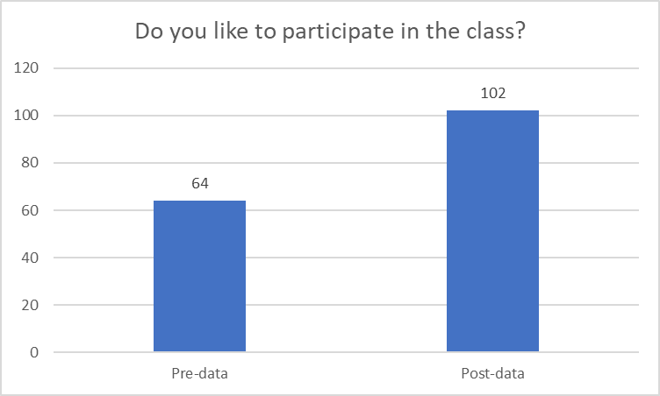

*Graph 3: Do you like to participate in the class*

Graph 3 shows a notable increase in students who enjoy class participation, increasing from 64 to 102. This suggests that the classroom environment has become more supportive and engaging, boosting students' confidence and motivation. The positive change indicates that the intervention effectively enhanced student participation and improved overall classroom dynamics.

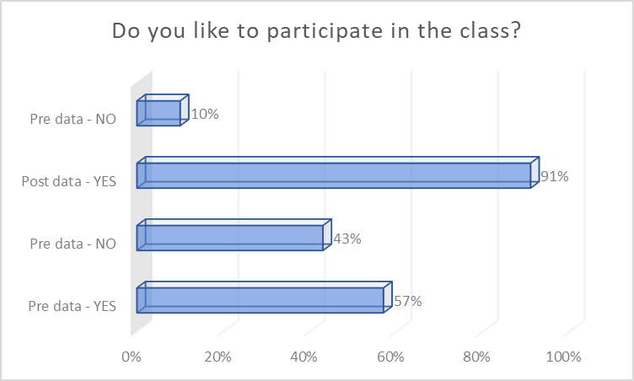

*Graph 4: Do you like to participate in the class*

The above horizontal bar graph 3 presents a comparative percentage analysis of students’ responses to the question - “Do you like to participate in the class?” before and after the intervention. Looking at the length of the bar, before the intervention, 57% of students responded affirmatively, while 43% indicated they did not enjoy participating. Following the intervention, the percentage of students who expressed a positive attitude toward class participation rose sharply to 91%, whereas negative responses dropped to just 10%.

In conclusion, the data demonstrate that the intervention had a substantial positive impact on student participation.

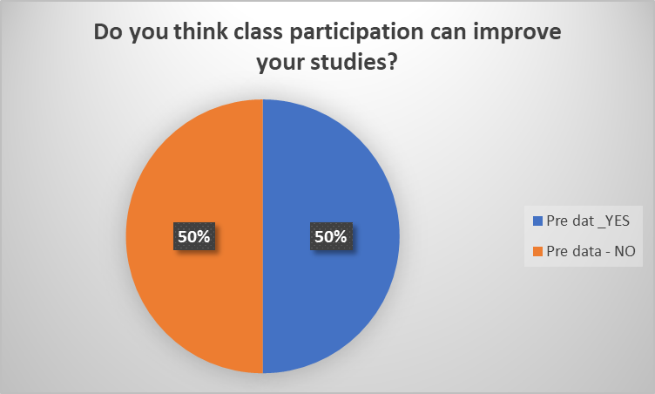

*Graph 5 Do you think class participation can improve your studies*

The above graph 5 shows that before any intervention, the students shared evenly split opinions – 50% say “Yes” and 50% say “No”.

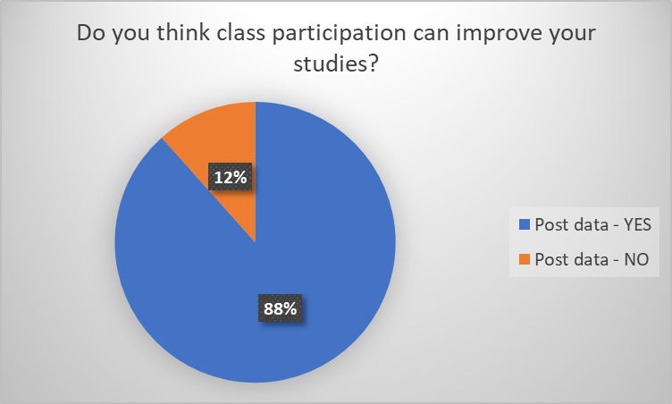

*graph 6: Do you think class participation can improve your studies*

The above circle graph 6 represents students’ beliefs on how class participation impacts their studies. The data show that, larger majority, 88%, perceived that participation in the class could improve their studies, while only 12% disagreed. This shows that the intervention had a positive impact on students’ beliefs that class participation enhances their academic learning.

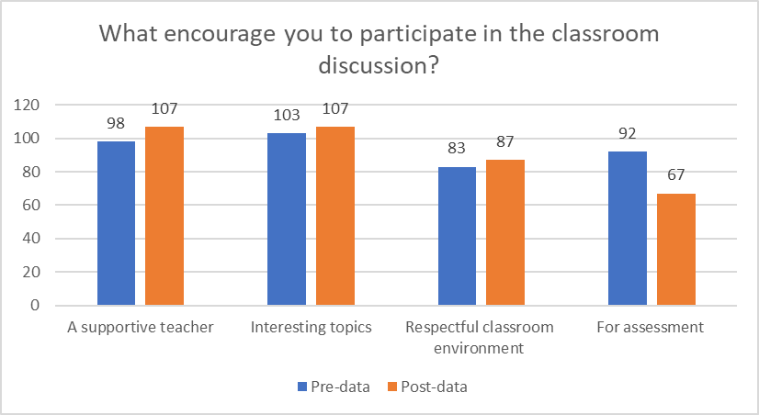

*Graph 7: What encourages you to participate in the classroom discussion*

Graph 7 above indicates the factors that encourage students to participate in the classroom discussion. As per the data analysis, it indicates that the factors like a supportive teacher (increase from 98 to 107) and interesting topics (increase from 103 to 107) are the most prominent factors that enhance students’ participation in the classroom discussion.

However, the for-assessmentcategory shows a notable **decline** in post-data (from 92 to 67), indicating that students were **less motivated by assessment-related participation** after the intervention. This could imply a **shift from extrinsic to intrinsic motivation,** where students began valuing more meaningful engagement, as teacher support and topic interest, over assessment pressures.

Overall, the data suggest that interventions aimed at improving classroom discussions were **effective in enhancing intrinsic motivators**, which is a positive indicator of a student-centered learning environment.

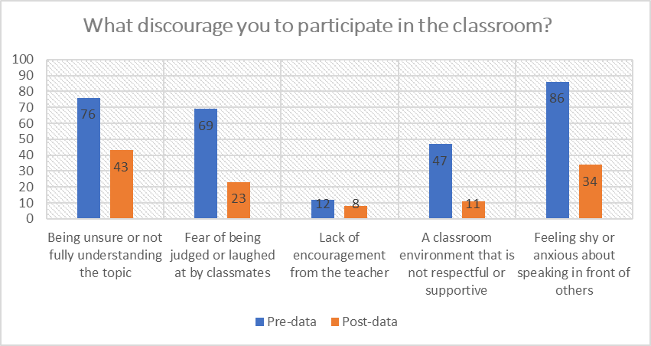

*Graph 8: What discourages you from participating in the classroom*

The Bar Graph 8 shows the comparative pre- and post-data analysis of factors that discourage students from participating in classroom discussions.

The graph identifies five key **dependent variables.** The feeling shy or anxious about speaking in front of others is the most prominent factor that discourages students from participating in the classroom (86% pre-data), however, it dropped to 34% (post-data) after the intervention. The data also shows that fear of being judged by classmates was another factor that discouraged students from participation, as per the pre-data (69%), but it drastically dropped to just 23% after the intervention.

Similarly, as per the graph the being unsure or not fully understanding the topic is the most prominent factor for discouraging students to participate in the class for both before and after the intervention, however, the data value changed from 76 to 43. Accordingly, the least reported discouraging factor, both before and after the intervention, is lack of encouragement from the teacher, which decreased from 12 to 8.

Overall, the results suggest that the intervention significantly reduced **barriers to classroom participation,** likely by fostering a more supportive, respectful, and confidence-building classroom environment.

# Research Ethics

Research ethics are important because they help ensure data is collected and analyzed without manipulation or falsification. In our research, we will follow several ethical principles. We will obtain approval from the school management for the research project. We also made the purpose and objectives of the research clear to the participants to ensure that there was no gender bias in the way we asked questions, conducted observations, and interviews. We also ensure that the responses provided by participants will be kept confidential to protect their privacy.

1. **Recommendations**

It was observed that the intervention strategies were highly effective, resulting in a significant improvement in student participation during class. Therefore, the team would like to recommend the following policies and practices:

1. The school can consider implementing professional development programs focused on student-centered teaching and learning strategies.
2. Institutionalize participation rubrics in subject-specific assessment plans.
3. Active participation by students should be formally recognized, with special acknowledgment given to the most engaged students in each class or period.
4. **Limitations**

This research is limited to specific grade levels at Pakshikha Central School, and the findings may not be generalizable to other classes or schools with different demographic or contextual settings. Results may vary depending on the class level, the academic background of students, and the geographical location of schools.

Furthermore, data collection was conducted solely through survey questionnaires. As such, the findings may differ if alternative research methods were employed. The reliability of the results may also be influenced by the honesty and interpretation of the respondents.

Additionally, the sample size was limited, which may affect the representativeness of the data. Time constraints and resource limitations further restricted the scope of the study, particularly in terms of longitudinal tracking and follow-up assessments.

Finally, potential biases in the design of the questionnaire and the possibility of socially desirable responses from students may also affect the accuracy and validity of the findings.

1. **Conclusion**

The action research aimed to explore and implement strategies to encourage active participation among Class 12 economics students at Pakshikha Central School. Through a combination of interviews, classroom observations, and survey questionnaires conducted before and after the intervention, the study revealed a marked improvement in student engagement and participation in classroom discussions.

The intervention strategies focusing on teacher encouragement, group activities, and creating an inclusive learning environment significantly impacted students’ perception of classroom dynamics. Post-intervention data indicated a substantial increase in the number of students who felt supported and motivated by their teacher, found the class more engaging, and preferred discussion-based learning over traditional lectures. Student responses also showed enhanced confidence and willingness to participate in class activities.

Overall, the findings confirm that active and intentional teaching practices, when combined with a supportive classroom culture, can successfully foster greater student participation and deeper understanding of subject matter. This study reinforces the value of action research as a tool for continuous professional reflection and improvement in teaching practices.

**COMPETING INTERESTS DISCLAIMER:**

Authors have declared that they have no known competing financial interests OR non-financial interests OR personal relationships that could have appeared to influence the work reported in this paper.

# References

Bardorfer, A. (2024). Fostering Students’ Active Participation in Higher Education: The Role of Teacher-Student Rapport. Athens Journal of Education, 11(3), 227–246. <https://doi.org/10.30958/aje.11-3-4>.

Bergdahl, N., Bond, M., Sjöberg, J., Dougherty, M., & Oxley, E. (2024, June 6). Unpacking Student Engagement in Higher Education Learning Analytics: A Systematic Review. <https://doi.org/10.13140/RG.2.2.16372.16000>.

Fassinger, P. A. (1995). Understanding classroom interaction: Students’ and professors’ contributions to students’ silence. Journal of Higher Education, 66, 82-96.

Freeman, S., Eddy, S., McDonough, M., & Mary Pat Wenderoth. (2014, May 12). Active Learning Increases Student Performance in Science, Engineering, and Mathematics. ResearchGate; Proceedings of the National Academy of Sciences. https://www.researchgate.net/publication/262267588_Active_Learning_Increases_Student_Performance_in_Science_

Kegan Paul Galven, J., & Fukada Y. (1998). Asian international students’ preferences for American universities. The CASTESOL Journal, 1, 29-49.

Michele M. Welkener. (2008). The Skillful Teacher: On Technique, Trust, and Responsiveness in the Classroom (review). The Journal of Higher Education, 79(5), 610–612. <https://doi.org/10.1353/jhe.0.0016>.

Piaget, J. (1932). The Language and Thought of the Child (2nd ed.). London: Routledge PHCB, (2019). Population and Housing Census of Bhutan, National Report. National

Statistical Bureau. Thimphu, Bhutan.

Ruiz Ulloa, B. C., and Adams, S. G. (2004). Attitude toward teamwork and effective teaming, Team Performance Management, 10(7/8), 145-151.

Totten, S., Silk, T., Digby, A., & Russ, P. (1991). Cooperative learning: A research guide.

New York: Garland

Vygotsky, L. (1978). Interaction between learning and development. Mind in Society.

Cambridge: MA: Harvard University Press.

Wade, R. C. (1994). Teacher education students’ views on class discussion: Implications for fostering critical reflection. Teaching and Teacher Education, 10, 231-243.

# Appendices

* 1. **Appendix A: Survey Questionnaires**

|  |  |  |  |  |  |
| --- | --- | --- | --- | --- | --- |
| **Survey Questions** | **SA** | **A** | **N** | **D** | **SD** |
| My teacher makes me feel that he/she care about me. |  |  |  |  |  |
| My teacher encourages me to do my best |  |  |  |  |  |
| My teacher wants me to speak more. |  |  |  |  |  |
| My teacher makes class interesting. |  |  |  |  |  |
| I am very active in class. |  |  |  |  |  |
| I like discussion rather than lecturing. |  |  |  |  |  |
| I usually participate more in class. |  |  |  |  |  |
| I don’t like speaking in class. |  |  |  |  |  |
| I like doing the class activity in the group. |  |  |  |  |  |

* 1. **Appendix B: Interview Questions**

|  |
| --- |
| **Interview Questions** |
| What do you understand by class participation? |
| Do you like to participate in the class? YES/NO |
| What encourages you to participate in the classroom? |
| What discourages you from participating in the classroom? |
| Do you think class participation can improve your studies? |

* 1. **Appendix C: Action Plan Table**

|  |  |  |  |
| --- | --- | --- | --- |
| **Month** | **Week** | **Activity** | **Remarks** |
| March | 1st week | Research proposal presentation |  |
| April | 2nd week | Pre-survey and  Observation (data collection) |  |

|  |  |  |  |
| --- | --- | --- | --- |
|  | 3rd week | Pre-interview (data collection) |  |
| May | 1st week | Finalizing the pre-base line data collection  and interpretation |  |
| May– August | 2nd and 3rd week | Adaptation of the intervention strategies |  |
| September | 1st and 2nd week | Post survey and observation Data collection |  |
| 3rd week | Post interview data collection |  |
| October | 1st and 2nd week | Analysis and interpretation of the post  data |  |

* 1. **Appendix D: Observation form for recording class participation**

|  |  |  |  |
| --- | --- | --- | --- |
| SI. NO. | Name | September | October |
| 1 |  |  |  |
| 2 |  |  |  |
| 3 |  |  |  |

* 1. **Appendix E: Survey question**

Dear students,

With due respect and warm regards, we Business Department is conducting research on how to encourage students to participate in the classroom discussion for and we need your genuine response to my survey questions. So that it can help us in doing research effectively. Your contribution will be appreciated, and your responses will remain confidential.

## *Instructions*

The following are the questions that were based on the classroom discussion and participation, which will comprise ten questions. For that, please read each item carefully and share your true response by ticking the most appropriate choice from the given degree, strongly agree, agree, neutral, disagree, and strongly disagree.

|  |  |  |  |  |  |
| --- | --- | --- | --- | --- | --- |
| **Questions** | **Strongly agree** | **Agree** | **Neutra l** | **Disagree e** | **Strongly disagree** |
| My teacher makes me feel that he/she care about me. |  |  |  |  |  |
| My teacher encourages me to do my best |  |  |  |  |  |
| My teacher wants me to speak more. |  |  |  |  |  |
| My teacher makes the class interesting. |  |  |  |  |  |
| The comments that I get on my work help me understand how  to do my work better |  |  |  |  |  |
| I am very active in class. |  |  |  |  |  |
| I like discussion rather than lecturing. |  |  |  |  |  |
| I usually participate more in  Class |  |  |  |  |  |
| I don’t like speaking in  Class |  |  |  |  |  |
| I like doing the class  activity in the group |  |  |  |  |  |