***Review Article***

**Grass Pea (Lathyrus sativus L.): An Underutilized Legume with Emerging Potential for Food Security, Climate Resilience, and Sustainable Agriculture-A review**

**Abstract**

Grass pea, or *Lathyrus sativus*, is a leguminous crop valued for its high nutritional value and its ability to withstand environmental challenges. Grass peas are valued for having a balanced amino acid profile, including essential amino acids like tryptophan and lysine, and a high protein content of 20–25%. It is a significant source of protein for the diet, especially in areas with restricted access to animal protein. On the other hand, excessive use of β-N-oxalyl-L-α,β-diaminopropionic acid (ODAP), a neurotoxic, might result in ailments related to lathyrism. In spite of challenges like reducing ODAP toxicity and improving market acceptance, grass peas have enormous potential as a sustainable crop that can support agricultural sustainability and food security in regions with limited resources. To achieve its full potential and ensure safe consumption everywhere, ongoing research and breeding efforts are crucial.

*Key words: Grass pea, Lathyrus sativus, ODAP, Neurolathyrism, neurotoxic*

**1. Introduction**

The urgency for **sustainable food security** has reached unprecedented levels, driven by rapid population growth, climate change, and mounting agricultural pressures. In this context, one often-overlooked yet promising crop is **grass pea (*Lathyrus sativus* L.)—**a hardy, nutrient-rich legume capable of thriving in some of the world's harshest growing conditions. It is a **self-pollinating grain legume** belonging to the **Fabaceae** family. What sets it apart is its exceptional resilience to drought, floods, and poor soils—traits that make it invaluable for farmers in marginal environments. In India, China, Bangladesh, Ethiopia and Nepal, as well as to a lesser extent in southern Europe, West Asia, North Africa, and South America, grass pea has been grown for millennia as a food and forage legume (Bell, 1989). It is cultivated as a forage crop in the Mediterranean region of western Australia (Siddique et al., 1996), Europe (Piergiovanni et al., 2013), and North America (Campbell et al., 1994), where it is regarded as an N-fixing crop for cereal production.

The grass pea has numerous advantages that make it a desirable crop in locations that are wet or dry, have low soil quality, and experience harsh weather conditions. Grass pea is distinguished from other legume species by having a strong, deep, soil-penetrating, pile root system that extends 1.5 m (Campbel et al., 1994), which increases its resistance to abiotic stress (Vaz Patto et al., 2006). Grass pea is frequently cultivated for both grain and feed purposes in South Asian nations. The crop's use as animal feed, rather than as sustenance for humans, has gained more important. According to reports, grass pea seeds are rich in proteins, essential amino acids, minerals, essential fatty acids, ascorbic acid, glutathione, folic acid, and total phenolic content (Tamburino et al., 2012). It is characterised by a high protein content (relatively rich in lysine) ranging from 23.0 to 34.2 percent, higher drought resilience, little disease and pest damage, high feed values, and nitrogen-fixing activity (Rizvi et al., 2016).

However, one significant disadvantage outweighs all other benefits: the presence of antinutritional factors (ANF In instance, -diamino-propionic acid (ODAP), a nonprotein amino acid that induces neurolathyrism and is a neurotoxic secondary metabolite, can be lowered by cooking along with the levels of the proteinaceous ANFs (Enneking, 2011). Because of the neurotoxin " β-N-oxalyl-L-α, β-diaminopropionic acid (ODAP or BOAA)," which is thought to be a probable cause of the neurological disorder "lathyrism" in humans when grass pea grains are consumed in excess for extended periods of time, this legume is still underappreciated despite having all these positive qualities.

**2. Taxonomy of Grass pea**

*Lathyrus sativus* is a diploid species (2n = 2x = 14) that is a member of the tribe Vicieae (also known as Fabaea), subfamily Papilionoideae, and family Leguminosae (also known as Fabaceae). The genus Lathyrus contains 150 species in 15 sections, with grass pea being one of them (Smartt et al., 1994). The grass pea is an abundantly branching suberect, straggling, or climbing herbaceous winter annual with stems that range in height from 0.6 to 9.0 m. The leaves are pinnately compound and typically have two leaflets that are linear-lanceolate and 25 to 150 mm long by 3 to 9 mm wide (Duke, 1981). The leaflets are sessile, whole, and have cuneate bases and acuminate apex L. sativus is a sub-erect, herbaceous winter annual plant. The stems can grow up to 25 to 60 cm in height. The *L. sativus* has pinnately complex leaves with two leaflets, with modified tendrils on the top ones. The flowers are axillary, single, and come in a range of hues, including blue, violet blue, pink, dark pink, bright yellow, white, and white with purple stripes (Fig 1). Each pod contains three to five white, grayish-brown, or yellowish seeds that are typically speckled or mottled, and they are oblong, 2.5 to 4.0 cm long, flat, and slightly curved (Duke, 1981). The seeds are angled, wedge-shaped, and have spots or mottling in addition to being white, brownish-gray, or yellow (Barpete, 2015).

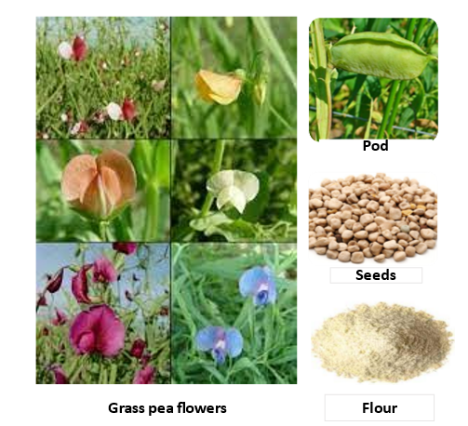

**Fig. 1. Characteristics of grass pea flower, pod, seed and flour**

**3. Nutrition of grass pea**

Grass pea seeds have a protein level of 8.6-34.6%, higher than that of chickpeas (18%), field peas (21%), and French beans (20%) (Longvah et al., 2017). The percentages of crude fiber and carbohydrates in seeds, respectively, have been shown to range from 1.1 to 1.7% and 48 to 52.3% (Tamburino et al., 2012). The overall protein content of grass pea seeds is made up of roughly 60% globulins and 30% albumins, with 90% of that protein being digestible with a 10% protein consumption (Gupta et al.,2021). According to Hanbury et al. (2000), the amino acid profiles of L. sativus are comparable to those of numerous grain legumes. Additionally, grass pea, like the majority of grain legumes, is poor in the critical sulfur-containing amino acids methionine and cysteine, but is abundant in the amino acid lysine, which is scarce in cereals. (Mahler-Slasky and Kislev 2010). In the same order, the total lipids, ascorbic acid, and glutathione each provide 1.67 g, 13.50 mg, and 15.90 mg/100 g of grass pea seeds. A significant source of vitamin B complex, grass pea seeds have 4.60 mg of thiamine (B1), 2.30 mg of riboflavin (B2), 16.40 mg of niacin (B3), 18.40 mg of pantothenic acid (B5), 5.80 mg of pyridoxine (B6), and 5.40 mg/kg of folic acid (B9). In addition, grass pea seeds contain high levels of ascorbic acid (42.5 mg/kg), retinol (34.9 g/kg), and carotene (323.3 g/kg) (52). In grass pea seeds, the concentrations of iron and zinc varied from 6.9 to 8.7 mg/100 g and from 2.43 to 26.7 mg/100 g, respectively (Urga et al, 2005). A significant source of vitamin B complex, grass pea seeds have 4.60 mg of thiamine (B1), 2.30 mg of riboflavin (B2), 16.40 mg of niacin (B3), 18.40 mg of pantothenic acid (B5), 5.80 mg of pyridoxine (B6), and 5.40 mg/kg of folic acid (B9). In addition, grass pea seeds contain high levels of ascorbic acid (42.5 mg/kg), retinol (34.9 g/kg), and carotene (323.3 g/kg) (Arslan, 2017). Only a few of the more well-known species of Lathyrus have had their polyphenol content, antioxidant activity, and usefulness examined. Lathyrus seeds contain between 0.1 to 5% (w/w) polyphenols. The concentration of tannins and polyphenols related with the colour of the seed coat were observed to range from 39 to 999 mg/kg (Deshpande and Campbell, 1992) in 100 lines of L. sativus. Ranabahu et al. (1993) investigated the flavonoids in the leaves of 36 species of Lathyrus, a group of polyphenols that are common in legumes. The antioxidant activity of the polyphenols from the non-cultivated L. maritimus was reported by Shahidi and coauthors (Shahidi, et al., 2001). *Lathyrus sativus*' mean protein content (29.71.5%) compares favorably to that of more common legumes like Glycine max and Lupinus species (Urga et al., 2005). Magnesium and phosphorus are present in larger amounts in the seeds, followed by calcium as reported by Urga et al., (2005). Along with offering high-quality proteins for both human and animal nutrition, the Lathyrus genus represents a potential new source of natural antioxidants.

**4. Chemistry of BOAA**

The chemical formula for β-ODAP, also known as BOAA or Dencichin, is C5H8N2O5, with a molecular weight of 176. ODAP is available in two forms: α-ODAP and β-ODAP isomers (Fig. 2). According to Gresta et al. (2014), the α-isomer of ODAP is less hazardous than the β-isomer and does not cause neurolathyrism. Toxicity is mostly determined by the ratio of β-ODAP to total ODAP. The β:α ratio typically hovers around 95:5, but can change depending on conditions. The neurotoxin BOAA is structurally related to the neurotransmitter glutamate found in Lathyrus species.

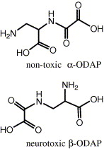

**Fig. 2. Two isomers of ODAP**

**5. Multifaceted use of grass pea**

Unlike other legumes, grass pea has evolved various morphological drought tolerance qualities as adaptive mechanisms, including as small leaves, winged stems, and a deep and broad root system. Thus, under drought stress, grass pea performance is highly related to root system development and distribution (Koevoets et al., 2016). Indeed, the deeper the root depth and biomass, the more effectively accessible soil moisture is taken (Fenta et al., 2014) (Fig 3).

It is one of the most affordable and the largest source of protein next to soybean. It is a hardy crop, tolerant to both drought and flooding. It fixes 60–124 kg/ha nitrogen under dry conditions (Kumar et al., 2020). Grasspea is an abandoned and underutilized crop that can be used to extract a variety of compounds beneficial to human health. It has high folic acid that plays a vital role in erythropoiesis (the production of red blood cells) along with nucleic acid and protein synthesis. Therefore, it is essential in preventing congenital disabilities (Tamburino et al., 2012)). The β-ODAP metabolite has been found to naturally heal wounds (Sharma et al., 2018). The seed oil of L. sativus has numerous therapeutic advantages. It is an effective cathartic. It can effectively treat scabies, allergies, and eczema. Grass pea kernels are used to make homeopathic medicines and share structural similarities with the neurotransmitter glutamate found in the Lathyrus species. Their roots contain phenol phytochemicals, which explain their radical scavenging effect. As a result, grass pea seeds have showed a wide range of therapeutic characteristics, indicating that they could be used as a future medicinal or pharmaceutical crop.

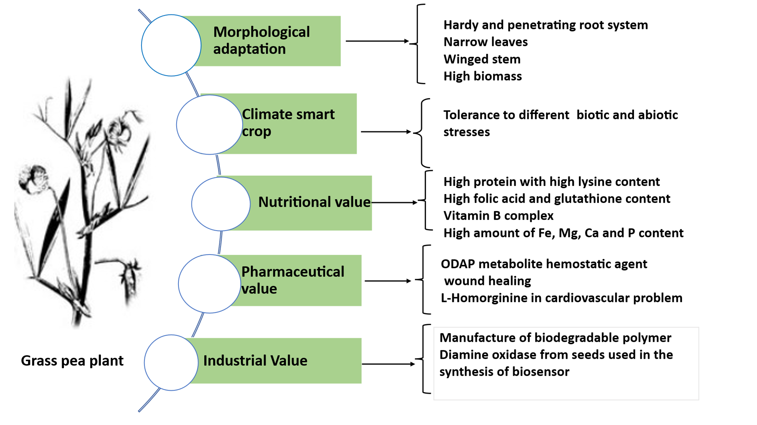

**Fig. 3. Multifaceted use of grass pea plant**

**6. Neurolathyrism of grass pea**

Since ancient times, Lathyrus species, especially L. sativus, have been linked to "lathyrism," or more specifically "neurolathyrism," a paralysis that affects both humans and animals. Overconsumption of grass pea (*Lathyrus sativus* L.) seeds results in neurolathyrism (Spencer & Schaumburg, 1983), a condition marked by loss of pyramidal cells in the region of the cortex responsible for controlling the leg as well as symmetrical axonal degeneration of crossed and uncrossed pyramidal tracts in the thoracic, lumbar, and sacral spinal cords (Haimanot et al., 1990). Lathyrism comes in two different forms: neurolathyrism and osteolathyrism. Consumption of the species *L. odoratus* (sweet pea), *L. hirsutus, L. pusillus, and L. roseus* might result in osteolathyrism, which is characterised by skeletal abnormalities (Roy, 1981). The hind limbs become weakened, and the muscles become rigid or paralysed. The category of neurolathyrism has been further subdivided into two subcategories within the Lathyrus genus. The first is brought on by the substance L-2,4-diaminobutyric acid (DABA), which is principally found in the perennial species *L. sylvestris* (Foster, 1990) and *L. latifolius* (Barrow et al., 1974). However, neither *L. cicera* nor *L. sativus* contain DABA (Padmanaban, 1980). The non-protein amino acid 3-(-N-oxalyl)-L-2,3-diamino propionic acid (ODAP, also known as b-N-oxalylamino-L-alanine or BOAA): which has been recorded in humans and animals after consumption of *L. sativus, L. cicera, L. ochrus, and L. clymenum*. ODAP has been discovered in the seeds of several different uncultivated Lathyrus species (Bell, 1964). Hugon et al. (2000) found that the paralysis is seldom reversible (and even then, only in the early stages of the symptoms), and this can have disastrous effects on underdeveloped communities who depend on L. sativus as their main source of food during times of food scarcity. Lathyrism is endemic to India, Bangladesh, Ethiopia, and Nepal, which are also significant global centres for L. sativus agriculture. Although outbreaks were also noted in Syria, Afghanistan, Algeria, China, France, Germany, Italy, Pakistan, Romania, Russia, and Spain during the 20th century (Hugon et al., 2000).

In numerous instances, boiling has been reported to lower ODAP levels; however, there are conflicting findings on the effects of various types of cooking (Akalu et al., 1998). According to Padmajaprasad et al. (1997), cooking grain and removing the water reduced ODAP levels by up to 90%. Zn deficiency in plants and humans, respectively, may be related to ODAP production and sensitivity (Lambein and Kuo, 1997). The growth of several insects and yeasts has also been reported to be inhibited by ODAP (Mehta et al., 1972), suggesting that it may have a protective role for plants.

While eating the protein-rich seeds of L. sativus, which contain a neuro-excitatory amino acid, is linked to neurolathyrism (meaning broken legs), konzo (meaning tied legs in the Yaka language), occurs when people consume the carbohydrate-rich roots of Manihot esculenta (cassava), which still contain residual cyanogens. Both diseases have oxidative stress as its aetiology, which is caused by a variety of reasons including micronutrient imbalances, the depletion of glutathione due to a diet lacking in sulfur-containing amino acids, antioxidants, and reducing power, and oxidative stress itself.

Because both diseases mostly affect extremely poor rural residents who live as subsistence farmers on marginal lands that are prone to drought, their epidemiology and socioeconomic backgrounds are also highly similar despite the two diseases occurring in different geographic regions.

Neurolathyrism epidemics in Bangladesh (1980s), India (1980s), and Ethiopia (1980s and 1990s) all spread during or after drought seasons (Bradbury and Lambein 2011). Konzo outbreaks in Mozambique and Tanzania (1980s and 1990s). The issue of whether konzo and neurolathyrism are brought on by intoxication, a nutrient deficiency, or a combination of both emerges. Simple dietary changes can lower the prevalence of neurolathyrism.

By including sufficient grains to raise the diet's amino acid score and antioxidant-containing foods (fruits and vegetables), the disease can be avoided (Getahun et al., 2003). Additionally, by using various food preparation techniques (such soaking in water or boiling), seeds can be partially detoxified, and grains can be roasted at 150 °C (Kumar et al., 2011). Additionally, it has been demonstrated that fermentation can reduce -ODAP by 80–90% (Kuo et al., 1995).

**7. Elimination of grass pea toxicity through food processing**

All plant organs possess the toxin -L-ODAP, however young shoots, leaves, and developing pods have the highest amount. Less frequently, grass pea shoots are used as a leafy vegetable after being steamed or boiled. These methods of preparation lower the toxicity to some extent by either partially converting -L-ODAP into ineffective -L-ODAP (Padmajaprasad et al., 1997) or by leaching away the toxin through steeping or boiling and discarding the water. Several researchers reported that boiling and fermentation with the fungal species Rhizopus oligosporus and Aspergillus oryzae appear to be more effective at reducing toxicity than roasting (Padmajaprasad et al., 1997). Processing techniques such as milling, boiling, soaking, fermenting, and sprouting are used to improve the nutritional qualities of grass peas while lowering antinutritional components (Solovieva et al., 2025). Roasting and boiling reduced β-ODAP levels by 12% and 38%, respectively, while increasing mineral content such as zinc, iron, and calcium. Soaking in boiling water lowers β-ODAP by 65-70%, trypsin inhibitors by 42-48%, and polyphenols by 30-37% (Srivastava and Khokhar, 1996). Simultaneously, these treatments may reduce the harmful compounds such as β-ODAP, trypsin inhibitors, polyphenols, amylase inhibitors, phytate, and tannins, making grass peas a safer and more nutritionally valuable ingredient for food products (Fig 4).

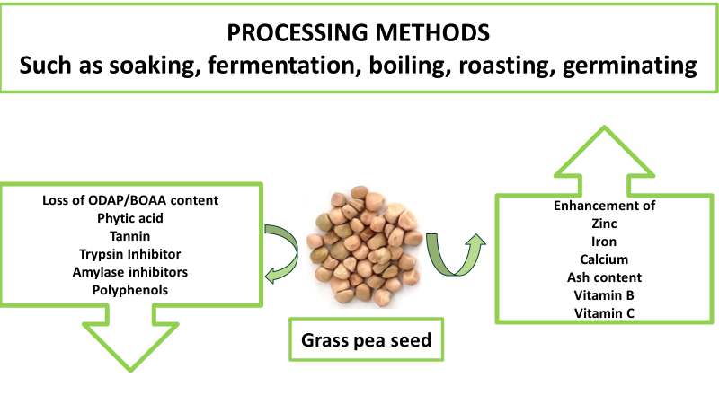

**Fig.4. Variations in nutritional composition of grass pea throughout processing**

**8. Use of Grass pea as animal feed**

Being a drought tolerant crop, the seed and leaves of grass pea can be used as an animal feed is tolerant for both high moisture (Sinha, 1980) and drought (Jiang et al., 2013). The proximate composition of grass pea seeds exhibits very good nutritional digestibility, low fat and acid detergent fiber (ADF) levels, and high starch and protein contents (Larbi et al., 2010). In a study conducted in Iran (Vahdani et al., 2014), the values of grass pea hay's crude protein (CP), neutral detergent fiber (NDF), and acid detergent fiber (ADF) were analyzed and found to be 232.4, 397, and 300.6 (g kg-1 DM) correspondingly.

**9. Conclusion**

Grass peas are resilient crops that provide nutritional advantages, especially in regions that are subject to environmental stressors. Even with all of its potential, there are challenges like neurotoxins (ODAP) that need to be carefully managed through breeding and processing techniques. By concentrating on these factors, scientists need to develop varieties that contribute to food security, sustainable agriculture, and greater quality of life for farming communities across the globe. The key objectives of future breeding programs should be to raise genetic diversity, improve yield potential, enhance agronomic attributes, and reduce the amount of ODAP in plants.

COMPETING INTERESTS: Authors have declared that no competing interests exist.

**Reference**

Akalu, G., Johansson, G. & Nair, B. M. (1998). Effect of processing on the content of b-N-oxalyl-a,b diaminopropionic acid (b-ODAP) in grasspea (Lathyrus sativus) seeds and our as determined by ow injection analysis. *Food Chemistry*, 62, 233-237

Arslan, M. (2017). Diversity for vitamin and amino acid content in grass pea (Lathyrus sativus L.). *Legume Research - An International Journal*, 40:803–10.10.18805/LR-369. doi: 10.18805/LR-369

Barpete, S. (2015). Genetic associations, variability and diversity in biochemical and morphological seed characters in Indian grass pea (Lathyrus sativus L.) accessions. *Fresenius Environmental Bulletin,* 24, 1-6

Barrow, M. V., Simpson, C. F. & Miller, E. J. (1974). Lathyrism: a review. *Quarterly Review of Biology*, 49,101-128

Bell, E. A. (1964). Relevance of biochemical taxonomy to the problem of lathyrism. *Nature,* 203, 378±380

 Bradbury, H.L. & Lambein, F. (2011). Konzo and neurolathyrism: similarities and dissimilarities between these crippling neurodegenerative diseases of the poor. *Food and Chemical Toxicology*, 49, 537–538

Campbell, C. G., Mehra, R. B., Agrawal, S. K., Chen, Y. Z., El Ali, A. M. A., Khawaja, H. I. T., Yadav, C. R., Toy, J. & Araya, W.A. (1994). **Current** status and future strategy in breeding grass pea (Lathyrus sativus). *Euphytica*,73,167–175.

Deshpande, S. S. & Campbell, C. G. (1992). Genotype variation in BOAA, condensed tannins, phenolics and enzyme inhibitors of grass pea (Lathyrus sativa). *Canadian Journal of Plant Science*,72, 1037-1047.

Duke, J. A. (1981). Handbook of legumes of world economic importance.1981; 199-265. Plenum Press, New York.

Enneking, D. (2011). The nutritive value of grasspea (Lathyrus sativus) and allied species, their toxicity to animals and the role of malnutrition in neurolathyrism. *Food and Chemical Toxicology*, 49(3), 694-709.

Foster, J. G. (1990). Flatpea (Lathyrus sylvestris L.): a new forage species? a comprehensive review. *Advances in Agronomy*, 43, 241-313.

Getahun, H., Lambein, F., Vanhoorne, M. & Van der Stuyft, P. (2003). Food-aid cereals to reduce neurolathyrism related to grass-pea preparations during famine. *Lancet*, 362, 1808–1810.

Gresta, F., Rocco, C., Lombardo, G. M., Avola, G. & Ruberto, G. (2014). Agronomic characterization and α-and β-ODAP determination through the adoption of new analytical strategies (HPLC-ELSD and NMR) of ten Sicilian accessions of grass pea. *Journal of Agricultural and Food Chemistry*, 62(11), 2436–2442.

Gupta, D. S., Barpete, S., Kumar, J. & Kumar, S. (2021). Breeding for Better Grain Quality in Lathyrus. In: Gupta DS, Gupta S, Kumar J, editors. Breeding for Enhanced Nutrition and Bio-Active Compounds in Food Legumes. Cham: Springer, 131–56. doi: 10.1007/978-3-030-59215-8_6

Haimanot, R. T., Kidane, Y. & Wuhib, E. (1990). Lathyrism in rural northern Ethiopia: A highly prevalent neurotoxic disorder. *International Journal of Epidemiology*, 19, 664–672.

Hanbury, C. D., Siddique, K. H. M., Galwey, N. W. & Cocks, P. S. (1999). Genotype environment interaction for seed yield and ODAP concentration of Lathyrus sativus L. and L. cicera L. in Mediterranean-type environments. *Euphytica,* 110, 45–60. doi: 10.1023/A:1003770216955

Hugon, J., Ludolph, A. C. & Spencer, P. S. (2000). b-N-oxalylamino-L-alanine. In: Spencer, P.S., Schaumburg, H. (Eds.), Experimental and Clinical Neurotoxicology, 2nd Edition. Oxford University Press, New York, 925-938.

Jiang, J., Su, M., Chen, Y., Gao, N., Jiao, C., Sun, Z., Li, F. & Wang, C. (2013). Correlation of drought resistance in grass pea (Lathyrus sativus) with reactive oxygen species scavenging and osmotic adjustment. *Biologia*, 68, 231-240.

Kumar, S., Bejiga, G. S., Ahmed, H., Nakkoul, A. & Sarker. (2011). Genetic improvement of grass pea for low neurotoxin (ODAP) content. *Food and Chemical Toxicology*, 49, 589–600.

Kumar, S., Gupta, P., Barpete, S., Choukri, H., Maalouf, F. & Sarkar, A. (2020). “Grass pea,” in *The Beans and the Peas, From Orphan to Mainstream Crops*. eds A. Pratap and S. Gupta (London: Elsevier). doi: 10.1016/B978-0-12-821450-3.00005-6

Kuo, Y. H., Bau, H. M., Quemener, B., Khan, J. K. (1995).Lambein, F. Solid-state fermentation of Lathyrus sativus seeds using Aspergillus oryzae and Rhizopus oligosporus sp T-3 to eliminate the neurotoxin β-ODAP without loss of nutritional value. *Journal of the Science of Food and Agriculture,* 69,81–89. <https://doi.org/10.1002/jsfa.2740690113>

Lambein, F. & Kuo, Y. H. (1997). Lathyrus sativus, a neolithic cropwith a modern future. An overview of the present situation.In: Grela ER (ed) Lathyrus sativus–cultivation and nutritivevalue in animals and human. International Scientific Con-ference, Radom 1997, Poland. Institute of Animal Nutri-tion, Agricultural University, Lublin, pp 6–1

Larbi, A., El-Moneim, A. A., Nakkoul, H., Jammal, B. & Hassan, S. (2010). Intra-species variations in yield and quality in Lathyrus species: 1. Grasspea (L. sativus L.). *Animal Feed science and technology*, 161:9-18

Longvah, T., Anantan, I., Bhaskarachary, K., Venkaiah, K. & Longvah, T. (2017). Indian Food Composition Tables. Hyderabad: National Institute of Nutrition, Indian Council of Medical Research, 2–58.

Mahler-slasky, Y., [Mordechai, E., Kislev](https://www.researchgate.net/profile/Mordechai-Kislev?_tp=eyJjb250ZXh0Ijp7ImZpcnN0UGFnZSI6InB1YmxpY2F0aW9uRG93bmxvYWQiLCJwYWdlIjoicHVibGljYXRpb24ifX0). (2010) Lathyrus consumption in Late Bronze and Iron Age sites in Israel: an Aegean affinity. *Journal of Archaeological Science*, 37(10), 2477-2485

Mehta, T., Hsu, A. F. & Haskell, B. E. (1972). Septicity of the neurotoxin from Lathyrus sativus as an amino acid antagonist. *Biochemistry*, 11, 4053-4063.

Padmajaprasad, V., Kaladhar, M.& Bhat, R. V. (1997). Thermal isomerisation of b-N-oxalyl-L-a,b-diaminopropionic acid, the neurotoxin in Lathyrus sativus, during cooking. *Food Chemistry*, 59:77-80.

Padmanaban, G. (1980).Lathyrogens. In: Liener, I.E. (Ed.), Toxic Constituents of Plant Foodstuffs, 2nd Edition. Academic Press, New York, 239±263

Piergiovanni, A., Francesco, L.& Massimo, Z. (2011). Environmental effects on yield, composition and technological seed traits of some Italian ecotypes of grasspea (Lathyrus sativus L.). Journal of the Science of Food and Agriculture, 91,122-129.

Ranabahu, P.& Harborne, J. F. (1993). The flavonoids of the genus Lathyrus and a comparison of flavonoid patters within the tribe Vicieae. *Biochemical Systematics and Ecology*, 21: 715-722.

Rizvi, A. H, Sarker, A. & Dogra, A. (2016). Enhancing grass pea (Lathyrus sativus L.) production in problematic soils of South Asia for nutritional security. *Indian Journal of Genetics and Plant Breeding*, 76(04),583-592. doi.org/10.5958/0975-6906.2016.00074.2

Roy, D. N. (1981). Toxic amino acids and proteins from Lathyrus plants and other leguminous species: a literature review. *Nutrition Abstracts and Reviews, Series A*, 51, 691-707

Shahidi, F., Chavan, U. D., Naczk, M. & Amarowicz, R. (2001). Nutrient distribution and phenolic antioxidants in air–classified fractions of beach pea (Lathyrus maritimus L.). *Journal of Agricultural and Food Chemistry*, 49, 926–933.

Sharma, M., Sahu, K., Singh, S.P. & Jain, B. (2018). Wound healing activity of curcumin conjugated to hyaluronic acid: In vitro and in vivo evaluation. *Artificial Cells, Nanomedicine, and Biotechnology, 46*, 1009–1017.

Siddique, K. H. M., Loss, S. P., Herwig, S. P. & Wilson, J. M. (1996). Growth, yield and neurotoxin (ODAP) concentration of three Lathyrus spp in Mediterranean-type environments of Western Australia. *Australian Journal of Experimental Agriculture*, 36, 209-218.

Smartt, J., Kaul, A., Araya, W. A., Rahman, M. M. & Kearney, J. (1994). Grasspea (Lathyrus sativus L.) as a potentially safe food legume crop. 144-155. In: F.J. Muehlbauer and W.J. Kaiser (eds.), Expanding the Production and Use of Cool Season Food Legumes. Kluwer Academic Publishers. Dordrecht, Netherlands

Solovieva, I., Miteva-Bölter, P., Marija Knez, M., Bessai, A. K., Barilli, E., Kasperczyk, N., Ranic, M., Gurinovic, M., Casado, P. J. L. Morales, N. A., Sanchez, M., Tisseyre, C., Schaer, B. and Xoplaki, E. (2025). Exploring the Potential and Challenges of *Lathyrus sativus* (Grass Pea) in European Agri-Food Value Chains: A Cross-Country Analysis. [*Sustainability*](https://www.mdpi.com/journal/sustainability), 17 (8), 3283[10.3390/su17083283](https://www.mdpi.com/2071-1050/17/8/3283)

Spencer, P. S. & Schaumburg, H. H. (1983). Lathyrism: a neurotoxic disease. *Neurobehavioral Toxicology and Teratology*, 5, 625– 629.

Srivastava, S. & Khokhar, S. (1996) Effects of processing on the reduction of β-ODAP (β-N-oxalyl-L-2,3 diaminopropionic acid) and antinutrients of khesari dhal, Lathyrus sativus. *Journal of the Science of Food and Agriculture*, 71, 50- 58

Tamburino, R., Guida, V., Pacifico, S., Rocco, M., Zarelli, A. & Parente A. (2012). Nutritional values and radical scavenging capacities of grass pea (’Lathyrus sativus’ L.) seeds in Valle Agricola district, Italy. *Australian Journal of Crop Science*, 6:149– 56.

Urga, K., Fufa, H., Biratu, E. & Husain, A. (2005). Evaluation of Lathyrus sativus cultivated in Ethiopia for proximate composition, minerals, β-ODAP and anti-nutritional components. *The African Journal of Food, Agriculture, Nutrition and Development*, 5,1–15. doi: 10.18697/ajfand.8.1030

Vahdani, N., Moravej, H., Rezayazdi, K. & Dehghan-Banadaki, M. (2014). Evaluation of Nutritive Value of Grass Pea Hay in Sheep Nutrition and Its Palatability as Compared with Alfalfa. *Journal of Agricultural Science & Technology*, 16(3)

Vaz Patto, M. C., Skiba, B., Pang, E. C. K., Ochatt, S. J., Lambein, F. & Rubiales, D. (2006). Lathyrus improvement for resistance against biotic and abiotic stresses: From classical breeding to marker assisted selection. *Euphytica*, 147, 133-147