Heavy metal bioaccumulation by the aneceic earthworm, *Alma nilotica* (Grube 1855) and the pollution level of biochar-amended e-waste-contaminated soil

.

ABSTRACT

|  |
| --- |
| **Aims:** To investigate the effect of amending e-waste contaminated soils with maize cob-based biochar on heavy metal bioavailability to *Alma nilotica* and soil pollution level.  **Study design:** Experimental design.  **Place and Duration of Study:** Laboratory of Applied Biology and Ecology (LABAE) and Laboratory of Soil Science and Environmental Chemistry at the University of Dschang, August 2024 and July 2025.  **Methodology:** The bioaccumulation bioassay followed the OECD (2010) test guidelines No.317 for Bioaccumulation on terrestrial oligochaetes. Soil samples were collected, dried and analyzed for the studied metals. Earthworms were exposed to both the culture soil, e –waste soil with and without biochar and biochar alone for a period of 35days were a soil sample and an earthworm was sampled after every 4days.Each of the sample was analyzed for Pb, Cu, Cd, Ni, Zn.  **Results:** Results indicated that the amended soil had improved pH, % organic carbon, and Cation Exchange Capacity. Biochar amendment reduced the heavy metal contamination and pollution levels by 59% and 64% respectively, especially when considering their bioavailable fractions in soil. Exposure of earthworms resulted in continuous Cd, Cu, Ni, Pb, and Zn uptake and simultaneous reduction in soil heavy metal concentrations. The heavy metal uptake by the earthworms reduced by 51.6% to 68.8% in the amended soil, resulting in higher heavy metal concentrations in the amended soils and indicating reduced metal bioavailability in the biochar amended e-waste soil. Consequently, the heavy metal bioaccumulation factors in the amended soil reduced by between 72.7% and 82.8%. Earthworms proved to be a good indicator of the heavy metals bioavailable fraction in soil.  **Conclusion:** These results have important implications for soil remediation using the biochar approach. However, these should be directly linked to earthworm growth and reproduction to ensure long-term protection of soil biota. |

*Keywords: Keywords: Earthworm, Biochar, Heavy Metals, E-waste, Bioaccumulation.*

1. INTRODUCTION

Waste Electrical and Electronic Equipment (WEEE), or e-waste, refers to waste from discarded electrical and electronic devices at the end of their life. The electronics industry is the largest and fastest-growing sector (Muskan et al., 2023). Due to shorter product lifespans, e-waste is the fastest-growing waste stream, with 62 billion kg generated globally in 2022, of which only 22.3% was recycled properly. Projections estimate that 82 billion kg of e-waste will be generated by 2030 (Balde et al., 2024).

E-waste contains hazardous and valuable components, with metals comprising about 50% (31 billion kg) of the total generated in 2022 (Balde et al., 2024). In Africa, e-waste management is inadequate, often relying on crude methods like burning to recover metals (Nfor et al., 2022a; Moyen & Archodoulaki, 2023). Uncontrolled dumping and informal recycling release toxic metals, raising soil heavy metal concentrations beyond critical thresholds for soil health (Atiemo et al., 2012; Kyere, 2016; Fosu-Mensah et al., 2017; Nfor et al., 2022a, b; Twagirayezu et al., 2022).

Soil heavy metal pollution is a significant environmental challenge that adversely affects soil fertility, food security, and human health, thereby hindering the achievement of global sustainability goals (FAO/UNEP, 2021). This pollution arises from overexploitation, uncontrolled waste dumping, informal recycling activities, and improper soil use, primarily through leaching and volatilization (Taraqqi-A et al., 2021). Heavy metals resist organic detoxification and bioaccumulate, leading to prolonged half-lives in soils (Taraqqi-A et al., 2021). Contaminated soils often contain elevated levels of lead (Pb), copper (Cu), Nickel (Ni), cadmium (Cd), and zinc (Zn), impacting extensive areas (O’Connor et al., 2018). The persistence and potential toxicity of heavy metals have garnered substantial attention due to their non-biodegradability (Chen et al., 2022). Heavy metal pollution poses a threat to soil-dwelling organisms, including earthworms, which are recognized as essential soil ecosystem engineers due to their roles in organic matter decomposition, nutrient cycling, pore creation, and soil formation (Elliston & Oliver, 2020; Gałwa-Widera, 2021; Bakht et al., 2022; Nfor et al., 2022b; Fai et al., 2023). Addressing soil pollution is crucial for ensuring a healthy environment and a sustainable future.

The combined use of earthworms and biochar, known as vermibiochar, has emerged as an environmentally friendly remediation technique (Rehman et al., 2023). Biochar, produced through the pyrolysis of biomass in a low-oxygen environment, effectively remediates heavy metal-contaminated water and soil (Sayyadian et al., 2018; Guo et al., 2020; Beusch, 2021; Chen et al., 2022).

Biochar effectively immobilizes and reduces the bioavailability of heavy metals (Park et al., 2011; Huang et al., 2020; Garau et al., 2022). It adjusts pH in acidic soils and has high cation exchange and buffering capacity, making it suitable for contaminated soils with metal(loid)s (Nyoka et al., 2021; Graziano et al., 2022). The combined use of earthworms and biochar, known as vermibiochar, has emerged as an environmentally friendly remediation technique (Rehman et al., 2023). Produced through biomass pyrolysis in a low-oxygen environment, biochar effectively remediates heavy metal-contaminated water and soil (Sayyadian et al., 2018; Guo et al., 2020; Beusch, 2021; Chen et al., 2022).

Earthworms ingest contaminated soil, metabolize the contaminants, and excrete them in a more stable form or accumulate them in their tissues, thereby reducing overall soil contamination (Rehman et al., 2023). However, Ukalska-Jaruga et al. (2022) found that various soil amendments, including different compost types, biosolids, and minerals, significantly decreased earthworm biomass and survival in metal-contaminated soils, with some amendments causing 100% mortality.

Despite these findings, the relationship between earthworm-biochar interactions and their effects on heavy metal bioaccumulation and pollution levels in e-waste-contaminated soils has not been fully established. The present study aims to assess the effect of corn cob-derived biochar amendment on heavy metal bioaccumulation by the anecic earthworm *Alma nilotica* (Grube, 1855) and its influence on contamination and pollution levels in e-waste-contaminated soils.

2. material and methods

**2.1 Collection of soil samples**

The e-waste contaminated soil was obtained from an informal e-waste recycling site located in Bonaberi, Douala, Cameroon. Surface soil samples were collected from 10 random points using a soil auger to a depth of 20 cm after clearing all e-waste debris and transported to the Laboratory of Applied Biology and Ecology (Department of Animal Biology, University of Dschang) in high-density polythene bags. On arrival, the samples were air-dried at ambient temperature (25°C) and relative humidity of 76% for 1 week, and then sieved with a 2 mm aperture stainless steel sieve to remove large soil particles and any earthworms or cocoons, as in Nfor et al. (2022a). The soil used to prepare the earthworm culture, which also served as the control soil in the bioaccumulation experiments, was obtained from an uncontaminated school garden.

**2.2 Earthworm culture**

The earthworm culture soil was prepared by combining uncontaminated garden soil with dried avocado leaves and fresh vegetable waste, as in Fai et al. (2023). To maintain appropriate humidity levels and prevent flies from landing on the medium, a layer of shredded cardboard weighing 260 g was used as a cover. The container was equipped with a perforated lid for proper aeration, and a mousseline tissue was employed to prevent moisture loss and the entry of insects into the culture medium (Fai et al., 2023). The prepared culture medium was allowed to stabilize for 14 days. Roughly 1,000 mature and juvenile earthworms, belonging to the species *A. nilotica* (Order: Opisthopora; Family: Glossoscolecidae), were sourced from CAVYLAND enterprise in Yaoundé, Cameroon. These earthworms, ranging in mass from 0.10 g to 0.21 g, were transported to the laboratory and introduced into a culture bowl containing 40 kg of culture soil (dimensions: 45 × 20 × 25 cm³). Before being used in the bioassays, the earthworms underwent a 14-day acclimatization period during which they were fed with finely ground cow dung obtained from a contamination-free source (cows not subjected to medication). Subsequently, the worms were provided with cow droppings as food and allowed to grow, reproduce, and produce juvenile earthworms for 2 months. The culture soil temperature remained between 21 to 23 °C, and the moisture content was maintained between 75% and 80%.

**2.3 Production and characterization of of biochar**

Biochar production from corn cob was done using the closed drum technique containing both an inner and an outer chamber (Novak et al., 2022). Approximately 5.4 kg of maize cobs underwent pyrolysis at a temperature of around 500-530°C under controlled oxygen conditions to limit combustion. The contents of the chamber were carefully monitored to prevent complete ash formation. Following pyrolysis, the biochar was treated with water to prevent further oxidation. Subsequently, the biochar was collected, exposed to sunlight for drying, and later finely crushed into particles (Tsamo et al., 2019).

**2.4 Bioaccumulation bioassay**

The bioaccumulation experiment was conducted following the guidelines outlined in the Organization for Economic Co-operation and Development (OECD) test 317 (OECD, 2010). Five distinct treatments—culture soil (positive control), e-waste soil, e-waste soil + biochar, and biochar alone (0.5%)—were established in triplicate, resulting in 15 test containers measuring 20 × 15 × 10 cm. The contents of the different treatments were thoroughly mixed and allowed to stabilize for 24 hours. Subsequently, 15 immature earthworms without a clitellum, with masses of 0.10 g to 0.14 g and lengths of 1.6 cm to 2.4 cm, were randomly selected from the culture population and introduced into each test container. Approximately 3.0 g of sieved cow dung was added to the surface of each container to serve as a food source, with additional servings provided weekly thereafter. Perforated lids were placed on the test containers to enable gaseous exchange between the substrate and atmosphere, as well as to allow sunlight exposure (Lowe & Butt, 2005). The bioaccumulation study consisted of two phases: a 21-day exposure phase followed by a 14-day depuration phase, resulting in total test duration of 35 days. At the end of the exposure phase, the remaining earthworms were removed from their respective test soils, rinsed quickly in distilled water, and placed in prepared non-e-waste soils in triplicate for post-exposure (depuration) studies. Earthworms and soil samples were collected on days 1, 3, 6, 9, 12, 15, 18, and 21 for the exposure phase and on days 24, 27, 31, and 35 for the depuration phase. During each sampling event, one soil sample and one earthworm were randomly selected from each container, amounting to 3 soil samples and 3 earthworms per treatment. The selected earthworms were rinsed with distilled water, dried on filter paper, and placed in small plastic containers. To ensure accurate determination of heavy metal levels in the earthworm tissues, the dried earthworms were refrigerated for 48 hours to allow purging of gut contents. Next, the purged worms were weighed using an electronic balance, rinsed with distilled water, transferred into 2.0-ml Invitrogen ribonuclease-free microcentrifuge tubes (Thermo Fisher Scientific), and preserved in a freezer at -20 °C until heavy metal analysis (Nfor et al., 2022b).

**2.5 Heavy metal analysis in soils, biochar and earthworms**

The soil and biochar physicochemical properties (pH, % organic matter, % organic carbon, C/N ratio, and cation exchange capacity) were analyzed at the Laboratory of Soils and Environmental Chemistry (Faculty of Agronomy and Agricultural Sciences, University of Dschang, Cameroon) following the methodologies described in Pauwel et al. (1992). Sample preparation and metal analyses (Cd, Cu, Ni, Pb, and Zn) in soil, biochar, and earthworms also followed the methods of Pauwel et al. (1992) as described in Fai et al. (2023).

**2.6 Data analysis**

To determine the level of heavy metal contamination of the biochar and e-waste soil, two indices of pollution (degree of contamination and modified degree of contamination) were calculated (Shirani et al., 2020). The degree of contamination ($C_{d}$) is the comprehensive pollution index for multiple contaminants, i.e., the sum of all contamination factors ($C_{f}^{i}$ $C_{f}^{i}$) for various heavy metals for each sample (Sivakumar et al., 2016). The contamination factor was calculated according to this equation:

$C_{f}^{i}=\frac{C_{0-1}^{i}}{C_{b}^{i}}$ $C_{f}^{i}=\frac{C_{m}^{i}}{C_{b}^{i}}$

Where $C_{f}^{i}$ ($C_{f}^{i}$ $C_{f}^{i}$) is the contamination factor of the metal of interest; ($C_{m}^{i}$ $C_{f}^{i}$) $C_{0-1}^{i}$ is the concentration of the metal *i* in the sample; ($C_{b}^{i}$ $C_{f}^{i}$) $C_{b}^{i}$ is the background metal concentration (i.e. metal concentration in the culture soil). The degree of contamination ($C_{d}$) was calculated according to this equation:

$C_{d}=\sum{C_{f}^{i}}$

The Modified Degree of contamination (${mC}_{d}$) was calculated according to this equation:

${mC}_{d}=\frac{\sum{C_{f}^{i}}}{n}$

Where n was the number of analysed elements, which in the present study was 5; i = ith element and $C_{f}^{i}$ was the Contamination Factor (Sivakumar et al., 2016; Shirani et al., 2020).

The ecological risk ($E_{r}^{i}$ $E_{r}^{i}$) posed by each metal was calculated according to this below equation (Ahamad et al. 2020):

$E_{r}^{i}=T_{r}^{i}*\frac{C_{m}^{i}}{C_{b}}$

Where: $T_{r}^{i}$ $T_{r}^{i}$ was the Toxic Response Factor of the metal i which accounts for the toxicity and the sensitivity; $C_{m}^{i}$ was the concentration of the metal i in a sample and $C_{b}^{i}$ was the ith metal concentration in the culture soil. $T_{r}^{i}$ $T_{r}^{i}$ $T_{r}^{i}$ Values for the selected metals were obtained from literature as Zn = 1, Cu = 5, Pb = 5, Ni = 5 and Cd = 30 (Rahman et al., 2014; Xu et al., 2016; and Ahamad et al., 2020). The Potential Ecological Risk Index (RI), which is the potential risk posed by all metals in a given sample (Xu et al., 2016) was calculated from this equation:

$$RI= ?_{i=1}^{n}{T_{r}^{i}*\frac{C_{i}}{C_{o}}}RI= \sum_{i=1}^{n}{T_{r}^{i}*\frac{C_{i}}{C_{o}}}$$

Samples were classified following the scales on Table 1 (Rahman et al., 2014; Zhang & Liu 2014; Xu et al., 2016; Ahamad et al., 2020).

**Table 1: Scales for classification of samples according to their levels of contamination, pollution or ecological risk relative to the culture soil.**

|  |  |  |  |  |
| --- | --- | --- | --- | --- |
| **Degree of contamination** | **Soil contamination level** | **Ecological Risk** | **Risk index** | **Pollution level** |
| mCd < 1.5 | very low | ER < 40 | RI < 94 | Low |
| 1.5 < mCd < 2 | Low | 40< ER< 80 | 94< RI< 188 | Moderate |
| 2 < mCd < 4 | Moderate | 80< ER< 160 | 188< RI< 376 | Considerable |
| 4 < mCd < 8 | High | ER ≥ 160 | RI ≥ 376 | Very High |
| 8 < mCd < 16 | Very high |  |  |  |
| 16 < mCd < 32 | Extremely high |  |  |  |
| 32 < mCd | Ultra high |  |  |  |

*Data represents the average results from three independent experiments conducted under controlled conditions. Significance determined at (P = .05); error bars indicate standard deviation.*

The datacollected from the bioassays were recorded in MS Excel spreadsheets and analysed using SPSS 14.0 and Sigma Plot 14.0 with graphs plotted in Sigma Plot 14.0. Differences in the heavy metal concentrations of treatments in the bioaccumulation bioassays were tested using the paired t-test after checking for normality using the Shapiro-Wilk test. Bioaccumulation Factors (BAFs) were determined at the end of the bioassay from equation 1:

BAF = $\frac{C_{earthworm}}{C_{soil}}$

Where: Cearthworm = heavy metal concentration in the earthworm and Csoil = heavy metal concentration in the soil. Linear regression analysis was used to determine the relationship between the BAFs and the respective initial heavy metal concentrations.

3. results and discussion

**3.1 Results**

**3.1.1 Effect of biochar amendment on the e-waste contaminated soil quality**

Before assessing the effect of biochar on earthworm heavy metal bioaccumulation, it was necessary to characterize the biochar and establish its effect on the e-waste contaminated (hereafter referred to as e-waste) soil quality. Both the culture and e-waste soils were slightly acidic, while the biochar had an alkaline pH (Table 2). Thus, the pH of the amended e-waste soil increased from 6.1 to 6.5. The biochar organic matter (OM) and organic carbon (OC) contents were respectively 9 and 14 times higher than in the e-waste soil, leading to a greater % OC in the biochar-amended e-waste soil, which increased over 4 times compared to the unamended soil. In addition, the C/N ratio of the biochar was almost 6 times higher than that of the e-waste soil, thus adding biochar to the e-waste soil doubled its C/N ratio. The cation exchange capacity (CEC) of the biochar was almost triple that of the e-waste soil, resulting in a higher CEC of the amended e-waste soil (Table 2).

**Table 2: Physico-chemical characteristics of biochar and e-waste soils (Biochar + E-waste soil refers to the biochar-amended e-waste soil)**

|  |  |  |  |  |  |
| --- | --- | --- | --- | --- | --- |
| **Sample** | **pH** | **Organic matter (%)** | **Organic carbon (%)** | **C/N** | **CEC (cmol/kg)** |
| Culture soil | 6.3 | 18.37 | 10.65 | 8.058 | 9.12 |
| Biochar | 9.03 | 38.7 | 34.5 | 13.69 | 42.11 |
| E-waste soil | 6.1 | 4.24 | 2.46 | 2.41 | 15 |
| Biochar + E-waste soil | 6.5 | 4.15 | 10.47 | 4.65 | 20.3 |

*Data are presented as mean values ± standard deviation (n = 3). All measurements were taken under controlled laboratory conditions to ensure accuracy and reproducibility.*

The initial heavy metal concentrations in the earthworms, culture soil, and biochar were negligible compared to the corresponding concentrations in the e-waste soil (Figure 1), indicating that they had not been exposed to heavy metal-contaminated soils and were thus appropriate for use in the study. The metal concentrations in the earthworms, culture soil, and biochar were also below their respective Canadian Soil Quality Guideline Values (CSQGVs) for the protection of environmental and human health, as shown in Supplementary Table 1. On the other hand, the heavy metal concentrations in the e-waste soils were at least two orders of magnitude higher and far above their respective CSQGVs for the protection of the environment and human health. In the e-waste soil, the Cd concentration was 45 times higher than the CSQGV, while the Cu and Ni concentrations were respectively 19 and 12 times over the guideline value. The Pb and Zn concentrations were respectively 6 and 4 times higher than their guideline values (Table 1). Cu was the most abundant metal in the e-waste soil, followed by Zn > Pb > Ni > Cd, with the heavy metal concentrations ranging from 979.8±4.8 mg/kg for Cd to 1718.03±66.9 mg/kg for Cu, as opposed to 3.04±0.04 mg/kg (Cd) to 26.4±4.6 mg/kg (Cu) in the biochar (Table 1). Biochar amendment did not reduce the total heavy metal concentrations in the contaminated soil. Instead, the total heavy metal concentrations were higher in the amended soil (Figure 1).

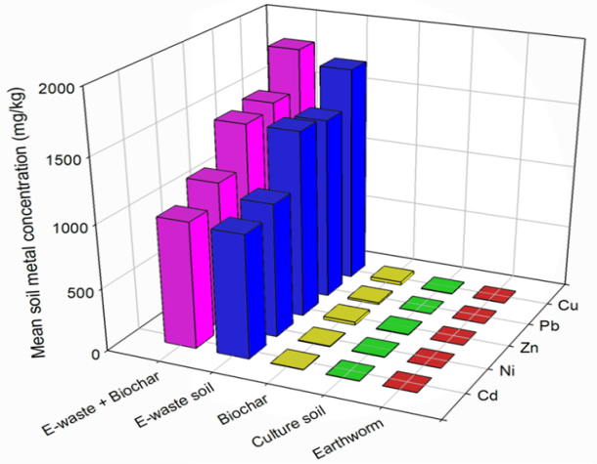

**Fig.1.** **Initial means metal concentrations (mg/kg) in the earthworms, biochar and soils**

The heavy metal contamination factors $C_{f}^{i}$ of the biochar ranged from 1.6 (Ni) to 8.9 (Pb), while the e-waste soil $C_{f}^{i}$ were two orders of magnitude higher, ranging from 342 (Ni) to 846 (Pb) (Figure 2a). The mean degree of contamination of the biochar from all 5 heavy metals based on total heavy metal concentrations was 24.9, as opposed to 2541.7 and 2663.7 for the e-waste contaminated soil. The mean modified degree of contamination (mCd = 5) showed that the biochar had a high contamination level (Figure 2a; Table 1), despite its relatively low total heavy metal concentrations compared to the e-waste contaminated soil. It was also moderately polluted based on the ecological risk index (RI = 144.5) (Figure 2b; Table 1). However, when the bioavailable fractions of the heavy metals were taken into consideration, the mCd and RI of the biochar decreased by 82% (mCd = 0.89±0.1) (Figure 2c) and 77% (RI = 32.6±2.8) (Figure 2d) respectively, falling into the lowest contamination and pollution categories (Table 1). The biochar was therefore considered suitable for use in the bioaccumulation bioassay. The mean mCd of the unamended e-waste and biochar-amended e-waste soils also decreased by 62% and 85% respectively, while the level of pollution based on the mean ecological risk index (RI) decreased by 81% and 93% respectively (Figures 2c and d).

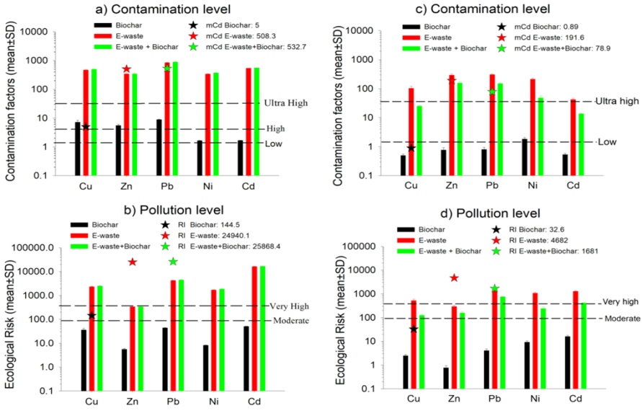

**Fig.2. Soil and Biochar contamination and pollution levels based on total (a and b) and bioavailable (c and d) heavy metal concentrations**

Amendment of the e-waste soil with maize cob biochar at 5% therefore reduced the heavy metal contamination level by 59% and pollution level by 64%. Despite these significant reductions, the biochar-amended e-waste soil contamination and pollution levels remained ultra/very high. The amount of heavy metal taken up by the earthworms by the end of the exposure period (day 21) of the bioaccumulation assay was considered the bioavailable fraction.

Pb contributed most to the degree of contamination both in the biochar (35.6%) and e-waste soils (33.3%). In the e-waste soil, this was followed by Cd (21.4%), Cu (18%), Zn (13.5%), and Ni (13.5%). In the biochar, the heavy metal contributions to the degree of contamination were in the order Pb > Cu (28.6%) > Zn (22.3%) > Cd (6.8%) > Ni (6.6%). Therefore, the biochar and e-waste soil had different heavy metal profiles, indicating that the maize cob from which the biochar was prepared did not have previous exposure to e-waste contaminated soil. Cd contributed most to the ecological risk both in the biochar (35.1%) and in the e-waste soil (65.5%), followed by Pb (30.7% and 17% respectively in biochar and e-waste soil). In reality, the e-waste contamination and pollution levels were off the scale, as the values were respectively 16 and 66 times higher than the lower limits for ultra-high contamination levels and very high pollution levels. These results underscore the significant soil contamination resulting from informal e-waste recycling activities in Douala, Cameroon.

Our results therefore show that amending the e-waste soil with biochar improved soil physicochemical characteristics like pH, OC, and CEC, as well as significantly reduced the heavy metal contamination and pollution levels. Calculating the contamination and pollution indices based on total heavy metal concentrations gave faulty results, as these estimates do not take into account the bioavailable fraction of the heavy metals, which is the fraction responsible for ecological effects.

**3.1.2 Effect of biochar on heavy metal bioavailability in the soil and uptake by earthworms**

It can be seen in every case that the metal concentrations in the culture soil and biochar were negligible throughout the bioaccumulation test duration (Figure 3). Also, in every case the metal concentrations in the unamended and biochar-amended e-waste contaminated (e-waste + biochar) soils decreased steadily over time (Figures 3 a, c, e, g, and i). In contrast, the metal concentrations in the earthworms increased steadily over time up to day 21 which was the exposure period, suggesting uptake and accumulation of metals by earthworms from the soil (Figures 3 b, d, f, h, and j). It was also observed that the rate of decrease of heavy metal concentrations in the unamended soil was faster than in the biochar-amended e-waste soil (Figures 3 a, c, e, g, and i). Concurrently, the uptake of metals by earthworms was higher in the unamended soil than in the biochar-amended e-waste soil (Figures 3 b, d, f, h, and j). This indicated that amendment of the e-waste contaminated soil with the biochar reduced the bioavailability of the heavy metals resulting in lower metal uptake by the exposed earthworms.

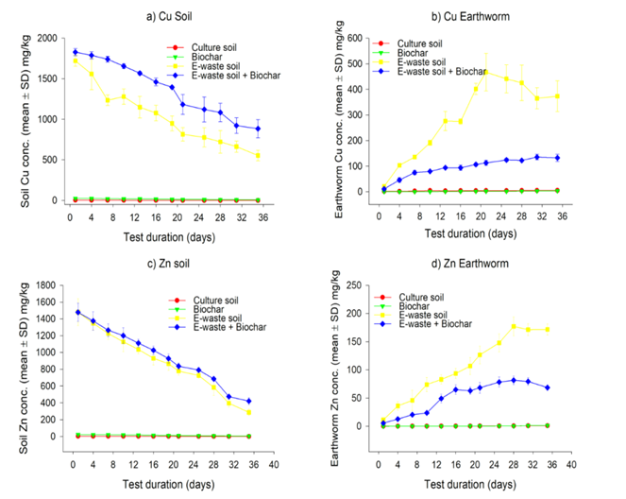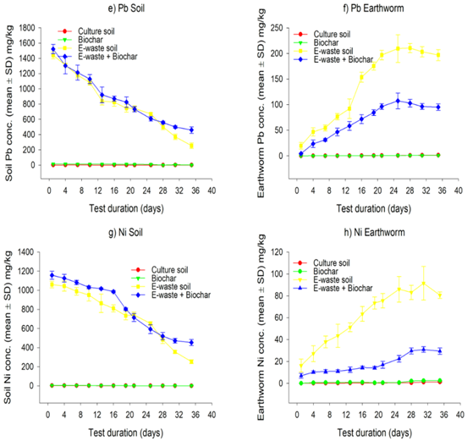

**Fig.3.** **Changes in metal concentrations in the soil and earthworms throughout the duration of the bioaccummulation experiment for Cu (a and b), Zn (c and d), Pb (e and f), Ni (g and h) and Cd (i and j).**

Figure 3 also shows that after the earthworms were taken out of the contaminated soil (Day 21) the metal concentrations in the earthworms no longer increased and even reduced to varying amounts showing some level of Figure 3: Changes in metal concentrations in the soil and earthworms throughout the duration of the bioaccummulation experiment for Cu (a and b), Zn (c and d), Pb (e and f), Ni (g and h) and Cd (i and j).deputation. It is worth noting that the Cu concentrations in the earthworms started reducing immediately after the worms were taken out of the contaminated medium (Figure 3b) while it took a longer period for the earthworms to depurate the other metals (Figures 3d, f, h, and j).

By the end of the 35-day period, the concentrations of metals in the earthworms were significantly lower in the biochar-amended soils compared to the unamended soil (Figure 4) showing that the earthworms bioaccumulated the heavy metals less in the amended soil. The heavy metal uptake by earthworms in the biochar-amended soil reduced by 68.8% for Cd, 64.4% for Cu, 63.5% for Ni, 60% for Zn and 51.6% for Pb. Conversely, the heavy metal concentrations in the biochar-amended soil were significantly higher than in the unamended e-waste soil, confirming the lower heavy metal uptake by the earthworms in the amended soil.

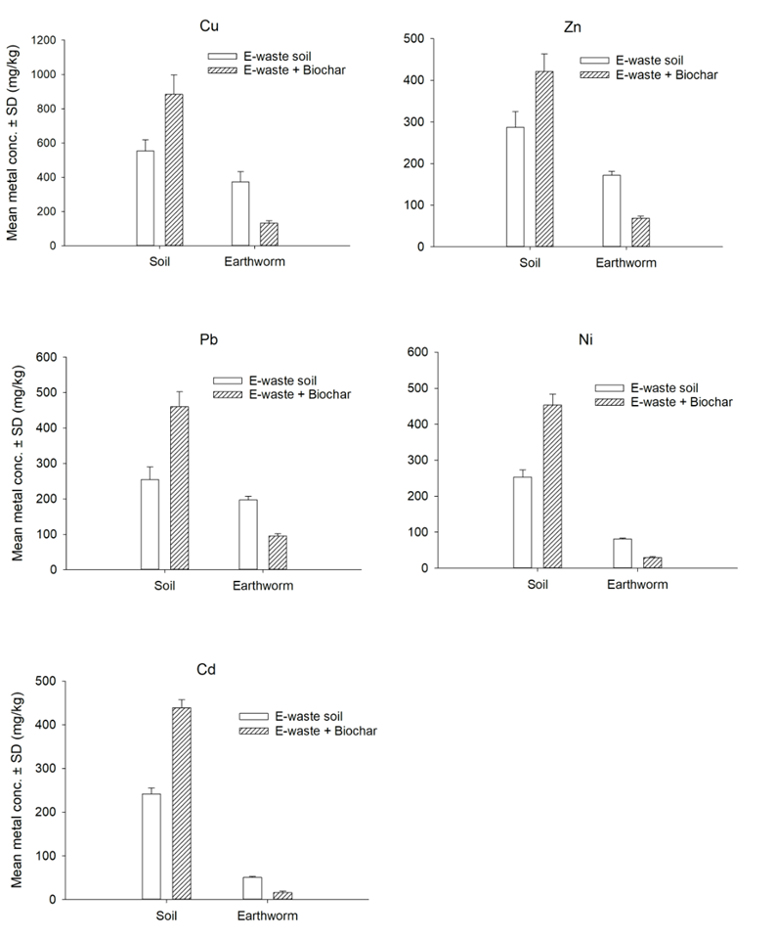

**Fig.4. Relationship between *Alma nilotica* mass and length in the positive control over 35days.**

The accumulation of heavy metals in the tissues of earthworms over time, expressed as bioaccumulation factors (BAFs), varied from one metal to the other and ranged from 0.21 for Cd to 0.77 for Pb with Cu, Zn and Ni having BAFs of 0.67. 0.6 and 0.32 respectively in the unamended soil (Figure 5). In the biochar-amended soil the BAFs reduced by between 72.7% for Zn and 82.8% for Cd with the Pb, Cu and Ni BAFs decreasing by 73.3%, 77.7% and 79.6% respectively. Pb had the highest BAF followed by Cu and Zn showing that these heavy metals are more easily taken up and accumulated by *Alma nilotica* compared to Cd and Ni.

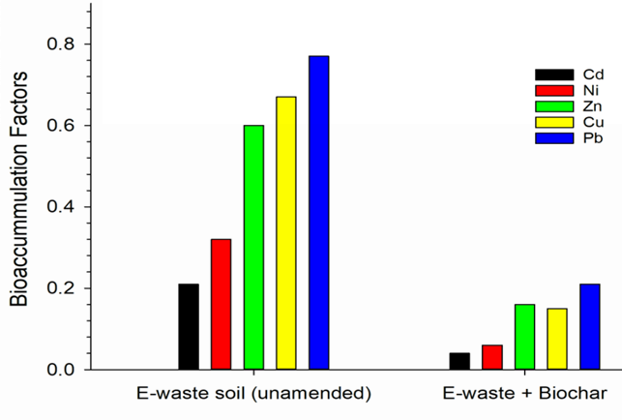

**Fig.5. Bioaccumulation factors of metals in unamended and biochar-amended e-waste soils.**

The BAFs correlated positively with the initial soil metal concentrations both in the amended and unamended soils (Figure 6). This may imply that the initial heavy metal concentrations are indicative of the relative abundance of the bioavailable fraction of the heavy metals in the sample that can be taken up by organisms.

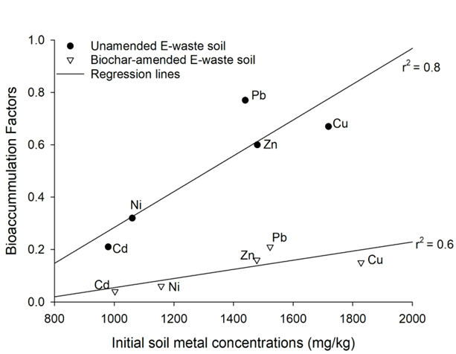

**Fig.6. Relationship between the initial soil heavy metal concentrations and the BAFs**

These results underscore the significant soil contamination resulting from informal e-waste recycling activities in Douala, Cameroon and thus the need for soil remediation. Amending the e-waste soil with biochar did not reduce the total heavy metal concentrations but it significantly reduced the heavy metal bioavailability to *Alma nilotica* leading to lower soil contamination and pollution levels.

3.2 Discussion

**3.2.1 Effect of biochar amendment on e-waste contaminated soil quality**

We set out to determine the relationship between biochar amendment to e-waste contaminated soil, heavy metal bioavailability, and bioaccumulation by *A. nilotica,* and the level of soil contamination/pollution. Feedstock greatly influences biochar characteristics, including porosity, specific surface area, pH, electrical conductivity, cation exchange capacity (CEC), and elemental content (Hou et al., 2023). We found that maize cob-based biochar possessed favourable characteristics that enabled it to improve the soil physicochemical properties. In particular, it increased the pH, % OC, C/N ratio, and the CEC. According to Hou et al. (2023), biochar generally has a high pH due to the presence of salts such as calcite (CaCO3), thus neutralizing acidic soils and improving the environment for soil microorganisms. Biochar is also known to have a high carbon content and is stable due to its aromatic nature, which makes it resistant to breakdown by biological and environmental factors (Singh et al., 2023; Jin et al., 2024; Pandian et al., 2024), implying that carbon in biochar can remain in the soil for hundreds to thousands of years, making it an excellent soil amendment for improving soil health and fertility over the long term (Jin et al., 2024).

The heavy metal concentrations in the e-waste soil were far above their respective background concentrations, as well as above the Canadian Soil Quality Guideline Values (CSQGVs) for the protection of environmental and human health (CCME, 1999). In addition, the e-waste soil had an ultra-high metal contamination level, culminating in a very high pollution level. This is in agreement with results obtained by Nfor et al. (2022b), who found all e-waste sites studied in Douala, Cameroon, to have ultra-high heavy metal contamination and pollution levels. Our results also showed that the addition of biochar to the e-waste contaminated soil significantly reduced the contamination and pollution levels, even though the amended soils still remained at ultra-high levels. Biochar has been reported to be a suitable material for heavy metal sequestration due to its substantial specific surface area and high sorption capacity (Hou et al., 2023; Pandian et al., 2024). However, the influence of biochar on the e-waste pollution levels was only possible to obtain after the exposure of earthworms to the amended soil and obtaining the bioavailable fraction of the heavy metals in the soil. Calculation of the pollution indices (mCd and RI) based on the total heavy metal concentrations in the soils indicated a higher level of contamination and pollution for the biochar-amended e-waste soil, which was faulty. It is therefore more accurate to calculate soil pollution indices using the bioavailable fractions of metal concentrations in the soil. Heavy metal uptake by *A. nilotica* in the present study gave a good indication of the relative bioavailable heavy metal fractions in the amended and unamended soils.

**3.2.2 Effect of Biochar Amendment on Heavy Metal Accumulation in Earthworms in Unamended and Biochar-Amended E-Waste Soils**

In the present study, earthworms in the e-waste contaminated soil exhibited continuous heavy metal uptake and bioaccumulation throughout the exposure period of 21 days, with a corresponding decrease in soil heavy metal concentrations. Several authors have reported that earthworms are known for their capacity to accumulate heavy metals from the soil, with concentrations typically increasing in the organisms over time while decreasing in the surrounding soil (Parihar et al., 2019; Huang et al., 2021; Xiao et al., 2022; Fai et al., 2023). However, *A. nilotica* bioaccumulated much fewer heavy metals from the e-waste soil in the presence of biochar compared to when there was no biochar. This indicated that while biochar addition did not reduce the initial total heavy metal concentration in the e-waste contaminated soil, it significantly lowered their bioavailability. Thus, the heavy metal uptake by the earthworms was a good indicator of their bioavailability to soil organisms. Reduced bio-accessibility of heavy metals in polluted soils following biochar amendments has been reported by other authors, including Huang et al. (2020), Wang et al. (2020), Guo et al. (2020), Garau et al. (2022), and Hou et al. (2023), who found that the decreased bioavailability of metals was a result of enhanced sorption due to the high porosity, large specific surface area, elemental content, and high CEC of biochar. The complexation of heavy metals with functional groups in biochar and the exchange with cations like Ca²⁺ and Mg²⁺ further reduced metal availability (Lu et al., 2014). Additionally, the alkalinity of the biochar facilitated lower metal bioavailability by promoting precipitation in soils (Paz-Ferreiro et al., 2013). Earthworms most probably enhanced the interaction between biochar and e-waste soil through their burrowing and feeding activities, which could have increased the biochar's effective surface area and its role as an immobilizing agent (Garau et al., 2022). Despite these benefits, biochar's inability to completely eliminate metal bioavailability points to limitations in its application (Taraqqi-A-Kamal et al., 2021).

**3.2.3 Bioaccumulation Factors of Metals in Unamended and Biochar-Amended E-Waste Soils**

Bioaccumulation is the gradual buildup of a pollutant from the environment in an organism over time, typically through soil or dietary absorption due to faster uptake than elimination rates (Fai et al., 2023). Earthworms are particularly effective at absorbing heavy metals from contaminated soils, largely due to their close contact with the soil matrix (Parihar et al., 2019; Nfor et al., 2022b). Their behavior, such as feeding and burrowing, can influence soil metal levels through bioaccumulation (Huang et al., 2020), and the accumulation of heavy metals in earthworms is associated with detrimental health effects (Sun et al., 2022). Our study revealed variable levels of heavy metal bioaccumulation by A. nilotica. Ukalska-Jaruga et al. (2022) found that Cd posed the highest risk in soils, particularly in the presence of high Zn and Pb concentrations. This is in agreement with our results when the total soil metal concentrations were used. The bioavailable fraction is more important than the total metal concentration because it is responsible for any observed ecological effects. When the bioavailable metal fractions, based on earthworm metal uptake, were considered, Pb contributed most to the contamination level as well as to the pollution level, expressed as the potential ecological risk index (RI) because Pb was taken up by A. nilotica 7 times more than Cd. Heavy metals can interact competitively, with Pb being more readily absorbed and retained in earthworm tissues than Cd (Bakht et al., 2022). Pb therefore had the highest bioaccumulation factor (BAF) in the present study, followed by Cu and Zn, with Cd having the least BAF. Earthworms can accumulate Pb over time due to their limited detoxification ability, resulting in elevated concentrations within their tissues (Bakht et al., 2022). This is in agreement with Fai et al. (2023), who found Pb to be the highest accumulated, by *A. nilotica* among the four heavy metals studied. Earthworm species differ in their heavy metal uptake, which may explain the differences between our study and that of Ukalska-Jaruga et al. (2022), who used *Eisenia veneta*, an epigeic earthworm species, as opposed to *A. nilotica,* which is an anecic species. Differences could also result from the type of soil amendment used, meaning that biochars may have different capabilities to reduce the bioavailability of different metals to earthworms (Ukalska-Jaruga et al., 2022). Yang et al. (2016) also found that bamboo and rice straw biochar were more effective at decreasing extractable Cu and Pb than removing extractable Cd and Zn from the soil. Previous studies have also shown that the bioaccumulation of heavy metals in earthworms is influenced by both soil metal concentrations and physicochemical interactions (Gaganmeet and Hundal, 2015; Lafiti et al., 2020). While Cd is known to accumulate in earthworms, it showed the weakest bioaccumulation in this study, likely due to a rise in soil pH (0.4) following biochar application, which favors the formation of insoluble cadmium compounds, thereby reducing its bioavailability (Qi et al., 2017; Medyńska-Juraszek & Ćwieląg-Piasecka, 2019).

The fluctuations in Ni concentrations in earthworm tissues suggest a limited capacity for Ni accumulation, consistent with findings indicating that *E. fetida* is less sensitive to Ni at lower concentrations (Nfor et al., 2022). During the depuration phase, different elimination rates were observed for the metals, with all metals absorbed by earthworms being expelled afterward. Among these, Cu was eliminated the fastest, followed closely by Zn. Cu levels in earthworms declined rapidly after removal from the contaminated environment, whereas other metals required longer for depuration. This rapid elimination of Cu suggests that *A. nilotica* regulates Cu more effectively than other metals (Fai et al., 2023). Studies by Richardson et al. (2020) and Parihar et al. (2019) support this, indicating that earthworms can maintain equilibrium levels of essential metals like Cu and Zn while struggling to do so for non-essential metals such as Pb, Cd, and Ni. Our results demonstrated that *A. nilotica* consistently accumulated Zn throughout the 21-day exposure period in both biochar-amended and unamended soils, with notable elimination during the depuration phase.

The positive correlation between initial heavy metal concentrations in both unamended and biochar-amended e-waste soils and earthworm bioaccumulation corroborates findings from Lafiti et al. (2020) and Nfor et al. (2022b). These studies reported that increases in soil heavy metal concentrations are typically associated with greater metal accumulation by earthworms. Biochar amendment mitigates this effect by lowering the BAFs, but the relationship is maintained.

4. Conclusion

In conclusion, this study highlights the significant role of biochar in improving the quality of e-waste contaminated soils while addressing heavy metal accumulation in earthworms. The incorporation of maize cob-based biochar not only enhanced organic carbon and organic matter content but also positively affected soil pH, C/N and CEC, promoting overall soil health. Despite the high concentrations of heavy metals in e-waste soils, biochar demonstrated its potential to significantly reduce the bioavailability of these metals, thereby decreasing their uptake by earthworms. Therefore, the heavy metal uptake by earthworms was a good indicator of the bioavailable fraction of the heavy metals in the soil. Based on this our results have shown that maize cob biochar amendment of e-waste contaminated soil results in significant reduction of the soil contamination and pollution levels. The study also revealed distinct patterns of heavy metal bioaccumulation, with *A. nilotica* exhibiting varying affinities for different metals with Pb being the most highly bioaccumulated heavy metal. Notably, the dynamics of metal uptake and elimination underscore the complex interactions between biochar, soil characteristics, and earthworm physiology. The findings advocate for the strategic use of biochar enhancing soil quality and contributing to sustainable remediation practices in areas affected by e-waste pollution. Overall, this research provides valuable insights into the benefits of biochar as a soil amendment in contaminated environments, while also emphasizing the need for further investigation into its long-term effects on soil biota and the environment.

**REFERENCES**

1. Ahamad, M. I., Song, J., Sun, H., Wang, X., Mehmood, M. S., Sajid, M., Su, P., & Khan, A. J. (2020). Contamination level, ecological risk, and source identification of heavy metals in the hyporheic zone of the Weihe River, China. International Journal of Environmental Research and Public Health, 17(3), 1070–1087. https://doi.org/10.3390/ijerph17031070.
2. Atiemo, S. M., Ofosu, F. G., Kwame, A. I. J., & Kuranchie, M. H. (2012). Assessing the heavy metals contamination of surface dust from waste electrical and electronic equipment (e-waste) recycling site in Accra, Ghana. Resource Journal of Environmental and Earth Sciences,4(5), 605-611. https://www.researchgate.net/publication/236545075.
3. Bakht, F., Khan, S., & Muhammad, S. (2022). Heavy metal bioavailability in the earthworm-assisted soils of different land types of Pakistan. Arabian Journal of Geosciences, 15, 186. https://doi.org/10.1007/s12517-022-09512-6.
4. Baldé, C. P., Ruediger, K., Tales, Y., Rosie, M., Elena, D., Shahana, A., Garam, B., Otmar, D., Elena, F., Vanessa, F., Vanessa, G., Sunil, H., Shunichi, H., Giulia, I., Deepali, S. K., Vittoria, L. D., Yuliya, L., Innocent, N., Noémie, Pralat., Michelle, W. (2024). The Global E-waste Monitor 2024. A publication by the International Telecommunication Union (ITU) and United Nations Institute for Training and Research (UNITAR). Geneva/Bonn. https://api.globalewaste.org/publications/file/297/Global-E-waste-Monitor-2024.
5. Beusch, C. (2021). Biochar as a Soil Ameliorant: How Biochar Properties Benefit Soil Fertility—A Review. Journal of Geoscience and Environment Protection, 9:28-46. https://doi.org/10.4236/gep.2021.910003.
6. CCME (1999). Canadian Soil Quality Guideline Values (CSQGVs) for the Protection of Environmental and Human Health. In: Canadian environmental quality guidelines. Canadian Council of Ministers of the Environment (CCME). https://www.ccme.ca/en.%20Accessed%20on%2025/11/2023.
7. Cheng, Y., Wang, B., Shen, J., Yan, P., Kang, J., Wang, W., Bi, L., Zhu, X., Li, Y., Wang, S., Shen, L., & Chen, Z. (2022). Preparation of novel N-doped biochar and its high adsorption capacity for atrazine based on π–π electron donor-acceptor interaction. Journal of Hazardous Materials, 432,128757. https://doi.org/10.1016/j.jhazmat.2022.128757.
8. Eliston, T., & Oliver, I. W. (2020). Ecotoxicological assessments of biochar additions to soil employing earthworm species *Eisenia fetida* and *Lumbricus terrestris*. Environmental Science and Pollution Research, 27, 33410-33418. https://doi.org/10.1007/s11356-019-04542-2.
9. Fai, P. B. A., Ngogang, J. N., Djeukam, M. K., Nfor, B., Julius, N. F., & Basud., N. (2023). Association between heavy metal uptake and growth and reproduction in the anecic earthworm, *Alma nilotica* (Grube 1855). *Ecotoxicology,* 32 (9), 1162-1173. https://doi.org/10.1007/s10646-023-02707-x.
10. FAO & UNEP. (2021). Global assessment of soil pollution – Summary for policy makers. Rome, FAO, 1, 84. https://doi.org/10.4060/cb4827en.
11. Fosu‐Mensah, B. Y., Addae, E., Yirenya‐Tawiah, D., & Nyame, F. (2017). Heavy metals concentration and distribution in soils and vegetation at Korle Lagoon area in Accra, Ghana.Cogent Environmental Science, 3(1), 1-14. https://doi.org/10.1080/23311843.2017.1405887.
12. Gałwa-Widera, M. (2021). Biochar-Production, Properties, and Service to Environmental Protection against Toxic Metals. Handbook of Assisted and Amendment: Enhanced Sustainable Remediation Technology, 53–75. https:// doi.org/ 10. 1002/ 97811.
13. Garau, M., Sizmur, T., Sean, C., Castaldi, P., & Garau, G. (2022). Impact of *Eisenia fetida* earthworms and biochar on potentially toxic element mobility and health of a contaminated soil. Science of the Total Environment, 806(3), 151-255. https://doi.org/10.1016/j.scitotenv.2021.151255.
14. Graziano, M., Martín-Peinado, F. J., & Delgado-Moreno, L. (2022). Application of Biochar for the Restoration of Metalloids Contaminated Soils. Applied Sciences, 12(4), 1918. https://doi.org/10.3390/app12041918.
15. Guo, M., Song, W., & Tian, J. (2020). Biochar-Facilitated Soil Remediation: Mechanisms and Efficacy Variations. Frontiers in Environmental Science*,* 8, 521-512. https://doi.org/doi: 10.3389/fenvs.2020.521512.
16. Hou, S., Wang, J., Dai, J., Boussafir, M., & Zhang, C. (2023). Combined effects of earthworms and biochar on PAHs-contaminated soil remediation: A review. Soil EcologyLetters, 5, 220158. https://doi.org/10.1007/s42832-022-0158-y.
17. Huang, C. D., Ge, Y., Yue, S. Z., Qiao, Y. H., & Liu, L. S. (2021). Impact of soil metals on earthworm communities from the perspectives of earthworm ecotypes and metal bioaccumulation. Journal of Hazardous Materials*,* 406, 124738. http://dx.doi.org/10.1016/j.jhazmat.2020.124738.
18. Huang, C., Wang, W., Yue, S., Adeel, M., & Qiao, Y. (2020). Role of biochar and *Eisenia fetida* on metal bioavailability and biochar effects on earthworm fitness. EnvironmentalPollution*,* 263, 114586. https://doi.org/10.1016/j.envpol.2020.1145.
19. Jin, X., Zhang, T., Hou., Y. et al (2024). Review on the effects of biochar amendment on soil microorganisms and enzyme activity. Journal of Soils and Sediments, 24, 2599-2612. https://doi.org/10.1007/s11368-024-03841-7.
20. Kyere, V. N. (2016). Environmental and health impacts of informal e‐waste recycling in Agbogbloshie, Accra, Ghana: Recommendations for sustainable management. Environmental Pollution Centers.http://hss.ulb.uni-bonn.de/2016/4325/432.5.
21. Latifi, F., Musa, F., & Musa, A. (2020). Heavy metal content in soil and their bioaccumulation in earthworms (*Lumbricus terrestris L*.). Agriculture and Forestry, 66 (1), 57-67. https://doi.org/:10.17707/AgricultForest.66.1.07.
22. Lowe, C., & Butt, R. (2005). Culture techniques for soil dwelling earth worms: *A review.* Journal of Pedobiologia, 49,401-413. https://doi.org/10.1016/J.PEDOBI.2005.04.005.
23. Lu P., Nuhfer N.T., Kelly S., Li Q., Konishi H., Elswick E., Zhu C. (2011): Lead coprecipitation with iron oxyhydroxide nano-parti­cles. Geochimica et Cosmochimica Acta, 75(16): 4547–4561. https://doi.org/10.1016/j.gca.2011.05.035.
24. Lu, K., Yang, X., Shen, J., Robinsonc, B., Huang, H., Liu, D., Bolane, N., Peib, J., & Wang, H. (2014). Effect of bamboo and rice straw biochars on the bioavailability of Cd, Cu, Pb and Zn to Sedum plumbizincicola. Agriculture, Ecosystems and Environment*,* 191, 124-132. https://doi.org/10.1016/j.agee.2014.04.010.
25. Mahipal, S. S., Mayuri, K., Manisha, N., Shriyash, M., Gaurav, P. S., & Bhaskar, C. (2016). Effect of Electronic waste on Environmental and Human health.Journal of Environmental Science, Toxicology and Food Technology,10, 98-104. https://doi.org/10.9790/2402-10090198104.
26. Medynska-Juraszek, A., Rivier, P., Rasse, D., & Joner, E. J. (2020). Biochar Affects Heavy Metal Uptake in Plants through Interactions in the Rhizosphere. Applied Sciences, 10, 5105. https://doi.org/10.3390/app10155105.
27. Moyen, M.G., & Archodoulaki, V. M. (2023). Electrical and Electronic Waste Management Problems in Africa: Deficits and Solution Approach. Environments*,* 10, 44. https://doi.org/10.3390/environments10030044.
28. Muskan J., Kumar, D., Chaudhary, J., Kumar, S., Sharma, S., & Singh Verma, A. (2023). Review on E-waste management and its impact on the environment and society. Waste Management Bulletin, 1(3), 34-44. https://doi.org/10.1016/j.wmb.2023.06.004.
29. Nfor, B., Fai, P. B. A., Fobil, J. N., & Basu, N. (2022a). Effects of Electronic and Electrical Waste-Contaminated Soils on Growth and Reproduction of Earthworm (*Alma nilotica*).Environmental Toxicology and Chemistry,41(2), 287-297. http://dx.doi.org/10.1002/etc.5198.
30. Nfor, B., Fai, P. B. A., Tamungang, S. A., Fobil., J. N., & Basu, J. (2022b). Soil Contamination and Bioaccumulation of Heavy Metals by a Tropical Earthworm Species (*Alma nilotica*) at Informal E-Waste Recycling Sites in Douala, Cameroon." Environmental Toxicology and Chemistry, 41(2), 356-368. http://dx.doi.org/10.1002/etc.5264.
31. Novak, J. M., Busscher, W. J., Laird, D. L., Ahmedna, M., Watts, D. W., & Mohamed, A. S. (2021). Impact of Biochar Amendment on Fertility of a Southeastern Coastal Plain Soil. Biochar,3, 615-624. https://doi.org/10.1007/s42773-021-00103-4.
32. Nyoka, N., Ogbeide, O., & Otomo, P. V. (2021). Reproduction and biomarker responses of *Eisenia fetida* after exposure to imidacloprid in biochar-amended soil. Biochar, 3, 615-624. https://doi.org/10.1007/s42773-021-00103-4.
33. O’Connor D., Peng T., Zhang J., Tsang D.C.W., Alessi D.S., Shen Z., Bolan N.S., Hou D. (2018b): Biochar application for the remediation of heavy metal polluted land: a review of in situ field trials. *Science of the Total Environment*, 619–620: 815–826.https:// doi.org/ 10.1016/j.scitotenv.2017.11.132.
34. OECD (2010). Test guideline 317: Bioaccumulation in terrestrial Oligochaetes. *Guidelines for the testing of chemicals.* https://doi.org/10.1787/2074577x*.*
35. Pandian, K., Vijayakumar, S., Mustaffa, M. R. A. F., Subramanian, P., & Chitraputhirapillai, S. (2024). "Biochar-a sustainable soil conditioner for improving soil health, crop production and environment under changing climate: a review. Frontiers inSoil Science, 4, 1376159. https://doi.org/10.3389/fsoil.2024.1376159.
36. Parihar, K., Kumar, R., & Sankhla, M.S. (2019). Impact of heavy metals on survivability of earthworms. International medico-legal reporter journal, 2 (3), 7. https://ssrn.com/abstract=3497689.
37. Park, J. H., Choppala, G. K., Bolan, N. S., Chaung, J. W., & Chuasavathi, T. (2011). Biochar reduces the bioavailability and phytotoxicity of heavy metals. Plant Soil, 348, 439-45. https://doi.org/:.10.1007/s11104-011.
38. Pauwel, J., VanraRanst, E., Verloo, M., & Mvondo, Z. (1992). Manuel de laboratoire de pedologie. Publications Agricol N0 28. AGCD Bruxelles, 265. https://biblio.ugent.be/publication/240233. .
39. Paz-Ferreiro, J., Lu, H., Fu, S., Méndez, A., & Gascó, G. (2014). Use of phytoremediation and biochar to remediate heavy metal polluted soils: A review. Solid Earth, 5, 65-75. https://doi.org/10.5194/se-5-65-2014.
40. Qi, F., Dong, Z., Lamb, D., Naidu, R., Bolan, N., Ok, Y., Liu, C., Khan, N., Johir M., & Semple K. (2017). Effects of acidic and neutral biochars on properties and Cadmium retention of soils. Chemosphere,180, 564-573. https://doi.org/10.1016/j.chemosphere.2017.04.014.
41. Rahman, M. S., Saha, N., & Molla, A. H. (2014). Potential ecological risk assessment of heavy metal contamination in sediment and water body around Dhaka export processing zone, Bangladesh. Environmental Earth Sciences, 71, 2293–2308. https://doi.org/10.1007/s12665-013-2631-5.
42. Rehman, S. U., De Castro, F., Marini, P., Aprile, A., Benedetti, M., & Fanizzi, F. P. (2023). Vermibiochar: A Novel Approach for Reducing the Environmental Impact of Heavy Metals Contamination in Agricultural Land. Sustainability, 15(12), 9380. https://doi.org/10.3390/su15129380.
43. Richardson, J. B., Görres, J. H., & Sizmur, T. (2020). Synthesis of earthworm trace metal uptake and bioaccumulation data: role of soil concentration, earthworm ecophysiology, and experimental design. Environmental Pollution, 262, 114-126. https://doi.org/10.1016/j.envpol.2020.114126.
44. Sayyadian, K., Moezzi, A., Gholami, A., Panahpour, E., & Mohsenifar, K. (2018). Effect of biochar on Cadmium, nickel and lead uptake and translocation in maize irrigated with heavy metal contaminated water. Applied Ecology and Environmental Research, 17(1), 969-982. http://dx.doi.org/10.15666/aeer/1701_969982.
45. Shirani, M., Afzali, K. N., Jahan, S., Strezov, J., & Soleimani‐Sardo, M. (2020). Pollution and contamination assessment of heavy metals in the sediments of Jazmurian plays in southeast Iran. Scientific Reports, 10, 4775. https://doi.org/10.1038/s41598-020-61838-x.
46. Singh, O., Singh, S., Singh, V. K., & Singh, A. (2023). Biochar: An Organic Amendment for Sustainable Soil Health. In: Baskar, C., Ramakrishna, S., Daniela La Rosa, A. (eds) Encyclopedia of Green Materials. Springer*, Singapore.* https://doi.org/10.1007/978-981-16-4921-9-265-1.
47. Sivakumar, S., Chandrasekaran, A., Balaji, G., & Ravisankar, R. (2016). Assessment of heavy metal enrichment and the degree of contamination in coastal sediment from south east coast of Tamilnadu, India. Journal of Heavy Metal Toxicity and Diseases*,* 1(2), 11–19. https://doi.org/10.21767/2473-6457.100011.
48. Taraqqi-A-Kamal, A., Atkinson, C. J., Khan, A., Zhang, K. K., Sun, P., Akther, S., & Zhang, Y. R. (2021). Biochar remediation of soil: linking biochar production with function in heavy metal contaminated soils. Plant and Soil Environment, 67(4), 183-201. https://doi.org/10.17221/544/2020-PSE.
49. Taraqqi-A-Kamal, A., Atkinson, C. J., Khan, A., Zhang, K. K., Sun, P., Akther, S. & Zhang, Y. R. (2021). Biochar remediation of soil: linking biochar production with function in heavymetal contaminated soils. Plant and Soil Environment, 67(4), 183-201. https://doi.org/10.17221/544/2020-PSE.
50. Tsamo, C., Assabe, M., Argue J., & Ihimbru, S. O. (2019). Discoloration of methylene blue and slaughter house wastewater using maize cob biochar produced using a constructed burning chamber: A comparative study*.* Scientific African*,* 3, 2468-2276. https://doi.org/10.1016/j.sciaf.2019.e00 078.
51. Twagirayezu, G., Olivier, I., Kui, H., Hui, X., Abias, U., Jean, C. N., Habasi, P. M., Febronie, N., & Auguste. C. I. (2022). Environmental Effects of Electrical and Electronic Waste on Water and Soil. Pollution. Journal of Environmental Studies*,* 31(3), 2507-2525. https://doi.org/10.15244/pjoes/144194.
52. Ukalska-Jaruga, A., Siebielec, G., Siebielec, S., & Pecio, M. (2022). The Effect of Soil Amendments on Trace Elements’ Bioavailability and Toxicity to Earthworms in Contaminated Soils. Applied Sciences, 12, 62-80. https://doi.org/10.3390/app12126280.
53. Xiao, R., Ali, A., Xu, Y. Q., Abdelrahman, H., Li, R. H., Lin, Y. B., Bolan, N., Shaheen, S. M., Rinklebe, J., & Zhang, Z.Q. (2022). Earthworms as candidates for remediation of potentially toxic elements contaminated soils and mitigating the environmental and human health risks: A review. Environment International*,* 158, 106-924. https://dx.doi.org/10.1016/j.envint.2021.106924.
54. Xu, J., Wang, H., Liu, Y., Ma, M., Zhang, T., Zheng, X., & Zong, M. (2016). Ecological risk assessment of heavy metals in soils surrounding oil waste disposal areas. Environmental Monitoring and Assessment, 188, 125. https://dx.doi.org/10.1007/s10661-016-5093.
55. Yang, X., Liu, J., McGrouther, K., Huang, H., Lu, K., Guo, X., He, L., Lin, X., Che, L., Ye, Z., & Wang, H. (2016). Effect of biochar on the extractability of heavy metals (Cd, Cu, Pb, and Zn) and enzyme activity in soil. Environmental science and pollution researchinternational, 23(2), 974–984. https://doi.org/10.1007/s11356-015-4233-0.
56. Zhang, L., & Liu, J. (2014). In situ relationships between spatial–temporal variations in potential ecological risk indexes for metals and the short term effects on periphyton in a macrophyte‐dominated lake: A comparison of structural and functional metrics. Ecotoxicology, 23(4):553-66. https://doi: 10.1007/s10646-014-1175-0.