***Original Research Article***

**Geospatial Assessment of Landslide Risk Susceptibility Using Frequency Ratio and Remote Sensing in the Tropical River Basin of the Western Ghats**

**ABSTRACT**

Wayanad is prone to unexpected landslides due to human interventions, unusual geological and abundant rainfall, which cause loss of life and property damage. This study was conducted to construct a landslide susceptibility map of the Kabani River Basin area in the Southern Western Ghats region using a statistical method. For this, we used previously recorded landslide locations and eleven landslide factors were used for modelling, namely lithology, geomorphology, slope angle, soil texture, distance from streams, distance from roads, distance from landmarks, topographic wetness index (TWI), rainfall, land use/land cover, and slope curvature, which were extracted from the spatial database.

Initially, the study presents a very comprehensive approach by mapping landslide-prone areas using relative frequency and prediction rate, which generates a Landslide Prone Area Index (LSI) and a susceptibility map. Furthermore, the study reveals that the southwest part of the study area is prone to landslides due to the extensive influence of 65° slope, intense rainfall, soil texture, topography moisture index, curvature, lithology and geomorphology. It also includes the distance to roads, lines and streams. The predicted pattern is highly similar to the area where landslides have occurred in the past, and it helps in future conservation planning and sustainable land use planning to mitigate landslide risk in the southern Western Ghats.

**Keywords:** Landslide Susceptibility, Frequency Ratio (FR), Remote Sensing (RS), Western Ghats, Land Use/Land Cover (LULC)

1. INTRODUCTION

A common but devastating natural disaster, a landslide represents the downward and outward movement of slope-forming materials such as rock, soil, and debris. (Gerrard 1994). Landslides occur when the stability of slopes is compromised due to natural and man-made factors. The sheer force of a landslide can cause devastating consequences, including loss of life, damage to infrastructure, and significant economic losses. (A. Saha et al. 2023; Tien Bui et al. 2012; Nadim et al. 2006). The underlying causes of landslides are multifaceted, including seismic conditions, hydrological changes, seismic activity, and human interventions leading to natural imbalances. Mountainous areas around the world are prone to landslides, and as a measure, from 1995 to 2014, more than 3850 landslides were recorded, resulting in the loss of more than 11,500 human lives and the death of approximately 1,63,500 people. (Haque et al. 2019). It has been recorded that approximately 95% of landslide incidents occur in developed countries and cause damage of 0.05% of the country's annual income. (Glade et al. 2005). Therefore, it is necessary to take decisive and effective steps to adopt precautionary measures and mitigation measures related to landslides. Landslide hazard assessment and mapping are crucial processes in understanding and mitigating landslide-related risks. Sensitivity assessment regarding the spatial division of landslide-prone areas depending on the topographic-ecological situation. (Merghadi et al.2020).

Growing awareness of landslide impacts and the need for urban development in challenging mountainous terrain has increased scientific interest in LSZ mapping. (Batar and Watanabe 2021; Chawla et al. 2019; Dikshit et al. 2020; Peethambaran et al. 2020; Pham et al. 2017). LSZ mapping methods have evolved, incorporating heuristic, semi-quantitative, statistical or probabilistic approaches. (Shano et al. 2020). In the coming era, and still today, machine learning (ML) algorithms have gained importance as advanced tools for modelling complex relationships between geo-ecological components (Pham et al. 2016a, b; Pradhan, 2013a). Despite their many advantages, these algorithms often do not perform well and currently face several limitations, such as low interpretability of the influence of factors, the possibility of overfitting in unbalanced datasets, and high computational requirements. (Hong et al. 2019; Pradhan et al. 2023; Tang et al. 2023). These challenges underscore the critical need for expert validation to improve the reliability and practical applicability of models. Conversely, while explainable, methods based solely on expert opinion may introduce biases and variations. (Erener et al. 2016; Yalcin 2008).

The objective of this research is to explore the effectiveness of using the frequency ratio model and prediction rate to analyse the landslide hazard of the Kamati River, a tributary of the Cauvery River flowing through southern India. The main objective of this research is to identify strengths and weaknesses and explore their potential to influence successful risk reduction measures. In this work, a comprehensive point mapping of landslide susceptibility in this area using relative frequency (RF) and prediction rate (PR) is reported.

The site is a hilly area that has already experienced several landslides, mainly in the south-western part, and no research in this area of the basin or the region situated by western the hat has ever been done. Therefore, determining the condition of slopes and identifying landslide-prone areas were crucial tasks. The study presents a very comprehensive approach by mapping landslide-prone areas using relative frequency and prediction rate, which generates a landslide-prone area index (LSI) and a susceptibility map. The evaluation of the model’s effectiveness and the identification of high-risk areas on the south-western slopes of the Kabani River basin provide valuable insights into precautionary measures to mitigate the impact of landslides due to the nature of rainfall and erosion. By improving landslide anticipation and management, this research contributes to the reliability and safety of the region, not only in the studied region but also beyond its geographical boundaries.

1. MATERIALS AND METHODS

In this study, a landslide occurrence table was created by collecting as much data as possible on recent and past landslides and evaluating the relationship between each conditioning factor and landslide probability. Using the provided methodology chart (Figure 1), the landslide probability was assessed, and the main factors that have caused landslides in the past were identified. The frequency ratio model was used to predict the probability of their occurrence in the future due to the influence of the same factors.

* 1. **Methodology**

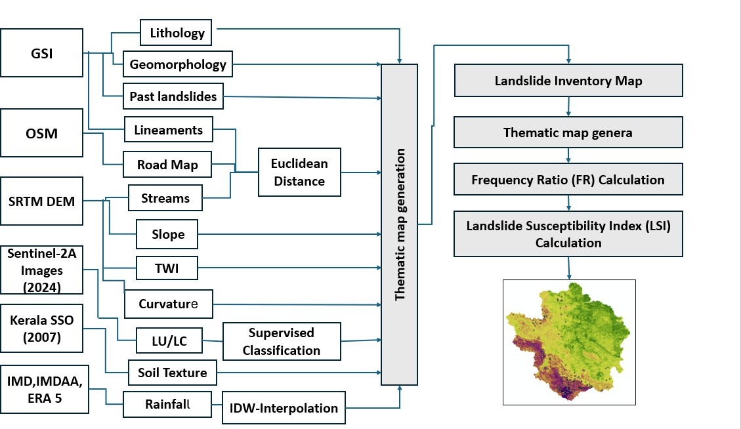

Fig 1: Methodology of Frequency ratio

* 1. **Frequency ratio (FR) method**

The FR method is used to rely on the concept of favourable function and to calculate the statistics between previous landslides and the occurrence of landslides, and the statistics between the conditioning factors of the landslide (Chung and Fabbri 1999; Vijith and Madhu 2008). Values greater than FR 1 indicate a strong relationship between the factor and the occurrence of landslides, while a value below 1 reflects a weak relationship (Lee and Sambath 2006; Vijith and Madhu 2008; Sharma and Mahajan 2018). A contingency table was prepared to calculate the corresponding FR for each landslide conditioning factor, and the ratio of landslide occurrence to non-occurrence was calculated using Eq. (1) as follows:

W ij =FL ij / FN ij (1)

where Wij is the FR of the ith class attribute of the jth causal factor, FLij is the FR of the landslides that occurred in the ith class of the factor j, and FNij is the FR of the non-occurred landslides in the class ‘i’ of the factor ‘j.’ The landslide susceptibility index (LSI) was computed by the summation of the FRs of all the landslide conditioning factors, followed by Eq. 2. $LSI=\sum_{i=1}^{n}{Wij}$ (2)

1. STUDY AREA

The Kabani river is an eastward flowing river (KRB area=1685 km²), an integral part of the south Indian Cauvery river system, also known as Dakshina Ganga. The selected drains in between the latitudes of 11°29’37.75”N to 11°59’5.93”N and the longitudes of 74°46’44.54”E to 76°18’1.26”E (figure 2). The KRB characterised the dendritic pattern, and the channel is in the 7th order. Kabani River originates from the northern Wayanad high range of elevations (2140 m above MSL) from the Western Ghats, by the confluence of two rivers, the Panamaram and Mananthavady River. Wayanad is a tableland, with the elevation ranging from 700 to 2100 meters above the Mean Sea Level, in the state of Kerala. The regional geology is dominated by Precambrian rocks; the predominant rock types include gneisses, schists, and granites (Nagaraju and Papanna, 2009).

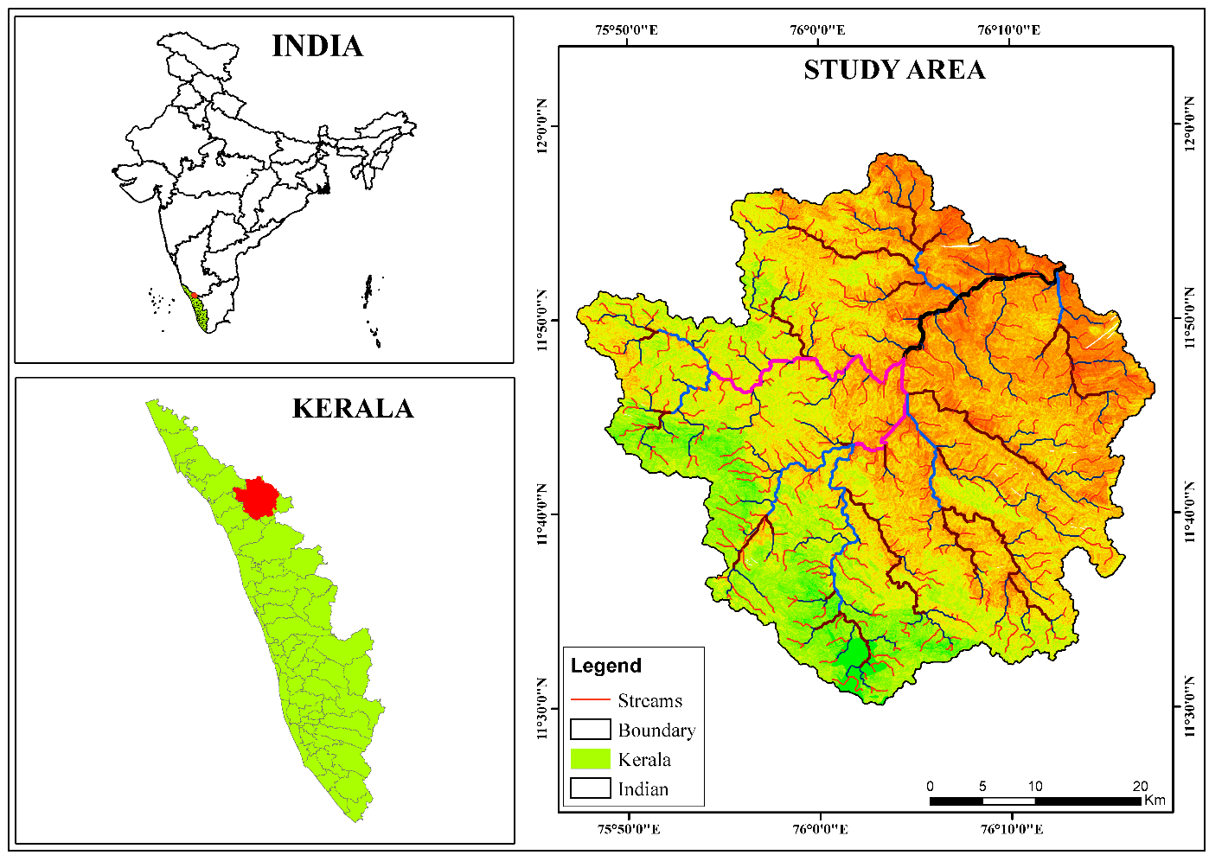

Fig 2. Location Map of the Study Area

Wayanad plateau is very complex, it leads to the formation of different landscapes through the activities of tectonics such as faults, folds and joints, and also continues denudation activities moulding their structure. The following climate of the KRB in to predominant tropical monsoon condition, characterized by distinct wet and dry season, with marked high temperature variation.

The period of June to September brings to high amount of precipitation, and the post-monsoon period from October to November experiences a reduction in the quantity of rainfall. The mean annual rainfall extended between the range of 1200 mm and 2500 mm. Rainfall is more in the south-west, as it moves to the north-east, it moves from heavy to low rainfall distribution. The highest temperature is found along the gently undulating terrain of the plateau, and the mean annual temperature is between 22.5°C and 35.8°C (Achu et al., 2021). That remarkably controls the region's hydrological pattern, and it is also directly influenced by the diverse soil types, from clay to loam in texture. It together promotes the different land use practices, such as agroforestry, paddy, plantation crops and tree plantations.

The study area rich in diverse system and lush topography align from evergreen and deciduous forests in the Western Ghats and this region (Anoop and Ganesh., 2023) supports a wide range of flora and fauna, including several types of endemic and endangered species.

1. RESULTS AND DISCUSSIONS
   1. **Data preparation and Landslide causative data and Factor selection**
      1. **Lithology**

Lithology is a major factor that directly controls landslide events, and variations in its composition also cause changes in the permeability of rock and soil, which controls slope stability (Kavzoglu et al. 2014). The study area, which is associated with the Precambrian Metamorphic Shield of Southern India, discloses the dominance of high-grade metamorphic rocks.

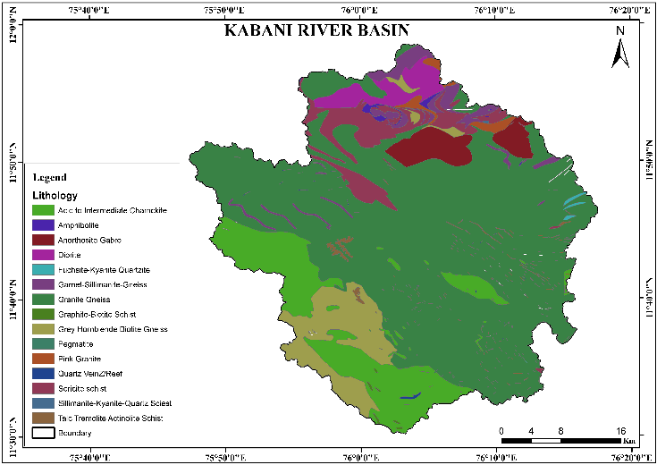

Fig: 3 Lithology

* + 1. **Geomorphology**

Geomorphology displays the surface features and characteristics of an area and indicates its susceptibility to hill slopes and denudational processes. Different landforms have different susceptibility to mass movements and, therefore, geomorphology is considered to be an essential factor in the initiation of shallow landslides (Krishnan et al. 2015). Among the various landforms, the rolling plain covers roughly 50% of the study area, followed by the highly dissected hills and valleys, and valley fill (areal coverage = 24% and 20%) (Fig. 4a).



Figure 4a, source: Geological Survey of India

* + 1. **Slope** **Angle**

Slope angle is widely used in landslide probability modelling, and is considered to be the most critical (Anpazhagan and Sajinkumar 2011; Achu et al. 2020; Febi et al. 2020). Since the magnitude of the sliding mass is directly related to the slope angle (Meaton et al. 2015; Chen et al. 2018), slope angle is considered to be one of the most important landslide factors. The slope angle of the study are the steepness ranges from 0° to 65.56°. The slope angle was reclassified into six different classes, such as <= 5°, 6–10°, 11–20°, 21–30°, 31–40°, and >=41°.

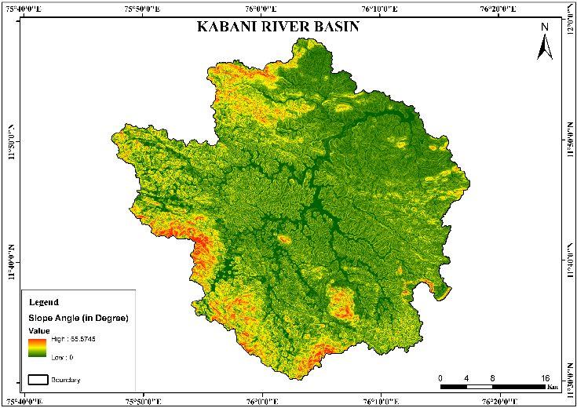

Figure 4b, source: SRTM DEM

* + 1. **Soil Texture**

The porosity and permeability of soil play a crucial role in the case of shallow landslide acceleration. In this region, the majority of the previously occurred landslides through the influence of intense rainfall triggered by the excess pore-water pressure generated in the soil (Kuriakose et al. 2009). Four soil textural classes characterise the soils of the study area, viz., clay (69.43% area), loam (18.36%), gravelly clay (11.28%), and gravelly loam (0.93%) (Fig. 4c).

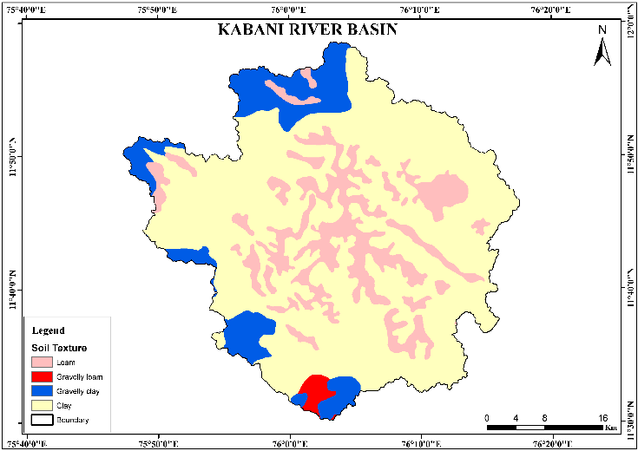

Figure 4c, Soil Texture, source: Kerala State Survey Organisation

* + 1. **Slope Curvature**

The curvature of the slope signifies the morphology, convergence and divergence of surficial water flow and identifies the slope stability (Ding et al. 2017). Normal curvature is a combination of plan curvature and profile curvature, which was established in the study. Convex slopes are often considered more stable compared to concave slopes because the former quickly drains the water into the lower slope area, while the latter is more likely to be unstable because water concentrates on the lower slope, leading to slope instability. (Stocking 1972).

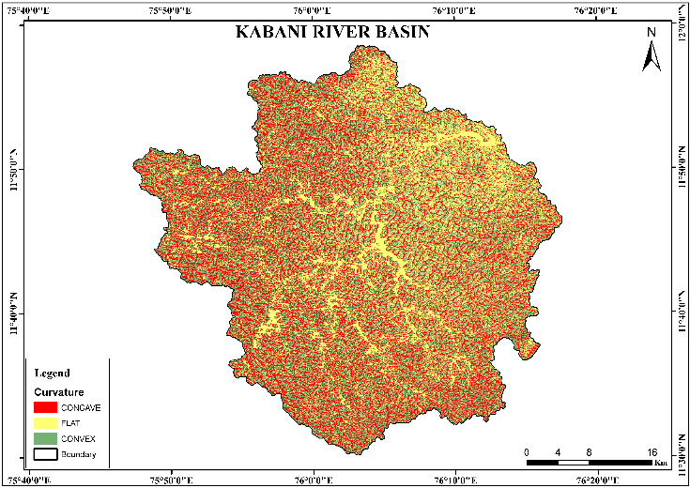

Figure. 4d, Curvature, source: SRTM DEM

* + 1. **Topographic Wetness Index (TWI)**

One of the important topographic variables is TWI, which implies saturation and runoff concentration of the soil (Beven and Kirkby 1979). The TWI is calculated based on the local slope and upslope contributing area affecting the soil moisture content in a calculation unit, where α represents the upslope area β represents the slope angle (Devkota et al. 2013). The TWI of the study area was reclassified into three classes. We classified the values of low, medium and high for the analysis purpose, i.e., < 5, 6–10 and >10, respectively.

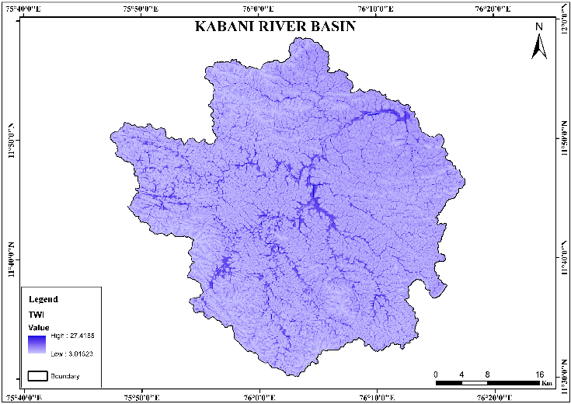

Figure. 4e: Topographic Wetness Index, source: SRTM DEM

* + 1. **Land use/Land cover**

Specifically, in rugged landscapes, unplanned land use/ land cover modification often leads to topographic changes affecting slope stability (Kayastha et al. 2013). The land use/land cover map was generated using the Sentinel 2A satellite image. Among the different land use/land cover types, Coffee agro-forestry (40.82%) dominates, followed by Deciduous Forest (20.88%), Agriculture (12.00%), Evergreen Forest (11.84%), Tea (4.96%), Barren land (4.29%), HA Grasslands (1.27%), Paddy (1.09%), Water body (1.03%), Tree plantation (1.00%), Built-up area (0.55%), and Forest plantation (0.26%).

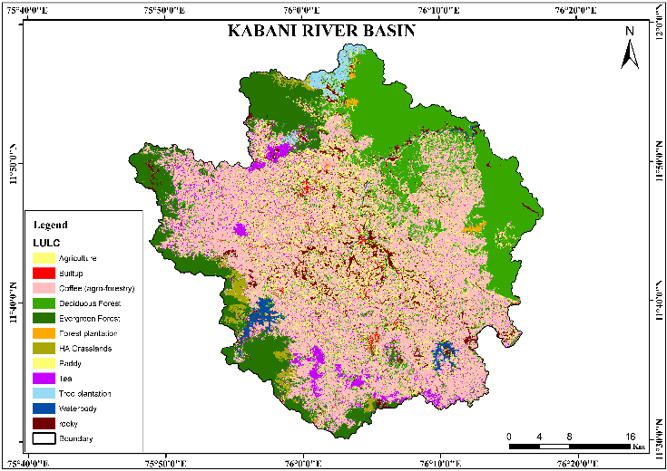

Figure.4f: LULC, source: Sentinel 2A Image

* + 1. **Rainfall**

This nature of rainfall events is the most critical landslide triggering factor in the southern WG, along with the majority of past landslide occurrences in the region were correlated with extreme rainfall events (Thampi et al. 1995). The rainfall choropleth map was generated using the IDW technique, through the rainfall data of twenty-four rain gauge stations for 2019 were collected from the IMD. The annual rainfall over the area was reclassified into three zones, namely, < 2500 mm, 2501–3500 mm and > 3501 mm for the analysis.

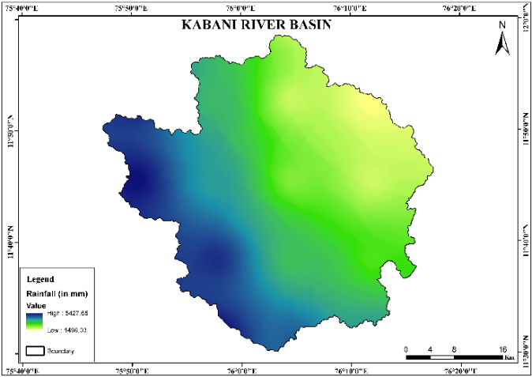  
Fig 4g : Rainfall, source: IMD IMDAA Era 5

* + 1. **Distance to Lineaments**

The distance from the Lineaments map is prepared from the Geological Survey of India (GSI). The relationship between lineament distance and landslides is found out using <200, 200–400, 400– 600, 600–800 and >800 m, the distance between the lineaments is calculated using the Euclidean distance due to the risk of the imbalance of slope.

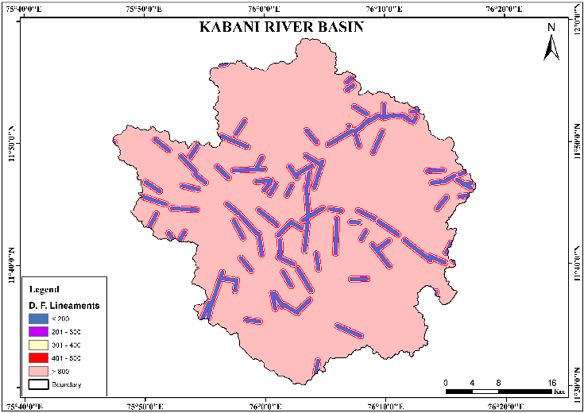

Figure. 4h : Lineaments, source: Geological Survey of India

* + 1. **Distance to Roads**

Road construction is a human-made cut and creation that causes slope instability (Bui et al., 2011). Road construction with a steeper slope is associated with a higher risk of accidents. Due to the potential for slope instability, the distance between roads was calculated using Euclidean distance. The study area is classified into 5 groups, such as; <100, 101-200, 201-300, 301-500 and >500 based on the distance from the road.

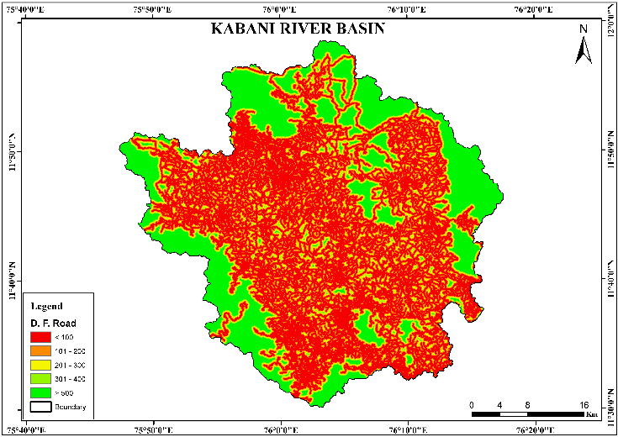

Fig. 4i: Road, source: Open Series Map

* + 1. **Distance to Streams**

Rivers in a watershed are the result of long-term interactions between creations that trigger slope instability, geographical features in the impact of water, and topography and slope (Bui et al., 2011). The distance from the streams is one of the proximity parameters, and the distance between the streams is calculated using the Euclidean distance due to the risk of the instability of the slopes. They are classified into <100, 101-200, 201-300, 301-500, and >500 (Fig. 4j) for the analysis.

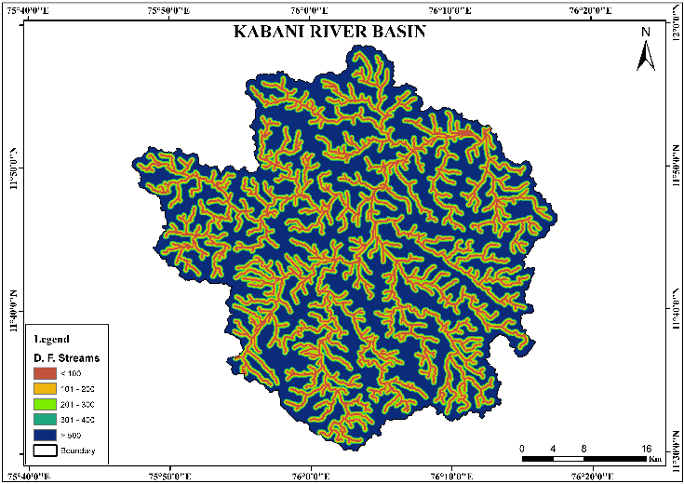

Fig. 4j: Rivers, source: SRTM DEM

* 1. **Analysis of the factors influencing landslides**

The frequency ratio and prediction rate for all classes were obtained from all prepared conditioning factors of the training dataset. The ratio of landslides and domains, frequency ratio, relative frequency, and prediction rate for each class and factor are displayed in Table 5a. The frequency ratio is frequently used in landslide susceptibility research. However, in this case, standardisation between 0 and 1 was applied to allow better comparison and understanding of the impact on the LSI calculation. As such, the prediction rate offers a weighting of the variables that affect the landslide susceptibility index.

Table. 1: The ratio of landslides and domains, frequency ratio, relative frequency, and prediction rate for each class and factor

|  |  |  |  |  |  |  |
| --- | --- | --- | --- | --- | --- | --- |
|  | ***Count*** | ***Fnij*** | ***Previous*** | ***FLij*** | ***Wij*** | ***FR*** |
| **CURVATURE** | | | | | | |
| Concave | 638464 | 0.34106 | 107 | 0.601 | 1.762 | 176.2 |
| Flat | 638256 | 0.34095 | 35 | 0.196 | 0.576 | 57.67 |
| Convex | 595256 | 0.31798 | 36 | 0.202 | 0.636 | 63.6 |
| **LU/LC** | | | | | | |
| Agriculture | 225015 | 0.12018 | 38 | 0.213 | 1.776 | 177.6 |
| Tea | 92970 | 0.04965 | 15 | 0.084 | 1.697 | 169.7 |
| Paddy | 20410 | 0.0109 | 1 | 0.005 | 0.515 | 51.53 |
| Rocky | 80326 | 0.0429 | 6 | 0.033 | 0.785 | 78.57 |
| Built-up | 10350 | 0.00553 | 2 | 0.011 | 2.032 | 203.2 |
| Deciduous Forest | 390954 | 0.2088 | 26 | 0.146 | 0.699 | 69.95 |
| Coffee (agroforestry) | 764104 | 0.4081 | 79 | 0.443 | 1.087 | 108.7 |
| Evergreen Forest | 221525 | 0.11831 | 10 | 0.056 | 0.474 | 47.48 |
| Water body | 19367 | 0.01034 | 0 | 0 | 0 | 0 |
| Forest Plantation | 4829 | 0.00258 | 0 | 0 | 0 | 0 |
| H.A Grasslands | 23747 | 0.01268 | 1 | 0.005 | 0.442 | 44.29 |
| Tree plantation | 18764 | 0.01002 | 0 | 0 | 0 | 0 |
| **SOILTEXTURE** | | | | | | |
| Clay | 1299961 | 0.69429 | 142 | 0.797 | 1.149 | 114.9 |
| Loam | 343856 | 0.18365 | 6 | 0.033 | 0.183 | 18.35 |
| Gravelly Clay | 211215 | 0.11281 | 12 | 0.067 | 0.597 | 59.76 |
| Gravelly Loam | 17328 | 0.00926 | 18 | 0.101 | 10.92 | 1092 |
| **GEOMORPHOLOGY** | | | | | | |
| Pediment | 10966 | 0.00586 | 1 | 0.005 | 0.959 | 95.92 |
| Valley Fill | 378476 | 0.20214 | 23 | 0.129 | 0.639 | 63.92 |
| Water Body - River | 27079 | 0.01446 | 3 | 0.016 | 1.165 | 116.5 |
| Rolling Plain | 935137 | 0.49944 | 72 | 0.404 | 0.809 | 80.98 |
| Active Quarry | 320 | 0.00017 | 0 | 0 | 0 | 0 |
| Residual Mound | 39361 | 0.02102 | 3 | 0.016 | 0.801 | 80.17 |
| Pedi plain | 9791 | 0.00523 | 0 | 0 | 0 | 0 |
| Channel Bar | 2625 | 0.0014 | 0 | 0 | 0 | 0 |
| Residual Hill | 2808 | 0.0015 | 0 | 0 | 0 | 0 |
| Plateau Remnant | 10505 | 0.00561 | 0 | 0 | 0 | 0 |
| Ridge | 4584 | 0.00245 | 0 | 0 | 0 | 0 |
| Hills and Valleys | 450709 | 0.24072 | 76 | 0.426 | 1.773 | 177.3 |
| **LITHOLOGY** | | | | | | |
| Garnet-Sillimanite- Gneiss | 50951 | 0.02725 | 0 | 0 | 0 | 0 |
| Sericite Schist | 97442 | 0.05211 | 4 | 0.022 | 0.431 | 43.12 |
| Amphibolite | 5520 | 0.00295 | 0 | 0 | 0 | 0 |
| Pink Granite | 14909 | 0.00797 | 0 | 0 | 0 | 0 |
| Diorite | 52066 | 0.02784 | 5 | 0.028 | 1.008 | 100.8 |
| Granite Gneiss | 1172789 | 0.62712 | 61 | 0.342 | 0.546 | 54.64 |
| Grey Hornblenblende | 136386 | 0.07293 | 30 | 0.168 | 2.31 | 231 |
| Biotite Gneiss |  |  |  | 539 | 995 | 995 |
| Talc Tremolite Actinolite | 13629 | 0.00729 | 1 | 0.005 | 0.77 | 77.08 |
| Schst |  |  |  | 618 | 874 | 744 |
| Pegmatite | 127 | 6.79E-05 | 0 | 0 | 0 | 0 |
| Quartz Vein/Reef | 2295 | 0.00123 | 1 | 0.005 | 4.577 | 457.7 |
| Acid to Intermediate | 252525 | 0.13503 | 74 | 0.415 | 3.078 | 307.8 |
| Charnockite |  |  |  | 73 | 754 | 754 |
| Silimanite-Kyanite- | 345 | 0.00018 | 0 | 0 | 0 | 0 |
| Quartz Schist |  |  |  |  |  |  |
| Anorthosite Gabbro | 66526 | 0.03557 | 1 | 0.005 | 0.157 | 15.79 |
| Graphite-Biotite Schist | 1646 | 0.00088 | 1 | 0.005 | 6.382 | 638.2 |
| Fuchsite-Kyanite | 2956 | 0.00158 | 0 | 0 | 0 | 0 |
| Quartzite |  |  |  |  |  |  |
| **SLOPE ANGLE** | | | | | | |
| 0-5 | 583398 | 0.31165 | 9 | 0.05 | 0.162 | 16.22 |
| 5.1-10 | 644301 | 0.34418 | 41 | 0.23 | 0.669 | 66.92 |
| 10.1-20 | 498176 | 0.26612 | 96 | 0.539 | 2.026 | 202.6 |
| 20.1-30 | 117967 | 0.06302 | 30 | 0.168 | 2.674 | 267.4 |
| 30.1-40 | 25976 | 0.01388 | 2 | 0.011 | 0.809 | 80.97 |
| > 40.1 | 2158 | 0.00115 | 0 | 0 | 0 | 0 |
| **RAINFALL** | | | | | | |
| < 2,500 | 540558 | 0.2887 | 0 | 0 | 0 | 0 |
| 2,501 - 3,500 | 527551 | 0.28176 | 21 | 0.117 | 0.418 | 41.87 |
| > 3,500 | 804252 | 0.42954 | 157 | 0.882 | 2.053 | 205.3 |
| **TWI** | | | | | | |
| Low | 1158069 | 0.61864 | 146 | 0.82 | 1.325 | 132.5 |
| Medium | 584369 | 0.31217 | 31 | 0.174 | 0.557 | 55.78 |
| High | 129515 | 0.06919 | 1 | 0.005 | 0.081 | 8.119 |
| **DISTANCE** **FROM STREAMS** | | | | | | |
| Very Near | 300503 | 0.16049 | 34 | 0.191 | 1.19 | 119 |
| Near | 253602 | 0.13545 | 25 | 0.14 | 1.036 | 103.6 |
| Average | 260174 | 0.13896 | 21 | 0.117 | 0.849 | 84.9 |
| Far | 410488 | 0.21924 | 41 | 0.23 | 1.05 | 105 |
| Very Far | 647594 | 0.34587 | 57 | 0.32 | 0.925 | 92.58 |
| **DISTANCE FROM ROAD** | | | | | | |
| Very Near | 897595 | 0.47939 | 139 | 0.78 | 1.628 | 162.8 |
| Near | 333893 | 0.17833 | 19 | 0.106 | 0.598 | 59.85 |
| Average | 145550 | 0.07774 | 14 | 0.078 | 1.011 | 101.1 |
| Far | 123485 | 0.06595 | 4 | 0.022 | 0.34 | 34.07 |
| Very Far | 371838 | 0.19859 | 2 | 0.011 | 0.056 | 5.657 |
| **DISTANCE FROM LINEAMENT** | | | | | | |
| Very Near | 112219 | 0.05993 | 6 | 0.033 | 0.562 | 56.24 |
| Near | 123530 | 0.06598 | 12 | 0.067 | 1.021 | 102.1 |
| Average | 132972 | 0.07102 | 5 | 0.028 | 0.395 | 39.55 |
| Far | 129427 | 0.06913 | 3 | 0.016 | 0.243 | 24.38 |
| Very Far | 1374213 | 0.73395 | 152 | 0.853 | 1.163 | 116.3 |
| **LSI (sum of wij) = 73.61519** | | | | | | |

Regarding the elevation factor, the area between 700 and 2028.67 metres exhibits a high RF value, which suggests that this region is susceptible to landslides and that such events have occurred more frequently in the past, particularly during periods of heavy rainfall. The RF value is greater for slopes ranging from 0° to 65.56°. Most global case studies have shown that high relief and steep slopes are primary causes of landslides (Y. Hong et al., 2007). Research indicates a distribution of landslides on flat surfaces, caused by the base of the landslide or the underlying bedrock (Cestras et al., 2022). Similarly, landslides tend to occur more often on concave slopes than on steep slopes. Concave slopes often concentrate water at their lower edges; however, they are generally more stable because water flow is more evenly distributed (Gimire & Timalsina, 2020). TWI represents the relationship between the amount of water accumulated in a specific area and the slope of the stream (Bevan & Kirkby, 1979; Benzogag et al., 2020).

TWI also showed that landslides are likely in our scenario, with TWI ranging from 3.01 to 27.41, indicating large landslides. Due to the ease of construction and slope cutting, and evacuation, especially in the study area, most roads are built on river banks. This may be due to the high risk in the upper reaches.

Rainfall naturally causes landslides. The annual average rainfall also increases with the increase in the study area, and the relative frequency suggests that rainfall above 3312 mm is more likely to cause landslides. Since our region is known for its frequent rainfall events, in some areas, the possibility of landslides occurring more frequently is possible if rainfall exceeds this figure (Sestrař et al., 2019). Finally, from a structural perspective, there is a correlation between the relative frequency values and the road crossing faults; landslides are also likely to occur in areas located within 200 m of the road, stream, and lineament.

* 1. **Landslide susceptibility map and validation**

The landslide susceptibility map of the Kabani River Basin displays a clear spatial pattern, where the western and southwestern regions show high and intense landslide susceptibility, indicated by the red to orange areas. These areas certainly fit the distribution of previous landslide events shown as black dots on the map. In contrast, the northeastern and eastern parts of the river basin, which are green, remain relatively stable. This spatial distribution highlights the dominant influence of topographic, climatic and geological parameters.

One of the primary contributors to this pattern is the high rainfall in the western part, where the Kabani River Basin is located in the lee of the Western Ghats. The region receives intense monsoon rainfall, which increases soil saturation and reduces slope stability. In addition, the presence of loamy soils, which retain water and become unstable when wet, makes this region particularly vulnerable to landslides. Loamy soils are fertile but structurally weak under saturated conditions, especially on sloping terrain. Sloping structure is an important factor, as sloping areas are more susceptible to gravitational movement.

The more the terrain is disturbed, the more sensitive the sloped areas are. Steep slopes accelerate surface runoff, erosion, and the downward movement of soil and debris. This is evident in the south and southwest, where extreme susceptibility overlaps with steep terrain. In addition, the curvature of the terrain also plays a role: concave slopes collect water and increase saturation, while steep slopes may be more susceptible to mass movement.

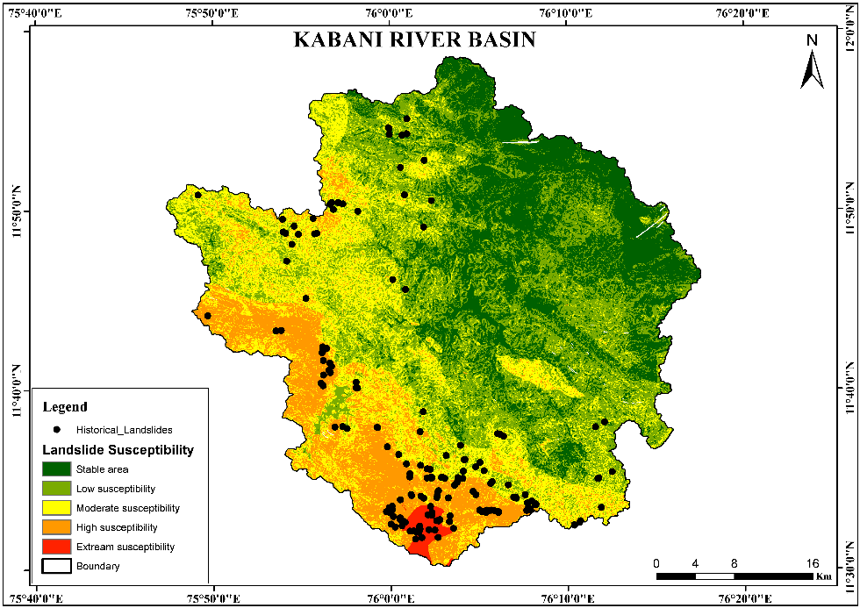

Fig. 5 : Landslide Susceptibility Map

The Topographic Wetness Index (TWI), which measures moisture accumulation and is partially connected to the instability of the surface. High potentials in valleys and depressions are often associated with areas of moderate to high potential. In addition, distance to streams affects drainage and erosion processes, with areas near streams experiencing more intense subsoil erosion, and proximity to roads introduces man-made instability from slope cutting and construction. Geological and structural constraints also make an important contribution. The type and composition of the lithology – the bedrock – influences the strength of the slope and the nature of the weathering; weaker and weathered rocks, such as phyllites or schists, are more likely to fail. Similarly, in terms of land use, different types of cultivation can accelerate landslides in some places while at the same time decreasing the impact of landslides in others. Distance to lineament, structural features such as faults and fractures, can indicate areas of weakness where landslides are more likely to initiate. Geomorphology, which includes landform classifications such as escarpments, pediments, and valleys, can help explain why some areas naturally initiate mass movement. For example, rugged hills and escarpments exhibit high landslide densities due to the instability of the area.

The integration of diverse factors such as climatology, topography, hydrology, and geology demonstrates a holistic approach used in the vulnerability assessment, which helps to more accurately identify areas at risk in the Kabani River Basin. The correlation between slope, soil type, and historical landslide locations confirms the effectiveness of this geospatial model in identifying hazardous areas, aiding disaster mitigation, and land use planning in the Kabani River Basin.

1. SUMMARY AND CONCLUSION

The landslide susceptibility assessment in the Kabani River Basin highlights a complex interplay of natural and anthropogenic factors influencing slope stability. The western and southwestern regions, characterised by steep slopes, high rainfall, loamy and clay soils, and weak geomorphology, show higher or more severe susceptibility than the northeastern regions. Key contributing parameters such as curvature, topographic wetness index (TWI), proximity to roads, streams, and lineaments, and lithological and geomorphological distributions and variations make the hazard mapping more accurate. The close alignment of past landslide events with areas identified as high-probability particularly confirms the reliability of the model. This analysis also underscores the importance of integrated geospatial approaches in landslide hazard zoning. Effective mitigation strategies in the river basin, land use planning, and infrastructure development should be prioritised for these high-risk areas to reduce potential landslides in the future.

REFERENCES

1. Abdul Rachman Rasyid1,2*, Netra P. Bhandary1 and Ryuichi Yatabe1 "Performance of frequency ratio and logistic regression model in creating GIS-based landslides susceptibility map at Lompobattang Mountain, Indonesia" Rasyid et al. Geoenvironmental Disasters (2016) 3:19 DOI 10.1186/s40677-016-0053-x
2. Abidi, A., Demehati, A. & El Qandil, M. Landslide Susceptibility Assessment Using Evidence Belief Function and Frequency Ratio Models in Taounate city (North of Morocco). Geotech Geol Eng 37, 5457–5471 (2019). https://doi.org/10.1007/s10706-019-00992-0
3. Achu AL, Aju CD, Reghunath R (2020) Spatial modelling of shallow landslide susceptibility: a study from the southern Western Ghats region of Kerala, India. Ann GIS, 1–19. https:// doi.org/ 10. 1080/19475 683. 2020. 17582 07
4. Achu, A. L., Thomas, J., Aju, C. D., Gopinath, G., Kumar, S.,&Reghunath, R. (2021). Machine-learning modelling of fire susceptibility in a forest-agriculture mosaic landscape of southern India. Ecological Informatics, 64, 101348.
5. Anbazhagan S, Sajinkumar KS (2011) Geoinformatics in terrain analysis and landslide susceptibility mapping in parts of Western Ghats, India. Geoinformatics in applied geomorphology. CRC Press, Boca Raton, pp 291–315
6. Ankur Sharma1 · Har Amrit Singh Sandhu1 · Claudia Cherubini2,” Enhanced landslide susceptibility zonation using GIS‑Based ensemble Techniques” Environmental Earth Sciences (2025) 84:37 https://doi.org/10.1007/s12665-024-12032-z
7. Benzougagh, B., Meshram, S.G., Baamar, B. et al. (2020).. Relationship between landslide and morpho-structural analysis: a case study in the Northeast of Morocco. Appl Water Sci 10, 175 (2020). https://doi.org/10.1007/s13201-020-01258-4.
8. Beven KJ, Kirkby MJ (1979) A physically based, variable contributing area model of basin hydrology/Un modèle à base physique de zone d’appel variable de l’hydrologie du bassin versant. Hydrol Sci J 24(1):43–69. https:// doi. org/ 10. 1080/ 02626 66790 94918 34
9. Bilașco, Ș., Roșca, S., Vescan, I., Fodorean, I., Dohotar, V., Sestras, P., 2021. A GIS-based spatial analysis model approach for identification of optimal hydrotechnical solutions for gully erosion stabilisation. Case Study. Appl. Sci. 11 (11), 4847. https://doi.org/10.3390/app11114847.
10. Bui, D.T., Lofman, O., Revhaug, I., Dick, O., 2011. Landslide susceptibility analysis in the Hoa Binh province of Vietnam using statistical index and logistic regression. Nat. Hazards 59 (3), 1413–1444. https://doi.org/10.1007/s11069-011-9844-2.
11. Cao, C., Chen, J., Zhang, W., Xu, P., Zheng, L., & Zhu, C. (2019). Geospatial Analysis of Mass-Wasting Susceptibility of Four Small Catchments in Mountainous Area of Miyun County, Beijing. International Journal of Environmental Research and Public Health, 16(15), 2801. https://doi.org/10.3390/ijerph16152801
12. Chen W, Shahabi H, Shirzadi A, Li T, Guo C, Hong H, Li W, Pan D, Hui J, Ma M, Xi M (2018) A novel ensemble approach of bivariate statistical-based logistic model tree classifier for landslide susceptibility assessment. Geocarto Int 1–23. https:// doi. org/ 10.1080/ 10106 049. 2018. 14257 38
13. Chung CJF, Fabbri AG (1999) Probabilistic prediction models for landslide hazard mapping. Photogramm Eng Remote Sens 65(12):1389–1399
14. D. Nagaraju and C. Papanna (2009) Hydrogeochemical Studies of Kabini River Basin,Karnataka, India vol.8, no.1, pp.111-118
15. Devkota KC, Regmi AD, Pourghasemi HR, Yoshida K, Pradhan B, Ryu IC, Dhital MR, Althuwaynee OF (2013) Landslide susceptibility mapping using certainty factor, index of entropy and logistic regression models in GIS and their comparison at Mugling-Narayanghat road section in Nepal Himalaya. Nat Hazards 65(1):135–165. https:// doi. org/ 10. 1007/ s11069- 012- 0347-6
16. Gerrard J (1994) The landslide hazard in the Himalayas: geological control and human action. Geomorphology 10(1–4):221–230. https:// doi. org/ 10. 1016/ 0169- 555X(94) 90018-3
17. Ghimire, M., Timalsina, N., 2020. Landslide Distribution and Processes in the Hills of Central Nepal: Geomorphic and Statistical Approach to Susceptibility Assessment. J. Geosci. Environ. Protection 08 (12), Article 12. https://doi.org/10.4236/ gep.2020.812017.
18. Glade T, Anderson M, Crozier MJ (Eds.) (2005) Landslide Hazard and Risk. Wiley. https:// doi. org/ 10. 1002/ 97804 70012 659
19. Gregory C. Ohlmacher Plan curvature and landslide probability in regions dominated by earth flows and earth slides Engineering Geology 91 (2007) 117–134
20. Haque U, da Silva PF, Devoli G, Pilz J, Zhao B, Khaloua A, Wilopo W, Andersen P, Lu P, Lee J, Yamamoto T, Keellings D, Wu J-H, Glass GE (2019) The human cost of global warming: Deadly landslides and their triggers (1995–2014). Sci Total Environ 682:673–684. https:// doi. org/ 10. 1016/j. scito tenv. 2019. 03. 415
21. Hawas Khan a, Muhammad Shafique b,⇑, Muhammad A. Khan a, Mian A. Bacha b, Safeer U. Shah b, Chiara Calligaris c ,Landslide susceptibility assessment using Frequency Ratio, a case study of northern Pakistan, The Egyptian Journal of Remote Sensing and Space Sciences 22 (2019) 11–24
22. Hong, Y., Adler, R., Huffman, G., 2007. Use of satellite remote sensing data in the mapping of global landslide susceptibility. Nat. Hazards 43 (2), 245–256. https:// doi.org/10.1007/s11069- 006-9104-z.
23. Kavzoglu, T., Sahin, E.K. & Colkesen, I. Landslide susceptibility mapping using GIS-based multi-criteria decision analysis, support vector machines, and logistic regression. Landslides 11, 425–439 (2014). https://doi.org/10.1007/s10346-013-0391-7
24. Kayastha P, Dhital MR, De Smedt F (2013) Application of the analytical hierarchy process (AHP) for landslide susceptibility mapping: a case study from the Tinau watershed, west Nepal. Comput Geosci 52:398–408. https:// doi. org/ 10. 1016/j. cageo. 2012. 11. 003
25. Krishnan MVN, Pratheesh P, Rejith PG, Vijith H (2015) Determining the suitability of two different statistical techniques in shallow landslide (debris flow) initiation susceptibility assessment in the western Ghats. Environ Res Eng Manag 70(4):26–39. https:// doi.org/10. 5755/j01.erem.70.4.8510
26. Kumar BM (2006) Land use in Kerala: changing scenarios and shifting paradigms. J Trop Agric 43:1–12
27. Kuriakose SL, Sankar G, Muraleedharan C (2009) History of landslide susceptibility and a chorology of landslide-prone areas in the Western Ghats of Kerala India. Environ Geol 57(7):1553–1568. https:// doi. org/ 10. 1007/ s00254- 008- 1431-9
28. Lee S, Sambath T (2006) Landslide susceptibility mapping in the Damrei Romel area, Cambodia using frequency ratio and logistic regression models. Environ Lithol 50(6):847– 855. https:// doi. org/ 10. 1007/ s00254- 006- 0256-7
29. Lee, S., Pradhan, B. Landslide hazard mapping at Selangor, Malaysia using frequency ratio and logistic regression models. Landslides 4, 33–41 (2007). https://doi.org/10.1007/s10346- 006-0047-y
30. Merghadi A, Yunus AP, Dou J, Whiteley J, ThaiPham B, Bui DT, Avtar R, Abderrahmane B (2020) Machine learning methods for landslide susceptibility studies: A comparative overview of algorithm performance. Earth Sci Rev 207:103225. https:// doi. org/ 10. 1016/j. earsc irev. 2020. 103225
31. Meten M, PrakashBhandary N, Yatabe R (2015) Effect of landslide factor combinations on the prediction accuracy of landslide susceptibility maps in the Blue Nile Gorge of Central Ethiopia. Geoenvironmental Disasters 2(1):9. https:// doi. org/ 10. 1186/s40677- 015- 0016-7
32. N. R. Anoop and T. Ganesh., 2023. The Forests and Elephants of Wayanad: Challenges for Future Conservation ,DOI: 10.18520/cs/v118/i3/362-367
33. Sestras, P., Bilașco, Ș., Roșca, S., Ilies, N., Hysa, A., Spalevi´c, V., Cîmpeanu, S.M., 2022. Multi-instrumental approach to slope failure monitoring in a landslide susceptible newly built-up area: Topo-Geodetic survey, UAV 3D modelling and ground-penetrating radar. Remote Sens. (Basel) 14 (22), 5822. https://doi.org/10.3390/ rs14225822.
34. Sharma S, Mahajan AK (2018) A comparative assessment of information value, frequency ratio and analytical hierarchy process models for landslide susceptibility mapping of a Himalayan watershed, India. Bull Eng Lithol Environ 1–18. https:// doi. org/ 10. 1007/ s10064- 018- 1259-9
35. Sonker, Irjesh & Tripathi, Jayant & Maurya, Swarnim. (2022). Remote sensing and GIS-based landslide susceptibility mapping using frequency ratio method in Sikkim Himalaya. Quaternary Science Advances. 8. 100067. 10.1016/j.qsa.2022.100067.
36. SSO (2007) Benchmark soils of Kerala. Soil Survey Organization, Government of Kerala, Thiruvananthapuram
37. Thampi PK, Mathai J, Sankar G (1995) A regional evaluation of landslide prone areas in the Western Ghats of Kerala. In: Abstracts of the national seminar on landslides in Western Ghats, 29–30 Aug 1995. Centre for Earth Science Studies, Government of Kerala, Thiruvananthapuram, India
38. Tien Bui D, Pradhan B, Lofman O, Revhaug I, Dick OB (2012) Landslide susceptibility mapping at Hoa Binh province (Vietnam) using an adaptive neuro-fuzzy inference system and GIS. Comput Geosci 45:199–211. https:// doi. org/ 10. 1016/j. cageo. 2011. 10. 031
39. Vijith H, Madhu G (2008) Estimating potential landslide sites of an upland sub-watershed in Western Ghat’s of Kerala (India) through frequency ratio and GIS. Environ Lithol 55(7):1397– 1405. https:// doi. org/ 10. 1007/ s00254- 007- 1090-2
40. Walker LR, Shiels AB (2013) Physical causes and consequences for Landslide Ecology
41. Zhang, Z., Yang, F., Chen, H. et al. GIS-based landslide susceptibility analysis using frequency ratio and evidential belief function models. Environ Earth Sci 75, 948 (2016). https://doi.org/10.1007/s12665-016-5732-0
42. Zizheng Guo a, Yu Shi b, Faming Huang b,⇑, Xuanmei Fan c, Jinsong Huang d ,2021, Landslide susceptibility zonation method based on C5.0 decision tree and K-means cluster algorithms to improve the efficiency of risk management.