Domestic Water Accessibility and its Implications to Household Income in Maswa District, Shinyanga Region, Tanzania

ABSTRACT
Water supply is an essential requirement for people; and its accessibility is connected to human livelihood. Water shortage affects households’ labour because of much time and energy spent on obtaining it. Unavailability of safe and clean water has several implications, among them include waterborne diseases, labour, income and time. The study looked at implication of water accessibility to household income. The study was conducted in Maswa District, Tanzania. A sample of 120 households was involved in the study. A household questionnaire and focus group discussions methods were used to collect primary data. Descriptive statistics and content analysis methods were applied in analyzing the collected data. The main findings of the study show that unavailability of safe and clean water led to affecting income through time and labour lost during fetching water. In addition, water borne diseases consumed labour, time and money for caring the patients. Most of labour used in fetching water was from women and female children. Consequently, the women faced problems of diseases caused by carrying water and time consumed during fetching the water, which bring conflicts with their husbands and lost time for other income generating income for households. The study concludes that unavailability of safe and clean water has implication to household income negatively.

Key words: water, accessibility, female, labour, time, traditional wells, shallow wells, diseases, conflict, income

1.0 INTRODUCTION
Clean and safe water availability for domestic uses is important for households’ economies. However, the reverse, becomes a common problem in African rural households. Women and children spend many hours and distance walking for water (Masawanya et al., 2014), which affects labour for household economic development activities. People in rural areas especially women spend hours each day fetching water instead of using that time for income generating activities thereby improving their income and diets (Rosen and Vincent, 1999). Moreover, poor quality of water affects people’s health, productivity and increases work load to the poor in the provision of water and its many domestic uses (Esrey et al., 1991; Prüss et al., 2002). Hence, water and sanitation services delivery has become one of the most challenging problems in both rural and urban areas in developing countries.

Tanzania remains one of the world’s poorest economies (Ref), importantly unavailability of water for domestic consumption imposes another challenge. For example, in 2007, about 41% of rural households had access to safe and clean water (PHDR, 2009). Of which 59.5% of the rural households had unprotected water and only 22.8% had piped water (PHDR, 2009). This shows that majority of rural households in Tanzania have poor access to safe and clean water, which in turn consumes labour, household income and time for other economic activities at both household and community levels. Given this fact that, unavailability of safe and clean water for domestic consumption, has economic impact. However, very little has been examined as the unavailability of safe and clean water has income implications at household level.

This study aimed at investigating the implication of domestic water accessibility for the households’ income in Maswa District which is found in Shinyanga Region. About 90% of the population in Maswa District lives in rural areas where the unavailability of water for domestic consumption has been a critical problem (PHDR, 2009). Findings of this study will be used to develop strategies for addressing water challenges in both rural and urban communities by involving policy makers, planners, and development partners. This will improve water availability and accessibility in rural and urban areas. Implications of unavailability of safe and clean water and related factors for this paper are summarized in Figure 1.
Background variable
- Age
- Sex
- Education
- Marital status
- Household size
Implications for household
- Reduced time for productive activities
- Spending on treatment of waterborne diseases
- Tiredness due to walking distance to water sources
- Less participation in social activities
- Absentees of pupils to school
- Insufficient of water fetched
- inadequate water storage system
- Insufficiency of water consumption per day

Independent variable:
- Distance to water sources
- Time spent to water sources
- Water quantity
- Means of water collection
- Means of water storage
- Water consumption

Water sources:
- Traditional wells,
- Shallow wells,
- Ponds,
- Tape water,
- Boreholes

Reduced household income

Figure 1: Conceptual framework showing domestic water accessibility and its implications for household income

2.0 RESEARCH METHODOLOGY

2.1 Description of the Study Area
Maswa District is bordered to the north by Bariadi District, East by Meatu District, South by Kishapu District and West by Mwanza Region (Figure 2). According to the 2012 Tanzanian National population and Housing Census, the population of Maswa District was 304,402 (URT, 2013). The District lies between the latitudes 2.45’ and 3.15’ South of the Equator and between the longitudes of 33.0’ and 34.1’ east of the Greenwich Meridian. The altitude of the District lies between 1200 m and 1300 m above sea level.

Maswa District has a semi arid climate with bimodal rainfall pattern of between 450 and 1000 mm with an average of 750mm. The average rainfall decreases from north to south and from west to east. The short rains start in mid November to mid January and the long rains start early March up to May. The average temperature is 26º C. Large parts of the district have few vegetative cover and the soil fertility in large tracks of the District is medium to poor.

The income of the district depends on agriculture output. However, if there are fluctuations to a large extent affect crops and livestock production. The basis of the district economy is agriculture and livestock keeping. According to URT (2013) national population census, about 76% of the population is employed in agriculture sector. The most important cash crops are cotton and rice. Food crops include sorghum/millets, maize, rice, sweet potatoes and groundnuts and some cassava.

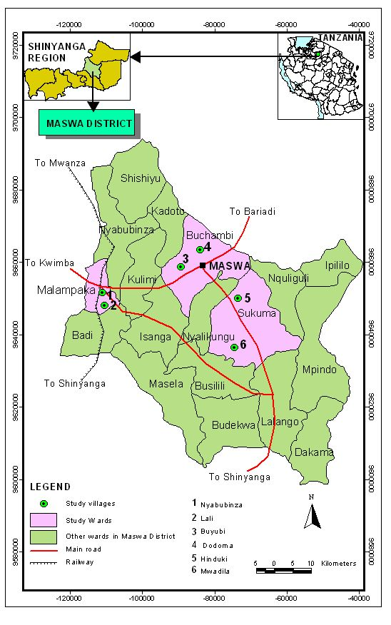
Figure 2: Map of Maswa District showing the study area

2.2 Research Design, Sampling Procedure and Sample Size
A cross-sectional research design was used. A purposive sampling was employed to select three Divisions namely Mwagala, Sengerema and Nung’hu. A random sampling technique was applied to obtain three wards out of 18. Two villages from each selected ward making a total of six (6) villages were selected randomly. In each selected village, twenty (20) households were selected randomly from village registry books. A total sample size of 120 households was obtained.

2.3 Data Collection and analysis
Data were collected through interview using a structured questionnaire administered to heads of selected households using personal in-depth approach. In the absence of the heads of households, any member of the household represented provided that he or she was in position of providing required information. Personal or Participant observation was used to collect qualitative data such as observation of water sources and their status, means of water collection and containers used to carry water from the source. These required direct observation of an activity. The method enabled to connect together different information collected by other methods. Data collected from structured and semi-structured questionnaires were analysed using Statistical Package for Social Sciences (SPSS) computer software.

3.0 RESULTS AND DISCUSSION

3.1 Water sources for domestic use
About 52% of respondents use shallow wells as their means for securing water access at their households. Traditional wells comprise 40% of all respondents, and the few respondents cover other water sources (Table 1). Shallow wells are not accommodating well the people because they are often too congested and dry up especially during dry season. For Traditional wells, the situation is worse since they are not protected and, in most cases, people share these sources with animals. Through group discussion, most of participants said that they were frequently suffering from diarrhea because they had been using unsafe water obtained from tradition wells. Only fewer households (3.3%) used tape water (private sources). These sources are located at the individual premises which are sometimes shared with neighbours. However, some of participants of FGDs said that they were poor and thus could not afford to own personal sources in the household. The findings show that many households in rural areas of Maswa District have a problem of accessing clean and safe water as they depend on shallow and traditional wells as shown in plates 1 and 2.

Table 1: Main water sources
Main water sources | Number | Percentage
Traditional wells | 48 | 40
Ponds | 4 | 3.3
Shallow wells | 63 | 52.8
Tape water | 4 | 3.3
Total | 120 | 100.0

Plate 1: Locally dug pit/well on the dry river beds in Hinduki village
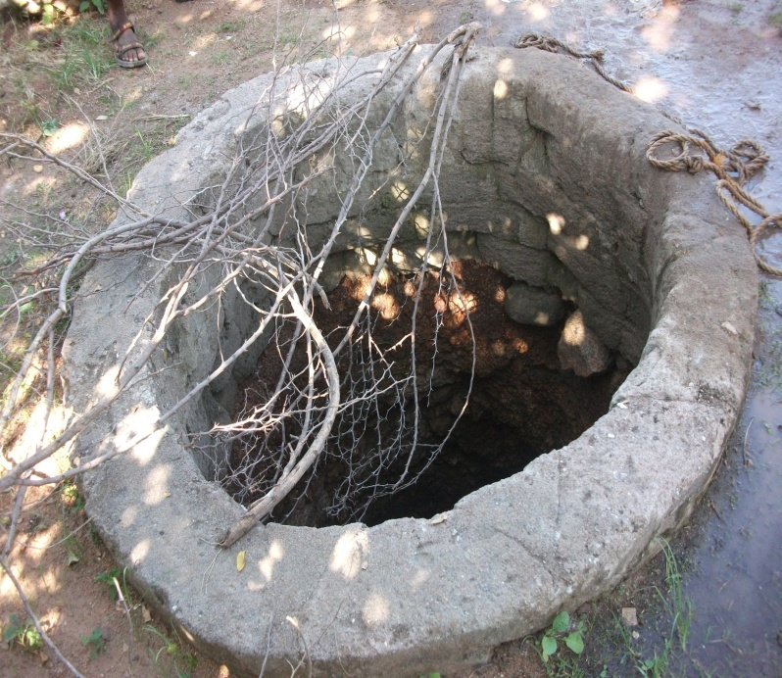
Plate 2: Traditional/Unprotected well in Buyubi village

3.2 Management and ownership of water sources
Findings show that water had been managed by community (76.7%), water user groups/associations (16.7%) and individuals (6.6%) (Table 2). Water user groups/associations were observed from villages where shallow wells exist. In this study respondents were asked to articulate how water sources had been maintained. Some of the villages’ water use groups were observed not to be active because shallow wells had not been discharging water sufficiently for them especially during dry seasons where sources dry up hence poor water discharge. For the case of traditional wells, they are known to be the property of the whole community and every person was responsible in maintaining the source either by cash or community labour contribution. From the observation, it can be noted that water sources in rural settings are owned and managed by the entire community where sources are located.
Table 2: Water sources management
Source maintenance | Number | Percentage
Owners/individuals/households | 8 | 6.6
Water users association | 20 | 16.7
Community | 92 | 76.7
Total | 120 | 100.0

3.3 Trends of water accessibility
Majority of water fetchers had to walk for a long distance from the homesteads to water sources/points spending more than half an hour (Table 3). For this case, most of water fetchers spent 30 minutes to more than 3 hours. This might be implying that the majority of the people in the study area are travelling a long journey to water sources which means much time is said to be consumed for water searching instead of performing other social and economic activities. The findings correspond to Rosen and Vincent (1999) that majority of people (especially women and girls) in sub Sahara Africa spent more time for domestic water searching and concluded that time saved from looking for water could be used in agricultural and other income generating activities.

Table 3: Time used to and from water sources
Time used to and fro water sources | Number | Percentage
Less than 30 minutes | 20 | 16.7
30 minutes -1 hour | 68 | 56.7
1 hour to 2 hours | 26 | 21.7
2 hours to 3 hours | 5 | 4.2
More than 3 hours | 1 | 0.8
Total | 120 | 100.0

Apart from the walking distance which took water collector to more than half an hour, they also spent in queues of drawing water. On average 32.5% of water collectors wait for 1 to 2 hours before they can draw water from the wells. On the other hand, others spent in the queues for over 2 hours (Table 4). This also shows that time spent in fetching water has socio-economic implications. Women said that: “we are accused by our husbands and be abused and beaten by them because of staying out of home for too long waiting at the water source to collect water”. Moreover, they said that “time we use for queuing sometimes makes children not to report at schools in time”. They also said that fighting for positions in queues at the source had been common. The study complies with the findings reported by Gleditsch et al. (2007) who observed that demand for natural resource principally water has been resulting to water use conflicts.

Table 4: Queuing time at water sources
Queuing | Number | Percentage
15 to 30 minutes | 17 | 14.2
30 minutes to 1 hour | 19 | 15.8
1 hour to 2 hours | 39 | 32.5
2 hours to 3 hours | 28 | 23.3
3 hours to 4 hours | 13 | 10.8
4 hours to 5 hours | 1 | 0.8
Do not wait | 3 | 2.5
Total | 120 | 100.0

3.4 Responsibility of water collection in Household
The considerable labour involved in water collection is almost exclusively done by women and children (95%). This clearly shows that women play a significant role in domestic water collection. This reveals that individuals responsible for fetching water are mostly women. What is observed in this study is not different from that reported by ADF (2006) which indicates that women in rural areas often travel long distances to collect water. They are also, at an increased risk of violence since they travel such great distances from their villages on a daily basis. This is also the case reported by many women in the FGDs that “ we are being facing a lot of problems related with spending more time in searching for water” they further mentioned the problems as among other violence between them and their husbands, wild animals, not taking care of their young children and foregoing other farm related activities.

In most societies, women have the primary responsibility for collecting and managing water for their households. In the best cases, water may be found at a local standpipe or nearby river. In the worst cases, getting water may be a day-long activity. It is not uncommon for women and girls in Africa to walk more than 10 kilometres to gather water for their families in the dry season. Girls are often tasked to help with the work and are forced to do other activities, rather than schooling.

Table 5: The responsibility of collecting water at the household (N=120)
Responsibility | Number | Percentage
Husband | 1 | 0.8
Wife | 30 | 25.0
Both husband and wife | 6 | 5.0
Children | 2 | 1.7
Mother and children | 78 | 65.0
Others | 2 | 1.7
None | 1 | 0.8
Total | 120 | 100

3.5 implications of water supply to households’ income
Time is an important resource for rural households. Respondents said that an activity like petty trade (57.5%), tailoring (24.2%), and food vender (17.5%) contributes to household income (Table 6).

Table 6: Activities could be performed instead of time dedicated to fetching water
Activities could be performed | Number | Percentage
Petty trade | 69 | 57.5
Tailoring | 29 | 24.2
Food vender | 21 | 17.5
None | 1 | 0.8
Total | 120 | 100

Non-farm income generating activities have become an important component of people’s livelihood among rural households because of increasing the total share of household income (Haggblade et al., 2007). If water services could be available at a reasonable distance, non-farm income generating activities could be performed hence household improvements in terms of income. Most of the people in Maswa District still do not have easy access to water. This has got a negative impact to the household due to long distance and time lost during water collection. They have been always travelling a distance of more than 1km to collect water and in most cases carrying it on their heads. Bringing water closer to households can help to reduce the burden laid upon women and children on looking for and collecting water, and thus, enabling them to participate in other productive economic activities for the welfare of their households and community at large. Moreover, time could also be used productively to generate human capital (e.g. especially through female child education), petty trading and food processing, casual labourers, or taking care of children at home, or even leisure. This suggests therefore that time spent on water collection could be and should be valued in monetary terms.

Women and children bear primary responsibility for water collection regardless the mode of transport they use for water collection. They continue to walk to and from the source, carrying water on their heads using jerrycans and saucepans. The burden of domestic water provision by women and children (usually girls) in developing countries is well known. Women participated in FGDs said that “ we spend more time in water collection activities than other socio-economic activities”. They further said that: “were are suffering from health related disease caused by carrying water, which in turn reduce our labour for income generating activities”. The observations pointed by women in this study are similar to the findings reported by Rosen and Vincent (1999), Mehretu and Mutambirwa (1992) and Makule (1997) that, water carriers, in developing countries, especially in Sub-Saharan Africa usually are women and children (mostly girls) and subjected to health problems such as headaches, general fatigue, and pains in the chest, neck, and waist leading to poor participation in social, economic and development activities which in turn reduces household income.

Inadequacy of rural water supply and sanitation coverage has been recognized to be a major contributor to human disease and malnutrition in Maswa and Tanzania in general (Table 7). Findings show 43.3% of households reported to be affected by diseases associated with waterborne diseases. Time wasted for taking care of patients and the use of household income for treatment constituted 26.7%. For this case, about 70% of respondents were highly affected by water related diseases (Table 7).

Table 7: Impact of Waterborne diseases
Impact | Number | Percentage
Not affected | 36 | 30
Spent a lot of money for treatment | 52 | 43.3
Use time for caring patients instead of production | 32 | 26.6
Total | 120 | 100.0

According to Hunter et al. (2000), about 20% of the world's population lacks access to safe drinking water, and more than 5 million people die annually from illnesses associated with unsafe drinking water or inadequate sanitation. Consequences connected with failure to provide adequate water services has resulted to loss work days, missing educational opportunities for school children, health care costs, and the draining of family resources.

Implications of the findings show that unavailability of safe and clean water consumes labour and time household income generation activities. This leads to low income generated at household level. In addition, water borne diseases related with the water consumed at the household level reduce laour and time for taking care of the patients. Apart from the labor and time spent for caring the patients, there is also money spent for treating the patients. This explanation observed in the study is tied up with WHO and UNICEF (2000). WHO and UNICEF (2000), it has been predicted that the health of the community members is clearly and directly impacted by improved water and sanitation services. The main outcome of the improved water services is the reduction in the number of cases of water related diseases and accordingly a proportionate reduction in the number of deaths. Therefore the decreased occurrence of sickness will then lead to decreased cost of health care, increased school attendance and more productive income activities.

4.0 CONCLUSIONS

The followings are the conclusions based on the study findings:
- Sources of water such as shallow wells, traditional wells, and hand dug wells in the river bed represent the most important water sources for rural households in the study area. The sources are being used throughout the year; discharge of water from these sources entail a great challenge due to its inability to supply to the needy community hence water shortage for the household in the study area. Improved access to convenient, reliable sources of safe water has an impact on health through reducing the time and energy burden on the household. This benefit is of particular significance to women and children, who bear the principal responsibility for seeking, drawing, and carrying water for domestic uses.
- It has been noted in the study district, that some household’s income was used for treating patients affected by water borne diseases. Waterborne diseases and income amount spent due to treating patients have implications to household’s labour, time and income.

REFERENCES
ADF (2006). Rural Water Supply and Sanitation Program in Tanzania Appraisal Report. [http://www.afdb.org/fileadmin/uploads/afdb/Documents/Project Operations/TZ-2006-086-EN-ADF-BD-WP-TANZANIA-RWSSI APPRAISAL-REPORT.PDF] site visited on 16/3/2021.
Esrey, S.A., Potash, J.B., R. and Shiff, C. (1991). Effects of improved water supply and sanitation on ascariasis, diarrhea, dracunculiasis, hookworm infection, schistosomiasis, and trachoma; Bulletin of the World Health Organization 69 (5):609-621.
Gleditsch, N. P., Nordås, R. and Salehyan, I. (2007). Climate Change, Migration, and Conflict. Coping with Crisis, Conflict, and Change: The United Nations and Evolving Capacities for Managing Global Crises. New York: International Peace Academy, [http://www.ipacademy.org.] Website visited on 6/11/2019.
Hinrichsen, D, (1998). Coastal Waters of the World: Trends, Threats and Strategies. Island Press, Washington, D.C. 298pp.
Hunter, P.R., J.M. Colford, M.W. Le Chevallier, S. Binder, P.S. Berger. (2000). Emerging Infectious Diseases, Journal of Waterborne Diseases 7, (3) 344-545.
Lenton, R., Lewis, K., & Wright, A.M. (2008), Water, Sanitation and the Millennium Development goals, Journal of International affairs; 61 (2):113-247.
Makule, D.E. (1997). Water and sanitation—gender perspective.
[http://www.lboro.ac.uk/departments/cv/wedc/23conts.htm] site visited on 27/12/2017.
Mehretu, A. and Mutambirwa C. (1992). Time and energy costs of distance in rural life space of Zimbabwe: case study of the Chiduku Communal Area. Social Science and Medicine 34(1):17-24.
Prüss A, Kay D, Fewtrell L and Bartram, J. (2002), Estimating the burden of disease from water, sanitation and hygiene at a global level. Environmental Health Perspectives 110(5):537-542.
REPOA (Research on Poverty Alleviation) (2010). Determinants of Rural Income in Tanzania: An Empirical Approach. Research Report 10/4, REPOA, Dar es Salaam, Tanzania. 27pp.
REPOA (2007). Rice Production in the Maswa District, Tanzania and its Contribution to Poverty Alleviation. Research Report No. 07.1, REPOA, Dar es Salaam, Tanzania. 48pp.
Rosen, S. and Vincent, J.R. (1999). Household water resources and rural productivity in Sub- Saharan Africa: a review of the evidence, Development discussion paper No. 673, Harvard Institute for International Development, Harvard University. [http://www.cid.harvard.edu/archive/events/cidneudc/papers/rosenvincent.pdf] site visited on 10/3/2018.
Sutton, S. (2008). The risks of technology-based MDG indicator for rural water supply. [http://www.rwsn.ch]. Site visited on 27/10/2010.
THDS (1996). Tanzania Health Demographic Survey. National Bureau of Statistics. Print Park Ltd. Dar es Salaam, Tanzania. 312 pp.
United Republic of Tanzania (URT) (2013). The 2012 Population and Housing Census General Report. Central Census Office, National Bureau of Statistics. Govt. Printers, DSM, Tanzania. 193pp.
URT (2009) Poverty and Human development Report 2009; Research and Analysis Working Group, Dar es Salaam, Tanzania.220pp.
URT (2007) Poverty and Human development Report 2005; Research and Analysis Working Group, Dar es Salaam, Tanzania.128pp.
WHO (2004). Water, sanitation, and hygiene links to health. [http://www.who.int/water_sanitation_health/facts2004/en/index.html], Site visited on 29/3/2010.
WHO and UNICEF (2004), Joint Monitoring Programme for Water Supply and Sanitation; Meeting the MDG Drinking Water and Sanitation Target: A Mid-Term Assessment of Progress
[www.who.int/water_sanitation_health/monitoring/jmp04.pdf] site visited on 9/7/2010
WHO and UNICEF (2000), Global Water Supply and Sanitation Assessment 2000 Report, Geneva/New York. [www.who.int/entity/water_sanitation_health/.../Glassessment1.pdf] site visited on 11/8/2011.
Masanyiwa, Z.S.; Niehof, A.; Termeer, C.J.A.M. (2015). Users' perspectives on decentralized rural water services in Tanzania. Gender, Place and Culture: A Journal of Feminist Geography 22:920 – 936

Asaba, R.B., Fagan, G. H., Kabonesa, C., and Mugumya, F. (2013). Beyond Distance and Time: Gender and the Burden of Water Collection in Rural Uganda. Journal of Gender and Water (2013).

