*Original Research Article*

Contribution of the use of banana trunk powder to the improvement of the mechanical performance of BTCS, made on a Public Works construction site under field conditions

ABSTRACT

|  |
| --- |
| The use of banana trunk powder as reinforcement in Stabilized Compressed Earth Blocks (SCEB) aims to improve the mechanical performance of these materials in real conditions, particularly after 28 days of curing. This approach is part of a logic of recovering agricultural waste and seeking economical solutions for construction, particularly suited to rural or low-resource areas. The objective is to evaluate the effect of different dosages of banana trunk powder on the flexural and compressive strength of SCEB, in comparison with conventional cement-based formulations. The tests carried out show that a moderate addition of 2% banana trunk powder, combined with 13% water, makes it possible to achieve a flexural strength of 2 ± 0.04 MPa and a compressive strength of 9.54 ± 0.30 MPa at 28 days, i.e. significantly superior performances to the controls without additive ( **0.91±0.05** MPa in flexion and **3.49** ± **0.31** MPa in compression). However, higher dosages lead to a decrease in mechanical properties. For comparison, the incorporation of cement in BTCS makes it possible to achieve up to 6.40 ± 0.16 MPa in flexion and 21.43 ± 0.28 MPa in compression for a dosage of 10%. These results confirm that banana trunk powder, at low concentration, constitutes an interesting alternative for reinforcing BTCS, while promoting the use of local resources and reducing construction costs. |

*Keywords: BTCS, banana trunk powder, cement, water, mechanical properties.*

1. INTRODUCTION

Access to affordable and sustainable housing remains a major challenge in many developing countries, where demographic pressure and the availability of limited conventional building materials accentuate the need for adapted innovations **(Mostafa & Uddin, 2015; Ganasen *et al.,* 2023; AlAttar *et al.,* 2023)**. In this context, the valorization of agricultural waste, such as fibers from banana trunks, offers a promising alternative to reinforce Stabilized Compressed Earth Blocks (SCEBs), while imposing the costs and environmental impact of construction **(Mostafa & Uddin, 2015; Anitha & Senthilselvan, 2022)**. The central issue lies in improving the mechanical performance of SCEBs, in order to ensure their structural reliability and large-scale adoption for housing. Banana fibers, known for their low density, flexural strength, and hydrophobicity, are likely to optimize the compressive and flexural strength of SCEBs, while promoting the use of local resources and sustainable management of agricultural waste **(Touré *et al.,* 2017)**. The objective of this study is to evaluate, under BTCS design conditions on a construction site, and after 28 days of curing, the contribution of banana trunk powder to the mechanical properties of BTCS, in order to propose innovative, economical construction solutions adapted to the needs of local populations.

2. material and methods

**2.1 Study site**

The work was carried out in the **autonomous district of Abidjan**, more precisely in the **commune of Cocody**, within the **Palmeraie district**, bordered by **Riviera**, **Angré**, **Cocody Centre** and **II-Plateau**. It also took place in the **Lagunes district**, particularly in the **Agnéby-Tiassa region**, which includes **Tiassalé** (120 km from Abidjan, approximately **60,000 inhabitants**, coordinates: **5°53' N, 4°49' W**), **N'Douci** (between Tiassalé and Agboville, approximately **40,000 inhabitants**, coordinates: **6°03' N, 5°01' W**) and **Agboville** (north of Tiassalé, approximately **120,000 inhabitants**, coordinates: **5°56' N, 4°13' W**). These localities, linked by strategic road axes, play a major economic and cultural role in their respective regions.

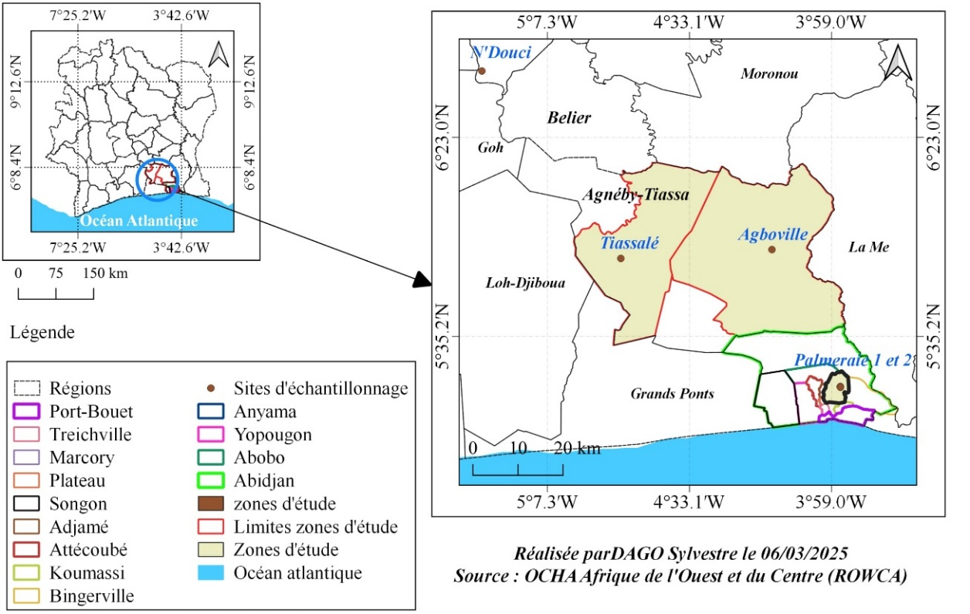

**Fig. 1. Location of study areas**

**2.2 Study materials**

The study involved samples of soil and plantain banana trunks from four major localities: Cocody palm grove, Agboville, Tiassalé and N'douci. Sample collection took place from March **2024 to February 2025**.

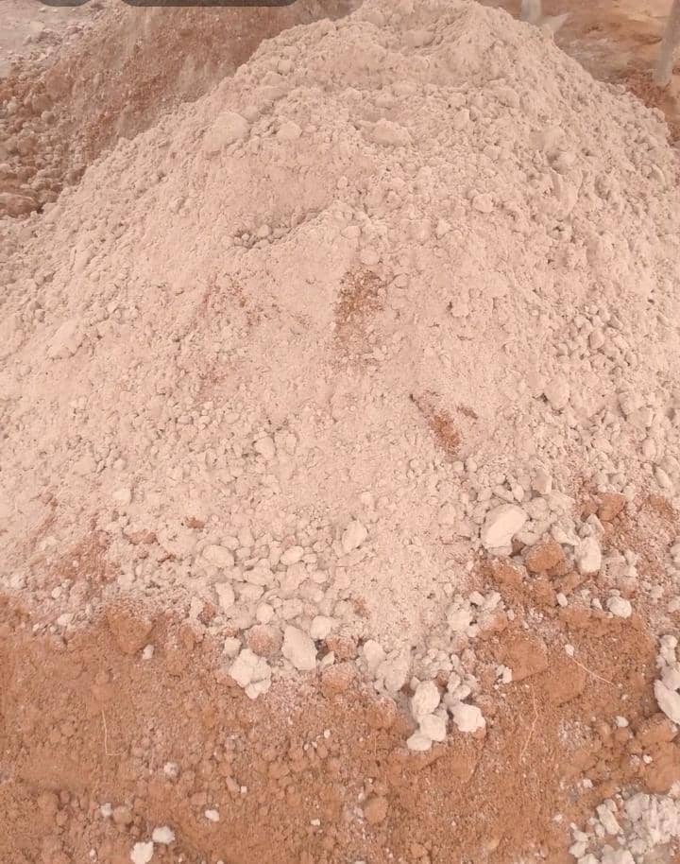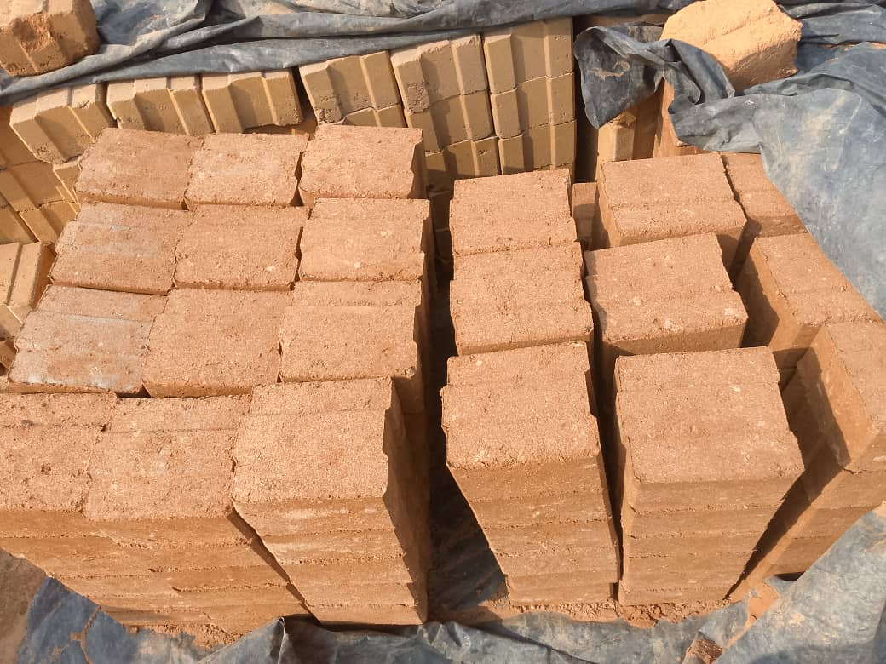

Fiber + Soil + Sand

**BTCS avec PTB**

Plantain banana trunk powder

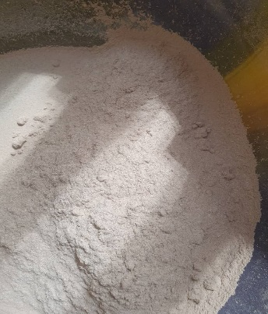

**Fig.2. Photographs of soil samples, banana trunk and BTCS**

**2.3 Technical equipment**

The technical equipment used for this study includes: The wheelbarrow plays a fundamental role in the efficient transport of soil, sand and other components to the construction site, facilitating logistics and continuity of operations, a precision scale and a cup to accurately measure the quantities of each additive, ensuring the reproducibility of the formulations. When preparing samples for the bearing capacity test, the CBR rammer allows compacting the materials according to strict standards, while the CBR press measures the penetration resistance, providing reliable data on the bearing capacity of the material. For the Proctor test, the mold and the Proctor rammer ensure compaction in successive layers, and the oven allows determining the optimal humidity and maximum dry density, essential conditions for optimizing the compactness and strength of the BTCS. The mixer is used to obtain a homogeneous mixture of soil, sand and additives, which is crucial for the cohesion and mechanical performance of the blocks, while the BTCS mold gives the standardized shape and dimensions to the blocks, ensuring their compatibility during construction. Other tools such as the ruler, the caliper, the thermometer and the hygrometer are also used to control the dimensions and the ambient conditions, thus contributing to the reliability of the tests and the final quality of the BTCS. All of these materials are essential to ensure the rigor of the tests, the reproducibility of the results and the optimization of the mechanical properties of the blocks in the field.

**2.4 Choice of sampling areas and sites**

The selection of sites for the construction of the BTCS (Stabilized Compressed Earth Bricks) as well as for the removal of soil and plantain trunks was carried out in four localities in Côte d'Ivoire: Cocody-Palmeraie, Agboville, Tiassalé and N'Douci. These localities were chosen because of their geographical specificities, the quality of their soils and their strong agricultural potential, particularly for the cultivation of plantain bananas. Cocody-Palmeraie, although in an urban environment, has agricultural areas favorable to this crop, while Agboville is distinguished by its fertile soils and favorable climate, making it an important production center. Tiassalé, characterized by hydromorphic soils and the presence of watercourses, benefits from ideal constant humidity, and N'Douci, with its rich soils and humid climate, is also a privileged area. This diversity of pedoclimatic conditions allows for the analysis of the influence of soil types and climates on the BTCS and the mechanical properties of plantain, thus ensuring the representativeness and transferability of the results to other regions. In addition, the good accessibility of these sites thanks to road infrastructure facilitates the transport of samples to the laboratories, which reinforces the feasibility and rigor of the study.

**2.5** **Sample collection**

For sampling, a single site was selected in each of the study areas, where specific plots were selected for sampling. At each site, four soil samples and four plantain trunk samples were randomly collected and then carefully packaged in new commercial bags, properly labeled to ensure their traceability. Three separate sampling campaigns were carried out over an eleven-month period, from March 2024 to February 2025, resulting in a total of 30 composite samples. All samples were then transported to the Cocody-Palmeraie site to undergo the various analyses and tests. This methodological approach ensures structured and representative data collection, which is essential for the reliability of the results obtained.

**2.6** **Processing process of plantain trunks collected from the study sites**

After collecting the plantain trunks from the study sites, rigorous processing was carried out to ensure the quality of subsequent analyses. The fibers were first extracted, carefully cleaned, and then cut into homogeneous fragments to facilitate the following steps. These samples were then placed in an oven at 105°C to remove any residual moisture, thus preventing any alteration that could affect the analytical results. Once dried, they were ground using a laboratory mill until a fine and homogeneous powder was obtained, essential to ensure the reproducibility of the analyses. The powder thus obtained was carefully packaged in airtight bags to preserve its physicochemical properties before being subjected to the various planned analyses.

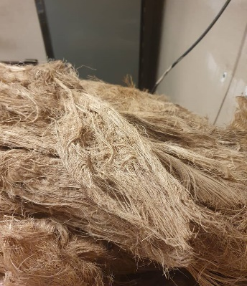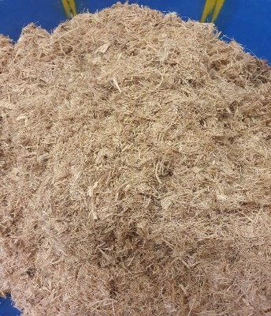

A

B1

C

B2



A

B1

C

B2

*A: Banana trunks, B 1 =B 2: Banana fiber, C: Plantain banana trunk powder*

**Fig.3. Processing process of plantain trunks**

**2.7 Mixing plan**



A

B1

C

B2



A

B1

C

B2

For the design and optimization of the mixes, **Design-Expert 3 software** was used, allowing the generation of a rigorous and efficient experimental plan. This software, recognized for its performance in optimizing formulations, made it possible to define **30 tests** for each mix, thus totaling **60 tests** in total plus **6** control tests. The two mixes studied are: **Mix 1** (banana trunk powder + sand + earth) and **Mix 2** (earth + sand + cement). This methodological approach, based on optimized experimental planning, makes it possible to evaluate the properties of composite materials and identify the optimal proportions to meet the specific requirements of the construction project.

|  |  |  |  |  |
| --- | --- | --- | --- | --- |
| Essay | Component 1 A:Clay+Sand % | Component 2 C:Water % | Component 1 A:Clay+Sand % | Component 2 C:Water % |
| 1 | 82.08 | 7.3872 | 100% | 9% |
| 1 | 8208 | 738.72 | 8208 | 738.72 |
| 2 | 82.08 | 8.208 | 100% | 10% |
| 2 | 8208 | 820.8 | 8208 | 820.8 |
| 3 | 82.08 | 9.0288 | 100% | 11% |
| 3 | 8208 | 902.88 | 8208 | 902.88 |
| 4 | 82.08 | 9.8496 | 100% | 12% |
| 4 | 8208 | 984.96 | 8208 | 984.96 |
| 5 | 82.08 | 10.6704 | 100% | 13% |
| 5 | 8208 | 1067.04 | 8208 | 1067.04 |
| 6 | 82.08 | 11.4912 | 100% | 14% |
| 6 | 8208 | 1149.12 | 8208 | 1149.12 |

Table 1. Mixing plan for the 100% soil control material

|  |  |  |  |  |  |  |  |  |  |  |  |  |  |
| --- | --- | --- | --- | --- | --- | --- | --- | --- | --- | --- | --- | --- | --- |
| Essay | Component 1 A:Clay+Sand % | Component 2 B: Cement % | Component 3 C:Water % | Component 1 A:Clay+Sand % | Component 2 B: Cement % | Component 3 C:Water % | Essay | Component 1 A:Clay+Sand % | Component 2 B: Cement % | Component 3 C:Water % | Component 1 A:Clay+Sand % | Component 2 B: Cement % | Component 3 C:Water % |
| 1 | 82.08 | 1.6416 | 7.3872 | 100% | 2% | 9% | 16 | 82.08 | 4.9248 | 9.8496 | 100% | 6% | 12% |
| 1 | 8208 | 164.16 | 738.72 | 8208 | 164.16 | 738.72 | 16 | 8208 | 492.48 | 984.96 | 8208 | 492.48 | 984.96 |
| 2 | 82.08 | 1.6416 | 8.208 | 100% | 2% | 10% | 17 | 82.08 | 4.9248 | 10.6704 | 100% | 6% | 13% |
| 2 | 8208 | 164.16 | 820.8 | 8208 | 164.16 | 820.8 | 17 | 8208 | 492.48 | 1067.04 | 8208 | 492.48 | 1067.04 |
| 3 | 82.08 | 1.6416 | 9.0288 | 100% | 2% | 11% | 18 | 82.08 | 4.9248 | 11.4912 | 100% | 6% | 14% |
| 3 | 8208 | 164.16 | 902.88 | 8208 | 164.16 | 902.88 | 18 | 8208 | 492.48 | 1149.12 | 8208 | 492.48 | 1149.12 |
| 4 | 82.08 | 1.6416 | 9.8496 | 100% | 2% | 12% | 19 | 82.08 | 6.5664 | 7.3872 | 100% | 8% | 9% |
| 4 | 8208 | 164.16 | 984.96 | 8208 | 164.16 | 984.96 | 19 | 8208 | 656.64 | 738.72 | 8208 | 656.64 | 738.72 |
| 5 | 82.08 | 1.6416 | 10.6704 | 100% | 2% | 13% | 20 | 82.08 | 6.5664 | 8.208 | 100% | 8% | 10% |
| 5 | 8208 | 164.16 | 1067.04 | 8208 | 164.16 | 1067.04 | 20 | 8208 | 656.64 | 820.8 | 8208 | 656.64 | 820.8 |
| 6 | 82.08 | 1.6416 | 11.4912 | 100% | 2% | 14% | 21 | 82.08 | 6.5664 | 9.0288 | 100% | 8% | 11% |
| 6 | 8208 | 164.16 | 1149.12 | 8208 | 164.16 | 1149.12 | 21 | 8208 | 656.64 | 902.88 | 8208 | 656.64 | 902.88 |
| 7 | 82.08 | 3.2832 | 7.3872 | 100% | 4% | 9% | 22 | 82.08 | 6.5664 | 9.8496 | 100% | 8% | 12% |
| 7 | 8208 | 328.32 | 738.72 | 8208 | 328.32 | 738.72 | 22 | 8208 | 656.64 | 984.96 | 8208 | 656.64 | 984.96 |
| 8 | 82.08 | 3.2832 | 8.208 | 100% | 4% | 10% | 23 | 82.08 | 6.5664 | 10.6704 | 100% | 8% | 13% |
| 8 | 8208 | 328.32 | 820.8 | 8208 | 328.32 | 820.8 | 23 | 8208 | 656.64 | 1067.04 | 8208 | 656.64 | 1067.04 |
| 9 | 82.08 | 3.2832 | 9.0288 | 100% | 4% | 11% | 24 | 82.08 | 6.5664 | 11.4912 | 100% | 8% | 14% |
| 9 | 8208 | 328.32 | 902.88 | 8208 | 328.32 | 902.88 | 24 | 8208 | 656.64 | 1149.12 | 8208 | 656.64 | 1149.12 |
| 10 | 82.08 | 3.2832 | 9.8496 | 100% | 4% | 12% | 25 | 82.08 | 8.208 | 7.3872 | 100% | 10% | 9% |
| 10 | 8208 | 328.32 | 984.96 | 8208 | 328.32 | 984.96 | 25 | 8208 | 820.8 | 738.72 | 8208 | 820.8 | 738.72 |
| 11 | 82.08 | 3.2832 | 10.6704 | 100% | 4% | 13% | 26 | 82.08 | 8.208 | 8.208 | 100% | 10% | 10% |
| 11 | 8208 | 328.32 | 1067.04 | 8208 | 328.32 | 1067.04 | 26 | 8208 | 820.8 | 820.8 | 8208 | 820.8 | 820.8 |
| 12 | 82.08 | 3.2832 | 11.4912 | 100% | 4% | 14% | 27 | 82.08 | 8.208 | 9.0288 | 100% | 10% | 11% |
| 12 | 8208 | 328.32 | 1149.12 | 8208 | 328.32 | 1149.12 | 27 | 8208 | 820.8 | 902.88 | 8208 | 820.8 | 902.88 |
| 13 | 82.08 | 4.9248 | 7.3872 | 100% | 6% | 9% | 28 | 82.08 | 8.208 | 9.8496 | 100% | 10% | 12% |
| 13 | 8208 | 492.48 | 738.72 | 8208 | 492.48 | 738.72 | 28 | 8208 | 820.8 | 984.96 | 8208 | 820.8 | 984.96 |
| 14 | 82.08 | 4.9248 | 8.208 | 100% | 6% | 10% | 29 | 82.08 | 8.208 | 10.6704 | 100% | 10% | 13% |
| 14 | 8208 | 492.48 | 820.8 | 8208 | 492.48 | 820.8 | 29 | 8208 | 820.8 | 1067.04 | 8208 | 820.8 | 1067.04 |
| 15 | 82.08 | 4.9248 | 9.0288 | 100% | 6% | 11% | 30 | 82.08 | 8,208 | 11.4912 | 100% | 10% | 14% |
| 15 | 8208 | 492.48 | 902.88 | 8208 | 492.48 | 8208 | 30 | 8208 | 820.8 | 1149.12 | 8208 | 820.8 | 1149.12 |

**Table 2. Mixing plan for material with cement**

|  |  |  |  |  |  |  |  |  |  |  |  |  |  |
| --- | --- | --- | --- | --- | --- | --- | --- | --- | --- | --- | --- | --- | --- |
| Essay | Component 1 A:Clay+Sand % | Component 2 B: Banana trunk powder% | Component 3 C:Water % | Component 1 A:Clay+Sand % | Component 2 B: Banana trunk powder% | Component 3 C:Water % | Essay | Component 1 A:Clay+Sand % | Component 2 B: Banana trunk powder% | Component 3 C:Water % | Component 1 A:Clay+Sand % | Component 2 B: Banana trunk powder% | Component 3 C:Water % |
| 1 | 82.08 | 1.6416 | 7.3872 | 100% | 2% | 9% | 16 | 82.08 | 4.9248 | 9.8496 | 100% | 6% | 12% |
| 1 | 8208 | 164.16 | 738.72 | 8208 | 164.16 | 738.72 | 16 | 8208 | 492.48 | 984.96 | 8208 | 492.48 | 984.96 |
| 2 | 82.08 | 1.6416 | 8.208 | 100% | 2% | 10% | 17 | 82.08 | 4.9248 | 10.6704 | 100% | 6% | 13% |
| 2 | 8208 | 164.16 | 820.8 | 8208 | 164.16 | 820.8 | 17 | 8208 | 492.48 | 1067.04 | 8208 | 492.48 | 1067.04 |
| 3 | 82.08 | 1.6416 | 9.0288 | 100% | 2% | 11% | 18 | 82.08 | 4.9248 | 11.4912 | 100% | 6% | 14% |
| 3 | 8208 | 164.16 | 902.88 | 8208 | 164.16 | 902.88 | 18 | 8208 | 492.48 | 1149.12 | 8208 | 492.48 | 1149.12 |
| 4 | 82.08 | 1.6416 | 9.8496 | 100% | 2% | 12% | 19 | 82.08 | 6.5664 | 7.3872 | 100% | 8% | 9% |
| 4 | 8208 | 164.16 | 984.96 | 8208 | 164.16 | 984.96 | 19 | 8208 | 656.64 | 738.72 | 8208 | 656.64 | 738.72 |
| 5 | 82.08 | 1.6416 | 10.6704 | 100% | 2% | 13% | 20 | 82.08 | 6.5664 | 8.208 | 100% | 8% | 10% |
| 5 | 8208 | 164.16 | 1067.04 | 8208 | 164.16 | 1067.04 | 20 | 8208 | 656.64 | 820.8 | 8208 | 656.64 | 820.8 |
| 6 | 82.08 | 1.6416 | 11.4912 | 100% | 2% | 14% | 21 | 82.08 | 6.5664 | 9.0288 | 100% | 8% | 11% |
| 6 | 8208 | 164.16 | 1149.12 | 8208 | 164.16 | 1149.12 | 21 | 8208 | 656.64 | 902.88 | 8208 | 656.64 | 902.88 |
| 7 | 82.08 | 3.2832 | 7.3872 | 100% | 4% | 9% | 22 | 82.08 | 6.5664 | 9.8496 | 100% | 8% | 12% |
| 7 | 8208 | 328.32 | 738.72 | 8208 | 328.32 | 738.72 | 22 | 8208 | 656.64 | 984.96 | 8208 | 656.64 | 984.96 |
| 8 | 82.08 | 3.2832 | 8.208 | 100% | 4% | 10% | 23 | 82.08 | 6.5664 | 10.6704 | 100% | 8% | 13% |
| 8 | 8208 | 328.32 | 820.8 | 8208 | 328.32 | 820.8 | 23 | 8208 | 656.64 | 1067.04 | 8208 | 656.64 | 1067.04 |
| 9 | 82.08 | 3.2832 | 9.0288 | 100% | 4% | 11% | 24 | 82.08 | 6.5664 | 11.4912 | 100% | 8% | 14% |
| 9 | 8208 | 328.32 | 902.88 | 8208 | 328.32 | 902.88 | 24 | 8208 | 656.64 | 1149.12 | 8208 | 656.64 | 1149.12 |
| 10 | 82.08 | 3.2832 | 9.8496 | 100% | 4% | 12% | 25 | 82.08 | 8.208 | 7.3872 | 100% | 10% | 9% |
| 10 | 8208 | 328.32 | 984.96 | 8208 | 328.32 | 984.96 | 25 | 8208 | 820.8 | 738.72 | 8208 | 820.8 | 738.72 |
| 11 | 82.08 | 3.2832 | 10.6704 | 100% | 4% | 13% | 26 | 82.08 | 8.208 | 8.208 | 100% | 10% | 10% |
| 11 | 8208 | 328.32 | 1067.04 | 8208 | 328.32 | 1067.04 | 26 | 8208 | 820.8 | 820.8 | 8208 | 820.8 | 820.8 |
| 12 | 82.08 | 3.2832 | 11.4912 | 100% | 4% | 14% | 27 | 82.08 | 8.208 | 9.0288 | 100% | 10% | 11% |
| 12 | 8208 | 328.32 | 1149.12 | 8208 | 328.32 | 1149.12 | 27 | 8208 | 820.8 | 902.88 | 8208 | 820.8 | 902.88 |
| 13 | 82.08 | 4.9248 | 7.3872 | 100% | 6% | 9% | 28 | 82.08 | 8.208 | 9.8496 | 100% | 10% | 12% |
| 13 | 8208 | 492.48 | 738.72 | 8208 | 492.48 | 738.72 | 28 | 8208 | 820.8 | 984.96 | 8208 | 820.8 | 984.96 |
| 14 | 82.08 | 4.9248 | 8.208 | 100% | 6% | 10% | 29 | 82.08 | 8.208 | 10.6704 | 100% | 10% | 13% |
| 14 | 8208 | 492.48 | 820.8 | 8208 | 492.48 | 820.8 | 29 | 8208 | 820.8 | 1067.04 | 8208 | 820.8 | 1067.04 |
| 15 | 82.08 | 4.9248 | 9.0288 | 100% | 6% | 11% | 30 | 82.08 | 8,208 | 11.4912 | 100% | 10% | 14% |
| 15 | 8208 | 492.48 | 902.88 | 8208 | 492.48 | 8208 | 30 | 8208 | 820.8 | 1149.12 | 8208 | 820.8 | 1149.12 |

**Table 3. Mixing plan for material with banana trunk powder**

**2.8 Methods for determining formulations**

The determination of the formulations is based on the precise preparation of an 8208 g material, carefully weighed, homogenized and then molded into specific shapes to ensure uniform distribution and standardized dimensions. The samples thus obtained are conditioned and protected on site, then exposed to natural ambient temperature and humidity conditions for a defined period of 28 days, which makes it possible to reproduce the hardening process and evolution of mechanical properties in a real environment. At the end of each exposure period, bending and compression tests are carried out to evaluate the mechanical strength of the samples, providing essential data on their capacity to withstand bending loads as well as their compressive strength, i.e. their ability to resist crushing. This methodical and rigorous approach guarantees a reliable and accurate characterization of the mechanical properties of the material.

3. results and discussion

This research examines the mechanical characteristics of stabilized compressed earth blocks (SCEB) made from soil and banana trunks subjected to different treatments, highlighting the significant influence of composition parameters on the strength and durability of the materials. The results show that the addition of fibers or components from the banana tree leads to significant variations in mechanical properties, particularly in terms of compressive and flexural strength, as well as improved durability against environmental aggressions and humidity cycles. These observations highlight the importance of the choice of treatments and dosages to optimize the performance of SCEBs, thus opening up promising prospects for the development of ecological, high-performance building materials adapted to local needs

**3.1 Results**

**3.1.1 Witness formulations at 28 days in the field**

The results in Table 4 show that, for the unstabilized control subjected to water additions of 9% to 14%, the flexural strength values vary from 0.63±0.11 to 1.06±0.09 MPa and those in compression from 3.02±0.15 to 3.66±0.72 MPa, with optimal performances observed at 13% water, i.e. 0.91±0.05 MPa in flexure and 3.49±0.31 MPa in compression.

**Table 4. Witness results**

|  |  |  |  |  |  |  |  |  |  |  |  |  |  |  |
| --- | --- | --- | --- | --- | --- | --- | --- | --- | --- | --- | --- | --- | --- | --- |
| Essay  Witness | Component 1 A:Clay+Sand % | Component 3 B: Water % | Total Mass (g) | BENDING RESULT | | |  | COMPRESSION RESULT | | | | | |  |
|  |  |  |  | R1 | R2 | R3 | **MOY** | R1 | R2 | R3 | R4 | R5 | R6 | **MOY** |
| 1 | 100% | 9% |  | 0.5 | 0.7 | 0.69 | **0.63**±**0.11** | 2.8 | 2.9 | 3.1 | 3 | 3.21 | 3.11 | **3.02**±**0.15** |
| 1 | 8208 | 738.72 | 8946.72 | 0.5 | 0.7 | 0.69 | **0.63**±**0.11** | 2.8 | 2.9 | 3.1 | 3 | 3.21 | 3.11 | **3.02**±**0.15** |
| 2 | 100% | 10% |  | 0.67 | 0.7 | 0.63 | **0.67**±**0.04** | 3.1 | 3.21 | 3.2 | 3.21 | 3.4 | 3.35 | **3.25**±**0.11** |
| 2 | 8208 | 820.8 | 9028.8 | 0.67 | 0.7 | 0.63 | **0.67**±**0.04** | 3.1 | 3.21 | 3.2 | 3.21 | 3.4 | 3.35 | **3.25**±**0.11** |
| 3 | 100% | 11% |  | 0.84 | 0.7 | 0.6 | **0.71**±**0.12** | 3.1 | 3.3 | 3.48 | 3.6 | 3.5 | 3.54 | **3.42**±**0.19** |
| 3 | 8208 | 902.88 | 9110.88 | 0.84 | 0.7 | 0.6 | **0.71**±**0.12** | 3.1 | 3.3 | 3.48 | 3.6 | 3.5 | 3.54 | **3.42**±**0.19** |
| 4 | 100% | 12% |  | 0.8 | 0.9 | 0.82 | **0.84**±**0.05** | 3.3 | 3.51 | 3.69 | 3.5 | 3.1 | 3.3 | **3.40**±**0.21** |
| 4 | 8208 | 984.96 | 9192.96 | 0.8 | 0.9 | 0.82 | **0.47**±**0.05** | 3.3 | 3.51 | 3.69 | 3.5 | 3.1 | 3.3 | **3.40**±**0.21** |
| 5 | 100% | 13% |  | 0.9 | 0.87 | 0.97 | **0.91**±**0.05** | 3.5 | 3.4 | 3.5 | 3.13 | 4.05 | 3.35 | **3.49**±**0.31** |
| 5 | 8208 | 1067.04 | 9275.04 | 0.9 | 0.87 | 0.97 | **0.91**±**0.05** | 3.5 | 3.4 | 3.5 | 3.13 | 4.05 | 3.35 | **3.49**±**0.31** |
| 6 | 100% | 14% |  | 1 | 1.02 | 1.16 | **1.06**±**0.09** | 3.5 | 3.4 | 3 | 3.03 | 4.85 | 4.15 | **3.66** ±**0.72** |
| 6 | 8208 | 1149.12 | 9357.12 | 1 | 1.02 | 1.16 | **1.06** ±**0.09** | 3.5 | 3.4 | 3 | 3.03 | 4.85 | 4.15 | **3.66** ±**0.72** |

**3.1.2 28-day treatment formulations with added banana powder fiber**

The analysis of mixtures composed of earth, sand and banana tree trunk powder (BTP) highlights significant variations in mechanical performance depending on the proportion of additive incorporated. At 2% BTP, test No. 5 stands out for the best performance, reaching 2±0.04 MPa in bending and 9.54±0.30 MPa in compression. On the other hand, an increase in the BTP content to 10% (test No. 25) leads to a marked drop in strength, with values of 0.38±0.01 MPa in bending and 1.06±0.04 MPa in compression, reflecting a structural degradation of the material at high additive concentration. These results highlight the importance of an optimal dosage of banana tree trunk powder to preserve the mechanical properties of earth-sand-BTP mixtures.

**Fig.4. Compression values of powder percentages**

**Fig.5. Flexural values of powder percentages**

|  |  |  |  |  |  |  |  |  |  |  |  |  |  |  |  |
| --- | --- | --- | --- | --- | --- | --- | --- | --- | --- | --- | --- | --- | --- | --- | --- |
| Essay | Component 1 A:Clay+Sand % | Component 2 B: Banana trunk powder % | Component 3 C:Water % | Total Mass (g) | BENDING RESULT | | |  | COMPRESSION RESULT | | | | | |  |
|  |  |  |  |  | R1 | R2 | R3 | **AVG** | R1 | R2 | R3 | R4 | R5 | R6 | **AVG** |
| 1 | 100% | 2% | 9% |  | 1.77 | 1.86 | 1.95 | **1.86**±**0.09** | 8.4 | 8.65 | 8.5 | 8.73 | 9 | 8.85 | **8.69**±**0.22** |
| 1 | 8208 | 164.16 | 738.72 | 9110.9 | 1.77 | 1.86 | 1.95 | **1.86**±**0.09** | 8.4 | 8.65 | 8.5 | 8.73 | 9 | 8.85 | **8.69**±**0.22** |
| 2 | 100% | 2% | 10% |  | 1.78 | 1.88 | 1.98 | **1.88**±**0.10** | 8.44 | 8.9 | 8.7 | 9.3 | 9 | 8.93 | **8.88**±**0.29** |
| 2 | 8208 | 164.16 | 820.8 | 9193 | 1.78 | 1.88 | 1.98 | **1.88**±**0.10** | 8.44 | 8.9 | 8.7 | 9.3 | 9 | 8.93 | **8.88**±**0.29** |
| 3 | 100% | 2% | 11% |  | 1.87 | 1.9 | 1.93 | **1.90**±**0.03** | 9.4 | 8.6 | 9 | 9.4 | 9.2 | 9.45 | **9.18**±**0.33** |
| 3 | 8208 | 164.16 | 902.88 | 9275 | 1.87 | 1.9 | 1.93 | **1.90**±**0.03** | 9.4 | 8.6 | 9 | 9.4 | 9.2 | 9.45 | **9.18**±**0.33** |
| 4 | 100% | 2% | 12% |  | 1.8 | 1.93 | 2.05 | **1.93**±**0.13** | 9.1 | 9.25 | 9.17 | 9.35 | 9.75 | 9.56 | **9.36**±**0.25** |
| 4 | 8208 | 164.16 | 984.96 | 9357.1 | 1.8 | 1.93 | 2.05 | **1.93**±**0.13** | 9.1 | 9.25 | 9.17 | 9.35 | 9.75 | 9.56 | **9.36**±**0.25** |
| 5 | 100% | 2% | 13% |  | 2 | 1.96 | 2.04 | **2.00**±**0.04** | 9.5 | 9.33 | 9.44 | 10.07 | 9.22 | 9.66 | **9.54**±**0.30** |
| 5 | 8208 | 164.16 | 1067 | 9439.2 | 2 | 1.96 | 2.04 | **2.00**±**0.04** | 9.5 | 9.33 | 9.44 | 10.07 | 9.22 | 9.66 | **9.54**±**0.30** |
| 6 | 100% | 2% | 14% |  | 2.06 | 2.11 | 2.16 | **2.11**±**0.05** | 11 | 8.8 | 8.5 | 10.2 | 10.3 | 10.9 | **9.94**±**1.06** |
| 6 | 8208 | 164.16 | 1149.1 | 9521.3 | 2.06 | 2.11 | 2.16 | **2.11**±**0.05** | 11 | 8.8 | 8.5 | 1.,2 | 10.3 | 10.9 | **9.94**±**1.06** |
| 7 | 100% | 4% | 9% |  | 2.1 | 2.2 | 2.3 | **2.20**±**0.10** | 5.9 | 6.05 | 6.15 | 6.21 | 6.35 | 6.58 | **6.21**±**0.24** |
| 7 | 8208 | 328.32 | 738.72 | 9275 | 2.1 | 2.2 | 2.3 | **2.20**±**0.10** | 5.9 | 6.05 | 6.15 | 6.21 | 6.35 | 6.58 | **6.21**±**0.24** |
| 8 | 100% | 4% | 10% |  | 2.08 | 2.31 | 2.44 | **2.28**±**0.18** | 6 | 6.21 | 6.35 | 6.43 | 6.59 | 6.99 | **6.43**±**0.34** |
| 8 | 8208 | 328.32 | 820.8 | 9357.1 | 2.08 | 2.31 | 2.44 | **2.28**±**0.18** | 6 | 6.21 | 6.35 | 6.43 | 6.59 | 6.99 | **6.43**±**0.34** |
| 9 | 100% | 4% | 11% |  | 2.08 | 2.31 | 2.54 | **2.31**±**0.23** | 6.4 | 6.58 | 6.69 | 6.3 | 6.85 | 7.02 | **6.64**±**0.27** |
| 9 | 8208 | 328.32 | 902.88 | 9439.2 | 2.08 | 2.31 | 2.54 | **2.31**±**0.23** | 6.4 | 6.58 | 6.69 | 6.3 | 6.85 | 7.02 | **6.64**±**0.27** |
| 10 | 100% | 4% | 12% |  | 2.17 | 2.36 | 2.55 | **2.36**±**0.19** | 6.5 | 6.65 | 6.8 | 6.99 | 7.16 | 6.82 | **6.82**±**0.24** |
| 10 | 8208 | 328.32 | 984.96 | 9521.3 | 2.17 | 2.36 | 2.55 | **2.36**±**0.19** | 6.5 | 6.65 | 6.8 | 6.99 | 7.16 | 6.82 | **6.82**±**0.24** |
| 11 | 100% | 4% | 13% |  | 2.22 | 2.45 | 2.68 | **2.45**±**0.23** | 6.87 | 6.82 | 7.4 | 7.35 | 6.95 | 7.6 | **7.17**±**0.33** |
| 11 | 8208 | 328.32 | 1067 | 9603.4 | 2.22 | 2.45 | 2.68 | **2.45**±**0.23** | 6.87 | 6.82 | 7.4 | 7.35 | 6.95 | 7.6 | **7.17**±**0.33** |
| 12 | 100% | 4% | 14% |  | 2.27 | 2.57 | 2.87 | **2.57**±**0.30** | 7.61 | 7.15 | 8.57 | 8.48 | 7.19 | 6.77 | **7.63**±**0.74** |
| 12 | 8208 | 328.32 | 1149.1 | 9685.4 | 2.27 | 2.57 | 2.87 | **2.57**±**0.30** | 7.61 | 7.15 | 8.57 | 8.48 | 7.19 | 6.77 | **7.63**±**0.74** |
| 13 | 100% | 6% | 9% |  | 0.85 | 0.88 | 0.91 | **0.88**±**0.03** | 4.4 | 4.55 | 4.75 | 4.65 | 4.85 | 5.1 | **4.72**±**0.24** |
| 13 | 8208 | 492.48 | 738.72 | 9439.2 | 0.85 | 0.88 | 0.91 | **0.88**±**0.03** | 4.4 | 4.55 | 4.75 | 4.65 | 4.85 | 5.1 | **4.72**±**0.24** |
| 14 | 100% | 6% | 10% |  | 0.86 | 0.91 | 0.96 | **0.91**±**0.05** | 4.5 | 4.7 | 4.85 | 4.95 | 5.35 | 5.1 | **4.91**±**0.30** |
| 14 | 8208 | 492.48 | 820.8 | 9521.3 | 0.86 | 0.91 | 0.96 | **0.91**±**0.05** | 4.5 | 4.7 | 4.85 | 4.95 | 5.35 | 5.1 | **4.91**±**0.30** |
| 15 | 100% | 6% | 11% |  | 0.93 | 0.96 | 0.99 | **0.96**±**0.03** | 4.8 | 5 | 5.2 | 5.3 | 5.1 | 5.4 | **5.13**±**0.22** |
| 15 | 8208 | 492.48 | 902.88 | 9603.4 | 0.93 | 0.96 | 0.99 | **0.96**±**0.03** | 4.8 | 5 | 5.2 | 5.3 | 5.1 | 5.4 | **5.13** ±**0.22** |
| 16 | 100% | 6% | 12% |  | 0.95 | 0.99 | 1.03 | **0.99**±**0.04** | 5.1 | 5.21 | 5.24 | 5.28 | 5.52 | 5.35 | **5.28**±**0.14** |
| 16 | 8208 | 492.48 | 984.96 | 9685.4 | 0.95 | 0.99 | 1.03 | **0.99**±**0.04** | 51 | 5.21 | 5.24 | 5.28 | 5.52 | 5.35 | **5.28**±**0.14** |
| 17 | 100% | 6% | 13% |  | 0.94 | 1.03 | 1.12 | **1.03**±**0.09** | 5 | 5.2 | 5.36 | 5.44 | 5.6 | 5.85 | **5.41**±**0.30** |
| 17 | 8208 | 492.48 | 1067 | 9767..5 | 0.94 | 1.03 | 1.12 | **1.03**±**0.09** | 5 | 5.2 | 5.36 | 5.44 | 5,6 | 5.85 | **5.41**±**0.30** |
| 18 | 100% | 6% | 14% |  | 1.02 | 1.08 | 1.14 | **1.08**±**0.06** | 5.49 | 5.31 | 5.6 | 5.82 | 5.68 | 5.9 | **5.63**±**0.22** |
| 18 | 8208 | 492.48 | 1149.1 | 9849.6 | 1.02 | 1.08 | 1.14 | **1.08**±**0.06** | 5.49 | 5.31 | 5.6 | 5.82 | 5.68 | 5.9 | **5.63**±**0.22** |
| 19 | 100% | 8% | 9% |  | 0.57 | 0.59 | 0.61 | **0.59**±**0.02** | 2.8 | 2.9 | 2.85 | 2.95 | 3 | 3.15 | **2.94**±**0.12** |
| 19 | 8208 | 656.64 | 738.72 | 9603.4 | 0.57 | 0.59 | 0.61 | **0.59**±**0.02** | 2.8 | 2.9 | 2.85 | 2.95 | 3 | 3.15 | **2.94**±**0.12** |
| 20 | 100% | 8% | 10% |  | 0.57 | 0.61 | 0.65 | **0.61**±**0.04** | 2.9 | 3 | 2.95 | 3.02 | 3.15 | 3.05 | **3.01**±**0.09** |
| 20 | 8208 | 656.64 | 820.8 | 9685.4 | 0.57 | 0.61 | 0.65 | **0.61**±**0.04** | 2.9 | 3 | 2.95 | 3.02 | 3.15 | 3.05 | **3.01**±**0.09** |
| 21 | 100% | 8% | 11% |  | 0.61 | 0.64 | 0.67 | **0.64**±**0.03** | 2.8 | 3 | 3.1 | 3.2 | 3.3 | 3.6 | **3.17**±**0.27** |
| 21 | 8208 | 656.64 | 902.88 | 9767.5 | 0.61 | 0.64 | 0.67 | **0.64**±**0.03** | 2.8 | 3 | 3.1 | 3.2 | 3.3 | 3.6 | **3.17**±**0.27** |
| 22 | 100% | 8% | 12% |  | 0.67 | 0.69 | 0.71 | **0.69**±**0.02** | 3.1 | 3.25 | 3.3 | 3.3 | 3.45 | 3.6 | **3.33**±**0.17** |
| 22 | 8208 | 656.64 | 984.96 | 9849.6 | 0.67 | 0.69 | 0.71 | **0.69**±**0.02** | 3.1 | 3.25 | 3.3 | 3.3 | 3.45 | 3.6 | **3.33**±**0.17** |
| 23 | 100% | 8% | 13% |  | 0.7 | 0.74 | 0.78 | **0.74**±**0.04** | 3.3 | 3.3 | 3.4 | 3.55 | 3.4 | 3.8 | **3.46**±**0.19** |
| 23 | 8208 | 656.64 | 1067 | 9931.7 | 0.7 | 0.74 | 0.78 | **0.74**±**0.04** | 3.3 | 3.3 | 3.4 | 3.55 | 3.4 | 3.8 | **3.46**±**0.19** |
| 24 | 100% | 8% | 14% |  | 0.72 | 0.77 | 0.82 | **0.77**±**0.05** | 3.2 | 3.35 | 3.45 | 3.55 | 3.65 | 3.85 | **3.51**±**0.23** |
| 24 | 8208 | 656.64 | 1149.1 | 10014 | 0.72 | 0.77 | 0.82 | **0.77**±**0.05** | 3.2 | 3.35 | 3.45 | 3.55 | 3.65 | 3.85 | **3.51**±**0.23** |
| 25 | 100% | 10% | 9% |  | 0.37 | 0.38 | 0.39 | **0.38**±**0.01** | 1.02 | 1.1 | 1.05 | 1.08 | 1.01 | 1.1 | **1.06**±**0.04** |
| 25 | 8208 | 820.8 | 738.72 | 9767.5 | 0.37 | 0.38 | 0.39 | **0.38**±**0.01** | 1.02 | 1.1 | 1.05 | 1.08 | 1.01 | 1.1 | **1.06**±**0.04** |
| 26 | 100% | 10% | 10% |  | 0.43 | 0.45 | 0.47 | **0.45**±**0.02** | 1.15 | 1.2 | 1.17 | 1.21 | 1.18 | 1.24 | **1.19**±**0.03** |
| 26 | 8208 | 820.8 | 820.8 | 9849.6 | 0.43 | 0.45 | 0.47 | **0.45**±**0.02** | 1.15 | 1.2 | 1.17 | 1.21 | 1.18 | 1.24 | **1.19**±**0.03** |
| 27 | 100% | 10% | 11% |  | 0.46 | 0.49 | 0.52 | **0.49**±**0.03** | 1.3 | 1.32 | 1.36 | 1.35 | 1.38 | 1.45 | **1.36**±**0.05** |
| 27 | 8208 | 820.8 | 902.88 | 9931.7 | 0.46 | 0.49 | 0.52 | **0.49**±**0.03** | 1.3 | 1.32 | 1.36 | 1.35 | 1.38 | 1.45 | **1.36**±**0.05** |
| 28 | 100% | 10% | 12% |  | 0.49 | 0.51 | 0.53 | **0.51**±**0.02** | 1.33 | 1.45 | 1.55 | 1.5 | 1.7 | 1.62 | **1.53**±**0.13** |
| 28 | 8208 | 820.8 | 984.96 | 10014 | 0.49 | 0.51 | 0.53 | **0.51**±**0.02** | 1.33 | 1.45 | 1.55 | 1.5 | 1.7 | 1.62 | **1.53**±**0.13** |
| 29 | 100% | 10% | 13% |  | 0.5 | 0.54 | 0.58 | **0.54**±**0.04** | 1.4 | 1.55 | 1.65 | 1.7 | 1.75 | 1.95 | **1.67**±**0.19** |
| 29 | 8208 | 820.8 | 1067 | 10096 | 0.5 | 0.54 | 0.58 | **0.54**±**0.04** | 1.4 | 1.55 | 1.65 | 1.7 | 1.75 | 1.95 | **1.67**±**0.19** |
| 30 | 100% | 10% | 14% |  | 0.52 | 0.57 | 0.62 | **0.57**±**0.05** | 1.6 | 1.7 | 1.75 | 1.85 | 2 | 1.9 | **1.80** ± **0.14** |
| 30 | 8208 | 820.8 | 1149.1 | 10178 | 0.52 | 0.57 | 0.62 | **0.57**± **0.05** | 1.6 | 1.7 | 1.75 | 1.85 | 2 | 1.9 | **1.80** ± **0.14** |

**Table 5. Results of the mixing plan with banana trunk powder**

**3.1.3 formulations with added cement**

The evaluation of the earth, sand and cement mixtures highlights a linear progression of mechanical performances as a function of the cement content. At 2% cement (test No. 1), the strengths reach 1.35±0.09 MPa in bending and 7.06±0.33 MPa in compression, while at 10% (test No. 30), they rise to 6.59±0.19 MPa and 21.43±0.28 MPa respectively. This regular increase confirms the effectiveness of cement as a binder, particularly at high concentrations, to significantly improve the flexural and compressive strength of earth-sand mixtures, which corroborates its decisive role in the optimization of stabilized construction materials.

**Fig.6. Compressive values of cement percentages**

**Fig.7. Flexural values of cement percentages**

**Table 6. Results of the mixing plan with cement**

|  |  |  |  |  |  |  |  |  |  |  |  |  |  |  |  |
| --- | --- | --- | --- | --- | --- | --- | --- | --- | --- | --- | --- | --- | --- | --- | --- |
| Essay | Component 1 A:Clay+Sand % | Component 2 B: Cement % | Component 3 C:Water % | Total Mass (g) | FLEXION RESULTS | | | , | COMPRESSION RESULT | | | | | |  |
|  |  |  |  |  | R1 | R2 | R3 | **MOY** | R1 | R2 | R3 | R4 | R5 | R6 | **MOY** |
| 1 | 100% | 2% | 9% |  | 1.26 | 1.35 | 1.44 | **1.35**±**0.09** | 7 | 7.46 | 7.35 | 6.8 | 7.15 | 6.6 | **7.06**±**0.33** |
| 1 | 8208 | 164.16 | 738.72 | 9110.88 | 1.26 | 1.35 | 1.44 | **1.35**±**0.09** | 7 | 7.46 | 7.35 | 6.8 | 7.15 | 6.6 | **7.06**±**0.33** |
| 2 | 100% | 2% | 10% |  | 1.35 | 1.39 | 1.43 | **1.39**±**0.04** | 7.52 | 7.85 | 6.8 | 7.28 | 7.45 | 6.98 | **7.31**±**0.38** |
| 2 | 8208 | 164.16 | 820.8 | 9192.96 | 1.35 | 1.39 | 1.43 | **1.39**±**0.04** | 7.52 | 7.85 | 6.8 | 7.28 | 7.45 | 6.98 | **7.31**±**0.38** |
| 3 | 100% | 2% | 11% |  | 1.45 | 1.48 | 1.51 | **1.48**±**0.03** | 7.3 | 7.6 | 7.85 | 7.95 | 8.1 | 7.65 | **7.74**±**0.29** |
| 3 | 8208 | 164.16 | 902.88 | 9275.04 | 1.45 | 1.48 | 1.51 | **1.48**±**0.03** | 7.3 | 7.6 | 7.85 | 7.95 | 8.1 | 7.65 | **7.74**±**0.29** |
| 4 | 100% | 2% | 12% |  | 1.55 | 1.64 | 1.73 | **1.64**±**0.09** | 8.02 | 8.3 | 9.01 | 8.15 | 8.35 | 8.2 | **8.34**±**0.35** |
| 4 | 8208 | 164.16 | 984.96 | 9357.12 | 1.55 | 1.64 | 1.73 | **1.64**±**0.09** | 8.02 | 8.3 | 9.01 | 8.15 | 8.35 | 8.2 | **8.34**±**0.35** |
| 5 | 100% | 2% | 13% |  | 1.72 | 1.76 | 1.8 | **1.76**±**0.04** | 8.75 | 9.2 | 8.8 | 8.15 | 8.55 | 8.6 | **8.68**±**0.34** |
| 5 | 8208 | 164.16 | 1067.04 | 9439.2 | 1.72 | 1.76 | 1.8 | **1.76**±**0.04** | 8.75 | 9.2 | 8.8 | 8.15 | 8.55 | 8.6 | **8.68**±**0.34** |
| 6 | 100% | 2% | 14% |  | 1.99 | 2.09 | 2 | **2.03**±**0.06** | 9.5 | 6.82 | 8.42 | 10.16 | 9.44 | 10.07 | **9.07**±**1.26** |
| 6 | 8208 | 164.16 | 1149.12 | 9521.28 | 1.99 | 2.09 | 2 | **2.03**±**0.06** | 9.5 | 6.82 | 8.42 | 10.16 | 9.44 | 10.07 | **9.07**±**1.26** |
| 7 | 100% | 4% | 9% |  | 2 | 2.16 | 2.32 | **2.16**±**0.16** | 11.06 | 10.94 | 10.95 | 10.84 | 10.98 | 11.24 | **11.00**±**0.14** |
| 7 | 8208 | 328.32 | 738.72 | 9275.04 | 2 | 2.16 | 2.32 | **2.16**±**0.16** | 11.06 | 10.94 | 10.95 | 10.84 | 10.98 | 11.24 | **11.00**±**0.14** |
| 8 | 100% | 4% | 10% |  | 2.37 | 2.51 | 2.65 | **2.51**±**0.14** | 10.65 | 11.64 | 11.83 | 10.85 | 11 | 11.63 | **11.27**±**0.49** |
| 8 | 8208 | 328.32 | 820.8 | 9357.12 | 2.37 | 2.51 | 2.65 | **2.51**±**0.14** | 10.65 | 11.64 | 11.83 | 10.85 | 11 | 11.63 | **11.27**±**0.49** |
| 9 | 100% | 4% | 11% |  | 2.5 | 2.72 | 2.94 | **2.72**±**0.22** | 11.55 | 11.56 | 12.03 | 11.15 | 11.9 | 12.03 | **11.70**±**0.35** |
| 9 | 8208 | 328.32 | 902.88 | 9439.2 | 2.5 | 2.72 | 2.94 | **2.2**±**0.22** | 11.55 | 11.56 | 12.03 | 11.15 | 11.9 | 12.03 | **11.70**±**0.35** |
| 10 | 100% | 4% | 12% |  | 2.93 | 2.77 | 3.09 | **2.93**±**0.16** | 12.5 | 12.7 | 11.93 | 12.77 | 13.12 | 12.62 | **12.61**±**0.39** |
| 10 | 8208 | 328.32 | 984.96 | 9521.28 | 2.93 | 2.77 | 3.09 | **2.93**±**0.16** | 12.5 | 12.7 | 11.93 | 12.77 | 13.12 | 12.62 | **12.61**±**0.39** |
| 11 | 100% | 4% | 13% |  | 2.92 | 3.16 | 3.4 | **3.16**±**0.24** | 13.5 | 12.55 | 13.13 | 12.95 | 13.87 | 13.56 | **13.26**±**0.48** |
| 11 | 8208 | 328.32 | 1067.04 | 9603.36 | 2.92 | 3.16 | 3.4 | **3.16**±**0.24** | 13.5 | 12.55 | 13.13 | 12.95 | 13.87 | 13.56 | **13.26**±**0.48** |
| 12 | 100% | 4% | 14% |  | 3.19 | 3.44 | 3.69 | **3.44**±**0.25** | 13 | 14.37 | 13.91 | 13.8 | 13.86 | 13.52 | **13.74**±**0.46** |
| 12 | 8208 | 328.32 | 1149.12 | 9685.44 | 3.19 | 3.44 | 3.69 | **3.44**±**0.25** | 13 | 14.37 | 13.91 | 13.8 | 13.86 | 13.52 | **13.74**±**0.46** |
| 13 | 100% | 6% | 9% |  | 3.36 | 3.62 | 3.88 | **3.62**±**0.26** | 13.9 | 14.05 | 14.91 | 14.3 | 13.86 | 13.54 | **14.09**±**0.47** |
| 13 | 8208 | 492.48 | 738.72 | 9439.2 | 3.36 | 3.62 | 3.88 | **3.62**±**0.26** | 13.9 | 14.05 | 14.91 | 14.3 | 13.86 | 13.54 | **14.09**±**0.47** |
| 14 | 100% | 6% | 10% |  | 3.54 | 3.88 | 4.22 | **3.88**±**0.34** | 14 | 13.58 | 14.91 | 14.44 | 14.06 | 14.36 | **14.23**±**0.45** |
| 14 | 8208 | 492.48 | 820.8 | 9521.28 | 3.54 | 3.88 | 4.22 | **3.88**±**0.34** | 14 | 13.58 | 14.91 | 14.44 | 14.06 | 14.36 | **14.23**±**0.45** |
| 15 | 100% | 6% | 11% |  | 2.76 | 2.97 | 3.18 | **2.97**±**0.21** | 14.09 | 14.37 | 13.91 | 14.71 | 14.56 | 14.52 | **14.36**±**0.30** |
| 15 | 8208 | 492.48 | 902.88 | 9603.36 | 2.76 | 2.97 | 3.18 | **2.97** ±**0.21** | 14.09 | 14.37 | 13.91 | 14.71 | 14.56 | 14.52 | **14.36** ± **0.30** |
| 16 | 100% | 6% | 12% |  | 3.77 | 4.03 | 4.29 | **4.03**±**0.26** | 15.04 | 13.95 | 13.41 | 15.71 | 15.06 | 14.88 | **14.68**±**0.84** |
| 16 | 8208 | 492.48 | 984.96 | 9685.44 | 3.77 | 4.03 | 4.29 | **4.03**±**0.26** | 15.04 | 13.95 | 13.41 | 15.71 | 15.06 | 14.88 | **14.68**±**0.84** |
| 17 | 100% | 6% | 13% |  | 4.14 | 4.28 | 4.42 | **4.28**±**0.14** | 14.4 | 15.1 | 15.07 | 15.45 | 15.08 | 15.01 | **15.02**±**0.34** |
| 17 | 8208 | 492.48 | 1067.04 | 9767.52 | 4.14 | 4.28 | 4.42 | **4.28**±**0.14** | 14.4 | 15.1 | 15.07 | 15.45 | 15.08 | 15.01 | **15.02**±**0.34** |
| 18 | 100% | 6% | 14% |  | 4.15 | 4.42 | 4.69 | **4.42**±**0.27** | 15.52 | 15.1 | 15.67 | 15.19 | 15.49 | 15.52 | **15.42**±**0.22** |
| 18 | 8208 | 492.48 | 1149.12 | 9849.6 | 4.15 | 4.42 | 4.69 | **4.42**±**0.27** | 15.52 | 15.1 | 15.67 | 15.19 | 15.49 | 15.52 | **15.42**±**0.22** |
| 19 | 100% | 8% | 9% |  | 4.5 | 4.86 | 5.22 | **4.86**±**0.36** | 16.4 | 17 | 17.3 | 17.49 | 17.9 | 18.85 | **17.49**±**0.83** |
| 19 | 8208 | 656.64 | 738.72 | 9603.36 | 4.5 | 4.86 | 5.22 | **4.86**±**0.36** | 16.4 | 17 | 17.3 | 17.49 | 17.9 | 18.85 | **17.49**±**0.83** |
| 20 | 100% | 8% | 10% |  | 4.71 | 4.95 | 5.19 | **4.95**±**0.24** | 16 | 16.9 | 17.3 | 17.64 | 18.1 | 19.9 | **17.64**±**1.32** |
| 20 | 8208 | 656.64 | 820.8 | 9685.44 | 4.71 | 4.95 | 5.19 | **4.95**±**0.24** | 16 | 16.9 | 17.3 | 17.64 | 18.1 | 19.9 | **17.64**±**1.32** |
| 21 | 100% | 8% | 11% |  | 4.74 | 5.05 | 5.36 | **5.05**±**0.31** | 16.5 | 17.2 | 17.7 | 17.91 | 18.4 | 19.25 | **17.83**±**0.95** |
| 21 | 8208 | 656.64 | 902.88 | 9767.52 | 4.74 | 5.05 | 5.36 | **5.05**±**0.31** | 16.5 | 17.2 | 17.7 | 17.91 | 18.4 | 19.25 | **17.83**±**0.95** |
| 22 | 100% | 8% | 12% |  | 4.89 | 5.13 | 5.37 | **5.13**±**0.24** | 16.5 | 17.2 | 17.7 | 17.92 | 18.55 | 19.89 | **17.96**±**1.17** |
| 22 | 8208 | 656.64 | 984.96 | 9849.6 | 4.89 | 5.13 | 5.37 | **5.13**±**0.24** | 16.5 | 17.2 | 17.7 | 17.92 | 18.55 | 19.89 | **17.96**±**1.17** |
| 23 | 100% | 8% | 13% |  | 5.1 | 5.36 | 5.62 | **5.36**±**0.26** | 17 | 17.67 | 17.95 | 18.08 | 18.45 | 19.26 | **18.07**±**0.76** |
| 23 | 8208 | 656.64 | 1067.04 | 9931.68 | 5.1 | 5.36 | 5.62 | **5.36**±**0.26** | 17 | 17.67 | 17.95 | 18.08 | 18.45 | 19.26 | **18.07**±**0.76** |
| 24 | 100% | 8% | 14% |  | 5.26 | 5.47 | 5.68 | **5.47**±**0.21** | 17.52 | 17.8 | 18.85 | 18.06 | 18.67 | 18.56 | **18.24**±**0.53** |
| 24 | 8208 | 656.64 | 1149.12 | 1001.8 | 5.26 | 5.47 | 5.68 | **5.47**±**0.21** | 17.52 | 17.8 | 18.85 | 18.06 | 18.67 | 18.56 | **18.24**±**0.53** |
| 25 | 100% | 10% | 9% |  | 5.7 | 5.97 | 6.24 | **5.97**±**0.27** | 19.3 | 20.1 | 20.4 | 20.61 | 21.2 | 22.05 | **20.61** ± **0.94** |
| 25 | 8208 | 820.8 | 738.72 | 9767.52 | 5.7 | 5.97 | 6.24 | **5.97**±**0.27** | 19.3 | 20.1 | 20.4 | 20.61 | 21.2 | 22.05 | **20.61** ± **0.94** |
| 26 | 100% | 10% | 10% |  | 5.85 | 6.13 | 6.41 | **6.13**±**0.28** | 19.5 | 20.1 | 20.6 | 20.85 | 21.4 | 23 | **20.81**±**1.33** |
| 26 | 8208 | 820.8 | 820.8 | 9849.6 | 5.85 | 6.13 | 6.41 | **6.13**±**0.28** | 19.5 | 20.1 | 20.6 | 20.85 | 21.4 | 23 | **20.81**±**1.33** |
| 27 | 100% | 10% | 11% |  | 5.96 | 6.27 | 6.58 | **6.27**±**0.31** | 20.1 | 20.62 | 20.85 | 21 | 21.3 | 22.12 | **21.00**±**0.68** |
| 27 | 8208 | 820.8 | 902.88 | 9931.68 | 5.96 | 6.27 | 6.58 | **6.27**±**0.31** | 20.1 | 20.62 | 20.85 | 21 | 21.3 | 22.12 | **21.00**±**0.68** |
| 28 | 100% | 10% | 12% |  | 6.2 | 6.33 | 6.46 | **6.33**±**0.13** | 19.72 | 20.43 | 21 | 21.22 | 22 | 23.15 | **21.25**±**1.20** |
| 28 | 8208 | 820.8 | 984.96 | 10013.8 | 6.2 | 6.33 | 6.46 | **6.33**±**0.13** | 19.72 | 20.43 | 21 | 21.22 | 22 | 23.15 | **21.25**±**1.20** |
| 29 | 100% | 10% | 13% |  | 6.21 | 6.49 | 6.5 | **6.40**±**0.16** | 21.43 | 21.1 | 21.4 | 21.2 | 21.9 | 21.52 | **21.43**±**0.28** |
| 29 | 8208 | 820.8 | 1067.04 | 10095.8 | 6.21 | 6.49 | 6.5 | **6.40**±**0.16** | 21.43 | 21.1 | 21.4 | 21.2 | 21.9 | 21.52 | **21.43**±**0.28** |
| 30 | 100% | 10% | 14% |  | 6.54 | 6.42 | 6.8 | **6.59**±**0.19** | 21.66 | 20.24 | 22.22 | 21.21 | 21.71 | 22.53 | **21.60**±**0.81** |
| 30 | 8208 | 820.8 | 1149.12 | 10177.9 | 6.54 | 6.42 | 6.8 | **6.59**±**0.19** | 21.66 | 20.24 | 22.22 | 21.21 | 21.71 | 22.53 | **21.60**±**0.81** |

**3.2 Discussion**

All the results highlight the decisive influence of the different additives and their dosage on the mechanical properties of compressed earth blocks. The unstabilized controls, optimized at 13% water, show modest resistances, illustrating the need for stabilization to meet **structural requirements (Poullain *et al.,* 2019; Guéret *et al.,* 2019)**. The incorporation of low-content (2%) banana stem powder (BSP) significantly improves flexural and compressive strength, but excessive concentration (10%) causes structural degradation, confirming the importance of optimal dosage for plant fibers, as also shown by studies on other natural fibers **(Oualit *et al.,* 2019; Christine *et al.,* 2018; Guéret *et al.,* 2019)**. These observations are consistent with recent literature, which highlights that the combination of low percentages of plant fibers and cement makes it possible to optimize both mechanical resistance and durability, while promoting more sustainable and economical construction solutions **(Poullain *et al.,* 2019; Oualit *et al.,* 2019; Christine *et al.,* 2018)**. Thus, the choice and dosage of additives must be carefully adapted to reconcile mechanical performance, durability and environmental impact, paving the way for innovative and ecological construction materials **(Guéret *et al.,* 2019; Christine *et al.,* 2018)**.

4. Conclusion

In conclusion, the incorporation of low-content banana trunk powder (2%) into Stabilized Compressed Earth Blocks (SCEB), produced on a construction site, significantly improves their mechanical performance at 28 days, particularly in bending and compression, while utilizing an abundant and local agricultural waste. This strategy makes it possible to obtain blocks that are more resistant and durable than unstabilized controls, while reducing costs and environmental impact, making it particularly suitable for rural or low-resource contexts. However, excessive dosage of banana trunk powder leads to a degradation of mechanical properties, highlighting the importance of precise adjustment of proportions to optimize performance and durability. Comparatively, the addition of cement remains more effective in achieving maximum strengths, but at the cost of a higher environmental impact. Thus, banana trunk powder, used in a reasoned manner, constitutes a promising alternative for the development of ecological, economical construction materials adapted to local needs, in line with recent recommendations on the use of natural fibers in BTCS.

References

* Acevedo, P., Morel, V., Favre, A., Lesage, M., Lacour, C., & Coppalle, A. (2021). Use of libs for the characterization of ash precursors (na, k, and ca) contained in wood biomass. International Journal of Technology, Innovation, Physics, Energy, and the Environment, 7(1).
* AlAttar, M., Sadek, D., & Ayoub, S. (2023). Recycling of industrial and agricultural wastes in compressed stabilized earth blocks for sustainable development. International Journal of Advanced Engineering and Business Sciences, 4(2), 199-221.
* Anitha, K. and Senthilselvan, S. (2022). Agricultural waste materials applications in the building industry – an overview. ECS Transactions, 107(1), 2371-2382.
* Belaribi, O., Safer, O., Belas, N., Belguesmia, K., & Sadok, R. (2024). Influence of perlite on the mechanical behavior, capillary absorption, and thermal conductivity of mortars. The Journal of Engineering and Exact Sciences, 10(3), 18800.
* Christine, D., Séraphin, D., Olivier, B., & Emeruwa, E. (2018). Effect of the addition of potash-treated coconut fibers on the mechanical properties of clay-cement-based building materials. European Scientific Journal ESJ, 14(36).
* Ganasen, N., Bahrami, A., & Krishnaraj, L. (2023). A scientometric analysis review on agricultural wastes used as building materials. Buildings, 13(2), 426.
* Guéret, S., Diélie, G., Bastin, F., Segato, T., Verbanck, M., & D’Ans, P. (2019). Influence of clay substitution by sedimentary waste in compressed raw earth bricks (crEBB) on abrasion resistance. Materials & Techniques, 107(3), 302.
* Hayek, M., Salgues, M., Habouzit, F., Bayle, S., Souche, J., Weerdt, K., … & Pioch, S. (2020). The influence of carbonation on the biocolonization of cementitious materials in the marine environment. Materials & Techniques, 108(2), 202.
* Mostafa, M. and Uddin, N. (2015). Effect of banana fibers on the compressive and flexural strength of compressed earth blocks. Buildings, 5(1), 282-296.
* Sajanthan, K., Balagasan, B., & Sathiparan, N. (2019). Prediction of compressive strength of stabilized earth block masonry. Advances in Civil Engineering, 2019(1).
* Oualit, M., Mélinge, Y., Jauberthie, R., & Abadlia, M. (2019). Durability of concrete for urban sanitation networks. Materials & Techniques, 107(2), 202.
* Poullain, P., Leklou, N., Laibi, A., & Gomina, M. (2019). Properties of compressed earth blocks made of traditional materials from Benin. Revue Des Composites Et Des Matériaux Avancés, 29(4), 233-241.
* Touré, P., Sambou, V., Faye, M., Thiam, A., Adj, M., & Azilinon, D. (2017). Mechanical and hygrothermal properties of compressed stabilized earth bricks (cseb). Journal of Building Engineering, 13, 266-271.