***Review Article***

**ANTERIOR AND POSTERIOR MATRIX SYSTEMS- A COMPREHENSIVE REVIEW**

**ABSTRACT**

Establishment of an ideal contact and contour between adjacent and opposing teeth are of paramount clinical importance as it ensures the correct deflection of food and debris from the interproximal spaces called embrasures. This prevents food impaction, restoration overhanging, interproximal caries, and subsequent periodontal disease. Establishing an ideal contact is and has always been a challenging task for the clinician. However, a close-to-ideal contact can be recreated using matricing and matrix systems. This review article presents the various types of anterior and posterior matrix systems available, its classifications, indications, contraindications, advantages and disadvantages. It also indicates the type of matrix to be used according to different clinical situations based on the category of caries.

**INTRODUCTION**

The existence of an anatomically accurate proximal contact and contour is crucial to maintain stability and occlusal harmony [1]. Failure to comprehend the relationships between adjacent teeth will not only lead to premature failure of restorations but will also lead to periodontal problems as well as the carious involvement of adjacent tooth surfaces [12]. Restoring lost contacts and contours is achieved by the use of matrix systems [2]. Matricing was invented in the year 1871 by Dr Louis Jack [1].

Definitions:

Matrix- According to Sturdevant, a matrix is a device that is applied to a prepared tooth before the insertion of the restorative material to assist in the development of the appropriate axial tooth contours and in order to confine the restorative material excess. [1]

Matricing- According to Marzouk, matricing is the procedure whereby a temporary wall is created opposite to the axial walls, surrounding areas of tooth structure that were lost during preparation. [2]

Ideal Requirements of a Matrix System: [1-3][11]

1. Ease of application and removal.
2. Should be rigid- to confine the restorative material during condensation and without displacement
3. Versatile enough to provide proper contacts and contours in various situations
4. Non-reactive
5. Economical

Objectives of Matricing: [1-3][11]

1. Must act as a temporary wall of resistance during introduction of the restorative material
2. Should provide shape to the restoration
3. Should confine the restoration
4. Must assist in isolating the gingiva and during rubber dam isolation
5. Must help in maintaining dry operative field; hence preventing contamination of the restoration
6. Prevention of gingival excess

**Various Classification of Matrices** [1][3]**:**

1. Depending on type of band material-
   1. Stainless steel
   2. Copper band
   3. Cellophane
   4. Mylar
2. Depending on preparation-
   1. Custom made/ anatomic matrix- Example : Compound matrix
   2. Mechanical matrix- Eg: Tofflemire matrix, Ivory No.1 matrix, Ivory No.8 matrix
3. Depending on mode of retention-
   1. With retainer- Eg: Tofflemire matrix, Ivory No.1 matrix, Ivory No.8 matrix
   2. Without retainer- Eg: Automatrix, Omnimatrix
4. Depending on cavity preparation-
   1. Class I with buccal or lingual extension-
      1. Barton matrix/Doube banded tofflemire matrix
   2. Class II cavities-
      1. Tofflemire matrix
      2. Ivory No.1matrix
      3. Ivory No.8 matrix
      4. Copper band matrix
      5. L band matrix
      6. T band matrix
      7. Automatrix
   3. Class III cavities-
      1. S-shaped
      2. Cellophane strips
      3. Mylar strips
   4. Class IV cavities-
      1. Cellophane strips
      2. Transparent celluloid crown forms
   5. Class V cavities-
      1. Window matrix
      2. Preformed transparent cervical matrix
5. Depending on site of use-
   1. Anterior matrix systems
   2. Posterior matrix systems

**Matrix Systems Used For Class I Restorations**

**BARTON/DOUBLE BANDED TOFFLEMIRE MATRIX**

Since the Tofflemire retainer with band doesn’t intimately adapt to the lingual groove, it can lead to land sliding of the restoration [13]. A piece of the stainless-steel matrix band placed between the lingual surface and the band already in position [14]. A wedge may be placed in between the strip of matrix band and the Tofflemire matrix band to prevent lingual displacement of the strip of matrix during condensation and for proper adaptation [1][2].

**Matrix Systems Used For Class II Restorations**

**UNIVERSAL TOFFLEMIRE MATRIX**

It was introduced by Dr Benjamin Franklin Tofflemire in the year 1946 (Fig 1). It is designed so that the band could be easily removed from the thumb screw retainer [1].

**Parts Of a Universal Tofflemire Matrix-**

Fig 1. Tofflemire Matrix

1. Head /Outer slot- to hold position of the band.
2. Locking vise/Diagonal slot- to receive the ends of the matrix band.
3. Pointed spindle.
4. Large knurled nut- to adjust the diameter of the matrix loop.
5. Small knurled nut- to lock in the matrix band.

Indications-

* For Class I cavities with buccal/lingual extensions
* For restoring unilateral/bilateral Class II cavities

Advantages-

* Ease of use
* Good contact and contour for most amalgam restorations
* Rigid and stable

Disadvantages-

* Does not provide optimum contact and contour for posterior composite restorations
* Not useful for extensive Class II restorations

2 sizes of tofflemire retainer available:

* Standard: Adult dentition
* Small: Primary dentition

Bands of tofflemire are of two types:

* Pre-contoured bands
* Non-contoured bands

**IVORY NO.1 MATRIX**

Matrix bands are made of brass, steel and come in various shapes and sizes [16]. The band is attached to the retainer via a wedge-shaped projection which engages the tooth at the embrasures of the unprepared surfaces [2] (Fig 2).

Indications- For restoring a unilateral Class II cavity especially when the contact on the unprepared side is very tight [17]

Advantages- Economical, can be sterilized

Disadvantage- Difficult to apply and remove

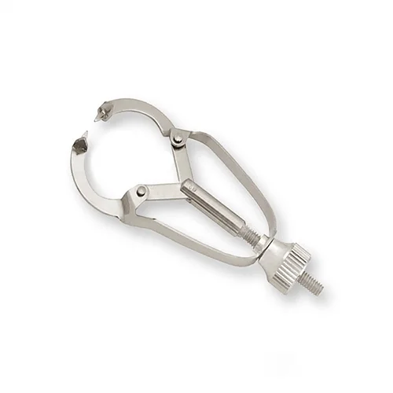

Fig 2. Ivory No.1 Matrix

**IVORY NO.8 MATRIX**

It was introduced in 1905. This system helps in restoring missing walls on both sides (MOD) by encircling the tooth [1][3] (Fig 3).

Advantages- Economical, can be sterilized

Disadvantages- Cumbersome to apply and remove

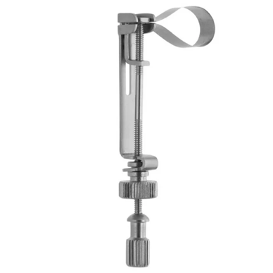

Fig 3. Ivory No. 8 Matrix

**COPPER BAND MATRIX**

Consists of assorted copper or stainless-steel full circle or ring bands (Fig 4).

Indication- MOD complex restorations

Advantages- Provides excellent contour

Disadvantage- Time consuming

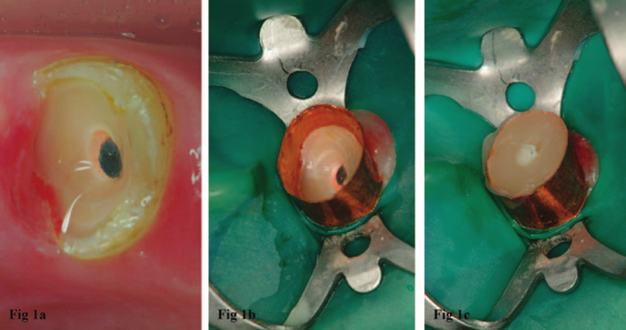

Fig 4. Copper Band Matrix

**AUTOMATRIX**

This is an alternative to the universal retainer. It is a retainer-less matrix system which usually comes with a tightening device (Automate) [15]. The bands are already formed into a circle and each band has a coil-like auto-lock loop [10]. The tightening wrench is inserted into the coil and turned clockwise to tighten the band. The matrix bands come in narrow, medium and wide sizes (Fig 5).

Advantage- Removes the need for bulky retainers, easy to place, good access.

Disadvantage- Bands are not pre-contoured making proximal contouring difficult.

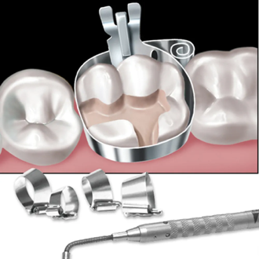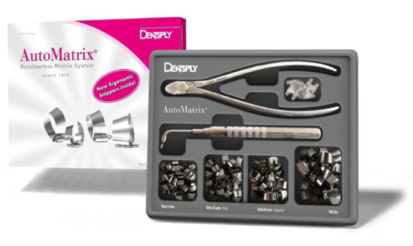

Fig 5. AutoMatrix

**OMNIMATRIX**

It was developed by Ultradent. It is a disposable, pre-assembled matrix system designed for efficient and precise restorations. It eliminates the complexities of traditional retainers (e.g., Tofflemire) by providing a simple and ergonomic solution for both posterior and anterior restorations [4] (Fig 6).

Indications-

* Class II restorations
* Class III, IV restorations- transparent Omnimatrix bands

Advantages-

* Easy to use- pre-assembled design; suitable for dentists at all experience levels
* Time saving- ready to use, quick to place
* Better patient comfort- compact design reduces bulk
* Versatile
* Precise

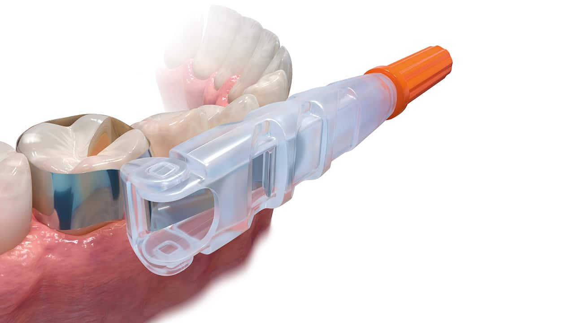

Fig 6. Omnimatrix

**SECTIONAL MATRIX SYSTEMS**

It is the most commonly used system for restoring proximal walls [18]. It is used in combination with a ring retainer or without and/or wedge for good contouring and ease of placement (Fig 7). It is the best way to achieve a strong contact point in Class II restorations while using composite resin [2][9].

Indications-

* Small to moderate Class II cavities
* For both amalgam and composite restorations

Advantages-

* Ease of use and good visibility
* Provides optimal contact, contour and embrasures
* Gingival adaptation of restoration is good

Disadvantages-

* Expensive
* Matrix bands may get deformed/dented easily especially if the contact area of the adjacent tooth is too close

**COMPONENTS OF SECTIONAL MATRIX SYSTEM**

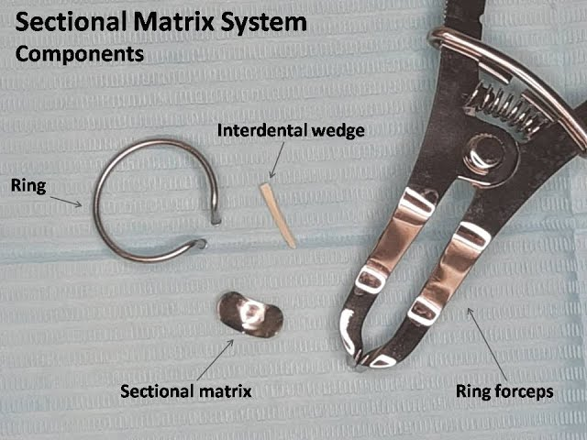

Fig 7. Parts of a Sectional Matrix System

Matrix Bands:

* Thin, pre-contoured metal or plastic bands designed to fit around the proximal surface of the tooth
* These bands are anatomically shaped to recreate natural tooth contours

Separation Rings:

* Spring-like rings that fit around the tooth to provide separation and stabilize the matrix band

Wedges:

* Triangular wooden or plastic pieces inserted interproximally to seal the gingival margin of the band, preventing overhangs
* Ensure a tight seal at the margin to avoid microleakage

**BIOCLEAR BIOFIT HD POSTERIOR MATRIX SYSTEM**

This is a new matrix technology and design that ensures reproduction of ideal tooth contours. It consists of a translucent white 75µ mylar (Fig 8). The stiffer mylar and placement tab provides a rigid structure that makes the matrix easy to place while the translucence of the mylar allows ample light to pass through for thorough light curing [19]. It leaves the composite more polished and contoured than the traditional metal matrices which leave a more matte finish.

The new shape of the Biofit matrices offers 30% more buccal/lingual and occlusal wrap than traditional matrices and will be appropriate for 75% of all posterior molar cases. Biofit HD matrices come in four sizes; Molar 4.5 mm, 5.5 mm, 6.5 mm, and Pre-Molar 5.5 mm.

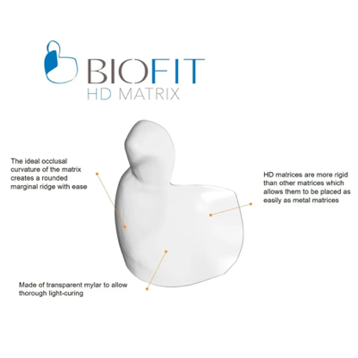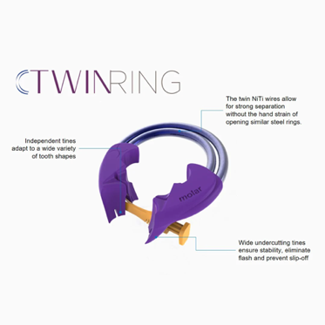

Fig 8. Bioclear Biofit HD Posterior Matrix System

Advantages-

* Improved Contact Points
* High-Definition Margins
* Better Adaptation
* Simplified Technique
* Enhanced Aesthetics
* Versatility
* Minimized Flash
* Support for Injection Moulding Technique

**Matrix Systems Used For Class III and Class IV Restorations (Anterior Matrix Systems)**

Classification of Anterior Matrix Systems [1-4][11]:

1. Transparent matrix systems-
   1. Mylar Strip
   2. Bioclear matrix
   3. Transparent crowns
   4. Contoured anterior matrices
2. Non-transparent matrix systems-
   1. Unica anterior
   2. Unica minideep
   3. Fusion anterior matrix
   4. Burton band anterior
3. Rigid matrix system- Putty index

**MYLAR STRIP**

A **Mylar strip** is a transparent, flexible plastic film commonly used in dentistry as a **matrix** for various dental procedures. Made of polyester material (often referred to as "Mylar," a brand name), these strips are primarily used in **anterior restorations (Fig 9).** It is 5.8 microns in thickness [3]. The matrix strip is burnished over the end of the steel instrument to produce a ‘belly’ in the strip, allowing for proper reproduction of contact and contour.

Advantages-

* Allows light to pass through
* Produces smooth and glossy finish

Disadvantages-

* Limited to anterior teeth (not suitable for most posterior restorations)
* May not provide sufficient rigidity for extensive restorations
* Requires careful placement to avoid overhangs or inadequate contact points

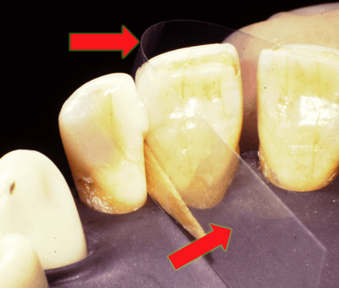

Fig 9. Mylar Strip

**S- SHAPED BANDS**

These bands have a distinctive S-shaped curvature that helps mimic the natural contours of the tooth structure. The mirror handle is used to produce the S-shape and the band is placed interproximally [4] (Fig 10). Impression compound can be used to provide stability to the matrix band.

Indications-

* For Class III and facial/lingual extensions of Class V
* Ideal for restoring distal part of canine and premolar

Advantages-

* Improved Contact Points
* Better Gingival Adaptation
* Reduced Finishing Time
* Ideal for Complex Cases

Disadvantages-

* Requires skill and experience for proper placement and adjustment
* Primarily designed for specific scenarios and may not be suitable for all restorations

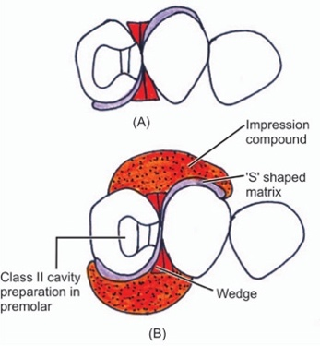

Fig 10. S-shaped Matrix Band

**L- SHAPED MATRIX BAND**

Indicated for inciso-proximal cavities, the strip is folded in an ‘L-Shape’. A wedge is used to help in adaptation of the strip. The angle formed when the strip is folded should approximate the tooth corner and support the matrix on the lingual surface (which is held by forefinger of the left hand) (Fig 11). It is often available in thin stainless steel or clear plastic for better visibility and light-curing of composite materials [20].

Advantages-

* Recreates Natural Contours
* Prevents Overhangs
* Improves Composite Curing
* Minimizes Finishing Work
* Versatility

Fig 11. L- shaped Matrix Band

**BIOCLEAR ANTERIOR MATRIX SYSTEM**

It was introduced by David Clark in the year 2007. It is utilized for restorative dentistry and aesthetic procedures where small areas need to be filled and have less curvature than diastema closure matrices. The anatomic structure of the Bioclear matrix allows for predictable repair or changes to a tooth's emerging profile which can be utilized wedge-free to close narrow areas with a large contact [7]. The papilla stabilizes and minimally seals the matrix once it is put in the sulcus. The anatomically formed matrices from Bioclear allow the composite to be injected/placed into the embrasure without the risk of an overhanging margin. It also smoothens up and contours the interproximal composite (Fig 12).

Indications-

* All anterior cases
* Diastema closure >1mm
* Development of new and exaggerated emergence profiles
* Closure of big black triangles

Advantages-

* Excellent cervical adaptation
* Superior to flat mylar strips
* Preserves gingival papilla
* Easy matrix selection

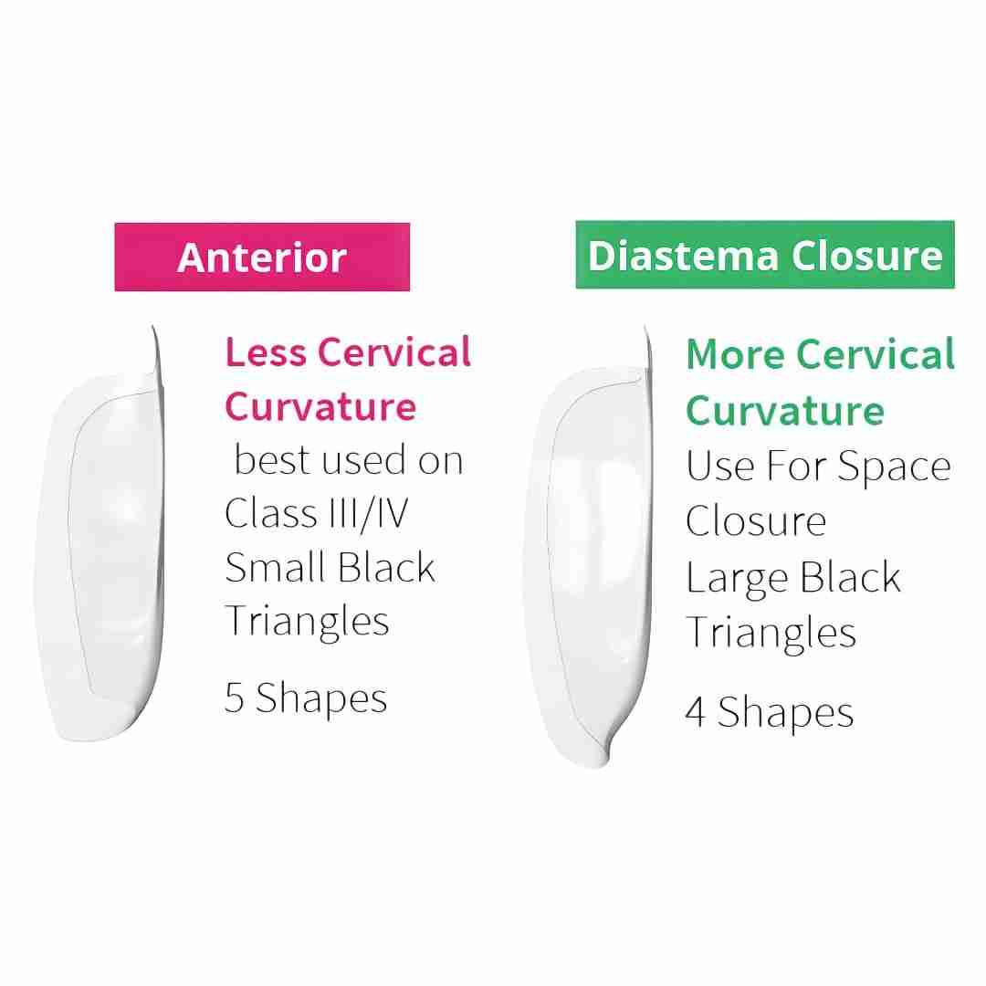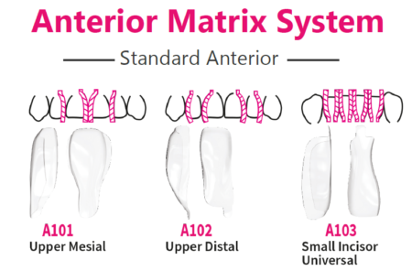

Fig 12. Bioclear Anterior Matrix System

**UNICA ANTERIOR MATRIX**

It was developed by Polydentia in partnership with Style Italiano in 2018. It’s curved shape responds to the various morphologies of anterior teeth allowing for simultaneous restoration of the proximal and cervical margins, even using rubber dams and/or gingival retraction cords, considerably reducing the chair time [4].

Placement wings on the matrix enable quick and efficient positioning, restoration of both proximal and cervical margins at once and anatomically restores the proximal margins to their contoured profile and easily manages the cervical area to the predictability of the restoration and gingival retraction [11] (Fig 13).

Indications-

* Class III, IV, and V anterior restorations
* Direct composite veneers

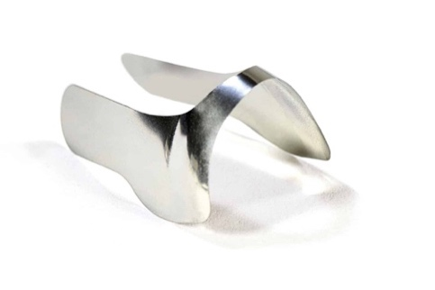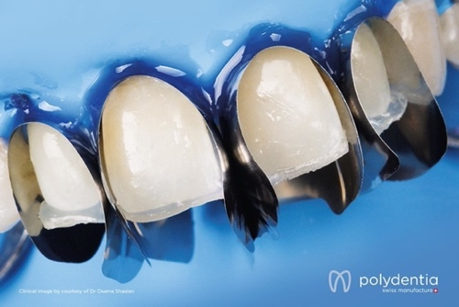

Fig 13. Unica Anterior Matrix

**UNICA ANTERIOR MINIDEEP MATRIX**

This is a smaller version of the Unica Anterior matrix system (Fig 14). It is made using a malleable alloy that may take on the necessary shape for smaller anterior teeth. It is considered as one of the best matrices for aesthetic restorations such as direct stratification composite veneers and shaping changes to maxillary central incisors, as well as direct Class III, IV, and V [4].

Indications-

* Maxillary and mandibular lateral incisors, mandibular central incisors, coronoid teeth, triangular teeth, peg laterals, and teeth with narrow cervical diameters

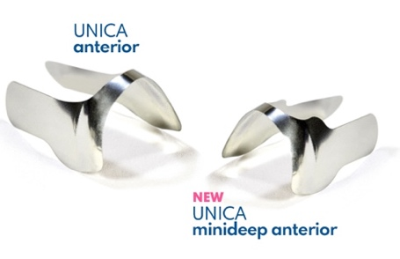

Fig 14. Unica Anterior MiniDeep

**TRANSPARENT CROWN FORM MATRICES**

They are ‘stock’ plastic crowns made of cellulose acetate which can be adapted to tooth anatomy. The entire crown form can be used for bilateral Class IV mesio-incisal-distal cavities. For unilateral Class IV cavities, the crown form is cut inciso-gingivally to use one half of the crown according to the side of the restoration [4] (Fig 15).

Indications-

* For large Class IV cavities
* Oblique fractures of anterior teeth

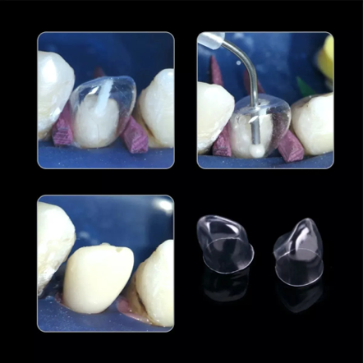

Fig 15. Transparent Crown Form Matrices

**FUSION TM ANTERIOR MATRIX SYSTEM**

It was introduced by Garrison Dental in 2021. The matrix bands are 0.0015” thick. The robust stainless steel matrix slips effortlessly into the sulcus, keeping its shape and contour deprived of distortion. The appropriate anatomical curvature is produced in a gingivo-incisal and facio-lingual orientation when properly inserted (Fig 16). It is superior for restoring deep carious lesions

Indications-

* In anterior restorations like Class III and IV crowns and composite veneers

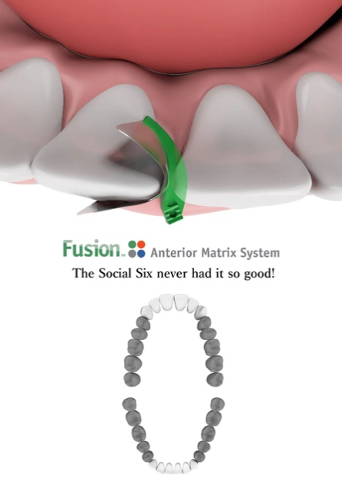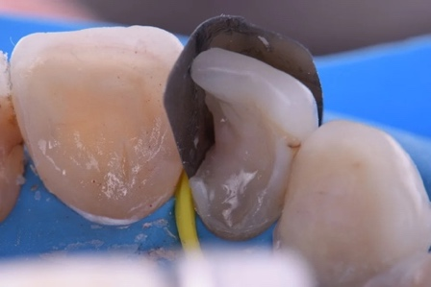

Fig 16. FusionTM Anterior Matrix

**BURTONBANDS MATRIX SYSTEM**

It was introduced by Dr Matthew Burton. It consists of a 38-micron metal matrix which is affixed to a plastic wedge in the design. The wedge's notched edge clicks into position, stabilizing the matrix and releasing both hands for restoration. The wedge has a distinctive handle form, and the matrix is curved yet flexible, allowing it to follow the shape of the tooth from the root surface to the incisal edge (Fig 17).

Advantages-

* Improving the face embrasures formation and enabling the incisal embrasure to be shaped and positioned correctly.
* Simple installation
* Control over contour and proximal contact is possible
* Seal the gingival margin to prevent isolation problems, extra flash, and overhang margins, while allowing access to sub-gingival cavities that are difficult to reach
* The height of the matrix can be reduced for diastema closure scenarios

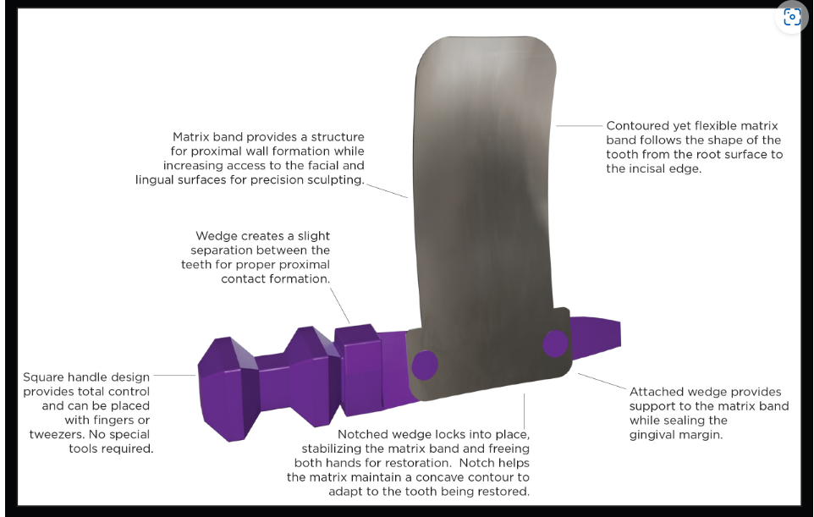

Fig 17. Burtonband Matrix System

**BLUE VIEW VARISTRIPTM MATRIX**

It is a contoured anterior matrix, which provides the ideal curvature and band height for practically all anterior restorations. From one end to the other end, the 0.05 mm thin (plastic) anatomical strip is tapered. The strip can be placed interproximally and then slid until the tooth heights are exactly aligned (Fig 18). The occluso-gingival anatomy is easily recreated with pre-contouring, and flat embrasures are avoided. Blue tint adds contrasts between the matrix and the tooth structures without jeopardizing composite resin polymerization.

Indications-

* It is excellent for Class IV and diastema closure cases.

 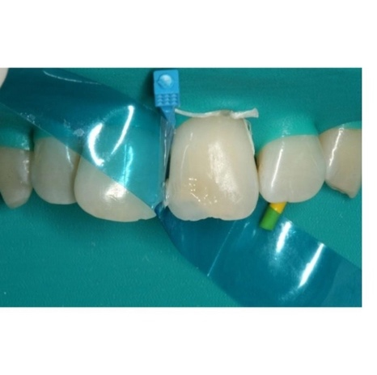

Fig 18. BlueView Varistrip Matrix Band

**MODIFIED PUTTY INDEX USING MYLAR STRIP**

It is a rigid type of matrix system where the putty index of the incisors is made when the defect to be corrected in incisors teeth is built up using direct technique or indirect technique. The putty index is placed on the palatal surface for composite insertion after acid-etching and bonding agent application on the tooth surface to be repaired. At this stage, a Mylar strip is placed over the adjacent tooth to prevent the adhesion of composite material, which differs from the typical approach [8] (Fig 19).

Advantages-

* Creates the correct contour and length of the incisal edge, which can then be used to guide and support the labial surface composite buildup
* Can also help with palatal surface moisture control
* Flexible matrix mylar strips help achieve the ideal aesthetic anatomic contour and a good labial surface finish

Limitations-

* Need for a second appointment

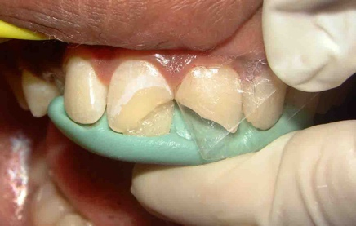

Fig 19. Putty Index

**CLEAR SILICONE INDEX**

It enables the polymerization of the composite resin through the transparent silicone material as well as the transfer of the tooth morphology from the waxed cast to the mouth [4][7]. It can be used to repair a single tooth or a row of teeth (Fig 20).

Feautures-

* Firm, but flexible
* Prevents the formation of an oxygen inhibition layer while using composites, so final polishing is easier
* Easy to drill holes for injection moulding technique

Advantages-

* Simple
* Time saving
* Achieves glossy finish
* Doesn’t necessitate polishing

Disadvantages-

* Only monochromatic shade can be used

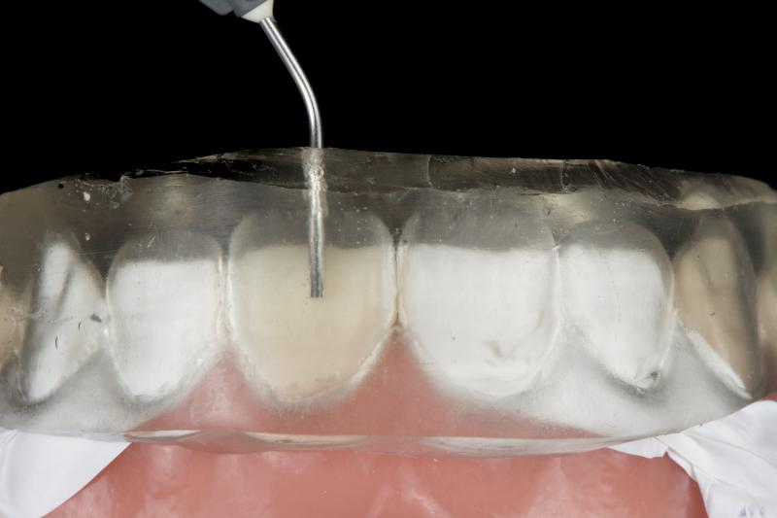

Fig 20. Clear Silicone Index

**Matrix Systems Used For Class V Restorations**

**CERVICAL MATRIX**

This is an instrument used for modelling composites in class V restorations, composed by five different sizes and flexible shell shapes [4] (Fig 21).

* Eg- Blue View cervical matrix kit (Garrison)

Types of cervical matrices-

1. Rigid Matrices-
   1. Made of materials like metal or thick plastic
   2. Provides stable support during restoration placement
2. Flexible Matrices-
   1. Made of transparent, flexible plastic
   2. Adapts well to irregular contours and allows for light curing of the composite

Advantages-

* Protects the restoration from contamination
* Eliminates air-inhibited layer
* Eliminates time spent hand sculpting and reduces finishing time

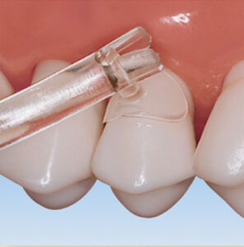

Fig 21. Cervical Matrix

**WINDOW MATRIX**

This is another type of matrix system used to restore cervical cavities on anterior teeth. It has a **window or a cut-out section** that provides access to the restorative area while maintaining support and contour for the restoration [4][7].

The window exposes the Class V cavity allowing for the direct placement of the restorative material. It is usually made from clear plastic to allow for light curing to pass through while using a composite restoration [4].

Indications-

* Cervical lesions caused by abrasion, erosion, abfraction or caries

Advantages-

* Precise placement of restoration
* Avoids overextension of material
* Helps in achieving a smooth and natural finish of the restoration

Disadvantages-

* It is technique sensitive
* May not adapt well to deep cavities

**CONCLUSION**

Matrix systems undoubtedly are indispensable tools in restorative dentistry, playing a critical role in achieving functional and aesthetic restorations. They provide support, contour, and proper adaptation of restorative materials to the prepared tooth, ensuring smooth margins, tight contact points, and a natural tooth anatomy.

From traditional matrix bands to modern systems like sectional, window, and cervical matrices, the variety of designs caters to different restorative requirements and challenges, including Class II, Class III, Class IV, and Class V restorations. Advancements in matrix technology, such as pre-contoured and transparent materials, have further enhanced efficiency, precision, and clinical outcomes.

The proper selection and use of matrix systems are essential for the success of restorations, minimizing risks like overhangs, open contacts, and microleakage. By mastering these tools and techniques, dentists can deliver high-quality restorations that restore both function and aesthetics, contributing to better patient satisfaction and overall oral health outcomes.

**REFERENCES**

1. Harald O Heymann, Edward J Swift, Jr., Andre V Ritter. ‘Sturdevant’s Art & Science of Operative Dentistry; A South Asian Edition. 2016
2. M.A. Marzouk, Simonton, Gross. ‘Operative Dentistry- Modern Theory and Practice’
3. Vimal Sikri .Textbook of Operative Dentistry, 3rd Edition
4. Urkande NK, Mankar N, Nikhade PP, Chandak M, Ikhar A, Patel A. Anterior Matrix Systems for Composite Restorations: A Review. Cureus. 2023 Apr 4;15(4):e37145. doi: 10.7759/cureus.37145. PMID: 37168162; PMCID: PMC10166279.
5. Ramya R, Raghu S. India: Emmess Medical Publisher; 2007. Clinical operative dentistry principles and practices.
6. Markose A. Restoring proximal contacts of teeth. IOSR J Dent Med Sci. 2017;16:46–49.
7. Owens BM, Phebus JG. An evidence-based review of dental matrix systems.. Gen Dent. 2016; 64:64–70
8. Blank JT. Modified putty index matrix technique with mylar strip and a new classification for selecting the type of matrix in anterior proximal/incisal composite restorations.
9. Summitt J M. Fundamentals of Operative Dentistry. Quintessence Publishing. 3rd Ed 2006.
10. Vaishnavi Rajendra Patekar, Nikhil Mankar, Karuna Burde, Aparna Achanta. Choice of Matrix System in Dentistry, J Res Med Dent Sci, 2022, 10 (11): 120-126.
11. Akshada Mungee, Rachit Mathur, Babra Khan, Ajay Kore. Everything About Matrix and Matrix Systems. A Review Article. IOSR Journal of Dental and Medical Sciences (IOSR-JDMS) e-ISSN: 2279-0853, p-ISSN: 2279-0861.Volume 23, Issue 7 Ser. 9 (July. 2024), PP 28-36
12. Ercoli C, Caton JG. Dental prostheses and tooth‐related factors. Journal of periodontology. 2018 Jun;89:S223-36.
13. Mandurino, M., Di Domenico, G. L., Baldani, S., Collivasone, G., Gherlone, E. F., Cantatore, G., & Paolone, G. (2023). Dental Restorations. *Bioengineering*, *10*(7), 820.
14. Rekow, E. D., Fox, C. H., Petersen, P. E., & Watson, T. (2013). Innovations in materials for direct restorations: why do we need innovations? Why is it so hard to capitalize on them?. *Journal of Dental Research*, *92*(11), 945-947.
15. Shaalan, O. O. (2020). Evaluation of matrix band systems for posterior proximal restorations among Egyptian dentists: a cross-sectional survey. *Acta Stomatologica Croatica*, *54*(4), 392.
16. Owens, B. M., & Phebus, J. G. (2016). An evidence-based review of dental matrix systems. *Gen Dent*, *64*(5), 64-70.
17. Malik, T. A. M. S. I. L. A., Malik, T. A. H. R. E. E. M., Mahmood, A. S. A. D., Naz, S. H. A. R. I. N. A., & Sajid, M. U. S. T. A. F. A. (2020). Choice of matrix system for class II composite restoration; a cross sectional survey among the dentists of Multan Dental College. *Pak J Med Health Sci*, *14*(4), 829-31.
18. Bailey, O. (2021). Sectional matrix solutions: the distorted truth. *British Dental Journal*, *231*(9), 547-555.
19. Sulaiman, T. A., Alsahafi, T. A., Frizoni, F. D. O., & Suliman, A. A. (2025). Reconstructing Tooth Proximal Surface With Composite Resin Using Contemporary Sectional Matrix Systems. *Journal of Esthetic and Restorative Dentistry*.
20. Jiang, T., Jiao, T., & Li, Y. (2016). Array mutual coupling reduction using L‐loading E‐shaped electromagnetic band gap structures. *International Journal of Antennas and Propagation*, *2016*(1), 6731014.