***Case report***

**A Rare occurrence of mucocele of ventral surface of the tongue -A case report**

**ABSTRACT:**

Mucoceles are benign lesions of the oral cavity, usually resulting from trauma or obstruction caused in salivary glands. However, their occurrence on the ventral surface of the tongue is rare and often misdiagnosed due to their hidden presentation. This case highlights an unusual mucous extravasation cyst presenting as a subtle swelling on the ventral tongue, emphasizing the need for careful clinical and histopathological evaluation. Prompt diagnosis and appropriate surgical intervention ensured complete resolution and prevented recurrence. This report underlines the necessity of considering mucocele in the differential diagnosis of lingual swellings.

Keywords: Mucocele, Ventral tongue, Mucous Extravasation, Oral Lesion, Salivary Gland Cyst

**INTRODUCTION:**

Mucoceles are benign, mucus-filled cystic lesions that most frequently originate from the minor glands of saliva. The floor of the mouth, the cheek mucosa, the lower lip, sometimes the ventral surface of the tongue are where they are most frequently found (1,2). Two main processes are involved in the pathophysiology of mucoceles: mucous retention brought on by ductal occlusion and mucous extravasation brought on by salivary duct rupture (3). Despite being common lesions in clinical practice, mucoceles are nevertheless rare and might be difficult to diagnose when they appear on the ventral tongue. These lesions could be mistaken for benign salivary gland tumours, vascular abnormalities, or pyogenic granulomas (4,5).

A combination of clinical assessment, imaging where required, and histological confirmation is required for an accurate diagnosis. In order to avoid problems like enlargement, prompt identification and treatment are essential. Mucoceles are benign, mucus-filled cystic lesions that most often start in the tiny salivary glands and are typically brought on by trauma or ductal occlusion. The preferred course of treatment is still surgical excision, which involves removing the related gland entirely to lower the chance of recurrence (6). These lesions may mimic other pathologies such as vascular malformations, pyogenic granulomas, or benign salivary gland tumors (4,5). Accurate diagnosis relies on a combined approach of clinical evaluation, imaging when necessary, and histopathological confirmation.

**CASE PRESENTATION**

A 20 yrs old male patient reported with the chief complaint of swelling in lower surface of tongue for past one month. Patient was normal before a month after which he noticed a small swelling in the lower border of the tongue which showed gradual increase to the current size. No pain and pus discharge evident. [Figure 1]

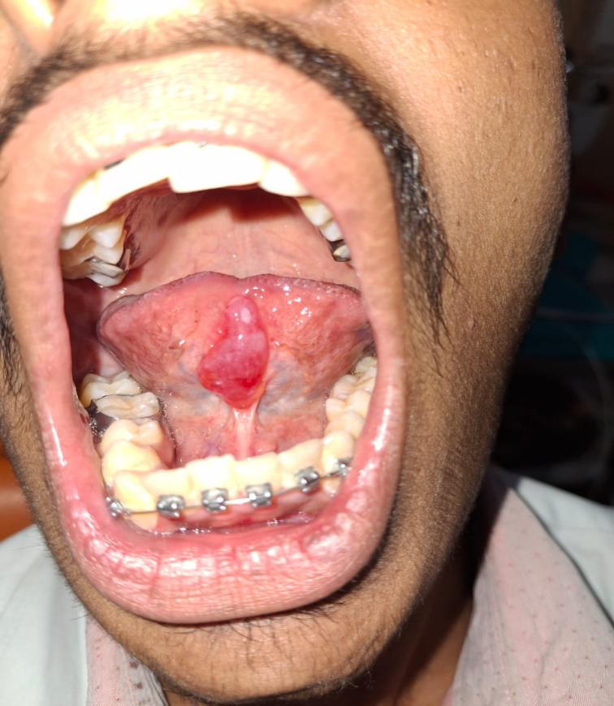

**Figure 1:** Intra Oral Findings

A 5x3 cm enlargement that is soft, variable, and non tender to the touch is found on the tongue's ventral surface. It has a dome form, is mucosa colored, well-defined, and shows no surface alterations. The inspectory results, including the growth's boundaries and extent, are validated by palpation. The swelling was tentatively diagnosed as mucocele since it is soft, fluctuating, and nontender to the touch.

Under local anaesthesia, the lesion was excised and the gross specimen was submitted for histopathology reporting which included several soft tissue fragments.Specimen was processed and routinely stained. Histopathology of the specimen showed reveals a non- keratinized stratified squamous epithelium with an irregular surface which seems to be thin and stretched out in most of the areas excepting in few areas where it is hyperplastic with proliferative rete processes. The underlying connective tissue area seems to be in fragments and reveals a homogenous eosinophilic to basophilic delicate mucinous component. [Figure 2].

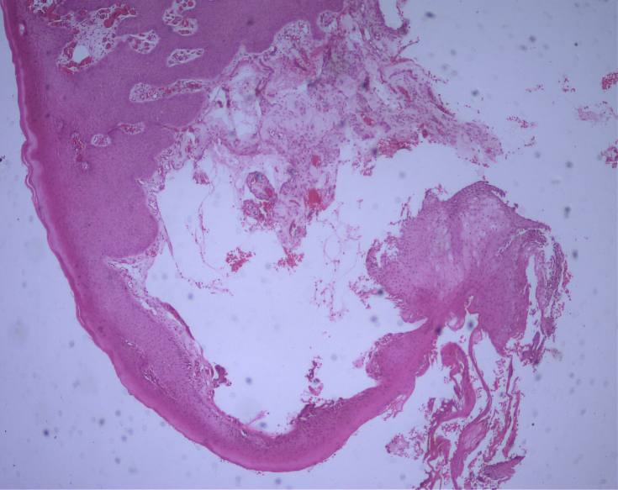

10x

**Figure 2:** Histopathology (H&E stain) showing fragmented connective tissue area which reveals a homogenous eosinophilic to basophilic mucinous component.

The rest of the connective tissue appears fibro-cellular with numerous endothelium lined capillaries of varying sizes and extravasated RBCs. Dispersed within the mucinous connective tissue areas are numerous macrophages/ mucinophages and acute and chronic inflammatory cells predominantly neutrophils, eosinophils, lymphocytes and plasma cells [Figure 3,4].

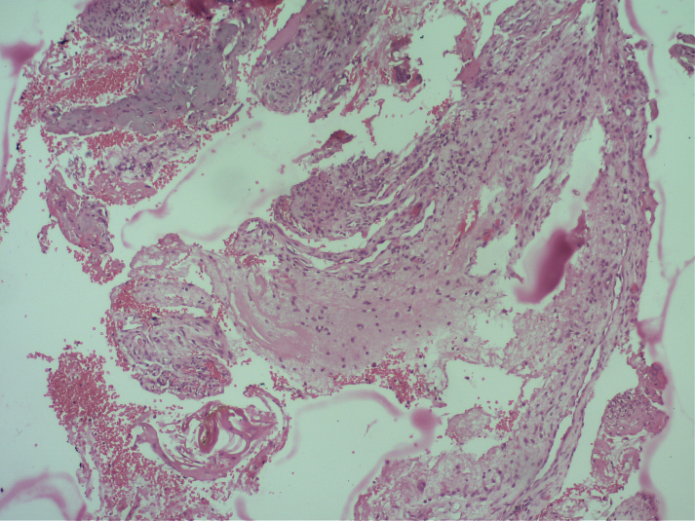

10x

**Figure 3:** Histopathology (H&E stain) showing Fibro-cellular connective tissue with numerous endothelium lined capillaries of varying sizes and extravasated RBCs dispersed within the mucinous connective tissue areas.

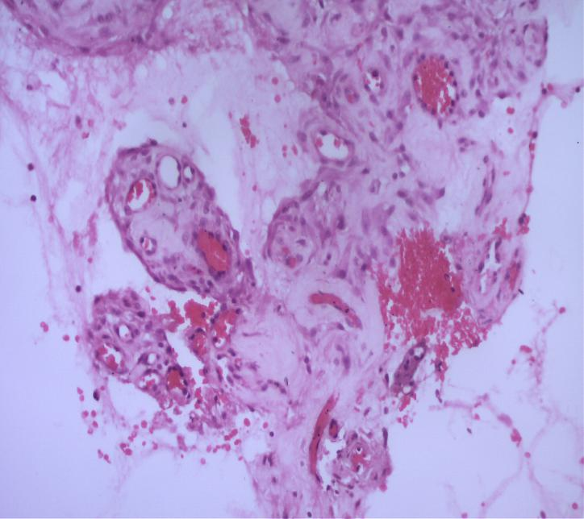

20x

**Figure 4:** Histopathology (H&E stain) showing numerous macrophages/ mucinophages and acute and chronic inflammatory cells predominantly neutrophils, eosinophils, lymphocytes and plasma cells

Mucin extravasation within the connective tissue is seen as amorphous, PAS-positive (magenta-pink) material under PAS staining. The most prevalent kind of mucocele on the ventral tongue, extravasation-type mucocele, is indicated by this mucin pool's frequent appearance of non-encapsulation. The bright magenta staining highlights glycoproteins and mucopolysaccharides (mucin) in the spilled salivary secretion [Figure 5]

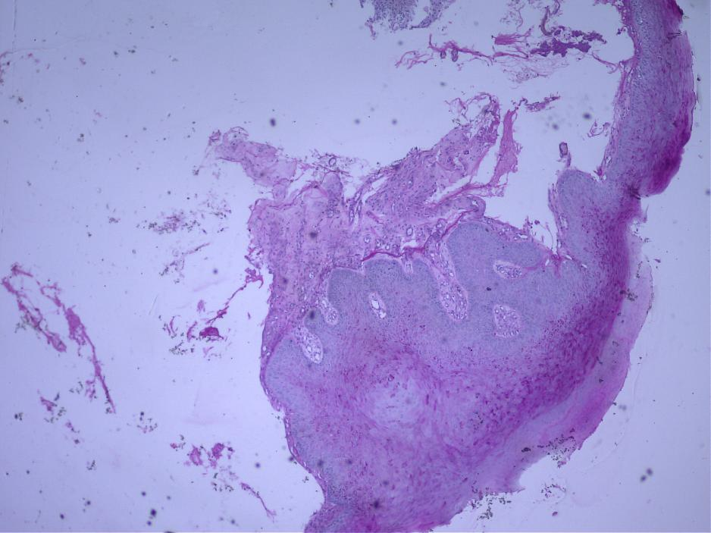

10x

**Figure 5:**PAS staining reveals **extravasation of mucin** within the connective tissue, presenting as **amorphous, PAS-positive (magenta-pink) material**.

The clinicopathological correlation led to a final diagnosis of Mucocele.The patient underwent surgical exicision under local anesthesia.

**DISCUSSION:**

One of the most common lesions of the salivary glands is mucocele, which is often arises due to mechanical injury that damages the duct of salivary glands and causes mucus to leak into the surrounding connective tissue (1). Although mucoceles are frequently encountered on the lower lip, they are uncommon and sometimes misdiagnosed when they arise on the ventral aspect of the tongue, specifically from the minor mixed salivary glands of tongue (2,3). Lesions originating from the minor salivary glands , are mixed small salivary glands located close to the ventral surface of tongue's midline, can manifest as soft, fluctuant swellings that resemble domes (4). These mucoceles can vary in size and, depending on their position and size, might cause discomfort or even obstruct speech or mastication (5). Clinical diagnosis is difficult because their presentation might resemble other pathologies including vascular lesions, lipomas, fibromas, or even malignant neoplasms (6).

Histologically, mucoceles are divided into two categories: mucous retention cysts, which are actual cysts bordered by epithelium, and mucous extravasation cysts, which are encircled by granulation tissue and lack an epithelial lining (7). Due to trauma-related aetiology, the majority of lesions on the ventral tongue are extravasation type, especially those originating from the Blandin–Nuhn glands (8). In order to prevent recurrence, treatment typically entails total surgical excision, which includes the removal of nearby small salivary glands (9).Although there have been reports of other treatments such laser ablation, cryosurgery, and marsupialization, surgical excision is still the gold standard because of its efficacy and decreased recurrence rates (10,11). As far as concerned the appropriate diagnosis and correct treatment the post operative prognosis is good.Any failure in complete removal of tissue associated with concerned salivary glands may lead to recurrence (12).Transition of mucocele into carcinomas are rare on complete and with proper marsupilization and less than 10 percentage of recurrence have been observed (13).

**CONCLUSION:**

Because of their hidden position and diverse presentation, mucoceles that arise on the ventral surface of the tongue especially from the minor salivary glands of tongue are uncommon and frequently clinically ignored.Accurate diagnosis, supported by histopathological evaluation, is essential to differentiate them from other oral pathologies.

To reduce the chance of recurrence, complete surgical excision—including the minor salivary glands involved—remains the preferred course of treatment. In addition to restoring patient comfort and oral function, early detection and treatment guarantee a great prognosis.The necessity of increased clinical awareness of such unusual presentations in normal oral examinations is highlighted by this instance.

**REFERENCES**

1. Baurmash HD. Mucoceles and ranulas. J Oral Maxillofac Surg. 2003;61(3):369–78.
2. Jinbu Y, Kusama M, Itoh H, Matsumoto K, Wang J, Noguchi T. Mucocele of the glands of Blandin–Nuhn: clinical and histopathologic analysis of 26 cases. Oral Surg Oral Med Oral Pathol Oral Radiol Endod. 2003;95(4):467–70.
3. Yamasoba T, Tayama N, Syoji M, Fukuta M. Clinicostatistical study of lower lip mucoceles. Head Neck. 1990;12(4):316–20.
4. Eveson JW, Wills EJ. Mucous extravasation cysts: a clinicopathological study of 95 cases. Br J Oral Surg. 1981;19(3):180–2.
5. Oliveira DT, Consolaro A, Freitas FJ. Histopathological spectrum of 112 cases of oral mucoceles in children. Int J Pediatr Otorhinolaryngol. 1993;26(3):223–7.
6. Harrison JD. Salivary mucoceles. Oral Surg Oral Med Oral Pathol. 1975;39(2):268–78.
7. Sakae T, Yoshida M, Morita M. Histological studies on mucous cysts in the oral region. Int J Oral Surg. 1975;4(6):306–12.
8. More CB, Bhavsar K, Varma S, Tailor M. Oral mucocele: a clinical and histopathological study. J Oral Maxillofac Pathol. 2014;18(Suppl 1):S72–7.
9. Bodner L, Talmi YP, Bar-Ziv J, Kronenberg J. Salivary gland mucoceles in children. Int J Pediatr Otorhinolaryngol. 1989;17(2):133–40.
10. Yagüe-García J, España-Tost AJ, Berini-Aytés L, Gay-Escoda C. Treatment of oral mucocele–scalpel versus CO₂ laser. Med Oral Patol Oral Cir Bucal. 2009;14(9):e469–74.
11. Oliveira MG, Consolaro A, Freitas FJ. Clinical-pathological study of oral mucoceles. Rev Gaúch Odontol. 1991;39(6):460–3.
12. Delbem AC, Cunha RF, Ribeiro LL, Vieira AE. Treatment of mucus retention phenomena in children by the micro-marsupialization technique: case reports. Pediatr Dent. 2000;22(2):155–8.
13. Baurmash HD. Mucoceles and ranulas. Journal of Oral and Maxillofacial Surgery. 2003 Mar 1;61(3):369-78.