***Case report***

**Ultrasound Discovery of a Myocardial Cleft : Case Report**

**Abstract**

We report the case of a 54-year-old patient with poorly controlled hypertension admitted for the management of exertional dyspnea due to a severe mitral regurgitation by restriction of the posterior valve. The TTE has objectified a cleft in the inferior myocardial wall. Myocardial clefts are common in the general population but often underdiagnosed. Appropriate echocardiographic views could help better identify and delineate them. Most studies consider them benign anatomical variants. It is essential to clarify their relevance in the clinical table to appropriately stratify additional tests and limit unnecessary invasive interventions.

**Introduction**

Myocardial clefts (or myocardial fissures) are defined as invaginations penetrating more than 50% of the thickness of the adjacent myocardium, generally perpendicular to the longitudinal axis of the left ventricle. These clefts tend to narrow or obliterate during systole without causing local hypokinesia or dyskinesia. They can appear in healthy individuals, as well as in patients with hypertrophic or hypertensive cardiomyopathy. Initially described in post-mortem studies of patients with HCM, doubts regarding the interpretation of imaging (angioventriculography or echocardiography) due to the presence of clefts in the left ventricular myocardium may lead to a series of additional tests (MRI...), sometimes even invasive (ventriculography…), to clarify their origin. Some older studies suggest that myocardial clefts may also help identify carriers of HCM mutations without left ventricular hypertrophy.

**Case Presentation**

We present the case of a 54-year-old patient, known to be poorly compliant hypertensive, admitted for management of exertional dyspnea. Echocardiography revealed severe mitral regurgitation due to restriction of the posterior valve, along with diffuse concentric left ventricular hypertrophy noted on electrical and echocardiographic assessment, and a left ventricular ejection fraction of 57%, with an altered global longitudinal strain of -11%. A myocardial cleft in the form of a fissure was identified, confined to the inferior myocardial wall and penetrating more than 50% of the wall thickness. This structure showed near-total obliteration during systole. The biological assessment indicated relative renal failure due to hypertensive nephropathy.

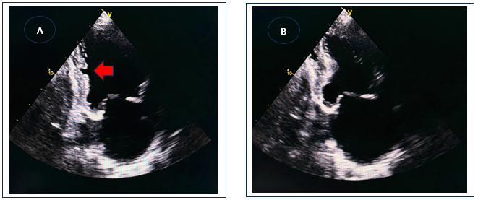

**Figure 1** : PLAX TEE views with a diastolic (A) and a systolic frame (B). In diastole (A), a crypt is well identified in the inferior wall extending for more than 50% of the wall thickness. The crypt is not evident in systole (B).

septum (arrow), extending for more than 50% of septal thickness. The crypt is not evident in systole (B).

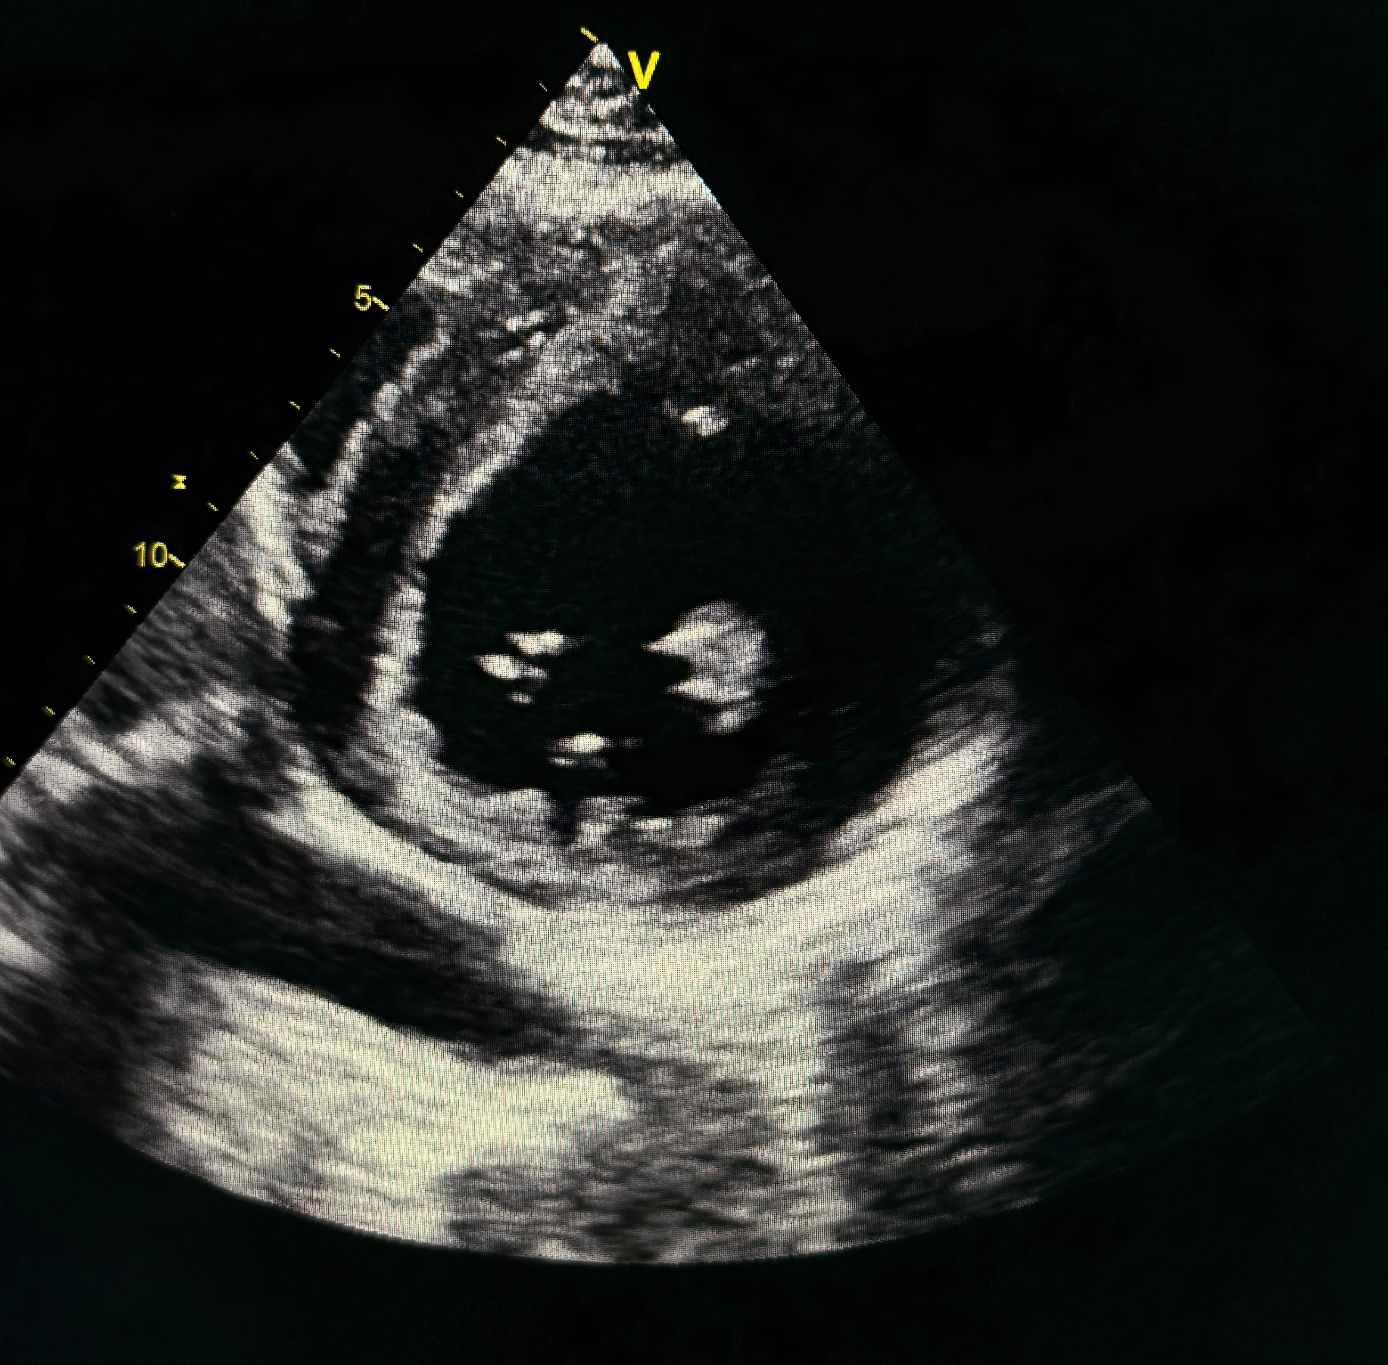

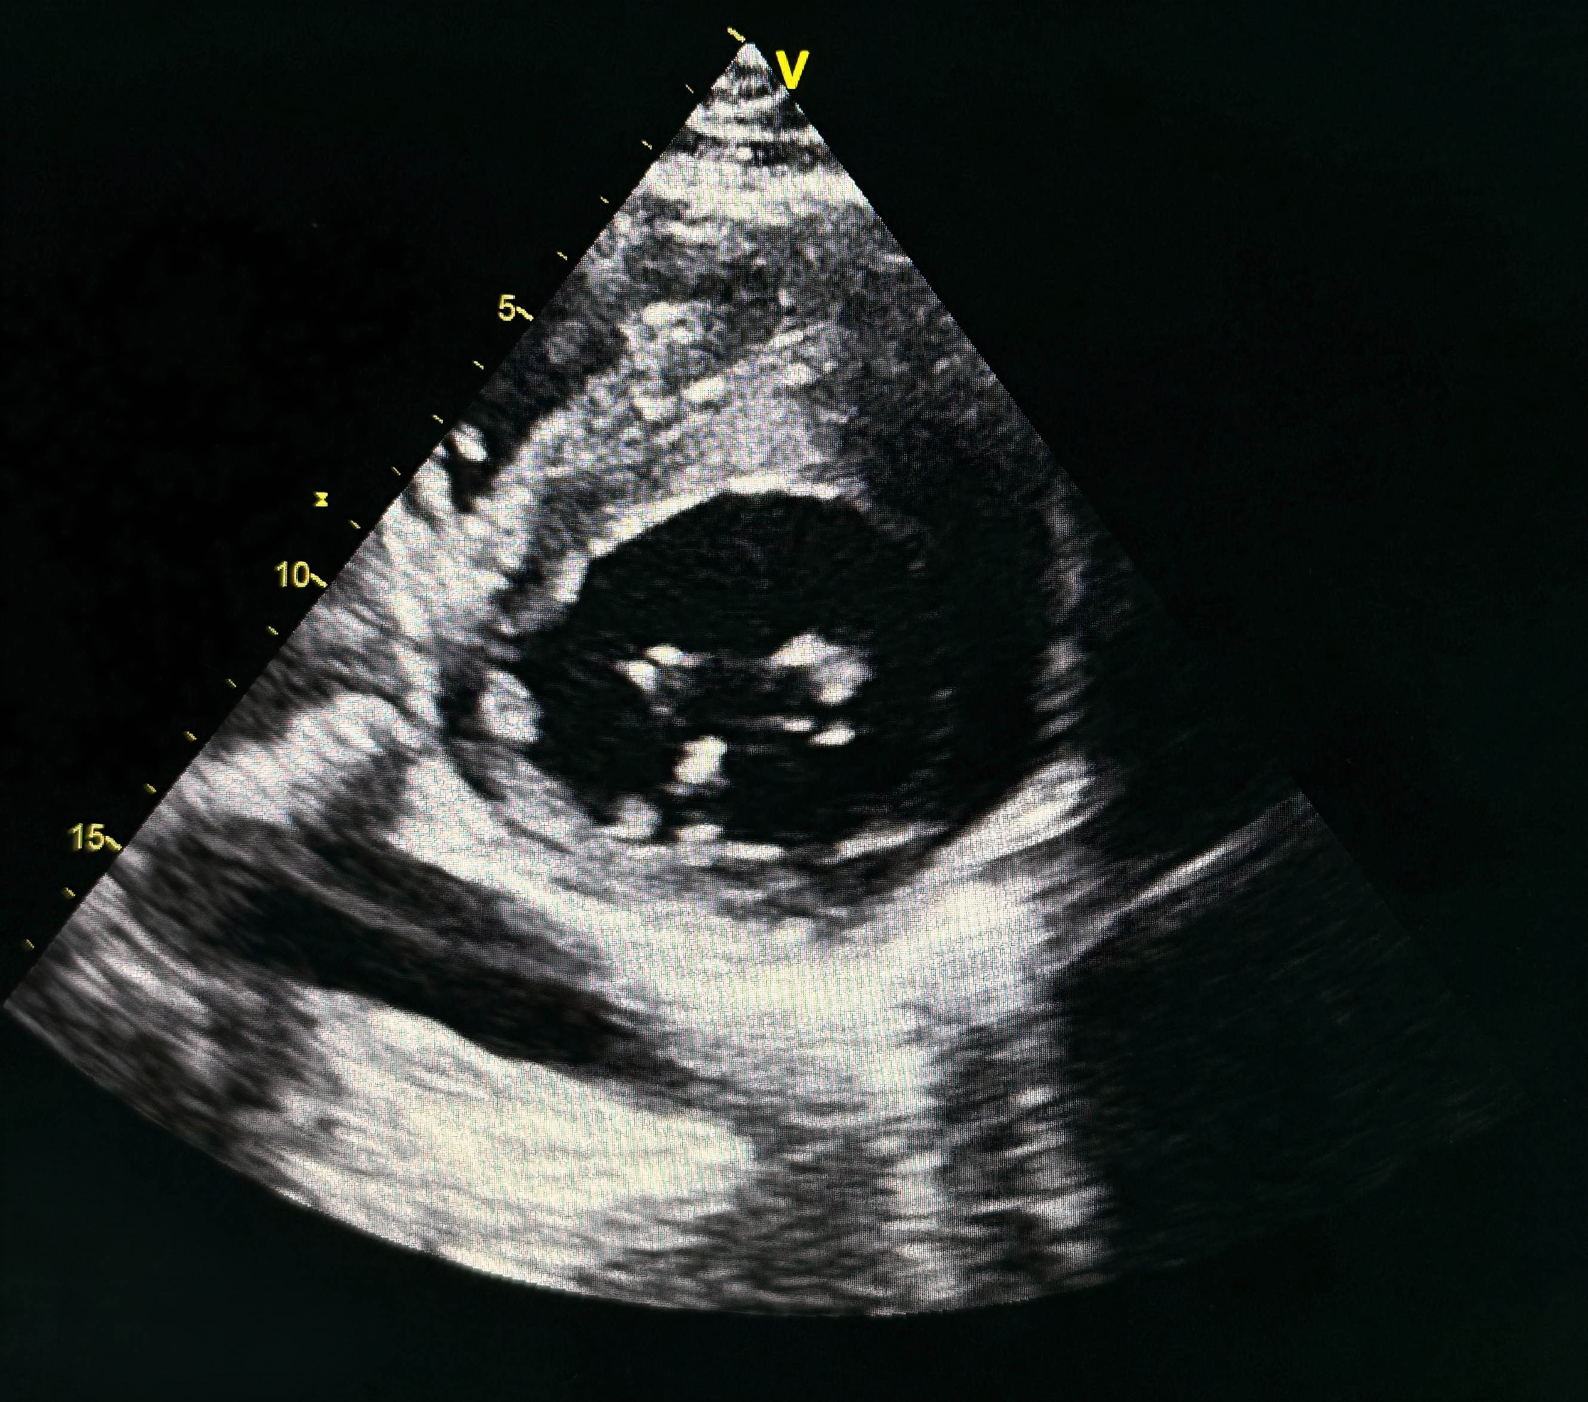

**Figure 2** : PSAX TEE views with a diastolic (A) and a systolic frame (B). In diastole (A), a crypt is well identified in the inferior wall (arrow). The crypt is not evident in systole (B).

nferior wall (arrow). The crypt is not evident in systole (B).

**Discussion**

Our study will be based on a literature review regarding the significance and incidence of the diagnosis of a myocardial cleft—which remains relatively rare or at least underdiagnosed in our daily practice—on the management approach, particularly regarding paraclinical and therapeutic decisions for these patients. In other words, is the presence of myocardial clefts pathological in itself or could it be a normal variant? This question has sparked considerable controversy across several studies, sometimes leading to discordant results, between those who consider the presence of clefts as a normal variant and others who believe it to be an early subclinical marker of myocardial hypertrophy, prompting genetic testing for HCM even before ventricular hypertrophy.

In most cases, authors describe the presence of clefts or fissures, mainly located in the inferoseptal wall, which do not extend beyond the epicardium.[1] Indeed, some studies suggest an association between ventricular clefts and the presence of genetic mutations related to HCM, even in the absence of left ventricular hypertrophy. The study by German and al. revealed the presence of ventricular clefts in 81% of cases in patients carrying genetic mutations associated with HCM. Such an association could be clinically beneficial, as identifying these anomalies could serve as a screening tool for familial cases of HCM. However, so far, there is no evidence linking the presence of clefts to a pathological condition, as more recent extensive studies, including that of Johansson et al. found that clefts were found in 8% of healthy volunteers studied.

They described two distinct locations:

* At the level of the basal inferior segment, observed only in healthy volunteers.
* At the septal level, observed in both healthy volunteers and patients referred for cardiac MRI for other indications.

The importance of this series lies in the fact that cardiac MRI detected myocardial clefts in over 8% of healthy individuals. This finding has no pathological significance but is important to know, as a misdiagnosis, such as non-compaction of the left ventricle, could be detrimental to the patient. Some studies have emphasized the need to better differentiate clefts from other anatomical anomalies of the left ventricle, such as pseudoaneurysms, true aneurysms, and diverticula. Indeed, these structural variations of the myocardium present distinct anatomical and histological characteristics, as well as different prognostic significances.[2]

In a study involving a group of patients with HCM, 39% of patients had 2 or more clefts, and 28% had 3 or more. In contrast, normal subjects had only one cleft, while patients with hypertension or aortic valve stenosis had 1 or 2. Only patients with HCM had 3 or more clefts.[3]

In our case, there is no indication that the presence of a single ventricular cleft contributed to our patient's clinical presentation, especially since an alternative cause was identified.

The patient exhibited the characteristics of hypertensive heart disease and severe mitral regurgitation explaining his dyspnea and underwent surgery for a mechanical valve replacement with good postoperative outcomes and optimization of his antihypertensive treatment.

Due to the sometimes discordant findings in the literature, where clefts are described on one hand as distinctive markers of HCM, but on the other hand as relatively benign, their interpretation remains uncertain.[4] Larger prospective studies are needed to determine the true prevalence of myocardial clefts in a healthy population and their actual clinical significance. Myocardial clefts, especially when multiple, could represent a pre-phenotypic marker of HCM. However, in normal patients with incidental findings of single clefts, they likely represent a normal variant.[5] Clefts should be differentiated from other defects of the myocardial wall that have different clinical significances, particularly in the presence of multiple clefts, which may mimic the trabeculations of non-compaction of the left ventricle.[6]

**Conclusion**

Myocardial clefts are common in the general population and often underdiagnosed. Most studies emphasize that clefts are benign anatomical variants.[7] Single myocardial clefts in the left ventricle are frequent in the general population and are not associated with major adverse cardiovascular events in the medium term. Myocardial clefts should be considered in the diagnostic process to limit unnecessary interventions; modified echocardiographic views could help optimally delineate them.[8]

**Abbreviations :**

**TTE** : Transthoracic Echocardiogram

**MRI** : Magnetic resonance imaging

**HCM** : Hypertrophic Cardiomyopathy

**PLAX**: Parasternal Long Axis

**PSAX** : Parasternal Short Axis

**Références  :**

1. Seraphim A, Papachristidis A, Bratt N, Shiu MF. Significance of left ventricular clefts-A case report. J Cardiol Cases. 2014;1(1):e6. doi: 10.1016/j.jccase.2013.12.006.
2. Myocardial Crypt in an Asymptomatic Young Athlete: How to Interpret? 2015.
3. Almeida JG, Ladeiras-Lopes R, Bettencourt N, Ferreira N, Ribeiro J, Ribeiro VG. Multiple myocardial crypts: multimodality imaging evaluation. 2016.
4. Prevalence and morphology of myocardial crypts in normal and hypertrophied myocardium by computed tomography. 2019.
5. Incidental detection of myocardial clefts in a patient with acute inferior ST-segment elevation myocardial infarction: a very unusual and potentially ominous association—a case-report. ESC Heart Fail. 2020.
6. Left ventricular myocardial crypts: morphological patterns and prognostic implications. ESC Heart Fail. 2020.

1. 2014 Significance of left ventricular clefts-A case report [Andreas Seraphim](https://pubmed.ncbi.nlm.nih.gov/?term=Seraphim+A&cauthor_id=30546784)[1](https://pubmed.ncbi.nlm.nih.gov/30546784/#full-view-affiliation-1), [Alexandros Papachristidis](https://pubmed.ncbi.nlm.nih.gov/?term=Papachristidis+A&cauthor_id=30546784)[1](https://pubmed.ncbi.nlm.nih.gov/30546784/#full-view-affiliation-1), [Naomi Bratt](https://pubmed.ncbi.nlm.nih.gov/?term=Bratt+N&cauthor_id=30546784)[1](https://pubmed.ncbi.nlm.nih.gov/30546784/#full-view-affiliation-1), [Man Fai Shiu](https://pubmed.ncbi.nlm.nih.gov/?term=Shiu+MF&cauthor_id=30546784)[1](https://pubmed.ncbi.nlm.nih.gov/30546784/#full-view-affiliation-1)DOI: [10.1016/j.jccase.2013.12.006](https://doi.org/10.1016/j.jccase.2013.12.006)
2. 2019 Prevalence and morphology of myocardial crypts in normal and hypertrophied myocardium by computed tomography
3. 2015 Myocardial Crypt in an Asymptomatic Young Athlete: How to Interpret?
4. *2016* Multiple myocardial crypts: multimodality imaging evaluation João Gonçalves Almeida M.D. | Ricardo Ladeiras-Lopes M.D. | Nuno Bettencourt Ph.D. | Nuno Ferreira M.D. | José Ribeiro M.D. | Vasco Gama Ribeiro M.D.
5. 2020 ECS EHJ case reports Incidental detection of myocardial clefts in a patient with acute inferior ST-segment elevation myocardial infarction: a very unusual and potentially ominous association—a case-report
6. *2016* Multiple myocardial crypts: multimodality imaging evaluation João Gonçalves Almeida M.D. | Ricardo Ladeiras-Lopes M.D. | Nuno Bettencourt Ph.D. | Nuno Ferreira M.D. | José Ribeiro M.D. | Vasco Gama Ribeiro M.D.
7. ESC EHJ 2020 Left ventricular myocardial crypts: morphological patterns and prognostic implications
8. *2016* Multiple myocardial crypts: multimodality imaging evaluation João Gonçalves Almeida M.D. | Ricardo Ladeiras-Lopes M.D. | Nuno Bettencourt Ph.D. | Nuno Ferreira M.D. | José Ribeiro M.D. | Vasco Gama Ribeiro M.D.