**Sodium Cyanide Exposure: Its Cardiovascular Impact and Cardiac Markers in Rabbits**

**ABSTRACT**

This study was designed to investigate cardiac marker levels in rabbits following sodium cyanide exposure.The rabbits were grouped into control and test and the study lasted for thirty days, sixty days and ninety days respectively. Cardiac Markers investigated are Lactate Dehydrogenase (LDH), Creatine Kinase (CK) and Troponin (TP). Data were expressed as mean ± Standard Deviation. Statistical differences between groups were computed using Graph pad prism 7.0 version. Results were analysed using analysis of variance (ANOVA) and significance between groups was taken at p< 0.05. The result showed significant (p< 0.05) increase in the levels of cardiac markers in thirty days, sixty days and ninety days exposures respectively. These findings suggest that sodium cyanide exposure can have significant and potentially life-threatening cardiovascular consequences.

**Keywords**: Cardiac markers, Sodium cyanide and Rabbits.

**INTRODUCTION**

Cyanide is a fast acting, potentially and deadly chemical that can exist in various forms 1. The toxic effects of cyanide ion in humans and animals are generally similar and are believed to result from inactivation of cytochrome oxidase and inhibition of cellular respiration and consequent histotoxic anoxia. The primary targets of cyanide toxicity in humans are the cardiovascular, respiratory and central nervous systems 2. The organs most susceptible to cyanide are the central nervous system (CNS) and the heart 3. Cyanide not only decrease the oxygen content of blood, but also decreases oxygen availability to tissue thereby producing a greater degree of tissue hypoxia than equivalent reduction in oxyhaemoglobin caused hypoxia. Organs with high oxygen demand, such as the heart and brain are most sensitive to hypoxia and account for the major clinical sequelae of cyanide poisoning 4.

Cyanide poisoning may produce some pathologic effects on different tissues that may manifest as alterations in biochemical parameters 5. Cyanide chronic intoxication may also produce some pathologic effects on different tissues that precede alterations in biochemical parameters. Consequently, certain types of cells are damaged and leaked enzymes into the blood, where they can be measured as indicators of cell damage. Enzymes are the catalyst of all biological and metabolic reaction in cells and their activities are considered as sensitive biochemical indicators used to investigate cellular injury, metabolic disturbances and enzymes inactivation or induction by exogenous chemicals 6. Alterations of the enzymes activities in functional organs may reflect the description of metabolic integrity 7. The most widespread problems arising from cyanide are from chronic /sub chronic exposures. Chronic cyanide toxicity is involved in the pathogenesis of some health problems. Moreover, chronic cyanide intoxication induces alteration in some tissue biochemical, histological and oxidative stress parameters in experimental animal model 7. There are species difference on the organ-specific biochemical markers and the susceptibility to various toxic agents 8.

**MATERIALS AND METHOD**

**PROCUREMENT OF MATERIALS**: Sodium cyanide, 98% purity, produced by Changsha Hekang Chemical Co. Ltd was purchased at Decosmiller Ventures, Ogbete, Enugu, Nigeria

**EXPERIMENTAL ANIMALS**: The experimental animals were purchased at Sandra Farm, Oyigbo, Rivers state, Nigeria.

**PLACE AND DURATION OF STUDY**: this study was carried out at Animal House, Applied and Environmental Biology Department, Rivers State University, Port Harcourt, Rivers State, Nigeria, between April, 2020 and November, 2020.

**Ethical Approval:** The Animal Welfare Act of 1985 of the United State of America for research and Institutional Animal Care and Use Committee (IACUC) protocol were strictly adhered to. All experiments have been examined and approved by the appropriate ethic committee.

**STUDY DESIGN:** A total of twenty-four (24) rabbits constitute the sample size. The animals used were divided into three groups with matched control. Four rabbits were assigned to each group and the study lasted for 90 days as follows: group one (0 – 30) days, Group two (0 – 60) days, Group three (0 – 90) days. Each rabbit in a group (treated group) was given 10ml of 0.05mg/kg sodium cyanide orallydaily for 90 days. The matched control and treated rabbits were given water *ad-libitum* and feed daily. The blood samples were taken for analysis at day 30, 60 and 90 respectively

**Collection of Sample:** The blood samples were collected into plain containers, kept for fifty minutes, then spun to separate supernatant for biochemical analysis. The heart organ was also harvested and preserved in 10% formal saline for histological analysis.

**BIOCHEMICAL ANALYSIS**: Troponin I was analysed using ELISA Method as Described by 9. Creatine Kinase Muscle and Brain (CKMB) was analysed using ELISA Method as Described by 10. Lactate Dehydrogenase (LDH) was analysed using ELISA Method as Described by 11.

**Statistical analysis.** Data are expressed as mean ± SD. Statistical differences between groups were computed using Graph pad prism 7.0 versions. Results were analysed using one-way analysis of variance (ANOVA) and significance between groups was taken at p < 0.05.

**RESULTS**

The result of analysis of cardiac marker parameters is presented in Table 1, 2 and 3. The result showed increase in concentration of cardiac markers in thirty days, sixty days and ninety days respectively compare to control.

Table 1: Mean ± SD of Cardiac Markers of Rabbits Fed with Top feeds mixed with sodium cyanide solution for 30 days Treatment

|  |  |  |  |  |
| --- | --- | --- | --- | --- |
| S/N | **Experimental Groups** | Parameters | | |
| **Lactate Dehydrogenase (IU/L)** | **Creatine Kinase (CK-MB) (IU/L)** | **Troponin (IU/L)** |
| 1 | Control | 182.40±2.21 | 237.10±1.67 | 0.41±0.08 |
| 2 | Test | 183.70±2.46 | 259.20±2.55 | 0.82±0.13 |
| 3 | F –value | 0.7644 | 14.55 | 5.438 |
| 4 | P –value | 0.4736 | <0.0001 | 0.0016 |

Table 2: Mean ± SD of Cardiac Markers of Rabbits Fed with Top feeds mixed with sodium cyanide solution for 60 days Treatment

|  |  |  |  |  |
| --- | --- | --- | --- | --- |
| S/N | **Experimental Groups** | Parameters | | |
| **Lactate Dehydrogenase (IU/L)** | **Creatine Kinase (CK-MB) (IU/L)** | **Troponin (IU/L)** |
| 1 | Control | 185.30±2.45 | 236.20±1.45 | 0.41±0.05 |
| 2 | Treated Group | 187.80±1.44 | 280.90±2.33 | 1.33±0.26 |
| 3 | T value | 1.747 | 32.67 | 6.902 |
| 4 | P value | 0.1313 | <0.0001 | 0.0005 |

Table 3: Mean ±SD of Cardiac Markers of Rabbits Fed with Top feeds mixed with sodium cyanide solution for 90 days Treatment

|  |  |  |  |  |
| --- | --- | --- | --- | --- |
| S/N | **Experimental Groups** | **Parameters** | | |
| **Lactate Dehydrogenase (IU/L)** | **Creatine Kinase (CK-MB) (IU/L)** | **Troponin (IU/L)** |
| 1 | Control | 184.50±2.35 | 236.70±1.57 | 0.40±0.05 |
| 2 | Treated Group | 189.30±0.41 | 296.30±2.18 | 1.87±0.12 |
| 3 | T value | 4.035 | 44.35 | 22.23 |
| 4 | P value | 0.0008 | <0.0001 | <0.0001 |

**Histology result of the heart**

Photomicrographs showing the histological findings of the heart tissues harvested from the experimental animal, rabbit, from various groups are shown in fig. 1 to fig. 4. The control slide shown in fig. 1 represent rabbits that were not exposed to sodium cyanide, while fig. 2, fig. 3 and fig. 4 are rabbits exposed to sodium cyanide for thirty, sixty and ninety days respectively. Histological examination revealed significant changes on sixty and ninety days while thirty days did not show any significant change. The different rabbits exhibited different features such as focal inflammatory cells and cardiomyocyte necrosis.

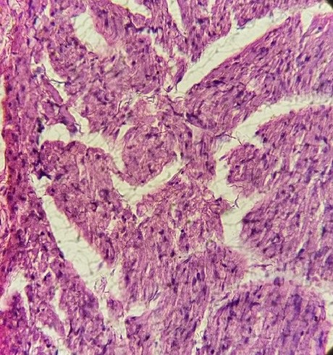

**281µm**

Branch bundle of Interventricular septum

**Fig. 1 Photomicrograph of Normal Heart Tissue Showing Normal Atria, Interventricular**

**Septa and Ventricules. H & E x400.**

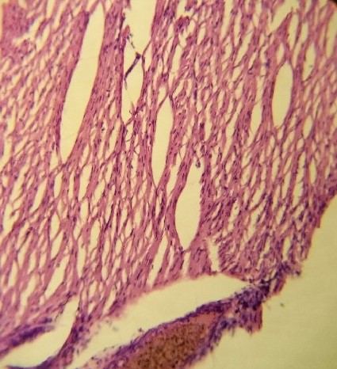

Cardiac muscle fibres

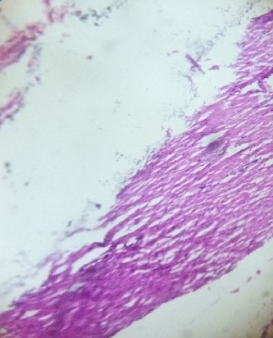

Cardiomyocyte

**Fig. 2 Photomicrograp of Heart Tissue Exposed to Sodium Cyanide for Thirty Days**

**Showing Areas of Cardiac Muscle Fibres. H & E x400.**

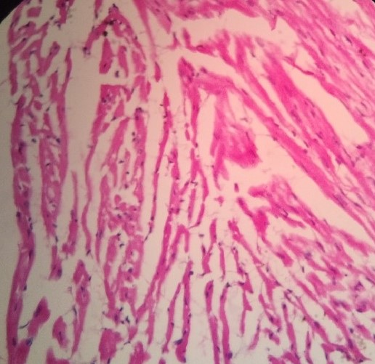

Papillary muscles

Cardiac muscle fibres

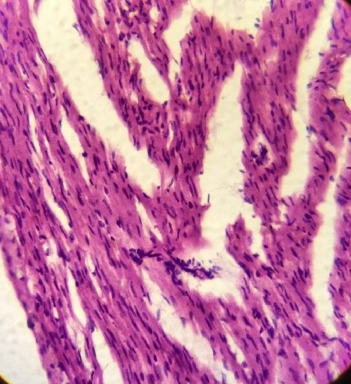

Focal inflammatory cells

**Fig. 3 Photomicrograph of Heart Tissue Exposed to Sodium Cyanide for Sixty Days**

**Showing Area of Focal Inflammatory Cells. H & E x400.**

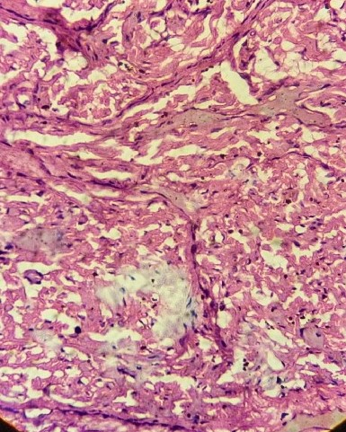

Cardiomyocytes

Cardiomyocyte necrosis

**Fig. 4 Photomicrograph of Heart Tissue Exposed to Sodium Cyanide for Ninety Days Showing Area of Cardiomyocyte Necrosis. H & E x400.**

**DISCUSSION**

The result of this study showed that serum lactate dehydrogenase concentration of the treated group was not significant (p>0.05) in thirty days and sixty days compared to control group; however, in ninety days its serum concentration was significantly (p<0.05) increased compared to control. This result revealed the chronic effect of cyanide on the heart muscle as reported by 12. which observed significant increase in the serum concentration of lactate dehydrogenase in rats exposed to cyanide. The observed increase is attributed to the histotoxic hypoxia effect of cyanide exposure on the myocardial cells; consequently, this enzyme, lactate dehydrogenase, is released into the plasma resulting to its serum concentration increase.

Heart is one of the target organs for cyanide exposure; the resultant effect is myocardial necrosis leading to increase in serum creatine kinase enzyme 2. This study observed significant increase in serum concentration of Creatine kinase in 30 days, 60 days and 90 days respectively. The observed increase could be linked to the hypoxia effect of cyanide exerted on the heart that is most sensitive to oxygen and the heart also demand more energy for its activity. The hypoxia condition occasioned by cyanide reduce cellular oxygen content and energy supply to the heart, this led to myocardial necrosis and cardiac markers (lactate dehydrogenase, creatine kinase and troponin 1) which is contained in the cytoplasm leaked into the plasma causing raise in their plasma levels. This finding is in line with the report of 13. which showed increased level of cardiac markers in serum of rabbits exposed to cyanide.

Similarly, this study observed significant (p<0.05) increase in serum concentration of Troponin 1 in the treated group in 30 days, 60 days and 90 days respectively compare to control. The observed increase in serum concentration of Troponin 1could be attributed to the hypoxia condition occasioned by cyanide which induced myocardial cellular necrosis and eventually the cytoplasmic content including Troponin 1leaked into plasma leading to its serum level increase. This result agrees with the report of 14 that observed increase level of Troponin 1 in the serum of rabbit exposed to cyanide.

The histopathology result of heart tissue showed focal inflammatory cells and cardiomyocyte necrosis. Heart is of the primary target organs of cyanide intoxication; therefore, this result did not only confirm histotoxic effect of cyanide on cardiomyocyte but also revealed the basis of increased serum cardiac markers observed in the biochemical analysis. This result is in line with the report of 3 that observed blood in ventricles and necrosis of the heart muscles in rabbits exposed to cyanide.

Sodium cyanide exposure can have severe cardiovascular impacts as evidenced by elevated cardiac markers such as lactate dehydrogenase, troponin, creatine kinase and histological changes in the heart tissues. These findings suggest that sodium cyanide exposure can have significant and potentially life-threatening cardiovascular consequences.

**REFERENCES**

Sanchez-Verlaan, P., Geeraerts, T., Buys, S., Riu-Poulene, B. Cabot, C., Fourcade, O., Megarbane, R. and Genestal, M. (2011). An unusual cause of severe lactic acidosis: cyanide poisoning after bitter almond ingestion. *Intensive Care Medicine,* 37(1), 168 - 169.

Gracia, R. and Shepherd, G. (2004). Cyanide Poisoning and Its Treatment. *Pharmacotheraphy,* 24, 1358 - 1365.

Agency for Toxic Substances and Disease Registry (ATSDR) (2006). Toxicological profile for cyanide. Atlanta, GA. USA. 56 - 67.

Carl, A. B.., Edward, R. A. (2001). Analytes of Hemoglobin Metabolism-Porphyrin, Iron and Bilirubin. In: Fundamentals of Clinical Chemistry, Fifth edition. Saunders. 603 - 621.

Mulla, A., Massey, K. L. and Kalra, J. (2005). Vitreous humor biochemical constituents: evaluation of between-eye differences. *American Journal of Forensic Medicine and Pathology*, 26, 146 - 159.

Okolie, N. P. and Osagie, A. U. (1999). Liver and Kidney Lesions and Associated Enzymes Changes Induced in Rabbits by Chronic Exposure of Cyanide. *Food and Chemistry Toxicology,* 37, 745 - 750.

Okolie, N. P. and Iroanya, C. U. (2003). Some Histologic and Biochemical Evidence for Mitigation of Cyanide Induced Tissue Lesions by Antioxidant Vitamin Administration in Rabbits. *Food and Chemistry toxicology,* 41, 463 - 469.

Sousa, A. B., Soto-Blanco, B. Guerra, J. L., Kimura, E. T. and Gorniak, S. L. (2002). Does Prolonged Oral Exposure to Cyanide Promote Hepatotoxicity and Nephrotoxicity? *Toxicology,* 174, 87 - 95.

Bhayana, V. and Henderson, A. (1995). Biochemical markers of myocardial damage. *Clinical Biochemistry,* 28, 1 - 29.

Apple, F. S. (1992). Acute myocardial infarction and coronary reperfusion. Serum cardiac markers for the 1990’s. *American Journal of Clinical Pathology*, 97(2), 217 – 226

Stevens, J. F., Tsang, W. and Newall, R. G. (1983). Measurement of the enzymes lactate dehydrogenase using enzyme linked immunosorbent assay. *Journal of Clinical Pathology*. 36, 1371 - 1376.

Amodu, A, Reuben, A. and Thagriki, D. (2020). Effect of Manihot esculenta and Manihot utilissima Cyanide extract on some biochemical parameters of albino rats. *Asian Journal of Research in Biochemistry*, 6, 13 – 28

Koschel, M. J. (2006). Management of the Cyanide-poisoned Patient. *Journal of Emergency Medicine,* 32, 19 - 26.

Sarko, J. and Pollack, C. V. (2002). Cardiac Troponin. *Journal of Emergency Medicine*, 23(1), 57 - 65.

Bhayana, V. and Henderson, A. (1995). Biochemical markers of myocardial damage. *Clinical Biochemistry,* 28, 1 - 29.

Carl, A. B.., Edward, R. A. (2001). Analytes of Hemoglobin Metabolism-Porphyrin, Iron and Bilirubin. In: Fundamentals of Clinical Chemistry, Fifth edition. Saunders. 603 - 621.

Apple, F. S. (1992). Acute myocardial infarction and coronary reperfusion. Serum cardiac markers for the 1990’s. *American Journal of Clinical Pathology*, 97(2), 217 – 226

Gracia, R. and Shepherd, G. (2004). Cyanide Poisoning and Its Treatment. *Pharmacotheraphy,* 24, 1358 - 1365.

Koschel, M. J. (2006). Management of the Cyanide-poisoned Patient. *Journal of Emergency Medicine,* 32, 19 - 26.

Mulla, A., Massey, K. L. and Kalra, J. (2005). Vitreous humor biochemical constituents: evaluation of between-eye differences. *American Journal of Forensic Medicine and Pathology*, 26, 146 - 159.

Okolie, N. P. and Iroanya, C. U. (2003). Some Histologic and Biochemical Evidence for Mitigation of Cyanide Induced Tissue Lesions by Antioxidant Vitamin Administration in Rabbits. *Food and Chemistry toxicology,* 41, 463 - 469.

Okolie, N. P. and Osagie, A. U. (1999). Liver and Kidney Lesions and Associated Enzymes Changes Induced in Rabbits by Chronic Exposure of Cyanide. *Food and Chemistry Toxicology,* 37, 745 - 750.

Sanchez-Verlaan, P., Geeraerts, T., Buys, S., Riu-Poulene, B. Cabot, C., Fourcade, O., Megarbane, R. and Genestal, M. (2011). An unusual cause of severe lactic acidosis: cyanide poisoning after bitter almond ingestion. *Intensive Care Medicine,* 37(1), 168 - 169.

Sarko, J. and Pollack, C. V. (2002). Cardiac Troponin. *Journal of Emergency Medicine*, 23(1), 57 - 65.

Sousa, A. B., Soto-Blanco, B. Guerra, J. L., Kimura, E. T. and Gorniak, S. L. (2002). Does Prolonged Oral Exposure to Cyanide Promote Hepatotoxicity and Nephrotoxicity? *Toxicology,* 174, 87 - 95.

Stevens, J. F., Tsang, W. and Newall, R. G. (1983). Measurement of the enzymes lactate dehydrogenase using enzyme linked immunosorbent assay. *Journal of Clinical Pathology*. 36, 1371 - 1376.