***Case report***

**Beyond the Bowel: A Rare Left Hepatic Duct–Duodenal Fistula Following Foreign Body Ingestion**

**Abstract-**

Fistula formation between the biliary system and the gastrointestinal tract is uncommon. There are various types of biliary-enteric fistulas, such as cholecystoduodenal, choledochoduodenal, and cholecystocolonic fistulas, with the most common being cholecystoduodenal. Most of these fistulas result from gallstone disease, but they can also be caused by peptic ulcer disease, neoplasms, or iatrogenic injuries during surgery. Our case report discusses a rare instance of a bilio-digestive fistula between the left hepatic duct and duodenum that developed after foreign body ingestion. This case highlights the importance of an active search and appropriate workup of a fistula, especially after foreign body ingestion. We will explore and describe this case's diagnosis, clinical course and treatment.

Keywords – Duodenal fistula, biliary fistula, biliary-enteric fistula, foreign body ingestion complications

**Introduction -**

A biliary fistula is an abnormal connection between the biliary system and another organ, cavity, or external surface. These fistulas are either external (biliary-cutaneous) or internal, such as biliobiliary, bilioenteric, or bronchobiliary fistulas [1]. Bioloenteric fistulas can be of a variety of types like cholecystoduodenal, cholecystocolonic and cholecystogastric [2]. Cholecystoduodenal is the most common type of biliary fistula, followed by cholecystocolonic and cholecystogastric [3]. These fistulas are mainly caused by inflammation due to gall stones [4].

The symptoms of bilioenteric fistula can be non-specific and may include abdominal pain, fever, nausea, vomiting, diarrhoea, malabsorption, and unintended weight loss. In some cases, more severe presentations such as melena, hematemesis, cholangitis, pancreatitis, or sepsis may occur [5].

**Case Presentation -**

A 59-year-old male presented with complaints of generalized abdominal pain and shortness of breath that began 10 days ago. The pain was not worsened by positional changes or food intake. He rated the pain 6 out of 10. He did not experience fever, jaundice, or diarrhea. On examination, his pulse rate was 104 beats per minute, blood pressure was 108/82, and his temperature was 36.8°C. Physical examination revealed mild pallor and cardiopulmonary examination was unrevealing. No rebound tenderness was noted during the examination. He has been smoking 5–8 cigarettes daily for 38 years and has had type 2 diabetes mellitus for 13 years. There is no history of psychiatric illness or gallstone disease in his medical record.

Blood tests, liver function tests and kidney function tests revealed no abnormalities. The patient underwent an ultrasound for his abdominal pain following an inconclusive physical examination and a chest X-ray to assess his shortness of breath. The ultrasound and chest X-ray revealed no abnormal findings. The patient was referred for a Contrast Enhanced Computed Tomography of the abdomen due to the uncertain nature of the etiology. CECT revealed tubular outpouching measuring 4.7 cm in length and 1.4 cm in diameter, originating from the first part of the duodenum and extending into the left hepatic duct however, there was no extension of the tract into or dilation of the left intrahepatic bile radicals. The presence of fistula was confirmed as the presence of air in the liver (Figure 1). Magnetic Resonance Cholangiopancreatography (MRCP) confirmed the presence of air within the hepatic ducts, visible within the liver parenchyma. Additionally, the MRCP revealed a sharply demarcated outline within the tubular tract, raising suspicion of possible foreign body presence (Figure 2). Given the suspicious characteristics of the tract, an endoscopy was subsequently performed. Endoscopy revealed an object of length 10-13 cm with the distal end in the second part of the duodenum (Figure 3, 4,). The proximal end was embedded in the first part of the duodenum. The proximal end of the foreign body was embedded in an opening. The foreign body (broken toothbrush) was removed (Figure 5).

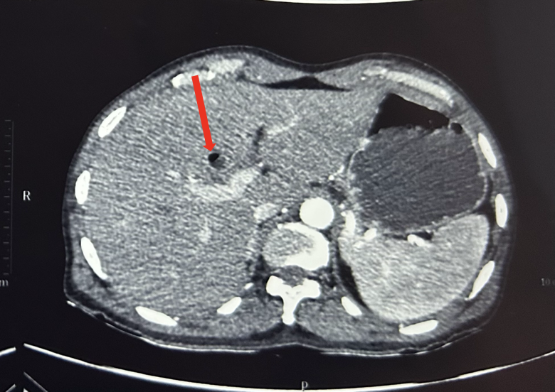

Figure 1 – Contrast Enhanced Computed Tomography of Abdomen - Findings Indicative of Air in Biliary Tree (red arrow) Secondary to Fistulous Connection

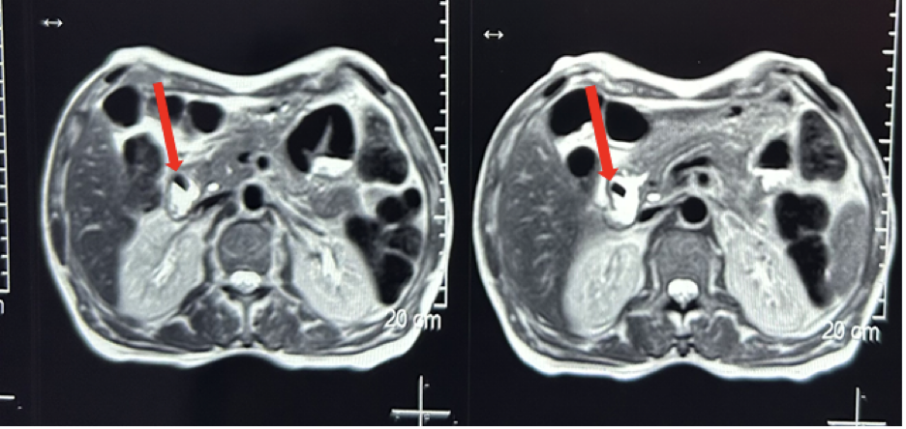

Figure 2 - Magnetic Resonance Cholangiopancreatography showing biliary tree filling defects with a sharp defined outline (red arrow) suggestive of a possible foreign body following ingestion.

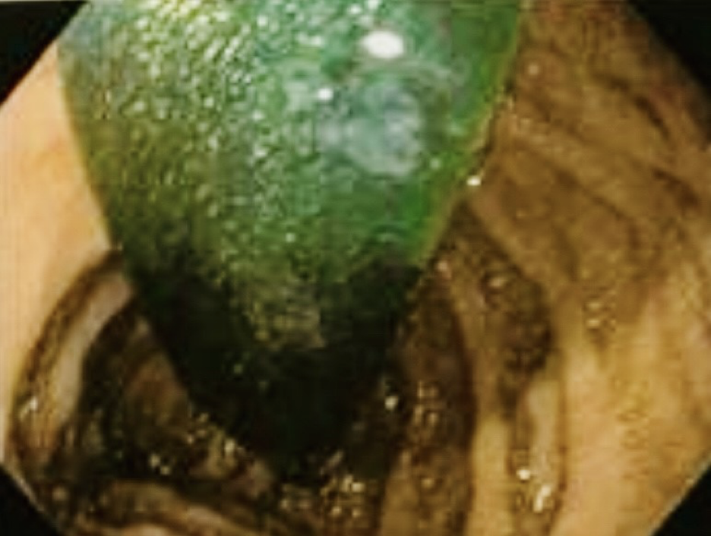

Figure 3 - **Endoscopic image showing retrieval of a broken toothbrush ingested by the patient as a foreign body.**

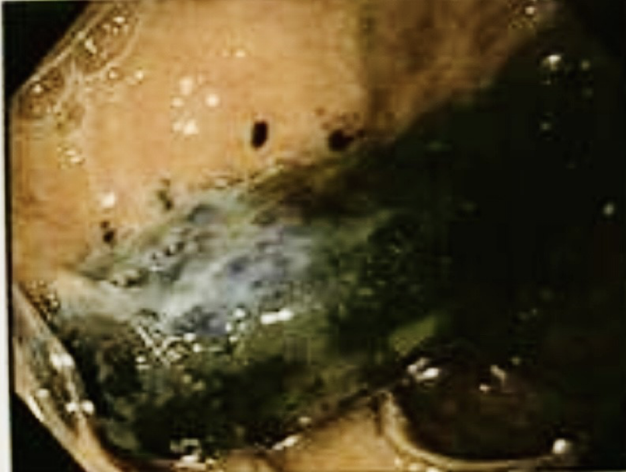

Figure 4 - **Endoscopic image showing retrieval of a broken toothbrush ingested by the patient as a foreign body.**

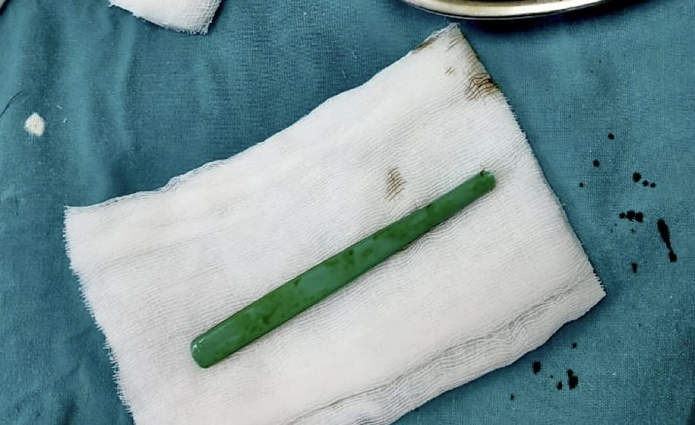

Figure 5 – Retrieved specimen of a foreign body (broken toothbrush) ingested by the patient, resulting in the formation of a left hepatic duct–duodenal fistula.

Based on medical symptoms and investigations, the preoperative diagnosis was a left hepatic duct-duodenal fistula. Following the retrieval of the foreign body during endoscopy and completion of appropriate investigations, open laparotomy was planned. During the operation, a tubular fistulous tract approximately 5 cm in length was identified, extending from the first part of the duodenum to the left hepatic duct (Figure 6). The tract was adhered to the stomach and omentum. A 60 mm Endo GIA stapler was used to divide the hepatico-duodenal fistula, effectively dividing the fistulous connection.

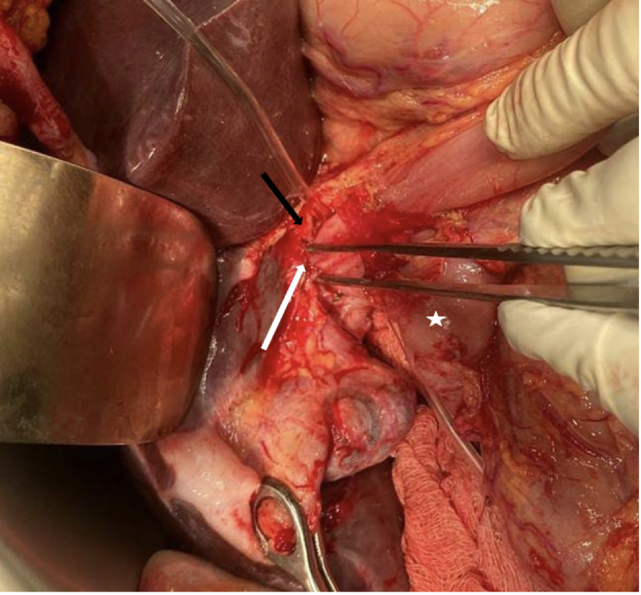

Figure 6 - Intraoperative findings revealing a fistulous tract (white arrow) establishing an abnormal communication between the left hepatic duct (black arrow) and the adjacent duodenum (star), consistent with a fistula.

The patient’s postoperative course was uneventful. The patient’s alkaline phosphatase, total bilirubin and total leukocyte count were within normal ranges of 280 U/L, 1.1 mg/dL and 12,000 cells/microL.

**Discussion**-

Internal biliary-enteric fistulas (IBFs) are extremely rare, accounting for only 0.4% to 1.9% of all biliary tract diseases [6]. The majority of IBFs occur spontaneously, while external biliary fistulas most often result from complications of surgical or percutaneous interventional procedures. Spontaneous internal biliary fistulas (SIBFs) are caused by gallstones in 91–94% of cases [7]. Other common causes of internal biliary fistulas include peptic ulcer disease, malignant neoplasm (duodenum, stomach, gall bladder) or Crohn’s disease of the duodenum [8]. Intrahepatic bile duct dilation disrupts the biliary environment, causing recurrent inflammation, bilirubin stone formation and can also lead to periductal portal hypertension and liver atrophy [4]. The symptoms of IBFs include abdominal pain, fever, nausea, vomiting, flatulence, fat intolerance, diarrhoea, and weight loss. Most of these symptoms are nonspecific and commonly associated with various gastrointestinal conditions. As a result, the diagnosis is often not suspected before surgery [9].

Some case reports suggest that duodenal fistulas have a mortality rate as high as 37.2 % [10]. Hence timely diagnosis of such fistulas and their management is of priority. Diagnosing biliary fistulas preoperatively can be quite challenging. According to one study, only 8–17% of biliary fistulas are accurately diagnosed before surgery [6]. Biliary-enteric fistulas, such as cholecystoduodenal fistulas, are often diagnosed using imaging, with CT being especially effective. In some cases, magnetic resonance imaging (MRI), as well as invasive procedures like endoscopic ultrasound (EUS) and endoscopic retrograde cholangiopancreatography (ERCP), may be required [11].

MRCP is capable of reliably demonstrating both normal and abnormal pancreatic and biliary ducts and accurately diagnosing the cause and site of obstruction [12]. MRCP may also be a useful tool for identifying "dangerous" anatomical changes and studying the biliary anatomy prior to surgery [13]. Considering these advantages, we decided to include MRCP in our diagnostic workup after encountering a possible biliary abnormality on CECT.

Management depends on the type and etiology of IBF. Cholecystectomy may be necessary if gallbladder disease is present [14]. The standard treatment for bilioenteric fistulas is open cholecystectomy with fistula closure, though laparoscopic and endoscopic approaches have recently shown favourable results [15]. Endoscopic stenting can be done for minor injuries; complex cases may require Roux-en-Y hepaticojejunostomy, with outcomes influenced by sepsis, duct damage, and GI tract involvement [16].

In our case - upon exploration, the left hepatic duct was minimally damaged, without visible biliary sludge and there was no evidence of biliary leak or stricture hence primary closure of the fistula seemed the most appropriate management. The fistula was likely a result of foreign body ingestion as there was no history or evidence of gallstone disease, neoplasm or abdominal surgeries.

**Conclusion-**

Our case highlights the rare occurrence of a duodenal-left hepatic duct fistula possibly resulting from foreign body ingestion. This underscores the importance of considering, actively searching and working up for a possible duodenal fistula in cases of foreign body ingestion. A thorough diagnostic workup, including modalities such as MRCP and CECT, is essential in suspected cases to identify the underlying pathology. Furthermore, this approach aids in differentiating between similar conditions, such as diverticulitis, in ensuring accurate diagnosis and management.

**References -**

1. Safaie-Shirazi S, Zike WL, Printen KJ. Spontaneous enterobiliary fistulas. *Surg Gynecol Obstet*. 1973;137(5):769-772.
2. MARSHALL SF, POLK RC. Spontaneous internal biliary fistulas. *Surg Clin North Am*. 1958;38(3):679-691. doi:10.1016/s0039-6109(16)35488-3
3. Park JM, Kang CD, Kim JH, et al. Cholecystoduodenal fistula presenting with upper gastrointestinal bleeding: A case report. *World J Clin Cases*. 2021;9(2):410-415. doi:10.12998/wjcc.v9.i2.410
4. Ming Q, Jun Y, Nai-Wen L, Lei C, Yu-Dong F, Shu-Guang W. The management of a duodenal fistula involving the right hepatic duct: a rare case report. Front Med (Lausanne). 2024;11:1346590. Published 2024 Feb 1. doi:10.3389/fmed.2024.1346590
5. Costi R, Randone B, Violi V, et al. Cholecystocolonic fistula: facts and myths. A review of the 231 published cases. *J Hepatobiliary Pancreat Surg*. 2009;16(1):8-18. doi:10.1007/s00534-008-0014-1
6. Beltrán M. A., Mirizzi syndrome: history, current knowledge and proposal of a simplified classification, World Journal of Gastroenterology. (2012) 18, no. 34, 4639–4650, <https://doi.org/10.3748/wjg.v18.i34.4639>, 2-s2.0-84867706266.
7. Inal M, Oguz M, Aksungur E, Soyupak S, Börüban S, Akgül E. Biliary-enteric fistulas: report of five cases and review of the literature. *Eur Radiol*. 1999;9(6):1145-1151. doi:10.1007/s003300050810
8. Duzgun AP, Ozmen MM, Ozer MV, Coskun F. Internal biliary fistula due to cholelithiasis: a single-centre experience. World J Gastroenterol. 2007;13(34):4606-4609. doi:10.3748/wjg.v13.i34.4606
9. LeBlanc KA, Barr LH, Rush BM. Spontaneous biliary enteric fistulas. South Med J. 1983;76:1249–1252. doi: 10.1097/00007611-198310000-00013.
10. CRAIGHEAD CC, RAYMOND AH Jr. With special reference to choledochoduodenal fistula complicating duodenal ulcer. *Am J Surg*. 1954;87(4):523-533. doi:10.1016/0002-9610(54)90414-6
11. Malik A, Bani Fawwaz BA, Michael M, Akram MO, Khan AH. Endoscopic Retrograde Cholangiopancreatography (ERCP): Used to Diagnose and Treat Cholecystoduodenal Fistula, a Rare Clinical Entity. Cureus. 2021;13(10):e18962. Published 2021 Oct 22. doi:10.7759/cureus.18962
12. Halefoglu AM. Magnetic resonance cholangiopancreatography: a useful tool in the evaluation of pancreatic and biliary disorders. World J Gastroenterol. 2007;13(18):2529-2534. doi:10.3748/wjg.v13.i18.2529
13. Rhaiem R, Piardi T, Renard Y, et al. Preoperative magnetic resonance cholangiopancreatography before planned laparoscopic cholecystectomy: is it necessary?. J Res Med Sci. 2019;24:107. Published 2019 Dec 23. doi:10.4103/jrms.JRMS_281_19
14. Yamashita H, Chijiiwa K, Ogawa Y, Kuroki S, Tanaka M. The internal biliary fistula--reappraisal of incidence, type, diagnosis and management of 33 consecutive cases. *HPB Surg*. 1997;10(3):143-147. doi:10.1155/1997/95363
15. Muñoz Leija MA, Alemán-Jiménez MC, Plata-Álvarez H, Cárdenas-Salas VD, Valdez-López R. Laparoscopic Management of Cholecystoduodenal and Cholecystocolic Fistula: A Clinical Case Report. Cureus. 2023;15(6):e40657. Published 2023 Jun 19. doi:10.7759/cureus.40657
16. Crespi M, Montecamozzo G, Foschi D. Diagnosis and Treatment of Biliary Fistulas in the Laparoscopic Era. *Gastroenterol Res Pract*. 2016;2016:6293538. doi:10.1155/2016/6293538