*Case report*

Double gastric peptic perforation in a 61-year-old patient, a case report

.

ABSTRACT

|  |
| --- |
| **Introduction:** Peptic ulcer perforation is one of the most frequent surgical emergencies, the major predisposing factor are Helicobacter pylori infection and NSAIDs chronic use.  **Presentation of the Case:** Our patient is a 61 year old male, with history of chronic smoking, admitted to the emergency room for generalized abdominal pain and vomiting, evolving for 5 days.  CT scan showed multiple fluid collections with gas bubbles, the patient wa operated on with the discovery of 2 gastric perforations, one in the pylorus and the other in the antrum, primary suture was perfomed with omental patch and peritoneal lavage, the post operative course was uneventful and the patient was discharged on the fifth day.  **Discussion:** peptic ulcer perforation is a frequent surgical emergency, however, double peptic perforation of the stomach is an extremely rare entity, its has been described few times in literature in patients with multiple risk factors.  **Conclusion:** Double peptic perforation is a rare entity that should be known by surgeons in order to minimize complications and mortality |

*Keywords: Double peptic perforation, Acute abdomen, Case report, Peptic ulcer.*

1. INTRODUCTION

Peptic ulcer disease is one of the most prevalent gastro intestinal diseases [1], Frequency varies in countries, and the major factors are Helicobacter pylori infection and the consumption of non steroidal anti inflammatory drugs [2], Perforation occurs in about 5 to 10% of patients with active ulcer disease. The diagnosis of the perforation is done by x ray and treatment is mostly surgical.

2. Presentation of the case

We present the case of a 61 year old male with history of smoking, presenting with generalized abdominal pain evolving for 5 days, with vomiting, the patient was admitted to the emergency room, and physical examination revealed a stable patient, with generalized abdominal tenderness and rigidity. Plain abdominal Xray showed no signs of pneumoperitoneum.

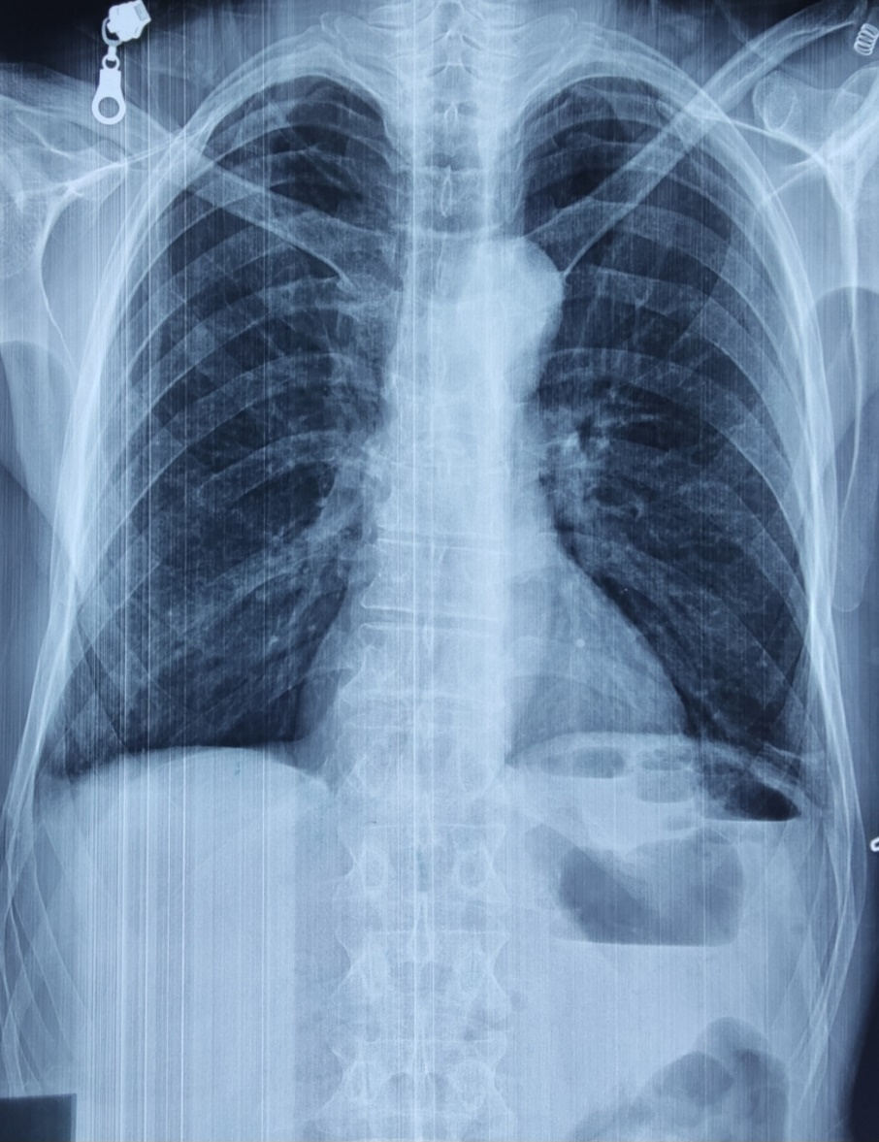

Figure1: plain abdominal x ray centered on the diaphragm.

A CT scan revealed the presence of 3 fluid collections with gas bubbles, in the gastric hepatic space, peri splenic, and in the liver measuring respectively 74x50mm, 40x80mm and 20x30mm.

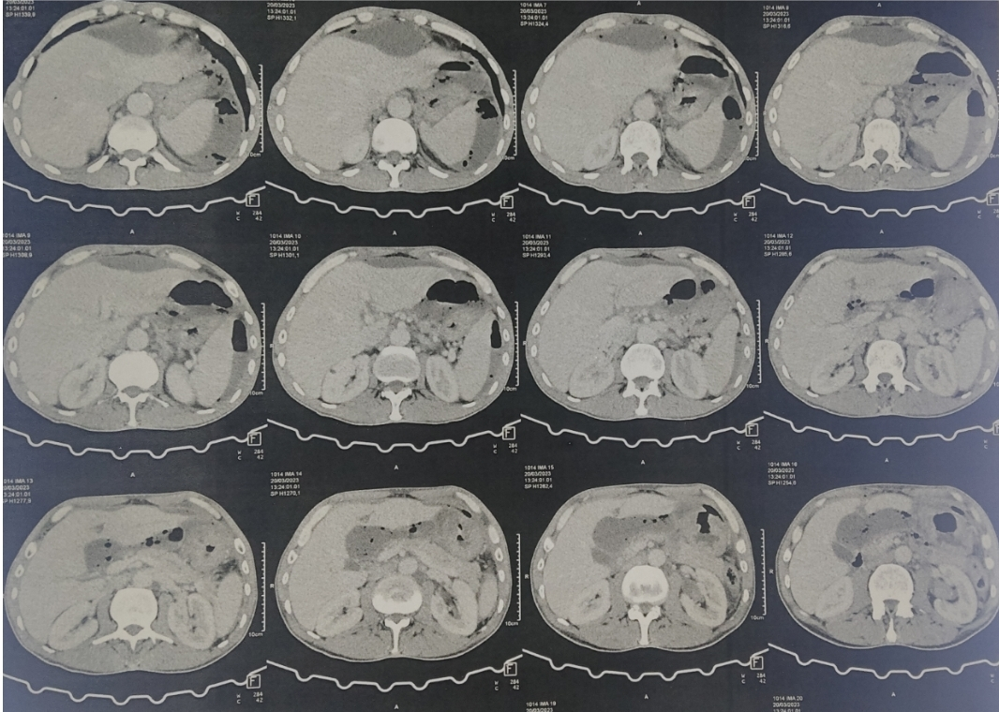

Figure 2: CT scan showing the fluid collections.

The patient was transferred to the operating room, and was operated on urgently. Upon incising, we found some adhesions with infra hepatic and peri splenic pus collections, and we discovered after liberating the adhesions, two gastric perforations of 0.5cm each, one in the antrum and the other was pyloric.

Both perforations were sutured primarily, with omental patch, a peritoneal lavage was performed and infra hepatic and left infra diaphragmatic drains were placed.

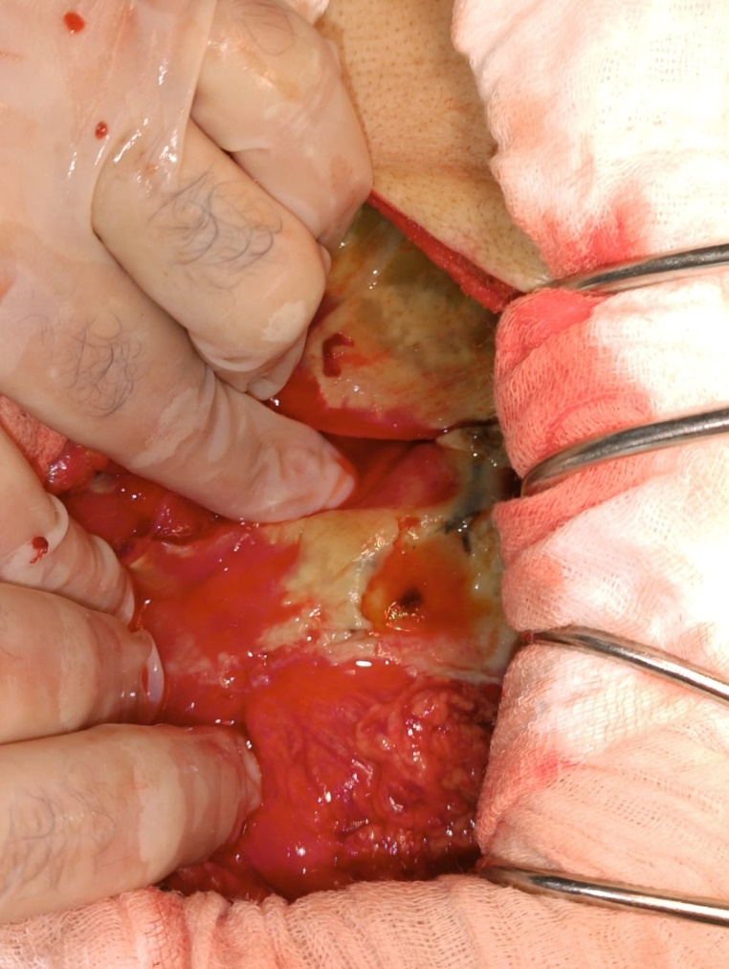

Figure 3: antrum perforation

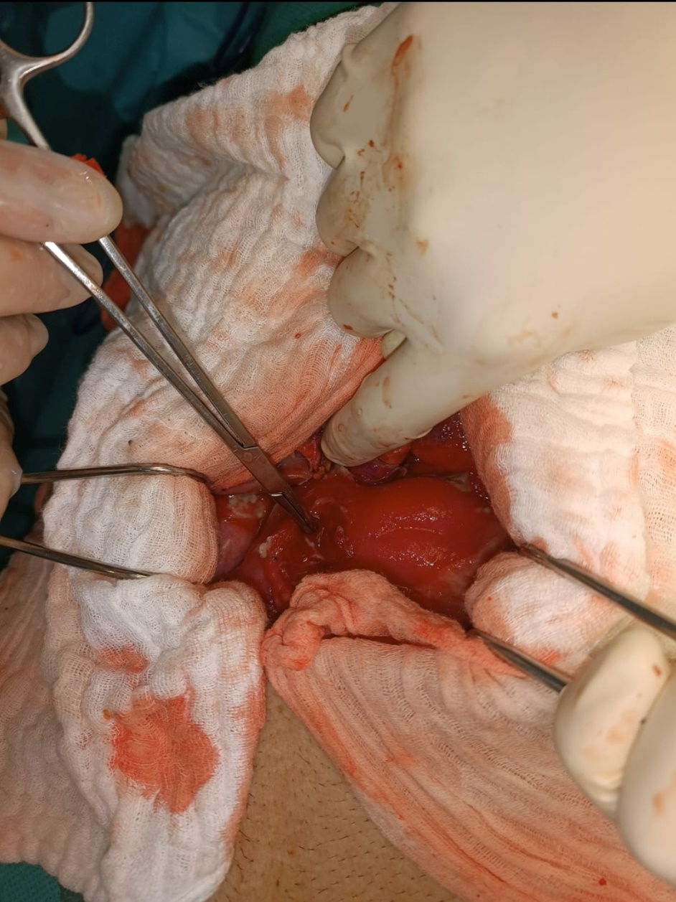

Figure4: the pyloric perforation

The post operative course was uneventful, and the patient was discharged on the fifth day.

3. discussion

Peptic ulcer perforation is one of the most frequent surgical emergencies, it is most frequently located in the pylorus and first part of the duodenum [3], the most common risk factors are Helicobacter pylori and chronic non-steroidal anti-inflammatory drugs use [4], other factor inducing chronic inflammation are stress, smoking and alcohol use.

Double peptic perforation is a very rare surgical entity, with only few articles describing such occurrence [5,6], it is mostly described in relation to trauma. Our patient did not have a history of chronic NSAIDs usage, his only predisposing factor was smoking (30 packs-years),

Conservative treatment is well described literature requiring close monitoring by a qualified team [7], laparoscopic repair by primary closure or grahams patch are the most used techniques [4], our patient had symptoms evolving for 5 days, and was on sepsis when admitted so the surgery was performed by laparotomy.

4. Conclusion

Peptic ulcer perforation is one of the most frequent abdominal emergencies, requiring prompt diagnosis, and expedited surgical treatment, double peptic perforation however, is a rare entity that should be known by surgeons and looked for during surgery.

Competing interests

Authors have declared that no competing interests exist.

Consent (where ever applicable)

All authors declare that written informed consent was obtained from the patient (or other approved parties) for publication of this case report and accompanying images. A copy of the written consent is available for review by the Editorial office/Chief Editor/Editorial Board members of this journal.

Ethical approval (where ever applicable)

All authors declare that ‘written informed consent was obtained from the patient (or other approved parties) for publication of this case report and accompanying images. A copy of the written consent is available for review by the Editorial office/Chief Editor/Editorial Board members of this journal.

References

1. Lanas A, Chan FKL. Peptic ulcer disease. Lancet. 2017 Aug 5;390(10094):613-624. doi: 10.1016/S0140-6736(16)32404-7. Epub 2017 Feb 25. PMID: 28242110.

2. BANZET P, PERNOD P. Un cas d'ulcère double perforé; bons résultats d'une opération de Dragstedt [Case of perforated double ulcer; successful results following Dragstedt operation]. Arch Mal Appar Dig Mal Nutr. 1953 Sep-Oct;42(9-10):1114-9. PMID: 13125702.

3. Bulut OB, Rasmussen C, Fischer A. Acute surgical treatment of complicated peptic ulcers with special reference to the elderly. World J Surg. 1996;20:574–7. doi: 10.1007/s002689900089.

4. Weledji EP. An Overview of Gastroduodenal Perforation. Front Surg. 2020 Nov 9;7:573901. doi: 10.3389/fsurg.2020.573901. PMID: 33240923; PMCID: PMC7680839.

5. Atul K. Sharma, Rakesh K. Sharma, Santosh K. Sharma, Devendra Soni, Tej Pratap Singh, Double peptic perforation: Report of a rare case, Asian Journal of Surgery,Volume 38, Issue 4,2015,Pages 239-241,ISSN 1015-9584,https://doi.org/10.1016/j.asjsur.2013.04.001.

6. Ozdemir K, Mantoglu B, Cakmak G, Dulger U, Bayhan Z, Eroz E. Double peptic ulcer perforation in a Covid-19 patient, extremely rare entity. Ulus Travma Acil Cerrahi Derg. 2023 Feb;29(2):252-254. doi: 10.14744/tjtes.2021.56346. PMID: 36748769; PMCID: PMC10198331.

7. Conservative management of perforated peptic ulcer. Lancet. 1989 Dec 16;2(8677):1429-30. PMID: 2574364.