*Case report*

Intra peritoneal migration of an intrauterine device, a case report

.

ABSTRACT

|  |
| --- |
| **Introduction:** Intrauterine devices are effective and reversible contraception methods, migration is rare complication described in this case report  **Presentation of the Case:** our patient is a 31 year old female, with history of surgery for small bowel obstruction 8 years ago, and placement of IUD 5 years ago. She presented symptoms of bowel obstruction, with tenderness of right lower quadrant. An emergency CT scan showed small bowel obstruction with a foreign object in the lower right quadrant of the abdomen.  The patient was operated urgently and a IUD was found in the peritoneum next to the caecum, the post operative course was uneventful and the patient discharged two days later.  **Discussion:** Migrating IUD is a rare complication although it is described in literature, it may occur during the insertion by an unnoticed perforation, or progressive transmural migration, it may be asymptomatic for a long time but once the migration is discovered it has to be extracted.  **Conclusion:** IUD is an effective, safe and reversible contraception method, the complications of which should be known by practitioners for an effective follow up. |

*Keywords: intrauterine device, acute abdomen, case report, migration.*

1. INTRODUCTION

Intrauterine devices (IUD) are effective, safe, and reversible methods of contraception, they work by either releasing copper or hormones rendering the environment unfavorable for sperm permeability, and fertilization. The complications of IUD include expulsion, cycle disruptions, increased risk of ectopic pregnancy and uterine perforation. Pregnancies and IUD migration are uncommon complications, occurring in 1 to 2 from 1,000 users [1].

2. Presentation of the case

We present the case of a 31 year old female, with a history of an abdominal surgery 8 years ago for small bowel obstruction, and placement of a IUD 5 years ago, Presenting generalized abdominal pain with bowel obstruction symptoms, physical examination of the patients found her in a stable condition with distended abdomen and tenderness in the right lower quardrant.

A plain abdominal x ray found some air-fluid levels with a foreign body in right lower quadrant of the abdomen.

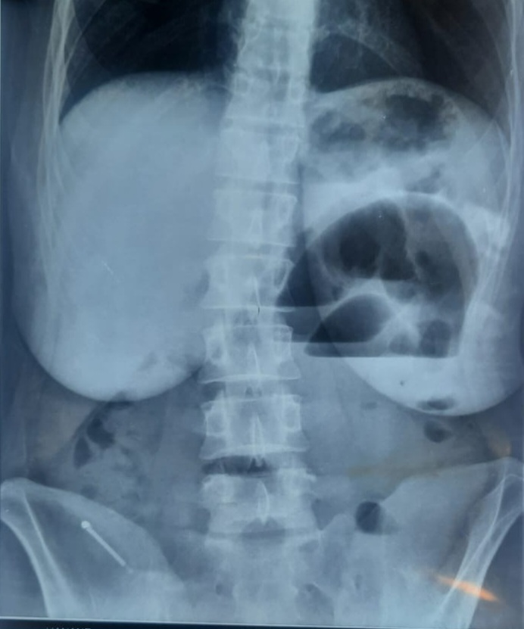

Figure1: plain abdominal x ray.

The CT scan showed signs of small bowel obstruction with suspicion of strangulation, and a foreign body in the right lower quadrant inside a 5cm collection.

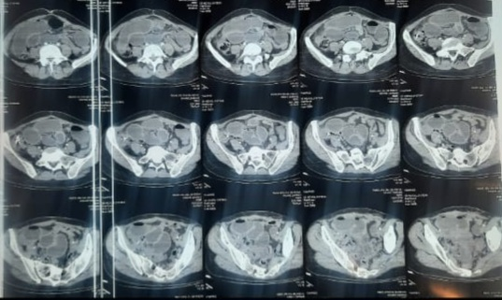

Figure 2: CT scan showing signs of obstruction and a foreign body.

The patient was transferred to the operating room, and was operated urgently. Upon incision there was a dilated small bowel with no obstruction, and there was a small collection of about 3cm in right lower quardrant of the abdomen next to the caecum which contained the IUD, the appendix was normal, the foreign body was extracted, and a peritoneal lavage was performed.

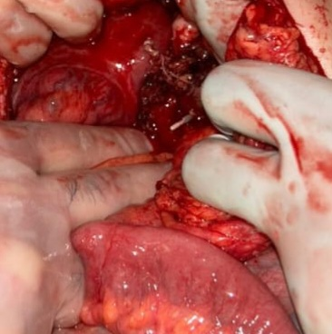

Figure 3: the foreign body in the right lower quadrant

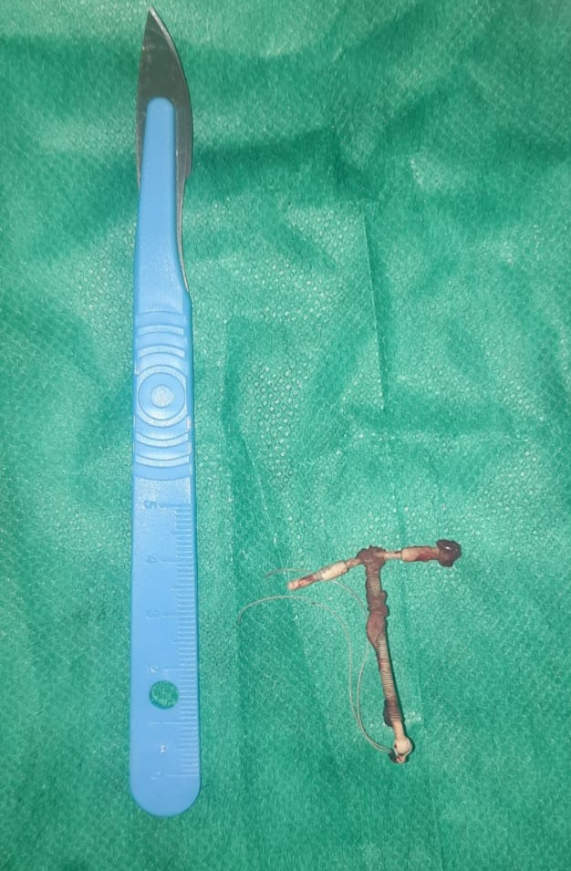

Figure 4: the IUD after extraction

The post operative course was uneventful, and the patient was discharged 2 days later.

3. discussion

IUD are safe, reversible and effective methods of contraception, they are either copper based or hormonal, it is up the patient to choose which variant to use [2].

The most common side effects of IUD are pain, irregular cycles, and rarely pelvic inflammatory disease, expulsion, perforation, and migration [3]

The misplacement of the device may occur and be unnoticed during insertion related to an unseen perforation, or be the result of gradual transmural migration [4], the IUD may be misplaced in any abdominal organ, including peritoneum [5], small bowel of colon [6], anterior abdominal wall[7].

Theses devices when misplaced may cause secondary complications, including acute appendicitis [8], bowel perforation [], peritoneal abcess [9] as it was with our case. When migrated, the device may be asymptomatic for a long time, and be discovered on a routine radiology test, however, it has to be extracted whenever discovered due to possible secondary complications[10].

4. Conclusion

The IUD is a globally accepted contraceptive method, they are highly effective, with low risks and relatively low cost, post insertion follow up and even self examination of the strings should help with early diagnosis of complications.

Consent (where ever applicable)

All authors declare that written informed consent was obtained from the patient (or other approved parties) for publication of this case report and accompanying images. A copy of the written consent is available for review by the Editorial office/Chief Editor/Editorial Board members of this journal.

Ethical approval (where ever applicable)

All authors declare that ‘written informed consent was obtained from the patient (or other approved parties) for publication of this case report and accompanying images. A copy of the written consent is available for review by the Editorial office/Chief Editor/Editorial Board members of this journal.

References

1. Addis NA, Sibhat YA, Molla YD, Mengestu WN, Seid AS, Damite MA, Worku MA. Migrated intra-uterine device to infra-umbilical skin: a rare case report. BMC Womens Health. 2024 Dec 30;24(1):672. doi: 10.1186/s12905-024-03522-0. PMID: 39736668; PMCID: PMC11684260.

2. Stephen Searle E. The intrauterine device and the intrauterine system. Best Pract Res Clin Obstet Gynaecol. 2014 Aug;28(6):807-24. doi: 10.1016/j.bpobgyn.2014.05.004. Epub 2014 Jun 5. PMID: 24947600.

3. Aoun J., Dines V.A., Stovall D.W., Mete M., Nelson C.B., Gomez-Lobo V. Effects of Age, Parity, and Device Type on Complications and Discontinuation of Intrauterine Devices. Obstet. Gynecol. 2014;123:585–592. doi: 10.1097/AOG.0000000000000144

4. Amaya SI, Henkel A, Blumenthal PD. Words matter: perforation… or transmural migration? BMJ Sex Reprod Health. 2023 Apr;49(2):74-75. doi: 10.1136/bmjsrh-2022-201738. Epub 2022 Dec 23. PMID: 36564157.

5. Benaguida H, Kiram H, Telmoudi EC, Ouafidi B, Benhessou M, Ennachit M et al. Intraperitoneal migration of an intrauterine device (IUD): A case report. Annals of medicine and surgery (2012). 2021;68:102547

6. Aliukonis V, Lasinskas M, Pilvelis A, Gradauskas A. Intrauterine device migration into the lumen of large bowel: a case report. Int J Surg case Rep. 2020;72:306–8.

7. Jing J. Case report: an intrauterine device hugging the musculus Rectus abdominis through the center of a cesarean scar. Front Surg. 2022;9:956856.

8. Sebai A, Elaifia R, Atri S, Hammami M, Haddad A, Kacem JM. Intrauterine device migration resulting in acute appendicitis: a case report. Int J Surg case Rep. 2024;117:109515.

9. Toumi O, Ammar H, Ghdira A, Chhaidar A, Trimech W, Gupta R, et al. Pelvic abscess complicating sigmoid colon perforation by migrating intrauterine device: a case report and review of the literature. Int J Surg case Rep. 2018;42:60–3.

10. WHO Scientific Group on Mechanism of Action, Efficacy of Intrauterine Devices . Mechanism of Action, Safety and Efficacy of Intrauterine Devices. Report of a WHO Scientific Group. Volume 753. WHO; Geneva, Switzerland: 1987. pp. 1–91. (World Health Organization Technical Report Series)