Case Report

Todani Type 1B Choledochal Cyst in A 2-Year-Old Child: A Rare Case With Biliary Reconstruction Using Roux-en-Y Hepaticojejunostomy

|  |
| --- |
| **Aims:** To Report cases of choledochal cyst, the flow of diagnosis, and management of these cases.  **Case Description:** Two cases of choledochal cysts were reported in 2-year-old children, presenting with abdominal mass, jaundice, abdominal discomfort, pale stools, and vomiting. Laboratory findings revealed elevated direct and total bilirubin levels, as well as elevated SGOT and SGPT. Abdominal ultrasound showed saccular dilatation of the common hepatic duct (CBD) extending to the proximal CBD, without intrahepatic bile duct dilation, indicative of a type 1B choledochal cyst. Abdominal CT scan revealed cystic duct dilation and gallbladder wall edema, with contrast enhancement and a fusiform cystic lesion from the CHD to the CBD. No carcinoma cells were identified on pathological examination.  **Discussion:** Choledochal cysts, particularly Todani type IB, present with variable clinical features despite similar anatomical involvement. Early diagnosis through imaging is essential, with MRCP offering the highest diagnostic accuracy. Surgical excision followed by Roux-en-Y hepaticojejunostomy remains the treatment of choice. Although the risk of malignancy is low after complete resection, incomplete excision significantly increases this risk, highlighting the importance of early detection, comprehensive imaging, and meticulous surgical planning.  **Conclusion:** Early recognition and surgical management of choledochal cysts are essential to prevent complications and reduce the risk of malignant transformation. |

*Keywords: choledochal cyst; hepaticojejunostomy; Todani Type 1b*

1. INTRODUCTION

Choledochal cyst is a congenital dilatation of the bile duct that can occur in the intrahepatic, extrahepatic, or both segments of the biliary tree. The incidence in Western populations is approximately 1 in 100,000–150,000 live births, while in Asian populations it ranges from 1 in 1,000–13,000 live births¹. This condition is more common in females, particularly during the first decade of life, with type I being the most frequent subtype².

Approximately 80% of choledochal cyst cases are diagnosed in infants and children during the first decade of life³. The clinical and pathological presentations vary depending on the patient’s age¹. In children, the most common symptoms are abdominal discomfort, jaundice, and an abdominal mass known collectively as the classical triad though this triad is present in only 20% of cases. Around 85% of pediatric patients present with only two of these symptoms, usually abdominal mass and jaundice. In infants, signs include jaundice, acholic stools, and vomiting, which may mimic biliary atresia, hepatic fibrosis, or cirrhosis. In adults, choledochal cysts are more likely to present with complications such as cholangitis, pancreatitis, or cyst rupture leading to peritonitis. Malignant transformation in the biliary tract occurs in approximately 10% to 30% of cases4,5,6,7.

Diagnostic modalities include abdominal ultrasonography, endoscopic retrograde cholangiopancreatography (ERCP), and magnetic resonance cholangiopancreatography (MRCP). Abdominal ultrasound is the initial diagnostic tool of choice, allowing clear visualization of intra- and extrahepatic duct dilatation. Computed tomography (CT) provides high accuracy and assists in preoperative planning. MRCP is considered the gold standard for diagnosing choledochal cysts, with a sensitivity ranging from 90% to 100%8,9.

The treatment of choice is total cyst excision followed by biliary reconstruction. Laparoscopic Roux-en-Y hepaticojejunostomy (RYHJ) has been shown to be a safe and effective method in both infants and children¹⁰. This case report aims to present and evaluate a Todani Type IB choledochal cyst in a 2-year-old child, focusing on the clinical diagnosis and biliary reconstruction using the RYHJ technique.

2. Presentation of case

We report two cases of choledochal cysts in 2-year-old children. The first patient presented with intermittent right upper quadrant abdominal pain and jaundice. Laboratory results showed elevated liver enzymes (SGOT 95 U/L, SGPT 149 U/L) and increased direct (1.02 mg/dL) and total bilirubin (1.71 mg/dL). The second patient had similar abdominal pain, accompanied by steatorrhea and tea-colored urine, but laboratory parameters were within normal limits.

Abdominal ultrasonography in both patients revealed saccular dilatation of the common hepatic duct (CHD) extending into the proximal common bile duct (CBD), with no intrahepatic bile duct (IHBD) involvement suggestive of a Todani type IB choledochal cyst. Contrast-enhanced CT confirmed cystic duct dilatation and a fusiform fluid-density lesion extending from the CHD to the CBD, without gallstones.

Both patients underwent open surgical excision of the cyst and gallbladder, followed by Roux-en-Y hepaticojejunostomy (RYHJ) reconstruction. The cyst was completely resected, and the hepaticojejunostomy was performed using a 50 cm Roux limb. Postoperative recovery was uneventful.

Macroscopic pathology showed a dilated CBD measuring approximately 2 cm in length and 1.5 cm in diameter, and a gallbladder measuring 9.5 × 6 × 1.5 cm with no stones or masses. Microscopic examination revealed cystic duct lined with columnar epithelium, fibrous stroma, focal mucosal erosion, lymphohistiocytic infiltration, and dilated blood vessels. No signs of malignancy were observed. By postoperative day two, the first patient showed clinical improvement with declining bilirubin and normalized liver enzyme levels.

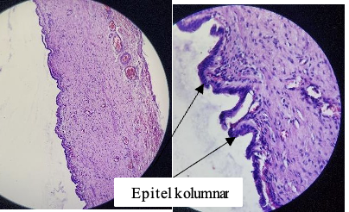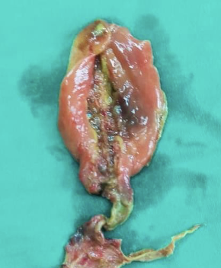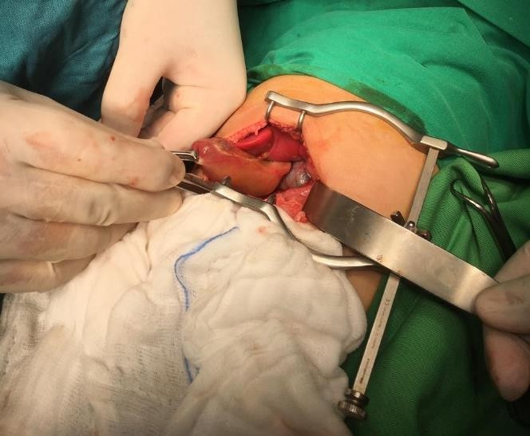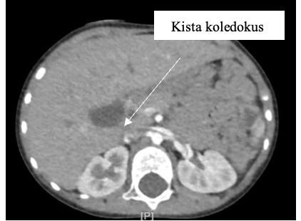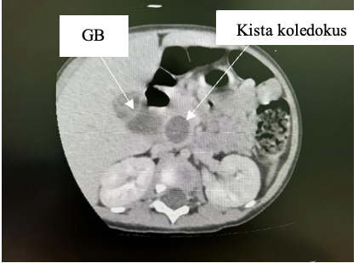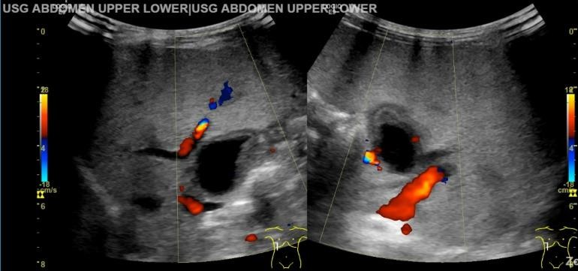

**Fig. 5. Surgical removal of the gallbladder and the choledochal duct.**

**Fig. 6. The cystically dilated coledocus duct appears partially lined with columnar epithelium. Stroma fibrous tissue.**

**Fig. 3. Abdominal CT scan of the second patient revealed a saccular cystic dilatation measuring approximately 1.9 × 2 × 2.5 cm in the proximal common bile duct.**

**Fig. 4. Intraoperatif exisi CC with hepaticojejunostomy reconstruction**

**Fig. 1. Abdominal ultrasound revealed an anechoic cyst measuring approximately 1.6 × 2.1 cm in the biliary tract.**

**Fig. 2. Contrast-enhanced axial abdominal CT scan of the first patient revealed a saccular cystic dilatation measuring approximately 1.9 × 2 × 2.5 cm in the proximal common bile duct, consistent with Todani type 1b.**

3. discussion

Choledochal cysts are rare congenital anomalies of the biliary tract, most commonly diagnosed during childhood. The classical triad—abdominal pain, right upper quadrant mass, and jaundice—is present in only a minority of pediatric patients11,12,13.Todani type I is the most common, and subtype IB, involving segmental saccular dilatation of the common bile duct, is among the rarest14,15.

In this report, we describe two cases of Todani type IB cysts in 2-year-old children with differing clinical manifestations, highlighting the variability of presentation even in anatomically similar lesions. One patient exhibited jaundice and elevated liver enzymes, while the other presented with steatorrhea and tea-colored urine but normal laboratory results. These differences emphasize the importance of including choledochal cysts in the differential diagnosis of abdominal symptoms in young children2,16,18.

Type I cysts are frequently associated with abnormal pancreaticobiliary ductal junctions (APBDJ), allowing pancreatic enzyme reflux into the bile duct and contributing to chronic irritation and cyst formation4. Diagnosis relies heavily on imaging. Ultrasound remains the initial modality due to its accessibility and sensitivity (71–97%), while contrast-enhanced CT helps delineate cyst anatomy. MRCP is considered the gold standard due to its non-invasiveness and high diagnostic accuracy (90–100%)17,19. ERCP, while therapeutic, is less favored due to its invasive nature and associated risks.

Management depends on cyst type and hepatobiliary involvement. Complete excision followed by biliary reconstruction is essential20. For type I cysts, Roux-en-Y hepaticojejunostomy (RYHJ) is widely accepted as the gold standard due to its safety and low complication rate21,23.Both of our patients underwent open total cyst excision with RYHJ, with no immediate postoperative complications.

Histopathological examination confirmed chronic inflammatory changes without malignancy. Although the risk of malignant transformation after complete excision is low (<1%), it rises significantly with incomplete resection, underscoring the importance of thorough surgical planning22. The overall malignancy risk in choledochal anomalies has been reported at 0.7%–6%, with chronic inflammation and cellular regeneration contributing to carcinogenesis24,25.

4. Conclusion

Choledochal cyst should be considered as a differential diagnosis in children presenting with abdominal pain. Early detection of this condition is crucial to prevent prolonged symptoms and to avoid delays in necessary surgical intervention. Once the diagnosis is established, timely surgical management is essential to prevent complications. Postoperative histopathological examination also plays a vital role in identifying any potential malignant transformation.

contributions included detailed documentation of the clinical case.

Consent AND ATHICAL APPROVAL

In accordance with university regulations, participant consent and ethical clearance have been obtained and are securely retained by the authors.

References

1. Bin TW, Twayana AR, Sunuwar N, et al. A rare case of choledochal cyst. F1000Research. 2022;11:919. doi:10.12688/f1000research.123930
2. Hung MH, Lin LH, Chen DF, Huang CS. Choledochal cysts in infants and children: experiences over a 20-year period at a single institution. Eur J Pediatr. 2011;170(9):1179-85. doi:10.1007/s00431-011-1429-2
3. Tigabie W, Tesfay H, Tamrat D, Raya K, Negussie T. Unusual variant of choledochal cyst in a child: a case report. Int J Surg Case Rep. 2020;75:117-21. doi:10.1016/j.ijscr.2020.09.023
4. Dira IKPA, Putra IGNS, Karyana IPG, Nesa NNM, Ariyanta KD, Dharmajaya IM. Choledochal cyst (CC) Todani type I in two years old girl: a case report. Intisari Sains Medis. 2023;14(3):1124-9. doi:10.15562/ism.v14i3.1839
5. Soares KC, Kim Y, Spolverato G, et al. Presentation and clinical outcomes of choledochal cysts in children and adults: a multi-institutional analysis. JAMA Surg. 2015;150(6):577-84. doi:10.1001/jamasurg.2015.0226
6. Murphy AJ, Axt JR, Lovvorn HN. Associations between pediatric choledochal cysts, biliary atresia, and congenital cardiac anomalies. J Surg Res. 2012;177(2):e59-63. doi:10.1016/j.jss.2012.04.018
7. Bhavsar MS, Vora HB, Giriyappa VH. Choledochal cysts: a review of literature. Saudi J Gastroenterol. 2012;18(4):230-6. doi:10.4103/1319-3767.98425
8. Sapulete EJ, Putra IGNS, Karyana IPG, Nesa NNM, Darmajaya IM, Ariyanta KD. A giant choledochal cyst in 8 years old female. Medicina (B Aires). 2019;50(2):410-4. doi:10.15562/medicina.v50i2.110
9. Yurttutan N, Karakus SC, Koku N, Demirci M, Ucak R. A giant choledochal cyst in infancy: a case report. Korean J Pediatr. 2016;59(5):239-41. doi:10.3345/kjp.2016.59.5.239
10. Hae KL, Seong JP, Bum HY, A LL, Jong HM, Yun WC. Imaging features of adult choledochal cysts: a pictorial review. Korean J Radiol. 2009;10(1):71-80. doi:10.3348/kjr.2009.10.1.71
11. Soares KC, Arnaoutakis DJ, Kamel I, et al. Choledochal cysts: presentation, clinical differentiation, and management. J Am Coll Surg. 2014;219(6):1167-80. doi:10.1016/j.jamcollsurg.2014.04.023
12. Jung SM, Seo JM, Lee SK. The relationship between biliary amylase and the clinical features of choledochal cysts in pediatric patients. World J Surg. 2012;36(9):2098-103. doi:10.1007/s00268-012-1619-8
13. Shah OJ, Shera AH, Zargar SA, et al. Choledochal cysts in children and adults with contrasting profiles: 11-year experience at a tertiary care center in Kashmir. World J Surg. 2009;33(11):2403-11. doi:10.1007/s00268-009-0184-2
14. Todani T, Watanabe Y, Narusue M, Tabuchi K, Okajima K. Congenital bile duct cysts: classification, operative procedures, and review of thirty-seven cases including cancer arising from choledochal cyst. Pediatr Surg. 1977;134:77-80. doi:10.1201/9781003341901-26
15. Miron A, Popa LG, Toma EA, Calu V, Parvuletu RF, Enciu O. The curious case of the choledochal cyst—revisiting the Todani classification: case report and review of the literature. Diagnostics. 2023;13(6). doi:10.3390/diagnostics13061059
16. Badebarin D, Aslanabadi S, Teimouri-Dereshki A, et al. Different clinical presentations of choledochal cyst among infants and older children. Medicine (Baltimore). 2017;96(17):e6679. doi:10.1097/MD.0000000000006679
17. Hoilat GJ, John S. Choledochal cyst. In: StatPearls [Internet]. Treasure Island (FL): StatPearls Publishing; 2023.
18. Fumino S, Ono S, Kimura O, Deguchi E, Iwai N. Diagnostic impact of computed tomography cholangiography and magnetic resonance cholangiopancreatography on pancreaticobiliary maljunction. J Pediatr Surg. 2011;46(7):1373-8. doi:10.1016/j.jpedsurg.2011.01.026
19. Ohashi T, Wakai T, Kubota M, et al. Risk of subsequent biliary malignancy in patients undergoing cyst excision for congenital choledochal cysts. J Gastroenterol Hepatol. 2013;28(2):243-7. doi:10.1111/j.1440-1746.2012.07260.x
20. Khandelwal C, Anand U, Kumar B, Priyadarshi RN. Diagnosis and management of choledochal cysts. Indian J Surg. 2012;74(1):29-34. doi:10.1007/s12262-011-0388-1
21. Narayanan SK, Chen Y, Narasimhan KL, Cohen RC. Hepaticoduodenostomy versus hepaticojejunostomy after resection of choledochal cyst: a systematic review and meta-analysis. J Pediatr Surg. 2013;48(11):2336-42. doi:10.1016/j.jpedsurg.2013.07.020
22. Watanabe Y, Toki A, Todani T. Bile duct cancer developed after cyst excision for choledochal cyst. J Hepatobiliary Pancreat Surg. 1999;6(3):207-12. doi:10.1007/s005340050108
23. Sharma A, Pandey A, Rawat J, Ahmed I, Wakhlu A, Kureel SN. Conventional and unconventional surgical modalities for choledochal cyst: long-term follow-up. Ann Pediatr Surg. 2011;7(1):16-8. doi:10.1097/01.XPS.0000393093.1853.99
24. Ten Hove A, de Meijer VE, Hulscher JBF, de Kleine RHJ. Meta-analysis of risk of developing malignancy in congenital choledochal malformation. Br J Surg. 2018;105(5):482-90. doi:10.1002/bjs.10798
25. Imazu M, Iwai N, Tokiwa K, Shimotake T, Kimura O, Ono S. Factors of biliary carcinogenesis in choledochal cysts. Eur J Pediatr Surg. 2001;11(1):24-7. doi:10.1055/s-2001-12190