***Case report***

**A Rare Occurrence of Cholecystogastric Fistula with Perforation Peritonitis: A Case Report**

**Abstract**

|  |
| --- |
| Cholecystogastric fistula is one of the rarest and most life-threatening complications of peptic ulcer disease. This disease can mimic other diseases such as perforation peritonitis and is too hard to be diagnosed preoperatively. This article presents a 33-year-old female with the presentation of abdominal pain, vomiting with sign and symptoms mimicking peptic perforation peritonitis. Xray FPA showed gas under diaphragm An emergency laparotomy was performed which revealed a cholecystogastric fistula with perforation perititonitis for which cholecystectomy with modified grahm patch repair was done. Cholecystogastric fistula should be considered a significant differential diagnosis in patients with abdominal pain, vomiting and peptic ulcer symptoms. |

Keywords: Peptic ulcer, Cholecystogastric fistula, Perforation peritonitis, Laparotomy, Cholecystectomy, Gastric malignancy

**Introduction**

Peptic ulcer disease is characterized by discontinuation in the inner lining of the gastrointestinal tract because of gastric acid secretion and pepsin. It can extend into muscularis propria layer of gastric epithelium. It affects four million people worldwide annually [[1](https://www.ncbi.nlm.nih.gov/pmc/articles/PMC9342757/#pone.0271284.ref001)] and has an estimated lifetime prevalence of 5−10% in the general population [[2](https://www.ncbi.nlm.nih.gov/pmc/articles/PMC9342757/#pone.0271284.ref002)]. Although the global prevalence of PUD has dramatically decreased in the past decades because of proton pump inhibitors [[3](https://www.ncbi.nlm.nih.gov/pmc/articles/PMC9342757/#pone.0271284.ref003)], the incidence of its complications has remained constant which are bleeding, perforation, gastric outlet obstruction, gastric malignancy and rarely biliarygastric fistulae[[4](https://www.ncbi.nlm.nih.gov/pmc/articles/PMC9342757/#pone.0271284.ref004)]. Cholecystoenteric fistula (CEF) is an abnormal communication between the gallbladder and luminal gastrointestinal (GI) tract. Cholecystoduodenal fistula (CDF) is the most common, followed by cholecystocolonic fistula (CCF) and rarely cholecystogastric fistula (CGF) [[5]](javascript:void(0)). There have been multiple reports of CGF as far back as 1956 [[6]](javascript:void(0)). While CGF is usually associated with chronic cholecystitis or long-standing cholelithiasis, other reported causes include peptic ulcer disease, inflammatory bowel disease, and GI malignancy [[1,7]](javascript:void(0)). We present a rare of case of cholecystogastric fistula secondary to peptic ulcer disease.

**Case Presentation**

We present a case of a 33-year-old lean female patient, housewife by occupation. Patient gave history of post-prandial abdominal pain, nausea and epigastric fullness for past 2 months for which USG abdomen was done and no significant abnormality was detected. There was no history of any chronic illness, substance abuse and no past operative history. Patient presented to the Surgical Emergency of Mathura Das Mathur Hospital, Jodhpur Rajasthan with complain of severe abdominal pain, vomiting and abdominal distention for 2 days. Severe Pain which was sudden in onset, burning in nature initially localized to epigastric region then became generalized to whole abdomen, non-radiating with 3-4 episodes of bilious vomiting, associated with fever and not relieved by analgesics. On presentation her vitals were: pulse - 114bpm, BP 90/60 mmhg, SpO2 97% RA. Patient was pale and febrile. Abdominal examination revealed distention, generalized tenderness and localized epigastric and right hypochondrium guarding, on percussion there was tympanic note over epigastrium and right hypochondrium, dull note at lower abdomen. Patient was resuscitated using intravenous fluids. Antibiotics were administered intravenously.

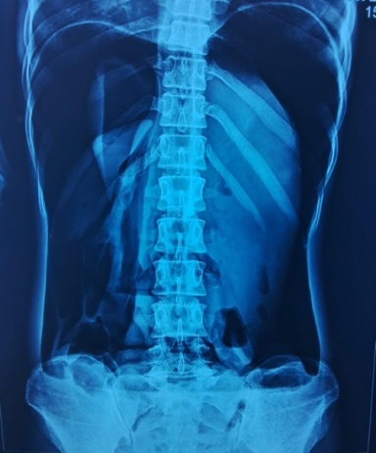.

Figure 1(Showing gas under diaphragm)

Patient undergone x ray FPA which shows gas under diaphragm (figure 1)

USG whole abdomen shows suboptimal study due to gaseous abdomen and moderate amount of free fluid with multiple septations, in CECT whole abdomen there was serpinginous fistulous tract with enhancing wall noted between the gall bladder and antro-pylorus region of stomach with possible rupture. Air foci were noted within GB lumen. Gross pneumoperitoneum and gross ascitis was also noted. (figure 2,3)

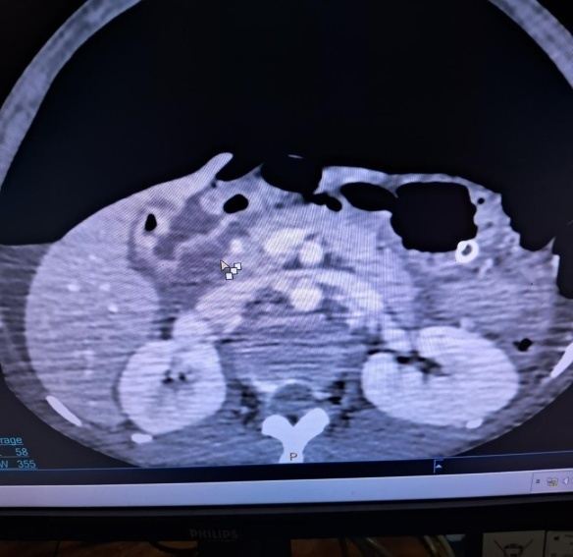 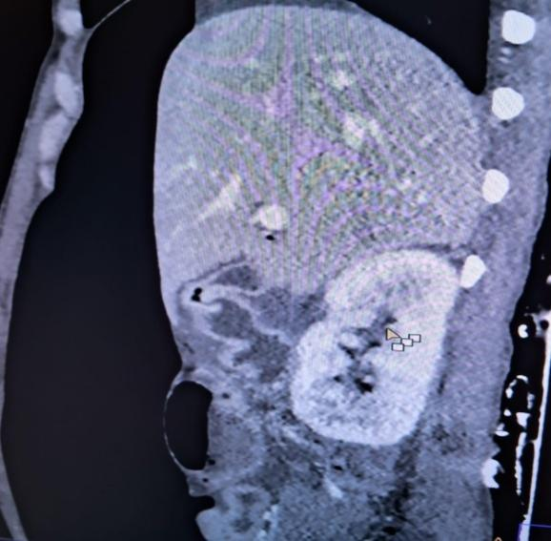

Figure 2(Axial view of cect shows gas in gall

bladder with fistula between GB and stomach) Figure 3(Sagittal view of cect shows gas in GB)

Under general anesthesia, patient was operated through a classical midline vertical incision . Intraoperatively there was ~1.5 litre bilious collection with ~200 gram pus flakes. The entire gut was edematous and inflammed . Pylorus was densely adherent to Gall Bladder fundus, on separation a fistulous tract was noted between stomach and GB, with a 3\*4 cm perforation at pyloric region and 2\*3 cm rent at fundus of gall bladder bladder (figure 4) with no gall bladder stone found within gall bladder lumen or ectopic site.

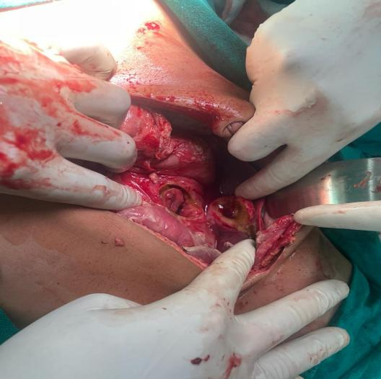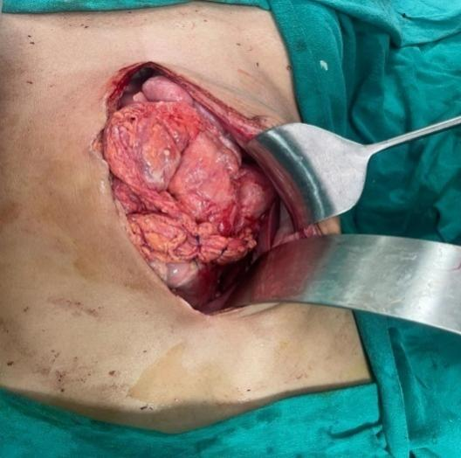

Figure 4 (blue arrow shows 2\*3cm GB perforation,

white arrow shows 3\*4cm gastric perforation) Figure 5 (modified grahm patch repair )

Peritoneal lavage was done with 5 litre normal saline then cholecystectomy with modified grahm patch repair was done using prolene 2-0 round body (Figure 5) and peritoneal drain placed in morrison pouch. Post operative period was uneventful.

Table 1 : Parameters analysed at the time of admission and postoperative day 1

|  |  |  |  |
| --- | --- | --- | --- |
| Parameter | At time of admission | Postoperative day 1 | Reference value |
| Hemoglobin | 9.6g/dl | 11.5g/dl | 11.0-15.0g/dl |
| Total leucocyte count | 17.79\*103 | 15.4\*103 | 4-10\*103 |
| Blood urea | 30mg/dl | 18mg/dl | 17-43mg/dl |
| Serum creatinine | 0.68mg/dl | 0.63mg/dl | 0.6-1.2mg/dl |
| SGOT/SGPT | 56/28 IU | 11/10 | 37/42IU |
| Serum albumin | 3.0gm/dl | 2.3gm/dl | 3.5-5.3gm/dl |

Patient was allowed orally on day 5. Drain removed on POD-6. Patient discharged and was advised to attend Gastroenterology OPD. Patient presented in gastroenterology dept. after one month with single episode of hemetemesis for which patient underwent UGI endoscopy which was s/o Peptic ulcer disease(Figure 6) . Patient was managed accordingly.

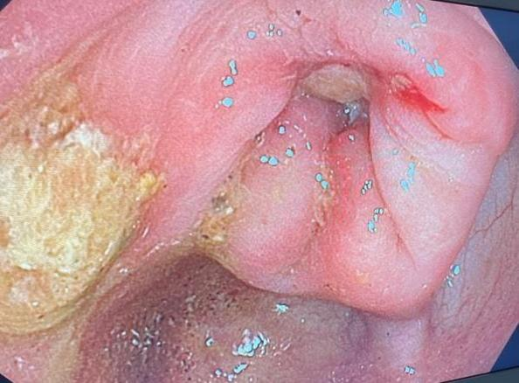

Figure 6 (UGI endoscopy shows deep prepyloric ulcer

of size 5\*5mm with yellowish exudates at base extending

into pyloric opening with erythematous

surrounding causing pyloric lumen narrowing)

**Discussion**

Biliary fistulas occur in 3–5% of patients with gallstones [8], with the duodenum being the most common site of fistulation followed by the stomach [9]. The risk associated with fistulation is the potential for gastrointestinal tract obstruction, which is said to happen most frequently at the terminal ileum and ileocecal valve. [10]. In our case, the patient displayed signs of perforation peritonitis, which is due to fistulating by peptic ulcer disease. This most commonly occurs in females in the seventh and eighth decades of life [11] and whilst this syndrome remains a rare clinical entity it is worth considering when evaluating elderly patients with chronic abdominal pain. With regards to imaging, CT remains the modality of choice when investigating a patient with suspected Cholecystogastric fistulas. Cholecystogastric fistulas have been reported as far back as 1956 and whilst once associated with high mortality the majority are now managed successfully due to improved radiological and endoscopic modalities and subsequent surgical intervention, as demonstrated in this case. Many still argue that ‘one-stage’ surgery involving fistula repair and cholecystectomy remains the only effective means of treatment [12]. However, whilst our patient also underwent ‘one-stage’ surgery as patient presented with peritonitis and underwent laparotomy with cholecystectomy and modified grahm patch repair . There is also increasing evidence for the use of interval cholecystectomy in patients where the removal of the gallbladder at the time of first operation is deemed inappropriate [13,14]. Some may argue that the patient should have undergone ‘two-stage’ surgery and return for cholecystectomy and fistula repair given the risk of disease recurrence. However, our patient experienced minimal morbidity and has no necessity for further surgery . Endoscopic treatment of cholecystogastric fistulas often offers a safer and more prudent solution to the problem given the patient group and likely associated co-morbidities., GIT haemorrhage, stone impaction and improper or partial stone manipulation and perforation peritonitis are often the mitigating factors for such failure and so surgical intervention is warranted.

Study limitations

This study aimed to pinpoint a rare complication of a relatively common disease, however, it provides little evidence concerning the treatment plan. It is a case report that needs to be endorsed by other studies higher in quality to allow us to know more about managing this condition.

**Conclusions**

Cholecystogastric Fistula is a rare complication of peptic ulcer disease. Patients may present with non-specific clinical symptoms, which makes the diagnosis difficult. Gas in Gall bladder and the presence of contrast in the gall bladder should always alert the clinician to the possibility of Cholecystogastric Fistula. Surgery should be considered in such cases. This case report is a reminder of a rare complication for a relatively common disease: peptic ulcer disease.

## REFERENCES

1. Zelickson MS, Bronder CM, Johnson BL, Camunas JA, Smith DE, Rawlinson D, et al. Helicobacter pylori is not the predominant etiology for peptic ulcers requiring operation. *Am Surg*. 2011;77: 1054–1060. [[PubMed](https://pubmed.ncbi.nlm.nih.gov/21944523)] [[Google Scholar](https://scholar.google.com/scholar_lookup?journal=Am+Surg&title=Helicobacter+pylori+is+not+the+predominant+etiology+for+peptic+ulcers+requiring+operation&author=MS+Zelickson&author=CM+Bronder&author=BL+Johnson&author=JA+Camunas&author=DE+Smith&volume=77&publication_year=2011&pages=1054-1060&pmid=21944523&)]

2. Lanas A, Chan FKL. Peptic ulcer disease. *Lancet (London, England).* 2017;390: 613–624. doi: 10.1016/S0140-6736(16)32404-7 [[PubMed](https://pubmed.ncbi.nlm.nih.gov/28242110)] [[CrossRef](https://doi.org/10.1016%2FS0140-6736(16)32404-7" \t "_blank)] [[Google Scholar](https://scholar.google.com/scholar_lookup?journal=Lancet+(London,+England).&title=Peptic+ulcer+disease&author=A+Lanas&author=FKL+Chan&volume=390&publication_year=2017&pages=613-624&pmid=28242110&doi=10.1016/S0140-6736(16)32404-7&)]

3. Kavitt RT, Lipowska AM, Anyane-Yeboa A, Gralnek IM. Diagnosis and Treatment of Peptic Ulcer Disease. *Am J Med*. 2019;132: 447–456. doi: 10.1016/j.amjmed.2018.12.009 [[PubMed](https://pubmed.ncbi.nlm.nih.gov/30611829)] [[CrossRef](https://doi.org/10.1016%2Fj.amjmed.2018.12.009" \t "_blank)] [[Google Scholar](https://scholar.google.com/scholar_lookup?journal=Am+J+Med&title=Diagnosis+and+Treatment+of+Peptic+Ulcer+Disease&author=RT+Kavitt&author=AM+Lipowska&author=A+Anyane-Yeboa&author=IM+Gralnek&volume=132&publication_year=2019&pages=447-456&pmid=30611829&doi=10.1016/j.amjmed.2018.12.009&)]

4. Sung JJY, Kuipers EJ, El-Serag HB. Systematic review: the global incidence and prevalence of peptic ulcer disease. *Aliment Pharmacol Ther*. 2009;29: 938–946. doi: 10.1111/j.1365-2036.2009.03960.x [[PubMed](https://pubmed.ncbi.nlm.nih.gov/19220208)] [[CrossRef](https://doi.org/10.1111%2Fj.1365-2036.2009.03960.x" \t "_blank)] [[Google Scholar](https://scholar.google.com/scholar_lookup?journal=Aliment+Pharmacol+Ther&title=Systematic+review:+the+global+incidence+and+prevalence+of+peptic+ulcer+disease&author=JJY+Sung&author=EJ+Kuipers&author=HB+El-Serag&volume=29&publication_year=2009&pages=938-946&pmid=19220208&doi=10.1111/j.1365-2036.2009.03960.x&)]

5.Nayak SK, Parthasarathi R, Gupta GHVR, Palanivelu C: [Laparoscopic approach in cholecystogastric fistula with cholecystectomy and omental patching: a case report and review](https://dx.doi.org/10.4103/jmas.JMAS_87_20). J Minim Access Surg. 2021, 17:245-8. [10.4103/jmas.JMAS\_87\_20](https://dx.doi.org/10.4103/jmas.JMAS_87_20)

6.Melamed JL, Parker ML: [Cholecystogastric fistula: report of a case](https://dx.doi.org/10.1001/jama.1956.02960410039009a" \t "_blank). JAMA. 1956, 160:463-4.[10.1001/jama.1956.02960410039009a](https://dx.doi.org/10.1001/jama.1956.02960410039009a)

7.Nakamura M, Hamanaka Y, Kawamura A, Suzuki T: [Successful preoperative diagnosis of a cholecystogastric fistula using endoscopic retrograde cholangiography: report of a case](https://dx.doi.org/10.1007/BF02385814). Surg Today. 1997, 27:567-70. [10.1007/BF02385814](https://dx.doi.org/10.1007/BF02385814)

8. Angrisani L, Corcione F, Tartaglia A, Tricarico A,Rendano F, Vincenti R, et al. Cholecystoenteric fistula (CF) is not a contraindication for laparoscopic surgery, *Surg Endosc*, 2001, vol. 15 (pg. 1038-41)[10.1007/s004640000317](https://doi.org/10.1007/s004640000317) [Google Scholar](https://scholar.google.com/scholar_lookup?title=Cholecystoenteric%20fistula%20%28CF%29%20is%20not%20a%20contraindication%20for%20laparoscopic%20surgery&author=L%20Angrisani&author=F%20Corcione&author=A%20Tartaglia&author=A%20Tricarico&author=F%20Rendano&author=R%20Vincenti&publication_year=2001&journal=Surg%20Endosc&volume=15&pages=1038-41) [Crossref](http://dx.doi.org/10.1007/s004640000317) [PubMed](http://www.ncbi.nlm.nih.gov/pubmed/11443421) [WorldCat](https://www.worldcat.org/search?q=ti:Cholecystoenteric%20fistula%20%28CF%29%20is%20not%20a%20contraindication%20for%20laparoscopic%20surgery&qt=advanced&dblist=638)

9. Chowbey PK, Bandyopadhyay SK, Sharma A, Khullar R, Soni V, Baijal M.Laparoscopic management of cholecystoenteric fistulas, *J Laparoendosc Adv Surg Tech A* ,2006, vol. 16 (pg. 467-72)[10.1089/lap.2006.16.467](https://doi.org/10.1089/lap.2006.16.467) [Google Scholar](https://scholar.google.com/scholar_lookup?title=Laparoscopic%20management%20of%20cholecystoenteric%20fistulas&author=PK%20Chowbey&author=SK%20Bandyopadhyay&author=A%20Sharma&author=R%20Khullar&author=V%20Soni&author=M%20Baijal&publication_year=2006&journal=J%20Laparoendosc%20Adv%20Surg%20Tech%20A&volume=16&pages=467-72) [Crossref](http://dx.doi.org/10.1089/lap.2006.16.467) [PubMed](http://www.ncbi.nlm.nih.gov/pubmed/17004870) [WorldCat](https://www.worldcat.org/search?q=ti:Laparoscopic%20management%20of%20cholecystoenteric%20fistulas&qt=advanced&dblist=638).

10. Arioli D, Venturini I, Masetti M, Romagnoli E, Scarcelli A, Ballesini P, et al. Intermittent gastric outlet obstruction due to a gallstone migrated through a cholecysto-gastricfistula: a new variant of ‘Bouveret's syndrome, *World J Gastroenterol*, 2008, vol. 14(pg.125-8)[10.3748/wjg.14.125](https://doi.org/10.3748/wjg.14.125) [Google Scholar](https://scholar.google.com/scholar_lookup?title=Intermittent%20gastric%20outlet%20obstruction%20due%20to%20a%20gallstone%20migrated%20through%20a%20cholecysto-gastricfistula%3A%20a%20new%20variant%20of%20%E2%80%98Bouveret%27s%20syndrome&author=D%20Arioli&author=I%20Venturini&author=M%20Masetti&author=E%20Romagnoli&author=A%20Scarcelli&author=P%20Ballesini&publication_year=2008&journal=World%20J%20Gastroenterol&volume=14&pages=125-8) [Crossref](http://dx.doi.org/10.3748/wjg.14.125) [PubMed](http://www.ncbi.nlm.nih.gov/pubmed/18176974) [WorldCat](https://www.worldcat.org/search?q=ti:Intermittent%20gastric%20outlet%20obstruction%20due%20to%20a%20gallstone%20migrated%20through%20a%20cholecysto-gastricfistula%3A%20a%20new%20variant%20of%20%E2%80%98Bouveret%27s%20syndrome&qt=advanced&dblist=638)

11. Masson JW, Fraser A, Wolf B,  Duncan K, Brunt PW, Sinclair TS .Bouveret's syndrome: gallstone ileus causing gastric outlet obstruction, *Gastrointest Endosc*, 1998, vol. 47 (pg. 104-5)[10.1016/S0016-5107(98)70308-6](https://doi.org/10.1016/S0016-5107(98)70308-6) [Google Scholar](https://scholar.google.com/scholar_lookup?title=Bouveret%27s%20syndrome%3A%20gallstone%20ileus%20causing%20gastric%20outlet%20obstruction&author=JW%20Masson&author=A%20Fraser&author=B%20Wolf&author=K%20Duncan&author=PW%20Brunt&author=TS%20Sinclair&publication_year=1998&journal=Gastrointest%20Endosc&volume=47&pages=104-5) [Crossref](http://dx.doi.org/10.1016/S0016-5107(98)70308-6) [PubMed](http://www.ncbi.nlm.nih.gov/pubmed/9468440) [WorldCat](https://www.worldcat.org/search?q=ti:Bouveret%27s%20syndrome%3A%20gallstone%20ileus%20causing%20gastric%20outlet%20obstruction&qt=advanced&dblist=638)

12.Pavlidis TE, Atmatzidis KS, Papaziogas BT, Papaziogas TB. Management of gallstone ileus, *J Hepatobiliary Pancreat Surg*, 2003, vol. 10(pg. 299-302)[10.1007/s00534-002-0806-7](https://doi.org/10.1007/s00534-002-0806-7) [Google Scholar](https://scholar.google.com/scholar_lookup?title=Management%20of%20gallstone%20ileus&author=TE%20Pavlidis&author=KS%20Atmatzidis&author=BT%20Papaziogas&author=TB%20Papaziogas&publication_year=2003&journal=J%20Hepatobiliary%20Pancreat%20Surg&volume=10&pages=299-302) [Crossref](http://dx.doi.org/10.1007/s00534-002-0806-7) [PubMed](http://www.ncbi.nlm.nih.gov/pubmed/14598150) [WorldCat](https://www.worldcat.org/search?q=ti:Management%20of%20gallstone%20ileus&qt=advanced&dblist=638)

13.McGillicuddy EA, Schuster KM, Barre K, Suarez L, Hall MR, Kaml GJ, et al. Non-operative management of acute cholecystitis in the elderly, *Br J Surg*, 2012, vol. 99 (pg. 1254-61) [10.1002/bjs.8836](https://doi.org/10.1002/bjs.8836) [Google Scholar](https://scholar.google.com/scholar_lookup?title=Non-operative%20management%20of%20acute%20cholecystitis%20in%20the%20elderly&author=EA%20McGillicuddy&author=KM%20Schuster&author=K%20Barre&author=L%20Suarez&author=MR%20Hall&author=GJ%20Kaml&publication_year=2012&journal=Br%20J%20Surg&volume=99&pages=1254-61) [Crossref](http://dx.doi.org/10.1002/bjs.v99.9) [PubMed](http://www.ncbi.nlm.nih.gov/pubmed/22829411) [WorldCat](https://www.worldcat.org/search?q=ti:Non-operative%20management%20of%20acute%20cholecystitis%20in%20the%20elderly&qt=advanced&dblist=638)

14. Bass G, Walsh TN. Non-operative management of acute cholecystitis in the elderly, *Br J Surg*, 2012, vol. 99 (pg. 1254-61)[Google Scholar](https://scholar.google.com/scholar_lookup?title=Non-operative%20management%20of%20acute%20cholecystitis%20in%20the%20elderly&author=G%20Bass&author=TN%20Walsh&publication_year=2012&journal=Br%20J%20Surg&volume=99&pages=1254-61) [Crossref](http://dx.doi.org/10.1002/bjs.v99.12) [PubMed](http://www.ncbi.nlm.nih.gov/pubmed/22829411) [WorldCat](https://www.worldcat.org/search?q=ti:Non-operative%20management%20of%20acute%20cholecystitis%20in%20the%20elderly&qt=advanced&dblist=638)