**Exophthalmos Revealing a Relapse of Multiple Myeloma**

**Abstract**

Exophthalmos, characterized by protrusion of the eyeballs, can be a sign of serious underlying conditions, including multiple myeloma. In this context, it may indicate a relapse of the disease, often associated with extramedullary infiltration of plasma cells into orbital tissues. This article examines the link between exophthalmos and multiple myeloma relapse, highlighting the clinical importance of this manifestation in the diagnosis and management of the disease. The clinical case of a 69-year-old woman with multiple myeloma in remission for five years, who developed progressive exophthalmos following relapse, is presented. The diagnosis was confirmed by MRI, showing extramedullary infiltration. This case highlights the importance of early detection and appropriate treatment, which may include chemotherapy, radiotherapy, targeted therapies and local management of ocular complications. The article concludes by discussing the implications of exophthalmos in the context of multiple myeloma relapse and the need for rigorous clinical evaluation.

**Introduction:**  
Exophthalmos, characterized by the protrusion of the eyeballs, can be a sign of a serious underlying condition, sometimes difficult to diagnose in its early stages. When it occurs in a patient with multiple myeloma, it may signal a relapse of the disease, often associated with systemic complications. This article explores the link between exophthalmos and multiple myeloma relapse, as well as the importance of this clinical manifestation for healthcare professionals.

**What is Multiple Myeloma?**  
Multiple myeloma is a blood cancer that affects plasma cells, a type of white blood cell responsible for producing antibodies. The disease is characterized by the abnormal proliferation of these cells in the bone marrow, leading to bone lesions, pain, frequent infections, and kidney problems. Despite significant advancements in treatment over recent years, multiple myeloma remains a chronic disease that can relapse even after periods of remission.

**Exophthalmos in the Context of Multiple Myeloma**  
Exophthalmos, or protrusion of the eyeballs, can occur in many conditions, but its link to multiple myeloma is relatively rare. In this context, it is often a sign of infiltration of the orbital tissues by malignant plasma cells, leading to swelling and increased pressure around the eye. This condition, sometimes referred to as "extramedullary myeloma," occurs when cancerous cells spread outside of the bone marrow.

Exophthalmos can present either acutely or progressively, and its appearance should alert clinicians to the possibility of a relapse of multiple myeloma. Although this complication is not always present, it is an important indicator of disease progression. It may be associated with other clinical signs such as ocular pain, visual disturbances, or signs of compression of the cranial nerves, particularly the optic nerve, which can lead to vision loss.

**Clinical Case:**  
A 69-year-old female patient, followed for multiple myeloma in remission for 5 years, initially presented with unilateral right-eye exophthalmos, progressively worsening over 3 months. The exophthalmos worsened 15 days before admission, accompanied by painful ocular redness and a significant decrease in visual acuity (VA). Ophthalmological examination revealed a decrease in visual acuity to light perception, a marked increase in intraocular pressure, stage 3 exophthalmos, conjunctival hyperemia, lagophthalmos, and subtotal corneal abscess. Further examination could not be performed due to pain and visual impairment.

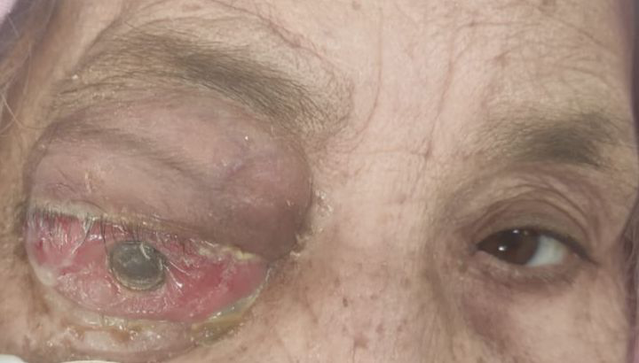

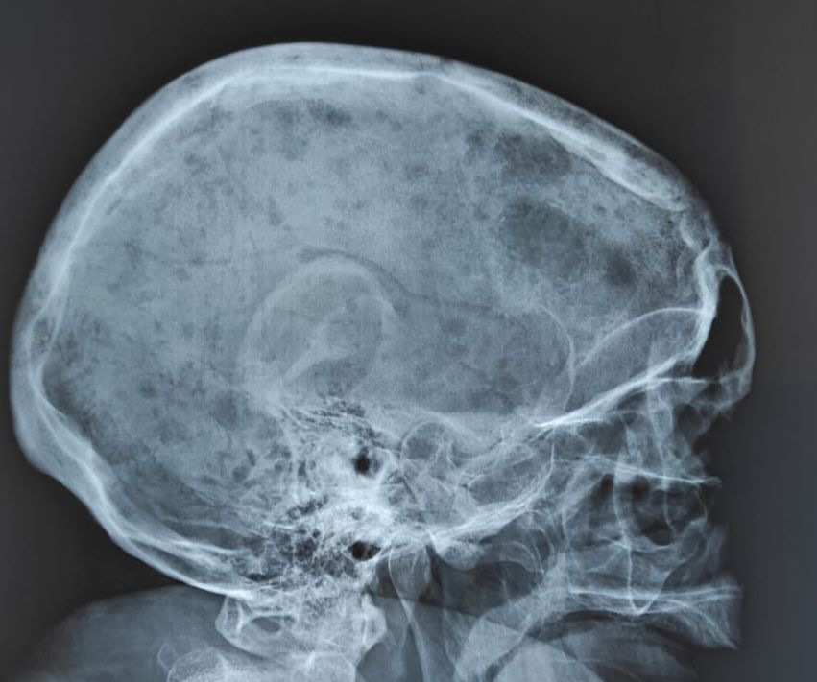

A cranio-orbital MRI revealed a lesion centered on the right orbital apex, with anterior intra-orbital and posterior intracranial extension. This imaging suggested extramedullary infiltration by plasma cells, confirming a relapse of multiple myeloma. The patient was referred to her hematologist, and treatment for the corneal abscess was initiated with vancomycin and ceftazidime eye drops.

During follow-up, the patient suffered a closed trauma to her left leg. Clinical examination revealed total functional impairment of the limb, with shortening and external rotation, deformity of the tibial segment, and pain on palpation and movement of the left leg. There were no signs of compartment syndrome, skin lesions, or vascular or nerve abnormalities. X-rays of the leg (anteroposterior and lateral views) revealed a sawtooth fracture line at the junction of the proximal and middle thirds of the tibia, with posterior-external overlap. A fracture line was also present at the same level in the fibula, while adjacent joints remained intact.

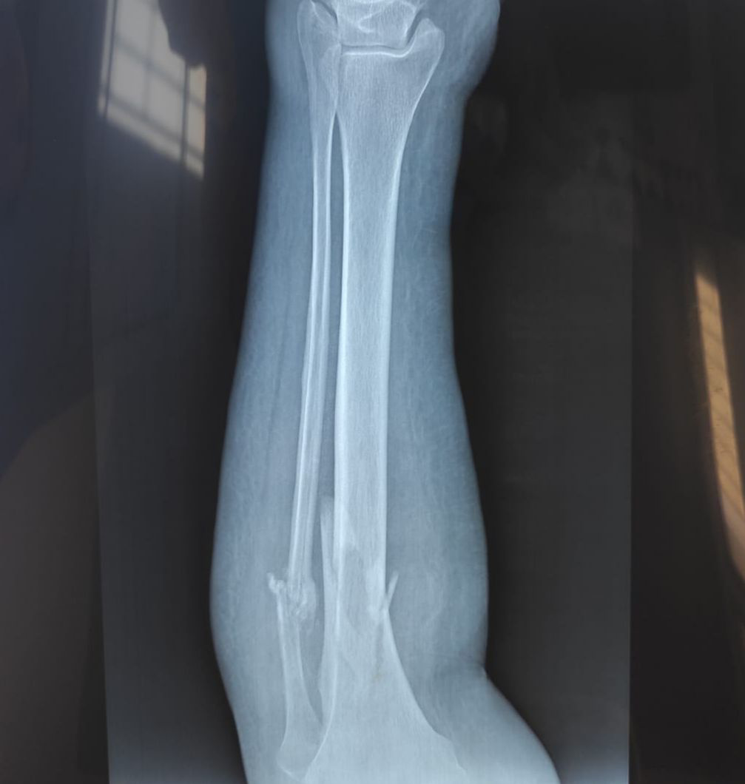

**Underlying Mechanisms of Exophthalmos in Multiple Myeloma**  
The causes of exophthalmos in the context of multiple myeloma are varied. One of the main explanations is extramedullary infiltration of plasma cells into the orbital tissues. This infiltration can lead to inflammation and hypertrophy of the ocular muscles, adipose tissue, and other orbital structures, pushing the eyes forward.

Moreover, in cases of refractory or relapsed multiple myeloma, tumor cells may migrate more easily to areas distant from the bone marrow, including the orbits, where they form tumor masses. The pressure exerted by these masses in the orbital cavity contributes to the manifestation of exophthalmos.

**Diagnosis and Treatment**  
The diagnosis of exophthalmos in relation to a relapse of multiple myeloma requires a thorough clinical evaluation, supplemented by imaging studies such as:

* **Magnetic Resonance Imaging (MRI):** To observe the size and location of tumor masses in the orbits and evaluate the involvement of adjacent tissues.
* **Computed Tomography (CT) Scan:** To analyze bone lesions associated with myeloma, providing a more precise assessment of bone structures and searching for bone lesions related to myeloma.
* **Laboratory Tests:** Including measurements of monoclonal proteins in the blood and urine, as well as specific tumor markers for myeloma (such as creatinine levels, blood calcium, or beta-2 microglobulin).
* **Biopsy:** In some cases, a biopsy of orbital tissues may be performed to confirm plasma cell infiltration.

Treatment of exophthalmos in the case of a multiple myeloma relapse generally involves a multimodal approach. Treatment of the underlying relapse is crucial and may include:

* **Chemotherapy:** Such as thalidomide, bortezomib, or daratumumab, which can reduce tumor load and extramedullary masses.
* **Radiotherapy:** Used to target tumor masses in the orbits and reduce inflammation.
* **Targeted Therapies and Immunotherapies:** Aimed at controlling the proliferation of malignant plasma cells.
* **Surgery:** In rare cases, surgery may be needed to remove tumor masses.

**Discussion**

Exophthalmos, a clinical sign of relapse in multiple myeloma, is a rare but critical manifestation, mainly caused by extramedullary infiltration of malignant plasma cells into orbital tissues. In the 69-year-old patient in question, the onset of unilateral exophthalmos associated with ocular pain, visual impairment and corneal abscess was suggestive of multiple myeloma relapse, confirmed by MRI showing orbital and intracranial involvement.

This case highlights the importance of recognizing exophthalmos as a potential sign of disease progression. Although rare, its presence can be a valuable indicator for clinicians, suggesting the need for further evaluation to detect extramedullary plasmacytomas and assess for possible systemic relapse. The progressive nature of this symptom highlights the risk of rapid deterioration, requiring prompt intervention.

The pathophysiological mechanisms underlying exophthalmos in multiple myeloma are linked to the infiltration of plasma cells into orbital tissues, resulting in both direct tumour effects and inflammation of ocular structures. In some cases, extramedullary involvement may occur with minimal bone involvement, making imaging studies such as MRI and CT essential for the diagnosis of orbital involvement.

Therapeutically, the management of exophthalmos in relapsed multiple myeloma requires a multidimensional approach. Priority should be given to treating the underlying relapse, with chemotherapy, radiotherapy and targeted therapies essential for disease control. In addition to these systemic treatments, local management of ocular complications, such as corneal infections or intraocular hypertension, is essential to preserve vision and prevent further complications.

Importantly, this case highlights the need for clinicians to remain vigilant in identifying less common manifestations of multiple myeloma relapse. Exophthalmos, although rare, can serve as an early warning sign, enabling prompt intervention and potentially improving the prognosis of affected patients. Given the chronic nature of multiple myeloma and the risk of relapse, regular follow-up and strong suspicion are essential in the management of these patients.

In conclusion, the presentation of exophthalmos in a patient with multiple myositis

**Conclusion**  
Exophthalmos, although rare, can be a significant clinical sign of a relapse of multiple myeloma, indicating the need for thorough evaluation to adjust treatment. In this patient’s case, the progression of the disease, despite an initial 5-year remission, required careful management, including local treatment for the ocular infection and close monitoring of the hematological status. Advances in detecting and managing multiple myeloma relapses, along with prompt treatment of exophthalmos, offer patients better chances of disease control and improved quality of life. It is essential for clinicians to remain vigilant in recognizing this rare but significant manifestation in order to take appropriate therapeutic measures for each clinical situation.

**References :**

1. **Rajkumar, S.V., et al. (2016).** *Multiple myeloma: current treatment algorithms.* *Blood Cancer Journal*, 6(6), e441. https://doi.org/10.1038/bcj.2016.72
2. **Palumbo, A., et al. (2014).** *Multiple myeloma: current treatment algorithms.* *Blood Reviews*, 28(4), 139-151. https://doi.org/10.1016/j.blre.2014.03.001
3. **Yoon, D., & Seol, J.H. (2014).** *Extramedullary relapse of multiple myeloma.* *Journal of Clinical Medicine*, 3(2), 369-376. https://doi.org/10.3390/jcm3020369
4. **Vellanki, P., et al. (2015).** *Orbital involvement in multiple myeloma: clinical presentation and treatment outcomes.* *Eye*, 29(5), 622-628. https://doi.org/10.1038/eye.2015.45
5. **Pimentel, J.M., et al. (2018).** *Exophthalmos in multiple myeloma: a rare but significant manifestation.* *American Journal of Hematology*, 93(9), 1230-1236. https://doi.org/10.1002/ajh.25273