***Case report***

**OVARIAN SERTOLI-LEYDIG CELL TUMOR, RETIFORM VARIANT WITH HETEROLOGOUS ELEMENTS IN A PEDIATRIC CASE**

**Abstract**

Ovarian Sertoli-Leydig cell tumors (SLTs) are rare neoplasms, representing less than 0.5% of ovarian tumors and 1 to 2% of pediatric ovarian tumors. We report the case of a 15-year-old adolescent girl with retiform variant SLT with heterologous elements, characterized by a solid, cystic abdominopelvic mass, associated with menometrorrhagia and dysuria, without signs of virilization. Histological examination revealed a mixed proliferation of Sertoli and Leydig cells, with the presence of heterologous elements of hepatoid appearance and a retiform component. Immunohistochemistry confirmed the diagnosis by the expression of calretinin, inhibin, CD99, and WT-1 in Sertoli cells, and Melan-A in Leydig cells. Treatment consisted of a right adnexectomy, without the use of adjuvant chemotherapy. This case illustrates the morphological and immunophenotypic diversity of pediatric SLTs, the importance of differential diagnosis with other ovarian tumors, as well as the need for multidisciplinary management and long-term monitoring, particularly due to the risk of associated DICER1 syndrome.

**Keywords:** Sertoli-Leydig tumor, ovary, child, retiform variant, heterologous elements, DICER1.

**Introduction**

Sertoli-Leydig tumors are defined by the WHO as tumors composed of Sertoli cells and Leydig cells in varying proportions, more or less associated with a primitive stroma and heterologous elements. They are very rare in the ovary, representing less than 0.5% of ovarian tumors and 1 to 2% of pediatric ovarian tumors. According to the 2020 WHO classification of tumors of the female genital tract, Sertoli-Leydig cell tumors are classified into four histological subtypes: well-differentiated tumors, moderately differentiated tumors, and poorly differentiated tumors. Heterologous elements are observed in 20 to 25% of moderately and poorly differentiated forms and also in the retiform subtype.

Molecularly, they are subdivided into 3 subtypes (DICER1-mutant, FOXL2-mutant, DICER1∕FOXL2-wild type). In children, moderately differentiated and poorly differentiated morphological forms including the retiform variant and with heterologous elements represent the majority of cases and are associated with a DICER1 mutation.

In light of this observation, we will discuss the anatomopathological characteristics of this rare ovarian tumor in children.

**Case Presenatation**

A 15-year-old girl was referred to the Rabat Children's Hospital for advice and management of a right ovarian mass with abdominal pain accompanied by menometrorrhagia and dysuria that had been developing for 3 months. She had no personal or family history of cancer. Clinical examination revealed a firm abdominopelvic mass extending beyond the umbilicus. No hirsutism or acne was noted. Tumor marker assays showed ACE levels at 1.3 ng/ml, CA at 19.9 and alpha-fetoprotein at 95.5 ng/ml.

Ultrasound revealed a mass with heterogeneous echostructure. Computed tomography showed a solid, cystic lesion of the right ovary with no evidence of compression of adjacent organs.

Intraoperatively, the ovarian mass was largely cystic with a solid area. Its surface was smooth without exophytic bud. It showed no adhesion to neighboring organs (omentum, uterus, adnexa, etc.). No peritoneal carcinomatosis was observed. A right adnexectomy was performed.

On macroscopic examination :The ovarian tumor measured 30x22x12 cm and weighed more than one kilogram with a smooth, whitish, taut surface. Upon opening, it presented a cystic appearance with a solid, yellowish nodule measuring 9x7 cm with a hard consistency. The cystic content was light yellow and fluid. Small endophytic budding nodules identical in appearance to the large nodule described above were observed in the cystic areas. The tube measured 11 cm in length and 0.5 cm in diameter.

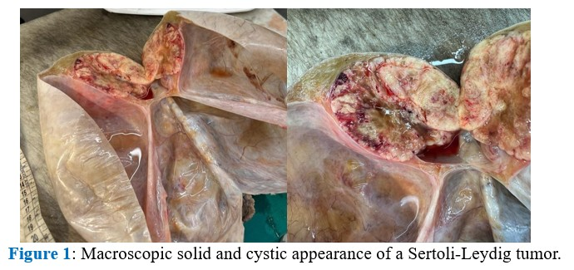

Microscopic examination showed tumor proliferation limited by an intact capsule comprising two cellular contingents (Figure 2):

-A predominant contingent of Sertoli cells consisting of medium-sized cells with clear or basophilic cytoplasm organized in cords, trabeculae and diffuse areas presenting moderate to marked atypia with sometimes rare anaplastic foci.

-A contingent of cells with eosinophilic cytoplasm with finely nucleolated rounded nuclei, reminiscent of Leydig cells, forming islets and small clusters especially at the periphery of the tumor. The number of mitoses was estimated at 7 mitoses per 10 fields at high magnification. Heterologous elements made up hepatocyte trabeculae and a retiform contingent were noted (Figure 3).

The tumor stroma was loose vascular edematous-fibrous showing no atypia with necrotic-hemorrhagic changes in places.

The cystic areas did not have their own covering and therefore corresponded to remodeling.

Immunohistochemical study (Figure 4) showed expression of Calretinin, Inhibin, CD99 and WT-1 in Sertoli cells and Melan-A positivity in Leydig cells. AE1/AE3 staining was focal. There was no expression of EMA, SALL4 and AFP in tumor cells.

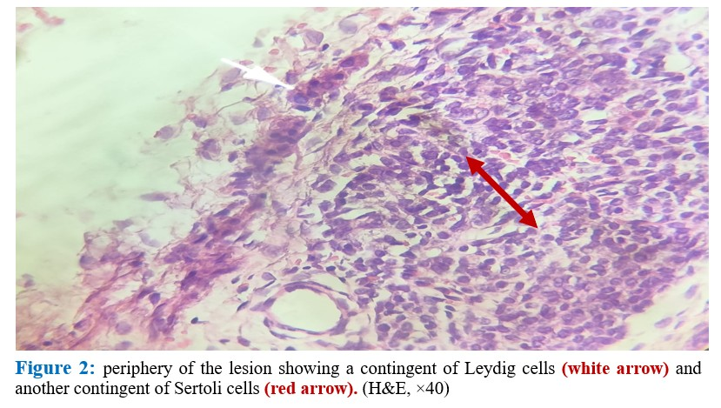

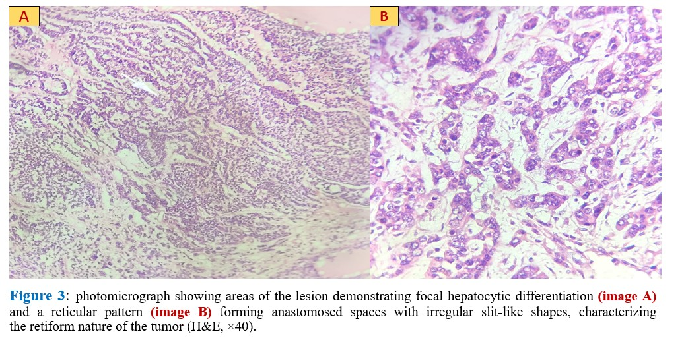

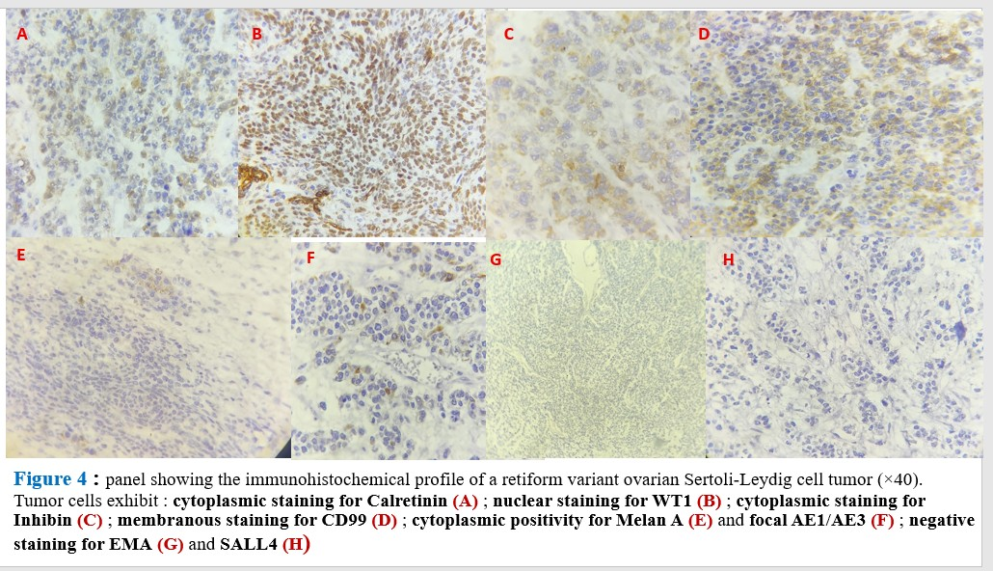

**Discussion**

Sertoli-Leydig cell tumors are rare ovarian tumors belonging to the group of mixed sex cord and stromal tumors. They represent less than 0.5% of ovarian tumors [1,2] and 1 to 2% of pediatric ovarian tumors. They are a mixed proliferation of sertoli cells with at least focal presence of Leydig cells. They occur in women of reproductive age with a mean age of 25 years but some cases are observed in children and women in menopause [5,15]. Less than 10% of cases are diagnosed in prepubertal and postmenopausal women [17]. They are classified according to WHO 2020 into several subtypes [6,8] (Table 1).They occur in sporadic forms or associated with DICER1 syndrome.

|  |
| --- |
| Table 1: Stromal and sex cord tumors (WHO classification 2020) |
| Mixed stromal and sex cord tumors |
| 1. Well-differentiated Sertoli-Leydig tumor (androgenic, secretory in 60%) 2. Moderately differentiated Sertoli-Leydig tumor (± heterologous elements) 3. Poorly differentiated Sertoli-Leydig tumor (± heterologous elements) 4. Sertoli-Leydig retiform tumor (± heterologous elements) 5. Sex cord tumor NOS (without differentiation) |

**The clinical presentation :**

Symptoms are not specific :The most common presentations are abdominal pain related to episodes of adnexal subtorsion (41.5% of cases), endocrine signs with menstrual cycle disorders (26.8%), precocious puberty (26%), signs of virilization (24.4%) related to the secretion of androgen hormones (hirsutism, clitoromegaly, breast atrophy, hoarse voice, oily skin, etc.) or abdominal distension (17%) [18]. The diagnosis of these tumors should be suspected in young women presenting with a pelvic mass and/or one of the aforementioned signs of virilization. There are rarely signs related to estrogen production.

This hypervirilization is manifested by an increase in testosterone levels in 80% of cases [14]. An increase in αFP is observed in retiform forms or with heterologous elements [18].

In the case of our patient, it was a menometrorrhagia evolving for 3 months associated with dysuria and abdominal distension. There were no signs of virilization. αFP was elevated (≥10 ng/ml). CEA was negative (≤5 ng/ml). No testosterone level was measured. The radiological appearance (ultrasound and CT) was that of a solidocystic right adnexal mass of approximately 30 cm in long axis without signs of compression of neighboring organs [25].

Sertoli-Leydig cell tumors are almost always unilateral. Bilateral synchronous involvement is rare. Tumor size varies between 5 and 15 cm with a mean diameter of 13.5 cm [7]. They most often present in a purely solid form [19]. Poorly differentiated tumors are large [1,3]. They can be solid, solid and cystic or cystic [5,14,30]. Sertoli-Leydig tumors with a heterologous component or a retiform appearance are most often cystic and can simulate cystic epithelial tumors [7]. However, their walls appear more rigid than in benign epithelial tumors or even borderline. There may be necrotic-hemorrhagic areas [19]. The cysts are multilocular with clear fluid content. In our patient's case, the tumor measured 14 cm in long axis and was solid and cystic in appearance.

Depending on the degree of differentiation, Sertoli cells exhibit different morphological architectures. Mitotic activity and cytonuclear atypia also vary. In well-differentiated forms, Sertoli cells form tubes and show neither atypia nor mitosis. The stroma contains a few Leydig cells. Tumors with intermediate differentiation generally consist of Sertoli cells arranged in cords, confluent tubular structures with mild to moderate nuclear atypia and mitoses (on average, 5 mitoses per 10 fields at high power). Leydig cells lack cytonuclear atypia. In poorly differentiated forms, the architecture is diffuse. Sertoli cells have an immature sarcomatoid appearance showing moderate to marked cytonuclear atypia. Mitotic activity is high, up to 20 mitoses per 10 fields at high power. Leydig cells are difficult to identify as small clusters, most often located on the periphery of the tumor. It should be noted that in the last two forms, heterologous elements are observed (bone tissue, cartilage, hepatocytes, gastrointestinal epithelium, neuroendocrine) and are seen in 5% of all cases of Sertoli-Leydig tumor and in 20 to 25% of poorly and moderately differentiated forms [2,4,7,8]. The most frequent heterologous component is a mucinous epithelium (intestinal or gastric type) in variable proportions which can sometimes wrongly lead to a diagnosis of mucinous cystadenoma [5,12,16].

In our case, Sertoli cells were mainly arranged in solid masses, trabeculae and crisscrossing cords with rare clusters of Leydig cells observed at the periphery. Mitotic figures were estimated at 07 mitoses per 10 fields at high magnification. The heterologous component was represented by trabeculae with a hepatoid appearance.

Sertoli-Leydig tumors have variable architectures with consequently many possible diagnoses [11,12]. If the meticulous histological analysis is essential to resolve the problem of differential diagnoses, an immunohistochemical complement can help to confirm the diagnosis of Sertoli-Leydig tumor. When the heterologous contingent predominates, the diagnosis of Sertoli-Leydig tumor is sometimes difficult, a mature teratoma or even a mucinous tumor must be eliminated [28]. In a mature teratoma, the different tissue contingents are numerous and more varied than in a Sertoli-Leydig tumor. In a mucinous tumor, there are multiloculated cysts with gelatinous content, the stroma is dense fibrous with variable cellularity while in a SLT the stroma is cellular with little fibrous and the cysts do not contain mucus [29].

The heterologous component can be carcinomatous, some cases have been reported and the problem can arise in extemporaneous examination if the sample was taken from this only, good sampling of the part is important [9,12].

Immunohistochemistry [22,23] is not of great help, but can eliminate many of the differential diagnoses. Sertoli cells are positive for inhibin and calretinin: these two markers are specific to sex cord tumors. Among others, Sertoli cells express cytokeratins AE1/AE3, CD56, SF-1, WT-1, FOXL2 and CD99. Melan-A, Vimentin, α-inhibin label Leydig cells. CK7 and EMA markers are negative; useful for distinguishing SLT from ovarian epithelial tumors. The heterologous contingent, if present, will express CK7, CK20, AE1/AE3 in case of glandular presentation, anti-hepatocyte antigen, anti-αFP, anti-ARGINASE if hepatocytes are present and euro-endocrine markers in case of associated neuroendocrine component.

The treatment of ovarian Sertoli-Leydig cell tumors mainly depends on the FIGO stage, the degree of tumor differentiation, the presence of heterologous elements, the patient’s age, and the desire to preserve fertility [12,13,17,31]. The FIGO classification, updated in 2020, takes into account the findings from preoperative imaging studies, surgical observations, and anatomo-cytopathological results and aims to better stratify prognosis and guide the therapeutic management of patients.

The benefit of adjuvant treatment is not yet well defined due to the few studies carried out to date. This is often carried out in advanced forms, poorly differentiated forms or if there is a heterologous contingent [20]. Chemotherapy based on bleomycin, etoposide and cisplatin (BEP) is used. Radiosensitivity of these tumors is reported in some publications, but at the cost of toxicity much higher than that of chemotherapy [21].

The recent discovery of alterations in the DICER [24,26,27,32] gene commonly clustered in DICER syndrome has allowed Sertoli-Leydig tumors to be classified into three molecular subtypes (Table 2):

|  |
| --- |
| Table 2: Molecular classification of Sertoli-Leydig tumors |
| DICER1 Anomalies |
| DICER1 mutant tumors: appear in young patients and induce symptoms of hyperandrogenism. They are moderately or poorly differentiated with heterologous elements. |
| FOXL2 mutant tumors: occur in postmenopausal patients and induce symptoms of hyperestrogenism. They are devoid of retiform or heterologous elements. |
| DICER1-FOXL2 wild-type tumors: appear in patients of intermediate age. They are generally well differentiated without retiform or heterologous elements. |

Surgical treatment alone was performed in our patient. An oncogenetic consultation was not performed. Instead, long-term monitoring was recommended for her and her family.

The prognosis of a Sertoli-Leydig tumor depends on several factors: the patient's age, the histological type of the tumor, the stage of the tumor at diagnosis, and the presence of molecular abnormalities in the DICER1 gene.

The younger the patient and the earlier the symptoms appear, the greater the risk of complications related to androgen excess. However, adolescents have a more favorable prognosis than older people because these tumors are less aggressive, and hormonal symptoms lead to earlier diagnosis. Well-differentiated tumors are more common, less aggressive, and still have a good prognosis with a five-year survival rate of 100% ; in moderately to poorly differentiated forms, the five-year survival rate drops to 80%. The presence of heterologous elements and the retiform pattern are also factors of poor prognosis. For tumors limited to the ovary (stage Ia), the 5-year survival rate is greater than 95%. For advanced stages (stage II/III) or metastatic disease, the survival rate drops to 0–34% [5,11,]. Intraoperative tumor rupture worsens the prognosis (stage Ic). Recurrences and asynchronous metastases are rare, but have been described 2 to 3 years after surgery. Tumors with heterologous elements are associated with a doubled risk of recurrence (45% vs 22% without) [18,33].

**Conclusion**

Sertoli-Leydig tumors are rare ovarian tumors. Diagnosis should be based on clinical presentation and the presence of an ovarian mass. Ultrasound is performed as a first-line procedure. Magnetic resonance imaging (MRI) remains the gold standard for exploring an ovarian tumor. Histological examination followed by immunohistochemical complementation can confirm the diagnosis and eliminate differential diagnoses. Treatment varies according to age, stage, and differentiation. The discovery of DICER gene alterations in Sertoli-Leydig tumors should lead to an oncogenetic consultation to screen for associated rare diseases and allow for appropriate follow-up.

**References**

1. Tavassoli FA, Mooney E, Gersell DJ, McCluggage WG, Konishi I, Fujii S et al. Sertoli-leydig cell tumors. In: Tavassoli FA, Devilee P, eds. World health organization classification of tumors, Pathology & Genetics. Tumors of the breast and female genital organs. Lyon: IARC Press 2000
2. Kostopoulou E, Talerman A.Ovarian Sertoli-leydig cell tumor of intermediate differentiation with immature skeletal muscle heterologous elements. Acta Obstet Gynecol Scand 2003; 82-197-8
3. Lantzsch T, Stoerer S, Lawrenz K, Buchmann J, Strauss G, Koelbl H.Sertoli-Leydig cell tumor. Arch Gynecol Obstet 2001; 264:206-8
4. Seidman JD, Patterson JA, Bitterman P.Sertoli-Leydig cell tumor associated with a mature cystic teratoma in a single ovary. Mod Pathol 1989; 2: 687-92
5. Young RH, Scully RE. Ovarian Sertoli-Leydig cell tumors. A clinicopathological analysis of 207 cases. Am J Surg Pathol 1985; 9:543-69.
6. Scully RE(1999) Histological typing of ovarian tumors. In: Sobin LH (ed) World Health Organization: International histological classification of tumors, 2nd edn. Springer, Berlin Heidelberg New York
7. Ching B, Klink A, Wang L.Pathologic quik case: a 22 year-old woman with a large right adnexal mass. Arch Pathol Lab Med 2004; 128:93-5
8. [Pathology Outlines- Sertoli-Leydig cell tumor](https://www.pathologyoutlines.com/topic/ovarytumorsertolileydig.html)
9. Virk R, Lu D.Mucinous adenocarcinoma as heterologous element in intermediate differentiated Sertoli-Leydig cell tumor of the ovary. Pathol Res Pract. 2010; 206:489–492.
10. Prat J, Young RH, Scully RE. Ovarian Sertoli-Leydig cell tumor with heterologous elements II, cartilage and skeletal muscles: a clinicopathologic analysis of twelve cases. Cancer. 1982; 50:2465–2475
11. Gui T, Cao D, Shen K, Yang J, Zhang Y, Yu Q, Wan X, Xiang Y, Xiao Y, Guo L. A clinicopathological analysis of 40 cases of ovarian Sertoli-Leydig cell tumors. Gynecol Oncol. 2012; 127:384–389.
12. Young RH, Prat J, Scully RE.Ovarian Sertoli-Leydig cell tumor with heterologous elements. Gastrointestinal epithelium and carcinoid: a clinicopathological analysis of thirty-six cases. Cancer. 1982; 50:2448–2456.
13. H.Y. Zhang. Clinicopathologic featus of ovarian Sertoli-Leydig cell tumors Int. I wink. Exp Path, 7(2014).
14. Prunty FT. Hirsutism: virilism and apparent virilism and their gonadal relationship. II. J Endocrinol 1967; 38:203—27
15. Mory N, Juan CF, Louis D. Histogenesis and histopathological characteristics of Sertoli-Leydig cell tumors. CME J Gynecol Oncol 2002; 7:114-20.
16. Chen L, Tunnell CD, Petris GD. Sertoli-Leydig cell tumor with heterologous element: a case report and a review of the literature. Int J Clin Exp Pathol 2014; 7:1176-81
17. Ritchie J, O'Mahony F, Garden A. Guideline for the management of ovarian cysts and children in adolescents. The British Society for Paediatric and Adolescent Gynecology [Internet]. June2017.http://www.britspag.org [Accessed on 10 June 2018.].
18. Schneider DT Orbach D Cecchetto G Stachowicz Stencel T et al Ovarian Sertoli Leydig cell tumors in children and adolescents ananalysis of the European Cooperative Study Groupon pediatric rare tumors EXPERT Eur J Cancer 2015 ; 51:543-50
19. Jung SE, Rha SE, Lee JM, Park SY, Oh SN, Cho KS, et al.CT and MRI findings of sex cord-stromal tumor of the ovary. AJR Am J Roentgenol 2005; 185:207–15
20. Fresneau B, Orbach D, Faure-Conter C, Verite C, et al. Sex-cord stromal tumors in children and adolescents: results of the TGM-95 Study. Pediatr Blood Cancer 2015; 62:2114-9.
21. Samant R, EC, Fung MF, Le T, Hopkins L, Senterman M. Palliative radiotherapy for recurrent granulosa cell tumor of the ovary: a report of 3 cases with radiological evidence of response. GynecolOncol. 2006; 102(2): 406-10
22. Kommoss F, Oliva E, Bhan AK, Young RH, Scully RE. Inhibin expression in ovarian tumors and tumor-like lesions: an immunohistochemical study. Mod Pathol 1998; 11:656-64.
23. Movahedi L, Kurman RJ.Calretinin: a more sensitive but less specific marker than alpha-inhibin for ovarian sex cord-stromal neoplasms: an immunohistochemical study of 215 cases. Am J Surg Pathol 2002; 26:1477-83.
24. Goulvent T, et al. DICER1 and FOXL2 mutations in ovarian sexcord stromal tumors: a GINECO Group study. Histopathology 2016; 68:279-85
25. Young RH, Scully RE. Differential diagnosis of ovarian tumors based primarily on their patterns and cell types. Semin Diagn Pathol. 2001; 18:161–235.
26. Robertson JC, Jorcyk CL, Oxford JT. DICER1 Syndrome DICER1 Mutations in Rare Cancers. Cancers 2018; 10: e10050143, <http://dx.doi.org/10.3390/cancers10050143>
27. Heravi-Moussavi A, et al. Recurrent Somatic DICER1 Mutations in Nonepithelial Ovarian Cancers. N Engl J Med 2012; 366:234-42.
28. Sharma S, Valiathan M, Kumar S, Kapoor S. Ovarian Sertoli-Leydig cell tumor with heterologous elements masquerading as mucinous tumor on frozen section: a case report. J Clin Diagn Res: JCDR 2015; 9: ED013 <http://dx.doi.org/10.7860/JCDR/2015/12311.6145>.
29. Chen L, Tunnell CD, Petris GD.Sertoli-Leydig cell tumor with heterologous element: a case report and a review of the literature. Int J Clin Exp Pathol 2014; 7:1176-81.
30. Grapin-Dagorno C, Chabaud M. Prepubertal ovarian cysts and tumors: surgical aspects. Arch Pediatr 2008; 15: 786-8.
31. Schultz KAP, Schneider DT, Pashankar F, et al. Management of ovarian and testicular sex cord-stromal tumors in children and adolescents. J Pediatr Hematol Oncol 2012; 34 (Suppl 2): ​​S55-63.
32. Schultz KAP, Harris AK, Finch M, et al. DICER1-related Sertoli-Leydig cell tumor and gynandroblastoma: clinical and genetic findings from the International Ovarian and Testicular Stromal Tumor Registry. Gynecol Oncol. 2017; 147:521-527.
33. Gouy S, Arf A, Maulard A, Pautier P, Bentivegna E, Leary A, et al. Results from a monocentric long-term analysis of 23 patients with ovarian Sertoli-Leydig cell tumors. Oncologist. 2019; 24:702–9