***Case report***

**Lipoma of the corpus callosum in children: A Case Report with Diagnostic Approach and Imaging Review**

**ABSTRACT**

Corpus callosum lipoma is a rare congenital intracranial malformation, often identified by chance in imaging studies. We report the case of a girl aged 4 with a history of two-year epilepsy, whose medication was discontinued. She presented in the emergency department with a febrile seizure episode. Brain CT scan revealed interhemispheric fatty-density mass with lobulated contours, with peripheral calcifications, and extension to the ventricles. Clinical presentation, imaging characteristics, and a review of the literature made the diagnosis of tubulonodular lipoma of the corpus callosum.

**Keywords:** Intracranial lipoma, corpus callosum, CT imaging, congenital malformation, epilepsy, child.

**INTRODUCTION**

Intracranial lipomas are rare malformative anomalies, found in less than 0.1% of intracranial space-occupying lesions. They are not true tumors but a malformation that is caused by the abnormal differentiation of the primitive meninx [1]. Corpus callosum lipoma occurs in 45% of intracranial lipomas, but is only 5% of tumors in this location [3]. Most cases are asymptomatic and become noticed by chance, but symptoms, such as epileptic seizures, can be a presenting feature [1,2]. We present here a young patient in whom a tubulonodular lipoma of the corpus callosum was diagnosed during imaging for a febrile seizure episode.

**CASE PRESENTATION**

The girl, aged 4 years and 4 months, was followed since she was one year old for epilepsy, treated with Depakine, which was withdrawn two years ago after marked improvement. She was admitted in pediatric emergency department with a febrile seizure that was accompanied by a generalized seizure**.**

Her overall condition was stable following initial management (administration of midazolam and restoration of consciousness) in the initial examination. She was a conscious patient with normal ENT, cardiopulmonary, and neurological examination findings, with no dysmorphic features. She was submitted to biological tests like CRP, hemogram, and liver function.

A CT scan of the brain(figure 1 and 2), which was acquired with axial helically acquired slices before and after contrast administration, showed a large interhemispheric mass in the corpus callosum. The lobulated mass was approximately 57 × 35 mm (approximately 5 cm) in size and was negative in density, as would be expected for adipose tissue, with peripheral calcifications and with some traversing vascular structures. The mass was nonenhancing following contrast administration. The mass extended intraventricularly, involving the bilateral choroid plexuses in part and displacing the frontal horns, with resulting dilation of the occipital horns. There was no evidence for any other density abnormalities or pathologic contrast uptake.

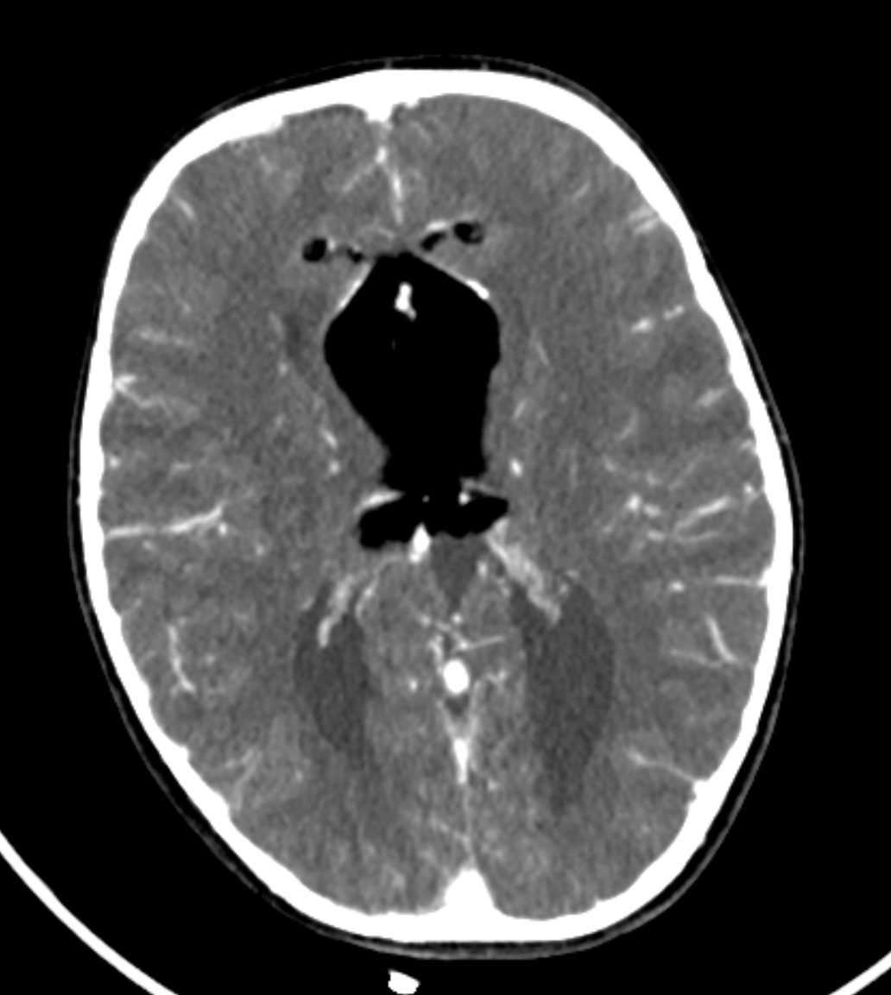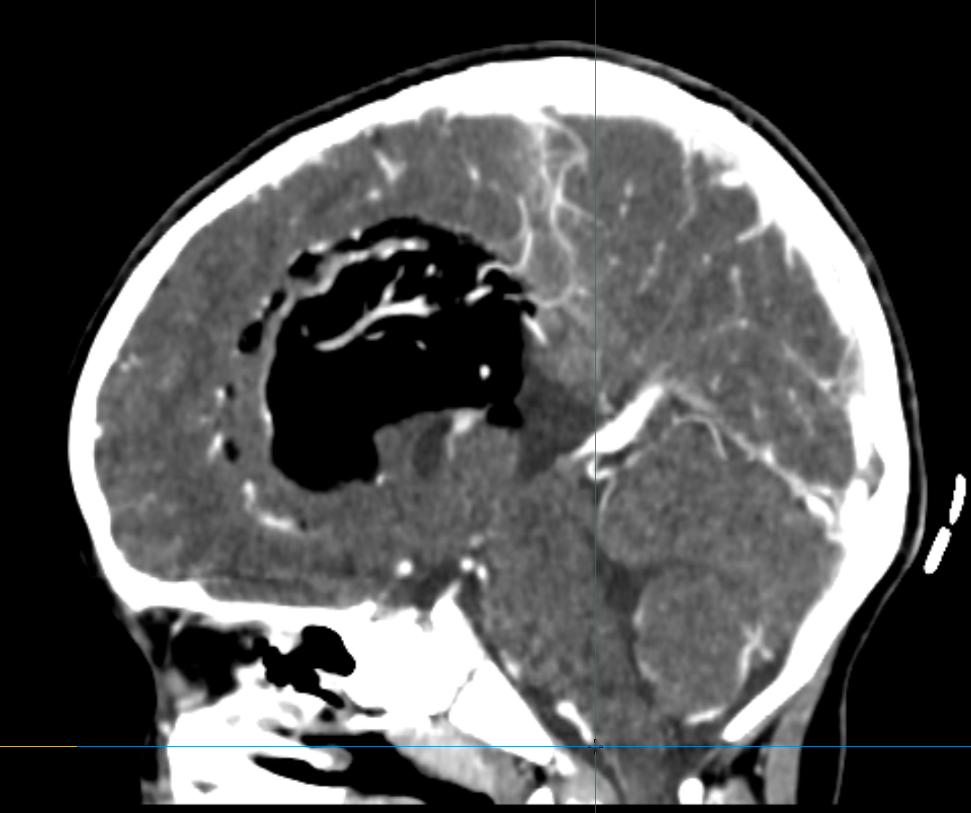

***Figure 1 and 2: Coronal and sagittal axial sections of the brain CT scan showing a formation of fatty density, lobulated configuration, located at the level of the corpus callosum and extending to the lateral ventricles, with the presence of peripheral calcifications.***

**DISCUSSION**

Intracranial lipomas result from a defect in the resorption process of the primitive meninx during the period between the 8th and the 10th weeks of gestation [4]. The resorption defect leads to the retention of adipose tissue in a position outside that in which it is normally located, forming a congenital malformation. They are not tumors but adipose tissue heterotopias, which explain their benign histology [6].

The most common location for intracranial lipomas is in the pericallosal region, with a strong tendency for the corpus callosum [1]. They are often discovered by chance, particularly in children and young adults, during imaging for non-specific reasons. In others, such lesions become symptomatic—e.g., headache, seizures, or neuropsychiatric disorders—commonly secondary to associated corpus callosum developmental anomalies [4,7].

There are two main forms of corpus callosum lipomas:

**The tubulonodular type**: More than 2 cm in thickness, this type is typically a rounded, lobulated mass. It is commonly accompanied by dysgenesis or agenesis of the corpus callosum and by peripheral calcifications. Intraventricular extension, as in our patient, is in support of the diagnosis and reflects a general involvement of the anatomical structure [1,3].

**The curvilinear type:** A more narrow type along the back edge of the corpus callosum, generally less associated with other cerebral malformations.

Here, the CT appearance—a fat-density mass, unchanged after administration of contrast, with peripheral calcifications—is typical for a tubulonodular lipoma of the corpus callosum. Intraventricular spread with involvement of the choroid plexuses is consistent with this diagnosis, as described in the literature [2,5]. These imaging characteristics often allow for non-invasive diagnosis, avoiding unnecessary procedures.

Therapeutically, as most corpus callosum lipomas are asymptomatic, management is generally conservative. In symptomatic cases, particularly in epilepsy, medical treatment is predominantly the mainstay. Surgery is rarely indicated due to the risk in the lesion's extensive vascularization and adhesion with surrounding structures, with the possibility of neurological complications increased [1,6].

Finally, the course in intracranial lipomas is often dictated by the presence and severity of concomitant anomalies. Retrospective studies, such as by Elster et al. [8], indicate that most people do not have major complications, and thus, follow-up and not aggressive surgical management is indicated. Also, with the advent of high-resolution imaging, such as with MRI, more accurate characterization of the lesion and assessment of concomitant anomalies is feasible, which is advantageous in planning therapy [7].

**CONCLUSION**

This illustrates the typical clinical and radiologic presentation in a child with a tubulonodular corpus callosum lipoma, which was discovered during a febrile seizure. CT scan remains the initial study, with non-invasive and accurate diagnosis by showing the fatty nature of the lesion and intraventricular enlargement. The treatment remains conservative, with symptomatic control of the epilepsy.

**CONSENT**

All authors declare that ‘written informed consent was obtained from the patient family for publication of this case report and accompanying images’.

**ETHICAL APPROVAL**

All authors hereby declare that all experiments have been examined and approved by the

appropriate ethics committee and have therefore been performed in accordance with the ethical standards laid down in the 1964 Declaration of Helsinki.

**DISCLAIMER (ARTIFICIAL INTELLIGENCE)**

Author(s) hereby declares that NO generative AI technologies such as Large Language Models (ChatGPT, COPILOT, etc.) and text-to-image generators have been used during the writing or editing of this manuscript.

**COMPETING INTERESTS**

Authors have declared that no competing interests exist.

**REFERENCES**

1. Taglialatela G, Galasso R, Taglialatela G, Conforti R, Volpe A, Galasso L. Lipomas of corpus callosum. Neuroanatomy. 2009;8:39-42. DOI:10.1159/000159219
2. Alam A, Ram S, Sahu S. Lipoma of the corpus callosum: diagnosis using magnetic resonance imaging. MJAFI. 2006;62:299-300. DOI:10.4103/0971-3026.291052
3. Bagdatoglu H, Ildan F, Doganay M, Goçer I, Cetinalp E, Karada Yi A. Lipomas of the corpus callosum: a report of four cases. Turkish Neurosurgery. 1994;4:34-37. DOI:10.1055/s-1994-13746
4. Jeffus, K., David Bourne, T., & Beatriz Lopes, S. (2009). Lipoma of the corpus callosum. International society of neuropathology.
5. Rahalkar AM, Rahalkar MD. Case Report: 2 cases of lipoma of corpus callosum (LoCC) associated with lipoma of choroid plexus (LoCP). Ind J Radiol Imag. 2006;16(4):719-721. DOI:10.4103/0971-3026.29347
6. Truwit CL, Barkovich AJ. Pathogenesis of intracranial lipoma. Radiology. 1990;175(2):331-335. DOI:10.1148/radiology.175.2.2322776
7. Anne G. Osborn. Diagnostic Neuroradiology .1994. Published by Mosby-Year Book, Inc. 936 pages. DOI:[10.1017/S0317167100040609](https://doi.org/10.1017/S0317167100040609)
8. Outaghyame S, Garmane A, Boutakiout B, Ouali Idrissi M, Cherif Idrissi El Ganouni N. Lipoma of the corpus callosum: Case report. Sch J Med Case Rep. 2021;9(9). doi:10.36347/sjmcr.2021.v09i09.020.