***Case report***

**Imaging Features of Mucinous Tubular and Spindle Cell Carcinoma: A Case Report and Review of the Literature**

**Abstract:**

**Mucinous tubular and spindle cell carcinoma (MTSCC)** is a rare epithelial renal tumor, first recognized as a distinct subtype of renal cell carcinoma (RCC) in the 2004 WHO classification. It is characterized by **low malignant potential and typically indolent clinical behavior**. Due to its rarity and **overlapping imaging features with other renal tumors**, accurate preoperative diagnosis remains challenging.

We report the case of a **42-year-old woman presenting with painless, non-clotting gross hematuria** persisting for four months. Ultrasound revealed a suspicious renal mass, which was further evaluated by **contrast-enhanced CT**, showing a **12 cm heterogeneous lesion** in the lower pole of the right kidney. The mass demonstrated **areas of hemorrhage and punctate calcifications**, along with **delayed, progressive enhancement**. There was **no evidence of adjacent organ invasion**. Histopathological examination following **right radical nephrectomy confirmed the diagnosis of MTSCC**.

This case highlights the **key role of imaging in the detection and surgical planning** of renal masses, although **definitive diagnosis relies on histopathological confirmation**.

**Keywords:** Mucinous tubular and spindle cell carcinoma, computed tomography, renal mass, low-grade tumor

**Introduction:**

**Mucinous tubular and spindle cell carcinoma (MTSCC)** is a rare renal epithelial neoplasm, recognized as a distinct subtype of renal cell carcinoma (RCC) in the **2004 World Health Organization (WHO) classification of urogenital tumors**. It accounts for **less than 1% of all RCCs** and is typically associated with **indolent behavior, low metastatic potential,** and a **predilection for middle-aged women**. Clinically, MTSCC is often detected incidentally during imaging studies or may present with **non-specific symptoms such as hematuria or flank pain**.

Imaging—particularly **contrast-enhanced computed tomography (CT)**—plays a central role in the detection and **initial characterization** of renal masses. However, the imaging findings of MTSCC are **non-specific and frequently overlap with those of other hypovascular RCC subtypes**, such as papillary or chromophobe RCC. Therefore, **histopathological evaluation, supplemented by immunohistochemistry, remains essential for a definitive diagnosis**.

In this report, we present a rare case of **MTSCC in a 42-year-old woman**, emphasizing its **contrast-enhanced CT features** and correlating them with histological findings to improve awareness and understanding of this uncommon tumor entity.

**Case presentation:**

A **42-year-old woman** with no significant medical or family history presented to our department with a **four-month history of intermittent, painless, gross hematuria without associated clotting**. She was afebrile and denied systemic symptoms such as weight loss, fatigue, or abdominal pain. **Physical examination was unremarkable**, and routine laboratory tests, including **renal function tests and complete blood count, were within normal limits**.

**Initial abdominal ultrasound revealed a heterogeneous solid mass** located in the lower pole of the right kidney. A subsequent **contrast-enhanced thoraco-abdominopelvic CT scan** demonstrated a **well-circumscribed soft tissue mass measuring 12 cm at its largest diameter**. The mass was heterogeneous, with **areas of spontaneous hyperdensity suggestive of intratumoral hemorrhage**, as well as **punctate calcifications** (**Figure 1**). Post-contrast images revealed **moderate, progressive, and heterogeneous enhancement, peaking in the delayed phase** (**Figure 2**). The lesion was in close contact with the duodenum, pancreas, liver, and gallbladder, with **obliteration of the surrounding fat planes but no clear signs of invasion**. No regional lymphadenopathy or distant metastases were detected.

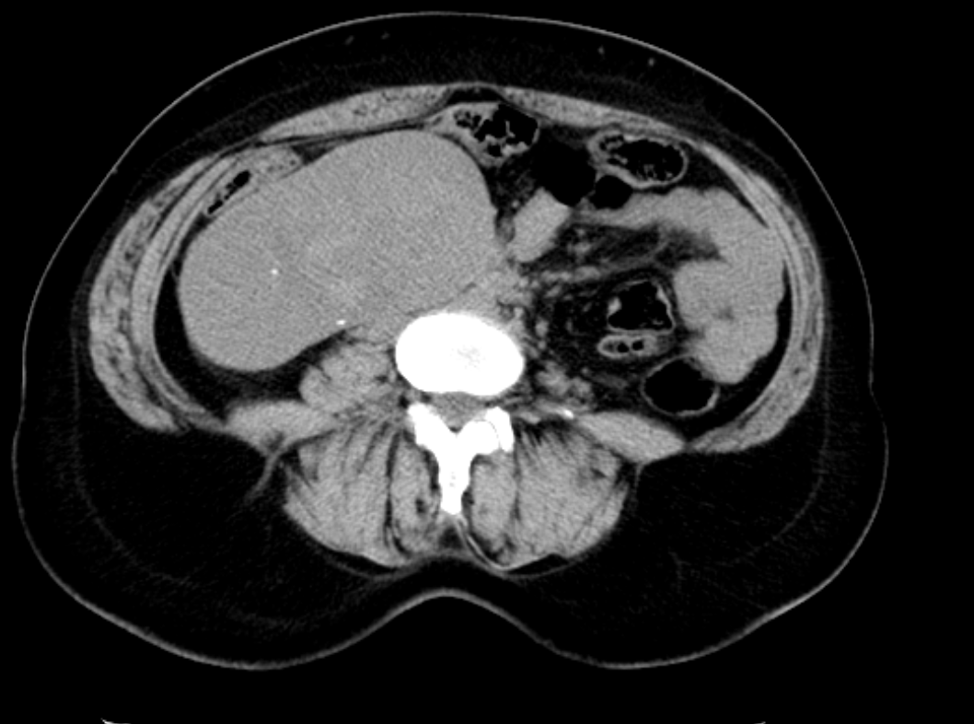

**Figure 1: Non-contrast-enhanced abdominal CT showing a heterogeneous right renal mass with a spontaneous attenuation of approximately 40 Hounsfield Units (HU) and punctate calcifications.**

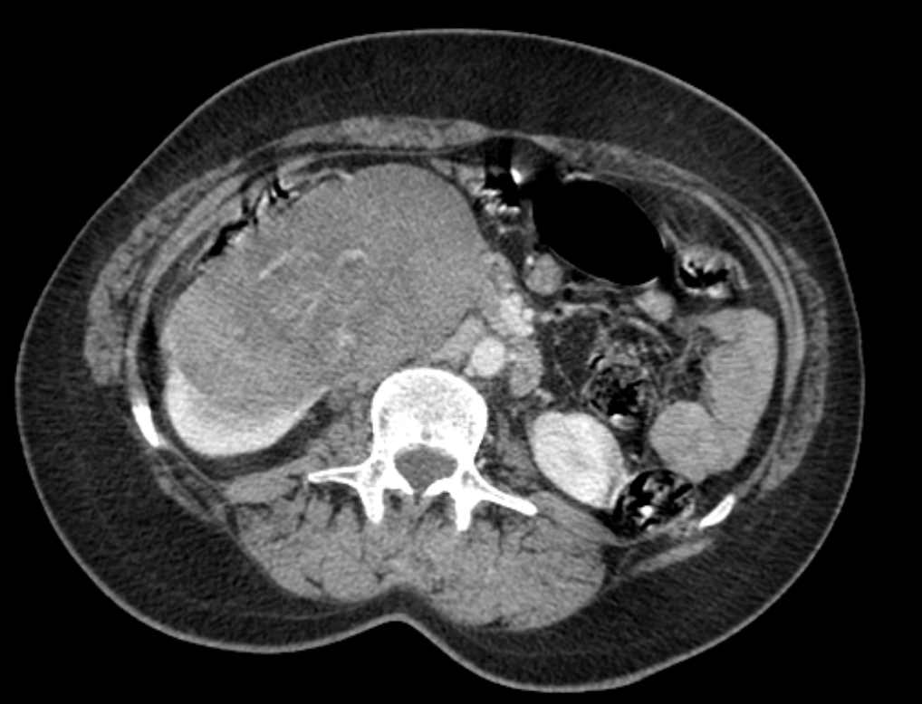

**A**

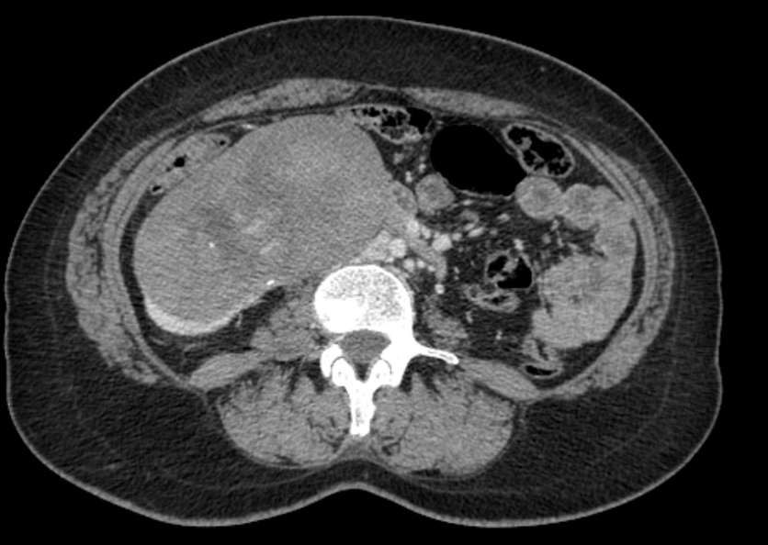

**B**

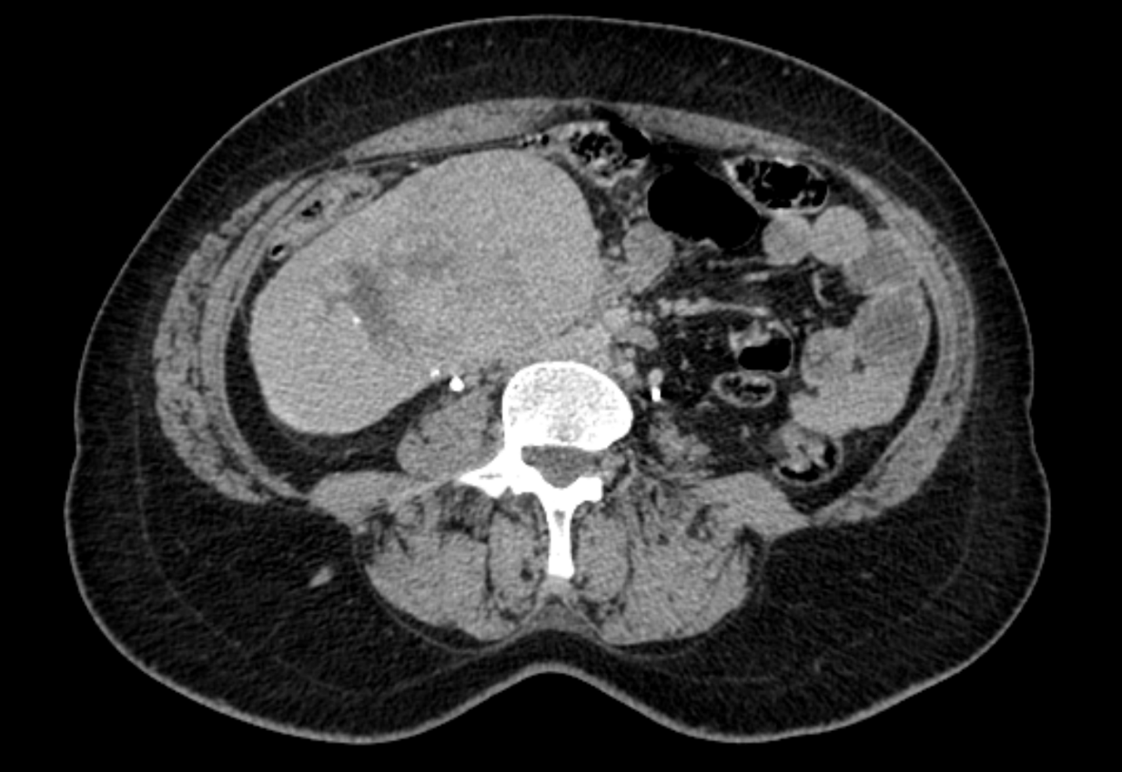

**C**

**Figures 2 : Contrast-enhanced abdominal CT demonstrating a 12 cm heterogeneous, hypovascular right renal mass with arterial phase attenuation of 60 HU (A), nephrographic phase of 70 HU (B), and delayed phase of 85 HU (C).**

The patient underwent **right radical nephrectomy.** Gross pathological examination of the specimen revealed a **tan-brown tumor localized to the lower pole of the kidney,** with **a well-demarcated margin. Histological analysis** showed **branching tubules and spindle-shaped epithelial cells embedded in abundant mucinous stroma,** along with **areas of necrosis and hemorrhage**. Immunohistochemical staining demonstrated **diffuse positivity for CK7, CK14, AE1/AE3 (CK8/18), and vimentin,** while **CD10 was negative**, helping to differentiate MTSCC from papillary RCC.

The **surgical margins were free of tumor**, and there was no involvement of the renal vein or ureter. The **postoperative course was uneventful**, and follow-up imaging revealed **no signs of recurrence or metastasis.**

**Discussion:**

Mucinous tubular and spindle cell carcinoma (MTSCC) is a rare and distinct subtype of renal cell carcinoma (RCC), accounting for less than 1% of all renal tumors **[1]**. First classified as a separate entity in the 2004 WHO classification, MTSCC is generally considered a low-grade malignancy with a favorable prognosis. It most commonly affects middle-aged women and is frequently discovered incidentally during imaging performed for unrelated reasons. However, when the tumors are large, patients may present with symptoms such as flank pain or gross hematuria **[2]**.

On imaging, MTSCC typically appears as a solitary, well-circumscribed renal mass with an expansile growth pattern and a spherical or ovoid shape, clearly separated from the adjacent renal parenchyma. On unenhanced CT, the lesion often appears homogeneous, while contrast-enhanced studies show a gradual and progressive enhancement pattern, peaking during the nephrographic or delayed phases. Lesions larger than 5 cm frequently exhibit heterogeneous enhancement due to internal hemorrhage, necrosis, or cystic changes **[3,4]**.

Although MRI findings are limited due to the rarity of this tumor, reported features include iso- to hyperintense signal on T2-weighted images, attributed to the mucinous stromal component, and delayed progressive enhancement after gadolinium injection **[3]**.

This progressive and delayed enhancement pattern helps differentiate MTSCC from clear-cell RCC, which typically demonstrates early and intense enhancement, although some overlap exists with other hypovascular subtypes such as papillary or chromophobe RCC **[7]**.

In our case, CT findings were consistent with classic MTSCC features. The tumor was large, well-defined, and heterogeneous, with moderate, progressive enhancement peaking in the delayed phase. The presence of intratumoral hemorrhage and punctate calcifications further supported the radiologic impression. While not pathognomonic, the combination of hypovascularity, internal complexity, and absence of invasive behavior suggested a low-grade neoplasm.

Although a combination of CT and MRI findings may raise suspicion for MTSCC and help differentiate it from other RCC subtypes, histopathological confirmation remains mandatory. Macroscopically, MTSCCs are usually well-circumscribed lesions with a broad size range (from <1 cm to >18 cm). Microscopically, they are composed of elongated, tightly packed tubules lined by spindle-shaped epithelial cells within a mucin-rich stroma **[5]**. Our case showed immunohistochemical results consistent with literature, with diffuse CK7, CK14, AE1/AE3, and vimentin positivity, and negative CD10 staining, which assists in differentiating MTSCC from papillary RCC **[6]**.

Surgical excision remains the treatment of choice, and prognosis is generally excellent in localized cases. Nevertheless, rare instances of sarcomatoid transformation or metastasis have been reported, which underscores the importance of appropriate postoperative surveillance **[6]**. In our case, the patient had an uncomplicated recovery, with no evidence of recurrence on follow-up imaging, and the tumor was staged as pT1N0Mx.

This case adds to the limited number of published MTSCC reports, particularly those with detailed imaging documentation. Given its rarity, well-characterized case reports are essential to better define the radiological spectrum of MTSCC and help distinguish it from other hypovascular renal tumors. By correlating imaging features with histopathology, this report contributes to the growing body of literature on MTSCC and highlights the value of CT in its non-invasive evaluation and surgical planning.

**Conclusion:**

Mucinous tubular and spindle cell carcinoma is a rare renal epithelial tumor with typically indolent behavior and low malignant potential. Although its imaging features—particularly on contrast-enhanced CT—can raise suspicion, they remain non-specific and often overlap with other hypovascular renal tumors. Therefore, histopathological confirmation is essential for definitive diagnosis. Early recognition of this entity and its characteristic imaging pattern may facilitate appropriate management and help avoid overtreatment. This case reinforces the value of imaging in the preoperative assessment and contributes to the growing knowledge of this uncommon tumor subtype.

**Consent:**

Written informed consent was obtained from the patient’s family for the publication of this case report and any accompanying images.

**Ethical approval:**

All authors declare that this study was reviewed and approved by the appropriate institutional ethics committee and conducted in accordance with the ethical standards of the 1964 Declaration of Helsinki and its later amendments.

**Disclaimer (artificial intelligence):**

The authors declare that no generative AI technologies (e.g., ChatGPT, Copilot, or text-to-image generators) were used in the writing or editing of this manuscript.

**Reference:**

**[1]** **Wang H**, **Peng X**, **Li L**, **Yang Y**. A retrospective study of imaging characteristics of mucinous tubular and spindle cell carcinoma in the kidney. Frontiers in Oncology, eCollection 2025.

**[2]** **Ziouani O, Rabil M, Elkhiyati A, Laghmari M, Ibn Attya A. The tubulomucinous and fusiform carcinoma of the kidney: a case report. On African Medical Journal. 2017;26:187.**

**[3]** **Cornelis F**, **Ambrosetti D**, **Rocher L**, et al. CT and MR imaging features of mucinous tubular and spindle cell carcinoma of the kidneys: A multi-institutional review. European Radiology. 2016;27:1087–1095.

**[4]** **Kenney P**, **Vikram R**, **Prasad S**, et al. Mucinous tubular and spindle cell carcinoma (MTSCC) of the kidney: A detailed study of radiological, pathological and clinical outcomes. BJU International. 2015;116:85–92.

**[5]** **Lopez-Beltran A**, **Scarpelli M**, **Montironi R**, **Kirkali Z**. 2004 WHO Classification of the Renal Tumors of Adults. European Urology. 2006;49:798–805.

**[6]** **Alves AS**, **Gaivão AM**, **Marques RC**, **Matos C**. Two rare entities in one patient: Mucinous tubular and spindle cell carcinoma of the kidney and peritoneal adenomyomas. Radiology Case Reports. 2021;16(8):1974–1979.

**[7]** **Hélénon O, Crosnier A, Eiss D, Poirée S, Méjean A, Correas JM. Diagnostic and pre-therapeutic imaging of malignant kidney tumors in adults. EMC Radiology and Medical Imaging – Genitourinary – Gyneco-obstetric – Breast. 2019;32(2):1–31.**