***Case report***

**A CASE REPORT ON EMPHYSEMATOUS PYELONEPHRITIS IN PATIENTS UNDER SGLT2 INHIBITOR THERAPY**

**ABSTRACT:**

Emphysematous pyelonephritis, or EPN, is a life-threatening necrotizing infection that affects the renal parenchyma and, in certain cases, the perirenal tissue of the kidney. This condition most commonly results in gas formation within the renal parenchyma, the collecting system, or the perinephric tissue. The target population for diabetes mellitus is affected by EPN, which has a high risk, with reported mortality ranging from 40% to 90%. Clinical presentation of the disease is almost identical to acute pyelonephritis and needs precise assessment by imaging, especially by computed tomography scans.

This case report covers the clinical presentation of EPN in a patient in his 70s and is on SGLT2 inhibitor therapy. This also brings to light the importance of an organized healthcare team's approach in adopting maximum care strategies for better patient outcomes, including aggressive surgery options and less aggressive options like percutaneous drainage and antimicrobial therapy.

**KEYWORDS:** Emphysematous pyelonephritis,antibiotics, diabetes mellitus, kidneys, renal function tests.

**INTRODUCTION:**

Emphysematous pyelonephritis is a fatal, rare medical condition in which urinary tract infections result in gas bubble formation on the kidneys and is predominant in individuals with uncontrolled diabetes mellitus. While it may present in non-diabetic patients also, the accounting percentages are less often and few of the risk factors include DM, immunosuppressant drugs, patients on SGLT2 inhibitors etc.

We report a case of emphysematous pyelonephritis in a diabetic patient diagnosed by radiological imaging, with successful treatment involving DJ stenting and bilateral pyelography along with antibiotic treatment. There is also past medical history of SGLT2 inhibitors and the causative organism for UTI was found to be *Pseudomonas aeruginosa.*

**CASE REPORT:**

A 71-year-old male, diabetic and on oral hypoglycaemic agents for the past 17 years, was admitted with chief complaints of diffuse abdominal pain along with increased frequency and urgency of urine since past 1 month. No history of haematuria or vomiting or fever or burning micturition. However, patient’s spouse complains of foul-smelling urine observed since past 2 weeks.  
Patient shares a history of use of Dapagliflozin, Metformin + Glimeperide drugs for diabetes and Perindopril, Amlodipine drugs for hypertension.

Upon examination the patient was found to be febrile, pulse rate of 109 bpm, BP of 157/77 mmHg, respiratory rate of 22 cpm. HbA1c was found 7%, haemoglobin of 10.4 g/dL, serum creatinine 1.26 mg/dL, TSH of 1.31 mU/L.

An USG was performed initially and showed the presence of gas bubbles but was misinterpreted to be lithiasis, however patient was found to be having prostatomegaly. But later the patient developed symptoms such as flank pain and a CT scan was performed. It showed gas in renal parenchyma suggesting evidence of emphysematous pyelonephritis.

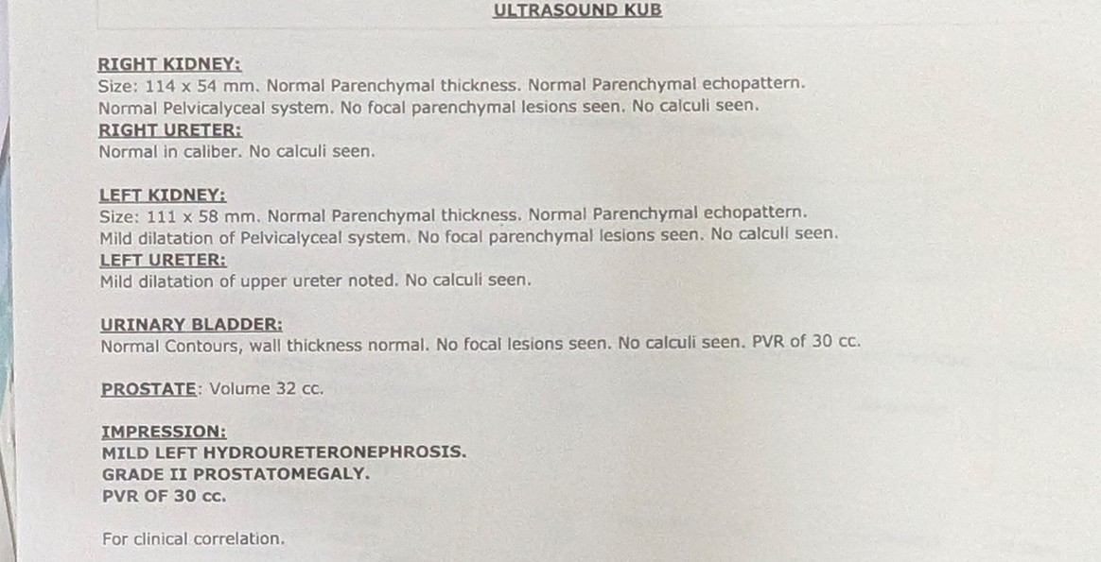

**Figure 1: Diagnostic report of the patient**

Antibiotic treatment was initiated shortly after a urine culture test was performed and the organism was reported to be *Pseudomonas aeruginosa* with sensitivity towards some β-lactams such as carbapenems, piperacillin/tazobactam, fluoroquinolones such as levofloxacin, moxifloxacin and others. Initially, surgery involving bilateral retrograde pyelography along with DJ stenting was done under local anaesthesia. Initially, the patient’s serum creatine levels were 2.76 mg/dL immediately after the surgery, dropped to 1.72 mg/dL and then to 1.26 mg/dL on day 5 and day 14 respectively.

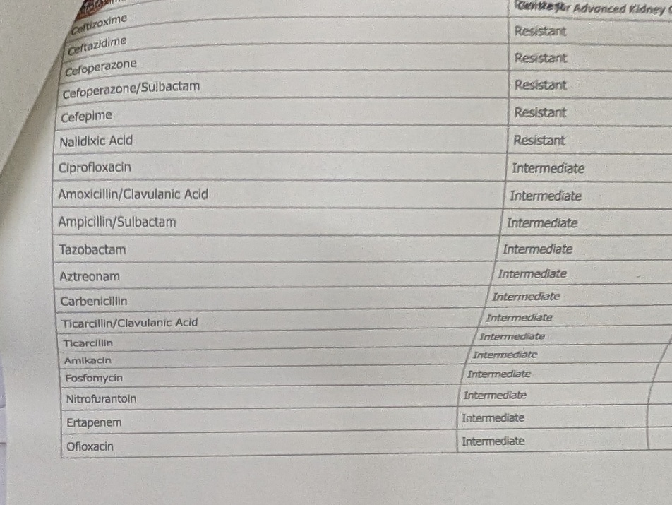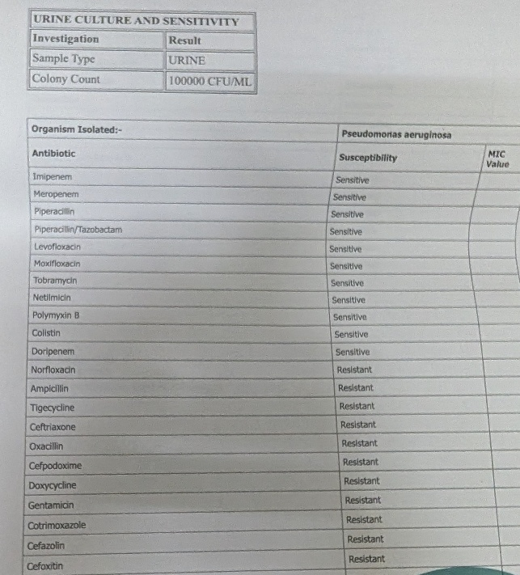

The treatment included Meropenem 1gm IV BD for 10 days, Tab. Levofloxacin 500mg BD for 10 days, Tab, Pantoprazole 40mg PO OD for 10 days, Tab. Tamsulosin 0.4mg OD till removal of stent, Tab. Amlodipine 5mg BD PO, Tab. Gliclazide 30mg OD, Tab. Linagliptin 5mg OD to be continued for control of comorbidities. Patient was also prescribed with Fosfomycin 3 gm PO OD, Tab. N- Acetylcysteine 600mg OD for 10 days to be taken at home.

**Fig 2: Diagnostic report of the patient (Contd.)**

Initially the stent was planned to be removed after 3 weeks but due to poor recovery the antibiotic therapy was continued for another 2 weeks and the stent was removed after 5 weeks of the surgery. The patient has been asked to follow up after 2 months with counselling done regarding management of comorbidities. The patient did present for the follow up with test results negative for urinary tract infection, better glycaemic and hypertension control and better quality of life. A follow up USG showed benign neoplasm of prostate for which Tamsulosin 0.4mg OD was prescribed or a period of 6 months.

**DISCUSSION:**

Emphysematous pyelonephritis is a fatal form of acute pyelonephritis, which is characterized by formation of gas bubbles by microbial organisms in the renal parenchyma which can lead to necrosis of the tissue. In this case report the findings align with the case reports by **Ubee SS et al.** that EP is presented in severe form in patients with uncontrolled diabetes.1 The patient’s symptoms for which he was hospitalized aligns with the study findings of **Koch GE et al**. which say requiring a surgical intervention in 40 to 90% of the cases.2

The symptoms with which the complication is presented are fever, chills, nausea, vomiting, flank pain, pneumaturia etc. The patient here also experiences same symptoms such as pain in the back, fever, vomitings etc.3 The conditions that favour the environment for emphysematous pyelonephritis are presence of acid fermenting bacteria, hyperglycemia in surrounding tissues, decreased perfusion to tissue.4 When these factors are present at same time, the disease progresses to worsening and rapid disease progression. While the common pathogens that cause EPN are *E. coli* and *Klebsiella pneumoniae* cases are reported with strains of *Pseudomonas aeruginosa*, *Enterococcus sp.* as well.5,6 Early interventions and management with antibiotics based on strains can not only be life saving but also reduces mortality rate and preserving kidney functioning.7 However, poor outcomes are associated with factors such as age on higher side, internal bleeding, thrombocytopenia. However hydronephrosis, urolithiasis and bacteremia do not influence the outcome.8 Another intervention that might influence the outcome is percutaneous drainage of abscesses over the kidney which may or may not be feasible in all patients.

**CONCLUSION:**

Emphysematous pyelonephritis is a life-threatening rare infection with high mortality, and thus there is a need for early diagnosis and management. The specialists should thus understand the most important predisposing factors that result in its occurrence. They should also take into consideration other though less common predisposing conditions, such as SGLT2 inhibitors use. While the incidence of urinary tract infections after SGLT2 inhibitor use is quite low, their universal usage for treatment of many socially important diseases makes it important to know all possible hazards of their usage, including the onset of severe urinary tract infections like emphysematous pyelonephritis.

**REFERENCES:**

1. Ubee SS, McGlynn L, Fordham M. Emphysematous pyelonephritis. BJU international. 2011 May;107(9):1474-8.
2. Koch GE, Johnsen NV. The Diagnosis and Management of Life-threatening Urologic Infections. Urology. 2021 Oct;156:6-15.
3. Desai R, Batura D. A systematic review and meta-analysis of risk factors and treatment choices in emphysematous pyelonephritis. Int Urol Nephrol. 2022 Apr;54(4):717-736.
4. Vivek V, Panda A, Devasia A (2012) Emphysematous pyelonephritis in a renal transplant recipient—Is it possible to salvage the graft? Ann Transpl 17(3):138–141
5. Aboumarzouk OM, Hughes O, Narahari K, Coulthard R, Kynaston H, Chlosta P et al (2014) Emphysematous pyelonephritis: time for a management plan with an evidence-based approach. Arab J Urol 12:106–115
6. Lu YC, Chiang BJ, Pong YH, Huang KH, Hsueh PR, Huang CY et al (2014) Predictors of failure of conservative treatment among patients with emphysematous pyelonephritis. BMC Infect Dis 14:418.
7. Gite VA, Shaw V, Agrawal M, Sankapal P, Maheshwari M (2021) Minimally invasive techniques as a first line approach in the management of emphysematous pyelonephritis—a single centre experience. J Postgrad Med 67(3):146–153
8. Wu SY, Yang SS, Chang SJ, Hsu CK. Emphysematous pyelonephritis: classification, management, and prognosis. Tzu Chi Med J. 2022 Apr 13;34(3):297-302. doi: 10.4103/tcmj.tcmj_257_21. PMID: 35912050; PMCID: PMC9333110.