**PLANTS UTILIZED AS ALTERNATIVE MEDICINES BY INHABITANTS OF MAPANAS, NORTHERN SAMAR, PHILIPPINES**

**ABSTRACT**

This descriptive research utilized the purposive sampling technique in an attempt to identify plant species used by local inhabitants as alternative medicines in five selected barangays of Mapanas, Northern Samar. It specifically aimed at collecting and identifying plant species least commonly utilized as medicine and screen these plants for the presence of secondary metabolites.

Results show a total of 44 plant species with medicinal applications, and these belonged to 24 plant families. Among these species, it was found that the five least commonly used medicinal plants were *Coleus blumei* Benth. (mayana; bidyara); *Citrus reticulata* Blanco (dalandan; dalanghita); *Ocimum tenuiflorum* L. (kulong-kugong; holy basil); *Piper betle* Linn. (luba; betel); and *Sansevieria trifasciata* Prain (sigbin sa hangin; snake plant; mother-in-law’s tongue).

Phytochemical analyses of these plants confirm the presence of anthraquinones, saponins, steroids, sterols, tannins, terpenoids, flavonoids, alkaloids, and phenolic compounds, although not all species characterized contain all these metabolites. The presence of these metabolites could possibly be the reason why these plants are effective as alternative medicines.

Likewise, these results imply that residents of the municipality of Mapanas, Northern Samar, Philippines, has a wealth of indigenous knowledge about plant species that possess medicinal attributes, utilizing them as alternatives to expensive commercial drugs.

It is therefore recommended that further chemical screening of these plants to characterize the active components or functional groups of these secondary metabolites through Fourier Transform Infrared (FTIR) spectroscopy technique be done as bases for drug discovery or development.

=================

**KEYWORDS:** *medicinal plants, secondary metabolites, inventory, alternative medicine, indigenous knowledge*

**INTRODUCTION**

Man’s interaction with plants has long been described as one of the factors influencing human civilization (Schaal, 2019). Plants provide food, fiber, shelter, and through man’s great ideas and resources, plants have been an effective remedy for curing various diseases (Institute of Food and Agricultural Sciences,2019).

Medicinal plants, whose organs contain substances that can be used for therapeutic purposes, or which are precursors for the synthesis of useful drugs (Sofowora, *et al.,* 2013) have been used in healthcare since time immemorial (Eshete and Molla, 2021). Studies have been carried out globally to verify their efficacy and some of the findings have led to the production of plant-based medicine (Sofowora, *et al.,* 2013).

Numerous medicines were first isolated from plant seeds and extracts. Many industrial products, such as rubber, paint bases, non-petroleum oils, gums, and sizing starches, are derived from seed plants as well. Most importantly, are the edible plants that are in the food base of human culture (Heneidy and Bidak, 2004).

Healing with medicinal plants is an old treatment method, as old as mankind itself, and an enormous amount of evidence showing the connection between humans and their search for drugs in nature, abound (Petrovska, 2012). Man’s struggle against disease led him to pursue drugs in barks, seeds, fruits, and other parts of plants (Srivastava, 2018).

Secondary plant metabolites are numerous chemical compounds produced by the plant cell through metabolic pathways derived from the primary metabolic pathways. They have been shown to possess various biological effects, providing the scientific bases for the use of herbs in traditional medicine in many ancient communities, having been described as antibiotic, antifungal, and antiviral, and therefore are able to protect plants from pathogens (Hussein and El-Anssary, 2018).

Plants play a vital role in every aspect of life of an organism (www.byjus.com). Thus, this study was initiated to screen the phytochemicals present in plants used by local inhabitants in selected barangays of Mapanas, Northern Samar, since no study of similar nature has been done in the locality.

*Objectives of the Study:*

This study aims to ascertain the phytochemical constituents of plants used by local inhabitants from selected barangays in Mapanas, Northern Samar.

Specifically, it has the following objectives: (1) document medicinal plants used by local inhabitants from selected barangays of Mapanas, Northern Samar; and, (2) screen for secondary metabolites the 5 least common medicinal plants collected, in terms of: a.) alkaloids; b.) terpenoids; c.) phenolics; d.) anthraquinones; e.) flavonoids; f.) tannins; g.) steroids; h.) saponin; and, i.) sterols.

**LITERATURE REVIEW**

Plants play a very important role in man’s life, fulfilling his food, fuel, timber, fibre, and medicinal needs. They are helpful in the mitigation of environmental pollution being the source of oxygen and a sink of carbon dioxide (Singh, 2018).

Similarly, medicinal plants contain, in one or more of its organs, substances that can be used for therapeutic purposes or which are precursors for the synthesis of useful drugs, and they have been used in healthcare since time immemorial. Studies to verify their efficacy have been done, and some of the findings have led to the production of plant-based medicines (Sofowora, *et al.,* 2013).

The World Health Organization (WHO) accounts about 60% of the world’s population relying on traditional medicine, and 80% of the population in developing countries depend almost entirely on traditional medical practices, in particular, herbal remedies, for their primary health. In the Philippines, more than 1500 medicinal plants used by traditional healers have been documented, and 120 plants have been scientifically validated for safety and efficacy. However, studies reveal that majority of the medicinal plants are threatened by man’s activities, leading to the continued decline of traditional herbal medicine, necessitating the adoption of management strategies to accelerate conservation of these valuable natural resources (Dapar, *et al.,* 2020).

A study of Hussein and El-Ansarry (2018), reveal there are several classes of secondary plant metabolites responsible for the biological activities of herbal medicines. Secondary plant metabolites exert their action on different molecular targets, which may be enzymes, mediators, transcription factors, or even nucleic acids. The use of herbal medicines therefore, should be based on comprehensive phytochemical studies for the determination of the chemical constituents of the herbs involved, allowing deduction of resultant pharmacological and toxicological effects, as well as possible synergistic or antagonistic effects due to the use of multiple component herbal formulae. For this reason, the isolation and structural elucidation of secondary plant metabolites, though ancient, is still a huge and fast-growing approach, and the techniques used for separation and analysis are advancing continuously.

In a review done by Kennedy and Wightman (2011), they assessed current evidence for the efficacy range of readily available plant-based extracts, and chemicals that may improve brain function, and research is sufficient to reach a conclusion as to their potential effectiveness as nootropics. Many of these candidate phytochemicals/ extracts can be grouped by the chemical nature of their potentially active secondary metabolite constituents into *alkaloids* (caffeine, nicotine), *terpenes* (ginkgo, ginseng, valerian, *Melissa officinalis,* sage), and *phenolic* *compounds* (curcumin, resveratrol, epigallo-catechin-3-gallate, *Hypericum perforatum*, soy isoflavones). Discussions in terms of how an increased understanding of the relationship between their ecological roles and central nervous system effects might further the field of natural, phytochemical drug discovery.

The antimicrobial activity of polyphenols and alkaloids among Middle Eastern plants was recently studied, and results show the Middle East encompassing a wide spectrum of plant diversity with over 20,000 different species in habitats ranging from deserts to snow-capped mountains. Polyphenols are one of the most numerous and diverse group of secondary metabolites; their antioxidant properties provide the bases for antimicrobial effects. Alkaloids provided the underlying structure for the development of several antibiotics with a diverse range of action. The ability of some plant secondary metabolites to act as a resistance-modifying agent is a promising field mitigating the spread of bacterial resistance (Othman, *et al.,* 2019).

Another study on the pharmacokinetics of anthraquinones from medicinal plants report that some anthraquinones and their glycosides, such as aloe-emodin, chrysophanol, emodin, physcion, rhein, and sennosides, have attracted the most pharmacokinetic (PK) research interest due to their greater biological activities and/or detectability. Anthraquinones are mainly absorbed in the intestines and are mostly distributed in blood flow-rich tissues and organs. They may have two absorption peaks because of the hepato-intestinal circle, reabsorption in organs/tissues and glycoside hydrolysis (Wang, *et al.,* 2021).

Moreover, a review of researches show the potential of phenolic compounds and extracts from medicinal and aromatic plants as biostimulants and bioprotectants in agriculture (Kisiriko, *et al.,* 2021).

Likewise, a study of Goto, Takahashi, Hirai, and Kawada (2010) mentioned the diversity of terpenoids, functions of Peroxisome Proliferator-activated Receptors (PPARs), and several terpenoids activating these PPARs . The prevalence of obesity worldwide has progressively increased over the past decades, and its unabated rise has spawned proportionate increases in obesity-associated metabolic disorders. Because most of the terpenoids are of plant origin and they are contained in vegetables and fruits, dietary terpenoids may contribute to a decreased risk of metabolic syndrome. Moreover, because the terpenoids constitute one of the largest families of natural products, more potent and useful PPAR activators may exist.

**METHODOLOGY**

*Locale of the Study*

The first phase of this study was conducted in selected barangays of Mapanas, Northern Samar, Philippines, particularly in Barangays Magtaon, Manaybanay, Naparasan, San Jose, and Siljagon.

The Municipality of Mapanas, Northern Samar is a 5th class municipality in the province of Northern Samar, Philippines which is subdivided into 13 barangays. The municipality has a land area of 117.85 square kilometers, (45.50 square miles), constituting 3.19% of Northern Samar’s total area. According to the 2020 census, it has a population of 14,234 people, thus, population density is computed at 121 inhabitants per square kilometer or 313 inhabitants per square mile. The municipality is located along the borders of the Pacific Ocean, it is considered one of the geographically isolated and disadvantaged areas (GIDA) in the Philippines because it is physically and socio-economically separated from mainstream society. Fishing and farming are the main sources of livelihood (Commission on Audit, 2010).

Barangay Magtaon, with a population of 2,236 (2020 Census), is situated at approximately 12.4970°N, 125.2506°E, in the island of Samar, with elevations estimated at 11.8 meters or 38.7 feet above mean sea level. Its vegetation is composed mainly of trees, grasses, and cultivated plants like rice and root crops. The residents raise animals like pig, cow, carabao, chicken, and other ruminants. Majority of the folks are farmers and fishermen with their main products such as root crops, rice, and copra (PhilAtlas, 2020).

Barangay Manaybanay is a residential area in the población, having a population of 1,441 (2020 Census) It is situated at approximately 2.4721°N,125.2616°E, in the island of Samar, with an elevation estimated at 5.0 meters or 16.4 feet above mean sea level. Like in many barangays of the municipality, majority of folks are farmers and fishermen, and their main products are root crops, rice, and copra (Phil Atlas, 2020).

Barangay Naparasan, located in the uplands of Mapanas, is forested, but flat areas are rice lands. It is inhabited by 521 individuals (2020 Census) and is situated at approximately 12.4219°N, 125.2339°E, in Samar island, with elevation estimated at 97.8 meters or 320.9 feet above mean sea level. Majority of the residents are farmers and their main products are root crops, rice, and copra (PhilAtlas, 2020).

Barangay San Jose is populated by 630 individuals (2020 Census), is situated at approximately 12.4223°N, 125.1584°E, in the island of Samar, and it can be considered as forestland and rice land. Elevation is estimated at 150.3 meters or 493.1 feet above mean sea level, with vegetation composed mainly of trees, grasses, and cultivated plants like rice and root crops. Farming is the main source of livelihood of the residents, producing root crops, rice, and copra (PhilAtlas, 2020).

Barangay Siljagon located in the uplands, is considered to be one of the forestland and riceland of Mapanas, and has a population of 1,631 (2020 Census). It is situated approximately at 12.4488°N, 125.2256°E with elevation estimated at 116.8 meters or 383.2 feet above the mean sea level. Majority of the residents are farmers, producing mainly root crops, rice, and copra (PhilAtlas, 2020).

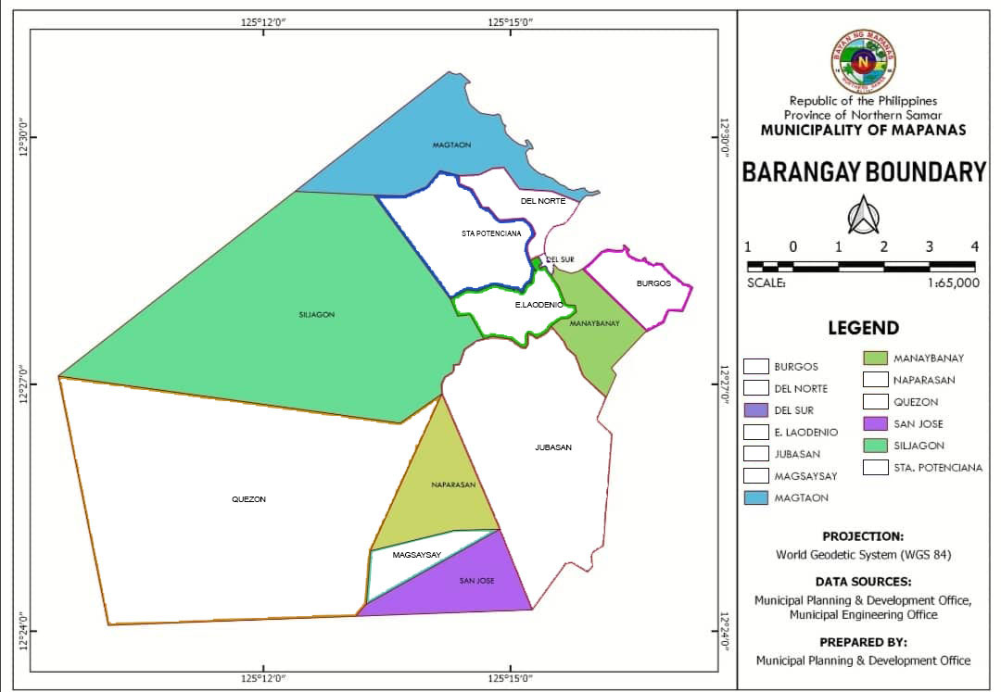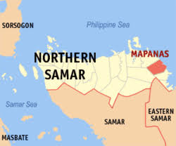

Figure 1. Map of the Mapanas, Northern Samar showing the Sampling sites

*Research Design*

This study used the descriptive research design focusing on the identification of plants utilized as alternative medicine by the inhabitants of selected barangays of Mapanas, Northern Samar.

*Sampling Techniques*

The purposive sampling technique, also called judgment sampling, is the deliberate choice of an informant due to the qualities the informant possesses and it is a nonrandom technique that does not need underlying theories or a set number of informants (Tongco, 2007). The data was gathered using a semi-structured interview guide to ascertain the residents’ knowledge on medicinal plants. A field walk, from early morning until late in the afternoon, was done during the collection of plant specimens.

*Data Gathering Procedures*

After permission was granted by the concerned local government officials and units, the researchers commenced the collection of all data needed to answer the objectives of the study. An interview guide, used to gather data from respondents, was constructed, with the first part eliciting personal information of the respondents, and the second part determined the medicinal uses of plants to the people of Mapanas, Northern Samar. The respondents were the villagers, aged at least 40 years old or older, either male or female and who have resided in the area for most of their lives, including the Barangay Health Workers (BHWs), Barangay Nutrition Scholars (BNSs), and the “albularyos”, “manarams” and “manhihilot” regardless of age or gender.

A field notebook was provided to record data gathered from the interviews.

*Collection and Identification of Specimen*

At least three samples of the five least commonly utilized plant with medicinal properties were collected in the study area, and brought to the Department of Biological Sciences, College of Science, University of Eastern Philippines - Main Campus, Catarman, Northern Samar for processing, and where an expert botanist authenticated the preliminary identification of the species done by the researchers.

*Preparation for Herbarium*

Preservation of collected plant specimens followed the procedures of Guevarra (2005), which involved drying (natural or artificial), poisoning to preserve specimens from insect and fungal attack, mounting in herbarium sheets, and labeling of specimens.

*Phytochemical Screening*

The five least commonly used medicinal, or the least commonly mentioned, plants by the local inhabitants were identified based on the information given by the respondents. The leaves of these medicinal plants were prepared for phytochemical screening, washing them with tap water to remove dirt, then rinsing with distilled water, and were air-dried. Once dry, the leaves were extracted manually using a plant juicer to get the crude extract which was then subjected to phytochemical screening for the presence of secondary metabolites, using different standard procedures.

Test for the Presence of Alkaloid

The procedures used by Guevara (2005) to test for the presence of alkaloids in plants, and its confirmatory tests, with Dragendorff’s and Mayer’s reagents, was strictly followed. A positive result was indicated by the presence of an orange precipitate in Dragendorff’s reagent and a white precipitate with Mayer’s reagent.

Test for the Presence of Anthraquinone

To test for anthraquinone, the procedures used by Mohammed, *et al.,* (2014) was utilized. It made use of 1g of the leaf extract placed in a dry test tube, with 20mL of chloroform added. This was heated in a steam bath for 5min, then the extract was filtered with an equal volume of 10% ammonia solution. This was shaken and the upper aqueous layer was observed for a bright pink coloration indicative of the presence of anthraquinone.

Test for the Presence of Flavonoids

One to five drops of concentrated hydrochloric acid (HCl) were added to the little amount of ethanolic extract of the plant material. Immediate development of a red color indicates the presence of flavonoids (Rao, *et al.,* 2016).

Test for the Presence of Phenolic Compound

A small amount of the ethanolic extract was taken with 1 mL of water in a test tube and 1 to 2 drops of Iron III chloride (FeCl3) was added. A blue, green, red or purple color is a positive test result (Rao, *et al.,* 2016).

Test for the Presence of Saponin

*The Capillary Tube Test*

Positive result, meaning the presence of saponin may be inferred, if the level of the plant extract in the capillary tube is half or less than the other tube containing water (Guevarra, 2005).

*Confirmatory Test for Saponin (Frothing Test)*

Three milliliters (3mL) of the aqueous solution of the extract was mixed with 10 mL distilled water in a test-tube, stoppered, and shaken vigorously for about 5 min, then allowed to stand for 30 min, and observed for honey comb froth, which was indicative of the presence of saponins (Auwal et al. 2014).

Test for the Presence of Steroid

To determine the presence of steroids, the Liebermann-Burchard’s test was used. An amount of 0.5g of the extract was dissolved in 10mL anhydrous chloroform and filtered, the solution being divided into two equal portions. The first portion was mixed with one mL of acetic anhydride, followed by the addition of 1mL of concentrated sulfuric acid down the side of the test tube to form a layer underneath. The test tube was observed for a green coloration indicative of steroids.

Utilizing Salkowski test, the second portion of the solution above was mixed with concentrated sulfuric acid carefully so that the acid formed a lower layer and the interface was observed for a reddish-brown color indicative of a steroid ring (Auwal, *et al.,* 2014).

Test for the Presence of Sterol

In this procedure, Salkowski’s test was used. The alcoholic extract of the plant was evaporated to incipient dryness, then was extracted with $CH{Cl}_{3}$. Few drops of acetic anhydride were added with concentrated sulfuric acid (from side wall of a test tube). The appearance of a yellow-colored ring (at the junction between the two liquids) which turns to red would indicate the presence of sterol group in the extract (Bhatt, 2019).

Test for the Presence of Tannins

Two milliliters (2mL) of the aqueous solution of the extract were added with a few drops of 10% ferric chloride solution (light yellow). The occurrence of blackish blue color showed the presence of gallic tannins, and a green-blackish color indicated presence of catechol tannins (Auwal, *et al.,* 2014).

Test for the Presence of Terpenoid

Into 2mL of the plant leaf extract was added 2mL of acetic anhydride and concentrated $H_{2}SO_{4}$. The formation of blue-green rings indicate the presence of terpenoids (Yanko, *et al.,* 2008).

Another procedure was also utilized. To 1 mL of the leaf extract, 2 mL of chloroform was added, after which 1.5 mL concentrated sulfuric acid was also added carefully. Formation of a reddish-brown color at the interface indicates the presence of terpenoids (Rajesh, *et al.,* 2014).

**RESULTS AND DISCUSSION**

From an earlier study which documented 44 plant species being used for medicinal purposes by the local inhabitants of selected barangays of Mapanas, Northern Samar, the five least commonly used or mentioned as medicinal plants were selected for phytochemical screening purposes.

The graphical data presented in Figure 2 shows the results of the interview done by the researchers about the medicinal plants used in treating ailments and diseases by the local inhabitants in selected barangays of Mapanas, Northern Samar. Information given by the respondents, in terms of their usage as well as to how many times the plants were mentioned for treating various ailments were the bases for the tally. The medicinal plant with a higher number of mentions, *i. e.,* frequently mentioned, was considered as commonly used by the respondents in the treatment of various ailments. On the other hand, the medicinal plant rarely mentioned as medicinal plant was considered as the least commonly used. Of the total number of plants collected and identified, *Sansevieria trifasciata* Prain (Sigbin sa Hangin), *Ocimum tenuiflorum* L. (Kulong-kugong), *Piper betle* Linn (Luba), *Citrus reticulata* Blanco (Dalandan), and *Coleus blumei* Benth (Bidyara) were documented as the least commonly used medicinal plants by local inhabitants for treating illnesses. Albeit the plants are present in their barangays, they rarely use it for medicinal purposes for lack of knowledge of their uses, also considering that there are other common plants which they prefer to use to treat their ailments.

Figure 2. Interview Results Highlighting the Most- and the Least-Commonly Used Medicinal Plants

As indicated in Figure 2, the 5 least commonly used medicinal plants were subjected to phytochemical screening techniques to test for the presence of secondary metabolites which could be the reason why these plants harbor medicinal effects.

Secondary plant metabolites are numerous chemical compounds produced by the plant cell through metabolic pathways derived from the primary metabolic pathways. They have been shown to possess various biological effects, providing the scientific bases for the use of herbs in traditional medicine in many ancient communities. They have been described as antibiotic, anti-fungal, and antiviral, and therefore are able to protect plants from pathogens (Hussein and El-Anssary, 2018).

Table 1 shows the summary of results for the phytochemical screening of the least commonly used medicinal plants identified by the researchers. It contains the different secondary metabolites tested using leaf extracts of the 5 least commonly used medicinal plants, namely: *Coleus blumei* Benth (Bidyara), *Citrus reticulata* Blanco (Dalandan), *Ocimum tenuiflorum* L. (Kulong-kugong), *Piper betle* Linn (Luba), and *Sansevieria trifasciata* Prain (Sigbin sa Hangin). Moreover, extracts from these plants were tested for the presence of secondary metabolites, using procedures from previously published studies, specifically for alkaloids, anthaquinone, flavonoids, phenolic compounds, saponin, steroid, sterol, tannin, and terpenoid.

It is clear that *Coleus blumei* Benth (Bidyara) leaf extract was negative for the presence of alkaloid, but all others tested positive, meaning they were present in the extract. This result is similar to that of Bismelah, *et al.,* (2019) whose report also show negativity of alkaloids in *Coleus blumei* Benth extract using Dragendorff’s reagent, although no reason for negativity of alkaloids was indicated in the study. The result implies that the presence of other secondary metabolites in “Bidyara” leaf extract might be one of the reasons for the efficacy of the medicinal plant in initiating menstruation among women inhabitants in selected barangays of Mapanas, Northern Samar.

In the case of *Citrus reticulata* Blanco (Dalandan) it is vivid that the leaf extract was negative for the presence of anthraquinone, flavonoids, saponin (foam test), steroid, and terpenoid, but was positive for the presence of alkaloids, phenolic compounds, saponin (capillary test), sterol, and tannin. Their presence in the leaf extract may imply it might be one of the reasons for the efficacy of the medicinal plant in the treatment of cough and chest pain.

Likewise, results of the phytochemical screening of *Ocimum tenuiflorum* L. (Kulong-kugong) leaf extract have shown that alkaloid (Mayer’s test), anthraquinone, flavonoids, and tannin were negative, but Dragendorff’s test detected the presence of alkaloids in the extract, as well as phenolic compounds, saponin, steroid, sterol, and terpenoid were also positive. The presence of these metabolites might be one of the reasons for the efficacy of the medicinal plant for treating headache.

Results of the phytochemical screening test of *Piper betle* Linn (Luba) leaf extract show that it is negative for the presence of anthraquinone and steroid, but all the other metabolites tested turned out positive. This might be one of the reasons why local inhabitants in selected barangays of Mapanas, Northern Samar use it for treating rheumatism.

Further, phytochemical screening test of *Sansevieria trifasciata* Prain (Sigbin sa Hangin) have shown that alkaloids (using Dragendorff's test), anthraquinone, flavonoids, saponin (using foam test), steroid, and sterol were negative in the leaf extract, but positive results were shown for alkaloid (using Mayer’s test), phenolic compounds, saponin (using capillary test), tannin, and terpenoid. The presence of these secondary metabolites in “Sigbin sa Hangin” leaf extract might be one of the reasons for the efficacy of the medicinal plant for treating stomachache.

Generally, the chemical characterization of the plant extracts revealed the presence of nine secondary metabolites, namely: alkaloids, anthraquinone, flavonoid, phenolic compounds, saponin, steroid, sterol, tannin, and terpenoid. However, not all of these compounds were found present in any one plant species.

Table 1. Summary Result of Phytochemical Screening of the Least Commonly Used Plants with Medicinal Applications in Mapanas, Northern Samar.

|  |  |  |  |  |  |
| --- | --- | --- | --- | --- | --- |
| **SECONDARY METABOLITE TEST** | **PLANT SPECIES** **LEAF EXTRACTS** | | | | |
| 1 | 2 | 3 | 4 | 5 |
| ALKALOID |  |  |  |  |  |
| Dragendorff’’s Test | - | + | + | + | - |
| Mayer’s Test | - | + | - | + | + |
| Confirmatory Test | - | + | - | + | - |
| ANTHRAQUINONE |  |  |  |  |  |
| Brontrager’s Test | + | - | - | - | - |
| FLAVONOIDS | + | - | - | + | - |
| PHENOLIC COMPOUNDS | + | + | + | + | + |
| SAPONIN |  |  |  |  |  |
| Capillary Test | + | + | + | + | + |
| Foam Test | + | - | + | + | - |
| STEROID | + | - | + | - | - |
| STEROL | + | + | + | + | - |
| TANNIN | + | + | - | + | + |
| TERPENOID | + | - | + | + | + |

LEGEND:

+ = Tested compound is present in the leaf extract

- = Tested compound is absent in the leaf extract

1 = *Coleus blumei* (L) Benth (Bidyara)

2 = *Citrus reticulata* Blanco (Dalandan)

3 = *Ocimum tenuiflorum* L. (Kulong-kugong)

4 = *Piper betle* Linn (Luba)

5 = *Sansevieria trifasciata* Prain (Sigbin sa Hangin)

**CONCLUSIONS**

Utilizing the descriptive research design, this study gained information about plants and their medicinal value. Samples of the species were collected, identified, and authenticated by a botanist in the College of Science, Univeersity of Eastern Philippines - Main Campus, Catarman, Northern Samar. Dried specimens were mounted on herbarium sheets and were properly labeled.

A total of 44 species of medicinal plants were documented, and of this number, the five least commonly used plant species were segregated, and they were *Ocimum tenuiflorum* L. (Kulong-kugong); *Coleus blumei* Benth (Bidyara); *Piper betle* Linn (Luba); *Citrus reticulata* Blanco (Dalandan); and *Sansevieria trifasciata* Prain (Sigbin sa Hangin).

These plants were subjected to chemical characterization, and phytochemical analyses of plant extracts revealed the presence of nine secondary metabolites, specifically alkaloids, anthraquinone, flavonoid, phenolic compounds, saponin, steroid, sterol, tannin, and terpenoid. However, not all of these compounds are present in any one plant species. The most commonly found secondary metabolite were saponin and phenolic compounds (which were present in all leaf extracts), while the least commonly available secondary metabolite is anthraquinone (present only in one leaf extract). Moreover, *Coleus blumei* (L) Benth. possessed the greatest number of secondary metabolites, with only alkaloids absent from the tested extract.

Further tests need to be done on a few more samples using other available procedures to validate results of some confirmatory tests which seems in conflict with standard results for such secondary metabolite.

Based on these findings, the researchers would like to propose a replicate study be done in other sites to fill the information vacuum on plant used by local inhabitants in the treatment of several common illnesses, especially in remote areas of the province. Extract of other medicinal plants may be subjected to further testing to verify the existence of other secondary products that could be the bases for the drug discovery or drug development. The use of other methods for phytochemical screening be done to further test the presence of secondary metabolites among plants traditionally used for medicinal purposes.

**REFERENCES**

Ali, S. S.M. Salman., M.T. Jan., M.S Afridi., M.S. Malik. 2014. Comparative Studies of Various Phytonutrients in Citrus Fruit. DOI:10.15228/2014.v04. i02.p04.

Amirkia, V., and M. Heinrich. 2014. Alkaloids as drug leads- a predictive structural and biodiversity-based analysis. Phytochem. *Lett.* 10, xlviii-liii. doi: 10.1016/j.phytol.2014.06.015.

Auwal, M.S., S. Saka., I.A. Mairiga., K.A. Sanda., A. Shuaibu., A. Ibrahim. Preliminary phytochemical and elemental analysis of aqueous and fractionated pod extracts of *Acacia nilotica* (Thorn *mimosa*). Vet Res Forum. 2014 Spring;5(2):95-100. PMID: 25568701;PMCID:PMC4279630.

Bayog, Maricris V. 2014. “Phytochemical Screening of *Selaginella plana* (KAMARIANG GUBAT) Leaf Extract. University of Eastern Philippines, University Town, Catarman, Northern Samar.

Bhatt, Ritika. 2019. Chemical Tests for Glycosides: General and specific. [https://gpatindia.com/chemical-tests-for-glycosides-general-and specific/#:~:text=(i)%20Haemolysis%20test%20%3A%20A,%E2%86%92%20the%20presence%20of%20saponins](https://gpatindia.com/chemical-tests-for-glycosides-general-and%20specific/#:~:text=(i)%20Haemolysis%20test%20%3A%20A,%E2%86%92%20the%20presence%20of%20saponins). Accessed: March 2, 2023

Bismelah, N.A., R. Ahmad., Z.H.M. Kassim., N.H. Kassim. 2019. *Coleus blumei* extract as a potential antibacterial oral rinse. IOP Conf. Ser.: Earth Environ. Sci. 269 012015.

Echano, Renieza M. 2009. Phytochemical Screening of *Jatropha multifida* Linn. (Coral Plants) Leaves and Stems Extracts. University of Eastern Philippines, Catarman, Northern Samar.

Fitzpatrick, L.R., T. Woldemariam. 2017. Comprehensive Medicinal Chemistry III. <https://www.sciencedirect.com/topics/medicine-and-dentistry/gallic-acid#:~:text=Gallic%20acid%20is%20a%20phenolic,fruit%2C%20root%2C%20and%20seed>. Accessed: March 2, 2023.

Goto, T., N. Takahashi., S. Hirai., and T. Kawada. 2010. Various Terpenoids Derived from Herbal and Dietary Plants Function as PPAR Modulators and Regulate Carbohydrate and Lipid Metabolism.

Herbal Medicine. Merriam-Webster.com Dictionary, Merriam-Webster, <https://www.merriam-webster.com/dictionary/herbal%20medicine>. Retrieved July 7, 2022.

[How Are Plants Important to Humans - Food, Fabrics, Medicines and Raw materials (byjus.com)](https://byjus.com/biology/importance-of-plants-to-humans/) accessed on: February 21, 2023.

<https://en.m.wikipedia.org/wiki/Mapanas>. Accessed: November 20, 2021.

[https://iwash.gov.ph/why-water-is-a-challenge-in-mapanasnothern-samar-and-how-it-is-addressed-by-the-integrated-wash approach-2/](https://iwash.gov.ph/why-water-is-a-challenge-in-mapanasnothern-samar-and-how-it-is-addressed-by-the-integrated-wash%20approach-2/). Accessed: October 9, 2021.

<https://www.coa.gov.ph/phocadownloadpap/userupload/annual_audit_report/LGUs/2019/Region-VIII/Municipalities/Northern-Samar/Mapanas_NoSamar_ES2019.pdf?__cf_chl_tk=70ANbYCW0fB47yUMbOfvUYf3GBp76HPlDwNaOhqa.oQ-1637233682-0-gaNycGzNCJE>. Accessed: November 20, 2021.

<https://www.collinsdictionary.com/dictionsry/english/sterol>. Accessed: December 11, 2022.

<https://www.google.com/search?q=mapanas+Northern+samar+map+legend&oq=mapanas+Northern+samar+map+legend&aqs=chrome..69i57j0i333l3.17896j0j4&client=ms-android-huawei-rev1&sourceid=chrome-mobile&ie=UTF-8#imgrc=SnoEGCx2MRxSCM> Accessed: October 10, 2021.

Hussein, R. A., and A.A El-Anssary. 2018. Plants Secondary Metabolites: The Key Drivers of the Pharmacological Actions of Medicinal Plants. In (Ed.), Herbal Medicine. IntechOpen.

Kennedy, D.O., E.L. Wightman. Herbal Extracts and Phytochemicals: Plant Secondary Metabolites and the Enhancement of Human Brain function, Advances in Nutrition, Volume 2, Issue 1, January 2011, Pages 32–50.

Kisiriko, M., M. Anastasiadi., L.A. Terry., A. Yasri., M.H. Beale., J.L. Ward. 2021. Phenolics from Medicinal and Aromatic Plants: Characterization and Potential as Biostimulants and Bioprotectants.

Lewis, R.S. 1993. Hawley’s Condensed Chemical Dictionary, Van Nostrand Reinhold, New York, 10th ed.

Luciano, Maria Lorena C. 2014. Phytochemical Screening of *Angelica keiskei koidzumi (*Tomorrow’s Leaf)Leaf Extract. University of Eastern Philippines, Catarman, Northern Samar.

Ludwiczuk, A., K. Skalicka- Wozniak., M.I. Georgiev. 2017. Chapter 11- Terpenoids.

Mohammed, M.A., S. Saka., A.M. Ismail., A.S. Kyari., S. Abdullahi., I. Amina. 2014. Preliminary phytochemical and elemental analysis of aqueous and fractionated pod extracts of *Acacia nilotica* (Thorn *mimosa*). Veterinary reseach forum: an international quarterly journal. 5. 95-100.

Naparasan. PhilAtlas. 2020. <https://www.philatlas.com/visayas/r08/northern-samar/mapanas/naparasan.html>. Accessed: November 8, 2021.

National Center for Biotechnology Information (2022). PubChem Compound Summary for CID 6780, Anthraquinone. Retrieved August 10, 2022 from <https://pubchem.ncbi.nlm.nih.gov/compound/Anthraquinone>

Othman, L., S. Ahmad., and R.M. Abdel-Massih. 2019. Antimicrobial Activity of Polyphenols and Alkaloids in Middle Eastern Plants.

Rajesh, K.D., S. Vasantha., N.V. Rajesh., P. Annamalai. (2014). Qualitative and quantitative phytochemical analysis in four pteridophytes. International Journal of Pharmaceutical Sciences Review and Research. 27. 408-412.

Rao, M. U.S., M. Abdurrazak., K. S. Mohd. 2016. Phytochemical Screening, Total Flavonoid and Phenolic Content Assays of Various Solvent Extracts of Tepal of *Musa paradisiaca*. Malaysian Journal of Analyical Sciences, Vol 20 No 5: 1181- 1190.

Raymunde, Jennifer P. 2014. Phytochemical Screening of *Cratoxyllum blancoi blume* (GUYONG-GUYONG) Leaf Extract. University of Eastern Philippines, Catarman, Northern Samar.

San Jose. PhilAtlas. 2020. <https://www.philatlas.com/visayas/r08/northern-samar/mapanas/san-jose.html>. Accessed: November 8, 2021.

Santoso J.D., A. Prasetyaningsih., K. Madyaningrana. 2020. Potency of *Citrus reticulata* Peel Extract as Active Compound of Non-Alcohol Based Gel Hand Sanitizer. Vol. 1, No. 2:79-86.

Serrano, Jezzel A. 2014. Phytochemical Screening of *Convolvulus arvensis* (Field bindweed) Leaf Extract. University of Eastern Philippines, Catarman, Northern Samar.

Sharma, T., B. Pandey., B.K. Shrestha., G.M. Koju., R. Thusa., N. Karki. 2020. Phytochemical Screening of Medicinal Plants and Study of The Effect of Phytoconstituents in Seed Germination.

Siljagon. PhilAtlas. 2020. <https://www.philatlas.com/visayas/r08/northern-samar/mapanas/siljagon.html> Accessed: February 22, 2022.

Srivastava A.K. 2018. “Synthesis of Medicinal Agents from Plants”. <https://doi.org/10.1016/B978-0-08-102071-5.00001-5>. <https://www.sciencedirect.com/science/article/pii/B9780081020715000015>. Accessed: July 7, 2022.

Swanson B.G. 2003. Tannins and Polyphenols. Encyclopedia of Food Sciences and Nutrition (Second Edition).

Tongco, M.D.C. 2007. Purposive Sampling as a Tool for Informant Selection. Department of Botany, University of Hawai`i at Manoa, 3190 Maile Way, Honolulu, HI, 96822 U.S.A. and Institute of Biology, University of the Philippines, Diliman, Quezon City, 1101, PHILIPPINES

Wang, D., X.H. Wang, X, Yu., F. Cao., X. Cai., P. Chen., M. Li., Y. Feng., H. Li., and X. Wang. 2021. Pharmacokinetics of Anthraquinones from Medicinal Plants.

Wink, M. 2015. Modes of Action of Herbal Medicines and Plant Secondary Metabolites. doi: 10.3390/medicines2030251.

**PHOTO-DOCUMENTATION OF TESTS CONDUCTED**

***Picture 1-Coleus blumei* Benth (Bidyara) Leaf Extract with Positive Results**

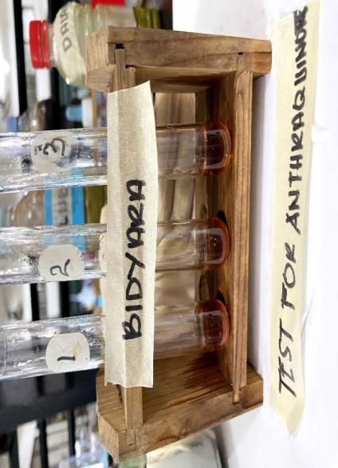

**Test for Anthraquinone**

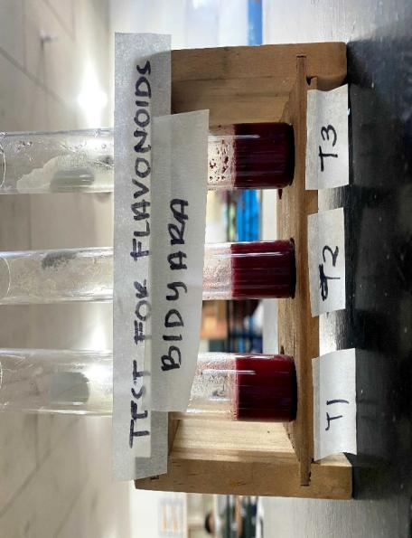

**Test for Flavonoid**

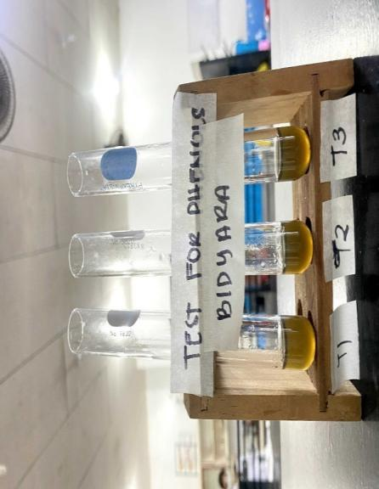

**Test Phenolic Compound**

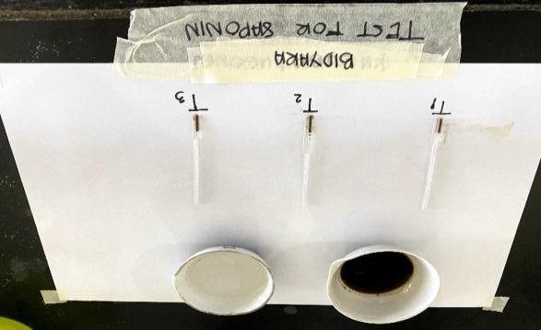

**Test for Saponin**

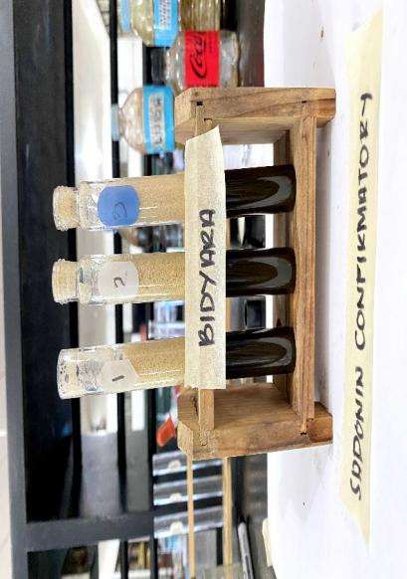

**Confirmatory Test for Saponin**

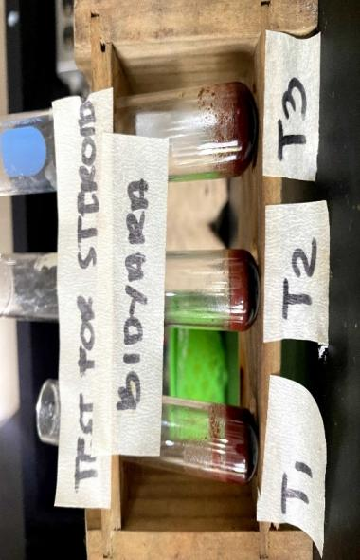

**Test for Steroid**

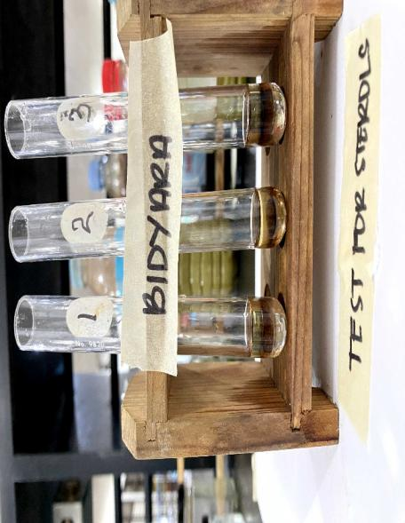

**Test for Sterol**

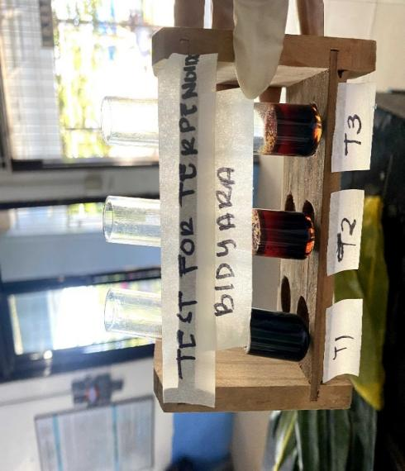

**Test for Terpenoid**

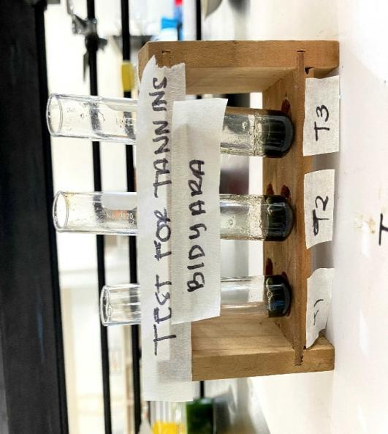

**Test for Tannin**

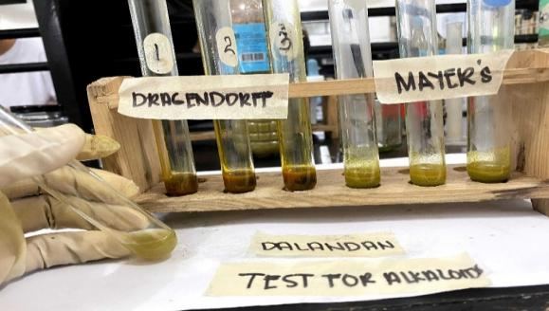

**Test for Alkaloid**

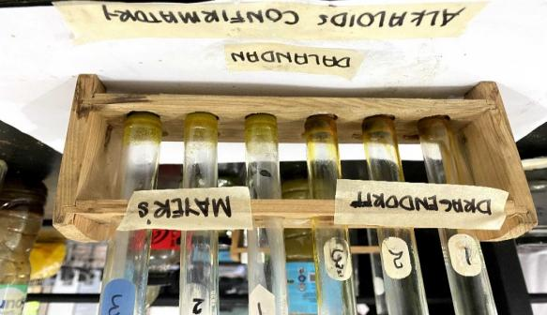

**Confirmatory Test for Alkaloid**

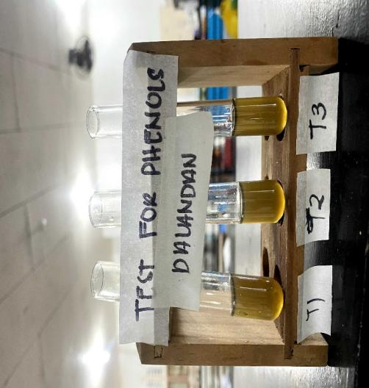

**Test for Phenolic Compound**

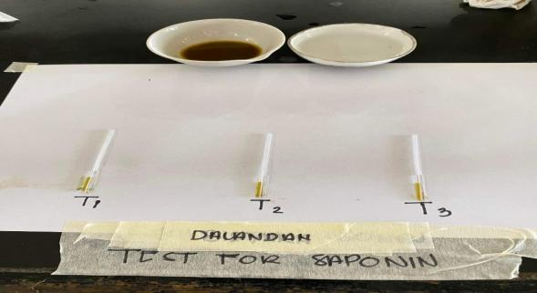

**Test for Saponin**

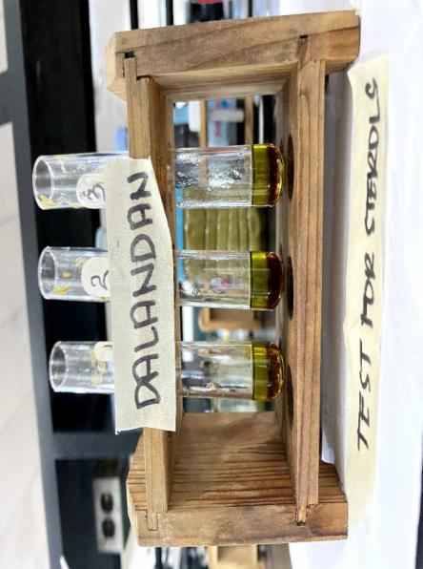

**Test for Sterol**

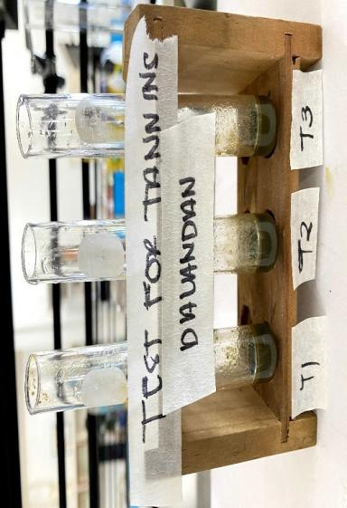

**Test for Tannin**

***Picture 2-Citrus reticulata* Blanco (Dalandan) Leaf Extract with Positive Results**

***Picture 3-Ocimum tenuiflorum* L. (Kulong-Kugong) Leaf Extract with Positive Results**

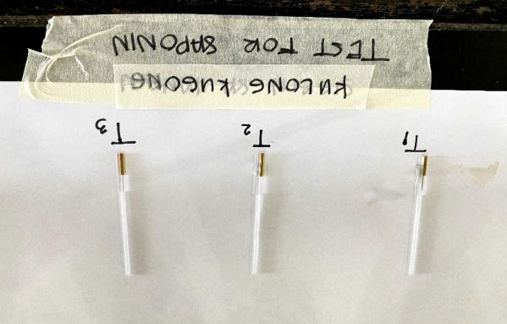

**Test for Saponin**

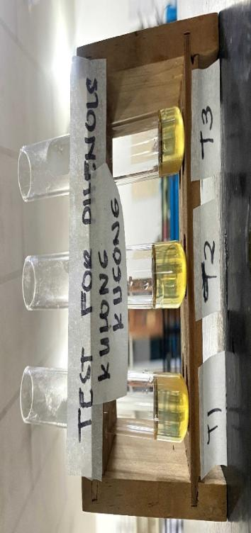

**Test for Phenolic Compound**

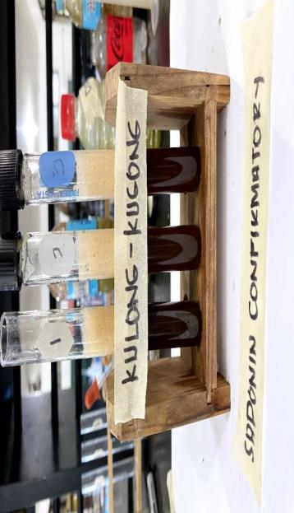

**Confirmatory Test for Saponin**

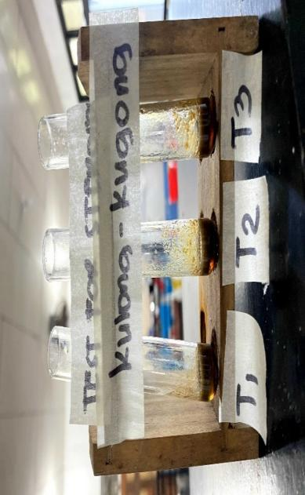

**Test for Steroid**

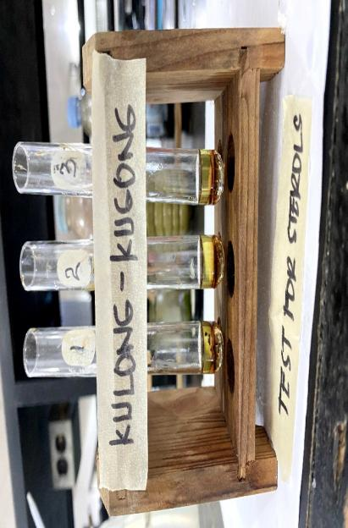

**Test for Sterol**

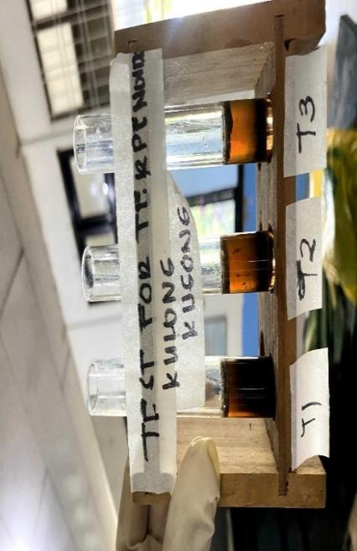

**Test for Terpenoid**

**Picture 4-*Piper betle* Linn (Luba) Leaf Extract with Positive Results**

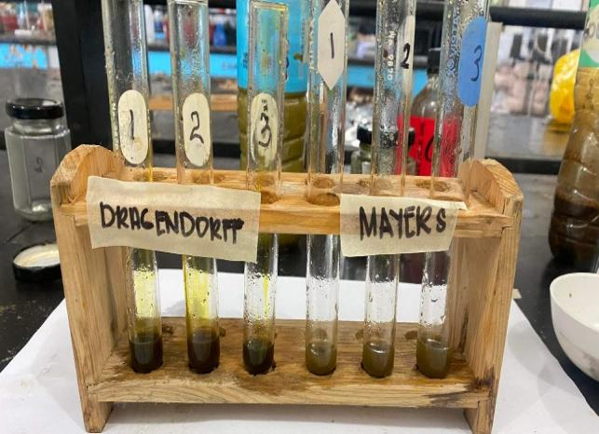

**Luba Test for Alkaloid**

**Test for Alkaloid**

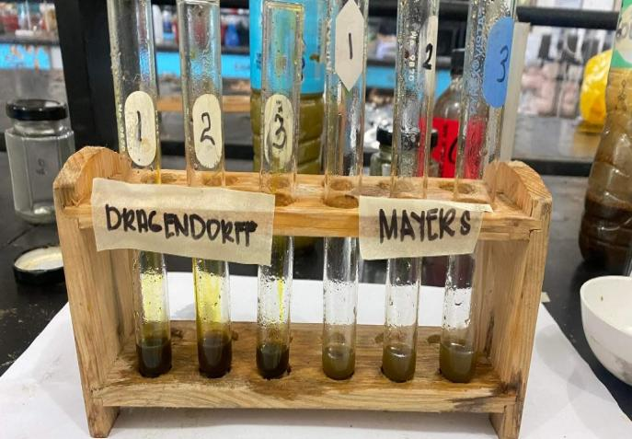

**Luba Alkaloid Confirmatory Test**

**Confirmatory Test for Alkaloid**

**Test for Flavonoid**

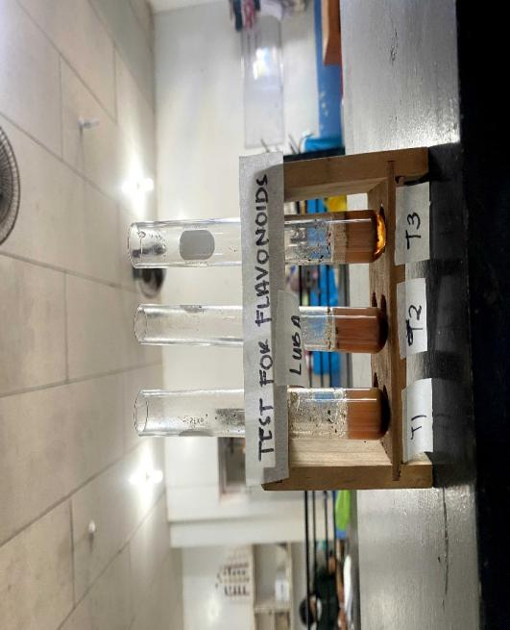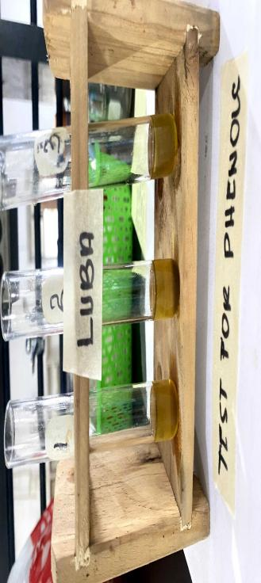

**Test for Phenolic Compound**

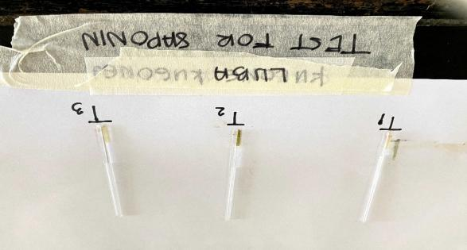

**Test for the Presence of Saponin**

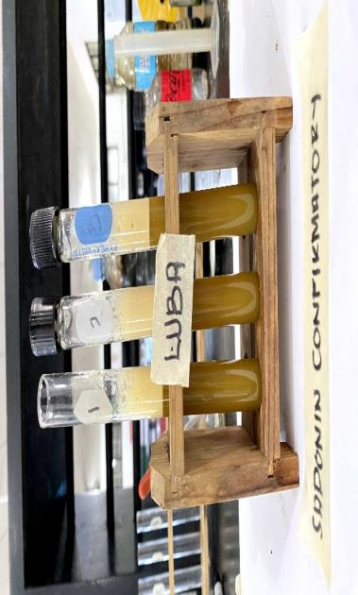

**Confirmatory Test for Saponin**

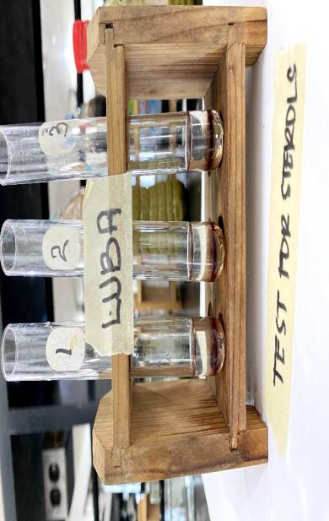

**Test for Sterol**

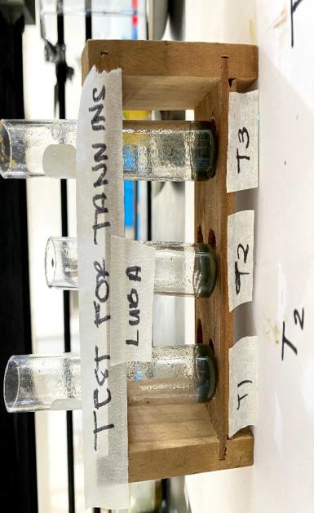

**Test for the Presence of Tannin**

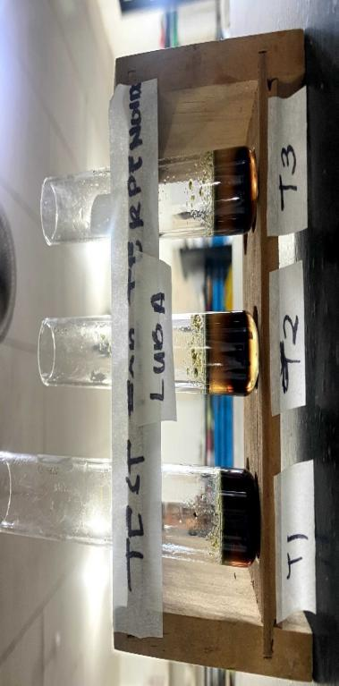

**Test for the Presence of Terpenoid**

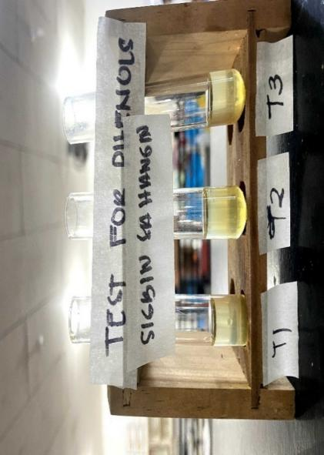

**Test for Phenolic Compound**

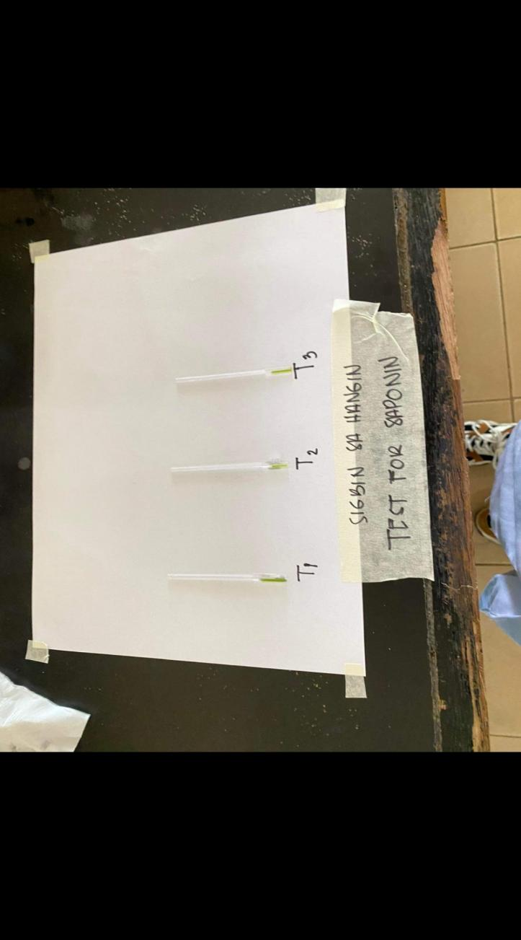

**Test for the Presence of Saponin**

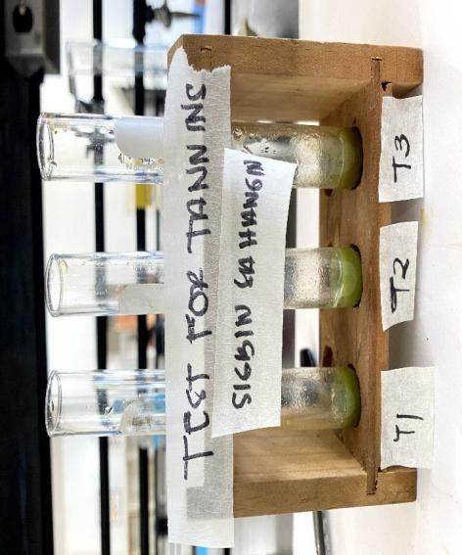

**Test for the Presence of Tannin**

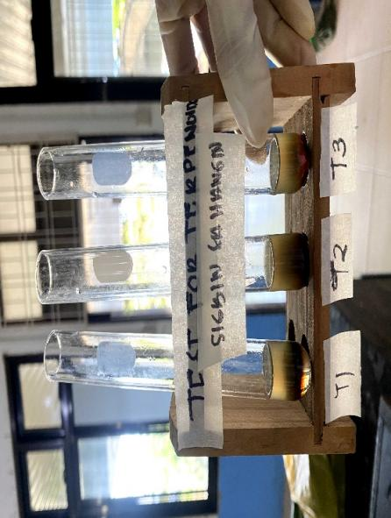

**Test for the Presence of Terpenoid**

***Picture 5-Sansevieria trifasciata* Prain (Sigbin Sa Hangin) Leaf Extract with Positive Results**