**Molecular characterization of cariogenic and non- cariogenic Streptoccoi species in dental plaque biofilm using 16S-23S rRNA gene spacer region amplification**

**Abstract:** Interspecies competitive exclusion of microbial diversity explained using 16S-23S rRNA gene spacer region amplification .Virulent and non-virulent strains of streptococci strain were isolated from dental plaque biofilm for analysis. DNA isolation done from plaque strains from dental biofilms of caries- active and caries-free subjects, respectively .Two pairs of primers were designed from the 16S–23S rRNA gene spacer region to amplify the variable and species-specific non-coding regions. The results revealed that the ITS lengths (246 to 391 bp) and sequences were highly conserved among strains within a species. The precision of utilising intergenic spacer sequencing for recognisable proof of viridian group *streptococci* was checked by 16S rDNA sequencing for all strains apart from strains of *Streptococcus oralis and Streptococcus mitis*, which were hard to separate by their 16S rDNA arrangements. Comparative sequence analysis of the 16S-23S rRNA spacer region sequences revealed that not only *Streptococcus mutans*, but also *Streptococcus* salivarius, *Streptococcus oralis* and *Streptococcus mitis* play equal role in oral disesase progression as compare to *Streptococcus mutans* which is reported in previous studies.

**KEY WORDS** : **16S-23S rRNA**, ***Streptococcus oralis*** *,* ***Streptococcus mitis****,*

**Dental plaque, Biofilm.**

Introduction

Genetics and molecular basis for virulence in oral disease analysed using the 16S r RNA gene sequencing technique. Application of 16S r RNA gene sequencing technique to study the oral microbiome will continue to contribute to our knowledge of the oral microbiome, and with new technologies, the depth and breadth of the information collected should be remarkable [1]. In a study it is revaled that the species that were previously thought to be associated primarily with health were also elevated in caries-active individuals, leading the authors to conclude that “the relationship of acid-base metabolism to 16S r RNA gene-based species assignments appears to be ‘complex’G’’ 30 [2]. Another reason why the 16S sequence alone appears inadequate to predict association of particular bacetria with oral diseases is related to the concept of phenotypic plasticity. To explore the relationship of Genotype and Cariogenic Potential in *Streptococcus mutans* numerous studies have demonstrated [3,4]. Biofilm in the form of supragingival and subgingival plaque is the etiologic agent in dental caries and periodontal diseases. The ability of bacteria to survive and persist in a given environment will depend, in part, on their inherent genetic plasticity, which determines their ability to respond to fluctuating local environmental condition or stresses [5].

Dental caries is a transmissible infectious disease in which *Streptococcus mutans* plays the major role. As in many infectious diseases, colonization by pathogens is required before the disease can occur. *Streptococcus mutans* are generally considered to be the principal etiological agent of dental caries [6].There is a range of virulence factors important for the establishment of *Streptococcus mutans* in the complex microbial community of dental biofilm. Studies of the virulence factors of *Streptococcus mutans* and their correlation with species biodiversity are fundamental to understanding the role played by colonization by different genotypes in the same individual, and the expression of characteristics that may or may not influence their virulence capacity and survival ability under different environmental conditions. Studies using phenotyping and/or genotyping methods strongly suggest that the mother is the major primary source of infection for children who carry *S.mutans* and/or *S.sobrinus* strains (2- 10) and the saliva is the principal vehicle by which transfer of *Streptococcusmutans* may occur [7]. examination

of the genetic structure of *Streptococus mitis* biovar 1 in its natural habitat in the human oral cavity and pharynx, and investigated the role of selected microbial properties (IgA1 protease production and the ability to bind salivary α-amylase) and host, spatial, and temporal factors play in determining the structure

of the bacterial population, they reported the

Genetic diversity in nine structural gene loci by MLEE

analysis of 19 and 13 isolates representing different REA types of Streptococcus mitis biovar 1 isolates from two individuals, compared to the diversity in the two collections combined [8] .In previous finding it is demonstrated tht *Streptococcus mutans*, the microbial species most strongly associated with dental caries [3,9,10,12,13].

**Material and methods**

DNA isolation from plaque strain from dental biofilm of caries active and caries free subject respectively.following the who norms for dental plaque sample collection and isolation. DNA isolation was carried out by using Cetyltrimethylammonium bromide (CTAB) method of DNA extraction [14,15,16]. The cultured single colony was centrifuged at 12500 rpm for

2 min, and the supernatant was discarded. The bacterial cells pellets were washed twice using Tris EDTA (TE) buffer. A 600 µl of CTAB buffer was added to the bacterial pellet, and the entire solution was kept in a heat bath at 65 °C for 30 min to ensure lysis of cell walls. Afterwards, 600 µl of a Chlorophorm: Isoamyl Alcohol solution (24:1, v/v) was added and mixed thoroughly by inverting 20-30 times. The mix was centrifuged at 12500 rpm for 7 min. Supernatent above the interphase was transferred to fresh tube to which 2.5 parts of cold 100% Ethanol was added. All the components were mixed thoroughly by inverting tubes and incubated at -20

°C for 30 min. Nucleicacids were allowed to pellet down as precipitate by centrifuging the mixture at 12500 rpm for 20 min at 4°C. Finally, the isolated nuclec cids were washed with 70% Ethanol. The pellet was air dries at 37°C until all the alcohol content evaporates and dried pellet was resuspended and dissolved in 50 μl of nuclease free water and stored at – 4°C for downstream PCR analysis.

# Polymerase Chain Reaction Setup

Species of bacterial isolates were identified by the combined use of universal primers for 16S-23S rRNA gene spacer amplification (RSA), and sequencing of the amplicons. We used Phusion high fidelity DNA polymerase (Thermo Scientific) to ensure the high fidelity of the amplicons. PCR reactions were conducted in a final volume of 20 µl containing: 1X PCR buffer, 1.5 mM MgCl2, 0.2 mM dNTPs each,

0.5 µM primer each, 0.02U/µl reaction of Phusion DNA polymerase supplemented with 1 µl of bacterial genomic DNA

Thermal program for PCR reaction was kept as below; 98°C -3 min

98°C -15 sec

58°C -20 sec

72°C -30 sec, from step 2, 35 cycles 72°C - 5 min

4°C - hold” (Gene Amp 9600, Perkin-Elmer, Norwalk, USA).

# Primer Design

Two pairs of primers were designed from the 16S-23S rRNA Gene spacer region to amplify the variable and species specific non-coding regions. First pair contains two primers i.e. G1 (GAAGTCGTAACAAGG) and L1 (CAAGGCATCCACCGT) was prepared according to PREVIOUS STUDY [15,16], which is to investigate the diversity of bacterial species. Second primer pair ITSF (GTCGTAACAAGGTAGCCGTA) and ITSR (GCCAAGGCATCCACC) are complimentary to 1443 position of 16S rRNA and 23 position of 23S rRNA of *E. coli* and used to analyze microbial diversity of soil samples [17].

# Bioinformatics Analysis

The amplified products of ~300 bp were gel excised and purified using gel extraction kit (Geneaid) and amplicons were sequenced (Eurofins, Banglore, India). Sequences obtained after sequencing were trimmed of low quality sequences in seqMan of DNA- Star program. The sequences of 16S-23S rRNA spacer region were downloaded from

NCBI database. Both the downloaded and obtained sequences were aligned in a Clustal-W alignment of Bioedit program to examine the homology and variations among the sequences.

**RESULT AND DISCUSSION**

**Molecular Analysis of strain isolated from caries active and caries free subject**

To study the microbial diversity of virulent strain isolated from dental plaque biofilm of caries active and caries free subject, the following molecular test conducted. Bacterial strains used in this study were- Strains C1 - C2 isolated from dental plaque biofilm from caries active subject and strain CF1

- CF2 isolated from dental plaque biofilm from caries free subject . Colony selection done by focusing on maximum percentage of strain recovered on mitis salivarius agar by conventional culture technique.

Isolated strain from caries active and caries free dental plaque biofilm sample were identified by morphological characteristics and biochemical identification method, further strain recovered maximum in number were selected for microbial characterization. In the present examination, we used a PCR strategy to recognize bacterial strain of known morphology and biochemical charecterisctics from dental plaque biofilm sample of caries active and caries free subject.

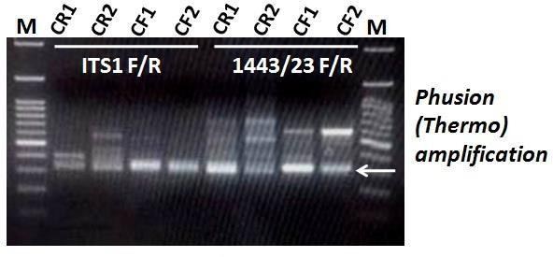

**Figure 1** PCR assay by Phusion high fidelity DNA polymerase (Thermo Scientific). Gel profile of PCR products using the Caries avtive (CR1 and CR2) and Caries free (CF1 and CF2) bacterial sample from dental plaque biofim and template and two pairs of primers used to amplify 16s rRNA and 23 position of 23S rRNA of species, M , Molecular size maker (100 bp DNA ladder, Gene direx company). bands correspond to ~350 bp for sequencing.

PCR techniques with preliminaries built dependent on the 16S rRNA arrangement are broadly used for their fast and delicate recognition of bacteremia [17,18]. The PCR of present investigation as shown in Fig 1 , illustrates clear full reaction by using the two pairs of primers which were designed from the 16S-23S rRNA Gene spacer region to amplify the variable and species specific non- coding regions. The result yielded amplicons of expected sizes , reaction stored with proofreading enzyme and sended for sequencing.

***Comparative sequence analysis of the 16S-23S rRNA spacer region sequences***

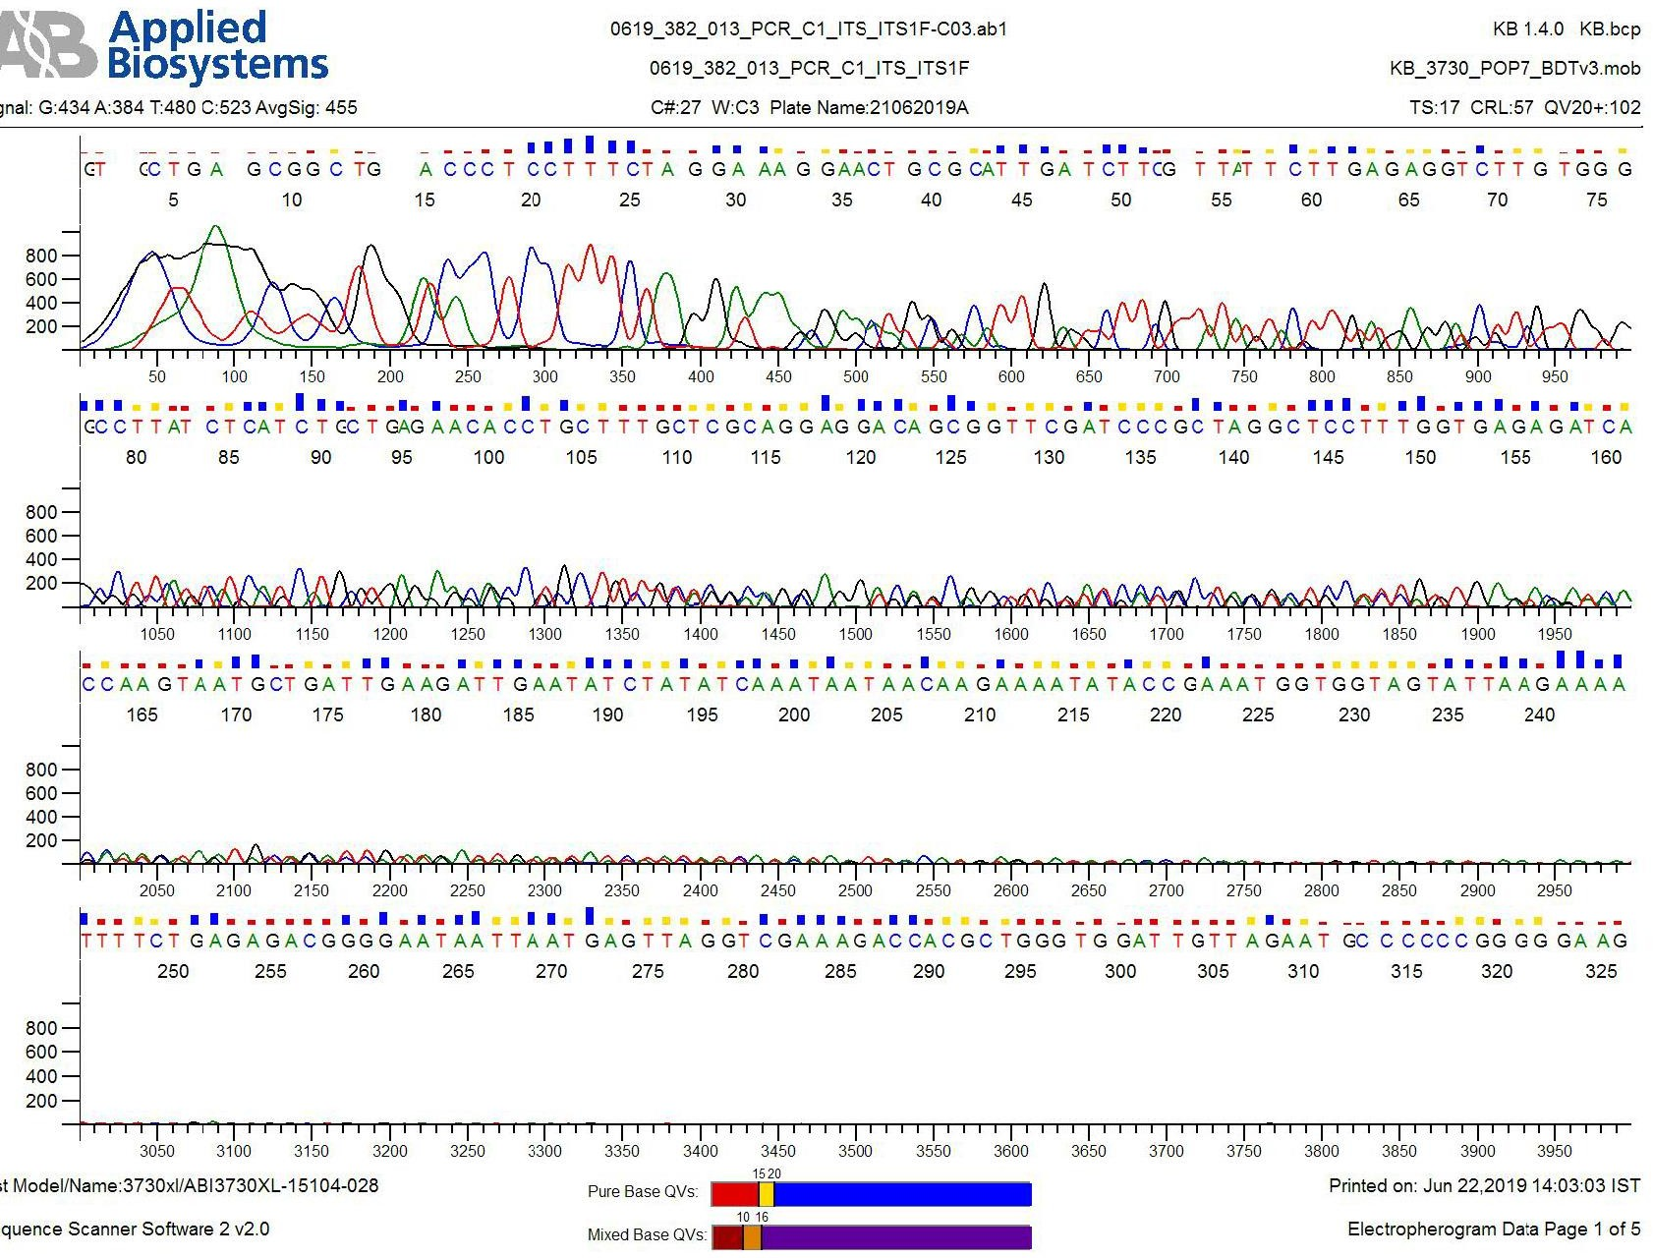

Fig. 2: **Chromatogram analysis of strain** 0619_382_013_PCR_C1_ITS_ITS1F-C03.ab1

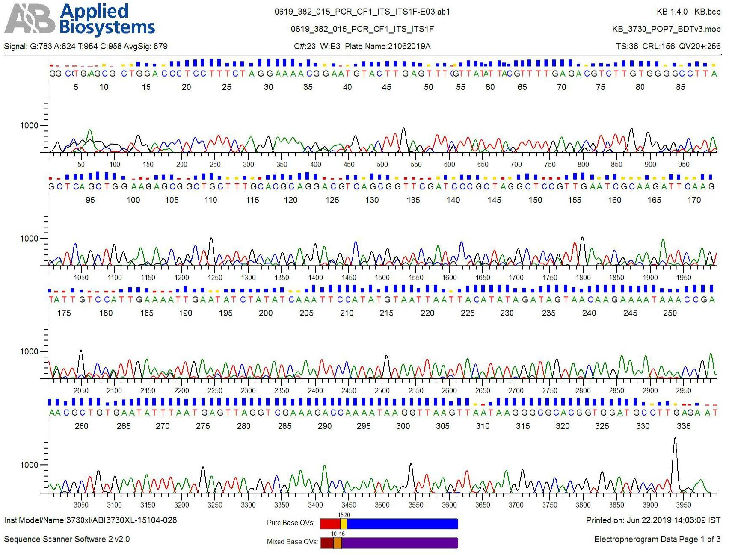

Fig 3: **Chromatogram analysis of strain** 0619_382_015_PCR_CF1_ITS_ITS1F-E03.ab1

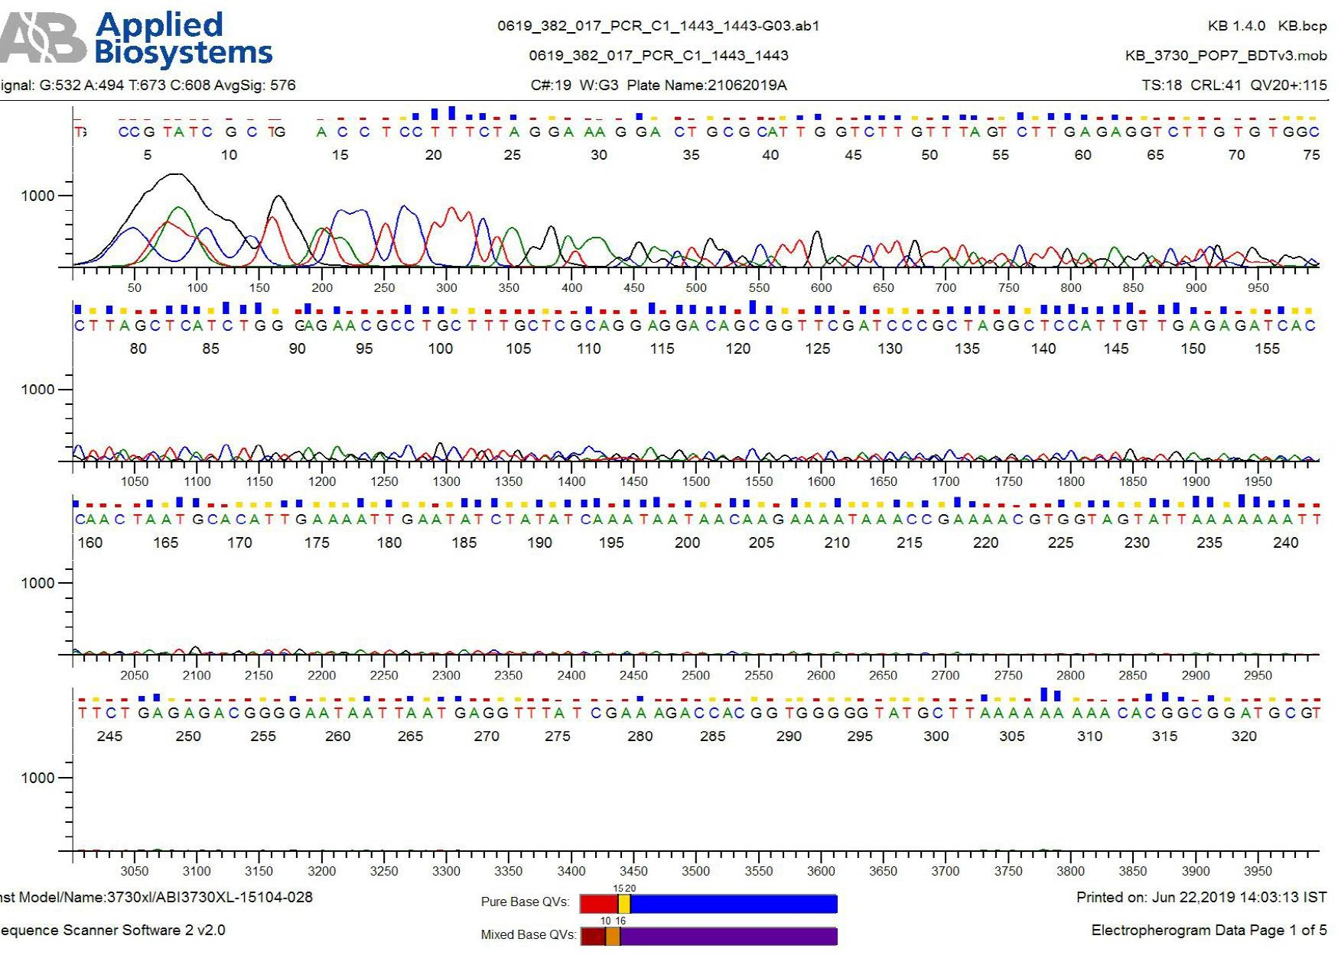

Fig. 4: **Chromatogram analysis of strain** 0619_382_017_PCR_C1_1443_1443-G03.ab1

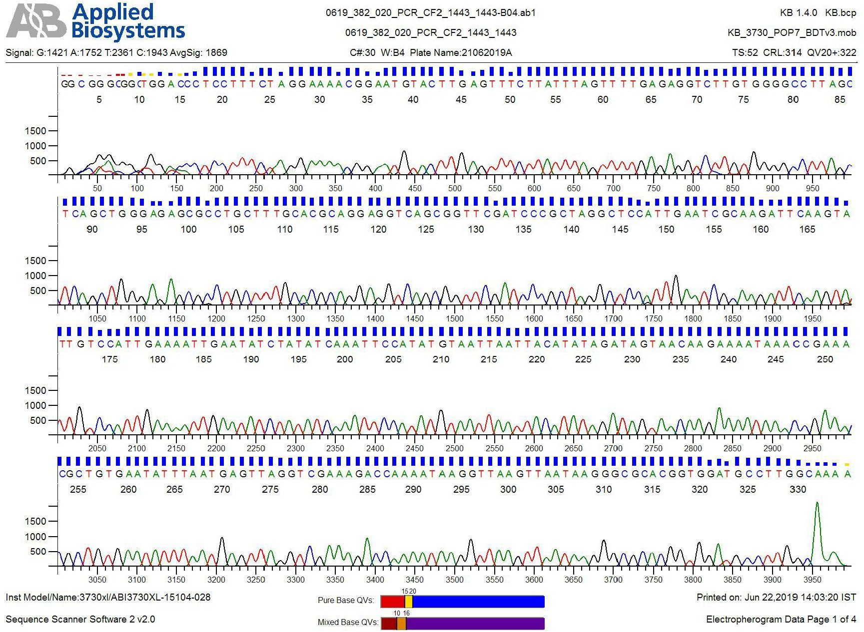

Fig. 5: **Chromatogram analysis of strain** 0619_382_020_PCR_CF2_1443_1443-B04.ab1

Purified PCR amplicons were sent for sequencing with ITSF and 1443F primers in a single pass reaction from Eurofins. The obtained sequences were trimmed for bad-quality mixed reads from both the ends in SeqMan tool of DNA STAR (Fig. 6).

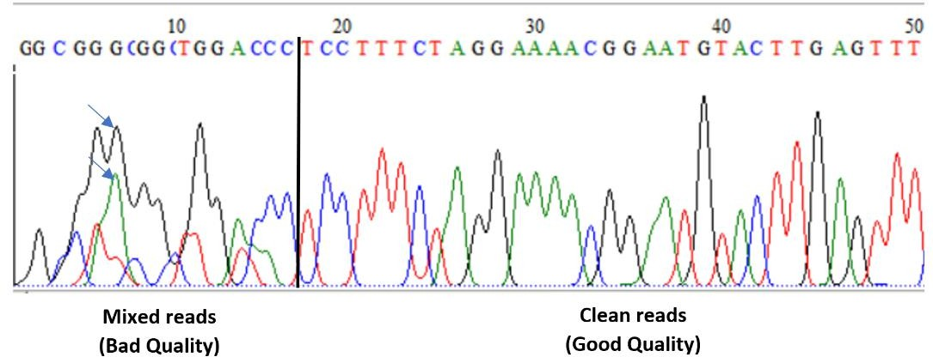

# Fig. 6: Chromatogram showing good and bad quality reads in raw sequences

The high-quality sequences were aligned in a local CLUSTAL-W alignment tool of BioEdit programme with selecting “full multiple alignment” and “bootstrap NJ tree” options (Fig. 6). Fully aligned sequences were checked for variations among two replicates like C1/C2 and CF1/CF2 with both primers, separately.

In these, presence of SNP’s/indels were examined manually, which was further confirmed with base calling values in chromatogram (.abi) files. It is obvious, that single pass sequences would show ambiguities in base calling. Thus, we modified only those SNP’s/Indels which are present among replicates and showed bad quality in the chromatogram. Indels which are present among two samples i.e. Caries (C) and Caries Free (CF) were considered as true differences and further used in downstream analysis.

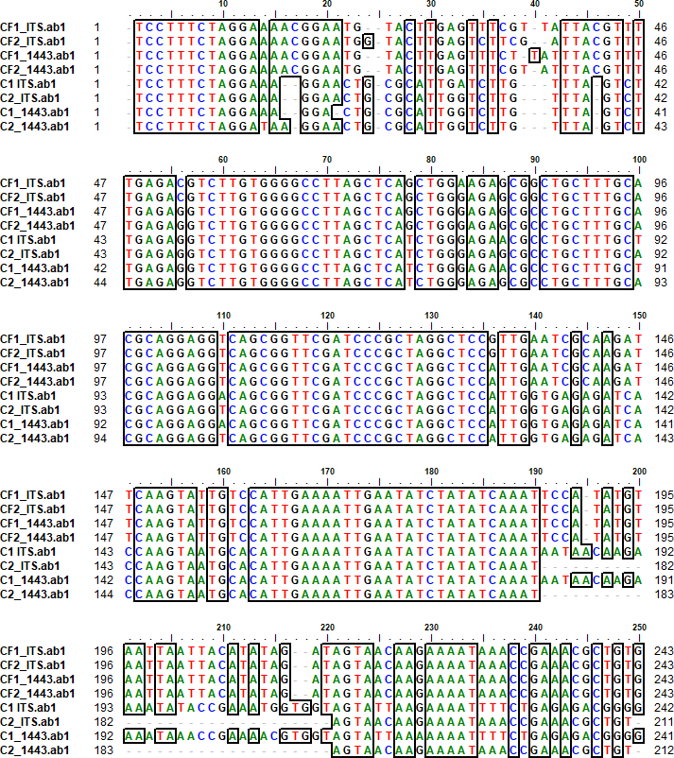

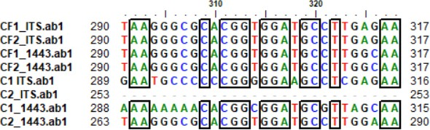

**Fig. 7: CLUSTAL W alignment of 16S-23S rRNA spacer region sequences obtained in duplicates (1,2) from the Caries**

**(C) and Caries Free (CF) samples using ITS and 1443 primers.**

The conserveness of blocks of 13, 20, 24 and 27 bases from 1-13, 52-77, 107-131 (Red underlined) and 159-186 nt position, indicates that all the samples are originated from same bacterial genera (Fig. 4). Presence of variations of >1 base was considered as indels that indicate that sequences are originated from a minimum of two different species (Fig. 8). Like, sequences of C1 and C2 samples are originated from one species and sequences of CF1/CF2 samples are originated from another species.

From NCBI BLAST-N analysis, we identified that the species representing two samples are *Streptococus salivarius*, *Streptococcus oralis* and *Streptococcus mitis* (Fig. 8 and 9). BLAST-N alignment for high similarity search indicates that the samples collected from caries Free (CF) mouth cavity belongs to *S. salivarius* with high identity (97%) and E- value (9e-152) (Fig. 8A). Few Gaps and SNPs are visible in alignment due to strain specific variations (Fig. 8A and B).

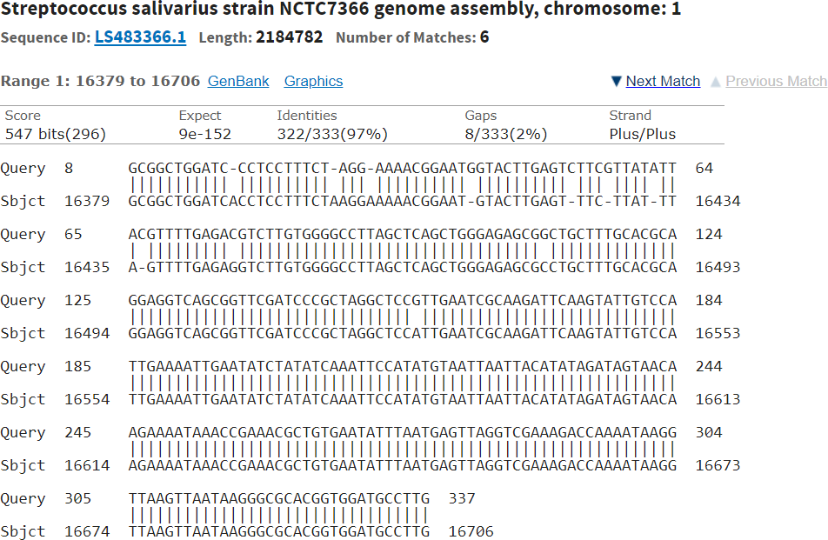**A**

**B**

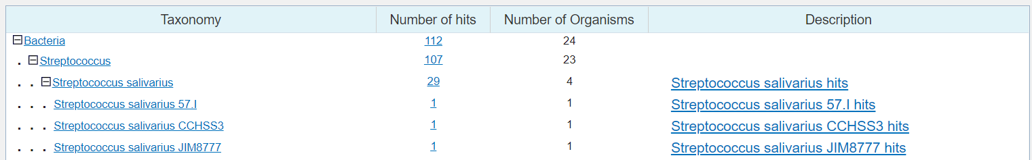

**Fig. 8 BLAST-N analysis of the sequence obtained from Caries Free (CF) sample (A) and number of hits to the top hit species/strains (B)**

On the contrary, sample collected from the caries containing moth cavity have high similarity to

*S. oralis* and *S. mitis* with high identity (98%) and E-value (2e-138) (Fig. 9 A and B). Similarly, gaps and SNPs are visible indicating variations among strains (Fig. 9A-C).

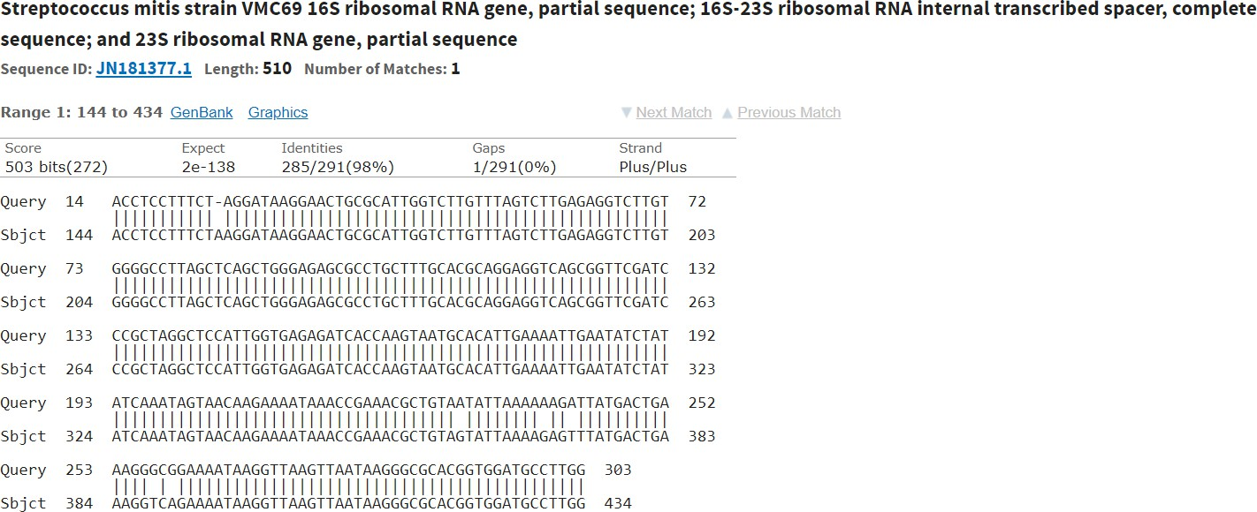**A**

**B**

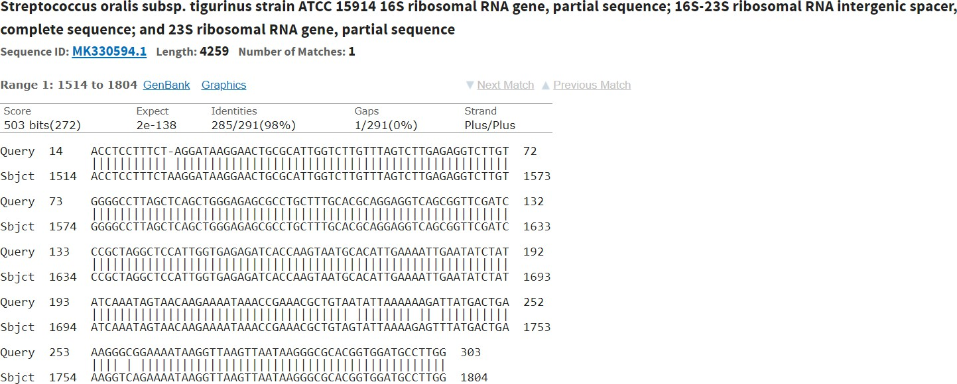

**C**

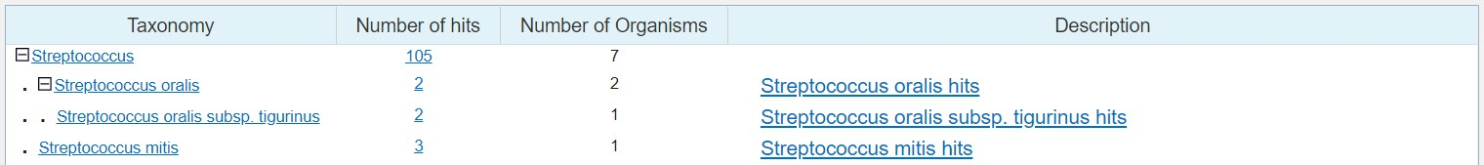

**Fig. 9 BLAST-N analysis of the sequence obtained from Caries (CF) containing sample (A and B) and number of hits to the top hit species/strains (C)**

The finding of present studies were in full agreement with the study **in which it is reported** that the application of 16S r RNA gene sequencing to analysis of the oral microbiome will continue to contribute to our knowledge of the oral microbiome, and with new technologies, the depth and breadth of the information collected should be remarkable [18]. Earlier finding demonstrated the natural transformation of *Streptococus strains that* have allowed investigators to analyze the functions of many genes in particular concern strain that are isolated from specific sources . Induction of genetic competence in these *streptococci is* mediated by quorum sensing, which depends on a competence stimulating peptide (CSP) signaling system [19].

In previous finding it is demonstrated that *Streptococcus mutans*, the microbial species most strongly associated with dental caries [3,9,10]. Similarly , *Streptococcus mutans,* the microbial species most strongly associated with carious lesion, is naturally present in the human oral microbial flora [2]. The result of present finding is in full agreement with

[21] who assayed and demonstrated the cariogenic property of *Mutans streptococci* that they were not among the aciduric isolates. Subjects without root caries harbored less microscopic organisms, and *Streptococcus anginosus* (pH 4.8) and *Streptococcus oralis* (pH 5.2) were the prevalent aciduric *microscopic organisms as compare to s.mutans. The result of the present studies was also in the agreement with* Chen *et al*., (2004) who evaluated the attainability of sequence analysis of the 16S-23S ribosomal DNA (rDNA) intergenic spacer (ITS) for the identification and demonstration of clinically applicable viridans group *streptococci*. According to present study on gene sequence result it is clear that *Streptococus salivarius* and *Streptococus mitis* exibit the carriogenic property , which is responsible for oral disese condition and its progress. In present finding *Streptococcus mitis and Streptococcus oralis* recovered from caries active sample reveal its importance as an etiological agent for dental caries as compare to *Streptococus mutans* in previous findings . The ITS regions of 29 reference strains (11 species) of viridans group *streptococci* were amplified by PCR and sequenced. These 11 species were *Streptococcus anginosus*, *Streptococcus constellatus*, Streptococcus *gordonii*, Streptococcus *intermedius*, Streptococcus *mitis*, *Streptococcus mutans*, *Streptococcus oralis*, *Streptococcus parasanguinis*, *Streptococcus salivarius*, *Streptococcus sanguinis*, and *Streptococcus uberis*. Result revealed that the ITS

lengths (246 to 391 bp) and sequences were highly conserved among strains within a species. The precision of utilizing intergenic spacer sequencing for recognizable proof of viridian group *streptococci* was checked by 16S rDNA sequencing for all strains apart from strains of *Streptococcus oralis and Streptococcus mitis*, which were hard to separate by their 16S rDNA arrangements. Taking everything into account, distinguishing proof of types of viridans group *streptococci* by intergenic spacer sequencing is solid and could be utilized as an option exact strategy for analyzing of *streptococci* viridans group.

Comparative sequence analysis of the 16S-23S rRNA spacer region sequences revealed that not only *Streptococcus mutans* but also *Streptococcus salivarius* and *Streptococcus mitis* play equal role in oral disesase progression as compare to *Streptococcus mutans* which is reported in various studies.

**COMPETING INTERESTS DISCLAIMER:**

Authors have declared that they have no known competing financial interests OR non-financial interests OR personal relationships that could have appeared to influence the work reported in this paper.

**REFERENCES**

1. Ranjan, Ravi, et al. "Analysis of the microbiome: Advantages of whole genome shotgun versus 16S amplicon sequencing." *Biochemical and biophysical research communications* 469.4 (2016): 967-977.
2. Bowman JS, Ducklow HW. Microbial Communities Can Be Described by Metabolic Structure: A General Framework and Application to a Seasonally Variable, Depth-Stratified Microbial Community from the Coastal West Antarctic Peninsula. PLoS One. 2015 Aug 18;10(8):e0135868. doi: 10.1371/journal.pone.0135868. PMID: 26285202; PMCID: PMC4540456.
3. Agnello M, Cen L, Shokeen B, He X, Shi W, Wong DTW, Lux R, Tran NC. Oral Microbiome: *Streptococcus mutans*/Caries Concordant-Discordant Children. Front Microbiol. 2022 Feb 17;13:782825. doi: 10.3389/fmicb.2022.782825. PMID: 35250921; PMCID: PMC8891984.
4. Butler III, R. R., Soomer-James, J. T., Frenette, M., & Pombert, J. F. (2017). Complete genome sequences of two human oral microbiome commensals: Streptococcus salivarius ATCC 25975 and S. salivarius ATCC 27945. *Genome Announcements*, *5*(24), e00536-17.
5. Benítez-Páez, A., Belda-Ferre, P., Cabrera-Rubio, R. and Mira, A., 2014. Streptococcus dentisani sp. nov., a novel member of the mitis group. *International journal of systematic and evolutionary microbiology*, *64*(Pt_1), pp.60-65.
6. Russell, S. L., J. R. Ickovics, and R. A. Yaffee. "Parity & untreated dental caries in US women." *Journal of dental research* 89.10 (2010): 1091-1096.
7. Napimoga, Marcelo Henrique, et al. "Transmission, diversity and virulence factors of Streptococcus mutans genotypes." *Journal of oral science* 47.2 (2005): 59-64.
8. Hohwy J, Reinholdt J, Kilian M. Population dynamics of Streptococcus mitis in its natural habitat. Infect Immun. 2001 Oct;69(10):6055-63. doi: 10.1128/IAI.69.10.6055-6063.2001. PMID: 11553543; PMCID: PMC98734.
9. Baron. (1996), “Microbiology of dental decay and periodontal disease”, Medical Microbiology., 99.
10. Cornejo, Lefebure, Bitar, Pavinski P.D, Lang, Richar (2012), “Evolutionary and population genomics of the cavity causing bacteria *Streptococcus mutans*”, Mol.Biol.Evol., 30 (4):881-893
11. Alsaimary. I.E. (2008), “Efficency of some antibacterial agents against *Streptococcus mutans* associated with tooth decay”, African Journal of Biotecnology, 8 (2).
12. Agnello, M., Cen, L., Shokeen, B., He, X., Shi, W., ... & Tran, N. C. (2022). Oral microbiome: streptococcus mutans/caries concordant-discordant

children. *Frontiers in Microbiology*, *13*, 143.

1. Wood DN, Weinstein KE, Podbielski A, Kreikemeyer B, Gaughan JP, Valentine S, Buttaro BA. Generation of metabolically diverse strains of Streptococcus pyogenes during survival in stationary phase. J Bacteriol. 2009 Oct;191(20):6242-

52. doi: 10.1128/JB.00440-09. Epub 2009 Aug 7. PMID: 19666718; PMCID: PMC2753042.

1. Eva Medina, Oliver Goldmann, Antonia W Toppel, Gursharan S Chhatwal, Survival of *Streptococcus pyogenes* within Host Phagocytic Cells: A Pathogenic Mechanism for Persistence and Systemic Invasion, *The Journal of Infectious Diseases*, Volume 187, Issue 4, 15 February 2003, Pages 597–

603, <https://doi.org/10.1086/373998>

1. Tel-Zur, N., et al. "Modified CTAB procedure for DNA isolation from epiphytic cacti of the genera Hylocereus and Selenicereus (Cactaceae)." *Plant Molecular Biology Reporter* 17 (1999): 249-254.
2. Petersen and Scheie, 2000 Petersen FC, Tao L, Scheie AA. DNA binding-uptake system: a link between cell-to-cell communication and biofilm formation. J Bacteriol. 2005 Jul;187(13):4392-400. doi: 10.1128/JB.187.13.4392-4400.2005. PMID: 15968048; PMCID: PMC1151753.
3. Cardinale, Massimiliano, et al. "Comparison of different primer sets for use in automated ribosomal intergenic spacer analysis of complex bacterial communities." *Applied and environmental microbiology* 70.10 (2004): 6147-6156.
4. Clarridge JE 3rd. Impact of 16S rRNA gene sequence analysis for identification of bacteria on clinical microbiology and infectious diseases. Clin Microbiol Rev. 2004 Oct;17(4):840-62, table of contents. doi: 10.1128/CMR.17.4.840-862.2004. PMID: 15489351; PMCID: PMC523561.
5. Sousa, Vanessa, et al. "Peri‐implant and periodontal microbiome diversity in aggressive periodontitis patients: a pilot study." *Clinical oral implants research* 28.5 (2017): 558-570.
6. Marchant, S., Brailsford, S. R., Twomey, A. C., Roberts, G. J., & Beighton, D. (2001). The predominant microflora of nursing caries lesions. *Caries research*, *35*(6), 397-406.Chen *et al*., (2004)
7. Paddick, James S., et al. "Effect of the environment on genotypic diversity of Actinomyces naeslundii and Streptococcus oralis in the oral biofilm." *Applied and environmental microbiology* 69.11 (2003): 6475-6480.
8. Lal D, Verma M, Lal R. Exploring internal features of 16S rRNA gene for identification of clinically relevant species of the genus Streptococcus. Ann Clin Microbiol Antimicrob. 2011 Jun 25;10:28. doi: 10.1186/1476-0711-10-28. PMID: 21702978; PMCID: PMC3151204.