Patient Safety During Transport: Comparing Chest Radiographs at the Bedside and in the Examination Room

.
ABSTRACT

The transportation of critically ill patients for diagnostic exams requires extreme caution, as it may compromise their clinical stability. To minimize these risks, strict protocols must be followed to ensure patient safety. This study evaluated image quality (IQ) in bedside chest radiographs compared to those performed in the examination room. Ten semi-anatomical phantom images were analyzed while maintaining a constant exposure index. Results indicated that exams performed in the examination room increased contrast (27.19%) but also raised the entrance surface dose (371.70%) due to the use of an anti-scatter grid inherent to the examination room and reduced the signal-to-noise ratio (SNR) (21.38%). Conversely, bedside images had lower radiation dose and higher SNR but lower contrast. The decision to transport the patient should balance diagnostic accuracy and radiation safety, guided by clinical judgment. Future studies may optimize protocols to enhance IQ while minimizing radiation exposure.

Keywords: Care in Radiology; Image Quality; Radiation Safety; Signal-to-Noise Ratio.

1. INTRODUCTION

The bedside chest radiograph is an essential diagnostic tool in Brazilian hospital routines (Ferreira, 2017). However, image quality (IQ) in this context may be compromised by various technical factors, such as the absence of an anti-scatter grid, for example (Sayed et al., 2023). Recent studies by Cè et al. (2024) have demonstrated that the use of new technologies associated with the digitization of radiographic images, such as image correction algorithms, can represent a significant advancement in achieving a balance between IQ and reduction of entrance surface dose (K_{a,e}). Nonetheless, the use of anti-scatter grids, although traditional, increases the patient’s K_{a,e} (Sayed et al., 2023).

The transportation of a critically ill patient for diagnostic exams or therapeutic procedures demands meticulous attention, given the complexity of their clinical condition. To minimize risks and prevent further deterioration of health, the decision to transport the patient must follow strict protocols and procedures established by ICU professionals, ensuring safety and stability throughout the process (Nascimento; Schweitzer; Moreira, 2018).

Although the increase in K_{a,e} is a factor to be considered, it may be justified by the improvement in image quality. In this context, the Signal-to-Noise Ratio (SNR) and radiographic contrast (RC) emerge as descriptors of IQ (Dance et al., 2014). SNR, which expresses the relationship between useful signal and noise in the image, directly influences the visibility of anatomical details (Bushberg; Boone, 2011; Moore et al., 2019). RC, in turn, arises from variations in X-ray beam attenuation across different tissues, highlighting differences between anatomical structures and aiding in lesion detection (Tompe; Sargar, 2020).

Given the relevance of bedside chest radiographs, especially for patients with reduced mobility (Häggmark et al., 2023), this study aims to investigate image quality and entrance surface dose in adult chest radiographs performed both at the bedside and in a dedicated examination room.

2. material and methods

This study was conducted in the radiodiagnostic laboratory of the Radiology and Medical Physics undergraduate programs at Universidade Franciscana (UFN), as part of research developed during the Image Processing course. For image acquisition, a high-frequency radiographic unit from Intecal (MAAF model) was utilized. A large focal spot (1.2 mm²) was chosen due to its suitability for chest examinations. The radiographs were performed using an anti-scatter grid with a ratio of 10:1 (52 lines/cm) and a source-to-image receptor distance (SID) of 1.40 meters.

Ten exposures were performed for each technique, simulating bedside imaging (without the anti-scatter grid) and table-based imaging (with the anti-scatter grid), as identified in Stage 1 of Figure 1, maintaining a tube voltage of 96 kV. For digital image capture, a computed radiography system from Carestream (Direct View Classic C model) was employed, featuring a 35 cm x 43 cm cassette, an image plate (IP) with a spatial resolution of 10 pixels/mm, and a bit depth of 16 bits. Image visualization was performed on the workstation monitor integrated into the system. Exposure measurements (K_{AIR}) were obtained using a solid-state dosimeter, model RADICAL 9015 (Figure 1 (Stage 2)), previously calibrated in a reference laboratory.

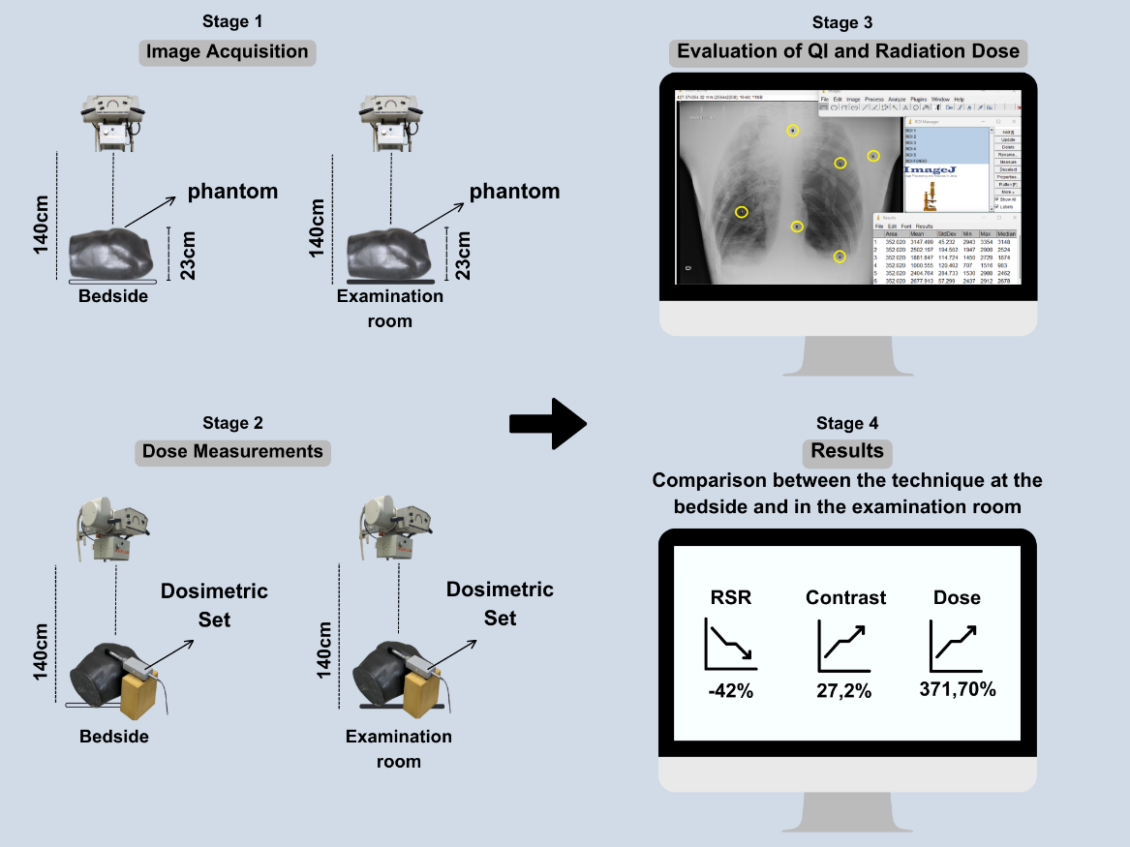

Fig. 1. Exposure Geometry for Phantom Image Acquisition and K_{a,e} Measurement

To compensate for the attenuation caused by the anti-scatter grid and maintain equivalent exposure indices, the product of tube current and exposure time (mA.s) was adjusted, resulting in values of 10 mA.s for the technique with the grid and 2 mA.s for the technique without the grid, as described in Equation 1.

${mA.s}_{Without grid}=\frac{{mA.s}_{With grid}}{4}$ (1)

The analysis of IQ was conducted using the ImageJ software through the simultaneous analysis of regions of interest (ROIs). Six regions of interest were selected for each image in areas that appeared visually homogeneous and free of bone artifacts. For the PA projection, the first ROI was centered on the sternum, the second on the upper right lobe of the lung, the third on the upper left lobe, the fourth on the middle lobe, the fifth on the lower left lobe, and the sixth on the lateral edge of the image without anatomy, representing the image background. All ROIs were circular and had the same area, as identified in Stage 3 of Figure 1.

The SNR was calculated to assess image quality. For this, the mean pixel intensity of signal-containing ROIs was compared to the mean intensity of the background ROI. Equation 2, proposed by Mraity et al. (2016), was used to calculate the SNR, considering the mean values of the signal ROIs divided by the value of the background ROI.

$SNR=\frac{Signal Average ROIs 1;2;3;4 and 5}{Background Noise ROI 6}$ (2)

Based on the signal and noise results, the mean values of SNR and RC were calculated using data from the ROIs according to Equation 2, proposed by Mraity et al. (2016). To evaluate RC in this study's images, those acquired with Technique 1 (using the grid) were used as the reference, following Equation 3.

$RC=ROI 3-ROI 6$ (3)

Since no reference values exist to define the limits for IQ descriptors, the "reference" values were those measured in the images acquired with Technique 1 using the grid. The percentage deviation (D%) was used to compare images relative to the reference image, following Equation 4.

$D\left(\%\right)=\left[\left(\frac{Technique with grid}{Technique without grid}-1\right)×100\right]$ (4)

3. results and discussion

Table 1 presents the mean values of SNR, contrast and K_{a,e} for radiographs performed with and without the use of anti-scatter grids.

Table 1. Average Values of SNR and Contrast Calculated Using Equations 2 and 3, respectively.
 | IQ Descriptors |  |  |  | Radiation Dose
 | Without | With | Without | With | Without | With
Image | SNR |  | Radiographic Contrast |  | K_{a,e} (mGy)
1 | 38,17 | 21,73 | 796,07 | 1033,33 | 0,2699 | 1,26
2 | 38,06 | 24,55 | 814,4 | 1072,86 | 0,2723 | 1,22
3 | 36,34 | 22,92 | 786,56 | 1049,88 | 0,2697 | 1,25
4 | 39,33 | 19,66 | 824,76 | 967,65 | 0,2654 | 1,25
5 | 40,09 | 21,6 | 827,89 | 1027,33 | 0,2478 | 1,25
Average | 38,4 | 22,09 | 809,93 | 1030,21 | 0,265 | 1,25
D% | -42% |  | 27,20% |  | 371,70%

It can be observed in Table 1 that the mean contrast with the grid was 1030.21, significantly higher than the 809.93 obtained without the grid, representing an increase of 27.20%. This result highlights the grid's ability to enhance the definition of areas of interest, a critical element for accurate diagnoses in radiographic imaging.

The use of the grid also led to a considerable increase in K_{a,e}. While the average dose without the grid was 0.265 mGy, it reached 1.25 mGy with the grid, representing a 371.7% increase. This highlights the need for careful consideration of the trade-off between improved image quality and the risks associated with patient radiation exposure.
On the other hand, SNR showed a 42% reduction with the grid, decreasing from 38.40 to 22.09, indicating an increase in image degradation, which may compromise overall image quality despite superior contrast.

When comparing our results with those of Cassol et al. (2024), both studies demonstrate the effectiveness of anti-scatter grids in increasing contrast and K_{a,e}, aligning with the literature (Dance et al., 2014). However, while Cassol et al. reported noise reduction in knee radiographs, our chest radiograph results did not follow this trend. This difference can be attributed to several factors, including variations in anatomical regions studied, radiographic techniques, protocols used, and equipment characteristics.

The findings of this study are consistent with previous research, emphasizing the importance of high contrast for effective differentiation of tissues and anatomical structures (Tompe; Sargar, 2020). This scenario underscores the need for a careful risk-benefit analysis tailored to clinical and diagnostic requirements, prioritizing both image quality and patient safety.

Moreover, the results support Ferreira (2017), who emphasized the importance of anti-scatter grids for obtaining high diagnostic-quality images. Thus, in examinations requiring high precision, the benefits of using grids often outweigh the risks associated with increased K_{a,e}, highlighting their significance in high-demand diagnostic contexts. Nonetheless, the clinical decision between performing a bedside chest radiograph and transporting the patient to the radiographic table requires a thorough assessment by a multidisciplinary team, including physicians and nurses. The attending physician evaluates the patient’s clinical condition and the risks associated with transport, weighing them against the need for high-quality diagnostic images. Radiology professionals, in turn, employ optimized techniques to minimize image quality loss in bedside examinations. Although our study demonstrates that the signal-to-noise ratio is preserved, a slight reduction in contrast is observed in bedside exams. However, patient transport carries significant risks, including falls and hemodynamic instability. The implementation of strict safety protocols and interprofessional collaboration is essential to ensure a safe and effective examination, aiming to optimize diagnostic outcomes.

4. Conclusion

The results of this study demonstrate that, in chest radiographic exams conducted in an examination room, the use of anti-scatter grids significantly enhances radiographic contrast. However, a reduction in SNR was noted compared to images acquired at the bedside without a grid. The decision to use a grid should be individualized, balancing the need for high diagnostic accuracy with radiation protection considerations. It should also be guided by the physician's clinical judgment to ensure patient safety and minimize risks, ultimately achieving a secure and effective diagnostic procedure.

Future studies involving different imaging systems could help generalize the findings, while the implementation of standardized acquisition protocols may contribute to improving image quality and reducing K_{a,e}.

References

Bushberg, J. T., & Boone, J. M. (2011). The essential physics of medical imaging. Lippincott Williams & Wilkins.

Cassol, L. V., Favarin, N. N., De Bail, F., Buss, E. L. R., Nogueira, L. P. T., da Costa Rosa, J. F., & Claus, T. V. (2024). The Influence of Anti-scatter Grid Usage for Knee Computerized Radiography. Physical Science International Journal, 28(4), 29-41.

Cè, M., Oliva, G., Rabaiotti, F. L., Macrì, L., Zollo, S., Aquila, A., & Cellina, M. (2024). Portable dynamic chest radiography: literature review and potential bedside applications. Medical Sciences, 12(1), 10.

Dance, D. R., Christofides, S., Maidment, A. D. A., McLean, I. D., & Ng, K. H. (2014). Diagnostic radiology physics: A handbook for teachers and students. endorsed by: American association of physicists in medicine, asia-oceania federation of organizations for medical physics, european federation of organisations for medical physics.

Ferreira, D. H. G. (2017). Comparação de radiografias digitais de tórax adquiridas no leito e no bucky por meio de regiões de interesse.

Häggmark, I., Shaker, K., Nyrén, S., Al-Amiry, B., Abadi, E., P. Segars, W., et al. (2023). Phase-contrast virtual chest radiography. Proceedings of the National Academy of Sciences, 120(1), e2210214120.

Moore, C. S., Wood, T. J., Jones, S., Saunderson, J. R., & Beavis, A. W. (2019). A practical method to calibrate and optimise automatic exposure control devices for computed radiography (CR) and digital radiography (DR) imaging systems using the signal-to-noise ratio (SNR) metric. Biomedical Physics & Engineering Express, 5(3), 035027.

Mraity, H. A., England, A., Cassidy, S., Eachus, P., Dominguez, A., & Hogg, P. (2016). Development and validation of a visual grading scale for assessing image quality of AP pelvis radiographic images. The British journal of radiology, 89(1061), 20150430.

Nascimento, K. C., Schweitzer, G., & Moreira, A. R. (2018). Elementos Fundamentais Para Segurança No Transporte Do Paciente Crítico. In: Vargas M. A. O. & Nascimento E. R. P. (Eds.). Proenf Programa De Atualização Em Enfermagem: Terapia Intensiva (1st ed., pp. 33-66). Porto Alegre: Artmed Panamericana

Sayed, M., Knapp, K. M., Fulford, J., Heales, C., & Alqahtani, S. J. (2023). The principles and effectiveness of X-ray scatter correction software for diagnostic X-ray imaging: A scoping review. European Journal of Radiology, 158, 110600.

Tompe, A., & Sargar, K. (2020). X-ray image quality assurance.

