**Long-term trends in PM2.5 levels in Delhi: A statistical approach (2010-2024)**

**Abstract**

Air pollution has now been recognized as a global health risk, with Delhi being one of the most severely affected cities worldwide. This study aims to assess the long-term trends in PM2.5 from 2010 to 2024 using statistical and time series analysis methods. Annual averages were analysed using descriptive statistics, the non-parametric Mann–Kendall test, Sen’s slope, simple linear regression analysis, and ARIMA forecasting. The annual mean concentrations of PM2.5 over the study period were 118.03 µg/m³, which is approximately 23 percent higher than the WHO standards of 5 µg/m³. The results of the Mann-Kendall test and Sen’s slope observed a declining trend of 3.38 µg/m³/year (τ = –0.702, p < 0.001). The AutoRegressive Integrated Moving Average (ARIMA) model predicts a continuous yet gradual decline in PM2.5 levels. The observed trend shows a modest decline in PM2.5 levels over the study period, yet concentrations remain well above safe limits that pose significant health risks.

**Keywords:** PM2.5, air pollution, Delhi, Mann-Kendall test, ARIMA forecasting

**Introduction**

Air pollution continues to pose a major threat to global health, with fine particulate matter (PM2.5)—particles measuring 2.5 micrometres or less—linked to serious illnesses including heart and lung diseases, strokes, and early deaths (WHO, 2021; Burnett et al., 2018). In 2019, exposure to PM2.5 was associated with over 4 million deaths worldwide (GBD 2019 Risk Factors Collaborators, 2020), highlighting the need for an increase in continuous monitoring to better inform both health policy and environmental regulations.

India continues to face mounting public health and environmental challenges due to air pollution, with recent studies highlighting an alarming rise in both exposure levels and associated health risks. Fine particulate matter (PM2.5), largely emitted from vehicle exhausts, industrial emissions, and biomass burning, remains a critical concern across Indian cities. Delhi has consistently been ranked among the most polluted cities globally, with pollution episodes particularly severe during winter months mainly due to temperature inversions and seasonal crop residue burning.

Many policy measures have been adopted to mitigate the effects of air pollution, which include the Graded Response Action Plan (GRAP) in 2017, adoption of Bharat Stage VI fuel standards in 2020, a ban on the use of firecrackers and biomass burning, and encouraging the usage of electronic vehicles (MoEFC, 2022). The COVID-19 lockdown brought a notable but temporary fall in the pollutant levels, highlighting the impact of anthropogenic activities in deteriorating the quality of air (Mahato et al., 2020; Sharma et al., 2020).

Although the measures have reduced the pollution levels, the long-term effectiveness of these measures is doubtful. Many studies in the literature have examined the short-term or seasonal changes in PM2.5 levels, but only a few have assessed the long-term pattern of the pollutants. The nature of analysis is mostly episodic, linked to high pollution levels during festivals, crop residue burning, or some weather condition. While these studies help in understanding short-term pollution risks, they provide limited insight into long-term patterns. Long-term analysis, on the other hand, helps us identify the consistent patterns separating it from the short-term variabilities. It provides a broader perspective on the factors affecting the changes in pollution levels.

This study aims to understand the long-term trend of the PM2.5 levels over a period of 15 years. The Mann-Kendall test and Sen’s slope estimator are used to identify the monotonic trend and to quantify the annual rate of change. A linear regression model was used to the direction and strength of temporal changes in the pollutant levels. Lastly, ARIMA model was used to forecast the PM2.5 concentration by capturing both the trend and autocorrelation in the time-series data. The main objective of this study is to understand the underlying trend in the annual averages of the pollutant using statistical approaches. This paper helps us understand the nature of pollutant concentration over the study period. The paper is divided into five sections. Section 2 discusses some of the relevant studies from the literature. Further, Section 3 discusses the material and methods of analysis, Section 4 details the findings and their interpretation, and Section 5 concludes the study by summarizing the key insights.

**2. Literature Review**

Delhi has regularly been among the most polluted cities in the world, and the concentrations of fine particulate matter (PM2.5) often exceeded the national and international air quality standards. The effectiveness of the proposed policy interventions cannot be fully gauged without a rigorous longitudinal analysis of PM2.5 levels, and neither can the seasonality of pollution in the region be explained without such analysis. Regression models and time-series analysis are important statistical methods that offer valuable insights about these time-varying patterns and are thus largely used in environmental studies.

The sound understanding of the long-term patterns of ambient PM2.5 concentrations is essential in evaluating the effectiveness of air quality mitigation strategies and the associated health impacts. Many recent studies have examined these trends in India and on a global level using both statistical and temporal-series methods. The landmark study by Guttikunda and Gurjar (2011) has used the Lagrangian atmospheric modelling to illustrate the seasonal difference in pollution levels. It was found that the pollution levels in winter months were 40-80% higher than in the summer season, explained by meteorological stagnation and reduced dispersion. Chowdhury et al. (2019) contributed to the seasonal-spatial dynamics of PM2.5 by analysing the high-resolution (1 km) MODIS MAIAC aerosol data during 15 years (2001-2016) in Delhi and the surrounding area of the National Capital Region (NCR). This study is a remarkable continuation of the spatial and temporal variability of PM2.5. The episodic spikes in the pollution levels were due to agricultural residue burning and localized emissions from urban areas. This highlights the importance of remote-sensing methods in identifying the different sources of pollution in a particular area.

Chetna et al. (2023) considered a longer time span from 2007 to 2021 and observed a non-linear trend in pollution levels. In their findings, they found short-term improvement in air quality followed by stagnation or even a decline. Such variations were strongly linked to changes in weather patterns and policy interventions. In their study, Verma and Nagendra (2022) have analysed the long-term changes in criteria pollutants. They observed that PM2.5 levels improved after 2016 but the pollution levels were still high in winter months. This implies that the emission control policies were partially successful in improving the air quality.

Previous studies have provided useful information on ambient PM2.5 concentrations, but most of them are based on similar analytical approaches. This paper addresses these constraints by examining the PM2.5 concentrations in Delhi between 2010 and 2024. It uses an integrated approach by combining non-parametric trend analysis with linear regression and the ARIMA model. This holistic approach allows a detailed analysis of long-term trends and also takes into account sudden shifts in air quality.

**3. Material and methods**

The purpose of this study is to comprehend the trend of the annual average of the PM2.5 concentrations in Delhi during 15 years, 2010-2024. The PM2.5 data was retrieved from the official website of Central Pollution Control Board (CPCB). Descriptive statistics, including the mean, median, minimum, maximum, and standard deviation, were calculated to have a summarized view of the distribution and variation of the pollutant over the study period. To understand the long-term trend in PM2.5, time series plots were used. Then, the Mann-Kendall test and Theil-Sen’s slope estimator were applied to confirm the direction and magnitude of the trend. Further, the ARIMA forecasting was applied to predict the future PM2.5 levels due to its practical usefulness in environmental forecasting.

This study used the newest version of the R program (R version 4.5.1) to conduct statistical analysis and visualization. Descriptive statistics and graphs were made in *ggplot2*. The trend estimation was done through the Mann-Kendall method (mk.test()) and Sen’s slope estimator (sens.slope()) using the *trend* package. To measure the association between the level of PM2.5 and the time, a simple linear regression model (lm()) was used. To make forecasts, an ARIMA model was fit with the auto.arima() command of the *forecast* package, and then stationarity was checked through the Augmented Dickey Fuller (adf.test()) and KPSS (kpss.test()) tests of the *tseries* package. The residual diagnostics (checkresiduals(), Box.test()) assured us of the validity of the model, and this allowed us to predict the PM2.5 levels in 5 year time, between 2025 and the year 2029.

**4. Results and discussion**

This section outlines the findings of the long-term trend analysis of the annual average of PM2.5 concentrations in Delhi during the study period from 2010 to 2024. Descriptive statistics and graphical analysis were used to give an idea of the overall trend. The non-parametric tests: Mann-Kendall and Theil-Sen’s slope estimator, were used to understand the direction and magnitude of the trend. Further, a simple linear regression model was applied to assess the strength and direction of the trend. Thereafter, ARIMA modelling as used to predict the future trends of PM2.5.

**4.1 Descriptive statistics**

Descriptive statistics were applied to understand the basic structure of the data, such as what the average pollution levels were in different years, how they varied over different years, and if the outliers in the data influenced the trend. This initial overview of the data helps us decide if further deep trend analysis is needed or not, gives an idea about the shifts and patterns, and the overall behaviour of the pollutant. Table 1 provides a summary of data using descriptive statistics.

**Table1. Descriptive statistics of PM2.5 concentrations in Delhi from 2010-2024**

|  |  |  |
| --- | --- | --- |
| Descriptive measure | Value (µg/m3) | Interpretation |
| Mean | 118.0 | The average value across 15 years |
| Median | 117.0 | This value is close to mean value indication low skewness of the dataset |
| Standard deviation | 16.5 | Indicates the annual variation in PM2.5 |
| Minimum | 93.0 | Lowest value observed in 2020 |
| Maximum | 144.0 | Peak pollution in 2016 |

Source: Computed by Author

The annual average over the study period was 118.0 µg/m3 which indicates that the pollution levels remained consistently high during the study period. The standard deviation of 16.5 µg/m3 reveals a moderate variation in the pollutant concentrations across years, which again depicts that the overall pollution levels remained elevated. The lowest level of PM2.5 concentrations were recorded in 2020 and highest in 2016, both these values far exceeded both national and WHO air quality standards. There was not much difference in the calculated values of mean and median indicating limited skewness in the data, which also means that the air quality was persistently poor across the years.

**4.2 Trend in annual PM2.5 levels**

*Figure 1* shows the yearly average levels of fine particulate matter (PM2.5) in Delhi from 2010 to 2024. PM2.5 refers to very small airborne particles, less than 2.5 micrometres in size, that can be inhaled deep inside the lungs, and even enter the bloodstream. The graphical presentation of annual average PM2.5 concentrations offers a clear visual presentation on how air pollution levels in Delhi have evolved over time. It enables the identification of long-term trends—whether increasing, decreasing, or remaining stable—which can be linked to changes in policy, shifts in economic activity, or variations in weather patterns. It also helps highlight important changes over time and makes it easier to understand how air quality has shifted during the 15-year period.

**Figure 1. Annual average PM2.5 in Delhi (2010-2024)**

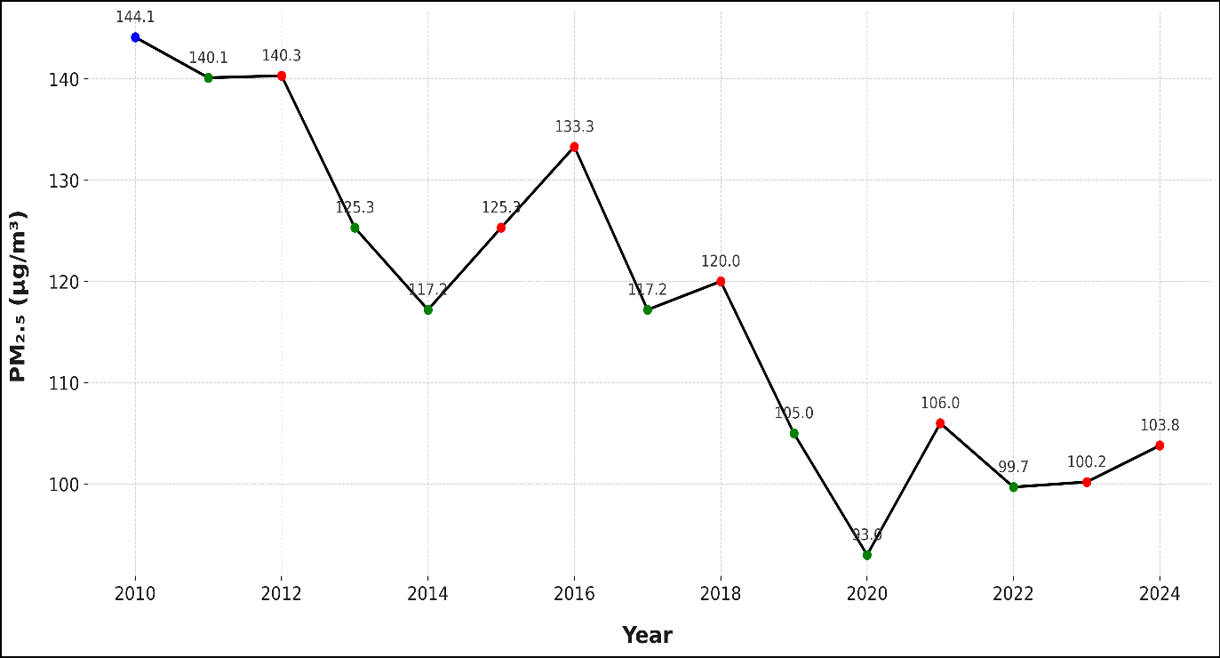

The blue point in the figure marks the beginning point. The orange points indicate and increase in pollution levels, while the green points represent a decline relative to previous year’s levels. From 2010 to 2012, Delhi experienced persistently high PM2.5 concentrations (~140–145 µg/m³) with minimal interannual variability. A notable decline began after 2012, with levels dropping below 130 µg/m³ by 2015. However, a short-term rise was observed during 2016–2017, reaching approximately 133 µg/m³. The most significant reduction occurred between 2018 and 2020, with concentrations falling sharply to ~93 µg/m³ in 2020—likely influenced by reduced anthropogenic activities during the COVID-19 lockdowns. Between 2021 and 2024, the trend stabilized, with minor fluctuations around 100–105 µg/m³, indicating moderate improvement but persistent exceedance of both national and international air quality standards.

**4.3 Year-on-Year changes in PM2.5** **levels**

While long-term trends provide essential insights into the direction of air quality improvement, year-on-year changes are critical to evaluating the impact of specific interventions, episodic emissions, and meteorological variability. *Figure 2* presents the percentage change in Delhi’s annual average PM2.5 concentrations from 2010 to 2024, visualizing interannual fluctuations that are not apparent in the overall trendline.

**Figure 2. Year-on-Year percentage change in annual average PM2.5 concentrations in Delhi (2010–2024)**

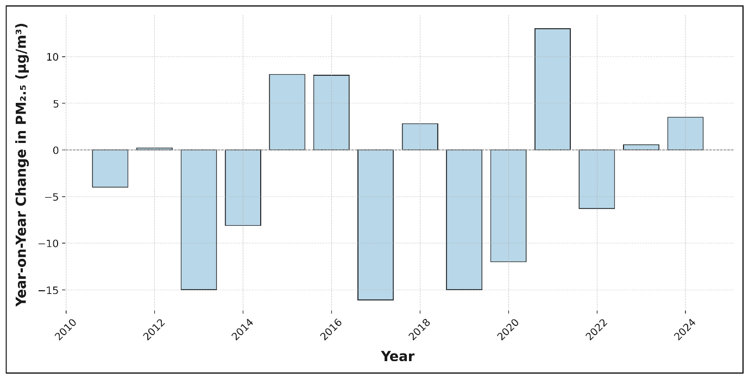

Annual PM2.5 concentrations in Delhi displayed notable year-on-year changes between 2010 and 2024. After a modest decline in 2011 (−2.78%), levels remained nearly unchanged in 2012 (+0.14%). Significant reductions occurred in 2013 (−10.69%) and 2014 (−6.46%), likely due to initial enforcement of pollution control measures and favourable meteorological conditions. However, this trend reversed in 2015 (+6.91%) and 2016 (+6.38%), likely influenced by seasonal biomass burning and festival-related emissions. A sharp decline resumed in 2017 (−12.08%), while 2018 registered a moderate increase (+2.39%).

Subsequent years saw further improvement, with major drops in 2019 (−12.50%) and 2020 (−11.43%), the latter largely attributed to COVID-19 lockdowns that restricted transport and industrial operations (Sharma et al., 2020; Mahato et al., 2020). In contrast, 2021 experienced the sharpest increase (+13.98%) in the dataset, coinciding with the post-lockdown revival of economic activity. The years that followed showed minimal year-on-year changes—2022 (−5.94%), 2023 (+0.55%), and 2024 (+3.49%)—indicating a potential stabilization in pollution levels.

These year-to-year changes in PM2.5 levels show that air pollution in Delhi is influenced by several factors. Government policies and pollution control efforts can bring improvements, but short-term events—like crop burning or festivals—often cause sudden rise. Weather conditions, such as wind or rainfall, also affect how pollution builds up or disperses. This means that to effectively manage air quality, efforts must be continuous throughout the year and flexible enough to respond to both long-term and sudden changes.

**4.4 Statistical trend analysis**

To assess the long-term trend in Delhi’s annual PM2.5 concentrations, we applied the Mann–Kendall test and Sen’s slope estimator. These nonparametric methods are well-suited for environmental time series due to their robustness against non-normality and outliers.

The Mann–Kendall test revealed a strong negative trend (τ = −0.702, *p* = 0.00035), confirming that the decline in PM2.5 levels from 2010 to 2024 is statistically significant. Complementing this, Sen’s slope estimated a median reduction of −3.38 µg/m³/year (95% CI: −4.34 to −2.03), indicating consistent annual improvements in air quality.

**4.5 Linear regression analysis of PM2.5 trend**

The linear regression analysis estimated a slope of -3.32 µg/m³, indicating that there was a steady decrease in PM2.5 concentrations during the study period. The negative sign of the slope implies that the air quality in Delhi was monotonically improving over the study period. The coefficient of determination (R2) was computed to be 0.81, which meant 81 % of the variability in the annual concentrations of PM2.5 was explained by the temporal trend.

Since the model has a simple structure with one variable and a small sample size, the adjusted R2 was calculated and was found to be 0.794. The R2 value explains 79.4% of the variations in the data, reflecting a strong and reliable fit. Thus, the trend and degree of association between time and PM2.5 concentrations are effectively estimated by the analysis. This means that the decline in the PM2.5 concentration is steady over the study period.

*Figure 3* illustrates the linear trend in the annual average of PM2.5 concentrations in Delhi over a period of 15 years, from 2010 to 2024.

**Figure 3. Linear regression of PM2.5 concentrations in Delhi (2010-2024)**

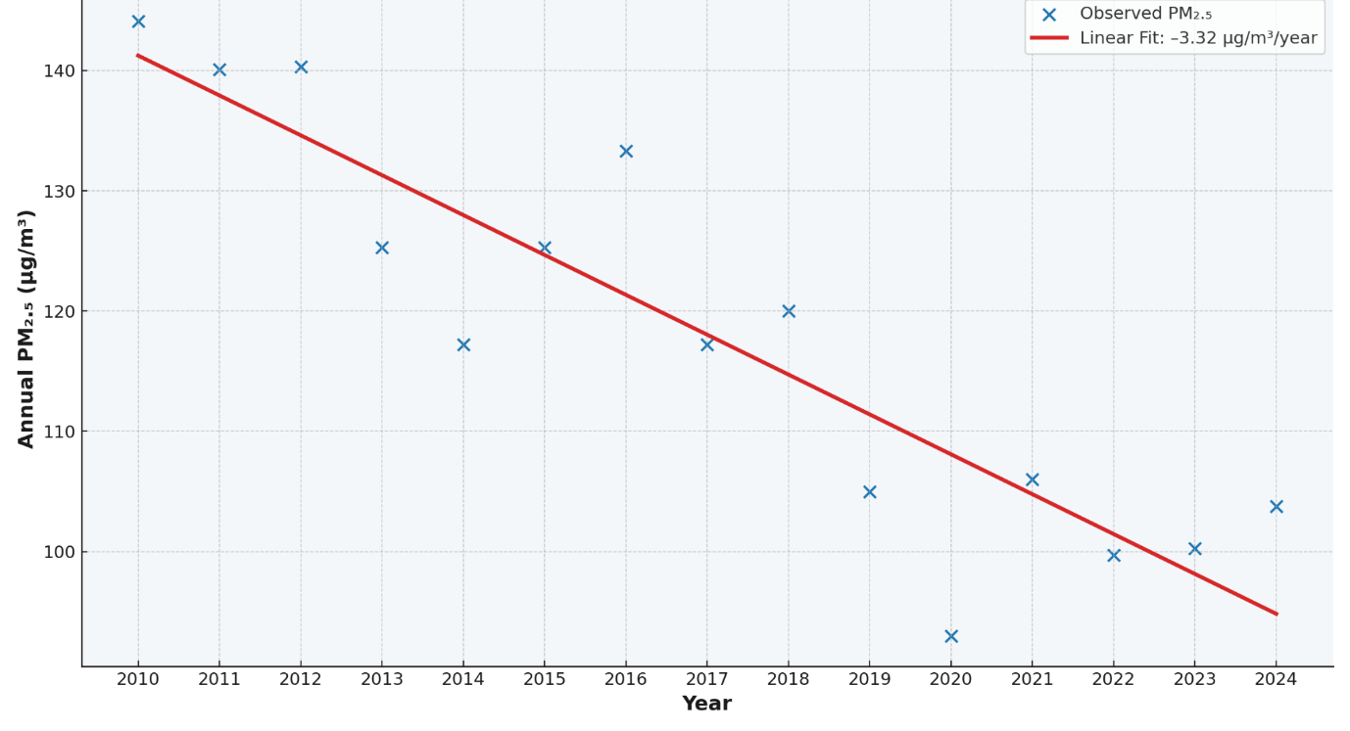

The blue markers on the graph represent the observed values showing interannual variations of the pollutant’s concentrations. The downward-sloping red line is the regression line representing a significant negative trend with a slope of -3.32 µg/m³. The findings suggest that the PM2.5 concentrations were declining gradually over the 15-year study period, along with some variations on an annual basis. The close correspondence of the trend line to the observed points suggests that the model is accurate, which is also reflected by the high R2 value of 0.81.

**4.6 Time series forecasting of PM2.5 using ARIMA**

To estimate the PM2.5 concentrations in Delhi after 2024, a time-series forecasting technique known as ARIMA. The model is based on the annual average observations of PM2.5 from 2010 to 2024. An initial examination of the data from the graph revealed a downward trend, which hints at the possibility that the time series is not stationary. This observation was statistically test with the Augmented-Dicky Fuller Test (ADF). The result of this test (test statistic = -1.56, p-value = 0.504) affirmed that the series is not stationary. We, therefore, applied the first-order differencing to get rid of the stationarity. The ADF results after differencing indicated a substantially lower value of -4.54 and a p-value of 0.00017, which shows that the adjusted series is now stationary and fits the model.

Thereafter, we examined the autocorrelation and partial autocorrelation plots of differenced series and discovered that the ARIMA (1,1,1) model is the best choice for our data. Based on this model, the prediction for next five years on PM2.5 levels was made until 2029.

*Figure 4 and Table 2* present the forecasted value of PM2.5 with the range of uncertainty (95% confidence interval) displayed by the grey band.

**Figure 4. ARIMA (1,1,1) forecast of PM2.5 (2025-2029)**

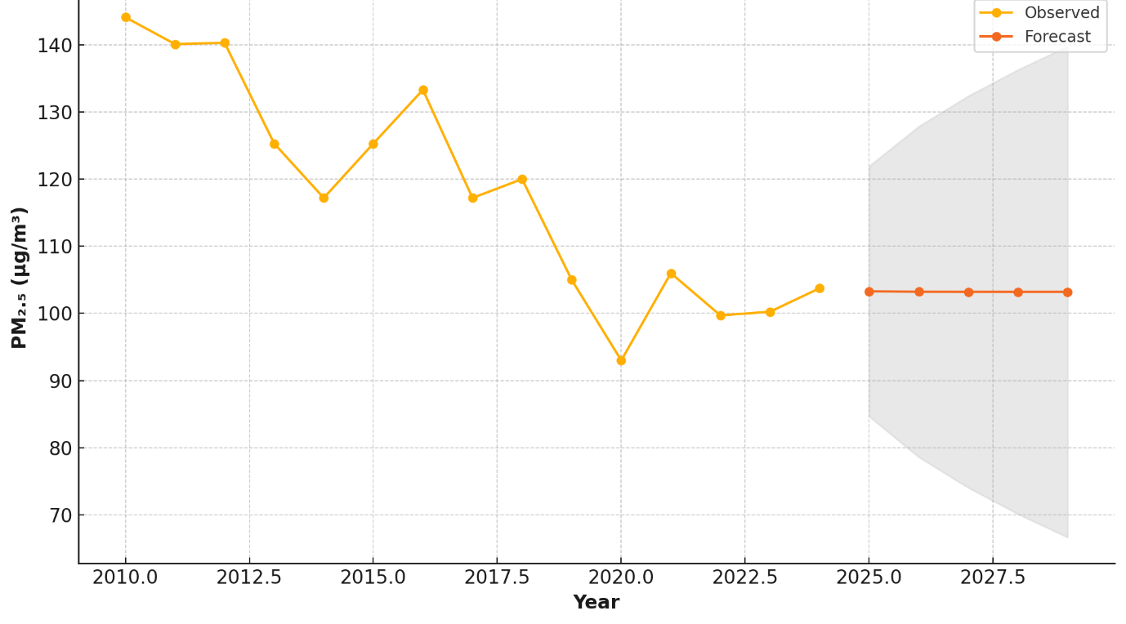

**Table 2: Forecasted annual average PM2.5 concentrations in Delhi (2025-2029)**

|  |  |  |  |
| --- | --- | --- | --- |
| Year | Forecasted PM2.5 | Lower CI | Upper CI |
| 2025 | 103.3 | 84.66 | 121.94 |
| 2026 | 103.22 | 78.6 | 127.84 |
| 2027 | 103.21 | 74.04 | 132.38 |
| 2028 | 103.2 | 70.14 | 136.27 |
| 2029 | 103.2 | 66.66 | 139.75 |

Source: Computed by Author

The orange line in the *Figure 4* presents the actual values of PM2.5 in the study period from 2010 to 2024, whereas the red line shows the predicted values for coming 5 years. The grey shaded band around the red line represents the 95% confidence interval, and gives a range in which the forecasted value may fall. The results of the ARIMA model predicts that the concentration of PM2.5 will remain relatively stable around 103 µg/m³ between 2025 and 2029 with very low inter-annual variations. However, the confidence interval (grey area) widens with the passage of each year indicating a higher uncertainty of predicted values in the later years. This highlights the fundamental shortcoming of the statistical predictions that fails to capture the unexpected changes in policy, emissions, or weather fluctuations that might directly impact the quality of air.

**5. Conclusion**

This study evaluated the temporal trend of the annual mean PM2.5 levels in the past 15 years (2010-2024) using statistical tools and time series analysis. The Mann-Kendall and Sen’s slope estimator demonstrated a declining trend with an annual decline of 3.38 µg/m³. The same findings were reaffirmed with the linear regression analysis (R2=0.807) exhibiting a strong relationship between the years of study and the PM2.5 levels. To predict future air quality, the annual PM2.5 data was fitted to the ARIMA (1,1,1) model. The choice of this model was based on the diagnostic tests of autocorrelation and partial autocorrelation. The results indicate that the concentrations of PM2.5 will remain relatively constant around 103 µg/m³ with variation within a small range of 103.30 to 103.20 µg/m³.

Despite slight improvement in air pollution levels observed in the last 10 years in Delhi, the PM2.5 levels are significantly higher than the national and WHO standards. The air quality is not even expected to improve in the next few years, and is projected to remain more or less stagnant. This clearly states that immediate and sustained efforts would be needed to curb the pollution levels. There is a need to improve the existing policies to bring noticeable changes in pollution levels. Also, in the future, empirical studies should focus on developing more detailed and refined models that incorporate meteorological factors, spatial heterogeneity, and more detailed information on the sources of emission.

**References**

1. World Health Organization. (2021). WHO global air quality guidelines: Particulate matter (PM₂.₅ and PM₁₀), ozone, nitrogen dioxide, sulfur dioxide and carbon monoxide. World Health Organization. <https://www.who.int/publications/i/item/9789240034228>
2. Burnett, R., Chen, H., Szyszkowicz, M., Fann, N., Hubbell, B., Pope III, C. A., ... & Spadaro, J. V. (2018). Global estimates of mortality associated with long-term exposure to outdoor fine particulate matter. *Proceedings of the National Academy of Sciences*, *115*(38), 9592-9597.
3. Murray, C. J., Aravkin, A. Y., Zheng, P., Abbafati, C., Abbas, K. M., Abbasi-Kangevari, M., ... & Borzouei, S. (2020). Global burden of 87 risk factors in 204 countries and territories, 1990–2019: a systematic analysis for the Global Burden of Disease Study 2019. *The lancet*, *396*(10258), 1223-1249.
4. Ministry of Environment, Forest and Climate Change. (2022). *Annual report 2021–22*. Government of India. <https://moef.gov.in/>
5. Mahato, S., Pal, S., & Ghosh, K. G. (2020). Effect of lockdown amid COVID-19 pandemic on air quality of the megacity Delhi, India. *Science of the total environment*, *730*, 139086.
6. Sharma, S., Zhang, M., Gao, J., Zhang, H., & Kota, S. H. (2020). Effect of restricted emissions during COVID-19 on air quality in India. *Science of the total environment*, *728*, 138878.
7. Chowdhury, S., Dey, S., Di Girolamo, L., Smith, K. R., Pillarisetti, A., & Lyapustin, A. (2019). Tracking ambient PM2. 5 build-up in Delhi national capital region during the dry season over 15 years using a high-resolution (1 km) satellite aerosol dataset. *Atmospheric Environment*, *204*, 142-150.
8. Chetna, Dhaka, S. K., Longiany, G., Panwar, V., Kumar, V., Malik, S., ... & Hayashida, S. (2023). Trends and variability of PM2. 5 at different time scales over Delhi: long-term analysis 2007–2021. *Aerosol and Air Quality Research*, *23*(5), 220191.
9. Guttikunda, S. K., & Gurjar, B. R. (2012). Role of meteorology in seasonality of air pollution in megacity Delhi, India. *Environmental monitoring and assessment*, *184*(5), 3199-3211.
10. Singh, V., Singh, S., & Biswal, A. (2021). Exceedances and trends of particulate matter (PM2. 5) in five Indian megacities. *Science of the Total Environment*, *750*, 141461.
11. Verma, N., & Nagendra, S. S. (2022). Long-term trend analysis of criteria pollutants in megacity of Delhi: Failure or success of control policies. *Urban Climate*, *45*, 101254.